Original Research Article
Synthesis and Characterization of Citrate-Reduced Silver Nanoparticles Augmented with Punica granatum Peel Extract

ABSTRACT

Silver nanoparticles are widely studied for biomedical and pharmaceutical applications because of their distinctive physicochemical properties and potential for surface modification. This study aimed to synthesise citrate-reduced silver nanoparticles and augment them with an ethanolic extract of Punica granatum peel, followed by physicochemical characterisation. Pomegranate peels were washed, dried, powdered, and extracted with ethanol using Soxhlet extraction. The extract was qualitatively screened for major phytochemical groups. Silver nanoparticles were prepared by chemically reducing silver nitrate with trisodium citrate, and the nanoparticle suspension was subsequently mixed with pomegranate peel extract at three amounts: 200 mg, 500 mg, and 1000 mg. The prepared nanoparticles were characterised by visual observation, UV–visible spectrophotometry, dynamic light scattering, and zeta potential analysis. Phytochemical screening confirmed the presence of polyphenols, tannins, flavonoids, terpenoids, and saponins in the ethanolic peel extract. Citrate-reduced silver nanoparticles exhibited a pale-yellow colour and a characteristic surface plasmon resonance peak at approximately 420 nm. Following augmentation with pomegranate peel extract, concentration-dependent spectral shifts were observed, with peaks at 360 nm, 370 nm, and 385 nm for the 200 mg, 500 mg, and 1000 mg extract-augmented formulations, respectively. Dynamic light scattering showed an increase in hydrodynamic diameter from 59 nm for citrate-reduced silver nanoparticles to 95 nm, 158 nm, and 212 nm after extract augmentation. Zeta potential values also varied with extract amount, indicating changes in surface charge and colloidal stability. These findings suggest an interaction between pomegranate peel phytochemicals and citrate-reduced silver nanoparticles.
Keywords: Silver nanoparticles; citrate reduction; Punica granatum; pomegranate peel extract; surface augmentation; UV–visible spectrophotometry; dynamic light scattering; zeta potential; phytochemicals; physicochemical characterisation

1. INTRODUCTION

Nanotechnology is an advanced field of science that has been applied across diverse domains, including biomedicine, because of its unique physicochemical properties. Nanoparticles are well suited to drug delivery because they can protect drugs from degradation, improve bioavailability, maintain drug stability and tissue specificity, reduce adverse effects, and enhance drug safety (Cooper et al., 2014). Silver nanoparticles (AgNPs) are among the most widely used metal nanoparticles and typically range from 1 to 100 nanometres in size. Silver nanoparticles exhibit antiangiogenic (Gurunathan et al., 2009), antioxidant (Padmavathi et al., 2022), and anticancer (Yin et al., 2022) effects.
Pomegranate (Punica granatum L.) is an ancient fruit-bearing plant originally native to Central Asia. The seeds, peels, leaves, and flowers of pomegranate contain phytochemicals such as alkaloids, polyphenols, flavonoids, saponins, and tannins (Elfalleh et al., 2012). The peel accounts for approximately 50% of the fruit's total weight and is a rich source of bioactive compounds, including phenolics, ellagitannins, flavonoids, and proanthocyanidins, together with essential minerals and complex carbohydrates (Sreekumar et al., 2014). Phytochemicals present in pomegranate exhibit antioxidant, anti-inflammatory, anticancer, antimicrobial, and cancer-chemopreventive properties (Charoensedtasin et al., 2024; Celiksoy & Heard, 2021; Middha et al., 2013; Moreira et al., 2017; Stefanou et al., 2020). Bioactive compounds in plants and their extracts may show potential in vitro activity but limited or no significant in vivo activity because of poor structural stability, solubility, absorption, and bioavailability; however, these limitations may be addressed through nanotechnology-based modifications (Gunasekaran et al., 2014).
Augmentation of AgNPs with P. granatum extract can enhance nanoparticle biocompatibility and biological efficacy through synergistic interactions. Recent plant-mediated AgNP studies indicate that plant phytochemicals can contribute to nanoparticle reduction and stabilisation, while spectroscopic and physicochemical analyses are used to assess particle formation, size, and surface characteristics (Agunbiade et al., 2025; Eker et al., 2025; Prema et al., 2026).

Studies focused on pomegranate peel have likewise reported its use in AgNP synthesis and characterisation, supporting the relevance of peel-derived phytochemicals to nanoparticle formation and physicochemical properties (Rani et al., 2024; Sari Gencag et al., 2025). However, available studies do not fully address the concentration-dependent physicochemical changes resulting from the augmentation of preformed citrate-reduced AgNPs with graded amounts of ethanolic P. granatum peel extract, particularly changes in optical response, hydrodynamic diameter, and zeta potential.
Therefore, the present study aimed to synthesise silver nanoparticles chemically using sodium citrate and subsequently augment them with P. granatum peel extract for potential biomedical applications.

2. MATERIALS AND METHODS

2.1 Preparation of Ethanolic Extract of Punica granatum Peel: Pomegranate peels were washed, shade-dried for 10 days, oven-dried at 40°C for 24 h, and powdered to obtain a homogeneous, finely granular consistency. The powder was subjected to Soxhlet extraction with absolute ethanol at 55°C. The extract was filtered, concentrated at 50°C, and further dried. The extract yield was 30% (w/w), and the dried extract was stored at 4°C for further experimental use.
2.2 Phytochemical Screening: The ethanolic extract was qualitatively screened for phenolics, tannins, flavonoids, terpenoids, and saponins using standard biochemical tests such as ferric chloride, ellagic acid, lead acetate, zinc-HCl reduction, Salkowski, and foam tests.
2.3 Synthesis and Characterisation of Silver Nanoparticles (AgNPs): A 100 mL solution of 0.001 M silver nitrate (AgNO₃) was heated to boiling. Subsequently, 5 mL of 1% trisodium citrate solution was added dropwise under continuous vigorous stirring. The reaction mixture was maintained at boiling temperature with constant stirring using a magnetic stirrer until a visible colour change from colourless to pale yellow was observed, indicating the formation of silver nanoparticles. Heating was then discontinued, and the solution was allowed to cool to room temperature while stirring continuously. The synthesised silver nanoparticles were subsequently subjected to characterisation studies. The synthesised AgNP suspension was mixed with 200 mg, 500 mg, and 1000 mg of P. granatum peel extract under magnetic stirring at room temperature. Following surface functionalisation with pomegranate peel extract (i.e. the addition of pomegranate peel extract so that its bioactive compounds could attach to or coat the surface of the silver nanoparticles), the modified nanoparticles (PPE-AgNPs) were recharacterised to confirm conjugation and changes in physicochemical properties. The solution was centrifuged, washed, and dried. Characterisation was performed using UV–visible spectrophotometry, dynamic light scattering (DLS) for particle size, and zeta potential analysis for stability.

3. RESULTS AND DISCUSSION

3.1 Qualitative Phytochemical Screening of Ethanolic Extract of Pomegranate Peel: Qualitative phytochemical screening showed the presence of polyphenols, tannins, flavonoids, terpenoids, and saponins in the ethanolic extract of pomegranate peel (Fig. 1). Qualitative phytochemical screening of the ethanolic extract of Punica granatum peel confirmed the presence of polyphenols, tannins, flavonoids, terpenoids, and saponins. These findings are consistent with those of Bhandary et al. (2012), Marka et al. (2013), and Pinnamaneni (2018). These phytoconstituents are known for their antioxidant and biological properties and can interact with nanoparticle surfaces through adsorption and surface coating.

Fig.1 Phytochemical Profile of Ethanolic Extract of Punica granatum Peel

3.2 Synthesis and Characterisation of Silver Nanoparticles:
3.2.1 Visual Observation: The AgNPs were synthesised using a chemical reduction method. The colourless AgNO₃ solution turned pale yellow, indicating the formation of AgNPs. This colour transformation is characteristic of silver nanoparticle formation. These observations are consistent with the findings reported by Rashid et al. (2013) and Abd El-Magid et al. (2023).
3.2.2 UV–Visible Spectrophotometry Using NanoDrop: The spectra, obtained using a NanoDrop model ND-1000 (USA) and Shimadzu UV 2450 (Japan), over a wavelength range of approximately 200–750 nm, represent the UV–visible spectrophotometric analysis of silver nanoparticles (AgNPs) and pomegranate extract-augmented silver nanoparticles (Fig. 2, a–d). A distinct absorption band was observed in the UV–visible region, with a characteristic surface plasmon resonance (SPR) peak appearing within the 400–450 nm region (approximately 420 nm). UV–visible spectrophotometric analysis of pomegranate peel extract-augmented silver nanoparticles (PPE-AgNPs) at different extract concentrations showed a distinct SPR band characteristic of silver nanoparticles within the 350–400 nm region. A concentration-dependent shift in the SPR peak was observed, with pomegranate peel extract-augmented silver nanoparticles prepared using 200 mg, 500 mg, and 1000 mg of pomegranate peel extract exhibiting SPR maxima at 360 nm, 370 nm, and 385 nm, respectively. These spectral shifts indicate modifications in the local dielectric environment surrounding the nanoparticles and suggest an interaction between the phytochemicals and the nanoparticle surface. The gradual shift in peak position may also reflect changes in particle size and surface characteristics following extract augmentation. The present findings are consistent with earlier studies (Abdelmigid et al., 2021; Agnihotri et al., 2014; Nosrati et al., 2025; Wypij et al., 2021).

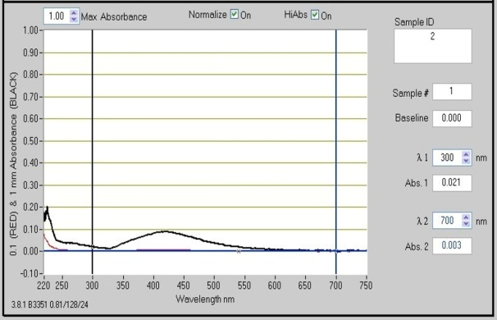  a | 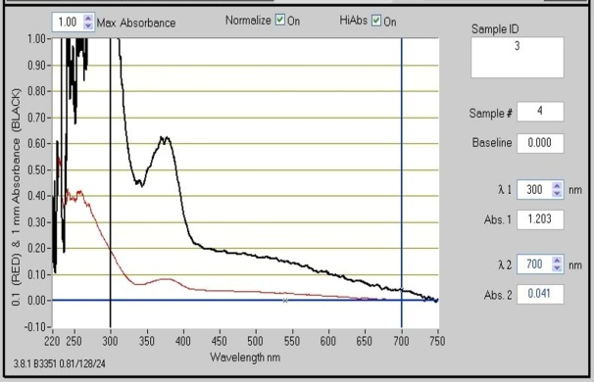  b
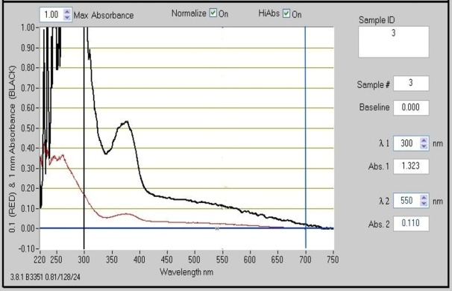  c | 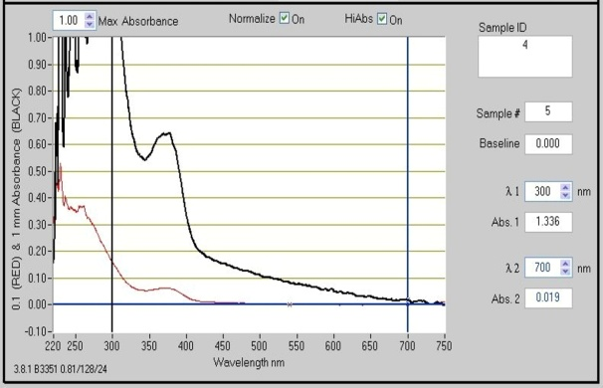  d

Fig.2 (a-d):UV-VIS Spectrophotometry of AgNPs (a), Punica granatum Peel Extract (200 mg) + AgNPs (b), Punica granatum Peel Extract (500 mg) + AgNPs (c) and Punica granatum Peel Extract (1000 mg) + AgNPs

3.2.3 Dynamic Light Scattering Spectroscopy (DLS): In dynamic light scattering (DLS) analysis, the intensity-based size distribution profile revealed a dominant, sharp peak with an average particle size of approximately 59 nm, indicating that most AgNPs were present within this nanoscale range (Malvern Zetasizer, model ZEN5600, UK). Average hydrodynamic diameters of approximately 95 nm with 200 mg of extract, 158 nm with 500 mg of extract, and 212 nm with 1000 mg of extract were noted (Fig. 3, a–d). Following augmentation with increasing concentrations of pomegranate peel extract, the particle size increased progressively, indicating surface coating of the nanoparticles by bioactive compounds present in the extract. The increase in particle size may be attributed to the formation of a phytochemical coating on the nanoparticle surface following augmentation with Punica granatum peel extract. Similar increases in hydrodynamic diameter following plant extract conjugation have been reported in previous nanoparticle studies (Fatimah & Aftrid, 2019; Mankad et al., 2020; Skandalis et al., 2017; Vanlalveni et al., 2021; Vinay et al., 2018).

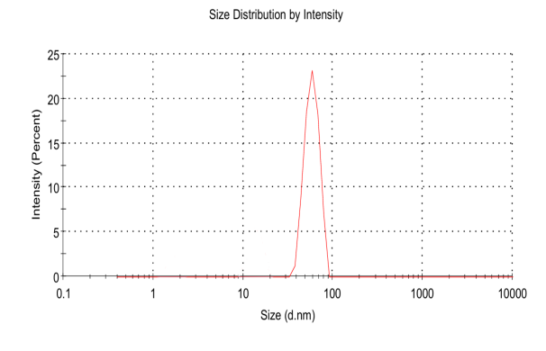  a | 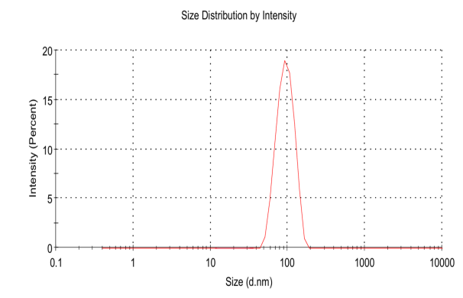  b
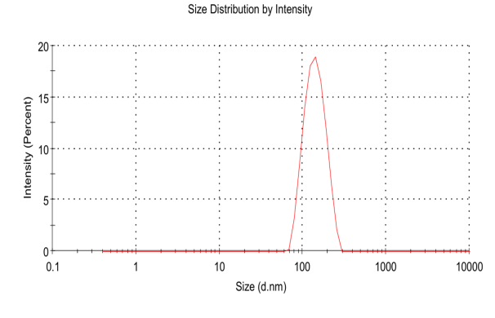  c | 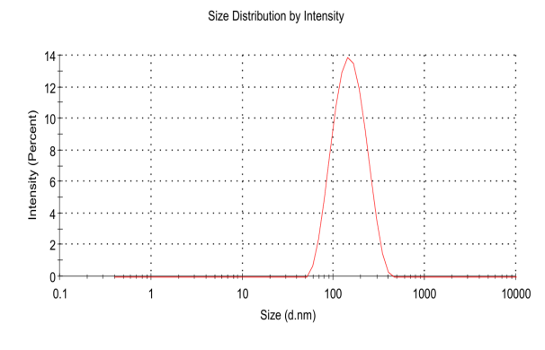  d

Fig.3(a-d): Dynamic Light Scattering Spectroscopy of AgNPs(a), Punica granatum Peel Extract (200 mg) + AgNPs (b), Punica granatum Peel Extract (500 mg) + AgNPs (c) and Punica granatum Peel Extract (1000 mg) + AgNPs

3.2.4 Zeta Potential Measurement: The zeta potential of the synthesised silver nanoparticles was −25.4 mV. Upon augmentation with pomegranate peel extract, the zeta potential values varied with extract concentration, measuring −10.7 mV, −20.4 mV, and −31.1 mV at extract amounts of 200 mg, 500 mg, and 1000 mg, respectively (Fig. 4, a–d). Zeta potential measurements provided insight into the colloidal stability of the synthesised nanoparticles. The citrate-reduced AgNPs exhibited a zeta potential of −25.4 mV, indicating moderate colloidal stability due to electrostatic repulsion between particles. Following augmentation with pomegranate peel extract, the zeta potential values varied according to extract concentration. The nanoparticles augmented with 200 mg of extract exhibited a lower negative charge, suggesting comparatively reduced stability. However, nanoparticles augmented with 500 mg and 1000 mg of extract showed increasingly negative zeta potential values. The highly negative zeta potential observed at the highest extract concentration indicates enhanced colloidal stability and a reduced tendency for aggregation. This increase in surface charge is likely due to the adsorption of negatively charged polyphenolic compounds onto the nanoparticle surface. These findings are similar to those reported in previous studies (Mostafa et al., 2024; Saad et al., 2021; Vinay et al., 2018).
Collectively, the UV–visible, DLS, and zeta potential analyses indicate that pomegranate peel extract interacted with citrate-reduced silver nanoparticles, resulting in changes in optical properties, particle size, and surface charge. The enhanced stability observed at higher extract concentrations suggests effective surface functionalisation by phytochemicals present in the peel extract. Such functionalised nanoparticles may possess improved biological properties owing to the combined effects of silver nanoparticles and pomegranate-derived bioactive compounds.

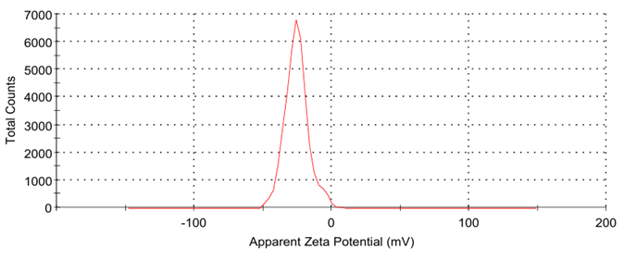  a | 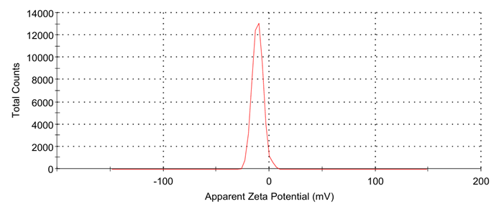  b
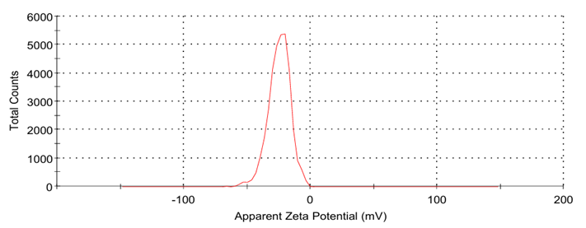  c | 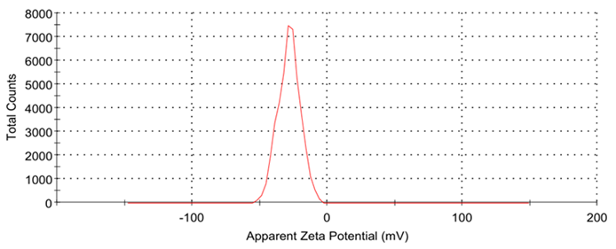  b  d  b

Fig.4(a-d): Zeta potential of AgNPs(a), Punica granatum Peel Extract (200 mg) + AgNPs (b), Punica granatum Peel Extract (500 mg) + AgNPs (c) and Punica granatum Peel Extract (1000 mg) + AgNPs

Conclusions
Silver nanoparticles were synthesised through the reduction of silver nitrate with trisodium citrate, as supported by the observed colour change and UV–visible spectrophotometric profile. The ethanolic extract of Punica granatum peel contained polyphenols, tannins, flavonoids, terpenoids, and saponins. Augmentation of citrate-reduced silver nanoparticles with the peel extract produced concentration-dependent changes in surface plasmon resonance, hydrodynamic diameter, and zeta potential. The progressive increase in hydrodynamic diameter from 59 nm to 95, 158, and 212 nm suggests interaction or surface coating by peel-derived phytochemicals. Surface charge also varied with the amount of extract, and the formulation containing 1000 mg produced the most negative zeta potential among the augmented formulations. Collectively, the findings show that pomegranate peel extract modified the measured physicochemical characteristics of citrate-reduced silver nanoparticles. However, the present results are limited to preliminary physicochemical evidence. Additional investigations of particle morphology, polydispersity, chemical bonding, storage stability, biological activity, cytotoxicity, biocompatibility, and safety are required before biomedical or pharmaceutical applicability can be established.

Limitations
This study was limited to the synthesis and basic physicochemical characterisation of citrate-reduced silver nanoparticles augmented with Punica granatum peel extract. The work did not include detailed morphological analysis by electron microscopy, Fourier transform infrared spectroscopy, X-ray diffraction, polydispersity index reporting, or statistical comparisons of replicate measurements. Biological activity, antimicrobial efficacy, cytotoxicity, biocompatibility, and in vivo safety were not evaluated. Therefore, the findings support only surface modification and preliminary stability assessment. Claims regarding biomedical or pharmaceutical applications should be considered preliminary until supported by additional functional and safety studies.

Declaration of AI Use

This manuscript was prepared through the combined contributions of all author(s), including contributions to the study design, data, content development, results, interpretation, and related scholarly work. The author(s) acknowledge the use of Grammarly and ChatGPT to assist with grammar checking, language refinement, and reference formatting. These AI-assisted tools were not used as authors and did not replace the intellectual contributions or scholarly judgement of the author(s). All AI-assisted outputs, including content, references, and interpretations, were carefully reviewed, revised, verified, and approved by the author(s). The author(s) accept full responsibility for the accuracy, integrity, and final content of the manuscript.

References

Abd El-Magid, A. D., AbdEl-Hamid, O. M., & Younes, M. A. (2023). The biochemical effects of silver nanoparticles and spirulina extract on experimentally induced prostatic cancer in rats. Biological Trace Element Research, 201(4), 1935–1945. https://doi.org/10.1007/s12011-022-03298-0
Abdelmigid, H. M., Morsi, M. M., Hussien, N. A., Alyamani, A. A., & Al Sufyani, N. M. (2021). Comparative analysis of nanosilver particles synthesized by different approaches and their antimicrobial efficacy. Journal of Nanomaterials, 2021, Article 2204776. https://doi.org/10.1155/2021/2204776
Agnihotri, S., Mukherji, S., & Mukherji, S. (2014). Size-controlled silver nanoparticles synthesized over the range 5–100 nm using the same protocol and their antibacterial efficacy. RSC Advances, 4(8), 3974–3983. https://doi.org/10.1039/C3RA44507K
Agunbiade, T. O., Agunbiade, O. J., Kolawole, P. E., Oke, K. O., & Kuku, A. (2025). Neem-mediated silver nanoparticles: Characterization and biological applications against mosquito larvae and pathogenic bacteria. Asian Journal of Research in Biochemistry, 15(5), 111–120. https://doi.org/10.9734/ajrb/2025/v15i5434
Bhandary, S. K., Kumari, S. N., Bhat, V. S., Sharmila, K. P., & Bekal, M. P. (2012). Preliminary phytochemical screening of various extracts of Punica granatum peel, whole fruit and seeds. Journal of Health and Allied Sciences NU, 2(4), 34–38. https://doi.org/10.1055/s-0040-1703609
Celiksoy, V., & Heard, C. M. (2021). Antimicrobial potential of pomegranate extracts. In V. S. Lagouri (Ed.), Pomegranate. IntechOpen. https://doi.org/10.5772/intechopen.95796
Charoensedtasin, K., Norkaew, C., Naksawat, M., Kheansaard, W., Roytrakul, S., & Tanyong, D. (2024). Anticancer effects of pomegranate-derived peptide PG2 on CDK2 and miRNA-339-5p-mediated apoptosis via extracellular vesicles in acute leukemia. Scientific Reports, 14, Article 27367. https://doi.org/10.1038/s41598-024-78082-2
Cooper, D. L., Conder, C. M., & Harirforoosh, S. (2014). Nanoparticles in drug delivery: Mechanism of action, formulation and clinical application towards reduction in drug-associated nephrotoxicity. Expert Opinion on Drug Delivery, 11(10), 1661–1680. https://doi.org/10.1517/17425247.2014.938046
Eker, F., Akdaşçi, E., Duman, H., Bechelany, M., & Karav, S. (2025). Green synthesis of silver nanoparticles using plant extracts: A comprehensive review of physicochemical properties and multifunctional applications. International Journal of Molecular Sciences, 26(13), Article 6222. https://doi.org/10.3390/ijms26136222
Elfalleh, W., Hannachi, H., Tlili, N., Yahia, Y., Nasri, N., & Ferchichi, A. (2012). Total phenolic contents and antioxidant activities of pomegranate peel, seed, leaf and flower. Journal of Medicinal Plants Research, 6(32), 4724–4730. https://doi.org/10.5897/JMPR11.995
Fatimah, I., & Aftrid, Z. H. V. I. (2019). Characteristics and antibacterial activity of green synthesized silver nanoparticles using red spinach (Amaranthus tricolor L.) leaf extract. Green Chemistry Letters and Reviews, 12(1), 25–30. https://doi.org/10.1080/17518253.2019.1569729
Gunasekaran, T., Haile, T., Nigusse, T., & Dhanaraju, M. D. (2014). Nanotechnology: An effective tool for enhancing bioavailability and bioactivity of phytomedicine. Asian Pacific Journal of Tropical Biomedicine, 4(Suppl. 1), S1–S7. https://doi.org/10.12980/APJTB.4.2014C980
Gurunathan, S., Lee, K. J., Kalishwaralal, K., Sheikpranbabu, S., Vaidyanathan, R., & Eom, S. H. (2009). Antiangiogenic properties of silver nanoparticles. Biomaterials, 30(31), 6341–6350. https://doi.org/10.1016/j.biomaterials.2009.08.008
Mankad, M., Patil, G., Patel, D., Patel, P., & Patel, A. (2020). Comparative studies of sunlight mediated green synthesis of silver nanoparticles from Azadirachta indica leaf extract and its antibacterial effect on Xanthomonas oryzae pv. oryzae. Arabian Journal of Chemistry, 13(1), 2865–2872. https://doi.org/10.1016/j.arabjc.2018.07.016
Marka, R., Talari, S., Penchala, S., Rudroju, S., & Nanna, R. S. (2013). Preliminary phytochemical analysis of leaf, stem, root and seed extracts of Arachis hypogaea L. International Journal of Pharmaceutical Sciences Review and Research, 20(1), 134–139. https://www.academia.edu/82191848/Preliminary_Phytochemical_Analysis_of_Leaf_Stem_Root_and_Seed_Extracts_of_Arachis_hypogaea_L
Middha, S. K., Usha, T., & Pande, V. (2013). HPLC evaluation of phenolic profile, nutritive content, and antioxidant capacity of extracts obtained from Punica granatum fruit peel. Advances in Pharmacological Sciences, 2013, Article 296236. https://doi.org/10.1155/2013/296236
Moreira, H., Ślęzak, A., Szyjka, A., Oszmiański, J., & Gąsiorowski, K. (2017). Antioxidant and cancer chemopreventive activities of cistus and pomegranate polyphenols. Acta Poloniae Pharmaceutica, 74(2), 688–698. https://www.ptfarm.pl/pub/File/Acta_Poloniae/2017/2/688.pdf
Mostafa, E. M., Badr, Y., Ramadan, M. A., Hashem, M. M., Abo-El-Sooud, K., Deif, H. N., & Faid, A. H. (2024). Laser enhanced photothermal effect of silver nanoparticles synthesized by chemical and green method on Gram-positive and Gram-negative bacteria. BMC Chemistry, 18, Article 163. https://doi.org/10.1186/s13065-024-01263-7
Nosrati, F., Fakheri, B., Ghaznavi, H., Mahdinezhad, N., Sheervalilou, R., & Fazeli-Nasab, B. (2025). Green synthesis of silver nanoparticles from plant Astragalus fasciculifolius Bioss and evaluating cytotoxic effects on MCF7 human breast cancer cells. Scientific Reports, 15, Article 25474. https://doi.org/10.1038/s41598-025-05224-5
Padmavathi, R., Kalaivanan, C., Raja, R., & Kalaiselvan, S. (2022). Antioxidant and antimicrobial studies of silver nanoparticles synthesized via chemical reduction technique. Materials Today: Proceedings, 69, 1339–1345. https://doi.org/10.1016/j.matpr.2022.08.505
Pinnamaneni, R. (2018). Preliminary phytochemical investigation of peel of pomegranate Punica granatum L. Research Journal of Pharmacy and Technology, 11(8), 3609–3613. https://doi.org/10.5958/0974-360X.2018.00664.9
Prema, M., Vidhya, S., Leema Rose, A., Janeeta Priya, F., Morris Princey, J., & Aparna, P. (2026). Microwave-assisted green synthesis of Terminalia chebula mediated silver nanoparticles and their biological applications. Uttar Pradesh Journal of Zoology, 47(5), 138–149. https://doi.org/10.56557/upjoz/2026/v47i55542
Rani, J., Singh, S., Beniwal, A., Kakkar, S., Moond, M., Sangwan, S., & Kumari, S. (2024). Pomegranate peel mediated silver nanoparticles: Antimicrobial action against crop pathogens, antioxidant potential and cytotoxicity assay. Discover Nano, 19, Article 160. https://doi.org/10.1186/s11671-024-04103-8
Rashid, M. U., Bhuiyan, M. K. H., & Quayum, M. E. (2013). Synthesis of silver nano particles (Ag-NPs) and their uses for quantitative analysis of vitamin C tablets. Dhaka University Journal of Pharmaceutical Sciences, 12(1), 29–33. https://doi.org/10.3329/dujps.v12i1.16297
Saad, P. G., Castelino, R. D., Ravi, V., Al-Amri, I. S., & Khan, S. A. (2021). Green synthesis of silver nanoparticles using Omani pomegranate peel extract and two polyphenolic natural products: Characterization and comparison of their antioxidant, antibacterial, and cytotoxic activities. Beni-Suef University Journal of Basic and Applied Sciences, 10, Article 29. https://doi.org/10.1186/s43088-021-00119-6
Sari Gencag, B., Kahraman, K., & Ekici, L. (2025). Green synthesis of silver nanoparticles from pomegranate peel and their application in PVA-based nanofibers for coating minced meat. Scientific Reports, 15, Article 17083. https://doi.org/10.1038/s41598-025-95349-4
Skandalis, N., Dimopoulou, A., Georgopoulou, A., Gallios, N., Papadopoulos, D., Tsipas, D., Theologidis, I., Michailidis, N., & Chatzinikolaidou, M. (2017). The effect of silver nanoparticles size, produced using plant extract from Arbutus unedo, on their antibacterial efficacy. Nanomaterials, 7(7), Article 178. https://doi.org/10.3390/nano7070178
Sreekumar, S., Sithul, H., Muraleedharan, P., Azeez, J. M., & Sreeharshan, S. (2014). Pomegranate fruit as a rich source of biologically active compounds. BioMed Research International, 2014, Article 686921. https://doi.org/10.1155/2014/686921
Stefanou, V., Papatheodorou, S., Tsakni, A., Lougovois, V., Talelli, A., Panourgias, G., Dariatos, A., & Tsaknis, I. (2020). Anti-inflammatory properties of pomegranate. International Journal of Advanced Research in Microbiology and Immunology, 2(1), 1–13.
Vanlalveni, C., Lallianrawna, S., Biswas, A., Selvaraj, M., Changmai, B., & Rokhum, S. L. (2021). Green synthesis of silver nanoparticles using plant extracts and their antimicrobial activities: A review of recent literature. RSC Advances, 11(5), 2804–2837. https://doi.org/10.1039/D0RA09941D
Vinay, C. H., Goudanavar, P., & Acharya, A. (2018). Development and characterization of pomegranate and orange fruit peel extract based silver nanoparticles. Journal of Manmohan Memorial Institute of Health Sciences, 4(1), 72–85. https://doi.org/10.3126/jmmihs.v4i1.21146
Wypij, M., Jędrzejewski, T., Trzcińska-Wencel, J., Ostrowski, M., Rai, M., & Golińska, P. (2021). Green synthesized silver nanoparticles: Antibacterial and anticancer activities, biocompatibility, and analyses of surface-attached proteins. Frontiers in Microbiology, 12, Article 632505. https://doi.org/10.3389/fmicb.2021.632505
Yin, M., Xu, X., Han, H., Dai, J., Sun, R., Yang, L., Xie, J., & Wang, Y. (2022). Preparation of triangular silver nanoparticles and their biological effects in the treatment of ovarian cancer. Journal of Ovarian Research, 15, Article 121. https://doi.org/10.1186/s13048-022-01056-3

