Original Research Article

Diversity of Endophytic Fungi Associated with the Aerial Roots of Ficus benghalensis L. in the Sacred Groves of Ponnamaravathi, Pudukkottai District, Tamil Nadu, India

ABSTRACT:

Endophytic fungi are asymptomatic microorganisms that colonise internal plant tissues and contribute to plant health, ecological interactions and secondary metabolite production. This study investigated the diversity of culturable endophytic fungi associated with the aerial roots of Ficus benghalensis L. collected from sacred groves at Ponnamaravathi, Pudukkottai District, Tamil Nadu, India. Healthy aerial root samples were collected during different seasonal periods and processed using surface-sterilisation and culture-dependent isolation methods. Sterilised root segments were inoculated on Potato Dextrose Agar (PDA) and incubated under laboratory conditions. Emerging fungal colonies were purified through repeated sub-culturing and identified using macroscopic and microscopic characters, including colony morphology, hyphal features, conidial arrangement and spore morphology. Nine culturable fungal taxa were recorded: Aspergillus flavus, Aspergillus niger, Aspergillus oryzae, Aspergillus fumigatus, Paecilomyces sp., Neotyphodium sp., Pseudosigmoidea sp., Rhizopus sp. and members of Mucormycotina. Seasonal variation was observed, with the highest recorded richness during summer. Aspergillus was the predominant genus among the isolates. The findings indicate that the aerial roots of F. benghalensis harbour a diverse assemblage of culturable endophytic fungi and may represent a useful source of fungal biodiversity. Because identification was based on morphology, molecular confirmation using ITS rDNA sequencing and further ecological, biochemical and functional studies are needed to confirm taxonomy and evaluate potential applications.

Keywords: Endophytic fungi; Ficus benghalensis; aerial roots; sacred groves; culturable fungi; seasonal variation; Aspergillus; morphological identification; fungal biodiversity; endophyte ecology

INTRODUCTION

Endophytic fungi are microorganisms that colonise the internal tissues of healthy plants without causing visible disease symptoms during at least part of their life cycle. These fungi may establish ecological interactions with their hosts that range from mutualism to latent pathogenicity. They are recognised for their roles in plant growth, stress tolerance, disease resistance and the production of biologically active secondary metabolites (Arnold, 2007; Rodriguez et al., 2009).

Endophytic fungi have been reported from many groups of terrestrial plants, including bryophytes, pteridophytes, gymnosperms and angiosperms, and they may inhabit leaves, stems, bark, roots, seeds, flowers and fruits. Most described endophytes belong to Ascomycota and their asexual morphs, although Basidiomycota, Mucoromycota and other fungal groups have also been recorded. The composition and diversity of endophytic fungal communities are influenced by host species, tissue type, plant age, geographical location, season and environmental conditions; therefore, different plant organs may harbour distinct fungal assemblages with different ecological functions (Porras-Alfaro & Bayman, 2011; Taylor et al., 2016). A recent culture-dependent study of Terminalia arjuna endophytic mycoflora reported Aspergillus and Rhizopus isolates and highlighted enzyme-related potential, supporting the relevance of culture-based surveys for preliminary documentation of endophytes (Karunaratne et al., 2026).

Endophytic fungi produce structurally diverse secondary metabolites with antimicrobial, antioxidant, anticancer, antiviral, anti-inflammatory and enzyme-inhibitory activities. The discovery of paclitaxel-producing endophytic fungi from Taxus species highlighted the pharmaceutical relevance of these microorganisms and encouraged research on endophytes associated with medicinal and economically important plants. Endophytic fungi are also being investigated as potential biological control agents, plant growth-promoting microorganisms and sources of industrial enzymes (Rustamova et al., 2022; Gao et al., 2025; Nazir et al., 2024). Recent work on endophytic fungi from Amazonian plants used both morphological and molecular characterisation and reported antimicrobial and biocontrol potential, supporting the need for confirmatory studies after preliminary culture-based surveys (Mendieta-Brito et al., 2025).

The banyan tree (Ficus benghalensis L.) is an ecologically and culturally important tree species in tropical Asia. In addition to its traditional medicinal relevance, the species has a distinctive growth habit, characterised by the development of numerous aerial roots that may eventually enter the soil and form supporting prop roots. During development, these aerial roots pass from an aerial habitat to the soil environment, creating a useful system for examining endophytic fungal communities associated with a single plant organ exposed to contrasting ecological conditions.

Although endophytic fungi have been investigated in medicinal plants and members of the genus Ficus, information on culturable endophytic fungi associated specifically with the aerial roots of F. benghalensis remains limited. Locality-specific information from sacred grove ecosystems is particularly inadequate, especially with respect to seasonal occurrence and morphology-based diversity assessment. Addressing this gap is important for documenting fungal biodiversity and for identifying isolates that may warrant future ecological, molecular and bioactivity studies.

Therefore, the present study was undertaken to isolate and identify culturable endophytic fungi associated with the aerial roots of Ficus benghalensis collected from Ponnamaravathi, Pudukkottai District, Tamil Nadu, India, using conventional morphological techniques. The study also evaluated seasonal variation in endophytic fungal diversity and provides baseline information for future molecular, ecological and bioactivity investigations.

OBJECTIVES
- To investigate the diversity of culturable endophytic fungi associated with Ficus benghalensis in Ponnamaravathi.

- To identify seasonal variation in the occurrence of endophytic fungal taxa during the study periods.

- To understand the ecological significance of the recorded endophytic fungi.

REVIEW OF LITERATURE
Pathak and Keharia (2014) investigated the antifungal activity of Bacillus subtilis K1 and performed mass spectrometric analysis of cyclic lipopeptides. The study identified C13-C16 beta-amino fatty acid variants of iturin A and iturin C, as well as C13-C17 beta-hydroxy fatty acid isoforms of surfactin with variation at the Val/Ile/Leu position. Seven variants of both iturins and surfactins were identified using tandem mass spectrometry.
Rajeswari et al. (2017) reported that endophytic fungi inhabit healthy plant tissues without causing visible damage to their hosts. They also highlighted that these fungi may produce secondary metabolites with potential antimicrobial activity. Their study emphasised the medicinal importance of Terminalia chebula, which is used in Ayurveda, Unani and Homeopathy.
dos Reis et al. (2022) reported that studies on endophytic fungi are affected by methodological biases from field sampling to data analysis, which may influence estimates of fungal diversity. The authors also stated that cultivation-dependent methods alone are insufficient for accurately assessing endophytic fungal diversity.
Taylor et al. (2016) reported that improved lineage-specific primers can support more accurate estimates of fungal diversity and abundance through Illumina amplicon sequencing. Such approaches indicate that molecular tools are useful for complementing culture-dependent and morphology-based identification.
Maheswari and Rajagopal (2013) studied the biodiversity of endophytic fungi in Kigelia pinnata during summer and winter. The diversity index of bark tissues was lower than that of leaf tissues in both seasons. Although Simpson's diversity index showed only slight variation, the evenness index indicated a more uniform distribution of fungal species during summer than in winter.
Suryanarayanan and Vijaykrishna (2001) isolated mitosporic fungi and several sterile forms as endophytes from the leaves and aerial roots of Ficus benghalensis. The aerial roots that had entered the soil showed higher colonisation frequencies than those growing in the air, suggesting that soil may serve as an additional source of endophytes. The study concluded that host tissue and environmental conditions influence endophytic fungal community composition.
Gopukumar and Praseetha (2015) reviewed the pharmacological importance of Ficus benghalensis. They reported that different parts of the plant possess medicinal properties and have been investigated for the treatment of several conditions. The authors suggested that further research could improve understanding of the therapeutic applications of this medicinal plant.
Murugesu et al. (2021) reported that Ficus species contain phytochemicals such as phenols, flavonoids, alkaloids, tannins, saponins, terpenoids, glycosides, sugars, proteins, essential oils and steroids. They also summarised pharmacological properties including antioxidant, antidiabetic, anti-inflammatory, anticancer, antimicrobial, hepatoprotective, wound-healing, anticoagulant and immunomodulatory activities.
Rauf et al. (2022) reported that extracts and carpachromene from the stem of Ficus benghalensis exhibited urease, tyrosinase and phosphodiesterase inhibitory activities. Molecular docking analysis further supported the binding interactions of the isolated compound with these enzymes.
Arnold (2007) emphasised the ecological and evolutionary importance of fungal endophytes. The author noted that the diversity of endophytic fungi and their relationships with plants make them an important area of biological research.
Chaudhari et al. (2022) reviewed the pharmacognostic, phytochemical and pharmacological potential of Ficus benghalensis. The authors reported that the plant has long been used in traditional medicine and that pharmacognostic and phytochemical studies have supported the presence of several bioactive compounds.
Pathak and Keharia (2014) isolated seven antagonistic Bacillus strains from the aerial roots of banyan trees. Among them, Bacillus subtilis K1 showed strong antifungal activity. Mass spectrometric analysis revealed the production of cyclic lipopeptides belonging to the surfactin, iturin and fengycin families.
Tripathi et al. (2015) reviewed the phytochemistry, pharmacology and toxicology of Ficus benghalensis. The authors reported that the plant contains flavonoids, flavonols, terpenoids, coumarins, carbohydrates, esters, ketones and serine proteases. They also summarised pharmacological activities such as antidiabetic, antibacterial, antioxidant, anti-inflammatory, wound-healing, immunomodulatory and hypolipidaemic properties.
Jayant and Vijayakumar (2021) evaluated the bioactive potential of the endophytic fungus Curvularia lunata isolated from Ficus religiosa. The fungal extracts exhibited antioxidant, antidiabetic and anti-inflammatory activities, indicating the presence of biologically active metabolites.
Govinda Rajulu et al. (2016) investigated endophytic fungal communities associated with the leaves and roots of eleven orchid species from Arunachal Pradesh, India. The study found higher fungal diversity in leaves than in roots, with clear tissue specificity and limited overlap between the two communities.
Omomowo et al. (2023) reviewed the biological significance of endophytic fungi and highlighted their potential as sources of anticancer, antimicrobial, antioxidant and immunosuppressive compounds. The authors suggested that these fungi have possible applications in medicine, agriculture and biotechnology.
Toppo et al. (2024) isolated and identified endophytic fungi from the leaves of Anisomeles indica. Ten fungal isolates were obtained, and five were identified using ITS1/ITS4 sequencing. The isolates were further evaluated for plant growth-promoting traits, secondary metabolite production and extracellular enzyme activities.
Rodriguez et al. (2009) classified non-clavicipitaceous endophytes into functional groups based on host colonisation patterns, transmission mechanisms, biodiversity and ecological functions.
Guevara-Araya et al. (2020) reported that Aristolochia chilensis harboured similar levels of endophytic fungal diversity in above-ground and below-ground tissues. However, the dominant fungal taxa differed between tissue types, resulting in distinct community structures.
Gao et al. (2025) reported that endophytic fungal diversity and plant-endophyte interactions vary with host, tissue and functional context. Their review highlighted the importance of methodological approaches, including molecular and omics-based tools, for understanding endophytic fungal communities in medicinal plants.
Suradkar et al. (2014) investigated the diversity of endophytic fungi in ten medicinal plant species during winter, summer and rainy seasons. A total of 20 fungal species were isolated from 630 stem and leaf segments. Their findings demonstrated that the diversity and occurrence of endophytic fungi varied among host plants and across seasons.
Nazir et al. (2024) further emphasised the biotechnological relevance of endophytic fungi and reported that these microorganisms represent potential sources of bioactive compounds with applications in antimicrobial discovery and sustainable agriculture.

MATERIALS AND METHODS
STUDY AREA

The present investigation was carried out in two sacred grove ecosystems located near Ponnamaravathi, Pudukkottai District, Tamil Nadu, India. These sacred groves have been protected for several centuries because of their religious, cultural and ecological significance, thereby providing suitable habitats for diverse plant and microbial communities.
The first sampling site was Nariyan Karuppar Temple Sacred Grove, situated at Ariyandipatti village near Ponnamaravathi (approximately 10.290427° N, 78.534673° E). The temple, believed by the local community to be more than 1,000 years old, is surrounded by a semi-natural forest ecosystem. A mature banyan tree (Ficus benghalensis L.), regarded as sacred by local people, was selected for the present study. The tree is traditionally worshipped as a deity, and various parts of the plant, particularly its aerial roots, have long been used in indigenous medicine for treating several ailments. The study site is located approximately 3 km from Ponnamaravathi town and remains relatively undisturbed because of continuous community protection.
The second sampling site was the Adaikalam Kathar Karuppar Temple Sacred Grove, another culturally significant temple ecosystem situated approximately 2.5 km from Ponnamaravathi. Similar to the first site, this sacred grove has been preserved for generations because of its religious importance and traditional conservation practices. The area supports a rich diversity of trees, shrubs, herbs and medicinal plant species, creating a favourable environment for microbial diversity. The sacred banyan trees within the temple premises are revered by local devotees and are considered symbols of spiritual and ecological significance.
Both sacred groves represent valuable repositories of biodiversity where minimal anthropogenic disturbance has contributed to the conservation of native vegetation and associated microorganisms. The unique ecological conditions and long-term protection of these sites make them suitable locations for investigating the diversity of culturable endophytic fungi associated with the aerial roots of Ficus benghalensis.

Aerial roots screened for endophytes:
The aerial root segment screened for endophytes was obtained from the sub-apical portion, approximately 5 mm behind the growing tip. To study the endophyte assemblage of aerial roots after their growth into soil, approximately 1,000 g of moist soil was collected from near the trunk of the tree and placed in a sterile polythene bag. The bag was tied around the tips of the aerial roots so that the roots were buried in the soil. The bags were left undisturbed for 40 days, after which the roots were screened as described above. In another experiment, the soil samples were autoclaved at 103 kPa for 20 minutes, left for one day and autoclaved again before use.

Picture 1 : Study site
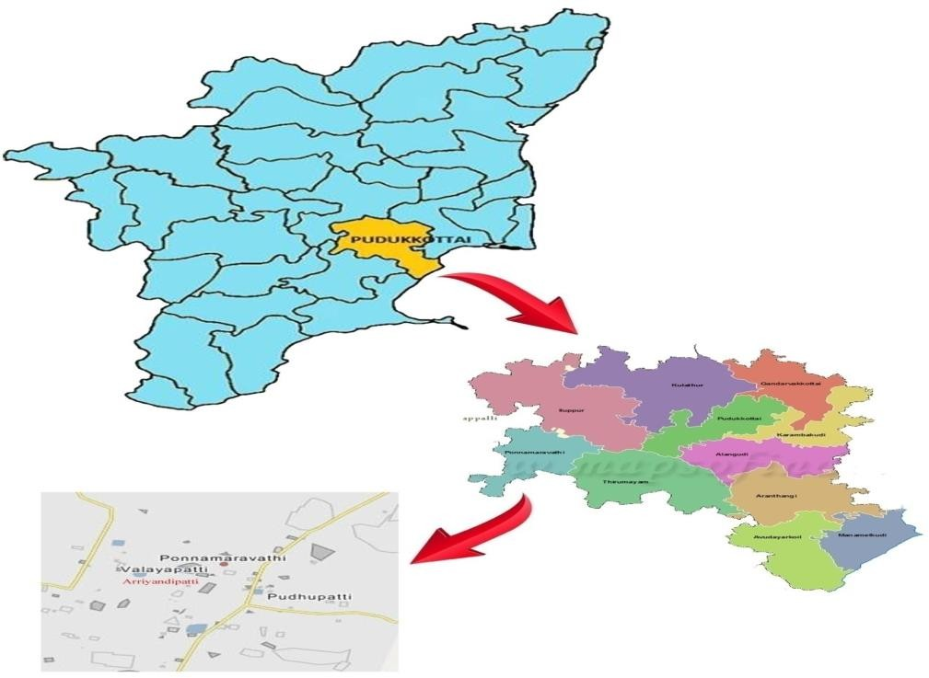
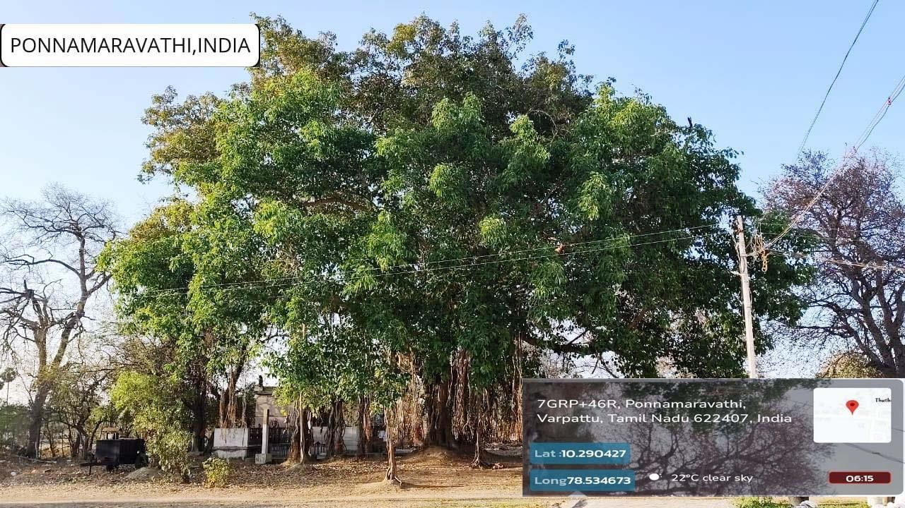

Sample Collections:

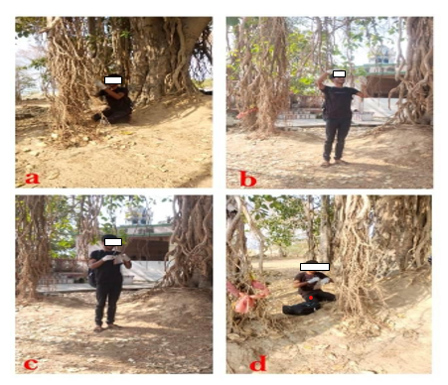

Figure 1. Collection of aerial roots upper and lower position roots sample collected from f.benghalensis at sacred traditional Nariyan karupar kovil forest Arriyandippatti village ponnamaravthy regions. a) Collection aerial root soil with position. B) Collecting aerial roots in soil under position c)stored aerial roots in sterile polythene bag using.d) Close tight up polythene bag with in 5 hours collect
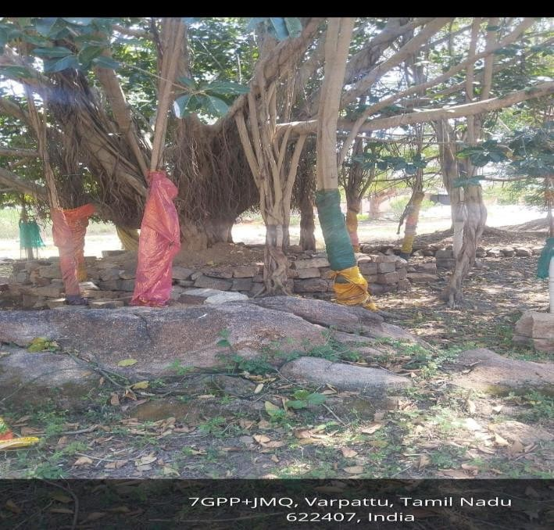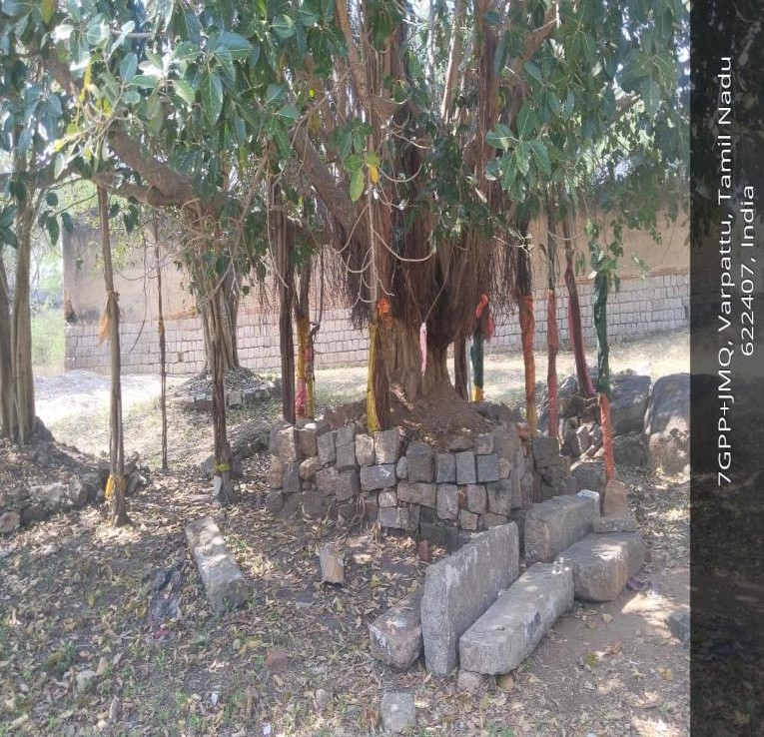
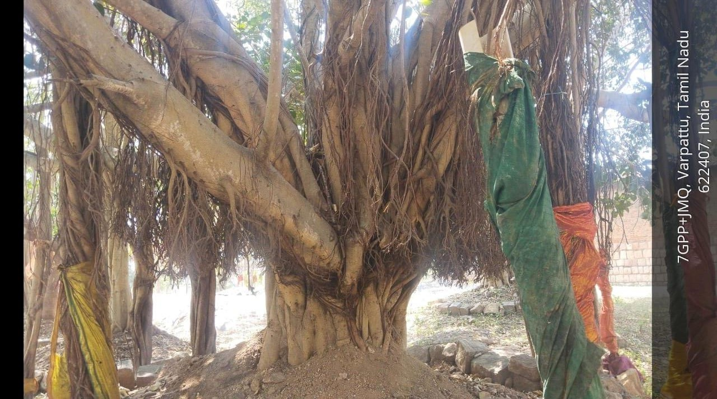

figure 2: collection of aerial roots upper and lower position roots sample collected places

Surface sterilization of tissues
The root segments (0.5 cm) were sterilised following Fisher et al. (1993). The segments were dipped in 75% ethanol for 1 minute, immersed in 4% NaOCl for 3 minutes and then rinsed with 75% ethanol for 0.5 minute (Arjunarao, 1971).

Isolation and identification of endophytes
The sterilised tissue samples were plated on Potato Dextrose Agar medium in Petri dishes. The Petri dishes were incubated at 26°C for 3 weeks in a light chamber under a 12-hour dark and 12-hour light cycle. The isolates were further examined using slide culture and subculture techniques.

A. Slide Culture Technique
The slide culture technique was used to examine the undisturbed arrangement of fungal hyphae, conidiophores, conidia and other reproductive structures, which are important for the morphological identification of fungal isolates.
- A sterile glass rod (V- or U-shaped) was placed inside a sterile Petri dish, and a sterile microscope slide was positioned on the glass rod using sterile forceps.
- Sterile Potato Dextrose Agar (PDA) was poured into a Petri dish to a depth of approximately 4 mm. After solidification, a 1 × 1 cm agar block was aseptically cut and transferred onto the sterile glass slide.
- The agar block was inoculated on all four sides with a small portion of the purified fungal culture using a sterile inoculating needle or loop. A sterile coverslip was gently placed over the agar block.
- A small quantity of sterile distilled water was added to the Petri dish to maintain humidity during incubation. The Petri dish was covered and incubated at 27 ± 2°C until adequate fungal growth and sporulation were observed.
- The developing fungal structures were periodically examined under a low-power microscope without disturbing the culture to monitor sporulation and reproductive morphology.
- After sufficient sporulation, the coverslip was carefully removed using sterile forceps and placed onto a drop of lactophenol cotton blue on a clean microscope slide. The stain was allowed to spread gradually beneath the coverslip to minimize air bubble formation and preserve the fungal structures.
- The agar block was then removed from the original slide using a sterile scalpel. A drop of lactophenol cotton blue was placed on the slide, and a fresh coverslip was gently mounted over the stained fungal material. Excess stain was removed, and the edges of the coverslip were sealed with clear nail polish to prepare a permanent mount.
- The prepared slides were examined under a compound microscope, and fungal isolates were identified based on microscopic characteristics such as hyphal morphology, conidiophore structure, conidial arrangement, and spore morphology using standard taxonomic keys.
B)SUB CULTURE TECHNIQUE

• Preparation: Surface-sterilized root segments were aseptically placed on Potato Dextrose Agar (PDA) medium supplemented with chloramphenicol (150 mg L⁻¹) to inhibit bacterial contamination. The inoculated Petri dishes were incubated at 26 ± 2°C for up to three weeks under controlled laboratory conditions to allow fungal growth.
• Isolation of Fungal Colonies: Emerging fungal colonies originating from the root segments were carefully observed and selected based on their distinct morphological characteristics.
• Subculturing: Individual fungal colonies were aseptically transferred to fresh PDA plates using a sterile inoculation needle or loop to obtain pure cultures.
• Incubation of Pure Cultures: The subcultured plates were incubated at 26 ± 2°C until sufficient mycelial growth was obtained for further examination.
• Purification: Repeated subculturing was carried out whenever necessary to eliminate mixed cultures and obtain axenic (pure) fungal isolates.
• Maintenance of Cultures: Pure fungal cultures were maintained on fresh PDA slants or plates under refrigerated conditions (4°C) and periodically subcultured to preserve their viability and purity.
• Morphological Characterization: The purified fungal isolates were identified based on macroscopic and microscopic characteristics, including colony morphology, pigmentation, texture, hyphal structure, conidial arrangement, and spore morphology, using standard mycological identification keys

RESULTS AND DISCUSSION

    - In the present investigation on endophytic fungal diversity in Ficus benghalensis from Ponnamaravathi, a total of nine endophytic fungal taxa were examined during three different seasonal periods over six months in 2023-2024.
    - Identification was based on the morphological characteristics of fungi grown on Potato Dextrose Agar (PDA). Macroscopic characters, including colony colour, diameter, growth pattern and reverse colour, were observed for seven days during fungal culture. Microscopic characterisation was carried out by observing the shape and size of conidia and hyphae. Conidial features, including arrangement, cell number and measurements, were also recorded.
    - Hyphae were examined for the presence or absence of septa and other morphological modifications. Based on comparison with the available literature, nine endophytic fungal taxa were identified: Aspergillus flavus, Aspergillus niger, Aspergillus oryzae, Aspergillus fumigatus, Paecilomyces sp., Neotyphodium sp., Pseudosigmoidea sp., Rhizopus sp. and members of Mucormycotina.

    - A total of nine endophytic fungal taxa representing three major fungal groups, including Ascomycota, Mucoromycota and Eurotiomycetes, were identified from the research site during the sampling periods of June-September and December-January.
    - The summer season recorded the highest number of isolates (5), followed by the monsoon season (3) and the winter season (2). Species diversity was comparatively higher during summer, intermediate during the monsoon season and lowest during winter.

    - The higher occurrence during summer may be associated with environmental conditions favourable for fungal growth, including suitable moisture and moderate temperature. In contrast, low relative humidity and extreme temperatures may inhibit fungal growth and spore germination.
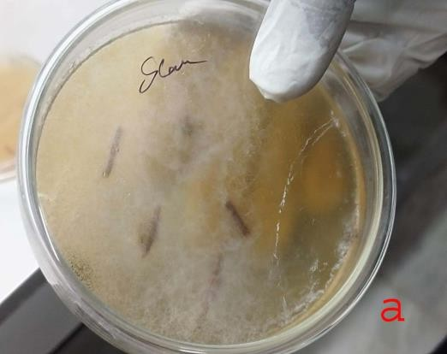
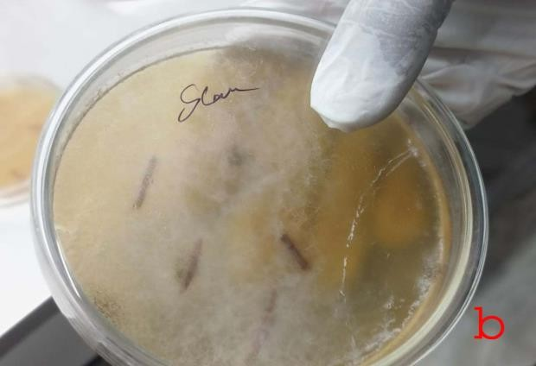
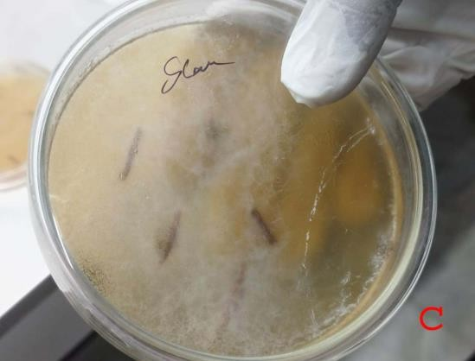
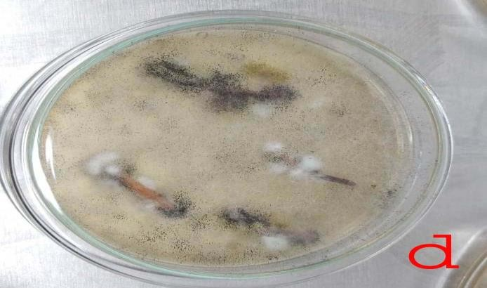

Figure 3. . The sterilized tissue samples were plated on Potato Dextrose Agar medium The petri dishes were incubated at 26 C for 3 weeks in a light chamber.a) aerial root inoculate with PDA medium b, c,d followed plates inoculated 3 weeks maintaining lab. After pure culture select in subculture methods

Sub culture & slide culture
23

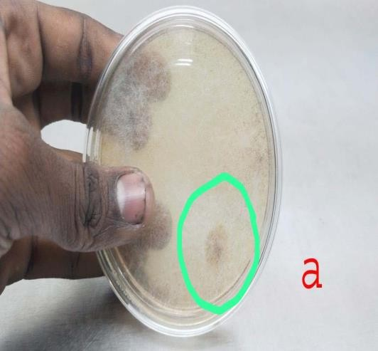
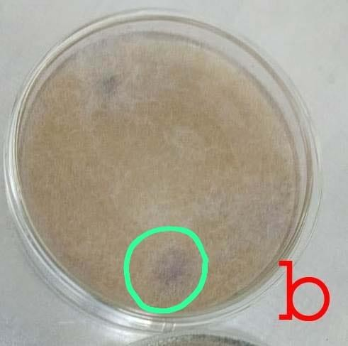
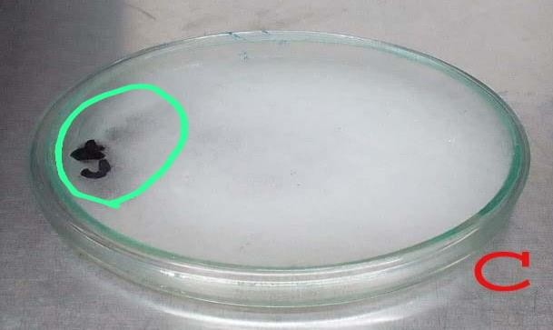
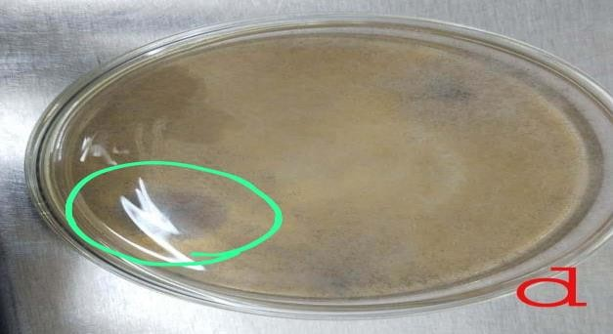
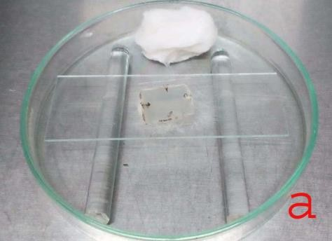
Figure4. These four subculture plates an isolate in different types of endophytic fungal species identify an marked as special type of endophytic fungi

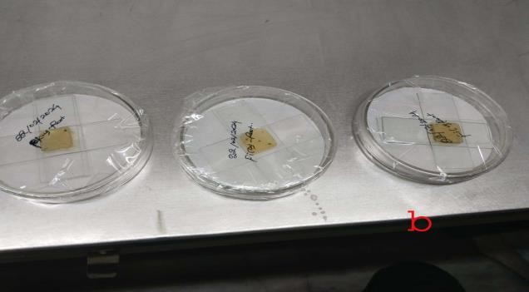
figure5. Slide culture species identify in slide culture methods with strain using (LPCB- lacto phenol cotton blue)

Fig 6 : Morhological characters of Endophytic Funic Species

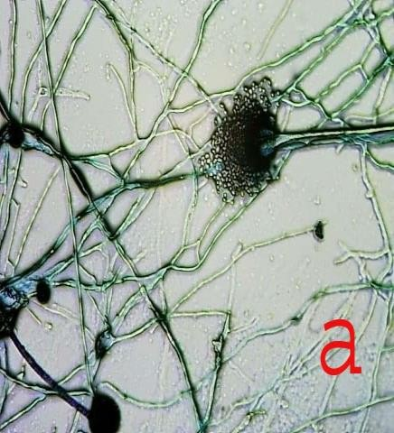
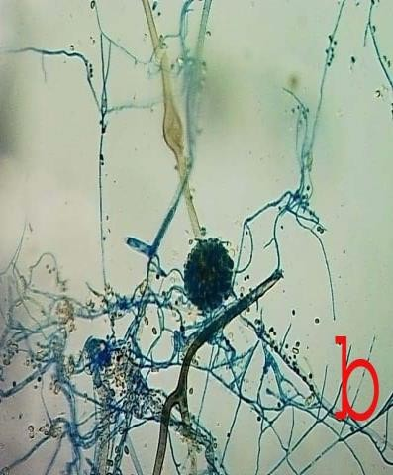
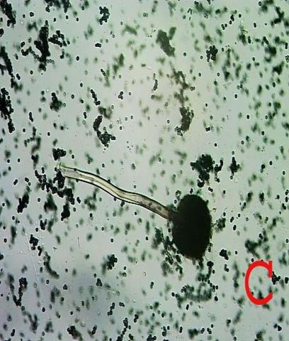
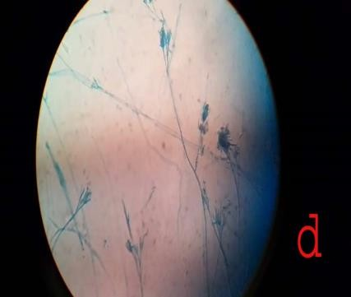
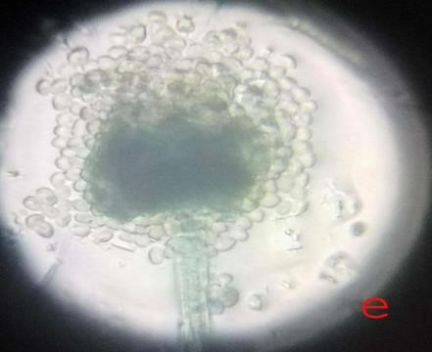
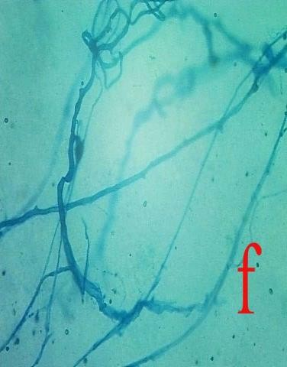
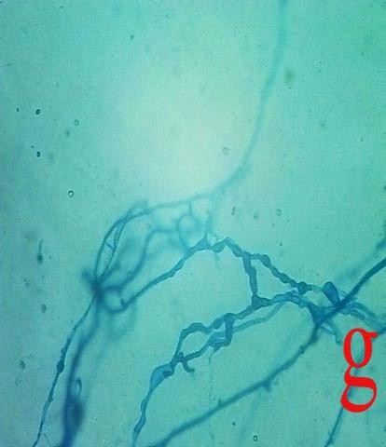
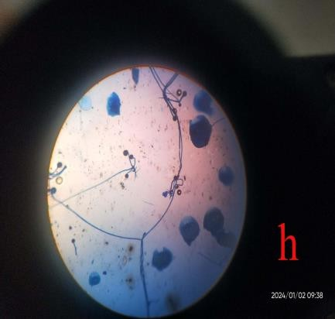
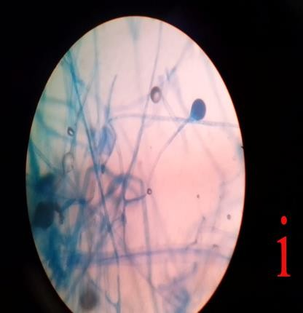

Microscopic view of endophytic fungal species

Aspergillus flavus
Aspergillus flavus has a complex morphology that is commonly described in relation to sclerotial formation. Group I includes L-strains with sclerotia greater than 400 micrometres in diameter, whereas Group II includes S-strains with sclerotia less than 400 micrometres in diameter. The fungus may reproduce asexually through conidia and sclerotia and sexually through ascospores associated with sclerotia. Asexual conidia are produced from phialides on conidiophore vesicles. The conidia are usually 3-6 micrometres in diameter, and the conidiophores arise from hyphal threads. The conidiophores are colourless and rough-textured, and the phialides may be uniseriate or biseriate.
The hyphae occur as thread-like, septate branches that form mycelium. Branched hyphae are hyaline at the septa and are too small to be seen with the naked eye. Aspergillus flavus may also reproduce sexually by producing ascospores within sclerotia when compatible strains are present. Colonies of Aspergillus flavus are initially white and soft, later becoming yellowish-green because of conidial pigmentation.

Aspergillus niger:

Macroscopic morphology: Aspergillus niger grows rapidly on Potato Dextrose Agar, initially producing a white to yellowish felt-like mycelial mat that quickly turns black as conidia develop the pigment aspergillin during maturation. The reverse side remains white to pale. Microscopic morphology: hyphae are septate and hyaline. Conidiophores are long (400-3,000 micrometres), with spherical vesicles at the apex measuring 30-75 micrometres. Aspergillus niger is biseriate, with metulae covering almost the entire vesicle surface from which the phialides extend. Conidia are globose, brown to black, 3.5-4.5 micrometres in diameter and rough-walled.

Aspergillus oryzae:

  - Aspergillus oryzae and Aspergillus flavus are closely related, and morphological and microscopic characters are important for distinguishing Aspergillus oryzae. The species can grow on several media, including Potato Dextrose Agar, on which growth is rapid and colonies are dense. On Czapek's agar, colonies may reach 7-8 cm in diameter after 7 days at 25°C, with a faintly yellowish margin that becomes yellow-green, similar to growth observed on malt extract agar.
Aspergillus oryzae generally shows optimal growth at 32-36°C (+/- 1°C) and does not grow above 44°C. It grows within a pH range around 5.0-6.0 and may germinate between pH 2.0 and 8.0. Under the microscope, Aspergillus oryzae is characterised by globose vesicles and elongated conidial chains. Its conidiophores are long, arise from the substrate and are rough-walled; the conidial heads are large and radiate, with globose to subglobose conidia. Aspergillus oryzae was isolated from Ficus benghalensis in the present study.
- Paecilomyces

Hyphae of Paecilomyces are hyaline and septate. Conidiophores are erect and irregularly branched at the apices. In some species, conidiophores bear metulae and phialides in a penicillus-like arrangement resembling Penicillium species. In other species of Paecilomyces, phialides arise directly from vegetative hyphae, either singly, in pairs or in whorls. Conidia are produced from the tips of phialides in chains that tend to bend away from the conidiophores. The phialides are long and delicate, tapering from a relatively broad base to slender distal tubes. The unicellular phialoconidia are small, approximately 3 micrometres in size.
- Aspergillus fumigatus

The morphology of Aspergillus fumigatus is defined by hyphae, conidia and conidiophores. The conidia are green and may have a spiny surface. They are approximately 2.5-3 micrometres in diameter and may be smooth or spinose. Conidia are produced in basipetal columnar chains from green phialides measuring approximately 6-8 by 2-3 micrometres. Some strains of Aspergillus fumigatus produce white conidia because they lack pigment. Conidial chains are produced directly on broadly clavate vesicles, approximately 20-30 micrometres in diameter, in the absence of metulae.
- Neotyphodium

Fungi of the genus Neotyphodium are systemic and constitutive symbionts of grasses in the subfamily Pooideae. Several grasses from Argentina have been reported to be infected by Neotyphodium species. These endophytes are generally similar in macro- and micromorphology and are phylogenetically related to Neotyphodium tembladerae.
Neotyphodium species have been examined in populations of the native grass Bromus auleticus from Argentina, where the incidence of endophytes was reported to be high across the populations investigated.
- Pseudosigmoidea

Pseudosigmoidea is a dark septate fungus. The isolate is characterised by pale to brown conidia with up to eight septa, measuring 68-132 x 4-7.9 micrometres. It is also distinctive because it produces conidia borne by long conidiogenous cells in agar medium with or without water, compared with P. cranei, which must be immersed in water to sporulate. Morphological analysis indicated that the isolate is distinct from P. cranei and has been described as P. ibarakiensis sp. nov. Pathogenicity tests using Chinese cabbage and cucumber seedlings indicated that the fungus can grow as an endophyte and colonise the root epidermal and cortical layers without causing visible disease symptoms in the host. This endophyte also supported cucumber growth under conditions in which NaNO3 was replaced by organic nitrogen and enabled Chinese cabbage to grow at low pH. It became established in several other plants, suggesting adaptability to a broad host range.
- Rhizopus

The genus Rhizopus is characterised by the presence of stolons and pigmented rhizoids, the formation of sporangiophores singly or in groups from nodes directly above the rhizoids, and apophysate, columellate, multispored and generally globose sporangia. After spore release, the apophyses and columella often collapse to form an umbrella-like structure. Sporangiospores are globose to ovoid, one-celled, hyaline to brown and striate in many species. Colonies are fast-growing and cover the agar surface with dense cottony growth that is initially white and becomes grey or yellowish-brown with sporulation.
- Mucormycotina

Colonies of Mucormycotina are very fast-growing, cottony to fluffy, white to yellow and become dark grey with sporangial development. Sporangiophores are erect, simple or branched, forming large terminal, globose to spherical and multispored sporangia, without apophyses and with well-developed subtending columellae. A conspicuous collarette, representing remnants of the sporangial wall, is usually visible at the base of the columella after sporangiospore dispersal. Sporangiospores are hyaline, grey or brownish, globose to ellipsoidal and smooth-walled or finely ornamented. Chlamydospores and zygospores may also be present.
Seasonable Variation of Endophytic Fungi
Table -1 Monsson Season

S.N  o | Monsoon Season  (June-September 2023) | Endophytic diversity Species | class | order | Family | Genus
1 | isolate 1 | Mucormycotina (saprophytic) | Mucoromycetes | Mucorales | Mucoraceae | Mucormycotina
2 | isolate 2 | Rhizopus | Mucoromycetes | Mucorala | Mucoraceae | Rhizopus

Table -2 Winter Season

S.N  o | Winter Season (December – January  2024) | Endophytic diversity Species | class | order | Family | Genus
1 | isolate 1 | Neotyphodium | Ascomycota | - | Pooideae | Neotyphodium
2 | isolate 2 | Pseudosigmoidea | Ascomycota | - | - | Pseudosigmoidea
3 | isolate 3 | Rhizopus | Mucormycot a | Mucorala | Mucoraceae | Rhizopus

Table -3 Summer Season

S.N  o | Summer Season (March – June  2024) | Endophytic diversity Species | class | order | Family | Genus
1 | isolate 1 | Aspergillus niger | Eurotiomycetes | Eurotiales | Aspergillaceae | Aspergillus
2 | isolate 2 | Aspergillus flavus | Eurotiomycetes | Eurotiales | Aspergillaceae | Aspergillus
3 | isolate 3 | Aspergillus oryza | Eurotiomycetes | Eurotiales | Aspergillaceae | Aspergillus
4 | isolate 4 | Aspergillus Fumigatus | Eurotiomycetes | Eurotiales | Aspergillaceae | Aspergillus
5 | isolate 5 | Paecilomyces sp. | Eurotiomycetes | Eurotiales | Aspergillaceae | Aspergillus
6 | isolate 1 | Mucor sp(saprophytic) | Ascomycoda | Mucorales | Mucoraceae | Mucormycoti na
7 | isolate 2 | Rhizopus | Mucormycota | Mucorala | Mucoraceae | Rhizopus

Conclusion
The present investigation recorded culturable endophytic fungi from the aerial roots of Ficus benghalensis collected from Ponnamaravathi, Pudukkottai District, Tamil Nadu, India. Based on cultural and microscopic observations, nine fungal taxa were recorded: Aspergillus flavus, Aspergillus niger, Aspergillus oryzae, Aspergillus fumigatus, Paecilomyces sp., Neotyphodium sp., Pseudosigmoidea sp., Rhizopus sp. and members of Mucormycotina. These findings indicate that the aerial roots of F. benghalensis provide a suitable habitat for different groups of culturable endophytic fungi.
Seasonal variation was observed in the occurrence of the isolates, with the summer period showing a comparatively higher representation of fungal taxa in the recorded data. Members of Aspergillus were the most frequently represented group among the identified isolates. The study therefore provides preliminary baseline information on the culturable endophytic fungal diversity associated with F. benghalensis in the selected sacred grove locality.
Because the identification was based on morphological characters, the results should be considered preliminary. Molecular identification and further ecological studies are necessary to confirm the taxonomic status of the isolates and to understand their functional roles. Future studies may also examine the bioactive potential of these fungi using appropriate biochemical and experimental methods.

Limitations
This study was limited to culturable fungi grown on Potato Dextrose Agar and identified using cultural, macroscopic and microscopic characters. Non-culturable or slow-growing endophytes may therefore have been missed. Details on sample size, replication and quantitative isolation frequency were limited, restricting statistical comparison among seasons. Molecular phylogenetic analysis, metabolite profiling and bioactivity testing were not performed; therefore, ecological and applied interpretations remain preliminary.
Declaration of AI Use

This manuscript was prepared through the combined contributions of all author(s), including contributions to the study design, data, content development, results, interpretation, and related scholarly work. The author(s) acknowledge the use of Grammarly and ChatGPT to assist with grammar checking, language refinement, reference formatting. These AI-assisted tools were not used as authors and did not replace the intellectual contributions or scholarly judgment of the author(s). All AI-assisted outputs, including content, references, and interpretations, were carefully reviewed, revised, verified, and approved by the author(s). The author(s) accept full responsibility for the accuracy, integrity, and final content of the manuscript.

REFERENCES

• Arjunarao, V. (1971). On the pathogenicity of Fusarium vasinfectum Atk.: Self-inhibitory principle of spores as a limiting factor in cotton wilt. Proceedings of the Indian Academy of Sciences, Section B, 73, 273–284. https://doi.org/10.1007/BF03045295
• Arnold, A. E. (2007). Understanding the diversity of foliar endophytic fungi: Progress, challenges, and frontiers. Fungal Biology Reviews, 21(2–3), 51–66. https://doi.org/10.1016/j.fbr.2007.05.003
• Chaudhari, R. N., Mulani, Y. M., More, P. V., Nikumbh, A. N., & Ahemad, A. I. A. T. (2022). Pharmacognostic, phytochemical, pharmacological potential on banyan tree (Ficus bengalensis L.). International Journal of Pharmacy and Pharmaceutical Research, 25(1), 237–253. https://ijppr.humanjournals.com/pharmacognostic-phytochemical-pharmacological-potential-on-banyan-tree-ficus-bengalensis-l/
• dos Reis, J. B. A., Lorenzi, A. S., & Vale, H. M. M. (2022). Methods used for the study of endophytic fungi: A review on methodologies and challenges, and associated tips. Archives of Microbiology, 204, Article 675. https://doi.org/10.1007/s00203-022-03283-0
• Fisher, P. J., Petrini, O., & Sutton, B. C. (1993). A comparative study of fungal endophytes in leaves, xylem and bark of Eucalyptus nitens in Australia and England. Sydowia, 45(2), 338–345. https://www.zobodat.at/pdf/Sydowia_45_0338-0345.pdf
• Gao, Y., Xu, Y., Dong, Z., Guo, Y., Luo, J., Wang, F., Yan, L., & Zou, X. (2025). Endophytic fungal diversity and its interaction mechanism with medicinal plants. Molecules, 30(5), Article 1028. https://doi.org/10.3390/molecules30051028
• Gopukumar, S. T., & Praseetha, P. K. (2015). Ficus benghalensis Linn.: The sacred Indian medicinal tree with potent pharmacological remedies. International Journal of Pharmaceutical Sciences Review and Research, 32(1), 223–227.
• Govinda Rajulu, M. B., Suryanarayanan, T. S., & Tangjang, S. (2016). Endophytic fungi of orchids of Arunachal Pradesh, North Eastern India. Current Research in Environmental & Applied Mycology, 6(4), 293–299. https://doi.org/10.5943/cream/6/4/7
• Guevara-Araya, M. J., Vilo, C., Urzúa, A., & González-Teuber, M. (2020). Differences in community composition of endophytic fungi between above- and below-ground tissues of Aristolochia chilensis in an arid ecosystem. Revista Chilena de Historia Natural, 93, Article 3. https://doi.org/10.1186/s40693-020-00091-y
• Jayant, K. K., & Vijayakumar, B. S. (2021). In-vitro bioactive potential of endophytic fungi Curvularia lunata isolated from medicinal plant Ficus religiosa. International Journal of Pharmaceutical Sciences and Research, 12(8), 4322–4330. https://doi.org/10.13040/IJPSR.0975-8232.12(8).4322-30
• Karunaratne, E. S., Daulagala, P. W. H. K. P., Gnanarathne, J. S., & Ediriweera, S. S. (2026). Isolation and exploitation of selected endophytic mycoflora from Terminalia arjuna for their production of extracellular enzymes. Asian Journal of Research in Botany, 9(1), 110–120. https://doi.org/10.9734/ajrib/2026/v9i1310
• Maheswari, S., & Rajagopal, K. (2013). Biodiversity of endophytic fungi in Kigelia pinnata during two different seasons. Current Science, 104(4), 515–518. https://currentscience.ac.in/Volumes/104/04/0515.pdf
• Mendieta-Brito, S., Sayed, M., Hamza, F. A., Son, E., Kim, D.-S., Plata, G., Dávila, M., & Pyo, S.-H. (2025). Identification, characterization, antimicrobial activity and biocontrol potential of four endophytic fungi isolated from Amazonian plants. Scientific Reports, 15, Article 39361. https://doi.org/10.1038/s41598-025-26865-6
• Murugesu, S., Selamat, J., & Perumal, V. (2021). Phytochemistry, pharmacological properties, and recent applications of Ficus benghalensis and Ficus religiosa. Plants, 10(12), Article 2749. https://doi.org/10.3390/plants10122749
• Nazir, A., Puthuveettil, A. R., Hussain, F. H. N., Hamed, K. E., & Munawar, N. (2024). Endophytic fungi: Nature’s solution for antimicrobial resistance and sustainable agriculture. Frontiers in Microbiology, 15, Article 1461504. https://doi.org/10.3389/fmicb.2024.1461504
• Omomowo, I. O., Amao, J. A., Abubakar, A., Ogundola, A. F., Ezediuno, L. O., & Bamigboye, C. O. (2023). A review on the trends of endophytic fungi bioactivities. Scientific African, 20, Article e01594. https://doi.org/10.1016/j.sciaf.2023.e01594
• Pathak, K. V., & Keharia, H. (2014). Identification of surfactins and iturins produced by potent fungal antagonist, Bacillus subtilis K1 isolated from aerial roots of banyan (Ficus benghalensis) tree using mass spectrometry. 3 Biotech, 4(3), 283–295. https://doi.org/10.1007/s13205-013-0151-3
• Porras-Alfaro, A., & Bayman, P. (2011). Hidden fungi, emergent properties: Endophytes and microbiomes. Annual Review of Phytopathology, 49, 291–315. https://doi.org/10.1146/annurev-phyto-080508-081831
• Rajeswari, S., Revathi, R., & Arvind Prasanth, D. (2017). Isolation and identification of endophytic fungi from Terminalia chebula of Eastern Ghats, Tamil Nadu. Asian Journal of Pharmaceutical and Clinical Research, 10(4), 21–23. https://doi.org/10.22159/ajpcr.2017.v10i4.15507
• Rauf, A., Ibrahim, M., Muhammad, N., Naz, S., Wadood, A., Khan, B., Ali, T., Saleem, M., Alsahammari, A., Alharbi, M., & Suleria, H. A. R. (2022). Enzyme inhibitory activities of extracts and carpachromene from the stem of Ficus benghalensis. BioMed Research International, 2022, Article 7053655. https://doi.org/10.1155/2022/7053655
• Rodriguez, R. J., White, J. F., Jr., Arnold, A. E., & Redman, R. S. (2009). Fungal endophytes: Diversity and functional roles. New Phytologist, 182(2), 314–330. https://doi.org/10.1111/j.1469-8137.2009.02773.x
• Rustamova, N., Niu, L., Bozorov, K., Sayyed, R., Aisa, H. A., & Yili, A. (2022). Plant-associated endophytic fungi: A source of structurally diverse and bioactive natural products. Plant Cell Biotechnology and Molecular Biology, 23(7–8), 1–19. https://doi.org/10.56557/pcbmb/2022/v23i7-87454
• Suradkar, K. P., Hande, D. V., & Kadu, S. R. (2014). Seasonal diversity of endophytic fungi from ten medicinal plants. International Journal of Current Microbiology and Applied Sciences, 3(9), 260–265. https://www.ijcmas.com/vol-3-9/K.P.Suradkar,%20et%20al.pdf
• Suryanarayanan, T. S., & Vijaykrishna, D. (2001). Fungal endophytes of aerial roots of Ficus benghalensis. Fungal Diversity, 8, 155–161. https://www.fungaldiversity.org/fdp/sfdp/FD_8_155-161.pdf
• Taylor, D. L., Walters, W. A., Lennon, N. J., Bochicchio, J., Krohn, A., Caporaso, J. G., & Pennanen, T. (2016). Accurate estimation of fungal diversity and abundance through improved lineage-specific primers optimized for Illumina amplicon sequencing. Applied and Environmental Microbiology, 82(24), 7217–7226. https://doi.org/10.1128/AEM.02576-16
• Toppo, P., Jangir, P., Mehra, N., Kapoor, R., & Mathur, P. (2024). Bioprospecting of endophytic fungi from medicinal plant Anisomeles indica L. for their diverse role in agricultural and industrial sectors. Scientific Reports, 14, Article 588. https://doi.org/10.1038/s41598-023-51057-5
• Tripathi, R., Kumar, A., Kumar, S., Prakash, S., & Singh, A. K. (2015). Ficus benghalensis Linn.: A tribal medicine with vast commercial potential. Indian Journal of Agriculture and Allied Sciences, 1(3), 95–102.

