Production of black henbane plants (Hyoscyamus niger) from callus farms using tissue culture techniques

Abstract
Black henbane (Hyoscyamus niger) is a medicinal plant that can be propagated under controlled conditions using plant tissue culture. This study evaluated callus induction, spontaneous shoot differentiation, rooting and acclimatisation from subcotyledonous stem segments. Seeds were surface-sterilised, germinated on solid Murashige and Skoog (MS) medium without growth regulators and maintained under controlled culture-room conditions. Subcotyledonous stem segments from 15-day-old seedlings were cultured on solid MS medium supplemented with 0.5 mg L⁻¹ 2,4-D and 1.0 mg L⁻¹ BA. The sterilisation procedure produced sterile seedlings with a 90% germination rate after six days. Callus induction occurred in 100% of the cultured stem segments. Ten days after the first callus subculture on the same medium, green structures appeared spontaneously and subsequently developed into shoots. After 30 days, the cultures produced an average of 15 shoots per callus piece, with a mean shoot length of approximately 3 cm and a 90% differentiation rate based on 60 recultured callus pieces. Excised shoots cultured on growth-regulator-free MS medium rooted within 8–10 days, with a 100% rooting rate. The regenerated plantlets were acclimatised in a sterilised soil and peat mixture and subsequently transferred to greenhouse conditions. Under the conditions tested, subcotyledonous stem callus supported spontaneous shoot regeneration, rooting and plant establishment in soil.

Keywords: Black henbane; Hyoscyamus niger; plant tissue culture; callus induction; subcotyledonous stem segments; spontaneous shoot regeneration; Murashige and Skoog medium; rooting; micropropagation; acclimatisation

Introduction
The black henbane plant (Hyoscyamus niger) belongs to the genus Hyoscyamus, one of the largest and most important genera in the nightshade family, Solanaceae. The family comprises widespread herbaceous dicotyledons, with approximately 98 genera and more than 3,000 species (Bejenaru et al., 2024). Plants are widely recognised as sources of medicines, either as traditional remedies or as sources of potent active ingredients derived from the metabolites they produce during growth (Chaachouay & Zidane, 2024). Alkaloids are among the most important groups of plant secondary metabolites because of their structural diversity and medicinal properties (Mohammed et al., 2024). Hyoscyamine and scopolamine are particularly important alkaloids in the Solanaceae family and serve as starting materials for the synthesis of many anticholinergic substances (Shim et al., 2022). These compounds are associated with the development of more than 50 drugs (Wen et al., 2024). Given the increasing demand for medicinal compounds, their low concentrations in plants, limited natural resources, and the risk of plant-species extinction, biotechnology has been considered a means of increasing medicinal-plant production (Niazian, 2019). One important technique in this field is plant tissue culture, which can facilitate the rapid, large-scale production of medicinal compounds and metabolites (Isah et al., 2018). Medicinal plants produce biologically active compounds, including alkaloids, flavonoids, and terpenes, with therapeutic properties (Nwozo et al., 2023). Through precise control of growth conditions and genetic modification (D’Amelia et al., 2021), plant tissue culture can support the production of these compounds and enhance the effectiveness of herbal medicines (Wang et al., 2017). Recent reviews indicate that tissue-culture systems can support controlled propagation and secondary-metabolite production in medicinal plants, although culture conditions must be optimised for each species and intended product (Anushi et al., 2023; Prashant & Bhawana, 2024). In recent years, biotechnology has advanced considerably, and plant tissue culture has become one of its most important techniques. Plant tissue culture involves removing a plant part, sterilising it, and culturing it outside the living organism on an artificial nutrient medium under controlled, contaminant-free conditions in a growth room (Malabadi et al., 2025). This technology enables the selection and production of plant strains that can withstand harsh environmental conditions and can be maintained for long periods. It also exploits cellular totipotency, whereby each plant cell has the potential to divide and develop into a complete plant (Khezri et al., 2024), thereby supporting the development of plant-cell culture techniques under defined conditions (Okoroafor, 2022). Micropropagation techniques have an important role in plant conservation and genetic improvement, particularly for pharmaceutical and medicinal plants. Laboratory-based production systems are increasingly being developed as alternatives to field production of plants used as sources of active compounds, helping to ensure year-round availability without seasonal effects (Bapat et al., 2023). Accordingly, tissue culture and the cultivation of plant cells and organs outside the plant body are important tools for producing plant-derived pharmaceuticals (Malabadi et al., 2025). Plant tissue culture is also a powerful tool in plant biology, agriculture, horticulture, and biotechnology (Thakur et al., 2024). It enables researchers to investigate plant growth and development and responses to environmental factors, thereby providing insights into plant physiology and genetics (Pasternak & Steinmacher, 2024). Important plant-tissue-culture techniques include micropropagation, callus culture, suspension culture, and organ culture (Isah et al., 2018). For example, micropropagation enables rapid plant multiplication from small tissue pieces (Abdalla et al., 2022), whereas suspension culture facilitates the production of biologically active compounds that may be difficult to extract from whole plants (Khalafalla, 2026). Plant tissue culture also provides a controlled platform for studying medicinal-plant biology, optimising growth conditions, and investigating the mechanisms underlying secondary-metabolite production (Fazili et al., 2022). Callus-based systems can provide renewable biomass for the study and production of specialised metabolites, although their performance depends on the explant source and plant-growth-regulator regime (Ram et al., 2022; Wijerathna-Yapa et al., 2025). Plant tissue culture has enabled the development of plants with desirable traits through genetic transformation, with broad applications in agriculture and biotechnology (Salaria et al., 2025). It is therefore both a research tool and a practical means of providing a continuous and sustainable source of plant material (Twaij et al., 2020). Tissue-culture techniques have been applied successfully to several Solanaceae species, particularly tobacco (Nicotiana tabacum), tomato (Solanum lycopersicum), and potato (Solanum tuberosum) (Brancato et al., 2025). Recent work on S. lycopersicum further indicates that explant type and plant-growth-regulator combinations influence callus induction and plantlet regeneration within the Solanaceae (Kumari et al., 2024). Tissue culture has also been applied to black henbane to induce callus, regenerate complete plants, and obtain medicinal compounds such as hyoscyamine and atropine (Abed & Jassim, 2024). Studies have reported the accumulation of these compounds in callus cultures derived from cotyledonary leaf segments, which are among the plant parts that respond well to tissue culture in this species (Isah et al., 2018). However, the available literature provides limited information on whether callus derived specifically from subcotyledonous stem segments of H. niger can undergo spontaneous shoot differentiation on the callus-induction medium and subsequently root on hormone-free MS medium. This gap warrants evaluation of a simple regeneration sequence using this explant source and the culture conditions described in the present study. The objective of this research was to develop a simple and effective tissue-culture method for regenerating H. niger, an important medicinal plant. The study may support future research on plant propagation, conservation, and the production of valuable medicinal compounds, and provides information for researchers in plant biotechnology and medicinal-plant science.

Materials and Methods
All experiments were conducted in the Plant Tissue Culture Laboratory, Department of Biology, College of Science, University of Mosul, Iraq. Seed sterilisation, sowing, production of sterile seedlings, establishment and maintenance of callus cultures, and related procedures for black henbane (H. niger) were performed under aseptic conditions in a laminar-flow cabinet. Before use, the floor and walls of the cabinet were wiped with cotton soaked in 70% ethanol, and the cabinet was operated for 30 min to create a sterile, contaminant-free environment. Culture media, glassware, instruments, and distilled water were sterilised in an autoclave (Gallen Kamp, UK) at 121°C and 1.02 kg cm⁻² for 18–20 min.

Surface sterilisation of black henbane (H. niger) seeds and seedling germination
The seeds of black henbane were surface-sterilised by immersion in 70% ethanol for 30 s with continuous agitation, followed by immersion in 5% sodium hypochlorite (commercial bleach) for 10 min. The seeds were rinsed three times with sterile distilled water for 2 min per rinse and placed on sterile filter paper to dry (Kareem, 2020). The sterilised seeds were placed in 100 mL bottles containing 30 mL of solid Murashige and Skoog (1962) MS medium, at a density of 6–8 seeds per bottle. The bottles were sealed with aluminium foil and maintained in a culture room in darkness at 24 ± 2°C. After germination, as indicated by radicle and plumule emergence, the seedlings were transferred to a 16 h light/8 h dark photoperiod at a light intensity of 2,000 lux.

Callus induction from subcotyledonous stem segments of black henbane (H. niger) seedlings
Healthy 15-day-old black henbane plantlets were removed from the MS medium. Their stems were cut immediately below the cotyledons into segments approximately 1.5–2 cm long, and three or four segments were placed on 30 mL of solid MS medium supplemented with 0.5 mg L⁻¹ 2,4-D and 1.0 mg L⁻¹ BA (Khafaji & Taha, 2023). The cultures were then maintained under the light/dark conditions described above.

Establishment and maintenance of callus cultures from subcotyledonous stems
Newly formed callus masses were excised individually from responsive subcotyledonous stem segments and placed in glass bottles containing 30 mL of solid MS medium supplemented with 0.5 mg L⁻¹ 2,4-D and 1.0 mg L⁻¹ BA to establish callus cultures. The cultures were subcultured every 15 days or whenever the callus became dark brown and the medium dried or cracked. During subculture, dead tissue was removed, and the remaining callus was divided into small pieces, each of which was transferred to a new bottle. The cultures were maintained in a growth room under a 16 h light/8 h dark photoperiod at 2,000 lux and 24 ± 2°C.

Differentiation of subcotyledonous-stem callus
To evaluate differentiation of subcotyledonous-stem callus, pieces weighing approximately 1.0 g were recultured on the same regeneration medium. The cultures were maintained at 24 ± 2°C under a 16 h light/8 h dark photoperiod with a light intensity of 2,000 lux to assess the suitability of the medium for differentiation.

Rooting of differentiated green shoots from subcotyledonous-stem callus
Groups of green shoots formed from subcotyledonous-stem callus were excised with a sharp, sterile scalpel when they reached 2.5–3 cm in length and had developed small leaves. The bases of individual shoots were inserted vertically into 30 mL of solid, growth-regulator-free MS medium (MSO) for rooting.

Results and Discussion
Surface-sterilisation efficiency of black henbane (H. niger) seeds and production of sterile seedlings
The surface-sterilisation method used for black henbane (H. niger) seeds was effective, producing sterile seeds with a 90% germination rate six days after culture. The seeds developed into healthy seedlings on solid MS medium without growth regulators or contamination (Figure 1).

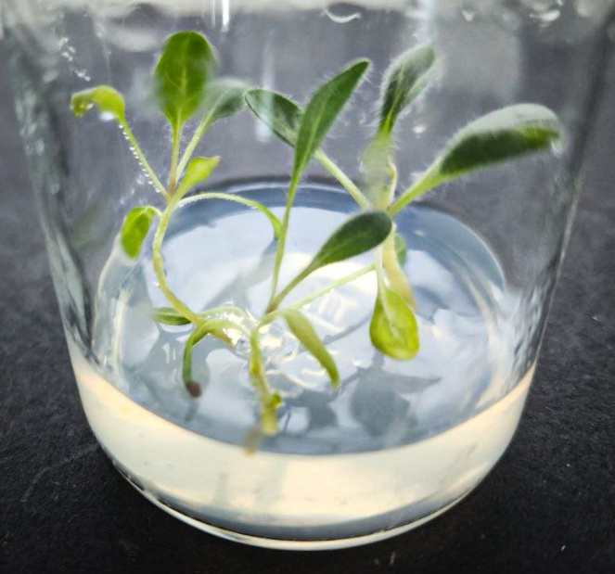

Figure (1): black henbane seedlings growing on solid MS free from growth regulators (MSO) medium at 15 days old.

Callus induction from subcotyledonous stem segments of black henbane (H. niger) seedlings and establishment of callus cultures
Placement of subcotyledonous stem segments from black henbane seedlings on solid MS medium supplemented with 0.5 mg L⁻¹ 2,4-D and 1.0 mg L⁻¹ BA resulted in 100% callus induction. After seven days of culture (Figure 2A), the cut ends of the segments began to swell, and callus masses formed after 15 days (Figure 2B). The masses expanded to cover the entire subcotyledonous stem segments after 22 days (Figure 2C) and continued to grow, producing typical callus cultures after 30 days (Figure 2D).
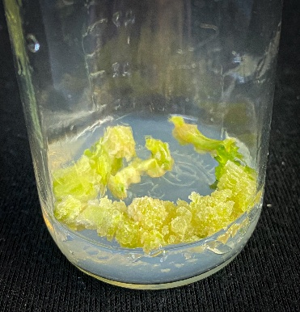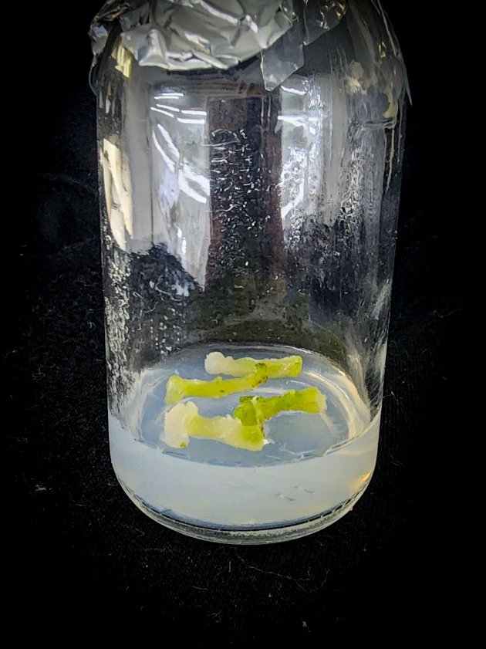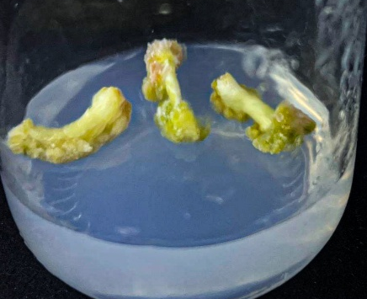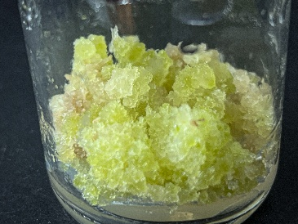
A
B
D
C

Figure (2): Stages of producing callus cultures from subcotyledonous stems segments of black henbane(H. niger) seedlings on solid MS medium supplemented with 0.5 mg L⁻¹ 2,4-D and 1.0 mg L⁻¹ BA after 30 days.
- Initiating callus from subcotyledonous stems segments for black henbane seedlings and swelling them after 7 days.
- The callus masses formed from (A) after 15 days.
- The callus masses develop from (B) to cover subcotyledonous stems segments after 22 days.
- Continued growth of callus masses from (C) and the production of a model plantation after 30 days.

Spontaneous formation of green shoots and shoot regeneration from callus of black henbane (H. niger) seedlings
One notable finding was the spontaneous appearance of green structures 10 days after the first subculture of the callus on the same nutrient medium (Figure 3A). These structures subsequently grew and developed into numerous vegetative shoots. After 30 days, the shoots averaged 15 per callus piece and approximately 3 cm in length, with a 90% success rate based on 60 recultured callus pieces (Figure 3B). The regenerated shoots also developed true leaves.

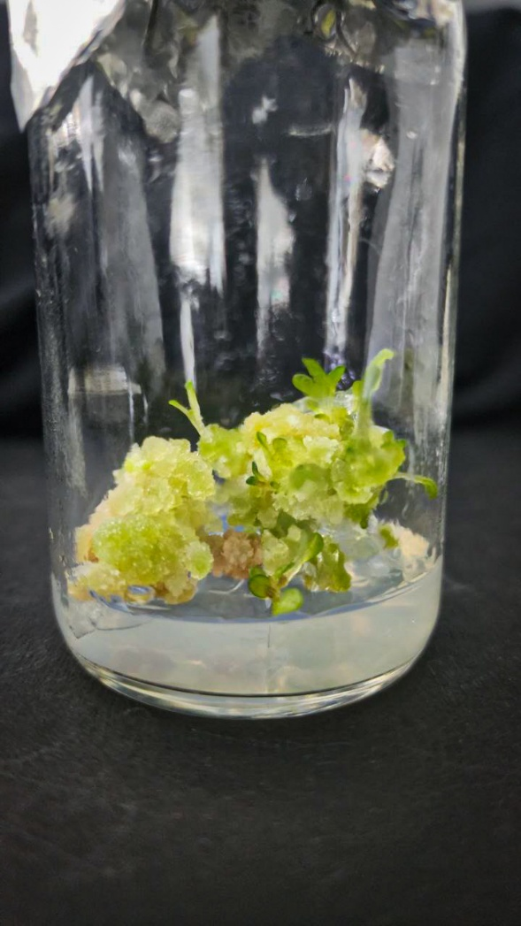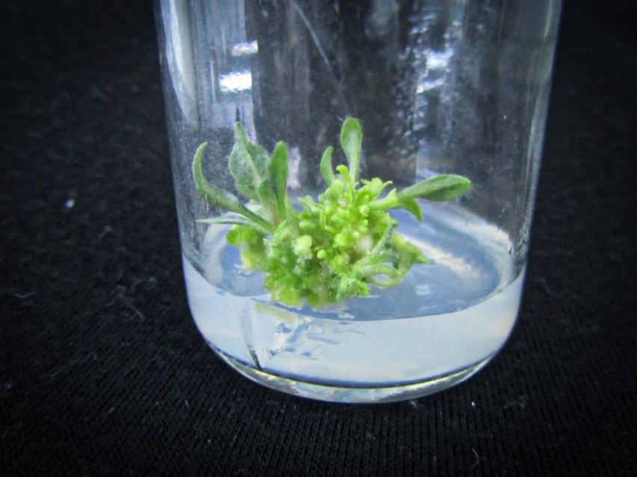
B
A

Figure (3): Automatic differentiation of shoots from callus pieces of black henbane(H. niger) seedlings grown on solid MS medium supplemented with 0.5 mg L⁻¹ 2,4-D and 1.0 mg L⁻¹ BA.
- The beginning of the formation of green structures spontaneously from the callus pieces planted on solid MS medium supplemented with 0.5 mg L⁻¹ 2,4-D and 1.0 mg L⁻¹ BA after 20 days.
- Automatic differentiation from (A) after 30 days.

Rooting naturally formed green shoots
The spontaneously formed green shoots were excised and cultured vertically on solid, growth-regulator-free MS medium (MSO). All tested shoots rooted within 8–10 days, corresponding to a 100% success rate. Small white structures initially appeared and subsequently developed into true roots that became thicker, longer, and intertwined (Figure 4), ultimately producing complete black henbane plants in the growth medium.

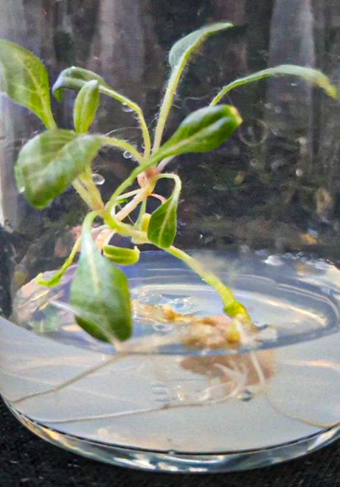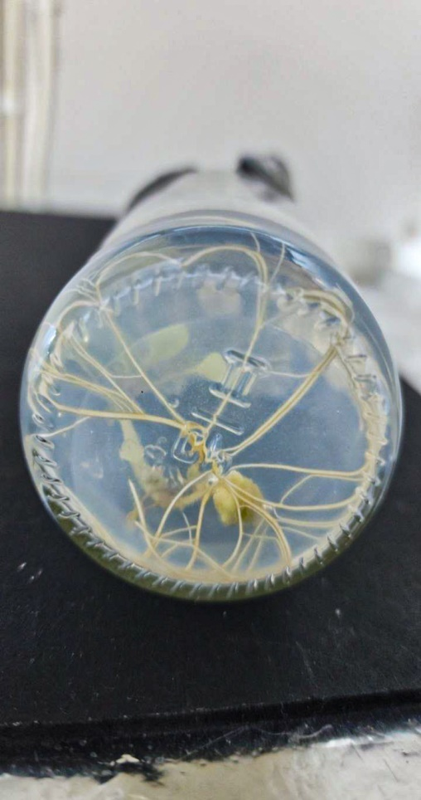
A
B

Figure (4): Formation of complete black henbane (H. niger) plants from the differentiation of subcotyledonous stems and their rooting in the growth medium.
A and B Rooting one of the excised green branches in full-strength MS free from growth regulators (MSO) medium after 20 days and form a complete black henbane plant in the growth medium.

Acclimatisation and transfer to soil of black henbane (H. niger) plants regenerated spontaneously from subcotyledonous-stem callus
After the plantlets had developed on complete, growth-regulator-free MS medium (MSO), they were removed from the medium (Figure 5A) and transferred to transparent plastic containers perforated at the base and filled with a sterilised 1:1 (w/w) mixture of soil and peat. The containers were covered with additional plastic boxes perforated at the top. Once growth had stabilised, the upper boxes were removed, and the plantlets remained in the growth chamber for 10 days (Figure 5B). The plants, together with the surrounding soil, were then transferred to larger trays containing the same substrate mixture (Figure 5C) and maintained for a further 10 days in the growth chamber before transfer to greenhouse conditions. The plants subsequently grew under environmental conditions.

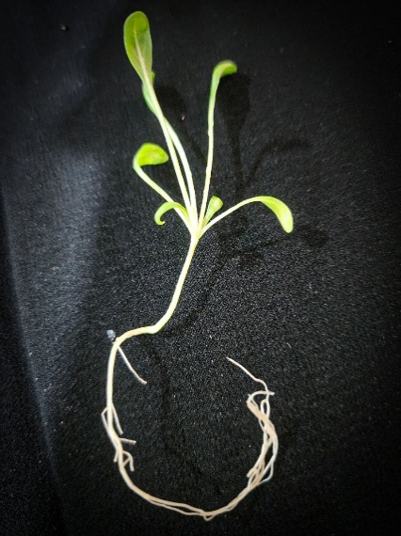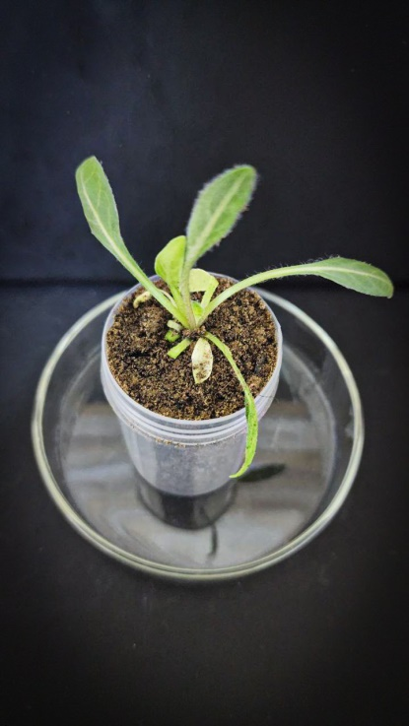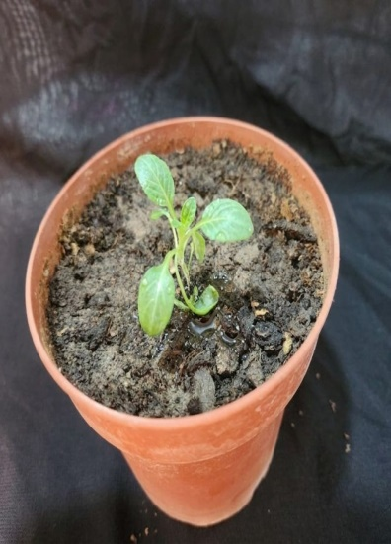
B
C
A

Figure (5): Acclimatization of black henbane (H. niger) plants resulting from callus differentiation of subcotyledonous stems callus of their seedlings
- A model of the complete black henbane plant that was lifted from the medium of the rooting after 20 days of rooting.
- The plant grew in a mix of soil and peatmoss in a plastic container 10 days after (A).
- The black henbane plant grew in a mix of soil and peatmoss in a anvil under greenhouse conditions 7 days after (B).

The production of healthy, vigorous seedlings depends on efficient seed-surface sterilisation and their establishment on culture medium without contamination (Istiandari & Faizal, 2025). The type and concentration of the sterilising agent and the optimum exposure time also influence the effectiveness of surface sterilisation (Sattarov & Kayumov, 2025). Auxins and cytokinins are among the most commonly used plant growth regulators in tissue culture and are often applied together to stimulate callus formation. Both regulate the cell cycle; auxin, in particular, regulates and promotes DNA replication before cell division, thereby affecting cell shape and increasing growth in callus cultures (Hassanen & Khalil, 2013; Saeed et al., 2021). Auxins also play a key role in dedifferentiation by reprogramming differentiated cells into an actively dividing state (Yu et al., 2025), whereas cytokinins directly stimulate cell division and delay senescence, thereby supporting callus formation (Sosnowski et al., 2023). The presence of auxins in solid MS medium, either alone or in combination with cytokinins, plays an important role in callus formation from subcotyledonous stem segments of Solanaceae plants (Adu Donyina et al., 2025). Al-Tai and Mohammed (2024) reported that whole leaves of lavender (Lavandula angustifolia) induced callus on MS medium supplemented with 3.0 mg L⁻¹ NAA and 10 mg L⁻¹ BA after 20 days, with a response rate of 96%, whereas solid, growth-regulator-free MS medium (MSO) did not induce callus. Adibian (2018) reported positive effects of NAA and Kin on callus induction and growth from subcotyledonous stem-segment cuttings of chamomile seedlings. NAA was used at concentrations of 0, 1.0, 2.0, and 4.0 mg L⁻¹ in combination with Kin at 0, 0.5, 1.0, and 2.0 mg L⁻¹. The most effective medium contained 1.0 mg L⁻¹ each of NAA and Kin and produced a response of 93.26%. A study of black henbane (Hyoscyamus niger) evaluated callus induction from leaf and internode explants using three combinations of plant growth regulators. The first combination contained 0.5 mg L⁻¹ 2,4-D and 1.0 mg L⁻¹ BA; the second contained 5.0 mg L⁻¹ each of NAA and BA; and the third contained 1.0 mg L⁻¹ 2,4-D and 5.0 mg L⁻¹ Kin. Callus induction from leaves reached 100% with the second combination, whereas the induction rate with the third combination was 87% (BiglariFarrash et al., 2024). Aljibouri et al. (2012) reported significant effects of growth regulators on callus weight and scopolamine concentration in black henbane cultured with 2.0 mg L⁻¹ BA and 0.5 mg L⁻¹ NAA. Another study reported the accumulation of alkaloids (scopolamine and atropine), phenols, and flavonoids in black henbane callus cultured on B5 medium supplemented with 2.0 mg L⁻¹ 2,4-D and 1.0 mg L⁻¹ BA under four LED-light treatments and with the amino acid glycine (Giglou et al., 2025). The spontaneous formation of shoots on the callus-induction medium may be related to the genetic constitution of the plant species, the competence of its cells for shoot formation, and endogenous hormone levels that trigger differentiation (Sidik et al., 2024). This response may also reflect cellular totipotency, which enables a plant cell to produce a complete plant (Babich et al., 2020). The ease of rooting of green shoots on solid, growth-regulator-free MS medium (MSO) may result from the capacity of the tissues to produce endogenous auxins at concentrations sufficient to stimulate rooting at the bases of the excised shoots, thereby making the external addition of growth regulators unnecessary in some cases (Mohammed & Al-Mallah, 2013; BiglariFarrash et al., 2024). The balanced composition of solid MSO medium may also have contributed by providing macro- and micronutrients in growth-supporting proportions, excluding cytokinins, and supplying an appropriate nitrogen level. This balance can limit excessive vegetative growth at the expense of root formation and provide conditions favourable for rooting (Bouchiha & Mazri, 2022). Similarly, the origin of the shoots from spontaneous differentiation may reflect prior physiological readiness. This phenomenon may represent an adaptive response to mild stress caused by excision and culture on a growth-regulator-free medium, in which the tissues perceive these conditions as a signal to activate internal mechanisms that enhance auxin synthesis or receptor sensitivity, thereby promoting rapid and widespread rooting (Larriba et al., 2021).

Conclusions
This study established a laboratory protocol for regenerating Hyoscyamus niger through tissue culture. Subcotyledonous stem segments cultured on the specified MS medium showed 100% callus induction, and 90% of the callus pieces produced spontaneous shoots. The regenerated shoots rooted at a rate of 100% on solid, growth-regulator-free MS medium (MSO), and the resulting plantlets were acclimatised and transferred to soil. These findings demonstrate that the tested culture sequence can support callus induction, spontaneous shoot differentiation, rooting, and acclimatisation of H. niger under the conditions used. The approach may provide a controlled, year-round alternative for propagating this medicinal species. However, its broader applicability and reproducibility should be evaluated using additional explants, growth-regulator treatments, and independent experiments. The regenerated tissues may also provide plant material for future studies on the production of hyoscyamine and scopolamine.
Limitations
This study assessed a single growth-regulator combination and did not include alternative or hormone-free controls for callus induction and shoot regeneration. The genetic fidelity and taxonomic identity of the regenerated plants were not confirmed by voucher, cytological or molecular methods. Alkaloid production was not quantified, and acclimatisation was evaluated qualitatively without a reported survival percentage or long-term greenhouse assessment.

Declaration of AI Use

This manuscript was prepared through the combined contributions of all author(s), including contributions to the study design, data, content development, results, interpretation, and related scholarly work. The author(s) acknowledge the use of Grammarly and ChatGPT to assist with grammar checking, language refinement, reference formatting. These AI-assisted tools were not used as authors and did not replace the intellectual contributions or scholarly judgment of the author(s). All AI-assisted outputs, including content, references, and interpretations, were carefully reviewed, revised, verified, and approved by the author(s). The author(s) accept full responsibility for the accuracy, integrity, and final content of the manuscript.

References
Abdalla, N., El-Ramady, H., Seliem, M. K., El-Mahrouk, M. E., Taha, N., Bayoumi, Y., Shalaby, T. A., & Dobránszki, J. (2022). An academic and technical overview on plant micropropagation challenges. Horticulturae, 8(8), Article 677. https://doi.org/10.3390/horticulturae8080677
Abed, A. S., & Jassim, E. H. (2024). Enhancement of the production of tropane alkaloids in Hyoscyamus niger L. callus using different biotic elicitors. Iraqi Journal of Science, 65(9), 4993–5004. https://doi.org/10.24996/ijs.2024.65.9.16
Adibian, M. (2018). The effect of different concentrations of growth regulators and the type of explants on embryogenesis and rooting of German chamomile (Matricaria chamomilla L.). Journal of Pure and Applied Microbiology, 12(3), 1281–1287. https://doi.org/10.22207/JPAM.12.3.30
Adu Donyina, G., Szarvas, A., Opoku, V. A., Mikó, E., Tar, M., Czóbel, S., & Monostori, T. (2025). Enhancing sweet potato production: A comprehensive analysis of the role of auxins and cytokinins in micropropagation. Planta, 261(4), Article 74. https://doi.org/10.1007/s00425-025-04650-z
Aljibouri, A. M. J., Al-Samarraei, K. W., Abd, A. S., Mageed, D. M., & Ali, A.-J. A. (2012). Alkaloids production from callus of Hyoscyamus niger L. in vitro. Journal of Life Sciences, 6(8), 874–882.
Al-Tai, A. A., & Mohammed, A. A.-H. (2024). Germination of lavender (Lavandula angustifolia) plant seeds and production of its seedlings callus cultures. Malaysian Journal of Microbiology, 20(6), 36–39. https://doi.org/10.21161/mjm.240006
Anushi, Jain, S., Rathod, M., Mishra, G., Kumari, V. L. P., Baksh, H., Saxena, S., & Prasad, L. (2023). Plant tissue culture for medical therapy: Unlocking the potential of medicinal plants. Current Journal of Applied Science and Technology, 42(46), 7–22. https://doi.org/10.9734/cjast/2023/v42i464289
Babich, O., Sukhikh, S., Pungin, A., Ivanova, S., Asyakina, L., & Prosekov, A. (2020). Modern trends in the in vitro production and use of callus, suspension cells and root cultures of medicinal plants. Molecules, 25(24), Article 5805. https://doi.org/10.3390/molecules25245805
Bapat, V. A., Kavi Kishor, P. B., Jalaja, N., Jain, S. M., & Penna, S. (2023). Plant cell cultures: Biofactories for the production of bioactive compounds. Agronomy, 13(3), Article 858. https://doi.org/10.3390/agronomy13030858
Bejenaru, C., Radu, A., Mogoşanu, G. D., Bejenaru, L. E., Biţă, A., & Segneanu, A.-E. (2024). Solanaceae Adans. family. In A.-E. Segneanu (Ed.), Natural products and medicinal properties of Carpathian (Romanian) plants (pp. 430–444). CRC Press. https://doi.org/10.1201/9781003270515-33
BiglariFarrash, R., Kheiri, A., & SaniKhani, M. (2024). The use of leaf and internode explants and different combinations of growth regulators for callus formation, regeneration and root formation of black henbane (Hyoscyamus niger L.). Journal of Research, 1(4), Article 93. https://www.sid.ir/paper/1520159/en
Bouchiha, F., & Mazri, M. A. (2022). Micropropagation du cactus (Opuntia ficus-indica) par organogenèse. African and Mediterranean Agricultural Journal–Al Awamia, 135, 1–15. https://doi.org/10.34874/imist.prsm/afrimed-i135.33263
Brancato, C., Heusch, N., & Berendzen, K. W. (2025). Compendium of Agrobacterium-mediated tissue culture transformation methods of various Solanaceae species. Methods and Protocols, 8(5), Article 107. https://doi.org/10.3390/mps8050107
Chaachouay, N., & Zidane, L. (2024). Plant-derived natural products: A source for drug discovery and development. Drugs and Drug Candidates, 3(1), 184–207. https://doi.org/10.3390/ddc3010011
D’Amelia, V., Docimo, T., Crocoll, C., & Rigano, M. M. (2021). Specialized metabolites and valuable molecules in crop and medicinal plants: The evolution of their use and strategies for their production. Genes, 12(6), Article 936. https://doi.org/10.3390/genes12060936
Fazili, M. A., Bashir, I., Ahmad, M., Yaqoob, U., & Geelani, S. N. (2022). In vitro strategies for the enhancement of secondary metabolite production in plants: A review. Bulletin of the National Research Centre, 46, Article 35. https://doi.org/10.1186/s42269-022-00717-z
Giglou, R. H., Giglou, M. T., Sobhanizadeh, A., & Szumny, A. (2025). Enhancing the accumulation of scopolamine and atropine in Hyoscyamus niger L. callus by LED light and glycine—A cheap method. BMC Plant Biology, 25, Article 1162. https://doi.org/10.1186/s12870-025-07062-z
Hassanen, S. A., & Khalil, R. M. A. (2013). In vitro production and biochemical analysis of silymarin from Silybum marianum plant. World Applied Sciences Journal, 22(1), 26–34. https://doi.org/10.5829/idosi.wasj.2013.22.01.2959
Isah, T., Umar, S., Mujib, A., Sharma, M. P., Rajasekharan, P. E., Zafar, N., & Frukh, A. (2018). Secondary metabolism of pharmaceuticals in the plant in vitro cultures: Strategies, approaches, and limitations to achieving higher yield. Plant Cell, Tissue and Organ Culture, 132(2), 239–265. https://doi.org/10.1007/s11240-017-1332-2
Istiandari, P., & Faizal, A. (2025). Integrating in vitro cultivation and sustainable field practices of sacha inchi (Plukenetia volubilis L.) for enhanced oil yield and quality: A review. Horticulturae, 11(2), Article 194. https://doi.org/10.3390/horticulturae11020194
Kareem, Z. J. (2020). Biomedical applications and secondary metabolite profiling of Hyoscyamus niger and Sesamum indicum seed, root and hairy root cultures [Doctoral dissertation, Georg-August-Universität Göttingen]. https://doi.org/10.53846/goediss-8301
Khalafalla, M. M. (2026). Plant cell suspension culture for plant secondary metabolite production: Current status, constraints, and future solutions. Polish Journal of Environmental Studies, 35(1), 1–14. https://doi.org/10.15244/pjoes/195703
Khafaji, M., & Taha, A. (2023). Photoperiod and UV light influence secondary metabolites of Hyoscyamus niger callus induced from leaves. Journal of Biotechnology Research Center, 17(2), 16–26. https://doi.org/10.24126/jobrc.2023.17.2.684
Khezri, M., Asghari-Zakaria, R., & Zare, N. (2024). Plant cell and tissue culture: Propagation, improvement, and conservation of medicinal plants. In N. Kumar (Ed.), Biosynthesis of natural products in plants: Bioengineering in post-genomics era (pp. 267–291). Springer Nature Singapore. https://doi.org/10.1007/978-981-97-2166-5_11
Kumari, A., Nagpal, A. K., & Katnoria, J. K. (2024). Potential of some explants for callus induction and plantlet regeneration in Solanum lycopersicum L. under treatment of different plant growth regulators. BioTechnologia, 105(3), 227–247. https://doi.org/10.5114/bta.2024.141803
Larriba, E., Sánchez-García, A. B., Justamante, M. S., Martínez-Andújar, C., Albacete, A., & Pérez-Pérez, J. M. (2021). Dynamic hormone gradients regulate wound-induced de novo organ formation in tomato hypocotyl explants. International Journal of Molecular Sciences, 22(21), Article 11843. https://doi.org/10.3390/ijms222111843
Malabadi, R. B., Chalannavar, R. K., & Kolkar, K. P. (2025). Plant cell totipotency: Plant tissue culture applications—An updated review. World Journal of Advanced Engineering Technology and Sciences, 16(2), 112–135. https://doi.org/10.30574/wjaets.2025.16.2.1262
Mohammed, A. A., & Al-Mallah, M. K. (2013). Determination of β-carotene in carrot (Daucus carota L.) plants regenerated from stems callus. Rafidain Journal of Science, 24(5), 27–36. https://doi.org/10.33899/rjs.2013.74507
Mohammed, N. J., Al-Behadili, W. A. A., & Al-Fahham, A. A. (2024). The chemical structure, classification and clinical significance of alkaloids. International Journal of Health & Medical Research, 3(10), 760–764. https://doi.org/10.58806/ijhmr.2024.v3i10n10
Murashige, T., & Skoog, F. (1962). A revised medium for rapid growth and bio assays with tobacco tissue cultures. Physiologia Plantarum, 15(3), 473–497. https://doi.org/10.1111/j.1399-3054.1962.tb08052.x
Niazian, M. (2019). Application of genetics and biotechnology for improving medicinal plants. Planta, 249(4), 953–973. https://doi.org/10.1007/s00425-019-03099-1
Nwozo, O. S., Effiong, E. M., Aja, P. M., & Awuchi, C. G. (2023). Antioxidant, phytochemical, and therapeutic properties of medicinal plants: A review. International Journal of Food Properties, 26(1), 359–388. https://doi.org/10.1080/10942912.2022.2157425
Okoroafor, U. E. (2022). Microbial contamination in plant tissue culture and elimination strategies. Nigerian Agricultural Journal, 53(2), 348–355. https://www.ajol.info/index.php/naj/article/view/243321
Pasternak, T. P., & Steinmacher, D. (2024). Plant growth regulation in cell and tissue culture in vitro. Plants, 13(2), Article 327. https://doi.org/10.3390/plants13020327
Prashant, S. P., & Bhawana, M. (2024). An update on biotechnological intervention mediated by plant tissue culture to boost secondary metabolite production in medicinal and aromatic plants. Physiologia Plantarum, 176(4), Article e14400. https://doi.org/10.1111/ppl.14400
Ram, K., Patel, A. K., Choudhary, S. K., & Shekhawat, N. S. (2022). In vitro callus proliferation for production of shikonin derivatives and protein profiling in Arnebia hispidissima (Lehm.) A.DC. Plant Cell Biotechnology and Molecular Biology, 23(3–4), 45–56. https://doi.org/10.56557/pcbmb/2022/v23i3-47407
Saeed, F., Younas, M., Fazal, H., Mushtaq, S., Rahman, F. U., Shah, M., Anjum, S., Ahmad, N., Ali, M., Hano, C., & Abbasi, B. H. (2021). Green and chemically synthesised zinc oxide nanoparticles: Effects on in vitro seedlings and callus cultures of Silybum marianum and evaluation of their antimicrobial and anticancer potential. Artificial Cells, Nanomedicine, and Biotechnology, 49(1), 450–460. https://doi.org/10.1080/21691401.2021.1926274
Salaria, N., Kumari, I., & Kumar, R. (2025). Tissue culture technology: An emerging viable technology to protect biodiversity in the face of biodiversity loss. In R. Kumar, N. Salaria, I. Kumari, & Y. A. Hajam (Eds.), Plant tissue culture technology: An innovative tool for the propagation, management, and conservation of Himalayan biodiversity (pp. 73–98). Apple Academic Press. https://doi.org/10.1201/9781779643445-4
Sattarov, A. N., & Kayumov, F. S. (2025). Research on methods for introducing white seed (Silybum marianum) into in vitro culture. Естественные науки в современном мире: теоретические и практические исследования, 4(5), 57–58. https://doi.org/10.5281/zenodo.15210804
Shim, K. H., Kang, M. J., Sharma, N., & An, S. S. A. (2022). Beauty of the beast: Anticholinergic tropane alkaloids in therapeutics. Natural Products and Bioprospecting, 12, Article 33. https://doi.org/10.1007/s13659-022-00357-w
Sidik, N. J., Agha, H. M., Alkamil, A. A., Alsayadi, M. M. S., & Mohammed, A. A. (2024). A mini-review of plant tissue culture: The role of media optimization and growth regulators in modern agriculture, callus induction, and applications. AUIQ Complementary Biological System, 1(2), 96–109. https://doi.org/10.70176/3007-973X.1019
Sosnowski, J., Truba, M., & Vasileva, V. (2023). The impact of auxin and cytokinin on the growth and development of selected crops. Agriculture, 13(3), Article 724. https://doi.org/10.3390/agriculture13030724
Thakur, S., Shruti, Hashmi, S., Mishra, S., Ekka, S. K., Kushwaha, A., & Kujur, R. (2024). A review on plant tissue culture. Asian Journal of Biology, 20(2), 14–18. https://doi.org/10.9734/ajob/2024/v20i2387
Twaij, B. M., Jazar, Z. H., & Hasan, M. N. (2020). Trends in the use of tissue culture, applications and future aspects. International Journal of Plant Biology, 11(1), Article 8385. https://doi.org/10.4081/pb.2020.8385
Wang, J., Li, J.-L., Li, J., Li, J.-X., Liu, S.-J., Huang, L.-Q., & Gao, W.-Y. (2017). Production of active compounds in medicinal plants: From plant tissue culture to biosynthesis. Chinese Herbal Medicines, 9(2), 115–125. https://doi.org/10.1016/S1674-6384(17)60085-6
Wen, M., Zeng, J., Qiu, F., Zhang, F., & Liao, Z. (2024). De novo synthesis of anticholinergic hyoscyamine and scopolamine in Nicotiana benthamiana based on elucidating the tropane alkaloid biosynthetic pathway of Anisodus luridus. Agronomy, 14(11), Article 2460. https://doi.org/10.3390/agronomy14112460
Wijerathna-Yapa, A., Hiti-Bandaralage, J., & Pathirana, R. (2025). Harnessing metabolites from plant cell tissue and organ culture for sustainable biotechnology. Plant Cell, Tissue and Organ Culture, 162, Article 55. https://doi.org/10.1007/s11240-025-03180-6
Yu, X., Hou, Y., Zhang, W., Gong, H., Liu, B., Song, X., Li, T., Yang, Y., & Zhu, J. (2025). Optimisation of somatic embryogenesis and transcriptomic analysis of the early stage of callus redifferentiation in Quercus suber L. Plants, 14(18), Article 2855. https://doi.org/10.3390/plants14182855

