Efficacy of Plant-Derived Biopesticides Against Aphids: A Comparative Evaluation of Custard Apple Seed Oil, Neem Oil, Castor Oil, and Tobacco Leaf Extract

Abstract
The present study evaluated the efficacy of selected plant-derived biopesticides against aphids associated with brinjal, common bean, and mungbean under laboratory and pot conditions. Treatments consisted of tobacco leaf extract, custard apple seed oil, castor oil, and neem oil, each applied at 2% and 5% concentrations, along with an untreated control. The experiments were arranged in a completely randomized design with nine treatments and three replications. Mortality of brinjal aphid and bean aphid was recorded at 12, 18, and 24 hours after spraying under laboratory conditions, whereas mungbean aphid mortality was assessed at 12-hour intervals for 72 hours in the pot experiment. Among the tested botanicals, 5% neem oil consistently resulted in the highest aphid mortality. In brinjal aphid, 5% neem oil caused 94.44% mortality at 24 hours, followed by 5% tobacco leaf extract with 83.33% mortality. In bean aphid, 5% neem oil and 5% tobacco leaf extract both resulted in 77.77% mortality at 24 hours. In the mungbean pot experiment, 5% neem oil achieved 100% mortality at 72 hours, followed by 5% tobacco leaf extract with 95.87% mortality and 2% neem oil with 89.96% mortality. The untreated control recorded no mortality in all experiments. However, tobacco leaf extract caused visible brown burning spots in the pot experiment, indicating possible phytotoxicity. The findings indicate that neem oil, particularly at 5%, showed comparatively higher efficacy against aphids in this this study.
Key word: Aphid, Custard Apple Seed Oil, Neem Oil, Castor Oil, and Tobacco Leaf Extract

INTRODUCTION
Aphid is minute to small (1-10 mm) soft-bodied, pear-shaped plant sap sucking insects of the family Aphididae under the order Hemiptera. They are of considerable agricultural importance because of their polymorphism, host alternating behavior, viviparity, and remarkable ability of transmitting plant viral diseases. Globally, over 250 aphid species are economically important pests of agricultural and horticultural crops. In Bangladesh, aphid fauna is mostly unrecorded; only about 30 aphid species under 20 genera infesting 58 host plants including annuals, perennials, vegetables, trees, shrubs and roses. In India, 10-90% yield losses to crops by aphids have been reported depending upon infestation and crop stage (Razaq et al.,2011). Aphids attack a wide range of plants including Brinjal or Eggplant (Solanum melongena L.), Common bean (Lablab purpureus L.), and Mung bean (Vigna radiate L.) that are very important vegetable and pulse crop of Bangladesh. Brinjal or eggplant (Solanum melongena L.) is the most common, popular and principal vegetables in Bangladesh and other parts of the world. Brinjal is the second most important vegetables crops in relation to its total production (Anon., 1996). This useful crop is grown all the year round in Bangladesh and covers 46558 ha( about 25.4% of the total vegetable area of the country) with a production of 341000 tons.. Brinjal is grown all over areas and in all seasons of Bangladesh. However, it is intensively grown in winter season in Jessore, Mymensingh, Narsingdi, Comilla, Savar, Bogra, Jamalpur, Dinajpur, Rajshahi and also southern districts of Bangladesh. Hyacinth bean known as common bean (Lablab purpureus L.) is also one of the most important winter vegetables in Bangladesh. It is very nutritious as the green pods contain a good amount of protein in addition to fiber, vitamins and minerals (Gopalan et al., 1982).
Mungbean (Vigna radiata L.) is a major legume crop grown widely in south and southeast Asia, mostly on small-scale family-owned farms. This low input, short duration crop is prized for its seeds, which are high in protein, easily digested, and consumed as food. It is an important source of dietary protein, especially in Indian Subcontinent where consumption of animal protein is very low.

But aphid infestation is one of the most limiting factors for increasing yield potential of these crops. Among various aphid species in Bangladesh specially in southern part brinjal is infested by Aphis gossypii, common bean is infested by Aphis craccivora and Mung bean is also infested by Aphis craccivora. Aphids generally attack plants and suck on stems, buds, leaves, flowers, fruits and pods of the plants. Then they digest these plant juices and excrete sticky, sugary ‘honeydew’ which may attract other garden insects like ants. Honeydew causes economic loss through physical contamination and through providing a nutrient source for fungi that contaminate produce and reduce photosynthesis rates by blocking sunlight. Indeed, these aphids are considered by many to be the most important vector of plant viruses throughout the world. Nymphs and adults are equally capable of virus transmission (Namba and Sylvester, 1981).
Different strategies are in practice to control these insect pests. Chemical control is most commonly used as effective method, and farmers are still relying on the chemicals to control variety of insect pests (Naranjo, 2001). However, the excessive use of insecticides may lead to serious problems such as pesticidal pollution, pest resurgence, mortality of natural enemies and pollinators, high cost of production, reduction in nitrogen fixation and loss of biodiversity (Milner, 2004).
Keeping in mind the above-mentioned problem, the proposed research work has been planned to understand the performance of botanicals on aphid, which are friendly to environment by low cost in Bangladesh that will be helpful for the farmers to take proper management strategies. Conversely, farmers gain the economic sustainability by the quality production.
Botanicals can play an important role in agriculture that are naturally occurring toxins extracted from plants, and are environmentally friendly. There are several advantages to use botanicals rather than synthetic insecticides. Plant derived insecticides break down quickly in the environment, resulting in little risk of residues on food crops and less risk to beneficial insects. Some materials can be used shortly before harvest. Most botanicals are fast acting and most, but not all, botanicals are of low to moderate toxicity to mammals.
The aim of this research work was to propose an alternative for aphid control in brinjal and country bean and avoid using large amounts of pesticides. Botanicals can offer a safe and effective alternative of conventional insecticides for controlling aphid within an integrated pest management program. The proposed study highlights the practical application of botanical insecticides for controlling aphid of brinjal and country bean.
The proposed research work was carried out to determine the efficacy of botanicals extracts for controlling the aphid and to determine the appropriate doses of botanical extracts on aphids.

MATERIALS AND METHODS

The experiments were carried out in Insect Pest Management (IPM) Laboratory of the Department of Entomology and vegetable farm of the Patuakhali Science and Technology University in Bangladesh.
Target Crop
Brinjal (Solanum melongena L.) and common Bean (Lablab purpureus L.) were used since these are the most popular vegetables cultivated by farmers in Bangladesh. Mungbean (Vigna Radiata) was used for pot experiment.
Planting of Seedlings
Healthy seedlings of 28 days aged with uniform height were transplanted into 1ft x 1ft height and diameter pot. The seedlings were watered immediately after transplanting.
Insects Rearing in Laboratory
Samples of several adult insect of brinjal and bean aphid were collected separately from their respective host plant at Patuakhali in Bangladesh and brought to IPM laboratory of the Department of Entomology of the Patuakhali Science and Technology University) with their host plant separately in a rearing chamber house for starting colonies. These colonies were reared in separate insect-rearing chambers at 25 ± 2°C, 60 ± 5% relative humidity, and a 16 h light/8 h dark (16L:8D) photoperiodic cycle.
Collection and Processing of Plant Materials
Fresh seeds of custard apple (Annonaa reticulata ), seeds of neem (Azadirachta indica), and seeds of castor (Ricinus communis.), were collected from the surrounding of the Patuakhali Science and Technology University and dried, whereas leaves of tobacco (Nicotiana tabacum) were purchased from market . After bringing them to the laboratory, they were washed in running water. After that the plant materials were kept in shade for air-drying and then they were preserved in refrigerator for seven days at 4 degree Celsius temperature.

Seed Oil Extraction
Extraction was carried out with drying of seed in microwave oven at 65º C about 24 hour . Then seed powder was made by grinding dried seed with electric grinding machine. About 1 g of powdered seed material was soaked in 50 mL of Acetone (50%) while frequently shaking before heating. Then heated at about 53º C degree centigrade for 10 minutes. After cooling centrifuged at 7,000 rpm for 15 min after which the extracts were filtered using Whatman # 1 filter paper (Whatman International Ltd., England) and were allowed to evaporate.

Experimental Design
In case of lab experiment brinjal leaf (one leaf per unit) and twig of bean (7-10 cm long and one twig per unit) were used as plant material. There were nine treatments with three replications for each. The treatments were T_{0:} Control (None) ; T₁: 2% of Tobacco leaf extracts (Nicotiana tabacum); T₂: 5% of Tobacco leaf extract (Nicotiana tabacum); T₃: 2% of Custard Apple Seed oil (Annona reticulata); T₄: 5% of Custard Apple Seed oil (Annona reticulata); T₅: 2% of Castor Oil (Ricinus communis) ; T₆: 5% of Castor Oil (Ricinus communis) ; T₇: 2% of Neem Oil (Azadirachta indica); T₈: 5% of Neem Oil (Azadirachta indica)
The effects (percent mortality) with the above listed treatments were observed in brinjal aphid (Aphis gpssypii) and bean aphid (Aphis craccivora). The experimental was designed following the Completely Randomized Design (CRD).
Pot Experiment
In the pot experiment mungbean (Vigna Radiata) was used as plant material. Seedlings were transplanted into pot (3 plants per pot). Similar, as above, treatments and replications were used.

Cultural Practices
The normal agronomic practices (e. g. watering, weeding, mulching, fertilization, sticking and pruning) recommended for growing vegetables in an experimental farm were followed.

Spraying Method
At first 6 adult aphids were released per unit. Then botanicals were sprayed after 6 hours of releasing aphids. Botanicals of 2% and 5% concentrations were sprayed (one spray) on experimental unit for brinjal and beans.. Both upper and lower surfaces of plant leaves and twigs were sprayed with botanicals. In case of pot experiment three sprays of botanicals were applied at 24 hours interval.

Data collection
Brinjal aphid and black bean aphid (6 aphids per twig) were released from their mother stock plant onto the selected experimental units 6 hours before of spraying for their settlement. In case of brinjal and bean aphid number of dead insects were counted and recorded after 12 hours, after 18 hours and after 24 hours after one spray. In case of mungbean dead insects were counted and recorded at 12 hours interval for 3 days. Finally mortality percentages (%) of these insects were calculated.

Statistical Analysis
Data were expressed in three individual replicates, and mean values ± standard error were plotted using Sigma plot 8.0 (Systat software, Inc., Point Richmond, CA, USA). Analysis of variance (ANOVA) was carried out in order to analyze the means by using PROC General Linear Model (GLM) with the Statistical Analysis System (SAS, 2002-2003 SAS Institute Inc., Cary, NC, USA) version 9.1 program. Significant differences among mean values were determined using Duncan’s Multiple Range Tests (DMRT) at 1% and 5% level of significance.

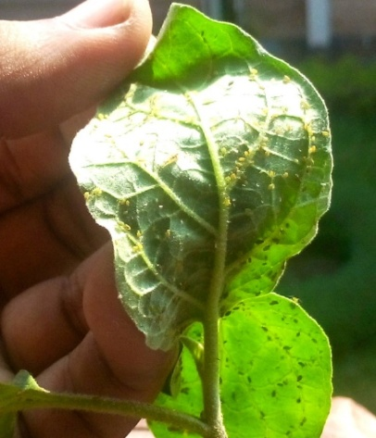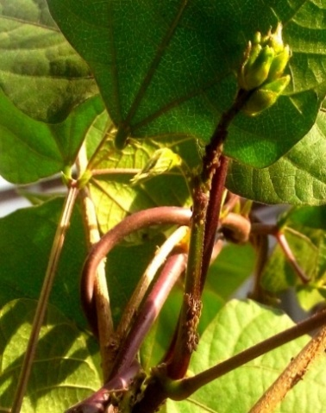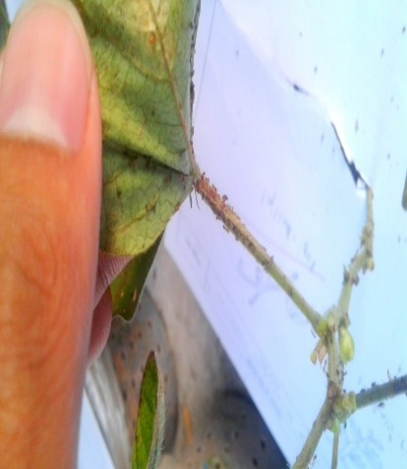

Figure 1: Rearing of brinjal aphid, bean aphid and mungbean aphid

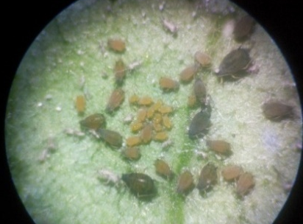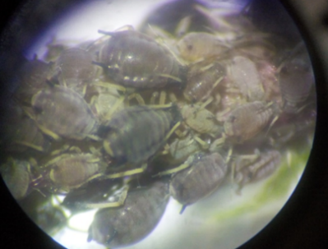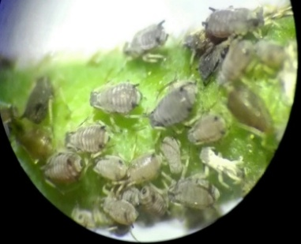

Figure 2: Colony of reared brinjal aphid, bean aphid and mungbean aphid under microscope

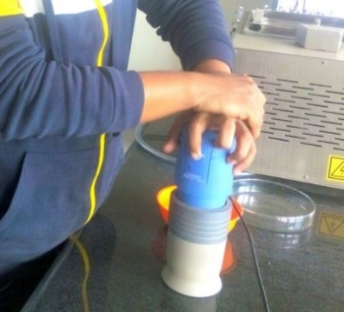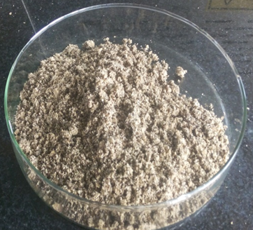

Figure 3: Drying and grinding of seed

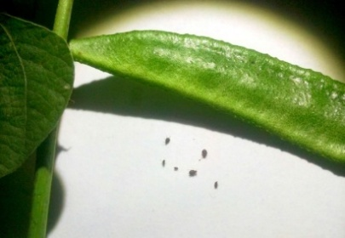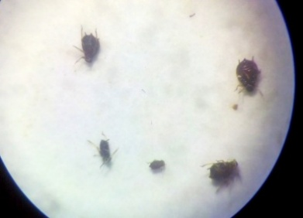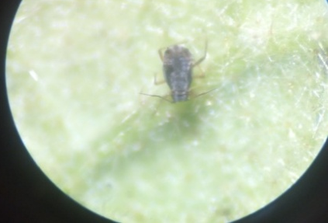
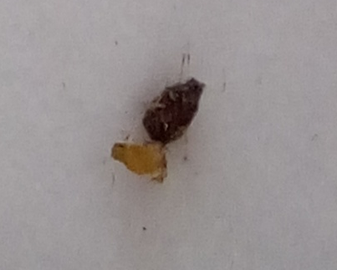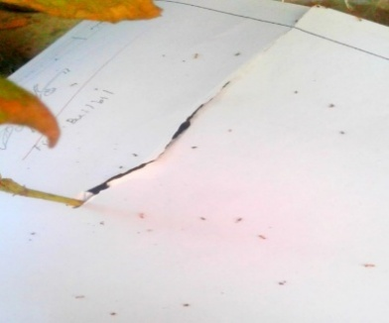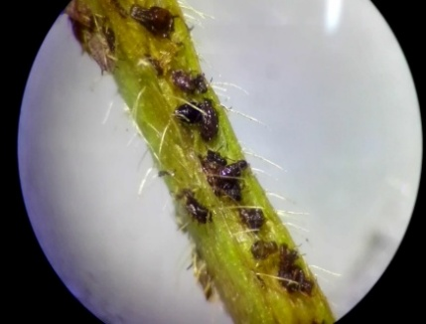

Figure 4: Dead insects under microscope

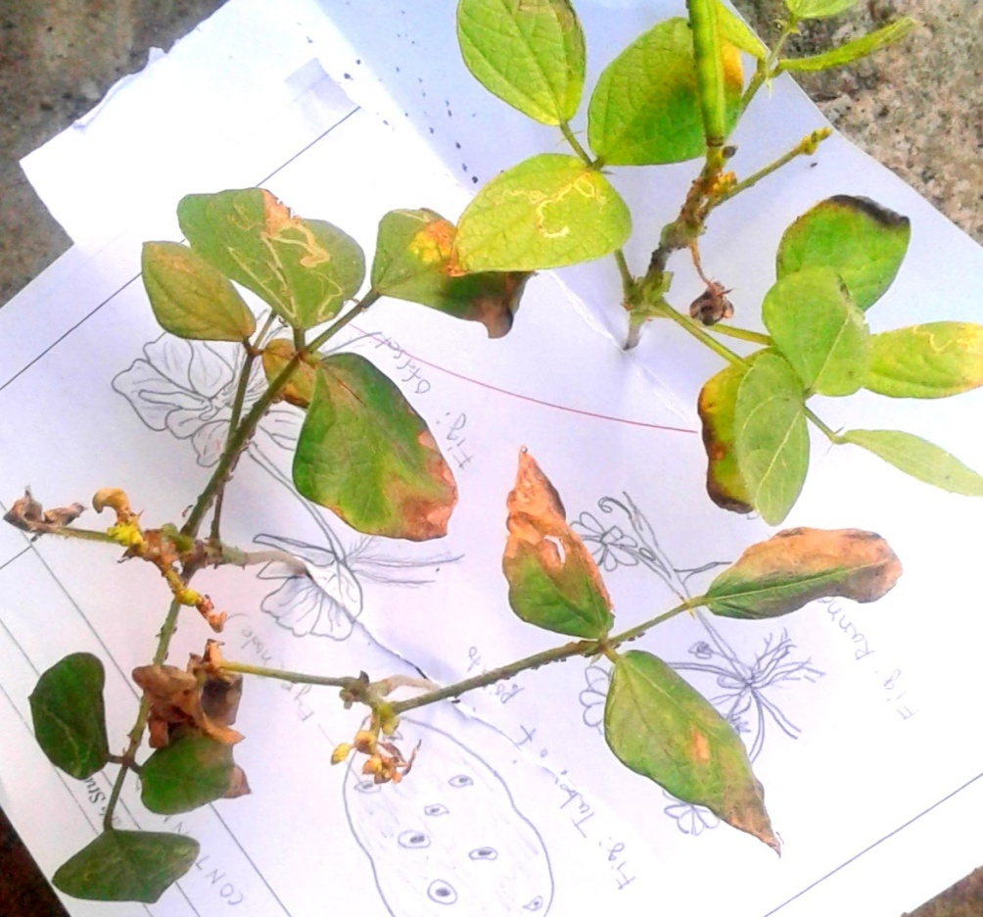
Brown burning spots

Figure 5: Phyotoxicity in case of tobacco leaf extract
in the pot experiment.

RESULTS

Performance of Botanicals on Aphid of Brinjal
Aphids were released from the colony of IPM lab of the Patuakhali Science and Technology University to the brinjal leaf on petridish with wet cotton 6 hours before spraying for their settlement. After spraying (one spray) the botanicals (Tobacco leaf extract 2%, Tobacco leaf extract 5%, Custard apple seed oil 2%, Custared apple seed oil 5%, castor oil 2%, Castor oil 5%, Neem oil 2%, Neem oil 5%) number of dead aphids were counted under microscope and recorded every 12 hours, 18 hours and 24 hours. After spray final mortality of aphid were calculated.

Figure 6: Performance of botanicals against aphid of brinjal

Highest mortality percentage for neem 5%(72.22%) at 12 hours after spray was highest, which was followed by tobacco leaf extract 5%( 44.44%), castor oil 5%(44.44%), custard apple seed oil 5% and neem oil 2%(38.88%). The result reveald the lowest mortality for custard apple seed oil 2%(22.22%) castor oli 2%(22.77) and tobacco leaf extract 2%(27.27%). In control no mortality was recorded. After 18 hours effect of botanical spray performance of neem oil 5%(77.77%) was highest followed by tobacco leaf extract 5%(61.11%), custard apple seed oil 5%(50%), castor oil 5%and 2%(44.44%), neem oil 2%(38.88%), custard apple seed oil 2%(33.33%), tobacco leaf extract 2%(27.27%), and control (0%) (Fig.6).

,
Figure 7: Performance of botanicals against brinjal aphid

The bar graph (Fig.8) shows that at first 12 hours performance of neem oil 5% was the highest followed by tobacco leaf extract 5%, castor oil 5%, custard apple seed oil 5% and neem oil 2%, tobacco leaf extract 2%, castor oli 2%, custard apple seed oil 2%, control. After18 hours effect of neem oil 5% was highest followed by tobacco 5%, custard apple seed oil 5%, castor oil 5%and 2%, neem oil 2%, custard apple seed oil 2%, tobacco leaf extracts 2%. In control no mortality was recorded.Furthermore, after 24 hours neem oil 5% showed highest mortality followed by tobacco leaf extract 5%, custared apple seed oil 5% and castor oil 5%. The result reveald that the lowest mortality for castor oil 2% and tobacco leaf extract 2% followed by%custard apple seed oil 2% and neem oil 2%. In control no mortality was recorded.

The efficacy of botanicals in defferent concentrationon brinjal leaf in the lab was in the order; Neem oil 5%> tobacco leaf extract 5%> custared apple seed oil 5%> castor oil 5%> neem oil 2%> custard apple seed oil 2%> tobacco leaf extract 2% and castor oil 2%> control.

Performance of Botanicals on Aphid of Bean
Aphids were released from the colony of IPM lab of thePatuakhali Science and Technology University on the bean twig in petridish with wet cotton 6 hours before of spraying for their settlement. After spraying (one spray) the botanicals (Tobacco leaf extract 2%, Tobacco leaf extract 5%, Custard apple seed oil 2%, Custared apple seed oil 5%, castor oil 2%, Castor oil 5%, Neem oil 2%, Neem oil 5%) number of dead aphids were counted under microscope and recorded every 12 hours, 18 hours and 24 hours. After spray final mortality of aphid were calculated. The mortality was highest for neem 5%(55.55%) followed by tobacco leaf extract 5%( 44.44%), castor oil 5%(38.88%) and custard apple seed oil 5%(38.88%), tobacco leaf extaract 2%(22.22%), cusstard apple seed oil 2%,castor oil 2% and neem oil 2%(16.66%). In control no mortality was recorded. After 18 hours effect of neem oil 5% is highest (61.11%) followed by tobacco leaf extract 5%(55.55%), custard apple seed oil 5%(50%), castor oil 5%(44.44%), neem oil 2%(38.88%), tobacco leaf extract 2% and custard apple seed oil (27.77), and castor oil 2%(22.77%). In control no mortality was recorded After 24 hours. Neem oil 5% and tobacco leaf extract 5%(77.77%)showed highest mortality (77.77%) , followed by custared apple seed oil 5% and castor oil 5% (61.11%). The result reveald the lowest mortality for custared apple seed oil 2% and tobacco leaf extract 2%(44.44%). Mortality with neem oil 2% was 50%. In control no mortality was recorded.

Figure 8: Performance of botanicals against aphid on bean

After first 12 hours mortality with neem oil 5% was the highest followed by tobacco leaf extract 5%, castor oil 5% and custard apple seed oil 5%, tobacco leaf extaract 2%, cusstard apple seed oil 2%, castor oil 2% and neem oil 2%, control (Fig.10). After 18 hours effect of neem oil 5% was highest followed by tobacco leaf extract 5%, custard apple seed oil 5%, castor oil 5%, neem oil 2%, tobacco leaf extract 2% and custard apple seed oil 2%, castor oil 2%. In control no mortality was recorded . After 24 hours neem oil 5% showed highest mortality, and then tobacco leaf extract 5%, custared apple seed oil 5% and castor oil 5%, neem oil 2%, custared apple seed oil 2% and tobacco leaf extract 2%. In control no mortality was recorded.
The efficacy of botanicals in defferent concentration on common bean twig in the lab condition is given below:
Neem oil 5%> Tobacco leaf extract 5%> Custared apple seed oil 5%> Castor oil 5%> Castor oil 2%> Neem oil 2%> Custard apple seed oil 2% and Tobacco leaf extract 2%> Control.

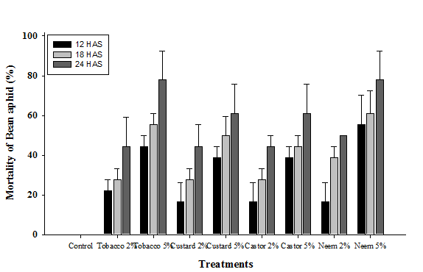

Figure 9: Performance of botanicals against aphid of bean

Performance of Botanicals against Aphid of Mungbean in the pot experiment
Aphids were reard in farm of the PSTU under natural condition on plants in pot. Three sprays of botanicals (Tobacco leaf extract 2%, Tobacco leaf extract 5%, Custard apple seed oil 2%, Custared apple seed oil 5%, castor oil 2%, Castor oil 5%, Neem oil 2%, Neem oil 5%) were done. After spraying the number of dead aphids were counted under microscope and recorded every 12 hours interval. After spray final mortality of aphid was calculated. The mortality percentages were shown highest forfor neem 5% at 24 hours interval. After spraying number of dead aphids were counted and recorded at every 12 hours interval for 3 days final mortality percentages (%) aphid were calculated. After 12 hours mortality percentage of neem oil 5% and custard apple seed oil 5% was the highest (6.86%) followed by castor oil 5%(6.15%), tobacco leaf extract 5% and tobacco leaf extract 2%, neem oil 2%( 2.86%), castor oil 2%(0.89%), and custard apple seed oil 2%(0.25%) In control no mortality was recorded. After 24 hours the mortality percentage was highest in neem oil 5%(13.08%) followed by tobacco extracts 5%(12.72%), neem oil 2%(10.21%), custard apple seed oil 5%(6.96%), tobacco extracts 2%(5.85%), castor oil 5%(5.73%), custard apple seed oil 2%(5.37%), castor oil 2%(5.04%), and control (0%).

Fig 10: Performance of botanicals for aphid of mung bean in the pot experiment

After 12 hours af second spray means total after 36 hours mortality was observed where tobacco leaf extracts 5% shown the highest mortality (29.39%) followed by tobacco leaf extracts 2%(22.04%), neem oil 5%(20.43), custard apple seed oil 5%(19.89%), neem oil 2%(17.56%), custard apple seed oil 2%(15.41%), castor oil 5%(12.54%), castor oil 2%(11.11%), control (0%). After 48 hours tobacco leaf extracts 5% showed the highest mortality (48.92%) followed by tobacco leaf extract 2%(37.09%), neem oil 5%(34.945), neem oil 2%(33.51%), and custard apple seed oil 5%(32.43%). The result reveald the lowest mortality with castor oil 2%(22.22%). Morality with castor oil 5% was 24.91% and custard apple seed oil 2% was 26.52%. In control no mortality was recorded. After , 48 hours and 60 hours of third spray mortality percentage was observed. The mortality was highest after 60 hours in tobacco leaf extract 5%(74.01%) followed by neem oil 5%(62.54%), neem oil 2%(57.52%), custard apple seed oil 5%(53.76%), castor oil 5%(53.33%), castor oil 2%(50.46%) tobacco leaf extract 2%(47.49%), , custard apple seed oil 2%(41.03%), and control (0%) Finally after 72 hours it was shown that the highest mortality was with neem oil 5%(100%) followed by tobacco leaf extract 5%(95.87%), neem oil 2%(89.96%), and custared apple seed oil 5%(77.41%), The result reveald the lowest mortality with castor oil 2%(46.23%). Mortality with castor oil 5% was 57.52% and custared apple seed oil 2% was 65.77%.In control no mortality was recorded.

The efficacy of different treatment on Mungbean in the pot experiment is given below:
Neem oil 5%> Tobacco leaf extract 5%> Neem oil 2%> Custared apple seed oil 5%> Custard apple seed oil 2%> Castor oil 5%> Castor oil 2%> Control.

DISCUSSION
Since ancient times several neem products. such as neem seed kernel, dry fruit extracts, neem oil, extracts from the leaves and barks etc. had been used in controlling insects. Several products of neem and tobacco leaf extract with different concentrations and formulations gave positive and different results on aphid and other insects of different plants in many research work ( Ali.S et al., (2016), Schädlingskunde et al.,(1992), Bahar.H et al.,( 2007), Azad et al.,(2012).

Ali.S et al. (2016) carried out a field study to examine the effect of bio-pesticides against sucking insect pests of brinjal crop under field conditions. Where mortality with Neem extracts was recorded was highest (82.60%), followed by Tobacco extract (75.95%). Similarly in the current experiment neem oil gave superior result than Tbacco leaf extract.

Schädlingskunde et al., (1992) evaluated that effect of application of Neem-Azal S. It gave effective result in suppression of bean aphid. This review of literature strongly supports current research work.

Bahar.H et al., (2007) reported that tobacco extract gave better results, recording about 74-90% aphid suppression followed by neem extracts (53-64%) on long yard bean aphid. These research works contradicts the present research work because in present research work neem oil shows the better result which followed by tobacco extracts.

Azad et al., (2012) evaluated the effect of eight botanical extracts on pest control in brinjal field. Water extracts of dried leaves of Khuksa (Ficus hispida), Chotra (Lantana sp.), Chirata (Swertia chrata), Neem (Azadirachta indica), Bael (Aegle marmelos), Holde-hurhuri (Cleome viscosa) and Marigold (Targetes erecta) and seeds of Mahogany (Swietenia mahagoni) were prepared and sprayed in experimental brinjal field at the Rajshahi University. Out of these botanicals, Khuksha leaves’ extract showed best performance against the pest attack compared to other extracts. But present research shows that neem oil gives better results than other botanicals.

Performance of Botanicals on Brinjal Aphid
The present study was accomplished through a lab field experiment conducted at IPM laboratory of the Department of Entomology at PSTU, Patuakhali in Bangladesh. The performance of different botanicals to reduce aphid were evaluated on brinjal leaf. Nine treatments such as T_{0:} Control (100% water) T₁: 2% of Tobacco leaf extract, T₂: 5%of Tobacco leaf extract, T₃: 2% of Custard Apple seed oil, T₄: 5% of Custard Apple seed oil, T₅: 2% of Castor oil, T₆: 5% of Castor oil ,T₇: 2% of Neem oil, T₈: 5% of Neem oil were tested on aphid and all these treatments were compared with each other. In case of brinjal crops, it is revealed that the given below trend of the mortality percentage of aphid was observed due to application of the different treatments as T₈: Neem oil 5%> T₂: Tobacco leaf extract 5%> T₄: Custard apple seed oil 5%> T₆: Castor oil 5%> T₇: Neem oil 2%> T₃: Custard apple seed oil 2%> T₁: Tobacco leaf extract 2% and T₅: castor oil 2%. T₈ which was significant at both 1% and 5% level.

Most effective result were obtained by T₈ (Neem Oil 5%) and T₂ (Tobacco Leaf Extract 5%) treatments. The review of literature on performance of same botanicals on different plants was available to support the current research work.

Performance of Botanicals on Bean Aphid
The present study was carried ut in a lab. The experiment was conducted at entomology laboratory at the PSTU, Patuakhali in Bangladesh. The performance of different botanicals to reduce aphid were evaluated on bean twig. Nine treatments such as T_{0:} Control (100% water) T₁: 2% of Tobacco leaf extract, T₂: 5%of Tobacco leaf extract, T₃: 2% of Custard Apple seed oil,T₄: 5% of Custard Apple seed oil, T₅: 2% of Castor oil, T₆: 5% of Castor oil ,T₇: 2% of Neem oil, T₈: 5% of Neem oil were tested on aphid and all these treatments were compared with each other. It is revealed that the trend of the mortality percentage of aphid was was; T₈: Neem oil 5%> T₂: Tobacco leaf extract 5%> T₄: Custard apple seed oil 5%> T₆: Castor oil 5%> T₇: Neem oil 2%> T₃: Custard apple seed oil 2%> T₁: Tobacco leaf extract 2% and T₅: castor oil 2%. T₈ which was significant at both 1% and 5% level.

Most effective result were obtained with T₈ (Neem Oil 5%) and T₂ (Tobacco Leaf Extract 5%) treatments. The review of literature on performance of same botanicals on different plants was available to support the current research work.

Performance of Botanicals on Mungbean Aphid in the pot condition
The present study was accomplished through a pot experiment conducted at the farm of the PSTU, Patuakhali in Bangladesh. The performance of different botanicals to reduce aphid were evaluated on mungbean. Nine treatments such as T_{0:} Control (100% water) T₁: 2% of Tobacco leaf extract, T₂: 5%of Tobacco leaf extract, T₃: 2% of Custard Apple Seed oil, T₄: 5% of Custard Apple Seed oil, T₅: 2% of Castor Oil, T₆: 5% of Castor Oil, T₇: 2% of Neem Oil, T₈: 5% of Neem Oil were tested on aphid and all these treatments were compared with each other.

It is revealed that the trend of the mortality percentage of aphid was as T₈: Neem oil 5%> T₂: Tobacco leaf extract 5%> T₇: Neem oil 2%> T₄: Custared apple seed oil 5%> T₁: Tobacco leaf extract 2%> T₃:Custard apple seed oil 2%> T₆:Castor oil 5%> T₅:Castor oil 2%> T_{0:} control. Here T₈ which was significant at both 1% and 5% level.

Most effective result obtained by T₈ (Neem Oil 5%) and T₂ (Tobacco Leaf Extract 5%) treatments. The review of literature on performance of same botanicals on different plants was available to support the current research work. But in the pot experiment there were some brown spots observed in case of tobacco leaf extract.
Conclusion
The present study compared the aphicidal effects of tobacco leaf extract, custard apple seed oil, castor oil, and neem oil at 2% and 5% concentrations against aphids of brinjal, common bean, and mungbean. The results showed that the effectiveness of the tested botanicals varied with plant species, treatment concentration, and exposure period. Among all treatments, 5% neem oil resulted in the highest mortality in brinjal aphid, bean aphid, and mungbean aphid. At 24 hours after spraying, 5% neem oil resulted in 94.44% mortality of brinjal aphid and 77.77% mortality of bean aphid. In the mungbean pot experiment, 5% neem oil caused 100% mortality at 72 hours. Tobacco leaf extract at 5% also showed considerable aphicidal activity, particularly in bean and mungbean aphids, but visible brown burning spots were observed in the pot experiment, suggesting possible phytotoxic effects. Custard apple seed oil and castor oil showed comparatively lower or moderate efficacy depending on crop and concentration. Based on these observations, 5% neem oil may be considered a promising botanical treatment for aphid management under the conditions of the present experiment. Further field-level evaluation is required before wider recommendation.
Limitations
The study was conducted under laboratory and pot conditions, and therefore the results may not fully represent aphid control under open-field environments. The number of aphids used per experimental unit was limited, and the experiment included only three replications, which may restrict the strength of statistical interpretation. The study assessed mortality over short observation periods and did not evaluate longer-term effects on aphid population recovery, crop growth, yield, or natural enemies. Although tobacco leaf extract showed high aphid mortality, visible phytotoxic symptoms were observed in the pot experiment, and this effect was not examined in detail. The chemical composition of the plant extracts and oils was not analyzed, and no comparison was made with a standard recommended insecticide. The experiment also did not include corrected mortality analysis for possible natural mortality. Further studies under field conditions with larger sample size, yield assessment, phytotoxicity evaluation, and environmental safety observations are needed.

REFERANCES
Aldyhim, Y. N.; khalil, A. F,(1993). Influence of temperature and day length on population development Of Aphis gossypii on Cucurbita pepo. Entomol. Exp 102:45-46.

Ashwag.Dr.(2016). Studies on the biological processes of the bean fly,Melanagromyza phaseoli(Tryon).Bulletin de la Society Entomologique d'Egypte, 52: 283-295.

Auclair.A,(1967). Host plant relation to insect behavior and reproduction 302:23-34.

Blua and Perring,(1992). Effects of zucchini yellow mosaic virus on colonization and feeding behavior of Aphis gossypii (Homoptera: Aphididae),34:12-13.

Blua MJ, (1991). Plant-mediated interactions between zucchini yellow mosaic virus and Aphis gossypii glover on cucurbit pepo L 402:12-45.

Ekukole,( 1990). Effect of some selected plants on the fecondity of Aphis gossypii Glover under laboratory conditions Cotton et Fibres Tropicales, 45, 263-266.

Ghatak, S. S., Mondal, S., Vishwakarma, R, (2009). Bio-efficacy of botan icals and bio-pesticides against brinjal shoot and fruit borer, Leucinodes orbonalis Guen. (Pyraustidae: Lepidoptera). Indian J. Entomol. 71(4): 284-287.

Ghovanlou, Dawson GW, (1976). Etude divers aspects morphologiques et de leur déterminisme chez Aphis gossypii Glover. Etude biologique. Cotton et Fibres Tropicales, 31, 223-229.

Graham.G,(1968).Principles of crowding effect in Aphis gossypii Glover (Aphididae, Homoptera). North Carolina State University at Raleigh 67:34-67.

Guldemond.L, (1994). Host races of Aphis gossypii on cucurbit and chrysanthemum 12:45-46.

Kocourek ,Godfrey, L. D.; Trumble (1994). Effect of temperature and intrinsic rate of increase Aphis gossypii reared on greenhouse cucurbit 56:78-90.

Liu and Perng,(1987). Influence of Temperature and Day Length Population Development of Aphis gossypii on cucurbut pepo 67:34-89.

Liu Y-C; Perng J-J,( 1987 ).Population growth and temperature-dependent effect of cotton aphid, Aphis gossypii Glover. Chinese Journal of Entomology, 7:95-111.

Mcleod.D, (1987). Evaluation of Bioagents against Mustard Aphid, Lipaphis erysimi (Kaltenbach) (Homoptera: Aphididae), under Net Covered Condition in Field.Journal of Biological Control, 22(2):321-326.

Narayanasamy,(2002). The ACCESS model: a transcultural nursing practice framework. Br J Nurs11(9): 643–50.

Nozato.N,(1989). Teneral Preflight Period and Individiual Variations in Aphis gossypii Glover(Homoptera:Aphididae) 56:12-34.

Owusu.O,(1994). Measuring Nutritional Intake of Adolescents in Ghana, West Africa 23:12-13.

Peitt and Smitwaz, (1982). Green peach aphid feeding damage to potato in various plant growth, 45:34-45.

Reinhard HJ,( 1927). The influence of parentage, nutrition, temperature, and crowding on wing production in Aphis gossypii, Glover. Texas Agricultural Experiment Station Bulletin, 353:1-19.

Sharma.U, and M. Muthu, (2016). Association and utilization of bio-agents in management of aphid insect-pests: a review nt. j. adv. res. 4(9), 2135-2139.

Slosser, A.H. Eliheneidy, (1989). A review of known and potential factors affecting the population dynamics of the cotton aphid. South-western Entomol. 14: 302-313.stages Journal of Economic Entomology 75(3): 431-435.

Stewart, Gupta, D.P. and Ram, (1980). "Effects of Aphis fabae Scop, and of its attendant ants and insect predators on yields of field beans (Viciafaba L.)23:45-46". Annals of Applied Biology. 60 (3): 445–453. doi:10.1111/j.1744-7348.1967.tb04499.x."Aphis fabae".AphID. 2012. Retrieved 2013-01-02.

Wilson and bossert,(1971). The Primer of Biology 32:65-66.

Wyatt and Brown,(1977). Effect of light intensity on Aphis gossypii, 89:23-78.

Zhang, G. X., and T. S.Zhong,(1990).Experimental studies in some aphid life cycle patterns and hybridization of the sibling species. pp. 37Ð50.InR. K. Campbell and R. S.Eikenbary [eds.], Aphid plant genotype interactions, Elsevier Publishers, Amsterdam, The Netherland, 23:78-90

