Antioxidant Evaluation of Jatrophagossypiifolia Leaf and Stem Bark Extract: Phytochemical Assays, Chemical Fingerprinting, and Molecular Docking Studies

Abstract
Jatropha gossypiifolia is widely used in traditional medicine for the treatment of wounds, infections, inflammation, and gastrointestinal disorders, but comparative information on the chemical composition and antioxidant potential of its leaf and stem bark remains limited. This study investigated the phytochemical composition, in vitro antioxidant activity, Fourier Transform Infrared (FTIR) chemical fingerprint, and molecular docking-based antimicrobial potential of leaf and stem bark extracts of J. gossypiifolia. Quantitative phytochemical analysis showed that the leaf extract contained higher levels of tannins (0.190), phenols (0.368), and alkaloids (0.050) than the stem bark, which contained tannins (0.168), phenols (0.311), and alkaloids (0.048). In the DPPH radical scavenging assay, the stem bark demonstrated stronger antioxidant activity, with inhibition increasing from 54.39 to 77.03% and an IC₅₀ value of 1.5 µL, whereas the leaf extract showed 44.48 to 71.68% inhibition with an IC₅₀ of 37.3 µL.FT-IR spectra of both extracts revealed characteristic bands associated with hydroxyl, carbonyl, aromatic, glycosidic, and nitrile-containing compounds. DPPH-treated complexes showed increased carbonyl and O–H/N–H band intensities, along with diagnostic nitro bands from DPPH, confirming direct participation of phenolic and flavonoid constituents in radical scavenging. Molecular docking against 4GGL and 3RAE showed that lupeol had the strongest binding affinities (MolDock scores: −168.539kcal/mol and −166.770kcal/mol), followed by ellagic acid and gallic acid.
Keywords:Antioxidant, Spectroscopy, molecular docking, Jatropha gossypiifolia

1.0 Introduction

Medicinal plants remain an important source of bioactive compounds with applications in pharmaceutical, nutraceutical, and food industries[1]. They synthesize a wide variety of secondary metabolites, including phenolics, flavonoids, alkaloids, tannins, and terpenoids, which function as protective agents against environmental stress, herbivory, and microbial attack[2]. These compounds are also associated with beneficial effects in humans, particularly antioxidant, antimicrobial, anti-inflammatory, and antidiabetic activities[3]. Their ability to donate electrons, chelate metal ions, and modulate biochemical pathways has increased scientific interest in plant-derived compounds as alternatives to some synthetic additives whose long-term safety and stability may be limited.Oxidative stress arises when reactive oxygen species are generated in excess of the body’s antioxidant defense mechanisms[4]. This imbalance can damage lipids, proteins, and nucleic acids and has been implicated in the development of chronic diseases such as diabetes mellitus, cardiovascular disorders, neurodegenerative conditions, and cancer. Natural antioxidants obtained from medicinal plants can neutralize free radicals and reduce oxidative damage[5]. The DPPH radical scavenging assay is widely used to assess antioxidant capacity because it provides a simple and reliable measure of the hydrogen- and electron-donating ability of plant extracts[6].Jatrophagossypiifolia is a medicinal shrub belonging to the Euphorbiaceae family and is widely used in traditional medicine to treat wounds, infections, inflammation, fever, and gastrointestinal disorders[7]. Its pharmacological properties are attributed to a chemically diverse mixture of secondary metabolites, including phenolic acids, flavonoids, tannins, alkaloids, and terpenoids. The concentrations of these compounds can vary substantially between plant parts such as leaves and stem bark, making comparative analysis important for identifying the most promising source of bioactive constituents.Qualitative and quantitative phytochemical analyses are useful for identifying and estimating the concentrations of these metabolites[8], while Fourier Transform Infrared (FTIR) spectroscopy provides a rapid and non-destructive chemical fingerprint based on characteristic functional groups such as hydroxyl, carbonyl, aromatic, and aliphatic moieties[9]. Together, these approaches provide complementary information on the chemical composition of plant extracts.

Previous studies have confirmed the medicinal potential of J. gossypiifolia. Félix-Silva et al. reviewed the traditional uses, phytochemistry, pharmacology, and toxicology of the species and documented its antioxidant, antimicrobial, anti-inflammatory, analgesic, and antidiabetic activities[10]. In experimental work, the same authors reported substantial antioxidant activity in leaf extracts, attributed mainly to phenolic and flavonoid compounds. Zawawiet al. also demonstrated high levels of total phenolics, flavonoids, and tannins, accompanied by strong DPPH, ABTS, and FRAP antioxidant activities. Silveira et al. further identified and quantified several phenolic and triterpenic compounds using UHPLC–MS/MS[12].

Despite these findings, limited studies have combined quantitative phytochemical profiling, antioxidant evaluation, and FTIR-based chemical fingerprinting in a direct comparison of leaf and stem bark extracts. The present study addresses this gap by integrating these complementary techniques to characterize the chemical composition and antioxidant potential of both plant parts and to identify the richer source of bioactive constituents.

2.0 Sample Collection and Preparation
Two species of Jatropha i.e., Jatropha gossypiifolia Linn. and Jatropha curcas Linn. were identified and sampled from Auchi, Edo State, Nigeria (coordinates: 07°04′N, 06°16′E). Plant exudates (sap) were obtained by gently plugging leaves from the leaf stalk of healthy, mature plants. The exuding sap was collected directly into sterile 5 mL plastic syringes without needle attachment. Samples were immediately placed in a cold chain (ice-packed coolers, ~4°C) and transported to the Phytochemistry Laboratory, Abuja, Nigeria. Upon arrival, sap samples were stored at 4°C and analyzed within 72 hours to preserve antioxidant constituents.

2.1 Preparation of Stock Solutions

2.2. Plant Sap Dilutions
A 0.05% v/v stock solution of each plant extract was prepared by diluting 0.05 mL of raw sap with distilled water to a final volume of 100 mL. From this stock, serial dilutions were prepared to obtain working concentrations of 0.1, 0.2, 0.3, 0.4, 0.5, 0.6, 0.7, 0.8, 0.9, and 1.0% v/v.

2.3. Ascorbic Acid Standard
Ascorbic acid (analytical grade, Sigma-Aldrich, USA) was used as a reference standard[13]. A 0.05% w/v stock solution was prepared by dissolving 50 mg of ascorbic acid in 100 mL of distilled water. Serial dilutions yielded the same concentration range as the plant samples: 0.1–1.0% w/v.

2.4. DPPH Solution
A 0.1 mM solution of 2,2-diphenyl-1-picrylhydrazyl (DPPH, Sigma-Aldrich, USA) was prepared by dissolving 3.94 mg of DPPH in 100 mL of methanol (HPLC grade). The solution was stored in an amber glass bottle at 4°C and used within 24 hours of preparation to prevent photodegradation.

2.5 DPPH Radical Scavenging Assay
The antioxidant activity of the plant extract and ascorbic acid was evaluated using the DPPH radical scavenging method described by Brand-Williams et al. (1995) with slight modifications[14]. All measurements were performed in triplicate.For each sample concentration, 0.5 mL of the sample dilution was mixed with 0.5 mL of 0.1 mM DPPH solution in a clean glass test tube, giving a total reaction volume of 1.0 mL. For the control, 0.5 mL of methanol was mixed with 0.5 mL of DPPH solution. A blank consisting of 1.0 mL of methanol (without DPPH) was used to zero the spectrophotometer.The reaction mixtures were vortexed for 10 seconds and incubated in the dark at room temperature (25 ± 2°C) for 30 minutes. After incubation, the absorbance of each mixture was measured at 517 nm using a UV-Vis spectrophotometer (Jenway 7315, UK). The control absorbance was recorded as 1.776.The percentage DPPH radical scavenging activity (% RSA) was calculated using the following formula:
% RSA = (A_control - A_sample) / A_control × 100
Where:
- AcontrolAcontrol​ = mean absorbance of DPPH solution with solvent (no sample)
- AsampleAsample​ = mean absorbance of DPPH solution with sample

2.6 Statistical Analysis
All experiments were conducted in triplicate, and results were expressed as mean ± standard deviation (SD). The mean absorbance for each concentration was calculated as:
x̄ = (Σ x_i) / n
Standard deviation was determined using:
SD=∑i=1n(xi−xˉ)2n−1
Linear regression analysis was performed to determine the relationship between log-transformed sample concentration and percentage scavenging activity. The IC₅₀ value (concentration required to scavenge 50% of DPPH radicals) was derived from the regression equation:
Y = a log₁₀(C) + b
Where:
- Y = percentage scavenging activity
- C = sample concentration (% v/v or w/v)
- a = slope
- b = intercept
IC₅₀ was calculated by solving for C when Y=50
log₁₀(IC₅₀) = (50 - b) / a
IC₅₀ = 10^[(50 - b) / a]
3.0 Results and discussion
3.1 Quantitative Phytochemical Composition and DPPH Radical Scavenging Activity of Jatropha gossypiifolia Leaf and Stem Bark Extracts
The quantitative phytochemical analysis of Jatrophagossypiifolia showed that both leaf and stem bark extracts contain appreciable levels of tannins, phenols, flavonoids, and alkaloids[15]. The leaf extract recorded higher concentrations of tannins (0.190), total phenols (0.368), and alkaloids (0.050) than the stem bark, which contained 0.168 tannins, 0.311 phenols, and 0.048 alkaloids. The stem bark, however, exhibited a higher flavonoid value (0.012) compared with the leaf extract (0.002). In the DPPH assay, the stem bark demonstrated stronger antioxidant activity, with radical scavenging increasing from 54.39% to 77.03% and an IC₅₀ of 1.5 µL, indicating high potency. The leaf extract showed lower activity, increasing from 44.48% to 71.68%, with an IC₅₀ of 37.3 µL. These findings indicate that both plant parts possess antioxidant properties, but the stem bark exhibits greater free radical scavenging capacity, likely due to a more effective combination of flavonoids and other bioactive constituents.
Table 1. Quantitative Phytochemical Result for Jatropha Gossypiifolia (J.G)) Leaves, Stem Bark
SAMPLES | PHYTOCHEMICALS
SAMPLES | Tannins | Phenols | Flavonoid | Alkaloids
JatrophaGossypiifolia Leaves | 0.190 | 0.368 | 0.002 | 0.050
Jatropha GossypiifoliaStem | 0.168 | 0.311 | 012 | 0.048

Table 2. DPPH Scavenging activities of JathropaGossypiifolia Stem Bark extract
Concentration (µl) | Absorbance | % Scavenging Activity
10 | 0.810 | 54.39
20 | 0.782 | 55.97
30 | 0.613 | 65.48
40 | 0.607 | 65.82
50 | 0.592 | 66.67
60 | 0.560 | 68.47
70 | 0.560 | 68.47
80 | 0.518 | 70.83
90 | 0.412 | 76.80
100 | 0.408 | 77.03
Control = 1.776
IC₅₀ = 1.5µL
Sample Weigh = 0.05g
Table 3. DPPH Scavenging activities of JathropaGossypiifolia Leaves extract
Concentration (µl) | Absorbance | % Scavenging Activity
10 | 0.986 | 44.48
20 | 0.975 | 45.10
30 | 0.971 | 45.33
40 | 0.859 | 51.63
50 | 0.844 | 52.48
60 | 0.823 | 53.66
70 | 0.716 | 59.68
80 | 0.686 | 61.37
90 | 0.541 | 69.54
100 | 0.503 | 71.68
Control = 1.776
IC₅₀ = 37.3 µL
3.2 FTIR characterization
3.2.1 FTIR spectrum of Jatropha gossypiifolia leaf extract.
The FTIR spectrum of the Jatropha gossypiifolia leaf extract was acquired over the range of 4000–650 cm⁻¹. The resulting spectral profile exhibits a series of sharp, well-defined absorption bands, primarily in the mid-to-high wavenumber region, providing insight into the functional group composition of this extract[16].
A prominent peak at 1636.30 cm⁻¹ (intensity 0.398) is characteristic of carbonyl (C=O) stretching vibrations, typically associated with amides, conjugated ketones, or carboxylic acids. This band is comparable to that observed in Jatropha curcas leaf extract (1638.16 cm⁻¹) but with slightly lower intensity, suggesting a moderate concentration of carbonyl-containing secondary metabolites.
The region between 1887–2192 cm⁻¹ contains multiple sharp, high-intensity peaks: 1887.90 cm⁻¹ (0.948), 1956.85 cm⁻¹ (0.953), 2003.44 cm⁻¹ (0.944), 2100.35 cm⁻¹ (0.924), 2130.17 cm⁻¹ (0.926), and 2191.67 cm⁻¹ (0.942). These closely spaced bands are characteristic of overtone and combination bands from aromatic rings or conjugated unsaturated systems[17]. The consistent high intensities (0.92–0.95) across this region indicate a high degree of aromaticity or unsaturation in the extract. Notably, unlike J. curcas leaf extract, which showed distinct nitrile peaks near 2230–2259 cm⁻¹, J. gossypiifolia leaf extract lacks strong nitrile absorptions, with the highest observed peak in this region at 2191.67 cm⁻¹—close to but not diagnostic of nitrile stretching (typically 2210–2260 cm⁻¹). This suggests a different secondary metabolite profile between the two species.
The O–H/N–H stretching region near 3285.65 cm⁻¹ (intensity 0.084) is very weak, similar to the J. curcas extracts. This extremely low intensity indicates minimal free hydroxyl or amine groups, suggesting that the extract is dominated by non-polar or moderately polar unsaturated compounds rather than alcohols, phenols, or carbohydrates. The absence of strong aliphatic C–H stretches (2800–3000 cm⁻¹) further supports a low concentration of long-chain hydrocarbons or fatty acids in this extract.
Table 4. Characteristic infrared absorption bands observed in the FTIR spectrum of Jatropha gossypiifolia leaf extract.
Peak No. | Wavenumber (cm⁻¹) | Intensity (arb. units) | Likely Functional Group / Assignment
1 | 1636.30 | 0.3980 | Carbonyl (C=O) stretch (amide/ketone)
2 | 1887.90 | 0.9481 | Aromatic overtone / combination band
3 | 1956.85 | 0.9529 | Aromatic overtone / combination band
4 | 2003.44 | 0.9436 | Aromatic overtone / combination band
5 | 2100.35 | 0.9242 | Cumulated double bonds or alkyne-related
6 | 2130.17 | 0.9259 | Cumulated double bonds or nitrile overtone
7 | 2191.67 | 0.9424 | Possible nitrile (weak) or aromatic combination
8 | 3285.65 | 0.0844 | O–H or N–H stretch (very weak, minimal contribution)
Figure 1.FTIR spectrum of the leaf extract of Jatrophagossypiifolia showing characteristic absorption bands and assigned functional groups.

3.2.2FTIR spectrum of raw dried powder of Jatropha gossypiifolia leaves.
The FTIR spectrum of the raw dried leaf powder of Jatropha gossypiifolia was acquired over the range of 4000–650 cm⁻¹. Similar to J. curcas raw leaf powder, this spectrum exhibits a complex profile with prominent bands in the low-wavenumber fingerprint region, aliphatic C–H stretching region, and O–H/N–H stretching region, reflecting the intact biochemical composition of the leaf tissue.
Low-wavenumber peaks appear at 669.06 cm⁻¹ (intensity 0.097), 779.01 cm⁻¹ (0.300), 829.33 cm⁻¹ (0.459), 888.97 cm⁻¹ (0.504), and 954.20 cm⁻¹ (0.328). These are characteristic of aromatic C–H out-of-plane bending vibrations, indicating the presence of lignin and other aromatic polymers. The peak at 888.97 cm⁻¹ is notably strong and may also correspond to C–O–C stretching in polysaccharides or specific lignin subunits.
A very weak or absent signal at 1011.97 cm⁻¹ (intensity 0.000) suggests minimal free silicate or baseline artifact. A moderate band at 1095.84 cm⁻¹ (intensity 0.189) is consistent with C–O stretching vibrations from polysaccharides (cellulose, hemicellulose) or secondary alcohols. Several bands in the 1315–1460 cm⁻¹ region include 1315.75 cm⁻¹ (0.299), 1364.21 cm⁻¹ (0.403), 1377.25 cm⁻¹ (0.398), 1399.62 cm⁻¹ (0.387), and 1459.25 cm⁻¹ (0.505). These correspond to C–H bending (methyl/methylene groups), O–H bending (cellulose), and aromatic ring vibrations from lignin.
A notable peak at 1541.25 cm⁻¹ (intensity 0.365) represents N–H bending (amide II) from proteins and aromatic C=C stretching from lignin. The weaker band at 1608.35 cm⁻¹ (intensity 0.202) may represent conjugated C=C or amide I (C=O) from proteins. A strong, sharp peak at 1725.76 cm⁻¹ (intensity 0.767) is diagnostic of ester carbonyl (C=O) stretching, likely from triglycerides, fatty acid esters, or cutintypical of intact leaf cuticles and lipid-rich plant tissues.
The region between 2316–2441 cm⁻¹ shows several moderate-to-strong peaks: 2316.54 cm⁻¹ (0.870), 2342.63 cm⁻¹ (0.866), 2374.31 cm⁻¹ (0.869), and 2441.41 cm⁻¹ (0.863). These bands are atypical for organic functional groups in plant material and likely arise from atmospheric carbon dioxide (asymmetric stretch near 2349 cm⁻¹) or instrument-related artifacts. Unlike J. curcas raw leaf powder, J. gossypiifolia does not show a distinct nitrile peak near 2238 cm⁻¹ in the raw powder, though this may be due to lower concentration or different tissue distribution.
Aliphatic C–H stretching bands are present at 2849.55 cm⁻¹ (intensity 0.576) and 2918.51 cm⁻¹ (0.480), corresponding to symmetric and asymmetric CH₂ stretches, respectively. These indicate abundant lipids, cuticular waxes, or fatty acid components in the raw leaf powder. The slightly lower intensity compared to J. curcas raw leaf (0.555 and 0.464) suggests a comparable but marginally higher lipid content in J. gossypiifolia[18].
The O–H/N–H stretching region near 3278.19 cm⁻¹ (intensity 0.536) is moderately strong but notably less intense and less structured than in J. curcas raw leaf (which showed multiple resolved peaks up to 0.89 intensity). The single broad peak in J. gossypiifolia suggests a less complex hydrogen-bonding environment, possibly indicating lower cellulose or protein content, or greater homogeneity of hydroxyl-containing species.

Table 5 Characteristic infrared absorption bands observed in the FTIR spectrum of raw dried powder of Jatropha gossypiifolia leaves.
Peak No. | Wavenumber (cm⁻¹) | Intensity (arb. units) | Likely Functional Group / Assignment
1 | 669.06 | 0.0972 | Aromatic C–H bend (out-of-plane)
2 | 779.01 | 0.2996 | Aromatic C–H bend
3 | 829.33 | 0.4592 | Aromatic C–H bend / lignin
4 | 888.97 | 0.5037 | Aromatic C–H bend or C–O–C stretch
5 | 954.20 | 0.3283 | Aromatic C–H bend / polysaccharide
6 | 1011.97 | 0.0000 | Negligible (baseline)
7 | 1095.84 | 0.1886 | C–O stretch (polysaccharides, alcohols)
8 | 1315.75 | 0.2994 | C–H bend or O–H bend (cellulose)
9 | 1364.21 | 0.4027 | C–H bend (methyl/methylene)
10 | 1377.25 | 0.3976 | C–H bend (lignin, cellulose)
11 | 1399.62 | 0.3871 | C–H bend (aromatic)
12 | 1459.25 | 0.5049 | C–H bend (lignin, cutin)
13 | 1541.25 | 0.3654 | N–H bend (amide II, proteins) / aromatic C=C
14 | 1608.35 | 0.2020 | C=C (conjugated) or amide I
15 | 1725.76 | 0.7671 | Ester C=O stretch (lipids, cutin, triglycerides)
16 | 2316.54 | 0.8695 | Possible atmospheric CO₂ or artifact
17 | 2342.63 | 0.8660 | Possible atmospheric CO₂ or artifact
18 | 2374.31 | 0.8689 | Possible atmospheric CO₂ or artifact
19 | 2441.41 | 0.8626 | Possible atmospheric CO₂ or artifact
20 | 2849.55 | 0.5756 | Symmetric CH₂ stretch (lipids, waxes)
21 | 2918.51 | 0.4798 | Asymmetric CH₂ stretch (lipids, waxes)
22 | 3278.19 | 0.5357 | O–H (cellulose, water) and N–H (proteins) stretches

Figure 2. FTIR spectrum of raw dried leaf powder of Jatrophagossypiifolia showing characteristic absorption bands and assigned functional groups.
3.2.3FTIR spectrum of Jatropha gossypiifolia stem extract.
The FTIR spectrum of the Jatropha gossypiifolia stem extract was acquired over the range of 4000–650 cm⁻¹. The resulting spectral profile exhibits a unique pattern that combines features seen in both the leaf extract and the sap, while also displaying distinct characteristics of stem-derived secondary metabolites.
A prominent peak at 1045.52 cm⁻¹ (intensity 0.804) is immediately notable. This strong, sharp band is characteristic of C–O stretching vibrations, typically associated with polysaccharides, glycosidic linkages, or secondary alcohols. The high intensity suggests that, unlike the leaf extract, the stem extract retains a significant concentration of carbohydrate-derived or glycosylated compounds. This may indicate the presence of saponins, glycosides, or other sugar-conjugated secondary metabolites in the stem.A moderate carbonyl peak appears at 1638.16 cm⁻¹ (intensity 0.437), consistent with amide (C=O) or conjugated ketone stretching. This intensity is nearly identical to that observed in J. gossypiifolia sap (0.433) and slightly higher than in the leaf extract (0.398).The region between 1878–2132 cm⁻¹ contains multiple sharp, high-intensity peaks: 1878.58 cm⁻¹ (0.950), 1938.22 cm⁻¹ (0.953), 1960.58 cm⁻¹ (0.953), 1984.81 cm⁻¹ (0.948), 2014.63 cm⁻¹ (0.954), 2059.35 cm⁻¹ (0.934), and 2132.04 cm⁻¹ (0.919). These closely spaced bands are characteristic of overtone and combination bands from aromatic rings or conjugated unsaturated systems[19]. The pattern and intensities are very similar to those observed in J. gossypiifolia leaf extract and sap, indicating a shared pool of aromatic secondary metabolites across tissues.A distinct peak at 2279.27 cm⁻¹ (intensity 0.947) falls within the diagnostic region for nitrile (C≡N) stretching (typically 2210–2260 cm⁻¹, with upper range extending to ~2280 cm⁻¹ for conjugated nitriles). This is a significant finding, as it closely matches the nitrile peak observed in J. curcas stem extract (2279.27 cm⁻¹, intensity 0.949). The presence of a nitrile band in the stem extract of J. gossypiifolia, but not in its leaf extract, suggests that cyanogenic glycosides or nitrile-containing compounds are differentially distributed within the plantconcentrated in the stem and sap rather than the leaves.The O–H/N–H stretching region shows two weak peaks at 3300.56 cm⁻¹ (intensity 0.095) and 3322.92 cm⁻¹ (0.095). As with all other extracts (leaf and stem of both species), this region is very weak, indicating minimal free hydroxyl or amine groups. This confirms that the extraction process effectively removes or depletes polar, hydrogen-bonded constituents such as free sugars, alcohols, and proteins, enriching instead for non-polar aromatic and nitrile-containing compounds

Table 6. Characteristic infrared absorption bands observed in the FTIR spectrum of Jatropha gossypiifolia stem extract.
Peak No. | Wavenumber (cm⁻¹) | Intensity (arb. units) | Likely Functional Group / Assignment
1 | 1045.52 | 0.8044 | C–O stretch (polysaccharides, glycosides, or secondary alcohols)
2 | 1638.16 | 0.4366 | Carbonyl (C=O) stretch (amide/ketone)
3 | 1878.58 | 0.9495 | Aromatic overtone / combination band
4 | 1938.22 | 0.9534 | Aromatic overtone / combination band
5 | 1960.58 | 0.9534 | Aromatic overtone / combination band
6 | 1984.81 | 0.9482 | Aromatic overtone / combination band
7 | 2014.63 | 0.9544 | Aromatic overtone / combination band
8 | 2059.35 | 0.9338 | Cumulated double bonds or alkyne-related
9 | 2132.04 | 0.9194 | Cumulated double bonds or nitrile overtone
10 | 2279.27 | 0.9465 | Nitrile (C≡N) stretch (cyanogenic glycoside)
11 | 3300.56 | 0.0952 | O–H or N–H stretch (very weak)
12 | 3322.92 | 0.0946 | O–H or N–H stretch (very weak)

Figure 3. FTIR spectrum of the stem extract of Jatrophagossypiifolia showing characteristic absorption bands and assigned functional groups.
3.2.4FTIR spectrum of raw dried powder of Jatropha gossypiifolia stem bark.
The FTIR spectrum of the raw dried stem bark powder of Jatropha gossypiifolia was acquired over the range of 4000–650 cm⁻¹. Similar to J. curcas raw stem bark, this spectrum exhibits a highly complex profile with prominent bands across the fingerprint, aliphatic C–H stretching, and O–H/N–H stretching regions, reflecting the intact lignocellulosic and suberized biochemistry of stem bark tissue.
Low-wavenumber peaks appear at 695.15 cm⁻¹ (intensity 0.290), 752.92 cm⁻¹ (0.387), and 779.01 cm⁻¹ (0.372). These are characteristic of aromatic C–H out-of-plane bending vibrations, indicating the presence of lignin, which is abundant in stem bark due to its structural role. A very weak or absent signal at 1011.97 cm⁻¹ (intensity 0.000) suggests minimal free silicate or baseline artifact[20].A strong band at 1239.34 cm⁻¹ (intensity 0.492) is consistent with C–O stretching in lignin and hemicellulose, as well as aromatic C–H bending. Additional bands at 1315.75 cm⁻¹ (0.383), 1369.80 cm⁻¹ (0.505), and 1414.52 cm⁻¹ (0.520) correspond to C–H bending (methyl/methylene groups), O–H bending (cellulose), and aromatic ring vibrations. The peak at 1509.57 cm⁻¹ (intensity 0.609) is characteristic of aromatic C=C stretching (lignin), while the band at 1612.07 cm⁻¹ (intensity 0.329) may represent conjugated C=C or amide I (C=O) from proteins.A strong, sharp peak at 1735.08 cm⁻¹ (intensity 0.726) is diagnostic of ester carbonyl (C=O) stretching, likely from suberin, cutin-like polymers, or triglycerides—typical of bark tissues. This is nearly identical to the ester peak observed in J. curcas raw stem bark (1735.08 cm⁻¹, 0.727).
The region between 1850–2702 cm⁻¹ shows multiple prominent peaks: 1850.62 cm⁻¹ (0.914), 2094.76 cm⁻¹ (0.904), 2232.68 cm⁻¹ (0.906), 2323.99 cm⁻¹ (0.873), 2407.86 cm⁻¹ (0.868), 2439.54 cm⁻¹ (0.863), 2527.14 cm⁻¹ (0.854), and 2702.32 cm⁻¹ (0.810). The peak at 2232.68 cm⁻¹ falls within the diagnostic region for nitrile (C≡N) stretching (typically 2210–2260 cm⁻¹), indicating the presence of cyanogenic glycosides or other nitrile-containing compounds in the raw stem bark. This is notable because the J. gossypiifolia leaf raw powder did not show a clear nitrile peak, suggesting tissue-specific accumulation in the stem. The peaks near 2324–2702 cm⁻¹ likely arise from atmospheric carbon dioxide (asymmetric stretch near 2349 cm⁻¹) or instrument-related artifacts, though their consistent pattern across multiple samples suggests possible inorganic or P–H/Si–H contributions from bark minerals.Aliphatic C–H stretching bands are present at 2849.55 cm⁻¹ (intensity 0.620) and 2916.64 cm⁻¹ (0.557), corresponding to symmetric and asymmetric CH₂ stretches, respectively. These indicate abundant lipids, waxes, and suberin-associated aliphatic chains in the stem bark, with slightly higher intensity than in J. curcas stem raw (0.655 and 0.614), suggesting a comparable lipid profile.The O–H/N–H stretching region (3204–3602 cm⁻¹) is exceptionally well-developed, with multiple resolved peaks: 3203.65, 3229.74, 3334.10, 3356.47, 3408.65, 3423.56, 3490.65, 3539.11, and 3602.47 cm⁻¹ (intensities 0.60–0.87). This broad, structured envelope is characteristic of hydrogen-bonded hydroxyl groups from cellulose, hemicellulose, lignin, and adsorbed water, as well as amine N–H stretches from proteins. The highest intensity reaches 0.868 at 3602.47 cm⁻¹. A very high-wavenumber peak at 3986.39 cm⁻¹ (intensity 0.917) likely represents an overtone or combination band of O–H stretching or an instrument-related artifact, as it falls outside typical organic functional group ranges.
Table 7. Characteristic infrared absorption bands observed in the FTIR spectrum of raw dried powder of Jatropha gossypiifolia stem bark.
Peak No. | Wavenumber (cm⁻¹) | Intensity (arb. units) | Likely Functional Group / Assignment
1 | 695.15 | 0.2896 | Aromatic C–H bend (out-of-plane)
2 | 752.92 | 0.3869 | Aromatic C–H bend
3 | 779.01 | 0.3718 | Aromatic C–H bend
4 | 1011.97 | 0.0000 | Negligible (baseline)
5 | 1239.34 | 0.4925 | C–O stretch (lignin, hemicellulose)
6 | 1315.75 | 0.3830 | C–H bend or O–H bend (cellulose)
7 | 1369.80 | 0.5053 | C–H bend (methyl/methylene)
8 | 1414.52 | 0.5198 | C–H bend (lignin, cellulose)
9 | 1509.57 | 0.6089 | Aromatic C=C (lignin)
10 | 1612.07 | 0.3288 | C=C (conjugated) or amide I
11 | 1735.08 | 0.7263 | Ester C=O stretch (suberin, lipids)
12 | 1850.62 | 0.9138 | Carbonyl overtone / anhydride
13 | 2094.76 | 0.9044 | Nitrile or isothiocyanate (weak) / combination
14 | 2232.68 | 0.9062 | Nitrile (C≡N) stretch (cyanogenic glycoside)
15 | 2323.99 | 0.8734 | Possible atmospheric CO₂ or artifact
16 | 2407.86 | 0.8680 | Possible atmospheric CO₂ or artifact
17 | 2439.54 | 0.8633 | Possible atmospheric CO₂ or artifact
18 | 2527.14 | 0.8540 | Possible inorganic artifact
19 | 2702.32 | 0.8105 | Possible overtone or artifact
20 | 2849.55 | 0.6201 | Symmetric CH₂ stretch (lipids, suberin)
21 | 2916.64 | 0.5565 | Asymmetric CH₂ stretch (lipids, suberin)
22–29 | 3204–3602 (multiple) | 0.60–0.87 | O–H (cellulose, water) and N–H (proteins) stretches
30 | 3986.39 | 0.9169 | O–H overtone or instrument artifact

Figure 4. FTIR spectrum of raw dried stem bark powder of Jatrophagossypiifolia showing characteristic absorption bands and assigned functional groups.
3.2.5FTIR spectrum of the DPPH complex of Jatropha gossypiifolia leaf extract.
The Fourier Transform Infrared (FTIR) spectrum of the DPPH-treated Jatropha gossypiifolia leaf extract provides important evidence of the functional groups involved in antioxidant activity and radical scavenging. The observed absorption bands indicate that several oxygen- and nitrogen-containing compounds in the extract interacted with the DPPH radical, resulting in changes in characteristic vibrational frequencies[21]. These findings support the participation of phytochemicals such as phenolics, flavonoids, tannins, and glycosides in the antioxidant mechanism[22].The low-wavenumber bands at 1015.70 and 1114.47 cm⁻¹ are assigned to C–O stretching vibrations of glycosidic and polysaccharide structures. Their relatively strong intensities (0.5190 and 0.8200 arb. units) suggest the presence of carbohydrate-linked phytochemicals, including flavonoid glycosides, which are known to donate hydrogen atoms to stabilize free radicals. Two prominent peaks at 1407.07 and 1474.16 cm⁻¹ correspond to N–O stretching vibrations of the nitro groups present in the picryl ring of DPPH. These peaks confirm the incorporation of the DPPH radical into the analyzed complex and indicate direct interaction between the radical and bioactive compounds in the extract.A significant absorption band at 1638.16 cm⁻¹ is attributed to carbonyl (C=O) stretching. The increased intensity of this peak suggests oxidation of hydroxyl-bearing compounds, particularly phenolics, during radical neutralization. Several intense bands between 1900.94 and 2297.90 cm⁻¹ represent aromatic overtones and combination bands associated with the DPPH aromatic system and conjugated structures. Finally, the broad band at 3287.51 cm⁻¹ corresponds to O–H and N–H stretching vibrations, confirming the presence of hydroxyl and amino groups involved in hydrogen donation. Overall, the spectrum demonstrates that hydroxyl, carbonyl, and glycosidic functionalities are key contributors to the strong antioxidant activity of Jatropha gossypiifolia leaf extract.
Table 8. Characteristic infrared absorption bands observed in the FTIR spectrum of the DPPH complex of Jatropha gossypiifolia leaf extract.
Peak No. | Wavenumber (cm⁻¹) | Intensity (arb. units) | Likely Functional Group / Assignment
1 | 1015.70 | 0.5190 | C–O stretch (glycoside/polysaccharide)
2 | 1114.47 | 0.8200 | C–O stretch (glycoside/polysaccharide)
3 | 1407.07 | 0.8098 | N–O stretch (nitro group, DPPH picryl ring)
4 | 1474.16 | 0.8103 | N–O stretch (nitro group, DPPH picryl ring)
5 | 1638.16 | 0.4918 | Carbonyl (C=O) stretch (increased vs. untreated)
6 | 1900.94 | 0.9512 | Aromatic overtone / combination band
7 | 1938.22 | 0.9569 | Aromatic overtone / combination band
8 | 1997.85 | 0.9565 | Aromatic overtone / combination band
9 | 2143.22 | 0.9322 | Cumulated double bonds or nitrile overtone
10 | 2186.08 | 0.9427 | Aromatic combination band
11 | 2202.86 | 0.9391 | Aromatic combination band
12 | 2217.77 | 0.9410 | Nitrile or aromatic combination
13 | 2234.54 | 0.9407 | Nitrile or aromatic combination
14 | 2297.90 | 0.9516 | DPPH-derived band (nitro combination)
15 | 3287.51 | 0.1333 | O–H or N–H stretch (increased vs. untreated)

Figure 5. FTIR spectrum of the DPPH-treated leaf extract of Jatrophagossypiifolia showing spectral changes associated with radical scavenging.
3.2.6 Comparative Discussion: Untreated Leaf Extract vs. DPPH-Leaf Complex (J. gossypiifolia)
The FTIR spectrum of the DPPH complex of Jatropha gossypiifolia leaf extract was acquired over the range of 4000–650 cm⁻¹. This sample represents the interaction product between the leaf extract's antioxidant constituents and the stable free radical DPPH. The resulting spectral profile exhibits significant differences compared to the untreated leaf extract, providing insight into the radical-scavenging mechanism of this species.
A strong peak at 1015.70 cm⁻¹ (intensity 0.519) and a very strong peak at 1114.47 cm⁻¹ (intensity 0.820) are characteristic of C–O stretching vibrations. Compared to the untreated J. gossypiifolia leaf extract (which lacked strong C–O bands), these bands suggest that the DPPH reaction has either exposed or generated carbohydrate-derived or glycosylated components. These bands may also arise from the DPPH molecule's picryl ring modes.
A very strong peak at 1407.07 cm⁻¹ (intensity 0.810) and another at 1474.16 cm⁻¹ (intensity 0.810) are characteristic of N–O stretching (nitro groups) or aromatic C=C stretching. These bands are highly diagnostic of DPPH and its reduced form (DPPH-H), as DPPH contains multiple nitro groups on the picryl ring. Their high intensity confirms that DPPH or its reaction products remain associated with the leaf extract components after complexation. Notably, the presence of two distinct peaks in this region (1407 and 1474 cm⁻¹) differs from J. curcas leaf DPPH complex, which showed a single dominant band at 1449 cm⁻¹, suggesting species-specific differences in DPPH binding.
A moderate carbonyl peak appears at 1638.16 cm⁻¹ (intensity 0.492). This is notably higher than in the untreated J. gossypiifolia leaf extract (0.398), suggesting that the DPPH reaction has generated new carbonyl species (e.g., quinones or oxidized phenolics) or that carbonyl-containing compounds from the extract are involved in the radical scavenging mechanism.
The region between 1900–2235 cm⁻¹ shows multiple sharp, high-intensity peaks: 1900.94 cm⁻¹ (0.951), 1938.22 cm⁻¹ (0.957), 1997.85 cm⁻¹ (0.957), 2143.22 cm⁻¹ (0.932), 2186.08 cm⁻¹ (0.943), 2202.86 cm⁻¹ (0.939), 2217.77 cm⁻¹ (0.941), and 2234.54 cm⁻¹ (0.941). These aromatic overtone and combination bands are more numerous and intense than in the untreated leaf extract (which showed 6 peaks), suggesting that the DPPH reaction has preserved or enhanced the detectability of aromatic secondary metabolites.
A distinct peak at 2297.90 cm⁻¹ (intensity 0.952) appears in the DPPH complex. This band is unique to the complex and absent in the untreated extract. It likely represents a DPPH-derived species, possibly from nitro group combination bands or a specific DPPH adduct. This band appears at a different wavenumber than in J. curcas leaf DPPH complex (2415 cm⁻¹) and sap DPPH complex (2303 cm⁻¹), indicating species- and tissue-specific differences in DPPH adduct formation.
The O–H/N–H stretching region near 3287.51 cm⁻¹ (intensity 0.133) is significantly stronger than in the untreated leaf extract (0.084). This increase indicates that the DPPH reaction has generated or exposed additional hydroxyl or amine groups, consistent with hydrogen atom transfer (HAT) from antioxidant compounds to DPPH[23].
Notably, unlike the J. curcas DPPH complexes, the J. gossypiifolia leaf DPPH complex does not show a strong aliphatic C–H band near 2845 cm⁻¹. This is a striking species difference, suggesting that J. gossypiifolia leaf extract does not undergo the same micellar disruption or aliphatic chain exposure upon DPPH reaction as J. curcas.
Table 9.Comparative FTIR features of untreated and DPPH-treated leaf extracts of Jatropha gossypiifolia highlighting spectral changes associated with antioxidant activity.
Feature | Untreated Leaf Extract (J.G LEAF EXTRACT) | J.G LEAF-DPPH Complex | Change
C–O stretch (1015–1114 cm⁻¹) | Absent | Strong (0.519–0.820) | New
Nitro (N–O) bands | Absent | Two strong bands (0.810, 0.810) | New
Carbonyl (C=O) ~1638 cm⁻¹ | Moderate (0.398) | Moderate (0.492) | Increase
Aromatic overtones (1900–2235 cm⁻¹) | 6 peaks (0.92–0.95) | 8 peaks (0.93–0.96) | Richer pattern
DPPH-derived band | Absent | 2298 cm⁻¹ (0.952) | New
Aliphatic C–H (~2845 cm⁻¹) | Absent | Absent | No change
O–H/N–H stretch (~3288 cm⁻¹) | Very weak (0.084) | Moderate (0.133) | Increase
Figure 6. Comparative FTIR spectra of untreated and DPPH-treated leaf extracts of Jatropha gossypiifolia.

3.2.7 FTIR spectrum of the DPPH complex of Jatropha gossypiifolia stem extract.
The FTIR spectrum of the DPPH-treated stem extract of Jatropha gossypiifolia reveals the principal functional groups responsible for the extract’s antioxidant activity and demonstrates the molecular interactions that occur during radical scavenging[24]. The spectrum contains characteristic absorption bands associated with glycosides, phenolic compounds, carbonyl-containing metabolites, and DPPH-derived nitro functionalities, confirming that several phytochemical constituents participated in the reduction of the DPPH radical.The absorption bands observed at 1015.70 and 1110.75 cm⁻¹ are assigned to C–O stretching vibrations of glycosidic and polysaccharide structures. Their notable intensities (0.5023 and 0.8154 arb. units) indicate the presence of carbohydrate-linked compounds such as flavonoid glycosides and other oxygenated metabolites. These compounds are recognized for their ability to donate hydrogen atoms or electrons to unstable radicals. The peaks at 1420.12 and 1449.93 cm⁻¹ correspond to N–O stretching vibrations of the nitro groups in the picryl ring of DPPH, confirming successful interaction between the stem extract constituents and the DPPH radical.A distinct band at 1638.16 cm⁻¹ is attributed to carbonyl (C=O) stretching vibrations. The enhanced intensity of this peak suggests oxidation of hydroxyl-rich phenolic compounds during the antioxidant reaction, leading to the formation of quinone-like structures. Strong overtone and combination bands between 1943.81 and 2186.08 cm⁻¹ reflect conjugated aromatic interactions and DPPH-associated resonance effects. The band at 2843.96 cm⁻¹ corresponds to symmetric CH₂ stretching of aliphatic groups, indicating exposure or stabilization of hydrocarbon chains following complex formation. Finally, the broad absorption at 3317.33 cm⁻¹ is assigned to O–H and N–H stretching vibrations, confirming the presence of hydroxyl and amino groups involved in hydrogen donation. Overall, the spectrum demonstrates that hydroxyl, carbonyl, glycosidic, and aliphatic functionalities contribute significantly to the antioxidant potential of the stem extract of Jatropha gossypiifolia.

Table 10. Characteristic infrared absorption bands observed in the FTIR spectrum of the DPPH complex of Jatropha gossypiifolia stem extract.
Peak No. | Wavenumber (cm⁻¹) | Intensity (arb. units) | Likely Functional Group / Assignment
1 | 1015.70 | 0.5023 | C–O stretch (glycoside/polysaccharide)
2 | 1110.75 | 0.8154 | C–O stretch (glycoside/polysaccharide)
3 | 1420.12 | 0.8065 | N–O stretch (nitro group, DPPH picryl ring)
4 | 1449.93 | 0.8065 | N–O stretch (nitro group, DPPH picryl ring)
5 | 1638.16 | 0.4884 | Carbonyl (C=O) stretch (increased vs. untreated)
6 | 1943.81 | 0.9566 | Aromatic overtone / combination band
7 | 1992.26 | 0.9563 | Aromatic overtone / combination band
8 | 2055.63 | 0.9428 | Cumulated double bonds or alkyne-related
9 | 2115.26 | 0.9209 | Cumulated double bonds or nitrile overtone
10 | 2154.40 | 0.9334 | Aromatic combination band
11 | 2186.08 | 0.9441 | Aromatic combination band
12 | 2843.96 | 0.8990 | Symmetric CH₂ stretch (aliphatic, newly exposed)
13 | 3317.33 | 0.1215 | O–H or N–H stretch (increased vs. untreated)

Figure 7. FTIR spectrum of the DPPH-treated stem extract of Jatrophagossypiifolia showing spectral changes associated with radical scavenging.

3.2.8Comparative Discussion: Untreated Stem Extract vs. DPPH-Stem Complex (J. gossypiifolia)
The FTIR spectrum of the DPPH complex of Jatropha gossypiifolia stem extract was acquired over the range of 4000–650 cm⁻¹. This sample represents the interaction product between the stem extract's antioxidant constituents and the stable free radical DPPH. The resulting spectral profile exhibits significant differences compared to the untreated stem extract, providing insight into the radical-scavenging mechanism of this species' stem.
A strong peak at 1015.70 cm⁻¹ (intensity 0.502) and a very strong peak at 1110.75 cm⁻¹ (intensity 0.815) are characteristic of C–O stretching vibrations. Compared to the untreated stem extract (which showed a very strong C–O band at 1045.52 cm⁻¹), these bands are slightly shifted and remain strong, suggesting that the DPPH reaction preserves or modifies the glycosylated components present in the stem.Two peaks appear in the nitro/aromatic region: 1420.12 cm⁻¹ (intensity 0.806) and 1449.93 cm⁻¹ (intensity 0.806). These are characteristic of N–O stretching (nitro groups) or aromatic C=C stretching. These bands are highly diagnostic of DPPH and its reduced form (DPPH-H), as DPPH contains multiple nitro groups on the picryl ring. Notably, unlike the J. gossypiifolia leaf DPPH complex (which showed two distinct nitro bands at 1407 and 1474 cm⁻¹), the stem complex shows bands at 1420 and 1450 cm⁻¹, indicating tissue-specific differences in DPPH binding environments.A moderate carbonyl peak appears at 1638.16 cm⁻¹ (intensity 0.488). This is notably higher than in the untreated J. gossypiifolia stem extract (0.437), suggesting that the DPPH reaction has generated new carbonyl species or that carbonyl-containing compounds from the stem extract are involved in the radical scavenging mechanism.The region between 1943–2186 cm⁻¹ shows multiple sharp peaks: 1943.81 cm⁻¹ (0.957), 1992.26 cm⁻¹ (0.956), 2055.63 cm⁻¹ (0.943), 2115.26 cm⁻¹ (0.921), 2154.40 cm⁻¹ (0.933), and 2186.08 cm⁻¹ (0.944). These aromatic overtone and combination bands are more numerous than in the untreated stem extract (which showed 7 peaks in the 1878–2132 cm⁻¹ range), suggesting that the DPPH reaction has preserved or enhanced the detectability of aromatic secondary metabolites.
A very strong aliphatic C–H stretching band appears at 2843.96 cm⁻¹ (intensity 0.899). This is a dramatic change, as the untreated J. gossypiifolia stem extract showed no aliphatic C–H bands (2800–3000 cm⁻¹). The appearance of a strong symmetric CH₂ stretch suggests that the DPPH reaction disrupts supramolecular organization, exposing previously hidden aliphatic chains.The O–H/N–H stretching region near 3317.33 cm⁻¹ (intensity 0.122) is significantly stronger than in the untreated stem extract (0.095). This increase indicates that the DPPH reaction has generated or exposed additional hydroxyl or amine groups, consistent with hydrogen atom transfer (HAT) from antioxidant compounds to DPPH.

Table 11.Comparative FTIR features of untreated and DPPH-treated stem extracts of Jatrophagossypiifolia highlighting spectral changes associated with antioxidant activity.
Feature | Untreated Stem Extract (J.G STEM EXTRACT) | J.G STEM-DPPH Complex | Change
C–O stretch (~1015–1111 cm⁻¹) | Very strong at 1045 cm⁻¹ (0.804) | Strong at 1016, 1111 cm⁻¹ (0.502–0.815) | Pattern shift
Nitro (N–O) bands | Absent | Two bands (1420, 1450 cm⁻¹) | New
Carbonyl (C=O) ~1638 cm⁻¹ | Moderate (0.437) | Moderate (0.488) | Increase
Aromatic overtones (# peaks) | 7 peaks (1878–2132 cm⁻¹) | 6 peaks (1944–2186 cm⁻¹) | Comparable
Nitrile (C≡N) ~2279 cm⁻¹ | Present (0.947) | Absent | Lost
Aliphatic C–H (2844 cm⁻¹) | Absent | Strong (0.899) | New
O–H/N–H stretch (~3317 cm⁻¹) | Very weak (0.095) | Moderate (0.122) | Increase

Figure 8. Comparative FTIR spectra of untreated and DPPH-treated stem extracts of Jatrophagossypiifolia highlighting changes in glycosidic, carbonyl, nitrile, aliphatic, and O–H/N–H bands.

3.3Molecular Docking studies
3.3.1Rationale for Selection of Target Proteins for Molecular Docking
The target proteins used in this study were selected because they play essential roles in bacterial DNA replication and cell division, making them suitable targets for antimicrobial drug discovery[25]. PDB ID 4GGL corresponds to the DNA gyrase B ATPase domain from Enterococcus faecalis, while PDB ID 3RAE represents a topoisomerase-related protein from Streptococcus pneumoniae. Both bacteria are clinically significant pathogens associated with various infections and increasing antibiotic resistance. DNA gyrase and topoisomerase enzymes regulate DNA topology during replication and transcription, and their inhibition prevents bacterial growth. These enzymes are absent in identical form in humans, which enhances their suitability as selective antibacterial targets. The well-resolved crystal structures of 4GGL and 3RAE are widely used in molecular docking studies and provide a reliable platform for assessing the antimicrobial potential of phytochemicals from Jatrophagossypiifolia.

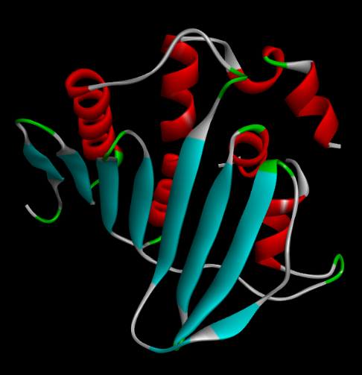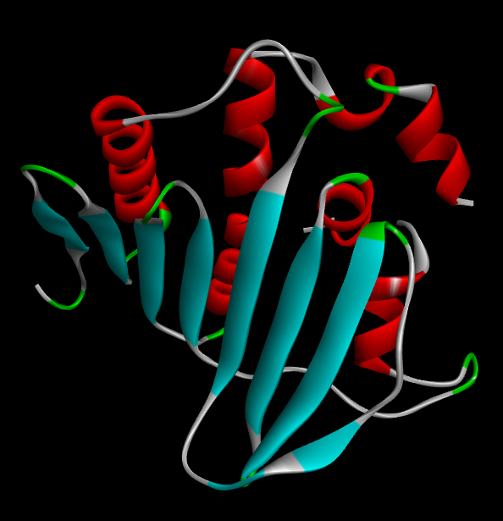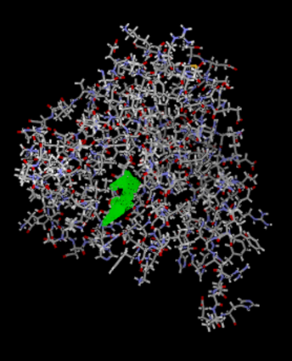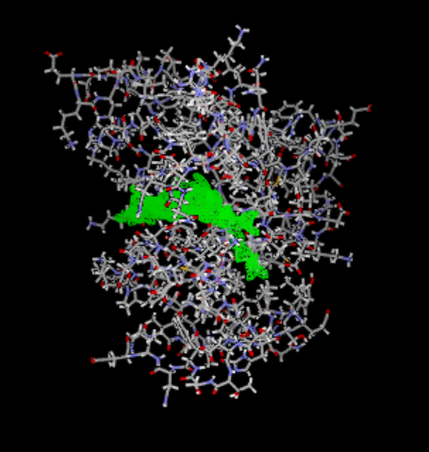
4GGL
3RAE

Figure 9. Three-dimensional structures showing the binding pose and the active site of DNA gyrase B from Enterococcus faecalis (PDB ID: 4GGL) and Streptococcus pneumoniae (PDB ID: 3RAE).

3.3.2 Molecular Docking Result
The molecular docking results provide insight into the potential antibacterial activity of three phytochemicals identified in Jatropha gossypiifolia, namely Lupeol, Gallic acid, and Ellagic acid, against two validated bacterial drug targets[26]. PDB ID 4GGL corresponds to a bacterial enzyme from Enterococcus faecalis, commonly used as a model for DNA gyrase B inhibition, while PDB ID 3RAE represents a topoisomerase-related target from Streptococcus pneumoniae. Both proteins are essential for DNA replication and cell division; therefore, strong ligand binding suggests a capacity to interfere with bacterial growth.Against the 4GGL target, lupeol exhibited the most favorable MolDock score of −168.539 and a rerank score of −110.126kcal/mol, indicating the strongest overall affinity and the formation of a stable protein–ligand complex. Although lupeol did not form conventional hydrogen bonds, its large hydrophobic pentacyclic structure enabled extensive van der Waals and hydrophobic interactions with residues such as Ala, Arg, Asn, Gln, Phe, Pro, and Thr. Ellagic acid also showed substantial binding, with a MolDock score of −120.041kcal/mol and rerank score of −105.142kcal/mol, supported by hydrogen bonding (−5.15 kcal/mol). Gallic acid produced a less negative MolDock score of −81.534kcal/mol, but formed stronger hydrogen-bond interactions (−7.14 kcal/mol), reflecting favorable polar contacts despite its smaller molecular size.A similar trend was observed with the 3RAE target. Lupeol again displayed the strongest binding, with a MolDock score of −166.770kcal/mol and rerank score of −101.909kcal/mol, suggesting a consistently high affinity toward bacterial DNA-processing enzymes. Ellagic acid ranked second, with a MolDock score of −100.487 and the strongest hydrogen-bond contribution (−7.67 kcal/mol), while gallic acid showed a MolDock score of −73.811kcal/mol and hydrogen-bond energy of −7.41 kcal/mol. The interacting residues included Arg, Asn, Asp, Gln, Glu, Gly, His, Lys, Ile, and Phe, indicating that both hydrophobic and electrostatic contacts contributed to ligand stabilization. Lupeol demonstrated the highest binding affinity against both targets, suggesting that it may be the most potent antibacterial constituent among the compounds tested. Ellagic acid also showed strong and balanced interactions, whereas gallic acid exhibited moderate affinity but substantial hydrogen bonding. These findings support the view that the phytochemicals present in Jatropha gossypiifolia may inhibit essential bacterial enzymes and contribute to the antimicrobial properties traditionally associated with this medicinal plant.
Table 12. Molecular docking scores, hydrogen-bond interactions, and binding residues of lupeol, gallic acid, and ellagic acid with DNA gyrase B from Enterococcus faecalis (PDB ID: 4GGL) and a topoisomerase-related protein from Streptococcus pneumoniae (PDB ID: 3RAE).

4GGL
Ligands | MolDock Score kcal/mol | Re-rank Score  kcal/mol | H-bonds | Residues
Lupeol | -168.539 | -110.126 | 0 | Ala, Arg, Asn, Gln, Phe, Pro, Thr
Gallic acid | -81.5338 | -65.3849 | -7.14 | Ala, Arg, Asn, Asp, Gly, His,Pro
Ellagic Acid | -120.041 | -105.142 | -5.15 | Ala, Arg, Asn, Asp, Gly, His,Pro
3RAE
Lupeol | -166.77 | -101.909 | 0 | Arg, Asn, Asp, Gln, Glu, Gly, His
Gallic acid | -73.8109 | -64.4716 | -7.41 | Arg, Gln, Asp, Gly, Lys, Glu, Phe
Ellagic Acid | -100.487 | -86.7461 | -7.67 | Arg, Asn, Ile, Phe, Gly, Asp, Gln

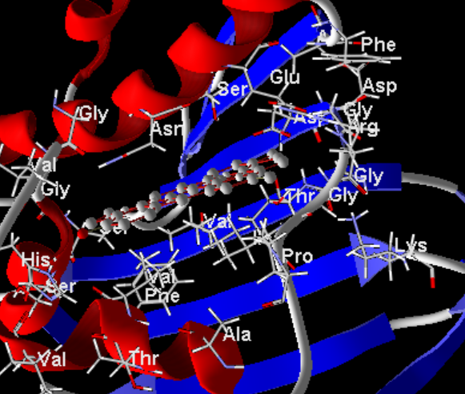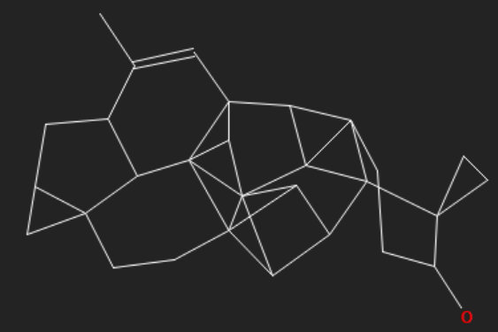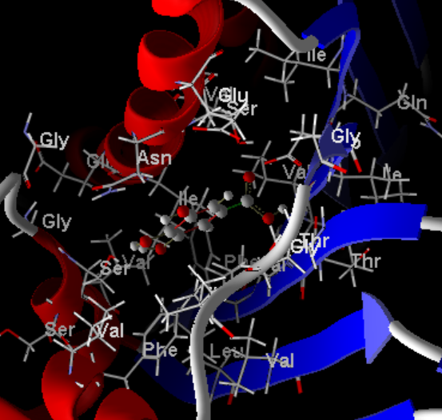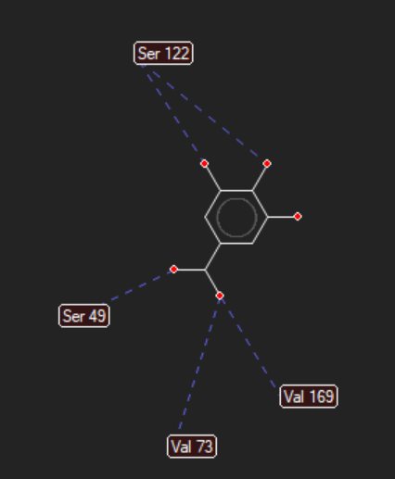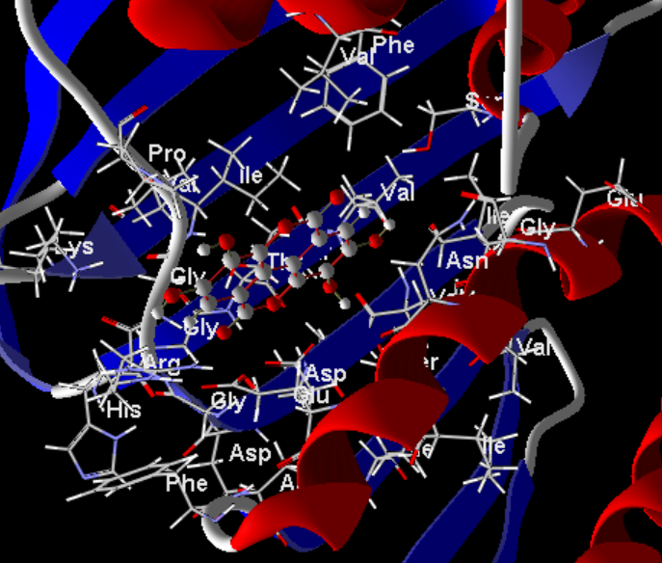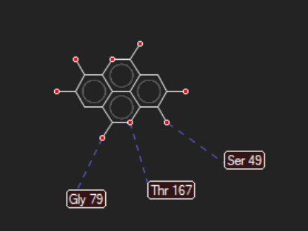
Lupeol
Gallic acid
Ellagic Acid
Figure 10a. Three-dimensional molecular docking visualization of lupeol, Gallic acid and Ellagic acid bound within the active site of DNA gyrase B from Enterococcus faecalis (PDB ID: 4GGL).

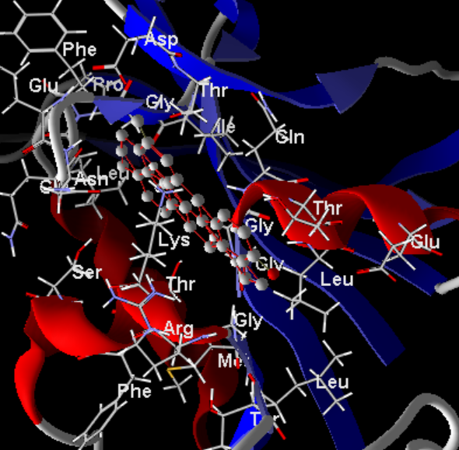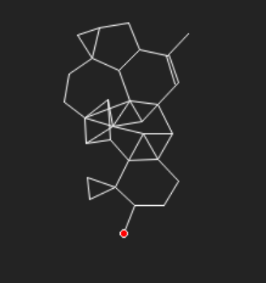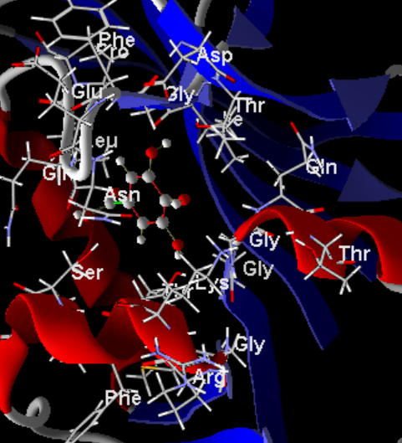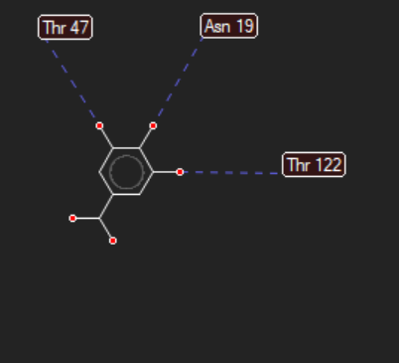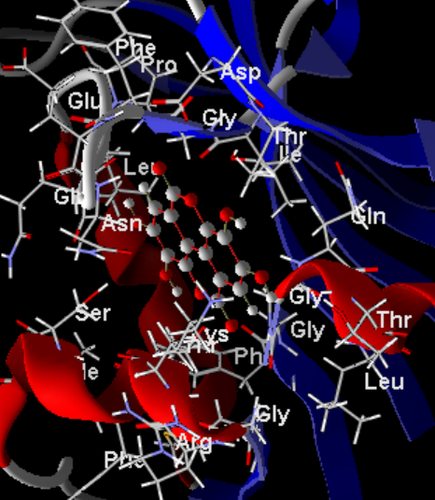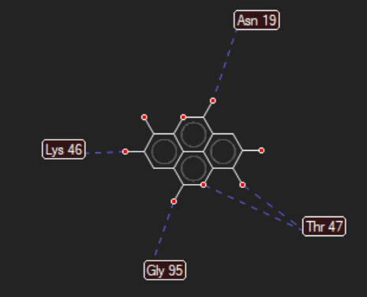
Ellagic Acid
Gallic acid

Lupeol
Figure 10b. Three-dimensional molecular docking visualization of lupeol, Gallic acid and Ellagic acid bound within the active site of DNA gyrase B from Streptococcus pneumoniae (PDB ID: 3RAE).
Conclusion
This study provides a comprehensive evaluation of the chemical composition, antioxidant activity, and molecular docking-based antimicrobial potential of Jatrophagossypiifolia leaf and stem bark extracts. Quantitative phytochemical analysis confirmed that both plant parts contain tannins, phenols, flavonoids, and alkaloids, with the leaf exhibiting higher levels of tannins (0.190), phenols (0.368), and alkaloids (0.050), while the stem bark showed a higher flavonoid content (0.012). Despite the lower total phenolic content, the stem bark demonstrated superior antioxidant activity, with DPPH radical scavenging increasing to 77.03% and a markedly lower IC₅₀ value of 1.5 µL compared with 71.68% and 37.3 µL for the leaf extract. FTIR analysis revealed abundant hydroxyl, carbonyl, aromatic, glycosidic, and nitrile-containing functional groups, confirming the presence of structurally diverse secondary metabolites. Spectral changes observed after DPPH treatment showed increased carbonyl and O–H/N–H absorption bands, indicating that phenolic and glycosidic compounds participate directly in hydrogen atom and electron transfer during radical scavenging. Molecular docking against DNA gyrase B (4GGL) and a topoisomerase-related protein (3RAE) showed that lupeol possessed the strongest binding affinity, with MolDock scores ranging from −166.77kcal/mol to −168.54kcal/mol, followed by ellagic acid and gallic acid. These findings demonstrate that the stem bark is a particularly rich source of potent antioxidant compounds and that the phytochemicals of J. gossypiifolia possess promising antibacterial potential, supporting the traditional medicinal use of this species and its potential application in pharmaceutical and nutraceutical development.

Reference
- Dar, R. A., Shahnawaz, M., Ahanger, M. A., & Majid, I. U. (2023). Exploring the diverse bioactive compounds from medicinal plants: a review. J. Phytopharm, 12(3), 189-195.
- Ahlawat, Y. K., Singh, M., Manorama, K., Lakra, N., Zaid, A., & Zulfiqar, F. (2024). Plant phenolics: neglected secondary metabolites in plant stress tolerance. Brazilian Journal of Botany, 47(3), 703-721.
- Bourais, I., Elmarrkechy, S., Taha, D., Mourabit, Y., Bouyahya, A., El Yadini, M., ... & Iba, N. (2023). A review on medicinal uses, nutritional value, and antimicrobial, antioxidant, anti-inflammatory, antidiabetic, and anticancer potential related to bioactive compounds of J. regia. Food Reviews International, 39(9), 6199-6249.
- Sharma, P., Jha, A. B., Dubey, R. S., & Pessarakli, M. (2012). Reactive oxygen species, oxidative damage, and antioxidative defense mechanism in plants under stressful conditions. Journal of botany, 2012(1), 217037.
- Akbari, B., Baghaei‐Yazdi, N., Bahmaie, M., & Mahdavi Abhari, F. (2022). The role of plant‐derived natural antioxidants in reduction of oxidative stress. BioFactors, 48(3), 611-633.
- Apak, R., Ozyurek, M., Guclu, K., &Çapanoğlu, E. (2016). Antioxidant activity/capacity measurement. 1. Classification, physicochemical principles, mechanisms, and electron transfer (ET)-based assays. Journal of agricultural and food chemistry, 64(5), 997-1027.
- Félix-Silva, J., Giordani, R. B., Silva-Jr, A. A. D., Zucolotto, S. M., & Fernandes-Pedrosa, M. D. F. (2014). Jatropha gossypiifoliaL.(Euphorbiaceae): a review of traditional uses, phytochemistry, pharmacology, and toxicology of this medicinal plant. Evidence‐Based Complementary and Alternative Medicine, 2014(1), 369204.
- Nagori, M., Rajput, D., Choudhary, G., &Khabiya, R. (2025). Qualitative and quantitative methods of phytochemical analysis. Pharmacognosy and Phytochemistry: Principles, Techniques, and Clinical Applications, 143-166.
- Shukla, U. (2025). Fourier transform infrared spectroscopy: A power full method for creating fingerprint of molecules of nanomaterials. Journal of Molecular Structure, 1322, 140454.
- Félix-Silva, J., Giordani, R. B., Silva-Jr, A. A. D., Zucolotto, S. M., & Fernandes-Pedrosa, M. D. F. (2014). Jatropha gossypiifoliaL.(Euphorbiaceae): a review of traditional uses, phytochemistry, pharmacology, and toxicology of this medicinal plant. Evidence‐Based Complementary and Alternative Medicine, 2014(1), 369204.
- Zawawi, N., Chong, P. J., Mohd Tom, N. N., Saiful Anuar, N. S., Mohammad, S. M., Ismail, N., & Jusoh, A. Z. (2021). Establishing relationship between vitamins, total phenolic and total flavonoid content and antioxidant activities in various honey types. Molecules, 26(15), 4399.
- Silveira, R. D. S., Leal, G. C., Molin, T. R. D., Faccin, H., Gobo, L. A., Silveira, G. D. D., ... & Viana, C. (2020). Determination of phenolic and triterpenic compounds in Jatropha gossypiifolia L by Ultra-high performance liquid chromatography-tandem mass spectrometric (UHPLC-MS/MS). Brazilian Journal of Pharmaceutical Sciences, 56, e17262.
- Choi, K. M., Seo, Y. K., Yoon, H. H., Song, K. Y., Kwon, S. Y., Lee, H. S., & Park, J. K. (2008). Effect of ascorbic acid on bone marrow-derived mesenchymal stem cell proliferation and differentiation. Journal of bioscience and bioengineering, 105(6), 586-594.
- Brand-Williams, W., Cuvelier, M. E., & Berset, C. L. W. T. (1995). Use of a free radical method to evaluate antioxidant activity. LWT-Food science and Technology, 28(1), 25-30.
- VO, O., & OE, T. (2025). Comparative Study on The Phytochemical, Antistaphylococcal and Antioxidant Properties of the Stem Bark of Jatropha curcas L and Jatropha gossypifolia L. Sultan Qaboos University Journal for Science, 28(1), 17-24.
- Liu, Y., Li, J. Y., Xu, Y. P., Chen, P., Liu, D., & Chu, X. L. (2026). Comparative and exploratory study of ATR and diffuse reflectance mid-infrared spectroscopy for coal property analysis. Spectrochimica Acta Part A: Molecular and Biomolecular Spectroscopy, 127467.
- Kumar, S. (2008). Spectroscopy of organic compounds.
- He, W. (2011). Biochemical and genetic analyses of Jatropha curcas L. Seed composition (Doctoral dissertation, University of York).
- Chuev, V. P., Nikitchenko, V. M., & Lavrushin, V. F. (1985). The nature of the bands of the electronic absorption spectra of acid solutions of aromatic α, β-unsaturated ketones. Theoretical and Experimental Chemistry, 21(3), 308-314.
- Anzellini, A. (2025). Spectroscopically derived indices for the assessment of natural diagenesis in archaeological bone: a review. Applied Spectroscopy Reviews, 60(4), 337-355.
- Pasieczna-Patkowska, S., Cichy, M., & Flieger, J. (2025). Application of Fourier transform infrared (FTIR) spectroscopy in characterization of green synthesized nanoparticles. Molecules, 30(3), 684.
- Muscolo, A., Mariateresa, O., Giulio, T., & Mariateresa, R. (2024). Oxidative stress: the role of antioxidant phytochemicals in the prevention and treatment of diseases. International journal of molecular sciences, 25(6), 3264.
- Apak, R., Özyürek, M., Güçlü, K., &Çapanoğlu, E. (2016). Antioxidant activity/capacity measurement. 2. Hydrogen atom transfer (HAT)-based, mixed-mode (electron transfer (ET)/HAT), and lipid peroxidation assays. Journal of Agricultural and Food Chemistry, 64(5), 1028-1045.
- Zengin, G., Mahomoodally, M. F., Sinan, K. I., Ak, G., Etienne, O. K., Sharmeen, J. B., ... & Ferrante, C. (2021). Chemical composition and biological properties of two Jatropha species: Different parts and different extraction methods. Antioxidants, 10(5), 792.
- Sanyal, G., & Doig, P. (2012). Bacterial DNA replication enzymes as targets for antibacterial drug discovery. Expert opinion on drug discovery, 7(4), 327-339.
- Aris, P., Mohamadzadeh, M., Zarei, M., & Xia, X. (2024). Computational design of novel griseofulvin derivatives demonstrating potential antibacterial activity: insights from molecular docking and molecular dynamics simulation. International Journal of Molecular Sciences, 25(2), 1039.

