DIVERSITY, THREATS AND CONSERVATION OF CATFISH (ORDER – SILURIFORMES) FROM SUB-BASIN OF WAINGANGA – CHULBANDH RIVER CONFLUENCE AT SONI- CHAPRAL, TALUKA LAKHANDUR, DISTRICT BHANDARA, MAHARASHTRA, INDIA

Abstract:
The present study of catfish was carried out from the Wainganga-Chulbandh River confluence at Soni Chapral, Taluka Lakhandur, District Bhandara, Maharashtra, India. It was conducted to explore the diversity, threats, and conservation status of catfish. The study was conducted from Dec 2024, to Nov 2025. Documented paper deals with the variety, Abundance, threats and conservation status (IUCN) of fish. The study was conducted within a range of 3 km from the confluence on both the upstream and downstream sides. In the present study, 13 species belonging to the Order Siluriformes, with 7 families and 9 genera, were reported. The dominant family among the catfish was Bagridae (46.15%), with 6 species; Siluridae (15.38%), with 2 species; Clariidae (7.69%); Pangasiidae (7.69%); Schilbeidae (7.69%); Sisoridae (7.69%); and Heteropneustidae (7.69%), each with 1 species recorded. (Graph No.1) Among the catfish species found, 9 were common, 1 was occasional, and 3 were Rare. According to the IUCN status, 10 species were in the least concern category, 2 species were in the Vulnerable (VU) category, while 1 species was in the Near threatened (NT) category. The distribution of catfish along the Wainganga-Chulbandh River system may be due to slow, stable state water movement and the width of the river, which ensures the continuous availability of nutrition. It is suggested that the Wainganga-Chulbandh River Confluence would be a suitable habitat for the conservation of freshwater catfish if the threats are diminished.
Keywords: Catfish, Siluriformes, Lakhandur, Bhandara, Chulbandh, Wainganga.
Introduction:
Rivers are nature's gifts to living beings. The Wainganga River is a vital waterway in Bhandara district, which is known as Maharashtra’s largest rice-growing district. Wainganga River (21⁰ 57’ ⁰” N) (79⁰ 34^{’0}” E) emerges at an elevation of 1048 m (3,438 ft.) above mean sea level. Lakhandur town of Bhandara district is situated on the bank of the Chulbandh river. Chulbandh dam is in Gondia district, which was part of the Bhandara district before bifurcation. Both Rivers are boon for the Peoples of Bhandara district. The Chulbandh River meets the Wainganga River at the place Soni, forming a confluence. An ichthyofaunal study conducted by various researchers reported that rivers have high diversity due to their less polluted environment and minimal anthropogenic activities. In India, out of 2500 species, 930 species survive in the freshwater ecosystem. (Jayaram, 1999) The diversity of ichthyofauna is an indicator of a healthy ecosystem (Nikam et al., 2014). Ichthyofaunal diversity of the Wainganga River, Bhandara, reported 51 species belonging to 8 orders and 15 families (Gadekar, 2015). The ichthyofaunal diversity of the Wainganga River around Desaiganj was reported to comprise 28 species belonging to 10 orders, 15 families, and 22 genera. In both studies, Order
Siluriformes reported the second most dominant order after Cypriniformes. Catfish diversity of Pranhita River, Sironcha reported 15 species belonging to the order Siluriformes (Sayyad, et al., 2018).Catfish diversity of the Wainganga River, Armori Taluka sub-basin area reported 13 species belonging to the order Siluriformes (Talmale, et al.,2025)
However, upon reviewing the literature, it is found that researchers have not explored the catfish Diversity, threats, and conservation status of the Wainganga and Chulbandh confluence at Soni Chapral. Therefore, the research has been carried out to create awareness regarding the threats and their conservation.
Materials and Methods:
The study was conducted within a range of 3 km from the confluence on both the upstream and downstream sides of the sub-basin of confluence at Soni-Chapral, Taluka Lakhandur, District- Bhandara, Maharashtra, India. The samples were collected with the help of local fishermen twice a week from the sampling site. Immediate photographs of fish were taken from different angles with a Canon 3000D DSLR camera. The fish were identified based on different standard taxonomic keys given by (Day F. 1988, 1978), (Jayaram K.C. 2002, 1999, 1991), (Talwar P. K.& Jhingran 1991), (Beaven C.R. 1877) & research articles used for the Identification process. The identified 13 fish species are tabulated in the standard format.
Table 1. Fin formula of recorded catfish species from the Wainganga–Chulbandh River confluence.
Sr. No. | Name of Fish | Fin Formula
1. | Mystus vittatus | D. 1/6-7; P. 1/8-9; V. i 5; A. 12-13; C. 17
2. | Mystus Cavasius | D. 1/7; P. 1/8; V. 6; A. 11; C. 19
3. | Mystus tengra | D. I/7; P. I/8; V. i 5; A. ii-iii/9-13; C. 14-19
4. | Rita gogra | D. I/6; P. I/10: V. i 5; A. iii-iv/8-9; C.19
5. | Rita kuturnee | D. I/6; P. I/10; V. 6; A. III/ii 8-9; C. 18
6. | Sperata seenghala | D. I/7; P. I/9; V. 8; A. 11-12; C. 19-21
7. | Ompak bimaculatus | D. 4; P. I/13; V. I/8; A. II-III/58-72; C. 17-18
8. | Wallago attu | D 5; P/13-15; V 8-10; A 77-93; C 18
9. | Clarias batrachus | D. 62-76; P. I/8-11; V. 6; A. 45-58; C. 15-17
10. | Bagarias bagarias | D. I/7; P. I/12; V. 6; A. iii 10-12; C. 17-20
11. | Pangasius pangasius | D. I/6-7; P. I/12-13; V. i 5; A. iv-v/26-29; C. 19
12. | Heteropneustes fossilis | D. 6-7; P. I/6-7; V. 6; A. 60-79; C. 17-19
13. | Clupisoma garua | D. I/7; P. I/9-11; V. I/6; A. iii-iv/27-47; C. 17-20

FIG 1. Study area showing: A. Satellite map of Soni-Chapral confluence; B. Fishing site; C. Soni fish market.
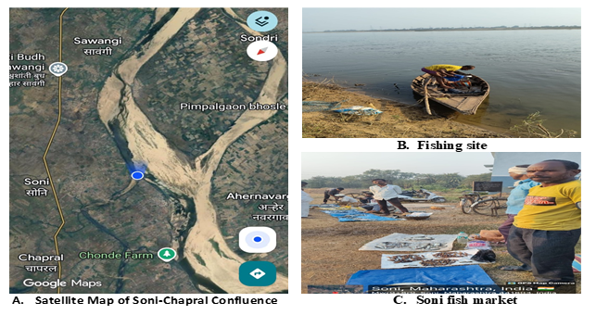
Table 2. Taxonomic details, common names, vernacular names, abundance, and IUCN status of catfish species recorded from the study area.
Sr.No. | Name of order | Name of family | Scientific name | Common Name | Vernacular Name | Abundance | IUCN status
1. | Siluriformes | Bagridae | Mystus vittatus | Striped dwarf catfish | Katwa | Common | LC
2. | Siluriformes | Bagridae | Mystus cavasius | Gangetic mystus | Jala katwa | Common | LC
3. | Siluriformes | Bagridae | Mystus tengara | Tengara | Rignya Katwa | Common | LC
4. | Siluriformes | Bagridae | Rita gogra | Velvet catfish | Ghogar | Common | LC
5. | Siluriformes | Bagridae | Sperata seenghala | Giant river catfish | Singta/Koir | Common | LC
6. | Siluriformes | Bagridae | Rita kuturnee | Deccain rita | Kurud katwa/kuddo | Common | LC
7. | Siluriformes | Sisoridae | Bagarias bagarias | Goonch | Bodh | Rare | VU
8. | Siluriformes | Pungasidae | Pangasius pangasius | Punga | Jarang | Rare | LC
9. | Siluriformes | Clariidae | Clarias batrachus | Walking catfish | Gavthi wagur | Rare | LC
10. | Siluriformes | Schilbeidae | Clupisoma garua | Ghaura | Wayali | Common | LC
11. | Siluriformes | Siluridae | Wallago attu | Helicopter catfish | Shiwada / Sawada | Common | VU
12. | Siluriformes | Siluridae | Ompak bimaculatus | Butter catfish | Waranja | Common | NT
13. | Siluriformes | Heteropneustidae | Heteropneustes fossilis | Stinging catfish | Singr/ingur | Occassional | LC

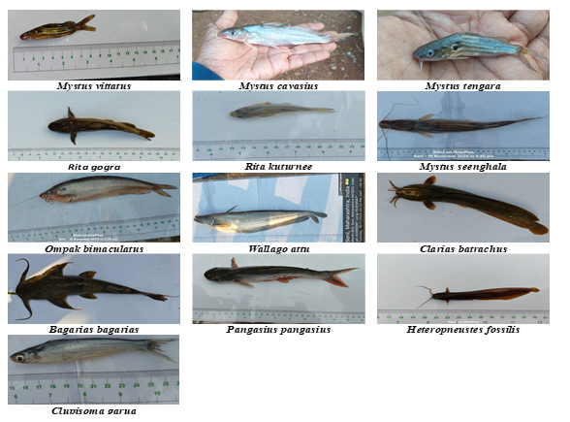

FIG 2. Photoplate showing catfish fauna of the Wainganga–Chulbandh confluence at Soni-Chapral.

FIG 3. Comparative study of species showing IUCN status, local abundance status, and species reported.
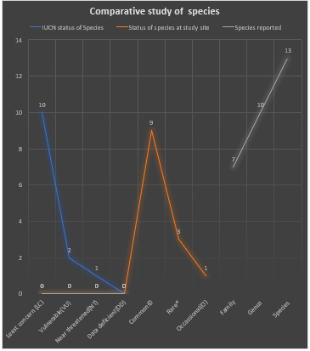

FIG 4. Family-wise distribution of catfish fauna showing number of genera and species in each family.

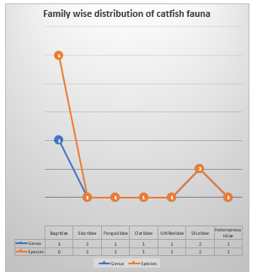

Result and Discussion:
The present study reported 13 species of catfish fauna at the Wainganga-Chulbandh confluence, belonging to the order Siluriformes with 7 families and 9 genera. Bagridae shows dominance among the reported families. 75% of the catfish fauna is commonly reported, whereas about 25% is reported rarely in the study. Wallago attu was reported in all seasons of the study year, whereas bagarias were mostly reported in the winter season. It is also reported that a few illegal practices were done in the study area. Day by day, human dependence on the river is increasing for livelihoods and anthropogenic activities (Kotelat and Whitten, 1996), which are responsible for increasing pollution, leading to a decline in Ichthyofauna. Fishermen capture small fish, which is one of the reasons for the future extinction of fish species from this area(Dudgaon, 2006). (Patra, 2011.) After the construction of Goshikhurd Dam on the Wainganga River, some species like Mystus oar, and “Kuddu’ which was similar in morphology to Glossogobius giurius, were on the way of extinct from this area as they were not even reported during the study period. (Dahanurkar, 2011) and (Sarkar, 2023. In Paddy fields, highly poisonous fertilisers are used, which, in the form of agricultural run-off, mix with river water, may lead to death and decline in ichthyofauna. (Acharjee et al.,2012) Though there is still diversity of rivers at confluence and the basin area is good, if such type of practices continues, they may lead to major loss of ichthyofauna, leading to loss of healthy and wealth of fishermen and living beings.
Species richness and family composition: The record of 13 siluriform species from seven families indicates moderate catfish richness for a localized river-confluence stretch. The numerical dominance of Bagridae in the present material is ecologically plausible because bagrid catfishes are commonly represented in Indian riverine assemblages and have also been reported as dominant or well-represented components in other regional catfish surveys (Patra, 2011; Sarkar, 2023; Talmale et al., 2025).
Comparison with regional river systems: Comparable studies from Indian freshwater systems show that catfish assemblages may vary considerably with channel depth, habitat complexity, submerged vegetation, local water quality, and fishing pressure. For example, the Karala River study recorded seven catfish species and noted uneven distribution across sites, while the Dhansiri River study emphasized the value of baseline documentation for poorly studied river stretches (Acharjee et al., 2012; Patra, 2011). Therefore, the present inventory provides useful baseline information for future monitoring of the Wainganga-Chulbandh confluence.
Confluence habitat interpretation: The occurrence of several common species at the confluence may be associated with heterogeneous hydraulic conditions, mixed habitats, and food availability produced where two channels meet. Recent work on large river confluences suggests that confluence zones can function as important nodes for fish productivity, diversity, and community connectivity when hydrological and habitat conditions remain suitable (Yuan et al., 2023).
Conservation status and local threats: The presence of vulnerable and near-threatened species in the present list, particularly Wallago attu, Bagarius bagarius, and Ompok bimaculatus, indicates that the site has conservation relevance beyond its local fishery value. Freshwater biodiversity is especially sensitive to interacting pressures such as overexploitation, pollution, habitat degradation, and flow modification, and these pressures often act together in river basins used intensively for agriculture and livelihood activities (Dudgeon et al., 2006).
Implications of damming and flow alteration: The observation that some previously known species were not recorded during the study period should be interpreted cautiously because absence in a one-year survey does not alone prove local extinction. However, damming and river regulation are widely reported to alter flow regimes, longitudinal connectivity, sediment transport, channel morphology, and fish habitat availability, all of which can influence native fish richness and assemblage structure (Chen et al., 2023; Cooper et al., 2017; Turgeon et al., 2019).
Agricultural runoff and management needs: The concern regarding agricultural runoff is relevant because freshwater systems receive land-use effluents from surrounding catchments, and pollution can interact with fishing pressure and habitat alteration to reduce ecosystem resilience. Management should therefore prioritize avoidance of destructive fishing methods, restriction of juvenile fish capture, regular monitoring of seasonal fish assemblages, and reduction of untreated agricultural and domestic discharge into the river (Acharjee et al., 2012; Dudgeon et al., 2006; Yuan et al., 2023).

Conclusion
The study recorded 13 species of catfishes belonging to the order Siluriformes from the Wainganga–Chulbandh River confluence at Soni-Chapral, District Bhandara, Maharashtra. These species represented 9 genera and 7 families, with Bagridae emerging as the dominant family. Most recorded species were locally common, while a few species were observed rarely or occasionally during the study period. The presence of species categorized as Vulnerable and Near Threatened highlights the ecological and conservation value of the confluence habitat. The study suggests that the confluence zone provides suitable habitat conditions for several catfish species, possibly due to water availability, habitat heterogeneity, and food resources. However, fishing pressure, capture of small fishes, agricultural runoff, habitat disturbance, and flow modification may affect the long-term persistence of native catfish diversity. Regular monitoring, awareness among local fishers, control of destructive fishing practices, and protection of riverine habitats are recommended for sustainable conservation of catfish fauna in the study area.

Limitation
This study was limited to one river-confluence stretch and one annual sampling period from December 2024 to November 2025. The classification of species as common, occasional, or rare was not supported by detailed quantitative catch-per-unit-effort data. Water-quality parameters, habitat variables, fishing intensity, and pollution load were not measured systematically. Some threats, including dam effects and agricultural runoff, were discussed descriptively rather than tested statistically. Species identification was based on morphology only, without molecular confirmation. Future studies should include seasonal abundance data, standardized sampling effort, water-quality assessment, habitat mapping, and long-term monitoring.
Declaration of AI Use

This manuscript was prepared through the combined contributions of all author(s), including contributions to the study design, data, content development, results, interpretation, and related scholarly work. The author(s) acknowledge the use of Grammarly and ChatGPT to assist with grammar checking, language refinement, reference formatting. These AI-assisted tools were not used as authors and did not replace the intellectual contributions or scholarly judgment of the author(s). All AI-assisted outputs, including content, references, and interpretations, were carefully reviewed, revised, verified, and approved by the author(s). The author(s) accept full responsibility for the accuracy, integrity, and final content of the manuscript.

Ethics Declaration: This is my original work which has not been published elsewhere and has not been submitted for publication anywhere else.
Disclaimer (Artifical Inteligence)
Author(s) hereby declares that NO generative AI technologies such as Large Language Models (ChatGPT, COPILOT, etc.) and text-to-image generators have been used during writing or editing of this manuscript.

COMPETING INTERESTS DISCLAIMER:
Authors have declared that they have no known competing financial interests OR non-financial interests OR personal relationships that could have appeared to influence the work reported in this paper.

References:
Acharjee, B. K., Das, M., Borah, P., & Purkayastha, J. (2012). Ichthyofaunal diversity of Dhansiri River, Dimapur, Nagaland, India. Check List, 8(6), 1163-1165. https://doi.org/10.15560/8.6.1163
Beavan, R. C. (1877). Handbook of the freshwater fishes of India: Giving the characteristic peculiarities of all the species at present known, and intended as a guide to students and district officers. L. Reeve & Co. https://doi.org/10.5962/bhl.title.5073
Chen, Q., Li, Q., Lin, Y., Zhang, J., Xia, J., Ni, J., Cooke, S. J., Best, J., He, S., Feng, T., Chen, Y., Tonina, D., Benjankar, R., Birk, S., Fleischmann, A. S., Yan, H., & Tang, L. (2023). River damming impacts on fish habitat and associated conservation measures. Reviews of Geophysics, 61(4), e2023RG000819. https://doi.org/10.1029/2023RG000819
Cooper, A. R., Infante, D. M., Daniel, W. M., Wehrly, K. E., Wang, L., & Brenden, T. O. (2017). Assessment of dam effects on streams and fish assemblages of the conterminous USA. Science of the Total Environment, 586, 879-889. https://doi.org/10.1016/j.scitotenv.2017.02.067
Dahanukar, N. (2011). Glyptothorax poonaensis. The IUCN Red List of Threatened Species 2011. https://www.iucnredlist.org
Day, F. (1878). The fishes of India; being a natural history of the fishes known to inhabit the seas and fresh waters of India, Burma, and Ceylon. William Dawson. https://doi.org/10.5962/bhl.title.62705
Dorlikar, A. V., & Thengare, M. R. (2022). Studies on fish diversity of Wainganga River around the Desaiganj region, District Gadchiroli, Maharashtra. Kornika Journal, 4(1), 19-22. https://www.entomologyjournals.com/assets/archives/2023/vol8issue9/8129-1694779461410.pdf
Dudgeon, D., Arthington, A. H., Gessner, M. O., Kawabata, Z. I., Knowler, D. J., Leveque, C., Naiman, R. J., Prieur-Richard, A. H., Soto, D., Stiassny, M. L. J., & Sullivan, C. A. (2006). Freshwater biodiversity: Importance, threats, status and conservation challenges. Biological Reviews, 81(2), 163-182. https://doi.org/10.1017/S1464793105006950
Gadekar, G. P. (2015). Ichthyofaunal diversity of Wainganga River, District Bhandara, Maharashtra, India. International Journal of Researches in Biosciences, Agriculture and Technology, 4(1), 19-22. https://www.scholarsresearchlibrary.com/articles/ichthyofaunal-diversity-of-wainganga-river-dist-bhandara-maharashtra-india.pdf
Jayaram, K. C. (1999). The freshwater fishes of the Indian region. Narendra Publishing House. https://books.google.com/books?id=hJAWAQAAIAAJ
Kar, D., Kumar, C., Bohra, C., & Singh, L. K. (Eds.). (2003). Fishes of Barak drainage, Mizoram and Tripura. In Environment, pollution and management (pp. 203-211). APH Publishing Corporation. https://books.google.com
Kottelat, M., & Whitten, T. (1996). Freshwater biodiversity in Asia with special reference to fish. World Bank Technical Paper No. 343. World Bank. https://documents.worldbank.org/en/publication/documents-reports/documentdetail/406791468770639011
Nikam, D. S., Shaikh, A. L., Sulunkhe, P. S., Kamble, A. B., & Rao, K. R. (2014). Ichthyofaunal diversity of Ashti Lake, Taluka Mohol, District Solapur, Maharashtra. International Global Journal for Research Analysis, 3(12). https://www.worldwidejournals.com/global-journal-for-research-analysis-GJRA/
Patra, A. K. (2011). Catfish (Teleostei: Siluriformes) diversity in Karala River of Jalpaiguri District, West Bengal, India. Journal of Threatened Taxa, 3(3), 1610-1614. https://doi.org/10.11609/JoTT.o2474.1610-4
Sarkar, T. (2023). Catfish diversity and conservation status in the River Teesta, West Bengal, India. International Journal of Ecology and Environmental Sciences, 49(3), 282-287. https://nieindia.org/Journal/index.php/ijees/article/view/2634
Sayyad, N., & Dhamani, A. (2018). Catfish fauna (Order: Siluriformes) diversity of Pranhita River sub-basin at Sironcha, Gadchiroli District, Maharashtra, India. International Journal of Life Sciences, A12, 235-239. https://www.ijlsci.in/
Talmale, A. D., Bansod, D. S., Chaudhari, S. S., & Wadpalliwar, G. (2025). Diversity, threats, and conservation of catfish (Order Siluriformes) from the sub-basin of the Wainganga River near Armori, District Gadchiroli, Maharashtra, India. The Bioscan, 20(2), 182-188. https://thebioscan.com/
Talwar, P. K., & Jhingran, A. G. (1991). Inland fishes of India and adjacent countries (Vol. 2). Oxford & IBH Publishing. https://books.google.com/books?id=Cr5PPgAACAAJ
Turgeon, K., Turpin, C., & Gregory-Eaves, I. (2019). Dams have varying impacts on fish communities across latitudes: A quantitative synthesis. Ecology Letters, 22(9), 1501-1516. https://doi.org/10.1111/ele.13283
Yuan, S., Qiu, J., Tang, H., Xu, L., Xiao, Y., Liu, M., Rennie, C., & Gualtieri, C. (2023). Fish community traits near a large confluence: Implications for its nodal effects in the river ecosystem. Journal of Hydrology, 626, 130335. https://doi.org/10.1016/j.jhydrol.2023.130335

