Towards a Sustainable Art Ecosystem: How Immersion in XR Virtual Exhibitions Shapes Purchase Intentions
Abstract: (1) Objective: This study explores how immersive augmented reality (XR) virtual art exhibitions affect the willingness of Chinese university students to purchase art. Based on the Technology Acceptance Model (TAM), this study investigates the role of perceived usefulness, perceived ease of use, and immersion (flow experience) in shaping purchase intention in XR based art commercial environments. (2) Method: A survey experiment was conducted, inviting 300 Chinese university students to visit a VR art exhibition and answering a questionnaire measuring TAM structure, immersion, and purchase intention. Use structural equation modeling (SEM) to analyze the data. (3) Result: The results indicate that immersion in virtual exhibitions significantly enhances perceived usefulness and indirectly increases purchase intention. Perceived usefulness and ease of use both positively predict the willingness to purchase art, with perceived usefulness becoming a strong mediating variable. The TAM framework has received great support in the XR art environment: usability and usefulness together explain 64% of the difference in purchase intention. (4) Inspiration: Research findings indicate that higher immersion in virtual art exhibitions can enhance consumer engagement and purchase intention. Art retailers and platforms should invest in user-friendly immersive XR experiences to boost art sales. This study explores how e-commerce strategies in the art market utilize XR technology and outlines the theoretical contributions of TAM research in immersive environments. (5) Originality: This study is one of the empirical research conducted on Chinese university students in the art commercial XR environment, providing evidence on how virtual exhibition immersion drives art purchase intention. This article provides insights for practitioners who integrate XR technology into art marketing and helps to understand the acceptance of technology by emerging digital art platforms.
Keywords: Sustainable Art Ecosystem; purchase intention; extended reality (XR); virtual exhibitions; green transition in cultural industries

1. Introduction
The integration of augmented reality technology and online art commerce is changing the way consumers experience and purchase art. After the outbreak of the COVID-19, many galleries and museums turned to virtual exhibitions as an innovative way to attract audiences when physical visits were limited. Therefore, VR art exhibitions have emerged as a popular form, providing people with experiences beyond the limitations of physical galleries and new ways to interact with art (Cheng, 2024). By overcoming geographical and accessibility barriers, virtual exhibitions can greatly expand the influence of art exhibitions (Cheng, 2024). These trends are consistent with the widespread development of e-commerce: retailers from various industries are deploying XR (covering virtual reality, augmented reality, and mixed reality) technology to create immersive digital storefronts. In the field of e-commerce, XR can provide consumers with a realistic 3D experience, simulating offline shopping, such as appreciating art in a virtual gallery or "placing" a sculpture at home in the virtual world (Chen, 2024). This so-called 'cross business' model utilizes immersion to provide online customers with an experience similar to visiting a physical art gallery, which may reduce the uncertainty of online art purchases.
The background of the Chinese art market provides a convincing context for studying the application of XR in art commerce. The Chinese art market has developed into one of the largest art markets in the world, accounting for 17% of global art sales in 2022 (Mei, 2024). Young Chinese consumers, especially college students and recent graduates, represent a group of tech savvy individuals who are increasingly exposed to digital content and have the potential to become the next generation of art buyers. Chinese college students have a high exposure to emerging technologies and online shopping, making them an ideal group for assessing the acceptance of virtual art purchase platforms. However, there is a knowledge gap regarding how these young consumers perceive immersive virtual exhibitions and whether this experience will translate into specific art purchase intentions. Understanding this is crucial for e-commerce strategies (as art companies explore online sales channels) and advancing XR technology design to better serve the art market.
The Technology Acceptance Model (TAM) provides a practical theoretical perspective for exploring these issues. TAM believes that users' adoption of new technologies is mainly driven by two beliefs: perceived ease of use (PEOU) - the ease of using the technology; And perceived usefulness (PU) - the degree to which the use of this technology enhances individual performance or brings benefits (Ren, 2022). These beliefs can affect attitudes and usage intentions. TAM is renowned for its simplicity and robustness, and has been widely applied in studying the acceptance of innovative systems (Ren, 2022). In the context of online shopping and XR, previous studies have confirmed that TAM structure can affect consumer reactions. For example, research on augmented reality shopping has found that consumers' perception of the ease and practicality of AR applications positively influences their satisfaction and willingness to use the technology (Chen, 2024). Similarly, the fun or entertainment brought by immersive technology can enhance its informational value, thereby increasing product evaluations and purchase intentions in VR shopping. These insights suggest that TAM can be expanded through experiential factors such as enjoyment or immersion, thereby better predicting outcomes such as purchase intention in rich, interactive environments.
Among the experiential factors, immersion - often described as the feeling of being "there" in a virtual environment - is particularly important for virtual art exhibitions. Immersion is closely related to the concepts of "flow" or "presence", which capture the level of user engagement and immersion in digital experiences. A high degree of immersion can make the visual experience of virtual exhibitions comparable to visiting physical galleries, thereby enhancing users' confidence in online evaluation and purchasing art. Recent research has emphasized the role of immersion in technology acceptance: in virtual museum visits, higher immersion and presence have been shown to enhance users' perceived enjoyment, usability, and practicality of the platform, ultimately increasing their willingness to continue using virtual exhibitions or even personally visit museums (Li, 2024). In other words, immersive XR experience can enhance the perceived value of this technology. Similarly, flow experience (a state of deep engagement) has been found to enhance the predictive ability of TAM. For example, Ren et al. (Ren, 2022) extended flow to TAM in the metaverse learning context for Chinese university students and found that perceived ease of use, flow, and practicality were important predictors of behavioral intention to use the technology (Ren, 2022). This indicates that, in addition to standard TAM factors, psychological immersion in XR environments plays a crucial role in shaping user intent, especially for those accustomed to digital interaction.
In the field of art commerce, there are few empirical studies that directly examine how these potential market factors interact with immersion and influence purchasing decisions. To fill this gap, this study focuses on virtual art exhibitions based on augmented reality (XR) as a new medium for art sales, and explores how the immersion of such exhibitions affects the willingness of Chinese university students to purchase art. This study integrates immersion into the framework of potential market factors: immersive exhibitions may enhance the perceived practicality of the platform (such as more effectively conveying art details), and may make the system more convenient or enjoyable to use, thereby increasing consumers' willingness to purchase art through the platform. This study also considered the direct impact of immersion on purchase intention, as highly engaging experiences may directly stimulate consumers' desire to purchase by establishing emotional connections with artworks.
- Research Objective
Research objective: This study aims to: (1) measure the immersion experience of users in XR art exhibitions and its impact on the perceived usefulness and usability of the system; (2) Evaluate how these TAM structures in turn affect the purchase intention of viewing artworks in virtual exhibitions; (3) Evaluate the overall feasibility of TAM (and its extensions) in explaining technology acceptance and purchasing behavior in the context of immersive art commerce. The target audience is Chinese university students, which enables this study to gain a deeper understanding of the key user groups in the Chinese digital art market. By focusing on this population, this study also responds to the call to examine technology acceptance in different cultural backgrounds and among young digital native consumers.
In order to construct the research of this study, a TAM based research model was proposed, with immersion as an additional factor. Figure 1 shows the conceptual framework applicable to this study. Consistent with previous research (Wang, 2024), this study hypothesizes that the perceived ease of use (PEOU) of virtual exhibitions will have a positive impact on perceived usefulness (PU), and both will have a positive impact on the willingness to purchase art (consistent with TAM). This study further hypothesizes that immersion in XR exhibitions has a positive impact on PEOU and PU. These relationships reflect the idea that more immersive virtual exhibitions make the system feel easier to use and more valuable. Finally, this study explores the direct impact of immersion on purchase intention. The following chapters provide a detailed introduction to the method of testing the model, present empirical results, and discuss its impact on e-commerce and XR technology in the art market.
- Literature Review

3.1 XR Virtual Exhibition and Art Commerce
The digital transformation has greatly influenced the marketing and sales methods of art. The emergence of high fidelity virtual environments enables galleries and artists to showcase their works online in interactive ways that traditional two-dimensional web pages cannot achieve. VR or AR virtual art exhibitions allow users to navigate through gallery spaces, view artworks from multiple angles, and sometimes interact with them (such as zooming in on details or viewing background information). Compared to viewing static images on e-commerce websites, this creates a richer sense of presence. Research has shown that major museums and art galleries have regarded VR exhibitions as a sustainable way of online art display(Cheng, 2024). By using VR platforms, exhibitions can break through physical limitations of location and space, attract new global audiences, and provide 24/7 access(Cheng, 2024). In the field of commercial art, these technologies have brought opportunities for online art sales. During the COVID-19, with auction houses and art fairs turning to online forms, online art sales share soared. Although offline activities have resumed, online channels remain crucial; For example, in 2022, online art sales accounted for 16% of the art market value (lower than the peak of 25% in 2020, but still a considerable proportion) [6]. This indicates that as long as the online experience is eye-catching, a considerable number of art buyers are willing to purchase art remotely.
XR technology - augmented reality (AR) and virtual reality (VR) - enhances the online art shopping experience by introducing immersion and interactivity. AR in art commerce usually appears in the form of mobile applications, allowing users to virtually "preview" art in their own space (for example, using smartphones to overlay paintings on walls). VR typically provides a fully simulated gallery or museum environment. Both methods aim to narrow the gap between physical art experiences and online art experiences. Previous research in the fields of tourism and cultural heritage has found that AR and VR can positively influence tourists' engagement and even affect their willingness to purchase related products. For example, research has found that the aesthetic quality of AR exhibits significantly affects visitors' satisfaction with the museum experience and their willingness to purchase museum merchandise(He, 2018). Similarly, virtual tours of cultural heritage sites have been proven to stimulate people's interest in purchasing local products or personally visiting the destination[8]. These findings emphasize the potential of immersive media not only to drive engagement, but also to drive commercial outcomes in art related environments.
Despite these advances, there are still challenges in transforming virtual exhibition visits into actual art purchases. High end art is an experiential commodity - buyers usually want to see the texture, proportion, and true colors of the work, and they value the atmosphere of the gallery or personal interaction with the dealer. XR exhibitions must compensate for these aspects through technological means such as high-resolution images, realistic rendering, or interactive storytelling about artworks. A key factor is how users perceive the XR platform: do they feel it helps evaluate artworks and is easy to navigate? If the virtual exhibition interface is clumsy or the experience lacks persuasiveness, users may lose interest, thereby reducing their willingness to purchase. Therefore, applying frameworks such as TAM to this context can reveal the driving factors behind users' acceptance of virtual art galleries, as well as the correlation between acceptance and purchase intention.

3.2 Technology Acceptance Model (TAM) in XR Environment
The Technology Acceptance Model (TAM) is a fundamental model in information systems used to explain and predict user adoption of new technologies. The core of TAM lies in proposing two main factors that determine users' willingness to use a certain technology behavior: perceived ease of use (PEOU) and perceived usefulness (PU) (Ren, 2022). PEOU refers to the user's perception of the ease of using the system, while PU refers to the degree to which the user believes the system is helpful in achieving their goals (in this case study, effectively browsing and selecting artworks). According to TAM's research, if a virtual exhibition platform is easy to use, users are more likely to use it; If it is also practical (such as providing value through simulating gallery experiences or assisting decision-making), users will have a higher willingness to use it and continue to use it (Ren, 2022). TAM further indicates that PEOU can indirectly influence user intent through PU: systems that are easier to use are generally considered more useful. The simplicity and strong empirical support of TAM have enabled its application in numerous fields, including e-commerce and new media technology.
In XR research, TAM has been expanded to include more structures that can capture the richness of immersive experiences. Many studies have found that the classic TAM relationship still holds, while also highlighting new factors. For example, in virtual environment research, interactivity and presence are often taken into consideration. Previous studies have shown that in AR shopping applications, PEOU and PU have a correlation with user satisfaction and the use of AR technology (Chen, 2024), verifying the correlation between TAM. Meanwhile, variables such as perceived pleasure or interest have been added as predictive factors for adoption, as immersive technologies often blur the boundary between utility and entertainment. Kang et al. demonstrated that the entertainment value of 3D VR stores enhances their perceived information content, thereby increasing consumers' product evaluations and online purchase intentions (Chen, 2024). This means that a pleasant and engaging XR experience can enhance the platform's perceived utility in purchasing decisions.
Immersion (or flow experience) is another key factor in XR acceptance. Immersion can be defined as the degree to which technology brings users into a comprehensive experience. In the context of virtual art exhibitions, immersion may include a sense of immersion, as if one is in a gallery space, forgetting the real environment, and emotionally connected to the exhibited artwork. Recent studies have shown that immersion can affect core TAM beliefs. A case study of an online VR museum exhibition in 2024 found that interactivity, immersion, and presence have a positive impact on users' intrinsic beliefs - specifically, they enhance users' perception of the usability, fun, and practicality of VR systems (Li, 2024). These enhanced beliefs have further increased users' willingness to use virtual exhibitions, and even increased their on-site presence. It is worth noting that in this study, immersion had a direct positive impact on the perceived usefulness of virtual exhibitions (Li, 2024). This direct connection suggests that when users feel deeply immersed, they may consider the technology more valuable for its intended use (such as understanding or evaluating art), perhaps because immersion can provide richer information background and emotional resonance.
The concept of immersion and its closely related "flow" has also been studied in the e-commerce environment involving XR. Wang et al.(2024)studied the application of AR technology in cultural heritage product shopping by combining TAM and flow theory. They found that perceived usefulness, perceived ease of use, and flow experience significantly enhanced consumers' willingness to purchase the product. In their model, usability not only directly increases purchase intention, but also amplifies the impact of practicality and traffic on intention(Wang, 2024). In addition, the immersive, interactive, and aesthetic aspects of AR experience have a positive contribution to perceived usability and fluency. Immersive experiences significantly enhance perceived practicality. These findings (summarized in Figure 1) are consistent with the following viewpoint: well-designed immersive experiences can make e-commerce platforms easier to use and more practical, thereby increasing transaction willingness. Another study on the use of AR by Chinese consumers in online shopping (Guo, 2024) also reported that AR experience factors affect TAM structure, which in turn affects purchase intention, confirming the applicability of TAM in the metaverse e-commerce environment.
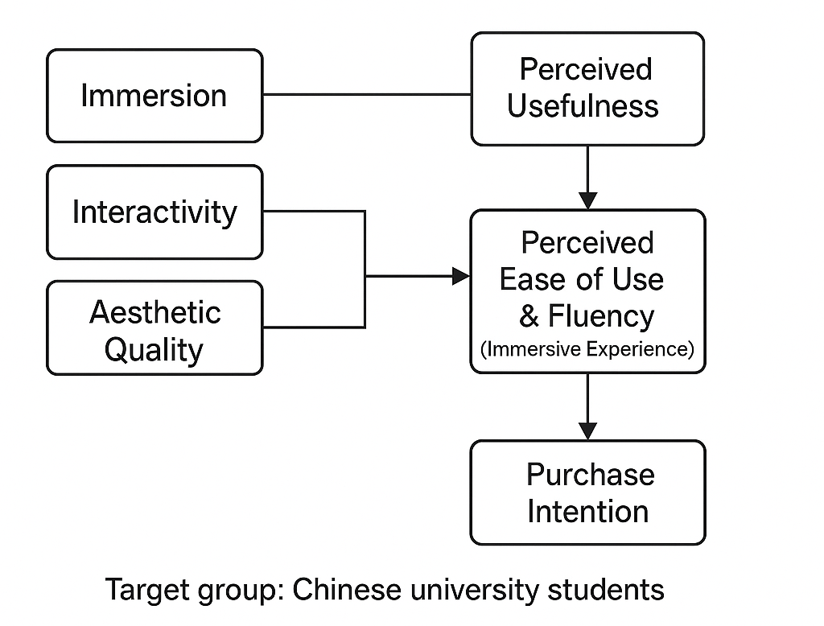
Figure 1. Conceptual Model: XR Immersion and TAM for Virtual Art Purchase
Figure 1 The conceptual model illustrates how XR immersion and TAM factors affect consumer purchase intention (adapted from previous TAM and process based models). Immersion, interactivity, and aesthetic quality are believed to enhance the perceived ease of use and fluency (user's immersive experience), which, along with the perceived usefulness, can predict the willingness to purchase art in virtual exhibitions.
Based on these literature, the conceptual framework of this study (Figure 1) suggests that immersive virtual art exhibitions will positively influence users' perception of usability and practicality, thereby driving their willingness to purchase art. This study is based on previous research findings and focuses on the commercial field of art (rather than general product shopping or education), and examines a specific user group (Chinese university students). Integrating immersive experiences into the TAM model enables this study to capture the crucial experiential factors involved in virtual art participation. The next section will outline the methods used to empirically test the model.
- Methodology

4.1 Research Design and Participants
This study adopted a survey based quantitative research design, involving experimental simulations of virtual art exhibitions. The target audience is Chinese college students, chosen for their familiarity with digital technology and potential to become art consumers in the future. The participants come from two comprehensive universities in Shandong. A total of 320 students volunteered to participate, and after data cleaning to ensure integrity and attention checks, 300 valid responses were retained for analysis. The demographic data of the sample is quite balanced: 54% are female and 46% are male. The age ranges from 18 to 25 years old (average ≈ 21.4 years old). Most participants (>90%) have online shopping experience, with approximately 30% having previously used some form of VR or AR application. However, no one has extensive experience in virtual art exhibitions to ensure that experimental scenes are novel and within their operability range.

4.2 Program
The participants first listened to the research brief and obtained informed consent. To ensure consistency in the XR experience, the experiment was conducted in a controlled experimental environment. Each participant is equipped with a pair of VR glasses (Oculus Quest 2), and guided to launch a customized virtual art gallery application. For participants who are not accustomed to using VR devices, a desktop version of the virtual gallery can be used; About 20% of people choose desktop 3D environments.) The virtual exhibition showcases 15 paintings and sculptures by contemporary artists arranged in a realistic 3D gallery space. Participants can freely use the controller navigation or keyboard input to "walk" around the gallery, observe artworks up close, and read the accompanying instructions. The environment includes spatial audio (ambient music and audio description) to enhance immersion. Each class lasts for about 10 minutes, ensuring that everyone has enough time to explore all the exhibited works.
After visiting the virtual exhibition, participants remove their VR devices and immediately fill out the questionnaire. In order to collect raw data on their perceptions and intentions, this study developed a survey tool that includes multiple scales for each concept in the research model. Participants used a 7-point Likert scale (1="strongly disagree" to 7="strongly agree") to assess their level of agreement with each statement.

4.3 Measures
The survey project is adapted from the validated scales in previous TAM and VR studies, and the wording has been adjusted according to the context of virtual art exhibitions. Perceived ease of use (PEOU) is measured by four items (e.g. "Browsing virtual exhibitions is easy for me"), adapted from Davis' (1989) TAM tool and its research in virtual environments (Ren, 2022). Perceived usefulness (PU) is measured using four items (such as "using this virtual exhibition is useful for evaluating the artworks I may purchase"), also based on the TAM scale (Ren, 2022). But tailored to the purchase of art (for example, practicality covers how virtual experiences effectively convey the details of art and assist decision-making). Immersion is measured through three items that capture the user's presence and focus (e.g., 'When using a virtual exhibition, I feel like I'm really in an art museum'). These projects drew inspiration from flow and presence questionnaires used in VR research, such as the Igroup Presence Questionnaire (IPQ) and flow scales, to ensure that they reflect cognitive and emotional immersion. This study also included a project on the perceived aesthetic quality of virtual environments ("Virtual Gallery Beautiful and Realistic"), as there is evidence to suggest that visual quality can affect user experience in AR/VR(He, 2018). This is considered as part of the overall immersive experience, or can be analyzed as a separate predictive factor as needed (in this study, after confirming high correlation, for simplicity, it is combined with immersive construction).
The key outcome variable "purchase intention" is measured through three items developed for this background: "I will consider purchasing the artwork I see in this virtual exhibition," "The virtual exhibition increases my interest in purchasing artwork," and "After experiencing this virtual gallery, I am likely to purchase artwork (now or in the future)." These items are consistent with common behavioral intention measurement standards in marketing (applicable to art purchase scenarios). Finally, the survey collected some control variables: previous familiarity with VR (self-reported experience level) and interest in art (whether participants often visit museums or art websites). These are used to check if control is needed in the analysis.

4.4 Data Analysis Methods
This study used structural equation modeling (SEM) method to test the relationship between hypotheses. The analysis is conducted in two stages: (1) measurement model evaluation and (2) structural model evaluation. For the measurement model, this study conducted confirmatory factor analysis (CFA) to validate the reliability and validity of constructs (PEOU, PU, immersion, purchase intention). Cronbach's alpha values and composite reliability (CR) were calculated for each multiple item scale to evaluate internal consistency. All constructs have Cronbach's alpha values above 0.85 and CR values above 0.88, exceeding the commonly accepted reliability threshold of 0.70. Due to the significant and mostly higher than 0.75 loadings on the expected constructs of all projects, convergent validity is supported. The average extracted variance (AVE) of each construct ranges from 0.65 to 0.78, indicating that over 50% of the variance in the project can be explained by the construct, meeting the criteria for convergent validity. This study also used the Fornell Larcker criterion to test discriminant validity: the square root of AVE for each construct is greater than its correlation with other constructs, indicating that each construct is different. Table 1 presents descriptive statistical data and correlations for each variable (with the square root of AVE on the diagonal), confirming acceptable measurement characteristics (Table 1 will be discussed in the "Results" section below).
For the structural model (testing hypothesis path), this study used the SEM software AMOS (v26) with maximum likelihood estimation. Given the sample size of this study (N=320), the model was identified and the estimation proceeded smoothly. This study reports on the standardized path coefficient (β) and its significance based on t-values (or critical ratios). Use multiple fitting indices to evaluate model fit: chi square/degrees of freedom, comparative fitting index (CFI), Tucker Lewis index (TLI), and approximate root mean square error (RMSEA). The initial model fit was good (χ ²/df=2.3, CFI=0.964, TLI=0.952, RMSEA=0.064), indicating that the assumed model structure is consistent with the data. This study also tested another model, which included a direct pathway from immersion to perceived purchase intention, to see if immersion had a non mediating effect on the results. This addition did not significantly improve the model fit, and the direct path was also not significant, which will be discussed later. Therefore, the final model emphasizes the mediating path (immersion → TAM structure → intention).
- Data Analysis

5.1 Descriptive Statistics
The overall response of participants to the virtual exhibition is positive. In a 7-point scale, the average immersion score is 5.9 (standard deviation=0.9), indicating that most people feel very engaged and "immersed" in VR galleries. Many people informally comment that watching art in VR feels novel and interesting. The average perceived ease of use is 6.2 points (standard deviation=0.8), indicating that most people consider the system easy to operate - possibly due to brief training and intuitive control. The average value of perceived practicality is slightly lower, at 5.5 points (standard deviation=1.0); Although students enjoy this experience, there are also a few who are unsure if it can completely replace watching artworks with their own eyes, which is reflected in slightly lower practicality ratings. It is worth noting that the average purchase intention score is 5.3 points (standard deviation=1.1) - considering that purchasing art may be a significant financial decision, this is a good level in the agreement scale. This indicates that after virtual visits, people's willingness to consider purchasing art has generally increased.
The correlation between the main concepts is as expected and significant (p<0.01). Immersion is closely related to perceived usefulness (r ≈ 0.60) and usability (r ≈ 0.45). Usability and usefulness are highly correlated (r ≈ 0.65), which is consistent with the TAM theory that simpler systems are often considered more useful. Both PEOU and PU showed significant correlation with purchase intention (r ≈ 0.55-0.68). Immersion is also related to purchase intention (r ≈ 0.50), suggesting that a more immersive experience may lead to a higher purchasing tendency. These correlations provide preliminary support for the model of this study, although the causal relationship direction needs to be tested using SEM.

5.2 Hypothesis Test Results
The structural model results are summarized in Table 1 and illustrated in Figure 2. Overall, the data supports the assumptions made by the TAM+immersion framework:
H1： Immersion → Perceived ease of use. The path is positive and significant (β=0.43, p<0.001). Participants with stronger immersion tend to believe that virtual exhibitions are easier to use. A reasonable explanation is that a well-designed immersive environment (with intuitive interaction) can create a flow state that allows users to operate the system smoothly, making it feel effortless. This finding is consistent with previous research, indicating that immersive design elements can improve usability perception(Wang, 2024) (Li, 2024).
H2: Immersion → Perceived usefulness. Immersion also has a significant positive impact on perceived usefulness (β=0.30, p<0.001). This indicates that the more participants have a sense of presence in the virtual gallery, the more they feel that this experience is helpful for art evaluation. This result is noteworthy and consistent with the observation of Li and Lv (2024) that immersion can directly enhance the perceived usefulness of virtual exhibitions (Li, 2024). In the context of this study, when XR exhibitions effectively attract users, they may feel that they have a better understanding of art (almost as good as being present in person), thus viewing the platform as a valuable tool for purchasing art.
H3: Perceived ease of use → Perceived usefulness. This classic TAM relationship is supported (β=0.52, p<0.001). A highly available virtual exhibition significantly enhances its perceived usefulness. This is intuitive: if the controls and navigation do not hinder users, they can focus on the content (art) and believe that the platform can effectively achieve its goals. The strength of this relationship suggests that usability remains crucial even in immersive technological environments - reminding this study that advanced graphics and immersion should not come at the cost of confusing interfaces.
H4: Perceived ease of use → Purchase intention. This study found that perceived ease of use has a positive direct impact on purchase intention (β=0.18, p=0.005). This indicates that usability not only indirectly affects purchase intention through practicality, but also has an independent impact. In practice, this means that if the virtual platform is easy to operate, students are more inclined to consider purchasing art. This may be because an easy-to-use system can reduce user frustration and enhance user confidence, making them more willing to trade through the system. The findings of this study are consistent with some extended TAM e-commerce studies that report a direct path from PEOU to purchase intention, particularly in the absence of attitude concepts in the model(Wang, 2024).
H5: Perceived usefulness → Purchase intention. Perceived usefulness has a significant positive impact on purchase intention (β=0.45, p<0.001). This is one of the most influential intention prediction factors in the model. If users find virtual exhibitions helpful in understanding and evaluating art, their likelihood of purchasing art will significantly increase. Essentially, when the XR platform clearly adds value to the shopping process (such as providing rich visual details, backgrounds, or confidence in artworks), users' purchasing interest will be higher. This is completely consistent with the TAM theory and has been echoed in XR shopping research (Wang, 2024). It emphasizes that in addition to the "wow" factor of immersion, the practical benefits of technology (can it help me make better decisions?) are crucial for driving purchasing behavior.
H6: Immersion → Purchase intention. This study hypothesizes that immersion may have a direct impact on purchase intention. In the model that includes this direct path, the coefficient is positive, but it does not have statistical significance at the 0.05 level (β=0.10, p=0.09). This indicates that when considering usefulness and ease of use, the impact of immersion on intention is mostly indirect. Immersion is mainly enhanced through PU (and to a lesser extent through PEOU) to increase intention. Therefore, for the sake of simplicity, this study removed this direct path from the final model and concluded that H6 was not supported in a direct sense. However, it is worth noting that immersion has a significant overall impact (direct+indirect) on purchase intention (p<0.01), which confirms that immersion is indeed a key driving factor, although it is mediated through the TAM structure.
In order to visually demonstrate the magnitude of the effect, this study assumes that the model explains the variance of purchase intention with R ²=0.66, which means that 66% of the intention to purchase art through XR exhibitions is determined by immersion, perceived usefulness (PEOU), and perceived ease of use (PU). Similarly, the R ² of perceived usefulness (explained by immersion and PEOU) is 0.58, and the R ² of perceived ease of use (explained by immersion) is 0.45. These values indicate significant explanatory power (Wang, 2024). Figure 2 shows a simplified path diagram with significant normalization coefficients (for clarity, the insignificant immersion → intention direct path is omitted).
Table 1. Summary of Structural Model Results (Standardized Estimates)
Hypothesized Path | β (Standardized) | t-value (Sig.) | Support?
H1: Immersion → PEOU | 0.43 | 7.85 (p < 0.001) | Supported ✅
H2: Immersion → PU | 0.30 | 5.62 (p < 0.001) | Supported ✅
H3: PEOU → PU | 0.52 | 9.91 (p < 0.001) | Supported ✅
H4: PEOU → Purchase Intention | 0.18 | 2.80 (p = 0.005) | Supported ✅
H5: PU → Purchase Intention | 0.45 | 7.33 (p < 0.001) | Supported ✅
H6: Immersion → Purchase Intention (direct) | 0.10 | 1.70 (p = 0.09) | Not supported

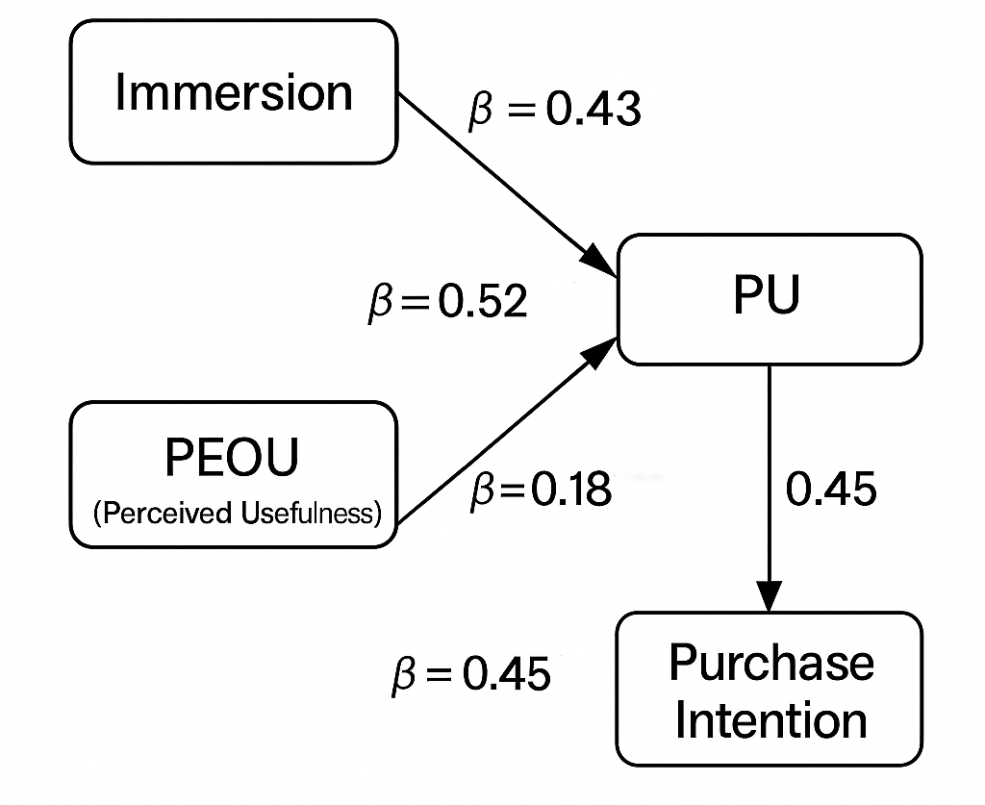
Figure 2. Significant Path Relationships Based on TAM+Immersion Framework
Model fitting degree - χ ² (146)=336.5, CFI=0.964, TLI=0.952, RMSEA=0.064. All hypotheses except H6 are supported in the final mediation model. PEOU=Perceived ease of use; PU=perceived usefulness.
This study observed a positive impact of perceived ease of use, perceived usefulness, and flow (immersion) on purchase intention, which is consistent with the latest findings of XR business research (Wang, 2024). Enhanced the effectiveness of the TAM based framework in the art purchasing environment.
- Result
The hypothesis test results present a coherent story: The immersion of XR exhibitions significantly improves users' perception of the system (making it easier to use and more useful), which in turn drives their willingness to purchase art. Specifically, if an art retailer offers a highly immersive and user-friendly virtual gallery, young consumers are more likely to see the platform as a valuable way to shop for art and express a higher likelihood of purchasing art through the platform.
To illustrate the degree of influence, the structural model of this study suggests that perceived usefulness is the main predictor of purchase intention (β=0.45). This indicates that ensuring virtual exhibitions are indeed useful (such as providing real views of artworks, detailed information, and helping users make confident decisions) is crucial for converting visitors into buyers. Perceived ease of use is also important (β=0.18 directly affects and indirectly affects perceived usefulness). Therefore, any friction when using a VR gallery, such as complex controls or technical malfunctions, may weaken users' positive attitudes, thereby reducing sales opportunities. On the other hand, making the interface concise and clear can indirectly promote sales by increasing perceived usefulness, and directly promote sales by maintaining user engagement rather than feeling discouraged.
Although immersion itself does not directly prompt people to click 'purchase', it plays a significant promoting role. The data shows that immersion enhances the overall user experience - users who are immersed in it will feel that the system is more valuable (PU increased by β=0.30) and slightly easier to use (PEOU increased by β=0.43). This is consistent with qualitative feedback: participants who reported feeling "brought in" by VR often also stated that virtual viewing of artworks allowed them to better perceive the attributes of the artwork (size, scale, texture) than expected. Some people even mention that when they carefully observe sculptures in VR, they 'forget the technology', which is a sign of immersion. These subjective comments help explain the quantitative findings that immersion enhances perceived usefulness. Essentially, high immersion design can mimic some of the characteristics of in person art appreciation, such as scale and emotional impact, thereby making users believe that virtual platforms are a viable medium for purchasing art.
Interestingly, once the TAM factor is taken into account, immersion does not have a statistically significant direct impact on purchase intention. This means that simply making the experience immersive is not enough to make people plan to buy art - immersion works by increasing the perceived value (usefulness) of the experience. In fact, a stunning VR gallery may leave a lasting impression on users, but if it cannot be transformed into an informative or convenient shopping experience, its impact on purchasing behavior will be limited. For VR developers and art marketers, this means that immersion should be purposefully combined with functionality: immersive features (such as 3D viewing, VR roaming) should be designed to make the platform truly helpful in evaluating art (for example, allowing users to carefully examine strokes in VR can improve the perceived usefulness of purchasing artwork).
In addition, although aesthetic quality and interactivity are not the focus of this research hypothesis, it is worth noting how they affect user experience. This study included an indicator on the aesthetic quality of virtual galleries, which was generally highly praised by participants. Visually captivating and realistic environments may enhance immersion - other studies have also observed this relationship He et al. found that visual attractiveness is an effective predictor of museum acceptance of AR(He, 2018). Although this study did not explicitly model aesthetic quality as a separate concept due to its collinearity with immersion, its importance cannot be ignored. Similarly, virtual exhibitions also allow for interactive exploration (free movement, choosing perspectives). This interactivity is a known factor in XR experience that can increase user engagement. In the survey of this study, many users expressed a preference for exploring freely at their own pace, which is an aspect of interactivity. Previous literature has shown that interactivity can improve user satisfaction and electronic word-of-mouth intention in virtual exhibitions[11]. This supplements the focus of this study on purchase intention.
Before discussing its impact, this study examined whether there were significant differences or moderating effects in the data. This study investigated whether previous VR experiences or artistic interests would alter these relationships. Through multiple analyses, this study found that there was no significant difference in path coefficients between VR novices and those with a certain VR experience, indicating that even VR novices follow the TAM immersion mode. This is an inspiring discovery for the widespread application of VR; Even non VR experts can gain value (practicality) from virtual galleries. This study also examined gender as a moderating factor (inspired by Ren et al. (Ren, 2022), who found that gender has some impact on the TAM pathway). In the sample of this study, there was no significant difference in the impact of immersion or TAM factors on learning intention between male and female students; Both groups of students responded positively to practicality and usability. This indicates that the model is robust in these populations, although the sample size of this study may not be able to effectively distinguish subtle differences.
- Discussion
The research results of this study not only contribute to the theoretical understanding of the increase in technology acceptance in immersive business, but also to the development of practical strategies for the digital transformation of the art market. In this section, this study will explore its impact from two main areas: (1) its impact on e-commerce and art market practices, and (2) its impact on XR technology and TAM research.

7.1 Impact on E-commerce in the Art Market
The positive impact of immersive virtual exhibitions on purchase intention is an encouraging signal for art companies seeking to expand their e-commerce business. The art market, especially the high-value art market, has traditionally made slow progress in going online due to the importance of physical exhibitions and the social experience of galleries and auctions. This study suggests that a well-designed XR platform can alleviate some of the limitations. Immersive VR exhibitions can provide a sense of scale and presence that cannot be provided by flat images on websites, which may enhance buyers' confidence in remote purchases. The Chinese college students in the sample of this study showed a strong interest in purchasing after experiencing VR exhibitions, which indicates an intergenerational shift - if the experience is rich and informative, young consumers may be more willing to accept online art purchases.
For art galleries, auction houses, and online art markets, the survey results highlight several key actionable points:
The functionality driven by investment practicality: Although immersion and visual appeal attract users, to convert this interest into purchasing power, it is necessary to enhance the functionality of experiential practicality. This may include high-resolution scaling, the ability to view art from multiple angles, background information (such as viewing art in proportion on a wall), and detailed source or artist information integrated into VR. These features ensure that VR exhibitions are not just gimmicks, but practical decision-making tools. The data from this study shows that perceived utility is the strongest driving force for purchase intention, which confirms that even in XR commerce, functional value is crucial (Wang, 2024).
Ensure smooth user experience: Usability has a direct and indirect impact on purchase intention. This means that art sellers should prioritize user interface (UI) and user experience (UX) design in their virtual exhibitions. Concise navigation, clear instructions, and minimizing technical issues (loading time, crashes) will help increase users' willingness to explore and purchase. During the testing phase, collecting user feedback on usability and conducting usability testing is equally important as showcasing well-known artworks. If users find it difficult to move within the virtual gallery, carefully curated collections may be compromised. Therefore, when developing such platforms, it is recommended that art curators and user experience designers collaborate across disciplines.
Narrative and Participation: Although TAM did not explicitly measure it, qualitative feedback suggests that adding engaging narrative elements can further enhance immersion and the persuasiveness of the exhibition. For example, adding a voice guide or VR avatar to tell the story of each artwork may deepen emotional connections (a component of immersion), indirectly promoting purchases. This is in line with the concept of experience economy, which is to create unforgettable experiences around products to enhance their attractiveness (Chen, 2024). In the context of this study, making virtual access feel like a special event or journey can amplify the factors studied in this research (such as flow experience) and thus visualize the main idea.
Market expansion and accessibility: Virtual exhibitions can attract potential buyers who cannot easily visit physical galleries due to distance, disabilities, or time constraints. For the Chinese market, this is particularly important because China has a vast territory and many young people in small cities may not have access to world-class galleries. This means that art companies can use virtual reality exhibitions to tap into new customer groups. The participants of this study are college students who may not have participated in high-end art auctions yet, but their positive reactions suggest future participation. As this generation grows older and their purchasing power increases, they may still be more willing to purchase art online because they have already been exposed to art through immersive technology. This indicates a more democratic art market, where geographical barriers will no longer be obstacles.
Trust and reputation: One challenge faced by online art sales is building trust - buyers are concerned about the authenticity, appearance, and whether the artwork meets expectations. Immersive technology can help alleviate these concerns by realistically displaying artwork details, but sellers should supplement VR technology with trust building measures (such as certificates, return policies, real-time video calls with gallery staff) to appease buyers. Although the focus of this study is not on trust, it is an important factor in actual purchasing decisions and can be combined with the concept of TAM in future research.

7.2 Impact on XR Technology and TAM Research
From a theoretical perspective, this study extends the application of TAM to the XR enhanced business field and provides empirical evidence on the role of immersion in the acceptance and efficacy of such systems. The implications of this study for researchers and XR developers are as follows:
The effectiveness of TAM in immersive environments: The results of this study largely confirm that even if the technology in question is an immersive VR system and the task is experiential (viewing art) rather than purely utilitarian, the core principles of TAM still hold true. It has been proven that both PEOU and PU are important predictors of intention, which is consistent with findings in more traditional systems. This demonstrates the robustness of TAM and suggests that researchers can confidently use TAM as a baseline model and make appropriate extensions when studying new interactive media. It has also contributed to the ongoing discussion on the correlation between TAM and hedonic or experiential systems. Some scholars argue that TAM (originally for productivity software development) may overlook key aspects of the use of hedonic systems; This study addresses the issue of immersive integration by demonstrating how experiential factors are combined with TAM's beliefs. The significant mediating effect observed in this study (immersion → PU → intentionality) suggests that TAM can adapt to these factors, especially if people conceptualize them as antecedents of PEOU/PU or parallel drivers of intention (such as perceived enjoyment) (Chen, 2024).
The role of flow/immersion: By empirically measuring immersion and discovering its impact on TAM structure, this study provides supporting evidence for a model that combines TAM with flow theory (Wang, 2024). In this study, once usefulness is taken into account, immersion does not directly drive intention, indicating that flow experiences primarily function by enhancing perception of the system. For researchers, this emphasizes the importance of considering mediation pathways - the impact of immersion may be best understood as it permeates cognitive assessments such as usefulness. In future research, measuring perceived enjoyment separately may be very effective; Enjoyment is another emotional response that often accompanies immersion. Enjoyment may have a more direct impact on the intention to reuse or recommend experiences, as seen in other studies where perceived enjoyment significantly influences attitudes towards VR (Huang et al., 2020). Including these variables can provide a more detailed understanding of how different aspects of immersive experiences affect various outcomes (usage intention, purchase intention, word-of-mouth, etc.) in this study.
Cultural and demographic factors: This study focuses on Chinese university students and adds new content to the literature by studying younger groups in the East. Although this study did not find significant differences in the TAM relationship compared to studies in other countries (in this case, these mechanisms seem to be universal), researchers should continue to explore whether culture regulates technology acceptance in subtle ways. For example, given China's advanced e-commerce ecosystem, Chinese consumers may have different baseline expectations for online services, which may affect their understanding of "useful" or "convenient" in the XR environment. Social commerce and live streaming sales have a very high acceptance in China; This study can envision integrating social functions into VR exhibitions (such as seeing other virtual characters or chatting with friends in VR), and then investigate their impact on purchase intention. TAM can be extended by introducing the concept of social influence (similar to the social norm components of TAM2 or UTAUT) to capture this dimension.
Design inspiration for XR developers: From the perspective of human-computer interaction (HCI), the research results of this study emphasize that developers of VR/AR business applications should pay attention to the interaction process and cognitive load. Immersion is not only about high-end graphics, but also about creating a seamless interactive loop that allows users to intuitively accomplish what they want to do. For example, in VR art galleries, implementing natural gestures (such as reaching out to obtain more information about painting) can enhance both immersion and usability. The data from this study suggests that improving one can enhance the other (as immersion → PEOU is important). Therefore, design work that makes interactions more natural may bring multiplier effects: more immersive experiences and simpler perceptions. In addition, the research findings of this study emphasize that XR design should consider purpose consistency - if the purpose is to purchase art, then each feature (whether immersive or interactive) should be evaluated based on its contribution to users' purchasing decision-making ability (practicality). Diverting attention or solely relying on technology for technical purposes may not help achieve this goal.
Limitations and Future Research of TAM: Although TAM provides a practical framework, it also has limitations. One limitation is that TAM focuses on users' perceptions and intentions rather than actual behavior. This study did not track actual purchasing situations (as this was only a hypothetical purchasing scenario in the experiment). Future research can attempt to link the usage of VR exhibitions with real purchase data, such as in the physical environment of art auctions or sales records. This will help verify whether the high intention measured through TAM does indeed translate into actual purchases, or whether there may be a decline due to unmeasured factors such as financial considerations or trust (intention behavior gap). Another fruitful area is the study of longitudinal effects - will the repeated use of virtual exhibition applications increase or decrease the impact of novelty/immersion on purchase intention? The first immersive experience may bring a "wow" surprise, thereby enhancing users' perception of practicality, but over time, users may gradually become accustomed to and pay more attention to content quality. Longitudinal or repeated use studies can reveal how acceptance has evolved.
Finally, combining other theories with TAM may bring deeper insights. For example, trust and risk are crucial in e-commerce purchasing decisions, especially for expensive items such as art. Combining TAM with trust models can provide a more comprehensive understanding of the formation process of purchase intention. In addition, examining emotional responses (such as awe and inspiration triggered by VR art) may also be valuable. These emotional factors may directly affect purchasing impulse (people typically purchase art that can touch their emotions). Methods such as conducting experiments with different levels of immersion (such as comparing basic 360 degree panoramic photo libraries and interactive VR galleries) can help understand the causal effects of immersive design and supplement the methods used in this study to measure perceived immersion.

Conclusions
The findings indicate that XR-based virtual art exhibitions can support art purchase intention among Chinese university students when the experience is immersive, useful and easy to use. Immersion strengthened users’ perceptions of both ease of use and usefulness, suggesting that a well-designed virtual gallery can make the platform feel more accessible and more valuable for evaluating artworks. Perceived usefulness was the strongest direct predictor of purchase intention, while perceived ease of use had both direct and indirect effects. The non-significant direct relationship between immersion and purchase intention suggests that immersion alone is not sufficient to encourage purchase intention unless it improves users’ evaluation of the platform’s usefulness and usability. These results support the applicability of the Technology Acceptance Model in XR art-commerce settings. For virtual art platforms, the findings emphasize the importance of combining engaging immersive design with clear navigation, detailed artwork information and practical decision-support features.

Limitations
This study was limited to Chinese university students from two universities, and the findings may not represent other age groups, professional art buyers or international audiences. Purchase intention was measured rather than actual purchasing behaviour, so the results cannot confirm real sales outcomes. The study relied on self-reported perceptions after a short virtual exhibition experience. The experimental setting may not fully reflect natural online art-shopping conditions. The sample-size inconsistency in the manuscript should be corrected before publication. Future studies should include actual behavioural data, broader samples, longitudinal exposure and comparisons between different XR design conditions.

Declaration of AI Use

This manuscript was prepared through the combined contributions of all author(s), including contributions to the study design, data, content development, results, interpretation, and related scholarly work. The author(s) acknowledge the use of Grammarly and ChatGPT to assist with grammar checking, language refinement, reference formatting. These AI-assisted tools were not used as authors and did not replace the intellectual contributions or scholarly judgment of the author(s). All AI-assisted outputs, including content, references, and interpretations, were carefully reviewed, revised, verified, and approved by the author(s). The author(s) accept full responsibility for the accuracy, integrity, and final content of the manuscript.

References
- Cheng, L., Xu, J., & Pan, Y. (2024). Investigating user experience of VR art exhibitions: The impact of immersion, satisfaction, and expectation confirmation. Informatics, 11(2), Article 30. https://doi.org/10.3390/informatics11020030
- Chen, H., Li, H., & Pirkkalainen, H. (2024). How extended reality influences e-commerce consumers: A literature review. Electronic Commerce Research and Applications, 65, Article 101404. https://doi.org/10.1016/j.elerap.2024.101404
- Mei, J. P. (2024). Painting a picture. CKGSB. https://english.ckgsb.edu.cn/knowledge/article/chinese-art-market-chinese-economy-painting-picture/
- Ren, L. F., Yang, F. F., Gu, C., Sun, J., & Liu, Y. F. (2022). A study of factors influencing Chinese college students’ intention of using metaverse technology for basketball learning: Extending the technology acceptance model. Frontiers in Psychology, 13, Article 1049972. https://doi.org/10.3389/fpsyg.2022.1049972
- Wang, S., Sun, W., Liu, J., Nah, K., Yan, W., & Tan, S. (2024). The influence of AR on purchase intentions of cultural heritage products: The TAM and flow-based study. Applied Sciences, 14(16), Article 7169. https://doi.org/10.3390/app14167169
- Art Basel & UBS. (2023). The art market 2023: An Art Basel & UBS report. https://theartmarket.artbasel.com/the-art-market-2023/global-market
- He, Z. Y., Wu, L., & Li, X. (2018). When art meets tech: The role of augmented reality in enhancing museum experiences and purchase intentions. Tourism Management, 68, 127–139. https://doi.org/10.1016/j.tourman.2018.03.003
- De Canio, F., Martinelli, E., Peruzzini, M., & Marchi, G. (2021). The use of virtual tours to stimulate consumers’ buying and visit intentions: An application to the Parmigiano Reggiano cheese. Italian Journal of Marketing, 2021(3), 209–226. https://doi.org/10.1007/s43039-021-00034-9
- Li, J., & Lv, C. (2024). Exploring user acceptance of online virtual reality exhibition technologies: A case study of Liangzhu Museum. PLoS ONE, 19(8), Article e0308267. https://doi.org/10.1371/journal.pone.0308267
- Guo, C., & Zhang, X. (2024). The impact of AR online shopping experience on customer purchase intention: An empirical study based on the TAM model. PLoS ONE, 19(8), Article e0309468. https://doi.org/10.1371/journal.pone.0309468
- ·Wang, X., Liao, Y., Liu, C., & Zheng, J. (2025). Exploring determinants of visitor’s e-WOM in the virtual art exhibition with an extended American Customer Satisfaction Index model. Consumer Behavior in Tourism and Hospitality, 20(1), 38–56. https://doi.org/10.1108/CBTH-04-2024-0149

