Land Cover Dynamics and Multitemporal Erosion-Sedimentation Modelling of the Rejoso Watershed for Sustainable Management

Abstract.
The Rejoso Watershed (DAS Rejoso) in Pasuruan Regency, East Java, has experienced progressive land cover degradation over the past decade, culminating in a major flood event in 2025 that inundated residential areas to depths exceeding one metre. This study integrates three analytical approaches: (1) multitemporal land use/cover change (LUCC) analysis using Sentinel-2 imagery for 2017, 2020, and 2024, supplemented by non-parametric statistical verification (Friedman test and Wilcoxon Signed-Rank test); (2) spatiotemporal erosion-sedimentation modelling using the Universal Soil Loss Equation (USLE) and Modified Universal Soil Loss Equation (MUSLE) with the Sediment Delivery Ratio (SDR); and (3) identification of erosion-sedimentation hotspots at the land mapping unit (SPL) level. Results reveal that forest cover declined by 2,721.64 ha over the study period, with the most pronounced acceleration occurring between 2020 and 2024 (− 13.97%), statistically confirmed as a significant and spatially consistent trend (Friedman χ²F = 13.64; p = .001; Kendall’s W = 0.568). Built-up land expanded consistently across all periods (Kendall’s W = 0.861; p < .001). Potential erosion hotspots were identified in SPL 20 (Tosari), while SPL 11 (Nguling) recorded the highest sediment yield across all periods. Despite an overall decline in total sediment yield from 328,695 to 251,005 tonnes/year, this reduction was driven by decreased rainfall erosivity rather than land cover improvement, underscoring the continued critical condition of the watershed. These findings provide a biophysical evidence base for prioritising conservation interventions in the Rejoso Watershed.
Keywords: land use/cover change; erosion modelling; sediment yield; USLE; MUSLE

1. Introduction
Watershed degradation driven by land cover change is one of the most pressing environmental challenges in tropical regions, where rapid population growth and agricultural expansion continuously exert pressure on natural ecosystems. The Rejoso Watershed (DAS Rejoso), located in Pasuruan Regency, East Java, Indonesia, exemplifies this challenge. Encompassing a total area of approximately 40,131 ha, the watershed spans from the volcanic slopes of Mount Bromo-Tengger in the upstream zone to the lowland coastal areas of Nguling in the downstream zone, traversing twelve administrative sub-districts.
Over the past decade, the watershed has experienced a marked shift in land cover composition, characterised by the conversion of natural forest to agricultural land, settlements, and open areas. This conversion has intensified surface runoff, reduced infiltration capacity, and increased sediment transport, ultimately contributing to recurrent flooding in downstream areas. The most severe manifestation of this process occurred in 2025, when a major flood inundated residential settlements in Kecamatan Rejoso to depths exceeding one metre, causing significant socioeconomic losses and highlighting the urgent need for evidence-based watershed management.
Despite the recognised importance of the Rejoso Watershed as a water resource for both agriculture and domestic supply, comprehensive quantitative assessments integrating multitemporal land cover dynamics with spatially explicit erosion-sedimentation modelling remain limited. Previous studies have addressed individual components, including land cover classification (Rasyidi et al., 2022), agroforestry dynamics (Wariunsora et al., 2024), and RTRW land use projections (Mujibadi et al., 2020), but none have simultaneously quantified LUCC trends with statistical significance testing and linked these to spatial erosion-sedimentation patterns across multiple time periods.
This study addresses that gap by integrating three analytical frameworks: (1) multitemporal LUCC analysis using Sentinel-2 satellite imagery for 2017, 2020, and 2024, with non-parametric statistical verification; (2) spatiotemporal erosion-sedimentation modelling using USLE and MUSLE coupled with the Sediment Delivery Ratio (SDR); and (3) identification of erosion and sedimentation hotspots at the land mapping unit level. The study aims to provide a biophysical evidence base for prioritising sustainable management interventions in the Rejoso Watershed.
2. Materials and Methods
2.1 Study Area
The Rejoso Watershed is located in Pasuruan Regency, East Java Province, Indonesia (7°35’–8°05’ S; 112°45’–113°10’ E). The watershed covers an area of approximately 40,131 ha, spanning twelve sub-districts from the highland volcanic zone of Tosari (upstream) to the coastal lowlands of Nguling (downstream). Elevation ranges from approximately 2,500 m above sea level in the upstream area to near sea level at the watershed outlet. The watershed encompasses diverse land cover types, including montane forest, agroforestry systems, dryland agriculture, paddy fields, and urban settlements.
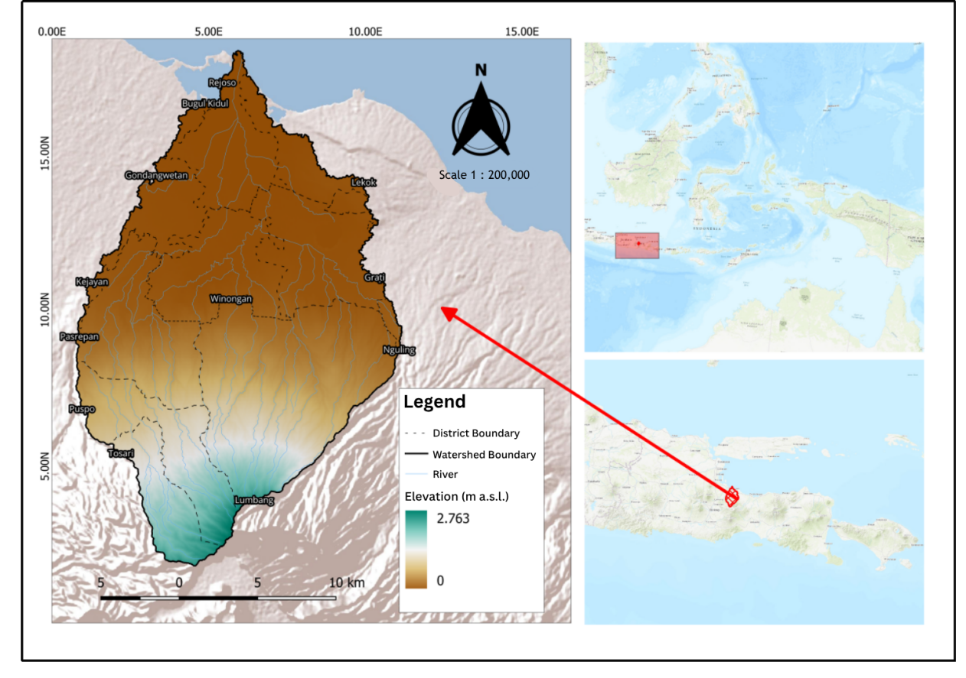
Figure 1. Study area map of the Rejoso Watershed, Pasuruan Regency, East Java, Indonesia.
2.2 Land Use/Cover Change (LUCC) Analysis
Land cover classification was performed using Sentinel-2 Level-2A multispectral imagery acquired for three reference years: 2017, 2020, and 2024. Images with cloud cover below 10% were selected and pre-processed using standard atmospheric correction procedures. Seven land cover classes were defined: water body, forest/vegetation, swamp, agricultural land, built-up land, bare land, and dryland (tegalan). Classification was performed using a supervised machine learning approach in Google Earth Engine.
To quantify land cover distribution per sub-district, spatial intersection analysis was conducted between the classified land cover maps and sub-district administrative boundaries (n = 12) using QGIS version 3.40.5. This produced a dataset of land cover area per class per sub-district for each of the three reference years, which served as the input for subsequent statistical analysis.
Statistical significance of land cover changes across the three periods was verified using non-parametric repeated-measures tests, as Mauchly’s Test confirmed that the sphericity assumption was not met (p < .05), precluding the use of parametric repeated-measures ANOVA (Field et al., 2025). The Friedman test was applied as a non-parametric alternative to detect significant differences across at least one pair of observation periods:
χ²F = [12 / nk(k+1)] ΣRj² − 3n(k+1)
where n is the number of spatial units (sub-districts; n = 12), k is the number of observation periods (k = 3), and Rj is the sum of ranks for period j. The strength of inter-unit consistency was assessed using Kendall’s W coefficient of concordance, with values approaching 1.0 indicating high consistency across sub-districts (Kendall & Babington Smith, 1939).
Where the Friedman test yielded a significant result (p < .05), the Wilcoxon Signed-Rank test was applied as a post-hoc procedure to identify specific periods with significant pairwise differences (Wilcoxon, 1945):
W = Σ [sgn(x2i − x1i) · Ri]
where W is the test statistic, x1i and x2i are the land cover area values for the two periods being compared for sub-district i, Ri is the rank of the absolute difference |x2i − x1i|, and sgn(·) is the sign function (+1 for positive differences, −1 for negative, 0 for no difference). All statistical analyses were conducted using JASP version 0.18 at a significance level of α = 0.05.
2.3 Erosion Modelling: USLE
Potential soil erosion was estimated using the Universal Soil Loss Equation (USLE; Wischmeier & Smith, 1978):
A = R · K · LS · C · P
where A is the annual soil loss (tonnes ha⁻¹ year⁻¹), R is the rainfall erosivity factor (MJ mm ha⁻¹ h⁻¹ year⁻¹), K is the soil erodibility factor (t ha h ha⁻¹ MJ⁻¹ mm⁻¹), LS is the slope length-steepness factor (dimensionless), C is the cover-management factor (dimensionless), and P is the support practice factor (dimensionless). The R factor was computed from daily rainfall data using the Modified Fournier Index. The K factor was derived from soil texture and organic matter content based on the Wischmeier and Smith nomograph. The LS factor was calculated from a Digital Elevation Model (DEM) at 30-m resolution. The C factor was assigned based on land cover class derived from the LUCC analysis. The P factor was determined based on field conditions and land management practices.
2.4 Sediment Yield Modelling: MUSLE and SDR
Sediment yield at the land mapping unit (SPL) level was estimated using the Modified Universal Soil Loss Equation (MUSLE; Williams, 1975):
Qs = 11.8 · (Vq · qp)°0.56 · K · LS · C · P
where Qs is the sediment yield per rainfall event (tonnes), Vq is the runoff volume (m³), and qp is the peak discharge (m³ s⁻¹). The MUSLE replaces the rainfall erosivity factor (R) in the USLE with a runoff energy term, enabling event-based estimation of sediment yield.
The Sediment Delivery Ratio (SDR) was applied to estimate the proportion of eroded material reaching the watershed outlet:
SDR = Qs / A
Spatial analysis was performed on 25 Land Mapping Units (SPL) derived through overlay of soil type, slope class, and land cover maps within the watershed boundary using QGIS. Each SPL was used as the unit of calculation for erosion and sedimentation estimation, enabling spatial identification of erosion and sedimentation hotspots.
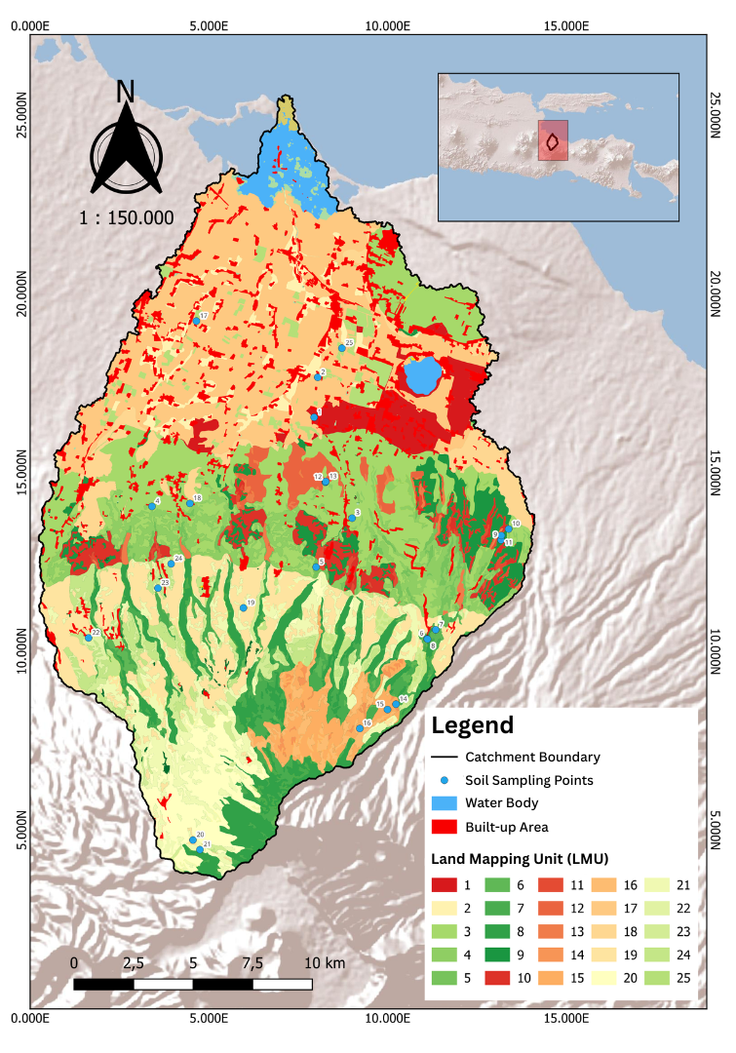
Figure 2. Distribution of 25 Land Mapping Units (SPL) in the Rejoso Watershed derived from overlay of soil type, slope class, and land cover.
3. Results and Discussion
3.1 Land Use/Cover Change 2017–2024
The multitemporal classification of Sentinel-2 imagery revealed significant land cover changes across the Rejoso Watershed between 2017 and 2024 (Table 1). Two dominant trends were identified: a decline in natural vegetation cover, particularly forest, and an expansion of built-up land and agricultural areas.
Table 1. Land cover change in the Rejoso Watershed, 2017–2024.
Land Cover Class | 2017 (ha) | 2020 (ha) | 2024 (ha) | Δ 2017–2020 (ha) | Δ 2017–2020 (%) | Δ 2020–2024 (ha) | Δ 2020–2024 (%)
Water Body | 956.09 | 1,060.00 | 1,066.01 | +103.91 | +10.87 | +6.01 | +0.57
Forest | 16,962.79 | 16,554.00 | 14,241.15 | −408.79 | −2.41 | −2,312.85 | −13.97
Swamp | 93.09 | 75.00 | 91.15 | −18.09 | −19.43 | +16.15 | +21.53
Agricultural Land | 11,884.21 | 12,930.00 | 12,799.64 | +1,045.79 | +8.80 | −130.36 | −1.01
Built-up Land | 5,234.34 | 6,182.00 | 6,853.31 | +947.66 | +18.11 | +671.31 | +10.86
Bare Land | 4.35 | 0.18 | 1.10 | −4.17 | −95.86 | +0.92 | +511.11
Dryland (Tegalan) | 4,996.53 | 3,324.00 | 5,074.50 | −1,672.53 | −33.47 | +1,750.50 | +52.66
Source: Analysis results, 2026
Forest cover declined by a total of 2,721.64 ha over the seven-year study period. The rate of loss accelerated markedly between 2020 and 2024 (−2,312.85 ha; −13.97%), compared to the relatively modest loss observed between 2017 and 2020 (−408.79 ha; −2.41%). Built-up land expanded consistently across both periods, recording gains of +947.66 ha (+18.11%) between 2017 and 2020 and +671.31 ha (+10.86%) between 2020 and 2024, representing a total expansion of 30.93% over the study period. These patterns are consistent with reported urbanisation pressures in the Pasuruan area, where the Green Coverage Index (IKTL) of Kota Pasuruan declined sharply from 45.12 in 2018 to 26 in 2024.
These changes also align with broader evidence that Sentinel-2 imagery is suitable for monitoring forest, agricultural and urban land-cover transitions, particularly when machine-learning classifiers are combined with appropriate pre-processing. In watershed contexts, conversion of forest or perennial vegetation to cropland and settlement generally increases runoff generation, reduces surface protection, and can elevate sediment production, although the magnitude varies with rainfall regime, slope, soil erodibility, and conservation practices (Phiri et al., 2020; Nampak et al., 2018; Sadhwani et al., 2022). Therefore, the observed forest decline and built-up expansion should be interpreted not only as land-cover transition, but also as a potential shift in hydrological response and sediment connectivity.

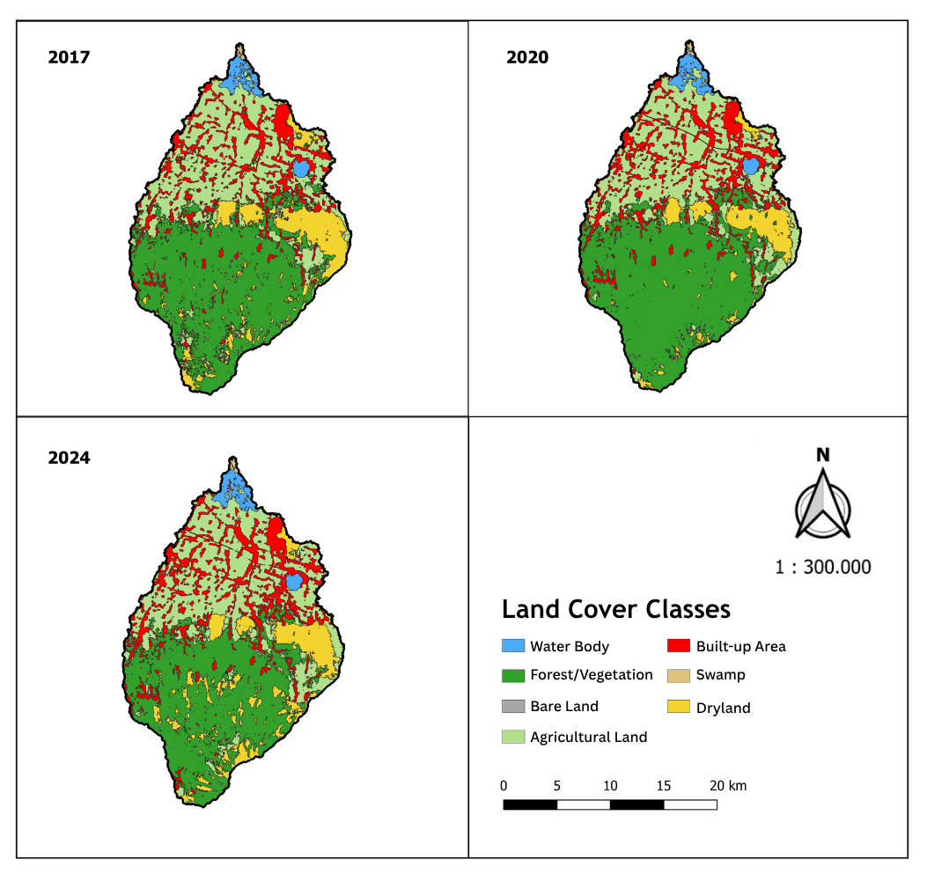
Figure 3. Multitemporal land cover maps of the Rejoso Watershed derived from Sentinel-2 classification: (a) 2017, (b) 2020, (c) 2024.
3.2 Statistical Significance of Land Cover Change
The Friedman test confirmed that statistically significant changes occurred in three of the seven land cover classes over the study period (Table 2). Forest cover showed a significant overall trend (χ²F = 13.64; p = .001; Kendall’s W = 0.568), with post-hoc Wilcoxon analysis revealing that the significant change was concentrated in the 2020–2024 period (W = 66.00; p = .004) and cumulatively across 2017–2024 (W = 59.00; p = .023). Built-up land exhibited the strongest and most consistent trend of all classes (χ²F = 20.67; p < .001; Kendall’s W = 0.861), with significant expansion confirmed across all three pairwise periods. Dryland (tegalan) showed a significant change primarily in the 2017–2020 period (W = 36.00; p = .014), with the subsequent rebound in 2020–2024 not reaching statistical significance (p = .076), indicating spatially heterogeneous and inconsistent dynamics.
The statistical confirmation is important because LUCC maps derived from remote sensing may contain class-level uncertainty and spatial noise; therefore, testing changes across repeated spatial units provides a more conservative basis for interpreting temporal trends. The use of the Friedman test, Kendall’s W and Wilcoxon signed-rank procedures is appropriate for repeated comparisons where normality or sphericity assumptions are not satisfied, because these methods evaluate ranked differences rather than relying on distributional assumptions (Friedman, 1937; Kendall & Babington Smith, 1939; Wilcoxon, 1945). This strengthens the interpretation that forest decline and built-up expansion were not merely descriptive fluctuations, but statistically supported watershed-scale changes.
Land Cover Class | χ²F | p | Kendall's W | W (2017–2020) | p | W (2020–2024) | p
Water Body | 0.514 | .773 | 0.021 | 8.000 | .183 | 20.00 | .813
Forest* | 13.64 | .001 | 0.568 | 22.00 | .351 | 66.00 | .004
Swamp | 3.000 | .223 | 0.125 | 3.000 | .371 | 0.000 | .371
Agricultural Land | 0.667 | .717 | 0.028 | 36.00 | .850 | 32.00 | .622
Built-up Land* | 20.67 | <.001 | 0.861 | 8.000 | .012 | 0.000 | <.001
Bare Land | 1.059 | .589 | 0.044 | 9.000 | .201 | 1.000 | .423
Dryland* | 7.600 | .022 | 0.317 | 36.00 | .014 | 7.000 | .076
Table 2. Results of Friedman test and Wilcoxon Signed-Rank test for land cover change, 2017–2024.
*Statistically significant (p < .05); Friedman test applied due to violation of sphericity assumption (Mauchly's Test, p < .05). Source: Statistical analysis results, 2026.
3.3 Erosion-Sedimentation Dynamics
Potential erosion rates estimated using USLE across the 25 SPLs showed considerable spatial variability. SPL 20, located in the upstream sub-district of Tosari, consistently recorded the highest potential erosion rates across all three study periods, attributable to the combination of steep slopes, high rainfall erosivity, and increasing conversion of forest cover to dryland agriculture. The spatial pattern of potential erosion is presented in Figure 4.
The identification of SPL 20 as an erosion hotspot is consistent with studies showing that high slope gradients, reduced canopy cover and exposed agricultural surfaces strongly increase modelled erosion risk in GIS-based USLE/RUSLE assessments (Pham et al., 2018; Park et al., 2011; Sadhwani et al., 2022). In practical terms, this suggests that conservation measures in upstream Tosari should prioritise slope stabilisation, vegetative cover restoration, contour-based farming and runoff interception rather than relying only on downstream flood-control structures.
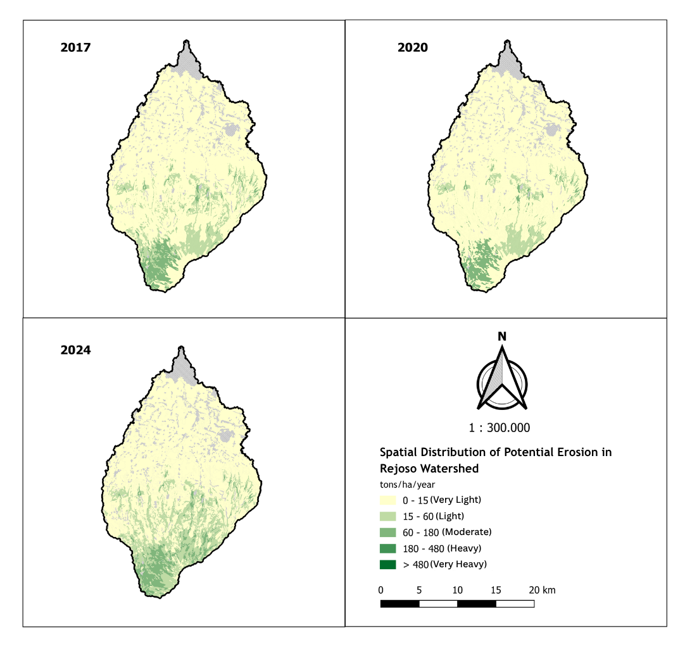
Figure 4. Spatial distribution of potential erosion estimated by USLE across 25 Land Mapping Units (SPL) of the Rejoso Watershed: 2017, 2020, 2024.
Sediment yield estimated using MUSLE revealed that SPL 11, located in the downstream sub-district of Nguling, recorded the highest sediment yield values consistently across all three periods. This result reflects the compound effect of accumulated runoff from upstream areas, high land cover disturbance, and proximity to the watershed outlet, which reduces the distance available for sediment deposition before reaching the river network.
Total sediment yield at the watershed level showed a declining trend across the study period, from approximately 328,695 tonnes/year in 2017 to 251,005 tonnes/year in 2024. However, this apparent improvement warrants careful interpretation. Analysis of the component factors indicates that the decline was primarily driven by a reduction in rainfall erosivity (R factor) rather than by improvements in land cover or conservation practices. Given that forest cover continued to decline substantially during the same period, the underlying vulnerability of the watershed to erosion and sedimentation has increased rather than decreased. A return to higher erosivity years would be expected to produce substantially elevated sediment yields.
The contrast between high potential erosion upstream and high sediment yield downstream is also plausible because delivered sediment depends on hillslope-channel connectivity, runoff energy, deposition opportunities and the location of each SPL relative to the drainage network. Similar studies have shown that sediment yield may respond strongly to land-cover disturbance and rainfall-runoff variability, so lower modelled yield during a low-erosivity period should not be interpreted as durable recovery unless supported by improvements in vegetation cover and conservation practices (Ouyang et al., 2010; Ranzi et al., 2012; Pal et al., 2021).
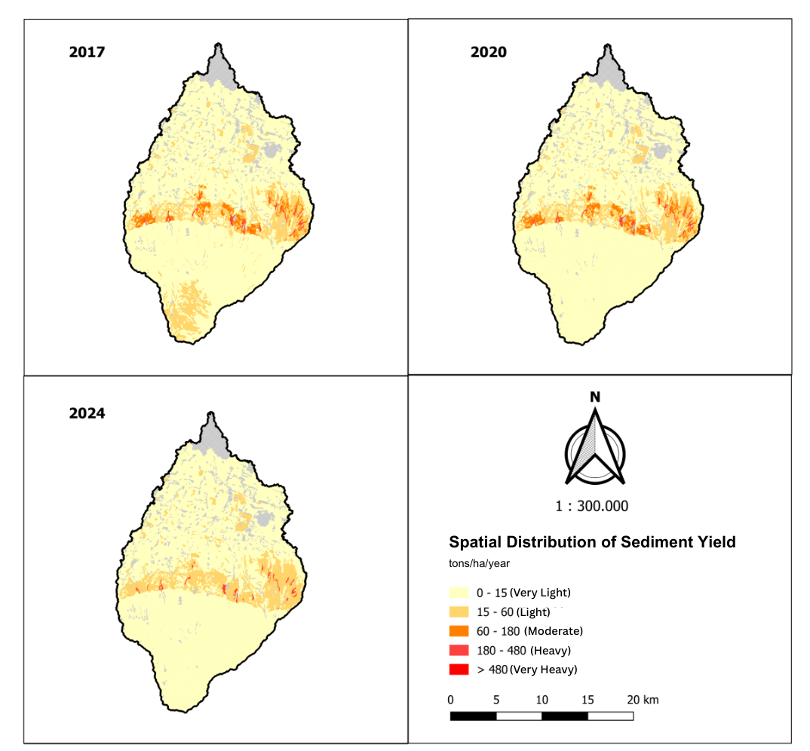
Figure 5. Spatial distribution of sediment yield estimated by MUSLE across 25 Land Mapping Units (SPL) of the Rejoso Watershed: 2017, 2020, 2024.
Conclusion
This study demonstrated that the Rejoso Watershed experienced significant land-cover changes between 2017 and 2024, particularly forest decline and built-up land expansion. Forest cover decreased most strongly during 2020–2024, while built-up land increased consistently across the study period. These changes indicate continuing pressure on the watershed’s ecological function and hydrological stability. The erosion-sedimentation modelling identified SPL 20 in Tosari as the main hotspot for potential erosion and SPL 11 in Nguling as the principal sediment-yield hotspot. Although the estimated total sediment yield declined from 328,695 tonnes/year in 2017 to 251,005 tonnes/year in 2024, this reduction should not be interpreted as watershed recovery because forest cover continued to decline. The findings suggest that conservation should prioritize upstream erosion-control measures, protection of remaining forest, rehabilitation of degraded dryland areas, and management of rapidly expanding built-up zones. The integrated approach used in this study can support spatial prioritization for sustainable watershed management.
Limitations
This study was limited by the availability and resolution of remote-sensing, rainfall, soil and hydrological data. Land-cover classification accuracy, training samples and validation results were not fully reported, which may affect confidence in the LUCC estimates. USLE and MUSLE modelling require several parameter assumptions, including rainfall erosivity, soil erodibility, cover-management factors, support practices, runoff volume and peak discharge. The study did not include field-based erosion or sediment measurements for model calibration. Future research should include accuracy assessment, ground validation, longer rainfall records, observed sediment data and detailed SPL-level parameter tables.
Declaration of AI Use

This manuscript was prepared through the combined contributions of all author(s), including contributions to the study design, data, content development, results, interpretation, and related scholarly work. The author(s) acknowledge the use of Grammarly and ChatGPT to assist with grammar checking, language refinement, reference formatting. These AI-assisted tools were not used as authors and did not replace the intellectual contributions or scholarly judgment of the author(s). All AI-assisted outputs, including content, references, and interpretations, were carefully reviewed, revised, verified, and approved by the author(s). The author(s) accept full responsibility for the accuracy, integrity, and final content of the manuscript.

References
Field, A., van Doorn, J., & Wagenmakers, E. J. (2025). Discovering statistics using JASP. SAGE Publications. https://uk.sagepub.com/en-gb/eur/discovering-statistics-using-jasp/book285437
Friedman, M. (1937). The use of ranks to avoid the assumption of normality implicit in the analysis of variance. Journal of the American Statistical Association, 32(200), 675-701. https://doi.org/10.1080/01621459.1937.10503522
Jiang, X., et al. (2025). Spatiotemporal dynamics of sediment yield in tropical watersheds. Catena, 240, Article 107985. https://www.sciencedirect.com/journal/catena/vol/240/suppl/C
Kendall, M. G., & Babington Smith, B. (1939). The problem of m rankings. The Annals of Mathematical Statistics, 10(3), 275-287. https://doi.org/10.1214/aoms/1177732186
Mujibadi, et al. (2020). Land use projection based on RTRW 2016-2029 in DAS Rejoso. Jurnal Ilmu Lingkungan, 18, 112-120. https://ejournal.undip.ac.id/index.php/ilmulingkungan
Nampak, H., Pradhan, B., & Mojaddadi, R. H. (2018). Assessment of land cover and land use change impact on soil loss in a tropical catchment by using multi-temporal SPOT-5 satellite images and revised universal soil loss equation model. Land Degradation & Development, 29(10), 3440-3455. https://doi.org/10.1002/ldr.3112
Ouyang, W., Hao, F., Skidmore, A. K., & Toxopeus, A. G. (2010). Soil erosion and sediment yield and their relationships with vegetation cover in upper stream of the Yellow River. Science of the Total Environment, 409(2), 396-403. https://doi.org/10.1016/j.scitotenv.2010.10.020
Pal, S. C., Chakrabortty, R., Roy, P., Chowdhuri, I., Das, B., Saha, A., & Shit, M. (2021). Changing climate and land use of 21st century influences soil erosion in India. Gondwana Research, 94, 164-185. https://doi.org/10.1016/j.gr.2021.02.021
Park, S., Oh, C., Jeon, S., Jung, H., & Choi, C. (2011). Soil erosion risk in Korean watersheds, assessed using the revised universal soil loss equation. Journal of Hydrology, 399(3-4), 263-273. https://doi.org/10.1016/j.jhydrol.2011.01.004
Pham, T. G., Degener, J., & Kappas, M. (2018). Integrated universal soil loss equation (USLE) and Geographical Information System (GIS) for soil erosion estimation in A Sap basin: Central Vietnam. International Soil and Water Conservation Research, 6(2), 99-110. https://doi.org/10.1016/j.iswcr.2018.01.001
Phiri, D., Simwanda, M., Salekin, S., Nyirenda, V. R., Murayama, Y., & Ranagalage, M. (2020). Sentinel-2 data for land cover/use mapping: A review. Remote Sensing, 12(14), Article 2291. https://doi.org/10.3390/rs12142291
Ranzi, R., Le, T. H., & Rulli, M. C. (2012). A RUSLE approach to model suspended sediment load in the Lo River (Vietnam): Effects of reservoirs and land use changes. Journal of Hydrology, 422-423, 17-29. https://doi.org/10.1016/j.jhydrol.2011.12.009
Rasyidi, et al. (2022). Agricultural and shrubland conversion to settlements in Kota Pasuruan. Jurnal Pengelolaan Lingkungan, 9, 45-52. https://scholar.google.com/scholar?q=%22Agricultural+and+shrubland+conversion+to+settlements+in+Kota+Pasuruan%22
Saaty, T. L. (1980). The analytic hierarchy process. McGraw-Hill. https://www.worldcat.org/title/analytic-hierarchy-process/oclc/5909699
Sadhwani, K., Eldho, T. I., Jha, M. K., & Karmakar, S. (2022). Effects of dynamic land use/land cover change on flow and sediment yield in a monsoon-dominated tropical watershed. Water, 14(22), Article 3666. https://doi.org/10.3390/w14223666
Wariunsora, et al. (2024). Agroforestry dynamics in the Rejoso Watershed. Jurnal Agroforestri Indonesia, 12, 88-97. https://scholar.google.com/scholar?q=%22Agroforestry+dynamics+in+the+Rejoso+Watershed%22
Williams, J. R. (1975). Sediment-yield prediction with universal equation using runoff energy factor. In Present and prospective technology for predicting sediment yields and sources (USDA ARS-S-40, pp. 244-252). United States Department of Agriculture. https://www.ars.usda.gov/ARSUserFiles/60600505/RUSLE/AH_537.pdf
Wischmeier, W. H., & Smith, D. D. (1978). Predicting rainfall erosion losses: A guide to conservation planning (Agriculture Handbook No. 537). United States Department of Agriculture. https://naldc.nal.usda.gov/catalog/CAT79706928
Wilcoxon, F. (1945). Individual comparisons by ranking methods. Biometrics Bulletin, 1(6), 80-83. https://doi.org/10.2307/3001968
Wunder, S. (2005). Payments for environmental services: Some nuts and bolts (CIFOR Occasional Paper No. 42). Center for International Forestry Research. https://doi.org/10.17528/cifor/001765

