From Waste Streams to Superbugs: How Pharmaceutical and Hospital Effluents Drive Antimicrobial Resistance in Urban Ecosystems
Abstract
Background:
Antimicrobial resistance (AMR) is a growing global health crisis, and more and more people are realising that environmental routes are a major part of the problem. The pharmaceutical industry and hospital wastewater leak substantial concentrations of antibiotic residues and resistant microbes into urban aquatic systems, providing intense selection pressures that promote resistance development.
Objectives:
This review consolidates contemporary research about the influence of pharmaceutical and hospital effluents on the emergence and propagation of antimicrobial resistance (AMR) within urban ecosystems, highlights critical knowledge deficiencies, and assesses policy and technology responses.
Methods:
A narrative literature study was performed, utilising peer-reviewed publications from PubMed, Scopus, and Web of Science (2000–2025) that focused on "antimicrobial resistance," "hospital wastewater," "pharmaceutical effluents," and "urban environments." Inclusion criteria included chemical, microbiological, and policy analyses pertinent to urban AMR dynamics.
Key Findings:
Evidence from various geographic areas indicates that pharmaceutical and hospital effluents frequently surpass anticipated no-effect concentrations for resistance selection, introducing multidrug-resistant organisms (e.g., ESBL-producing Enterobacterales) and mobile resistance genes into municipal wastewater systems. Traditional wastewater treatment facilities have inconsistent effectiveness in eliminating these pollutants, but environmental dispersal promotes horizontal gene transfer among indigenous bacteria. Regulatory frameworks are still not very good, with few binding effluent standards and poor enforcement.
Conclusions:
Effluent-driven AMR in urban ecosystems necessitates coordinated efforts that incorporate environmental monitoring, enforceable discharge limitations, and scalable advanced treatment technology. To stop the environmental cycle of resistance amplification, we need a One Health model that connects public health, environmental policy, and industry.
Keywords
Antimicrobial resistance; Pharmaceutical effluents; Hospital wastewater; Urban ecosystems; Environmental risk; Regulatory strategies.
- Introduction
Antimicrobial resistance (AMR) has become one of the most serious public health challenges of the 21st century. It makes antibiotics, which have long been the foundation of modern treatment, less effective. The World Health Organisation (WHO) sees AMR as a global problem that could undo decades of medical progress, causing infections that can't be treated, longer illnesses, and more deaths. While the clinical misuse and overuse of antibiotics are well recognised as major causes, an increasingly crucial aspect of this problem exists outside of hospitals—in the environmental pathways that spread and amplify resistance[1].
One of the most important but often overlooked environmental factors is the trash that comes from making drugs and running healthcare facilities. When making, mixing, and cleaning medicines, pharmaceutical production waste often contains significant levels of active pharmaceutical ingredients (APIs), especially antibiotics. These residues can put selective pressure on ambient microbiota, even at low concentrations, which speeds up the establishment and survival of resistant bacteria. Hospital effluents are also complicated mixes of antimicrobial agents, disinfectants, metabolites, and resistant bacteria that patients shed. Hospital discharges usually include more leftover antibiotics and multidrug-resistant organisms than regular household wastewater[2]. They generally don't get enough pretreatment before they go into municipal sewer systems.
Urban ecosystems provide a distinctive and very favourable setting for the dissemination of antimicrobial resistance (AMR) via various waste streams. When there are a lot of people living in one place, antibiotic use goes up. On the other hand, complex and interconnected wastewater systems make it easier for different microbial species and pharmaceutical pollutants to mix. Wastewater treatment plants (WWTPs), which are the main way cities deal with sewage, are not made to entirely get rid of drugs or resistance genes, so they can get into surface waters, sediments, and soils. In many areas that are growing quickly, untreated or only partially treated effluents are dumped straight into natural bodies of water, making the problem worse[3].
These elements coming together make urban aquatic and terrestrial ecosystems hotspots for horizontal gene transfer, which lets resistant bacteria spread far beyond their original clinical or industrial sources. This environmental reservoir of resistance presents a dual threat: it jeopardises ecological integrity and facilitates the reintroduction of resistant infections into human populations via water, food, and direct contact.
With the rapid growth of cities, the growth of drug manufacture, and the growing global problem of AMR, it is both important and necessary to critically examine the role of pharmaceutical and hospital effluents in determining resistance dynamics within urban ecosystems. This article consolidates existing research, delineates critical knowledge deficiencies, and assesses mitigation solutions to provide a comprehensive, cross-sectoral approach to this intricate environmental health issue. Figure 1 shows the main origins, transmission routes, and re-entry points of AMR in urban environments. It also shows the interwoven pathways that link pharmaceutical and hospital effluents to environmental reservoirs and then to humans[4].
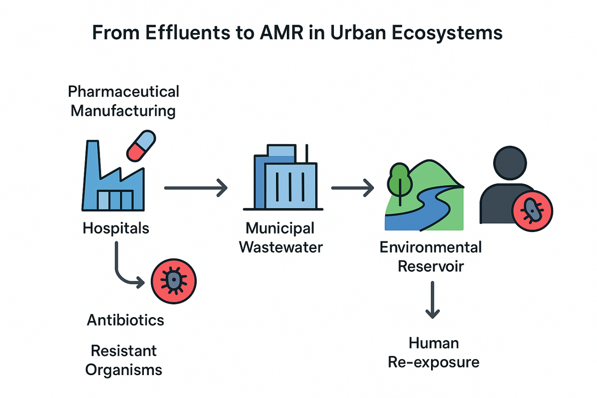
Figure 1 summarizes the principal pathways through which pharmaceutical and hospital effluents contribute to the emergence, amplification, and dissemination of antimicrobial resistance within urban ecosystems.

2. Literature Search Strategy
This review adopted a narrative literature review approach to synthesize current evidence regarding the contribution of pharmaceutical and hospital effluents to antimicrobial resistance (AMR) within urban ecosystems. Relevant literature was identified through a comprehensive search of PubMed, Scopus, and Web of Science databases. Additional publications were located through manual searches of reference lists and reports published by international organizations, including the World Health Organization (WHO), the United Nations Environment Programme (UNEP), and other agencies involved in environmental health and antimicrobial resistance monitoring.
2.1 Database Search
The literature search covered studies published between January 2000 and June 2025. Search terms included combinations of the keywords "antimicrobial resistance," "antibiotic resistance," "pharmaceutical effluents," "hospital wastewater," "urban ecosystems," "wastewater treatment," "antibiotic residues," "environmental contamination," "antimicrobial resistance genes," and "One Health." Boolean operators were used to refine searches and improve the retrieval of relevant studies. The search strategy was designed to capture research addressing environmental pathways of resistance emergence, dissemination, and mitigation within urban settings.
2.2 Eligibility Criteria
Studies were included if they investigated pharmaceutical manufacturing effluents, hospital wastewater, municipal wastewater systems, antibiotic residues, antimicrobial resistance genes, resistant microorganisms, environmental transmission pathways, ecological impacts, wastewater treatment technologies, or policy responses related to environmental antimicrobial resistance. Eligible sources included peer-reviewed journal articles and authoritative reports published in English. Studies focused exclusively on clinical antimicrobial resistance without environmental relevance, conference abstracts, editorials, opinion papers, and publications lacking sufficient methodological detail were excluded from the review.
2.3 Study Selection
The database search initially identified approximately 385 records. Following the removal of duplicate records, titles and abstracts were screened for relevance to the objectives of the review. A total of 142 publications were selected for full-text assessment. Following detailed evaluation against the inclusion and exclusion criteria, 68 studies were retained for the final review. These studies represented a broad geographical distribution and provided evidence relating to pharmaceutical pollution, hospital wastewater, environmental reservoirs of resistance, wastewater treatment performance, and regulatory responses.
2.4 Data Extraction
Information was systematically extracted from eligible studies to facilitate comparison and synthesis. Extracted data included study location, characteristics of wastewater sources, concentrations of antibiotic residues, prevalence of resistant microorganisms, occurrence of antimicrobial resistance genes, treatment technologies evaluated, environmental impacts observed, and regulatory or policy recommendations. Particular attention was given to studies examining mechanisms of resistance selection, environmental dissemination, and human re-exposure pathways.
2.5 Narrative Synthesis
A thematic narrative synthesis approach was employed to integrate findings across the included studies. Evidence was organized into four major thematic areas: pharmaceutical effluents as sources of environmental contamination, hospital wastewater as a reservoir of antimicrobial resistance determinants, ecological interactions driving resistance amplification within urban ecosystems, and mitigation strategies and regulatory responses. This approach enabled the identification of recurring patterns, emerging challenges, knowledge gaps, and future research priorities while providing a comprehensive overview of the environmental dimensions of antimicrobial resistance from a One Health perspective.
Figure 1 summarizes the principal pathways through which pharmaceutical and hospital effluents contribute to the emergence, amplification, and dissemination of antimicrobial resistance within urban ecosystems.
- Background: AMR Mechanisms & Effluent Pathways
The environmental aspect of antimicrobial resistance (AMR) is influenced by the ongoing influx of antibiotic residues and resistant bacteria into both natural and manmade water systems. Most of these inputs come from human activities, namely making drugs, providing health care, and using antibiotics in the community. Unused or broken-down antibiotics leave the body through urine and faeces from people and animals, or they are released into the water as part of industrial waste. Resistant bacteria, including clinically relevant strains, disseminate along analogous pathways—excreted by patients, transported inside biofilms, or growing in waste-holding systems. Chemical pollutants and living microorganisms together make the perfect environment for resistance traits to be chosen, last, and spread[4,5].
In environmental settings, bacterial resistance arises through two principal mechanisms:
1. Mutation and selection: Random genetic changes might change the targeting or metabolic pathways of bacteria, making them less sensitive to antibiotics. Antibiotics, even in low quantities, create selective pressure that helps resistant forms survive[6].
2. Horizontal gene transfer (HGT) — HGT is important in the environment because it lets bacteria transmit resistant traits across species and genera through transformation (taking up free DNA), transduction (phage-mediated transfer), and conjugation (plasmid exchange). Integrons, transposons, and plasmids are examples of mobile genetic elements that help spread numerous resistance genes quickly, which typically leads to multidrug resistance[7].
These processes are made better by environmental factors, such as the availability of nutrients, the diversity of microbes, and the creation of biofilms. Biofilms, in particular, serve as microenvironments characterised by elevated cell density and gene exchange rates, protecting bacteria from environmental stresses and facilitating the maintenance of resistance genes[8].
There are many ways that drug residues and bacteria that are resistant to antibiotics get into larger bodies of water:
1. Direct discharge from pharmaceutical and healthcare institutions - Industrial wastewater that isn't treated properly might have antibiotic levels that are many times greater than therapeutic doses, which puts a lot of strain on the bacteria. Untreated hospital wastewater often has leftover drugs and a lot of multidrug-resistant organisms (MDROs), like Escherichia coli, Klebsiella pneumoniae, and Pseudomonas aeruginosa[9].
2. Combined sewer overflows (CSOs) happen when stormwater and sewage share the same pipes in many cities. When it rains a lot, treatment plants let extra flow go through without treating it, sending untreated or partially treated wastewater full of antibiotics and bacteria that are resistant to them straight into receiving waterways. This sporadic but substantial discharge introduces concentrated microbiological and chemical burdens into the environment[10].

Wastewater treatment plants (WWTPs) – Conventional treatment procedures are not tailored to remove pharmaceutical residues or resistance genes, even though WWTPs are necessary for getting rid of pathogens. Research indicates that WWTP effluents can retain quantifiable concentrations of antibiotics and identifiable levels of resistance determinants, such as extended-spectrum β-lactamase (ESBL) genes. The sludge from these facilities, which is typically used as fertiliser for crops, can spread resistance even more into soils and the microbiomes that are connected with crops[11].

Antibiotics and resistance genes can stay in the environment for a long time after they are introduced. They can interact with the microbes that are already there in rivers, lakes, wetlands, and sediments. Aquatic habitats, characterised by significant microbial diversity and fluctuating physical conditions, function as centres for the amplification and redistribution of resistance genes. From this point, resistant bacteria and genetic material can be moved downstream, get into groundwater, or be absorbed by agricultural irrigation systems. This creates several ways for the germs to get back into human and animal populations[11,12].
To come up with good approaches to stop these things, you need to know how they work and how they get there. By clarifying the dual role of environmental compartments as both reservoirs and conduits for resistance, public health initiatives can evolve from mere clinical stewardship to include comprehensive, environmentally-focused treatments.
- Pharmaceutical Effluents in Urban Environments
Making drugs and throwing away unneeded prescriptions in the wrong way are two important but largely ignored causes of environmental antibiotic loading. Manufacturing plants, especially in places where rules aren't very strict, often release effluents with very high levels of active pharmaceutical ingredients (APIs). For example, in the Patancheru region of central India, the levels of antibiotics in wastewater were said to be orders of magnitude more than what is needed to treat individuals. It is said that enough ciprofloxacin is released every day to treat 44,000 people, which shows how bad the pollution is[13]. Globally, manufacturing wastewaters containing anti-infectives have ranged from approximately 4,900 ng/L to nearly 920 million ng/L (0.005–920 g/L), with a median value around 300,000 ng/L[14]

In China’s Pearl River Delta, monitoring across 15 pharmaceutical facilities revealed maximum influent antibiotic levels such as lincomycin reaching around 56,258 ng/L (56 µg/L), with a notably high detection frequency of norfloxacin[15]. Such findings illuminate how urban industrial clusters can act as potent point sources of resistance-selective contamination.
In addition to industrial sources, improperly disposing of leftover prescriptions by flushing them down the toilet or throwing them away in an informal way is a major way that pharmaceuticals get into metropolitan water systems. For example, surface water monitoring in Lagos State, Nigeria, found many pharmaceuticals, with maximum concentrations between 75 and 129 µg/L and mean values for 13 chemicals similarly in the µg/L range. These are the highest amounts reported in the world[13,16].

Municipal solid waste also lets pharmaceutical residues into urban environments. Research conducted in Ghana's Ejisu-Juaben municipality detected various medicines, including antibiotics such as amoxicillin, doxycycline, and metronidazole, in leachate (0.01–74.5 µg/L) and soil (0.06–305 µg/kg, with amoxicillin being the most prevalent), indicating pollution originating from dumpsites.[17].

A lot of rivers around the world have drugs in them. The Kabul River and its tributaries in Pakistan have ciprofloxacin (410–1,810 ng/L), amoxicillin (180–850 ng/L), and cefixime (120–600 ng/L). Ecotoxicological and antimicrobial-resistance risk evaluations revealed very elevated risk quotients for ciprofloxacin, with the potential resistance development risk (RQ_ARD) attaining approximately 28 for ciprofloxacin alone[18]. In China, raw river water samples from key basins like the Yellow and Yangtze also had penicillins, cephalosporins, and sulfonamides at average levels of tens to hundreds of ng/L (for example, penicillin ~26–116 ng/L and sulfonamides up to 505 ng/L in some basins)[19]. A broader global comparison found that rivers like the Ganges exhibited median sulfamethoxazole (SMX) and trimethoprim (TMP) concentrations of 10.9 and 431 ng/L, respectively, markedly exceeding levels in the Yangtze or Rhine[20].
These data collectively demonstrate how pharmaceutical manufacturing, improper disposal, dumpsite leachate, and untreated or inadequately treated urban wastewater converge to introduce a variety of antibiotics at concentrations ranging from ng/L to mg/L and even g/L into urban water systems and soils. These high levels put a lot of pressure on selection, which helps resistant microbes spread, makes it easier for horizontal gene transfer to happen, and creates environmental reservoirs of resistance[21].

Case studies from India, China, Pakistan, Nigeria, and Ghana demonstrate the complex character of pharmaceutical pollution in urban settings, manifesting as concentrated effluents from pharmaceutical facilities, overburdened municipal systems, or unregulated disposal practices.
Urban environments frequently serve as convergence zones for various antibiotic pollution streams, impacting both environmental integrity and public health, as resistance traits disseminate and circulate between environmental reservoirs and human populations. To make good environmental and regulatory changes, you need to understand these processes[22].
- Hospital Effluents: Pathways & Risks
Hospital wastewater (HWW) is a unique and significant factor in the dynamics of urban antimicrobial resistance because it combines three risk factors: high levels of different antimicrobial compounds, a lot of microbes from humans (including pathogens and commensals that are resistant to antimicrobials), and wastewater infrastructure that mixes clinical loads with sewage from the rest of the city[23]. Hospital discharges typically demonstrate elevated frequencies and concentrations of antibiotics, disinfectants, and metabolites, along with a more diverse profile of multidrug-resistant organisms (MDROs), including extended-spectrum β-lactamase (ESBL)-producing Escherichia coli and Klebsiella pneumoniae, carbapenemase producers, and other clinically significant taxa, in comparison to household sewage. The combination of chemicals and biological materials in HWW makes it a selective place for resistance to develop and a concentrated source of antibiotic-resistance genes (ARGs) that infiltrate municipal systems[24,25].
Chemical characterisation of hospital effluents across diverse geographies reveals measurable antibiotic concentrations frequently in the ng·L⁻¹ to low µg·L⁻¹ range, with occasional hotspots far exceeding typical environmental levels. Comparative studies have reported HWW antibiotic levels substantially higher than influent municipal sewage, with peak values reported in some surveys up to tens of µg·L⁻¹ (e.g., maximum reported residential + hospital effluent values up to ~35,500 ng·L⁻¹ in compiled datasets). These concentrations are important because predicted no-effect concentrations for selection (PNECs) for some antibiotics (e.g., ciprofloxacin ≈ 0.064 µg·L⁻¹) are within or below reported environmental ranges, indicating that even low-level residues in HWW can impose selection for resistance[26,27].
Microbial investigations have consistently shown a higher prevalence and variety of ARGs and culturable MDROs in hospital discharges. Metagenomic and culture-based surveys reveal a plethora of class 1 integrons, plasmid-encoded β-lactamase genes (e.g., bla_CTX-M, bla_NDM), sulfonamide/trimethoprim resistance loci, and mobile colistin resistance determinants in hospital wastewater, occasionally including novel carbapenemases not yet prevalent in clinical isolates—indicating that hospital sewers may serve as crucibles for emergent genotypes[28]. Culture-dependent monitoring simultaneously produces elevated levels of ESBL- and carbapenemase-producing Enterobacterales in untreated HWW and in subsequent receiving waters, with reductions attained but not completely eradicated by standard wastewater treatment methods[28].

Empirical case studies demonstrate both prevalence and contextual variety. A metagenomic analysis of hospital sewage in Mumbai revealed a complex resistome characterised by the presence of carbapenemase genes and a significant abundance of clinically relevant taxa, highlighting the risk of hospital wastewater contaminating urban waterways with high-risk antibiotic resistance genes (ARGs)[29]. In Europe, routine wastewater surveillance in Switzerland has demonstrated that culturable ESBL-E. coli are consistently present in sewage, functioning as a sentinel for population-level carriage patterns. In West Africa, studies of hospital wastewater from Korle Bu Teaching Hospital (Accra, Ghana) found several multidrug-resistant isolates and showed that on-site treatment was not always effective, which could lead to the spread of these infections in urban tropical areas[30]. Comparative studies indicate that low- and middle-income countries (LMICs) and regions with restricted on-site treatment capacity frequently exhibit elevated levels of antibiotic residues and antibiotic-resistant gene (ARG) abundance in hospital wastewater (HWW). However, high-income settings are not exempt; episodic releases, combined sewer overflows, and inadequate removal at wastewater treatment plants (WWTPs) facilitate the dissemination of ARGs into the broader environment[25].

From an operational standpoint, traditional hospital sewer connections to municipal wastewater treatment plants (WWTPs) present a dual challenge: WWTPs handle concentrated clinical loads that can isolate and amplify antibiotic-resistant genes (ARGs) in treatment bioreactors, while treated effluents and biosolids may still harbour ARGs and residual antimicrobials that re-enter receiving environments. Studies indicate incomplete removal of antibiotics and antimicrobial resistance genes (ARGs) throughout treatment trains, with effectiveness differing by compound, treatment technique, and operational conditions; notably, the application of sludge to land significantly expands the spatial distribution of clinical ARGs[16,31]

The chemical and microbiological evidence shows that hospital effluents are high-risk point sources for urban AMR. This is because they concentrate selection pressure, include clinically important ARGs (including mobile components), and connect directly to public wastewater infrastructure. This combination calls for focused measures, including source control, antimicrobial stewardship, on-site pretreatment, and advanced treatment upgrades, to reduce the specific threats that HWW poses to urban ecosystems. Figure 2 shows that hospital wastewater always has greater levels of important antibiotics than municipal wastewater. This shows that hospital wastewater is a high-risk source of resistance selection in urban environments[25,32].
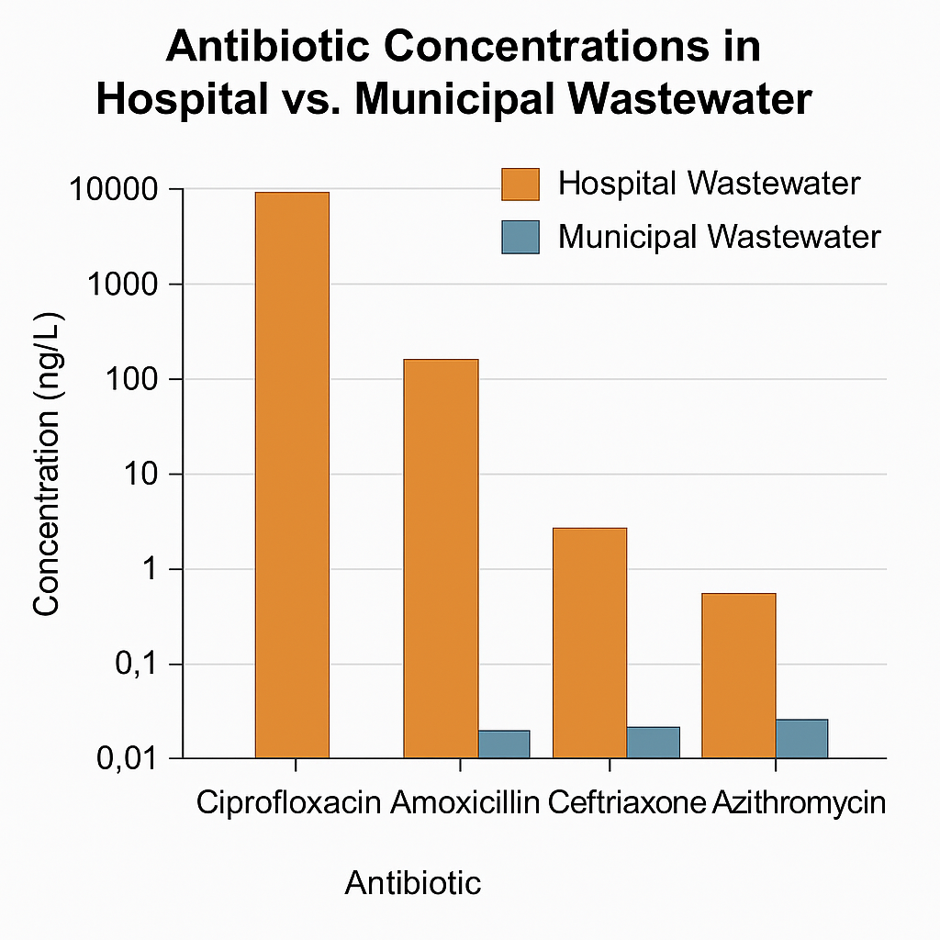
Figure 2. Antibiotic Concentrations in Hospital vs. Municipal Wastewater
Comparative bar chart showing measured concentrations (ng/L) of selected antibiotics, ciprofloxacin, amoxicillin, ceftriaxone, and azithromycin in hospital wastewater (orange) and municipal wastewater (blue). Data illustrate consistently higher antibiotic levels in hospital effluents, often exceeding predicted no-effect concentrations for resistance selection.

- Interactions & Ecological Impacts
The merging of pharmaceutical and hospital waste in urban wastewater systems creates complicated ecological interfaces where chemical and microbiological pollutants mix in ways that make antimicrobial resistance (AMR) selection and spread worse. Environmental selection pressure is the main part of this process. It is a long-term, non-lethal exposure of microbial communities to antimicrobial drugs. Antibiotics can stop bacteria that are sensitive to them from growing, even at levels that are far lower than what is needed for treatment. This lets resistant subpopulations grow. These sub-inhibitory levels are especially dangerous because they can cause stress responses, speed up mutation rates, and encourage the movement of resistance genes by horizontal gene transfer (HGT)[32].
In situations with mixed wastewater, the selection landscape is further influenced by co-contaminants such as heavy metals, disinfectants, and biocides, many of which apply co-selective pressure. For instance, metals like copper and zinc can help select for resistance genes that are on the same mobile genomic elements as antibiotic resistance determinants. This co-selection makes resistance genes last longer and spread more, even when there aren't a lot of antibiotics present.
The effects on ecosystems go beyond the wastewater matrix itself. When resistant bacteria and resistance genes are released into rivers, lakes, wetlands, or soils, they come into contact with a wide range of microbes in the environment. Transformation, transduction, and conjugation are horizontal gene transfer pathways that help ARG spread. Aquatic sediments and biofilms function as "hotspots" for horizontal gene transfer (HGT) due to their high microbial densities, stable microenvironments, and frequent physical interactions among cells. Genes that make bacteria resistant to β-lactams, fluoroquinolones, sulfonamides, and even last-resort drugs like colistin have been found in environmental isolates that are very far from clinical settings. This shows how far this ecological gene exchange may go[33,34].
The environmental resistome, which is made up of ARGs found in non-pathogenic bacteria, is a place where resistance can come back in human infections. Commensal or opportunistic bacteria in the environment can serve as genetic intermediates, facilitating the transfer of ARGs to pathogenic strains under selecting conditions. Wastewater treatment plants (WWTPs) can be important places for gene exchange to happen because they bring together heterogeneous microbial communities from different sources and put them under selective pressures from leftover antimicrobials[35].
Human health implications of these ecological interactions are significant. Resistant bacteria and ARGs can re-enter human populations through multiple pathways:
- Drinking water – Inadequate treatment or contamination of source water used for municipal supply can introduce ARGs and resistant bacteria directly into domestic systems.
- Recreational contact – Swimming, fishing, or other activities in contaminated waters can lead to direct exposure.
- Food chain – Irrigation with contaminated water can transfer ARGs to crop-associated microbiomes; seafood harvested from impacted waters may carry resistant bacteria.
- Occupational exposure – Workers in wastewater treatment, sanitation, and aquaculture may be repeatedly exposed to high levels of resistant microbes[36].
The public health burden encompasses more than just the danger of infection. Environmental ARG spread makes it harder to treat infections since it keeps bringing resistant characteristics into clinical settings all the time, which could make stewardship efforts less effective. Furthermore, the mobility of ARGs implies that even ephemeral environmental contamination incidents, such as combined sewage overflows or illicit industrial discharges can provide enduring effects on microbial communities and resistance dynamics[4].
In conclusion, the interactions between effluents, environmental microbiomes, and ecological processes form a feedback loop: human-made pollution favours resistance, environmental systems spread and diversity ARGs, and these ARGs return to human and animal populations. This interaction highlights the need for a unified One Health approach, acknowledging the interconnectedness of human, animal, and environmental health in combating AMR. Figure 3 shows how AMR transmission in urban ecosystems is self-reinforcing. It shows how resistant viruses move across environmental reservoirs, human hosts, and clinical settings through recurrent selection and exposure events[37].
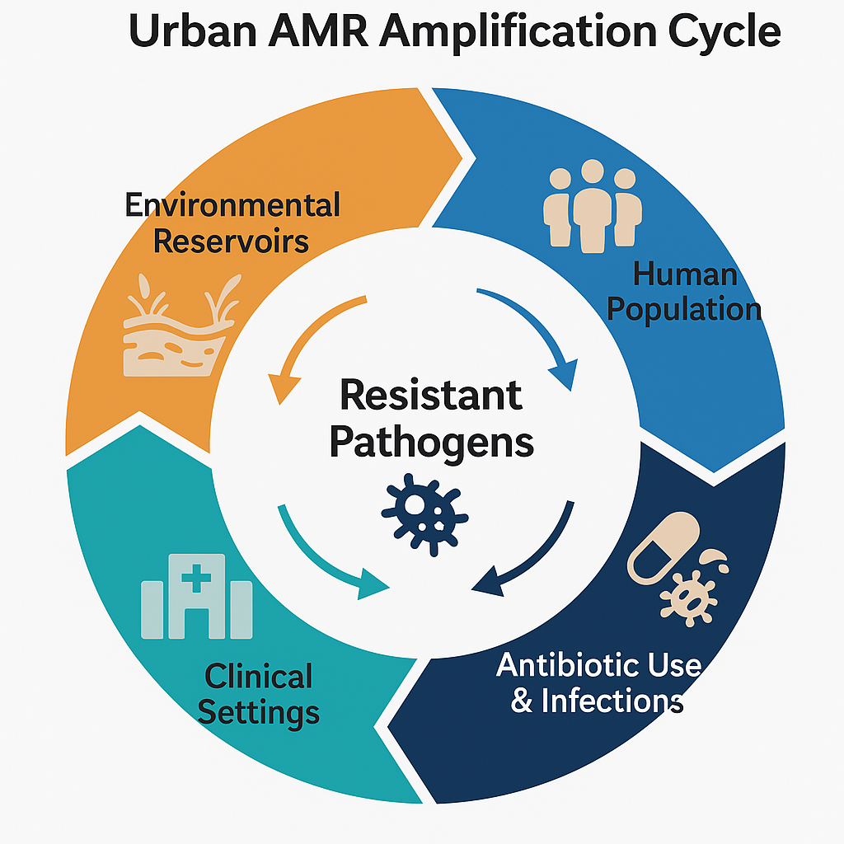
Figure 3. Urban AMR Amplification Cycle. Infographic illustrating the cyclical reinforcement of antimicrobial resistance (AMR) between environmental reservoirs, human populations, antibiotic use and infections, and clinical settings. Arrows indicate continuous feedback loops through which resistant pathogens and resistance genes circulate, amplifying AMR across urban ecosystems.
To summarize the major environmental pathways through which pharmaceutical and hospital effluents contribute to antimicrobial resistance in urban ecosystems, Table 1 presents the principal sources, contaminants, ecological impacts, and associated AMR risks identified in the reviewed literature.
Table 1. Major Sources of Effluent-Driven Antimicrobial Resistance in Urban Ecosystems
Source | Major Contaminants | Environmental Impact | AMR Risk
Pharmaceutical manufacturing effluents | Active pharmaceutical ingredients, particularly antibiotics, chemical intermediates, and antimicrobial residues | Elevated antibiotic concentrations in receiving waters, sediments, and soils; strong selection pressure on environmental microbiota | High
Hospital wastewater | Antibiotic residues, disinfectants, multidrug-resistant organisms, antimicrobial resistance genes | Introduction of clinically important resistance determinants into municipal wastewater systems | High
Municipal wastewater treatment plant effluents | Residual antibiotics, resistant bacteria, resistance genes, treated biosolids | Dissemination of resistance determinants into aquatic and terrestrial environments due to incomplete removal | High
Combined sewer overflows | Untreated sewage containing antibiotics and resistant microorganisms | Episodic release of concentrated contaminants into urban waterways during storm events | Moderate to High
Pharmaceutical disposal from households | Unused and expired medications are discharged into sewage systems | Continuous low-level contamination of urban water systems | Moderate
Landfill and dumpsite leachate | Pharmaceutical residues, antibiotics, and resistant bacteria | Contamination of surrounding soils, groundwater, and surface waters | Moderate
Agricultural reuse of wastewater and biosolids | Residual antimicrobials, resistant microorganisms, and resistance genes | Transfer of resistance determinants into agricultural soils and crop-associated microbiomes | High
Environmental reservoirs, including rivers, sediments, wetlands, and biofilms | Accumulated antibiotic residues and antimicrobial resistance genes | Amplification of resistance through microbial interactions and horizontal gene transfer | Very High

- Mitigation Strategies & Regulatory Responses
To stop antimicrobial resistance (AMR) caused by pharmaceutical and hospital waste, we need to use a combination of legislative, technological, and operational measures. Several countries have set or suggested guidelines for the release of antibiotics and resistant microorganisms into the environment, but these rules differ greatly in terms of their breadth and how strictly they are enforced. The Water Framework Directive of the European Union says that specific priority compounds must be monitored. Recent AMR action plans have also called for monitoring antibiotic residues and resistance genes in the environment[4]. In India, draft guidelines have put limitations on the levels of important antibiotics, like ciprofloxacin and azithromycin, that can be found in wastewater from pharmaceutical manufacturing. Sweden has taken a more cautious approach by using environmental risk assessments in its procurement procedures to push vendors to make greener products. But in most places across the world, there are not many legally binding limitations on effluent antibiotics, and hospital wastewater pretreatment standards are still the exception rather than the rule[6].
On the technological front, multiple advanced treatment options have demonstrated potential to reduce antibiotic loads and resistance gene abundance in effluents:
- Advanced oxidation processes (AOPs), including ozonation, photocatalysis, and Fenton-based methods, can degrade a broad spectrum of antibiotics and disrupt genetic material.
- Advanced filtration technologies, such as nanofiltration, reverse osmosis, and membrane bioreactors (MBRs), offer high removal efficiencies for both chemical residues and microbial contaminants.
- Constructed wetlands and hybrid ecological systems combine physical, chemical, and biological removal mechanisms, providing low-energy, adaptable solutions for decentralised hospital or pharmaceutical wastewater treatment[38].
Despite promising pilot and full-scale demonstrations, implementation is still not consistent. Some of the problems are expensive construction and operational costs, not enough technical know-how, and the fact that many cities don't have enforceable performance targets. Even when technologies are used, their effectiveness is frequently only measured by how well they remove chemicals, and not how they affect the number and movement of ARGs downstream[39].
Enforcement loopholes make mitigation even less effective. In a lot of low- and middle-income countries, limited resources make it hard to do frequent checks and make sure people are following the rules. There are still very few rules about how to get rid of old pharmaceuticals, and storm events can cause untreated bypasses in combined sewer systems. Additionally, worldwide pharmaceutical supply chains make it harder to hold people accountable because manufacturing hubs that serve global markets may not have as strict environmental rules as the countries that import them[40].
To fill these gaps, we need unified policy frameworks that include environmental AMR monitoring, required pre-discharge treatment for high-risk effluents, and rewards for clean manufacturing technology. In addition to teaching people how to properly dispose of medicine and working together across sectors under a One Health framework, these steps can greatly lower the environmental causes of AMR in cities [40].

- Conclusions
Pharmaceutical manufacturing effluents and hospital wastewater represent important environmental pathways through which antimicrobial residues, resistant microorganisms, and antimicrobial resistance genes may enter urban ecosystems. The manuscript shows that these waste streams can contribute to selective pressure in wastewater systems and receiving environments, particularly where treatment capacity is limited or where effluents are discharged without adequate pretreatment. Urban wastewater networks, treatment plants, surface waters, sediments, soils, and biofilms may support the persistence and exchange of resistance determinants, creating opportunities for resistant bacteria and resistance genes to circulate between environmental reservoirs and human populations. Although conventional wastewater treatment can reduce contaminant loads, it may not consistently remove antibiotic residues or resistance genes. Addressing this challenge requires strengthened environmental monitoring, improved hospital and pharmaceutical effluent management, scalable treatment technologies, safe disposal practices, and enforceable discharge standards. A One Health approach is necessary because the environmental dimensions of antimicrobial resistance are connected to human health, healthcare delivery, pharmaceutical production, water quality, and ecological integrity. Integrating environmental surveillance with public health and regulatory action may help reduce resistance amplification in urban ecosystems and support broader antimicrobial resistance control efforts.

Future Directions
Future research should also expand the application of wastewater-based epidemiology as a tool for monitoring population-level resistance trends and identifying environmental hotspots of resistance emergence. Advances in artificial intelligence, machine learning, and digital environmental monitoring systems offer promising opportunities to improve predictive risk assessment, optimize surveillance efforts, and support real-time decision-making. In addition, greater investment is needed in affordable and scalable wastewater treatment technologies designed specifically for low- and middle-income countries, where infrastructure limitations often increase environmental exposure risks.
From a governance perspective, stronger One Health frameworks are required to integrate environmental regulators, public health authorities, water utilities, healthcare institutions, and the pharmaceutical industry into coordinated antimicrobial resistance management strategies. Future policy development should prioritize enforceable discharge standards, environmental accountability across pharmaceutical supply chains, and international collaboration aimed at reducing the environmental burden of antimicrobial resistance.
By combining scientific innovation, technological advancement, environmental stewardship, and coordinated governance, urban ecosystems can be transformed from reservoirs of resistance amplification into critical components of global antimicrobial resistance prevention and control efforts.
Limitations
This review is limited by its narrative design and reliance on previously published studies and reports. Although the manuscript describes database searching and study selection, it does not provide a full reproducible search strategy, detailed screening records, quality appraisal, or formal risk-of-bias assessment. The included evidence covers diverse geographic settings, wastewater sources, analytical methods, and environmental conditions, which limits direct comparison across studies. Some reported concentrations, risk estimates, and case examples may vary according to sampling time, treatment infrastructure, detection methods, and local antibiotic-use patterns. The manuscript does not conduct meta-analysis or quantitatively pool findings. In addition, the review depends on available literature, and evidence from regions with limited environmental monitoring may be underrepresented. Future work should use standardized sampling, harmonized analytical methods, transparent study-selection procedures, and stronger linkage between environmental measurements and human exposure pathways.

Declarations

Competing Interests
The authors declare that they have no competing interests.

Ethical Approval and Consent to Participate
Not applicable. This study is a narrative review based exclusively on previously published literature and did not involve human participants, animals, or identifiable personal data.

Availability of Data and Materials
No new datasets were generated or analyzed during the current study. All information included in this review was obtained from publicly available published literature.

Artificial Intelligence Declaration
The authors acknowledge the use of artificial intelligence-assisted tools for language improvement, grammar checking, and manuscript organization during the preparation of this review. All scientific content, interpretation of evidence, conclusions, and final editorial decisions were developed, verified, and approved by the authors. The authors accept full responsibility for the accuracy, integrity, and originality of the manuscript.

Declaration of AI Use

This manuscript was prepared through the combined contributions of all author(s), including contributions to the study design, data, content development, results, interpretation, and related scholarly work. The author(s) acknowledge the use of Grammarly and ChatGPT to assist with grammar checking, language refinement, reference formatting. These AI-assisted tools were not used as authors and did not replace the intellectual contributions or scholarly judgment of the author(s). All AI-assisted outputs, including content, references, and interpretations, were carefully reviewed, revised, verified, and approved by the author(s). The author(s) accept full responsibility for the accuracy, integrity, and final content of the manuscript.

REFERENCES

1. Antimicrobial resistance [Internet]. [cited 2025 Aug 11]. Available from: https://www.who.int/news-room/fact-sheets/detail/antimicrobial-resistance
2. Hiew SY, Low BY. A systematic review of the knowledge, attitude, and practice of healthcare professionals and healthcare professional students towards household pharmaceutical waste disposal. Explor Res Clin Soc Pharm. 2024 Dec 19;17:100556. doi:10.1016/j.rcsop.2024.100556 PubMed PMID: 39877296; PubMed Central PMCID: PMC11773479.
3. Liu N, Zhang L, Xue H, Yang Z, Meng F. Sources, dissemination, and risk assessment of antibiotic resistance in surface waters: A review. Emerging Contaminants. 2025 Mar 1;11(1):100455. doi:10.1016/j.emcon.2024.100455
4. Salam MdA, Al-Amin MdY, Salam MT, Pawar JS, Akhter N, Rabaan AA, et al. Antimicrobial Resistance: A Growing Serious Threat for Global Public Health. Healthcare (Basel). 2023 Jul 5;11(13):1946. doi:10.3390/healthcare11131946 PubMed PMID: 37444780; PubMed Central PMCID: PMC10340576.
5. Tang KWK, Millar BC, Moore JE. Antimicrobial Resistance (AMR). Br J Biomed Sci. 2023 Jun 28;80:11387. doi:10.3389/bjbs.2023.11387 PubMed PMID: 37448857; PubMed Central PMCID: PMC10336207.
6. Muteeb G, Rehman MT, Shahwan M, Aatif M. Origin of Antibiotics and Antibiotic Resistance, and Their Impacts on Drug Development: A Narrative Review. Pharmaceuticals. 2023 Nov;16(11):11. doi:10.3390/ph16111615
7. Emamalipour M, Seidi K, Zununi Vahed S, Jahanban-Esfahlan A, Jaymand M, Majdi H, et al. Horizontal Gene Transfer: From Evolutionary Flexibility to Disease Progression. Front Cell Dev Biol. 2020 May 19;8:229. doi:10.3389/fcell.2020.00229 PubMed PMID: 32509768; PubMed Central PMCID: PMC7248198.
8. Sharma S, Mohler J, Mahajan SD, Schwartz SA, Bruggemann L, Aalinkeel R. Microbial Biofilm: A Review on Formation, Infection, Antibiotic Resistance, Control Measures, and Innovative Treatment. Microorganisms. 2023 Jun 19;11(6):1614. doi:10.3390/microorganisms11061614 PubMed PMID: 37375116; PubMed Central PMCID: PMC10305407.
9. Mehanni MM, Gadow SI, Alshammari FA, Modafer Y, Ghanem KZ, El-Tahtawi NF, et al. Antibiotic-resistant bacteria in hospital wastewater treatment plant effluent and the possible consequences of its reuse in agricultural irrigation. Front Microbiol. 2023 Apr 18;14:1141383. doi:10.3389/fmicb.2023.1141383 PubMed PMID: 37143530; PubMed Central PMCID: PMC10153669.
10. Jung YE, Jeong MM, Jun H, Smith T. Contemplation of Improvement Efforts to Manage Combined Sewer Overflows. Infrastructures. 2023 Oct;8(10):150. doi:10.3390/infrastructures8100150
11. Mutuku C, Gazdag Z, Melegh S. Occurrence of antibiotics and bacterial resistance genes in wastewater: resistance mechanisms and antimicrobial resistance control approaches. World J Microbiol Biotechnol. 2022;38(9):152. doi:10.1007/s11274-022-03334-0 PubMed PMID: 35781751; PubMed Central PMCID: PMC9250919.
12. Ripanda A, Rwiza MJ, Nyanza EC, Hossein M, Alfred MS, El Din Mahmoud A, et al. Ecological consequences of antibiotics pollution in sub-Saharan Africa: Understanding sources, pathways, and potential implications. Emerging Contaminants. 2025 Jun 1;11(2):100475. doi:10.1016/j.emcon.2025.100475
13. Ugoeze K, Alalor C, Ibezim C, Chinko B, Owonaro P, Anie C, et al. Environmental and Human Health Impact of Antibiotics Waste Mismanagement: A Review. Advances in Environmental and Engineering Research. 2024 Jan;5(1):1–21. doi:10.21926/aeer. 2401005
14. Gevao B, Uddin S, Krishnan D, Rajagopalan S, Habibi N. Antibiotics in Wastewater: Baseline of the Influent and Effluent Streams in Kuwait. Toxics. 2022 Apr 1;10(4):174. doi:10.3390/toxics10040174 PubMed PMID: 35448435; PubMed Central PMCID: PMC9025492.
15. Liu Y, Shi X, Chen X, Ding P, Zhang L, Yang J, et al. Spatial Distribution and Risk Assessment of Antibiotics in 15 Pharmaceutical Plants in the Pearl River Delta. Toxics. 2023 Apr 17;11(4):382. doi:10.3390/toxics11040382 PubMed PMID: 37112609; PubMed Central PMCID: PMC10143516.
16. Gomes MP. The Convergence of Antibiotic Contamination, Resistance, and Climate Dynamics in Freshwater Ecosystems. Water. 2024 Jan;16(18):2606. doi:10.3390/w16182606
17. Otoo BA, Amoabeng IA, Darko G, Borquaye LS. Antibiotic and analgesic residues in the environment – Occurrence and ecological risk study from the Sunyani municipality, Ghana. Toxicol Rep. 2022 Aug 7;9:1491–500. doi:10.1016/j.toxrep.2022.07.003 PubMed PMID: 36518454; PubMed Central PMCID: PMC9743463.
18. Shams DF, Izaz M, Khan W, Nayab S, Tawab A, Baig SA. Occurrence of selected antibiotics in urban rivers in northwest Pakistan and assessment of ecotoxicological and antimicrobial resistance risks. Chemosphere. 2024 Mar 1;352:141357. doi:10.1016/j.chemosphere.2024.141357
19. Wang J, Yan Z, Qiao Y, Liu D, Feng C, Bai Y. Distribution and Characterization of Typical Antibiotics in Water Bodies of the Yellow River Estuary and Their Ecological Risks. Toxics. 2023 Apr 23;11(5):400. doi:10.3390/toxics11050400 PubMed PMID: 37235215; PubMed Central PMCID: PMC10223483.
20. Pesce S, Kergoat L, Paris L, Billet L, Besse-Hoggan P, Bonnineau C. Contrasting Effects of Environmental Concentrations of Sulfonamides on Microbial Heterotrophic Activities in Freshwater Sediments. Front Microbiol. 2021 Nov 3;12:753647. doi:10.3389/fmicb.2021.753647 PubMed PMID: 34803976; PubMed Central PMCID: PMC8597937.
21. Wu J, Han Z, Ma X, Su M, Hamidian AH, Zhang Y, et al. A Database on Antibiotics and Antibiotic Resistance in Wastewater and Solid Waste from Pharmaceutical Industry Based on a Systematic Review. China CDC Wkly. 2025 Jan 17;7(3):92–100. doi:10.46234/ccdcw2025.015 PubMed PMID: 39867820; PubMed Central PMCID: PMC11757902.
22. Ortúzar M, Esterhuizen M, Olicón-Hernández DR, González-López J, Aranda E. Pharmaceutical Pollution in Aquatic Environments: A Concise Review of Environmental Impacts and Bioremediation Systems. Front Microbiol. 2022 Apr 26;13:869332. doi:10.3389/fmicb.2022.869332 PubMed PMID: 35558129; PubMed Central PMCID: PMC9087044.
23. Lawal O, Orenolu IO, Ajobiewe MA, Forson KAAM, Agu UF, Fidelix ME, et al. Hospital-Acquired Infections in the Age of Antimicrobial Resistance and Smart Surveillance. Australian Journal of Biomedical Research. 2025 Aug 16;1(1):aubm002. doi:10.63946/aubiomed/16759
24. Endalamaw K, Tadesse S, Asmare Z, Kebede D, Erkihun M, Abera B. Antimicrobial resistance profile of bacteria from hospital wastewater at two specialized hospitals in Bahir Dar city, Ethiopia. BMC Microbiol. 2024 Dec 19;24:525. doi:10.1186/s12866-024-03693-8 PubMed PMID: 39695370; PubMed Central PMCID: PMC11657465.
25. Hounmanou YMG, Houefonde A, Nguyen TT, Dalsgaard A. Mitigating antimicrobial resistance through effective hospital wastewater management in low- and middle-income countries. Front Public Health. 2025 Jan 29;12:1525873. doi:10.3389/fpubh.2024.1525873 PubMed PMID: 39944563; PubMed Central PMCID: PMC11816359.
26. Deedat FZ, Faya AM, Gumbi BP, Johnston DMG, Karpoormath R, Essack SY. The association between antibiotic use in hospitals and residual antibiotic concentrations in hospital effluents: a pilot study. JAC Antimicrob Resist. 2025 May 12;7(3):dlaf070. doi:10.1093/jacamr/dlaf070 PubMed PMID: 40356741; PubMed Central PMCID: PMC12066823.
27. Ekwanzala MD, Lehutso RF, Kasonga TK, Dewar JB, Momba MNB. Environmental Dissemination of Selected Antibiotics from Hospital Wastewater to the Aquatic Environment. Antibiotics (Basel). 2020 Jul 21;9(7):431. doi:10.3390/antibiotics9070431 PubMed PMID: 32708321; PubMed Central PMCID: PMC7400012.
28. Lawal OP, Babatunde JO, Owusu-Ansah S, Ani CP, Adegbesan AC, Hashim H, et al. Antibiogram and Molecular Characterization of Extended-Spectrum Beta-Lactamase-Producing Klebsiella pneumoniae in a Nigerian Teaching Hospital. Microbes, Infection and Chemotherapy. 2025 Mar 24;5:e2305–e2305. doi:10.54034/mic.e2305
29. Marathe NP, Berglund F, Razavi M, Pal C, Dröge J, Samant S, et al. Sewage effluent from an Indian hospital harbors novel carbapenemases and integron-borne antibiotic resistance genes. Microbiome. 2019 Jun 27;7:97. doi:10.1186/s40168-019-0710-x PubMed PMID: 31248462; PubMed Central PMCID: PMC6598227.
30. Conforti S, Holschneider A, Sylvestre É, Julian TR. Monitoring ESBL-Escherichia coli in Swiss wastewater between November 2021 and November 2022: insights into population carriage. mSphere. 9(5):e00760-23. doi:10.1128/msphere.00760-23 PubMed PMID: 38606968; PubMed Central PMCID: PMC11328990.
31. Punch R, Azani R, Ellison C, Majury A, Hynds PD, Payne SJ, et al. The surveillance of antimicrobial resistance in wastewater from a one health perspective: A global scoping and temporal review (2014–2024). One Health. 2025 Dec 1;21:101139. doi:10.1016/j.onehlt.2025.101139
32. Endale H, Mathewos M, Abdeta D. Potential Causes of Spread of Antimicrobial Resistance and Preventive Measures in One Health Perspective-A Review. Infect Drug Resist. 2023 Dec 8;16:7515–45. doi:10.2147/IDR.S428837 PubMed PMID: 38089962; PubMed Central PMCID: PMC10715026.
33. Ifedinezi OV, Nnaji ND, Anumudu CK, Ekwueme CT, Uhegwu CC, Ihenetu FC, et al. Environmental Antimicrobial Resistance: Implications for Food Safety and Public Health. Antibiotics. 2024 Nov;13(11):1087. doi:10.3390/antibiotics13111087
34. Murray S, Gale F, Adams D, Dalton L. A scoping review of the conceptualisations of food justice. Public Health Nutr. 26(4):725–37. doi:10.1017/S1368980023000101 PubMed PMID: 36682382; PubMed Central PMCID: PMC10131151.
35. Galgano M, Pellegrini F, Catalano E, Capozzi L, Del Sambro L, Sposato A, et al. Acquired Bacterial Resistance to Antibiotics and Resistance Genes: From Past to Future. Antibiotics. 2025 Mar;14(3):3. doi:10.3390/antibiotics14030222
36. Kusi J, Ojewole CO, Ojewole AE, Nwi-Mozu I. Antimicrobial Resistance Development Pathways in Surface Waters and Public Health Implications. Antibiotics (Basel). 2022 Jun 18;11(6):821. doi:10.3390/antibiotics11060821 PubMed PMID: 35740227; PubMed Central PMCID: PMC9219700.
37. Ma L chao, Zhao H qing, Wu LB, Cheng Z le, Liu C. Impact of the microbiome on human, animal, and environmental health from a One Health perspective. Sci One Health. 2023 Aug 25;2:100037. doi:10.1016/j.soh.2023.100037 PubMed PMID: 39077043; PubMed Central PMCID: PMC11262275.
38. Silva JA. Advanced Oxidation Process in the Sustainable Treatment of Refractory Wastewater: A Systematic Literature Review. Sustainability. 2025 Jan;17(8):3439. doi:10.3390/su17083439
39. Lawal O, Elechi K, Adekunle F, Farinde O, Kolapo T, Igbokwe C, et al. A Review on Artificial Intelligence and Point-of-Care Diagnostics to Combat Antimicrobial Resistance in Resource-Limited Healthcare Settings like Nigeria: Review Article. Journal of Pharma Insights and Research. 2025 Apr 5;3(2):2. doi:10.69613/reeh4906
40. Nyarko K, Whale J, Urmee T. Drivers and challenges of off-grid renewable energy-based projects in West Africa: A review. Heliyon. 2023 Jun 1;9(6):e16710. doi:10.1016/j.heliyon.2023.e16710

