Evaluation of Cytoplasmic and Stromal Components of Diseased Skin Tissue with Annatto Seed-Pigment Crude Extract

ABSTRACT
Background: Interest in natural dyes has expanded because of their biodegradability, low toxicity and widespread availability. Some components of natural dyes such as polyphenol which Bixa orellana (Annatto) has, exhibit high affinity for denatured and inflammatory proteins, a characteristic that enhances their binding in diseased tissues.
Aim: The research aimed to evaluate cytoplasmic and stromal components of diseased skin tissues with annatto seed-pigment crude extract.
Study Design: This was experimental research. The crude extracts prepared using 95% ethanol and acetone as solvents were compared with the conventional eosin counterstain. They were applied on skin tissue sections with established three histopathological diagnoses such as chronic granulomatous inflammation, lichen planus, and chronic spongiotic dermatitis.
Methodology: Pigment of Bixa orellana was extracted in 95% ethanol and acetone using maceration method, 100g of the seeds were soaked in 200ml of 95% ethanol and another 100g soaked in 200ml of acetone at 25ºC for 72 hours. Total of 90 archived skin tissue blocks were used-30 of chronic granulomatous inflammation, 30 of lichen planus, 30 of chronic spongiotic dermatitis. Phytochemicals of interest were determined using UV visible spectrophotometer and also stability of the extracts was conducted. The extracts were used to stain the tissues in comparison with standard eosin counterstain.
Results: Quantitative screening revealed polyphenol and carotenoids as two major components at the average of 67mg/ml and 27mg/ml respectively. Both 95% ethanol and acetone extracts were stable for a minimum of 8 weeks. Staining interaction showed that 95% ethanol extract performed better than acetone extract as counterstain but both are inferior to standard eosin. However, both extracts were able to demonstrate all the parameters. Comparative staining ability of Hematoxylin and Eosin (H&E), Hematoxylin with 95% Ethanol, and Hematoxylin with Acetone in chronic granulomatous inflammation, lichen planus and chronic spongiotic dermatitis using the Kruskal-Wallis test expressed in mean rank ± standard deviation and corresponding p values showed that H&E had the highest rank of 10.5, followed by hematoxylin and 95% ethanol at 6.5 and then hematoxylin and acetone at 3.5 with p˂0.05 which is statistically significant.
Conclusion: A new staining approach known as Hematoxylin and Annatto Seed Pigment Extract (ASPE) staining technique for use on skin diseases has been established. It only requires little modification. Its plant origin makes it environmentally friendly, and reduces dependence on imported synthetic dyes.
Keywords: Cytoplasm, stroma, skin, disease, counterstain, annatto, eosin, extract, crude

- INTRODUCTION
The skin is the largest organ of the integumentary system in human (Gaikwad et al., 2016) and has a surface area of 1.5–2 m², covering the surface of the human body. It is in direct contact with the external environment and protects us from environmental factors (Chambers & Vulmanovic-Stejic, 2020).

Though skin diseases are among the most frequently occurring illnesses of human, the specialized layers and the histochemical components adjourn greatly to support immune resilience for possible intendant approach to health within short time frame. Consequently, the histomorphology of the skin that covers any region contributes majorly against disease development as is said of cervix (Ndubuka et al., 2019a). The microscopic revelation of skin tissue constituents by mere staining with biological dyes establishes, confirms and gives supportive evidential characteristics of disease identification, development, differentiation, and possible prognosis to advice treatment and management (Ndubuka et al., 2019b)

Skin and subcutaneous disorders were the fourth leading cause of non-fatal disease burden worldwide in the last decade (Hay et al., 2010) with increasing prevalence (Verhoeven et al., 2008). Furthermore, studies have shown that a high proportion of skin lesions remain undiagnosed or incorrectly classified even after clinical and histological evaluation, reflecting significant clinicopathological discordance in dermatology (Tomislava et al., 2022; Patterson, 2016).
Histological stains are substances or biological dyes which colour tissue in order to aid optical differentiation of tissue component (Avwioro, 2010). Dyes are coloured substances which impact colour on materials such as textile, cosmetic, food, drugs, rubber plastics, hair, fur and tissues. There are two types of dyes, natural dyes and synthetic (Bhuyan & Salkia, 2005). Stains are prepared from dyes which have been manufactured to rigid specification or have been subjected to rigid quality assurance procedures to ensure that they are suitable for this specialized purpose.
Bixa orellana (Annatto) plant is popularly known as Achiote or lipstick tree. The Igbo in South Eastern Nigeria discovered it during Nigeria-Biafra war and used it then for cosmetic reasons and today, it has formed part of ornamental shrubs in the region. Central and South American populations used the seeds to colour their bodies and lips.).
Conventional hematoxylin and eosin (H&E) staining remains the standard technique for histopathological evaluation of skin tissues; however, eosin is synthetic, relatively costly, and environmentally hazardous (Suvarna et al., 2019). There is therefore an increasing need to explore safe, cost-effective, eco-friendly, and locally available alternatives that can provide comparable or improved cytoplasmic contrast for dermatopathological diagnosis (Yadav et al., 2020).
- MATERIALS AND METHODS

2.1 Study Area
The study was conducted at Anatomic Pathology Laboratory of University of Port Harcourt Teaching Hospital, Port Harcourt (UPTH), located in Alakahia, Rivers State, Nigeria.
Rivers State is bounded on the south by Atlantic Ocean, to the north by Imo and Abia states, to the east by Akwa Ibom and to the west by Bayelsa and Delta States.
The state lies on coordinates 4º 45’N 6 º 50’E. It covers a land mass of 11,077 square kilometers and has a population of 635 people per square kilometer.
UPTH is a tertiary healthcare facility that performs multiple functions in education, diagnosis, clinical treatment, research, referral of medical and health-related cases. Its host communities include Aluu, Alakahia, and Choba, situated within Ikwerre and Obio/Akpor Local Government Areas of Rivers State, with their administrative headquarters in Isiokpo and Rumuodomaya respectively.

The teaching hospital is a 1000-bed multi-specialist center dedicated to treatment, teaching, research and healthcare management. The hospital functions under its parent institution, University of Port Harcourt.

2.2 Study Design
This was as an experimental study. It was designed as to evaluate the staining performance of annatto (Bixa orellana) seed extracts prepared using 95% ethanol and acetone as solvents, in comparison with the conventional eosin counterstain. The study focused on skin tissue sections with established histopathological diagnoses such as chronic granulomatous inflammation, lichen planus, and chronic spongiotic dermatitis at University of Port Harcourt Teaching Hospital.
Grouping of Slides
For each disease, there were:
- Positive control group: The slides were stained with Mayers hematoxylin and eosin, where eosin was used as a standard counterstain.
- Experimental groups marked group A and group B and group C.
Group A represented Chronic granulomatous inflammation, which was stained with Mayers hematoxylin and 95% ethanol annatto seed crude extract, where the latter served as a counterstain and another slide stained with Mayers hematoxylin and acetone annatto seed crude extract, where the latter served as a counterstain.
Group B represented Lichen planus, which was stained with Mayers hematoxylin and 95% ethanol annatto seed crude extract, where the latter served as a counterstain and another slide stained with Mayers hematoxylin and acetone annatto seed crude extract, where the latter served as a counterstain.
Group C represented Chronic spongiotic dermatitis, which was stained with Mayers hematoxylin and 95% ethanol annatto seed crude extract, where the latter served as a counterstain and another slide stained with Mayers hematoxylin and acetone annatto seed crude extract, where the latter served as a counterstain.

Sample Size
90 skin tissue blocks were used, from which slides were produced which comprised 3 skin diseases, 3 staining techniques and 2 duplicates of each.
2.3 Eligibility Criteria
Inclusion Criteria
The study included formalin-fixed, paraffin-embedded skin biopsy specimens with confirmed histopathological diagnoses as skin diseases. Only tissue blocks with well-preserved epidermal and dermal components were included, and specimens that had been routinely processed using standard histopathological techniques prior to selection for the study.

Exclusion Criteria
Poorly fixed or autolyzed skin tissue samples, tissue sections that exhibited extensive processing artefacts, specimens with incomplete epidermal or dermal layers, and tissue blocks with insufficient material for repeat sectioning and staining were excluded from the study.

2.4 Plant Identification
The seeds were taken from a garden in Ubima, Rivers State and the plant taxonomic identification and assigning of specimen voucher number were carried out at the department of Plant Science and Biotechnology, Rivers State University, Port Harcourt. A voucher specimen number RSUPBH0196 was given by Dr. M.G. Ajuru.

2.5 Pigment Extraction and Phytochemical analysis procedure
The annatto seeds were properly cleaned to remove dirt and weighed. 100g of annatto seeds were soaked in 200ml of 95% ethanol. Another 100g of annatto seeds were soaked in 200ml of acetone. The extraction of pigment from annatto seeds (Bixa orellana) was done in 95% ethanol and acetone using maceration method for 3 days at room temperature, agitated occasionally (Rodriguez-Amaya, 2016). The extracts were filtered once with Whatman filter paper and stored in brown bottle ready for use. The pH of 95% ethanol extract and acetone extract was regulated to 5.8 and 4.5 respectively. 100g of the seeds were taken for extraction for phytochemical analysis. The sample was then prepared in accordance with ISO17025. Phytochemicals of interest were determined using the UV visible (UV-Visible 752pro) that operates with the principle of spectrophotometry via scan analysis with the wavelength range of 200-1100nm. At each wavelength, its adsorption was compared with the UV developed reference standard for phytochemicals. This enabled us to determine the phytochemicals present and their quantification was done with the help of the dilution factor using Beer-Lambert’s law which gave us the actual concentration which was expressed in mg/ml.

2.6 Stability Period Evaluation
The stability of annatto seed crude extracts of acetone and 95% ethanol was estimated by monitoring pigment stability through checking absorbance with UV-Vis spectrophotometer, testing pH with pH meter, sedimentation/separation by visual observation and odour by sensory perception (Scotter, 1995; Lawless & Heyman, 2010; McGuire,1992) over a period of 8 weeks at room temperature. The absorbance was done in triplicates and mean of the values taken. Percentage retention of pigment was calculated to assess stability.

2.7 Staining Procedure:
Positive Control: Hematoxylin and Eosin Staining
Paraffin-embedded tissue sections were first deparaffinized in xylene and rehydrated through a descending ethanol series, followed by rinsing in distilled water. Slides were then immersed in Mayers hematoxylin solution for 15 minutes to stain nuclei, before differentiation in 1% acid alcohol and bluing with ammonia water. Counterstaining was performed with eosin for 1 minute, to highlight cytoplasmic and stromal elements. Sections were dehydrated through ascending grades of alcohol concentrations, cleared in xylene, and mounted in DPX. See table 1

Table 1: Hematoxylin and Eosin Staining Technique
Step | Procedure | Reagent | Time
1. | Deparaffinization | Xylene | 5 minutes
2. | Deparaffinization | Xylene | 5 minutes
3. | Rehydration | 100% Ethanol | 3 minutes
4. | Rehydration | 90% Ethanol | 3 minutes
5. | Rehydration | 70% Ethanol | 3 minutes
6. | Rehydration | 50% Ethanol | 3 minutes
7. | Rehydration | Distilled water | 3 minutes
8. | Nuclear staining | Mayers hematoxylin | 15 minutes
9. | Washing | Running tap water | 3 minutes
10. | Differentiation | 1% acid alcohol | 3 seconds
11. | Washing | Running tap water | 3 minutes
12. | Counterstaining | Eosin | 1 minute
13. | Dehydration | 70% Ethanol | 2 minutes
14. | Dehydration | 90% Ethanol | 2 minutes
15. | Dehydration | 100% Ethanol | 2 minutes
16. | Dehydration | 100% Ethanol | 2 minutes
17. | Clearing | Xylene | 3 minutes
18 | Clearing | Xylene | 3 minutes
Experimental Group: Acetone Extract
Sections were freed from wax with xylene and brought to distilled water through descending grades of ethyl alcohol (100%, 90%, 70%, & 50%); stained with Mayer’s hematoxylin for 15 minutes and rinsed in running tap water. They were differentiated with 1% acid alcohol until only nuclei were stained, rinsed in running tap water and ‘blued’ in ammoniacal water for 1 minute. Furthermore, the sections were counterstained with Extract for 15 minutes, and then dehydrated in ascending grades of alcohol concentrations, cleared in xylene and mounted in DPX. See table.2

Table .2: Hematoxylin and Acetone Extract Staining Technique
Step | Procedure | Reagent | Time
1. | Deparaffinization | Xylene | 5 minutes
2. | Deparaffinization | Xylene | 5 minutes
3. | Rehydration | 100% Ethanol | 3 minutes
4. | Rehydration | 90% Ethanol | 3 minutes
5. | Rehydration | 70% Ethanol | 3 minutes
6. | Rehydration | 50% Ethanol | 3 minutes
7. | Rehydration | Distilled water | 3 minutes
8. | Nuclear staining | Mayers hematoxylin | 15 minutes
9. | Washing | Running tap water | 3 minutes
10. | Differentiation | 1% acid alcohol | 3 seconds
11. | Washing | Running tap water | 3 minutes
12. | Counterstaining | Acetone extract | 15 minutes
13. | Dehydration | 70% Ethanol | 2 minutes
14. | Dehydration | 90% Ethanol | 2 minutes
15. | Dehydration | 100% Ethanol | 2 minutes
16. | Dehydration | 100% Ethanol | 2 minutes
17. | Clearing | Xylene | 3 minutes
18 | Clearing | Xylene | 3 minutes

95% Ethanol Extract:
Sections were freed from wax with xylene and brought to distilled water through descending grades of ethyl alcohol (100%, 90%, 70%, & 50%); stained with Mayer’s hematoxylin for 15 minutes and rinsed in running tap water. They were differentiated with 1% acid alcohol until only nuclei were stained, rinsed in running tap water and ‘blued’ in ammoniacal water for 1 minute. Furthermore, the sections were counterstained with Extract for 15 minutes, then dehydrated through ascending grades of alcohol concentrations, cleared in xylene and mounted in DPX. See table 3

Table 3: Hematoxylin and 95% Ethanol Extract Staining Technique
Step | Procedure | Reagent | Time
1. | Deparaffinization | Xylene | 5 minutes
2. | Deparaffinization | Xylene | 5 minutes
3. | Rehydration | 100% Ethanol | 3 minutes
4. | Rehydration | 90% Ethanol | 3 minutes
5. | Rehydration | 70% Ethanol | 3 minutes
6. | Rehydration | 50% Ethanol | 3 minutes
7. | Rehydration | Distilled water | 3 minutes
8. | Nuclear staining | Mayers hematoxylin | 15 minutes
9. | Washing | Running tap water | 3 minutes
10. | Differentiation | 1% acid alcohol | 3 seconds
11. | Washing | Running tap water | 3 minutes
12. | Counterstaining | 95% Ethanol extract | 15 minutes
13. | Dehydration | 70% Ethanol | 2 minutes
14. | Dehydration | 90% Ethanol | 2 minutes
15. | Dehydration | 100% Ethanol | 2 minutes
16. | Dehydration | 100% Ethanol | 2 minutes
17. | Clearing | Xylene | 3 minutes
18 | Clearing | Xylene | 3 minutes

2.8 Statistical analysis
Data generated from the study were expressed as mean rank plus or minus standard deviation (SD). The scores were analyzed using SPSS version 24 (IBM, Armonk, NY, USA). Statistical significance was set at P ˂ 0.05 and results were presented in tabular format.

RESULTS
4.1 Quantitative Screening for Phytochemical Components in the Annatto Seed
Phytochemical analysis of annatto seed constituents reveals that there are two major components namely, polyphenol and carotenoids at the average of 67 mg/ml and 27 mg/ml respectively. Polyphenol contains phenolic acid, ligans, stibenes and phenol, while carotenoids contain alpha carotene, beta carotene and lycopene. Iso- rotenoids was absent as seen in table 4.

Table 4. Quantitative Screening for Phytochemical Components in the Annatto Seed
S/N. | Components | Qualitative | Quantitative (mg/ml)
1 | Polyphenol |  | 67.00
A | Phenolic Acid | +
B | Lignans | +
C | Stibenes | +
D | Phenol | +
2 | Carotenoids |  | 27.00
A | Alpha Carotene | +
B | Beta Carotene | +
C | Lycopene | +
D | Iso-rotenoids | -

Key for qualitative result:
+ Detected, - Not detected.

4.2 Evaluation of Stability Period of 95% Ethanol Extract
The study’s findings on the stability period of 95% ethanol extract as presented in Table 5, show stability of the extract over an 8-week observation period at storage temperature of 25ºC. The result indicates no measurable change in absorbance values at wavelength of 400nm, no observable change in colour intensity, no development of foul odour or rancid, minimal sedimentation and no variation in pH as it remained constant at 5.8. Stability assessment showed 100% pigment retention during the storage period with no measurable pigment change.
Absorbance measurement @ 400nm (week 1): 0.8157
Absorbance measurement @ 400nm (week 8): 0.8157
Δ Absorbance approximately 0.0000.

Table 5 Evaluation of Stability Period of 95% Ethanol Extract
Date | (Weeks)  Time Point | Storage Temperature (ºC) | Absorbance@400nm (mean) | Pigment Retention  (%) | pH | Sedimentation | Colour/Appearance | Odour
01-03-2025 | T₀ | 25 | 0.8157 | 100 | 5.8 | None | Brown-Orange | No rancid
08-03-2025 | T₁ | 25 | 0.8157 | 100 | 5.8 | Minimal | Same | No rancid
15-03-2025 | T₂ | 25 | 0.8157 | 100 | 5.8 | Minimal | Same | No rancid
22-03-2025 | T₃ | 25 | 0.8157 | 100 | 5.8 | Minimal | Same | No rancid
29-03-2025 | T₄ | 25 | 0.8157 | 100 | 5.8 | Minimal | Same | No rancid
05-04-2025 | T₅ | 25 | 0.8157 | 100 | 5.8 | Minimal | Same | No rancid
12-04-2025 | T₆ | 25 | 0.8157 | 100 | 5.8 | Minimal | Same | No rancid
19-04-2025 | T₇ | 25 | 0.8157 | 100 | 5.8 | Minimal | Same | No rancid
26-04-2025 | T₈ | 25 | 0.8157 | 100 | 5.8 | Minimal | Same | No rancid

Time
T0 = Immediately after extraction
T1 = 1 week
T2 = 2 weeks
T3 = 3 weeks
T4 = 4 weeks
T5 = 5 weeks
T6 = 6 weeks
T7 = 7 weeks
T8 = 8 weeks

Evaluation of Stability Period of Acetone Extract
The study’s findings on the stability period of acetone extract as presented in Table 6, show stability of the extract over an eight-week observation period at storage temperature of 25ºC. The result indicates minimal absorbance value variation at wavelength of 400nm, no observable change in colour intensity, no development of foul odour or rancid, minimal sedimentation and no variation in pH as it remained constant at 4.5. Stability assessment showed 99.97% pigment retention during the storage period with 0.03% observed pigment decrease.
Absorbance measurement @400nm (week 1): 0.9990
Absorbance measurement @400nm (week 8): 0.9987
Δ Absorbance: 0.003.
0.03% observed decrease

Table 6 Evaluation of Stability Period of Acetone Extract

Date | (Weeks)  Time Point | Storage Temperature (ºC) | Absorbance@400nm (mean) | Pigment Retention  (%) | pH | Sedimentation | Colour/Appearance | Odour
01-03-2025 | T₀ | 25 | 0.9990 | 100 | 4.5 | None | Dark brown-orange | No rancid
08-03-2025 | T₁ | 25 | 0.9990 | 100 | 4.5 | Minimal | Same | No rancid
15-03-2025 | T₂ | 25 | 0.9990 | 100 | 4.5 | Minimal | Same | No rancid
22-03-2025 | T₃ | 25 | 0.9990 | 100 | 4.5 | Minimal | Same | No rancid
29-03-2025 | T₄ | 25 | 0.9990 | 100 | 4.5 | Minimal | Same | No rancid
05-04-2025 | T₅ | 25 | 0.9990 | 100 | 4.5 | Minimal | Same | No rancid
12-04-2025 | T₆ | 25 | 0.9990 | 100 | 4.5 | Minimal | Same | No rancid
19-04-2025 | T₇ | 25 | 0.9990 | 100 | 4.5 | Minimal | Same | No rancid
26-04-2025 | T₈ | 25 | 0.9987 | 99.97 | 4.5 | Minimal | Same | No rancid

Time
T0 = Immediately after extraction
T1 = 1 week
T2 = 2 weeks
T3 = 3 weeks
T4 = 4 weeks
T5 = 5 week
T6 = 6 weeks
T7 = 7 weeks
T8=8weeks
Comparative Analysis of The Three Staining Techniques on Chronic Granulomatous Inflammation Using Kruskal Wallis Test
Table 7 presents the comparative staining ability of Hematoxylin and Eosin (H&E), Hematoxylin with 95% Ethanol, and Hematoxylin with Acetone in chronic granulomatous inflammation using the Kruskal-Wallis test. The results are expressed as mean rank ± standard deviation, alongside chi-square (χ²) values and corresponding p-values. For nuclear clarity, H&E demonstrated the highest mean rank (10.5 ± 0.2), followed by hematoxylin & 95% ethanol (6.5 ± 0.12), while hematoxylin & acetone showed the lowest (2.5 ± 0.01). The Kruskal-Wallis test revealed a statistically significant difference among the groups (χ² = 12.0, p = 0.004), indicating superior nuclear definition with H&E staining. Similarly, in cytoplasmic staining, H&E recorded the highest mean rank (10.5 ± 0.2), compared to hematoxylin & 95% ethanol (6.5 ± 0.3) and hematoxylin & acetone (2.5 ± 0.2), with a significant difference observed (χ² = 12.0, p = 0.005). In terms of stromal staining, H&E again exhibited the highest mean rank (10.5 ± 0.01), followed by hematoxylin & 95% ethanol (6.5 ± 0.00) and hematoxylin & acetone (2.5 ± 0.004), with a statistically significant variation (χ² = 12.0, p = 0.004). For nuclear-cytoplasmic contrast, H&E maintained the highest ranking (10.5 ± 0.02), while hematoxylin & 95% ethanol and hematoxylin & acetone had mean ranks of 5.5 ± 0.00 and 3.5 ± 0.05 respectively, with a significant difference (χ² = 8.0, p = 0.009). Likewise, tissue morphology preservation showed H&E with the highest mean rank (10.5 ± 0.023), followed by hematoxylin & 95% ethanol (5.5 ± 0.009) and hematoxylin & acetone (3.5 ± 0.05), with significant differences (χ² = 12.0, p = 0.009). For staining uniformity, H&E recorded the highest mean rank (10.5 ± 0.1), compared to hematoxylin & 95% ethanol (5.5 ± 0.087) and hematoxylin & acetone (3.5 ± 0.04), with the Kruskal-Wallis test indicating statistical significance (χ² = 8.0, p = 0.009). In assessing pathologic features, H&E also ranked highest (10.5 ± 0.08), followed by hematoxylin & 95% ethanol (6.5 ± 0.012) and hematoxylin & acetone (2.5 ± 0.032), with a significant difference (χ² = 12.0, p = 0.004). Finally, for background clarity, H&E showed superior performance (10.5 ± 0.032), compared to hematoxylin & 95% ethanol (5.5 ± 0.015) and hematoxylin & acetone (3.5 ± 0.059), with a statistically significant difference (χ² = 12.0, p = 0.009).

Table 7 Comparative Analysis of the Three Staining Techniques on Chronic Granulomatous Inflammation Using Kruskal Wallis Test

Parameter | Staining Technique | Mean Rank | Standard Deviation | Chi-Square value | P value of Kruskal Wallis Test
Nuclear clarity | Hematoxylin & Eosin | 10.5 | 0.2
 | Hematoxylin & 95% Ethanol | 6.5 | 0.12 | 12.0 | 0.004
 | Hematoxylin & Acetone | 2.5 | 0.01
Cytoplasmic staining | Hematoxylin & Eosin | 10.5 | 0.2
 | Hematoxylin & 95% Ethanol | 6.5 | 0.3 | 12.0 | 0.005
 | Hematoxylin & Acetone | 2.5 | 0.2
Stromal staining | Hematoxylin & Eosin | 10.5 | 0.01
 | Hematoxylin & 95% Ethanol | 6.5 | 0.00 | 12.0 | 0.004
 | Hematoxylin & Acetone | 2.5 | 0.004
Nuclear cytoplasmic contrast | Hematoxylin & Eosin | 10.5 | 0.02
 | Hematoxylin & 95% Ethanol | 5.5 | 0.00 | 8.0 | 0.009
 | Hematoxylin & Acetone | 3.5 | 0.05
Tissue morphology preservation | Hematoxylin & Eosin | 10.5 | 0.023
 | Hematoxylin & 95% Ethanol | 5.5 | 0.009 | 12.0 | 0.009
 | Hematoxylin & Acetone | 3.5 | 0.05
Staining uniformity | Hematoxylin & Eosin | 10.5 | 0.1
 | Hematoxylin & 95% Ethanol | 5.5 | 0.087 | 8.0 | 0.009
 | Hematoxylin & Acetone | 3.5 | 0.04
Pathologic features | Hematoxylin & Eosin | 10.5 | 0.08
 | Hematoxylin & 95% Ethanol | 6.5 | 0.012 | 12.0 | 0.004
 | Hematoxylin & Acetone | 2.5 | 0.032
Background clarity | Hematoxylin & Eosin | 10.5 | 0.032
 | Hematoxylin & 95% Ethanol | 5.5 | 0.015 | 12.0 | 0.009
 | Hematoxylin & Acetone | 3.5 | 0.059

NOTE: Values are statistically significant at P˂0.05, the higher the mean rank the higher the staining ability

Comparative Analysis of the Three Staining Techniques on Lichen Planus Using Kruskal Wallis Test
Table 8 presents the comparative staining performance of Hematoxylin and Eosin (H&E), Hematoxylin with 95% Ethanol, and Hematoxylin with Acetone in lichen planus using the Kruskal-Wallis test, with results expressed as mean rank ± standard deviation, alongside chi-square (χ²) values and corresponding p-values. For nuclear clarity, H&E exhibited the highest mean rank (10.5 ± 0.05), followed by hematoxylin & 95% ethanol (6.0 ± 0.01), while hematoxylin & acetone recorded the lowest (3.0 ± 0.01). The observed difference was statistically significant (χ² = 8.0, p = 0.009), indicating superior nuclear visualization with H&E. Similarly, in cytoplasmic staining, H&E showed the highest mean rank (10.5 ± 0.5), compared to Hematoxylin & 95% ethanol (6.5 ± 0.7) and hematoxylin & acetone (2.5 ± 0.3), with a significant difference among groups (χ² = 8.0, p = 0.005). In stromal staining, H&E maintained the highest mean rank (10.5 ± 0.21), followed by hematoxylin & 95% ethanol (6.0 ± 0.010) and Hematoxylin & acetone (3.0 ± 0.014), with statistical significance observed (χ² = 8.0, p = 0.009). For nuclear–cytoplasmic contrast, H&E again ranked highest (10.5 ± 0.01), while hematoxylin & 95% ethanol and Hematoxylin & acetone had mean ranks of 5.5 ± 0.02 and 3.5 ± 0.05 respectively, with a significant difference (χ² = 12.0, p = 0.009). Similarly, tissue morphology preservation showed H&E with the highest mean rank (10.5 ± 0.03), followed by hematoxylin & 95% ethanol (6.5 ± 0.010) and hematoxylin & acetone (2.5 ± 0.05), with statistically significant variation (χ² = 12.0, p = 0.004). For staining uniformity, H&E recorded the highest mean rank (10.5 ± 0.12), compared to hematoxylin & 95% ethanol (5.5 ± 0.087) and hematoxylin & acetone (3.5 ± 0.04), with a significant difference among groups (χ² = 12.0, p = 0.010). In evaluating pathologic features, H&E again demonstrated superior performance (10.5 ± 0.08), followed by hematoxylin & 95% ethanol (6.5 ± 0.012) and hematoxylin & acetone (2.5 ± 0.032), with statistical significance (χ² = 12.0, p = 0.004). Lastly, for background clarity, H&E showed the highest mean rank (10.5 ± 0.032), while hematoxylin & 95% ethanol (6.5 ± 0.015) and hematoxylin & acetone (2.5 ± 0.059) recorded lower values, with a significant difference (χ² = 12.0, p = 0.004).

Table 8 Comparative Analysis of The Three Staining Techniques on Lichen Planus Using Kruskal Wallis Test
Parameter | Staining Technique | Mean Rank | Standard Deviation | Chi-Square value | P value of Kruskal Wallis Test
Nuclear clarity | Hematoxylin & Eosin | 10.5 | 0.05
 | Hematoxylin & 95% Ethanol | 6.0 | 0.01 | 8.0 | 0.009
 | Hematoxylin & Acetone | 3.0 | 0.01
Cytoplasmic staining | Hematoxylin & Eosin | 10.5 | 0.5
 | Hematoxylin & 95% Ethanol | 6.5 | 0.7 | 8.0 | 0.005
 | Hematoxylin & Acetone | 2.5 | 0.3
Stromal staining | Hematoxylin & Eosin | 10.5 | 0.21
 | Hematoxylin & 95% Ethanol | 6.0 | 0.010 | 8.0 | 0.009
 | Hematoxylin & Acetone | 3.0 | 0.014
Nuclear cytoplasmic contrast | Hematoxylin & Eosin | 10.5 | 0.01
 | Hematoxylin & 95% Ethanol | 5.5 | 0.02 | 12.0 | 0.009
 | Hematoxylin & Acetone | 3.5 | 0.05
Tissue morphology preservation | Hematoxylin & Eosin | 10.5 | 0.03
 | Hematoxylin & 95% Ethanol | 6.5 | 0.010 | 12.0 | 0.004
 | Hematoxylin & Acetone | 2.5 | 0.05
Staining uniformity | Hematoxylin & Eosin | 10.5 | 0.12
 | Hematoxylin & 95% Ethanol | 5.5 | 0.087 | 12.0 | 0.010
 | Hematoxylin & Acetone | 3.5 | 0.04
Pathologic features | Hematoxylin & Eosin | 10.5 | 0.08
 | Hematoxylin & 95% Ethanol | 6.5 | 0.012 | 12.0 | 0.004
 | Hematoxylin & Acetone | 2.5 | 0.032
Background clarity | Hematoxylin & Eosin | 10.5 | 0.032
 | Hematoxylin & 95% Ethanol | 6.5 | 0.015 | 12.0 | 0.004
 | Hematoxylin & Acetone | 2.5 | 0.059

NOTE: Values are statistically significant at P˂0.05, the higher the mean rank the higher the staining ability
Comparative Analysis of The Three Staining Techniques on Chronic Spongiotic Dermatitis Using Kruskal Wallis Test
Table 9 presents the comparative staining ability of Hematoxylin and Eosin (H&E), Hematoxylin with 95% Ethanol, and Hematoxylin with Acetone in chronic spongiotic dermatitis using the Kruskal-Wallis test. The results are expressed as mean rank ± standard deviation, with corresponding chi-square (χ²) values and p-values. For nuclear clarity, H&E recorded the highest mean rank (10.5 ± 0.2), followed by hematoxylin & 95% ethanol (6.5 ± 0.12), while hematoxylin & acetone showed the lowest (2.5 ± 0.01). This difference was statistically significant (χ² = 12.0, p = 0.004), indicating superior nuclear staining with H&E. Similarly, in cytoplasmic staining, H&E demonstrated the highest mean rank (10.5 ± 0.2), compared to hematoxylin & 95% ethanol (6.5 ± 0.3) and hematoxylin & acetone (2.5 ± 0.2), with a significant difference among groups (χ² = 12.0, p = 0.004). In stromal staining, H&E again showed the highest mean rank (10.5 ± 0.01), followed by hematoxylin & 95% ethanol (6.5 ± 0.00) and hematoxylin & acetone (2.5 ± 0.004), with a statistically significant difference (χ² = 12.0, p = 0.005). For nuclear-cytoplasmic contrast, H&E maintained the highest ranking (10.5 ± 0.02), while hematoxylin & 95% ethanol and hematoxylin & acetone recorded mean ranks of 5.5 ± 0.00 and 3.5 ± 0.05 respectively, with a significant difference (χ² = 12.0, p = 0.009). Likewise, tissue morphology preservation showed H&E with the highest mean rank (10.5 ± 0.023), followed by hematoxylin & 95% ethanol (6.5 ± 0.009) and hematoxylin & acetone (2.5 ± 0.05), with statistical significance observed (χ² = 12.0, p = 0.004). For staining uniformity, H&E recorded the highest mean rank (10.5 ± 0.1), compared to hematoxylin & 95% ethanol (6.5 ± 0.087) and hematoxylin & acetone (2.5 ± 0.04), with a significant difference among groups (χ² = 8.0, p = 0.005). In assessing pathologic features, H&E again ranked highest (10.5 ± 0.08), followed by hematoxylin & 95% ethanol (6.5 ± 0.012) and hematoxylin & acetone (2.5 ± 0.032), with statistical significance (χ² = 12.0, p = 0.004). Finally, for background clarity, H&E demonstrated the highest mean rank (10.5 ± 0.032), compared to hematoxylin & 95% ethanol (6.0 ± 0.015) and hematoxylin & acetone (3.0 ± 0.059), with a significant difference (χ² = 8.0, p = 0.009).

Table 9 Comparative Analysis of The Three Staining Technique on Chronic Spongiotic Dermatitis Using Kruskal Wallis Test
Parameter | Staining Technique | Mean Rank | Standard Deviation | Chi-Square value | P value of Kruskal Wallis Test
Nuclear clarity | Hematoxylin & Eosin | 10.5 | 0.2
 | Hematoxylin & 95% Ethanol | 6.5 | 0.12 | 12.0 | 0.004
 | Hematoxylin & Acetone | 2.5 | 0.01
Cytoplasmic staining | Hematoxylin & Eosin | 10.5 | 0.2
 | Hematoxylin & 95% Ethanol | 6.5 | 0.3 | 12.0 | 0.004
 | Hematoxylin & Acetone | 2.5 | 0.2
Stromal staining | Hematoxylin & Eosin | 10.5 | 0.01
 | Hematoxylin & 95% Ethanol | 6.5 | 0.00 | 12.0 | 0.005
 | Hematoxylin & Acetone | 2.5 | 0.004
Nuclear-cytoplasmic contrast | Hematoxylin & Eosin | 10.5 | 0.02
 | Hematoxylin & 95% Ethanol | 5.5 | 0.00 | 12.0 | 0.009
 | Hematoxylin & Acetone | 3.5 | 0.05
Tissue morphology preservation | Hematoxylin & Eosin | 10.5 | 0.023
 | Hematoxylin & 95% Ethanol | 6.5 | 0.009 | 12.0 | 0.004
 | Hematoxylin & Acetone | 2.5 | 0.05
Staining uniformity | Hematoxylin & Eosin | 10.5 | 0.1
 | Hematoxylin & 95% Ethanol | 6.5 | 0.087 | 8.0 | 0.005
 | Hematoxylin & Acetone | 2.5 | 0.04
Pathologic features | Hematoxylin & Eosin | 10.5 | 0.08
 | Hematoxylin & 95% Ethanol | 6.5 | 0.012 | 12.0 | 0.004
 | Hematoxylin & Acetone | 2.5 | 0.032
Background clarity | Hematoxylin & Eosin | 10.5 | 0.032 | 8.0
 | Hematoxylin & 95% Ethanol | 6.0 | 0.015 |  | 0.009
 | Hematoxylin & Acetone | 3.0 | 0.059
NOTE: Values are statistically significant at P˂0.05, the higher the mean rank the higher the staining ability
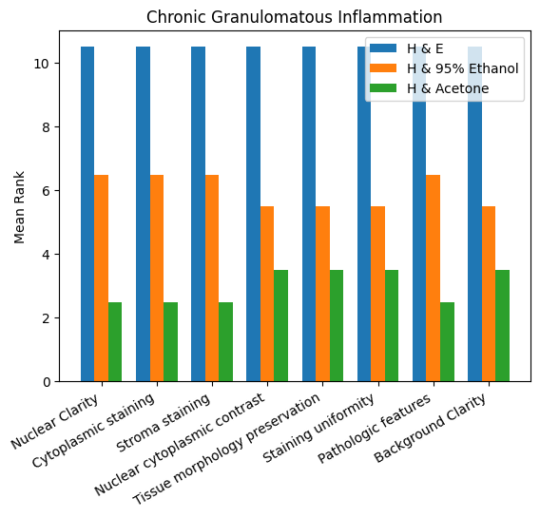
Figure 1 Bar Chart of the Three Staining Techniques on Chronic Granulomatous Inflammation

The chart illustrates a comparative analysis of the staining ability of Hematoxylin and Eosin (H&E), Hematoxylin with 95% Ethanol, and Hematoxylin with Acetone across various histological parameters in chronic granulomatous inflammation. H&E consistently shows the highest mean rank across all parameters, including nuclear clarity, cytoplasmic staining, stromal staining, nuclear cytoplasmic contrast, tissue morphology preservation, staining uniformity, pathologic features, and background clarity, indicating superior staining performance. hematoxylin with 95% ethanol demonstrates moderate effectiveness, while hematoxylin with acetone consistently records the lowest mean ranks. Overall, the chart clearly highlights H&E as the most effective staining method, followed by ethanol-extract staining, with acetone-extract staining being the least effective across all evaluated parameters.

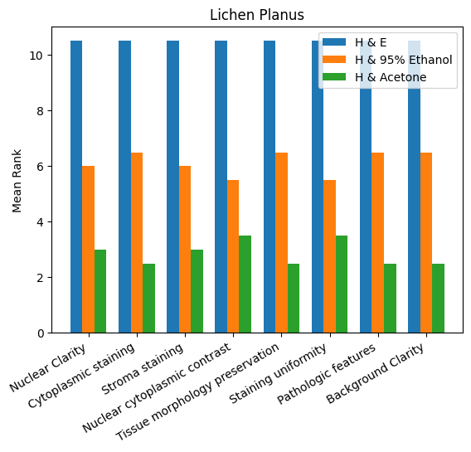
Figure 2 Bar Chart of the Three Staining Techniques on Lichen Planus

The chart illustrates a comparative analysis of the staining ability of Hematoxylin and Eosin (H&E), Hematoxylin with 95% Ethanol, and Hematoxylin with Acetone across various histological parameters in lichen planus. H&E consistently shows the highest mean rank across all parameters, including nuclear clarity, cytoplasmic staining, stromal staining, nuclear cytoplasmic contrast, tissue morphology preservation, staining uniformity, pathologic features, and background clarity, indicating superior staining performance. Hematoxylin with 95% ethanol demonstrates moderate effectiveness, while hematoxylin with acetone consistently records the lowest mean ranks. Overall, the chart clearly highlights H&E as the most effective staining method, followed by ethanol-extract staining, with acetone-extract staining being the least effective across all evaluated parameters.

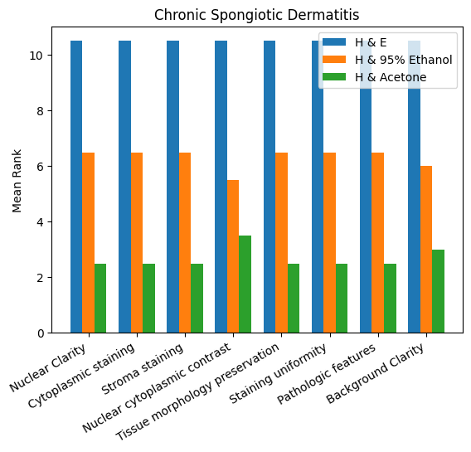
Figure.3 Bar Chart of the Three Staining Techniques on Chronic Spongiotic Dermatitis

The chart illustrates a comparative analysis of the staining ability of Hematoxylin and Eosin (H&E), Hematoxylin with 95% Ethanol, and Hematoxylin with Acetone across various histological parameters in chronic spongiotic dermatitis. H&E consistently shows the highest mean rank across all parameters, including nuclear clarity, cytoplasmic staining, stroma staining, nuclear cytoplasmic contrast, tissue morphology preservation, staining uniformity, pathologic features, and background clarity, indicating superior staining performance. Hematoxylin with 95% ethanol demonstrates moderate effectiveness, while hematoxylin with acetone consistently records the lowest mean ranks. Overall, the chart clearly highlights H&E as the most effective staining method, followed by ethanol-extract staining, with acetone-extract staining being the least effective across all evaluated parameters.

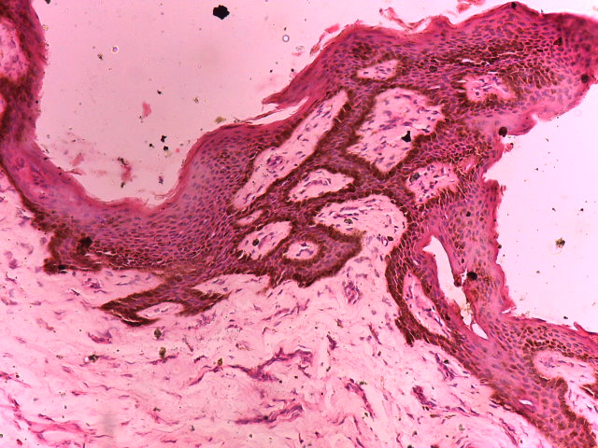
Figure.4 Photomicrograph of a Skin section diagnosed as Chronic Granulomatous Inflammation and stained with Hematoxylin and Eosin showed acanthosis and epidermolysis in a typical papillary fashion with clear nucleo-cytoplasmic differentiation in epidermis (red arrows) and dermis (black arrows). (H&E x100).

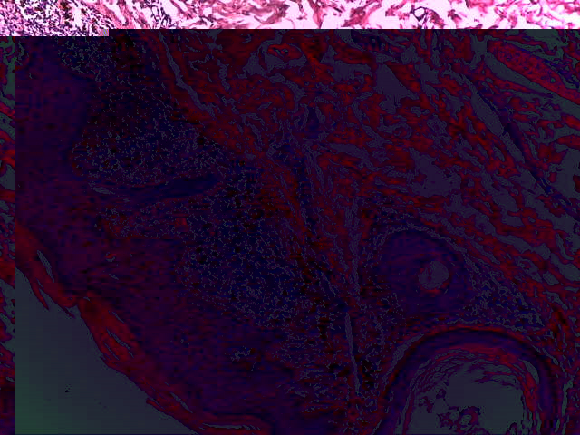
Figure.5 Photomicrograph Section of skin tissue with Lichen Planus with papilloma, nevus, cyst formation and mononuclear cell infiltration. The section showed clear stained tissue with well differentiated nucleus and cytoplasm cellularly and well delineated epidermis (blue arrows) and dermal structures (red arrows), (H&Ex400).

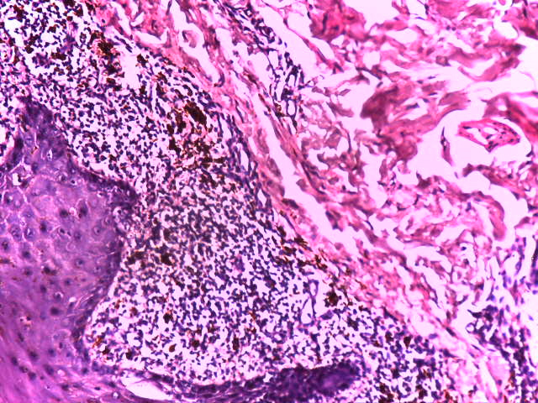
A
A
B
c
c
Figure.6. Photomicrograph section of skin tissue with chronic spongiotic dermatitis. The hematoxylin stain demonstrated clear nuclear cytoplasmic differentiation with refractive intensity between the nucleus and cytoplasm cellularly with melanocytic infiltration (blue arrows) and between the epidermis and dermis structurally showing spongiosis and hyperkeratosis. (H&E x400).

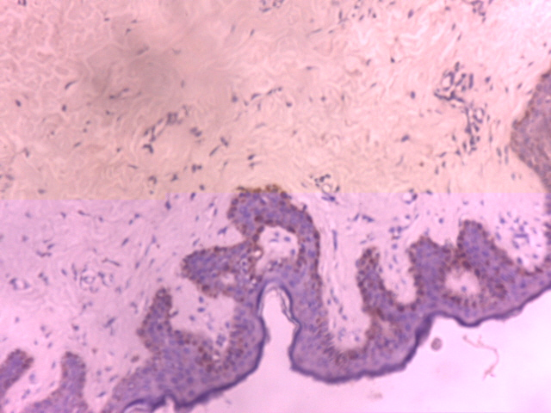
F

Figure 7 Photomicrograph of a skin section showing Chronic Granulomatous Inflammation stained with Hematoxylin and counterstained with 95% Ethanol crude Extract of Annatto seed. Section showed epidermal acanthosis (black arrows) at the epidermis but poor dermal structures expression (red arrows). (H & 95% Ethanol Extract x100).

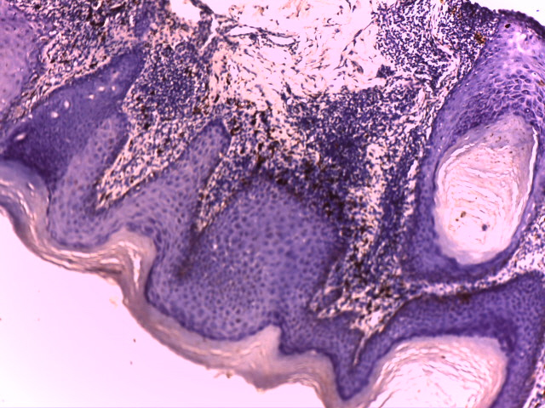
Figure.8. Photomicrograph of a section of Skin tissue from a patient with Lichen Planus. Section showed the epidermis with well demonstrated hyper keratinization (blue arrows) and pigmentation in the stratified epithelial tissue with infiltration of melanocytes (red arrows) and myxoid dermis (green arrows) with focal thinning and thickened granular layer (yellow arrow) with irregular epidermal hyperplasia. (H & 95% Ethanol Extract x400).

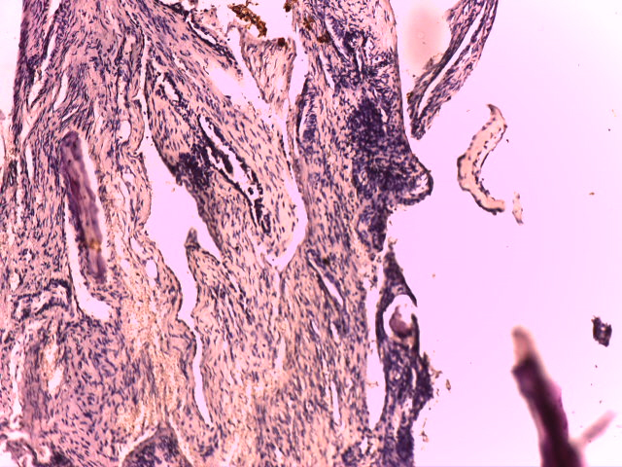
Figure.9 Photomicrograph of a section of Skin tissue from a patient with Chronic Spongiotic Dermatitis. Section showed dermal elements with fluid collection (blue arrows). (H & 95% Ethanol x100)
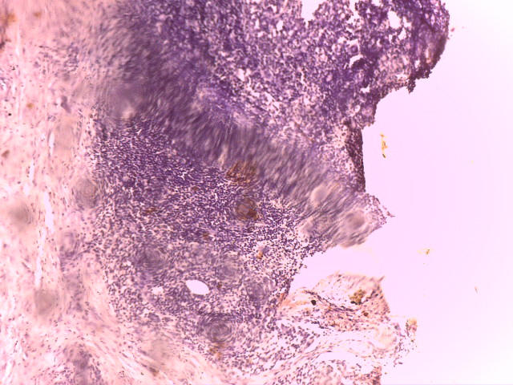
Figure 10 Photomicrograph of a section of skin tissue from a patient with Chronic Granulomatous Inflammation. Section showed granuloma dermal reaction (blue arrows). (H & Acetone Extract x100)

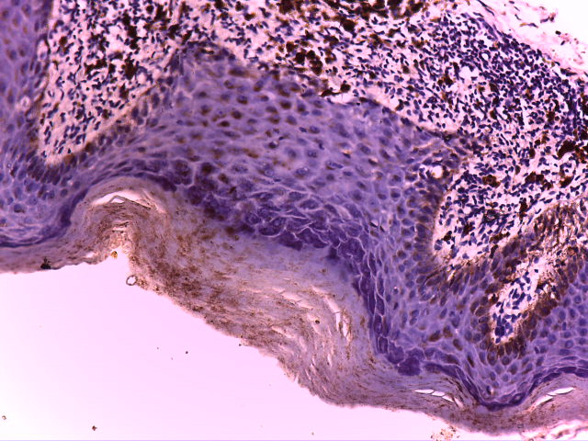
Figure.11 Photomicrograph of a section of skin tissue taken from a patient with Lichen planus. Section showed thickened epidermal layer with hyperkeratosis (black arrow) and infiltration of melanin pigments in keratinocytes. There is also infiltration of melanocytes at the hypodermis and epithelial tissue hyper-keratinization (red arrows), (H &Acetone x400)

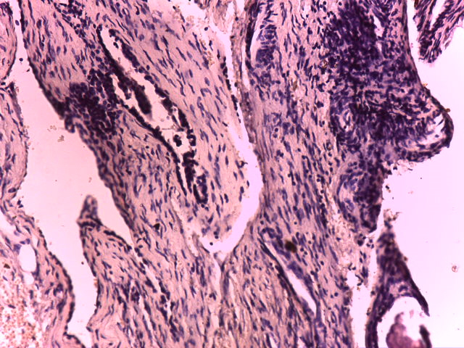
Figure.12 Photomicrograph of a section of skin tissue taken from a patient with Chronic Spongiotic Dermatitis. Section showed dermal elements with inflammatory cells (blue arrows) (H & Acetone Extract x400)

5. DISCUSSION
Phytochemical screening of the annatto (Bixa orellana) seed pigment used in this study revealed the presence of two major pigment-related groups: polyphenols and carotenoids. The polyphenolic compounds identified included phenolic acids, lignans, stilbenes, and phenols, while the carotenoid fraction comprised alpha carotene, beta carotene and lycopene. Polyphenols are known to have several hydroxyl (-OH) groups, enabling them to form hydrogen bonds and electrostatic interactions with tissue proteins, especially denatured and inflammatory proteins (Shahid et al., 2013). Carotenoids, on the other hand, are greatly conjugated, lipophilic pigments responsible for yellow to orange coloration and have affinity for lipid-rich and proteinaceous cellular components (Rodriguez-Amaya, 2016). The predominance of polyphenols in the extract therefore contributed substantially to the dye-tissue interactions observed in this study.
The observed differences in staining performance between the two annatto extracts can be largely explained by their pH values. Annatto pigments behave as weak acidic dyes, and their binding to tissue components is highly dependent on the degree of ionization, which is influenced by pH (Rodriguez-Amaya, 2016; Culling et al., 2014).
At a moderately acidic pH, such as 5.8, annatto pigments are sufficiently ionized to bind effectively to basic amino groups of cytoplasmic and stromal proteins. This explains the improved cytoplasmic staining, clearer stromal definition, and better contrast with hematoxylin-stained nuclei observed with the ethanol extract. Conversely, at a lower pH of 4.5, excessive protonation of tissue binding sites may reduce dye-protein interactions, resulting in weaker overall staining intensity, as observed with the acetone extract (Bancroft & Gamble, 2019).
Acetone and 95% ethanol extracts maintained physical and chemical stability at 25ºC during 8-week storage. They maintained stable pH and no significant change in colour intensity. There was equally absence of foul odour, minimal sedimentation and little or no change in absorbance. This entails that the solvents are capable of maintaining the integrity of the extract over a long time. Othman et al. (2019) recorded that polarity of solvents are enablers of pigment stability and that ethanol and acetone are among the most potent in retention of pigment and oxidative stability. This, therefore, is consistent with the results.
The hematoxylin and eosin (H&E) stained section of chronic granulomatous inflammation provides the baseline for evaluating the performance of the experimental annatto seed extract. In the H&E slide, the epidermis is clearly stratified, with a discernible keratin layer that appears partly separated. The granular layer is focally thinned, and acanthosis is evident, driven by mononuclear inflammatory infiltration. Within the dermis, there are multiple clusters of inflammatory cells, including mononucleated giant-cell forms distributed within a thin fibrous stroma which indicated stromal staining at 10.5 mean rank and tissue morphology preservation represented 10.5. These features, especially the presence of giant cells and chronic inflammatory infiltrates, are characteristic of chronic granulomatous inflammation (Kumar et al., 2021; Rosai, 2011) at mean rank of 10.5 of the pathologic features. H&E achieves its typical excellent contrast, with sharply defined nuclei stained by hematoxylin and vividly eosinophilic cytoplasm and stroma, enabling easy recognition of pathological structures (Bancroft & Gamble, 2019; Suvarna et al., 2019) accounted to nuclear-cytoplasm contrast mean rank 10.5. In comparison, therefore, in figure 7, the section stained with the 95% ethanol annatto extract demonstrates a moderate degree of cytoplasmic and stromal coloration, with the stain extracts imparting light orange hue. Nuclear details remain fairly distinct, allowing identification of nuclear outlines, though with reduced crispness relative to eosin, resulting in 6.5 mean rank. The stroma is lightly stained of 6.5 mean rank, resulting in a weak cytoplasmic-to-nuclear contrast with result showing 5.5 mean rank. Despite this limited contrast, important histological features, including inflammatory cell clusters, fibrous tissue, and giant-cell formations-remain identifiable, which gave rise to pathologic features having a mean rank of 6.5. The orange tone produced by the extract on paraffin wax processed tissue slides is consistent with carotenoid-based dyes such as bixin and norbixin derived from Bixa orellana, which are known to impart yellow-orange within distinct wavelength of light that cells cytoplasmic contents were coloured differentially intense as when counter stained with eosin dye. This was considered less intense in two studies than eosin (Avwioro, 2011; Rodriguez-Amaya, 2016). However, the stain adequately demonstrates tissue architecture and cellular distribution, supporting its potential diagnostic utility (Prento, 2009).
The acetone extract of annatto produces an even lighter orange staining reaction compared with the ethanol extract, showing weaker cytoplasmic intensity of 2.5 mean rank and low stromal uptake of the same mean rank of 2.5 as shown in figure 10. This lack of increasing binding capacity of lipophenolic group on acidic contents of cells should have favoured nuclear colour prominence over cytoplasm. Nuclear features remain visible at mean rank of 2.5 but with noticeably less contrast than observed in both the ethanol extract and the standard eosin stain showing that binding power of lipophenolic group is dependent on another factor in this study. Therefore, the lighter staining produced by the acetone extract is likely attributable to reduced pigment solubility and extraction efficiency in acetone solvent when compared with ethanol, resulting in a lower concentration of dye components available for binding to tissue proteins (Shahidi & Ambigaipalan, 2015). Although all major tissue structures such as epidermal layers, inflammatory infiltrates, fibrous stroma, and giant cells remained demonstrable showing both tissue morphology preservation and pathologic features demonstration at mean rank of 3.5. Their visualization requires more careful assessment due to reduced optical contrast, as consistent with reports on weaker plant dye uptake under suboptimal extraction conditions (Avwioro, 2011).
The H&E-stained section of lichen planus served as the diagnostic benchmark for evaluating the staining performance of the annatto extracts. In the H&E preparation, the epidermis demonstrates prominent acanthosis, focal thinning, and a thickened granular layer-findings typical of lichen planus, in which hypergranulosis and irregular epidermal hyperplasia are hallmark features (Kumar et al., 2021). The whorl-like separation of keratin strands due to edema reflects surface orthokeratosis, another feature reported in chronic lichenoid dermatitis. The presence of colloid bodies (Civatte bodies) is especially significant, as these apoptotic keratinocytes are classic indicators of interface dermatitis and are characteristic of lichen planus (Bancroft & Gamble, 2019; Prasad & Prabhu, 2019). Although the dermis is scanty in this section, the dense inflammatory infiltrate limiting stromal visibility aligns with the band-like lichenoid infiltrate composed predominantly of lymphocytes, which is diagnostic of lichen planus (Kumar et al., 2021). This gave rise to all the parameters having a mean rank of 10.5.
On the slide counterstained with the 95% ethanol annatto extract of pH 5.8 as shown in figure.8, epidermal and dermal features remain clearly distinguishable, despite the light orange coloration imparted by carotenoid-based pigments. Acanthosis, granular layer thickening, keratin separation, and Civatte bodies are well visualized, indicating that the ethanol extract preserved the architectural integrity required for recognition of lichenoid interface dermatitis which gave rise to tissue morphology preservation and pathologic features demonstration of mean rank 6.5. The moderately acidic pH of 5.8 favoured optimal ionization of annatto seed pigments, enhancing their interaction with basic cytoplasmic and stromal proteins (Kiernan, 2015; Bancroft & Gamble, 2019). Notably, the darker orange staining of Civatte bodies suggests increased dye affinity for apoptotic keratinocytes. This enhanced uptake is attributable to protein denaturation within Civatte bodies, which exposes binding sites for acidic, protein-reactive dyes such as polyphenol-rich plant pigments (Prasad & Prabhu, 2019).
The acetone extract of pH 4.5 in figure 11 with a mean rank 2.5 allowed also identification of key diagnostic features of lichen planus, including acanthosis, granular layer thickening, keratin separation, and Civatte bodies, but produced a much lighter staining reaction than the ethanol extract. The lower pH likely resulted in excessive protonation of tissue binding sites, reducing electrostatic interactions between dye molecules and cytoplasmic proteins and thereby diminishing staining intensity (Kiernan, 2015; Culling et al., 2014). Furthermore, acetone has a lower extraction efficiency for annatto seed pigments compared with ethanol, resulting in reduced availability of carotenoids and polyphenols for lipophenolic group tissue binding (Rodriguez-Amaya, 2016).
The basal cell cytoplasm was particularly faint in the acetone extract with a mean rank of 2.5, likely because basal keratinocytes are rich in nucleoproteins that require adequate acidic dye concentration for optimal visualization (Culling et al., 2014; Suvarna et al., 2019).
The H&E section of chronic spongiotic dermatitis revealed a pathological pattern characterized by epidermal vesiculation, disruption of the granular layer, and variable acanthosis, together with a conspicuous inflammatory reaction in the dermis. The presence of intraepidermal vesicles elevating and thinning the epidermis reflects epidermal spongiosis or micro vesiculation, a common feature of inflammatory and interface dermatoses, including lupus erythematosus (Kumar et al., 2021; Elder et al., 2020). It showed a high mean rank of 10.5 for pathologic features and other parameters.
In the section counterstained with the 95% ethanol annatto extract of pH 5.8 in figure 9, all histological features, including vesiculation, granular layer disruption, acanthosis, and dermal inflammatory infiltration were preserved and clearly recognizable. Tissue morphology preservation represented mean rank of 6.5 as well as the pathologic features. The moderately acidic pH of 5.8 favored effective ionization of annatto pigments, thereby enhancing electrostatic interaction with basic cytoplasmic and stromal proteins involved in inflammatory reactions (Kiernan, 2015; Bancroft & Gamble, 2019). The orange cytoplasmic staining imparted by annatto seed pigment provided sufficient contrast with mean rank 6.5 to delineate epidermal layers and stromal changes of same mean rank of 6.5, maintaining diagnostic clarity despite being lighter than eosin.
The acetone extract of pH 4.5 shown in figure 12 also allowed identification of essential pathological features, including vesicles, acanthosis, granular layer disruption, and dermal inflammation with a mean rank of 2.5. However, staining intensity was noticeably weaker than that produced by the ethanol extract.

Conclusions
The study showed that annatto seed pigment extract can demonstrate cytoplasmic and stromal components in selected diseased skin tissues when used with Mayer’s hematoxylin. Phytochemical analysis identified polyphenols and carotenoids as the major pigment-related constituents, and both 95% ethanol and acetone extracts remained stable during the eight-week observation period at 25°C. Among the experimental extracts, the 95% ethanol annatto extract provided better staining performance than the acetone extract, particularly for cytoplasmic and stromal visualization. However, conventional hematoxylin and eosin staining consistently produced superior nuclear clarity, cytoplasmic contrast, stromal definition, tissue morphology preservation, staining uniformity, and background clarity. Therefore, annatto seed pigment extract should not yet be considered a complete substitute for eosin in routine diagnostic histopathology. With further optimization of extraction conditions, pH, staining time, concentration, and validation by blinded observers, annatto extract may serve as a useful plant-derived counterstain in histological teaching, research, or selected laboratory settings.

Limitations
This study was limited to three skin disease categories and archived tissue blocks from one setting. The staining assessment method, observer number, scoring scale, and blinding procedure require clearer description. Inter-observer agreement was not reported. The extracts were evaluated for only eight weeks, and long-term stability was not assessed. Advanced chemical characterization of pigment fractions was not performed. Further validation using larger tissue sets, optimized protocols, and blinded comparison with routine eosin staining is required.
Declaration of AI Use

This manuscript was prepared through the combined contributions of all author(s), including contributions to the study design, data, content development, results, interpretation, and related scholarly work. The author(s) acknowledge the use of Grammarly and ChatGPT to assist with grammar checking, language refinement, reference formatting. These AI-assisted tools were not used as authors and did not replace the intellectual contributions or scholarly judgment of the author(s). All AI-assisted outputs, including content, references, and interpretations, were carefully reviewed, revised, verified, and approved by the author(s). The author(s) accept full responsibility for the accuracy, integrity, and final content of the manuscript.

Ethical Permit
All authors hereby declare that all experiments have been examined and approved by the appropriate ethics research committee.
Conflict of interest
All authors declare there is no conflict of interest.

REFERENCES
- Gaikwad, S.L., Kumawat, U.D., Sakhare, N.A. & Grace, F. (2016). Histopathological spectrum of skin lesions experience at rural based hospital. International Journal of Current Research,8(08), 36223-36227.
- Chambers, E. S. & Vukmanovic-Stejic, M. (2020). Skin barrier immunity and ageing. Immunology,160, 116–125.
- Ndubuka, G.I.N., Ngwogu, K.O., Ejeta, K.O., Okafor, C.W., Ajugo, E., Nwosu, I.O. & Nwosu, I.L. (2019a). The Occurrence and Pattern of Uterine Cervix Lesions in the Tropics: The Igbo Women of Eastern Nigeria Experience. International Journal of Forensic Science and Pathology, 6(1), 400-406.
- Hay, R.J., Johns, N.E., Williams, H.C., Bolliger, I.W., Dellavalle, R.P., Margolis, D.J., Marks, R., Naldi, L., Weinstock, M.A. &Wulf, S.K. (2014). The global burden of skin disease in 2010: An analysis of the prevalence and impact of skin conditions. Journal of Investigative Dermatology,134, 1527–1534.

- Tomislavia, S., Vladimir, T., Marin, R., Anja, D. & Bosko, D. (2022). Analysis of Types of Skin Lesions & Diseases in Everyday Infectious Disease Practice-How Experienced Are We? Life (Basel), 12(7), 978.

- Patterson, J. W. (2016). Diagnostic clues.In J. W. Patterson (Edition), Weedon’s skin pathology,19–33. Churchill Livingstone.
- Avwioro, O. G. (2010). Theory of staining: Histochemistry & Tissue Pathology, Principles &Techniques (3rd Edition). Nigeria: Claverianum Press Limited.

- Bhuyan, R. & Saikia, C.N. (2005). Isolation of Colour Components from Native Dye-Bearing Plants in Northeastern India. Bioresource Technology, 96, 363-372.

- Suvarna, S. K., Layton, C. & Bancroft, J. D. (Eds.). (2019). Bancroft’s theory and practice of histological techniques (8th ed.). Elsevier.

- Yadav, S., Singh, R. & Kumar, N. (2020). Exploration of herbal dyes as potential substitutes for eosin in histopathology. Journal of Oral and Maxillofacial Pathology, 24(3), 550–556.

- Rodriguez-Amaya, D. B. (2016). Natural food pigments and colorants. Wiley-Blackwell.

- Scotter, M.J. (1995). The chemistry and analysis of annatto in food and cosmetics. Food Chemistry, 53(2), 177-185.

- Lawless, H.T. & Heymann, H. (2010). Sensory evaluation of food: Principles and practice (second edition) Springer.

- McGuire, R.G. (1992). Reporting of objective colour measurements. HortScience, 27(12), 1254-1255.

- Shahid, M., Shahid-ul-Islam & Mohammad, F. (2013). Recent advancements in natural dye application: A review. Journal of Cleaner Production,53,310-331. https://doi.org/10.1016/j.jcle.pro.2013.03.031

- Culling, C. F. A., Allison, R. T. & Barr, W. T. (2014). Cellular pathology technique (5th edition). Butterworth-Heinemann.

- Bancroft, J. D., & Gamble, M. (2019). Theory and practice of histological techniques (8th ed.). Elsevier.

- Othman, A., Ismail, A., Ghani, N. A. & Adenan, I. (2019). Effect of solvent extraction on antioxidant and antimicrobial properties of different parts of Bixa orellana. Food Chemistry, 114(1), 45–49.

- Kumar, V., Abbas, A. K. & Aster, J. C. (2021). Robbins and Cotran pathologic basis of disease (10th edition). Elsevier.

- Rosai, J. (2011). Rosai and Ackerman’s surgical pathology (10th edition). Elsevier.

- Avwioro, O. G. (2011). Histochemical uses of plant dyes. African Journal of Biotechnology, 10(46), 9475–9482.

- Prento, P. (2009). Staining of macromolecules: Possible mechanisms and examples. Biotechnic & Histochemistry, 84(4), 139–158.

- Shahidi, F. & Ambigaipalan, P. (2015). Phenolics and polyphenolics in foods, beverages and spices: Antioxidant activity and health effects-A review. Journal of Functional Foods,18,820-897. https://doi.org/10.1016/j.jff.2015.06.018

- Prasad, N. & Prabhu, V. (2019). Evaluation of plant-derived pigments as histological stains. International Journal of Scientific Research, 8(2), 40–44.

- Kiernan, J. A. (2015). Histological and histochemical methods: Theory and practice (5th edition). Scion Publishing.

- Elder, D. E., Massi, D., Scolyer, R. A. & Willemze, R. (2020). WHO classification of skin tumours (4th ed.). IARC.

