Molecular Docking Study of Selected Phytoconstituents Against Human Diabetic Target Proteins

Abstract
Diabetes mellitus is a chronic metabolic disorder characterized by persistent hyperglycaemia resulting from impaired insulin secretion, reduced insulin action, or both. Plant-derived phytoconstituents are increasingly explored as potential sources of antidiabetic lead molecules because of their structural diversity and reported biological relevance. The present study evaluated selected phytoconstituents for their binding interactions with diabetes-related target proteins using molecular docking and physicochemical assessment. Compounds selected from medicinal plants, including Momordica charantia, Trigonella foenum-graecum, Syzygium cumini, and Gymnema sylvestre, were obtained from PubChem and prepared for docking analysis. Molecular docking was performed using PyRx with AutoDock Vina against alpha-glucosidase, PPAR-gamma, and PPAR-delta receptors. Ligand–receptor interactions were visualized using BIOVIA Discovery Studio, and selected ADME-related physicochemical parameters were evaluated.
Among the screened compounds, Momordicoside 1 showed the strongest binding affinity against alpha-glucosidase, with a docking score of -9.8 kcal/mol. Several flavonoids, including Quercetin, Kaempferol, Catechin, Apigenin, and Genistein, showed consistent binding interactions across the selected targets. Kaempferol and Quercetin displayed favourable docking scores against PPAR-delta, while Apigenin and Vitexin showed strong interaction with PPAR-gamma. The ADME-related assessment indicated that several flavonoids had acceptable molecular weight, lipophilicity, hydrogen bonding capacity, and topological polar surface area values compared with more complex molecules. Overall, the findings suggest that selected phytoconstituents, particularly flavonoids and Momordicoside 1, may provide useful starting points for further investigation. However, these results are based on computational analysis and require experimental validation through in vitro and in vivo studies before any therapeutic relevance can be confirmed.
Keywords: Diabetes mellitus, Molecular docking, Phytoconstituents, Alpha-glucosidase, PPAR-gamma, Antidiabetic activity, AutoDock Vina

1. Introduction
Diabetes mellitus is one of the most common metabolic disorders worldwide and is characterized by elevated blood glucose levels caused by defects in insulin secretion, insulin action, or both. Persistent hyperglycaemia can lead to severe complications affecting the eyes, kidneys, nerves, and cardiovascular system. Type 2 diabetes mellitus is the most prevalent form and is mainly associated with insulin resistance and impaired glucose metabolism.
Currently available antidiabetic drugs are effective in controlling blood glucose levels but are often associated with side effects, high cost, and limited long-term efficacy. Therefore, there is increasing interest in medicinal plants and plant-derived compounds as alternative therapeutic agents. Many medicinal plants contain bioactive phytoconstituents with antihyperglycemic, antioxidant, and insulin-sensitizing properties.
Molecular docking is a computer-aided drug discovery technique widely used to predict ligand–protein interactions and binding affinity. It helps identify potential drug candidates by estimating the stability of ligand–receptor complexes. Docking studies reduce experimental workload, save time, and support the identification of promising compounds for further biological evaluation.
The present study investigates the interaction of selected phytoconstituents from Momordica charantia, Trigonella foenum-graecum, Syzygium cumini, and Gymnema sylvestre against diabetes-related target proteins using molecular docking techniques.
2. Materials and Methods
2.1 Selection of Phytoconstituents
Selected phytoconstituents were obtained from PubChem based on their reported antidiabetic activity and medicinal importance. The selected compounds included Quercetin, Kaempferol, Catechin, Apigenin, Genistein, Momordicoside 1, Cucurbitacin B, Vicine, Trigonelline, and other phytochemicals given in table 1.
Table 1: Formula and Structure of Phytoconstituents
SR NO | PHYTOCONSTITUENTS | FORMULA | STRUCTURE
1 | 5-hydroxytryptamine | C₁₀H₁₂N₂O | 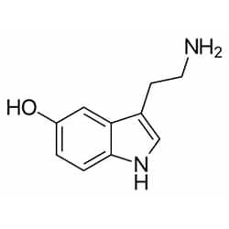
2 | Quercetin | C₁₅H₁₀O₇ | 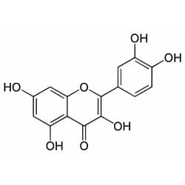
3 | Kaempferol | C₁₅H₁₀O₆ | 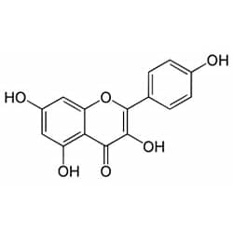
4 | Cucurbitacin-b | C₃₂H₄₆O₈ | 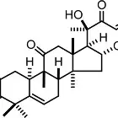
5 | Ascorbic acid | C₆H₈O₆ | 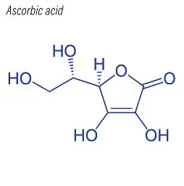
6 | Arginine | C₆H₁₄N₄O₂ | 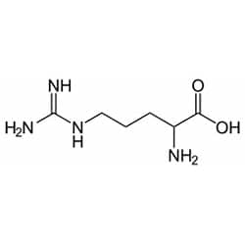
7 | Catechin | C₁₅H₁₄O₆ | 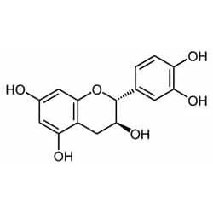
8 | Momordicoside-1 | C₄₂H₆₂O₁₆ | 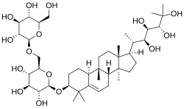
9 | Momordicin-2 | C₃₆H₅₈O₉ | 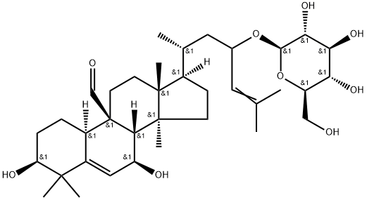
10 | Conduritol-A | C₆H₁₀O₄ | 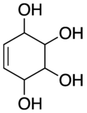
11 | 3-methyl pent 1 ene | C₆H₁₂ | 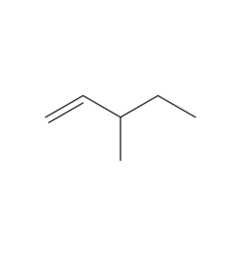
12 | Vicine | C₁₀H₁₆N₄O₇ | 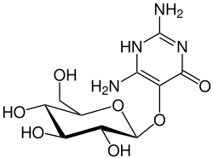
13 | Gallic acid | C₇H₆O₅ | 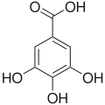
14 | Vitexin | C₂₁H₂₀O₁₀ | 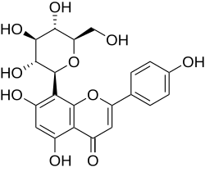
15 | Apigenin | C₁₅H₁₀O₅ | 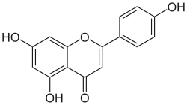
16 | Genistin | C₁₅H₁₀O₅ | 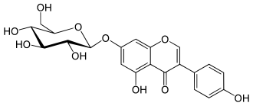
17 | Trigonelline | C₇H₇NO₂ | 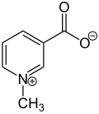
18 | Azardiradione | C₂₈H₃₄O₆ | 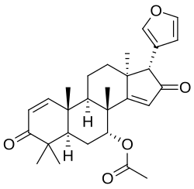
19 | Gymnemagenin | C₃₀H₅₀O₄ | 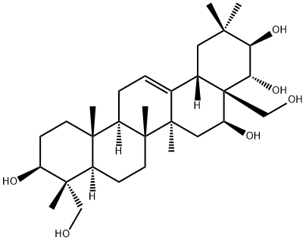
20 | Nimbin | C₃₀H₃₆O₉ | 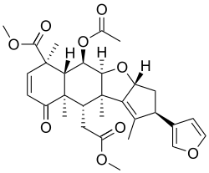
21 | Nimbolide | C₂₇H₃₀O₇ | 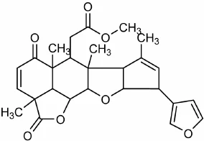
22 | Salannin | C₃₄H₄₄O₉ | 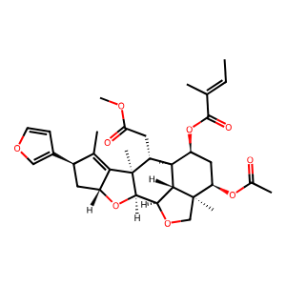

4.4 Preparation of Receptors
The target protein associated with diabetes was obtained from the Protein Data Bank. The receptor structure was prepared by removing water molecules and other unwanted components to make it suitable for docking analysis. The Schematic Diagram of receptors are given in Figure 1.
Sr No. | Name Of Receptors | Structure
1 | Alpha glucosidase | 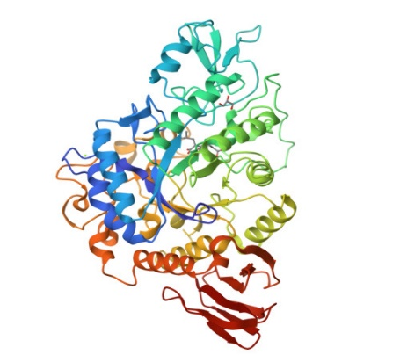
2 | PPAR-GAMMA | 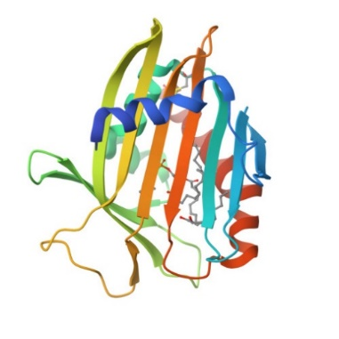
3 | PPAR DELTA | 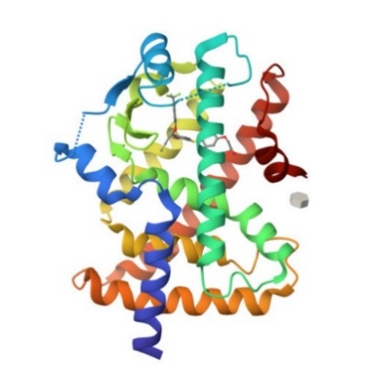

Fig 1: Structure of Ligands
2.2 Preparation of Ligands
The molecular structures of selected phytoconstituents were downloaded from PubChem in suitable file formats. Ligands were energy minimized and converted into PDBQT format using PyRx and Open Babel software.
2.3 Preparation of Receptors
Target proteins associated with diabetes mellitus, including alpha-glucosidase, PPAR-γ, and PPAR-δ, were obtained from the Protein Data Bank (PDB). Protein preparation involved removal of water molecules, heteroatoms, and co-crystallized ligands followed by addition of hydrogen atoms and charge stabilization.
2.4 Molecular Docking Study
Molecular docking simulations were performed using AutoDock Vina integrated in the PyRx platform. A grid box was generated around the active site of the receptors with a spacing of 1 Å. During docking, receptors were treated as rigid molecules while ligands remained flexible.
Binding affinity scores were expressed in kcal/mol. Lower binding energy values indicated stronger and more stable ligand–protein interactions.
2.5 Result Analysis and Visualization
Docking interactions, hydrogen bonding, and amino acid interactions were analyzed using BIOVIA Discovery Studio. ADMET and physicochemical parameters such as molecular weight, hydrogen bond donors and acceptors, lipophilicity, TPSA, and synthetic accessibility were evaluated.
3. Results and Discussion
3.1 Docking Analysis
The molecular docking study demonstrated that several phytoconstituents exhibited strong binding affinity against diabetes-related target proteins.
Among the screened compounds, several phytoconstituents demonstrated significant binding affinity toward the target proteins (shown in Table no. 1).
Momordicoside 1 showed the highest binding affinity with a docking score of -9.8 kcal/mol against alpha-glucosidase, suggesting strong inhibitory potential.
Kaempferol and Quercetin exhibited consistently high binding energies across all targets, with values reaching up to -9.0 kcal/mol and -8.8 kcal/mol, respectively.
Catechin also demonstrated strong interaction with docking scores around -8.4 to -8.5 kcal/mol. The docking score of phytoconstituents are given in table 3.
These compounds may serve as promising candidates for enzyme inhibition due to their stable ligand–protein interactions.
3.1.1 Alpha-Glucosidase
Among all compounds, Momordicoside 1 showed the highest binding affinity against alpha-glucosidase with a docking score of −9.8 kcal/mol. Flavonoids such as Quercetin, Kaempferol, Apigenin, Genistein, and Catechin also demonstrated strong binding affinity ranging from −8.3 to −8.5 kcal/mol.
3.1.2 PPAR-γ
Vitexin and Apigenin showed strong interaction with PPAR-γ receptors. Catechin, Quercetin, and Genistein also demonstrated favourable docking scores indicating stable ligand–receptor interactions.
3.1.3 PPAR-δ
Kaempferol and 3-methylpent-1-ene exhibited the best docking scores against PPAR-δ receptors. Quercetin, Catechin, Apigenin, and Genistein also maintained strong interactions.
3.2 Comparative Analysis
Flavonoids (Quercetin, Kaempferol, Catechin, Apigenin, Genistein) consistently demonstrated strong binding across all targets, suggesting their broad-spectrum inhibitory potential. The presence of phenolic hydroxyl groups enhances hydrogen bonding and π–π stacking interactions, improving binding stability.
Momordicoside 1 showed exceptional binding toward alpha-glucosidase but weaker interaction with other proteins, indicating target specificity.
3.2.5 Interpretation of Binding Affinity
Binding energies below -7.0 kcal/mol are generally considered significant. In this study:
Several compounds exceeded this threshold, indicating strong ligand–protein interactions.
The presence of hydroxyl groups and aromatic rings in flavonoids likely contributed to hydrogen bonding and π–π interactions within the active site.
The docking results suggest that:
Quercetin, Kaempferol, Catechin, and Genistein are the most promising multi-target inhibitors. Momordicoside 1 is a potent and selective inhibitor for alpha-glucosidase.
These phytocompounds may contribute to antidiabetic activity through enzyme inhibition and warrant further in vitro and in vivo validation.
3.3 ADMET and Physicochemical Analysis
ADMET analysis indicated that flavonoids possessed favourable pharmacokinetic properties.
Quercetin and Kaempferol showed acceptable molecular weight and lipophilicity. Catechin exhibited good solubility and hydrogen bonding properties. Compounds with high TPSA values such as Vicine may exhibit limited membrane permeability.
Complex molecules such as Momordicoside 1 and Momordicin-2 may face bioavailability challenges due to poor solubility and higher molecular complexity. Interactions of protein with phytoconstituent are given in Figure. 2
The overall analysis suggested that flavonoids represent promising multi-target antidiabetic candidates with balanced docking performance and drug-like properties.
3.3.1 Comparative Analysis
The pharmacokinetic properties of selected compounds were analyzed using parameters such as LogS (solubility), molecular weight, hydrogen bonding capacity, lipophilicity (LogP), TPSA, and synthetic accessibility.
3.3.2 Solubility and Lipophilicity
Compounds like Arginine and Gallic acid showed high solubility, indicating good absorption potential.
Lupeol, beta-sitosterol, and betulinic acid exhibited poor solubility (low LogS), which may limit bioavailability. Optimal LogP values (~1–3) were observed for Kaempferol, Quercetin, and Genistein, suggesting a good balance between solubility and permeability.
3.3.3 Molecular Weight and Drug-Likeness
Most active flavonoids (e.g., Quercetin – 302.24 g/mol, Kaempferol – 286.24 g/mol) fall within Lipinski’s rule (<500 g/mol). Larger molecules such as Cucurbitacin B and Momordicin (>500 g/mol) may face permeability limitations.
3.3.4 Hydrogen Bonding and TPSA
Compounds like Quercetin and Catechin possess multiple hydrogen bond donors/acceptors, enhancing binding interactions.
However, high TPSA (>140 Å²) (e.g., Vicine) may reduce membrane permeability.
3.3.5 Synthetic Accessibility
Most flavonoids showed moderate synthetic accessibility (2–4), indicating feasibility for drug development. Complex molecules such as Momordicoside showed higher values (>6), suggesting synthesis challenges.
3.3.6. Overall Interpretation:
Flavonoid-rich compounds are the most promising due to their strong binding affinity and favourable pharmacokinetic profile. Structure–activity relationship (SAR) suggests that hydroxyl groups and aromatic rings enhance protein binding. Compounds with poor ADMET properties may still be useful after structural modification or nano formulation approaches.
Quercetin, Kaempferol, Catechin, and Genistein emerged as the most promising multi-target inhibitors. Momordicoside 1 showed exceptional potency against alpha-glucosidase. The integration of docking and ADMET analysis highlights potential candidates for further in vitro and in vivo studies in antidiabetic drug development.

Conclusion
The present molecular docking study evaluated selected phytoconstituents against diabetes-related target proteins, including alpha-glucosidase, PPAR-gamma, and PPAR-delta. The docking results indicated that Momordicoside 1 had the strongest binding affinity against alpha-glucosidase, while flavonoids such as Quercetin, Kaempferol, Catechin, Apigenin, and Genistein showed consistent interactions with multiple targets. These interactions may be associated with the presence of hydroxyl groups and aromatic structural features that support hydrogen bonding and other ligand–protein interactions. The physicochemical and ADME-related evaluation further suggested that several flavonoids possess comparatively suitable properties, including acceptable molecular weight, lipophilicity, and hydrogen bonding capacity. In contrast, larger and more structurally complex compounds may have limitations related to solubility, permeability, or synthetic accessibility. The study supports the preliminary computational relevance of selected plant-derived compounds as possible antidiabetic lead candidates. However, molecular docking provides only predictive evidence. Therefore, enzyme inhibition assays, cellular studies, pharmacokinetic evaluation, toxicity assessment, and in vivo validation are necessary before drawing firm conclusions regarding efficacy or safety.

Limitations
This study has several limitations. The findings are based only on molecular docking and physicochemical prediction, and no experimental validation was performed. Therefore, the reported binding affinities should be interpreted as preliminary computational results rather than direct evidence of antidiabetic activity. Docking scores may vary depending on receptor preparation, ligand conformation, grid parameters, software settings, and selected protein structures. The study also did not include molecular dynamics simulation, binding free-energy calculation, redocking validation, or comparison with standard antidiabetic drugs. ADME-related findings were limited to selected physicochemical parameters and do not confirm actual absorption, distribution, metabolism, excretion, or toxicity in biological systems. In addition, computational interaction patterns do not necessarily reflect activity in complex physiological conditions. Further in vitro enzyme inhibition studies, cell-based assays, toxicity studies, and in vivo experiments are required to confirm the biological relevance, safety, and therapeutic potential of the selected phytoconstituents.
Declaration of AI Use

This manuscript was prepared through the combined contributions of all author(s), including contributions to the study design, data, content development, results, interpretation, and related scholarly work. The author(s) acknowledge the use of Grammarly and ChatGPT to assist with grammar checking, language refinement, reference formatting. These AI-assisted tools were not used as authors and did not replace the intellectual contributions or scholarly judgment of the author(s). All AI-assisted outputs, including content, references, and interpretations, were carefully reviewed, revised, verified, and approved by the author(s). The author(s) accept full responsibility for the accuracy, integrity, and final content of the manuscript.

PPAR DELTA
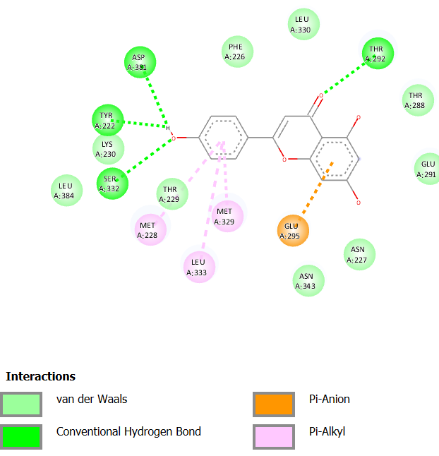
[a] Apigenin
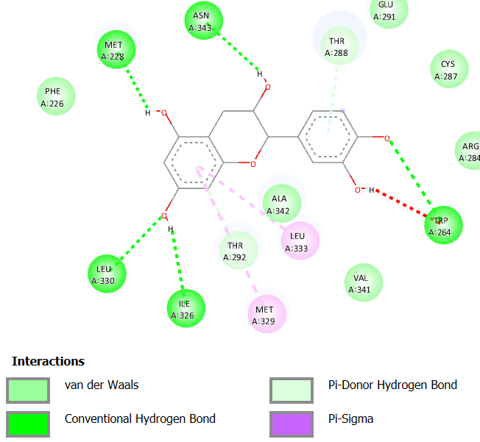
[b] Catechin
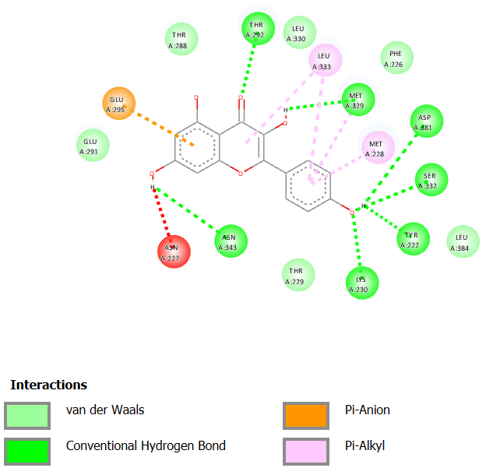
[c] Kaempferol
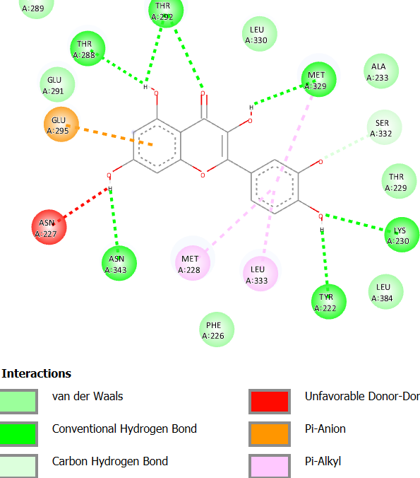
[d] Quercetin
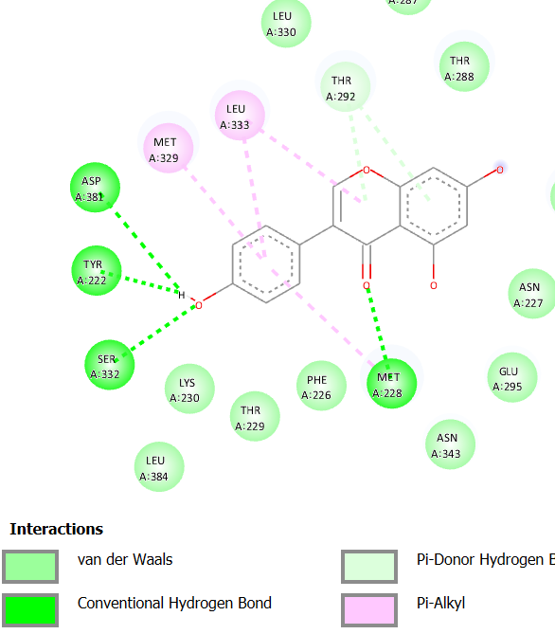
[e] Genistein

2.PPAR GAMMA
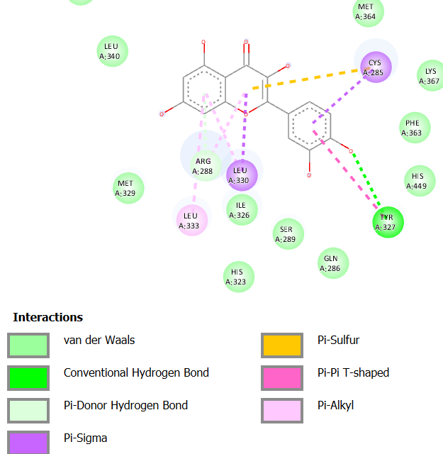
[a] Quercetin

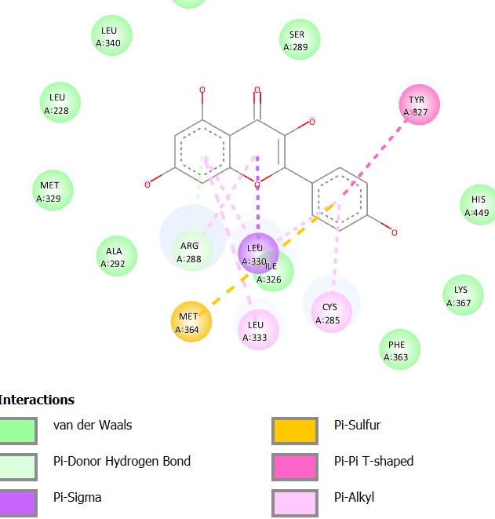
[b]Kaempferol
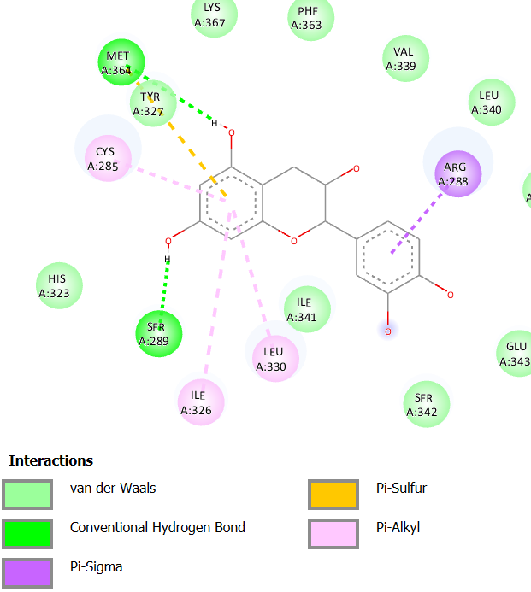
[c] Catechin
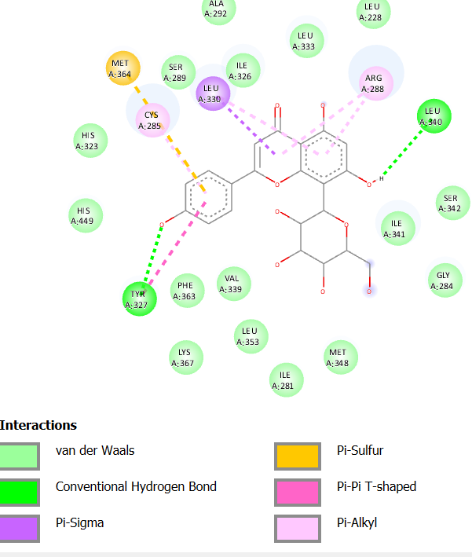
[d] Apigenin
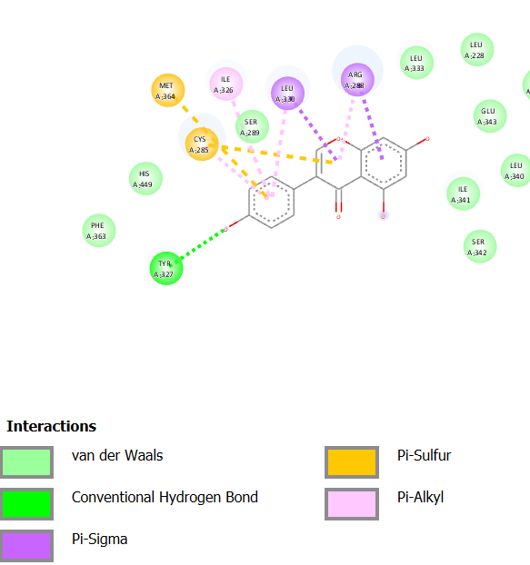
[e] Genistein
Figure 2: Interactions of Various Phytoconstituents with Receptors (PPAR DELTA and PPAR GAMMA).

Table 2: Docking score of Phytoconstituents
Sr. no | Phytocompounds | Binding energy (kcal/mol)
Sr. no | Phytocompounds | Alpha-glucosidase | PPAR  GAMMA | PPAR  DELTA
1 | 5-hydroxytryptamine | -6.8 | -5.8 | -6.4
2 | Quercetin | -8.3 | -7.3 | -8.8
3 | Kaempferol | -8.3 | -7.2 | -9
4 | Cucurbitacin B | -7.8 | -3.6 | -4.1
5 | Ascorbic acid | -6 | -5.8 | -5.8
6 | Arginine | -6 | -5 | -6.2
7 | catechin | -8.4 | -7.6 | -8.5
8 | Momordicoside 1 | -9.8 | -2.3 | -7.1
9 | Momordicin-2 | -8.5 | -3 | -4.4
10 | Conduritol A | -4.9 | -5.3 | -5.5
11 | 3-methylpent-1-ene | -6.4 | -7.7 | -8.9
12 | Vicine | -8.4 | -6.6 | -7.5
13 | Gallic acid | -6.1 | -5.5 | -6.3
14 | Nevirapine | -6.7 | -7.4 | -7.8
15 | Vitexin | -6.3 | -8.6 | -5.8
16 | Apigenin | -8.3 | -8.6 | -8.8
17 | Genistein | -8.3 | -8.2 | -8.5
18 | Trigonelline | -4.8 | 6.3 | -5.7
19 | Azardiradione | -6.8 | -0.9 | -0.3
20 | Gymnemagenin | -3 | -2.2 | 2
21 | Nimbin | -4.3 | -0.8 | -2
22 | Nimbolide | -5.8 | -5.8 | -3.7
23 | Salannin | 0.2 | -3.8 | -1.3

Sr  no | Constituent  Name | Log s | Solubility | Mol  Weight | HBA | HBD | Log p | TPSA | Synthetic Accessibility
1 | 5-hydroxytryptamine | -2.25 | 9.87 | 176.22 | 2 | 3 | 1.18 | 62.24 | 1.42
2 | Quercetin | -3.16 | 2.11 | 302.24 | 7 | 5 | 1.63 | 131.36 | 3.23
3 | Kaempferol | -3.31 | 1.40 | 286.24 | 6 | 4 | 1.70 | 111.13 | 3.14
4 | Cucurbitacin B | -4.57 | 1.50 | 558.70 | 8 | 3 | 3.77 | 138.20 | 6.79
5 | Ascorbic Acid | 0.23 | 3.01 | 176.12 | 6 | 4 | -0.3 | 107.22 | 3.47
6 | Arginine | 2.05 | 1.95 | 174.20 | 4 | 4 | 0.27 | 127.72 | 2.47
7 | Catechin | -2.22 | 1.74 | 290.27 | 6 | 5 | 1.33 | 110.38 | 3.50
8 | Momordicoside | -6.06 | 3.88 | 441.67 | 3 | 2 | 00 | 49.69 | 7.29
9 | Momordicin-2 | -5.55 | 1.77 | 634.84 | 9 | 6 | 3.59 | 156.91 | 8.06
10 | Conduritol A | 0.56 | 5.36 | 146.14 | 4 | 4 | 1.04 | 80.92 | 3.90
11 | 3-methylpent-1-ene | -1.96 | 9.31 | 84.16 | 00 | 0 | 2.23 | 0 | 1.76
12 | Vicine | 0.16 | 1.22 | 304.26 | 8 | 7 | -0.3 | 197.17 | 4.59
13 | Gallic acid | 1.64 | 3.90 | 170.12 | 5 | 4 | 0.21 | 97.99 | 1.22
14 | Nevirapine | -3.21 | 162 | 266.30 | 3 | 1 | 2.42 | 63.57 | 2.30
15 | Vitexin | -2.84 | 6.29 | 432.38 | 10 | 7 | 1.63 | 181.05 | 5.12
16 | Apigenin | -3.94 | 3.07 | 270.24 | 5 | 3 | 1.89 | 90.90 | 2.96
17 | Genistein | -3.72 | 5.11 | 270.24 | 5 | 3 | 1.91 | 90.90 | 2.87
18 | Trigonelline | -1.39 | 5.59 | 137.14 | 2 | 0 | -3.1 | 44.01 | 1.04
19 | Azardiradione | -5.58 | 1.17 | 450.57 | 5 | 0 | 3.17 | 73.58 | 5.89
20 | Gymnemagenin | -5.35 | 2.26 | 506.71 | 6 | 6 | 3.32 | 121.38 | 6.82
21 | Nimbin | -4.20 | 3.45 | 540.60 | 9 | 0 | 3.68 | 118.34 | 6.54
22 | Nimbolide | -3.94 | 5.30 | 466.52 | 7 | 0 | 3.18 | 92.04 | 6.07
23 | Salannin | -5.51 | 185 | 596.71 | 9 | 0 | 3.61 | 110.5 | 7.04
Table 3: Physical chemical properties of phytoconstituents in ADME

References
- Cleveland Clinic. Diabetes Mellitus. Available from: https://my.clevelandclinic.org/health/diseases/7104-diabetes
- Centers for Disease Control and Prevention. Diabetes Symptoms. Available from: https://www.cdc.gov/diabetes/signs-symptoms/index.html
- Sliwoski G, Kothiwale S, Meiler J, Lowe EW. Computational methods in drug discovery. Pharmacol Rev. 2014; 66(1):334–395.
- Lionta E, Spyrou G, Vassilatis DK, Cournia Z. Structure-based virtual screening for drug discovery. Curr Top Med Chem. 2014; 14(16):1923–1938.
- Tanazi KR, Yam MF, Sadikun A, Asmawi MZ. In vitro and in silico evaluation of antidiabetic compounds from Endiandra kingiana. J Ethnopharmacol. 2023; 315:116603.
- Dej-Adisai S, Pitakbut T. Flavonoids from Bauhinia pulla as α-glucosidase inhibitors: in vitro and molecular docking study. BMC Complement Med Ther. 2021; 21:253.
- Saha S, Ghosh S. Molecular docking study of phytochemicals from Tinospora cordifolia against diabetic targets. Future J Pharm Sci. 2024; 10:45.
- Ahmed D, Sharma M. Evaluation of Beta vulgaris phytochemicals as antidiabetic agents using docking studies. Sci Rep. 2024; 14:58338.
- Kazeem MI, Adamson JO. Review on plant-derived α-glucosidase inhibitors and their molecular docking studies. S Afr. J Bot. 2024; 161:120–130.
- Alam MA, Rahman MM. AI-assisted molecular docking of Ficus religiosa phytochemicals targeting DPP-4. Comput Biol Med. 2025; 170:107901.
- Rajapaksha IG, Perera PR. Molecular docking and ADMET study of plant-derived antidiabetic compounds. J Mol Graph Model. 2024; 125:108567.
- Verma P, Singh A. ADMET and molecular docking studies of herbal antidiabetic compounds. J Biomol Struct Dyn. 2024; 42:5560–5572.
- Gupta R, Sharma AK. Phytochemical screening and docking analysis of antidiabetic plants. J Ethnopharmacol. 2022; 284:114783.
- Das S, Chatterjee S. Natural products as antidiabetic agents: docking and pharmacological insights. Curr Pharm Des. 2024; 30:1120–1135.
- Ahmed S, Khan RA. Plant-based inhibitors of carbohydrate-digesting enzymes: a review. Front Pharmacol. 2023; 14:118900.

