Case report

Giant High-Risk Cutaneous Squamous Cell Carcinoma of the Lower Abdominal Wall: A Challenging Case Report

Abstract
Cutaneous squamous cell carcinoma is a common non-melanoma skin cancer that usually develops on chronically sun-exposed areas. Involvement of the lower abdominal wall is uncommon and may create diagnostic, oncological, and reconstructive challenges, particularly when the tumor is large or shows high-risk pathological features. We report the case of a 67-year-old man who presented with a progressively enlarging ulcerated suprapubic cutaneous mass measuring approximately 6.5 × 6 cm. Computed tomography showed a localized abdominal wall lesion without invasion of the fascial or muscular layers, and inguinal ultrasonography did not identify regional lymphadenopathy. The patient underwent wide local excision with oncological margins, resulting in a soft-tissue defect of approximately 14 × 9 cm. Reconstruction was achieved using a modified abdominoplasty-like advancement and translation plasty, allowing primary closure without mesh reinforcement. Histopathological examination confirmed a moderately differentiated non-keratinizing invasive squamous cell carcinoma with vascular emboli. Surgical margins were negative, measuring 0.8–2.8 cm laterally and 1 cm in depth. The postoperative course was uneventful. Because of the high-risk features, the patient received adjuvant radiotherapy to the tumor bed using volumetric modulated arc therapy. At 18 months of follow-up, there was no evidence of local recurrence, regional lymph node involvement, distant metastasis, abdominal wall weakness, or incisional hernia. This case highlights the importance of complete oncological excision, individualized reconstruction, and careful postoperative surveillance in giant high-risk cutaneous squamous cell carcinoma of an uncommon abdominal wall location.
Keywords: Cutaneous squamous cell carcinoma, abdominal wall, wide excision, reconstruction

Introduction
Cutaneous squamous cell carcinoma (cSCC) accounts for approximately 20% of non-melanoma skin cancers and represents a significant public health concern worldwide (Rogers et al., 2015). Chronic ultraviolet radiation exposure remains the principal etiological factor; however, chronic inflammation, scars, immunosuppression, and genetic susceptibility may also contribute to tumor development.
Most cSCCs occur on sun-exposed regions, particularly the head, neck, and upper extremities. Involvement of the abdominal wall is uncommon and may therefore pose diagnostic and therapeutic challenges (Xiaoyou et al., 2024). Surgical excision remains the gold standard treatment and aims to achieve complete tumor removal while minimizing recurrence risk.

Case Presentation
A 67-year-old man who presented with a progressively enlarging ulcerated suprapubic mass. Clinical examination revealed a fungating lesion measuring approximately 6.5 × 6 cm (Fig. 1). Computed tomography demonstrated a localized abdominal wall process without invasion of the muscular or fascial layers. Inguinal ultrasonography showed no lymphadenopathy.
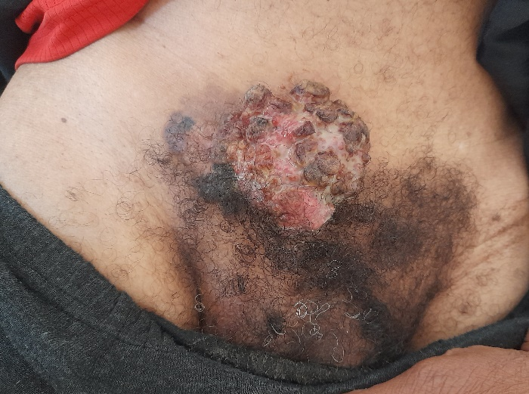
Fig 1: Preoperative view of a large ulcerated suprapubic cutaneous mass measuring 6.5 × 6 cm.
The patient underwent wide local excision with oncological margins. The resulting defect measured approximately 14 × 9 cm (Fig. 2). The surgical specimen was oriented and submitted for histopathological examination (Fig. 3).
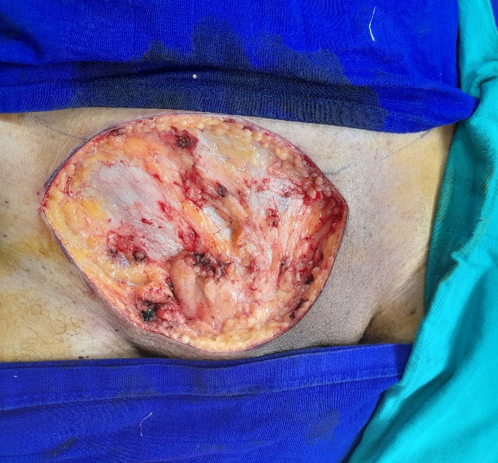
Fig 2: Intraoperative view of the abdominal wall defect following wide local excision.
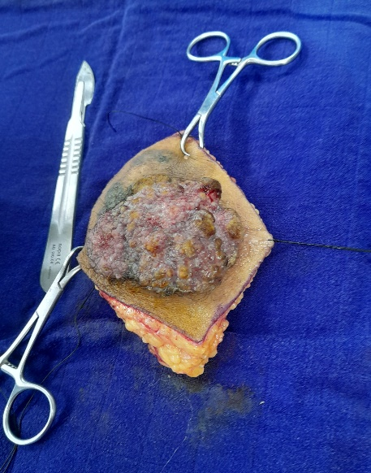
Fig 3: The oriented surgical specimen.
Reconstruction was achieved using a modified abdominoplasty-like advancement and translation plasty, allowing primary closure without mesh reinforcement.
Histopathological examination demonstrated a moderately differentiated non-keratinizing invasive squamous cell carcinoma with vascular emboli. Surgical margins were negative both laterally (0.8–2.8 cm) and deeply (1 cm).
The postoperative course was uneventful. The patient received adjuvant radiotherapy to the tumor bed using volumetric modulated arc therapy (VMAT), in order to achieve conformal dose distribution and reduce toxicity to adjacent structures.
At 18 months of follow-up, no local recurrence, regional lymph node involvement, distant metastasis, abdominal wall weakness, or incisional hernia was observed. The aesthetic outcome was satisfactory (Fig. 4).
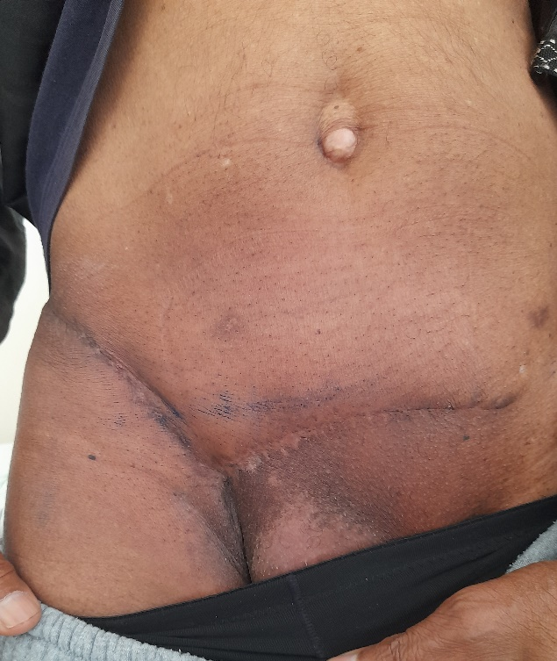
Fig 4: Clinical appearance at 18 months of follow-up showing no evidence of local recurrence.

Discussion
Cutaneous squamous cell carcinoma (cSCC) accounts for approximately 20% of non-melanoma skin cancers and represents the second most common cutaneous malignancy after basal cell carcinoma (Rogers et al., 2015; Xiaoyou et al., 2024). Most lesions occur on chronically sun-exposed areas such as the head, neck, and upper extremities. In contrast, involvement of the lower abdominal wall is uncommon and relatively infrequently reported in the literature (Que et al., 2018). Although no universally accepted definition exists, lesions exceeding 5 cm in diameter are commonly classified as giant cutaneous squamous cell carcinomas. The present lesion measured 6.5 × 6 cm and therefore fulfilled the criteria generally used to define a giant cSCC.
Several risk factors have been associated with cSCC development, including ultraviolet radiation exposure, chronic inflammation, scars, immunosuppression, and premalignant lesions such as Bowen disease (Schmults et al., 2021). In our patient, the lesion developed in a non-sun-exposed region, highlighting the heterogeneous biological behavior of cutaneous SCC.
Current international guidelines recommend complete surgical excision as the gold standard treatment for localized cSCC (Schmults et al., 2021). Surgical margins should be adapted according to tumor size, histological differentiation, and high-risk features. The primary objective is complete tumor removal with histologically negative margins while preserving function and minimizing morbidity (Alexander et al., 2026).
Several pathological features identified in our case classified the tumor as high risk. These included a tumor diameter exceeding 6 cm, moderate differentiation, ulceration, infiltrative growth pattern, and most importantly the presence of vascular emboli (Yildizdal et al., 2026). Among the high-risk histopathological features, lymphovascular invasion is considered one of the strongest predictors of nodal metastasis and disease-specific mortality. Its presence therefore justifies close postoperative surveillance even after complete tumor excision (Brancaccio et al., 2021). For this reason, careful long-term surveillance was considered mandatory despite complete excision.
Preoperative imaging plays an important role in the assessment of large abdominal wall tumors (Porrello et al., 2023). In the present case, computed tomography demonstrated preservation of the muscular and fascial planes, which facilitated complete resection while avoiding the need for complex abdominal wall reconstruction. Likewise, inguinal ultrasonography revealed no regional lymphadenopathy, supporting a localized disease stage.
Large defects of the abdominal wall following oncologic resection often require reconstructive procedures ranging from skin grafting and local flaps to component separation techniques and prosthetic mesh reinforcement (Makiguchi et al., 2015). The choice depends on the size and depth of the defect as well as involvement of the musculoaponeurotic layer.
In our patient, the absence of fascial involvement allowed reconstruction using a modified abdominoplasty-like advancement and translation plasty. The reconstructive challenge was amplified by the large postoperative defect measuring 14 × 9 cm. Despite its size, preservation of the musculoaponeurotic layer enabled tension-controlled closure using local tissue advancement without prosthetic reinforcement. Compared with mesh-based reconstruction or more complex flap procedures, this technique provided adequate coverage while reducing donor-site morbidity, operative complexity, and the risk of mesh-related complications (Hew et al., 2024; Hope et al., 2026). Furthermore, no postoperative hernia or abdominal wall weakness was observed during follow-up.
Several studies have emphasized the importance of achieving histologically clear margins in high-risk cSCC (Zhang et al., 2015). Complete excision remains the most significant predictor of local disease control (Ahmad et al., 2023). In the present case, pathological examination confirmed tumor-free margins ranging from 0.8 to 2.8 cm laterally and 1 cm in depth, supporting the oncological adequacy of the procedure.
Adjuvant radiotherapy is generally reserved for giant cutaneous squamous cell carcinomas with high-risk features such as positive margins, deep invasion, nodal involvement, or recurrent disease. Modern techniques such as VMAT allow precise target coverage while limiting radiation exposure to adjacent organs (Muto et al., 2021). In our case, complete surgical excision with negative margins, the absence of nodal or distant metastases, and adjuvant VMAT radiotherapy contributed to favorable disease control during follow-up.
At 18 months of follow-up, our patient remained free of local recurrence, regional nodal disease, and distant metastasis. Although this outcome is encouraging, the presence of vascular emboli justifies prolonged surveillance because late recurrence remains possible. Longer follow-up is warranted to confirm durable oncological control (Ruiz et al., 2019).

Conclusions
Giant cutaneous squamous cell carcinoma of the lower abdominal wall is an uncommon presentation that may require individualized oncological and reconstructive management. In the present case, preoperative imaging confirmed that the lesion was limited to the soft tissue, without invasion of the fascial or muscular layers. This allowed wide local excision with histologically negative margins while avoiding complex abdominal wall reconstruction. The resulting 14 × 9 cm defect was closed using a modified abdominoplasty-like advancement and translation plasty, which provided adequate coverage without mesh reinforcement. Histopathological identification of a moderately differentiated invasive squamous cell carcinoma with vascular emboli supported classification of the tumor as high risk and justified close postoperative monitoring. Adjuvant radiotherapy was administered to the tumor bed using volumetric modulated arc therapy. At 18 months, the patient remained free of local recurrence, regional nodal disease, distant metastasis, abdominal wall weakness, and incisional hernia. This case supports the role of complete excision, careful pathological assessment, appropriate reconstruction, and prolonged follow-up in selected patients with large high-risk cutaneous squamous cell carcinoma of the abdominal wall.
Limitations
This report describes a single patient and therefore cannot establish the general effectiveness or superiority of the reconstructive approach used. The follow-up period of 18 months is clinically useful but remains insufficient to exclude late recurrence or delayed metastatic progression, particularly in a high-risk tumor with vascular emboli. Some clinical and pathological details are limited, including formal tumor staging, depth of invasion, complete assessment of perineural involvement, and the full radiotherapy dose and fractionation schedule. The absence of regional lymphadenopathy was based on inguinal ultrasonography, and no additional nodal staging procedure was described. Because cutaneous squamous cell carcinoma of the lower abdominal wall is uncommon, comparison with larger series is difficult. Further reports with longer follow-up and more detailed oncological assessment are needed to clarify optimal management strategies for similar cases.

Consent
As per international standards or university standards, patient written consent has been collected and preserved by the author.

Ethical Approval
As per international standards or university standards written ethical approval has been collected and preserved by the author.
Declaration of AI Use

This manuscript was prepared through the combined contributions of all author(s), including contributions to the study design, data, content development, results, interpretation, and related scholarly work. The author(s) acknowledge the use of Grammarly and ChatGPT to assist with grammar checking, language refinement, reference formatting. These AI-assisted tools were not used as authors and did not replace the intellectual contributions or scholarly judgment of the author(s). All AI-assisted outputs, including content, references, and interpretations, were carefully reviewed, revised, verified, and approved by the author(s). The author(s) accept full responsibility for the accuracy, integrity, and final content of the manuscript.

Competing Interests
Author have declared that no competing interests exist
Source of support
Declared none.

References
- Rogers, H. W., Weinstock, M. A., Feldman, S. R., & Coldiron, B. M. (2015). Incidence Estimate of Nonmelanoma Skin Cancer (Keratinocyte Carcinomas) in the U.S. Population, 2012. JAMA dermatology, 151(10), 1081–1086. https://doi.org/10.1001/jamadermatol.2015.1187
- Xiaoyou T., Tingyi Y., Daojiang Y., et al. (2024). Current insights and future perspectives of ultraviolet radiation (UV) exposure: Friends and foes to the skin and beyond the skin. Environment International, 185: 108535. https://doi.org/10.1016/j.envint.2024.108535
- Que, S. K. T., Zwald, F. O., & Schmults, C. D. (2018). Cutaneous squamous cell carcinoma: Incidence, risk factors, diagnosis, and staging. Journal of the American Academy of Dermatology, 78(2), 237–247. https://doi.org/10.1016/j.jaad.2017.08.059
- Schmults, C. D., Blitzblau, R., Aasi, et al. (2021). NCCN Guidelines® Insights: Squamous Cell Skin Cancer, Version 1.2022. Journal of the National Comprehensive Cancer Network: JNCCN, 19(12), 1382–1394. https://doi.org/10.6004/jnccn.2021.0059
- Stratigos, A. J., Dessinioti, C., Garbe, C., et al. (2026). European consensus-based interdisciplinary guideline for invasive cutaneous squamous cell carcinoma: Part 2. Treatment - update 2026. European journal of cancer (Oxford, England : 1990), 243, 116764. Advance online publication. https://doi.org/10.1016/j.ejca.2026.116764
- Yildizdal, S., Cavusoglu, G., Kucukguven, A., Calis, M., Vargel, I. (2026). Prognostic Factors for Recurrence in Cutaneous Squamous Cell Carcinoma: A Retrospective Analysis of 347 Patients. Turkish Journal of Plastic Surgery, 34(1), 15-20. DOI: 10.4103/tjps.tjps_56_25
- Brancaccio, G., Briatico, G., Pellegrini, C., Rocco, T., Moscarella, E., & Fargnoli, M. C. (2021). Risk Factors and Diagnosis of Advanced Cutaneous Squamous Cell Carcinoma. Dermatology practical & conceptual, 11(Suppl 2), e2021166S. https://doi.org/10.5826/dpc.11S2a166S
- Porrello, G., Cannella, R., Alvarez-Hornia Pérez, E., Brancatelli, G., & Vernuccio, F. (2023). The Neoplastic Side of the Abdominal Wall: A Comprehensive Pictorial Essay of Benign and Malignant Neoplasms. Diagnostics (Basel, Switzerland), 13(2), 315. https://doi.org/10.3390/diagnostics13020315
- Makiguchi, T., Yokoo, S., Takaku, Y., Morita, H., & Yasuda, M. (2015). Squamous cell carcinoma arising from abdominal wall defect lesion complicated with cloacal exstrophy. Plastic and reconstructive surgery. Global open, 3(3), e315. https://doi.org/10.1097/GOX.0000000000000286
- Hew, C. Y., Rais, T., Antoniou, S. A., Deerenberg, E. B., & Antoniou, G. A. (2024). Prophylactic Mesh Reinforcement Versus Primary Suture for Abdominal Wall Closure after Elective Abdominal Aortic Aneurysm Repair with Midline Laparotomy Incision: Updated Systematic Review Including Time-To-Event Meta-Analysis and Trial Sequential Analysis of Randomized Controlled Trials. Annals of vascular surgery, 109, 149–161. https://doi.org/10.1016/j.avsg.2024.06.026
- Hope, W. W., Abdul, W., & Winters, R. (2023). Abdominal Wall Reconstruction. In StatPearls. StatPearls Publishing. Available from: https://www.ncbi.nlm.nih.gov/books/NBK431108/
- Zhang, Y., Chen, B. O., Zhu, J., & Chen, L. U. (2015). Squamous cell carcinoma of unknown primary site presenting with an abdominal wall lesion as the primary symptom: A case report and review of the literature. Oncology letters, 10(4), 2161–2165. https://doi.org/10.3892/ol.2015.3520
- Halim, A. S., & Ramasenderan, N. (2023). High-risk cutaneous squamous cell carcinoma (CSCC): Challenges and emerging therapies. Asian journal of surgery, 46(1), 47–51. https://doi.org/10.1016/j.asjsur.2022.04.079
- Muto, P., & Pastore, F. (2021). Radiotherapy in the Adjuvant and Advanced Setting of CSCC. Dermatology practical & conceptual, 11(Suppl 2), e2021168S. https://doi.org/10.5826/dpc.11S2a168S
- Ruiz, E. S., Karia, P. S., Besaw, R., & Schmults, C. D. (2019). Performance of the American Joint Committee on Cancer Staging Manual, 8th Edition vs the Brigham and Women's Hospital Tumor Classification System for Cutaneous Squamous Cell Carcinoma. JAMA dermatology, 155(7), 819–825. https://doi.org/10.1001/jamadermatol.2019.0032

