Case report
Diagnosis and Therapeutic Management of Dermatophytosis in a Short-haired Cat

Abstract
A two-year-old male domestic short-haired cat was presented to the Veterinary Clinical Complex, Rajendranagar, with a history of progressive generalised alopecia, scaling and cutaneous lesions affecting the face and trunk. The clinical examination showed multiple areas of hair loss characterised by patches with crusting, scaling and broken hairs. Dermatological evaluation, including Wood's lamp examination, demonstrated characteristic apple-green fluorescence of affected hairs, suggestive of Microsporum canis infection. The diagnosis of feline dermatophytosis was further supported by fungal culture findings. The cat was treated with a combination of systemic antifungal therapy, topical antifungal management and nutritional supplementation. Progressive clinical improvement, resolution of skin lesions and satisfactory hair regrowth were observed during follow-up examinations. This case emphasises the importance of combining clinical and diagnostic findings for the timely diagnosis of feline dermatophytosis and shows how effective combined therapeutic management can lead to favourable clinical outcomes.
Keywords: Cat, Microsporum canis, Wood's lamp, Alopecia
Introduction
Dermatophytosis is a common fungal skin disease of domestic animals caused by keratinophilic fungi belonging primarily to the genera Microsporum, Trichophyton and Epidermophyton. Among cats, Microsporum canis is recognised as the predominant etiological agent and is of particular importance because of its contagious nature and zoonotic potential (Scott et al., 2001; Moriello, 2014). Infection is generally confined to keratinised tissues such as hair, skin and claws, resulting in variable clinical manifestations ranging from focal alopecia to generalised dermatitis.
Recent epidemiological and diagnostic reviews emphasize that dermatophytes remain clinically important superficial fungal pathogens, and zoophilic species such as Microsporum canis require careful attention because animal reservoirs may contribute to recurrent exposure and zoonotic transmission (Hayette & Sacheli, 2015; Rajagopalan et al., 2018).
Because dermatophytosis can resemble parasitic, bacterial, allergic and other inflammatory dermatoses, interpretation of clinical signs should be supported by mycological confirmation whenever possible, particularly when systemic therapy or environmental control is being considered (Hayette & Sacheli, 2015; Moriello et al., 2017).
Affected cats commonly exhibit alopecia, scaling, crusting, broken hairs and a characteristic moth-eaten appearance of the coat, although asymptomatic carrier states may also occur (Sparkes et al., 1993; Miller et al., 2013). Diagnosis is based on compatible clinical findings supported by diagnostic techniques such as Wood’s lamp examination and fungal culture, the latter being regarded as the reference method for definitive confirmation (Moriello et al., 2017). Successful management relies on a combination of systemic and topical antifungal therapy together with environmental decontamination to reduce fungal spore burden and minimise recurrence. The present report describes the clinical presentation, diagnosis and successful therapeutic management of feline dermatophytosis caused by Microsporum canis in a domestic short-haired cat.
Topical antifungal measures have a supportive role in reducing fungal contamination of the hair coat, but published evidence indicates that they are best integrated with systemic therapy and environmental hygiene in generalized or contagious cases (Diesel et al., 2011; Moriello et al., 2017; Rajagopalan et al., 2018).
Materials and Methods
A two-year-old intact male domestic short-haired cat weighing 3.5 kg was presented to the Veterinary Clinical Complex, Rajendranagar, for evaluation of a progressive dermatological disorder. A detailed history was obtained from the owner, followed by a general physical and dermatological examination. Wood's lamp examination was performed in a darkened room to detect fluorescence of affected hairs. Hair and scale samples were collected from active lesions and subjected to fungal culture on Sabouraud Dextrose Agar (SDA) and Potato Dextrose Agar (PDA) for isolation and identification of the causative organism. Therapeutic management was instituted following diagnosis, and the animal was monitored periodically to evaluate clinical response and treatment outcome. As this report describes a single clinical case, statistical analysis was not applicable.
Case History and Clinical Findings
A two-year-old intact male domestic short-haired cat weighing 3.5 kg was presented to the Veterinary Clinical Complex with a history of progressive hair loss and skin lesions over the face and body. The owner reported gradual extension of lesions over the preceding few weeks. Appetite, water intake, urination, and defecation were normal. Vaccination and deworming were reported to be regular. On clinical examination, the animal was alert and active with a rectal temperature of 101.3°F. Dermatological examination revealed generalised alopecia involving the face, neck, dorsum and trunk. The affected areas showed scaling, crust formation, broken hairs and a characteristic moth-eaten appearance of the coat. Mild erythema was observed in some regions without marked pruritus.
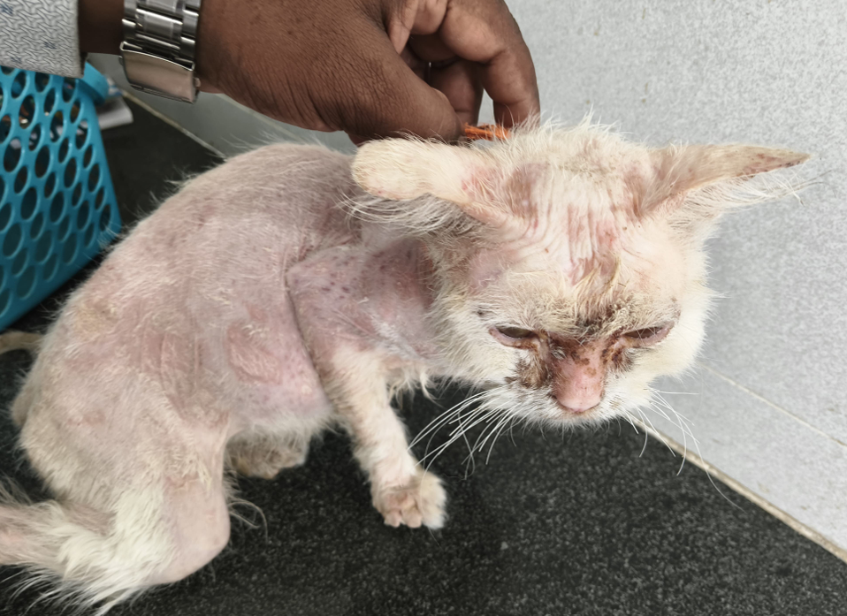
Figure 1. Generalized alopecia and scaling observed over the face and trunk of the affected cat.
Diagnostic Investigations
Based on the clinical presentation, dermatophytosis, demodicosis, notoedric mange, bacterial folliculitis and allergic dermatitis were considered as differential diagnoses. Wood's lamp examination performed in a darkened room revealed distinct apple-green fluorescence of affected hairs, suggestive of Microsporum canis infection (Moriello et al., 2017). Fluorescence was observed along the hair shafts of affected areas, supporting a presumptive diagnosis of dermatophytosis (Fig. 2). For laboratory confirmation, hairs and scales collected from fluorescent lesions were cultured on Sabouraud Dextrose Agar (SDA) and Potato Dextrose Agar (PDA). Following incubation, characteristic white cottony colonies with yellow pigmentation were observed (Figs. 3 and 4). Microscopic examination of the cultured colonies revealed spindle-shaped, rough-walled macroconidia containing more than six compartments, consistent with the morphological characteristics of Microsporum canis (Moriello, 2014).
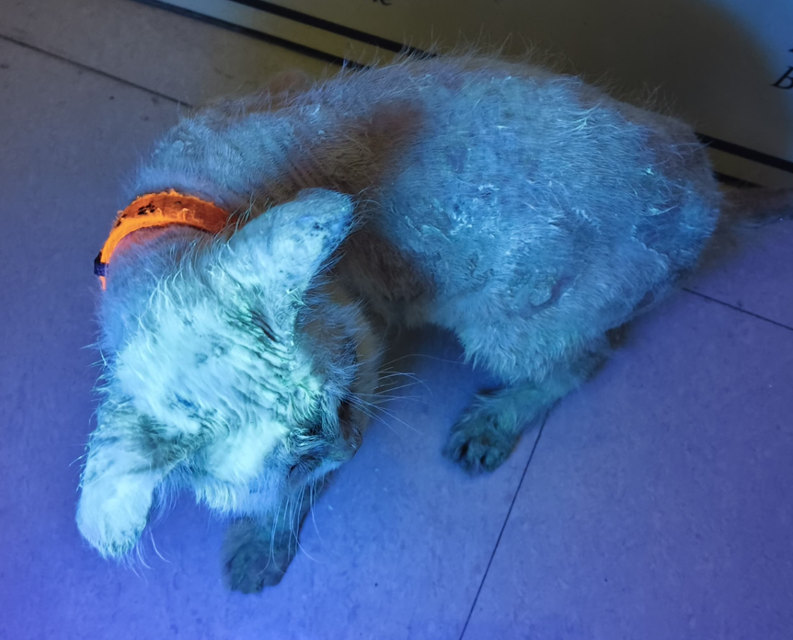
Figure 2. Positive apple-green fluorescence of affected hairs under Wood's lamp examination suggestive of Microsporum canis dermatophytosis.
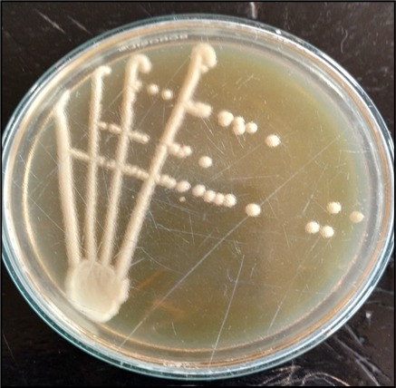
Fig. 3. Growth of dermatophyte colonies on Sabouraud Dextrose Agar (SDA), characterized by white to creamy fungal colonies following incubation.
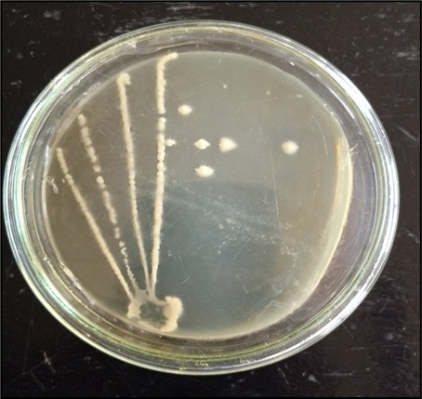
Fig. 4. Potato Dextrose Agar (PDA) culture demonstrating characteristic dermatophyte colony growth.
Based on the clinical findings, positive Wood's lamp examination and fungal culture results, the case was confirmed as feline dermatophytosis caused by Microsporum canis.
Discussion
Therapeutic management was initiated using itraconazole syrup (Itropet) administered orally at 1 ml once daily for seven days, along with topical application of Demoscanil lotion diluted at 0.25 ml in 10 ml of water on alternate days. Supportive therapy included Multistar Pet syrup at 1 ml orally once daily to promote skin healing and hair regrowth. Histavet was administered intramuscularly at a total dose of 4 mg. Ivermectin (Neomec) was administered subcutaneously at 200 µg/kg body weight during the initial stage of case management while parasitic dermatoses were being considered among the differential diagnoses.
The owner was advised to use a miconazole–chlorhexidine shampoo twice weekly to reduce fungal contamination of the hair coat. Administration of itraconazole with food was recommended to improve drug absorption and gastrointestinal tolerance. Environmental management included routine cleaning and disinfection of bedding, grooming equipment and the animal’s surroundings to minimise environmental contamination and reduce the risk of reinfection. Clinical improvement was evident during follow-up examinations. A marked reduction in scaling and crusting was observed within one week of therapy, accompanied by early hair regrowth in previously alopecic areas. Progressive resolution of skin lesions and improvement in coat condition indicated a favourable response to treatment.
The combined therapeutic approach used in this case is consistent with published recommendations indicating that extensive feline dermatophytosis should be managed through concurrent systemic antifungal therapy, topical reduction of infective material and environmental decontamination rather than by a single treatment modality alone (Diesel et al., 2011; Moriello et al., 2017; Rajagopalan et al., 2018).
The use of miconazole-chlorhexidine shampoo is also biologically plausible because topical antifungal washing can help decrease the surface fungal burden on hairs and scales, thereby complementing systemic treatment and reducing contamination of the immediate environment (Diesel et al., 2011; Hayette & Sacheli, 2015).
Dermatophytosis is one of the most frequently encountered fungal skin diseases in cats and is predominantly associated with Microsporum canis, a dermatophyte of considerable veterinary and public health importance due to its zoonotic potential (Scott et al., 2001; Moriello, 2014). Cats may act as both clinically affected animals and asymptomatic carriers, thereby serving as important reservoirs of infection for other animals and humans. The clinical manifestations observed in the present case, including generalised alopecia, scaling, crusting, broken hairs and a characteristic moth-eaten appearance of the coat, are in agreement with the findings reported in previous studies of feline dermatophytosis (Miller et al., 2013).
Wood's lamp examination remains a rapid, inexpensive and useful screening tool in routine veterinary dermatology. In the present case, the demonstration of characteristic apple-green fluorescence along infected hair shafts provided valuable preliminary evidence of M. canis infection. However, because not all dermatophyte species fluoresce and only a proportion of naturally infected M. canis strains exhibit fluorescence, Wood's lamp findings should be interpreted in conjunction with other diagnostic methods (Moriello et al., 2017). Fungal culture remains an important confirmatory test (Moriello et al., 2017), and in the present case, the isolation of characteristic colonies together with identification of spindle-shaped, rough-walled macroconidia confirmed the diagnosis.
This diagnostic interpretation is consistent with current diagnostic principles for dermatophytosis, which recommend using Wood's lamp examination as a rapid screening method while relying on fungal culture or microscopic identification for confirmation when clinical decisions depend on species-level diagnosis (Hayette & Sacheli, 2015; Moriello et al., 2017).
Successful management of feline dermatophytosis requires a combination of systemic antifungal therapy, topical treatment and environmental decontamination to reduce fungal spore burden and prevent reinfection (Moriello et al., 2017). The favourable clinical response observed in the present case, characterised by reduction in scaling and crusting together with progressive hair regrowth, supports the effectiveness of an integrated therapeutic approach. Early diagnosis, appropriate treatment and maintenance of environmental hygiene are essential for successful disease control and reduction of zoonotic risk.
Environmental control is especially relevant in companion-animal dermatophytosis because infective arthroconidia may remain associated with shed hairs and fomites; therefore, regular cleaning of bedding, grooming tools and contact surfaces is an important adjunct to animal treatment and follow-up monitoring (Hayette & Sacheli, 2015; Rajagopalan et al., 2018).

Conclusion
This case describes dermatophytosis in a two-year-old domestic short-haired cat diagnosed through clinical examination, Wood’s lamp evaluation and fungal culture. The presence of generalized alopecia, scaling, crusting, broken hairs and apple-green fluorescence of affected hairs provided important preliminary evidence of Microsporum canis infection, while fungal culture and microscopic morphology supported confirmation of the diagnosis. Therapeutic management using systemic antifungal treatment, topical antifungal measures, supportive care and environmental hygiene was associated with visible clinical improvement during follow-up. Reduction in scaling and crusting, improvement in coat condition and progressive hair regrowth indicated a favourable response to the treatment protocol used in this case. The report emphasizes that feline dermatophytosis should be approached through combined diagnostic and therapeutic measures, particularly because of its contagious nature and zoonotic relevance. Wood’s lamp examination may be useful as a rapid screening method, but confirmatory testing remains important for accurate diagnosis and appropriate clinical management.

Limitation
This report is limited to a single clinical case and therefore cannot establish the general efficacy of the treatment protocol. The manuscript does not provide drug concentrations in detail for all administered products, and dosage is not consistently expressed on a mg/kg basis. Follow-up findings are described clinically, but post-treatment fungal culture or other laboratory confirmation of mycological cure is not reported. The duration of follow-up is also not clearly defined. Therefore, the outcome should be interpreted as clinical improvement in one affected cat rather than definitive evidence of complete elimination of infection.

Conflict of Interest
The authors declare that there is no conflict of interest regarding the publication of this manuscript.
Declaration of AI Use

This manuscript was prepared through the combined contributions of all author(s), including contributions to the study design, data, content development, results, interpretation, and related scholarly work. The author(s) acknowledge the use of Grammarly and ChatGPT to assist with grammar checking, language refinement, reference formatting. These AI-assisted tools were not used as authors and did not replace the intellectual contributions or scholarly judgment of the author(s). All AI-assisted outputs, including content, references, and interpretations, were carefully reviewed, revised, verified, and approved by the author(s). The author(s) accept full responsibility for the accuracy, integrity, and final content of the manuscript.

References
Miller, W. H., Griffin, C. E., & Campbell, K. L. (2013). Muller and Kirk’s small animal dermatology.
Moriello, K.A. (2014). Dermatophytosis in cats and dogs: A practical guide to diagnosis and therapy. Veterinary Clinics of North America: Small Animal Practice, 44(6): 1109–1121.
Moriello, K. A., Coyner, K., Paterson, S., & Mignon, B. (2017). Diagnosis and treatment of dermatophytosis in dogs and cats. Clinical Consensus Guidelines of the World Association for Veterinary Dermatology. Veterinary dermatology, 28(3), 266-e68.
Scott, D.W., Miller, W.H. and Griffin, C.E. (2001). Muller and Kirk's Small Animal Dermatology. 6th Edn., W.B. Saunders, Philadelphia.
Sparkes, A.H., Gruffydd-Jones, T.J., Harbour, D.A. and Werrett, G. (1993). Epidemiological and clinical aspects of dermatophytosis in cats. Journal of Small Animal Practice, 34: 169–172.
Diesel, A., Verbrugge, M., & Moriello, K. A. (2011). Efficacy of eight commercial formulations of lime sulphur on in vitro growth inhibition of Microsporum canis. Veterinary Dermatology, 22(2), 197-201. https://doi.org/10.1111/j.1365-3164.2010.00928.x
Hayette, M.-P., & Sacheli, R. (2015). Dermatophytosis, trends in epidemiology and diagnostic approach. Current Fungal Infection Reports, 9(3), 164-179. https://doi.org/10.1007/s12281-015-0231-4
Rajagopalan, M., Inamadar, A., Mittal, A., Miskeen, A. K., Srinivas, C. R., Sardana, K., Godse, K., Patel, K., Rengasamy, M., Rudramurthy, S., & Dogra, S. (2018). Expert consensus on the management of dermatophytosis in India (ECTODERM India). BMC Dermatology, 18, Article 6. https://doi.org/10.1186/s12895-018-0073-1

