GC-MS Based Identification of Bio-active Phytoconstituents in Bryophyllum pinnatum

.
ABSTRACT

Aims: Bryophyllum pinnatum (Lam.) Oken is a medicinal plant widely used in traditional systems of medicine for the management of inflammatory disorders, wounds, infections, kidney stones, and gastrointestinal ailments. The present study was undertaken to characterize the phytochemical constituents of the methanolic whole plant extract of Bryophyllum pinnatum using gas chromatography–mass spectrometry (GC–MS).
Study design: GC MS Analysis
Place and Duration of Study: Trichy Research Institute of Biotechnology Pvt. Ltd, Trichy between April 2026 to July 2026.
Methodology: Whole plant of Bryophyllum pinnatum were shade-dried, powdered, and extracted with methanol using standard extraction procedures. The concentrated extract was subjected to GC–MS analysis under optimized chromatographic conditions. Identification of phytoconstituents was performed by comparing the obtained mass spectra with those available in the National Institute of Standards and Technology (NIST) mass spectral library.
Results: GC–MS analysis revealed the presence of several phytochemicals belonging to different chemical classes, including phenolic compounds, terpenoids, steroids, fatty acids, alcohols, esters, sugars, and other bioactive metabolites. Major constituents identified included compounds such as D-allose, 2,6-dimethoxyphenol (syringol), o-mentha-1(7),8-dien-3-ol, glucuronic acid γ-lactone, lanostane-type triterpenoids, and other minor constituents. Many of these compounds have been previously associated with antioxidant, anti-inflammatory, antimicrobial, hepatoprotective, and cytoprotective activities. However, several compounds identified by GC–MS require further confirmation using complementary analytical techniques because library matching alone provides tentative identification.
Conclusion: The GC–MS profile demonstrated that the methanolic extract of Bryophyllum pinnatum contains a diverse range of phytochemicals that may contribute to its traditional medicinal properties. The identified constituents support the plant's potential as a source of bioactive molecules for pharmacological applications. Nevertheless, isolation, structural characterization, and biological evaluation of the individual compounds are necessary to confirm their therapeutic significance and to establish a correlation between the phytochemical composition and the observed pharmacological activities.

Keywords: GC-MS analysis, Bryophillum pinnatum, Bioactive compounds, Methanolic extract, Phytoconstituents

1. INTRODUCTION

Herbal medicines are being adopted worldwide as people increasingly use plant-derived bioactive compounds to treat a range of diseases, from bacterial infections to cancer. (Riffat Latif, 2025) Medicinal plants have historically been important in ethnomedicine and are often considered safer, cheaper, and easier to access than synthetic drugs. According to the WHO, more than 80% of people worldwide rely on plant-derived traditional medicines for basic healthcare. Global interest in these plants as alternatives to synthetics has surged in recent decades. While synthetic medicines are usually based on a single chemical, plant extracts contain diverse phytoconstituents such as flavonoids, alkaloids, polyphenols, and terpenoids (Prawej Ansari, 2025).
Bryophyllum pinnatum (Linn.) is a medicinally important plant recognized for its broad therapeutic applications. Commonly known as "miracle leaf," "life plant," or "love plant," its name derives from Greek roots: bryo, meaning "to sprout," and phyllum, meaning "leaf" (Sneha Gavali, 2025). Bryophyllum pinnatum first came from Madagascar. Now it grows in many warm parts of the world. It also grows in Nepal, Thailand, Pakistan, parts of Africa and the Americas, China, and India. (Mac-Kalunta, 2022).
Synonyms: Cotyledon pinnata Lam, Bryophyllum calycinum, Bryophyllum calyculata, Cotyledon calyculata, Crassula pinnata, Crassuvia floripendia, Verea pinnata, Kalanchoe pinnata. (Ramesh D ingole, 2020)
Vernacular names (Chaithra SR, 2020 and Swati Pirdhankar, 2024)
- Sanskrit: Parnabeeja, Asthibhaksha
- English: Air Plant, Miracle Leaf, Life Plant
- Hindi: Zakhmhaiyat, Patharchoor
- Kannada: Gandukalinga, Kadu basale
- Malayalam: Elamarunga
- Tamil: Malaikalli, Ranakalli, Ranapala, Gayamari
- Marathi: Gayamari
- Bengali: Koppatha, Pathar kuchi
Taxonomy (Seema V, 2012)
- Kingdom: Plantae
- Subkingdom: Tracheobionta (vascular plants)
- Division: Spermatophyta (seed plants)
- Sub-Division: Magnoliophyta (flowering plants)
- Class: Magnoliopsida (dicotyledons)
- Subclass: Rosidae
- Order: Rosales
- Family: Crassulaceae (stonecrop family)
- Genus: Bryophyllum
- Species: Bryophyllum pinnatum (Lam.) Oken
Bryophyllum pinnatum contains diverse phytochemicals including flavonoids, alkaloids, glycosides, steroids, and tannins, contributing to its therapeutic effects. It exhibits anti-inflammatory, antimicrobial, antioxidant, analgesic, nephroprotective, and wound-healing activities. Traditional applications include treatment of kidney stones, urinary disorders, skin infections, wounds, ulcers, asthma, and bronchitis. Its juice is used for stomach issues, fever, and insect bites. Research has confirmed many traditional claims, highlighting its relevance to modern therapeutics. (Samrin Sheikh, 2025). In this research article GC-MS analysis of methanolic extract of whole plant of Bryophyllum pinnatum.

2. material and methods
Bryophyllum pinnatum whole plant was collected in the month of April 2025 from Tirunelveli District, Tamil Nadu. The whole plant was authenticated by Dr. M. Syed Ali Fathima, Assistant Professor and Head, Sadakathullah Appa Arts and Science College, Tirunelveli. (Specimen Number: SAC/BOT/BORS007/MAY, 2026).

2.2 EXTRACTION OF PLANT MATERIAL
The whole plant of Bryophyllum pinnatum was dried and powdered. Then it was defatted with n-hexane using Soxhlet apparatus followed by extraction with methanol. Finally, it was concentrated by vacuum evaporator.

2.3 GC-MS ANALYSIS
The methanolic whole plant extract was filtered through a 0.22 µm membrane filter before analysis. Approximately 1 µL of the filtered extract was injected into the GC–MS system in split mode. Separation was carried out using a fused silica capillary column (e.g., 30 m × 0.25 mm internal diameter × 0.25 µm film thickness). High-purity helium (99.999%) was used as the carrier gas at a constant flow rate of 1.0 mL/min.
The injector temperature was maintained at 250°C, and the interface temperature at 280°C. The oven temperature program was typically set from 60°C (held for 2 min), increased at 10°C/min to 280°C, and held for 10 min. The mass spectrometer operated in electron ionization (EI) mode at 70 eV, with a mass scan range of m/z 40–600. (National Institute of Standards and Technology)
The chromatographic peaks were identified by comparing their mass spectra with those available in the National Institute of Standards and Technology (NIST) and/or Wiley mass spectral libraries. The relative abundance of each compound was calculated from the peak area percentage in the total ion chromatogram (TIC). (McLafferty FW, 1993)

3. results and discussion

GC-MS was used to identify and quantify compounds in the plant sample. Analysis of the methanolic extract of Bryophyllum pinnatum whole plant revealed 71 methanol -soluble compounds. Identification was confirmed using molecular formula, retention time, and peak area data. Full results and the TIC curve are shown in Figure 1 and Table 2.
3.1 GC-MS profile and comparison with published phytochemical evidence
The present profile indicates a chemically heterogeneous methanolic extract, with early-eluting low-molecular-weight compounds and later-eluting fatty acids, terpenoids, sterols, tocopherol and triterpenoid-type constituents. This pattern is consistent with earlier GC-MS and phytochemical investigations of B. pinnatum/K. pinnata leaves, which reported polar and non-polar metabolites, phenolics, terpenoids, steroids, fatty-acid derivatives and other bioactive classes in different extracts (Faboro et al., 2016; Das & Kamble, 2024; Isibor, 2026). The detection of n-hexadecanoic acid, octadecanoic acid, cis-vaccenic acid, squalene, lupeol, beta-sitosterol acetate, campesterol and alpha-tocopherol suggests that the methanolic whole-plant extract contains both lipid-derived constituents and phytosterol/triterpenoid-related metabolites; however, the peak-area response in GC-MS should be interpreted as relative abundance rather than absolute concentration unless validated calibration is performed (Faundes-Gandolfo et al., 2024; Faboro et al., 2016).
3.2 Biological relevance of the detected metabolite classes
The presence of phenolic compounds, fatty acids, sterols and terpenoid/triterpenoid metabolites may provide a chemical basis for the traditional use of B. pinnatum, but the present data do not by themselves confirm biological activity. Previous peer-reviewed studies reported antioxidant, antimicrobial, anti-inflammatory and cytotoxic or anticancer-related responses from B. pinnatum/K. pinnata extracts using biological assays, supporting the need to connect chemical profiling with targeted bioassays in future work (Agarwal & Shanmugam, 2019; Das & Kamble, 2024; Faundes-Gandolfo et al., 2024). Therefore, compounds such as alpha-tocopherol, squalene, beta-sitosterol-related derivatives, campesterol and lupeol should be treated as hypothesis-generating markers until isolated compounds or standardized fractions are tested.
3.3 Analytical interpretation and limitations of library-based identification
The compound assignments listed in Table 1 should be considered tentative because they are based mainly on mass-spectral library matching and retention time. Robust GC-MS annotation typically requires library match quality, reverse-match values, retention indices against an n-alkane series, comparison with reference spectra or standards and, for structurally similar sterols and triterpenoids, complementary techniques such as LC-MS/MS or NMR (Faboro et al., 2016; Faundes-Gandolfo et al., 2024). In addition, phthalate peaks such as diethyl phthalate and bis(2-ethylhexyl) phthalate should be interpreted cautiously because phthalates are ubiquitous plasticizers that may originate from containers, solvents or laboratory consumables; blank controls and validated procedures are needed before assigning them as genuine plant metabolites (Alshehri et al., 2022).

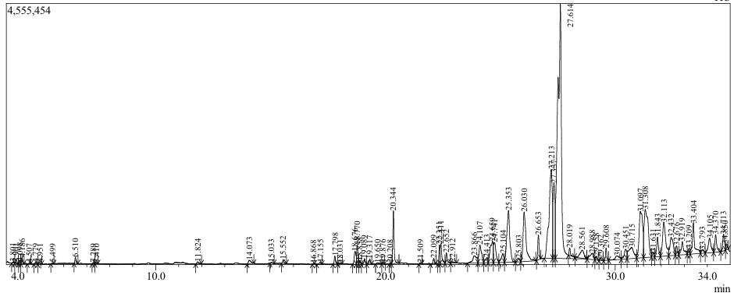
Fig. 1. Chromatogram of Bryophyllum pinnatum

Table 1. Peak report of Bryophyllum pinnatum

Peak | Retention Time | Area | Height | Name
1 | 3.801 | 99232 | 19863 | p-Xylene
2 | 3.901 | 65716 | 20014 | Silane, diethyldimethyl-
3 | 4.098 | 101577 | 34661 | 1-Pyrrolidinecarboxaldehyde
4 | 4.186 | 316442 | 104567 | 1-Pyrrolidinecarboxaldehyde
5 | 4.507 | 76109 | 20506 | Butane, 1,1,3-trimethoxy-
6 | 4.779 | 132649 | 25120 | D-Glucuronic acid, .gamma.-lactone
7 | 4.951 | 99867 | 24176 | Isopropyl acetate
8 | 5.499 | 55498 | 15633 | Decane
9 | 6.510 | 329807 | 106266 | 2-Propanol, 1-[1-methyl-2-(2-propenyloxy) ethoxy
10 | 7.289 | 50893 | 16100 | Decane
11 | 7.410 | 54511 | 15158 | (Methoxymethyl)trimethylsilane
12 | 11.824 | 210524 | 33421 | Phenol, 2,6-dimethoxy-
13 | 14.073 | 459620 | 59121 | beta-D-Glucopyranose, 1,6-anhydro-
14 | 15.033 | 73625 | 16656 | n-Decanoic acid
15 | 15.552 | 256792 | 68723 | Diethyl Phthalate
16 | 16.868 | 51543 | 15338 | 1,9-Nonanediol
17 | 17.155 | 123825 | 31420 | Pentadecanal-
18 | 17.798 | 548806 | 139749 | Tetradecanoic acid
19 | 18.031 | 102978 | 16090 | Z-2-Heptenoic acid, 3-iodo-
20 | 18.676 | 1108328 | 222681 | Benzoic acid, 4-hydroxy-3,5-dimethoxy-
21 | 18.770 | 1288683 | 338312 | Neophytadiene
22 | 18.858 | 250095 | 57784 | 4-Methyldocosane
23 | 19.089 | 430230 | 94166 | 3,7,11,15-Tetramethyl-2-hexadecen-1-ol
24 | 19.317 | 341702 | 90591 | 3,7,11,15-Tetramethyl-2-hexadecen-1-ol
25 | 19.650 | 180138 | 17149 | Tetrahydrofuran-2-ol, 3,4-di[1-butenyl]-
26 | 19.876 | 87283 | 26825 | Tridecanoic acid, methyl ester
27 | 20.208 | 49543 | 14128 | 1-Undecanol
28 | 20.344 | 3559917 | 919814 | n-Hexadecanoic acid
29 | 21.509 | 68613 | 19589 | Octadecanoic acid
30 | 22.099 | 339404 | 94151 | 3,7,11,15-Tetramethyl-2-hexadecen-1-ol
31 | 22.351 | 1108639 | 328359 | 9,12-Octadecadienoic acid (Z,Z)-
32 | 22.411 | 1637775 | 342950 | cis-Vaccenic acid
33 | 22.652 | 865506 | 184543 | Octadecanoic acid
34 | 22.912 | 221611 | 23250 | 9-Eicosyne
35 | 23.866 | 1651717 | 125674 | 5 beta.-Pregnane-3.alpha.,20.alpha.-diol, bis(p
36 | 24.107 | 2580338 | 312668 | PFP derivative of epicoprostanol
37 | 24.413 | 722209 | 87977 | Obtusifoliol
38 | 24.659 | 3545575 | 369549 | Obtusifoliol
39 | 24.741 | 2397959 | 352052 | Obtusifoliol
40 | 25.104 | 1192561 | 150449 | Tricyclo[20.8.0.0(7,16)]triacontane, 1(22),7(1
41 | 25.353 | 8166006 | 902802 | Lupeol
42 | 25.803 | 412499 | 59897 | 1-Naphthalenepropanol, .alpha.-ethenyldecahy
43 | 26.030 | 8034099 | 865047 | (3S,8S,9S,10R,13R,14S,17R)-17-((2R,5R)-5-
44 | 26.653 | 1546959 | 430449 | Bis(2-ethylhexyl) phthalate
45 | 27.213 | 15852328 | 1553759 | 9,19-Cyclolanostan-3-ol, acetate, (3.beta.)-
46 | 27.337 | 8050498 | 1315442 | Cycloartanol
47 | 27.614 | 50951709 | 4381185 | 9,19-Cycloergost-24(28)-en-3-ol, 4,14-dimeth
48 | 28.019 | 539181 | 128780 | 2-Methyltetracosane
49 | 28.561 | 1695124 | 142148 | Cholest-5-en-3-ol, 4,4-dimethyl-, (3.beta.)-
50 | 28.988 | 1202169 | 109632 | 9,19-Cyclolanost-24-en-3-ol, (3.beta.)-
51 | 29.158 | 288265 | 62031 | Octacosane, 1-iodo-
52 | 29.362 | 149073 | 36187 | Tricosyl acetate
53 | 29.608 | 870801 | 214449 | Squalene
54 | 30.074 | 850909 | 63472 | Masticadienonic acid, methyl ester (isomer 1)
55 | 30.451 | 1293814 | 165912 | Octatriacontyl pentafluoropropionate
56 | 30.715 | 3285620 | 195217 | 9,19-Cyclolanost-25-en-3-ol, 24-methyl-, (3.b
57 | 31.097 | 8837559 | 809287 | 9,19-Cyclolanostan-3-ol, 24-methylene-, (3.be
58 | 31.308 | 10457419 | 838564 | 9,19-Cyclolanostan-3-ol, acetate, (3.beta.)-
59 | 31.631 | 582258 | 84963 | Triacontane, 1-iodo-
60 | 31.843 | 2143455 | 339049 | Octacosyl acetate
61 | 32.113 | 5958676 | 590239 | 9,19-Cyclolanost-24-en-3-ol, acetate, (3.beta.)
62 | 32.432 | 3291902 | 318455 | 2H-1-Benzopyran-6-ol, 3,4-dihydro-2,7,8-trim
63 | 32.676 | 839749 | 162439 | Stigmasta-5,22-dien-3-ol, acetate, (3.beta.)-
64 | 32.919 | 2105661 | 227234 | .beta.-Sitosterol acetate
65 | 33.209 | 627849 | 100083 | (10E,14E)-6,7-Epoxy-6,10,14-trimethyl-3-met
66 | 33.404 | 3910458 | 536790 | dl-.alpha.-Tocopherol
67 | 33.793 | 513722 | 57795 | 2,2,4a,7a-Tetramethyldecahydro-1H-cyclobuta
68 | 34.105 | 2378098 | 254122 | 9,19-Cyclolanostan-3-ol, 24-methylene-, (3.be
69 | 34.370 | 1870814 | 302078 | Octacosyl acetate
70 | 34.713 | 1652678 | 286963 | Campesterol
71 | 34.850 | 552864 | 98530 | Chola-5,22-dien-3-ol, (3.beta.,22Z)-

Table 1. Peak report of Bryophyllum pinnatum

Compound name | Mol. Formula | Mol. weight | Structure
D-Glucuronic acid, gamma-lactone |  |  | 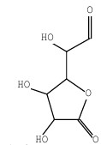
Phenol, 2,6-dimethoxy- | C8H10O3 | 154 | 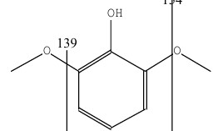
D-Allose | C6H12O6 | 180 | 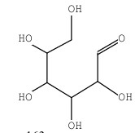
(4,7-Dimethoxy-2H-1,3-benzodioxol-5-yl) methanol | C10H12O5 | 212 | 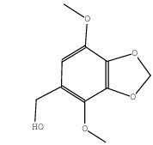
4-hydroxy-3,5-dimethoxy-, hydrazide | C9H12N2O4 | 212 | 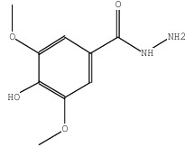
Tetrahydrofuran-2-ol, 3,4-di[1-butenyl] | C12H20O2 | 196 | 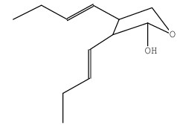
Piperityl angelate | C15H24O2 | 236 | 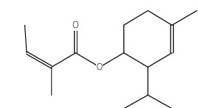
o-Mentha-1(7),8-dien-3-ol | C10H16O | 152 | 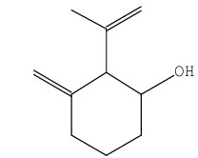
5 beta.-Pregnane-3 alpha.,20 alpha-diol | C27H34F10O4 | 612 | 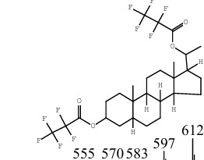
epicoprostanol | C30H47F5O2 | 534 | 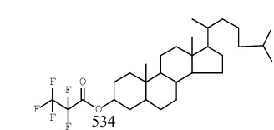  -
Lanost-7-en-3-one, (9.beta.,13.alpha.,14.beta.,17.alpha.) | C30H50O | 426 | 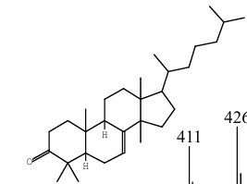
Epilupeol $$ 20(29)-Lupen-3alpha-ol | C32H52O2 | 468 | 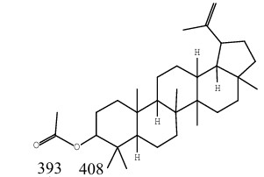
beta-Sitosterol | C29H50O | 414 | 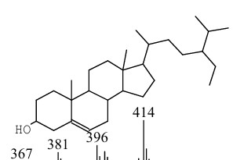
Pollinastanol or Cycloartanol | C30H52O | 428 | 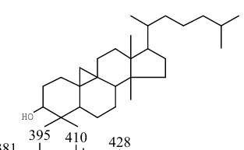
9,19-Cycloergost-24(28)-en-3-ol | C32H52O2 | 468 | 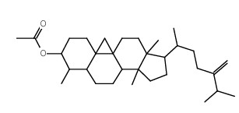
Masticadienonic acid | C31H48O3 | 468 | 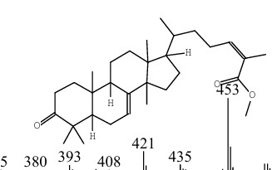
Sclaral (sclareolide lactol) | C16H28O2 | 252 | 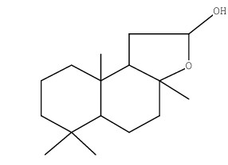
Vitamin E | C29H50O2 | 430 | 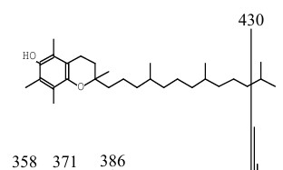
Androst-5-en-3-ol, | C21H34O | 302 | 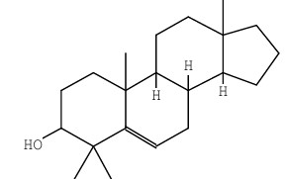
Campesterol | C28H48O | 400 | 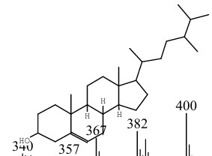

Table: 2 Some important compounds and their structure, Molecular formula and weight present in extract

4. Conclusions
The GC-MS analysis of the methanolic whole-plant extract of Bryophyllum pinnatum indicated the presence of several phytochemical constituents belonging to different chemical groups, including phenolics, fatty acids, terpenoids, sterols, sugars, alcohols and esters. The detected profile suggests that the plant contains diverse secondary metabolites that may be relevant for future pharmacological investigation. Compounds such as neophytadiene, n-hexadecanoic acid, squalene, lupeol, β-sitosterol derivatives, α-tocopherol and campesterol were among the notable constituents identified from the chromatographic profile. These findings provide preliminary support for further phytochemical exploration of the plant. However, compound identification by GC-MS library matching should be considered tentative. Confirmatory analysis using reference standards, retention indices, LC-MS/MS, NMR spectroscopy and isolation of individual compounds is required before firm conclusions can be made about the chemical composition and biological significance of the extract.

Limitations
This study is limited to GC-MS profiling of a methanolic whole-plant extract and does not include isolation or confirmation of individual compounds using reference standards. Library-based identification may produce tentative or false-positive assignments, especially for structurally related compounds. Match scores, retention indices, replicate runs and peak-area percentages are not adequately reported. Some detected compounds may represent contaminants or derivatization artifacts and require verification. The study does not test antioxidant, antimicrobial, anti-inflammatory, anticancer or other biological activities, so pharmacological relevance cannot be directly concluded. Seasonal, geographical and plant-part variations were not assessed. Further validated phytochemical and bioactivity studies are required.

Declaration of AI Use

This manuscript was prepared through the combined contributions of all author(s), including contributions to the study design, data, content development, results, interpretation, and related scholarly work. The author(s) acknowledge the use of Grammarly and ChatGPT to assist with grammar checking, language refinement, reference formatting. These AI-assisted tools were not used as authors and did not replace the intellectual contributions or scholarly judgment of the author(s). All AI-assisted outputs, including content, references, and interpretations, were carefully reviewed, revised, verified, and approved by the author(s). The author(s) accept full responsibility for the accuracy, integrity, and final content of the manuscript.

COMPETING INTERESTS DISCLAIMER:
Authors have declared that they have no known competing financial interests OR non-financial interests OR personal relationships that could have appeared to influence the work reported in this paper.

References

Riffat Latif., Ta uﬁq Nawaz. (2025). Medicinal plants and human health: a comprehensive review of bioactive compounds, therapeutic effects, and applications. Phytochemistry Reviews, 25 (3), 123-131.
Prawej Ansari et.al. (2025), Therapeutic Potential of Medicinal Plants and Their Phytoconstituents in Diabetes, Cancer, Infections, Cardiovascular Diseases, Inflammation and Gastrointestinal Disorders. Biomedicines, 13 (2), 454-458.
Rashmi Bagul (2025). Bryophyllum Pinnatum: A Comprehensive Review of its Phytochemistry and Pharmacological Activities. International Journal of Pharmaceutical Sciences, 3 (12), 2987-2994.
Mac-Kalunta, Ahamefula, C.Odii, B. Ibe (2022). Comparative Studies of the yeid and chemical constituents of Bryophyllum Pinnatum By cold maceration and soxhlet extraction methods, Journal of the Chemical Society of Nigeria, 3 (47), 807-817.
Ramesh D Ingole, Avinash B, Thalkari, Pawan N. Karwa, Krushna K, Zambare, Pallavi S, Shinde. (2020) Bryophyllum Pinnatum: A Magical Herb, Journal of Pharmacognosy and Phytochemistry. 12(3), 162-167.
Chaithra SR, Bijesh Vatakkeel, Siju E N. (2020) A Review on Pharmacological activities of Bryophyllum Pinnatum Linn. American Journal of Pharmacy and Health research, 2(8).
Swati Pirdhankar, Om Thorve, dr Rupali tasgonkar. (2024) Bryophyllum Pinnatum: Traditional Remedies, Growth, and Future prospect in Medicine. International journal of Research publication and review,11 (5), 2942-2948.
Seema V, Pattewar, Kalanchoe Pinnata: Phytochemical and Pharmacological profile. International journal of phytopharmacy, 2012, 2(1).
Samrin Sheikh, Nikita Bhandakkar, Pallavi Khairkar, Renuka Mahajan (2025), Pharmacological and Phytochemical Profile of Bryophyllum Pinnatum, International Journal of Pharmaceutical Sciences, 3 (2), 876-882.
Casarett & Doull's Toxicology: The Basic Science of Poisons. (2019) Klaassen CD, editor. 9th ed. New York: McGraw-Hill Education.
Harborne's Phytochemical Methods. Harborne JB. 3rd ed. London: Chapman & Hall; 1998.
Hossain MA, Izuishi K, Maeta H. D-Allose induces cell cycle arrest in human cancer cells through upregulation of TXNIP. International Journal of Oncology. 2005;26(5):1263–1268.
Yamaguchi F, Takata M, Kamitori K, Nonaka M, Dong Y, Sui L, et al. Rare sugar D-allose has antioxidant and cytoprotective effects in experimental models. Journal of Biosciences and Bioengineering. 2008;106(3):292–295.
National Center for Biotechnology Information. PubChem Compound Summary for benzodioxole derivatives.
National Institute of Standards and Technology. NIST/EPA/NIH Mass Spectral Library. Gaithersburg (MD): National Institute of Standards and Technology; latest edition.
McLafferty FW, Tureček F. Interpretation of Mass Spectra. 4th ed. Sausalito (CA): University Science Books; 1993.

Agarwal, H., & Shanmugam, V. K. (2019). Anti-inflammatory activity screening of Kalanchoe pinnata methanol extract and its validation using a computational simulation approach. Informatics in Medicine Unlocked, 14, 6-14. https://doi.org/10.1016/j.imu.2019.01.002
Alshehri, M. M., Ouladsmane, M. A., Aouak, T. A., ALOthman, Z. A., & Hadj Ahmed, A. Y. B. (2022). Determination of phthalates in bottled waters using solid-phase microextraction and gas chromatography tandem mass spectrometry. Chemosphere, 304, 135214. https://doi.org/10.1016/j.chemosphere.2022.135214
Das, L., & Kamble, V. A. (2024). Evaluation of bioactive constituents and antimicrobial activity of Bryophyllum pinnatum against bacterial and fungal pathogens. International Journal of Plant and Environment, 10(2), 258-264. https://doi.org/10.18811/ijpen.v10i02.14
Faboro, E. O., Wei, L., Liang, S., McDonald, A. G., & Obafemi, C. A. (2016). Phytochemical analyzes from the leaves of Bryophyllum pinnatum. European Journal of Medicinal Plants, 14(3), 1-10. https://doi.org/10.9734/EJMP/2016/25912
Faundes-Gandolfo, N., Jara-Gutiérrez, C., Párraga, M., Montenegro, I., Vera, W., Escobar, M., Madrid, A., Valenzuela-Valderrama, M., & Villena, J. (2024). Kalanchoe pinnata (Lam.) Pers. leaf ethanolic extract exerts selective anticancer activity through ROS-induced apoptotic cell death in human cancer cell lines. BMC Complementary Medicine and Therapies, 24, Article 269. https://doi.org/10.1186/s12906-024-04570-7
Isibor, J. (2026). Phytochemistry and bioactivity studies of Bryophyllum pinnatum: A review. Discover Chemistry, 3, Article 33. https://doi.org/10.1007/s44371-025-00360-3

