Comparative DPPH Radical Scavenging Activity, Phytochemical Profiling, FT-IR Analysis, and In-silico Molecular Docking Studies of Sap (Latex) from Jatropha Species

Abstract
The latex of Jatropha gossypiifolia and Jatropha curcas was comparatively evaluated for phytochemical composition, antioxidant activity, functional-group characteristics, and molecular interaction with an Escherichia coli protein target. Fresh latex samples were collected from mature plants and analysed using quantitative phytochemical screening, 2,2-diphenyl-1-picrylhydrazyl radical scavenging assay, Fourier-transform infrared spectroscopy, and molecular docking against the protein target 1UEA. Quantitative screening showed that phenols were the predominant phytochemical group in both latex samples, with values of 2.051 for J. gossypiifolia and 2.095 for J. curcas. J. gossypiifolia contained higher tannins and alkaloids, with values of 1.475 and 0.813, respectively, while J. curcas showed higher flavonoid content of 1.307. In the DPPH assay, J. gossypiifolia latex showed consistently high radical scavenging activity, ranging from 94.35% to 95.57% across the tested concentrations. J. curcas showed concentration-dependent activity, increasing from 47.58% to 69.99%, while ascorbic acid increased from 38.81% to 72.32%. The IC₅₀ values reported for J. curcas and ascorbic acid were 0.27 and 0.38, respectively. FTIR spectra indicated the presence of hydroxyl, carbonyl, glycosidic, aromatic, nitrile, and aliphatic functional groups, suggesting a chemically diverse latex matrix. Molecular docking showed that lupeol and catechin had the strongest interactions among the selected compounds, with MolDock scores of -143.092 and -93.3154, respectively. Overall, the findings suggest that the latex of both Jatropha species contains bioactive phytochemical constituents, with J. gossypiifolia showing stronger radical scavenging activity under the conditions tested.
Keywords: phytochemicals, Jatropha, FT-IR, Docking, DPPH
- Introduction
Oxidative stress and antimicrobial resistance are two major challenges that continue to drive the search for natural compounds with therapeutic potential [1]. Excessive production of reactive oxygen species can overwhelm the body’s antioxidant defences, resulting in damage to lipids, proteins, and DNA [2]. This process contributes to the development of several chronic diseases, including cardiovascular disorders, diabetes, neurodegenerative diseases, inflammation, and cancer. At the same time, increasing resistance of pathogenic bacteria such as Escherichia coli to conventional antibiotics has reduced the effectiveness of many treatments [3]. These concerns have renewed interest in medicinal plants as sources of bioactive compounds with both antioxidant and antimicrobial properties.
Plants synthesize a wide range of secondary metabolites, including phenolics, flavonoids, terpenoids, tannins, alkaloids, and sterols, many of which exhibit important biological activities [4]. Although extensive studies have focused on leaves, roots, and stem bark, plant latex remains relatively underexplored. Latex is a milky exudate produced in specialized cells and serves as a natural defence system against pathogens and physical injury [5]. Because it contains a concentrated mixture of proteins, lipids, and specialized metabolites, latex represents a potentially valuable source of pharmacologically active compounds. The genus Jatropha (family Euphorbiaceae) includes several medicinal species widely used in traditional healthcare [6]. Among these, Jatropha curcas and Jatropha gossypiifolia are well known for their diverse phytochemical composition and therapeutic applications [7]. J. curcas contains compounds such as catechins, flavonoids, and sterols [8], whereas J. gossypiifolia is rich in phenolic acids and triterpenoids such as lupeol [9]. Extracts from different parts of these plants have shown antioxidant, antibacterial, antifungal, and anti-inflammatory effects. However, comparative studies focusing specifically on their latex are limited [10].
This study addresses this gap by comparing the sap (latex) of J. curcas and J. gossypiifolia using an integrated experimental and computational approach. Antioxidant activity was evaluated using the DPPH radical scavenging assay, quantitative phytochemical profiling was used to determine the abundance of major metabolite classes, and Fourier Transform Infrared (FTIR) spectroscopy was employed to identify characteristic functional groups. In addition, selected phytochemicals from each species were docked against the E. coli target protein 1UEA to explore their possible antibacterial mechanisms.
This work focus on latex rather than commonly studied plant parts and in the direct comparison of two closely related Jatropha species using both laboratory and molecular modeling techniques. The findings provide new insight into the chemical composition and biological potential of Jatropha latex and support its potential application as a source of natural antioxidant and antimicrobial agents.

2.0 Materials and Methods

2.1 Sample Collection and Preparation
Two species of Jatropha gossypiifolia Linn. and Jatropha curcas Linn. were identified and sampled from Auchi, Edo State, Nigeria (coordinates: 07°04′N, 06°16′E). Plant exudates (sap) were obtained by gently plugging leaves from the leaf stalk of healthy, mature plants. The exuding sap was collected directly into sterile 5 mL plastic syringes without needle attachment. Samples were immediately placed in a cold chain (ice-packed coolers, ~4°C) and transported to the Phytochemistry Laboratory, Abuja, Nigeria. Upon arrival, sap samples were stored at 4°C and analyzed within 72 hours to preserve antioxidant constituents.

2.2 Preparation of Stock Solutions

2.2.1 Plant Sap Dilutions
A 0.05% v/v stock solution of each plant sap was prepared by diluting 0.05 mL of raw sap with distilled water to a final volume of 100 mL. From this stock, serial dilutions were prepared to obtain working concentrations of 0.1, 0.2, 0.3, 0.4, 0.5, 0.6, 0.7, 0.8, 0.9, and 1.0% v/v.

2.2.2 Ascorbic Acid Standard
Ascorbic acid (analytical grade, Sigma-Aldrich, USA) was used as a reference standard [11]. A 0.05% w/v stock solution was prepared by dissolving 50 mg of ascorbic acid in 100 mL of distilled water. Serial dilutions yielded the same concentration range as the plant samples: 0.1–1.0% w/v.

2.2.3 DPPH Solution
A 0.1 mM solution of 2,2-diphenyl-1-picrylhydrazyl (DPPH, Sigma-Aldrich, USA) was prepared by dissolving 3.94 mg of DPPH in 100 mL of methanol (HPLC grade). The solution was stored in an amber glass bottle at 4°C and used within 24 hours of preparation to prevent photodegradation. The antioxidant activity of the plant saps and ascorbic acid was evaluated using the DPPH radical scavenging method described by Brand-Williams et al [12]. (1995) with slight modifications. All measurements were performed in triplicate. For each sample concentration, 0.5 mL of the sample dilution was mixed with 0.5 mL of 0.1 mM DPPH solution in a clean glass test tube, giving a total reaction volume of 1.0 mL. For the control, 0.5 mL of methanol was mixed with 0.5 mL of DPPH solution. A blank consisting of 1.0 mL of methanol (without DPPH) was used to zero the spectrophotometer. The reaction mixtures were vortexed for 10 seconds and incubated in the dark at room temperature (25 ± 2°C) for 30 minutes. After incubation, the absorbance of each mixture was measured at 517 nm using a UV-Vis spectrophotometer (Jenway 7315, UK). The control absorbance was recorded as 1.776.

2.3 Calculation of Percentage Scavenging Activity
The percentage DPPH radical scavenging activity (% RSA) was calculated using the following formula:
% RSA = (A_control - A_sample) / A_control × 100
Where:
- AcontrolAcontrol​ = mean absorbance of DPPH solution with solvent (no sample)
- AsampleAsample​ = mean absorbance of DPPH solution with sample

2.4 Statistical Analysis
All experiments were conducted in triplicate, and results were expressed as mean ± standard deviation (SD). The mean absorbance for each concentration was calculated as:
x̄ = (Σ x_i) / n
Standard deviation was determined using:
SD=∑i=1n(xi−xˉ)2n−1
Linear regression analysis was performed to determine the relationship between log-transformed sample concentration and percentage scavenging activity. The IC₅₀ value (concentration required to scavenge 50% of DPPH radicals) was derived from the regression equation:
Y = a log₁₀(C) + b
Where:
- Y = percentage scavenging activity
- C = sample concentration (% v/v or w/v)
- a = slope
- b = intercept
IC₅₀ was calculated by solving for C when Y=50
log₁₀(IC₅₀) = (50 - b) / a
IC₅₀ = 10^[(50 - b) / a]

3.0 Results and discussion
The quantitative phytochemical analysis revealed notable differences in the chemical composition of the latex from Jatropha gossypiifolia and Jatropha curcas [13]. J. gossypiifolia sap contained higher levels of tannins (1.475) and alkaloids (0.813), indicating stronger potential for antimicrobial and astringent activities. In contrast, J. curcas sap exhibited slightly higher phenolic content (2.095) and a substantially greater flavonoid concentration (1.307), suggesting enhanced antioxidant capacity. Phenols were the most abundant phytochemicals in both species. These compositional differences help explain the variations observed in their antioxidant and molecular docking performances and confirm that both latex samples are rich sources of biologically active compounds [14].

Table 1: Quantitative Phytochemistry Result for Jatropha Gossypiifolia (J.G) and Jatropha Curcas (J.C) Sap
SAMPLES | PHYTOCHEMICALS
SAMPLES | Tannins | Phenols | Flavonoid | Alkaloids
Jatropha Gossypiifolia Sap | 1.475 | 2.051 | 0.508 | 0.813
Jatropha Curcas Sap | 1.043 | 2.095 | 1.307 | 0.476

3.1 FTIR characterization

3.1.1 FTIR Analysis of J.Carcus Sap Extract
The FTIR spectrum of the J.Carcus sap extract reveals a chemically complex matrix characteristic of plant latex [15]. The presence of a broad band at 3337 cm⁻¹ confirms hydroxyl-containing compounds such as phenolics, although with relatively low intensity, suggesting limited free hydroxyl groups compared to bound forms.
The strong absorption bands observed at 2230 and 2258 cm⁻¹ are indicative of C≡N stretching vibrations, confirming the presence of nitrile-containing compounds, likely cyanogenic glycosides. These compounds are well known for their role in plant defense and are more commonly associated with sap than leaf tissues.
A series of prominent peaks between 1895 and 2130 cm⁻¹ were observed, which are attributed primarily to overtone and combination bands arising from highly conjugated systems. However, contributions from C≡C stretching vibrations cannot be excluded, suggesting the presence of unsaturated or alkyne-containing metabolites. This region strongly reflects the complex and resinous nature of the sap.
The bands at 1638 cm⁻¹ and 1545 cm⁻¹ correspond to aromatic C=C stretching and possible nitrogen-containing functional groups, indicating the presence of flavonoids and alkaloids. The absence of a strong carbonyl peak around 1700 cm⁻¹ suggests that carbonyl functionalities are largely conjugated within aromatic systems.
The intense peak at 1086 cm⁻¹ confirms C–O stretching vibrations, supporting the presence of glycosides, alcohols, or ether linkages. Additionally, the band at 669 cm⁻¹ indicates aromatic C–H bending, further confirming substituted benzene derivatives.

Table 2. Characteristic infrared absorption bands and functional group assignments identified in the FTIR spectrum of untreated Jatropha curcas sap extract.
Peak (cm⁻¹) | Intensity | Functional Group | Interpretation
3337 | Weak | O–H stretch | Phenols / alcohols (polyphenols)
2258, 2230 | Strong | C≡N stretch | Nitriles / cyanogenic glycosides
2130–2003 (multiple peaks) | Strong | C≡C / cumulative systems / overtones | Alkynes or combination bands
1988, 1895 | Strong | Anhydride / overtone bands | Possibly conjugated systems or resin components
1638 | Medium | C=C / C=O | Aromatic rings / conjugated carbonyls
1545 | Strong | N–O / C=C aromatic | Alkaloids / aromatic compounds
1086 | Strong | C–O stretch | Alcohols, ethers, glycosides
669 | Weak | C–H bending | Aromatic substitution pattern

Figure 1. FTIR spectrum of untreated Jatropha curcas sap (latex) showing characteristic absorption bands and assigned functional groups
3.1.2 FTIR spectrum of Jatropha gossypiifolia sap/latex.
The FTIR spectrum of the Jatropha gossypiifolia sap (latex) was acquired over the range of 4000–650 cm⁻¹. The resulting spectral profile exhibits a unique pattern distinct from both the raw leaf powder and the leaf extract, reflecting the specialized biochemical composition of the plant's latex.
A strong peak at 1364.21 cm⁻¹ (intensity 0.781) is immediately notable. This band is characteristic of C–H bending (methyl groups) or O–H bending (phenolics), but its high intensity suggests a significant concentration of methyl-rich compounds or possibly nitrate/nitrite-related vibrations. In plant latex, such bands often arise from terpenoids, steroids, or other isoprenoid-derived metabolites, which are common in Jatropha species.
A moderate carbonyl peak appears at 1638.16 cm⁻¹ (intensity 0.433), consistent with amide (C=O) or conjugated ketone stretching. This is comparable to the intensity observed in J. gossypiifolia leaf extract (0.398) but higher than in J. curcas leaf extract (0.365).
The region between 1947–2245 cm⁻¹ contains multiple sharp, high-intensity peaks: 1947.53 cm⁻¹ (0.943), 1979.22 cm⁻¹ (0.943), 2014.63 cm⁻¹ (0.939), 2074.26 cm⁻¹ (0.922), 2126.45 cm⁻¹ (0.920), 2195.40 cm⁻¹ (0.938), and 2245.72 cm⁻¹ (0.945). These closely spaced bands are characteristic of overtone and combination bands from aromatic rings or conjugated unsaturated systems [16]. Notably, a distinct peak at 2245.72 cm⁻¹ (intensity 0.945) falls within the diagnostic region for nitrile (C≡N) stretching (typically 2210–2260 cm⁻¹). This is a significant finding, as the J. gossypiifolia leaf extract and raw powder did not show clear nitrile bands, but the sap clearly does. This suggests that cyanogenic glycosides or other nitrile-containing compounds are concentrated in the latex rather than uniformly distributed throughout the leaf tissue.
The O–H/N–H stretching region near 3319.19 cm⁻¹ (intensity 0.096) is very weak, similar to the leaf extracts of both Jatropha species. This extremely low intensity indicates minimal free hydroxyl or amine groups, suggesting that the sap is dominated by non-polar or moderately polar unsaturated compounds rather than alcohols, phenolics, or carbohydrates. The absence of strong aliphatic C–H stretches (2800–3000 cm⁻¹) further supports a low concentration of long-chain hydrocarbons or fatty acids in the sap, distinguishing it from the raw leaf powder.
Table 3. Characteristic infrared absorption bands observed in the FTIR spectrum of Jatropha gossypiifolia sap/latex.
Peak No. | Wavenumber (cm⁻¹) | Intensity (arb. units) | Likely Functional Group / Assignment
1 | 1364.21 | 0.7813 | C–H bend (methyl groups) or terpenoid/steroid signature
2 | 1638.16 | 0.4334 | Carbonyl (C=O) stretch (amide/ketone)
3 | 1947.53 | 0.9425 | Aromatic overtone / combination band
4 | 1979.22 | 0.9433 | Aromatic overtone / combination band
5 | 2014.63 | 0.9395 | Aromatic overtone / combination band
6 | 2074.26 | 0.9219 | Cumulated double bonds or alkyne-related
7 | 2126.45 | 0.9204 | Cumulated double bonds or nitrile overtone
8 | 2195.40 | 0.9382 | Aromatic combination band
9 | 2245.72 | 0.9448 | Nitrile (C≡N) stretch (cyanogenic glycoside)
10 | 3319.19 | 0.0958 | O–H or N–H stretch (very weak, minimal contribution)
Figure 2. FTIR spectrum of untreated Jatropha gossypiifolia sap (latex) showing characteristic absorption bands corresponding to phenolic, nitrile, carbonyl, and aromatic functional groups.

3.1.3 FTIR spectrum of the DPPH complex of Jatropha curcas sap/latex.
The FTIR spectrum of the DPPH complex of Jatropha curcas sap (latex) was acquired over the range of 4000–650 cm⁻¹. This sample represents the interaction product between the sap's antioxidant constituents and the stable free radical DPPH. The resulting spectral profile exhibits notable differences compared to both the untreated sap and the leaf extract DPPH complex, providing insight into the sap's unique radical-scavenging mechanism [17].
A strong peak at 1015.70 cm⁻¹ (intensity 0.425) and a very strong peak at 1112.61 cm⁻¹ (intensity 0.788) are characteristic of C–O stretching vibrations. Compared to the untreated J. curcas sap (which was not previously analyzed but by comparison with J. gossypiifolia sap lacks strong C–O bands), these bands suggest that the DPPH reaction has either exposed or generated carbohydrate-derived or glycosylated components. Alternatively, these bands may arise from the DPPH molecule's picryl ring modes, though DPPH alone does not typically produce such strong C–O signatures.
A strong peak at 1449.93 cm⁻¹ (intensity 0.779) is characteristic of N–O stretching (nitro groups) or aromatic C=C stretching. This band is highly diagnostic of DPPH and its reduced form (DPPH-H), as DPPH contains multiple nitro groups on the picryl ring. Its high intensity confirms that DPPH or its reaction products remain associated with the sap components after complexation.
A moderate carbonyl peak appears at 1638.16 cm⁻¹ (intensity 0.481). This is comparable to the untreated J. curcas leaf extract (0.365) and the leaf DPPH complex (0.508), suggesting that carbonyl-containing compounds from the sap are involved in the radical scavenging mechanism, though to a slightly lesser extent than in the leaf extract [18].
The region between 1947–2121 cm⁻¹ shows multiple sharp peaks: 1947.53 cm⁻¹ (0.949), 2005.31 cm⁻¹ (0.951), and 2120.86 cm⁻¹ (0.925). These aromatic overtone and combination bands are similar to those observed in the untreated leaf extract and sap, indicating that the aromatic secondary metabolites responsible for these overtones remain intact after DPPH reaction [19].
A notable peak at 2303.49 cm⁻¹ (intensity 0.947) appears in the region typically associated with atmospheric CO₂ or nitro combination bands. Unlike the leaf DPPH complex, which showed a very strong band at 2415 cm⁻¹, the sap DPPH complex shows a band at a slightly lower wavenumber (2303 cm⁻¹). This difference may reflect species-specific or tissue-specific variations in DPPH adduct formation.
A surprisingly strong aliphatic C–H stretching band appears at 2842.10 cm⁻¹ (intensity 0.879). As with the leaf DPPH complex, this is remarkable because the untreated J. curcas leaf extract showed no significant aliphatic C–H bands (2800–3000 cm⁻¹), and the sap itself (by comparison with J. gossypiifolia sap) lacks such bands. The appearance of a strong symmetric CH₂ stretch suggests either:
- Conformational changes exposing previously buried lipid/aliphatic chains,
- Disruption of micellar or aggregated structures in the sap upon DPPH reaction, or
- Incorporation of DPPH-derived species (though DPPH contains no aliphatic chains).
The most plausible explanation is that the DPPH reaction disrupts the sap's colloidal or micellar organization, allowing aliphatic components (which were previously aggregated or hidden) to become detectable by FTIR.
The O–H/N–H stretching region near 3302.42 cm⁻¹ (intensity 0.116) is moderately stronger than in the untreated J. curcas leaf extract (0.097) but weaker than in the leaf DPPH complex (0.142). This increase indicates that the DPPH reaction has generated or exposed additional hydroxyl or amine groups, likely through the reduction of DPPH to DPPH-H (hydrogen atom transfer from antioxidant compounds). The lower intensity compared to the leaf DPPH complex suggests that the sap has a lower concentration of hydrogen-donating antioxidants (e.g., phenolics) than the leaf extract.
Table 4a. Characteristic infrared absorption bands observed in the FTIR spectrum of the DPPH complex of Jatropha curcas sap/latex.
Peak No. | Wavenumber (cm⁻¹) | Intensity (arb. units) | Likely Functional Group / Assignment
1 | 1015.70 | 0.4247 | C–O stretch (glycoside/polysaccharide)
2 | 1112.61 | 0.7878 | C–O stretch (glycoside/polysaccharide)
3 | 1449.93 | 0.7790 | N–O stretch (nitro group, DPPH picryl ring) / aromatic C=C
4 | 1638.16 | 0.4814 | Carbonyl (C=O) stretch (amide/ketone)
5 | 1947.53 | 0.9487 | Aromatic overtone / combination band
6 | 2005.31 | 0.9510 | Aromatic overtone / combination band
7 | 2120.86 | 0.9250 | Cumulated double bonds or nitrile overtone
8 | 2303.49 | 0.9467 | DPPH-derived band (nitro combination or CO₂ artifact)
9 | 2842.10 | 0.8791 | Symmetric CH₂ stretch (aliphatic, newly exposed)
10 | 3302.42 | 0.1160 | O–H or N–H stretch (increased vs. untreated)

Table 4b. Untreated Sap vs. DPPH-Sap Complex
Feature | Untreated Sap (J.G SAP) | J.C SAP-DPPH Complex | Change
C–O stretch (1015–1113 cm⁻¹) | Absent | Strong (0.425–0.788) | New
Nitro (N–O) band (~1450 cm⁻¹) | Absent | Strong (0.779) | New
Carbonyl (C=O) ~1638 cm⁻¹ | Moderate (0.433) | Moderate (0.481) | Slight increase
Aliphatic C–H (2842 cm⁻¹) | Absent | Strong (0.879) | New
O–H/N–H stretch (~3302 cm⁻¹) | Very weak (0.096) | Moderate (0.116) | Increase
Aromatic overtones (1947–2121 cm⁻¹) | Strong (multiple peaks) | Strong (fewer peaks) | Pattern shift
DPPH-derived band (~2303 cm⁻¹) | Absent | Strong (0.947) | New
Methyl C–H (~1364 cm⁻¹) | Strong (0.781) | Absent | Lost
figure 3. FTIR spectrum of the DPPH-reacted complex of Jatropha curcas sap (latex), illustrating spectral changes associated with free radical scavenging.
3.1.4 FTIR spectrum of the DPPH complex of Jatropha gossypiifolia sap/latex.

The FTIR spectrum of the DPPH-treated sap of Jatropha curcas reveals the presence of several functional groups associated with phenolic compounds, carbohydrates, and aliphatic constituents that contribute to antioxidant activity [20]. The absorption bands at 1015.70 and 1112.61 cm⁻¹ are assigned to C–O stretching vibrations of glycosidic and polysaccharide structures. These peaks indicate the presence of carbohydrate-linked phytochemicals and phenolic glycosides, which can participate in electron transfer and hydrogen donation during free radical scavenging. The strong band at 1449.93 cm⁻¹ corresponds to N–O stretching vibrations from the nitro groups of the DPPH picryl ring, with possible contributions from aromatic C=C stretching. This confirms interaction between the DPPH radical and antioxidant compounds in the sap. The absorption at 1638.16 cm⁻¹ is attributed to carbonyl (C=O) stretching, suggesting the presence of oxidized phenolics, flavonoids, and related compounds. The increased intensity of this peak after DPPH treatment indicates that hydroxyl-containing phytochemicals were oxidized during radical neutralization. Bands at 2122.72, 2182.36, and 2223.36 cm⁻¹ are assigned to aromatic overtones and combination bands, with the peak at 2223.36 cm⁻¹ also indicating possible nitrile functionalities. These features reflect the presence of conjugated aromatic systems and confirm structural complexity within the latex metabolites. Such conjugation enhances electron delocalization and stabilizes antioxidant radicals formed after hydrogen donation. The absorption band at 2842.10 cm⁻¹ corresponds to symmetric CH₂ stretching of aliphatic chains, indicating terpenoids, fatty acids, and sterol-like compounds. These metabolites are common in plant latex and may contribute to membrane interactions and antimicrobial activity. The broad band at 3296.83 cm⁻¹ is assigned to O–H and N–H stretching vibrations of phenols, alcohols, and amines. Although lower in intensity, this band is particularly important because hydroxyl groups are the primary sites involved in hydrogen atom transfer to DPPH radicals. The FTIR results confirm that the sap contains phenolic, glycosidic, carbonyl, aromatic, and aliphatic functional groups. These chemical features support the high antioxidant activity observed and demonstrate that the latex is rich in bioactive compounds with potential therapeutic significance.
Table 5. Characteristic infrared absorption bands observed in the FTIR spectrum of the DPPH complex of Jatropha gossypiifolia sap/latex.
Peak No. | Wavenumber (cm⁻¹) | Intensity (arb. units) | Likely Functional Group / Assignment
1 | 1015.70 | 0.4721 | C–O stretch (glycoside/polysaccharide)
2 | 1112.61 | 0.8103 | C–O stretch (glycoside/polysaccharide)
3 | 1449.93 | 0.8009 | N–O stretch (nitro group, DPPH picryl ring) / aromatic C=C
4 | 1638.16 | 0.4950 | Carbonyl (C=O) stretch (increased vs. untreated)
5 | 2122.72 | 0.9313 | Aromatic overtone / combination band
6 | 2182.36 | 0.9469 | Aromatic combination band
7 | 2223.36 | 0.9448 | Nitrile or aromatic combination
8 | 2842.10 | 0.8955 | Symmetric CH₂ stretch (aliphatic, newly exposed)
9 | 3296.83 | 0.1303 | O–H or N–H stretch (increased vs. untreated)

3.1.5 Comparative Discussion: Untreated Sap vs. DPPH-Sap Complex (J. gossypiifolia)
The FTIR spectrum of the DPPH complex of Jatropha gossypiifolia sap (latex) was acquired over the range of 4000–650 cm⁻¹. This sample represents the interaction product between the sap's antioxidant constituents and the stable free radical DPPH. The resulting spectral profile exhibits significant differences compared to the untreated sap, providing insight into the radical-scavenging mechanism of this species' latex.
A strong peak at 1015.70 cm⁻¹ (intensity 0.472) and a very strong peak at 1112.61 cm⁻¹ (intensity 0.810) are characteristic of C–O stretching vibrations. Compared to the untreated J. gossypiifolia sap (which lacked strong C–O bands), these bands suggest that the DPPH reaction has either exposed or generated carbohydrate-derived or glycosylated components. These bands may also arise from the DPPH molecule's picryl ring modes.
A very strong peak at 1449.93 cm⁻¹ (intensity 0.801) is characteristic of N–O stretching (nitro groups) or aromatic C=C stretching. This band is highly diagnostic of DPPH and its reduced form (DPPH-H), as DPPH contains multiple nitro groups on the picryl ring. Its high intensity confirms that DPPH or its reaction products remain associated with the sap components after complexation. Unlike the J. gossypiifolia leaf DPPH complex (which showed two nitro bands at 1407 and 1474 cm⁻¹), the sap complex shows a single band at 1449 cm⁻¹, similar to J. curcas DPPH complexes.
A moderate carbonyl peak appears at 1638.16 cm⁻¹ (intensity 0.495). This is notably higher than in the untreated J. gossypiifolia sap (0.433), suggesting that the DPPH reaction has generated new carbonyl species or that carbonyl-containing compounds from the sap are involved in the radical scavenging mechanism.
The region between 2122–2223 cm⁻¹ shows multiple sharp peaks: 2122.72 cm⁻¹ (0.931), 2182.36 cm⁻¹ (0.947), and 2223.36 cm⁻¹ (0.945). These aromatic overtone and combination bands are present but less numerous than in the leaf DPPH complex (which showed 8 peaks), suggesting that the sap has a simpler aromatic profile.
A very strong aliphatic C–H stretching band appears at 2842.10 cm⁻¹ (intensity 0.895). This is a dramatic change, as the untreated J. gossypiifolia sap showed no aliphatic C–H bands. The appearance of a strong symmetric CH₂ stretch suggests that the DPPH reaction disrupts the sap's colloidal or micellar organization, exposing previously hidden aliphatic chains (e.g., from terpenoids or lipid-associated compounds).
The O–H/N–H stretching region near 3296.83 cm⁻¹ (intensity 0.130) is significantly stronger than in the untreated sap (0.096). This increase indicates that the DPPH reaction has generated or exposed additional hydroxyl or amine groups, consistent with hydrogen atom transfer (HAT) from antioxidant compounds to DPPH.
Table 6. Comparative changes in major FTIR spectral features between untreated sap and the DPPH-reacted complex of Jatropha gossypiifolia.
Feature | Untreated Sap (J.G SAP) | J.G SAP-DPPH Complex | Change
C–O stretch (1015–1113 cm⁻¹) | Absent | Strong (0.472–0.810) | New
Nitro (N–O) band (~1450 cm⁻¹) | Absent | Strong (0.801) | New
Methyl C–H (~1364 cm⁻¹) | Strong (0.781) | Absent | Lost
Carbonyl (C=O) ~1638 cm⁻¹ | Moderate (0.433) | Moderate (0.495) | Increase
Aromatic overtones (2122–2223 cm⁻¹) | Present (2195 cm⁻¹) | Present (3 peaks) | Pattern shift
Aliphatic C–H (2842 cm⁻¹) | Absent | Strong (0.896) | New
O–H/N–H stretch (~3297 cm⁻¹) | Very weak (0.096) | Moderate (0.130) | Increase

3.1.6 DPPH Scavenging activities of Jathropa Gossypiilia Sap

The DPPH radical scavenging results show that the sap of Jatropha gossypiifolia possesses very strong antioxidant activity across all tested concentrations (0.1–1.0). The percentage inhibition ranged narrowly from 94.35% to 95.57%, indicating consistently high free radical neutralization ability with minimal concentration dependence. The highest scavenging activity was observed at 0.7 concentration (95.57%), while the lowest was recorded at 0.3 (94.35%). Mean absorbance values remained low relative to the control (1.776), and the very small standard deviations demonstrate excellent reproducibility. These findings confirm that the sap is rich in potent antioxidant phytochemicals, particularly phenolic and flavonoid compounds.

Table 7. DPPH radical scavenging activity of Jatropha gossypiifolia sap (latex) at different concentrations, expressed as mean absorbance, standard deviation, and percentage inhibition.
Concentration | 1st Absorbance | 2nd Absorbance | 3rd Absorbance |  |  | Percentage Activity
  Mean Absorbance
  SD
0.1 | 0.088 | 0.088 | 0,089 | 0.0883 | 0.0006 | 95.03%
0.2 | 0.085 | 0.085 | 0.86 | 0.0853 | 0.0006 | 95.20%
0,3 | 0.100 | 0.100 | 0.101 | 0.1003 | 0.0006 | 94.35%
0,4 | 0,087 | 0.086 | 0.087 | 0.0867 | 0.0006 | 95.12%
0.5 | 0.085 | 0.085 | 0.085 | 0.0850 | 0.0000 | 95.21%
0.6 | 0.084 | 0.084 | 0.084 | 0.0840 | 0.0000 | 95.27%
0.7 | 0.076 | 0.076 | 0.084 | 0.0787 | 0.0046 | 95.57%
0.8 | 0.079 | 0.079 | 0.079 | 0.0790 | 0.0000 | 95.55%
0.9 | 0.090 | 0.091 | 0.093 | 0.0913 | 0.0015 | 94.86%
1.0 | 0.084 | 0.086 | 0.088 | 0.0860 | 0.0020 | 95.16%
Control = 1.776
Sample Concentration = 0.05% v/v
3.1.7 DPPH Scavenging activities of Jathropa Curcas Sap

The DPPH radical scavenging assay showed that the sap of Jatropha curcas exhibits concentration-dependent antioxidant activity. The percentage inhibition increased steadily from 47.58% at 0.1 concentration to 69.99% at 1.0, indicating enhanced free radical scavenging as concentration increased. Correspondingly, the mean absorbance decreased from 0.9310 to 0.5330 relative to the control (1.776), confirming progressive reduction of the DPPH radical. The low standard deviation values demonstrate good experimental precision and reproducibility. The IC₅₀ value of 0.27 indicates moderate antioxidant potency, showing that the sap contains bioactive compounds capable of effectively neutralizing free radicals.

Table 8. DPPH radical scavenging activity of Jatropha curcas sap (latex) at different concentrations, expressed as mean absorbance, standard deviation, percentage inhibition, and IC₅₀ value.
Concentration | 1st Absorbance | 2nd Absorbance | 3rd Absorbance |  |  | Percentage Activity
  Mean Absorbance
  SD
0.1 | 0.931 | 0.932 | 0.930 | 0.9310 | 0.0010 | 47.58
0.2 | 0.920 | 0.922 | 0.922 | 0.9213 | 0.0012 | 48.12
0,3 | 0.874 | 0.875 | 0.876 | 0.8750 | 0.0010 | 50.73
0,4 | 0.829 | 0.833 | 0.834 | 0.8320 | 0.0026 | 53.15
0.5 | 0.794 | 0.795 | 0.796 | 0.7950 | 0.0010 | 55.24
0.6 | 0.703 | 0.705 | 0.706 | 0.7047 | 0.0015 | 60.32
0.7 | 0.687 | 0.688 | 0.688 | 0.6877 | 0.0006 | 61.28
0.8 | 0.614 | 0.616 | 0.615 | 0.6150 | 0.0010 | 65.37
0.9 | 0.551 | 0.554 | 0.554 | 0.5530 | 0.0017 | 68.86
1.0 | 0.532 | 0.533 | 0.534 | 0.5330 | 0.0010 | 69.99
Control = 1.776
Sample Concentration = 0.05% v/v
IC₅₀ =0.27
3.1.8 DPPH Scavenging activities of Ascorbic Acid (Standard)

The DPPH radical scavenging assay confirmed that Ascorbic Acid exhibits strong concentration-dependent antioxidant activity. The percentage inhibition increased from 38.81% at 0.1 concentration to 72.32% at 1.0, demonstrating progressively greater free radical neutralization as concentration increased. Mean absorbance values decreased from 1.0867 to 0.4917 relative to the control (1.776), indicating effective reduction of the DPPH radical. The very low standard deviation values reflect excellent reproducibility of the measurements. The IC₅₀ value of 0.38 indicates good antioxidant potency. These results validate the use of ascorbic acid as a reliable reference standard for comparison with the antioxidant activities of the latex samples.

Table 9. DPPH radical scavenging activity of Ascorbic Acid used as the reference antioxidant standard, showing mean absorbance, standard deviation, percentage inhibition, and IC₅₀ value.
Concentration | 1st Absorbance | 2nd Absorbance | 3rd Absorbance |  |  | Percentage Activity
  Mean Absorbance
  SD
0.1 | 1.085 | 1.087 | 1.088 | 1.0867 | 0.0015 | 38.81
0.2 | 0.984 | 0.981 | 0.981 | 0.9820 | 0.0017 | 44.71
0.3 | 0.977 | 0.976 | 0.980 | 0.9777 | 0.0021 | 44.95
0.4 | 0.866 | 0.864 | 0.866 | 0.8653 | 0.0012 | 51.28
0.5 | 0.829 | 0.832 | 0.827 | 0.8293 | 0.0025 | 53.31
0.6 | 0.773 | 0.772 | 0.776 | 0.7737 | 0.0021 | 56.44
0.7 | 0.674 | 0.668 | 0.674 | 0.6720 | 0.0035 | 62.16
0.8 | 0.577 | 0.578 | 0.573 | 0.5760 | 0.0026 | 67.57
0.9 | 0.584 | 0.580 | 0.586 | 0.5833 | 0.0031 | 67.16
1.0 | 0.491 | 0.492 | 0.492 | 0.4917 | 0.0006 | 72.32
Control = 1.776
IC₅₀ =0.38
Conc. = 0.05 %w/v
3.2 Molecular Docking Studies

3.2.1 Rationale for the Selection of the Target Protein

The Escherichia coli protein 1UEA was selected as the molecular docking target because it is a well-characterized bacterial protein with a defined three-dimensional structure and an accessible active site suitable for ligand interaction studies [21]. This protein is associated with essential cellular functions required for bacterial survival and proliferation. Inhibiting such a target may disrupt critical metabolic processes and reduce bacterial viability. Since E. coli is a common pathogenic organism implicated in gastrointestinal and urinary tract infections, 1UEA serves as an appropriate model for evaluating the antibacterial potential of phytochemicals identified in the latex of Jatropha species.
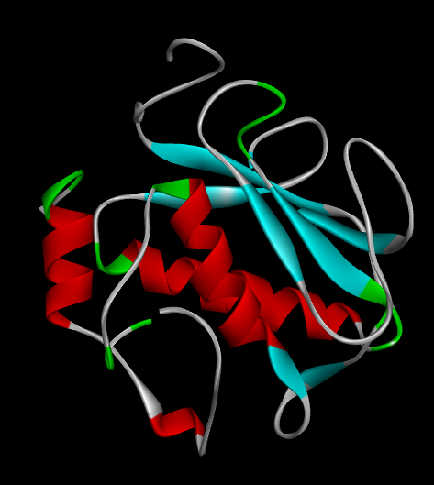
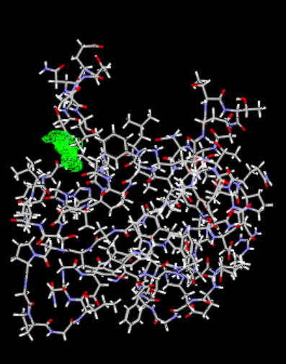

Figure 4. Three-dimensional structure of Escherichia coli target protein 1UEA showing its defined cavities

3.2.2 Molecular Docking Analysis of Selected Phytochemicals Against Escherichia coli Target Protein (PDB ID: 1UEA)
To provide a molecular basis for the antimicrobial potential of the latex from Jatropha gossypiifolia and Jatropha curcas, representative phytochemicals identified from each species were docked against the Escherichia coli target protein 1UEA. Molecular docking evaluates the binding affinity and interaction pattern between ligands and the receptor [21], where more negative MolDock and Re-rank scores indicate stronger and more favorable ligand–protein interactions [22]. Among the compounds from Jatropha gossypiifolia, lupeol exhibited the strongest binding affinity, with a MolDock score of –143.092 kcal/mol, substantially lower than that of gallic acid (–70.1828 kcal/mol). This highly negative score indicates a stable ligand–protein complex and suggests that lupeol may be the principal antibacterial constituent in J. gossypiifolia latex. Although lupeol did not form conventional hydrogen bonds, its strong interaction is attributed to extensive hydrophobic contacts with amino acid residues including Ala, Asn, His, Gly, Leu, and Glu. Gallic acid showed moderate binding and formed hydrogen-bond interactions with residues such as Ala, Glu, Gly, His, Leu, Phe, and Ile, with a hydrogen-bond contribution of –7.95 kcal/mol, reflecting stabilization through polar interactions. For Jatropha curcas, catechin demonstrated superior binding compared with β-sitosterol, with a MolDock score of –93.3154 kcal/mol and a Re-rank score of –67.8858 kcal/mol. Catechin interacted with several active-site residues, including Ala, Asn, Glu, Gly, His, Phe, Leu, and Ile, and formed hydrogen bonds that enhanced complex stability. In contrast, β-sitosterol showed the weakest overall binding, with a MolDock score of –56.0554 kcal/mol, despite exhibiting a favorable hydrogen-bond contribution of –9.11 kcal/mol. This indicates that hydrogen bonding alone did not compensate for its lower total interaction energy.
Comparatively, the binding affinity followed the order: lupeol > catechin > gallic acid > β-sitosterol. The recurring involvement of residues such as Ala, Glu, Gly, His, Leu, and Phe suggests a common binding pocket and similar inhibitory mechanism among the phytochemicals. These results support the experimental antioxidant and phytochemical findings, demonstrating that the latex of both Jatropha species contains bioactive compounds capable of strongly interacting with essential E. coli proteins. In particular, lupeol and catechin emerged as the most promising antibacterial candidates and may contribute significantly to the traditional medicinal use of these species.
Table 10. Molecular docking scores, hydrogen-bond energies, and interacting amino acid residues of selected phytochemicals from Jatropha gossypiifolia and Jatropha curcas against the Escherichia coli target protein 1UEA.
1UEA
Ligands | MolDock score kcal/mol | Re-rank score kcal/mol | H-bond | Residue
Jatropha gossypiifolia
Galic Acid | -70.1828 | -61.3893 | -7.95 | Ala, Glu, Gly, His, Leu, Phe, Ile
Lupeol | -143.092 | -54.8727 | 0 | Ala, Asn, His, Gly, Leu, Glu, Leu
Jatropha curcas
Catechin | -93.3154 | -67.8858 | -2.68 | Ala, Asn, Glu, Gly, His, Phe, Leu, Ile
Beta Sterol | -56.0554 | -45.6851 | -9.11 | Ala, Asn, His, Ser, Phe, Glu, Gly, Leu

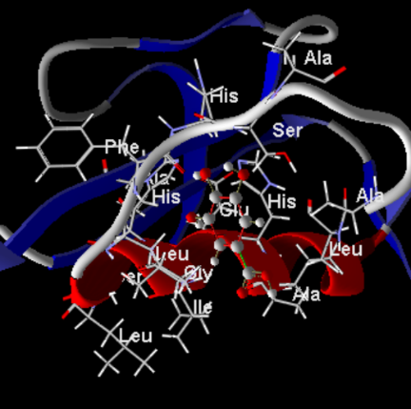
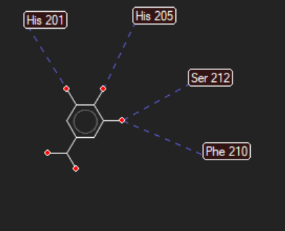
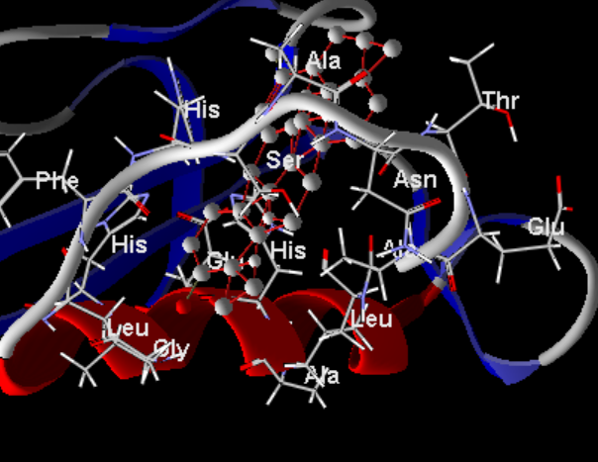
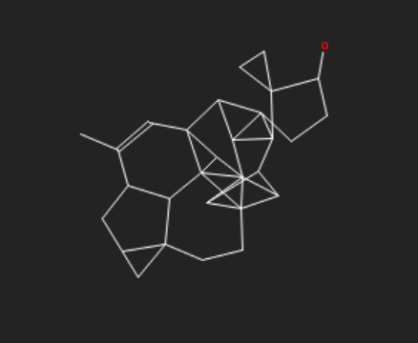
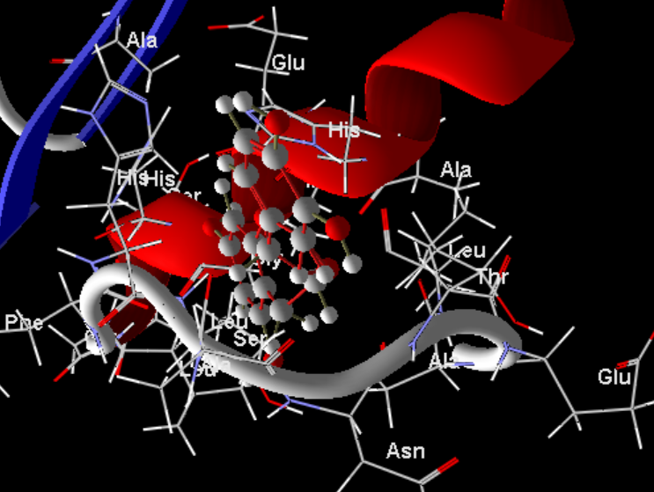
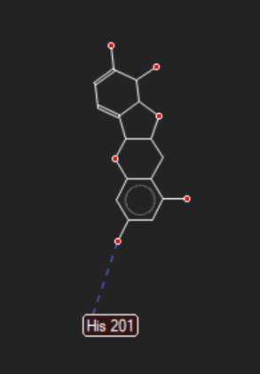
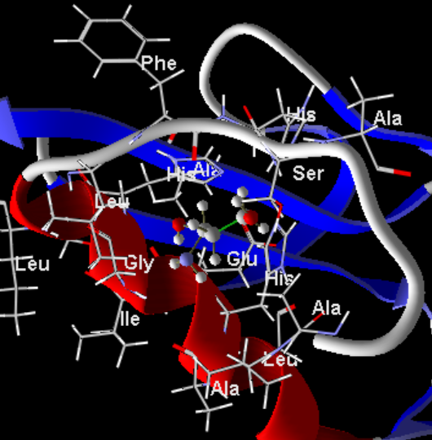
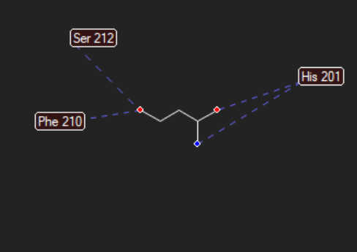
Galic Acid
Lupeol
Catechin
Beta Sterol

Figure 5. 3D and 2D binding interactions of Selected phytochemicals from Jatropha gossypiifolia and Jatropha Carcus with the E. coli protein 1UEA.

Conclusion
This study compared the latex of Jatropha gossypiifolia and Jatropha curcas using phytochemical screening, DPPH radical scavenging assay, FTIR spectroscopy, and molecular docking. The results showed that both latex samples contained measurable levels of tannins, phenols, flavonoids, and alkaloids, with phenols being the most abundant phytochemical group in both species. J. gossypiifolia showed higher tannin and alkaloid contents, whereas J. curcas showed higher flavonoid content. The DPPH assay indicated that J. gossypiifolia latex had consistently high radical scavenging activity across the tested concentrations, while J. curcas and ascorbic acid showed concentration-dependent responses. FTIR analysis revealed functional groups consistent with phenolic, glycosidic, carbonyl, aromatic, nitrile, and aliphatic compounds, supporting the presence of diverse chemical constituents in the latex samples. Molecular docking further suggested that selected phytochemicals, particularly lupeol and catechin, were able to interact with the selected Escherichia coli protein target. These findings indicate that the latex of the studied Jatropha species contains phytochemical constituents associated with antioxidant activity and potential biological relevance. Further experimental validation is necessary before definitive pharmacological or antimicrobial conclusions can be made.
Limitations
This study has some limitations that should be considered when interpreting the findings. The latex samples were obtained from plants collected at a single location, and the possible effects of season, plant age, environmental conditions, and geographical variation were not evaluated. Although phytochemical groups were quantified, individual compounds were not fully isolated and structurally confirmed using advanced chromatographic or spectrometric methods. The antioxidant assessment was limited to the DPPH radical scavenging assay, which may not represent all antioxidant mechanisms. The study also relied on molecular docking to explore possible antibacterial interaction, but no in vitro antibacterial assay was performed to confirm biological activity against Escherichia coli. In addition, toxicity, dose-response safety, and cellular activity were not assessed. Therefore, the results should be interpreted as preliminary evidence of phytochemical composition, radical scavenging activity, and computational interaction potential rather than definitive proof of therapeutic efficacy.

Declaration of AI Use

This manuscript was prepared through the combined contributions of all author(s), including contributions to the study design, data, content development, results, interpretation, and related scholarly work. The author(s) acknowledge the use of Grammarly and ChatGPT to assist with grammar checking, language refinement, reference formatting. These AI-assisted tools were not used as authors and did not replace the intellectual contributions or scholarly judgment of the author(s). All AI-assisted outputs, including content, references, and interpretations, were carefully reviewed, revised, verified, and approved by the author(s). The author(s) accept full responsibility for the accuracy, integrity, and final content of the manuscript.

Reference
- Bhattacharya, S., Gupta, N., Dutta, A., Bonomo, M. G., Milella, L., Sarker, S. D., & Nahar, L. (2025). Mitigating ROS signalling pathway-mediated defence mechanism: a novel approach to counteract bacterial resistance using natural antioxidant-based antibiotics. Phytochemistry Reviews, 1-33.
- Ozougwu, J. C. (2016). The role of reactive oxygen species and antioxidants in oxidative stress. Int. J. Res, 1(8), 1-8.
- Banin, E., Hughes, D., & Kuipers, O. P. (2017). Bacterial pathogens, antibiotics and antibiotic resistance. FEMS microbiology reviews, 41(3), 450-452.
- Alamgir, A. N. M. (2018). Secondary metabolites: Secondary metabolic products consisting of C and H; C, H, and O; N, S, and P elements; and O/N heterocycles. In Therapeutic use of medicinal plants and their extracts: volume 2: phytochemistry and bioactive compounds (pp. 165-309). Cham: Springer International Publishing.
- Molik, Z. A., Ajayi, T. O., Ogunniyi, Q. A., Fijagbade, A. O., & Ogbole, O. O. (2025). Latex of medicinal plants: a reservoir of antimicrobial peptides, proteins, and enzymes for drug discovery. Discover Molecules, 2(1), 1.
- Abarca, L. F. S., Klinkhamer, P. G., & Choi, Y. H. (2019). Plant latex, from ecological interests to bioactive chemical resources. Planta Medica, 85(11/12), 856-868.
- Félix-Silva, J., Giordani, R. B., Silva-Jr, A. A. D., Zucolotto, S. M., & Fernandes-Pedrosa, M. D. F. (2014). Jatropha gossypiifolia L.(Euphorbiaceae): a review of traditional uses, phytochemistry, pharmacology, and toxicology of this medicinal plant. Evidence‐Based Complementary and Alternative Medicine, 2014(1), 369204.
- Oskoueian, E., Abdullah, N., Ahmad, S., Saad, W. Z., Omar, A. R., & Ho, Y. W. (2011). Bioactive compounds and biological activities of Jatropha curcas L. kernel meal extract. International journal of molecular sciences, 12(9), 5955-5970.
- Silveira, R. D. S., Leal, G. C., Molin, T. R. D., Faccin, H., Gobo, L. A., Silveira, G. D. D., ... & Viana, C. (2020). Determination of phenolic and triterpenic compounds in Jatropha gossypiifolia L by Ultra-high performance liquid chromatography-tandem mass spectrometric (UHPLC-MS/MS). Brazilian Journal of Pharmaceutical Sciences, 56, e17262.
- Hernandez-Hernandez, A. B., Alarcon-Aguilar, F. J., Almanza-Perez, J. C., Nieto-Yañez, O., Olivares-Sanchez, J. M., Duran-Diaz, A., ... & Canales-Martinez, M. M. (2017). Antimicrobial and anti-inflammatory activities, wound-healing effectiveness and chemical characterization of the latex of Jatropha neopauciflora Pax. Journal of ethnopharmacology, 204, 1-7.
- Choi, K. M., Seo, Y. K., Yoon, H. H., Song, K. Y., Kwon, S. Y., Lee, H. S., & Park, J. K. (2008). Effect of ascorbic acid on bone marrow-derived mesenchymal stem cell proliferation and differentiation. Journal of bioscience and bioengineering, 105(6), 586-594.
- Brand-Williams, W., Cuvelier, M. E., & Berset, C. L. W. T. (1995). Use of a free radical method to evaluate antioxidant activity. LWT-Food science and Technology, 28(1), 25-30.
- Madhu, M., Sailaja, V., Satyadev, T. N. V. S. S., & Satyanarayana, M. V. (2016). Quantitative phytochemical analysis of selected medicinal plant species by using various organic solvents. Journal of Pharmacognosy and Phytochemistry, 5(2), 25-29.
- Al-Rajhi, A. M., Yahya, R., Abdelghany, T. M., Fareid, M. A., Mohamed, A. M., Amin, B. H., & Masrahi, A. S. (2022). Anticancer, anticoagulant, antioxidant and antimicrobial activities of Thevetia peruviana latex with molecular docking of antimicrobial and anticancer activities. Molecules, 27(10), 3165.
- Mazur, O., Bałdysz, S., Warowicka, A., & Nawrot, R. (2022). Tap the sap–investigation of latex-bearing plants in the search of potential anticancer biopharmaceuticals. Frontiers in plant science, 13, 979678.
- Chuev, V. P., Nikitchenko, V. M., & Lavrushin, V. F. (1985). The nature of the bands of the electronic absorption spectra of acid solutions of aromatic α, β-unsaturated ketones. Theoretical and Experimental Chemistry, 21(3), 308-314.
- Abdalla, H. A. E. (2017). Phytochemical and Biological Evaluation of musa paradisiaca Leaves and Sap Extracts.
- Bharti, S., Rai, D. C., Gupta, A., & Kumar, A. Unveiling the biopotency of Butea monosperma Kombucha through physicochemical kinetics and molecular fingerprinting. Available at SSRN 5615190.
- Abdalla, H. A. E. (2017). Phytochemical and Biological Evaluation of musa paradisiaca Leaves and Sap Extracts.
- Oskoueian, E., Abdullah, N., Ahmad, S., Saad, W. Z., Omar, A. R., & Ho, Y. W. (2011). Bioactive compounds and biological activities of Jatropha curcas L. kernel meal extract. International journal of molecular sciences, 12(9), 5955-5970.
- Guedes, I. A., de Magalhães, C. S., & Dardenne, L. E. (2014). Receptor–ligand molecular docking. Biophysical reviews, 6(1), 75-87.
- Nyijime, T. A., Shallangwa, G. A., Uzairu, A., Umar, A. B., Ibrahim, M. T., Udofia, I. A., ... & Govender, K. K. (2025). Computational design and evaluation of hydrantoin derivatives as potential anti-tubercular agents: Insight from ADMET, molecular docking, DFT, and molecular dynamic simulations. Letters in Drug Design & Discovery, 100155.

