Analyzing Social Media’s Role in Developing Emotional Attachment and Driving Cross Buying Behavior: A Bibliometric Study

.
ABSTRACT

Abstract
This study maps the development of scholarly literature on social media marketing, emotional attachment, and cross-buying behavior through a bibliometric approach. Bibliographic data were collected using Publish or Perish from the Crossref database with three search keywords: Social Media Marketing, Emotional Attachment, and Cross-Buying. Each keyword search produced 1,000 publication records, resulting in an initial dataset of 3,000 documents. The records were analyzed using VOSviewer to examine keyword co-occurrence networks, overlay visualization, and density visualization. The results show that the literature is organized around several connected keyword clusters. One major cluster centers on social media marketing and includes related terms such as social media, advertising, brand, brand awareness, brand image, purchase intention, and loyalty. Another major cluster centers on attachment and includes terms such as emotion, individual, age, correlation, and attachment style. Several connecting terms, including factor, review, and mediating role, appear between these clusters, indicating conceptual links between social media marketing and emotional attachment in the analyzed literature. The overlay visualization suggests temporal variation in the emergence of research topics, while the density visualization shows that attachment and social media marketing are the most prominent keywords in the dataset. Overall, the findings indicate that research on digital marketing increasingly connects social media-based interaction with emotional relationships and consumer purchasing outcomes. The study contributes by providing a structured overview of the knowledge base and by identifying dominant themes and potential areas for further research on the relationship between social media marketing, emotional attachment, and cross-buying behavior in contemporary digital marketing scholarship.

Keywords: Social Media Marketing, Emotional Attachment, Cross Buying

1. INTRODUCTION
The development of digital technology has transformed the way companies interact with consumers, particularly through the use of social media as an increasingly dominant marketing communication channel. Social media enables brands to shift from one-way communication patterns to ongoing interactive dialogue with consumers, creating more dynamic and personalized relationships in the digital environment. This transformation makes social media a strategic platform for building long-term relationships between brands and consumers through interaction, participation, and relevant content. Various studies have shown that marketing activities through social media can influence consumer engagement with brands, brand awareness, brand image, and various consumer purchasing behavior outcomes (Drossos et al., 2023; Santos et al., 2022; Zeqiri et al., 2024). Furthermore, consumer engagement formed through social media activities has also been shown to influence loyalty, willingness to pay premium prices, and electronic word-of-mouth in the digital environment (Changani et al., 2022; Fondevila-Gascón et al., 2020; V. Kumar et al., 2022; Zeqiri et al., 2024; Zha et al., 2023). In this context, social media functions not only as a marketing communication tool but also as an ecosystem that facilitates social interaction, the formation of perceptions, and emotional connections between consumers and brands. Therefore, understanding how social media shapes emotional connections with consumers is becoming increasingly important in modern marketing research.
Digital marketing literature indicates that consumer brand engagement is a key mechanism bridging social media marketing activities with various consumer behavioral outcomes. Consumer engagement is understood as a multidimensional process encompassing cognitive, affective, and behavioral dimensions in brand-related activities on social media (Changani et al., 2022; Cheung et al., 2020; Reyvina & Tjokrosaputro, 2024; Zeqiri et al., 2024). Across various industry contexts, high consumer engagement through social media has been shown to foster stronger relationships between consumers and brands and generate more positive behavioral responses. Research also highlights that several key elements in social media marketing, such as interactivity, electronic word-of-mouth, and digital content trends, play a significant role in increasing consumer engagement with brands (Cheung et al., 2020; Santos et al., 2022). Furthermore, the phenomenon of influencers, user-generated content, and parasocial interactions with public figures or content creators are also important factors that strengthen consumer relationships with brands on social media (Fan et al., 2023; Ferreira et al., 2021; Zha et al., 2023). Authentic content and user participation in creating brand experiences have also been shown to increase brand trust and retention, ultimately influencing consumer purchasing decisions (B. Kumar, 2024; Moisescu et al., 2025). Thus, social media serves not only as a marketing communication tool but also as a means of creating more emotional and meaningful brand experiences for consumers. The development of digital technology has transformed the way companies interact with consumers, particularly through the use of social media as an increasingly dominant marketing communication channel. Social media enables brands to shift from one-way communication patterns to ongoing interactive dialogue with consumers, creating more dynamic and personalized relationships in the digital environment. This transformation makes social media a strategic platform for building long-term relationships between brands and consumers through interaction, participation, and relevant content. Various studies have shown that marketing activities through social media can influence consumer engagement with brands, brand awareness, brand image, and various consumer purchasing behavior outcomes (Drossos et al., 2023; Santos et al., 2022; Zeqiri et al., 2024). Furthermore, consumer engagement formed through social media activities has also been shown to influence loyalty, willingness to pay premium prices, and electronic word-of-mouth in the digital environment (Changani et al., 2022; Fondevila-Gascón et al., 2020; Zeqiri et al., 2024; Zha et al., 2023). In this context, social media functions not only as a marketing communication tool but also as an ecosystem that facilitates social interaction, the formation of perceptions, and emotional connections between consumers and brands. Therefore, understanding how social media shapes emotional connections with consumers is becoming increasingly important in modern marketing research.
Digital marketing literature indicates that consumer brand engagement is a key mechanism bridging social media marketing activities with various consumer behavioral outcomes. Consumer engagement is understood as a multidimensional process encompassing cognitive, affective, and behavioral dimensions in brand-related activities on social media (Changani et al., 2022; Cheung et al., 2020; Reyvina & Tjokrosaputro, 2024; Zeqiri et al., 2024). Across various industry contexts, high consumer engagement through social media has been shown to foster stronger relationships between consumers and brands and generate more positive behavioral responses. Research also highlights that several key elements in social media marketing, such as interactivity, electronic word-of-mouth, and digital content trends, play a significant role in increasing consumer engagement with brands (Cheung et al., 2020; Santos et al., 2022). Furthermore, the phenomenon of influencers, user-generated content, and parasocial interactions with public figures or content creators are also important factors that strengthen consumer relationships with brands on social media (Fan et al., 2023; Ferreira et al., 2021; Zha et al., 2023). Authentic content and user participation in creating brand experiences have also been shown to increase brand trust and retention, ultimately influencing consumer purchasing decisions (B. Kumar, 2024; Moisescu et al., 2025). Thus, social media serves not only as a marketing communication tool but also as a means of creating more emotional and meaningful brand experiences for consumers.

One important aspect of the relationship between consumers and brands is the formation of emotional attachment to the brand. Emotional attachment is an emotional bond that reflects the depth of the relationship between consumers and brands and its connection to the consumer's identity and self-concept (Ahuvia et al., 2022; Hemsley‐Brown, 2022; Sriwidadi et al., 2022). The literature shows that emotional attachment to brands often arises through psychological processes involving psychological ownership, namely the feeling that a brand or product is part of the consumer's self (Chen et al., 2022; Jiang et al., 2021; Kou & Powpaka, 2020). This feeling of psychological ownership then develops into a deeper emotional connection with the brand, which further drives loyalty and repeat purchase intentions (Fu et al., 2023; Hemsley‐Brown, 2022; Sriwidadi et al., 2022). Furthermore, emotional attachment can also be strengthened through meaningful brand experiences, engagement in brand communities, and value congruence between brands and consumers (Ahuvia et al., 2022; Hong-ru & Chelliah, 2024; Jiang et al., 2021). In a digital context, brand experiences formed through interactions on social media can trigger feelings of psychological ownership and emotional attachment to brands (Chen et al., 2022). This suggests that social media has significant potential for building emotional connections between consumers and brands, ultimately influencing consumer behavior.
Emotional attachment to brands not only influences consumer loyalty but can also encourage a wider range of purchasing behaviors, including cross-buying. Cross-buying refers to consumers' tendency to purchase additional products or services from the same company or within the same ecosystem (Latusi et al., 2023; Singh et al., 2023; Zhang & Yu, 2020). This behavior is increasingly relevant in digital and e-commerce environments that offer multiple product categories and integrated services within a single platform. Research shows that various factors such as perceived value, consumer trust, perceived risk, and digital platform design can influence consumers' propensity to cross-buy (Dong et al., 2024; ÖZDEMİR & Bayraklı, 2022; Singireddy, 2023). Furthermore, the diversity of information, online reviews, and the influence of influencers also play a role in encouraging consumers to purchase additional products within the digital ecosystem (Julianti et al., 2025; Nartea & Barrera, 2024; Pratama, 2025). Thus, in the context of modern digital marketing, social media and various digital marketing stimuli have the potential to expand consumer purchasing behavior through complex psychological and social mechanisms.

Although numerous studies have addressed the relationship between social media marketing, consumer engagement, emotional attachment, and consumer purchasing behavior, studies that systematically map the development of research on this topic are still relatively limited. Most previous studies have used empirical approaches such as surveys and structural equation modeling to examine the relationships between variables in specific contexts (Changani et al., 2022; Cheung et al., 2020; Drossos et al., 2023; V. Kumar et al., 2022; Santos et al., 2022). These approaches provide in-depth understanding of cause-and-effect relationships in specific contexts, but they do not fully reflect the overall development of knowledge in the academic literature. Therefore, a bibliometric approach is needed to map the knowledge structure, research trends, and relationships between concepts in the literature discussing the role of social media, emotional attachment, and cross-buying. Bibliometric analysis allows researchers to systematically identify key research themes, scientific collaboration networks, and the development of research topics over time. Thus, this approach can provide a comprehensive overview of the direction of research development and research gaps that still need to be explored. Based on this background, this study aims to analyze and map the development of scientific literature discussing the role of social media in forming emotional attachments and their impact on cross-buying behavior using a bibliometric analysis approach. This study also seeks to identify key research themes, publication development trends, and conceptual relationships between key variables in the digital marketing and consumer behavior literature. By mapping the knowledge structure in this field, this study is expected to provide theoretical contributions to understanding the relationship between social media, emotional attachment, and cross-buying in the context of digital marketing. Furthermore, this research can also provide practical implications for marketers in designing more effective social media marketing strategies that build emotional connections with consumers and encourage broader purchasing behavior in the digital ecosystem.
Research Questions (for bibliometric analysis research)
a. How has the development of scientific publications on the role of social media in forming emotional attachments and their impact on cross-buying occurred in the marketing literature?
b. What are the main research themes, dominant keywords, and conceptual relationships that emerge in research on social media, emotional attachment, and cross-buying?
c. Which authors, institutions, and journals have been most influential in the development of the literature related to social media, emotional attachment, and cross-buying?
d. What is the structure of the collaboration network and research trends in studies on social media, emotional attachment, and cross buying based on bibliometric analysis?

2. methodology
This study uses a bibliometric analysis approach to map the development of scientific literature related to the role of social media in forming emotional attachment and its implications for cross-buying. The bibliometric approach was chosen because it can provide a systematic overview of the knowledge structure, research trends, and relationships between concepts within a research field. In the context of digital marketing, studies on consumer engagement, emotional relationships with brands, and various purchasing behavior outcomes have grown rapidly in various sectors such as retail, fashion, hospitality, and electronics (Fondevila-Gascón et al., 2020; V. Kumar et al., 2022; Reyvina & Tjokrosaputro, 2024; Silva et al., 2024; Zeqiri et al., 2024). Furthermore, previous research has also shown that emotional attachment and consumer engagement are important mechanisms in explaining the relationship between social media marketing activities and various consumer behavior outcomes (Changani et al., 2022; Cheung et al., 2020; Drossos et al., 2023; Santos et al., 2022). In the consumer-brand relationship literature, emotional attachment is seen as an emotional bond formed through psychological processes such as psychological ownership, consumer involvement, and value congruence between the brand and the consumer (Ahuvia et al., 2022; Chen et al., 2022; Fu et al., 2023; Hemsley‐Brown, 2022; Sriwidadi et al., 2022). Meanwhile, research on cross-buying shows that cross-product or service purchasing behavior is influenced by various factors such as perceived value, trust, perceived risk, and various digital marketing stimuli in the online platform ecosystem (Dong et al., 2024; Julianti et al., 2025; Latusi et al., 2023; Nartea & Barrera, 2024; ÖZDEMİR & Bayraklı, 2022; Pratama, 2025; Singh et al., 2023; Singireddy, 2023; Zhang & Yu, 2020). Therefore, a bibliometric approach is used in this study to identify patterns of literature development, main research themes, and conceptual relationships between the three topics more comprehensively.

The data collection process was conducted using Publish or Perish software, utilizing the Crossref database as a source of scientific publication data. Data searches were conducted using three main keywords: Social Media Marketing, Emotional Attachment, and Cross Buying. Each keyword was used as a separate search query to obtain relevant scientific publication data. In each search, the maximum number of publication data retrieved was 1,000 documents, resulting in a total of 3,000 initial publications. The extracted data included bibliographic information such as article title, author name, year of publication, journal source, abstract, and keywords used by the author. The data obtained from Publish or Perish was then exported in RIS or CSV format to facilitate bibliometric analysis using VOSviewer software. At this stage, a data cleaning process was also carried out to ensure keyword consistency, eliminate data duplication, and ensure that the analysis focused on the research's keyword elements.
Data analysis in this study was conducted using VOSviewer, focusing on keyword-based analysis. Three main types of analysis were conducted in this study: network analysis, trend analysis (overlay visualization), and density visualization. Network analysis was used to identify relationships between keywords that frequently appear together in the research literature, thereby depicting the conceptual structure of research related to social media, emotional attachment, and cross-buying. Trend analysis was used to observe the development of research topics over time based on the color of the visualization indicating the publication period of certain keywords. Meanwhile, density analysis was used to identify the most dominant research topics in the literature based on the intensity of keyword appearance in the dataset. Using this approach, the study was able to map key research clusters and identify research areas that have been extensively researched and those that still have opportunities for further development. This approach allows researchers to obtain a comprehensive overview of the structure and development of the literature related to the relationship between social media marketing, emotional attachment, and cross-buying behavior in the context of digital marketing.

3. results
3.1. Keyword Network Analysis Results (Network Visualization)

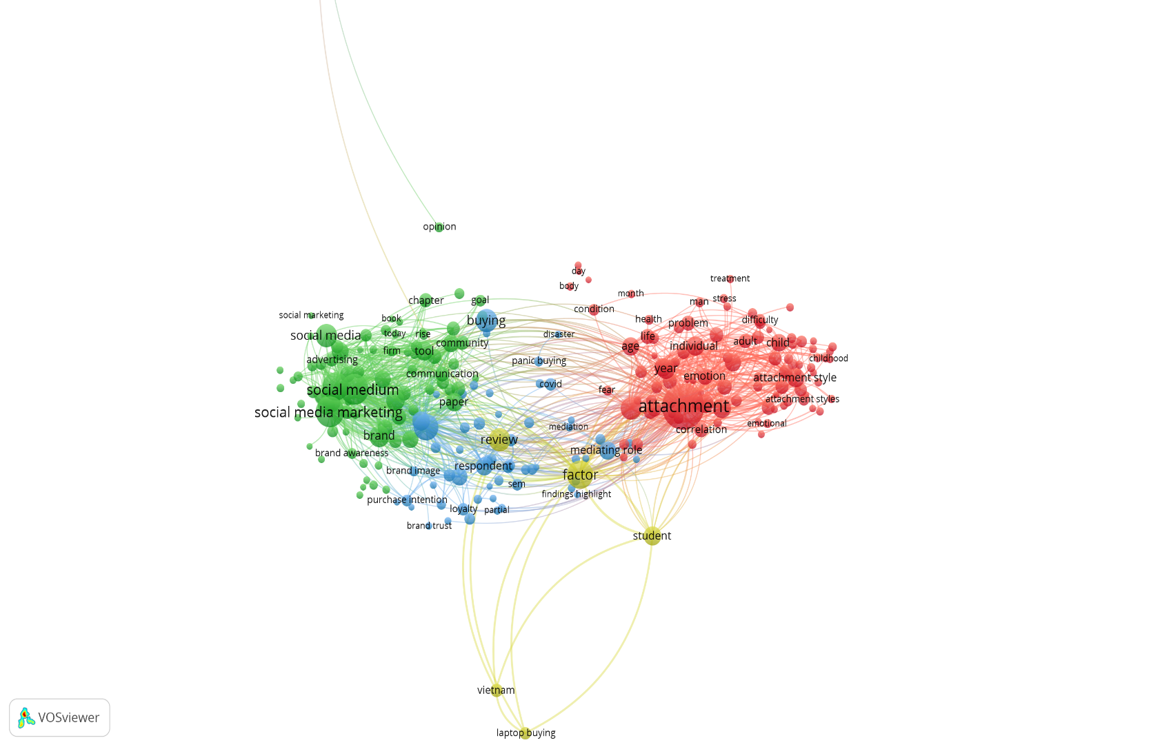

Figure 1. Network Visualization

Network analysis was conducted using VOSviewer using a keyword-based co-occurrence analysis approach, obtained from 3,000 publication data downloaded using Publish or Perish software from the Crossref database. The network visualization results show that keywords appearing in the dataset form several research clusters connected by keyword co-occurrence relationships. Each cluster is represented by a different color, indicating a group of research topics that frequently appear together in the literature.

The network mapping results show that the keyword "attachment" appears as one of the largest nodes in the network, indicating its high frequency of occurrence in the dataset. This keyword is connected to various other keywords such as emotion, individual, age, correlation, and attachment style. Furthermore, this keyword also has network relationships with other keywords related to marketing and consumer behavior, such as factor, mediating role, and review.

On the other side of the network, the keyword "social media marketing" appears as a key node in a different cluster. This keyword is related to other keywords such as social media, advertising, brand, brand awareness, brand image, purchase intention, and loyalty. This relationship demonstrates the interconnection between social media marketing topics and various concepts related to consumer behavior and marketing outcomes.
In addition to these two main clusters, the network visualization also displays several connecting keywords connecting the social media marketing cluster with the emotional attachment cluster. Keywords such as factor, mediating role, and review appear in the central area of ​​the network, connecting the two topic groups. The presence of these connecting keywords indicates a co-occurrence relationship between research on social media marketing and research on emotional attachment in the analyzed publication dataset.
The network visualization also shows the presence of several additional keywords appearing in the research network, such as buying, community, communication, panic buying, covid, and respondent. These keywords appear with smaller node sizes than the main keywords, indicating a lower frequency of occurrence in the analyzed publication dataset. Overall, the network analysis results indicate that the analyzed literature structure consists of several research topic clusters interconnected through keyword co-occurrence relationships.

3.2. Keyword Cluster Distribution
Based on the network analysis results, the keywords in the research dataset can be grouped into several main clusters as follows:

Table 1. Cluster Distribution

Cluster | Visualization Color | Main Keywords
Cluster 1 | Red | attachment, emotion, individual, age, correlation, attachment style
Cluster 2 | Green | social media marketing, social media, advertising, brand, brand awareness
Cluster 3 | Blue | purchase intention, brand image, brand trust, loyalty, respondent
Cluster 4 | Yellow | factor, mediating role, review, findings highlight
Cluster 5 | Other | buying, community, communication, panic buying, covid

The table above shows the grouping of keywords based on the closeness of co-occurrence relationships in the analyzed research network.

3.3. Research Trend Analysis Results (Overlay Visualization)
Research trend analysis was performed using the overlay visualization feature in VOSviewer software. This visualization displays the temporal changes in keyword appearance within the analyzed publication dataset. The colors in the visualization indicate the relative time period of keyword appearance, with blue indicating earlier publications and yellow indicating more recent publications.

The visualization results show that the keywords social media marketing, social media, and advertising appear in colors that tend to fall within the blue to green spectrum. This indicates that these keywords appeared earlier in the analyzed publication period. Other keywords appearing in a similar color range include brand, communication, and community.

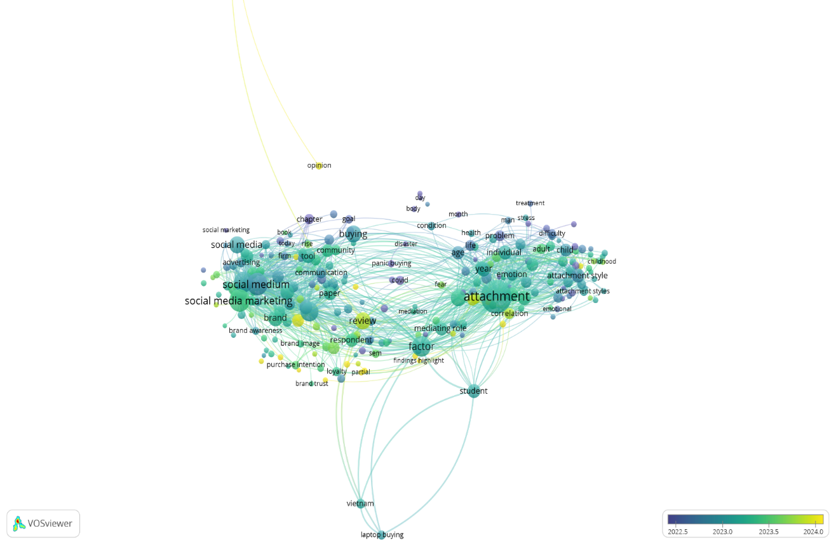

Figure 2. Overlay Visualization

Meanwhile, several other keywords, such as attachment, emotion, individual, and attachment style, appear with colors that tend toward greener to yellower. This indicates that these keywords appeared in a more recent publication period in the research dataset. Furthermore, keywords such as factor, review, and mediating role also appear in relatively lighter colors in the trend visualization.
The trend visualization also shows that several keywords related to purchasing behavior, such as buying and purchase intention, appear in the green spectrum. This indicates that these keywords appeared in the middle publication period in the analyzed dataset. Thus, the overlay visualization provides an overview of the temporal distribution of keyword occurrences in the analyzed literature.

3.4. Keyword Density Analysis Results (Density Visualization)
Density analysis was performed using density visualization in VOSviewer software. This visualization shows the intensity of keyword occurrences in the analyzed publication dataset. Lighter colors indicate areas with higher keyword density, while darker colors indicate lower density.

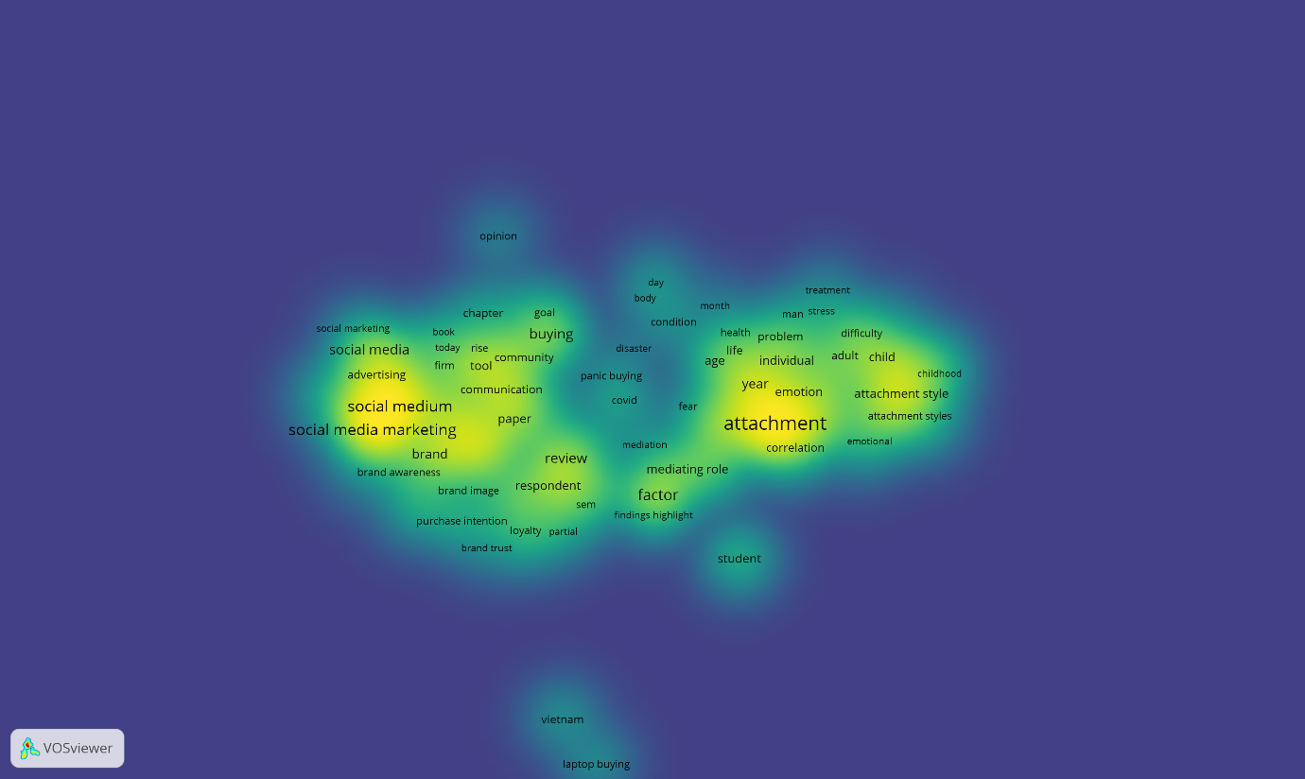

Figure 3. Density Visualization

The visualization results show that the areas with the highest density are the keywords "attachment" and "social media marketing." These two keywords appear in bright yellow on the density map, indicating a high frequency of occurrence in the analyzed publication dataset.

In addition to these two primary keywords, several other keywords also appear in relatively high density areas, such as "social medium," "brand," "emotion," and "factor." These keywords appear in green to yellow areas in the density visualization.

Meanwhile, several other keywords, such as "student," "Vietnam," and "laptop buying," appear in lower density areas. These keywords are displayed in green to blue, indicating a lower frequency of occurrence than the primary keywords.

The density visualization also shows that keywords related to social media marketing tend to be clustered on the left side of the map, while keywords related to emotional attachment tend to be located on the right side. The center area of ​​the map shows the presence of several keywords that serve as a bridge between the two topic groups.

3.5. Summary of Key Findings
Based on the network, trend, and keyword density analysis using VOSviewer, several key findings from the analyzed publication dataset are as follows:
a. The keywords "attachment" and "social media marketing" are the keywords with the largest node size in the research network.
b. The research network forms several keyword clusters indicating distinct research topic groups.
c. The social media marketing cluster includes keywords such as "social media," "advertising," "brand," and "brand awareness."
d. The emotional attachment cluster includes keywords such as "attachment," "emotion," "individual," and "attachment style."
e. Several keywords such as "factor," "mediating role," and "review" appear as links between different research clusters.
f. Trend visualizations demonstrate temporal variations in keyword occurrences in the publication dataset.
g. Density visualizations demonstrate that some keywords appear more frequently than others.
h. The distribution of keywords in the visualization map demonstrates the relationship between social media marketing and emotional attachment topics in the analyzed literature.

4. discussion
4.1. Development of Research Publications on Social Media Marketing, Emotional Attachment, and Cross-Buying
The first research question in this study is the development of scientific publications regarding the role of social media in forming emotional attachment and its impact on cross-buying behavior. The results of the bibliometric analysis indicate that the analyzed literature forms two large research topic groups: research focused on social media marketing and research focused on attachment or emotional attachment. This finding is consistent with the literature showing that social media has evolved into a primary marketing channel capable of forming more interactive relationships between companies and consumers in the digital environment (Drossos et al., 2023; Santos et al., 2022; Zeqiri et al., 2024). This development occurs in line with the transformation of marketing from one-way communication to two-way communication, which allows consumers to actively participate in the interaction process with brands.

In digital marketing literature, social media marketing activities have been shown to have a strong relationship with consumer brand engagement, which in turn influences various consumer behavioral outcomes such as loyalty, willingness to pay a premium, and purchase intention (Changani et al., 2022; Fondevila-Gascón et al., 2020; V. Kumar et al., 2022; Zha et al., 2023). The results of keyword network mapping in this study indicate that concepts such as brand, brand awareness, purchase intention, and loyalty appear in the same cluster as social media marketing. This suggests that research on social media marketing often focuses on its impact on various marketing performance indicators and consumer behavior.

On the other hand, the research cluster focusing on attachment shows links to concepts such as emotion, individual, age, and attachment style. These findings align with the literature explaining that emotional attachment is an emotional connection formed between consumers and brands related to self-identity, emotional experiences, and deeper psychological processes within the consumer-brand relationship (Ahuvia et al., 2022; Hemsley‐Brown, 2022; Sriwidadi et al., 2022). In this literature, emotional attachment often emerges as a consequence of consumer engagement with brands, which occurs through various interactions within the brand ecosystem, including interactions facilitated by social media.

Furthermore, the literature also shows that emotional attachment to brands can develop through psychological mechanisms such as psychological ownership, which is the feeling that a brand is part of the consumer's self (Chen et al., 2022; Jiang et al., 2021; Kou & Powpaka, 2020). This feeling of psychological ownership then develops into a stronger emotional attachment that can influence various consumer behaviors such as loyalty and repeat purchases (Fu et al., 2023; Hemsley‐Brown, 2022; Sriwidadi et al., 2022). Thus, the network mapping results in this study indicate that the analyzed literature reflects two main research streams in digital marketing: research on social media marketing activities and research on emotional attachment in consumer–brand relationships.

4.2. Main Research Themes and Conceptual Relationships in the Literature
The second research question in this study is to identify the main research themes and conceptual relationships between social media marketing, emotional attachment, and cross-buying. The results of the network analysis indicate that several keywords, such as factor, review, and mediating role, emerged as links between different research clusters. The presence of these keywords indicates that many studies in the literature focus on examining the relationships between variables in the context of digital marketing and consumer behavior.

Previous literature indicates that consumer engagement with brands often acts as a mediating variable between social media marketing activities and various consumer behavioral outcomes (Changani et al., 2022; Cheung et al., 2020; Zeqiri et al., 2024). Consumer engagement is understood as a multidimensional process encompassing cognitive, affective, and behavioral aspects in consumer interactions with brands on social media. In this context, social media marketing activities such as interactivity, electronic word of mouth, and digital content trends can increase consumer engagement with brands which then influence consumer attitudes and behaviors towards the brand (Cheung et al., 2020; Santos et al., 2022).

Furthermore, literature also shows that various social mechanisms within social media, such as user-generated content and interactions with influencers, can strengthen emotional connections between consumers and brands (Fan et al., 2023; Ferreira et al., 2021; B. Kumar, 2024; Moisescu et al., 2025). Consumers often perceive user-generated content as more authentic and can increase trust and engagement with a brand. In this context, brand experiences formed through digital interactions can trigger emotional attachment to the brand, which then influences consumer behavior.

In the literature on consumer purchasing behavior, emotional attachment to a brand is often associated with various behavioral outcomes such as loyalty, brand advocacy, and repeat purchases (Hemsley‐Brown, 2022; Hong-ru & Chelliah, 2024; Sriwidadi et al., 2022). Furthermore, emotional attachment can influence consumers' propensity to purchase additional products from the same brand or within the same ecosystem. This phenomenon is known as cross-buying, which is the tendency of consumers to purchase multiple additional products or services within a single brand ecosystem or digital platform (Latusi et al., 2023; Singh et al., 2023; Zhang & Yu, 2020).

The literature shows that cross-buying behavior is influenced by various factors such as perceived value, perceived risk, consumer trust, and various digital marketing stimuli within the online platform ecosystem (Dong et al., 2024; ÖZDEMİR & Bayraklı, 2022; Singireddy, 2023). Furthermore, the diversity of information, online reviews, and the influence of influencers can also influence consumers' decisions to purchase across products or services (Julianti et al., 2025; Nartea & Barrera, 2024; Pratama, 2025). Thus, the results of the bibliometric analysis in this study indicate that the literature on social media marketing and emotional attachment is conceptually related to the literature on consumer purchasing behavior, including cross-buying behavior.

4.3. Research Network Structure and Significance of Findings
The third research question in this study is the structure of the research network in the literature discussing social media marketing, emotional attachment, and cross-buying. The results of the bibliometric analysis indicate that the analyzed research network forms several clusters interconnected through keyword co-occurrence relationships. This network structure indicates that research in the field of digital marketing and consumer behavior is multidisciplinary and involves various interrelated concepts.

The significance of this finding is that research on social media marketing cannot be separated from research on the emotional relationship between consumers and brands and various consumer behavioral outcomes. Social media serves as a platform that enables more intense interactions between brands and consumers, which ultimately can form stronger emotional relationships between consumers and brands. These emotional relationships can then influence various consumer behaviors, including loyalty, brand advocacy, and cross-product purchasing.

By using a bibliometric approach, this study provides a more comprehensive overview of the structure of the literature discussing the relationship between social media marketing, emotional attachment, and consumer purchasing behavior. This approach allows researchers to systematically identify key research themes, relationships between concepts, and research developments in this field.

4.4. Research Implications
This research has several important implications for the development of marketing and consumer behavior. Theoretically, this research contributes to mapping the knowledge structure in the literature that addresses the relationship between social media marketing, emotional engagement, and consumer purchasing behavior. By identifying key research clusters and the relationships between concepts in the literature, this research helps clarify how various concepts in digital marketing interrelate in explaining consumer behavior.

Furthermore, this research also makes a methodological contribution by demonstrating how a bibliometric analysis approach can be used to map the development of literature in the field of digital marketing. This approach allows researchers to identify research trends, key research themes, and research gaps that need to be explored in future research.

Practically, the results of this research provide implications for marketing practitioners in designing more effective social media marketing strategies. By understanding how interactions on social media can shape emotional engagement between consumers and brands, companies can design more effective content and communication strategies to build long-term relationships with consumers.

4.5. Research Limitations
Although this study provides a comprehensive overview of the structure of the analyzed literature, several limitations warrant consideration. First, the publication data used in this study came solely from the Crossref database, downloaded through the Publish or Perish software. Using a single database source may limit the scope of the literature analyzed in this study.

Second, the bibliometric analysis in this study used only keywords as the unit of analysis in mapping the research network. This approach allows for mapping conceptual relationships within the literature, but does not analyze the content or context of each publication in depth.
Third, this study focused on mapping the structure of the literature and did not empirically test the relationship between social media marketing, emotional attachment, and cross-buying. Therefore, future research could develop an empirical model to examine the relationship between these three concepts in the context of digital marketing.

Conclusion
This study concludes that the literature on social media marketing, emotional attachment, and cross-buying behavior forms a connected body of research within digital marketing and consumer behavior. Based on the bibliometric analysis of 3,000 documents obtained from the Crossref database through Publish or Perish, the keyword network shows two dominant thematic areas. The first relates to social media marketing and includes concepts such as brand, brand awareness, advertising, purchase intention, and loyalty. The second relates to attachment and includes concepts such as emotion, individual, age, and attachment style. The appearance of linking keywords such as factor, review, and mediating role indicates that these themes are not isolated, but are connected through studies examining relationships among marketing activities, consumer emotions, and behavioral outcomes. The overlay and density visualizations further show differences in topic development and keyword concentration across the dataset. These results provide a useful overview of how scholarly attention has developed around the role of social media in shaping emotional relationships with consumers and supporting purchasing behavior across products or services. The study also demonstrates the usefulness of bibliometric analysis for identifying research clusters, dominant keywords, and conceptual connections in digital marketing literature for future scholarly inquiry.
Limitations
This study has several limitations. First, the bibliographic data were collected only from the Crossref database through Publish or Perish. As a result, relevant publications indexed in other databases may not have been included in the analysis. Second, the study used keyword-based analysis in VOSviewer, which is useful for mapping conceptual relationships but does not provide an in-depth content analysis of each publication. Third, the study focused on bibliometric mapping rather than empirical testing. Therefore, it does not directly measure the causal relationships among social media marketing, emotional attachment, and cross-buying behavior. Fourth, the analysis depends on the quality and consistency of the metadata, titles, abstracts, and keywords available in the extracted records. Future studies may expand the database coverage, apply additional bibliometric techniques, and combine bibliometric results with empirical methods to provide a deeper and more context-specific understanding of the topic.

Declaration of AI Use

This manuscript was prepared through the combined contributions of all author(s), including contributions to the study design, data, content development, results, interpretation, and related scholarly work. The author(s) acknowledge the use of Grammarly and ChatGPT to assist with grammar checking, language refinement, reference formatting. These AI-assisted tools were not used as authors and did not replace the intellectual contributions or scholarly judgment of the author(s). All AI-assisted outputs, including content, references, and interpretations, were carefully reviewed, revised, verified, and approved by the author(s). The author(s) accept full responsibility for the accuracy, integrity, and final content of the manuscript.

Competing Interests
Authors have declared that no competing interests exist.

REFERENCES
Ahuvia, A., Izberk‐Bilgin, E., & Lee, K. (2022). Towards a Theory of Brand Love In services: The Power of Identity and Social Relationships. Journal of Service Management, 33(3), 453–464. https://doi.org/10.1108/josm-06-2021-0221
Changani, S., Kumar, R., & Tripathi, S. (2022). Does Social Media Marketing Stimulate Customer Engagement in Virtual Brand Communities? Examining the Related Outcomes. https://doi.org/10.46254/in02.20220308
Chen, C., Zhang, J., Bu, X., & Gao, J. (2022). Fueling the Passion: The Role Online Brand Experiences Play in Developing Harmonious or Obsessive Brand Passion. Human Systems Management, 41(5), 629–642. https://doi.org/10.3233/hsm-211566
Cheung, M. L., Pires, G. D., & Rosenberger, P. J. (2020). The Influence of Perceived Social Media Marketing Elements on Consumer–brand Engagement and Brand Knowledge. Asia Pacific Journal of Marketing and Logistics, 32(3), 695–720. https://doi.org/10.1108/apjml-04-2019-0262
Dong, X., Li, B., Xie, K., Zhao, X., & Xiao, M. (2024). The Effect of the Product Categories Diversity Recommended on Cross‐buying in Electronic Commerce Platforms: The Moderating Role of User Navigation Heterogeneity. Journal of Consumer Behaviour, 24(1), 304–331. https://doi.org/10.1002/cb.2393
Drossos, D., Coursaris, C. K., & Kagiouli, E. (2023). Social Media Marketing Content Strategy: A Comprehensive Framework and Empirically Supported Guidelines for Brand Posts on Facebook Pages. Journal of Consumer Behaviour, 23(3), 1175–1192. https://doi.org/10.1002/cb.2269
Fan, F., Chan, K., Wang, Y., Li, Y., & Prieler, M. (2023). How Influencers’ Social Media Posts Have an Influence on Audience Engagement Among Young Consumers. Young Consumers, 24(4), 427–444. https://doi.org/10.1108/yc-08-2022-1588
Ferreira, A. G., Crespo, C. F., & Mendes, C. (2021). Effects of Athletic Performance and Marketable Lifestyle on Consumers’ Engagement With Sport Celebrity’s Social Media and Their Endorsements. International Journal of Sports Marketing and Sponsorship, 23(2), 259–277. https://doi.org/10.1108/ijsms-12-2020-0211
Fondevila-Gascón, J.-F., Polo-López, M., Rodríguez, J. A. R., & Bernal, P. M. (2020). Social Media Influence on Consumer Behavior: The Case of Mobile Telephony Manufacturers. Sustainability, 12(4), 1506. https://doi.org/10.3390/su12041506
Fu, M., Yan, L., Xiong, W., & Guo, S. (2023). The Influence Path of Customer Gratitude on Repeat Purchase Intention Based on SEM: An Analysis of Chain Mediation Effect. Advances in Economics and Management Research, 4(1), 218. https://doi.org/10.56028/aemr.4.1.218.2023
Hemsley‐Brown, J. (2022). Antecedents and Consequences of Brand Attachment: A Literature Review and Research Agenda. International Journal of Consumer Studies, 47(2), 611–628. https://doi.org/10.1111/ijcs.12853
Hong-ru, M. A., & Chelliah, S. (2024). Accessing the Influence of Perceived Brand Authenticity and Value Co-Creation on Brand Loyalty of China’s Insurgent Brands: The Mediating Role of Psychological Ownership. Humanities and Social Sciences Letters, 12(2), 289–307. https://doi.org/10.18488/73.v12i2.3708
Jiang, Y., Liao, J., Chen, J., Hu, Y., & Du, P. (2021). Motivation for Users’ Knowledge-Sharing Behavior in Virtual Brand Communities: A Psychological Ownership Perspective. Asia Pacific Journal of Marketing and Logistics, 34(10), 2165–2183. https://doi.org/10.1108/apjml-06-2021-0436
Julianti, N., Tahu, G. P., & Mitariani, N. W. E. (2025). The Effect of Influencer Credibility and Trust on Impulse Buying Behavior With Purchase Intention as Mediation Somethinc Skincare ProductsThe Effect of Influencer Credibility and Trust on Impulse Buying Behavior With Purchase Intention as Mediation Somethinc Skincare Products. Journal of Economics Finance and Management Studies, 08(07). https://doi.org/10.47191/jefms/v8-i7-36
Kou, Y., & Powpaka, S. (2020). Pseudo-Ownership Advertising Appeal Creates Brand Psychological Ownership: The Role of Self-Construal and Customer Type. Journal of Product & Brand Management, 30(2), 215–230. https://doi.org/10.1108/jpbm-08-2019-2527
Kumar, B. (2024). The Impact of User-Generated Content on Brand Perception: A Case Study of Social Media Platforms. Interantional Journal of Scientific Research in Engineering and Management, 08(04), 1–5. https://doi.org/10.55041/ijsrem32702
Kumar, V., Khan, I., Fatma, M., & Singh, A. (2022). Engaging Luxury Brand Consumers on Social Media. Journal of Consumer Marketing, 39(1), 121–132. https://doi.org/10.1108/jcm-10-2020-4175
Latusi, S., Sarti, E., Martinelli, E., & Luceri, B. (2023). Predictors of Cross-Buying in Grocery Retailing: The Role of Non-Traditional Product/Service Categories. Sinergie Italian Journal of Management, 41(1), 107–126. https://doi.org/10.7433/s120.2023.06
Moisescu, O. I., Gică, O. A., Herle, F., Dan, I., & Sarstedt, M. (2025). Does One Size Fit All? The Role of Extraversion in Generating Electronic Word‐of‐Mouth Through Social Media Brand Page Engagement. Psychology and Marketing, 42(7), 1827–1847. https://doi.org/10.1002/mar.22205
Nartea, M., & Barrera, R. T. (2024). Impact of Digital Marketing in Purchase Decision and Buying Behaviour of Gen Z. Jurnal the Messenger, 15(1), 1–18. https://doi.org/10.26623/themessenger.v15i1.2547
ÖZDEMİR, Y. E., & Bayraklı, S. (2022). A Case Study on Building a Cross-Selling Model Through Machine Learning in the Insurance Industry. European Journal of Science and Technology. https://doi.org/10.31590/ejosat.895069
Pratama, M. E. H. (2025). Pengaruh Influencer Marketing Dan Online Customer Review Padakeputusan Pembelian Dengan Minat Beli Sebagai Variabel Mediasi Pada Pelanggan Platform Tiktok Shop Di Kota Yogyakarta. Jurnal Manajemen Motivasi, 22(1), 478–490. https://doi.org/10.29406/jmm.v22i1.8444
Reyvina, R., & Tjokrosaputro, M. (2024). The Effect of Social Media Marketing on Awareness and Brand Image of Local Fashion Through Consumer Brand Engagement. Ijaeb, 2(2), 3417–3429. https://doi.org/10.24912/ijaeb.v2i2.3417-3429
Santos, S., Gonçalves, H. M., & Teles, M. (2022). Social Media Engagement and Real‐time Marketing: Using Net‐effects and Set‐theoretic Approaches to Understand Audience and Content‐related Effects. Psychology and Marketing, 40(3), 497–515. https://doi.org/10.1002/mar.21756
Silva, C., Silva, S., & Rodrigues, A. C. (2024). Instagram as a Digital Marketing Tool of a Hotel Brand. International Conference on Tourism Research, 7(1), 390–400. https://doi.org/10.34190/ictr.7.1.2103
Singh, A. K., Raghuwanshi, S., Sharma, S., Khare, V., Singhal, A., Tripathi, M., & Banerjee, S. (2023). Modeling the Nexus Between Perceived Value, Risk, Negative Marketing, and Consumer Trust With Consumers’ Social Cross-Platform Buying Behaviour in India Using Smart-PLS. Journal of Law and Sustainable Development, 11(4), e488. https://doi.org/10.55908/sdgs.v11i4.488
Singireddy, S. (2023). Multi-Policy Synergies: A Data-Driven Analysis of Consumer Behavior and Cross-Selling Strategies in Auto, Home, Life, and Umbrella Insurance. JRTDD. https://doi.org/10.53555/jrtdd.v6i10s(2).3600
Sriwidadi, T., Prabowo, H., Sari, R., Wong, F., & Alfarizi, M. (2022). Effect Brand Psychological Ownership and Value Congruity to Brand Attachment and Behavioral Brand Loyalty Through Customer Brand Engagement. https://doi.org/10.46254/eu05.20220195
Zeqiri, J., Koku, P. S., Dobre, C., Milovan, A.-M., Hasani, V. V, & Paientko, T. (2024). The Impact of Social Media Marketing on Brand Awareness, Brand Engagement and Purchase Intention in Emerging Economies. Marketing Intelligence & Planning, 43(1), 28–49. https://doi.org/10.1108/mip-06-2023-0248
Zha, T., Aw, E. C., Dastane, O., & Fernando, A. G. (2023). Social Media Marketing for Luxury Brands: Parasocial Interactions and Empowerment for Enhanced Loyalty and Willingness to Pay a Premium. Marketing Intelligence & Planning, 41(8), 1138–1161. https://doi.org/10.1108/mip-05-2023-0192
Zhang, X., & Yu, X. (2020). The Impact of Perceived Risk on Consumers’ Cross-Platform Buying Behavior. Frontiers in Psychology, 11. https://doi.org/10.3389/fpsyg.2020.592246

