GEOLOGICAL OCCURRENCE AND DISTRIBUTION OF HEAVY METALS IN NIGERIAN COAL AND CLAY: INDUSTRIAL, ENVIRONMENTAL, AND HEALTH IMPLICATIONS — A REVIEW

Abstract
Heavy metals are naturally occurring elements that can become environmentally hazardous when present at elevated concentrations. Coal and clay are among Nigeria’s most important geological resources, contributing significantly to energy production, industrial development, construction, and ceramic manufacturing. However, these materials also contain varying amounts of heavy metals that may be released into the environment during mining, processing, utilization, and disposal. This review examines the geological occurrence, distribution, and concentration of heavy metals in Nigerian coal and clay deposits and discusses their industrial, environmental, and health implications. The reviewed studies reveal considerable variations in heavy metal concentrations across different deposits due to differences in geological setting, mineral composition, and depositional history. Nigerian coal deposits generally contain higher concentrations of heavy metals than clay deposits. Manganese concentrations in coal range from 6.06 to 783.93 mg/kg, nickel from 39.69 to 85.38 mg/kg, chromium from 7.14 to 36.57 mg/kg, copper from 67.21 to 94.93 mg/kg, and strontium from 24.08 to 383 mg/kg. In contrast, clay deposits typically contain lower concentrations, with copper ranging from 0.113 to 1.228 mg/kg, zinc from 2.972 to 4.755 mg/kg, lead from 0.731 to 2.193 mg/kg, nickel from 0.712 to 5.25 mg/kg, and cadmium reaching 2.80 mg/kg in some locations. Elevated mercury and cadmium levels have also been reported in certain edible clays. The findings indicate that coal poses a greater risk of heavy metal release through mining, combustion, and fly ash generation, whereas clay related concerns are mainly associated with industrial applications and geophagic consumption. Continuous monitoring, effective environmental management, and stricter regulatory measures are therefore essential for sustainable resource utilization and the protection of public health.
Keywords: Heavy metals, coal, clay, Nigeria, environmental pollution, geochemistry, public health, review.

1.0 Introduction
Heavy metals are element with high density and toxicity even at low concentrations. These metals naturally occur in the Earths crust and are introduced into the environment through both natural process and human activities (Aghanwa et al., 2025).
Nigeria is rich in significant mineral resources, including coal, clay (Dechaine & Grey, 2010), and crude oil (Etukudo & Etukudo, 2018). These materials play vital roles in energy production, industrial manufacturing and economic development (Awaka-Ama et al., 2024). However, they also serve as reservoirs of heavy metals, which can be released into the environment during extraction and processing (Adamu et al., 2025a).
Heavy metals occur naturally in geological materials such as coal and clay, but their concentrations vary depending on the depositional environment, mineral composition, and geological history. Elevated concentrations may pose environmental and health risks during mining, processing, combustion, and utilization (Akpakpan et al., 2024).
Nigeria subsurface is geochemically significant, as one of the most complex terrains in sub-Saharan Africa (Obaje, 2009). In Nigeria coal deposits are mainly distributed across the Benue Trough, Anambra basin, Sokoto basin and Gombe (Nwajide, 2013; Adamu et al., 2022). During coal combustion, the organic carbonaceous components are burnt off to produce energy, while the inorganic mineral constituents present in the coal do not completely combust. Instead, these minerals melt, fuse, and solidify into very fine particles that are carried along with flue gases. The particles are later captured using pollution-control devices such as electrostatic precipitators and baghouse filters, and the collected material is known as fly ash (Ward, 2016).
The composition of fly ash is directly related to the mineral matter originally present in coal, including silica, alumina, iron oxides, calcium compounds, and several trace heavy metals such as lead (Pb), cadmium (Cd), chromium (Cr), arsenic (As), and mercury (Hg) (Adamu, et al., 2025b). During combustion, many of these heavy metals become concentrated in the ash fraction, resulting in the transfer of toxic elements from coal into fly ash Ogala et al., 2010).
Improper handling or disposal of fly ash can create serious environmental concerns. Heavy metals contained in the ash may leach into surrounding soils and groundwater systems, thereby contaminating water resources and agricultural lands. In addition, wind-blown fly ash particles can contribute to air pollution and increase human exposure to toxic metals through inhalation (UNEP, 2019). Therefore, effective management and safe disposal practices are essential to minimize the environmental and public health risks associated with fly ash generation.
Clay is a naturally occurring fine-grained earth material mainly composed of hydrous aluminium silicate minerals formed through the weathering and alteration of rocks over long geological periods (Nton & Elueze, 2005). In Nigeria, clay deposits occur widely across both sedimentary basins and weathered basement terrains. Large kaolin and ball clay deposits are found in states such as Katsina (Kankara), Ogun, Oyo, Ondo (Ifon), Anambra (Ukpor), Cross River, Kaduna, Plateau, Nasarawa, Kogi, and parts of Akwa Ibom State (Abuh et al., 2014; Edemumoh et al., 2024). Many of these deposits are associated with the Benue Trough, the Niger Delta region, and the coastal plain sands of southern Nigeria. Nigerian clays naturally contain several metallic elements and trace heavy metals including chromium (Cr), nickel (Ni), cadmium (Cd), lead (Pb), copper (Cu), zinc (Zn), manganese (Mn), cobalt (Co), and iron (Fe) (Udo et al., 2023a; Nduka et al., 2020).
Despite numerous studies on heavy metals in individual materials, there is limited comparative analysis of heavy metals in coal and clay in Nigeria. This creates a gap in understanding their relative contributions to environmental contamination and industrial implications.
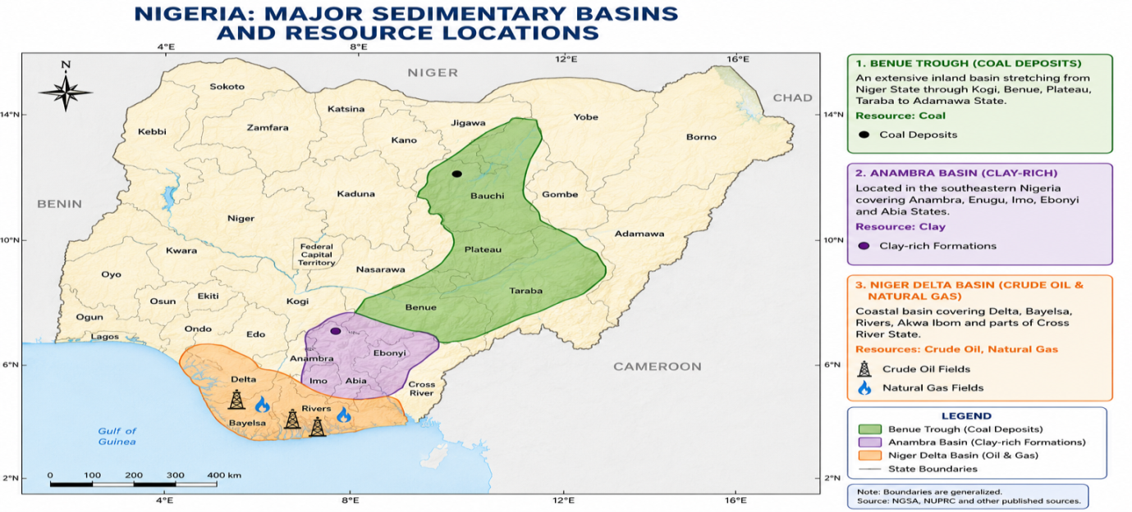

Figure 1: Nigerian Map showing major sedimentary Basins and resource locations
- Geological and Geochemical Framework of Nigeria

2.1 Geological Setting of Nigerian Sedimentary Basins
Nigeria possesses one of the most diverse geological settings in Africa, consisting of both Precambrian basement rocks and extensive sedimentary basins formed through several tectonic and depositional events over geological time (Udo et al., 2023b). The country’s geology reflects a complex history involving continental rifting, marine transgressions, sediment accumulation, and tectonic deformation that occurred from the Precambrian to the Cenozoic era (Obaje, 2009). These geological processes led to the formation of major sedimentary basins that now host economically important mineral resources such as coal and clay.
The major sedimentary basins in Nigeria include the Benue Trough, Anambra Basin, Niger Delta Basin, Sokoto Basin, Chad Basin, Dahomey Basin, and Bida Basin. Among these, the Benue Trough and Anambra Basin are particularly important for coal deposits, while the Niger Delta Basin remains the country’s principal petroleum-producing province (Nwajide, 2013). The Benue Trough was formed during the Early Cretaceous as a result of the separation of the African and South American plates. It extends for nearly 1,000 km across Nigeria and contains thick sequences of sedimentary rocks rich in coal-bearing formations such as the Mamu Formation and Enugu Shale (Obaje, 2009).
The Anambra Basin developed after tectonic uplift and deformation within the Benue Trough and contains some of Nigeria’s most economically viable coal deposits, including those at Onyeama, Ogbete, and Okpara in Enugu State (Akande et al., 2011). In contrast, the Niger Delta Basin formed through the accumulation of massive sediments transported by the Niger and Benue rivers into the Atlantic Ocean. The basin contains thick sequences of sandstone, shale, and deltaic deposits that serve as source rocks, reservoirs, and seals (Akinpelu, 2021).
Clay deposits are widely distributed across Nigeria and occur in both sedimentary and weathered basement terrains. Significant clay deposits are found in Katsina, Ogun, Ondo, Kogi, Plateau, Cross River, Nasarawa, and Akwa Ibom States. These clays are formed mainly through the weathering and alteration of feldspar-rich rocks and subsequent transportation and deposition in riverine and coastal environments (Nton & Elueze, 2005).

2.2 Mineralogical Characteristics of Coal and Clay
The mineralogical composition of coal and clay largely determines their industrial properties and heavy metal content. Nigerian coal consists mainly of organic carbonaceous matter mixed with mineral impurities such as quartz, pyrite, calcite, clay minerals, and feldspar. The coals are predominantly sub-bituminous to bituminous in rank and are characterized by moderate ash and low sulfur contents compared to many global coal deposits (Amobi et al., 2022). Pyrite is particularly important because it acts as a host mineral for several heavy metals including arsenic, lead, and mercury.
Clay minerals in Nigeria are mainly composed of kaolinite, illite, montmorillonite, quartz, feldspar, and iron oxides. Kaolinite-rich deposits are common in Kankara and parts of Ogun and Ondo States, while lateritic clays containing iron and manganese oxides occur widely in tropical weathering environments (Nton & Elueze, 2005). The high surface area and adsorption capacity of clay minerals enable them to retain metallic ions and other contaminants within their structure.

2.3 Geochemical Behaviour of Heavy Metals
Heavy metals in geological materials are controlled by several geochemical processes including weathering, adsorption, oxidation-reduction reactions, mineral dissolution, and biological interactions. In coal deposits, heavy metals are commonly associated with sulfide minerals such as pyrite, organic matter, and clay fractions. During mining and combustion, these metals may become mobilized and concentrated in fly ash, mine drainage, and atmospheric emissions (Izah et al., 2018).
In clay deposits, heavy metals are often adsorbed onto clay mineral surfaces or associated with iron and manganese oxides. The fine particle size and high cation exchange capacity of clays make them effective natural adsorbents for metals such as chromium, cadmium, lead, zinc, and nickel. Environmental conditions such as pH, temperature, and redox potential strongly influence the mobility and bioavailability of these metals (Oze et al., 2020).

2.4 Heavy Metal Distribution in Nigerian Coal Deposits
One of the earliest comprehensive investigations into trace elements in Nigerian coal was conducted by Ogala et al. (2012), who examined major oxides and trace element distributions in coal and coaly shale seams from the Enugu Escarpment. The authors reported that most trace elements were associated with mineral matter and that concentrations generally fell within ranges reported for world coals. They concluded that the studied coals did not present significant environmental or technological concerns and that the elemental distributions reflected predominantly detrital inputs into the depositional environment.
Similarly, Adedosu et al. (2007) investigated trace metals in Benue Trough coals using Energy Dispersive X-ray Fluorescence (EDXRF). Their findings revealed appreciable concentrations of iron, titanium, vanadium, chromium, nickel, and copper. The study suggested that the occurrence of these elements could be attributed to mineral phases such as pyrite, siderite, rutile, and ilmenite. The abundance of iron and titanium indicated the possibility of recovering economically valuable metals from coal combustion residues.

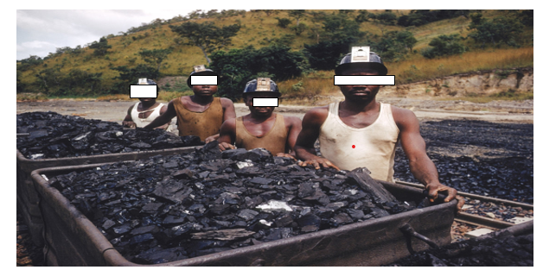

Figure 2. Coal mining in Enugu district, Nigeria
Recent studies have expanded the understanding of heavy metal contamination across Nigerian coal deposits. Uloko et al. (2025a) employed Instrumental Neutron Activation Analysis (INAA) to determine heavy metal concentrations in coal samples collected from Maiganga, Gboko, Onyeama, Okobo, Opoko-Obido, Odagbo, and Ofugo coal fields. Their results showed concentrations ranging from 4.69–18.40 mg/kg for vanadium, 4.82–185 mg/kg for manganese, 0.11–0.33 mg/kg for arsenic, 0.19–0.74 mg/kg for uranium, 7.14–16.60 mg/kg for chromium, 1.49–9.10 mg/kg for cobalt, 312–383 mg/kg for strontium, 0.12–296 mg/kg for antimony, 92–296 mg/kg for barium, and 0.26–2.39 mg/kg for thorium. The report revealed that manganese, strontium, and antimony concentrations exceeded some international guideline values, indicating possible environmental concerns.
Uloko et al. (2025b) further evaluated toxic metal distributions in Nigerian coal deposits from Maiganga, Gboko, Onyeama, Okobo, Opoko-Obido, Odagbo, and Ofugo in Kogi State using EDXRF analysis. Reported concentrations ranged from 25.74 –36.57 mg/kg for chromium, 141.16 –783.93 mg/kg for manganese, 39.69–85.38 mg/kg for nickel, 67.21 – 94.93 mg/kg for copper, 24.08–176.70 mg/kg for strontium, and 7.49–35.47 mg/kg for lead. Several of these values exceeded regulatory limits established by environmental agencies, particularly for manganese, nickel, copper, and lead. The authors concluded that some Nigerian coal deposits are significantly enriched in potentially toxic metals.
The metals concentrated in fly ash determine whether that ash can be reused in construction or must be managed as hazardous waste (Ward, 2016). In ceramic production, elevated levels of transition metals affect fired product colour, porosity, and food-contact compliance (Abuh et al., 2014).

2.5 Comparative Assessment of heavy metal content in Nigerian Coal Deposits
Comparative evaluation of Nigerian coal deposits reveals substantial spatial variations in heavy metal composition. Maiganga coal generally exhibits the highest manganese concentrations, reaching approximately 784 mg/kg, while Kogi coal fields show exceptionally elevated strontium concentrations. Enugu coal deposits tend to contain lower concentrations of toxic metals relative to Maiganga and Kogi deposits. In a comparative elemental study of coal deposits from Enugu, Benue, and Delta States, Ezeh and Okeke (2016) reported that arsenic, lead, and cadmium concentrations were highest in Delta coal, while Enugu coal contained relatively higher concentrations of economically important trace minerals.
Furthermore, this study revealed considerable spatial variations in heavy metal concentrations. The Enugu coal deposit contains relatively low concentrations of Pb (9.54 mg/kg), As (0.49 mg/kg), Cr (10.32 mg/kg), Mn (10.63 mg/kg), Ni (4.55 mg/kg), Co (1.78 mg/kg), and Cu (10.69 mg/kg). Strontium (Sr) was not detected. In contrast, coal deposits from Maiganga (Gombe State), Gboko (Benue State), and Onyeama (Enugu State) exhibit substantially higher concentrations of Cr (25.74 – 36.57 mg/kg), Mn (141.16 – 783.93 mg/kg), Ni (39.69 – 85.38 mg/kg), Cu (67.21 – 94.93 mg/kg), and Sr (24.08 – 176.70 mg/kg), indicating greater enrichment of trace metals. Arsenic was not detected in these deposits.
Coal deposits from Okobo, Odagbo, Ofugo, and Opoko-Obido in Kogi State show lower Cr concentrations (7.14 – 16.60 mg/kg) and variable Mn levels (6.06–273 mg/kg), while arsenic occurs at trace levels (0.18–0.33 mg/kg). These deposits are characterized by exceptionally high Sr concentrations (312–383 mg/kg).
However this review revealed that manganese, nickel, copper, and strontium are the dominant heavy metals in Nigerian coal deposits, with Mn reaching as high as 783.93 mg/kg in some locations.
These regional differences are largely attributed to variations in source rock mineralogy, depositional environments, Diagenesis , and hydrogeological conditions. Coal deposits associated with mineral-rich sediments often exhibit greater trace element enrichment than those deposited in relatively cleaner sedimentary environments.

Table 1: Comparative Table of Heavy Metal Concentrations in Nigerian Coal (mg/kg).
Location | Pb | As | Cr | Mn | Ni | Co | Cu | Sr
Enugu | 9.54 | 0.49 | 10.32 | 10.63 | 4.55 | 1.78 | 10.69 | ND
Maiganga (Gombe) | 7.49–35.47 | ND | 25.74–36.57 | 141.16–783.93 | 39.69–85.38 | ND | 67.21–94.93 | 24.08–176.70
Gboko (Benue) | 7.49–35.47 | ND | 25.74–36.57 | 141.16–783.93 | 39.69–85.38 | ND | 67.21–94.93 | 24.08–176.70
Onyeama (Enugu) | 7.49–35.47 | ND | 25.74–36.57 | 141.16–783.93 | 39.69–85.38 | ND | 67.21–94.93 | 24.08–176.70
Okobo (Kogi) | 7.49–35.47 | 0.18–0.33 | 7.14–16.60 | 6.06–273 | ND | 1.49–9.10 | ND | 312–383
Odagbo (Kogi) | 7.49–35.47 | 0.18–0.33 | 7.14–16.60 | 6.06–273 | ND | 1.49–9.10 | ND | 312–383
Ofugo (Kogi) | 7.49–35.47 | 0.18–0.33 | 7.14–16.60 | 6.06–273 | ND | 1.49–9.10 | ND | 312–383
Opoko-Obido (Kogi) | 7.49–35.47 | 0.18–0.33 | 7.14–16.60 | 6.06–273 | ND | 1.49–9.10 | ND | 312–383

2.6 Heavy Metal Concentration in Nigerian Clay Deposits and Edible Clays

2.6.1 Heavy Metals in Clay Deposits
Adegoke et al. (2011) investigated the concentrations of Cu, Zn, Cr, Pb, As, Mn, Cd, and Ni in clay samples collected from Ara-Ijero, Ire-Ekiti, and Isan-Ekiti in south western Nigeria, and reported that Cu, Zn, Cr, Pb, As, and Mn concentrations were generally below international permissible limits, while Cd and Ni concentrations exceeded recommended limits in some locations. The highest manganese concentration (189.85 mg/kg) was observed in the Isan-Ekiti mixed clay sample. The study concluded that prolonged use of clay products from these deposits may result in bioaccumulation of toxic metals.
Picture 1 : Nigerian Clay Deposits
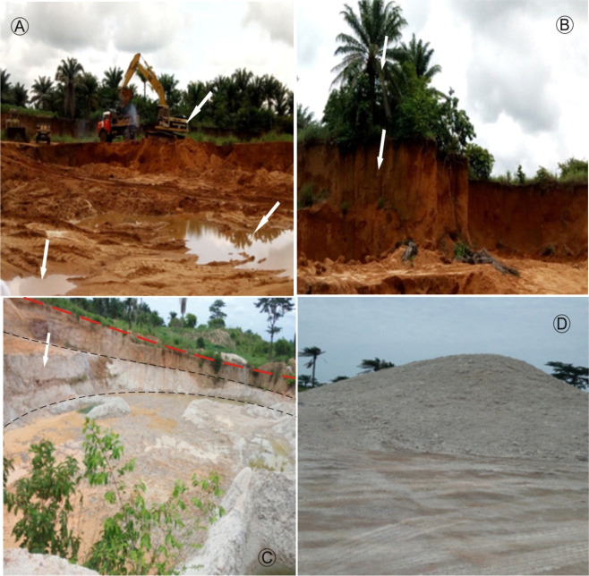
Similarly, Owolala et al. (2021) assessed heavy metal concentrations in kaolin clay obtained from five locations in Ute, Ondo State. The study found that concentrations of Pb, As, Zn, Cd, Mn, Se, and Cr were within maximum permissible limits. The abundance pattern was Pb > As > Zn > Cd > Mn > Se > Cr. It was concluded that the clay deposits were essentially uncontaminated and safe for industrial and domestic use.

2.6.2 Heavy Metals in Edible Clay
Consumption of edible clay (geophagy) is common among pregnant women and children in Nigeria. However, concerns have been raised regarding exposure to toxic metals.
Kelle et al. (2018) evaluated heavy metal concentrations in edible clay samples (Nzu and Ulo) sold in major markets in Onitsha, Anambra State. Their findings showed elevated mercury concentrations in most samples and elevated cadmium levels in some samples. It was concluded that the concentrations of Cd and Hg could pose health risks to consumers and recommended caution in the consumption of edible clay.
Ekuma and Ogunyemi (2019) determined the concentrations of Cu, Co, and Ni in edible kaolin obtained from Enyigba, Ebonyi State. Concentrations of Co (0.012 mg/kg), Cu (0.113 mg/kg), and Ni (0.712 mg/kg) were significantly below WHO permissible limits. The study concluded that consumption of approximately 20 g/day of the clay would not pose significant health risks based on these metals.
Recently, Umar et al. (2024) investigated bentonite (Ulo) and kaolin (Nzu) sold in northwestern Nigeria. The study revealed that both clays contained essential minerals but also measurable concentrations of heavy metals. Kaolin exhibited significantly higher levels of lead, and arsenic than bentonite. The authors recommended cautious consumption, especially among pregnant women, due to the potential health implications of chronic exposure.

2,7 Comparative Assessment of Heavy Metal Concentrations in Nigerian Clays
Heavy metal concentrations in Nigerian clays are generally lower than those reported for coal. Pottery clay from Ara-Ijero, Ekiti State, contains Cu (1.228 mg/kg), Zn (3.566 mg/kg), Pb (0.731 mg/kg), and Ni (5.25 mg/kg), with nickel identified as the relatively elevated metal. Brick clay from Ire-Ekiti shows even lower concentrations, including Cu (0.921 mg/kg), Zn (2.972 mg/kg), Pb (2.193 mg/kg), and Ni (2.25 mg/kg), with all metals reported below permissible limits. Pottery clay from Isan-Ekiti contains Cu (0.616 mg/kg), Zn (4.755 mg/kg), Pb (0.731 mg/kg), Cd (2.80 mg/kg), Ni (4.50 mg/kg), and As (4.50 mg/kg), with elevated cadmium identified as a concern. Kaolin deposits from Ute, Ondo State, were reported to contain heavy metals within permissible limits, indicating minimal contamination.
Similarly, edible kaolin from Enyigba, Ebonyi State, contained Cu (0.113 mg/kg) and Ni (0.712 mg/kg), both below WHO recommended limits. However, studies on edible clay (Nzu/Ulo) from Onitsha revealed elevated concentrations of mercury (Hg) and cadmium (Cd) in some samples, suggesting potential health risks associated with geophagic consumption. Bentonite and kaolin samples from north-western Nigeria also contained detectable heavy metals, with lead concentrations reportedly higher in kaolin. cautious consumption and utilization of these materials was recommended.
However, the reviewed studies demonstrate considerable geographical variation in heavy metal concentrations within Nigerian clay deposits. Industrial and pottery clays generally exhibited low concentrations of most toxic metals, although elevated cadmium and nickel were reported in some Ekiti State deposits. Edible clays showed greater concern because of direct human consumption, particularly regarding mercury, cadmium, lead, and arsenic.
The differences observed among locations may be attributed to geological composition, weathering processes, mining activities, anthropogenic contamination, and local environmental conditions. Despite many values remaining below international limits, continuous monitoring is recommended because heavy metals are non-biodegradable and may accumulate over time ( Eduok et al., 2012).
Table 2: Comparative Review on Heavy Metal Concentrations in some Nigerian Clays
Study | Location | Clay Type | Cu (mg/kg) | Zn (mg/kg) | Pb (mg/kg) | Cd (mg/kg) | Ni (mg/kg) | As (mg/kg) | Hg  (mg/kg)
Adegoke et al., 2011 | Ara-Ijero, Ekiti | Pottery clay | 1.228 | 3.566 | 0.731 | ND | 5.25 | ND | ND
Adegoke et al., 2011 | Ire-Ekiti | Brick clay | 0.921 | 2.972 | 2.193 | ND | 2.25 | ND | ND
Adegoke et al., 2011 | Isan-Ekiti | Pottery clay | 0.616 | 4.755 | 0.731 | 2.80 | 4.50 | 4.50 | ND
Owolala et al., 2021 | Ute, Ondo State | Kaolin | Within MPL | Within MPL | Within MPL | Within MPL | Within MPL | Within MPL | Within MPL
Kelle et al., 2018 | Onitsha | Edible clay (Nzu/Ulo) | Variable | Variable | Variable | Elevated in some samples | - | - | Elevated in some samples
Ekuma & Ogunyemi, 2019 | Enyigba, Ebonyi | Edible kaolin | 0.113 | - | - | - | 0.712 | - | ND
Umar et al., 2024 | North-West Nigeria | Bentonite & Kaolin | Present | Present | Higher in kaolin | Present | Present | Present | ND

2.8 Comparative Review of Heavy Metal Concentrations in Nigerian Coal and Clay
Coal generally contains significantly higher concentrations of heavy metals than clay. Metals such as Mn, Ni, Cu, Cr, and Sr occur at tens to hundreds of milligrams per kilogram in coal deposits, whereas clay deposits typically contain concentrations below 10 mg/kg for most measured elements. In coal, Mn, Ni, Cu, Cr, and Sr are the dominant trace metals. Mn exhibits the highest enrichment, reaching 783.93 mg/kg in some deposits. Conversely, clays are characterized by relatively low Cu, Zn, Pb, and Ni concentrations, with occasional enrichment of Cd and Hg in edible clays. Arsenic is generally absent or occurs at very low concentrations in Nigerian coal deposits, except for trace amounts in Kogi coalfields (0.18–0.33 mg/kg). In clay deposits, arsenic was detected at 4.50 mg/kg in Isan-Ekiti pottery clay, representing a comparatively higher concentration than in most coal samples.
Both coal and clay deposits exhibit strong geographical variation in metal concentrations. Coal deposits in Gombe, Benue, and parts of Kogi State tend to contain higher heavy metal loads than those in Enugu. Similarly, clay deposits differ considerably depending on mineralogical composition and source location.
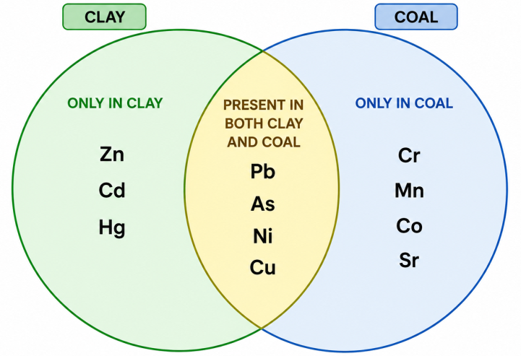
Figure 3: Distribution of heavy metal in Nigerian clay and coal

2.8 Environmental and Health Implications

The environmental significance of heavy metals in coal arises from their potential release during mining, transportation, combustion, and waste disposal. Heavy metals such as lead, arsenic, chromium, nickel, and manganese can contaminate soil, groundwater, and surface water systems (Nsi et al., 2020; Bassey et al., 2026, Etuk et al., 2020) Chronic exposure to these metals has been associated with neurological disorders, kidney damage, respiratory illnesses, cardiovascular diseases, reproductive abnormalities, and carcinogenic effects (Akpakpan et al., 2024).
Studies conducted around coal mining areas have also demonstrated the transfer of heavy metals into surrounding soils. For example, investigations in the Maiganga coal mining environment revealed measurable concentrations of nickel, cadmium, chromium, and copper in surrounding soils, suggesting potential migration of contaminants from mining operations into nearby ecosystems.
Coal mining and combustion usually release heavy metals into the environment through fly ash, bottom ash, and gaseous emissions. The elevated Mn, Ni, Cu, and Cr contents in some Nigerian coal deposits may contribute to environmental contamination if not properly managed. However, lime may be added to acidic wastewater released during coal mining to neutralize its acidity (Etuk et al., 2012).
For clay deposits, the primary concern relates to human exposure through industrial use and geophagy (consumption of edible clay). Elevated Cd and Hg levels reported in some edible clay samples may pose chronic health risks, including kidney damage and neurological disorders. Also . Long-term exposure to lead may damage the nervous system, kidneys, liver, and cardiovascular system (Akpakpan et al., 2023).
In children, lead exposure is strongly associated with reduced intelligence quotient (IQ), learning difficulties, behavioural disorders, and delayed neurological development. Adults exposed to high concentrations may experience hypertension, memory loss, reproductive problems, and anemia (Kabata-Pendias, 2011; WHO, 2022).
Copper (Cu), Zinc (Zn), and Iron (Fe) are essential trace elements required for normal body functions, but excessive exposure may still become harmful (Akpakpan et al., 2012). Elevated copper levels may cause liver and gastrointestinal disorders, while excessive zinc intake can interfere with immune function and copper metabolism. High iron accumulation may contribute to tissue damage and oxidative stress in the body (Kabata-Pendias, 2011).
Table 3. Industrial Implications of Heavy Metal Content: Summary by Resource and Sector
Resource | Sector | Key Metal(s) | Primary Industrial Problem | Recommended Action
Coal | Power Generation | Hg, As, Pb | Atmospheric emissions during combustion; ash leachate risk | Install FGD + Hg sorbent injection; lined ash ponds
Coal | Cement/Construction | Pb, Cr, As | Fly ash heavy metal content limits clinker substitution | Basin-specific ash testing before cement blending
Clay | Ceramics | Cr, Fe, Cd | High Cr affects product colour; Cd in glazes leaches acid | Cr speciation analysis; eliminate Cd glaze raw materials
Clay | Agriculture | Cd, Pb | Cd bioaccumulation in food crops on amended soils | Mandatory Cd threshold testing before soil application
Source: Compiled from Izah et al. (2018); Abuh et al. (2014); Nduka et al. (2020)

Conclusions
This review shows that Nigerian coal and clay deposits contain variable concentrations of heavy metals that reflect differences in geological origin, mineral composition, depositional environment, and weathering history. Coal deposits generally show higher concentrations of metals such as manganese, nickel, chromium, copper, lead, and strontium than most clay deposits, indicating a greater potential for environmental release during mining, combustion, and ash disposal. Clay deposits usually contain lower concentrations of most measured metals, but some industrial and edible clays show elevated levels of cadmium, mercury, lead, arsenic, or nickel, which may be important where the materials are used in ceramics, construction, agriculture, or direct consumption. The potential pathways of exposure include contaminated soil, surface water, groundwater, airborne particulates, industrial products, and ingestion of edible clay. Although many reported values remain within acceptable limits in some locations, the non-biodegradable nature of heavy metals and their potential for accumulation require continuous attention. Sustainable utilization of Nigerian coal and clay should therefore be supported by routine geochemical testing, site-specific environmental assessment, appropriate handling of mine and combustion wastes, and public health awareness in areas where edible clay consumption is practiced.

Limitation
This review is limited by the availability, scope, and comparability of published data on heavy metals in Nigerian coal and clay deposits. The reviewed studies differ in sampling locations, sample types, analytical methods, target metals, reporting units, and reference standards, which limits direct comparison across deposits. Some studies provide detailed numerical concentrations, while others report values only as present, elevated, variable, or within permissible limits. In several cases, the specific regulatory limits used for comparison are not clearly stated. The review also relies mainly on secondary data and does not include new laboratory analysis, field sampling, or independent verification of reported concentrations. Spatial coverage is uneven, with some coalfields and clay deposits better represented than others. In addition, health and environmental implications are discussed from reported metal concentrations and known exposure pathways, but site-specific risk assessment, bioavailability testing, and long-term exposure measurements were not performed. These limitations should be considered when interpreting the findings.
Declaration of AI Use

This manuscript was prepared through the combined contributions of all author(s), including contributions to the study design, data, content development, results, interpretation, and related scholarly work. The author(s) acknowledge the use of Grammarly and ChatGPT to assist with grammar checking, language refinement, reference formatting. These AI-assisted tools were not used as authors and did not replace the intellectual contributions or scholarly judgment of the author(s). All AI-assisted outputs, including content, references, and interpretations, were carefully reviewed, revised, verified, and approved by the author(s). The author(s) accept full responsibility for the accuracy, integrity, and final content of the manuscript.

References
Abuh, M. A., Akpomie, G. K., Nwagbara, J. O., Abia-Bassey, N., Ape, D. I., & Onuoha, K. E. (2014). Single-step sequential extraction technique and physicochemical characteristics of sediment/soil: Studies on elemental pollution status of Odukpani area, Cross River State, southeastern Nigeria. Journal of Chemical, Biological and Physical Sciences, 4(3), 2123–2135.
Adamu, L. M., Alege, T. S., Ochu, G. D., Odoma, A. N., Ebeh, A., Ohiemi, A. F., Etukudo, N. J., Adesina, D. E.,Umar, M. U., & Obaje, N. G. (2025b). Terrigenous Inputs, Redox Shifts, and Ree Partitioning in Shankodi-Jangwa Coal, Middle Benue Trough, Nigeria: Implications for Green Energy Mineral Prospecting. African Journal of Engineering and Environment Research, 7(2), 182-200.

Adamu, L. M., Obaje, N. G., Alege, T. S., Odoma, A. N., Ebeh, A., Ohiemi, A. F., Ochu, G. D., Umar, M. U., Etukudo, N. J., Adesina, D. E., & Isaac, O. B. (2025a). Signatures of Key Petroleum System Elements: Outcrop Examples from the Northern Anambra Basin, Central Nigeria. African Journal of Engineering and Environment Research, 7(2), 103-126.

Adamu, L. M., Obaje, N. G., Ayuba, R., Kovona, M. T., Adesina, D. A., Etukudo, N. J., & Aliyu, U. O. (2022). Litho-Bio-Facies Analysis and Systematic Paleontology of Sediments in Amansiodo-1 Well, Anambra Basin, Southeastern Nigeria. Earth Sciences, 11(3), 96-108.
Adedosu, T. A., Adedosu, H. O., & Adebiyi, F. M. (2007). Geochemical and mineralogical significance of trace metals in Benue Trough coal, Nigeria. Journal of Applied Sciences, 7(20), 3101–3105.
Adegoke, J. A., Oseni, S. O., & Adegbola, R. B. (2011). The concentration of heavy metals in selected clay samples in Ekiti State, Southwestern Nigeria. Report and Opinion, 3(8), 17–25.
Aghanwa, C. I., Umueni, U. E., Etukudo, N. J., Amachree, J. B., Okpoji, A. U., & Ejeka, C. J. (2025). Atmospheric Deposition of Soot and Heavy Metals from Gas Flaring into Surface Waters of Ebocha, Rivers State, Nigeria. Asian Journal of Environment & Ecology, 24(11), 137-147.

Akande, S. O., Olobaniyi, S. B., Ojo, O. J., Gusiag, K., & Abimbola, A. F. (2011). Palynofacies, coalification and petroleum prospects of coal and associated sediments in the Anambra Basin, southeastern Nigeria. Journal of Mining and Geology, 47(2), 81-98.
Akpakpan, A.E., Inam, E.J. and Itoro E. U., (2023). Preparation, Characterization and Application of Soda Lignin and its Ester Derivatives as Adsorbents in the Adsorption of Pb²⁺ and Cd²⁺ from wastewater. J. Mater. Environ. Sci., 14, Issue 1, 82-96
Akpakpan, A. E. Eduok, U. M. Udiong, D. S. Udo, I. E. Ntukuyoh, A. I. (2012).Level of Metals in Kernels and Shells of Oil Palm and Coconut Fruits. International Journal of Modern Chemistry, 2(1): 20-27
Akpakpan, A. E. Willie, I. N. Uwanta, E. J. Akpanudo, N. W. Fatunla O. K. and Ikpe, E. E. (2024). Influence of Operating Variables on the Adsorption of Pb²⁺ and Cd²⁺ from wastewater using Gmelina arborea Kraft lignin and its ester derivatives. Journal of Natural and Applied Sciences Pakistan, 6 (2),1950-1968

Amobi, J. O., Ofoma, A. E., Okafor, P. N., Dim, C. I. P., Onwuchekwa, C. N., Ekpo, I. M., & Iyioku, M. U. (2022). Determination of coking properties and heat values of coals from parts of Benue Trough and Anambra Basin for their industrial and domestic uses. NAPE Bulletin, 31(2), 107–114.
Awaka-Ama, J. J., Udo, G. J., Uwanta, E. J., Igwe R., Etukudo, N. J., & Akpanudo, N. W. (2024).Comparative Analysis of Heavy Metal Contamination in Regular and Artisanal Petroleum Products in Akwa Ibom State, South-South Nigeria. Communication in Physical Sciences, 11(3), 559-568.
Bassey, M. E., Iwatt, M. U., Umana, S. I., Akan, O. D., & Akpakpan, A. E. (2026). Heavy Metal Resistance in Microorganisms Isolated from Waste Dumpsites in Uyo Metropolis, Nigeria. South Asian Journal of Research in Microbiology, 20(3), 42–49. https://doi.org/10.9734/sajrm/2026/v20i3494

Dechaine, G. P., & Gray, M. R. (2010). Chemistry and association of vanadium compounds in heavy oil and bitumen. Energy & Fuels, 24(5), 2795-2808.
Edemumoh, E. E., Uwanta, E. J., Awaka-Ama, J. J., Udo, G. J., Etukudo, N. J., Nyong, A. E., Igwe, R., Okon, C. P., & Abasi, E. O. (2024). Structural and Morphological Analysis of Untapped Clay Deposits in Itu Local Government Area Akwa Ibom State, Nigeria and its Potentials as Raw Material for Petroleum Refining. Journal of Engineering Research and Reports, 26(2), 131–144.

Eduok, U. M.,. Akpakpan, A. E., Umoren, S. A.., Etim U. J. (2012). Corrosion inhibition and adsorption behavior of Cocos nucifera L. coir dust on mild steel in 1 M HCl: Synergistic effect of iodide ions. International Journal of Advance Scientific Research and Technology 1(2): 339-360.
Ekuma, C.M., & Ogunyemi, T.C. (2019). Determination of Some Heavy Metals (Cu, Co, Ni) in Edible Clay from South Eastern Nigeria and Its Effect Due to Consumption. Asian Journal of Chemical Sciences, 6(2), 1–7.
Etuk, B. A., Udiong, D. S. Akpakpan, A. E. (2012). The Effect of Lime on some Physicochemical Properties of Palm Oil. International Journal of Modern Chemistry, 2(1): 1-6.

Etuk, B. A., Udiong, D. S. and Akpakpan, A. E. (2020). Human Health Risk Assessment of Trace Metals in Water from Cross River Estuary, Niger Delta, Nigeria. Asian Journal of Chemical Sciences 7(3): 1-11

Etukudo, I. U., & Etukudo, N. J. (2018). Bentonites – Stabilized Emulsions Pre – Absorbed onto Stabilizing Solids; Impact on Crude Oil Components from Ekpe Offshore Platform, Nigeria. International Journal of Advancement in Physical Sciences, 8(2), 88-93.
Ezeh, E., & Okeke, O. (2016). Proximate and elemental analysis of some Nigerian coal deposits. British Journal of Environmental Sciences, 4(3), 34–38.
Izah, S. C., Ineyougha, E. R., & Aigberua, A. O. (2018). A review of the implications of heavy metals in coal and coal fly ash in Nigeria. International Journal of Advanced Research in Botany, 4(2), 1-13.
Kabata-Pendias, A. (2011). Trace elements in soils and plants (4th ed.). CRC Press.
Kelle, H.I., Otokpa, E.O., Oguezi, V.U., & Ibekwe, F.C. (2018). Assessment of Heavy Metals in Edible Clays Sold in Onitsha Metropolis of Anambra State, Nigeria. FUW Trends in Science and Technology Journal, 3(2), 610–614.
Nduka, J. K., Orisakwe, O. E., Ezenweke, L. O., & Okereke, H. O. (2020). Heavy metal contamination of food crops and soils in oil-producing communities of the Niger Delta, Nigeria. Environmental Monitoring and Assessment, 192 (4), 252.
Nduka, J. K., Orisakwe, O. E., Ezenweke, L. O., & Okereke, H. O. (2020). Heavy metal contamination of food crops and soils in oil-producing communities of the Niger Delta, Nigeria. Environmental Monitoring and Assessment, 192 (4), 252.
Nsi, E. W., Uwanta, E. J., Akpakpan, A. E., & Ekwere, I. O. (2020). Analytical assessment of borehole water in some local government areas of Akwa Ibom State, South-South Nigeria. European Scientific Journal, 16(13), 122–136

Nton, M. E., & Elueze, A. A. (2005). Compositional characteristics and industrial assessment of sedimentary clay bodies in parts of Lagos and Ogun states, southwestern Nigeria. Journal of Mining and Geology, 41(1), 37-47.
Nton, M. E., & Elueze, A. A. (2005). Compositional characteristics and industrial assessment of sedimentary clay bodies in parts of Lagos and Ogun states, southwestern Nigeria. Journal of Mining and Geology, 41(1), 37-47.
Nwajide, C. S. (2013). Geology of Nigeria's sedimentary basins. CSS Bookshops.
Obaje, N. G. (2009). Geology and mineral resources of Nigeria. Springer.
Ogala, J. E. (2012). The distribution of major and trace elements in the Maastrichtian coals of the Anambra Basin. Journal of Geography and Geology, 4(2), 22-41.
Ogala, J. E., Omo-Irabor, O. O., Finkelman, R. B., & Akaegbobi, I. M. (2010). Major oxides and trace element distributions in coal and coaly shale seams in the Enugu Escarpment of south-eastern Nigeria. Global Journal of Geological Sciences, 8(2), 175–186.
Owolala, O. D., Adegbule, O. F., Oyegoke, D. A., & Fasuyi, F. O. (2021). Analytical evaluation of heavy metals obtained from clay samples in Ute, Nigeria. Achievers Journal of Scientific Research, 3(1), 137–143.
Oze, C., Bird, D. K., & Fendorf, S. (2020). Chromium mobility in tropical soils: Leaching and chemical fractionation. Geochimica et Cosmochimica Acta, 265, 70–89.

Udo, I. G., Udofia, P. A., Etukudo, N. J., & Ibanga, I. M. (2023a). Sedimentary Facies Analysis of sandstone Member of the Imo Formation in Northeastern Part of the Niger Delta Basin, Nigeria. International Journal of Engineering and Science, 12(6), 25-37.

Udo, I. G., Udofia, P. A., Etukudo, N. J., & Ibanga, I. M. (2023b). Facies Analysis and Depositional Environment of Sandstone Member of the Imo Formation in Northeastern Part of Akwa Ibom State, Niger Delta Basin, Nigeria. Journal of Applied Geology and Geophysics, 11(3), 08-18.
Uloko, F. O., Agomuo, J. C., & Agu, M. N. (2025a). Quantitative assessment of heavy metals contamination in Nigerian coal using instrumental neutron activation analysis. Nigerian Journal of Physics, 34(1), 13–20. https://doi.org/10.62292/njp.v34i1.2025.364
Uloko, F. O., Omar, R. S., Agomuo, J. C., & Agu, M. N. (2025b). Assessment of heavy metals in Nigerian coal using EDXRF: Environmental and health implications (Preprint). SSRN. https://ssrn.com/abstract=5202793
Umar, N.B., Garba, M.G., & Kaida, I.Z. (2024). Essential Minerals, Heavy Metals, and Consumption Prevalence of Edible Clay Sold in Some North-Western States of Nigeria. FRsCS, 3(4), 31–40
UNEP. (2019). Global Mercury Assessment 2018. United Nations Environment Programme.
using Well Logs. International Journal Earth Sciences Knowledge and Applications, 4(2), 259-270.
Ward, C. R. (2016). Analysis, origin and significance of mineral matter in coal: An updated review. International Journal of Coal Geology, 165, 1–27.
WHO. (2022). Guidelines for drinking-water quality (4th ed., 1st addendum). World Health Organization. https://www.who.int/publications/i/item/9789240045064

