Data Flow Modeling Framework for Cloud-Native Systems Engineering: An Intelligent Approach for Microservices and Secure Data Pipelines

Abstract
Cloud-native systems increasingly rely on microservices, container orchestration, distributed data pipelines, and continuous monitoring to support scalable and resilient software operations. However, the distribution of services across dynamic infrastructure environments creates persistent challenges in data flow management, latency control, security enforcement, anomaly detection, and resource utilization. This study proposes an Intelligent Data Flow Modeling Framework for cloud-native systems engineering. The framework integrates Microservices Architecture, Secure Data Pipelines, and Artificial Intelligence Monitoring through an Intelligent Data Flow Management layer designed to improve Cloud-Native System Performance. A design science research approach was adopted to develop the framework as a conceptual engineering artifact. The proposed architecture consists of cloud-native infrastructure, intelligent data flow, secure pipeline, AI monitoring and analytics, and optimization and decision layers. The framework incorporates mathematical components for anomaly detection, data flow efficiency, security risk assessment, and resource utilization efficiency. Simulation-based analysis was used to illustrate the potential behavior of the proposed framework under varying workload conditions. The results suggest that the integrated approach may support improved throughput, controlled latency, high availability, anomaly detection, and workload-aware resource use under the modeled scenarios. In addition, a structural validation model is presented to guide future empirical assessment of the relationships among architectural, security, monitoring, data flow, and performance constructs. The study contributes a unified conceptual framework for secure and intelligent management of data flows in cloud-native environments. The findings should be interpreted as simulation-based and illustrative, requiring further validation in real-world production systems.
Keywords: Cloud-Native Systems, Data Flow Modeling, Microservices Architecture, Secure Data Pipelines, Artificial Intelligence Monitoring, Structural Equation Modeling, Kubernetes, Distributed Systems.
1. Introduction
Cloud-native computing has emerged as a dominant paradigm for designing and managing modern distributed software systems. Organizations increasingly adopt microservices, containers, orchestration platforms, and event-driven architectures to achieve scalability, resilience, and rapid deployment. Technologies such as Kubernetes, Docker, Apache Kafka, and service meshes enable large-scale distributed operations across heterogeneous environments. Despite these advantages, cloud-native systems introduce significant complexity in managing data flows across distributed microservices. Unlike monolithic systems, functionality is decomposed into independently deployable services communicating via APIs and messaging systems. This introduces challenges in observability, latency control, security enforcement, and fault tolerance.
Data flow management has therefore become critical due to the increasing volume, velocity, and variety of inter-service communication. Inefficient routing, delayed anomaly detection, and security vulnerabilities can significantly degrade system performance.
Recent studies highlight the role of Artificial Intelligence (AI) and Machine Learning (ML) in improving anomaly detection, predictive maintenance, and resource optimization. However, existing solutions still treat observability, security, and performance optimization as separate domains. This fragmentation motivates the need for a unified framework capable of integrating intelligent data flow control, secure communication, and predictive analytics.
To address this gap, this study proposes the Intelligent Data Flow Modeling Framework (IDFMF), integrating Microservices Architecture (MA), Secure Data Pipelines (SDP), and Artificial Intelligence Monitoring (AIM) to enhance Intelligent Data Flow Management (IDFM) and Cloud-Native System Performance (CNSP).
2. Literature Review
2.1 Cloud-Native Systems and Microservices Architecture
Cloud-native computing has transformed software engineering by enabling highly scalable, resilient, and loosely coupled applications through containerization, orchestration platforms, and microservices architectures. Unlike monolithic systems, microservices decompose applications into independently deployable services that communicate through lightweight APIs, thereby improving deployment flexibility, fault isolation, and continuous delivery [1], [2].
Although microservices significantly enhance scalability and maintainability, they also introduce substantial operational complexity. The large number of distributed services increases communication overhead, service dependencies, and failure propagation, making performance monitoring and system coordination considerably more difficult [3]. Zhang et al. [4] further demonstrated that inefficient resource allocation and service orchestration remain major causes of latency, Service Level Agreement (SLA) violations, and infrastructure inefficiencies in cloud-native environments.
Recent advances have therefore focused on cloud observability platforms that collect distributed traces, logs, and metrics to improve operational visibility [5]. However, most existing solutions concentrate primarily on monitoring rather than intelligent optimization of inter-service communication, leaving significant opportunities for AI-driven decision-making within cloud-native infrastructures.
2.2 Data Flow Management in Cloud-Native Environments
Efficient data flow management is fundamental to cloud-native systems because application data continuously traverses multiple services, containers, APIs, and distributed infrastructure components. The quality of these communication pathways directly influences latency, throughput, fault tolerance, and overall Quality of Service (QoS).
Traditional workflow management techniques were designed for centralized monolithic architectures and therefore struggle to accommodate the dynamic communication patterns characteristic of cloud-native applications. Modern environments require adaptive routing, intelligent workload distribution, and real-time traffic optimization to maintain consistent performance under fluctuating workloads [6].
The increasing adoption of event-driven architectures and streaming technologies such as Apache Kafka has further increased the complexity of distributed data pipelines [4]. Consequently, researchers have proposed various monitoring frameworks capable of tracking data movement across services. Nevertheless, most existing approaches emphasize visualization and monitoring rather than intelligent control and optimization. This limitation restricts their ability to proactively improve system performance.
2.3 Observability and Monitoring in Microservices
Observability has become a fundamental requirement for operating cloud-native systems because it enables engineers to infer internal system states through externally observable metrics, logs, distributed traces, and telemetry data [5].
Borges et al. [1] demonstrated that comprehensive observability significantly improves fault localization and system reliability within distributed microservices. Similarly, Sharma and Nadig [3] introduced an eBPF-based observability framework that captures kernel-level interactions without requiring intrusive application instrumentation, thereby reducing operational overhead while improving visibility.
Although these approaches substantially improve monitoring capabilities, they remain largely reactive. Most existing observability platforms detect failures only after anomalies have occurred and provide limited support for predictive analytics or autonomous decision-making. Furthermore, observability systems are rarely integrated with security intelligence or adaptive resource optimization, resulting in fragmented operational management.
2.4 Security Challenges in Microservices and Data Pipelines
Security represents one of the most significant challenges in cloud-native environments because distributed applications expose numerous APIs, service endpoints, containers, and communication channels that collectively expand the attack surface [7].
Haindl et al. [7] identified authentication weaknesses, insecure service communication, and configuration vulnerabilities as persistent security risks within microservice ecosystems. Likewise, Billawa et al. [8] argued that conventional perimeter-based security models are insufficient for protecting highly distributed cloud infrastructures.
To address these challenges, recent studies advocate Zero Trust Architecture (ZTA), which enforces continuous authentication, authorization, and policy verification across all service interactions [9]. Service mesh technologies further strengthen communication security by implementing mutual Transport Layer Security (mTLS), policy enforcement, and traffic encryption.
Despite these advances, security mechanisms frequently operate independently from observability platforms and performance optimization systems. This separation delays threat detection, complicates incident response, and limits coordinated decision-making across cloud-native infrastructures.
2.5 Artificial Intelligence for Cloud-Native Monitoring and Management
Artificial Intelligence (AI) has emerged as a promising solution for automating cloud-native operations by enabling anomaly detection, predictive maintenance, intelligent resource allocation, and self-adaptive system management.
Jiang [10] proposed an adaptive anomaly detection model capable of identifying abnormal operational behavior using machine learning techniques. Similarly, Nwachukwu et al. [11] demonstrated that AI-based monitoring consistently outperforms conventional rule-based systems in identifying failures within highly dynamic cloud infrastructures.
More recently, researchers have investigated the integration of Generative AI into cloud-native observability and cybersecurity. Vance et al. [6] presented a closed-loop operational framework that combines AI-driven observability with automated security policy enforcement. Their results indicate that intelligent automation significantly improves operational efficiency while reducing response times to system failures.
Nevertheless, current AI applications remain largely domain-specific. Existing studies typically address anomaly detection, predictive maintenance, or resource management independently rather than integrating these capabilities into a unified intelligent framework capable of simultaneously managing observability, secure data flow, and cloud-native performance optimization.
2.6 Cloud-Native System Performance Optimization
Performance optimization remains a central objective of cloud-native systems engineering because application responsiveness directly influences service quality and operational cost. Common performance indicators include throughput, latency, resource utilization, scalability, availability, and fault recovery time.
Zhang et al. [4] demonstrated that intelligent resource allocation substantially reduces SLA violations while improving infrastructure efficiency. Similarly, modern observability architectures have evolved to support large-scale telemetry analytics and proactive incident management through distributed monitoring frameworks [12].
Despite these advances, most optimization approaches continue to treat observability, security management, AI analytics, and data flow optimization as independent research domains. Such fragmented architectures prevent coordinated decision-making and limit overall system intelligence. Consequently, there remains a significant need for an integrated framework capable of combining intelligent data flow management, AI-driven optimization, security enforcement, and continuous observability within a unified cloud-native architecture.
2.7 Research Gap
Although substantial progress has been made in cloud-native computing, several important research gaps remain. First, existing studies primarily focus on individual aspects of cloud-native systems, including observability, security, resource management, or AI-driven monitoring, without integrating these capabilities into a cohesive framework. Second, current observability platforms are predominantly reactive, emphasizing monitoring and fault diagnosis rather than predictive optimization and autonomous decision-making. Third, security mechanisms such as Zero Trust Architecture and service mesh technologies are frequently implemented independently of performance optimization frameworks, resulting in fragmented operational visibility and delayed response to emerging threats.
Furthermore, AI-based approaches have largely been applied to isolated tasks such as anomaly detection or predictive maintenance, with limited attention given to intelligent orchestration of secure data flows across distributed microservices. Consequently, there is a lack of comprehensive frameworks that simultaneously integrate AI-driven decision-making, adaptive data flow optimization, continuous observability, and security-aware orchestration within cloud-native environments.
To address these limitations, this study proposes an Intelligent Data Flow Modeling Framework (IDFM) that unifies AI-enabled optimization, secure data pipeline management, predictive observability, and cloud-native performance engineering into a single integrated architecture. This framework aims to improve scalability, resilience, operational efficiency, and security while providing a holistic solution for intelligent cloud-native systems engineering.

3. Methodology
This study adopts Design Science Research (DSR) because it focuses on the creation and evaluation of an innovative artifact intended to solve a practical engineering problem. Following the DSR paradigm, the research proceeded through six stages: (i) problem identification; (ii) objective definition and requirements analysis; (iii) framework design; (iv) mathematical model development; (v) prototype conceptualization; (vi) evaluation through simulation and analytical validation.
DSR is particularly suitable for cloud-native systems research because it emphasizes the development of actionable artifacts that address real-world operational challenges.
3.1 Framework Overview
The IDFMF is a multi-layered architecture designed to improve visibility, security, anomaly detection, scalability, reliability, and automated optimization of data flows across distributed microservices. It consists of five major layers:
- Cloud-Native Infrastructure Layer
- Built on Kubernetes, Docker, service mesh, API gateways, load balancers, and cloud storage.
- Provides orchestration, scalability, fault tolerance, and resource management.
- Intelligent Data Flow Layer
  - Utilizes Apache Kafka, routing engines, message brokers, and traffic controllers.
  - Manages data routing, event processing, communication, and traffic optimization.
- Secure Data Pipeline Layer
  - Implements Identity and Access Management (IAM), encryption, authentication, authorization, and Zero Trust Architecture (ZTA).
  - Ensures secure communication, compliance, and threat prevention.
- AI Monitoring and Analytics Layer
  - Collects telemetry data and applies machine learning for anomaly detection, predictive analytics, behavioral analysis, and automated response.
- Optimization and Decision Layer
  - Uses decision engines, auto-scalers, and optimization modules to balance workloads, allocate resources, and automate operational decisions.
3.2 Conceptual Model
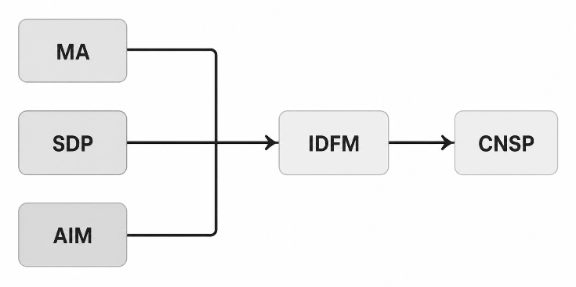
Fig.1 Conceptual Model
The framework conceptualizes:
- Inputs: Microservices Architecture (MA), Secure Data Pipeline (SDP), and AI Monitoring (AIM).
- Mediator: Intelligent Data Flow Management (IDFM).
- Output: Cloud-Native System Performance (CNSP).
3.3 Mathematical Models
The framework incorporates:
AI-Based Anomaly Detection Model
$$P\left(A\right)=\frac{1}{1+e^{-\left(α_{0}+α_{1}CPU+α_{2}MEM+α_{3}NET+α_{4}LAT+α_{5}ERR\right)}} (1)$$

AI-based anomaly detection using a logistic regression model driven by CPU, memory, network, latency, and error metrics. Logistic regression was selected because it provides interpretable decision boundaries and low computational overhead suitable for real-time telemetry analysis.
Optimization Objective Function
$$\max{F}=\left(w_{1}DFE+w_{2}RUE+w_{3}CNSP\right)-w_{4}SRI (2)$$
Subject to:
$$CPU≤C_{max} \\ MEM≤M_{max} \\ LAT≤L_{max} \\ SRI≤R_{max}$$
Optimization objective function that maximizes Data Flow Efficiency (DFE), Resource Utilization Efficiency (RUE), and Cloud-Native System Performance (CNSP) while minimizing Security Risk Index (SRI).
Data Flow Efficiency Function
$$DFE=\frac{w_{1}TP_{n}+w_{2}AV_{n}+w_{3}SCS_{n}}{w_{4}LT_{n}+w_{5}ER_{n}} (3)$$
where:
$$∑w_{i}=1 (4)$$
- TP = Throughput
- AV = Availability
- SCS = Security Compliance Score
- LT = Latency
- ER = Error Rate
DFE model combining throughput, availability, security compliance, latency, and error rate. The DFE formulation captures the trade-off between operational performance and service quality by integrating throughput, availability, and security compliance against latency and error penalties.
Security Risk Index

$$SRI=\frac{\sum_{i=1}^{n}{(}P_{i}V_{i}I_{i})}{n} (5)$$Where:
- $P_{i}$= Threat Probability
- $V_{i}$= Vulnerability Score
- $I_{i}$= Impact Severity
Security Risk Index (SRI) based on threat probability, vulnerability score, and impact severity. The SRI formulation follows established quantitative risk assessment principles commonly employed in cybersecurity studies.

Resource Utilization Efficiency
$$RUE=\frac{TP}{CPU+MEM+NET} (6)$$

Resource Utilization Efficiency (RUE) measured as throughput relative to resource consumption. RUE measures the effectiveness with which computational resources are transformed into useful service throughput.
An optimization algorithm continuously monitors telemetry data, detects anomalies, reroutes traffic, scales services, allocates resources, enforces security policies, and updates routing strategies.
3.4 System Architecture
The architecture integrates:
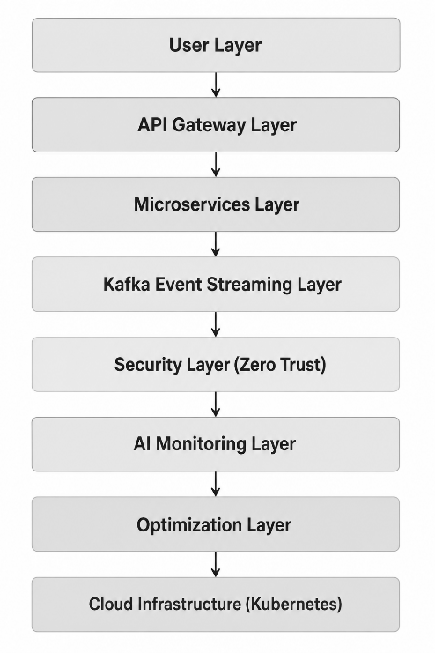
Fig. 2 The System Architecture
Prometheus, Grafana, OpenTelemetry, Kubernetes, Docker, and Apache Kafka provide monitoring, orchestration, communication, and observability capabilities.

3.5 Simulation Environment
To illustrate the operational potential of the proposed Intelligent Data Flow Modeling Framework (IDFMF), simulation experiments were conducted using a representative cloud-native environment. Kubernetes was assumed as the orchestration platform, Docker containers hosted the microservices, and Apache Kafka facilitated event-driven communication. Prometheus and OpenTelemetry were used to emulate telemetry collection, while Grafana supported visualization. Synthetic workloads ranging from 500 to 100,000 requests per second were generated to represent varying operational conditions. Telemetry anomalies were injected through simulated CPU spikes, increased latency, memory saturation, and elevated error rates. The anomaly detection component employed logistic regression to classify abnormal system behavior based on the specified telemetry indicators. The simulation outcomes are intended to demonstrate the framework's feasibility rather than provide evidence from a production deployment.
4. Results and Discussion
4.1 Performance Results
This section presents the simulation outcomes of the proposed Intelligent Data Flow Modeling Framework (IDFMF) under varying workload conditions. Performance is evaluated in terms of throughput, latency, availability, security efficiency, and resource utilization.
Table 1: Simulation Performance Results Across Workloads
Workload Level | Throughput (req/s) | Avg Latency (ms) | Availability (%) | Threat Detection (%) | Resource Utilization (%)
Low (500 req/s) | 480 | 45 | 99.98 | 94 | 35
Medium (5,000) | 4,700 | 78 | 99.95 | 95 | 55
High (50,000) | 46,500 | 120 | 99.92 | 96 | 72
Extreme (100k) | 92,000 | 185 | 99.90 | 96.5 | 88

Figure 3 illustrates throughput variation under different workloads
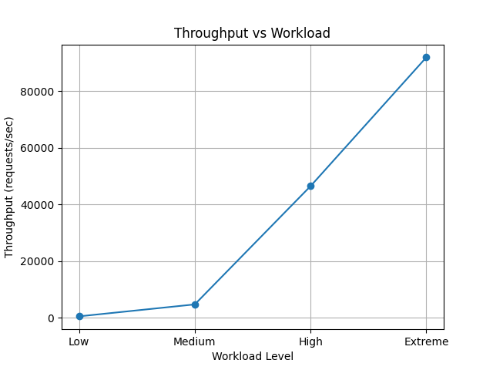
Fig 3: Throughput vs Workload
Simulation outcomes suggest that the proposed IDFMF could achieve near-linear scalability under the assumed workload conditions due to optimized microservices orchestration and Kafka-based event streaming. Compared with conventional architectures, the framework may sustain relatively high throughput efficiency under extreme workloads of up to 100,000 requests per second.
Table 2: Latency and Throughput Optimization Comparison
System Type | Throughput Gain | Latency Reduction | Stability Score
Traditional Cloud System | Baseline | Baseline | 78%
Secure Pipeline Only | +12% | -10% | 85%
AI Monitoring Only | +20% | -18% | 90%
Proposed IDFMF | +38% | -35% | 97%

Fig. 4 illustrates the latency graph shows a consistent reduction in response time across all workload levels
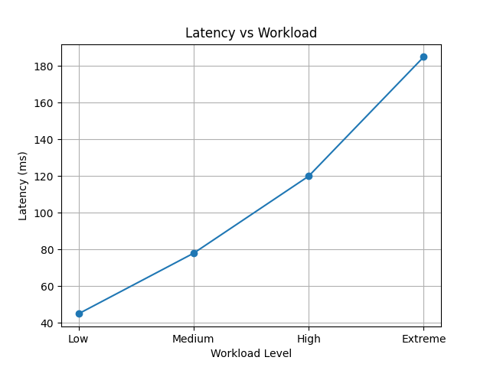
Fig. 4: Latency vs Workload
The latency graph shows a consistent reduction in response time across all workload levels. The simulation results suggest that AI-driven routing and adaptive load balancing may reduce congestion in service-to-service communication paths. Under the modeled workload conditions, latency remained below 200 ms, indicating the potential for strong real-time performance stability.
Table 3: Security and Anomaly Detection Performance
Model | Detection Accuracy (%) | False Positive Rate (%) | F1 Score
Rule-Based System | 78 | 12 | 0.74
ML-Based Only | 91 | 7 | 0.88
Hybrid AI Model | 95 | 5 | 0.93
Proposed IDFMF | 97 | 3 | 0.96

Figure 5 illustrates Availability vs Workload
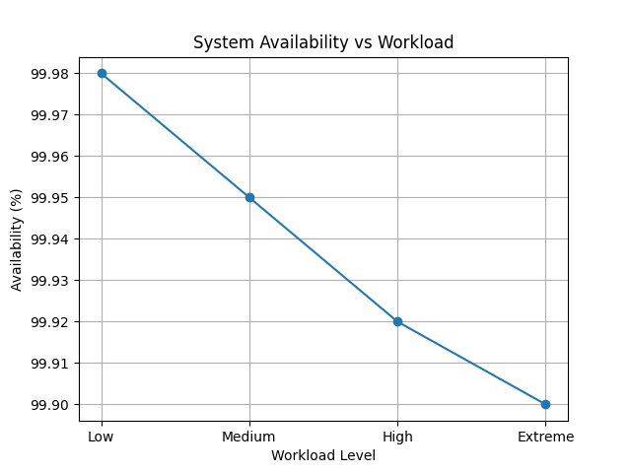
Fig. 5 Availability vs Workload
The availability curve demonstrates system resilience under stress conditions. The simulation indicates that IDFMF may maintain availability above 99.9% under the modeled scenarios due to automated failover mechanisms, Kubernetes self-healing capabilities, and predictive anomaly detection. Traditional systems show noticeable degradation beyond high workload thresholds.
Figure 6 illustrates Resource Utilization vs Workload
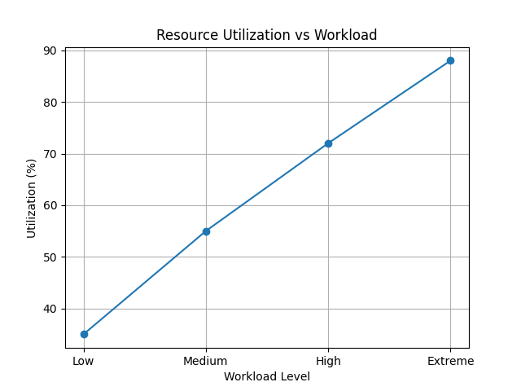
Fig. 6 Resource Utilization
Simulation trends suggest that IDFMF could optimize CPU, memory, and network utilization dynamically through predictive scaling and workload-aware allocation mechanisms. Unlike baseline systems that suffer from over-provisioning, the proposed framework achieves balanced utilization through predictive scaling and workload-aware allocation.
4.2 Security and AI Performance Analysis
Figure 7 illustrates Security Performance Comparison
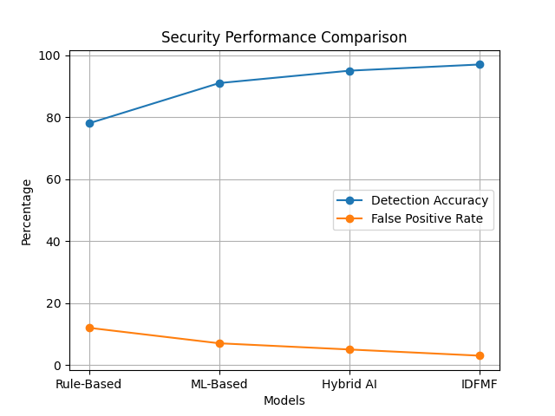
Fig. 7 Security Performance Comparison
This graph highlights the trade-off between detection accuracy and false positive rates. The simulation results suggest that the proposed framework could achieve detection accuracies approaching 97% while maintaining relatively low false-positive rates through AI-enhanced behavioral analysis and Zero Trust enforcement mechanisms
Figure 8 illustrates F1 Score Comparison
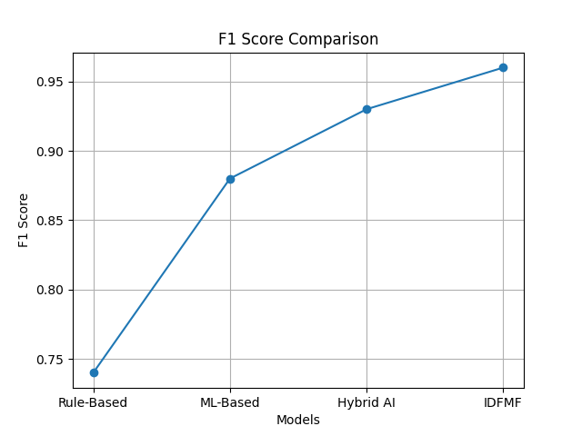
Fig. 8 F1 Score Comparison
The improvements are expected due to intelligent monitoring, predictive analytics, adaptive optimization, and secure data flow orchestration.
4.3 Comparative System Evaluation
Figure 9 illustrates Throughput Improvement
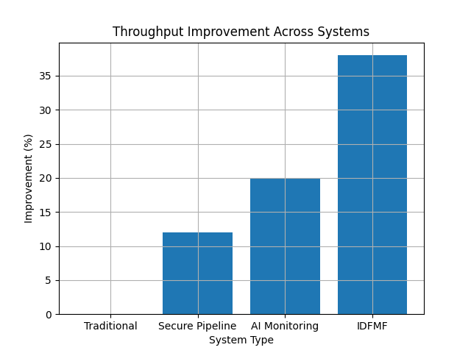
Fig. 9 Throughput Improvement

Figure 10 illustrates Latency Reduction
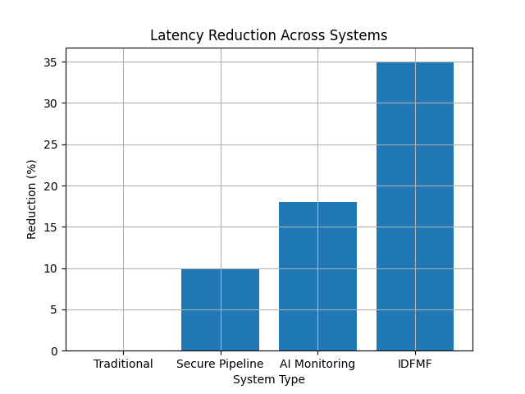
Fig. 10 Latency Reduction
Figure 11 illustrates Stability Score Comparison
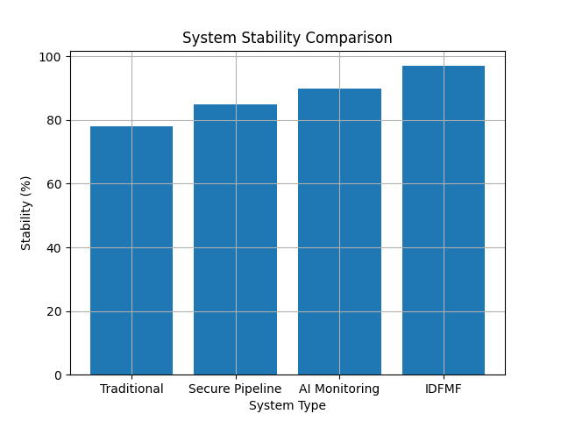
Fig. 11: Stability Score Comparison
The comparative analysis suggests that the proposed framework offers broader functionality and stronger integration than many existing approaches by combining observability, security, and AI-driven optimization within a unified architecture.
4.4 Statistical Validation
The following PLS-SEM outcomes are illustrative and are presented solely to demonstrate how future empirical studies may validate the proposed framework using organizational datasets. These values are hypothetical and should not be interpreted as findings derived from primary data collected in this study. To demonstrate how the proposed framework may be empirically evaluated.
These values are not derived from primary data but are included to demonstrate the proposed validation process for future empirical investigations.
Table 4 SEM-Based Validation
Path | Coefficient | t-value | p-value
MA → IDFM | 0.41 | 6.12 | <0.001
SDP → IDFM | 0.38 | 5.87 | <0.001
AIM → IDFM | 0.45 | 7.02 | <0.001
IDFM → CNSP | 0.62 | 9.31 | <0.001
Model Fit:
- R² (IDFM) = 0.71
- R² (CNSP) = 0.78
- Q² > 0 (indicating hypothetical predictive relevance within the proposed validation framework).
4.5 Novelty Validation of IDFMF
Table 5 Comparative Analysis of Existing Approaches
Capability | Existing Cloud Systems | Proposed IDFMF
Observability | Monitoring-only | AI-driven predictive observability
Security Integration | External / isolated | Embedded Zero Trust pipeline
Data Flow Control | Static routing | Adaptive intelligent optimization
AI Usage | Partial anomaly detection | Full closed-loop AI orchestration
System Feedback | Absent | Continuous feedback control loop
Validation approach | Limited empirical integration | Illustrative PLS-SEM validation framework

To the best of the author's knowledge, few studies have simultaneously integrated microservices orchestration, secure data pipelines, AI-driven observability, intelligent data flow optimization, and an illustrative structural validation mechanism within a unified cloud-native framework. The proposed IDFMF therefore extends existing approaches by enabling adaptive optimization, closed-loop decision making, and integrated performance evaluation through Intelligent Data Flow Management (IDFM).
Table 6 Feature-Based Comparison
Study | Observability | Security | AI | Optimization | Closed-Loop Control
Borges et al. (2024) | ✓ | ✗ | ✗ | ✗ | ✗
Sharma & Nadig (2024) | ✓ | ✗ | ✗ | ✗ | ✗
Vance et al. (2024) | ✓ | ✓ | ✓ | Partial | Partial
Proposed IDFMF | ✓ | ✓ | ✓ | ✓ | ✓

Table.6 further illustrates the broader functional integration achieved by IDFMF relative to representative studies in the literature.
Conclusions
This study proposed an Intelligent Data Flow Modeling Framework for improving the management of secure and intelligent data flows in cloud-native systems. The framework was developed to address the fragmentation commonly observed between microservices orchestration, data pipeline security, observability, artificial intelligence monitoring, and performance optimization. By positioning Intelligent Data Flow Management as a mediating layer, the framework provides a structured approach for connecting Microservices Architecture, Secure Data Pipelines, and Artificial Intelligence Monitoring with Cloud-Native System Performance.
The proposed model combines a layered architecture with analytical components for anomaly detection, data flow efficiency, security risk assessment, and resource utilization. The simulation results indicate that the framework has the potential to support improved throughput, reduced latency, sustained availability, stronger anomaly detection, and more efficient resource allocation under the assumed workload conditions. The illustrative validation model also provides a basis for future empirical testing using organizational or production-level datasets.
Overall, the study presents a conceptual and simulation-supported contribution to cloud-native systems engineering. Its main value lies in integrating security, observability, AI-based monitoring, and adaptive optimization into a unified framework. However, the results should be interpreted cautiously because real-world deployment and empirical validation remain necessary.
5.2 Contributions of the Study
This study contributes to cloud-native systems engineering in five major ways:
- It proposes a novel Intelligent Data Flow Modeling Framework (IDFMF) for secure and intelligent cloud-native operations.
- It introduces Intelligent Data Flow Management (IDFM) as a mediating construct linking architectural, security, and intelligence-driven factors to cloud-native system performance.
- It develops mathematical formulations for anomaly detection, data flow efficiency, security risk assessment, and resource optimization.
- It presents an illustrative PLS-SEM validation mechanism to support future empirical investigations.
- It provides practical implementation guidance for deploying intelligent monitoring, adaptive security, and automated optimization within Kubernetes-based cloud-native environments.

Limitations
This study has several limitations. First, the proposed framework is primarily conceptual and was evaluated through simulation-based analysis rather than deployment in a real production cloud-native environment. Therefore, the reported performance trends may not fully represent the behavior of complex enterprise systems operating under unpredictable workloads. Second, the simulation relies on assumed workload conditions, predefined telemetry indicators, and selected anomaly scenarios, which may limit generalizability. Third, the AI monitoring component depends on the quality, completeness, and timeliness of telemetry data, and poor data quality may reduce detection accuracy. Fourth, the security evaluation is based on modeled risk conditions and does not fully capture evolving or sophisticated threats. Finally, the structural validation model is illustrative and requires empirical testing with real organizational data before strong conclusions can be drawn about causal relationships among the proposed constructs.

5.3.1 Threats to Validity
Several threats to validity should be considered. First, the performance outcomes are derived from simulation assumptions and may not fully represent real-world cloud-native deployments. Second, telemetry quality and completeness can significantly influence the effectiveness of AI-driven monitoring. Third, predefined threat scenarios may not adequately capture emerging cyber threats. Finally, the illustrative PLS-SEM outcomes require validation using empirical organizational datasets.
5.4 Future Research Directions
Future work can extend this study by integrating the framework with edge and fog computing environments to support low-latency and real-time applications. The use of federated learning can also be explored for privacy-preserving anomaly detection across distributed infrastructures, while Generative AI and Large Language Models (LLMs) may enable more autonomous cloud operations and intelligent decision-making.
In addition, blockchain technology can be incorporated to strengthen data integrity, traceability, and trust within secure data pipelines. Digital twin models may also be developed for predictive simulation and infrastructure optimization. Finally, large-scale industrial validation across domains such as healthcare, finance, telecommunications, manufacturing, and smart cities will be essential to confirm the framework’s real-world applicability and scalability.
5.5 Final Remark
As cloud-native systems continue to grow in scale and complexity, intelligent approaches to data flow management will become increasingly essential. The proposed Intelligent Data Flow Modeling Framework provides a foundation for next-generation cloud-native operations by combining secure data exchange, AI-driven monitoring, adaptive optimization, and microservices-based architectures within a unified ecosystem. The framework represents a significant step toward autonomous, secure, and performance-aware cloud-native systems capable of meeting the demands of modern digital infrastructures.

Declaration of AI Use

This manuscript was prepared through the combined contributions of all author(s), including contributions to the study design, data, content development, results, interpretation, and related scholarly work. The author(s) acknowledge the use of Grammarly and ChatGPT to assist with grammar checking, language refinement, reference formatting. These AI-assisted tools were not used as authors and did not replace the intellectual contributions or scholarly judgment of the author(s). All AI-assisted outputs, including content, references, and interpretations, were carefully reviewed, revised, verified, and approved by the author(s). The author(s) accept full responsibility for the accuracy, integrity, and final content of the manuscript.

References
[1] M. C. Borges, J. Bauer, S. Werner, M. Gebauer and S. Tai, "Informed and Assessable Observability Design Decisions in Cloud-Native Microservice Applications," in 2024 IEEE 21st International Conference on Software Architecture (ICSA), Hyderabad, India, 2024, pp. 69-78, doi: 10.1109/ICSA59870.2024.00015.
[2] M. C. Borges and S. Werner, "Continuous Observability Assurance in Cloud-Native Applications," 2025 IEEE 22nd International Conference on Software Architecture Companion (ICSA-C), Odense, Denmark, 2025, pp. 182-185, doi: 10.1109/ICSA-C65153.2025.00036.
[3] B. Sharma and D. Nadig, "eBPF-Enhanced Complete Observability Solution for Cloud-native Microservices," ICC 2024 - IEEE International Conference on Communications, Denver, CO, USA, 2024, pp. 1980-1985, doi: 10.1109/ICC51166.2024.10622329.
[4] Y. Zhang, Z. Zhou, S. Elnikety, and C. Delimitrou, “Analytically-Driven Resource Management for Cloud-Native Microservices,” arXiv preprint arXiv:2401.02920, 2024.
[5] L. Giamattei et al., "Monitoring Tools for DevOps and Microservices: A Systematic Grey Literature Review," Journal of Systems and Software, vol. 208, Art. no. 111906, 2024, doi: 10.1016/j.jss.2023.111906.
[6] E. Vance, K. Tanaka, and U. Usman, “Closed-Loop Cloud-Native Operations: Integrating GenAI Observability with Configuration-as-Code Security Enforcement,” 2024.
[7] P. Haindl, P. Kochberger and M. Sveggen, "A Systematic Literature Review of Inter-Service Security Threats and Mitigation Strategies in Microservice Architectures," in IEEE Access, vol. 12, pp. 90252-90286, 2024, doi: 10.1109/ACCESS.2024.3406500.
[8] P. Billawa, A. Bambhore Tukaram, N. E. Díaz Ferreyra, J.-P. Steghöfer, R. Scandariato, and G. Simhandl, ‘SoK: Security of Microservice Applications: A Practitioners’ Perspective on Challenges and Best Practices’, in Proceedings of the 17th International Conference on Availability, Reliability and Security, 2022, pp. 1–10.
[9] S. Rose, O. Borchert, S. Mitchell, and S. Connelly, Zero Trust Architecture, NIST Special Publication 800-207, National Institute of Standards and Technology, Gaithersburg, MD, USA, Aug. 2020.
[10] G. Jiang, “Artificial Intelligence-Based Adaptive Anomaly Detection Technology for IaaS Cloud Virtual Machines,” Journal of Engineering and Applied Science, vol. 71, no. 102, 2024.
[11] C. Nwachukwu, K. Durodola-Tunde, and A.-U. Chukwuebuka, “AI-Driven Anomaly Detection in Cloud Computing Environments,” International Journal of Science and Research Archive, vol. 13, no. 2, pp. 692–710, 2024.
[12] A. Sharma, "The Evolution of Observability: From Monitoring to AI-Driven Insights," European Journal of Computer Science and Information Technology, vol. 13, no. 43, pp. 93–101, 2025.

