Original Research Article
Comparative Assessment of Polycyclic Aromatic Hydrocarbon levels in Air and Associated Health Risks in some Communities in Eleme, Rivers State, Nigeria
Abstract
This study assessed polycyclic aromatic hydrocarbons (PAHs) in indoor and outdoor air from Akpajo, Alesa and Aleto communities in Eleme Local Government Area, Rivers State, Nigeria, and evaluated the associated inhalation health risks. Air samples were collected during dry and wet seasons from indoor and outdoor microenvironments and analysed for selected PAH congeners after solvent extraction using dichloromethane (1:1 v/v) and gas chromatography-mass spectrometry. Total PAH concentrations varied across community, season and microenvironment, ranging from 7.40 µg/m³ in Alesa wet-season indoor air to 30.55 µg/m³ in Aleto dry-season outdoor air. The mean total PAH concentration was highest in Aleto (21.41 µg/m³), followed by Akpajo (11.80 µg/m³) and Alesa (10.39 µg/m³). Dry-season concentrations were higher than wet-season concentrations, with mean values of 18.18 µg/m³ and 10.88 µg/m³, respectively. Outdoor air also showed a higher mean concentration than indoor air. Anthracene, pyrene, benzo(k)fluoranthene, naphthalene and fluorene were the dominant pooled congeners. Health-risk estimates indicated higher lifetime average daily dose and incremental lifetime carcinogenic risk in children than adults across all sampling conditions. The highest child incremental lifetime carcinogenic risk was observed in Aleto dry-season outdoor air. Analysis of variance showed significant seasonal effects for total PAHs and selected congeners, while principal component analysis retained three components that explained 90.73% of the total variance. The findings indicate measurable PAH contamination in the studied communities and support routine monitoring and exposure-reduction measures.

Keywords: Polycyclic Aromatic Hydrocarbons, Indoor, Outdoor, Akpajo, Alesa, Aleto, Eleme, Nigeria

INTRODUCTION
Air pollution remains one of the most important environmental-health concerns in industrial and urbanizing regions. It includes chemical, physical and biological alterations in the natural composition of air that may impair human health, reduce visibility, damage vegetation and alter ecosystem processes. In the Niger Delta, air pollution is strongly linked to petroleum-related activities, road traffic, generator use, open burning, industrial operations and construction-related dust.
Polycyclic aromatic hydrocarbons are a class of semi-volatile organic compounds made up of two or more fused aromatic rings. They are formed mainly during incomplete combustion of organic matter, including petroleum products, biomass, refuse and coal-derived materials. Because PAHs can partition between vapour and particle phases, they are transported through air, deposited on surfaces and vegetation, and may enter the human body through inhalation, ingestion and dermal contact.
Eleme Local Government Area in Rivers State is an important industrial corridor that hosts petrochemical, refining, port, transportation, commercial and residential activities. The communities of Akpajo, Alesa and Aleto are therefore environmentally relevant for PAH monitoring because residents may be exposed to mixed indoor and outdoor emission sources. Indoor concentrations may be influenced by outdoor infiltration, cooking practices, generator use and ventilation, whereas outdoor concentrations may reflect traffic, industrial activities, dust resuspension and seasonal atmospheric dispersion.
The aim of this paper is to present a detailed journal-style analysis of PAHs in air for Akpajo, Alesa and Aleto using the attached thesis and the supplied PAHs-in-air publication template. The specific objectives are to: quantify PAH concentrations in indoor and outdoor air during dry and wet seasons; estimate adult and child inhalation exposure and carcinogenic risk; evaluate whether season, environment and community significantly influenced PAH levels; use PCA to identify major patterns in PAH co-occurrence; and discuss implications for monitoring and public-health protection.

PAHs are produced when carbon-rich fuels and organic materials burn under oxygen-limited or inefficient combustion conditions. Important sources include vehicular exhaust, petroleum handling, industrial furnaces, power generators, gas flaring, biomass burning, refuse burning and cooking emissions. Lower-molecular-weight PAHs are more volatile, whereas higher-molecular-weight PAHs are more particle-associated and may persist on soot, dust and fly ash.
Atmospheric PAHs undergo dilution, dispersion, photochemical transformation, wet and dry deposition, and sorption to particulate matter. Seasonal meteorology is therefore important. Dry seasons can increase suspended dust and limit wet scavenging, whereas wet seasons can reduce airborne concentrations through rainfall washout and increased atmospheric mixing.

Indoor air may contain PAHs from indoor combustion and from infiltration of outdoor pollution. In communities where households use fuel-burning devices, generators or poorly ventilated kitchens, indoor PAH exposure can be important. Outdoor air is affected by traffic density, road condition, industrial activities and open burning. The indoor/outdoor comparison therefore provides insight into micro environmental exposure and potential source dominance.
Children are usually a sensitive receptor group in exposure assessment because dose per unit body weight can be higher than for adults. When a risk model uses body weight, inhalation rate, exposure duration and averaging time, child lifetime average daily dose can exceed adult dose under the same air concentration.

Several PAHs are toxic, mutagenic or carcinogenic. Benzo(a)pyrene is commonly used as an indicator carcinogenic PAH, while other congeners may contribute to overall toxicity depending on their potency and exposure route. Inhalation exposure is especially relevant for communities located near roads, industrial stacks, generator clusters and dust-generating activities.

Environmental data vary across time, space and microenvironment. ANOVA helps determine whether differences among season, indoor/outdoor environment or community are statistically meaningful. PCA is complementary because it reduces a multivariate PAH dataset into a smaller number of components and helps identify co-varying groups of pollutants that may reflect shared emission sources, atmospheric behaviour or site-specific processes.

MATERIALS AND METHODS
Study area
The study covered Akpajo, Alesa and Aleto in Eleme Local Government Area, Rivers State, Nigeria (Fig.1). Eleme is located within an industrialized part of the Niger Delta and is influenced by petrochemical facilities, refining-related activities, ports, traffic corridors, markets, residential settlements and road construction. The area experiences a tropical wet-and-dry climate, with wet season generally from April to October and dry season from November to March.
During the thesis study period, construction activities were reported along the Eleme section of the East-West Expressway and the Rivers State Ring Road corridor. Such activities may increase suspended dust and resuspension of particle-bound contaminants, while traffic congestion and generator use may add combustion-related PAHs.

Sampling design
Air samples were collected from indoor and outdoor microenvironments in the selected communities during dry and wet seasons. The design allowed comparison by community, season and environment. Indoor samples represented residential or school-related exposure settings, while outdoor samples represented ambient exposure near community activity zones.

Materials, reagents and instrumental analysis
Materials included sampling pump, glass-fibre filter papers, sorbent tubes, masking tape, conical flasks, volumetric flasks, measuring cylinders, pipettes, desiccator, fume hood, personal protective equipment and laboratory glassware. Instruments in the wider thesis included handheld weather station PCE-FWS 20N, Aerocet Handheld Particle Mass Counter 531S, Aeroqual 500 series air-quality monitor, High-Volume Air Sampler, rotary evaporator and GC-MS instrumentation.
PAHs retained on filter papers were extracted after cutting the filters into small pieces and placing them in extraction flasks. Extraction was conducted using 100-150 mL dichloromethane:hexane (1:1 v/v) for 16-24 hours. Extracts were concentrated by rotary evaporation to about 1-2 mL and analysed by gas chromatography-mass spectrometry. The approach is consistent with semivolatile organic compound analysis by GC-MS.

Health-risk assessment
Human-health risk was evaluated using lifetime average daily dose (LADD) and incremental lifetime carcinogenic risk (ILCR) for adults and children. Total LADD and total ILCR were obtained by summing compound-specific values across PAH components with available slope factors.
Total risk was obtained as the summation of component-specific values across PAHs with available slope factor.

Health Risk Calculation for PAHs in Air
A. The general equation used for Lifetime Average Daily Dose is:
LADD = (C x IR x EF x ED) / (BW x AT) (1)
B. The carcinogenic risk is estimated as:
ILCR = LADD x SF (2)
C. For total risk across all PAH components:
ΣLADD = LADD1 + LADD2 + LADD3 + ... + LADDn (3)
ΣILCR = ILCR1 + ILCR2 + ILCR3 + ... + ILCRn (4)

Symbol Meaning Unit/description
C Pollutant concentration Air: µg/m3; Plant leaves: mg/kg
IR Intake rate Air: inhalation rate (m3/day); Plant: ingestion rate (kg/day)
EF Exposure frequency days/year
ED Exposure duration years
BW Body weight kg
AT Averaging time days
SF Cancer slope factor (mg/kg-day)-1
LADD Lifetime Average Daily Dose mg/kg-day
ILCR Incremental Lifetime Carcinogenic Risk unitless probability

Statistical analysis
Analysis of variance was applied to evaluate the effects of season, indoor/outdoor environment and community on PAH concentrations. Statistical decisions were interpreted at p < 0.05. Results are presented for individual PAH congeners and total PAHs.
Principal component analysis was applied to the PAH-in-air dataset to describe the dominant multivariate patterns. Sampling adequacy was evaluated with the Kaiser-Meyer-Olkin statistic and Bartlett's test of sphericity. Components were retained using the thesis PCA output, and rotated loading patterns were used to interpret co-varying PAH groups.

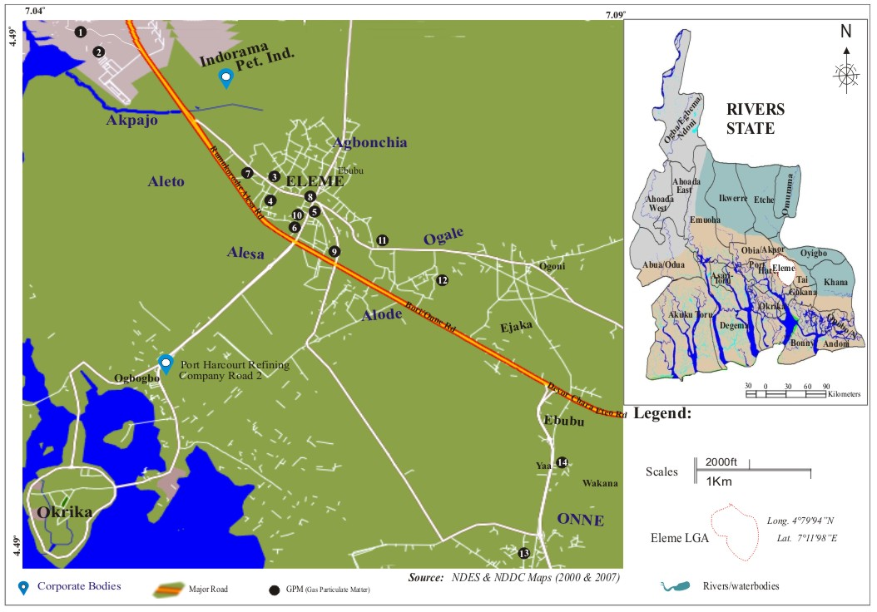
Fig. 1: The Study Area Showing Sampling Locations

RESULTS AND DISCUSSION

The results of the study are presented in Table 1 and Figure 2. PAHs were detected in all selected communities, seasons and microenvironments. Total PAHs ranged from 7.40 to 30.55 µg/m³, indicating substantial variability across community, season and indoor/outdoor setting.
Across all conditions, the pooled mean total PAH concentration was 14.53 µg/m³. The highest total PAH value occurred at Aleto dry-season outdoor air (30.55 µg/m³), followed by Aleto dry-season indoor air (22.20 µg/m³) and Aleto wet-season outdoor air (20.70 µg/m³). The lowest value occurred at Alesa wet-season indoor air (7.40 µg/m³).
Community mean total PAH concentration was highest in Aleto (21.41 µg/m³), followed by Akpajo (11.80 µg/m³) and Alesa (10.39 µg/m³). Dry-season mean concentration (18.18 µg/m³) was higher than wet-season mean concentration (10.88 µg/m³), suggesting stronger dry-season accumulation or reduced washout. Outdoor air averaged 15.75 µg/m³, higher than indoor air at 13.32 µg/m³.

Table 1. Concentrations of PAH congeners in indoor and outdoor air across Akpajo, Alesa and Aleto (µg/m³).
PAH Component | Akpajo Dry Indoor | Akpajo Dry Outdoor | Akpajo Wet Indoor | Akpajo Wet Outdoor | Alesa Dry Indoor | Alesa Dry Outdoor | Alesa Wet Indoor | Alesa Wet Outdoor | Aleto Dry Indoor | Aleto Dry Outdoor | Aleto Wet Indoor | Aleto Wet Outdoor
Naphthalene | 0.45 | 2.25 | 0.20 | 1.00 | 0.15 | 0.30 | 0.15 | 0.20 | 5.65 | 4.95 | 1.45 | 3.25
Acenaphthylene | 1.20 | 1.25 | 0.80 | 0.60 | 0.45 | 1.20 | 0.35 | 0.95 | 1.95 | 2.30 | 1.40 | 1.45
Acenaphthene | 0.40 | 0.25 | 0.15 | 0.10 | 0.20 | 0.45 | 0.10 | 0.20 | 0.35 | 0.85 | 0.10 | 0.60
Fluorene | 0.40 | 1.40 | 0.20 | 0.50 | 0.65 | 0.85 | 0.50 | 0.35 | 2.45 | 4.05 | 1.45 | 3.00
Phenanthrene | 1.50 | 0.05 | 0.85 | 0.10 | 0.10 | 0.10 | 0.05 | 0.10 | 3.45 | 4.10 | 1.45 | 2.55
Anthracene | 2.25 | 3.15 | 1.70 | 2.20 | 2.75 | 2.15 | 2.15 | 1.80 | 2.75 | 7.65 | 2.20 | 5.40
Fluoranthene | 1.00 | 0.90 | 0.55 | 0.75 | 0.10 | 0.05 | 0.00 | 0.00 | 1.25 | 2.40 | 1.00 | 1.50
Pyrene | 5.45 | 2.35 | 3.05 | 1.30 | 4.15 | 4.45 | 2.35 | 2.95 | 2.25 | 1.90 | 1.85 | 1.45
Benzo(a)anthracene | 0.05 | 0.05 | 0.00 | 0.10 | 0.40 | 0.50 | 0.15 | 0.15 | 0.10 | 0.90 | 0.00 | 0.65
Chrysene | 0.05 | 0.05 | 0.00 | 0.10 | 0.55 | 0.55 | 0.20 | 0.25 | 0.05 | 0.15 | 0.00 | 0.10
Benzo(b)fluoranthene | 0.05 | 0.05 | 0.00 | 0.10 | 0.70 | 0.75 | 0.15 | 0.30 | 0.05 | 0.10 | 0.00 | 0.00
Benzo(k)fluoranthene | 3.85 | 1.85 | 1.75 | 0.85 | 2.00 | 2.55 | 1.25 | 0.80 | 1.90 | 1.20 | 1.30 | 0.75
Benzo(a)pyrene | 0.00 | 0.00 | 0.00 | 0.00 | 0.00 | 0.00 | 0.00 | 0.00 | 0.00 | 0.00 | 0.00 | 0.00
Indeno(1,2,3-c,d)pyrene | 0.00 | 0.00 | 0.00 | 0.00 | 0.00 | 0.00 | 0.00 | 0.00 | 0.00 | 0.00 | 0.00 | 0.00
Dibenz(a,h)anthracene | 0.00 | 0.00 | 0.00 | 0.00 | 0.00 | 0.00 | 0.00 | 0.00 | 0.00 | 0.00 | 0.00 | 0.00
Benzo(g,h,i)perylene | 0.00 | 0.00 | 0.00 | 0.00 | 0.00 | 0.00 | 0.00 | 0.00 | 0.00 | 0.00 | 0.00 | 0.00
Total PAHs | 16.65 | 13.60 | 9.25 | 7.70 | 12.20 | 13.90 | 7.40 | 8.05 | 22.20 | 30.55 | 12.20 | 20.70

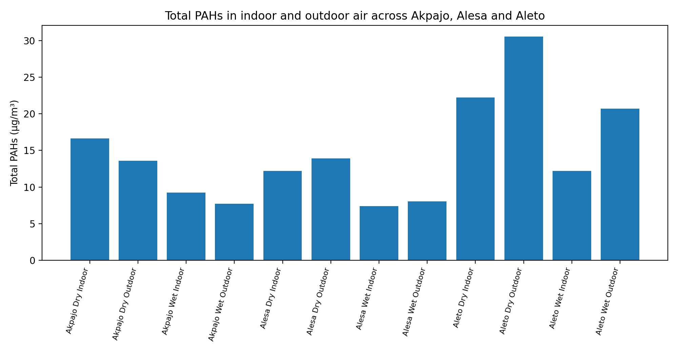
Figure 2. Total PAH concentrations by community, season and indoor/outdoor environment.

Table 2. Summary statistics for total PAHs in air.
Summary metric | Value (µg/m³)
Minimum total PAHs | 7.40
Maximum total PAHs | 30.55
Overall mean total PAHs | 14.53
Mean: dry season | 18.18
Mean: wet season | 10.88
Mean: indoor | 13.32
Mean: outdoor | 15.75

Table 3. Ten highest pooled PAH congeners across the 12 Akpajo-Alesa-Aleto air conditions.
PAH Component | Pooled concentration
Anthracene | 36.15
Pyrene | 33.50
Benzo(k)fluoranthene | 20.05
Naphthalene | 20.00
Fluorene | 15.80
Phenanthrene | 14.40
Acenaphthylene | 13.90
Fluoranthene | 9.50
Acenaphthene | 3.75
Benzo(a)anthracene | 3.05

Health-risk results
Health-risk estimates followed the concentration pattern but were also affected by compound-specific slope factors. Children recorded higher LADD and ILCR than adults in every condition because the exposure model yields a larger dose per unit body weight for the child receptor.
Seven of the twelve child ILCR values exceeded 1.00E-04. The highest child ILCR occurred at Aleto dry-season outdoor air (4.12E-04), followed by Alesa dry-season outdoor air (3.07E-04), Aleto wet-season outdoor air (2.93E-04), Alesa dry-season indoor air (2.45E-04) and Akpajo dry-season indoor air (1.78E-04). Adult ILCR exceeded 1.00E-04 at Alesa dry-season outdoor, Aleto dry-season outdoor and Aleto wet-season outdoor conditions.

Table 4. Summary of total PAHs and inhalation health-risk estimates for adults and children.
Location | Season/environment | Total PAHs (µg/m³) | Adult LADD | Child LADD | Adult ILCR | Child ILCR
Akpajo | Dry season indoor | 16.65 | 3.97E-03 | 1.12E-02 | 6.33E-05 | 1.78E-04
Akpajo | Dry season outdoor | 13.60 | 3.25E-03 | 9.13E-03 | 3.41E-05 | 9.60E-05
Akpajo | Wet season indoor | 9.25 | 2.21E-03 | 6.21E-03 | 2.55E-05 | 7.17E-05
Akpajo | Wet season outdoor | 7.70 | 1.84E-03 | 5.17E-03 | 2.68E-05 | 7.55E-05
Alesa | Dry season indoor | 12.20 | 2.91E-03 | 8.19E-03 | 8.72E-05 | 2.45E-04
Alesa | Dry season outdoor | 13.90 | 3.32E-03 | 9.33E-03 | 1.10E-04 | 3.07E-04
Alesa | Wet season indoor | 7.40 | 1.77E-03 | 4.97E-03 | 4.00E-05 | 1.12E-04
Alesa | Wet season outdoor | 8.05 | 1.92E-03 | 5.41E-03 | 3.36E-05 | 9.42E-05
Aleto | Dry season indoor | 22.20 | 5.30E-03 | 1.49E-02 | 4.21E-05 | 1.18E-04
Aleto | Dry season outdoor | 30.55 | 7.30E-03 | 2.05E-02 | 1.47E-04 | 4.12E-04
Aleto | Wet season indoor | 12.20 | 2.91E-03 | 8.19E-03 | 1.89E-05 | 5.32E-05
Aleto | Wet season outdoor | 20.70 | 4.94E-03 | 1.39E-02 | 1.04E-04 | 2.93E-04

Analysis of variance for PAHs in air
ANOVA was used to identify whether season, indoor/outdoor environment and community produced statistically significant differences in PAH concentrations. The results show that total PAHs varied significantly by season (F = 4.64, p = 0.0396), but not by indoor/outdoor environment (p = 0.5356) or community (p = 0.1131) when all communities in the wider thesis dataset were considered.
For individual PAHs, season significantly influenced acenaphthene, benzo(b)fluoranthene, benzo(k)fluoranthene and pyrene. Indoor/outdoor environment significantly influenced acenaphthene, anthracene and benzo(a)anthracene. Community significantly influenced acenaphthylene, benzo(b)fluoranthene, chrysene, fluoranthene, fluorene and phenanthrene. These findings indicate that PAH behaviour was not controlled by a single factor; instead, different congeners responded to different spatial and seasonal processes.

Table 5. ANOVA results for PAHs in air from the Study Areas
Parameter | Factor | df (B,W) | F | p | Decision
Acenaphthene | Season | 1,29 | 6.21 | 0.0187 | Significant
Acenaphthylene | Season | 1,29 | 2.18 | 0.1504 | Not significant
Anthracene | Season | 1,29 | 1.93 | 0.1750 | Not significant
Benzo(a)Pyrene | Season | 1,29 | N/A | N/A | Not significant
Benzo(a)anthracene | Season | 1,29 | 2.79 | 0.1058 | Not significant
Benzo(b)fluoranthene | Season | 1,29 | 4.22 | 0.0491 | Significant
Benzo(g,h,i)perylene | Season | 1,29 | N/A | N/A | Not significant
Benzo(k)fluoranthene | Season | 1,29 | 8.33 | 0.0073 | Significant
Chrysene | Season | 1,29 | 3.95 | 0.0565 | Not significant
Dibenz(a,h)anthracene | Season | 1,29 | N/A | N/A | Not significant
Fluoranthene | Season | 1,29 | 2.24 | 0.1454 | Not significant
Fluorene | Season | 1,29 | 0.39 | 0.5377 | Not significant
Indeno(1,2,3-c,d)pyrene | Season | 1,29 | N/A | N/A | Not significant
Naphthalene | Season | 1,29 | 0.06 | 0.8016 | Not significant
Phenanthrene | Season | 1,29 | 0.30 | 0.5896 | Not significant
Pyrene | Season | 1,29 | 9.45 | 0.0046 | Significant
Total PAHs | Season | 1,29 | 4.64 | 0.0396 | Significant
Acenaphthene | Environs | 1,29 | 8.94 | 0.0056 | Significant
Acenaphthylene | Environs | 1,29 | 0.62 | 0.4381 | Not significant
Anthracene | Environs | 1,29 | 9.46 | 0.0045 | Significant
Benzo(a)Pyrene | Environs | 1,29 | N/A | N/A | Not significant
Benzo(a)anthracene | Environs | 1,29 | 15.79 | 4.30e-04 | Significant
Benzo(b)fluoranthene | Environs | 1,29 | 0.82 | 0.3732 | Not significant
Benzo(g,h,i)perylene | Environs | 1,29 | N/A | N/A | Not significant
Benzo(k)fluoranthene | Environs | 1,29 | 4.05 | 0.0537 | Not significant
Chrysene | Environs | 1,29 | 1.52 | 0.2278 | Not significant
Dibenz(a,h)anthracene | Environs | 1,29 | N/A | N/A | Not significant
Fluoranthene | Environs | 1,29 | 0.05 | 0.8332 | Not significant
Fluorene | Environs | 1,29 | 2.33 | 0.1374 | Not significant
Indeno(1,2,3-c,d)pyrene | Environs | 1,29 | N/A | N/A | Not significant
Naphthalene | Environs | 1,29 | 0.28 | 0.5983 | Not significant
Phenanthrene | Environs | 1,29 | 0.53 | 0.4714 | Not significant
Pyrene | Environs | 1,29 | 3.55 | 0.0697 | Not significant
Total PAHs | Environs | 1,29 | 0.39 | 0.5356 | Not significant
Acenaphthene | Community | 6,24 | 0.91 | 0.5064 | Not significant
Acenaphthylene | Community | 6,24 | 2.88 | 0.0292 | Significant
Anthracene | Community | 6,24 | 1.73 | 0.1573 | Not significant
Benzo(a)Pyrene | Community | 6,24 | N/A | N/A | Not significant
Benzo(a)anthracene | Community | 6,24 | 1.13 | 0.3761 | Not significant
Benzo(b)fluoranthene | Community | 6,24 | 3.70 | 0.0095 | Significant
Benzo(g,h,i)perylene | Community | 6,24 | N/A | N/A | Not significant
Benzo(k)fluoranthene | Community | 6,24 | 0.93 | 0.4909 | Not significant
Chrysene | Community | 6,24 | 4.27 | 0.0046 | Significant
Dibenz(a,h)anthracene | Community | 6,24 | N/A | N/A | Not significant
Fluoranthene | Community | 6,24 | 2.53 | 0.0484 | Significant
Fluorene | Community | 6,24 | 5.01 | 0.0019 | Significant
Indeno(1,2,3-c,d)pyrene | Community | 6,24 | N/A | N/A | Not significant
Naphthalene | Community | 6,24 | 2.23 | 0.0753 | Not significant
Phenanthrene | Community | 6,24 | 4.70 | 0.0027 | Significant
Pyrene | Community | 6,24 | 1.29 | 0.2998 | Not significant
Total PAHs | Community | 6,24 | 1.95 | 0.1131 | Not significant
Note: Significance was interpreted at p < 0.05. N/A indicates insufficient variation for F-test calculation.

Principal component analysis
PCA of individual PAHs in air was statistically suitable based on the thesis output. The KMO value for individual PAHs in air was 0.621, and Bartlett's test was significant at p < 0.001, indicating that the correlation structure was adequate for component extraction.
Three principal components were retained for individual PAHs in air and together explained 90.73% of total variance. PC1 explained 52.98%, PC2 explained 21.19% and PC3 explained 16.56%. High positive PC1 loadings for several lower- and mid-molecular PAHs suggest a broad combustion/source mixture influence, while PC2 and PC3 separate additional congener groups that may reflect differences in volatility, particle affinity, microenvironment and source contributions.

Table 6. PCA adequacy and variance summary.
Dataset | n | Variables | KMO | Bartlett chi-square |  | df | p-value | Retained PCs | Cumulative variance (%)
Conventional air pollutants (particulate matter and gases) | 42 | 11 | 0.570 | 280.01 | 55 |  | p < 0.001 | 4 | 79.58
Heavy metals in air | 28 | 5 | 0.401 | 214.79 | 10 |  | p < 0.001 | 2 | 89.70
Individual PAHs in air | 27 | 12 | 0.621 | 480.86 | 66 |  | p < 0.001 | 3 | 90.73
Leaf biochemical parameters | 52 | 5 | 0.475 | 158.79 | 10 |  | p < 0.001 | 2 | 83.35

Table 7. Eigenvalue and variance structure for PCA of individual PAHs in air.
Component | Eigenvalue | Variance (%) | Cumulative (%)
PC1 | 6.602 | 52.98 | 52.98
PC2 | 2.641 | 21.19 | 74.17
PC3 | 2.064 | 16.56 | 90.73
PC4 | 0.391 | 3.14 | 93.87
PC5 | 0.296 | 2.38 | 96.25
PC6 | 0.179 | 1.43 | 97.68
PC7 | 0.136 | 1.09 | 98.77
PC8 | 0.065 | 0.52 | 99.29
PC9 | 0.050 | 0.40 | 99.69
PC10 | 0.028 | 0.23 | 99.92
PC11 | 0.006 | 0.05 | 99.97
PC12 | 0.004 | 0.03 | 100.00

Table 8. Rotated PCA loadings for individual PAHs in air.
Variable | PC1 | PC2 | PC3
Naphthalene | +0.772 | -0.444 | -0.339
Acenaphthylene | +0.846 | -0.405 | +0.025
Acenaphthene | +0.950 | +0.143 | +0.121
Fluorene | +0.909 | -0.246 | -0.328
Phenanthrene | +0.786 | -0.487 | -0.050
Anthracene | +0.897 | -0.036 | -0.276
Fluoranthene | +0.697 | -0.573 | +0.283
Pyrene | -0.154 | +0.306 | +0.939
Benzo(a)anthracene | +0.873 | +0.441 | -0.178
Chrysene | +0.016 | +0.990 | +0.119
Benzo(b)fluoranthene | -0.134 | +0.962 | +0.151
Benzo(k)fluoranthene | -0.079 | -0.061 | +0.997
Note: Loadings with larger absolute values show stronger association with the component.

The PAH data show clear evidence of spatial and seasonal heterogeneity across Akpajo, Alesa and Aleto. Aleto recorded the highest total PAH burden in three of the four Aleto conditions and the highest community mean. This suggests that local emission intensity, traffic, industrial activity, microclimate, dust resuspension or a combination of these factors may have been stronger around Aleto sampling points during the study.
The dry-season elevation is environmentally plausible for Eleme. Lower rainfall during dry periods reduces wet scavenging of airborne pollutants, while dusty roads, construction, vehicular movement and generator emissions may increase particle-bound PAHs. Wet-season values were generally lower, consistent with dilution and washout, although Aleto wet-season outdoor air still remained high, showing that rainfall did not eliminate PAH exposure.
Anthracene and pyrene were the largest pooled contributors among the quantified congeners, followed by benzo(k)fluoranthene and naphthalene. The dominance of combustion-related PAHs is consistent with mixed petroleum, traffic, biomass/waste-burning and industrial emissions. The detection of higher-molecular-weight carcinogenic PAHs, even at lower concentrations, is important because risk is strongly influenced by toxicity and slope factors rather than concentration alone.
The risk assessment highlights children as a priority receptor group. Child LADD and child ILCR exceeded adult values in all scenarios, and several child ILCR estimates were above the 1.00E-04 risk-screening benchmark used in the thesis narrative. Aleto dry-season outdoor air produced the highest risk, indicating that outdoor exposure in the dry season may be a key driver of inhalation risk.
The ANOVA findings strengthen the interpretation that seasonal variation is important for total PAHs and selected congeners. However, the non-significant community effect for total PAHs in the wider statistical output does not mean communities are identical; rather, it indicates that total PAH differences across all communities and observations did not reach the p < 0.05 threshold in that model. Individual congeners showed significant community effects, implying that congener-specific profiles may be more diagnostic than total PAHs alone.
The PCA results indicate that most PAH variance can be summarized by three components. PC1 had strong positive loadings for naphthalene, acenaphthylene, acenaphthene, fluorene, phenanthrene and fluoranthene, suggesting a dominant shared source or co-transport pattern. Additional components separated other PAHs, supporting the conclusion that multiple sources and environmental processes influenced PAH distributions in air.

Conclusion
PAHs were detected in indoor and outdoor air across Akpajo, Alesa and Aleto communities in Eleme Local Government Area, Rivers State, Nigeria. Total PAH concentrations varied with community, season and microenvironment, with the highest concentration recorded in Aleto dry-season outdoor air and the lowest in Alesa wet-season indoor air. The overall pattern showed higher PAH concentrations during the dry season than the wet season, and higher mean concentrations outdoors than indoors. Among the quantified congeners, anthracene, pyrene, benzo(k)fluoranthene, naphthalene and fluorene contributed substantially to the pooled PAH burden. The health-risk assessment indicated that children had higher estimated exposure and incremental lifetime carcinogenic risk than adults under the same environmental conditions. Several child risk estimates exceeded the risk-screening benchmark applied in the study, with Aleto dry-season outdoor air showing the highest value. Statistical analysis indicated that season significantly influenced total PAHs and selected congeners, while principal component analysis showed that three components accounted for most of the observed PAH variability. Overall, the results indicate that PAH contamination is present in the studied communities and that regular monitoring, emission reduction, improved dust control and risk communication are needed, particularly for children and other sensitive groups.
Limitations
This study provides useful information on PAH occurrence in indoor and outdoor air in selected Eleme communities; however, some limitations should be considered when interpreting the findings. The investigation was limited to three communities and two seasonal periods, which may not fully represent long-term temporal variation in PAH concentrations. The sampling design also focused on selected indoor and outdoor microenvironments, and wider spatial coverage may be required to capture local differences in traffic density, industrial activity, household practices and ventilation conditions. Source identification was based on observed concentration patterns and statistical grouping rather than direct source-apportionment modelling. Therefore, the contribution of specific emission sources could not be quantified. Health-risk estimates were derived from exposure assumptions and available toxicity parameters, and actual individual exposure may vary with age, activity pattern, occupation, residence time and indoor behaviour. Despite these limitations, the study provides a relevant screening-level assessment of PAH contamination and associated inhalation risk in the selected communities.

REFERENCES

Ana, G. R. E. E., Sridhar, M. K. C., & Emerole, G. O. (2012). Polycyclic Aromatic Hydrocarbon Burden in Ambient Air in selected Niger Delta communities in Nigeria. Journal of the Air & Waste Management Association.
Aghanenu, A. S., & Uffie, E. J. (2018). Economic Growth and Pollution In Nigeria: An Econometric Assessment. European Journal of Economic and Financial Research, 3(2).
Antai, A. S., Ekpo, I. E., & Okon, A. O. (2020). Evaluation of dry season Ambient Air Quality in Eleme industrial zone of Rivers State, Nigeria. Journal of Applied Sciences and Environmental Management, 24(2), 157–164.
Ede, P. N., & Edokpa, D. O. (2015). Regional Air Quality of the Nigeria’s Niger Delta. Open Journal of Air Pollution, 4(1), 7-15.
Evelyn, M. I., & Tyav, T. T. (2012). Environmental Pollution in Nigeria: The Need For Awareness Creation For Sustainable Development. Journal of Research in Forestry, Wildlife and Environment.
Fann, N., Brennan, T., Dolwick, P., Gamble, J. L., Ilacqua, V., Kolb, L., Nolte, C. G., Spero, T. L., & Ziska, L. (2016). Chapter 3: Air Quality Impacts. The Impacts of Climate Change on Human Health in the United States.
Ghetu, C. C., Rohlman, D., Smith, B. W., Scott, R. P., Adams, K. A., Hoffman, P. D., & Anderson, K. A. (2022). Wildfire impact on indoor and outdoor PAH air quality. Environmental science & technology, 56(14), 10042-10052.
Maliszewska-Kordybach, B. (1999). Sources, concentrations, fate and effects of polycyclic aromatic hydrocarbons (PAHs) in the environment. Part A: PAHs in air. Polish Journal of Environmental Studies, 8, 131-136.
Mannan, M., & Al-Ghamdi, S. G. (2021). Indoor air quality in buildings: a comprehensive review on the factors influencing air pollution in residential and commercial structure. International journal of environmental research and public health, 18(6), 3276.
Mohan, D., Thiyagarajan, D., & Murthy, P. B. (2013). Toxicity of exhaust nanoparticles. African Journal of Pharmacy and Pharmacology, 7(7), 318-331.
Obanya, H., Amaeze, N., Togunde, O., & Otitoloju, A. (2018). Air pollution monitoring around residential and transportation sector locations in Lagos Mainland. Journal of Health and Pollution, 8(19), 180903.
Salem, A. A., Soliman, A. A., & El-Haty, I. A. (2009). Determination of nitrogen dioxide, sulphur dioxide, ozone and ammonia in ambient air using the passive sampling method associated with ion chromatography.
U.S. Environmental Protection Agency. (2018). Method 8270E: Semivolatile organic compounds by gas chromatography/mass spectrometry (GC/MS). Test Methods for Evaluating Solid Waste, Physical/Chemical Methods.
University Corporation for Atmospheric Research (UCAR). (2022). What’s in the Air. UCAR Center for Science Education.
World Health Organization (WHO). (2019). Health Consequences of Air Pollution on populations. Geneva, Switzerland
World Health Organization (WHO). (2021). Ambient (outdoor) Air Pollution. WHO Global Air Quality Guidelines(AQG).
World Health Organization. (2023). Improving the capacity of countries to report on air quality in cities: Users’ guide to the repository of United Nations tools. World Health Organization.
Yorkor, B., Leton, T. G., & Ugbebor, J. N. (2017). The role of meteorology for seasonal variation in air pollution level in Eleme, Rivers State, Nigeria. Journal of Scientific Research and Reports, 17(3), 1–17.

