Numerical Solution of Fourth Order Ordinary Differential Equation Using Liouvillian Approach

Abstract
This study investigates a numerical approach for approximating solutions of fourth-order ordinary differential equations whose known closed-form solutions can be expressed in Liouvillian-type functions. The work focuses on converting selected fourth-order equations into equivalent systems of first-order ordinary differential equations and solving the resulting systems by the classical fourth-order Runge–Kutta method. The numerical approximations are then compared with known analytical solutions in order to assess the accuracy of the computed values. Two illustrative examples are considered. In the first example, a polynomial solution is approximated, and polynomial fitting is used to examine whether the numerical data can recover the expected quadratic form. In the second example, an equation with exponential and trigonometric components is considered, and the numerical values are used to guide the reconstruction of a solution form involving exponential and sinusoidal terms. The results show close agreement between the Runge–Kutta approximations and the corresponding analytical solutions for the selected test problems and step sizes. The study suggests that numerical sampling, combined with appropriate model fitting, can provide useful guidance in identifying candidate closed-form structures for some fourth-order ordinary differential equations. However, the approach depends on the suitability of the assumed fitting model and on the quality of the numerical data. Therefore, the method should be regarded as a computational aid for selected cases rather than a general replacement for symbolic methods such as differential Galois analysis.
Key words: Liouvillian solutions, Ordinary differential equations, Galois group, Runge-Kutta methods.

- Introduction
The study of differential equations has been done by many scholars over the years. Many studies and publications have been made on solutions of Liouvillian functions of differential equations by mathematicians like Otsubo [44], Singer [34], among others. The first discoveries were made by Liouville [25], who brought a major contribution in the study of differential equations. In a series of research over the years, he introduced the concept of Liouvillian functions and how they can be used to solve mainly first and second order differential equations. Since then, many researchers including Ulmer [33] have conducted many studies on solving higher order differential equations with Liouvillian solutions.
Singer [35] and others conducted a series of research over the years on computing Liouvillian functions and their solutions as the solutions of ordinary differential equations. They examined several algorithms developed by previous researchers like Mark [29] and Kovacic to determine the coefficients of differential equations and their Liouvillian forms. These researchers took the approach of using differential Galois groupings and mathematical computations of the same to determine Liouvillian solutions of fourth order ordinary differential equations, in which case, the equations were reduced to lower orders. This was followed by a computation of invariants and semi invariants arising from the transformations that produced the Liouvillian functions, and then used algorithms to determine such solutions [58].
Kovacic [35] developed the Kovacics algorithm that has been the basis from which many algorithms have emerged. This led to a major breakthrough in solving ordinary differential equations using Liouvillian functions but could only solve up to second order ordinary differential equations. Many other researchers like Kobuyo [27] and Giles [18] also developed algorithms that have been useful in computing the Liouvillian forms of differential equations which were initially mainly used for second order ordinary differential equations. Many mathematicians like George [17] have since made several attempts in developing algorithms for solving higher order ordinary differential equations but none has ever been as accurate and efficient as the Kovacic’s algorithm.
Najmuddin [39] conducted a research on Liouvillian solutions of fourth order ordinary differential equations by use of numerical methods. The equations were reduced to lower orders giving rise to a system of first order equations which were substituted into the original equation and solved numerically using power series methods like Euler methods, the Runge-Kutta and other numerical methods. In most cases the numerical methods proved effective, approximating the solutions to the exact values of the ordinary differential equations.
In a recent research conducted by Thierry [57], a third order ordinary differential equation was considered. The equation was transformed into subgroups of reducible solvable forms and irreducible forms. The irreducible forms were further grouped as invariants and semi invariants. Analysis of the subgroups was done to establish existence of Liouvillian functions and an algorithm was used to determine their solutions. This was used for third order ordinary differential equations.
The method used in transformations and the Galois group analysis was very theoretical, complex and required many computations ranging from the differential Galois groups, primitive and non-primitive forms and also computations into invariants and semi invariants. In their study, Michael [33], the researchers acknowledged the technicalities and the time cost involved in their work, for example there was no direct access to the Liouvillian groups which required further computations making the process lengthy and tedious. There was also no clear guide on which grouping to use making it a trial and error exercise and still the presence of Liouvillian solution was not guaranteed.
The study of Liouvillian functions and their applications in mathematical modeling and engineering science has gained the attention of many researchers in the recent past. Habib [21] in his book, numerical methods for ordinary differential equations, demonstrated how first order ordinary differential equations can be used to express a differential equation in terms of its simplified algebraic forms which simplifies the process of solving complex ordinary differential equations. These simplified algebraic expressions can then be used to approximate the Liouvillian solutions of higher order ordinary differential equations. This is useful in indicating the expected behavior of the equation at given points which helps in modeling with increased accuracy and efficiency [7]. Not all differential equations have exact Liouvillian solutions, in such cases, numerical methods have been used to approximate the Liouvillian solutions and have always proved authentic and reliable [1]. The aim of this study therefore, was to provide a simple novel approach to Liouvillian solutions of FOODE.
Several researchers have used different numerical methods to approximate solutions of differential equations. We examine the Runge-Kutta method related work as it is the method that was used in this study to approximate Liouvillian solutions of the FOODE. Several Mathematicians have studied the Runge-Kutta methods and their effectiveness in numerical iterations [48]. Amirul [3] conducted a research on comparative study on numerical solution of an initial value problem for ODE with Euler and Runge-Kutta methods. A problem was formulated of the form; y = g (t, y(t)), where f (x, y(x)) is a given function and y(x) is the solution of the differential equation. The Euler method was used to approximate the solution of the differential equation using the formula [23]
The Runge-Kutta method was also used to approximate the solution of the same differential equation. The accuracy of these methods depended on the step size h. The Euler method was found to be less accurate as compared to the Runge-Kutta method which was found to be more stable, more efficient and more accurate as it converged to the exact solution of the initial value problem [52].
Another study was conducted by Shampine [51] on comparing error estimations for Runge-Kutta methods. The study estimated the local error obtained in using the Runge-Kutta (RK) method by varying the step sizes. It was observed that the RK methods are fairly stable but resulted in a non-asymptotic behavior when large step size is used which required further studies. Gowri [28] studied the numerical solution of the quadratic Ricatti differential equation. The Runge-Kutta method was used in solving the equation. The results obtained at different points were analyzed for absolute errors and it was observed that the RK4 method approximated the results exactly.
Another study was conducted by [5] on Analysis and comparative study on numerical solutions of initial value problems in ordinary differential equations with Euler and Runge-Kutta methods. The Euler method and the Runge-Kutta methods were used comparatively to solve an initial value problem. It was concluded that the Runge-Kutta method was more consistent, converged faster and accurately hence more appropriate for the solution of initial value problem in ordinary differential equations. The Runge-Kutta methods has been extensively discussed by [24] in his work, numerical methods in engineering with MATLAB. Various Runge-Kutta methods and their modification with Matlab functions have been discussed. It’s concluded that the Runge-Kutta methods are extensive, elaborate and reliable in approximating ordinary differential equations.
1.1 Motivation for the Study
Previous research on Liouvillian solutions used complex and tedious symbolic computational analysis like Galois groups. These approaches may not apply to all differential equations especially where the equations are complex. Sometimes when the differential Galois groups or the Lie symmetry points are known, the Liovillian solutions are not guaranteed creating the need for further computations. This study sought to obtain Liouvillian solutions of a fourth order ordinary differential equation using simple numerical techniques like the Runge-Kutta methods combine with model fitting techniques to obtain the Liouvillian solutions by reverse application.

- Solvable Equations of Fourth Order Ordinary Differential Equations
In this section we define the fourth order ordinary differential equation, convert it into a system of first order ODEs and apply the initial conditions. We consider a fourth order ordinary differential equation below
A₀(x)y⁴ + A₁(x)y’’’ + A₂(x)y’’ + A₃(x)y’ + A₄(x)y = g(x)
Taking
v₁(x) = y(x)
v₂(x) = y’(x)
v₃(x) =y’’(x)
v₄(x) = y’’’(x)
This implies that;
v’₁(x) = v₂(x)
v’₂(x) = v₃(x)
v’₃(x) = v₄(x)
v’₄(x) = g (x – v₁(x) – v₂(x) – v₃(x) – v₄(x))
We take initial conditions as follows;
v₁(x) = α
v₂(x) = β
v₃(x) = γ
v₄(x) = δ
We use the Runge–Kutta method (RK4) with Matlab to solve the reduced forms of the fourth order ordinary differential equation and compare the results with known analytical solution to establish accuracy.
- Numerical Example 1
The examples used in this section were obtained from previous research work done by other mathematicians. The fourth order ordinary differential equations used were solved by analytical methods and the Liouvillian solutions obtained in the previous work have been used in this study as a basis for comparison for the accuracy of the RKM used in this study. Consider the fourth order ordinary differential equation below;
y⁴ – x²y’’’+ 3xy’’ – $\frac{6}{x}$y’ + 6y = g(x)
The exact solution was given as; y = x² with the following initial conditions;
v₁(0) = 0
v₂(0) = 0
v₃(0) = 2
v₄(0) = 0
3.1 Reduction of to a system of first order differential equations.
We rearrange the equation as follows;
y4 = g(x) - $\frac{6}{x}$y + 6y’ - 3xy’’ +x²y’’’)
We let; u₁ = y
u₂ = y’’
u₃ = y’’
u₄ = y’’’
This implies that; u’₁ = v₂ = y’
u’₂ = v₃= y’’
u’₃ = v₄ = y’’’
u’₄ = g((x) - $\frac{6}{x}$u₁ + 6u₂ - 3xu₃ + 3x²u₄))
3.2 Runge-Kutta Algorithm Application and Solution

We then used the Runge-Kutta algorithm to estimate the values using Matlab. This was executed as follows with the given initial conditions
v₁(0) = 0
v₂(0) = 0
v₃(0) = 2
v₄(0) = 0
We randomly chose a step size h = 0.125 and applied the RK4 method with Matlab.

Table 1: Comparison between the RK4 and the exact solution.

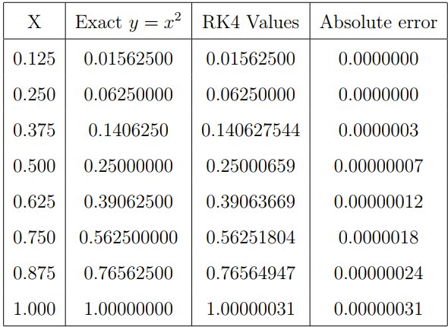

The results above demonstrate that the RK4 method was able to approximate the exact solution accurately, proving its effectiveness in approximating the solutions of FOODE.

3.3 Graphical representation and interpretation
The results obtained in the table above were plotted comparatively against the values of h and represented in the figure below;

Figure 1: Graphical representation of the RK4 values against the step size x
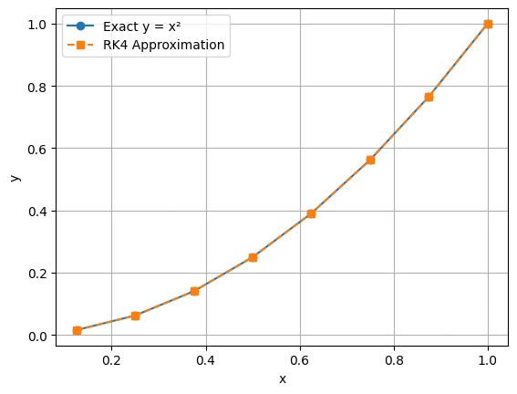
The RK4 and the exact solutions were comparatively plotted against the values of x at the given step sizes. The exact and the approximated solutions demonstrates a perfect agreement pointing to a hyperbolic curve as shown below. The nature of this curve provides a basis for further estimation using model fits to obtain the Liouvillian solutions.
3.4 Determination of the exact Liouvillian function from the Numerical approximation
In the above example, the exact solution was known and the approximation was made in comparison to the known exact solution which was provided through symbolic computation. Assuming the Liouvillian solution was not known, such that the exact values as provided in the above tables were not available, we seek to determine if we can estimate the exact solutions from the RK approximated values.
We observed that the RK4 method approximated accurately the exact Liouvillian solution of the fourth order ordinary differential equation. From observation, the graph produced appears to be a polynomial curve. We fit a polynomial to the curve and use the values from the RK4 approximated values to estimate the exact Liouvillian solution, assuming it was not known.
We begin by fitting a quadratic function to the curve as shown below. We fit a polynomial model to the graph to determine the exact Liouvillian solutions. We consider a quadratic equation of the general form
y = ax² + bx + c
We pick the values from the table and substituted in the equation as shown below.
When y (0) = 0, c = 0 hence; y = ax² + bx
We pick the paired points (0.125, 0.01562525) and (0.25, 0.812360) from the table and substitute in equation in order to solve for a and b as follows;
Solving the two equations simultaneously we obtain
a = 1.000243955 and b = -0.000028494375. The estimated solution therefore becomes
y = 1.000243955x² – 0.000028494375x
We see that as the accuracy increases, step size h tends to zero; the coefficient of x² stabilizes to 1 whereas the coefficient of x tends to 0. The estimated solution therefore tends to y = x² which is quadratic and Liouvillian. We again try to fit a cubic function to the curve to as shown below and study the relationship;
Consider a general cubic function of the form
y = ax³ + bx² + cx + d
Taking:
y(0) = 0, d = 0, y =ax³ + bx² + cx
We take three paired points from the table above and substitute in this equation to be able to solve for a, b and c as follows; (0.125, 0.1562525), (0.25, 0.0625081238), (0.375, 0.1406435144)
Solving these equations gives the values of a, b and c as follows;
a = 0.00010328063, b = 1.000070468271, c = 0.000010573974 and d = 0
The approximated solution therefore becomes;
y= 0.00010328063x³ + 1.000070468271x² + 0.000010573974x

Picture 1 : A graph showing a quadratic fit to the RK4 solution

3.5 Summary of findings
We observed that as the accuracy increases the coefficients of x³ and x tends to 0 whereas the coefficient of x² tends to 1.This implies that the Exact Liouvillian solution of the fourth order ordinary differential equation tends to the parabolic equation
y = x²
which is in perfect agreement with the one provided through symbolic computation. From this example, we see that since the RK4 methods approximated accurately the exact solution of the differential equation, we can use the same method to derive by approximation the Liouvillian solution in situations where symbolic computations cannot be used.
4 Numerical Example 2
We consider a FOODE of the form
y⁴ – y’’’– y’’ – y’ – 2y = 0 (4.1)
with initial conditions: y (0) = y’ (0) = y’’ (0) = 0; y’’’ (0) = 30 and the variable x being in the interval [0, 2]
Equation (4.1) was analyzed by [24] in his book Numerical methods for engineering with Matlab, and found the exact solution under the given conditions to be
y(x) = 2e^{2x} - 5e^{-x} + 3cos(x) - 9sin(x)
For our case, we analyze the FOODE using the same conditions and the exact solution for our numerical solution and analysis
4.1 Reduction to a system of first order differential equations
We reduce equation to a system of first order ODEs as follows. Given the equation
y⁴ – y’’’ – y’’ – y’ – 2y = 0
We rearrange the equation above in terms of; c₁ = y
c₂ = y’
c₃ = y’’
c₄ = y’’’
This can be expressed as: y’₁ = c₂
y’₂ = c₃
y’₃ = c₄
c’₄ = g (y₃ + y₂ + y₁ + 2y)
This can be rewritten as; c₁’ = c₂ = y’
c’₂ = c₃ = y’’
c’₃ = c₄ = y’’’
c₄’ = g (y₃ + y₂ + y₁ + 2y)
The equation above is solved using the RK4 method with Matlab and the results are shared in the table below.

Table 2 : showing the comparison between the Runge-Kutta values and the Exact solution

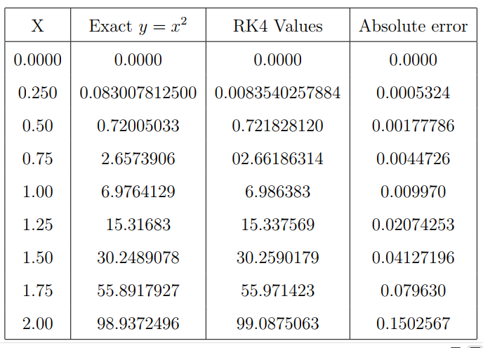

4.2 Graphical representation and interpretation
In the above example, the exact solutions were known and the approximations were made in comparison to the known exact solution which was provided through symbolic computation. Assuming the Liouvillian solution was not known, such that the exact values as provided in the above tables are not available, we seek to determine if we can estimate the exact solutions from the Runge-Kutta approximated values.
Figure 2: Comparison of Runge-Kutta Approximation against the Exact Solutions
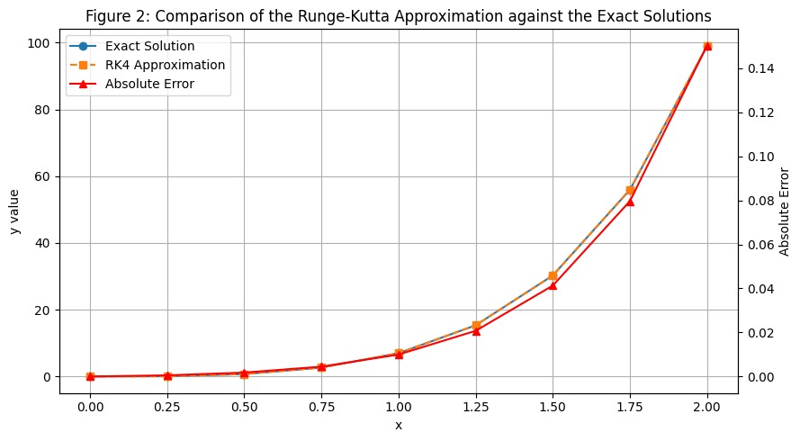

4.3 Determination of the exact Liouvillian function from the Numerical approximation
The ordinary differential equation above is linear with constant coefficients whose characteristic equation can be given as;
λ₄ – λ₃ – λ₂ – λ₁ + 2 = 0
Since the differential equation is linear with constant coefficients, the exact solution will be the sum of the exponential terms;
y(x) = c₁e^{kx} + c₂e^{mx} + c₃e^{nx} + c₄e^{tx}
where k, m, n and t are the roots of the characteristic polynomial. Solving the characteristic equation gives;
(λ - 2) (λ + 1) (λ² + λ + 1) = 0
The solution of this equation gives the exponential terms;
u₁(x) = e^{2x}
u₂(x) = e^{-x}
u₃(x) = cos(x)
u₄(x) = sin(x)
These functions u_{i}(s) are Liouvillian by definition. We proceeded to estimate the LF by inspection. We fit an exponential model equation of the form;
y(x) = A₁e^{2x} + A₂e^{-x} + A₃cos(x)+ A₄sin(x)
By observation, the graph revealed an exponential growth. To be able to approximate the exact function, we fitted an exponential model to the graph as shown below.
4.4 Reconstruction of the Liouvillian solution using the RK4 values
In order to solve for the A_{i}(s), we reconstruct the exact solution using the classical Prony-Type exponential model fitting with the RK approximated values as exact samples since the approximation was in very close agreement with the exact solutions. We compute the linear recurrence coefficients from the RK4 data using the step size h = 0:25 and the Euler’s general fourth order homogenous linear recurrence relation formula of the form;
y_{i+4} +v₁y_{i+3}+v₂y_{i+2} + v₃y_{i+1} + v₄y_{i} = 0
Substituting the y_{i}(s) from the RK4 values we obtain the values of v_{i}(s) as follows; For i = 0
6:986383 + 2.66186314v₁ + 0.7218283v₂ + 0.08354025v₃ = 0
For i = 1
15.337569+6.986383v₁+2.66186314v₂+0.72182812v₃+0.08354025v₄
For i = 2
30.2590179+15.337569v₁+6.986383v₂+2.66186314v₃+0.72182812v₄ = 0

For i = 3
55.971423+30.2590179v₁+15.337569v₂+6.986383v₃+2.66186314v₄ = 0
For i = 4
99.087506+55.971423v₁+30.2590179v₂+15.337569v₃ + 6.986383v₄ = 0
Solving the above equation yields the following values for the v_{i}(s)
v₁’ =-4.36507161
v₂’= 6.98739335
v₃’ = 4.91505184
v₄’= 1.28381297
Assuming the exact solution was not known such the characteristic equation 4.7.1 was not known, we assume a characteristic polynomial equation of the general form
r⁴ – v₁r³ – v₂r² – v₃r-v₄ = 0
We fit these values into our characteristic equation and solve for the values of r_{i} (s) in;
r⁴ – v₁r³ – v₂r² – v₃r-v₄ = 0
r⁴ + 4.36507161r³ – 6.98739335r² – 1.28381297
Solving this we get the ri(s), (r =1, 2, 3, 4) to be;
r₁’= 1.6484375
r₂’= 0.7788086
r₃’= 0.968913
r’₄ ± 0:247396i
Assuming a general solution of the form;
f(x) =p₁e^{mx} + p₂e^{tx} + p₃e^{ux} + p₄e^{vx}
We solved for constants using the Lyapunov characteristic exponent formula
λ_{i} = $\frac{1}{hlnr}$
Taking h = 0.25 and substituting, we get
m’ =2.000
t’ = -1.000
u’= i
v’= -i
The exact model structure follows the form;
y(x) = p₁e^{2x} + p₂e^{-x} + p₃e^{ix} + p₄e^{-ix}
We use the Runge-Kutta values and we fit coefficients using the RK4 data to obtain the values of the pi(s) as shown below;
Taking the values of y at the given points
y (0) = 0
y (0.25) = 0.083007813
y (0.5) = 0.720050415
y (0.75) = 2.657390709
Upon substitution, we get that;
p₁ = 2
p₂ = -5
p₃ = 1:5 + 4:5i
p₄ = 1:5 - 4:5i
When we sum the complex conjugate terms, we got that;
P₃e^{ix} + p₄e^{-ix}= 3cosx - 9sinx
The exact reconstructed solution of the ODE becomes;
f’(x)= 2e^{2x} - 5e^{-x} + 3cos(x) - 9sin(x)
4.5 Summary of findings
From the two examples above, we prove that the Runge-Kutta algorithm approximated accurately the exact Liouvillian solution of the fourth order ordinary differential equation. The Runge-Kutta values were then treated as sampled date and used to inversely reconstruct the Liouvillian functions that could produce the same set of data assuming the exact solutions were not known. We have seen that both the polynomial and the exponential fit models used were able to approximate accurately the exact Liouvillian solutions that had been earlier obtained by analytical methods.
In example 1, we fitted both a quadratic and a cubic model using the RK4 values as sampled data. We observe that the set of data tends to stabilize at y = x2 which was earlier given as the Liouvillian solution of the ODE.
In example 2, we determined the characteristic polynomial of the FOODE and used the Prony method to determine the unknown coefficients by substituting the RK4 values. We obtained with precision the exact values as those obtained analytically and reconstructed the correct Liouvillian solution, proving that this approach is accurate and effective.

Conclusion
This study considered the use of the fourth-order Runge–Kutta method for approximating solutions of selected fourth-order ordinary differential equations associated with Liouvillian-type closed forms. The fourth-order equations were reduced to systems of first-order equations, and numerical approximations were generated for prescribed initial conditions. In the examples considered, the computed values showed close agreement with the known analytical solutions. The numerical data were further used to guide model fitting, including polynomial fitting in the first example and exponential-trigonometric reconstruction in the second example. These results indicate that accurate numerical approximations can assist in identifying plausible functional forms for certain differential equations when the expected structure is simple or can be reasonably inferred. The findings also show that numerical methods may complement symbolic approaches by providing evidence about the behaviour of solutions and by supporting exploratory reconstruction of candidate formulas. Nevertheless, the method requires careful selection of the fitting model, validation against the differential equation, and appropriate error analysis. Future work should include broader classes of fourth-order equations, systematic residual testing, comparison with other numerical methods, and clearer criteria for identifying when a fitted function can be accepted as a valid Liouvillian-type solution.

recommendation
This study therefore recommends further research on Liouvillian properties of systems of first order differential equations. This study used the fit model technique to approximate the Liouvillian solutions of the fourth order differential equations; further research should focus on other numerical methods that can be used to determine Liouvillian solutions of more complex higher order ordinary differential equations.

Limitations
The study is limited to a small number of selected fourth-order ordinary differential equations with known analytical solutions. Therefore, the results do not establish a general method for determining Liouvillian solutions of arbitrary fourth-order equations. The reconstruction procedure depends on choosing an appropriate model form, such as a polynomial, exponential, or trigonometric expression, and this choice may not be evident for more complicated equations. The numerical results are also affected by the selected step size, initial conditions, and rounding of computed values. A rigorous convergence analysis, residual verification, and sensitivity study are not fully developed. In addition, the method is tested mainly by comparison with already known exact solutions, which limits its ability to demonstrate performance in genuinely unknown cases. Further validation is required before the approach can be considered reliable for general symbolic reconstruction.
Declaration
Conflict of interest: The author declares no conflict of interest. The author has no relevant financial interest to disclose.
Data availability statement
No datasets were generated from any source during the current study, the parameters used for analysis and simulation were obtained from related research materials.
Declaration of AI Use

This manuscript was prepared through the combined contributions of all author(s), including contributions to the study design, data, content development, results, interpretation, and related scholarly work. The author(s) acknowledge the use of Grammarly and ChatGPT to assist with grammar checking, language refinement, reference formatting. These AI-assisted tools were not used as authors and did not replace the intellectual contributions or scholarly judgment of the author(s). All AI-assisted outputs, including content, references, and interpretations, were carefully reviewed, revised, verified, and approved by the author(s). The author(s) accept full responsibility for the accuracy, integrity, and final content of the manuscript.

References
[1] [44] Otsubo S. , Solutions of an algebraic differential equation of the first order in a Liouvillian extension of the coefficient field, Osaka Journal of Mathematics, 16 (1), (1979), 289-293
[2] Michael S. , Felix U. , A Kovacic style Algorithm for Liouvillian solutions of third order differential equations, International Journal of Engineering Research and Developement, (2009)
[3] Jesper L. , Sturm and Liouville’s Work on Ordinary Linear Differential Equations, The Emergence of Sturm-Liouville Theory, Journal of Pure Mathematics, (1986)
[4] Michael F. S. and Ulmer F. , Liouvillian Solutions of third orderLinear Differential Equations, New bounds and Necessary Conditions, Dept of Mathematics, North Carolina State University, (2001)
[5] Michael F. S. , Liouvillian Solutions of Linear Differential Equations with Liouvillian Coefficient, Journal of Symbolic Computation,11, (1991), 251-273
[6] Mark V. H. and Jean V. R. , Liouvillian Solutions of Linear Differential Equations of order Three and Higher, Florida State University, (1999)
[7] Webb K. , Numerical Methods for Engineers, 8th edition (2021)
[8] Kobuyo J. O., Numerical Algorithms for direct solutions of Fourth Order Ordinary Differntial Equations, Department of Mathematics Federal University of Nigeria, (2014)
[9] George B. , A reduction Algorithm for an ordinary Differential Equation with Lie group, SIAM Journal of Applied Mathematics, (1990)
[10] Najmuddin A. and Charan S. , Study of Numerical Solution of Fourth Order Ordinary Differential Equations by fifth Order RungeKutta Methods, International Journal of Scientific Research in Science,Engineering and Technology, 6(1), 2020
[11] Thierry C. and Camilo S., Liouvillian Solutions of Third Order Differential Equations, Association for Computing Mathematics, (2024)
[12] Pushap L. S. , Review Paper on the Runge-Kutta methods to Study Numerical Solutions of initial value problems in Ordinary Differential Equations, International Journal of Applied Mathematics and Statistical Sciences, 10(1), (2021) 2319-3980
[13] Autar K. , Runge-Kutta Fousing Fourth Order Method for Ordinary Differential Equations, http://numericalmethods.eng.usf.edu, (2010)
[14] Adak M. and Mandal M., Numerical Solution of Fourth-Order Boundary Value Problems for Euler-Bernoulli Beam Equation, Journal of Physics Conference Series, (2021)
[15] Pushap L. S. , Review Paper on the Runge-Kutta methods to Study Numerical Solutions of initial value problems in Ordinary Differential Equations, International Journal of Applied Mathematics and Statistical Sciences, 10(1), (2021) 2319-3980
[16] Amirul I., A Comparative Study on Numerical Solutions of Initial Value Problems (IVP) for Ordinary Differential Equations (ODE) with Euler and Runge Kutta Methods, American Journal of Computational Mathematics, 5, (2015), 393-404
[17] Izabela Z. , Solution of Differential Equation of the Euler Bernoulli Beam, Journal of Applied Mathematics and Computational Mechanics , 13(4), (2014), 157-162
[18] Sharmin B. and Samiran M. , A Comparative Study on Classical Fourth Order and Butcher Sixth Order Runge-Kutta Methods with Initial and Boundary Value Problems, International Journal of Material and Mathematical Sciences, 3(1), (2021) 8-21
[19] Shampine L. F. and Watts H. A. , Comparing Error Estimates for Runge-Kutta Methods, Mathematics of Computation, (1971)
[20] Maheswari T. , Gowri P. , A Case Study on Runge Kutta 4th Order Differential Equations and Its Application, Imperial Journal of Interdisciplinary Research 3(2), (2017)

[21] Agom E. U., Numerical solution of Fourth Order Linear Differential Equation by Adomian Decomposition Method, British Journal of Mathematics and computer Science, 17, (2016), 1-8
[22] Andres L., Granados M., Fitting Experimental data , A Journal of Applied Mathematics and Science Engineering, (2010)
[23] Anthony O. ,Pius T.and Favour O. , Analysis and Comparative Study of Numerical Solutions of Initial, Value Problems (IVP) in Ordinary Differential Equations (ODE) With Euler and Runge Kutta Methods, American Journal of Engineering Research , 8(8), (2019), 40
[25] Allande S. , Fitting a linear regression model by least square estimations , A Journal of Applied Mathematics and Science Engineering , 19, (1995), 107-121
[26] Autar K. , Runge-Kutta Fousing Fourth Order Method for Ordinary Differential Equations, http://numericalmethods.eng.usf.edu, (2010)
[27] Blessing I. A. , Numerical solution of fourth order initial value problems using Novel Block Order Algorithm, Journal of Nepal Mathematical Soceity, 6(2), (2024)
[28] Byakatonda D. , An overview of numerical and analytical methods for solving ordinary differential equations, University of Kisubi, (2024)
[29] Daniel P. , Tarsche M. , Parameter Estimation for Exponential Sums by approximate Prony Method, Chemnitz University of Technology, 90(5), 2020, 1631-1642
[30] David B., An implementation of Kovacic Algorithm for solving second order linear homogenous differential equations, Department of Mathematical Scienc Research institute, (2001)
[31] Delphine B. , Fourth Order Linear Differential Equations with imprimitive groups, University of Philadelphia USA , (2003)
[32] Dennis G Z. , A First Course in Differential Equations, Fifth Edition, (1992)
[33] Edwards C.H.,David E.P. , Differential Equations and boundary value problems, Computing and Modeling, The university of Georgia,New Jersey, (1996)
[34] Eman A. , Zainab A. M. , Solution of nth order ordinary differential Equations using Lie-Group, Department of Mathematics, College science University of Iraq, 3(2), (2020)
[35] Farlow J. ,James E. H,Beverly H.W., Differential Equations and Linear Algebra, Third Edition, (2002)
[36] Giles L. , Mark V., H. , Liouvillian solutions of irreducible second order differential equations, Department of Mathematics, Florida State University, (1990)
[37] Gunawan N. , Reduction of Higher Order Linear Diferential Equations to second Order and Integral Evaluation of Exact Solutions, Mathematica Aeterna, 4(2), (2014),175-189
[38] Gurpreet S. , Numerical Study on Solving Fourth Order Ordinary Differential Equations, Journal of Applied Mathematics and Physics, 12(3) (2024).
[39] Hassan A. Numerical comparison of various order Explicit Runge-Kutta methods with Matlab solver, Asian Journal of of mathematics and computer Research 25 (5), (2018), 259-274
[40] Jaan K. , Numerical Methods in Engineering with Matlab, Second Edition, 2006
[41] Kayode S. , Duromola M. K. , Lie Symmetry,Differential Equations and applications, Journal of Scientific Research and Reports, 21, (2014), 2792-2800
[42] Maria P.B, Masun B.and Osei K. , Analytic Methods for Solving Higher Order Ordinary Differential Equations, Dept. of Mathematical and Computational Science, University of Texas, (2019)
[43] Michael F. S. , Liouvilllian solutions of nth order homogenous ordinary differential equation, American Journal of Mathematics, 15(4), (1981), 661-682.
[44] Michael F. S. , Formal Solutions of Differential Equations, Journal of Symbolic Computations,10, (1990), 59-94
[45] Mohammed S. M ., Direct Explicit Integrators of RK typefor Solving Special Fourth Order Differential Equations with an Application, GlobalJournal of Pure and Applied Mathematics, 12(6), (2016), 4687- 4715
[46] Momoh A. , Duromola M., K. , Numerical integration of fourth order initial value problems of ordinary differential equation using linear multistep algorithm,Journal of Physics, Mathematics and Statistics, (2025)
[47] Nagle R. K., Saff E. B. , Fundamentals of Differential Equations and Boundary Value Problems, Second Edition (1996)
[48] Nidhi S. ,Gaurav K. , Lie Symmetry method to solve Linear Ordinary differentila equations of first order, International Journal of Engineering Research and Developement, 18, (2022), 14-20
[49] Nourra O. , Liouvillian solutions of Third order homogenous ordinary differential equations, Journal of Mathematics Research, 11, (2019)
[50] Olabode B. T. , A six Step Scheme for the Solution of Fourth Order Differential Equation, Pacific Journal of Science and Technology, 10(1) (2016)
[51] Osborne M. , Smyth. , A modified Prony Algorithm for Exponential Function Fitting, SIAM journal on Sientific Computing, 16(1), 1996
[52] Paul H. K. , Integration of a class of Transcendental Liouvillian Functions with Error Function Part II, Journal of Symbolic Computation, 16, (1993), 227-241
[53] Paul D. , Diferential Equations, International series in pure and applied mathematics (1968)
[54] Person A. C. , Solving Homogenous Linear Differential Equations of order four in terms of equations of smaller orders, A PHD thesis, North Carolina State University 1978
[55] Randal N. , Brown C. , , Lyapunov Exponent Calculation, A Journal of symbolic computing , (2015)
[56] Raphael B. , Liouvillian Solutions of Ordinary Linear Difference Equations, Global Journal of Pure and Applied Mathematics, (2004)
[57] Shepley L. R ., Differential Equations, Third Edition (1964)
[58] Teresa C. and Hajto Z. , Algebraic Groups and Galois Group Theory, American Mathematical Soceity Providence, 112, (2010)
[59] Thilan P, , Mathematical Modeling II, Department of Mathematics, University of Ruhuna(2021)
[60] Thomas D, Generalized prony method , A Journal of Inverse problems, (2013)

