Case report

Acute Hypervitaminosis D Following Accidental Ingestion of Cholecalciferol Capsules in a Kitten: A Case Report

Abstract
Vitamin D toxicosis is an uncommon but potentially life-threatening poisoning in companion animals characterized by persistent hypercalcaemia and hyperphosphatemia that may result in metastatic soft tissue mineralization, acute kidney injury and cardiovascular complications. A two-month-old domestic long-haired kitten weighing approximately 1 kg was presented with a history of accidental ingestion of three vitamin D₃ capsules 3 days before admission. The kitten exhibited repeated vomiting, anorexia, reduced water intake, lethargy and constipation. Physical examination revealed mild dehydration, pale mucous membranes and delayed capillary refill time. Serum biochemical analysis demonstrated marked hypercalcaemia (17.1 mg/dL) and hyperphosphatemia (10.73 mg/dL), confirming acute cholecalciferol intoxication. The kitten was successfully managed with intravenous fluid therapy, furosemide, prednisolone, antiemetics, gastroprotective therapy and supportive care, resulting in progressive clinical recovery. This report emphasizes the importance of obtaining an accurate exposure history and initiating early treatment to improve clinical outcome and minimize irreversible tissue injury.
Keywords: Cholecalciferol, vitamin D toxicosis, kitten, hypercalcaemia, hyperphosphatemia, feline.

Introduction
Vitamin D is a fat-soluble secosteroid hormone essential for maintaining calcium and phosphorus homeostasis, skeletal mineralization and normal neuromuscular function (Ettinger et al., 2024). Cholecalciferol (vitamin D₃), the most biologically active form used in nutritional supplements, pharmaceutical preparations and rodenticides, undergoes sequential hydroxylation in the liver and kidneys to form calcitriol, which regulates intestinal calcium absorption, bone remodelling and renal calcium conservation (Peterson and Talcott, 2021; Plumb, 2024). Excessive ingestion of cholecalciferol disrupts normal calcium homeostasis, leading to sustained hypercalcaemia and hyperphosphataemia. As the calcium-phosphorus product increases, mineralization occurs in soft tissues, particularly the kidneys, myocardium, lungs and blood vessels, predisposing affected animals to acute kidney injury, cardiac dysfunction and multi-organ complications (Peterson and Talcott, 2021; Ettinger et al., 2024). Clinical signs generally develop within 12–72 hours after exposure and commonly include vomiting, anorexia, lethargy, dehydration, constipation, polyuria and polydipsia (Peterson and Talcott, 2021).
Accidental ingestion of cholecalciferol-containing rodenticides, human vitamin supplements, topical vitamin D analogues and contaminated commercial pet foods are the principal causes of vitamin D intoxication in companion animals (Wehner et al., 2013; Vecchiato et al., 2021; Mellanby et al., 2005). Although the condition is well documented in dogs, naturally occurring cases in cats remain relatively uncommon, particularly those involving accidental ingestion of pharmaceutical vitamin D preparations. Early recognition based on a reliable exposure history and characteristic biochemical abnormalities is critical for successful management and favourable prognosis (Peterson and Talcott, 2021).
The present report describes the clinical presentation, diagnosis and successful medical management of acute cholecalciferol intoxication following accidental ingestion of vitamin D₃ capsules in a young kitten.

Case History and Clinical Findings
A two-month-old domestic long-haired kitten weighing approximately 1.0 kg was presented to the Veterinary Clinical Complex, College of Veterinary Science, Rajendranagar, Hyderabad, with a history of accidental ingestion of three vitamin D₃ (cholecalciferol) capsules (60,000 IU each) approximately 24 hours before presentation. According to the owner, the kitten had consumed the capsules accidentally while unattended. Based on a body weight of 1.0 kg, the estimated exposure was 180,000 IU (approximately 4.5 mg/kg) of cholecalciferol, which is substantially higher than the reported toxic dose capable of inducing severe hypercalcaemia and soft tissue mineralization in companion animals (Chasnick & Levy, 2026; Peterson & Talcott, 2021).
Within 24 hours of ingestion, the kitten developed four episodes of vomiting, followed by anorexia, reduced water intake, lethargy, and absence of defecation for two days (Figure 1). No previous history of systemic illness, medication, or exposure to other toxic substances was reported. On examination, the kitten was depressed but responsive. Rectal temperature was 102.4°F at presentation and 101.1°F on the following day. Mild dehydration, pale mucous membranes and a capillary refill time of 2–4 seconds were observed. Cardiovascular, respiratory and neurological examinations were unremarkable.
Based on the history and clinical presentation, acute cholecalciferol toxicosis was considered the primary diagnosis. Differential diagnoses included acute nephrotoxicity, ethylene glycol intoxication, pancreatitis and severe gastroenteritis.
Serum biochemical analysis revealed hypercalcaemia (17.1 mg/dL; reference interval: 10.4–13.0 mg/dL) and hyperphosphataemia (10.73 mg/dL; reference interval: 5.0–7.3 mg/dL) (Figure 3). Concurrent elevation of serum calcium and phosphorus is characteristic of vitamin D intoxication and reflects increased intestinal calcium absorption, enhanced bone resorption and reduced renal calcium excretion (Peterson and Talcott, 2021). The biochemical findings, together with the documented exposure history, confirmed acute cholecalciferol toxicosis and warranted immediate therapeutic intervention to prevent metastatic soft tissue mineralization and renal injury (Ettinger et al., 2024).
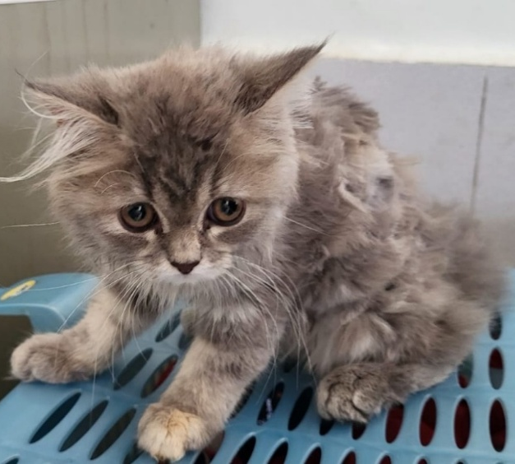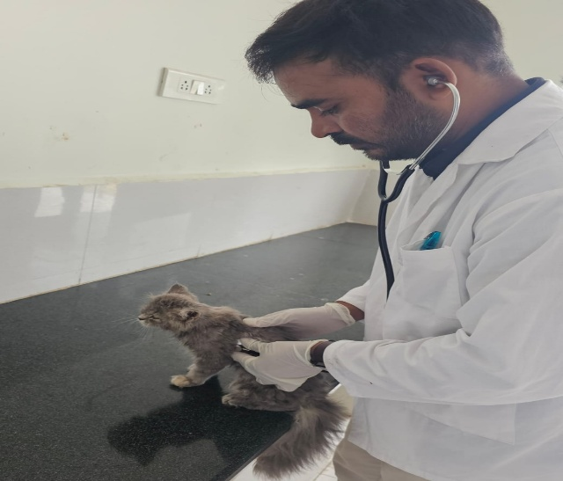
Figure 1& 2 Clinical appearance of the kitten at presentation showing depression and reduced responsiveness.
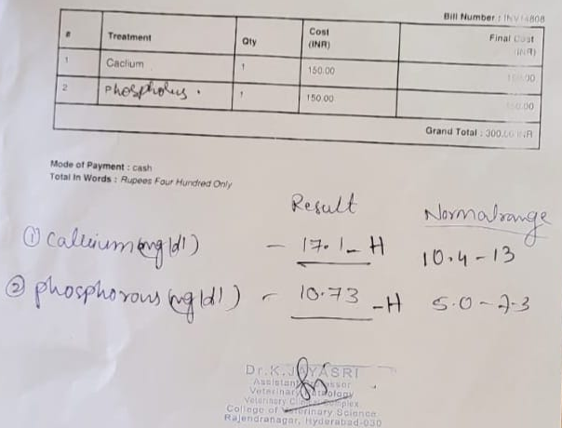
Figure 3. Serum biochemical profile demonstrating marked hypercalcaemia (17.1 mg/dL) and hyperphosphataemia (10.73 mg/dL), confirming acute cholecalciferol intoxication.

Diagnostic Evaluation and Therapeutic Management

A diagnosis of acute cholecalciferol (vitamin D₃) toxicosis was established based on the history of accidental ingestion of vitamin D₃ capsules, compatible clinical signs, and characteristic serum biochemical abnormalities. Serum biochemistry revealed marked hypercalcaemia (17.1 mg/dL) and hyperphosphataemia (10.73 mg/dL), confirming severe disruption of calcium-phosphorus homeostasis. Concurrent elevation of serum calcium and phosphorus is a hallmark of vitamin D intoxication and results from excessive intestinal calcium absorption, increased osteoclastic bone resorption, and enhanced renal tubular calcium reabsorption mediated by elevated calcitriol concentrations (Peterson & Talcott, 2021; Ettinger et al., 2024). The calculated calcium-phosphorus (Ca × P) product was 183.5 mg²/dL², markedly exceeding the threshold of 60–70 mg²/dL² associated with an increased risk of metastatic soft tissue mineralization. Such severe derangements predispose affected animals to pathological mineral deposition in the kidneys, myocardium, lungs, gastric mucosa, and blood vessels, potentially leading to acute kidney injury, cardiac dysfunction, and other life-threatening complications if treatment is delayed (Peterson & Talcott, 2021; Ettinger et al., 2024). Although determination of serum 25-hydroxyvitamin D [25(OH)D] concentration can provide definitive confirmation of vitamin D intoxication, this assay is not routinely available in most veterinary diagnostic laboratories. Consequently, diagnosis is generally based on a documented history of exposure together with compatible clinical signs and characteristic clinicopathological findings (Peterson & Talcott, 2021; Wehner et al., 2013).

Considering the substantial toxic exposure (180,000 IU; approximately 4.5 mg/kg cholecalciferol), severe hypercalcaemia, and the high risk of irreversible soft tissue mineralization, intensive medical management was instituted immediately. Intravenous isotonic crystalloid fluid therapy was initiated to correct dehydration, restore renal perfusion, increase glomerular filtration rate, and promote urinary calcium excretion (calciuresis). Aggressive fluid therapy remains the cornerstone of treatment for cholecalciferol toxicosis, as it enhances renal elimination of calcium, minimizes further renal injury, and facilitates the response to adjunctive antihypercalcaemic therapies (Peterson & Talcott, 2021; Ettinger et al., 2024). Following correction of hydration status, furosemide was administered to increase urinary calcium excretion by inhibiting calcium reabsorption in the thick ascending loop of Henle. Prednisolone was included to reduce intestinal calcium absorption, suppress osteoclastic bone resorption and facilitate renal calcium elimination. These agents remain standard components of medical management in uncomplicated cases of vitamin D intoxication (Plumb, 2024). Supportive treatment included ondansetron to control vomiting and improve feed intake, pantoprazole for gastric protection, N-acetylcysteine as an antioxidant, and Hepamerz® syrup (L-ornithine-L-aspartate) to provide supportive hepatocellular care during systemic intoxication. Although these medications do not directly reduce circulating vitamin D concentrations, they contribute to stabilization of the patient and recovery of normal physiological function. Serial monitoring of hydration status, appetite, urine output and serum calcium and phosphorus concentrations was performed throughout hospitalization to evaluate therapeutic response and detect potential complications. Continuous biochemical monitoring is recommended because vitamin D metabolites have a prolonged biological half-life, and hypercalcaemia may persist for several days or weeks following exposure (Peterson & Talcott, 2021; Chasnick & Levy, 2026)
Discussion
Clinical improvement was observed within the initial days of treatment. Vomiting ceased, appetite gradually returned and water intake improved. The kitten became progressively brighter and more active, with normalization of hydration status and resolution of gastrointestinal signs. No clinical evidence of renal or cardiovascular complications was observed during hospitalization, and the patient was discharged with instructions for continued monitoring and follow-up biochemical evaluation.
The estimated ingested dose of approximately 4.5 mg/kg (180,000 IU/kg) substantially exceeded the reported toxic threshold for cholecalciferol and was sufficient to induce severe hypercalcaemia and systemic toxicity in dogs and cats. (Klainbart & Aroch, 2024; Chasnick & Levy, 2026). The magnitude of exposure was consistent with the rapid onset of gastrointestinal signs and the marked hypercalcaemia and hyperphosphatemia observed in the present kitten. Despite the substantial toxic exposure, presentation within 24 hours and prompt initiation of medical therapy likely prevented the development of acute kidney injury and clinically significant metastatic soft tissue mineralization.
Vitamin D intoxication is an important differential diagnosis in companion animals presenting with acute gastrointestinal signs and unexplained hypercalcaemia, particularly when there is potential access to vitamin supplements or cholecalciferol-containing products. While most published feline cases have been associated with contaminated commercial diets or rodenticides, accidental ingestion of pharmaceutical vitamin D preparations has been reported less frequently (Wehner et al., 2013; Vecchiato et al., 2021). The present case therefore contributes to the limited literature describing acute pharmaceutical vitamin D intoxication in young cats.
The clinical findings observed in this kitten, including vomiting, anorexia, lethargy and hypercalcaemia with concurrent hyperphosphatemia, are consistent with previously reported cases of cholecalciferol poisoning (Wehner et al., 2013; Vecchiato et al., 2021). These abnormalities develop because excessive calcitriol promotes continuous calcium and phosphorus absorption from the intestine while simultaneously increasing bone resorption and reducing renal calcium excretion (Peterson and Talcott, 2021).
Successful management depends primarily on early recognition and rapid initiation of therapy before irreversible mineralization occurs. Aggressive fluid therapy remains the most effective initial intervention, whereas loop diuretics and glucocorticoids further facilitate reduction of serum calcium concentrations (Ettinger et al., 2024). In severe or refractory cases, bisphosphonates such as pamidronate or zoledronate and calcitonin have been successfully used to achieve sustained control of hypercalcaemia (Peterson and Talcott, 2021; Plumb, 2024). However, these advanced therapies were not required in the present case because conventional medical management resulted in rapid clinical improvement.
The favourable outcome was attributed to the relatively early presentation following toxin exposure, prompt biochemical diagnosis and immediate institution of appropriate therapy before development of clinically significant renal injury. This case highlights the importance of obtaining a thorough history in suspected poisoning cases and emphasizes that early intervention can significantly improve prognosis even in young animals with marked biochemical abnormalities.

Conclusion
Acute cholecalciferol toxicosis should be considered when a cat develops acute gastrointestinal signs after possible access to vitamin D supplements, particularly when hypercalcaemia and hyperphosphataemia are present. In this kitten, the reported ingestion of three 60,000-IU capsules represented an estimated exposure of 180,000 IU, or approximately 4.5 mg/kg. The exposure history, clinical signs, and biochemical findings were strongly supportive of vitamin D toxicosis. Intravenous fluid therapy, followed by furosemide, prednisolone, antiemetic treatment, gastric protection, and supportive care, was associated with improvement in vomiting, appetite, hydration, and activity during hospitalisation. The case also illustrates the need to obtain a detailed medication-exposure history and to begin management before persistent calcium–phosphorus abnormalities result in clinically apparent organ injury. Nevertheless, recovery should be confirmed through serial measurements of calcium, phosphorus, renal variables, and, where available, ionised calcium or vitamin D metabolites. Human vitamin supplements should be stored securely to prevent accidental exposure of companion animals.

Limitations
This report is limited by the absence of serum 25-hydroxyvitamin D measurement, ionised calcium, renal and hepatic profiles, urinalysis, blood pressure, electrocardiography, and diagnostic imaging. Treatment doses, routes, frequencies, fluid rate, hospitalisation duration, and serial biochemical values are not reported. Consequently, treatment response and the absence of renal, cardiovascular, or soft-tissue complications cannot be independently assessed. The ingestion was owner-reported, and the exact quantity consumed was not confirmed. The exposure interval is inconsistent between the abstract and case history. Long-term follow-up findings are unavailable, and the claim of complete recovery is therefore not adequately supported by clinical or laboratory evidence.
Declaration of AI Use

This manuscript was prepared through the combined contributions of all author(s), including contributions to the study design, data, content development, results, interpretation, and related scholarly work. The author(s) acknowledge the use of Grammarly and ChatGPT to assist with grammar checking, language refinement, reference formatting. These AI-assisted tools were not used as authors and did not replace the intellectual contributions or scholarly judgment of the author(s). All AI-assisted outputs, including content, references, and interpretations, were carefully reviewed, revised, verified, and approved by the author(s). The author(s) accept full responsibility for the accuracy, integrity, and final content of the manuscript.

Conflict of Interest
The authors declare that there is no conflict of interest regarding the publication of this manuscript.

References
Chasnick, A., & Levy, J. K. (2026). Acute vitamin D toxicosis in an adult cat. JFMS Open Reports, 12, 20551169261448248. https://doi.org/10.1177/20551169261448248
Ettinger, S. J., Feldman, E. C., & Côté, E. (2024). Textbook of Veterinary Internal Medicine: Diseases of the Dog and Cat (9th ed.). Elsevier.
Mellanby, R. J. (2016). Beyond the skeleton: The role of vitamin D in companion animal health. Journal of Small Animal Practice, 57(4), 175–180. https://doi.org/10.1111/jsap.12458 (Wiley Online Library)
Mellanby, R. J., Mee, A. P., Berry, J. L., & Herrtage, M. E. (2005). Hypercalcaemia in two dogs caused by excessive dietary supplementation of vitamin D. Journal of Small Animal Practice, 46(7), 334–338. https://doi.org/10.1111/j.1748-5827.2005.tb00329.x (Wiley Online Library)
Peterson, M. E., & Talcott, P. A. (2021). Small Animal Toxicology (4th ed.). Elsevier.
Plumb, D. C. (2024). Plumb's Veterinary Drug Handbook (10th ed.). Wiley-Blackwell.
Rumbeiha, W. K. (2013). Cholecalciferol. In M. E. Peterson & P. A. Talcott (Eds.), Small Animal Toxicology (3rd ed., pp. 489–497). Elsevier. (MSD Veterinary Manual)
Vecchiato, C. G., Delsante, C., Galiazzo, G., Perfetti, S., Pinna, C., Sabetti, M. C., et al. (2021). Case report: A case series linked to vitamin D excess in pet food: Cholecalciferol toxicity observed in five cats. Frontiers in Veterinary Science, 8, 707741. https://doi.org/10.3389/fvets.2021.707741
Wehner, A., Hartmann, K., & Hirschberger, J. (2013). Vitamin D intoxication caused by ingestion of commercial cat food in three cats. Journal of Feline Medicine and Surgery, 15(9), 730–736. https://doi.org/10.1177/1098612X13489298

