Original Research Article

Investigation on Endophytic fungal Diversity of Ficus benghalensis in Ponnamaravathi, Pudukkottai District, Tamil Nadu India

ABSTRACT:
Endophytic fungi are microorganisms that colonize internal plant tissues without causing visible disease symptoms. The present study investigated culturable endophytic fungi associated with the aerial roots of Ficus benghalensis collected from Ponnamaravathi, Pudukkottai District, Tamil Nadu, India. Healthy aerial root samples were collected from the study area during different seasonal periods and processed using standard surface-sterilization and culture-based methods. Root segments were sterilized with ethanol and sodium hypochlorite, placed on Potato Dextrose Agar medium, and incubated under laboratory conditions. Emerging fungal colonies were purified through sub-culturing and examined using macroscopic and microscopic characters, including colony morphology, hyphal features, conidial arrangement, and spore characteristics.
A total of nine culturable fungal taxa were recorded from the aerial roots of F. benghalensis. The isolates were identified morphologically as Aspergillus flavus, Aspergillus niger, Aspergillus oryzae, Aspergillus fumigatus, Paecilomyces sp., Neotyphodium sp., Pseudosigmoidea sp., Rhizopus sp., and members of Mucormycotina. Seasonal occurrence varied among the sampling periods, with a greater number of fungal taxa recorded during the summer period compared with the other seasons. Species of Aspergillus were prominent among the isolates obtained in this investigation. The findings indicate that the aerial roots of F. benghalensis support a diverse assemblage of culturable endophytic fungi. However, the present identification is based on morphological characters, and further molecular studies are required for accurate taxonomic confirmation. Additional biochemical and ecological investigations may help clarify the functional significance of these fungi and their possible relevance in agricultural or biotechnological research.

Keywords: Endophytic fungi, Ficus benghalensis, aerial roots, fungal diversity, seasonal variation, Aspergillus spp.

INTRODUCTION

A guild of fungi consisting of ascomycetes and mitosporic forms constitute the fungal endophyte assemblages of the tissues of diverse groups of plants These fungi are in association with their host tissues with ought inducing any disease symptoms at least for sometime Entophytic fungi have been isolated from leaves, twigs, barks and roots of several angiosperm and gymnosperm members Although we know about the occurrence and identity of fungal endophytes we know precious little about their biology For example, though there are a few studies on the changes in endophyte and saprophyte communities of intact and decomposing leave there are not many reports on the status of endophyte community of a plant organ as the organ grows from one environment into another. The aerial root of Ficus benghalensis appears to be an ideal plant organ to study this phenomenon as it originates near the crown of the tree, grows down through the air and then grows into the soil to constitute the prop root. Endophytes are microorganisms living in the tissues of plants without causing any harm, both the endophytes and the plants experience symbiotic relationship.
Endophytic fungi The term “endophyte”, originally introduced refers to any organisms occurring within plant tissues, distinct from the epiphytes that live on plant surfaces. defined endophytes as mutualists that colonise aerial parts of living plant tissues and do not cause symptoms of disease, from which pathogenic and mycorrhizal fungi are excluded. proposed an expansion of Carroll’s definition to include all organisms inhabiting plant organs that, at some time in their life, can colonise internal plant tissues without causing apparent harm to the host. Therefore, latent pathogens known to live symptomlessly inside host tissues that have an epiphytic phase in their life cycle are also endophytes. that endophytes and certain types of mycorrhizae, e.g. ectendomycorrhizae, ericoid mycorrhizae and pseudomycorrhizae, are indistinct. Therefore, certain mutualistic root-inhabited or mycorrhizal fungi associated with plants in the Ericaceae and Orchidaceae have been referred to as endophytes. Endophytic microorganisms may or may not grow in culture media, i.e. may or may not be cultivated, and can inhabit the interior of plant tissues and organs without causing damage to its host and without producing structures emerging from the external plants. However, while there are many . Endophytic fungi have been associated with plants for over 400 million years and have within all known plants, including a broad range of host orders, families, genera and species, in ecosystems as diverse as mosses , ferns , grasses , shrubs, deciduous and coniferous trees , and lichens. Endophytic fungi mainly consist of members of the Ascomycota or their mitosporic fungi, as well as some taxa of the Basidiomycota, Zygomycota and Oomycota , which can produce various bioactive chemicals, promote host growth and resistance to environmental stress, and decompose litter. Therefore, endophytic fungi, as an important component of natural ecosystems, can play a key role in material and energy recycle

Most endophytes isolated to date have been ascomycetes and their asexual morphs, however showed that several endophytes may also basidiomycetes. Several studies provide evidence to support the hypothesis that saprobe host specificity in plants is dependent on internal endophytes, while others indicate that host components may regulate the endophytes. There are numerous examples of endophytes that become pathogen. These pathogens sporulate when leaves senesce, or the plants are stressed or when the plants produce fruit that will eventually rot which is the ideal time to sporulate . Many recent studies have shown that endophytes produce an extraordinary array of functional metabolites. Large numbers of metabolites are produced by so called “creative fungi” which include species of Acremonium, Aspergillus, Fusarium and Pencillium. isolated around 6500 endophytic fungi and tested their biological potential. They analyzed 135 secondary metabolites and found that 51% of bioactive compounds (38% for soil isolates) isolated from endophytic fungi were new natural compounds. Some endophytes may become slightly pathogenic to the plant under adverse conditions; other endophytes are able to suppress those latent pathogens. Although the first discovery of endophytes already dates back to1904, this group ofmicroorganisms at first did not receive muchattention in the decades to follow . This changed dramatically afterthe detection of paclitaxel in the endophytic fungus Taxomyces andreanae that was reported to be isolated from Taxus brevifolia, the latter being the original source of this important anti–cancer drug . Medicinal plants are reported to harbour endophytes , which in turn provide protection to their host from infectiousagents and also provide adaptability to survive in adverse environmentalconditions. Endophytic fungi are known to have mutualistic relationsto their hosts, often protecting plants against herbivory, insect attack or tissue invading pathogens .
Ever since the discovery of the rich diversity of the endophytic fungi, their population dynamics, their role in improvingplant growth, plant health , their distribution in the plant, themetabolites they secrete and their potency to produce novelcompounds within the plants , have formed an important aspect of many research studies.
There are approximately 300,000 plant species on earth and each individual plant is the host to one or more endophytes, and many of them maycolonize certain hosts . The described populations of endophytic strains are few, which mean the opportunity to findnew strains and targeting natural products from endophytic microorganisms that colonize plants in different niches and ecosystemsis abundant. Medicinal plants had been used to isolate and characterize directlythe bioactive metabolites. However, the discovery of fungal endophytes inside these plants with capacityto produce the same compounds shifted the focus of new drug sources from plants to fungi. Bioactive natural products from endophytic fungi, isolated from different plant species, are attracting considerableattention from natural product chemists and biologists alike, which is clearly depicted by the steady increase of publications devoted to this topic during the recent years.

OBJECTIVES
- Investigation on Endophytic fungal Diversity in Ficus benghalensis Ponnamaravathi.

- Three Different kinds of Seasonable variation Endophytic Species Indentified.

- The understand the ecological significance of the endophytic fungi.

REVIEW OF LITERATURE
The authors noted Khandelwal Sharad et al…( 2019 ) in this study investigation this study, the three temperate region growing trees particularly tree bark has been studied for its entophytic assemblage and its crude extract were screened for antioxidant constituents like phenols, tannin, flavonoid, etc ..
The study of investigated Khyati V. and Pathak , Hareshkumar Keharia (2013 ) antifungal activity and in detail mass spectrometric investigation of cyclic lipopeptides such as C13–C16 b-amino fatty acid variants of iturin A as well as iturin C and C13–C17 b-OH fatty acid isoforms of surfactin exhibiting variation in Val/Ile/Leu at position 4. Seven different variants of iturins as well as of surfactins produced by B. subtilis K1 could be identified by tandem mass spectrometry.
The discover RAJESWARI.S REVATHI.R and ARVIND PRASANTH (2016) Endophytic fungi live inside the higher plants, apparently without causing any harm to the hosts and its produce the secondary metabolites are potential antimicrobial activity Terminalia chebula has been used in Ayurveda, Unani, and Homeopathy medicine. These occurred in Adriana Sturion Lorenzi2 and Helson Mario Martinsr (2022) There are many methodological biases and limitations on endophytic fungi studies from field collection to data processing that jeopardizes information on fungal diversity In most cases , the cultivation – depend methods are extremely imprecise to access the diversity of endophytic fungi most cases, the cultivation-depend - methods are extremely imprecise to access the diversity of endophytic fungi.
The study of (Taylor etal..2016 and Wu et al 2019). However, many fungal taxonomists consider the cultivation-independent approaches taxonomically problematic because Therefore, it is strongly recommended a polyphasic approach combining different methodologies to produce meaningful information on endophtic fungi.
The study of S. Maheswari, and K. Rajagopa l (2013) Analysis on Biodiversity of entophytic fungi in kigelia pinnata during two different seasons Diversity index of bark tissue during summer and winter is low when compared to the leaf tissue during the same seasons Though Simpson diversity does not show much variation during the two seasons in the tissues, there is variation in evenness index, especially during summer in both the tissues indicating that uniform occurrence of various species is prevalent in summer than winter seasons.
The study on T.S. Suryanarayanan and D. Vijaykrishna (2001) Mitosporic fungi and several sterile forms were isolated as endophytes from the leaf tissues and aerial roots of Ficus benghalensis (Moraceae). Although similar number of endophyte species was present in lamina and petiole , the endophytic fungi more densely colonized the petiole. The species composition and the colonization frequency of the endophytes were more for the aerial roots entering the soil when compared with those growing in the air since the roots recruited some endophytes from the soil. The endophyte assemblages of the leaf and aerial root and of the aerial root growing in the air and soil showed little overlap suggesting that the nature of the host tissue as well as the environment determine the endophyte composition of a host.
In the present investigation on S.T. Gopukumar and P.K. Praseetha (2015) Ficus benghalensis, it is noticeable that most of the Pharmacological activities were evaluated different parts of the Ficus benghalensis. But the drug obtained from this plant is little low when compared to other medicinal plants. Since researches are working on this plant over different scenarios such as diabetes cancer, leprosy et. The production and usage of drugs from Ficus benghalensis will boost the growth of medical world.
The analysis Suganya murugaseu, Jinap selamat, and Vignaswari perumal (2021) contained a wide range of phytoconstituents, including phenols, flavonoids, alkaloids, tannins, saponins, terpenoids, glycosides, sugar, protein, essential and volatile oils, and steroids. Existing studies on the pharmacological functions have revealed that the observed Ficus species possessed a broad range of biological properties, including antioxidants, ant diabetic, anti-inflammatory, anticancer, antitumor and anti proliferative, antimutagenic, antimicrobial, anti-helminthic, hepatoprotective, wound healing, anticoagulant, immunomodulatory activities, Apart from the plant parts and their extracts, the endophytes residing in these host plants were discussed as well.
The authors discovered on Muhammad Ibrahim et al.. (2022) Ficus benghalensis the species the crude extract and isolated compound showed significant urease, tyrosinase, and phosphodiesterase inhibitory potential. Furthermore, the molecular docking studies also confirmed the binding mode of the isolated compound in the active site of urease, tyrosinase, and phosphodiesterase. The docking study shows that the isolated compound fits well into the active site of all three enzymes and makes strong bonds with all three enzymes. Our compound might possess the potential to inhibit all three enzymes and effectively treat different diseases associated with these enzymes.
The author identify A. Elizabeth Arnold (2007) Understanding the ecology, evolution, and importance of fungal endophytes is a daunting prospect given the tremendous number of fungi capable of forming endophytic associations and their uniqueness relative to other plant-associated microbes.
The study of Rakesh.N.Chaudhari etal...( 2022 ) Plant life has been serving humankind for centuries by providing a good source of medicines. Active constituents from plants are isolated and used for analysis, treatment, mitigation, and inhibition of various diseases, but many crude drugs are also in use. Ficus bengalensis L.is one of the most important plants of traditional medicines and is still in use, to treat various diseases, particularly diabetes, reproductive system disorders, inflammatory conditions, and swellings. Because of its importance in traditional medicines, its quality control factors are established by pharmacognostic studies and various phytochemicals have also been isolated and recognized. Pharmacological studies on various parts of the plant have confirmed its use in traditional medicines.
The isolate on K.V. Pathak and H. Keharia (2013) Seven fungal antagonistic bacilli were isolated from aerial roots of banyan tree, exhibiting broad spectrum of antifungal activity, among which
B. subtilis K1 isolate was found to be most potent. The ICMS analysis revealed that all these isolates produced cyclic lipopeptides belonging to surfactin, iturin and fengycin families and exhibited varying degree of heterogeneity
The survey on authors noted Ruchita Tripathi et al. (2015) plant description, phytochemical constitution, pharmacological prospectus and toxicological study of F. benghalensis Linn. (Moraceae), a medicinal plant found throughout India. This plant has a great medicinal value as it has been reported to have verstile phytochemical constituents including ketones, flavonols and flavonoids, terpenoids, coumarins, esters, carbohydrates, serine protease. It has pharmacological activities such as antidiabetic, hypolipidemic, anthelmintic, antibacterial, immunomodulatory, antistress and antiallergic, antioxidant, antiinflamatory, antidiarhoeal, analgesic and antipyretic, antiatherogenic, wound healing and growth promoting. Thus the plant has great medicinal and commercial potential for humans.
This work intends to highlight the K. K. Jayant and B. S. Vijayakumar (2021) the bioactive potential of endophytic fungus Curvularia lunata isolated from Ficus religiosa. Extracts obtained from the fungi understudy were tested invitro for their possible applications as anti-oxidant, anti-diabetic and antiinflammatory agents. I The ability of the extracts to donate protons to stabilize the free radicals shows us the lead that metabolites present in extract have anti-oxidant property.
Suryanarayanan TS1 etal..(2016) The leaf and root tissues of eleven orchid species occurring in Arunachal Pradesh, north eastern state of India were screened for their endophyte assemblages. The diversity of endophytes was higher in the leaves when compared to that in the roots. The endophytes exhibited tissue specificity and there was little overlap between the leaf and root assemblages.
The study of endophytic species John Ayobami Amao etal..(2023) s. These properties include anticancer, antimicrobials, immunosuppressant and antioxidant functions. These fungi could become the future of medicine, agriculture and industrialisation revolutions, based on all of the possible biochemical produced by endophytes.
PrabhaToppo etal. (2024) the present study aims to isolate and identify endophytic fungi associated with the leaves of Anisomeles indica L. an important medicinal plant of the Terai-Duars region of West Bengal. A total of ten endophytic fungi were isolated from the leaves of A. indica and fve were identifed using ITS1/ ITS4 sequencing based on their ability for plant growth promotion, secondary metabolite production, and extracellular enzyme production.
The present study aims R. J. Rodriguez (2009) etal Here, we show that NC-endophytes represent three distinct functional groups based on host colonization and transmission, in planta biodiversity and fitness
The present study M. J. Guevara-Araya et al.(2020) study indicate that A. chilensis harbors a similar diversity of endophytic fungi in above- and below-ground tissues. Dominant endophytic fungi were found to be dependent on tissue type, which potentially resulted in marked differences in community structure between above- and below-ground tissues. Ecological processes potentially affecting this pattern are discussed.
Authors should be noted Chang-Kyun Kim et al.(2013) This observation indicates that endophyte distribution is influenced by the distribution of host plants. Surveys for endophytic fungi have been conducted at all altitudes, with specimens being found at all sites; however, endophytic fungi have an ability to adapt to variations in abiotic and biotic conditions along the altitudinal gradient .
The authors occurred K.P.Suradkar*,D.V.Hande and S.R.Kadu(2014)ten medicinal plants were analy zed for the presence of endophyticfungi during three different seasons (winter,summer,and rainy). A total of 20fungalspecies were isolated from 630segments of stem and leaves and identified based on the morphology of fungal culture and spores.

MATERIALS AND METHODS
STUDY AREA

An ancient a sacred traditional Nariyan karupar kovil forest. Victory will be here as a guardian temple it was thousand years old as present at Banyan tree( Ficus benghalensis) people worship this tree as a deity People use the name of this tree root for many medicinal properties.Arriyandippatti village ponnamaravthy Pudukkottai.The latitude-10.290427 and latitude-78534673 collectig place at Small village in Arriyandipatti. Surrounding region is forest regions present ponnamaravathy with 3km distance.
An another one place of traditional and scared Adaikalam kathaar karupar kovil.In south india,a temple it was thousand years old as present in Ponnamaravathy with 2.5km distance.Preserving the cultural and historical heritage of shri Ayyanar temple is of utmost importance.Efforts are being made to maintain the structural integrity plants live herbals. People worship this tree as a goddess.

Aerial roots screened for endophytes:
The aerial root segment that was screened was obtained from the sub apical portion about 5 mm behind the growing up under In order to study the endophyte assemblage of aerial root after its growth into the soil the following method was adopted. Approximately 1000 grams of moist soil was collected from near the trunk of the tree and was placed in sterile polythene bag. This bag was tied around the tips of the aerial roots such that the roots were buried in the soil. The bags were left undisturbed for 40 days and the roots screened as mentioned above. In another experiment, the soil samples were autoclaved (103 kPa for 20 minutes), left over for a day and autoclaved again before use

Picture 1 : Study site
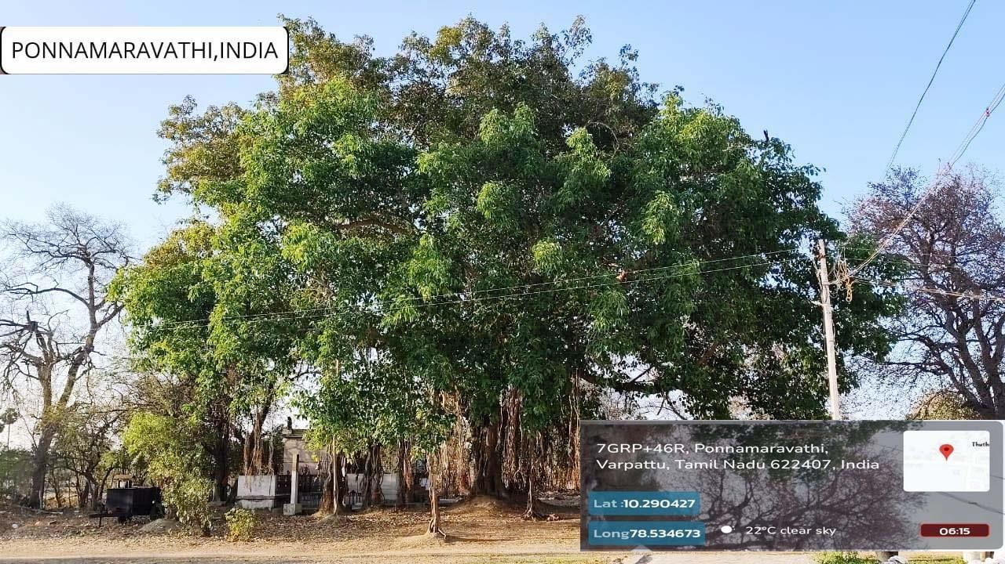
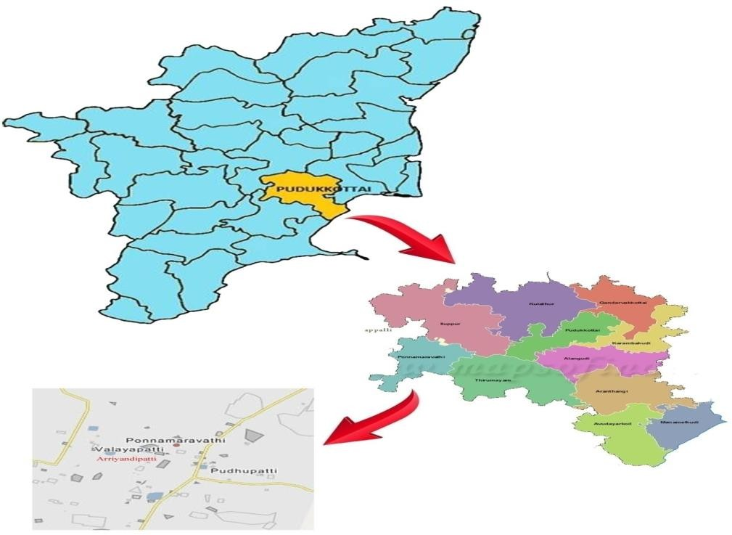

Sample Collections:

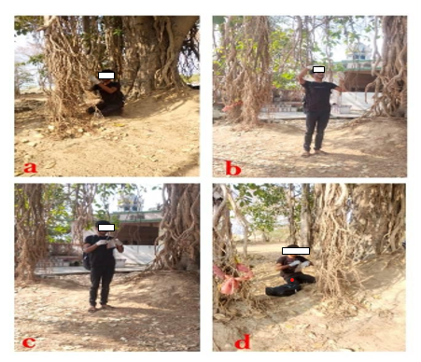

Figure 1. Collection of aerial roots upper and lower position roots sample collected from f.benghalensis at sacred traditional Nariyan karupar kovil forest Arriyandippatti village ponnamaravthy regions. a) Collection aerial root soil with position. B) Collecting aerial roots in soil under position c)stored aerial roots in sterile polythene bag using.d) Close tight up polythene bag with in 5 hours collect
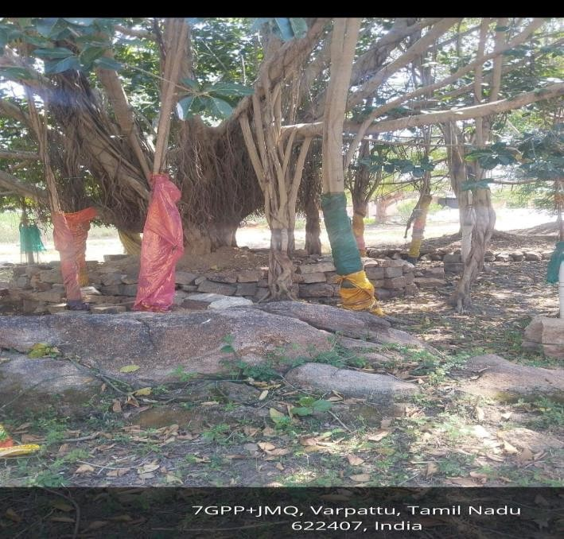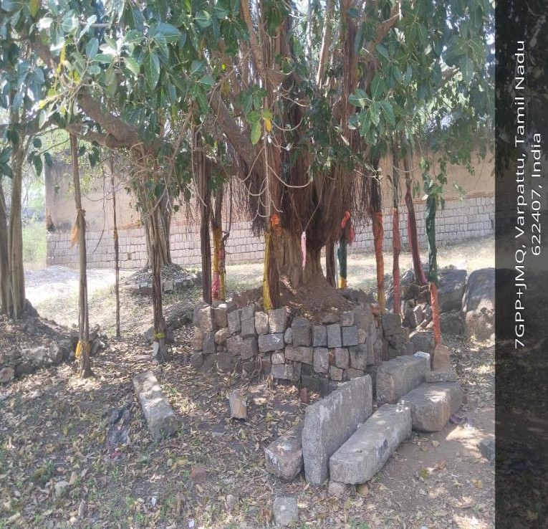
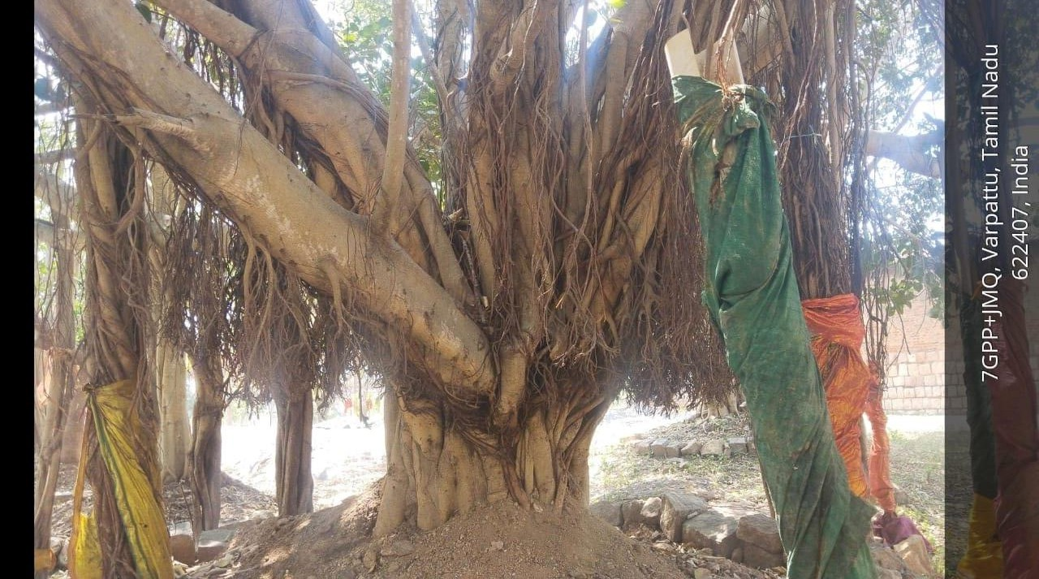

figure 2: collection of aerial roots upper and lower position roots sample collected places

Surface sterilization of tissues
The root segments cut (0.5 cm) were sterilized following the method of Fisher et al. (1993). The segments were dipped in 75% ethanol for 1 minute, immersed in 4% NaOCl for 3 minutes and then rinsed with 75% ethanol for 0.5 minute

Isolation and identification of endophytes
The sterilized tissue samples were plated on Potato Dextrose Agar Medium contained in Petri dishes the Petri dishes were incubated at 26 C for 3 weeks in a light chamber. The light regimen was 12 hours dark: 12 hours light cycles. Another method is involved at A) slide culture techniques B) Sub culture techniques.
- slide culture techniques:
  - The slide culture technique permits the microscopic observation of the undisturbed relationship of spores to hyphae.This relationship is often essential for the identification fungus.
  - In a sterile Petri dish place a V or U shaped ¼ inch glass rod .Place a sterile 1x3 inch glass slide on the glass rod with tweezers
  - Pour potato dextrose agar or meal agar to depth of 4mm into a sterile Petri dish.Cut a1x1 cm block using a lined square grid as a background.
  - Transfer the agar block aseptically onto the slide and inoculate each side with the fungus. Place a sterile glass cover slip over the agar block. Add small amount of sterile water, replace the lid and incubate at 27°C
  - The fungal spores will develop in the air space between the glass slide and the cover slip. The development of the mature structures can be followed by removing the petric dish cover and examining the edge of the agar block with low-power objective.
  - When sporulation appears to be well developed, remove the coverslip carefully and lay onto a drop of lacto phenol cotton blue bubble formation and disturbance of fungal structures is minimized if the slide is balanced on teasing needle forceps and gently lowered to the surface, allowing the cotton blue to spread slowly underneath the coverslip
  - When sporulation appears to be well developed, remove the coverslip carefully and lay onto a drop of lacto phenol cotton blue bubble formation and disturbance of fungal structures is minimized if the slide is balanced on teasing needle forceps and gently lowered to the surface, allowing the cotton blue to spread slowly underneath the coverslip.
  - When sporulation appears to be well developed, remove the coverslip carefully and lay onto a drop of lacto phenol cotton blue bubble formation and disturbance of fungal structures is minimized if the slide is balanced on teasing needle forceps and gently lowered to the surface, allowing the cotton blue to spread slowly underneath the coverslip.
  - The agar block may be removed from the culture slide by lifting it off the slide with a scalpel into 5%phenol.A drop of cotton blue is placed on the slide and a coverslip put on.The amount of cotton blue used should be just sufficient to reach the edge of the coverslip. Greater quantities will leak from the edges and make sealing the coverslip difficult.Excess moisture must be removed and the coverslip may be sealed with clear nail polish or tar vanish by ringing the edges with a small brush.

- Sub culture techniques:
  - Preparation: Start by preparing sterile growth media in The sterilized tissue samples were plated on Potato Dextrose Agar medium contained in Petri dishes, amended with Chloramphenicol (150 mg/l). The petri dishes were incubated at 26 C for 3 weeks in a light chamber
  - Inoculation: Using a sterilized inoculation loop or needle,carefully transfer a small amount of the orginal fungal culture to the agar plate.
  - Spread Plate Method: If you are using agar plates , gently spread sample over the surface using the loop.This helps separate the microorganisms and encourages individual colonies to form.
  - Incubation: Place the incubated plates or tubes in an incubator set to the appropriate temperature.just like plants need sunlight,microorganisms need the right conditions to grow.
  - Observation: Check your cultures regularly. You’ll start to see colonies of fungi growing. These colonies identified.

  - Subculturing: Once the colonies are well-established,you can perform another subculture.Take a tiny bit to a new plate or tube with fresh media. This ensures you have apure culture and can study a specific microorganism.

  - Maintaining purity : Over time, cultures can become contaminated with unwanted microorganisms.Subculturing helps maintain the purity of your target microorganism.

  - Study of characteristics: By subculturing, you can study the characteristics and behaviors of specific fungi an specialize for endophytic fungi controlled condition

RESULTS AND DISCUSSION

    - In present investigation on endophytic fungi diversity in Ficus benghalensis from Ponnamaravathy.total of 9 endophytic fungal species were examined during three different kind of seaeons variation species occurred the period of (2023-2024)a total 6 months work.
    - Identification is based on morphological characteristics of the fungi grown on the culture medium(PDA).The morphology including macroscopic and microscopic characteristics.The macroscopic identification of colony such as color, diameter,colony growth,colony reverse,the observation was done for seven days during the fungal culturing MIcrosporic characterization was done by observing shape size of conidia,and hyphae. Observation of conidia including its arrangements ( singular,chain or cluster) ,cell number( unicellular or multicellular),and conidial measurement.
    - Observation of hyphae was also performed on the presence or absence of septa in hyphae its morphological modification the results capered with literature identified 9 endophytic fungal species as followed
      - Aspergillus flavus

      - Aspergillus niger
c ) Aspergillus oryza
- pacilomyces
- Aspergillus fumigates
- Neotyphodium g)Pseudosigmoidea
- Rhizopus
- Mucormycotina.
    - A totally 9 endophytic fungal species-9 family 3 divison - Ascomycota,Mucormycota,Eurotiomycetes its identified at research site(.june-september,December-january).
    - The summerseason had the highst numberof isolate(5) followed by Monsoon seson (3) and winter season(2).Species diversity was highest during the summer season and monsoon season neutral and lowest winter season.

    - Summer season because that the groeth of fungi is favored high moisture and moderate temperatures and thatlow relative humidity and extreme temperatures inhibit growth and highly spore germination.
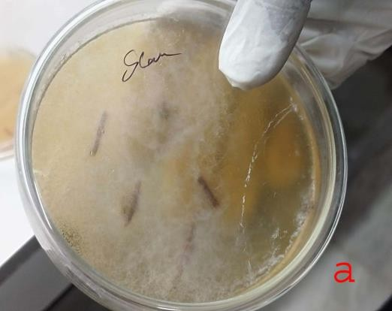
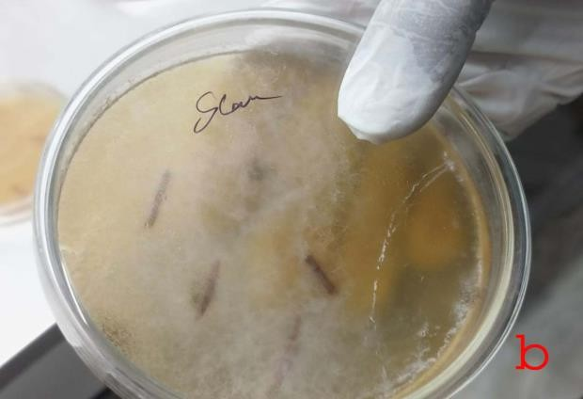
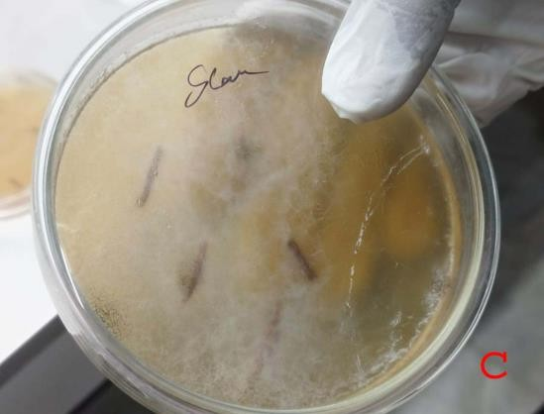
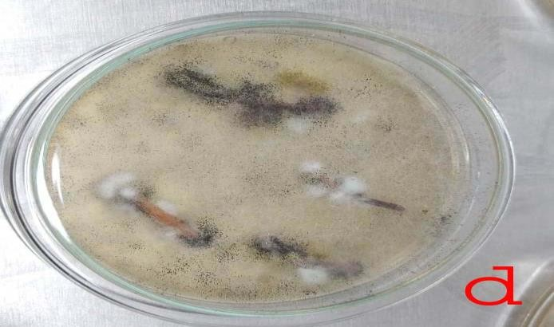

Figure 3. . The sterilized tissue samples were plated on Potato Dextrose Agar medium The petri dishes were incubated at 26 C for 3 weeks in a light chamber.a) aerial root inoculate with PDA medium b, c,d followed plates inoculated 3 weeks maintaining lab. After pure culture select in subculture methods

Sub culture & slide culture
23

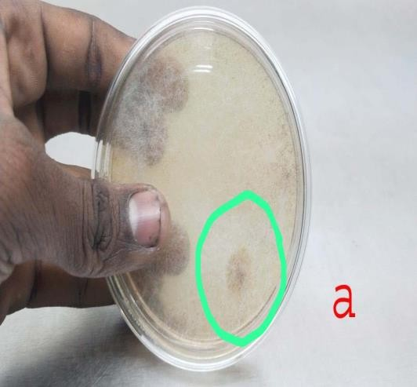
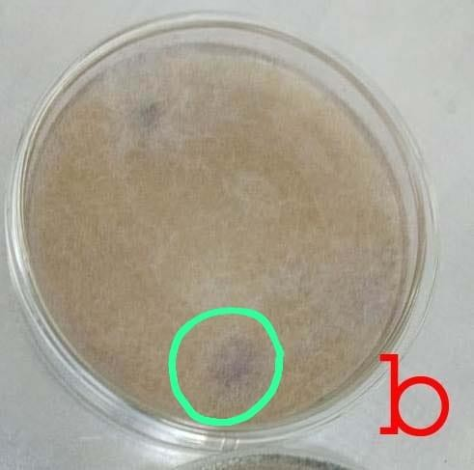
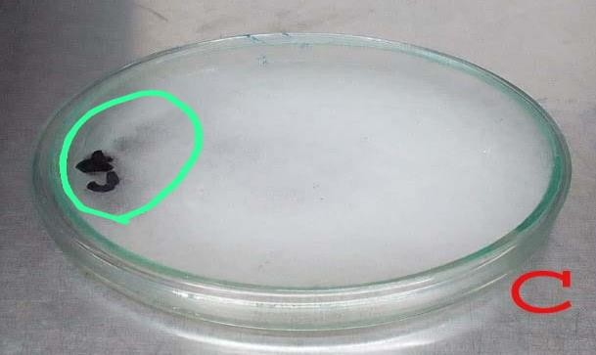
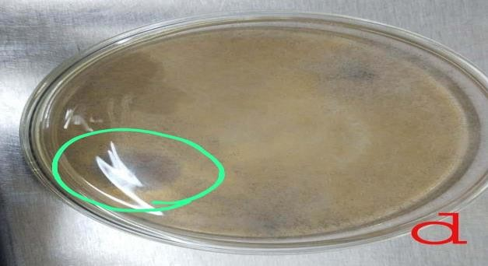
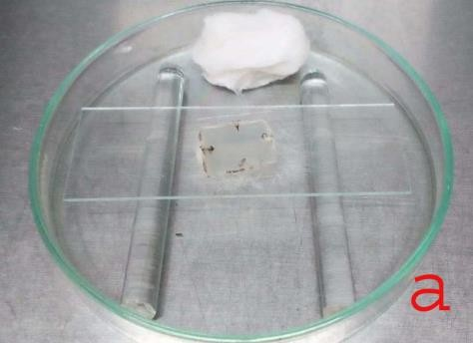
Figure4. These four subculture plates an isolate in different types of endophytic fungal species identify an marked as special type of endophytic fungi

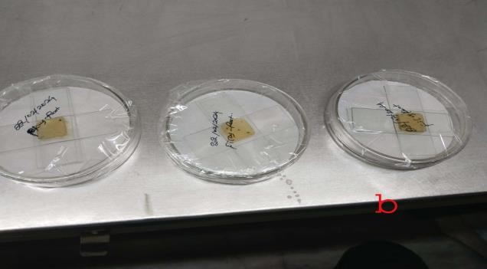
figure5. Slide culture species identify in slide culture methods with strain using (LPCB- lacto phenol cotton blue)

Fig 6 : Morhological characters of Endophytic Funic Species

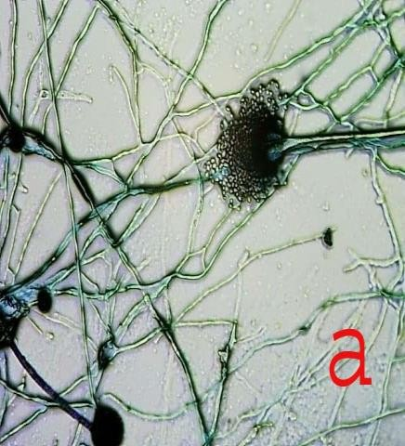
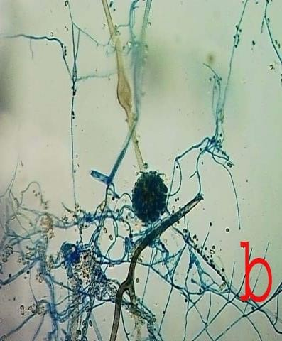
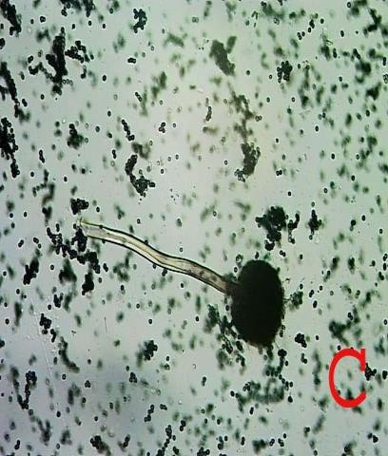
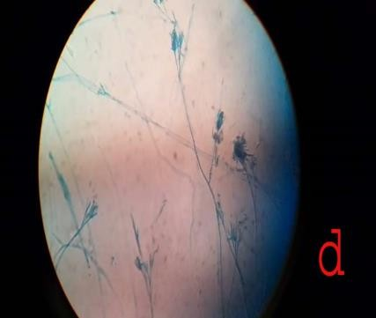
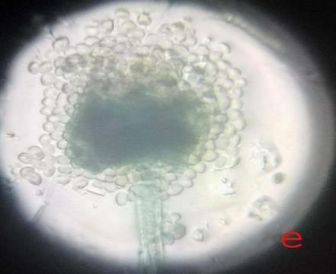
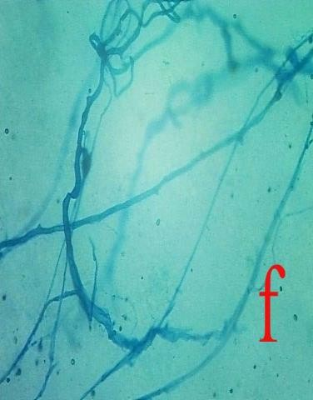
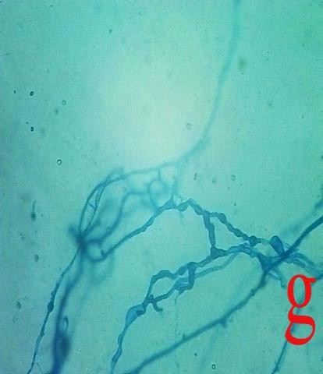
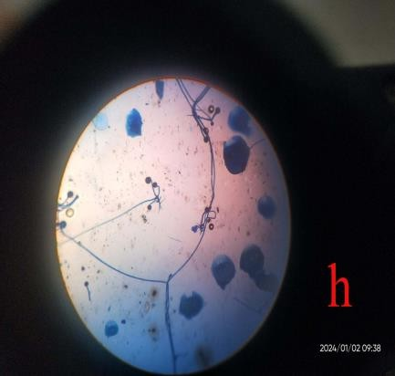
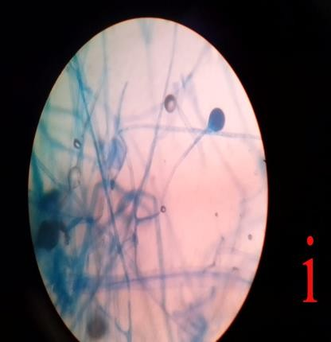

Microscopic view of endophytic fungal species

A.Aspergillus Flavus
A as a identify( Fig 5) The Aspergillus flavus group of fungi has a complex morphology that is classified based on the formation of sclerotia. Group I has L-strains whose sclerotia are greater than 400μm in diameter and Group ll has S strains with sclerotia less than 400μm in diameter. They also have both sexual and asexual forms of reproduction. Asexual reproduction produces conidia spore and sclerotia while sexual reproduction produces sclerotia. Aspergillus flavus produces asexual spores known as conidia. The conidial spores are produced from the phialides on the conidiophore vesicles.The conidia spores have a thick mycelial mat that can be seen with unaided eyes and have a size of 3 to 6 µm.The conidiophore originates from the hyphal threads. The conidiophores are colorless and rough-textured. The phialides originating from the conidiophore are both uniseriate and biseriate
Hyphae occur as thread-like septate branches that form mycelium.They branched hyphae have hyaline in each septae. The hyphae are very tiny and can not be seen with naked eyes. Aspergillus flavus can also reproduce sexually producing ascospores contained within the sclerotia. Sexual reproduction occurs between two compatible strains with different vegetative forms that are cultured together.Aspergillus flavus produces white soft velvetly colonies that turn yellowish- green, a pigment of the conidial spores.

Aspergillus niger:

A macroscopic morphology ; Rapidly growing on Potato-Dextrose c starting with a white to yellowish felt-like mat of mycelia, quickly turning black as conidia develop the pigment aspergillin during maturation. Reverse remains white to pale in colour. Microscopic morphology: Septate, hyaline( clear) hyphae. Conidiophores ( stipes) are long ( 400-3000 μm) with spherical vesicles at the apex measuring 30-75 μm. Aspergillus niger is biseratemetulae just about cover the entire surface from which the phialides extend. Conidia are globose , brown to black in colour, measure 3.5-4.5 μm in diameter and have a rough surface.

Aspergillus oryzae:

  - oryzae and A. flavus, and eventually morphological and microscopic characteristics are the conclusive techniques used to identify A. oryzae. A. oryzae have the ability to grow on many media including, potato dextrose agar on which the growth is fast with heavy colonies, Czapek’s agar on which colonies after 7 days at 25 °C attaining 7–8 cm in diameter with faintly yellowish margin shifting to yellow green similar to the growth obtained on malt extract agar. Generally, A. oryzae has an optimal growth, at temperature of 32–36 °C (± 1 °C) and it cannot grow above 44
°C, in pH ranging between 5.0, and 6.0 and it can germinate at pH from 2.0 to 8.0. A. oryzae could grow in corn flour with a water content of about 16% Under microscope, A. oryzae is famous by its globose vesicle with elongated conidial chains, which look like fluffy-white strands on the substrate inhibited by A. oryzae conidiophores are long, arising from substrate, rough-walled, conidial head large, radiate.( with globose to subglobose conidia. A. oryzae has been isolate in f.benghalensis
- Paecilomyces

Hyphae Of Paecilomyces are hyaline abd sepate. Conidiophores are erect with irregular branching at the apices. In some species Conidiophores bear metulae and phialides it. A pencilius arrangement resembling penizillium species. In other species of Paecilomyces the Phialides arise directly from the Vegetative hyphae singly and in pairs or whorls. In all species Conidia are produced from the tips of the phialides in chains thet trend to bend away from the Conidiophores. The Phialides are long and delicate , and they taper from the relatively large base to slender tubes at their distal ends like bottles with lo-o-o-ong narrow necks. The unicellular Phialoconidia are small(approximately 3mu mm
- Aspergillus fumigatus

The morphology of Aspergillus fumigatus is defined by the hyphal conidia and conidiophores.They have a green spiked conidia i.e the surface has small spikes covering its surface.The conidia are 2.5-3um in diameter.The conidia have a smooth surface or spiked (spinose).Conidia are produced in column chains that are basipetal (facing downwards) from green phialides of 6-8 by 2-3um in size.Some A. fumigatus strains produce white conidia because they lack pigment.Conidia chains are produced directly on broadly clavate vesicles (20-30um in diameter) in the absence of metulae (one of the outermost branches of a conidiophore from which flask-shaped phialides radiate)
- Neotyphodium

The fungi of genus Neotyphodium are systemic, constitutive, symbionts of grasses of subfamily Pooideae. However the ancestral sexual species have not been detected in this region. Several grasses from Argentina are infected by Neotyphodium species. These endophytes are in general very similar macro- and micromorphologically and phylogenetically conform to species
N. tembladerae. However the Neotyphodium spp. In this work we studied the incidence and characterized the diversity of Neotyphodium species in populations of the native grass Bromus auleticus from Argentina. The incidence of endophytes was 100% in all populations investigated
- Pseudosigmoidea

A dark septate fungus of Pseudosigmoidea.The isolate is characterized by pale to brown conidia with up to 8 septa measuring 68–132 × 4–7.9 mm. It is also unique in producing conidia borne by long conidogenious cells in agar medium with or without water, compared to P. cranei, which must be immersed in water to sporulate. Morphological analysis indicated that the isolate is distinct from P. cranei and is described as a new species, P. ibarakiensis sp. nov. Pathogenicity tests of Chinese cabbage and cucumber seedlings indicated that the fungus grows as an endophyte and colonizes, inter and intracellularly, the root epidermal and cortical layers without causing apparent disease symptoms in the host. This endophyte showed the ability to support cucumber plant growth under conditions where NaNO3 was replaced by organic nitrogen but also conferred to Chinese cabbage the ability to grow at low pH. It also became successfully established in six other plants, including the Brassicae, Solanaceae, Poaceae, and Liliacea families, suggesting its adaptability to a broad range of host plants.
- Rhizopus

The genus Rhizopus is characterised by the presence of stolons and pigmented rhizoids, the formation of sporangiophores, singly or in groups from nodes directly above the rhizoids, and apophysate, columellate, multispored, generally globose sporangia. After spore release the apophyses and columella often collapse to form an umbrella-like structure. Sporangiospores are globose to ovoid, one-celled, hyaline to brown and striate in many species. Colonies are fast growing and cover an agar surface with a dense cottony growth that is at first white becoming grey or yellowish brown with sporulation.
- Mucormycotina

Colonies are very fast growing, cottony to fluffy, white to yellow, becoming dark-grey, with the development of sporangia. Sporangiophores are erect, simple or branched, forming large (60-300 µm in diameter), terminal, globose to spherical, multispored sporangia, without apophyses and with well-developed subtending columellae. A conspicuous collarette (remnants of the sporangial wall) is usually visible at the base of the columella after sporangiospore dispersal. Sporangiospores are hyaline, grey or brownish, globose to ellipsoidal, and smooth-walled or finely ornamented. Chlamydospores and zygospores may also be present.
Seasonable Variation of Endophytic Fungi
Table -1 Moonsson Season

S.N  o | Moonsson Season  (June-September 2023) | Endophytic diversity Species | class | order | Family | Genus
1 | isolate 1 | Mucormycotina (saprophytic) | Ascomycoda | Mucorales | Mucoraceae | Mucormycotina
2 | isolate 2 | Rhizopus | Mucormycot a | Mucorala | Mucoraceae | Rhizopus

Table -2 Winter Season

S.N  o | Winter Season (December – Janaray  2024) | Endophytic diversity Species | class | order | Family | Genus
1 | isolate 1 | Neotyptwdium | Ascomycota | - | Pooideae | Neotyptwdium
2 | isolate 2 | Pseudosigmoidea | Ascomycota | - | - | Pseudosigmoide a
3 | isolate 3 | Rhizopus | Mucormycot a | Mucorala | Mucoraceae | Rhizopus

Table -3 Summer Season

S.N  o | Summer Season (March – June  2024) | Endophytic diversity Species | class | order | Family | Genus
1 | isolate 1 | Aspergillus niger | Erotiomycetes | Eurotiales | Asperagillaceae | Aspergillus
2 | isolate 2 | Aspergillus Flovus | Erotiomycetes | Eurotiales | Asperagillaceae | Aspergillus
3 | isolate 3 | Aspergillus oryza | Erotiomycetes | Eurotiales | Asperagillaceae | Aspergillus
4 | isolate 4 | Aspergillus Fumigatus | Erotiomycetes | Eurotiales | Asperagillaceae | Aspergillus
5 | isolate 5 | Pacilomyces | Erotiomycetes | Eurotiales | Asperagillaceae | Aspergillus
6 | isolate 1 | Mucormycotina (saprophytic) | Ascomycoda | Mucorales | Mucoraceae | Mucormycoti na
7 | isolate 2 | Rhizopus | Mucormycota | Mucorala | Mucoraceae | Rhizopus

Conclusion
The present investigation recorded culturable endophytic fungi from the aerial roots of Ficus benghalensis collected from Ponnamaravathi, Pudukkottai District, Tamil Nadu, India. Based on cultural and microscopic observations, nine fungal taxa were reported: Aspergillus flavus, Aspergillus niger, Aspergillus oryzae, Aspergillus fumigatus, Paecilomyces sp., Neotyphodium sp., Pseudosigmoidea sp., Rhizopus sp., and members of Mucormycotina. The results suggest that aerial roots of F. benghalensis provide a suitable habitat for different groups of endophytic fungi.
Seasonal variation was observed in the occurrence of the isolates, with the summer period showing a comparatively higher representation of fungal taxa in the recorded data. Members of Aspergillus were the most frequently represented group among the identified isolates. These findings provide preliminary information on the culturable endophytic fungal diversity associated with F. benghalensis in the selected locality.
Since the identification was carried out using morphological characters, the results should be considered preliminary. Molecular identification and further ecological studies are necessary to confirm the taxonomic status of the isolates and to understand their functional roles. Future studies may also examine the bioactive potential of these fungi using appropriate biochemical and experimental methods.

Limitations
This study has several limitations. The identification of fungal isolates was based only on cultural, macroscopic, and microscopic characters. Therefore, species-level identification may not be fully reliable without molecular confirmation using appropriate DNA-based methods. The study was also limited to culturable fungi grown on Potato Dextrose Agar, and non-culturable or slow-growing endophytes may not have been detected. Details on sample size, number of root segments, replication, and quantitative isolation frequency were limited, which restricts statistical comparison among seasons. The seasonal interpretation is based on the isolates recorded during the sampling periods and should be confirmed using a larger and more systematic sampling design. No molecular phylogenetic analysis, metabolite profiling, or bioactivity testing was performed. Therefore, any potential ecological, agricultural, pharmaceutical, or biotechnological significance of the isolates remains preliminary and requires further experimental validation.
Declaration of AI Use

This manuscript was prepared through the combined contributions of all author(s), including contributions to the study design, data, content development, results, interpretation, and related scholarly work. The author(s) acknowledge the use of Grammarly and ChatGPT to assist with grammar checking, language refinement, reference formatting. These AI-assisted tools were not used as authors and did not replace the intellectual contributions or scholarly judgment of the author(s). All AI-assisted outputs, including content, references, and interpretations, were carefully reviewed, revised, verified, and approved by the author(s). The author(s) accept full responsibility for the accuracy, integrity, and final content of the manuscript.

REFERENCE:
- Arjuna Rao, V. (1971). On the pathogenicity of Fusarium vasinfectum Atk. and self-inhibitory principles of spores as a limiting factor in cotton wilt. Proceedings of the Indian Academy of Sciences, 73B, 273–284.
- Porras-Alfaro, A., & Bayman, P. (2011). Hidden fungi, emergent properties: Endophytes and microbiomes. Annual Review of Phytopathology, 49, 291–315.
- Brydon-Miller, M., Kral, M., Maguire, P., Noffke, S., Sabhlok, A., Denzin, N. K., & Lincoln, Y. S. (2011). Jazz and the banyan tree. In N. K. Denzin & Y. S. Lincoln (Eds.), The SAGE Handbook of Qualitative Research (pp. 387–400). SAGE Publications.
- Bills, G. F. (1996). Isolation and analysis of endophytic fungal communities from woody plants. In S. C. Redlin & L. M. Carris (Eds.), Endophytic Fungi in Grasses and Woody Plants: Systematics, Ecology and Evolution (pp. 31–65). APS Press, St. Paul, Minnesota, USA.
- Bacon, C. W., & White, J. F. Jr. (2000). Physiological adaptations in the evolution of endophytism in the Clavicipitaceae. In C. W. Bacon & J. F. White Jr. (Eds.), Microbial Endophytes (pp. 237–263). Marcel Dekker Inc., New York.
- Carroll, G. C. (1988). Fungal endophytes in stems and leaves: From latent pathogen to mutualistic symbiont. Ecology, 69, 2–9.
- Dai, Y. C., Cui, B. K., Si, J., He, S. H., Hyde, K. D., Yuan, H. S., Liu, X. Y., & Zhou, L. W. (2015). Dynamics of the worldwide number of fungi with emphasis on fungal diversity in China. Mycological Progress, 14, 62.
- Redlin, S. C., & Carris, L. M. (Eds.). (1996). Endophytic Fungi in Grasses and Woody Plants: Systematics, Ecology and Evolution. APS Press, St. Paul, Minnesota, USA.
- Fisher, P. J., Petrini, O., & Petrini, L. E. (1991). Endophytic ascomycetes and deuteromycetes in roots of Pinus sylvestris. Nova Hedwigia, 52, 11–15.
- Fisher, P. J., Petrini, O., & Sutton, B. C. (1993). A comparative study of fungal endophytes in leaves, xylem and bark of Eucalyptus in Australia and England. Sydowia, 45, 338–345.
- Stone, J., & Petrini, O. (2004). Endophytes of forest trees: A model for fungus–plant interactions. In The Mycota, Vol. V: Plant Relationships (pp. 129–140). Springer.
- De Bary, A. (1866). Morphologie und Physiologie der Pilze, Flechten und Myxomyceten. Leipzig: W. Engelmann.
- Fahn, A. (1990). Plant Anatomy (4th ed.). Pergamon Press, Oxford.
- Kowalski, T., & Kehr, R. D. (1992). Endophytic fungal colonization of branch bases in several forest tree species. Sydowia, 43, 137–168.
- Cotter, H. V. T., & Blanchard, R. O. (1982). The fungal flora of Fagus grandifolia. Mycologia, 74, 836–843.
- Praveen, G., Bohra, N. K., & Purohit, D. K. (2008). Endophytic mycoflora of inner bark of Prosopis cineraria, a keystone tree species of the Indian Desert. American-Eurasian Journal of Botany, 1(1), 1–4.
- Rayner, A. D. M. (1998). Presidential address: Fountains of the forest—The interconnectedness between trees and fungi. Mycological Research, 102(12), 1441–1449.
- Dighton, J., White, J. F., & Oudemans, P. (2005). The Fungal Community: Its Organization and Role in the Ecosystem (3rd ed.). CRC Press, Boca Raton.
- Zinniel, D. K., Lambrecht, P., Harris, N. B., Feng, Z., Kuczmarski, D., Higley, P., Ishimaru, C. A., Arunakumari, A., Barletta, R. G., & Vidaver, A. K. (2002). Isolation and characterization of endophytic colonizing bacteria from agronomic crops and prairie plants. Applied and Environmental Microbiology, 68, 2198–2208.
- Varma, P. K., Uppala, S., Pavuluri, K., Jaya Chandra, K., Chapala, M. M., & Vijay Krishna, K. (2017). Endophytes: Role and functions in crop health. In D. P. Singh et al. (Eds.), Plant–Microbe Interactions in Agro-Ecological Perspectives (pp. 291–310). Springer.
- Suryanarayanan, T. S., Murali, T. S., & Venkatesan, G. (2002). Occurrence and distribution of fungal endophytes in tropical forests across a rainfall gradient. Canadian Journal of Botany, 80, 818–826.
- Suryanarayanan, T. S., Murali, T. S., Thirunavukkarasu, N., Govindarajulu, M. B., Venkatesan, G., & Sukumar, R. (2011). Endophytic fungal communities in woody perennials of three tropical forest types of the Western Ghats, southern India. Biodiversity and Conservation, 20, 913–928.
- Suryanarayanan, T. S., & Rajagopal, K. (2000). Fungal endophytes (phellophytes) of some tropical forest trees. The Indian Forester, 126(2), 165–170.
- Suryanarayanan, T. S., Thirumalai, E., Prakash, C. P., Govindarajulu, M. B., & Thirunavukkarasu, N. (2009). Fungi from two forests of southern India: A comparative study of endophytes, phellophytes, and leaf litter fungi. Canadian Journal of Microbiology, 55, 419–426.
- Murali, T. S., Thirunavukkarasu, N., Govindarajulu, M. B., & Suryanarayanan, T. S. (2013). Fungal communities of symptomless bark of tropical trees. Mycosphere, 4(3), 635–645.

- Arjuna Rao, V. (1971). On the pathogenicity of Fusarium vasinfectum Atk. and self-inhibitory principles of spores as a limiting factor in cotton wilt. Proceedings of the Indian Academy of Sciences, Section B, 73, 273–284.
- Porras-Alfaro, A., & Bayman, P. (2011). Hidden fungi, emergent properties: Endophytes and microbiomes. Annual Review of Phytopathology, 49, 291–315.
- Brydon-Miller, M., Kral, M., Maguire, P., Noffke, S., Sabhlok, A., Denzin, N., & Lincoln, Y. (2011). Jazz and the banyan tree. In Handbook of Qualitative Research (pp. 387–400).
- Bills, G. F. (1996). Isolation and analysis of endophytic fungal communities from woody plants. In S. C. Redlin & L. M. Carris (Eds.), Endophytic Fungi in Grasses and Woody Plants: Systematics, Ecology and Evolution (pp. 31–65). APS Press.
- Bacon, C. W., & White, J. F. Jr. (2000). Physiological adaptations in the evolution of endophytism in the Clavicipitaceae. In C. W. Bacon & J. F. White Jr. (Eds.), Microbial Endophytes (pp. 237–263). Marcel Dekker.
- Carroll, G. C. (1988). Fungal endophytes in stems and leaves: From latent pathogen to mutualistic symbiont. Ecology, 69, 2–9.
- Dai, Y. C., Cui, B. K., Si, J., He, S. H., Hyde, K. D., Yuan, H. S., Liu, X. Y., & Zhou, L. W. (2015). Dynamics of the worldwide number of fungi with emphasis on fungal diversity in China. Mycological Progress, 14, 62.
- Redlin, S. C., & Carris, L. M. (Eds.). (1996). Endophytic Fungi in Grasses and Woody Plants: Systematics, Ecology and Evolution. APS Press.
- Fisher, P. J., Petrini, O., & Petrini, L. E. (1991). Endophytic ascomycetes and deuteromycetes in roots of Pinus sylvestris. Nova Hedwigia, 52, 11–15.
- Fisher, P. J., Petrini, O., & Sutton, B. C. (1993). A comparative study of fungal endophytes in leaves, xylem and bark of Eucalyptus in Australia and England. Sydowia, 45, 338–345.
- Stone, J. K., & Petrini, O. (2004). Endophytes of forest trees: A model for fungus–plant interactions. In The Mycota (Vol. 5B, pp. 129–140).
- de Bary, A. (1866). Morphologie und Physiologie der Pilze, Flechten und Myxomyceten. Leipzig: W. Engelmann.
- Fahn, A. (1990). Plant Anatomy. Pergamon Press.
- Kowalski, T., & Kehr, R. D. (1992). Endophytic fungal colonization of branch bases in several forest tree species. Sydowia, 43, 137–168.
- Cotter, H. V. T., & Blanchard, R. O. (1982). The fungal flora of Fagus grandifolia. Mycologia, 74, 836–843.
- Praveen, G., Bohra, N. K., & Purohit, D. K. (2008). Endophytic mycoflora of inner bark of Prosopis cineraria. American-Eurasian Journal of Botany, 1, 1–4.
- Rayner, A. D. M. (1998). Presidential address: Fountains of the forest—the interconnectedness between trees and fungi. Mycological Research, 102, 1441–1449.
- Dighton, J., White, J. F., & Oudemans, P. (2005). The Fungal Community: Its Organization and Role in the Ecosystem. CRC Press.
- Zinniel, D. K., Lambrecht, P., Harris, N. B., Feng, Z., Kuczmarski, D., Higley, P., Ishimaru, C. A., Arunakumari, A., Barletta, R. G., & Vidaver, A. K. (2002). Isolation and characterization of endophytic colonizing bacteria from agronomic crops and prairie plants. Applied and Environmental Microbiology, 68, 2198–2208.
- Varma, P. K., Uppala, S., Pavuluri, K., Jaya Chandra, K., Chapala, M. M., & Vijay Krishna, K. (2017). Endophytes: Role and functions in crop health. In D. P. Singh et al. (Eds.), Plant–Microbe Interactions in Agro-Ecological Perspectives (pp. 291–310). Springer.
- Suryanarayanan, T. S., Murali, T. S., & Venkatesan, G. (2002). Occurrence and distribution of fungal endophytes in tropical forests across a rainfall gradient. Canadian Journal of Botany, 80, 818–826.
- Hawksworth, D. L. (2004). Fungal diversity and its implications for genetic resource collections. Studies in Mycology, 50, 9–17.
- Hawksworth, D. L. (2001). The magnitude of fungal diversity: The 1.5 million species estimate revisited. Mycological Research, 105, 1422–1432.
- Suryanarayanan, T. S., Murali, T. S., Thirunavukkarasu, N., Govinda Rajulu, M. B., Venkatesan, G., & Sukumar, R. (2011). Endophytic fungal communities in woody perennials of three tropical forest types of the Western Ghats. Biodiversity and Conservation, 20, 913–928.
- Suryanarayanan, T. S., & Rajagopal, K. (2000). Fungal endophytes (phellophytes) of some tropical forest trees. Indian Forester, 126, 165–170.
- Suryanarayanan, T. S., Thirumalai, E., Prakash, C. P., Govinda Rajulu, M. B., & Thirunavukkarasu, N. (2009). Fungi from two forests of southern India. Canadian Journal of Microbiology, 55, 419–426.
- Murali, T. S., Thirunavukkarasu, N., Govindarajulu, M. B., & Suryanarayanan, T. S. (2013). Fungal communities of symptomless bark of tropical trees. Mycosphere, 4, 635–645.
- Mariana, P. A. H., Fernando, A. O. S., Yumi, O., Rodrigues, L., Santos, J. C., Corrêa, A., Geraldo, W. F., & Carlos, A. R. (2011). Distribution of endophytic fungi in Bauhinia brevipes. Acta Botanica Brasilica, 25, 815–821.
- Rodriguez, R. J., White, J. F. Jr., Arnold, A. E., & Redman, R. S. (2009). Fungal endophytes: Diversity and functional roles. New Phytologist, 182, 314–330.
- Shankar, N. B., & Shashikala, J. (2010). Diversity and structure of fungal endophytes. Mycosphere, 1, 265–274.
- Mohali, S., Burgess, T., & Wingfield, M. (2005). Diversity and host association of Lasiodiplodia theobromae. Forest Pathology, 35, 385–396.
- Selim, K. A., Nagia, M. M., & Ghwas, D. E. E. (2017). Endophytic fungi are multifunctional biosynthesizers. In Endophytic Fungi: Diversity, Characterization and Biocontrol (pp. 39–92).
- Venkatesan, G., & Ramesh Kumar, J. (2020). Diversity of endophytic fungal assemblages in Vallisneria spiralis. International Journal of Life Sciences, 8, 299–307.

- Dai, Y. C., Cui, B. K., Si, J., He, S. H., Hyde, K. D., Yuan, H. S., Liu, X. Y., & Zhou, L. W. (2015). Dynamics of the worldwide number of fungi with emphasis on fungal diversity in China. Mycological Progress, 14(62), 1–9.
- Blackwell, M. (2011). The fungi: 1, 2, 3…5.1 million species? American Journal of Botany, 98(3), 426–438.
- Hawksworth, D. L., & Lücking, R. (2017). Fungal diversity revisited: 2.2 to 3.8 million species. Microbiology Spectrum, 5(4), FUNK-0052-2016.
- Hata, K., & Futai, K. (1995). Endophytic fungi associated with healthy pine needles and needles infested by the pine needle gall midge (Thecodiplosis japonensis). Canadian Journal of Botany, 73, 384–390.
- Ludwig, J. A., & Reynolds, J. F. (1988). Statistical Ecology: A Primer on Methods and Computing. John Wiley & Sons.
- Fisher, R. A., Corbet, A. S., & Williams, C. B. (1943). The relation between the number of species and the number of individuals in a random sample of an animal population. Journal of Animal Ecology, 12, 42–58.
- Arnold, A. E., Maynard, Z., Gilbert, G. S., Coley, P. D., & Kursar, T. A. (2000). Are tropical fungal endophytes hyperdiverse? Ecology Letters, 3(4), 267–274.
- Stone, J. K., Bacon, C. W., & White, J. F. Jr. (2000). An overview of endophytic microbes: Endophytism defined. In C. W. Bacon & J. F. White Jr. (Eds.), Microbial Endophytes (pp. 3–29). Marcel Dekker.
- Tan, R. X., & Zou, W. X. (2001). Endophytes: A rich source of functional metabolites. Natural Product Reports, 18, 448–459.
- Suryanarayanan, T. S., Venkatesan, G., & Murali, T. S. (2003). Endophytic fungal communities in leaves of tropical forest trees: Diversity and distribution patterns. Current Science, 85(4), 489–493.
- Anonymous. (1999). The Wealth of India (Vol. F–G). Council of Scientific and Industrial Research, New Delhi.
- Satyavati, G. V., & Raina, M. K. (1976). Medicinal Plants of India. Indian Council of Medical Research.
- Council of Scientific and Industrial Research. (1976). The Wealth of India. CSIR Publications.
- Bakshi, D. N. G., Pal, D. C., & Sensarma, P. (2001). A Lexicon of Medicinal Plants in India. Naya Prokash.
- Goswami, K., & Hawkes, S. F. (2004). Sacred Trees and Indian Life. Aryan Books International.
- Ramakrishnan, P. S., Saxena, K. G., & Chandra Shekara, U. M. (1998). Conserving the Sacred for Biodiversity Management. Science Publishers.
- Kosambi, D. D. (2000). Myth and Reality: Studies in the Formation of Indian Culture. Popular Prakashan.
- Chopra, R. N. (1988). Glossary of Indian Medicinal Plants. Scientific Publishers.
- Chopra, R. N. (1933). Indigenous Drugs of India: Their Medical and Economic Aspects. Art Press.
- Jayaweera, D. M. A. (1981). Medicinal Plants Used in Ceylon. National Science Council of Sri Lanka.
- Pullaiah, T. (2006). Encyclopaedia of World Medicinal Plants. Regency Publications.
- Subramanian, P. M., & Misra, G. S. (1977). Chemical constituents of Ficus benghalensis. Indian Journal of Chemistry, 15B, 762.
- Sheeja, C., Augusti, K. T., & Kidwai, J. R. (1992). Antidiabetic effect of glycoside of pelargonidin isolated from the bark of Ficus benghalensis. Indian Journal of Biochemistry and Biophysics, 29, 380–382.
- Kumar, R. V., & Augusti, K. T. (1989). Antidiabetic effect of a leucocyanidin derivative isolated from the bark of Ficus benghalensis. Indian Journal of Biochemistry and Biophysics, 26(6), 400–404.
- Subramanian, P. M., & Misra, G. S. (1978). Chemical constituents of Ficus benghalensis (Part II). Polish Journal of Pharmacology and Pharmacy, 30(4), 559–562.
- Daniel, R. S., & Augusti, K. T. (2003). Mechanism of antiatherogenic and related effects of Ficus benghalensis flavonoids in experimental animals. Indian Journal of Experimental Biology, 41, 296–303.
- Geetha, B. S., & Augusti, K. T. (1994). Hypoglycemic effects of leucodelphinidin derivative isolated from Ficus benghalensis. Indian Journal of Physiology and Pharmacology, 38(3), 220–222.
- Augusti, K. T. (1975). Hypoglycemic action of bengalenoside, a glucoside isolated from Ficus benghalensis in normal and alloxan diabetic rabbits. Indian Journal of Physiology and Pharmacology, 19, 218–220.
- Augusti, K. T., Daniel, R. S., Cherian, S., Sheela, C. G., & Nair, C. R. (1994). Effect of leucopelargonidin derivative from Ficus benghalensis in diabetic dogs. Indian Journal of Medical Research, 82–86.
- Cherian, S., & Augusti, K. T. (1995). Insulin-sparing action of leucopelargonidin derivative isolated from Ficus benghalensis. Indian Journal of Experimental Biology, 33, 608–611.
- Kumar, R. V., & Augusti, K. T. (1994). Insulin-sparing action of leucocyanidin derivative isolated from Ficus benghalensis. Indian Journal of Biochemistry and Biophysics, 31, 73–76.
- Cherian, S., & Augusti, K. T. (1993). Antidiabetic effects of leucopelargonidin glycoside isolated from Ficus benghalensis. Indian Journal of Experimental Biology, 31(1), 26–29.
- Patil, V. V., Patil, R. B., & Patil, V. R. (2009). Pharmacognostical studies and evaluation of anti-inflammatory activity of Ficus benghalensis. Journal of Young Pharmacists, 1(1), 49–54.
- Aswar, M., Aswar, U., Watkar, B., Vyas, M., Wagh, A., & Gujar, K. N. (2008). Anthelmintic activity of Ficus benghalensis. International Journal of Green Pharmacy, 2(3), 170–172.
- Taur, D. J., Nirmal, S. A., Patil, R. Y., & Kharya, M. D. (2007). Anti-stress and anti-allergic effects of Ficus benghalensis bark in asthma. Natural Product Research, 21(14), 1266–1270.
- Shukla, R., Anoop, K., Prabhu, K. M., & Murthy, P. S. (2004). Antioxidant effect of aqueous extract of the bark of Ficus benghalensis in hypercholesterolemic rabbits. Journal of Ethnopharmacology, 92, 47–51.
- Mousa, O., Vuorela, P., Kiviranta, J., Wahab, S. A., Hiltunen, R., & Vuorela, H. (1994). Bioactivity of certain Egyptian Ficus species. Journal of Ethnopharmacology, 41, 71–76.
- Mandal, S. C., Pal, M., Mukherjee, P. K., Saha, K., & Saha, B. P. (1998). Screening of antidiarrhoeal activity of selected medicinal plants. Journal of Ethnopharmacology, 60, 85–89.
- Suryanarayanan, T. S., & Vijaykrishna, D. (2001). Fungal endophytes of aerial roots of Ficus benghalensis. Fungal Diversity, 8, 155–161.
- Vikas, V. P., Patil, V. R., Narkhede, S. B., & Jawale, N. M. (2010). Analgesic and antipyretic activities of Ficus benghalensis bark. International Journal of Pharmaceutical Research, 2(2), 20–24.
- Sharma, R. S., Chandra, S., Rai, K. D., & Mehta, S. (2009). Antioxidant activities and phenolic contents of some Indian medicinal plants. Journal of Medicinal Plants Research, 3(11), 944–948.
- Shukla, R., Anoop, K., Prabhu, K. M., & Murthy, P. S. (1995). Hypolipidemic effect of water extract of Ficus benghalensis in alloxan-induced diabetic rabbits. Indian Journal of Clinical Biochemistry, 10(2), 119–121.
- Agrawal, V., & Chauhan, B. (1988). Composition and hypolipidemic effect of dietary fibre from selected plant foods. Plant Foods for Human Nutrition, 38(2), 189–197.
- Gabhe, S. Y., Tatke, P. A., & Khan, T. A. (2006). Evaluation of the immunomodulatory activity of methanolic extract of Ficus benghalensis roots in rats. Indian Journal of Pharmacology, 38(4), 271–275.
- Biswas, T. K., & Mukherjee, B. (2003). Plant medicines of Indian origin for wound healing: A review. International Journal of Lower Extremity Wounds, 2(1), 25–39.
- Ruskin, S., Kumar, V. P., Gopukumar, S. T., & Praseetha, P. K. (2014). Evaluation of phytochemical, antibacterial and anticancer activity of Cissus quadrangularis. International Journal of Pharmaceutical Sciences Review and Research, 28(1), 12–15.
- Rose, P. A., Praseetha, P. K., Madhulika, B., Princy, A., Sunitha, A., & Murthy, S. C. (2013). Drug-embedded PVP-coated magnetic nanoparticles for targeted killing of breast cancer cells. Technology in Cancer Research & Treatment, 12(5), 463–472.
- Suryanarayanan, T. S., & Vijaykrishna, D. (2001). Fungal endophytes of aerial roots of Ficus benghalensis. Fungal Diversity, 8, 155–161.
- Vikas, V. P., Patil, V. R., Narkhede, S. B., Jawale, N. M., & Patil, P. R. (2010). Analgesic and antipyretic activities of Ficus benghalensis bark. International Journal of Pharmaceutical Research, 2(2), 20–24.
- Sharma, R. S., Chandra, S., Rai, K. D., & Mehta, S. (2009). Antioxidant activities and phenolic contents of aqueous extracts of selected Indian medicinal plants. Journal of Medicinal Plants Research, 3(11), 944–948.
- Shukla, R., Anoop, K., Prabhu, K. M., & Murthy, P. S. (1995). Hypolipidemic effect of aqueous extract of Ficus benghalensis in alloxan-induced diabetic rabbits. Indian Journal of Clinical Biochemistry, 10(2), 119–121.
- Agrawal, V., & Chauhan, B. (1988). Composition and hypolipidemic effect of dietary fibre from selected plant foods. Plant Foods for Human Nutrition, 38(2), 189–197.
- Gabhe, S. Y., Tatke, P. A., & Khan, T. A. (2006). Evaluation of the immunomodulatory activity of the methanolic extract of Ficus benghalensis roots in rats. Indian Journal of Pharmacology, 38(4), 271–275.
- Biswas, T. K., & Mukherjee, B. (2003). Plant medicines of Indian origin for wound healing activity: A review. International Journal of Lower Extremity Wounds, 2(1), 25–39.
- Shabi Ruskin, R., Kumar, V. P., Gopukumar, S. T., & Praseetha, P. K. (2014). Evaluation of phytochemical, antibacterial and anticancer activity of Cissus quadrangularis. International Journal of Pharmaceutical Sciences Review and Research, 28(1), 12–15.
- Rose, P. A., Praseetha, P. K., Madhulika, B., Princy, A., Sunitha, A., & Murthy, S. C. (2013). Drug-embedded PVP-coated magnetic nanoparticles for targeted killing of breast cancer cells. Technology in Cancer Research & Treatment, 12(5), 463–472.
- Arjuna Rao, V. (1971). On the pathogenicity of Fusarium vasinfectum Atk. and self-inhibitory principles of spores as a limiting factor in cotton wilt. Proceedings of the Indian Academy of Sciences, Section B, 73, 273–284.
Arnold, A. E. (2007). Understanding the ecology, evolution, and importance of fungal endophytes. Fungal Biology Reviews.
- Arnold, A. E., Maynard, Z., Gilbert, G. S., Coley, P. D., & Kursar, T. A. (2000). Are tropical fungal endophytes hyperdiverse? Ecology Letters, 3(4), 267–274.
- Bacon, C. W., & White, J. F. Jr. (2000). Physiological adaptations in the evolution of endophytism in the Clavicipitaceae. In Microbial Endophytes (pp. 237–263). Marcel Dekker.
- Bills, G. F. (1996). Isolation and analysis of endophytic fungal communities from woody plants. In S. C. Redlin & L. M. Carris (Eds.), Endophytic fungi in grasses and woody plants: Systematics, ecology and evolution (pp. 31–65). APS Press.
- Carroll, G. C. (1988). Fungal endophytes in stems and leaves: From latent pathogen to mutualistic symbiont. Ecology, 69(1), 2–9.
- Dai, Y. C., Cui, B. K., Si, J., He, S. H., Hyde, K. D., Yuan, H. S., Liu, X. Y., & Zhou, L. W. (2015). Dynamics of global fungal diversity. Mycological Progress, 14, 62.
de Bary, A. (1866). Morphologie und physiologie der pilze, flechten und myxomyceten. W. Engelmann.
- Dighton, J., White, J. F. Jr., & Oudemans, P. (2005). The fungal community: Its organization and role in the ecosystem (3rd ed.). CRC Press.
- Fahn, A. (1990). Plant anatomy (4th ed.). Pergamon Press.
- Fisher, P. J., Petrini, O., & Petrini, L. E. (1991). Endophytic fungi in Pinus sylvestris. Nova Hedwigia, 52, 11–15.
- Fisher, P. J., Petrini, O., & Sutton, B. C. (1993). Fungal endophytes in Eucalyptus. Sydowia, 45, 338–345.
Gopukumar, S. T., & Praseetha, P. K. (2015). Pharmacological importance of Ficus benghalensis. International Journal of Research in Pharmacy.
- Hawksworth, D. L., & Lücking, R. (2017). Fungal diversity revisited. Microbiology Spectrum, 5(4).
- Kim, S. H., et al. (2013). Endophytic fungi and environmental adaptation. Fungal Ecology.
- Kowalski, T., & Kehr, R. D. (1992). Endophytic colonization in forest trees. Sydowia, 43, 137–168.
- Lorenzi, A. S., et al. (2022). Methodological biases in endophytic fungal studies. Fungal Diversity.
- Maheswari, P., & Rajagopal, K. (2013). Seasonal variation in endophytic fungi. Journal of Plant Science.
- Murugesu, S., et al. (2021). Phytochemical and pharmacological properties of Ficus spp. Phytomedicine Reports.
- Pathak, K. V., & Keharia, H. (2013). Antifungal cyclic lipopeptides from Bacillus subtilis. Journal of Applied Microbiology.
- Porras-Alfaro, A., & Bayman, P. (2011). Hidden fungi, emergent properties. Annual Review of Phytopathology, 49, 291–315.
- Praveen, G., Bohra, N. K., & Purohit, D. K. (2008). Endophytic fungi in desert trees. American-Eurasian Journal of Botany, 1(1), 1–4.
111.Rajeswari, P., et al. (2016). Endophytic fungi and bioactive metabolites. Journal of Mycology.
112. Rayner, A. D. M. (1998). Fountains of the forest. Mycological Research, 102(12), 1441–1449.
113. Rodriguez, R. J., et al. (2009). Fungal endophytes: Diversity and function. New Phytologist, 182, 314–330.
114. Stone, J. K., Bacon, C. W., & White, J. F. Jr. (2000). Endophytic microbes overview. In Microbial Endophytes. Marcel Dekker.
115. Suryanarayanan, T. S., & Vijaykrishna, D. (2001). Endophytes of Ficus benghalensis. Fungal Diversity, 8, 155–161.
Suryanarayanan, T. S., et al. (2002). Endophyte distribution in tropical forests. Canadian Journal of Botany, 80, 818–826.
116. Taylor, J. W., et al. (2016). Fungal identification approaches. Nature Reviews Microbiology.
Wu, Y., et al. (2019). Endophytic fungi diversity studies. Frontiers in Microbiology.
117. Zinniel, D. K., et al. (2002). Endophytic bacteria isolation. Applied and Environmental Microbiology, 68, 2198–2208.

