Isolation, Molecular Identification, and Lipid Productivity of Indigenous Chlorella sorokiniana Under BG11, Algal Broth, and NPK Fertilizer Media: Implications for Low-Cost Biodiesel Feedstock Development in Northern Nigeria.

Abstract
Microalgae are potential third-generation feedstocks for biodiesel production, but region-specific information on indigenous strains and low-cost cultivation media remains limited in Northern Nigeria. This study isolated freshwater microalgae from aquatic environments within Abdullahi Fodio University of Science and Technology, Aliero, Kebbi State, Nigeria, and evaluated the growth and lipid productivity of selected Chlorella sorokiniana isolates cultivated in BG11, algal broth, and NPK fertilizer media. Eighteen water samples were collected from ponds, drainage water, runoff water, reservoir water, and botanical garden ponds. Microalgae were initially screened by microscopy, and selected Chlorella isolates were further characterized using ITS rRNA gene amplification, sequencing, BLAST comparison, and phylogenetic analysis. Cultures were maintained under controlled laboratory conditions at 25 ± 2°C with a 12:12 h light-dark cycle for 44 days. Biomass accumulation was monitored by dry cell weight, while lipids were extracted using the Bligh and Dyer method. Microscopic examination revealed Chlorella spp., Spirogyra spp., Chlamydomonas spp., Oedogonium spp., Microspora spp., Euglena spp., and Characium spp. Molecular analysis confirmed the selected isolates as Chlorella sorokiniana. BG11 supported the highest biomass production, with a final dry biomass of 35.48 g/L, specific growth rate of 0.140 day⁻¹, and biomass productivity of 0.842 g/L/day. Algal broth produced intermediate growth performance, with 19.61 g/L final biomass, 0.126 day⁻¹ specific growth rate, and 0.465 g/L/day biomass productivity. NPK medium produced the lowest values, with 7.26 g/L final biomass, 0.102 day⁻¹ specific growth rate, and 0.170 g/L/day biomass productivity. The reported lipid contents were 27.05%, 23.12%, and 16.12% for BG11, algal broth, and NPK medium, respectively. The findings indicate that BG11 is the most effective medium under laboratory conditions, while algal broth may provide a practical alternative for further optimization.
Keywords: Chlorella sorokiniana, BG11 medium, NPK medium, algal broth, lipid extraction, Biomass productivity, Kebbi State, Nigeria

Introduction
The increasing global demand for energy, coupled with the environmental consequences of fossil fuel consumption, has intensified the search for renewable and sustainable alternatives (Badamasi et al., 2024). Conventional petroleum-based fuels are associated with greenhouse gas emissions, climate change, and air pollution, all of which pose significant risks to ecosystems and public health (Hassan et al., 2021; Cheung et al., 2022).
Among the various renewable energy options, biofuels derived from biological resources have gained considerable attention due to their potential for carbon neutrality and compatibility with existing energy infrastructure (Datta et al., 2024). Biofuels include biodiesel, bioethanol, biohydrogen, and biogas, which can be produced from plant biomass, agricultural residues, waste materials, and microbial systems (Deora et al., 2022).
first and second-generation biofuels face limitations such as competition with food crops, land use constraints, and relatively low energy yields (Chowdhury et al., 2019). Microalgae have emerged as a promising third-generation biofuel feedstock due to their high photosynthetic efficiency, rapid growth rate, and ability to accumulate substantial quantities of lipids suitable for biodiesel production (Chowdhury et al., 2019). Unlike terrestrial crops, microalgae do not require arable land and can be cultivated in a wide range of aquatic environments, including wastewater systems, thereby reducing production costs and environmental burden. Members of the genus Chlorella are particularly attractive for biofuel applications due to their robustness, adaptability, and relatively high lipid productivity under optimized culture conditions (Mathimani and Pugazhendhi, 2019).
The productivity of microalgal biomass and lipid accumulation is strongly influenced by environmental and nutritional factors, particularly culture media composition (Okoro et al., 2019). Defined media such as BG11 provide balanced concentrations of nitrogen, phosphorus, trace elements, and vitamins, which support optimal metabolic activity and cell division (Ghomari et al., 2022). Low-cost alternatives such as fertilizer-based media (e.g., NPK) and nutrient-rich organic broths are being explored to reduce production costs, although their effectiveness varies across species and environmental conditions (Mahmood and Khudhair, 2017).
Despite extensive global research on microalgal biodiesel, there remains limited empirical data on the comparative performance of locally available and low-cost culture media for Chlorella spp in Northern Nigeria. Most existing studies focus on laboratory-adapted strains or high-cost cultivation systems, leaving a gap in region-specific optimization strategies that consider economic feasibility and local resource availability.
Therefore, this study aimed to isolate and identify indigenous microalgae from aquatic environments in Kebbi State, Nigeria, Evaluate the growth performance, and lipid accumulation of Chlorella spp cultivated in BG11, algal broth, and NPK fertilizer media. The study further seeks to determine the most suitable low-cost cultivation strategy for enhanced biomass and lipid productivity, contributing to the development of economically viable microalgal biodiesel systems in resource-limited settings.
Methodology
Study area
The study was conducted at Abdullahi Fodio University of Science and Technology, Aliero (AFUSTA). Sample collection took place within AFUSTA from ponds, drainage water, stagnant water, and other water bodies. Aliero is predominantly agrarian, recognized as a major producer of onions in Nigeria, and its residents are widely known for traditional bone-setting across West and Central Africa (Umar et al., 2023).
Research design
The research adopted a convenience and multifaceted study design that involved sample collection, microscopy, PCR-based molecular identification, media optimization, cultivation, and lipid extraction.
Sample collection and preparation
A total of 18 water samples of 100 ml each were collected following the method described by Phang et al., (2015). Samples were taken from aquarium ponds, tap runoff water, water drainages, reservoir ponds, and botanical garden ponds using sterile containers, covered with aluminum foil, and transported to the Postgraduate Microbiology Laboratory at KSUSTA for further analysis. Serial dilution of samples was performed by transferring 1 ml of sample into 9 ml of sterile distilled water in tubes labeled 10¹ to 10⁶ following the procedure of Cao et al., (2024).
Media preparation
Media used for cultivation included Algal Broth (Biomarks), BG-11 medium, and NPK medium. Algal Broth was prepared by dissolving 1.87 g in 1000 ml of distilled water, stirring with a magnetic stirrer, and autoclaving at 121°C for 15 minutes. BG-11 medium preparation followed Badamasi et al., (2023), using nine stock solutions consisting of major nutrients and trace metals, all stored in dark conditions until required. NPK medium was prepared by diluting 20:20:20 commercial fertilizer to 0.5 and 1.0 g/L, autoclaving, and storing under dark conditions (Lathifah et al., 2021).
Sample inoculation was carried out using the pour plate method, where 0.5 ml of 10², 10⁴, and 10⁶ dilutions were spread onto algal agar plates following Cheung et al., (2022). Plates were incubated at 25±2°C under fluorescent light for 7 days in 12:12 light-dark condition. Sub-culturing was performed by transferring isolates into Algal Broth, BG-11, and NPK media in 500 ml conical flasks using sterile loops and incubating for 2–6 weeks under constant light exposure as described by Foo et al., (2023).
Identification of microalgae
Microscopic identification
Identification of microalgae isolates was conducted using both microscopy and molecular techniques. For microscopic examination, wet mount slides were prepared and observed for morphological characteristics such as size, shape, and appearance, which were compared with the microalgae identification guide by Fawley and Fawley, (2020).
Molecular identification
DNA Extraction
Genomic DNA was extracted from algal cultures using the Zymo Research Quick-DNA™ Fungal/Bacterial Miniprep Kit according to the manufacturer's instructions (Zymo Research, 2020). Briefly, 50–100 mg (wet weight) of algal biomass was suspended in 200 uL phosphate-buffered saline (PBS) and transferred into a ZR BashingBead™ Lysis Tube containing 750 uL lysis solution. The samples were homogenized at maximum speed for 5 min using a bead-beating system and subsequently centrifuged at 10,000 × g for 1 min. Approximately 400 uL of the supernatant was transferred into a Zymo-Spin™ IV Spin Filter and centrifuged at 7,000 × g for 1 min. The filtrate was mixed with 1,200 uL DNA binding buffer and loaded onto a Zymo-Spin™ IIC column. Following centrifugation at 10,000 × g for 1 min, the column was washed sequentially with 200 uL DNA Pre-Wash Buffer and 500 uL DNA Wash Buffer. Purified DNA was eluted with 100 uL DNA Elution Buffer and stored at −20°C until further molecular analysis.
PCR Amplification
The internal transcribed spacer (ITS) region was amplified using the universal primers ITS1 (5′-TCCGTAGGTGAACCTGCGG-3′) and ITS4 (5′-TCCTCCGCTTATTGATATGC-3′). PCR amplification was carried out in a final reaction volume of 25 uL containing 2.5 uL of 10× PCR buffer, 1.0 uL of 25 mM MgCl₂, 1.0 uL each of forward and reverse primers, 1.0 uL DMSO, 2.0 uL of 2.5 mM dNTP mix, 0.1 uL Taq DNA polymerase (5 U/uL), 3.0 uL template DNA (10 ng/uL), and nuclease-free water to volume.
Amplification was performed in a thermal cycler under the following conditions: initial denaturation at 94°C for 5 min, followed by 36 cycles of denaturation at 94°C for 30 s, annealing at 54°C for 30 s, and extension at 72°C for 45 s. A final extension step was carried out at 72°C for 7 min, followed by holding at 10°C. PCR products were resolved by electrophoresis on 1.5% agarose gel stained with SafeView dye and visualized under UV illumination. A 50 bp DNA ladder (New England Biolabs, USA) was used as a molecular size marker. The expected amplicon size was approximately 450 bp (Sambrook and Russell, 2001).
DNA Sequencing and Bioinformatic Analysis
Successful PCR products were subjected to Sanger sequencing using an ABI 3500 Genetic Analyzer (Applied Biosystems, USA). Cycle sequencing reactions were performed using approximately 25 ng of purified PCR product. The sequencing protocol consisted of an initial denaturation at 96°C for 1 min, followed by 25 cycles of denaturation at 96°C for 10 s, annealing at 50°C for 5 s, and extension at 60°C for 4 min.
Sequencing products were purified using the ethanol/EDTA precipitation method. Briefly, 5 uL of 125 mM EDTA and 60 uL of absolute ethanol were added to each reaction, mixed thoroughly, and incubated at room temperature for 15 min. Samples were centrifuged at 2,000–3,000 × g for 30 min, washed with 70% ethanol, and centrifuged again at 1,650 × g for 15 min. The purified sequencing products were air-dried, resuspended in injection buffer, and analyzed using the ABI 3500 Genetic Analyzer.
The resulting nucleotide sequences were edited and assembled using BioEdit software and compared with reference sequences available in the National Center for Biotechnology Information (NCBI) database using the Basic Local Alignment Search Tool (BLAST). Phylogenetic analysis was conducted using Molecular Evolutionary Genetics Analysis (MEGA) software to determine the taxonomic identity and evolutionary relationships of the isolates.
Cultivation
Microalgae cultivation was performed in BG-11, NPK, and Algal Broth under controlled conditions including fluorescent light, aeration, and temperatures between 25±2°C to determine optimal growth and lipid production (Lathifah et al., 2021). Growth was monitored every two days by measuring dry cell weight. Samples (10 ml) were filtered using pre-weighed GF/F filters and dried at 60°C for 24 hours, after which biomass weight was recorded. Specific growth rate was calculated following Liang et al., (2013). Biomass was harvested through centrifugation at 10,000 rpm to separate cells from the culture medium (Deng et al., 2022). The collected biomass was dried in an oven at 40°C for 2 hours as recommended by Čagalj et al. (2021). Lipids were extracted by Bligh and Dyer method (chloroform:methanol 2:1), followed by centrifugation to isolate the oil layer, which was carefully collected using a pipette (Mat Husin et al., 2024).
Statistical Analysis
A statistical analysis was performed to evaluate the significance of differences observed among the three-culture media (BG11, Algal Broth, and NPK) in terms of biomass accumulation, specific growth rate, and lipid yield. All experimental data were expressed as mean ± standard deviation.
One-way analysis of variance (ANOVA) was employed to determine whether there were statistically significant differences among the means of the different culture media. Where observed differences suggest differences were observed (p < 0.05), Tukey’s post hoc test was applied for pairwise comparison of means. Statistical significance was considered at a 95% confidence level (p < 0.05).
All analyses were conducted using SPSS version 25.

Results

Microscopic identification
Microscopic examination of water samples collected from different aquatic environments in Kebbi State revealed a diverse assemblage of freshwater microalgae. The taxa identified included Chlorella spp., Spirogyra spp., Chlamydomonas spp., Oedogonium spp., Microspora spp., Euglena spp., and Characium spp. The distribution of these organisms varied across sampling locations, with Chlorella spp. and filamentous green algae such as Spirogyra spp. being the most frequently encountered.

Table 1: Microalgae identified microscopically, and the location they were found.
S/N | Pond type | Location | Microalgae found
1 | Aquarium Pond | Behind Post graduate hostel | Chlorella spp, Spirogyra spp, Chlamydomonas spp
2 | Tap run off water | Close to student mosque and girls’ hostel | Spirogyra spp, Microscopa spp
3 | Water drainage | Along library to PG hostel road | Chlamydomonas spp, Oedogonium spp, Spirogyra spp.
4 | Reservoir pond | Student hostels reservoir | Microspora spp, Chlorella spp, Chlamydomonas spp.
5 | Botanical garden pond | Botanical garden | Chlorella spp, Microspora spp.

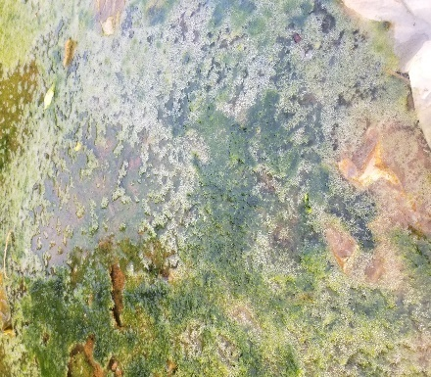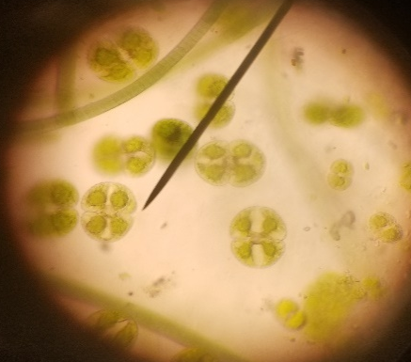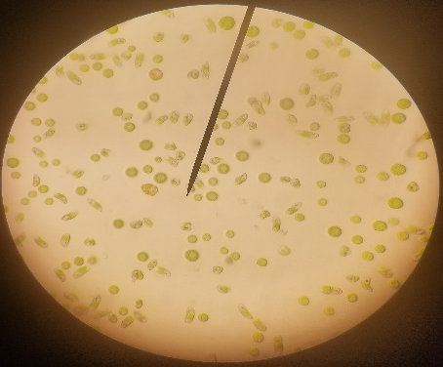
Figure 1: showing some physical and microscopic view of some microalgae found.

Molecular identification
Molecular analysis based on ITS rRNA gene sequencing confirmed the identity of selected isolates as Chlorella sorokiniana. PCR amplification produced a distinct band of approximately 450 bp, consistent with expected ITS fragment size for green microalgae.
BLAST analysis showed high sequence similarity with reference Chlorella sorokiniana strains, confirming taxonomic assignment. Although the phylogenetic reconstruction using maximum parsimony revealed strong clustering with reference sequences, full validation requires deposition of sequences in a public database (GenBank accession numbers are PZ524763, PZ524764,
and PZ524765).
Nanodrop spectrophotometer was used to measure the quality of the DNA based on concentration and purity which the DNA shows a good purity result. Out of Chlorella spp isolates identified using colony morphology, and microscopic identification. Three Chlorella spp were identified using conventional PCR and sequencing methods. The PCR results showed that a band of about 450 base pairs (bp) of DNA gene sequence was successfully obtained from Chlorella spp. The obtained sequences were subjected into the Basic local alignment search tool BLAST in the National Center for Biotechnology Information (NCBI) database to compare with known Chlorella spp sequences stored in the bank. Sequences of Chlorella sorokiniana from NCBI that showed similarity with the isolate were downloaded and a phylogenetic tree was constructed to determine the evolutional relationship of a sequence of these isolate with known Chlorella spp. isolate from NCBI. The phylogenetic tree was constructed using Clustal- Muscle and neighbour-joining methods and bootstrapping performed by creating1000 trials.

Table 2: Algae nanodrop result for algal DNA analysis

Sample ID | Nucleic acid | A260Abs | A280Abs | 260/280 | 260/230 | Sample type | Factor
BG11 | 16 ng/ul | 0.321 | 0.171 | 1.88 | 1.1 | DNA | 50
NPK | 7.7 ng/ul | 0.153 | 0.092 | 1.66 | 0.17 | DNA | 50
Biomark | 18 ng/ul | 0.36 | 0.182 | 1.98 | 0.79 | DNA | 50

Electrophoresis results
Electrophoresis results showed clear bands indicating successful DNA extraction and potential for further genetic analysis.

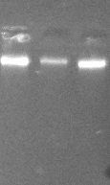
Figure 2: Electrophoresis results showing the bands of the three Chlorella sorokiniana (A Pond, R Pond and B Pond) DNA gene sequence of 450 base pair from all the sample.

Figure 3. Maximum Parsimony analysis of taxa
The evolutionary relationship of the isolated microalga and related taxa was inferred using the Maximum Parsimony (MP) method implemented in MEGA version 6.0. The analysis included 10 nucleotide sequences obtained from the ITS region. All codon positions (1st, 2nd, and 3rd) together with non-coding regions were included in the analysis. Positions containing gaps and missing data were excluded, resulting in a final dataset of 212 nucleotide positions.
The most parsimonious tree was generated using the Subtree-Pruning-Regrafting (SPR) algorithm with random addition of sequences (10 replicates). One of the ten equally parsimonious trees obtained is presented in Figure 3. The tree had a length of 93, with a consistency index (CI) of 1.000, retention index (RI) of 1.000, and composite index (CI × RI) of 1.000, indicating a high level of consistency and reliability among the analyzed sequences. The phylogenetic analysis confirmed the taxonomic placement of the isolate and demonstrated its evolutionary relationship with closely related microalgal species.
Growth Performance of the culture media
Significant differences in growth performance were observed among the three-culture media (BG11, algal broth, and NPK fertilizer medium). Growth followed a typical sigmoid pattern characterized by lag, exponential, and stationary phases across all treatments.
BG11 medium supported the highest biomass accumulation throughout the cultivation period, reaching a maximum value of 35.48 g/L (dry weight). This was followed by algal broth (19.61 g/L) and NPK medium (7.26 g/L).

Table 3: The average growth of the microalgae cultivated in three different media (n ꞊ 3)
Days | BG11 average | Broth average | NPK average
2 | 0.1±0.01 | 0.1±0.01 | 0.1±0.01
4 | 0.226±0.06 | 0.193±0.11 | 0.12±0.20
6 | 0.403±0.01 | 0.37±0,31 | 0.27±0.31
8 | 0.733±0.03 | 0.617±0.21 | 0.407±0.12
10 | 0.967±0.04 | 0.773±0.17 | 0.623±0.15
12 | 1.31±0.12 | 0.91±0.27 | 0.737±0.25
14 | 1.837±0.04 | 1.337±0.31 | 0.95±0.22
16 | 2.4±0.13 | 1.823±0.32 | 1.223±0.42
18 | 3.82±0.33 | 2.613±0.14 | 1.797±0.15
20 | 5.167±0.43 | 3.777±0.42 | 2.703±0.42
22 | 7.71±0.12 | 5.35±0.12 | 3.397±0.30
24 | 9.863±0.34 | 7.38±0.38 | 4.193±0.24
26 | 17.75±0.21 | 9.203±0.19 | 4.87±0.32
28 | 25.403±0.43 | 13.663±0.17 | 5.683±0.12
30 | 34±0.11 | 18.523±0.23 | 7.173±0.11
32 | 35.397±0.02 | 19.48±0.23 | 7.267±0.14
34 | 35.45±0.018 | 19.556±0.19 | 7.32±0.18
36 | 35.477±0.22 | 19.66±0.25 | 7.31±0.10
38 | 35.487±0.38 | 19.653±0.21 | 7.293±0.21
40 | 35.497±0.32 | 19.641±0.23 | 7.293±0.41
42 | 35.494±0.28 | 19.627±0.32 | 7.283±0.12
44 | 35.484±0.12 | 19.61±0.11 | 7.26±0.02
Mean ± standard deviation.

Figure 4: Growth curve of the three-culture media.
Table 4: Result of algal culture media, specific growth rate, biomass productivity, and total biomass produced.
S/N | Culture media | SGR u (day⁻¹) | P_{B} (g/L (Dry weight)/day) | Total Biomass produced g/L (dry weight)
1 | BG11 | 0.140 | 0.842 | 35.333
2 | Algal broth | 0.126 | 0.465 | 19.227
3 | NPK | 0.102 | 0.170 | 7.197
SGR= specific growth rate, P_{B} = biomass productivity.
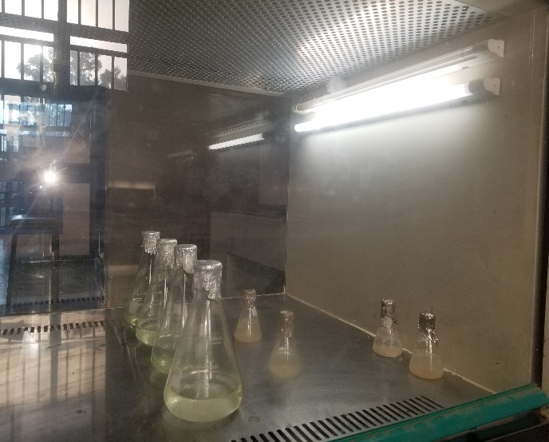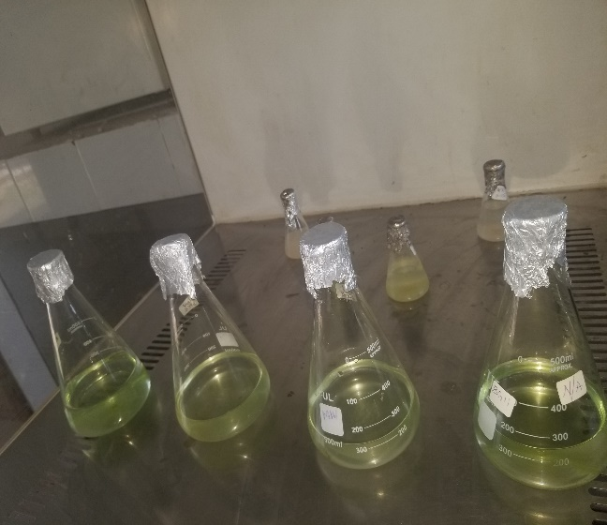
Figure 5: Showing the growth of microalgae after a week.
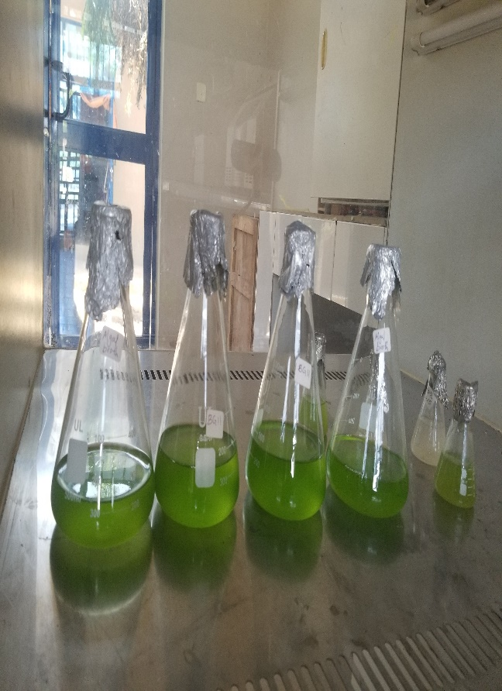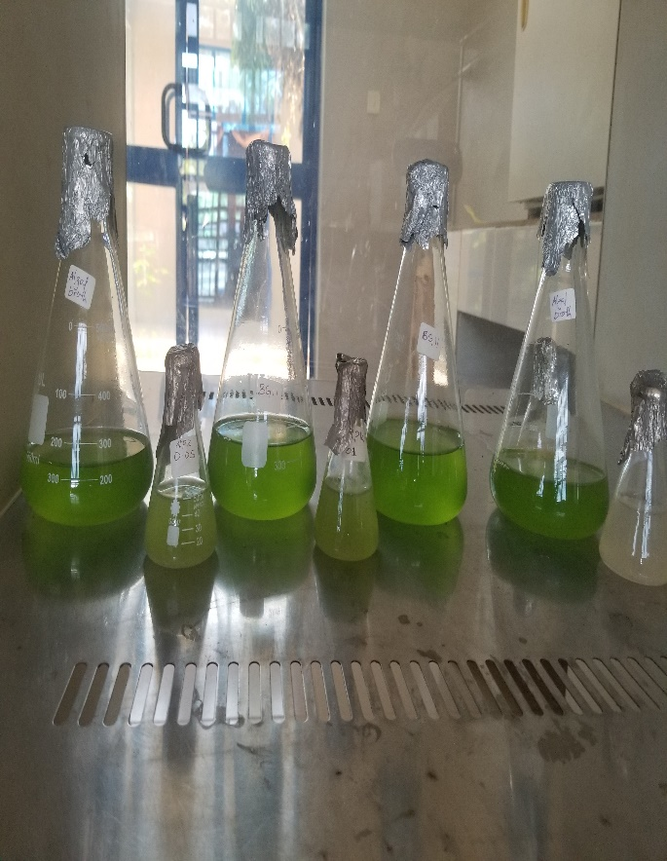
Figure 6: Showing the growth of the microalgae after a month.

Lipid yield from the three different media
BG11 medium produced the highest lipid yield of 28.46g/L (27.05%), followed closely by algal broth 13.23g/L (23.12%), while NPK medium recorded markedly lower lipid content 3.45g/L (16.12%).
Table 5: Result of algal culture media, dry biomass used and oil yield from algal biomass
S/N | Culture Media | Dry Biomass used g/L (dry weight) | Oil yield g/L | Percentage lipid content
1 | BG11 | 30 | 28.46 | 27.05%
2 | Algal broth | 15 | 13.23 | 23.12%
3 | NPK | 7 | 3.45 | 16.12%

Discussion
Microscopic examination of 18 water samples collected from diverse aquatic habitats within AFUSTA revealed a rich assemblage of freshwater microalgae, including Chlorella spp., Spirogyra spp., Chlamydomonas spp., Oedogonium spp., Microspora spp., Euglena spp., and Characium spp. The prevalence of Chlorella spp. across multiple sampling sites including the aquarium pond, reservoir pond, and botanical garden pond is consistent with the cosmopolitan distribution of this genus in nutrient enriched freshwater bodies (Mathimani and Pugazhendhi, 2019). The cooccurrence of filamentous green algae such as Spirogyra spp. and flagellated forms like Chlamydomonas spp. reflects the ecological diversity of these habitats, which is likely influenced by the agrarian character of the surrounding landscape and associated nutrient runoff from agricultural activities, particularly onion cultivation for which the Aliero region is well known (Umar et al., 2023).
This study corresponds to the work of Kadam et al., 2020 that identified Chlorella sorokiniana, Chlorella vulgaris, Spirogyra and Chlamydomonas with other many classes of algae within his study area, the optimized pH range 7.0 used in this study have differ slightly from pH detect by Kadam et al., (2020) that show the pH range 7.52 (± 0.09) to 8.03 ( ± 0.05), which may be the strains in that region grow best in such pH range. Also, the work agreed with the work of Saber et al., 2022 that isolated Chlorella sorokiniana, Chlorella vulgaris, and Characium spp.
Oyewumi et al., (2018), also isolated Chorella spp, Characium spp, and Euglena spp from different ponds in Ijigba Layout, off Oda Road and Federal University of Technology in Akure, Ondo State, Nigeria and isolated Botryococcus spp., Botrydiopsis spp., Nannochloropsis spp., Oscillatoria spp that were not isolated in the present study area which could be due to the different region of the study area.
The work is similar with the work of Umar et al., (2021) which showed a pH range of 6.42 to 7.36 that is within the neutral pH that support the growth of most microalgae, A total of eighteen algal species were identified, out of which Ten (10) species belong to the Class Chlorophyceae which include Chlorella spp, and Spirogyra , five (5) species belong to the Class Cyanophyceae, such as Oscillatoria species and three (3) species belong to the Class Bacillariophyceae which study was so similar with this work which could be due to all the studies are in a close geographical region that is northern part of Nigeria (Bashir et al., 2022).
Molecular characterization via ITS rRNA gene sequencing confirmed the selected isolates as Chlorella sorokiniana, a species well-recognized for its high photosynthetic efficiency, thermotolerance, and superior lipid accumulation capacity under optimized or stress conditions (Okoro et al., 2019). The successful generation of distinct PCR amplicons of approximately 450 bp consistent with expected ITS fragment sizes for green microalgae and the high-confidence BLAST matches to reference Chlorella sorokiniana sequences in the NCBI database collectively validate the accuracy and reliability of the molecular identification protocol. The phylogenetic tree constructed using the Maximum Parsimony method yielded a consistency index (CI) and retention index (RI) of 1.000, indicating a high level of phylogenetic signal and unambiguous taxonomic placement of all three isolates. The deposition of sequences under GenBank accession numbers PZ524763–PZ524765 ensures the reproducibility and verifiability of this work by the broader scientific community.
The work agrees with the work of Fathy et al., (2023) that used ITS1 and 4 for the identification of chlorella spp which yield positive result and also tally with the work of Mutizabal-Aros et al., (2024) that used the ITS primer for identification of the whole class and family of microalgae which he targets chlorophyta, and ulvophyceae. Fawley and Fawley, (2020) also identified a number of eukaryotic microorganisms including algae.
All three culture media supported the characteristic sigmoid growth pattern of Chlorella sorokiniana, encompassing lag, exponential, and stationary phases over the 44-day cultivation period. However, pronounced and statistically significant differences in biomass accumulation were observed among the three media. BG11 medium consistently supported the most vigorous growth, achieving a maximum dry cell weight of 35.48 g/L, a specific growth rate (SGR) of 0.140 day⁻¹, and a biomass productivity of 0.842 g/L/day. These superior outcomes are attributable to the chemically defined and comprehensively balanced nutrient composition of BG11, which supplies optimal concentrations of nitrogen (as NaNO₃), phosphorus, magnesium, calcium, iron, and a complete suite of trace elements and micronutrients essential for microalgal metabolic activity and cell division (Ghomari et al., 2022). The precise availability of these nutrients in bioavailable forms minimizes nutritional bottlenecks during the exponential phase, enabling sustained and rapid cell proliferation. These results are broadly consistent with the literature, where BG11 is consistently reported as one of the most effective defined media for Chlorella spp. cultivation (Mathimani and Pugazhendhi, 2019).
Algal broth (Biomarks) produced intermediate growth performance, yielding a maximum biomass of 19.61 g/L, SGR of 0.126 day⁻¹, and biomass productivity of 0.465 g/L/day — approximately 55% of the biomass productivity achieved with BG11. Although this represents a substantial reduction relative to the defined medium, these values remain noteworthy given the lower cost and simpler preparation of commercial algal broth formulations. The nutrient profile of algal broth, while less precisely defined than BG11, still provides a reasonably balanced supply of macro and micronutrients that sustains progressive microalgal growth across all cultivation phases. This makes algal broth a viable candidate for intermediate-scale cultivation where the recurring cost of BG11's nine-component stock solution system is prohibitive (Mahmood and Khudhair, 2017). The relative reduction in biomass productivity compared to BG11 may reflect suboptimal nitrogen-to-phosphorus ratios or the absence of specific trace elements that are critical cofactors in the photosynthetic electron transport chain and carbon fixation enzymes.
NPK fertilizer medium recorded the lowest growth metrics across all parameters, with a maximum biomass of 7.26 g/L, SGR of 0.102 day⁻¹, and biomass productivity of 0.170 g/L/day — approximately 20% of BG11 productivity. These outcomes, while modest, nonetheless confirm that NPK fertilizer at the concentrations tested (0.5–1.0 g/L) can support meaningful microalgal growth, consistent with prior reports on fertilizer-based cultivation systems in tropical settings (Lathifah et al., 2021). The substantially lower performance of NPK medium is attributable to multiple factors: the absence of essential micronutrients and trace metals (iron, manganese, cobalt, molybdenum) that function as critical cofactors in photosynthetic enzyme systems; potential ionic imbalances arising from the fixed 20:20:20 NPK macronutrient ratio, which may not align with the specific stoichiometric demands of Chlorella sorokiniana; and the possible precipitation of phosphate at the tested concentrations in the absence of chelating agents such as EDTA. Despite these limitations, the cost advantage of NPK fertilizer over both BG11 and commercial algal broth is considerable, particularly in Kebbi State and similar rural Northern Nigerian settings where agricultural-grade fertilizers are locally available, familiar to producers, and significantly more affordable than laboratory-grade nutrient formulations.
El-Fayoumy et al., 2020, and Zhou et al., 2021, also report the suitability and high growth rate of using BG11 media for the growth of chlorella species which the result disagreed with the work of Mahmood and Khudhair, (2017), that showed the maximum biomass concentration reaches to 0.3249 g L-1 when cultivated in NPK fertilizer. Also the study of Mtaki et al., (2021) showed biomass productivity of (0.1701 ± 0.0007 g/L/day) in C. vulgaris grown in AWW + 1.0 NPK medium. These findings underscore the necessity of selecting appropriate media for algal cultivation to enhance biofuel production yields and de Carvalho et al., (2019) showed BG11 media to be one of the best media for the cultivation of Chlorella species, Pandey et al.,(2023), also showed that BG11 media is one of the best media for the cultivation of fresh water algae.
Lipid extraction using the Bligh and Dyer chloroform-methanol method revealed that BG11-cultivated biomass yielded the highest oil content of 28.46 g/L (27.05% of dry biomass weight), followed by algal broth (13.23 g/L; 23.12%) and NPK medium (3.45 g/L; 16.12%). The lipid content percentages across all three media fall within the ranges reported in the literature for Chlorella sorokiniana under similar growth conditions, which typically span 15–35% of dry weight depending on nutrient regime, light intensity, CO₂ availability, and the growth phase at harvest (Mathimani and Pugazhendhi, 2019; Datta et al., 2024).
The superior lipid yield in BG11 medium reflects both the larger absolute biomass produced and the adequacy of the nutritional environment in supporting the full complement of biochemical pathways involved in lipid biosynthesis. In microalgae, the accumulation of triacylglycerols (TAGs) suitable for transesterification into fatty acid methyl esters (FAMEs) is regulated by the interplay between photosynthetic carbon fixation rates, nitrogen availability, and the intracellular carbon-to-nitrogen (C:N) ratio (Deora et al., 2022). Under the nitrogen-replete conditions provided by BG11 throughout the cultivation period, Chlorella sorokiniana efficiently allocated photosynthetically fixed carbon between biomass production and constitutive lipid storage. It is important to note that lipid yields in BG11 could potentially be further elevated through deliberate nitrogen starvation during a secondary stress phase a well-established strategy for inducing TAG accumulation in microalgae which was not employed in the present study and represents a promising avenue for future optimization (Okoro et al., 2019).
The lipid content of 23.12% recorded for algal broth medium is particularly significant from a practical and commercial standpoint. This percentage approaches and arguably meets the threshold commonly cited for economically viable microalgal biodiesel production (20–25% lipid content by dry weight), suggesting that algal broth could support a cost-effective dual-purpose cultivation system without fundamentally compromising fuel yield potential (Datta et al., 2024). The 16.12% lipid content obtained from NPK medium, while the lowest recorded among the three media, nonetheless compares favorably with or exceeds the lipid content of several conventional oilseed crops used in first-generation biodiesel production including soybean (approximately 18–20%) and sunflower (approximately 25–32% under optimal conditions) when considered on a land-use-normalized or productivity-per-area basis, given the significantly higher biomass productivity of microalgal systems per unit area compared to terrestrial crops (Chowdhury et al., 2019). This reinforces the comparative advantage of microalgal cultivation systems even under nutritionally suboptimal conditions.
One-way ANOVA confirmed that differences in biomass accumulation, specific growth rate, and lipid yield among the three culture media were statistically significant at the 95% confidence level (p < 0.05), and Tukey's post hoc test further validated that each medium performed distinctly and significantly differently from the others across all measured parameters. This rigorous statistical treatment strengthens the reliability and discriminatory power of the comparative conclusions drawn in this study and ensures that the observed differences reflect genuine biological and nutritional effects rather than experimental variability.
The results collectively position BG11 as the superior medium for maximum biomass and lipid productivity in controlled research settings; algal broth as the most promising cost-effective intermediate option with commercially viable lipid content for scale-up trials; and NPK as the most affordable formulation, suitable for scenarios where cost minimization is the primary objective, though its performance warrants further optimization before deployment in production systems. Compared to analogous studies conducted in other tropical and West African settings, the biomass and lipid values obtained in BG11 in this study are competitive and attest to the suitability of the local environmental conditions and the inherent productivity of the indigenous Chlorella sorokiniana strains isolated (Okoro et al., 2019). The use of locally adapted strains may confer physiological resilience advantages over laboratory-adapted or imported strains, including greater tolerance to ambient temperature fluctuations and local water chemistry, further supporting the rationale for indigenous strain isolation and characterization.

Conclusions
This study demonstrated the presence of diverse freshwater microalgae in aquatic habitats within Abdullahi Fodio University of Science and Technology, Aliero, Kebbi State, Nigeria. Microscopic screening identified several algal taxa, while molecular analysis of selected isolates confirmed their identity as Chlorella sorokiniana. The comparative cultivation experiment showed that culture medium composition strongly influenced biomass accumulation, specific growth rate, biomass productivity, and lipid yield. Among the three media tested, BG11 produced the highest biomass and lipid performance, reflecting its balanced nutrient composition and suitability for laboratory-scale cultivation of Chlorella sorokiniana. Algal broth supported moderate growth and lipid accumulation, suggesting that it may serve as a simpler alternative medium where fully defined BG11 preparation is not practical. NPK fertilizer medium supported algal growth but produced the lowest biomass and lipid values, indicating that the formulation tested was less suitable without further optimization or micronutrient supplementation. Overall, the results provide preliminary comparative data on indigenous Chlorella sorokiniana cultivation under different nutrient conditions in Northern Nigeria. Further work should verify lipid calculations, characterize fatty acid composition, and evaluate optimized low-cost media under larger-scale cultivation conditions before any practical biodiesel application is proposed.

Limitations
This study has several limitations that should be considered when interpreting the findings. The cultivation experiment was conducted under controlled laboratory conditions, and the results may not directly represent performance in outdoor ponds, raceway systems, or larger photobioreactors where light intensity, contamination, evaporation, mixing, and temperature variation may affect productivity. Lipid extraction was limited to total lipid estimation, and the study did not determine fatty acid composition or biodiesel quality parameters. Therefore, the suitability of the extracted lipids for biodiesel production requires further confirmation through fatty acid methyl ester profiling and fuel property analysis. The NPK medium was evaluated only within the reported concentration range, and additional optimization of fertilizer concentration and micronutrient supplementation may be required. Molecular identification was based on ITS sequencing, but detailed BLAST identity values, query coverage, and sequence-verification information should be included. Future studies should also include stronger statistical reporting and pilot-scale validation.

Recommendations
Based on the findings of this study, the following recommendations are made to guide future research endeavors, practical implementation, and policy development in support of microalgal biodiesel production in Northern Nigeria and comparable resource-limited tropical settings:
1. Continuation of BG11-based research for biological optimization: BG11 medium should continue to serve as the reference standard for laboratory-scale studies aimed at maximizing biomass and lipid productivity of Chlorella sorokiniana. Its chemically defined composition provides the controlled nutritional environment necessary for elucidating metabolic responses to variables such as light intensity, CO₂ concentration, temperature, and nitrogen stress. In particular, two stage cultivation strategies combining nitrogen-replete growth in BG11 followed by deliberate nitrogen starvation should be investigated as a means to substantially increase lipid accumulation beyond the 27.05% recorded in this study, potentially approaching the 40–50% lipid content achievable under optimized stress induction in Chlorella sorokiniana.
2. Pilot scale evaluation of algal broth as an intermediate-cost cultivation medium: Given the competitive lipid content (23.12%) and acceptable biomass productivity achieved in algal broth, this formulation presents the most favorable balance between performance and cost for transition to pilot-scale production. Future studies should evaluate algal broth performance in open raceway ponds and closed photobioreactor systems under ambient Nigerian climatic conditions, paying particular attention to contamination control, culture stability over extended periods, and the economics of medium preparation relative to productivity outcomes. Optimization of algal broth concentration and potential supplementation with targeted micronutrients should also be systematically investigated.
3. Systematic optimization of NPK medium formulation with micronutrient supplementation: The markedly lower performance of the standard NPK (20:20:20) formulation at 0.5–1.0 g/L suggests that the current macronutrient ratio and concentration are suboptimal for Chlorella sorokiniana. Future investigations should systematically vary NPK concentrations across a broader range (0.25–3.0 g/L) and evaluate the effect of supplementing NPK with iron EDTA and a standard trace metal solution on biomass and lipid productivity. Identifying a supplemented NPK formulation that meaningfully narrows the performance gap with BG11 while preserving the cost advantage of fertilizer-based media could make optimized NPK medium a genuinely viable option for small-scale and community-level biodiesel production enterprises in rural Northern Nigeria.
4. Fatty acid profiling and comprehensive biodiesel quality characterization: Future work should incorporate GC-MS analysis of FAMEs derived from biomass produced in each of the three culture media to characterize the fatty acid composition and calculate key biodiesel quality parameters, including cetane number, iodine value, saponification value, degree of unsaturation, and cold filter plugging point. This information is indispensable for determining whether the biodiesel produced from each medium meets international quality standards and for understanding how medium composition influences the fatty acid profile — knowledge that could inform deliberate cultivation strategies aimed at tailoring fuel properties for specific applications.
5. Integration of microalgal cultivation with agricultural wastewater treatment: Kebbi State's status as Nigeria's foremost onion-producing region generates significant volumes of agricultural wastewater and effluent streams rich in nitrogen and phosphorus. Future research should investigate the growth and lipid productivity of the indigenous Chlorella sorokiniana strains isolated in this study when cultivated in diluted agricultural wastewater, domestic effluent, or aquaculture discharge. Such an approach would simultaneously reduce freshwater consumption, eliminate the cost of medium preparation, provide a degree of biological wastewater treatment, and reduce the environmental footprint of both agricultural activities and microalgal cultivation — representing a compelling circular economy proposition for the region.
6. Techno-economic analysis and life cycle assessment at commercially relevant scales: For the findings of this study to meaningfully inform investment and policy decisions, a detailed techno-economic analysis (TEA) and life cycle assessment (LCA) comparing the three cultivation media should be conducted at commercially relevant production scales. This analysis should encompass the full value chain from medium preparation and cultivation through harvesting by centrifugation, lipid extraction, and transesterification, quantifying net energy ratios, production costs per litre of biodiesel equivalent, capital expenditure requirements, and greenhouse gas emission savings relative to conventional petroleum diesel under Northern Nigerian conditions. Such a study would provide the rigorous economic and environmental evidence base necessary to attract investment and guide policy support for microalgal biofuel development in the region.
7. Strengthening institutional capacity and policy frameworks for microalgal biofuel development: The research capacity established at AFUSTA through this study should be systematically expanded through targeted investment in photobioreactor and pilot-scale cultivation infrastructure, advanced analytical instrumentation, and researcher training programs in microalgal biotechnology. Inter-institutional collaboration with federal universities and research institutes in Nigeria, as well as international partnerships, should be actively pursued to accelerate knowledge transfer and technology development. Concurrently, policy advocacy efforts should engage state and federal authorities to develop enabling frameworks including renewable energy incentives, biofuel blending mandates, targeted research grants, and public-private partnership mechanisms that facilitate the transition from promising laboratory findings such as those reported in this study to commercially viable and economically self-sustaining microalgal biodiesel enterprises, consistent with the objectives of Nigeria's Energy Transition Plan and the nation's commitments under the Paris Agreement.
Ethical Statement
This study did not involve animal or human subjects. Environmental sampling was conducted in accordance with institutional research guidelines.
References
Badamasi, m., abdullahi, b., suleiman, k., and habib, a. (2023). The effect of temperature and photoperiod on bioremediation potentials of mono and mixed cultures of chlorophyte and cyanobacteria for municipal wastewater treatment. Ethiopian journal of environmental studies & management, 16(1).
Bashir, M. A., Wu, S., Zhu, J., Krosuri, A., Khan, M. U., and Aka, R. J. N. (2022). Recent development of advanced processing technologies for biodiesel production: A critical review. Fuel Processing Technology, 227, 107120.
Cao, A., Cagide, E., and Vilariño, N. (2024). The great morphological diversity of cyanobacteria is the basis for their classifica-tion in Bergey’s Manual of Systematic Bacteriology [9–11], which has divided cyano-bacteria into five subsections: I (= Order Chroococcales) II (= Order Pleurocapsales). Environmental Toxicology: Non-bacterial Toxins, 197.
Cavelius, P., Engelhart-Straub, S., Mehlmer, N., Lercher, J., Awad, D., and Brück, T. (2023). The potential of biofuels from first to fourth generation. PLoS Biology, 21(3), e3002063.
Chen, H. H., Xue, L. L., Liang, M. H., and Jiang, J. G. (2020). Intervention of triethylamine on Dunaliella tertiolecta reveals metabolic insights into triacylglycerol accumulation. Algal Research, 47, 101876.
Cheung, S. L., Short, S. M., & Allen, D. G. (2022). The influence of wastewater pretreatment, attachment material, and inoculation strategy on the growth of target algal species in cultivated biofilms. Journal of Applied Phycology, 34(1), 113-125.
Chowdhury, H., and Loganathan, B. (2019). Third-generation biofuels from microalgae: a review. Current opinion in green and sustainable chemistry, 20, 39-44.
Datta, D., Biswas, S., Barman, D., Mandal, E., and Das, B. (2024). Evolution, Challenges and Benefits of Biofuel Production and Its Potential Role in Meeting Global Energy Demands. In Emerging Sustainable Technologies for Biofuel Production (pp. 595-632). Cham: Springer Nature Switzerland.
de Carvalho, J. C., Sydney, E. B., Tessari, L. F. A., and Soccol, C. R. (2019). Culture media for mass production of microalgae. In Biofuels from algae (pp. 33-50). Elsevier.
Deora, P. S., Verma, Y., Muhal, R. A., Goswami, C., and Singh, T. (2022). Biofuels: An alternative to conventional fuel and energy source. Materials Today: Proceedings, 48, 1178-1184.
Dharmaprabhakaran, T., Karthikeyan, S., Periyasamy, M., and Mahendran, G. (2020). Algal biodiesel-promising source to power CI engines. Materials Today: Proceedings, 33, 2870-2873.
Elkelawy, M., Abdel-Rahman, A. K., Abou-Elyazied, A., and El-malla, S. M. (2022). Experimental investigation on emission and combustion characteristics of an industrial burner using biogas co-fired with diesel and biodiesel. Egyptian Sugar Journal, 19, 29-43.
Fathy, W. A., Techen, N., Elsayed, K. N., Essawy, E. A., Tawfik, E., Alwutayd, K. M., and Ross, S. A. (2023). Applying an internal transcribed spacer as a single molecular marker to differentiate between Tetraselmis and Chlorella species. Frontiers in Microbiology, 14, 1228869.
Fawley, M. W., and Fawley, K. P. (2020). Identification of eukaryotic microalgal strains. Journal of applied phycology, 32, 2699-2709.
Fayyaz, M., Chew, K. W., Show, P. L., Ling, T. C., Ng, I. S., and Chang, J. S. (2020). Genetic engineering of microalgae for enhanced biorefinery capabilities. Biotechnology advances, 43, 107554.
Ferreira, G. F., Rios Pinto, L. F., Carvalho, P. O., Coelho, M. B., Eberlin, M. N., Maciel Filho, R., and Fregolente, L. V. (2021). Biomass and lipid characterization of microalgae genera Botryococcus, Chlorella, and Desmodesmus aiming high-value fatty acid production. Biomass Conversion and Biorefinery, 11, 1675-1689.
Foo, S. C., Mok, C. Y., Ho, S. Y., and Khong, N. M. (2023). Microalgal culture preservation: Progress, trends and future developments. Algal Research, 71, 103007.
Ghomari, S., Benabdesslem, Y., Mhamdia, C., Daoud Hamdi, S., Khaled, M. B., and Cherifi, K. (2022). Simplification of the Culture Medium and Action of The Bioreactor Material on The Stimulation of Chlorella vulgaris Production. Egyptian Academic Journal of Biological Sciences, C Physiology & Molecular Biology, 14(2).
Hassan, A., Ilyas, S. Z., Jalil, A., and ullah, Z. (2021). Monetization of the environmental damage caused by fossil fuels. Environmental Science and Pollution Research, 28, 21204-21211.
Kadam, A. D., Kishore, G., Mishra, D. K., and Arunachalam, K. (2020). Microalgal diversity as an indicator of the state of the environment of water bodies of Doon valley in Western Himalaya, India. Ecological Indicators, 112, 106077.
Kargbo, H., Harris, J. S., and Phan, A. N. (2021). “Drop-in” fuel production from biomass: Critical review on techno-economic feasibility and sustainability. Renewable and Sustainable Energy Reviews, 135, 110168.
Kreps, B. H. (2020). The rising costs of fossil‐fuel extraction: an energy crisis that will not go away. American journal of economics and sociology, 79(3), 695-717.
Kumar, A., Johari, S., and Verma, P. (2021). Global Warming and Third Generation Algal Biofuels: A Review. The Journal of Plant Science Research, 37(1), 155-165.
Lathifah, W., Fikri, R. A., Hidayati, N. A., Anggraini, I. D., Putri, N., Prabowo, B., and Marno, S. (2021, May). Effect of commercial NPK fertilizer on growth and biomass of Navicula sp. and Nannochloropsis sp. In IOP Conference Series: Earth and Environmental Science (Vol. 762, No. 1, p. 012060). IOP Publishing.
Mahmood, K. A., and Khudhair, E. M. (2017). Experimental study for commercial fertilizer NPK (20: 20: 20+ TE N: P: K) in microalgae cultivation at different aeration periods. Iraqi Journal of Chemical and Petroleum Engineering, 18(1), 99-110.
Mathimani, T., and Pugazhendhi, A. (2019). Utilization of algae for biofuel, bio-products and bio-remediation. Biocatalysis and agricultural biotechnology, 17, 326-330.
Mtaki, X., Liu, F., Helian, Y., Li, C., Wu, Z., Li, H., and Zhou, S. (2021). Current application of MOFs based heterogeneous catalysts in catalyzing transesterification/esterification for biodiesel production: A review. Energy Conversion and Management, 229, 113760.
Mutizabal-Aros, J., Ramírez, M. E., Haye, P. A., Meynard, A., Pinilla-Rojas, B., Núñez, A., and Contreras-Porcia, L. (2024). Morphological and Molecular Identification of ulva spp.(ulvophyceae; Chlorophyta) from Algarrobo Bay, Chile: Understanding the Composition of Green Tides. Plants, 13(9), 1258.
Okoro, V., Azimov, U., Munoz, J., Hernandez, H. H., and Phan, A. N. (2019). Microalgae cultivation and harvesting: Growth performance and use of flocculants-A review. Renewable and Sustainable Energy Reviews, 115, 109364.
Oyewumi, O. O., and Olukunle, O. F. (2018). Isolation and Identification of Microalgae from Fresh Water. Journal of Sustainable Technology, 9(1), 71-78.
Padder, S. A., Khan, R., and Rather, R. A. (2024). Biofuel generations: New insights into challenges and opportunities in their microbe-derived industrial production. Biomass and Bioenergy, 185, 107220.
Pang, S. J., Liu, F., Shan, T. F., Xu, N., Zhang, Z. H., Gao, S. Q., and Sun, S. (2010). Tracking the algal origin of the Ulva bloom in the Yellow Sea by a combination of molecular, morphological and physiological analyses. Marine environmental research, 69(4), 207-215.
Patel, A., Karageorgou, D., Rova, E., Katapodis, P., Rova, U., Christakopoulos, P., and Matsakas, L. (2020). An overview of potential oleaginous microorganisms and their role in biodiesel and omega-3 fatty acid-based industries. Microorganisms, 8(3), 434.
Purkan, P., Nidianti, E., Abdulloh, A., Safa, A., Retnowati, W., Soemarjati, W., and Wook Kim, S. (2019). Biodiesel production by lipids from Indonesian strain of microalgae Chlorella vulgaris. Open Chemistry, 17(1), 919-926.
Raheem, A., Azlina, W. W., Yap, Y. T., Danquah, M. K., and Harun, R. (2015). Thermochemical conversion of microalgal biomass for biofuel production. Renewable and Sustainable Energy Reviews, 49, 990-999.
Saber, A. A., El-Refaey, A. A., Saber, H., Singh, P., van Vuuren, S. J., and Cantonati, M. (2022). Cyanoprokaryotes and algae: classification and habitats. In Handbook of Algal Biofuels (pp. 1-38). Elsevier.
Sambrook, J., and Russell, D. W. (2001). Molecular Cloning: A Laboratory Manual. Cold Spring Harbor Laboratory Press.
Sharma, A. K., Sahoo, P. K., Singhal, S., and Joshi, G. (2016). Exploration of upstream and downstream process for microwave assisted sustainable biodiesel production from microalgae Chlorella vulgaris. Bioresource technology, 216, 793-800.
Sun, Y., Hao, Q., Cui, C., Shan, Y., Zhao, W., Wang, D., and Guan, D. (2022). Emission accounting and drivers in East African countries. Applied Energy, 312, 118805.
Umar, L., Bashir, A., Haruna, I., Hadiza, G. A., and Shamsudeen, A. J. (2021). Study of Algal Species Isolated From River Ginzo in Katsina State, as a Potential Source for Biodiesel Production. Journal of Applied Sciences and Environmental Management, 25(5), 793-798.
Umar, S., Hassan, U., and Alhassan, Y. J. (2023). Factors influencing adoption of improved onion production practice in aliero and yauri local government areas, kebbi state, nigeria. African journal of sustainable agricultural development, 4(4), 1-11.
Wang, T., Jiang, Z., Zhao, B., Gu, Y., Liou, K. N., Kalandiyur, N., and Zhu, Y. (2020a). Health co-benefits of achieving sustainable net-zero greenhouse gas emissions in California. Nature Sustainability, 3(8), 597-605.
Wang, Y., Yang, H., Zhang, X., Han, F., Tu, W., and Yang, W. (2020b). Microalgal hydrogen production. Small Methods, 4(3), 1900514.
Xu, H., Lee, U., Coleman, A. M., Wigmosta, M. S., and Wang, M. (2019). Assessment of algal biofuel resource potential in the United States with consideration of regional water stress. Algal Research, 37, 30-39.
Yaashikaa, P. R., Devi, M. K., and Kumar, P. S. (2022). Algal biofuels, Technological perspective on cultivation, fuel extraction and engineering genetic pathway for enhancing productivity. Fuel, 320, 123814.
Zymo Research Corp. (2020). ZymoBIOMICS™ DNA Miniprep Kit Protocol. Zymo Research.

