Production of black henbane plants (Hyoscyamus niger) from callus farms using tissue culture techniques

Abstract
The study showed the success of the surface sterilization method for black henbane (Hyoscyamus niger) seeds used as indicated by obtaining sterile seeds with a 90% germination rate after 6 days of planting and it produced healthy seedlings when planted on solid MS medium free of growth regulators. The placement of subcotyledonous stems segments from seedlings on solid MS medium supplemented with 0.5 mg L⁻¹ 2,4-D and 1.0 mg L⁻¹ BA led to successfully inducing callus from them with a 100% success rate. One of the notable results of the study was that, after 10 days of the first replanting of the callus on the same nutrient medium, green structures began to appear spontaneously, which later grew and developed into vegetative shoots in large numbers, averaging 15 per callus piece, with an average length of 3 cm and a 90% rate after 30 days. The resulting shoots also had true leaves. The spontaneously formed green shoots, which were cut and planted vertically in solid MSO medium, rooted easily with a rate of 100% after 8-10 days, After the new plants developed the acclimatization of plants resulting from the spontaneous differentiation from subcotyledonous stems segments calluses was successful and they were transferred to the soil. These plants have proven their ability to grow and withstand environmental conditions.

Keywords: Black henbane (Hyoscyamus niger) plants, Tissue culture, MS medium, Rooting, Acclimatization

Introduction
The black henbane plant (Hyoscyamus niger) belongs to the genus Hyoscyamus, which is one of the most important and largest genera of the nightshade family, Solanaceae. Its plants are widespread herbaceous dicotyledons, comprising about 98 genera and more than 3,000 species (Bejenaru et al., 2024), Plants have been described as a common source of medicines, whether in the form of traditional remedies or potent active ingredients due to the metabolic compounds they produce as they grow (Chaachouay and Zidane, 2024). Alkaloids are considered one of the most important groups of secondary metabolites in plants because of their structural diversity and various medicinal properties (Mohammed et al., 2023), Hyoscyamine and scopolamine can be considered among the most interesting molecules of the alkaloids that belong to the Solanaceae family and they serve as the starting point for synthesizing most anticholinergic substances (Shim et al., 2022), They are the ones responsible for developing more than 50 drugs (Wen et al., 2024). And given the increasing demand for compounds with medicinal properties, the low concentrations of these compounds in plants, the limited natural resources, and the trend of plant species extinction Biotechnology has been seen as a way to increase the production of medicinal plants (Niazian, 2019), One of the important techniques in this field is plant tissue culture, which can quickly produce medicines and metabolic products on a large scale (Isah et al., 2018). Medicinal plants produce a range of biologically active compounds like alkaloids, flavonoids, and terpenes that have therapeutic properties (Nwozo et al., 2023), Through precise control of growth conditions and genetic modification (D’Amelia et al., 2021). Plant tissue culture can produce these compounds, which increases the effectiveness of herbal medicines (Wang et al., 2017). In recent years, there has been remarkable progress in the use of biotechnology, as plant tissue culture has become one of the most important advanced techniques in this field. The term plant tissue culture refers to taking any plant part, sterilizing it, and growing it outside the living organism on artificial nutrient media, under controlled conditions free from contaminants, and developing it in growth rooms (Malabadi et al., 2025). This technology enables the selection and production of plant strains that can withstand harsh environmental conditions and maintain them for long periods, in addition to the fact that plant cells have inherent potential like totipotency, meaning that every plant cell is capable of dividing and growing to produce a complete plant (Khezri et al., 2024), Which led to the enhancement and development of plant cell culture techniques under their specific conditions (Okoroafor, 2022). Micropropagation techniques play an important role in preserving plants and improving them genetically, especially pharmaceutical and medicinal plants, Currently, there is a trend to develop in-lab production systems as an alternative to field production of plants used as sources of active compounds, to ensure these compounds are available in desired amounts throughout the year without being affected by the seasons (Bapat et al., 2023). Therefore, tissue culture technology and the cultivation of plant cells and organs outside the plant body are considered an essential and indispensable tool in the production of plant-derived pharmaceuticals (Malabadi et al., 2025). It is considered a powerful tool in the fields of plant biology, agriculture, horticulture, and biotechnology (Mishra et al., 2024). It allows researchers to explore and understand the complexities of plant growth and development, as well as their responses to various environmental factors, providing clear insights into plant physiology and genetics (Pasternak and Steinmacher, 2024). One of the most important advantages of plant tissue culture is its diversity through different techniques, including micropropagation, callus culture, suspension culture, and organ culture (Isah et al., 2018). For example, micropropagation allows plants to reproduce quickly by growing small pieces of tissue (Abdalla et al., 2022), while suspension culture makes it easier to produce biologically active compounds that might be hard to extract from whole plants (Khalafalla, 2025). Moreover, plant tissue culture is considered a key tool for research and development in the field of medicinal plants, as it provides a controlled platform to study plant biology, optimize growth conditions, and investigate the mechanisms behind the production of secondary metabolites (Fazili et al., 2022). Plant tissue culture has made it possible to develop plants with desirable traits through genetic transformation, which has far-reaching effects in agriculture and biotechnology (Salaria et al., 2026). Plant tissue culture is not just a tool for scientific research; it is also a practical application with various uses and a continuous, sustainable source of plant materials (Twaij et al., 2020). Many studies have pointed out the success of plant tissue culture technology and its applications on many plants from the Solanaceae family, most importantly tobacco (Nicotiana tabacum), tomato (Solanum lycopersicum), and potato (Solanum tuberosum) (Brancato et al., 2025), This technique was also applied to the black henbane plant to create callus and produce complete plants, as well as to extract medical compounds from it like hyoscyamine and atropine (Abed and Jassim, 2024). Many studies have pointed out that these compounds accumulate in tissue culture farms of cotyledon leaf pieces, which are considered one of the plant parts most responsive to tissue culture in this plant (Isah et al., 2018).

Materials and Methods
All experiments of this study were conducted within the Plant Tissue Culture Laboratory of the Department of Biology / College of Science / University of Mosul / Iraq. Seed sterilization, planting, producing sterile seedlings, callus cultures, and maintaining them for black henbane plants (Hyoscyamus niger) and others were carried out in sterile conditions inside a laminar air flow cabinet. Before starting work, the cabinet’s floor and walls were wiped with sterilized cotton soaked in 70% ethanol and operated for half an hour to create a sterile, contaminant-free environment. Meanwhile, the culture media, glassware, all tools, and distilled water used were sterilized with an autoclave (Autoclave; Gallen Kamp; UK) at 121°C under 1.02 kg/cm² pressure for 18–20 minutes.

Surface sterilization of black henbane seeds and germination of their seedlings
The seeds of the black henbane plants were surface-sterilized by soaking them in 70% ethyl alcohol for 30 seconds with continuous stirring, then in 5% sodium hypochlorite (commercial bleach) for 10 minutes. They were washed three times with distilled water for two minutes each time and placed on filter paper for drying (, 2020 Kareem). The sterilized seeds were placed in 100 ml bottles containing 30 ml of solid Murashige and Skoog (1962) MS medium, at a rate of 6-8 seeds per bottle. The mouths of the bottles were sealed with aluminum foil, and the samples were kept in a culture room in the dark at a temperature of 24 ± 2°C. After the seeds germinated (radicle and plumule appeared), they were moved to a photoperiod of 16 hours of light at an intensity of 2000 lux and 8 hours of darkness.

Inducing callus from subcotyledonous stems segments of black henbane seedlings
Healthy black henbane plantlets, 15 days old, were taken from the middle of the MS medium, then their stems were cut just below the subcotyledonous stems to about 1.5–2 cm, and every 3 or 4 pieces were placed on 30 ml of solid MS medium supplemented with 0.5 mg L⁻¹ 2,4-D and 1.0 mg L⁻¹ BA (Taha, 2023), then they were kept in the culture room under the light/dark conditions mentioned earlier.

Formation of callus farms on subcotyledonous stems and their maintenance
The newly formed callus masses were excised from the portions of subcotyledonous stems that responded individually and placed in glass bottles containing 30 ml of solid MS medium supplemented with 0.5 mg L⁻¹ 2,4-D and 1.0 mg L⁻¹ BA for the purpose of generating cultures. The cultures were maintained regularly every 15 days whenever the callus turned dark brown and the medium dried and cracked, by removing the dead parts and dividing the remaining callus into small pieces, placing each piece into a new bottle. The cultures were kept in a growth room under 16 hours of light at 2000 lux / 8 hours of dark, at a temperature of 24 ±2°C.

The differentiation of the callus of subcotyledonous stems
For the purpose of differentiating of the callus of subcotyledonous stems, pieces weighing approximately 1.0 g were taken from them and re-cultivated on the same regeneration medium and kept in the culture room under light conditions with a photoperiod of 16 hours of light at an intensity of 2000 lux / 8 hours of darkness and a temperature of 24 ±2°C to observe the suitability of the medium for differentiation.

Rooting differentiated green branches from subcotyledonous stems
The groups of green shoots formed from callus of subcotyledonous stems, when they reached 2.5 - 3 cm in length and contained small leaves, were removed using a sharp, sterilized scalpel, and their bases were planted individually and upright in 30 ml of solid MSO medium without growth regulators for rooting purposes.

Results and Discussion
Surface sterilization efficiency of black henbane (Hyoscyamus niger) seeds and the production of sterile seedlings
The surface sterilization method for black henbane seeds used in this study was successful, as shown by obtaining sterile seeds with a 90% germination rate after 6 days of planting, and it produced healthy seedlings when planted on solid MS medium without growth regulators and contamination (Figure 1).

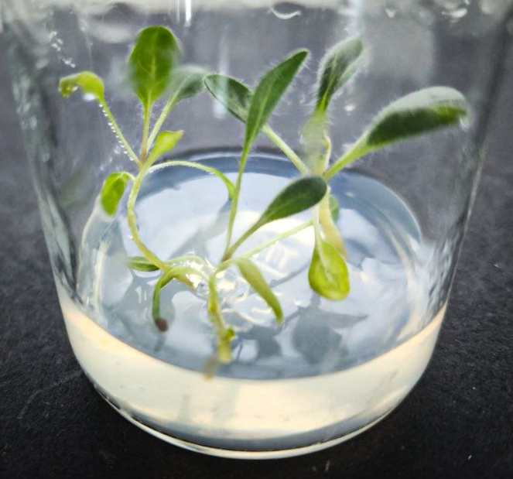

Figure (1): black henbane seedlings growing on solid MSO medium at 15 days old.

Inducing callus from subcotyledonous stems segments of black henbane seedlings and forming its cultures
Placing subcotyledonous stems segments taken from black henbane seedlings onto solid MS medium supplemented with 0.5 mg L⁻¹ 2,4-D and 1.0 mg L⁻¹ BA led to 100% success in inducing callus. After 7 days of planting (Figure 2, A), the pieces began to swell from their cut ends, forming callus masses after 15 days (Figure 2, B). These masses developed to cover all the subcotyledonous stems segments after 22 days (Figure 2, C), and continued growing to produce a typical callus culture after 30 days (Figure 2, D).
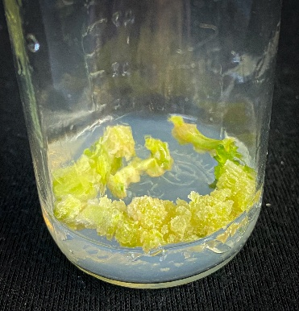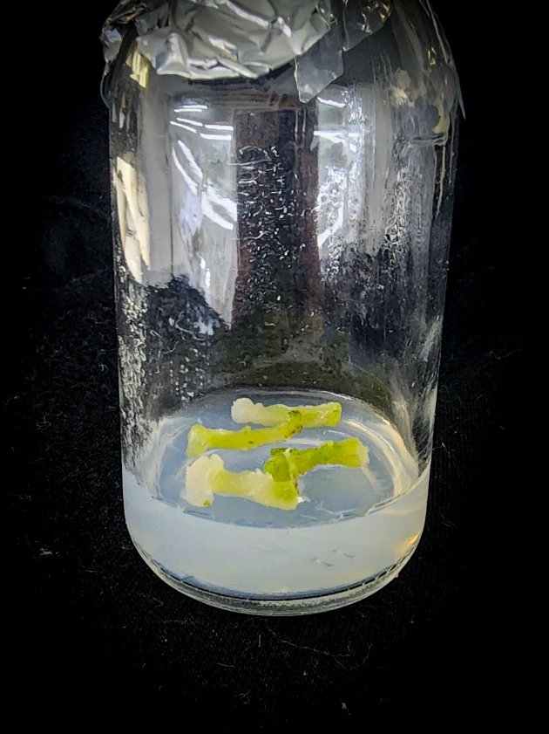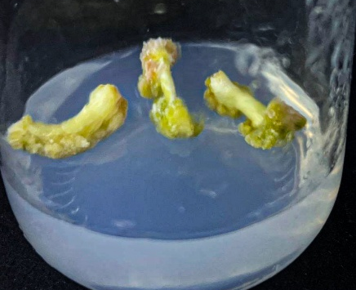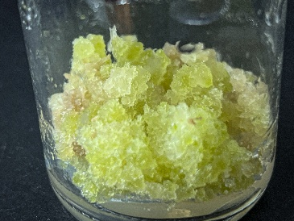
A
B
D
C

Figure (2): Stages of producing callus cultures from subcotyledonous stems segments of black henbane seedlings on solid MS medium supplemented with 0.5 mg L⁻¹ 2,4-D and 1.0 mg L⁻¹ BA after 30 days.
- Initiating callus from subcotyledonous stems segments for black henbane seedlings and swelling them after 7 days.
- The callus masses formed from (A) after 15 days.
- The callus masses develop from (B) to cover subcotyledonous stems segments after 22 days.
- Continued growth of callus masses from (C) and the production of a model plantation after 30 days.

Automatic formation of green shoots from subcotyledonous stems callus of black henbane seedlings
One of the notable results of the study was that after 10 days of the first subculture of the callus on the same nutrient medium, green structures started to appear spontaneously (Figure 3, A), which later grew and developed into vegetative shoots in large numbers, averaging 15 per callus piece and about 3 cm in length, with a 90% success rate (based on 60 callus pieces re-cultured) after 30 days (Figure 3, B). The resulting shoots also had true leaves.

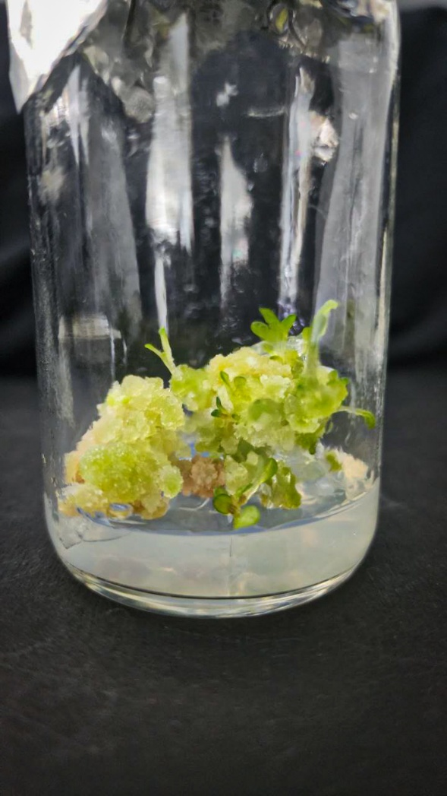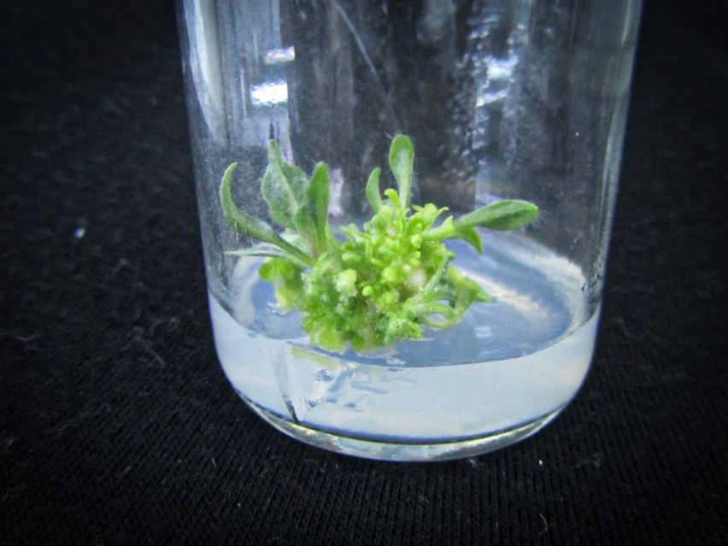
B
A

Figure (3): Automatic differentiation of shoots from callus pieces of black henbane seedlings grown on solid MS medium supplemented with 0.5 mg L⁻¹ 2,4-D and 1.0 mg L⁻¹ BA.
- The beginning of the formation of green structures spontaneously from the callus pieces planted on solid MS medium supplemented with 0.5 mg L⁻¹ 2,4-D and 1.0 mg L⁻¹ BA after 20 days.
- Automatic differentiation from (A) after 30 days.

Rooting naturally formed green shoots
The spontaneously formed green shoots, which were excised and planted vertically in solid MSO medium, rooted easily with a 100% success rate for all the tested shoots after 8-10 days. Small white growths started to appear, which then developed into real roots, becoming thicker, longer, and intertwined with each other (Figure 4), ultimately producing a complete black henbane plant in the growth medium.

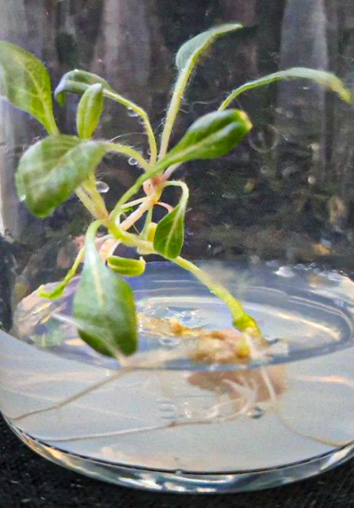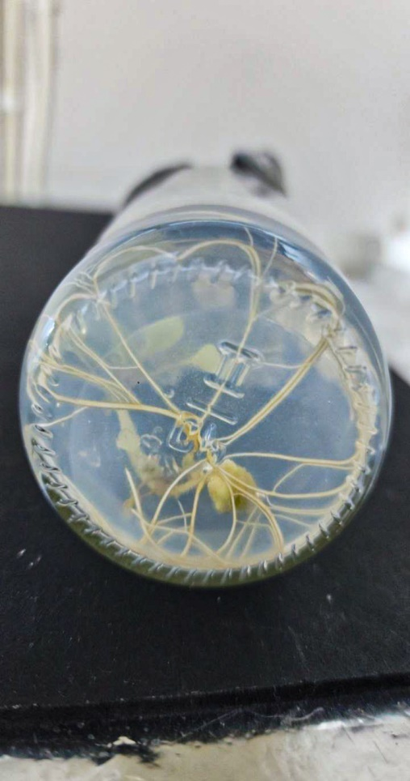
A
B

Figure (4): Formation of complete black henbane plants from the differentiation of subcotyledonous stems and their rooting in the growth medium.
A and B Rooting one of the excised green branches in full-strength MSO medium after 20 days and form a complete black henbane plant in the growth medium.

Acclimating black henbane plants resulting from spontaneous differentiation subcotyledonous stems callus and transferring them to soil
After the developing plants formed on the complete MSO medium, they were lifted from their medium (Figure 5, A) and placed in transparent plastic containers perforated at the bottom, containing a sterilized mixture of soil and peat at a 1:1 ratio (weight:weight), and covered with other plastic boxes perforated at the top. After their growth stabilized, the top boxes were removed while the samples remained inside the growth chamber for 10 days (Figure 5, B). Then the plants along with their soil were transferred to larger trays containing the same mixture (Figure 5, C) and stayed for another 10 days inside the growth chamber before being moved to greenhouse conditions. These plants proved capable of growing and withstanding environmental conditions.

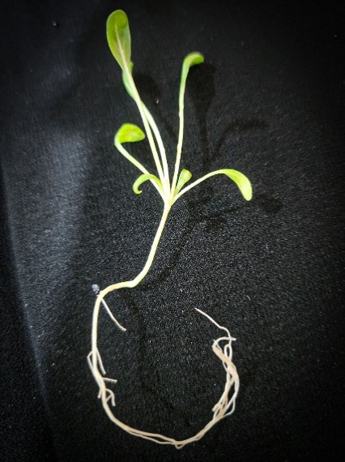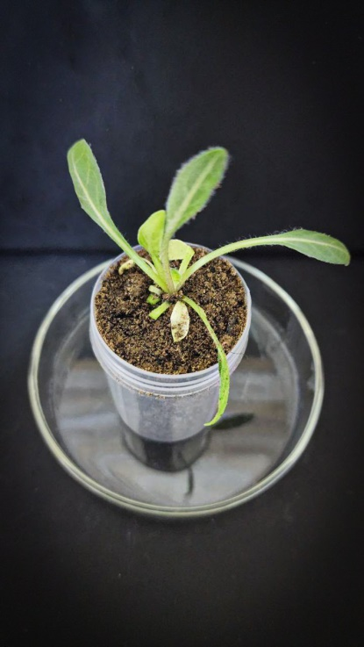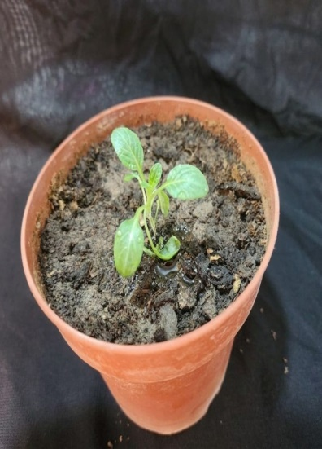
B
C
A

Figure (5): Acclimatization of black henbane plants resulting from callus differentiation of subcotyledonous stems callus of their seedlings
- A model of the complete black henbane plant that was lifted from the medium of the rooting after 20 days of rooting.
- The plant grew in a mix of soil and peatmoss in a plastic container 10 days after (A).
- The black henbane plant grew in a mix of soil and peatmoss in a anvil under greenhouse conditions 7 days after (B).

The process of producing any healthy and vigorous seedlings depends on how efficient the seed surface sterilization process is and planting them in the medium without contamination (Istiandari and Faizal, 2025). Also, the type and concentration of the sterilizing agent and the optimal exposure time play a role in how effective the surface sterilization process is (Sattarov and Kayumov, 2025). Auxins and cytokinins are among the most commonly used growth regulators in plant tissue culture, and they are usually used together to stimulate callus formation. Both types help regulate the cell cycle, with auxin specifically regulating and promoting DNA replication that comes before cell division, and thus directly affecting changes in cell shape and increasing growth in callus tissue cultures (Hassanen and Khalil, 2013; Saeed et al., 2021). Auxins also play a key role in dedifferentiation, reprogramming differentiated cells back into an actively dividing state (Yu et al., 2025), while cytokinins directly stimulate cell division and prevent aging, which helps in forming callus masses (Sosnowski et al., 2023). The presence of auxins in the solid MS growth medium, either alone or mixed with cytokinins, plays a key role in promoting callus formation from subcotyledonous stems segments of plants in the Solanaceae family (Adu Donyina et al., 2025). The results obtained by (Al-Tai and Mohammed, 2024) indicated that the whole leaves of the lavender plant Lavandula angustifolia could induce callus when planted on MS medium supplemented with 3.0 mg L⁻¹ NAA and 10 mg L⁻¹ BA after 20 days at a rate of 96%, whereas the MSO medium failed to promote callus formation. The results of the study conducted by (Mohammad, 2018) revealed the positive role of the growth regulators NAA and Kin in inducing and growing callus from subcotyledonous stems segments cuttings of chamomile seedlings. NAA was used at concentrations of (0, 1.0, 2.0, 4.0) mg L⁻¹ combined with Kin at concentrations of (0, 0.5, 1.0, 2.0) mg L⁻¹, and the best medium for promoting growth was the MS medium containing 1.0 mg L⁻¹ of both NAA and Kin, achieving a percentage of 93.26%. A study on black henbane (Hyoscyamus niger) looked into inducing callus from leaf parts and nodes of its seedlings using different concentrations of intersecting growth regulators in three groups. The first group used 0.5 mg L⁻¹ of 2,4-D and 1.0 mg L⁻¹ of BA, while the second group used 5.0 mg L⁻¹ of both NAA and BA. The third group had 1.0 mg L⁻¹ of 2,4-D and 5.0 mg L⁻¹ of Kin. The results showed that callus induction in the second group from the leaves reached 100%, and the induction rate for the third group was 87% (BiglariFarrash et al., 2024). A study conducted by (Aljibouri et al., 2012) showed that there are significant effects of growth regulators on callus weight and scopolamine compound concentrations in black henbane using 2.0 mg L⁻¹ of BA and 0.5 mg L⁻¹ of NAA. Another study showed the accumulation of alkaloid compounds (scopolamine and atropine) phenols and flavonoids in the callus of black henbane plants in a B5 medium supplied with 2.0 mg L⁻¹ of 2,4-D and 1.0 mg L⁻¹ of BA from growth regulators using 4 different levels of LED light and the amino acid glycine (Giglou et al., 2025). The spontaneous formation of shoots on the same callus induction medium is attributed to the genetic makeup of the plant species used and the efficiency of its cells in forming shoots, as well as the levels of plant hormones within the tissues that triggered differentiation (Sidik et al., 2024). It’s also due to the cells’ inherent totipotency, which allows each cell to produce a whole plant (Babich et al., 2020). The results showed that the ease of rooting green shoots grown on solid MSO medium without growth regulators comes from the plant tissues' ability to produce their own auxins, reaching the ideal concentration that stimulates rooting at the base of the cut shoots. This sometimes makes external addition of growth regulators unnecessary (Mohammed and Al-Mallah, 2013; BiglariFarrash et al., 2024). The solid MSO medium played a key role with its balanced composition, providing major and minor elements in growth-supporting ratios, being free of cytokinins, and containing a suitable nitrogen level. This balance prevents excessive vegetative growth at the expense of root formation, thus providing an ideal environment that the plant cuttings responded to effectively (Bouchiha and Mazri, 2022). Similarly, the source of green branches, represented by spontaneously formed branches, reflects the state of prior physiological readiness. This phenomenon can be explained as an adaptive response to mild stress caused by cutting and planting in a medium free of growth regulators, where plant tissues perceive these conditions as a signal to activate their internal mechanisms to enhance auxin synthesis or increase receptor sensitivity to it, leading to a rapid and widespread rooting response (Larriba et al., 2021).

Conclusions
Black henbane seedlings were successfully established from surface-sterilized seeds on growth-regulator-free Murashige and Skoog medium. Hypocotyl explants formed callus on medium containing 0.5 mg L⁻¹ 2,4-D and 1.0 mg L⁻¹ BA. Following subculture on the same medium, green structures developed into multiple shoots, with a reported regeneration response of 90% among 60 callus pieces. The regenerated shoots rooted on hormone-free MS medium and were subsequently transferred to a soil–peat mixture for acclimatization. These observations demonstrate that hypocotyl-derived callus can support the regeneration of complete H. niger plants under the tested laboratory conditions. Further replicated experiments are required to evaluate protocol consistency, acclimatization survival and genetic stability.

Limitations
The investigation tested only one growth-regulator combination and did not include hormone-free or alternative-treatment controls for callus induction and shoot regeneration. Complete sample sizes were not reported for germination, callus induction, rooting and acclimatization, and no statistical measures of variation were provided. Plant identity and genetic fidelity were not confirmed using voucher, cytological or molecular methods. Alkaloid production was not measured. Acclimatization success was described qualitatively without a survival percentage or long-term greenhouse assessment.

Declaration of AI Use

This manuscript was prepared through the combined contributions of all author(s), including contributions to the study design, data, content development, results, interpretation, and related scholarly work. The author(s) acknowledge the use of Grammarly and ChatGPT to assist with grammar checking, language refinement, reference formatting. These AI-assisted tools were not used as authors and did not replace the intellectual contributions or scholarly judgment of the author(s). All AI-assisted outputs, including content, references, and interpretations, were carefully reviewed, revised, verified, and approved by the author(s). The author(s) accept full responsibility for the accuracy, integrity, and final content of the manuscript.

References

Abdalla, N., El-Ramady, H., Seliem, M. K., El-Mahrouk, M. E., Taha, N., Bayoumi, Y., and Dobránszki, J. (2022). An academic and technical overview on plant micropropagation challenges. Horticulturae, 8(8): 677.‏
Abed, A. S. and Jassim, E. H. (2024). Enhancement of the production of tropane alkaloids in the Hyoscyamus niger L. callus using different biotic elicitors. Iraqi Journal of Science, 4993-5004.‏
Adu Donyina, G., Szarvas, A., Opoku, V. A., Miko, E., Tar, M., Czóbel, S., and Monostori, T. (2025). Enhancing sweet potato production: a comprehensive analysis of the role of auxins and cytokinins in micropropagation. Planta, 261(4): 1-14.‏
Aljibouri, A. M. J., Al-samarraei, K. W., Abd, A. S., Mageed, D. M., and Ali, A. J. A. (2012). Alkaloids production from callus of Hyoscyamus niger L. in vitro. Journal of Life Sciences, 6(8): 874.
Al-Tai, A. A., and Mohammed, A. A. H. (2024). Germination of lavender (Lavandula angustifolia) plant seeds and production of its seedlings callus cultures. Malaysian Journal of Microbiology, 20(6):(p.p 36 -39).
Babich, O., Sukhikh, S., Pungin, A., Ivanova, S., Asyakina, L., and Prosekov, A. (2020). Modern trends in the in vitro production and use of callus, suspension cells and root cultures of medicinal plants. Molecules, 25(24): 5805.‏
Bapat, V. A., Kavi Kishor, P. B., Jalaja, N., Jain, S. M., and Penna, S. (2023). Plant cell cultures: biofactories for the production of bioactive compounds. Agronomy, 13(3): 858.
Bejenaru, C., Radu, A., Mogoşanu, G. D., Bejenaru, L. E., Biţă, A., and Segneanu, A. E. (2024). Solanaceae Adans. Family. In Natural Products and Medicinal Properties of Carpathian (Romanian) Plants (pp. 430-444). CRC Press.
BiglariFarrash, R., Kheiri, A., and SaniKhani, M. (2024). The Use of Leaf and Internode Explants and Different Combinations of Growth Regulators for Callus Formation, Regeneration and Root Formation of Black Henbane (Hyoscyamus niger L.). Journal of Research, 1(4): 93.
Bouchiha, F., and Mazri, M. A. (2022). Micropropagation du cactus (Opuntia ficus indica) par organogenèse. African and Mediterranean Agricultural Journal-Al Awamia, (135): 1-15.
Brancato, C., Heusch, N., and Berendzen, K. W. (2025). Compendium of Agrobacterium-Mediated Tissue Culture Transformation Methods of Various Solanaceae Species. Methods and Protocols, 8(5): 107.
Chaachouay, N., and Zidane, L. (2024). Plant-derived natural products: a source for drug discovery and development. Drugs and Drug Candidates, 3(1), 184-207.
D’Amelia, V., Docimo, T., Crocoll, C., and Rigano, M. M. (2021). Specialized metabolites and valuable molecules in crop and medicinal plants: The evolution of their use and strategies for their production. Genes, 12(6): 936.‏
Fazili, M. A., Bashir, I., Ahmad, M., Yaqoob, U., and Geelani, S. N. (2022). In vitro strategies for the enhancement of secondary metabolite production in plants: a review. Bulletin of the National Research Centre, 46(1): 35.
Giglou, R. H., Giglou, M. T., Sobhanizadeh, A., and Szumny, A. (2025). Enhancing the accumulation of scopolamine and atropine in Hyoscyamus niger L. callus by LED light and glycine-a cheap method. BMC Plant Biology, 25(1): 1162.
Hassanen, S. A., and Khalil, R. M. (2013). In vitro production and biochemical analysis of silymarin from Silybum marianum plant. World Appl. Sci. J, 22(1): 26-34. http://dx.doi.org/10.5829/idosi.wasj.2013.22.01.2959
Isah, T., Umar, S., Mujib, A., Sharma, M. P., Rajasekharan, P. E., Zafar, N., and Frukh, A. (2018). Secondary metabolism of pharmaceuticals in the plant in vitro cultures: strategies, approaches, and limitations to achieving higher yield. Plant Cell, Tissue and Organ Culture (PCTOC), 132(2), 239-265.‏
Istiandari, P., and Faizal, A. (2025). Integrating In Vitro Cultivation and Sustainable Field Practices of Sacha Inchi (Plukenetia volubilis L.) for Enhanced Oil Yield and Quality: A Review. Horticulturae, 11(2): 194.‏
Kareem, Z. J. (2020). Biomedical applications and secondary metabolite profiling of Hyoscyamus niger and Sesamum indicum seed, root and hairy root cultures (Doctoral dissertation, Georg-August-Universität Göttingen).‏
Khalafalla, M. M. (2025). Plant cell suspension culture for plant secondary metabolite production: Current status, constraints, and future solutions. Pol. J. Environ. Stud, 10: 1-14.
Khezri, M., Asghari-Zakaria, R., and Zare, N. (2024). Plant cell and tissue culture: propagation, improvement, and conservation of medicinal plants. In Biosynthesis of Natural products in plants: Bioengineering in Post-genomics Era (pp. 267-291). Singapore: Springer Nature Singapore.‏
Larriba, E., Sánchez-García, A. B., Justamante, M. S., Martínez-Andújar, C., Albacete, A., and Pérez-Pérez, J. M. (2021). Dynamic hormone gradients regulate wound-induced de novo organ formation in tomato hypocotyl explants. International Journal of Molecular Sciences, 22(21): 11843.
Malabadi, R. B., Chalannavar, R. K., and Kolkar, K. P. (2025). Plant cell totipotency: Plant tissue culture applications-An updated review. World Journal of Advanced Engineering Technology and Sciences, 16(02): 112-135.
Mishra, S., Ekka, S. K., Kushwaha, A., and Kujur, R. (2024). A review on plant tissue culture. Asian J. Biol, 20(2): 14-18.
Mohammad, A (2018). The effect of different concentrations of growth regulators and the type of explants on embryogenesis and rooting of german chamomile (Matricaria chamomilla L.). J. Pure Appl. Microbiol., 12(3):1281-1287.
Mohammed, A. and M. Al-Mallah, (2013). Determination of β-carotene in Carrot (Daucus carota L.) plants regenerated from stems callus. Rafidain Journal of Science, 24(5): 27-36.
Mohammed, N. J., Al-Behadili, W. A. A., ana Al-fahham, A. A. (2024). The chemical structure, classification and clinical significance of alkaloids. Int. J. Health Med. Res, 3, 760-764.
Murashige, T. and Skoog, F. (1962). A revised medium for rapid growth and bioassay with tobacco tissue culture. Physiol. Plant., 15(3): 473 -479.
Niazian, M. (2019). Application of genetics and biotechnology for improving medicinal plants. Planta, 249(4): 953-973.
Nwozo, O. S., Effiong, E. M., Aja, P. M., and Awuchi, C. G. (2023). Antioxidant, phytochemical, and therapeutic properties of medicinal plants: A review. International Journal of Food Properties, 26(1): 359-388.
Okoroafor, U. E. (2022). Microbial contamination in plant tissue culture and elimination strategies. Nigeria Agricultural Journal, 53(2): 348-355.
Pasternak, T. P., and Steinmacher, D. (2024). Plant growth regulation in cell and tissue culture in vitro. Plants, 13(2): 327.
Saeed, F., Younas, M., Fazal, H., Mushtaq, S., Rahman, F. U., Shah, M.,... and Abbasi, B. H. (2021). Green and chemically synthesized zinc oxide nanoparticles: Effects on in-vitro seedlings and callus cultures of Silybum marianum and evaluation of their antimicrobial and anticancer potential. Artificial Cells, Nanomedicine, and Biotechnology, 49(1): 450-460. https://doi.org/10.1080/21691401.2021.1926274
Salaria, N., Kumari, I., and Kumar, R. (2026). Tissue Culture Technology: An Emerging Viable Technology to Protect Biodiversity in the Face of Biodiversity Loss. In Plant Tissue Culture Technology (pp. 73-98). Apple Academic Press.
Sattarov, A. N., and Kayumov, F. S. (2025). Research On Methods For Introducing White Seed (Silybum Marianum) In Vitro Culture. Естественные науки в современном мире: теоретические и практические исследования, 4(5): 57-58. https://doi.org/10.5281/zenodo.15210804
Shim, K. H., Kang, M. J., Sharma, N., and An, S. S. A. (2022). Beauty of the beast: anticholinergic tropane alkaloids in therapeutics. Natural Products and Bioprospecting, 12(1), 33.
Sidik, N. J., Agha, H. M., Alkamil, A. A., Alsayadi, M. M. S., and Mohammed, A. A. (2024). A Mini review of plant tissue culture: the role of media optimization, growth regulators in modern agriculture, callus induction and the applications. AUIQ Complementary Biological System, 1(2): 96-109.‏
Sosnowski, J., Truba, M., and Vasileva, V. (2023). The impact of auxin and cytokinin on the growth and development of selected crops. Agriculture, 13(3): 724.
Taha, A. (2023). Photoperiod and UV light influence secondary metabolites of Hyoscyamus niger callus induced from leaves. Journal of Biotechnology Research Center, 17(2): 16-26.‏
Twaij, B. M., Jazar, Z. H., and Hasan, M. N. (2020). Trends in the use of tissue culture, applications and future aspects. International Journal of plant biology, 11(1).
Wang, J., Li, J. L., Li, J., Li, J. X., Liu, S. J., Huang, L. Q., and Gao, W. Y. (2017). Production of active compounds in medicinal plants: from plant tissue culture to biosynthesis. Chinese Herbal Medicines, 9(2): 115-125.‏
Wen, M., Zeng, J., Qiu, F., Zhang, F., and Liao, Z. (2024). De Novo Synthesis of Anticholinergic Hyoscyamine and Scopolamine in Nicotiana benthamiana Based on Elucidating Tropane Alkaloid Biosynthetic Pathway of Anisodus luridus. Agronomy, 14(11): 2460.‏
Yu, X., Hou, Y., Zhang, W., Gong, H., Liu, B., Song, X., and Zhu, J. (2025). Optimization of Somatic Embryogenesis and Transcriptomic Analysis of the Early Stage of Callus Redifferentiation in Quercus suber L. Plants, 14(18): 2855.

