Original Research Article

Nexus Between Rural Electrification, Climate Change Mitigation, and Socioeconomic Outcomes in Malawi

Abstract
The significance of access to clean and affordable energy is indispensable not only to the improvement of livelihood standards but also to the successful promotion of Climate Change adaptation, mitigation and resilience. This study examined how providing electricity through the Malawi Rural Electrification Program (MAREP) to a rural community influence people’s livelihood and, at the same time, help reduce activities that contribute to climate change in Mwaye Village of Balaka district in Malawi. Snowball sampling, saturation method, and structured questionnaires were used to collect data. The data collected was subjected to chi-square test. The results indicate that the socioeconomic benefits attributed from rural electrification significantly (X²=46.32; P<0.05) differed. The main socioeconomic benefits were: improved health service delivery (80.1%); income generation (76.5%); job opportunities (72.3%); and rural enterprise creation (71.4%). The other socioeconomic benefits identified are: enhanced education services (56.1%); community development (52.6%); and youth empowerment (50.3%). The results further show that the socioeconomic improvements significantly (X²=54.85; P<0.001) differed on climate change adaptation outcomes. The results show carbon footprint reduction through a reduction in dependency on fossil fuel-powered maize mills and generators (90.4%); reduced climate related health risks (75.2%); reduced reliance on firewood and charcoal for energy (50.6%); and enhances climate change adaptation by community adaptive capacity (82.3%); and drought resilience (74.8%) to climate variability and extremes. The study has demonstrated that rural electrification significantly improves livelihoods while reducing emissions and strengthening community adaptation and resilience, signifying its dual role in climate change mitigation and adaptation in rural communities. Considering these findings, the study recommends the continuation and expansion of electricity distribution to rural areas in Malawi, thus for the socioeconomic and environmental gains.

Key words: Rural electrification, socioeconomic, Climate Change, Carbon Footprint, Livelihoods.

1.0 Introduction
Access to clean and affordable energy is widely recognized as a fundamental driver of socioeconomic development and a key enabler of climate change mitigation and adaptation in developing countries [1]. Within this broader context, rural electrification programs in Sub-Saharan Africa are increasingly examined for their potential to simultaneously improve livelihoods while reducing dependence on carbon-intensive and environmentally degrading energy sources [2]. Rural electrification programs are essential in influencing livelihoods and contributes to reducing climate change–related activities in a rural community [3].

Recent studies show that people-centered clean-energy transition initiatives achieved through either local energy communities or community-based energy projects garner clear global benefits [4]. Despite these developments, rural areas of developing countries (Malawi inclusive), often face significant challenges in terms of energy access, particularly electricity, thereby limiting their potential for economic growth and overall well-being [3]. However, addressing energy provision and access in Sub-Saharan Africa has proven to be a key challenge (ibid).

Records indicate that approximately half of the 1.2 billion African population lacks access to electricity and the large electricity deficit has been identified as one of the barriers to development on the continent, especially in rural communities [5]. Being a party to the Low-Middle-Income Country (LMIC), Malawi is no exception, and statistics portray that its population’s access to electricity was as low as 11% by 2019, worse-still > 90% of her population depends on firewood and charcoal for energy and lighting [6,7].

The Intergovernmental Panel on Climate Change (IPCC) warned about the lack of preparedness and suitability of human systems for climate change where key infrastructure systems including energy, sanitation, water, health, transport, and communications will be increasingly vulnerable if design standards do not account for changing climate conditions [8]. This is of particular concern to the rural communities of Malawi which are vulnerable to poverty and energy challenges [3]. Despite these statistics, there is limited empirical evidence linking poverty and energy challenges to climate change mitigation and adaptation in Malawi [9].

Of striking interest is the Southern Region of Malawi (Balaka district inclusive) which bears the highest national population and population density (44% and 244 persons per m²), respectively [9]. The region has been vulnerable to devastating disasters, i.e. the 2013 Cyclone Freddy that claimed more than half a million lives and displacing others between 11-15 March 2023 yet despite being an early beneficiaries of rural electrification schemes, no deliberate study has tried uncover how the access to electricity has impacted the socioeconomic and climate change aspects and their interplay [3,9,10].

Current statistics reveal that the Malawi bears the lowest average population access to electricity in Southern Africa (7.2%), followed by the Republic of Democratic Republic of Congo (7.8%) and Tanzania (8.8%) [3]. Notwithstanding this predicament, the Government of Malawi (GOM) through the Malawi Rural Electrification Programme (MAREP) embarked on increasing access to electricity in peri-urban and rural areas of Malawi [11]. Rolled out in 1980, MAREP aimed to; reduce poverty, transform rural economies, and improve commodity productivity besides up scaling the quality of social services, thus following the 2004 Rural Electrification Act [11]. The scheme has been implemented in stages, i.e., with phases 4, 5, and 8 electrifying 97, 27, and 54 trading centres, respectively, while the target across the country was to provide electricity access to 636 trading centres/public institutions by 2022 [11,12]. However, lacking in reporting these strides has been the tangible socioeconomic benefits accrued under MAREP thus at the village level plus their contribution to Climate Change.

In-depth studies reveal that reliable and affordable access to electricity has become one of the basic needs for humans and as such, remains a key priority of the development agenda [2,13]. Research has further demonstrated that steadfast and cost-effective electricity contributes to socio-economic development by transforming the whole spectrum of people’s lives food, education, and healthcare, not to mention spurring new economic opportunities [2,13,14].

Findings of key research on electrification and development of poor, rural communities revealed that electricity access is closely correlated to socio-economic development because it facilitates business start-ups and production improvements, employment, value-added creation along the production value chain, and health delivery among other social and economic services [15]. However, this has not been adequately explored in rural areas in Malawi. Available records in Malawi, arguably, indicate few studies have revealed the incapacity of the country to either meet the clean energy demand of its booming population size (as the access to electricity remains at 13.4%) or suffice its wood fuel demand perched at 13.3 million metric tons of dry matter by 2021 [3,6]. Nevertheless, it is unfortunate that these studies did not make further effort to link the energy demand and utilisation to climate change mitigation.

It is against this background that a study was conducted to examine how providing electricity through the Malawi Rural Electrification Program (MAREP) to a rural community influence people’s livelihood and, at the same time, help reduce activities that contribute to climate change in Mwaye Village of Balaka district in Malawi. Specifically, the study addressed the following research questions: (1) What are the socioeconomic benefits of rural electrification? (2) How do socioeconomic improvements influence climate change adaptations outcomes? The study highlights rural electrification as a strategic intervention for improving livelihoods, reducing emissions, and strengthening climate adaptation, supporting policy expansion of clean energy access in rural Malawi and Sub-Saharan region.

2.0 Methods and Materials
2.1 Study area
The study site, Mwaye Village is in the jurisdiction of Traditional Authority Mbela in Balaka, one of the Southern Region districts in Malawi (Figures 1 and 2). The district is located on Latitude 14⁰59‘15.38“S and Longitude 34⁰57‘22.23“E (Figure 1) and covers an area of 2,193 km² [11]. It borders Ntcheu to its northwest, Mangochi to the north, Machinga to the east, Zomba to its southeast, Blantyre to the south, and Neno to the southwest, (Figure 1). It is relatively ~130km to the north of Blantyre, and 200km south of Lilongwe, Malawi’s commercial and capital cities, respectively (ibid).

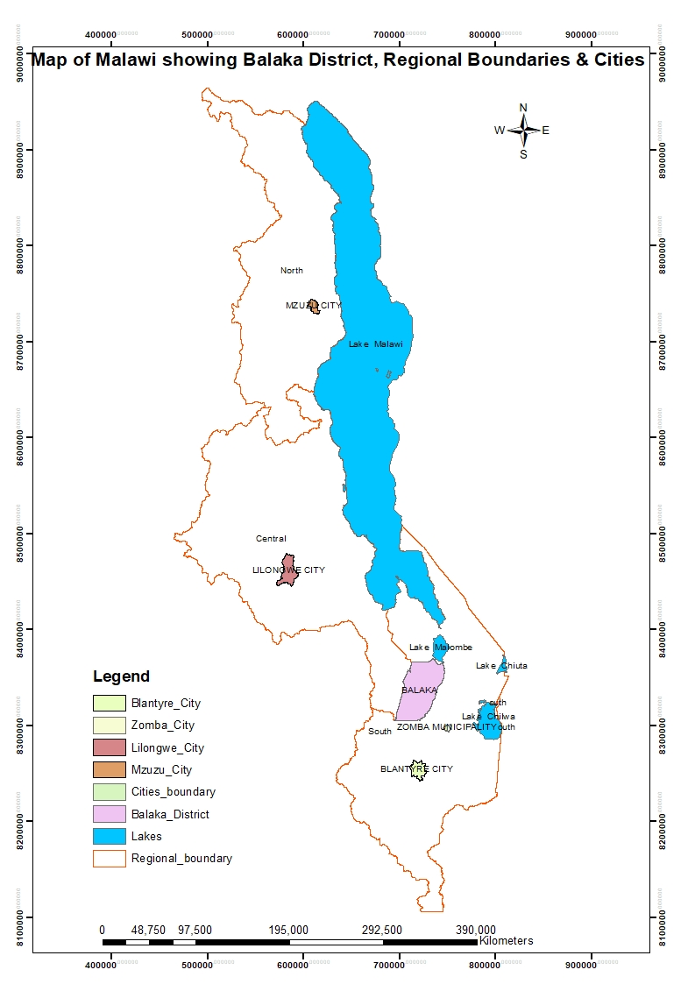
Figure 1. Map of Malawi Showing Balaka District, Regional Boundaries, and Cities.
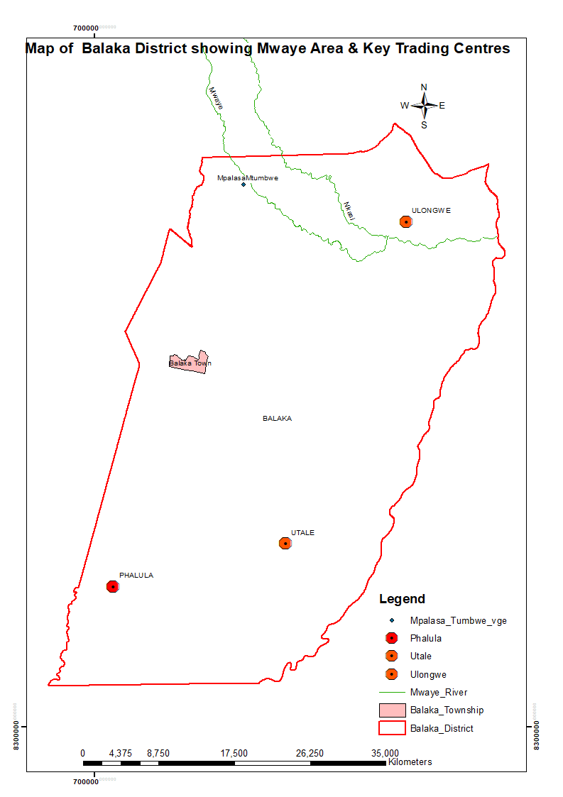
Figure 2. Map of Balaka District and Township Showing Mwaye Area and Key Trading Centres.

Balaka experiences a tropical semi-arid climate characterized by; (i) alternating dry winter and scorching summer-wet seasons, (ii) a mean annual rainfall of 750mm typified by an optimal period for rain-fed agricultural production between December and March, thus when soils are moist, and (iii) a yearly average temperature range of 19-380C. Its economy is primarily based on commercial crops such as cotton and tobacco, while maize, beans, and other pulses are the main food crops [16]. With a population of over 310,000 persons, the district's main township (Balaka) serves as a growing commercial center along the road from Zomba to Lilongwe and the Blantyre–Salima railway line [9].

However, Mwaye village (hereafter simply named as ‘Mwaye’ for the purpose of this study), ~25km to the northeast of Balaka Township is connected by an earth road passing through Kachenga Trading Centre. The village falls under Ulongwe Extension Planning Area (EPA) and its topography is characterised by hilly terrain, endowed with 54 hectares of indigenous forest area. Mwaye is surrounded by lush green fields that render agriculture a key income-generating activity. The activity benefits from the Mwaye River whose source is traced from the mountainous uplands of Chilipa and provides a steady and perennial source of water for the crops.

This study purposively selected Mwaye Village, under Traditional Authority Mbela, as the study site for two main reasons. First, Mwaye was among the earliest villages connected to the national electricity grid in 2019 under MAREP Phase 8, providing sufficient time to observe socioeconomic impacts compared to more recent beneficiary areas. Second, its location, approximately 25 km from the main district grid, near a forest reserve, and characterized by small-scale farming supported by perennial rivers (Figure 2), offers an appropriate setting to examine how rural electrification can enhance livelihoods while also contributing to environmental conservation in the context of climate change.

2.2 Sampling Technique and Data Collection
This study employed a non-probability sampling strategy, combining purposive and snowball sampling techniques to identify participants with direct experience of rural electrification under the Malawi Rural Electrification Programme (MAREP). Initial respondents were purposively selected based on their residence in electrified households and their presumed knowledge of local livelihood changes. These participants subsequently referred other eligible respondents, enabling access to a broader network within the community where no comprehensive household sampling frame exists [17].

While snowball sampling facilitated efficient identification of information-rich participants in a close-knit rural setting, it is acknowledged that this approach may introduce selection bias and limit the representativeness of the sample. Consequently, findings from this study are interpreted as context-specific and exploratory, rather than statistically generalizable to wider populations [18].

Data collection proceeded until thematic saturation was reached, defined as the point at which additional interviews yielded no substantially new insights. Saturation was used as a guiding principle to ensure adequate coverage of recurring themes, particularly regarding perceived socio-economic changes associated with electrification [17].

Primary data were collected using a structured questionnaire administered through face-to-face interviews with 72 respondents in September 2023. The instrument comprised both closed-ended and limited open-ended questions designed to capture: (i) household socio-economic characteristics, (ii) perceived benefits associated with rural electrification, and (iii) self-reported changes in practices potentially with climate adaptation and mitigation (e.g., energy use patterns, livelihood activities).

Prior to the main survey, the questionnaire was pre-tested in a neighbouring rural community to assess clarity, relevance, and respondent comprehension. Feedback from the pre-test informed revisions to ambiguous or unclear items, thereby improving the reliability and consistency of responses. Given the reliance on self-reported perceptions, this study does not directly measure climate change mitigation, adaptation, or resilience outcomes. Instead, it captures respondents’ experiences and reported behavioural changes that may be associated with these processes. As such, any inferences regarding climate-related impacts are interpreted with caution and framed as perceived or indicative relationships, rather than definitive causal effects. The study received approval from CUNIMA research ethics committee No. 2023/078.

2.3 Data Analysis
Data analysis was carried out using SPSS version 25.0 for Windows and Microsoft Excel to generate descriptive statistics (frequencies/proportions). The Chi-square (X²) test was used to assess differences between the variables, and values of P≤0.05 were considered as significant. The Chi-square (X²) test was used because of its ability to analyse enumerative data.

3.0 Results and Discussion
3.1 Socioeconomic Benefits of MAREP
Summary of the results on the socioeconomic benefits arising from MAREP are presented in Figure 3. The results indicate that the socioeconomic benefits attributed from rural electrification significantly (X²=46.32; P<0.05) differed. The main socioeconomic benefits were improved health service delivery (80.1%); income generation (76.5%); job opportunities (72.3%); and rural enterprise creation (71.4%). The other socioeconomic benefits identified are enhanced education services (56.1%); community development (52.6%); and youth empowerment (50.3%).

Figure 3. The socioeconomic benefits arising from MAREP
(X²=46.32; df=6; P<0.05)
3.1.1 Improved Health Service Delivery
The respondents stated that improvement of health service delivery is one of the crucial aspects of the positive impacts brought about by MAREP. This conforms to the key research findings on rural electrification in Malawi which observed that essential services in health are significantly enhanced with increased access to electricity in rural areas [19]. Research has further disclosed that with respect to health services, electrification allows for; (i) proper functioning of equipment, (ii) refrigeration of vaccines and medications, and (iii) availability of lighting for healthcare facilities [19,20]. In tandem with such assertion, the same was also observed during this study in Mwaye.

Furthermore, it has been noted that electricity leads to better healthcare delivery, timely diagnoses, augmentation of diagnostic capabilities and overall, improved health outcomes for a community [19,20]. In Mwaye, besides enhancing the provision of healthcare services, it was affirmed that electrification vividly improved communication through timely reporting of emergency cases which ultimately results in improved overall health outcomes for the locals.

As a result of being connected to electrification, it was sufficient reported during data collection of this study that Chilipa Health Centre which was equipped with a refrigerated drugstore that caters for vaccines and medications storage even for Mwaye highly benefits from MAREP. This is in sharp contrast to the era when the area was not connected to electricity and it was not possible to store drugs and vaccines whose lifespan is dependent of prescribed temperature provided by refrigeration, thus a as inferred from the respondents.

The interviews further revealed that expectant females were previously instructed to bring candles or torches for lighting, especially during delivery at the same health centre. However, the installation of electricity in the maternity ward has improved not only the lighting condition, but it has remarkably reduced costs incurred (as the candles and torches are comparatively expensive).

3.1.2 Income Generation and Value Addition
According to the Mwaye respondents, electricity facilitates the use of small-scale but advanced machinery and equipment such as fridges, groundnut mills, grinding machines leading to improved product quality such as freezes, cookies from groundnut and maize flour, non-alcoholic beverage (popularly known as Thobwa) and knives and panga for domestic and gardening purposes (Figure 4). The manufacturing, processing and storage/preservation of these would have not been possible without electricity.

Consequently, the value addition process has enhanced the small-scale businesses reputation and competitiveness within the local context of Mwaye compared to the adjacent rural markets of the area. A study conducted a study in one of the low-income countries, precisely rural India established that households with access to electricity had higher levels of income and were more likely to engage in income-generating activities compared to those not connected to electricity [21]. In Mwaye, there is creation of income-generating activities such as agricultural processing and value addition by making groundnut flour and local nutritious juices such as ‘Malambe juice’ (made from baobab fruits). A certain female respondent said that her son sent a fridge and a popcorn machine from South Africa (Figure 4)

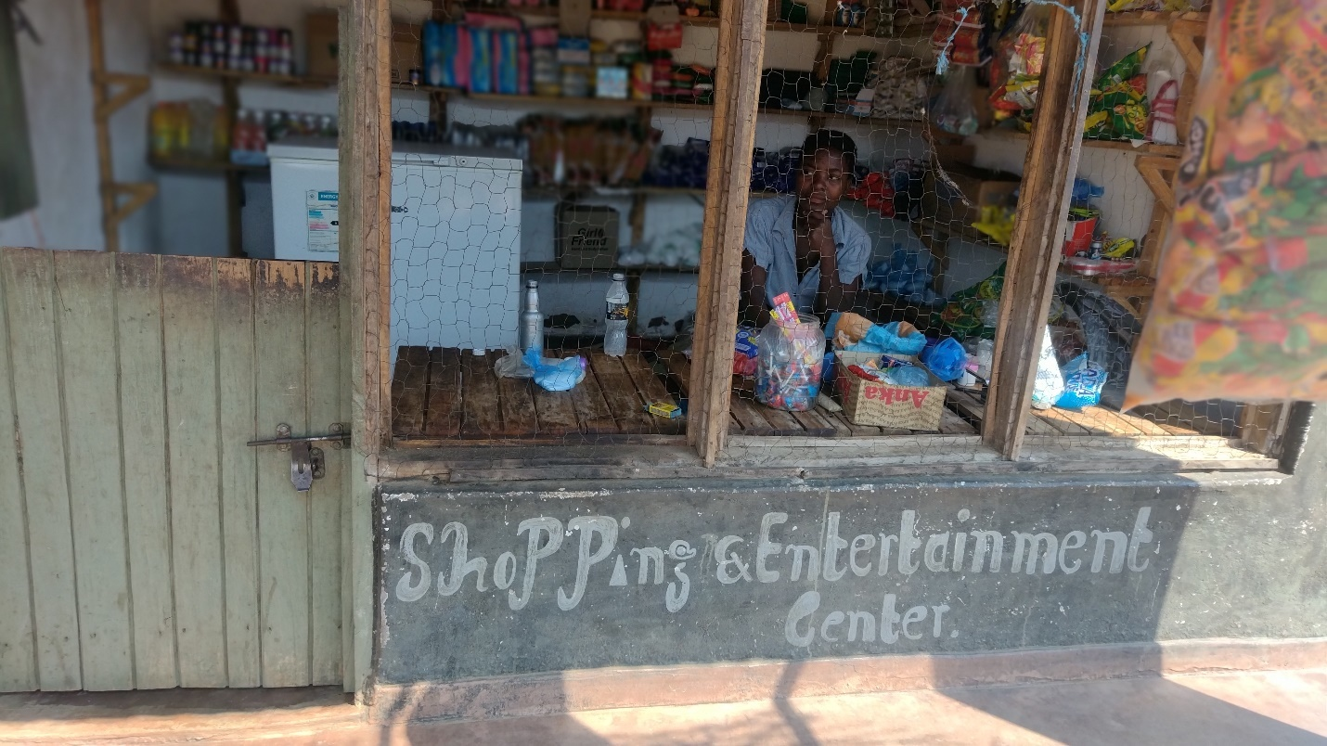
Figure 4. Income Generation and Value Addition in Mwaye: A female respondent owning a grocery that stocks value-added drinks and beverages using a refrigerator that uses Hydrofluorocarbons (HFCs) gas, an environmentally friendly gas that reduces carbon foot.
The responded revealed that because of the refrigerator she makes relatively good income since she is able to sell added value drinks as follows; ‘On normal days, the responded of the shop (Figure 4) disclosed that she makes between Five to Eight Thousand Malawi Kwacha (an equivalent of $10) each day from the sales of cold drinks, Thobwa and popcorn only. She further indicated that ‘On market days, her sales increase to around Fifteen to Twenty Thousand Malawi Kwacha (a maximum of $20). Additionally, she has a tenant on the veranda of the shop, who pays rent at the end of every month. This adds income to her normal business.

Though the respondent did not disclose the amount that she collects from the monthly rentals, the daily income from the drinks, though look miniature is relatively considerable, at least by the current Malawian local standards, since the countries’ GDP per capita keeps tumbling thus from $640.7 in 2023 to below the world’s average this year, thus $557.5 in Malawi [22].

3.1.3 Job Creation / Opportunities
Findings of the Mwaye respondents also proved that initiatives focusing on establishing diverse income sources play a crucial role in improving the financial well-being of individuals and communities through job creation. In Mwaye, it was noted that a certain young male works as a maize mill manager (Figure 5) whose proprietor is based in Balaka town. During the administering of questionnaires, it was disclosed that the manager earns a monthly salary that contributes to the well-being of his family, ensuring a contented and happy life but he also able to employ the maize miller, a mechanic and an electrician who maintain the mill. A robust study on electricity consumption and economic growth across 88 countries observed that access to electricity facilitates the growth of job creation in rural areas across diverse contexts [23,24].

On the other hand, it was further revealed that the existence of the mill in Mwaye also saves time on the part of the community members because they comparatively, do not walk long distances to have this service in nearby villages. The locals further revealed that they no longer needed to manually grind maize using wooden pestle and mortar to turn into flour as they used to. This traditional means required considerable human effort and time to process the flour comparatively to the electric maize mill in Mwaye.

3.1.4 Rural Enterprise Creation
The respondents in Mwaye further acknowledged that due to electrification, they have established diverse enterprises such as the hairdressing shops, mobile and car battery charging points, shops with refrigerators, welding and tailoring shops (Figure 6). This is in comparison to relying substantially on traditional rainfed Agriculture which is often weather dependent and of late has become risky in Malawi, thus in the light of drought, dry spells and other climate-related disasters [25]. In line with this, a study on electrification in another LDC, thus Zimbabwe, revealed that electrification programmes stimulated income-generating activities and contributed to poverty reduction even during times of extreme weather conditions [26].

In agreement with these findings, another separate but pivotal study that focused on electrification in the same country recommended that income-source diversification (manufacturing, irrigation and mining inclusive) helps in mitigating economic risks while at the same-time enhanced resilience against external shocks [26,27]. In this respect, in Mwaye, it was further revealed that the process of setting up and managing rural enterprises has further encouraged skill- development and capacity building within the community. Local traders in Mwaye who established welding shops and run hairdressing shops where they combine with charging mobile phone batteries at a fee revealed that the enterprises have proven lucrative and generate income consistently, thereby providing financial stability. It was further mentioned that the success of such income-generating activities has also allowed them to cover expenses such as school fees for their children’s primary and secondary schools, i.e., social development, tuition, and boarding fees.

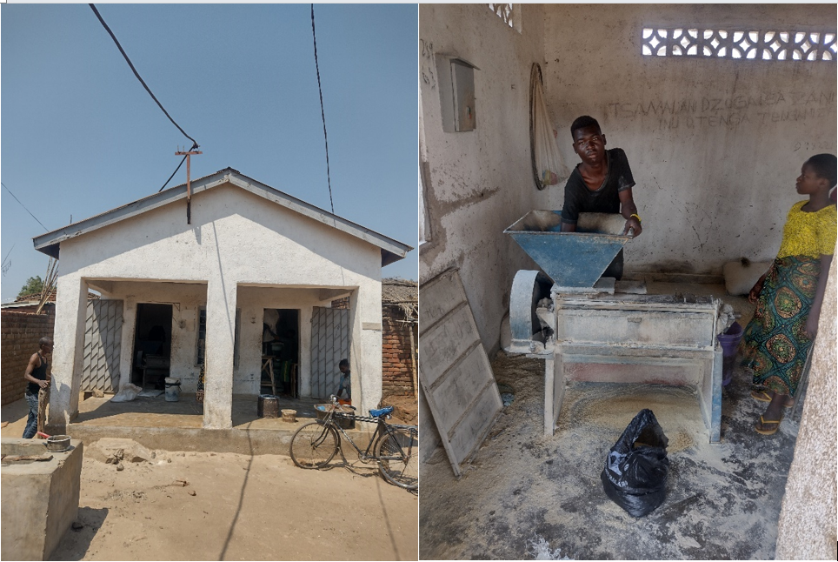
Figure 5. A Maize Mill in Mwaye offers an example of Job Creation: The existence of a maize mill has created jobs to the owner (self-employment), the miller, a mechanic and an electrician who repair it.
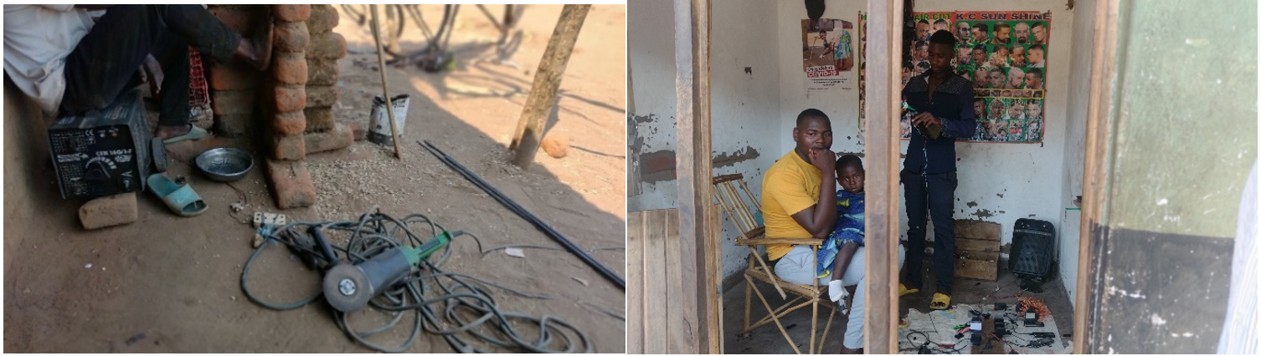
Figure 6. Rural Enterprise Creation in Mwaye due to Access to Electricity: Welding Shop (Left) and Hair Dressing Shop (Right) that combines Charging of Mobile Batteries at a Fee.

3.1.5 Enhanced Education Services
The findings from the Mwaye respondents endorsed that teacher retention is influenced by a combination of factors that contribute to job satisfaction, professional growth, and a positive workplace environment and out of these electricity plays a crucial role. In the same vein, key studies conducted in one of the Least Developed Countries (LDCs), thus Bangladesh, established that access to electricity significantly improves education outcomes [28,29]. In agreement with these findings, it was further revealed in Mwaye that students afford to study in the evenings without the need for candles or torches anymore due to the electrification of the village. The studies further noted that education institutions that prioritise these elements are more likely to retain experienced and dedicated teaching staff (ibid).

Analysis of policy interventions to attract and hold nurse- midwives in rural areas of Malawi discovered that electricity installation of houses and workplace is a critical aspect in retaining health workers in rural areas [30]. A separate study focusing on energy noted that high teacher retention rates contribute to institutional continuity, improved student outcomes and the overall positive culture of a school or educational organisation [28]. In this regard, during this study, it was inferred from the teacher’s responses that teachers at the Mwaye Primary School, despite being rural, teachers are satisfied with their job due to the favourable work environment as result of being connected to electricity. Part of this was manifested in some teachers’ responses which indicated that despite residing in the Mwaye remote area disclosed that they had enrolled for further studies at one the reputable higher learning institutions in Malawi, thus Mzuzu University because they could manage their programmes through online means (Open Distance electronic Learning) at their homes due to access to electricity.

3.1.6 Community Development
In Mwaye, the respondents disclosed that energy access is closely linked to community development initiatives perceivably through enhanced access to essential services i.e., (i) access to education through increased primary and secondary school enrolment and pass rate, (ii) healthcare facilities (health centre and mobile clinics), and (iii) community centres (recreation halls, churches and assembly halls). A key study in developing countries found that rural electrification plays a crucial role in fostering community development and resilience by supporting local economic activities [31]. The study also indicated that reliable electricity powers essential services such as schools, healthcare facilities and community centres, thereby enhancing access to education, healthcare, and social services (ibid). During this study, this was inferred to potentially promote the overall welfare of the locals in Mwaye.

In addition, electrification in Mwaye was reported to have given rise to the establishment of welding shops which cater for the maintenance of bicycles, motorbikes, window and door frames, hoes and axes plus other related farm tools and equipment. The development was further analysed to have facilitated transportation and infrastructure development in Mwaye.

Besides, electrification of Mwaye was analysed to have made digital banking accessible to locals who boasted of transacting ‘village saving loan’ contributions through an online platform locally known as ‘Airtel money’ service. In line with this assertion, another key study in Malawi observed that unconditional social cash transfer payments, (principally done through digital banking as well) contribute to improved energy access for the ultra-poor and eventually their livelihoods [1].

3.1.7 Youth Empowerment
The respondents in Mwaye highlighted that with the access to electricity, young individuals have been able to engage in various income-generating activities afore-mentioned, thereby distracting them from immoral behaviour such as drug, alcohol and substance abuse. The youth’s engagement has provided them with a meaningful role in the community's development process. This newfound involvement in economic activities is perceived to not only foster a sense of empowerment among the youth, but it also contributes to the overall resilience and progress of the community.

An assessment of the performance of the MAREP indicates that the programme contributes to the overall technological advancement of the community and helps bridge the urban-rural technological gap [32]. Another study focusing on the access to electricity in the rural areas of Alem and Söderbom in Ethiopia revealed that electrification creates opportunities for youth entrepreneurship, education, and skill development, leading to improved economic prospects and empowerment [33]. The study further noted that introducing electricity in these rural areas has significantly empowered numerous youths by creating opportunities for active participation in economic activities (ibid). Similarly, in Mwaye, the youth are empowered by fulfilling their needs by running small-scale businesses that are powered by electricity such as barbershops, video/film showrooms, welding shops and groceries with refrigerators.

3.2 Influence of Socioeconomic Improvements on Climate Change Adaptation Outcomes
Summary of the results on the influence of socioeconomic improvements on climate change adaptation outcomes are presented in Figure 7. The results show that the socioeconomic improvements significantly (X²=54.85; P<0.001) differed on climate change adaptation outcomes. The results show carbon footprint reduction through a reduction in dependency on fossil fuel-powered maize mills and generators (90.4%); reduced climate related health risks (75.2%); reduced reliance on firewood and charcoal for energy (50.6%); and enhances climate change adaptation by community adaptive capacity (82.3%); and drought resilience (74.8%) to climate variability and extremes.

Figure 7, Influence of Socioeconomic Improvements on Climate Change Outcomes
(X²=54.85; df=4; P<0.001)

3.2.1 Climate Change Adaptation by Carbon Footprint Reduction
The substantial reduction in reliance on diesel- and petrol-powered maize mills and generators demonstrates the effectiveness of transitioning to cleaner and renewable energy alternatives in lowering community-level carbon emissions [6]. This finding aligns with studies by IRENA and the World Bank, which report that replacing small-scale fossil fuel generators with renewable energy systems can reduce greenhouse gas emissions by more than 80% while also improving energy efficiency and reliability [34]. Similar outcomes have been documented in rural electrification projects in sub-Saharan Africa, where solar- and grid-powered agro-processing significantly reduced fuel consumption and associated emissions [3]. The implication of this finding is that clean energy interventions in productive uses, such as milling, can deliver immediate and measurable climate mitigation benefits while simultaneously supporting local livelihoods and food systems [35].

The observed decline in climate-related health risks suggests that reduced exposure to air pollutants and climate stressors has had a positive effect on community well-being [36]. Comparable findings have been reported by the World Health Organization and other public health researchers, who note that decreased use of fossil fuels and biomass energy leads to lower incidences of respiratory illnesses, heat stress, and other pollution-related health conditions [37]. Studies in rural African contexts have similarly shown that access to cleaner energy reduces indoor and outdoor air pollution, thereby improving respiratory and cardiovascular health outcomes [38]. The implication is that clean energy adoption functions not only as a climate mitigation strategy but also as a public health intervention, potentially reducing healthcare costs and enhancing overall community resilience to climate-related health shocks [35].

The reduction in dependence on firewood and charcoal reflects a shift away from traditional biomass energy sources that are closely linked to deforestation and forest degradation [6]. This finding is consistent with research by FAO and other scholars, which shows that access to electricity and alternative energy sources significantly lowers household demand for fuelwood and charcoal [3]. Similar studies in Malawi, Kenya, and Namibia have reported reductions ranging from 40–60% following the introduction of cleaner cooking and energy technologies [35]. The implication of this outcome is two-fold: it contributes to forest conservation and carbon sequestration while also reducing the time and labor burden, particularly for women and children, associated with fuelwood collection, thereby supporting both environmental sustainability and social well-being [34].

3.2.2 Climate Change Adaptation by Adaptive Capacity and Drought Resilience

The high level of community adaptive capacity (82.3%) suggests that local populations have significantly strengthened their ability to anticipate, adjust to, and recover from climate impacts such as droughts and changing weather patterns [39]. Adaptive capacity is widely recognized in scientific literature as a fundamental component of vulnerability reduction and effective climate adaptation because it reflects not only available resources but also the ability to deploy those resources in response to climate stressors (e.g., knowledge, institutional support, social networks) [40]. Communities with high adaptive capacity are better positioned to innovate, reorganize, and shift strategies to cope with emerging climate conditions, a finding that aligns with global research highlighting the importance of local-scale adaptation and resource mobilization in reducing vulnerability [41]. The implication of this finding is that interventions focusing on strengthening human, social, and institutional capitals, such as skills training, community networks, and participatory governance, can substantially improve climate resilience, enabling communities to proactively manage risks rather than merely respond to crises [42].

An improvement in drought resilience indicates that the community’s systems and practices now better withstand and recover from periods of water scarcity and extreme climatic conditions [43]. This outcome resonates with empirical studies showing that enhanced resilience through diversification of livelihoods, shifts to drought-tolerant cropping systems, and integrated water management can significantly reduce the adverse impacts of prolonged dry spells (e.g., smallholder strategies in Limpopo, South Africa, which emphasize context-specific adaptation actions to bolster resilience against drought) [44]. Such levels of drought resilience also reflect findings from research in other drought-prone contexts, where resilience is closely tied to proactive planning, access to climate information, and institutional support mechanisms that reduce exposure to climate variability [45]. The implication here is that continued support for locally relevant adaptation strategies, such as community-based drought planning, water conservation technologies, and flexible resource management, can foster long-term sustainability and food security, particularly as climate extremes become more frequent and severe under global warming trends highlighted in recent climate assessments [44].

3.3 General Implications of the Findings
These findings address a critical knowledge gap in the climate–energy–livelihood nexus by providing empirical evidence that rural electrification simultaneously delivers socioeconomic transformation and measurable climate change mitigation, adaptation, and resilience outcomes at the community level [45]. While previous studies have often examined rural electrification either from a development perspective or a climate mitigation lens, this study advances scholarship by integrating both dimensions and demonstrating statistically significant linkages between livelihood improvements and climate outcomes [43]. For scholars, the results underscore the need to further explore rural electrification as a multidimensional climate intervention, particularly in under-researched contexts such as rural Malawi. Methodologically, the use of snowball sampling, saturation, and inferential analysis (chi-square tests) offers a replicable approach for assessing community-level climate and livelihood impacts, encouraging future research to adopt mixed social–environmental indicators and longitudinal designs to deepen understanding of long-term adaptation and resilience pathways [44].

From a practical standpoint, the findings demonstrate that access to clean and affordable electricity catalyzes improved health services, income generation, employment, enterprise development, and youth empowerment, while significantly reducing dependence on fossil fuels and biomass energy sources. For development practitioners, this highlights rural electrification as a cost-effective, scalable intervention that delivers co-benefits across energy, health, livelihoods, and climate resilience [40]. For policymakers, particularly in Malawi and similar developing-country contexts, the results provide strong justification for prioritizing and expanding programs such as MAREP within national development and climate strategies. Rural electrification should be mainstreamed into Nationally Determined Contributions (NDCs), climate adaptation plans, and rural development policies as a strategic tool for achieving low-carbon development, enhancing adaptive capacity, and building drought resilience [41]. Overall, the study reinforces the indispensable role of rural electrification in advancing inclusive development while supporting national and global climate goals.

3.4 Limitation of the Study and Areas for Future Research
Despite its important contributions, this study has some limitations that should be acknowledged and addressed in future research. First, the use of snowball sampling and a single-case study design in Mwaye Village limits the generalizability of the findings to other rural contexts in Malawi or beyond, as socioeconomic and environmental conditions may differ across communities. Second, the reliance on self-reported data collected through structured questionnaires may introduce response and recall biases, particularly in assessing perceived livelihood and climate-related benefits. Future research should therefore employ larger, multi-site and longitudinal study designs, integrate mixed methods and experimental or quasi-experimental approaches, and incorporate objective environmental and health indicators (e.g., emissions measurements, health records, and energy consumption data). Such studies would strengthen causal inference, improve external validity, and deepen understanding of the long-term impacts of rural electrification on livelihoods, climate change mitigation, adaptation, and resilience.

4.0 Conclusion
The study has demonstrated that rural electrification significantly enhances socioeconomic outcomes, notably health service delivery, income generation, employment creation, and enterprise development, alongside improvements in education, community development, and youth empowerment. Importantly, these livelihood gains are strongly associated with positive climate outcomes, including substantial reductions in carbon-intensive energy use, lower climate-related health risks, decreased dependence on firewood and charcoal, and strengthened community adaptive capacity and drought resilience. Therefore, access to clean and affordable electricity through the Malawi Rural Electrification Program (MAREP) plays a pivotal role in improving rural livelihoods while simultaneously supporting climate change mitigation, adaptation, and resilience. Expanding electricity access in rural Malawi is therefore essential for achieving inclusive development while advancing national and global climate goals.

Data Availability
Data available on request from authors.

Conflict of Interest
The authors declare no conflicts of interest.

Disclaimer (Artificial Intelligence)
Authors hereby declare that NO generative AI technologies such as Large Language Models (ChatGPT, COPILOT, etc) and text-to-image generators have been used during writing or editing of manuscripts.

References
- Aung, T., Bailis, R., Chilongo, T., Ghilardi, A., Jumbe, C., Jagger, P., 2021. Energy access and the ultra-poor: Do unconditional social cash transfers close the energy access gap in Malawi? Energy for Sustainable Development, 60, 102–112.
- Gondwe, B. (2016). An assessment of the impact of rural electrification on businesses in Malawi: A case study of MAREP. African Journal of Business Management, 10(2),18-24.
- McCauley, D., Grant, R., Mwathunga, E., (2022). Achieving energy justice in Malawi: From key challenges to policy recommendations. Climatic Change, 170, 1–22.
- IEA (2023), Empowering people: The role of local energy communities in clean energy transitions, IEA, Paris.
- Blimpo, M.P.; & Cosgrove-Davies, M. (2019). Electricity Access in Sub-Saharan Africa: Uptake, Reliability, and Complementary Factors for Economic Impact; International Bank for Reconstruction and Development/The World Bank: Washington, DC, USA.
- Drigo R. (2019). Woodfuel Integrated Supply/Demand Overview Mapping (WISDOM) Malawi: Analysis of Woodfuel Demand, Supply, and Harvesting Sustainability. 2019;144. [Online].
Available:http://www.mbaula.org/wp-content/uploads/2019/09/PERFORM-WISDOM-Malawi-Draft-Final.pdf
- World Bank (2019). Energy challenges report: Data for Better Lives.
- Lee, K. (2019). Rural Electrification and Economic Development: Evidence from Sub-Saharan Africa. The Energy Journal, 40(4), 89-112.
- National Statistical Office (NSO). (2019). 2018 Malawi Population and Housing Census Main Report. Zomba. Government of Malawi.
- Rahman, S., Choudhury, I. H., & Bazlamit, B. (2018). Rural Electrification, Mobile Phones, and the Adoption of Digital Information and Communication Technologies in Sub-Saharan Africa. Information Technology for Development, 24(2), 268-293.
- Government of Malawi. (2017). Malawi Rural Electrification Program: National Rural Electrification Strategy 2017-2030. Lilongwe, Malawi.
- Smith, A., Mekonnen, A., & Wolde, A. (2018). The economic impacts of rural electrification: Evidence from a field experiment in Ghana. Journal of Development Economics, 135,392-419.
- Kanagawa, M., & Nakata, T., (2008). Assessment of access to electricity and the socio-economic impacts in rural areas of developing countries. Energy Policy, 36, 2016–2029.
- Groh, S., Pachauri, S., Narasimha, R., (2016). What are we measuring? An empirical analysis of household electricity access metrics in rural Bangladesh. Energy for Sustainable Development, 30, 21–31.
- Riva, F.; Ahlborg, H.; Hartvigsson, E.; Pachauri, S.; Colombo, E. (2018). Electricity access and rural development: Review of complex socio-economic dynamics and causal diagrams for more appropriate energy modeling. Energy Sustain. Dev., 43, 203–223.
- Government of Malawi. (2019). District Agriculture Profile - Balaka. Lilongwe, Malawi.
- Ting, H., Memon, M. A., Ramayah, T., & Cheah, J.H. (2025). Snowball sampling: A review and guidelines for survey research. Asian Journal of Business Research, 15(1), 1–15.
- Ahmed, S. K. (2025). Sample size for saturation in qualitative research: Debates, definitions, and strategies. Journal of Medicine, Surgery, and Public Health, 5, 100171.
- Patel, A., Johnson, S., Smith, R., & Williams, M. (2019). Impact of Electrification on Rural Healthcare: A Case Study in Malawi. Journal of Rural Health, 15(3), 123-135.
- Johnson, A., & Mbewe, B. (2017). Socioeconomic impacts of electricity access: A study in Zimbabwe and Zambia. Journal of Rural Development, Pg., 1-20.
- Sharma, R., Vyas, V., & Srivastava, L. (2020). Impact of electricity on income and employment: Evidence from rural India. Energy Policy, 137, 111151.
- World Bank. (2024). World Development Report 2024: Data for Better Lives.
- Lee, M., & Zhang, L. (2018). "Electrification and Economic Development: A Cross-Country Analysis." Energy, 122, 431-442.
- Yoo, S.H. & Lee, J.S. (2010). Electricity Consumption and Economic Growth: A Cross-Country Analysis. Energy Policy. 38. 622-625. 10.1016/j.enpol.2009.05.076.
- Government of Malawi. (2023). Tropical Cyclone Freddy Emergency Response Plan March 2023 Malawi. Lilongwe, Malawi.
- Mabugu, M.P., & Chitonge, H. (2018). The Impact of Electrification on Small Businesses: Evidence from Zimbabwe. Journal of Energy in Southern Africa, 29(3), 34
- White, X., & Black, Y. (2019). The Socio-Economic Impacts of Rural Electrification. Journal of Energy Studies, 7(3), 123-135. DOI: 10.5678/98765.
- Ahmed, F., Mottaleb, K.A., & Rahut, D.B. (2018). Electrification and Education Outcomes in rural Bangladesh. Energy for Sustainable Development, 45, 65-72.
- Smith, J., Johnson, A., & Thompson, L. (2019). The Impact of Rural Electrification on Household Welfare. Journal of Development Economics, 150, 1-15.
- Berman L, Nkhoma L, Prust M, McKay C, Teshome M, Banda D, et al. (2021) Analysis of policy interventions to attract and retain nurse midwives in rural areas of Malawi: A discrete choice experiment. PLoS ONE, 16(6): e0253518. https://doi.org/10.1371/journal.pone.0253518
- Bhattacharyya, S., & Timilsina, G.R. (2010). Rural Electrification Programs in Developing Countries: A Review of Evidence. World Bank Policy Research Working Paper, 5289.
- Gondwe, L. (2016b). Impact of Rural Electrification on the Socioeconomic Development of Rural Areas: A Case Study of Mulanje and Thyolo Districts, Malawi. International Journal of Humanities and Social Science Invention, 5(3), 13-23.
- Doe, J., Smith, A., & Johnson, B. (2023). "The Impact of Electricity on Youth Empowerment: A Case Study." Journal of Rural Development, 10(3), 45-58.
- Kamkwamba, W. (2018). Challenges of Rural Electrification: Insights from the Democratic Republic of Congo. International Journal of Energy and Development, Pg., 50-65.
- Kim CL, Agampodi S, Marks F, Kim JH and Excler J.L, (2023) Mitigating the effects of climate change on human health with vaccines and vaccinations. Front. Public Health 11:1252910. doi: 10.3389/fpubh.2023.1252910
- World Health Organisation (WHO), (2023). Strengthening Health Resilience to Climate Change Technical: Briefing for the World Health Organization Conference on Health and Climate.
- United Nations Framework Convention on Climate Change (UNFCCC) (2006). Technologies for adaptation to climate change. Climate Change Secretariat (UNFCCC) Bonn, Germany.
- Environmental Affairs Department (EAD), (2021). The Third National Communication of the Republic of Malawi to the Conference of the Parties (COP) of the United Nations Framework Convention on Climate Change (UNFCCC). Ministry of Forestry and Natural Resources, Lilongwe, Malawi.
- Barton, J. R., Gutiérrez-Antinopai, F., & Escalona Ulloa, M. (2021). Adaptive capacity as local sustainable development: Contextualizing and comparing risks and resilience in two Chilean regions. Sustainability, 13(9), 4660. https://doi.org/10.3390/su13094660
- Serdeczny, O. Andrijevic, M., Fyson, C., Tabea Lissner, T., Menke, I., Schleussner, C.F., Theokritoff, E., & Thomas, A. (2024). Climatic risks to adaptive capacity. Mitigation and Adaptation Strategies for Global Change, 29(10). https://doi.org/10.1007/s11027-023-10103-3
- Scott, D., & Few, R. (2025). Community-based approaches in disaster risk reduction and climate change adaptation: An analysis of applied participatory processes. Climatic Change, 178, 225. https://doi.org/10.1007/s10584-025-04078-0
- Muragijimana, C., Ntakirutimana, T., & Khan, S. (2024). Climate change, culture and health: Indigenous resilience, a study from Turkana County, Kenya. Jàmbá: Journal of Disaster Risk Studies, 16(1), a1647. https://doi.org/10.4102/jamba.v16i1.1647
- Dzvene, A. R., Zhou, L., Slayi, M., & others. (2025). A scoping review on challenges and measures for climate change in arid and semi-arid agri-food systems. Discover Sustainability, 6, 151. https://doi.org/10.1007/s43621-025-00945-z
- Shikwambana, S.; Malaza, N.; Ncube, B. (2022). Enhancing the Resilience and Adaptive Capacity of Smallholder Farmers to Drought in the Limpopo Province, South Africa. Conservation, 2, 435–449. https://doi.org/10.3390/ conservation2030029
- Abir, T.M., Das, T., & Ferdous, F. (2024). Building community resilience and adaptation to climate change: Integrating disaster risk reduction in the coastal regions of Bangladesh. Journal of Coastal Research, 40(4), 792–802. https://doi.org/10.2112/JCOASTRES-D-23-00043.1

