Detecting the Effect of Western Himalayan Conditions on Cowpea (Vigna unguiculata L.) Core Set Germplasm and Seed Physical Traits
Abstract
Seed physical traits are important determinants of yield-related attributes, seed appearance and consumer market preference in cowpea. The present investigation was conducted under Western Himalayan conditions to assess variability and trait associations for ten physical seed traits in 254 diverse cowpea genotypes, including four checks, and to identify promising lines for future breeding programmes. Considerable variability was observed across all studied traits, indicating substantial diversity among the evaluated genotypes. Seed length, seed breadth, seed width, breadth/width ratio and aspect ratio ranged from 5.33 to 11.67 mm, 3.87 to 9.80 mm, 3.03 to 18.60 mm, 0.87 to 2.13 and 0.30 to 2.31, respectively. The ranges for equivalent diameter, sphericity, seed volume and surface area also indicated clear phenotypic variation. Seed volume and surface area ranged from 25.17 to 256.17 mm³ and 46.01 to 196.59 mm², respectively, with mean values of 69.82 and 95.76. The coefficient of variation was highest for seed volume (38.39%), followed by 100-seed weight (34.05%) and surface area (25.97%), suggesting comparatively greater scope for selection in these traits. Correlation analysis showed positive associations among several seed physical traits. Seed length was positively correlated with seed breadth, aspect ratio, surface area, seed volume and equivalent diameter, while seed breadth was positively associated with seed thickness, breadth/thickness ratio, surface area, volume and aspect ratio. The first two principal components of the PCA biplot explained 80% of the total variation, supporting visual interpretation of trait relationships and their contributions to variability. These findings show that the cowpea core set contains useful variability for selecting genotypes with desirable seed physical traits.
Keywords: Cowpea; Vigna unguiculata; core set germplasm; Western Himalayan conditions; seed physical traits; genetic variability; trait association; seed volume; seed surface area; principal component analysis; breeding selection
1.0 Introduction
Cowpea [Vigna unguiculata (L.) Walp. subsp. unguiculata] is a multipurpose crop that provides high-quality plant protein for human diets, nutritious forage for livestock and a cash-generating commodity for farmers (Owade et al., 2020; Kim et al., 2025). It can be used at all stages of growth as a vegetable crop or as dry mature seeds for cooking and canning (Saidi et al., 2010; Boukar et al., 2015; Odogwu et al., 2021). Cowpea is a diploid species with 2n = 2x = 22 and a genome size of about 620 million base pairs (Abraha Rahiel Hagos et al., 2024), and it is native to Africa but is now widely cultivated worldwide (Herniter et al., 2020). Among legumes, cowpea has emerged as a promising crop for food security and nutrition (Da Silva et al., 2018); its grains contain up to 33% protein, 63% carbohydrates and 4.6% lipids (Jayathilake et al., 2018), while its foliage contains 14-21% protein and crop residues contain 6-8% protein (Jackson, 2009). Cowpea grains are low in fat (<2%) and salt (16 mg/100 g), but high in potassium (1112 mg/100 g) and dietary fibre (~11%) (U.S. Department of Agriculture [USDA], 2021). Cowpea protein is rich in essential amino acids, except cysteine and methionine. Cowpea is a drought-tolerant, warm-weather crop. Its drought-hardy nature enables the crop to maintain some growth under moisture-stress conditions (Bijarniya et al., 2024). This trait is also supported by the deep-rooting habits of some varieties and accounts for the crop’s ability to grow and yield under semi-desert conditions (Soni et al., 2018). Cowpea is primarily cultivated by small-scale farmers in various regions worldwide under arid conditions because of its natural drought resistance and ability to fix atmospheric nitrogen, thereby improving soil fertility (Singh, 1997; Singh, 2014; Boukar et al., 2019; Horn & Shimelis, 2020). Cowpea can also be intercropped with other major crops, such as pearl millet (Pennisetum glaucum), maize (Zea mays), sorghum (Sorghum bicolor) and cassava (Manihot esculenta L.). According to the Food and Agriculture Organisation (FAO), global cowpea production in 2021 was approximately 8.99 million metric tonnes harvested from an area of around 14.91 million hectares (FAOSTAT, 2021). In India, it is cultivated mainly in Rajasthan, Maharashtra, Karnataka, Gujarat, Tamil Nadu, Andhra Pradesh and Madhya Pradesh, where the area under the crop was 55,800 hectares, with production of 35,600 tonnes and productivity of 638.6 kg/ha (INDIASTAT, 2021). However, despite its importance, cowpea productivity remains low in many countries, including India, owing to the cultivation of traditional landraces, limited genetic improvement and vulnerability to biotic stresses, such as storage pests, particularly bruchid beetles (Callosobruchus spp.), which cause severe post-harvest losses (Deshpande et al., 2011; Tripathi et al., 2019). The improvement of cowpea for consumer preference, yield stability and stress resistance largely depends on the effective utilisation of the genetic diversity available within the species (Timko et al., 2007; Fatokun et al., 2012). Cowpea exhibits considerable variability in agronomic, morphological and resistance traits, yet this diversity remains underexploited in breeding programmes (Deshpande et al., 2018; Doggalli et al., 2024). Systematic assessment of genetic diversity among genotypes is therefore essential for identifying genetically divergent parents for hybridisation (Swarup et al., 2021).
Although cowpea shows considerable diversity in agronomic, morphological and resistance traits, the systematic evaluation of a large cowpea core set for seed physical traits under Western Himalayan conditions remains limited. This gap is important because seed size, weight, sphericity and related physical attributes influence consumer preference, milling efficiency and the design of post-harvest processing machinery. Therefore, evaluating variability and trait associations in diverse germplasm under these conditions is necessary for identifying genotypes with useful seed physical characteristics. The primary objectives of this research were to: 1) assess the extent of variability and determine the strength and direction of associations among seed physical traits; and 2) visualise and compare the distribution patterns of seed physical traits.
2.0 Materials and Methods
2.1 Location of study: The present study was undertaken during summer 2023 in the research field and laboratory of the Division of Genetics and Plant Breeding, Faculty of Agriculture, Wadura (34°17′ N and 74°33′ E, at an altitude of 1594 m a.s.l.). The soil of the main experimental site at Wadura is a typical Inceptisol with a clay-loam texture. The pH was almost neutral (7.2), with organic carbon of 0.65%, electrical conductivity of 0.18 dS/m and CEC of 16 meq/kg.
2.2 Plant material: A set of 254 cowpea genotypes representing a diverse core set developed by NBPGR, based on geographical location, growth habit, seed traits and reaction to biotic and abiotic stresses, including four checks (SHCP-1, SHCP-2, WCP-1 and WCP-2), was released by SKUAST-Kashmir.
2.3 Experimental design: The experimental material was evaluated using an augmented block design (ABD) comprising ten blocks. Each block contained 25 genotypes along with four checks, which were replicated across all blocks (25 + 4 = 29 in each block). Each entry was grown in a four-metre-long row, maintaining a planting geometry of 45 cm between rows and 15 cm between plants.
2.4 Crop management: The management practices were uniform and homogeneous and comprised seed treatment with the fungicide Captan 50WP and the insecticide Imidacloprid 17.8% at the rate of 2 ml/kg seed. The pre-emergence herbicide Pendimethalin was applied at a dose of 1.25 L/ha, along with timely manual weeding. The recommended dose of fertilisers (NPK), comprising a basal dose and a top dressing of urea at the V3 stage (first open trifoliate leaf), was applied. The crop was irrigated intermittently to avoid drought stress that would have confounded the results.

3.0 Seed physical traits recorded in the present study
3.1 Seed length (mm): Seed length was measured using digital vernier callipers and averaged across 10 representative seeds for each genotype.
3.2 Seed breadth (mm): Seed breadth was measured using digital vernier callipers and averaged across 10 representative seeds for each genotype.
3.3 Seed width (mm): Seed width was measured using digital vernier callipers and averaged across 10 representative seeds for each genotype.
3.4 Length/breadth ratio: The length/width ratio of seeds (LWR) was calculated using the relationship LBR = L/B given by Hauhouot-O’Hara et al. (2000). The average of ten randomly drawn seeds was taken.
3.5 100-seed weight (g): The 100-seed weight of three randomly drawn samples of sun-dried seeds from each experimental plot was weighed in grams, and the average was taken.
3.6 Seed volume (mm³): Seed volume (V) in mm³ was calculated using the relationship V = πB²L² / 6 (2L - 3), where B = (WT)¹/², given by Mohsenin (1970), and was averaged for ten randomly drawn seeds.
3.7 Surface area (mm²): Seed surface area (A) in mm² was calculated using the relationship A = πBL²/2L - B, given by Mohsenin (1970), and was averaged for ten randomly drawn seeds.
3.8 Aspect ratio: The aspect ratio of seeds (Ra) was calculated using the relationship Ra = W/L given by Hauhouot-O’Hara et al. (2000). The average of ten randomly drawn seeds was taken.
3.9 Equivalent diameter: The geometric mean diameter (Dm) was calculated using the relationship Dm = (LWT)¹/³ given by Mohsenin (1970). The average of ten randomly drawn seeds was taken.
3.10 Sphericity: Seed sphericity (Φ) was calculated as a function of the three principal dimensions using the relationship Φ = [(LWT)¹/³/L] × 100, given by Mohsenin (1970), and was averaged for ten randomly drawn seeds.
4.0 Results
4.1 Variability for seed physical traits: Significant variability was observed in the evaluated seed physical parameters, as outlined below and listed in Table 1.
Seed length had a mean value of 7.79 ± 0.07, with a range of 5.33 to 11.67 and a CV of 15.71. Among the genotypes, seed length was highest in IC471953 (11.67 mm), IC471926 (11.43 mm), IC58905 (11.20 mm), EC724421 (11.03 mm) and IC202701 (11.03 mm), whereas genotype IC372726 (5.33 mm) had the lowest seed length.
Seed breadth had a mean value of 5.78 ± 0.05, with a range of 3.87 to 9.80 and a CV of 14.47. Among the genotypes, seed breadth was highest in IC319513 (9.80 mm), EC724421 (8.03 mm), EC244130 (7.77 mm), EC100034 (mm) and EC724805 (7.57 mm), whereas genotype IC334368 (3.87 mm) had the lowest seed breadth.
Seed width had a mean value of 4.61 ± 0.07, with a range of 3.03 to 18.60 and a CV of 23.99. Among the genotypes, seed width was highest in IC606802 (18.60 mm), IC331106 (8.07 mm), EC724805 (7.23 mm), EC244130 (6.83 mm) and IC590843 (6.43 mm), whereas genotype IC91446 (3.03 mm) had the lowest seed width.
Aspect ratio had a mean value of 0.60 ± 0.009, with a range of 0.30 to 2.31 and a CV of 22.94. Among the genotypes, aspect ratio was highest in IC606802 (2.31), IC331106 (1.07), EC472264 (0.79), EC724378 (0.78) and EC98661 (0.77), whereas genotype IC58905 (0.31) had the lowest aspect ratio.
The seed breadth/width ratio had a mean value of 1.27 ± 0.007, with a range of 0.87 to 2.13 and a CV of 8.78. Among the genotypes, seed breadth/width ratio was highest in IC319513 (2.13), IC58905 (1.56), IC536609 (1.52), IC397455 (1.49) and EC724421 (1.48), whereas genotype IC606802 (0.88) had the lowest seed breadth/width ratio.
Seed volume had a mean value of 69.82 ± 1.72 mm³, with a range of 25.17 to 256.17 and a CV of 38.39. Among the genotypes, seed volume was highest in IC606802 (256.18), EC724805 (165.25), EC244130 (154.77), EC724421 (145.86) and EC738216 (136.93), whereas genotype IC91446 (25.17) had the lowest seed volume.
Equivalent diameter had a mean value of 5.88 ± 0.04, with a range of 4.11 to 8.11 and a CV of 12.83. Among the genotypes, EC724805 (8.11) and IC606802 (8.00) had the highest equivalent diameter, whereas the lowest value was recorded in IC91446 (4.11).
Sphericity had a mean value of 76.25, with a range of 52.29 to 100.00 and a CV of 8.34. Among the genotypes, sphericity was highest in IC606802 (100), IC331106 (91.17), EC98661 (90.33), EC724378 (89.41) and EC472252 (89.31), whereas the lowest value was recorded in IC58905 (52.30).
4.2 Raincloud plots for seed physical traits
A raincloud plot is a hybrid of a dot plot, box plot and kernel density plot that shows peaks in the data. It is used to visualise the distribution of numerical data, including the overall shape of the distribution, the centre (median), the spread of the data and the presence of any outliers. The variation pattern for ten seed physical traits is presented as raincloud plots (Figure 2).
4.3 Pearson’s correlation among seed physical traits
A heat map illustrating correlations among ten seed physical traits was generated, with colours and their intensities indicating the strength and direction of trait relationships. Blue represents positive correlations, brown-red indicates negative correlations and white denotes no correlation. Figure 3 displays the heat map of seed physical traits.
4.4 PCA biplot for seed physical traits
The biplot was constructed based on the first two PCs, which accounted for 80% of the variation, to capture the most important trait contributions to the total variation and their relationships with the trait of interest. Principal component relations of the first two PCs were used to construct the biplot (Figure 3). In the biplot, the relationship and variance contribution are depicted by the angle between traits and the length of the arrow, respectively.

Table 1. Descriptive statistics of seed physical traits
Statistic | Minimum | Maximum | Mean | CV (%)
SL (mm) | 5.33 | 11.67 | 7.79 | 15.71
SB (mm) | 3.87 | 9.8 | 5.78 | 14.47
ST (mm) | 3.03 | 18.6 | 4.61 | 23.99
100SW (gm) | 3.8 | 30.82 | 15.11 | 34.05
B/W | 0.87 | 2.13 | 1.27 | 8.78
ED | 4.11 | 8.11 | 5.88 | 12.83
SPH | 52.29 | 100 | 76.25 | 8.34
SA | 46.01 | 196.59 | 95.76 | 25.97
AR | 0.3 | 2.31 | 0.6 | 22.94
VOL (mm³) | 25.17 | 256.17 | 69.82 | 38.39
Where: CV = coefficient of variation; SL = seed length; SB = seed breadth; ST = seed thickness; 100SW = seed weight; B/W = breadth/width ratio; ED = equivalent diameter; SPH = sphericity; SA = surface area; AR = aspect ratio; VOL = volume.
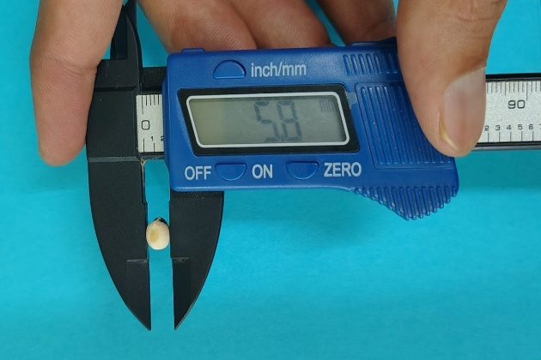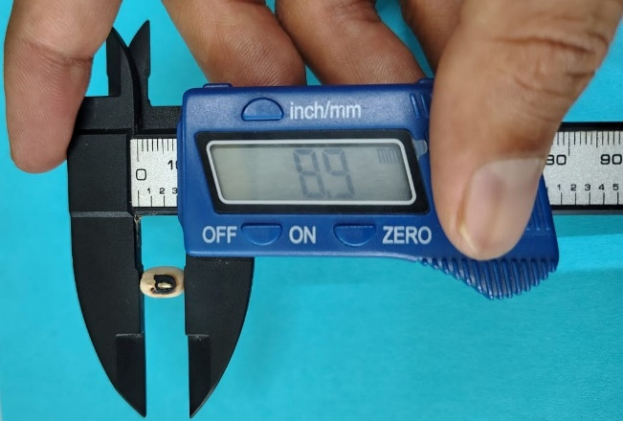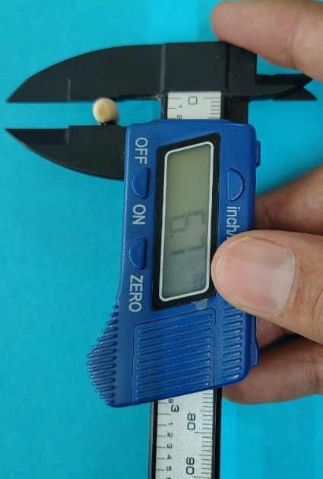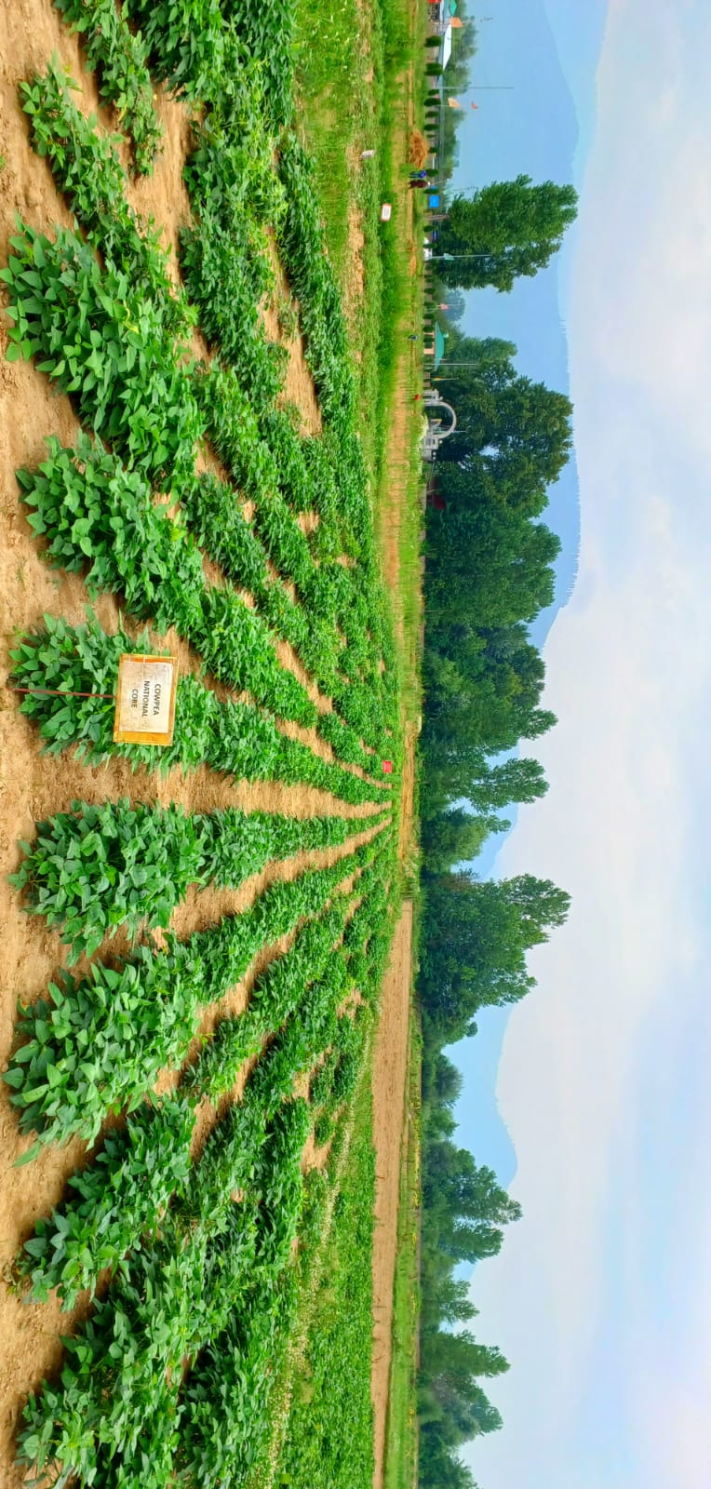
Figure 1. Seed dimensions measured by vernier calliper and field trial.
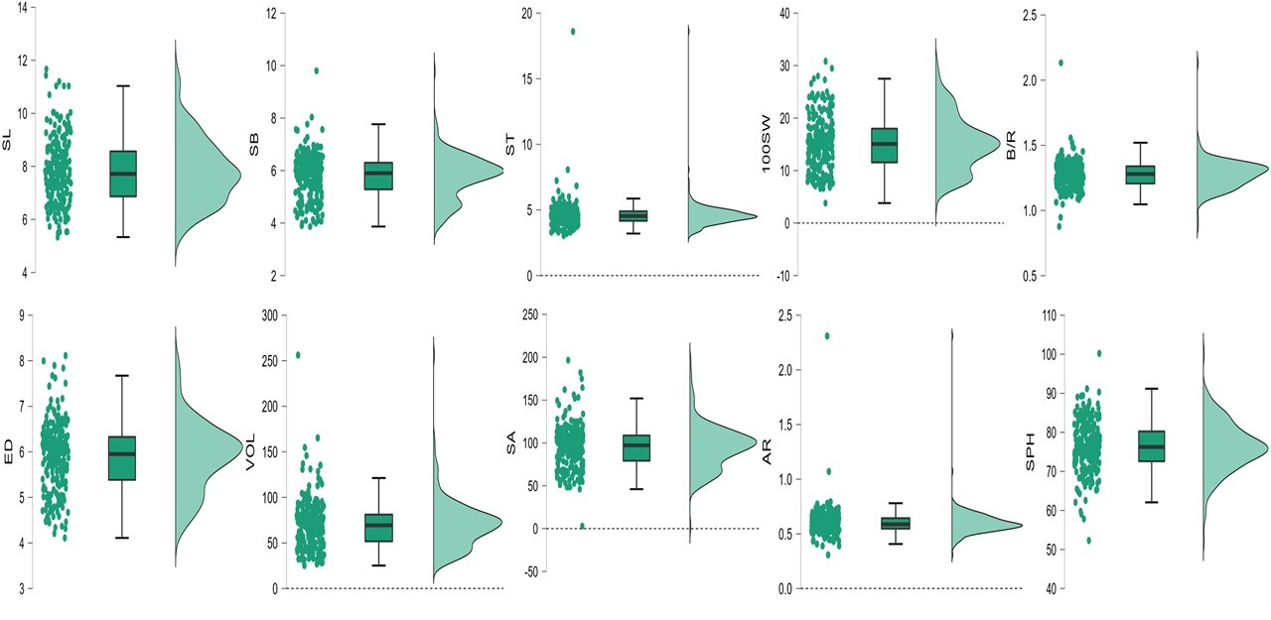
Figure 2. Raincloud plots for various seed physical traits.
Where: SL = seed length; SB = seed breadth; ST = seed thickness; 100SW = seed weight; B/W = breadth/width ratio; ED = equivalent diameter; VOL = volume; SA = surface area; AR = aspect ratio; SPH = sphericity.
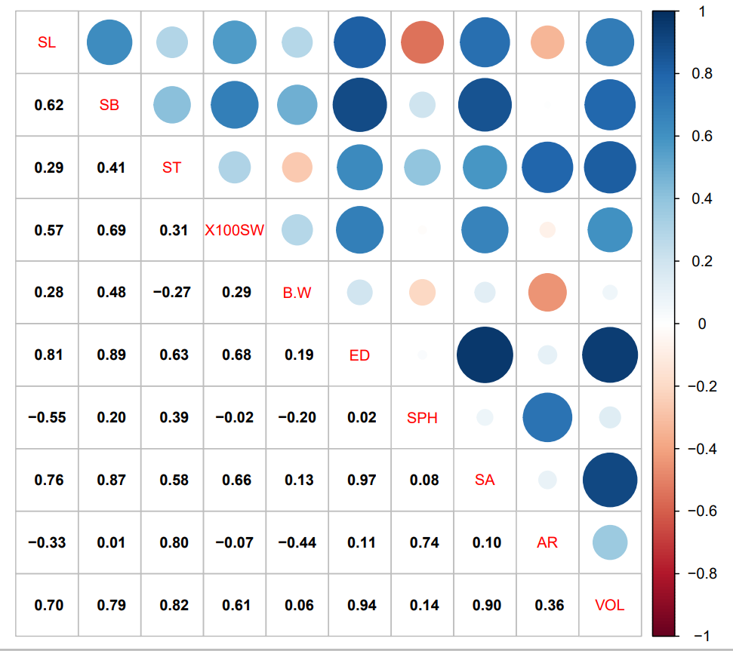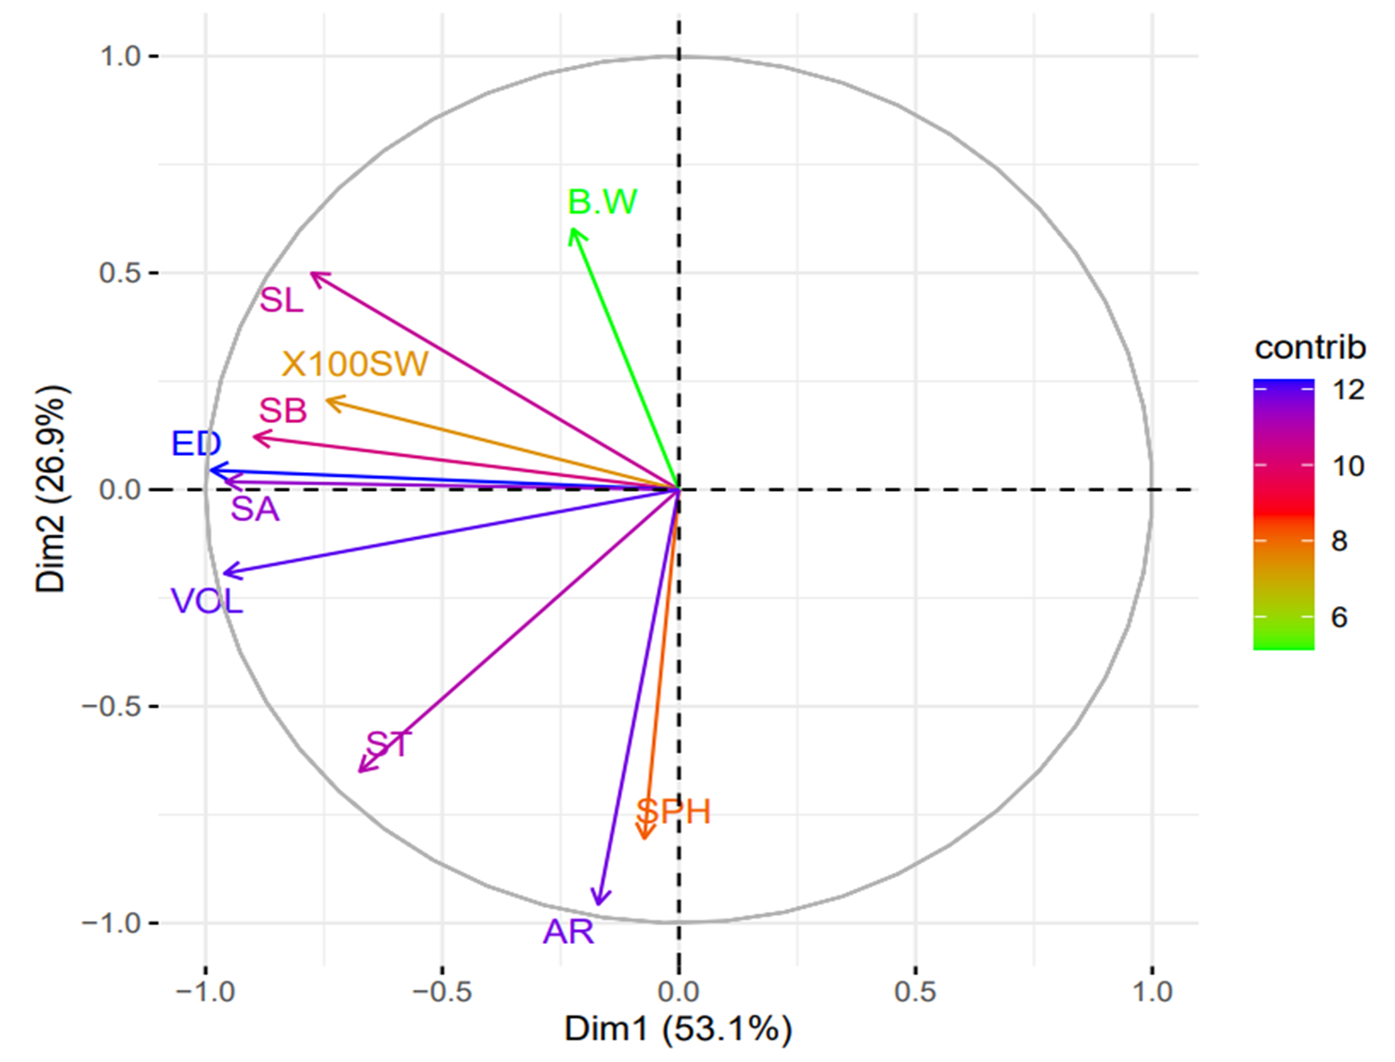
Figure 3. Heat map and PCA biplot for various cowpea seed physical traits.
5.0 Discussion
In the present study, substantial variability was observed in ten seed physical traits among 254 cowpea genotypes, indicating considerable diversity in the evaluated material, as reflected by the wide ranges and CV values. Substantial variability was recorded for seed length, breadth, width, seed breadth/width ratio and seed aspect ratio, which ranged from 5.33 to 11.67 mm, 3.87 to 9.80 mm, 3.03 to 18.60 mm, 0.87 to 2.13 and 0.30 to 2.31, respectively. Similar results were reported by Gull et al. (2017), who characterised fifteen cowpea genotypes for seed physical traits and showed that seed length was highest in C-14 (9.66 mm), followed by C-8 (9.15 mm) and C-7 (9.07 mm), whereas the lowest seed length was recorded in C-6 (6.98 mm). Similarly, for seed breadth, the highest value was observed in C-4 (6.98 mm), followed by C-11 (6.93 mm) and C-8 (6.83 mm), while the lowest value was recorded in C-10 (4.70 mm). The length/breadth ratio was highest in C-4 (1.74), followed by C-10 (1.67) and C-2 (1.65), and lowest in C-8 (1.34). Seed length, breadth and width are not only important economic traits but also important yield-determining traits. These traits also determine the overall appearance of seeds and influence their marketability based on local consumer preferences (Sofi et al., 2022).
Substantial variability was observed in equivalent diameter, sphericity and aspect ratio, which ranged from 4.11 to 8.11 mm, 52.29 to 100.00 and 0.30 to 2.31, respectively. Similar results were reported by Tchiagam et al. (2011) in cowpea genotypes and by Wani et al. (2017) and Buzera et al. (2018) in common bean genotypes. Substantial variability was also observed in seed volume and seed surface area, which ranged from 25.17 to 256.17 mm³ and 46.01 to 196.59 mm², with mean values of 69.82 and 95.76, respectively. Similar results were reported by Kabas et al. (2007), with seed volume and seed surface area ranging between 0.15 and 0.21 cm³ and 145.98 and 185.206 mm², respectively. The mean values of these traits were 0.18 ± 0.03 and 161.104 ± 25.48, respectively. Trait dispersion, as depicted by CV values, was highest for seed volume (38.39%), followed by 100-seed weight (34.05%), surface area (25.97%), seed width (23.99%), aspect ratio (22.94%), seed length (15.71%), seed breadth (14.47%), equivalent diameter (12.83%), breadth/width ratio (8.78%) and sphericity (8.34%).
The Pearson correlation analysis of ten seed physical traits is presented in the heat map in Figure 3. Among the positive correlations, seed length was significantly correlated with seed breadth, seed aspect ratio, surface area, volume and equivalent diameter. Similarly, seed breadth was significantly correlated with seed thickness, seed breadth/seed thickness, surface area, volume and aspect ratio. Similar results have been reported in temperate beans by earlier workers, including Saba et al. (2015), Rani (2022) and Sofi et al. (2022).
6.0 Conclusions
The evaluation of 254 cowpea genotypes under Western Himalayan conditions showed substantial variability for the ten seed physical traits studied. Wide ranges for seed length, breadth, thickness, 100-seed weight, surface area, seed volume, equivalent diameter, sphericity, breadth/width ratio and aspect ratio indicated that the core set contains useful phenotypic diversity. The highest coefficients of variation were recorded for seed volume, 100-seed weight and surface area, suggesting that these traits may provide comparatively greater opportunity for selection within the evaluated material. The observed positive associations among several seed traits indicate that improvement in selected seed dimensions may be accompanied by favourable changes in related physical attributes. The PCA biplot further supported the interpretation of trait relationships, as the first two principal components accounted for 80% of the total variation. Overall, the findings demonstrate that the evaluated germplasm can serve as a useful source of variation for cowpea improvement programmes focused on seed physical traits. The identified variability may assist breeders in selecting genotypes with desirable seed size, weight, surface area and volume for targeted trait improvement and breeding decision-making. However, further multi-environment evaluation would be required before recommending specific lines for broader breeding use or cultivation in contrasting agro-ecological conditions.

7.0 Limitations
The present study was limited to the evaluation of seed physical traits in one growing season and at a single Western Himalayan location. Therefore, the observed variability and trait associations represent the performance of the tested genotypes under the specific experimental conditions described in this manuscript. Environmental effects across years, locations and management systems were not assessed, and the stability of promising genotypes could not be determined from the available data. The study focused on physical seed traits, whereas biochemical, culinary, molecular and post-harvest quality parameters were not included. In addition, the use of an augmented block design allowed the evaluation of a large set of genotypes, but most test entries were not replicated in the same manner as the checks. These limitations should be considered when interpreting the results. Further multi-location and multi-season studies, supported by additional quality and molecular analyses, would strengthen the selection of cowpea genotypes for breeding programmes.

Disclaimer (Artificial intelligence)

Author(s) hereby declare that NO generative AI technologies such as Large Language Models (ChatGPT, COPILOT, etc.) and text-to-image generators have been used during the writing or editing of this manuscript.

References

Abraha Rahiel Hagos, A., Badji, A., Ozimati, A., Dramadri, O. I., Edema, R., & Adipala, E. (2024). Advancing resilient legume crops for sustainable agriculture and feeding Africa: Genetics and genomics studies on cowpea and common bean. African Journal of Rural Development, 9(1), 16–36. https://afjrdev.org/index.php/jos/article/view/463
Bijarniya, D., Shafi, S., Zaffar, A., Riyaz, I., Fatima, S., Zargar, S. M., Tripathi, K., Vara Prasad, P. V., & Sofi, P. A. (2024). Identification of resistant sources for pod shattering in a cowpea (Vigna unguiculata L.) core collection using a modified screening system based on weighted level scores using random impact method. Plant Genetic Resources: Characterization and Utilization, 22(6), 378–384. https://doi.org/10.1017/S1479262124000388
Boukar, O., Fatokun, C. A., Roberts, P. A., Abberton, M., Huynh, B. L., Close, T. J., Kyei-Boahen, S., Higgins, T. J. V., & Ehlers, J. D. (2015). Cowpea. In A. M. De Ron (Ed.), Grain legumes (pp. 219–250). Springer. https://doi.org/10.1007/978-1-4939-2797-5_7
Boukar, O., Togola, A., Chamarthi, S., Belko, N., Ishikawa, H., Suzuki, K., & Fatokun, C. (2019). Cowpea [Vigna unguiculata (L.) Walp.] breeding. In J. M. Al-Khayri, S. M. Jain, & D. V. Johnson (Eds.), Advances in plant breeding strategies: Legumes (Vol. 7, pp. 201–243). Springer. https://doi.org/10.1007/978-3-030-23400-3_6
Buzera, A., Kinyanjui, P., Ishara, J., & Sila, D. (2018). Physical and cooking properties of two varieties of bio-fortified common beans (Phaseolus vulgaris L.) grown in DR Congo. Food Science and Quality Management, 71, 1–12.
Da Silva, A. C., da Costa Santos, D., Teixeira Junior, D. L., da Silva, P. B., dos Santos, R. C., & Siviero, A. (2018). Cowpea: A strategic legume species for food security and health. In Legume seed nutraceutical research. IntechOpen. https://doi.org/10.5772/intechopen.79006
Deshpande, S. K., Mani, B. R., Desai, S. A., Nagarathna, T. K., & Hanchinal, R. R. (2018). Review on characterization of cowpea germplasm in terms of distinctness, uniformity, stability and novelty for morphological, quality and yield attributing parameters. International Journal of Current Microbiology and Applied Sciences, 7(6), 1124–1139. https://doi.org/10.20546/ijcmas.2018.706.134
Deshpande, V. K., Makanur, B., Deshpande, S. K., Adiger, S., & Salimath, P. M. (2011). Quantitative and qualitative losses caused by Callosobruchus maculatus in cowpea during seed storage. Plant Archives, 11(2), 723–731.
Doggalli, G., Monya, D., Kumar, M. B., Manjunath, P., & Khokale, S. K. (2024). Breeding techniques and approaches for developing abiotic stress-tolerant crop cultivars: A comprehensive review. Plant Cell Biotechnology and Molecular Biology, 25(7–8), 101–125. https://www.ikprress.org/index.php/PCBMB/article/view/8745
FAOSTAT. (2021). FAOSTAT statistical database. Food and Agriculture Organization of the United Nations. https://www.fao.org/faostat/en/#home
Fatokun, C. A., Boukar, O., & Muranaka, S. (2012). Evaluation of cowpea (Vigna unguiculata (L.) Walp.) germplasm lines for tolerance to drought. Plant Genetic Resources: Characterization and Utilization, 10(3), 171–176. https://doi.org/10.1017/S1479262112000214
Gull, M., Sofi, P. A., Mir, R. R., Ara, A., Rashid, M., Tahir, M., Shafi, S., & Rather, I. A. (2017). Natural variation for seed physical and hydration parameters in cowpea (Vigna unguiculata L.) in relation to hard to cook trait. International Journal of Pure & Applied Bioscience, 5(4), 321–330. https://doi.org/10.18782/2320-7051.3000
Hauhouot-O’Hara, M., Criner, B. R., Brusewitz, G. H., & Solie, J. B. (2000). Selected physical characteristics and aerodynamic properties of cheat seed for separation from wheat. Agricultural Engineering International: The CIGR Journal of Scientific Research and Development, 2. https://ecommons.cornell.edu/items/bc81cdcb-5880-4059-a569-c4ad528c9453
Herniter, I. A., Muñoz-Amatriaín, M., & Close, T. J. (2020). Genetic, textual, and archeological evidence of the historical global spread of cowpea (Vigna unguiculata [L.] Walp.). Legume Science, 2(4), e57. https://doi.org/10.1002/leg3.57
Horn, L. N., & Shimelis, H. (2020). Production constraints and breeding approaches for cowpea improvement for drought-prone agro-ecologies in Sub-Saharan Africa. Annals of Agricultural Sciences, 65(1), 83–91. https://doi.org/10.1016/j.aoas.2020.03.002
IndiaStat. (2021). IndiaStat statistical database. https://www.indiastat.com/
Jackson, J. C. (2009). Protein nutritional quality of cowpea and navy bean residue fractions. African Journal of Food, Agriculture, Nutrition and Development, 9(2), 764–778. https://doi.org/10.4314/ajfand.v9i2.19225
Jayathilake, C., Visvanathan, R., Deen, A., Bangamuwage, R., Jayawardana, B. C., Nammi, S., & Liyanage, R. (2018). Cowpea: An overview on its nutritional facts and health benefits. Journal of the Science of Food and Agriculture, 98(13), 4793–4806. https://doi.org/10.1002/jsfa.9074
Kabas, O., Yilmaz, E., Ozmerzi, A., & Akinci, I. (2007). Some physical and nutritional properties of cowpea seed (Vigna sinensis L.). Journal of Food Engineering, 79(4), 1405–1409. https://doi.org/10.1016/j.jfoodeng.2006.04.022
Kim, D.-K., Ochar, K., Iwar, K., Ha, B.-K., & Kim, S.-H. (2025). Cowpea (Vigna unguiculata L.) production, genetic resources and strategic breeding priorities for sustainable food security: A review. Frontiers in Plant Science, 16, Article 1562142. https://doi.org/10.3389/fpls.2025.1562142
Mohsenin, N. N. (1970). Physical properties of plant and animal materials: Structure, physical characteristics and mechanical properties. Gordon and Breach. https://doi.org/10.4324/9781003062325
Odogwu, B. A., Uzogara, M. O., Worlu, H., & Agbagwa, I. O. (2021). Factors affecting stakeholders’ preferences for cowpea grains in selected parts of Nigeria. African Journal of Food, Agriculture, Nutrition and Development, 21(3), 17669–17681. https://doi.org/10.18697/ajfand.98.19890
Owade, J. O., Abong’, G., Okoth, M., & Mwang’ombe, A. W. (2020). A review of the contribution of cowpea leaves to food and nutrition security in East Africa. Food Science & Nutrition, 8(1), 36–47. https://doi.org/10.1002/fsn3.1337
Saba, I., Sofi, P. A., Kandoliya, U. K., & Baba, Z. A. (2015). Natural variation for seed physical, biochemical and culinary traits in common bean (Phaseolus vulgaris L.). Current Botany, 6, 1–8. https://doi.org/10.19071/cb.2015.v6.2820
Saidi, M., Itulya, F. M., Aguyoh, J. N., & Ngouajio, M. (2010). Effects of cowpea leaf harvesting initiation time and frequency on tissue nitrogen content and productivity of a dual-purpose cowpea–maize intercrop. HortScience, 45(3), 369–375. https://doi.org/10.21273/HORTSCI.45.3.369
Singh, B. B. (2014). Cowpea: The food legume of the 21st century. Crop Science Society of America. https://doi.org/10.2135/2014.cowpea
Singh, B. B. (Ed.). (1997). Advances in cowpea research. International Institute of Tropical Agriculture. https://biblio.iita.org/documents/U97BkSinghAdvancesNothomNodev.pdf-45be564622a7b078d846162082dc956d.pdf
Sofi, P. A., Mir, R. R., Zargar, S. M., Rani, S., Fatima, S., Shafi, S., & Zaffar, A. (2022). What makes the beans (Phaseolus vulgaris L.) soft: Insights into the delayed cooking and hard-to-cook trait. Proceedings of the Indian National Science Academy, 88, 142–159. https://doi.org/10.1007/s43538-022-00075-4
Sofi, P. A., Shafi, S., Fatima, S., Rani, S., Ahmad, R., Banoo, A., Gani, S., Zargar, S. M., Padder, B. A., Zaffar, A., & Ashraf, A. (2022). Characterization of Western Himalayan small-seeded red beans (Phaseolus vulgaris L.) for yield, quality and resilience. Plant Genetic Resources: Characterization and Utilization, 20(5), 337–347. https://doi.org/10.1017/S1479262123000230
Soni, R. K., Shekhawat, S. S., & Kumar, M. (2018). Genetic variability study in cowpea [Vigna unguiculata (L.) Walp.] for green fodder yield and related traits. Indian Research Journal of Genetics and Biotechnology, 10(3), 428–435.
Swarup, S., Cargill, E. J., Crosby, K., Flagel, L., Kniskern, J., & Glenn, K. C. (2021). Genetic diversity is indispensable for plant breeding to improve crops. Crop Science, 61(2), 839–852. https://doi.org/10.1002/csc2.20377
Tchiagam, J.-B. N., Bell, J. M., Nassourou, A. M., Njintang, N. Y., & Youmbi, E. (2011). Genetic analysis of seed proteins contents in cowpea (Vigna unguiculata L. Walp.). African Journal of Biotechnology, 10(16), 3077–3086. https://doi.org/10.5897/AJB10.2469
Timko, M. P., Ehlers, J. D., & Roberts, P. A. (2007). Cowpea. In C. Kole (Ed.), Pulses, sugar and tuber crops (pp. 49–67). Springer. https://doi.org/10.1007/978-3-540-34516-9_3
Tripathi, K., Gore, P. G., Ahlawat, S. P., Tyagi, V., Semwal, D. P., Gautam, N. K., Rana, J. C., & Kumar, A. (2019). Cowpea genetic resources and its utilization: Indian perspective—A review. Legume Research, 42(4), 437–446. https://doi.org/10.18805/LR-4146
U.S. Department of Agriculture. (2021). United States Department of Agriculture. https://www.usda.gov/
Wani, I. A., Sogi, D. S., Wani, A. A., & Gill, B. S. (2017). Physical and cooking characteristics of some Indian kidney bean (Phaseolus vulgaris L.) cultivars. Journal of the Saudi Society of Agricultural Sciences, 16(1), 7–15. https://doi.org/10.1016/j.jssas.2014.12.002

