Original Research Article
In vitro regeneration of Hymenodictyon orixense (Roxb.) Mabb., a highly valuable tree species of Rubiaceae family

.
ABSTRACT

Hymenodictyon orixense (Roxb.) Mabb. (Rubiaceae) also called as Bridal Couch tree, is a medicinal tree species parts of which are rich source of bioactive metabolites imparting the plant an impressive antioxidant, antimicrobial, anti-inflammatory and anti-apoptotic activities. Early loss of viability in seeds, lack of optimized propagation methods and increased anthropogenic pressure has led to conservation concern in this valuable tree species. The paper presents a robust in vitro propagation protocol for mass multiplication of H. orixense through seedling explants. In vitro seed germination was done in basal Murashige & Skoog’s (MS) medium and nodal segments from aseptically grown seedlings were used for further culture establishment. MS medium supplemented with 0.25 mg L⁻¹ kinetin was found optimal producing the highest mean shoot number (7.67 ± 0.88) and mean shoot length (4.91 ± 0.15cm). The addition of 0.025 mgL⁻¹ GA₃ during shoot multiplication cycle enhanced the shoot length to a mean 8.49 ± 0.33 cm nearly double the shoot length achieved with kinetin alone. Root formation was 100% with ½ strength MS medium containing 1 mg L⁻¹ IAA and 0.025 mg L⁻¹ kinetin with highest mean number of roots. A 15-day cycle in optimized medium without gelling agent enhanced the quality of in vitro roots and developed plantlets were successfully acclimatized under greenhouse conditions with 85% survival. As the species possesses considerable medicinal importance, the propagation method described in the present study offers significant potential for the large-scale multiplication of selected genotypes exhibiting superior phytochemical characteristics. Furthermore, this approach may serve as an effective strategy for the ex situ conservation of the species, thereby contributing to its sustainable utilisation and long-term preservation.

Keywords: Hymenodictyon orixense, micropropagation, conservation, MS medium

1. INTRODUCTION

Hymenodictyon orixense (Roxb.) Mabb. (family Rubiaceae) is a highly valued traditional medicine species also known by synonyms such as Hymenodictyon excelsum (Roxb.) Wall., and Cinchona orixensis Roxb. (Razafimandimbison and Bremer, 2006). The genus comprises of about 30 species, among which H. orixense is an ethno-medicinally important and ecologically significant species of tropical areas. It is commonly called as the Bridal Couch Tree as it bears beautiful flowers in panicles at the end of branches. The tree is also suggested as an ornamental in landscaping and as shade tree around large gardens and open areas. Indian subcontinent as well as South Central China, including the Philippines and Indo-China regions, comprises the native range of this species. In India, it is found in semi-evergreen forests of Western Ghats and Shivalik region of North-Western Himalayas covering altitude range of 500-800m. In Bangladesh, the tree has been used as an afforestation and reforestation species (Islam et al. 2022).
Various ethno-medicinal uses have been attributed to this species and almost every plant part like stem, bark, leaves, root and wood is used in treatment of various kinds of disease conditions (Roy et al., 2026). In Maharashtra state of India, H. orixense have been documented to be used in hair gland infections or folliculitis (Jagtap et al., 2006). Esha et al., (2012) have also documented traditional medicinal role of its stem in hemorrhoids treatment by the Chakma tribes of Bangladesh. Chemical analysis of active methanolic extract of its stem bark revealed the presence of scopoletin as key constituent and which has application as febrifuge, and also used in throat, appetite and tumor cure (Swe, 2008). The tree is also source of various bioactive compounds such as anthraquinones, coumarins, and irridoid glycosides (Chakraborty et al. 2017, Pradhan et al 2020).
Apart from ethnomedicinal uses, wood of H. orixense is also considered as high-quality and is utilized in making various articles like toys, packing boxes, tea chests, pencils, brush holders and drumming instruments (Razafimandimbison and Bremer 2006). Although the species has several documented uses in traditional medicine and is also being researched for its applications in treatment of HIV infections, cancer and Alzheimer’s disease, not much work has been done with respect to screening and selection of germplasm, genetic diversity of the species and methods of efficient propagation. The species is generally propagated through seeds and regeneration from seeds is affected by early loss of viability in seeds. Direct seeding in this species is not recommended as the seed is very small (about 160,000 seeds/kg) and easily washed away (Islam et al., 2022). In a study in Uttarakhand state of India, the species was found to be scantly distributed in its natural range and suitable conservation efforts were emphasized to be taken up for its sustenance (Chandra et al., 2022). This prompts to further explore propagation methods in this important but lesser known tree species so that germplasm conservation can be carried out and selected germplasm can be effectively propagated. Also, studies have reported impact of increasing anthropogenic pressures that is threatening natural populations of this species and indicate the need for conservation and future sustenance of species (Roy et al., 2026). Plant tissue culture based regeneration remains a viable alternative to establish a mass propagation method for H. orixense. The technology has already been widely utilized in a number of horticultural, medicinal as well as woody species and offers several advantages over conventional propagation methods (Bhardwaj et al., 2025, Minj et al., 2025). To the best of our knowledge, no reports of in vitro regeneration are available in this species. The present work was therefore aimed at in vitro aseptic germination of H. orixense seeds and optimization of stepwise shoot multiplication and root development in vitro.

2. material and methodS

2.1 Plant material
H. orixense seeds were obtained from Tree Seed Laboratory, FSM Division, Forest Research Institute, India. The seeds wrapped in a muslin cloth were washed under running tap water for 10 minutes. Thereafter these were treated with Cetrimide® solution (3-4 drops of Cetrimide in 100 ml of water) for 10 minutes. Antifungal treatment was given with 0.2% Nativo® (Tebuconazole 50% + Trifloxystrobin 25% WG) fungicide for 30 minutes followed by rinsing thrice in distilled water. Final surface sterilization was given under aseptic conditions with 0.1% HgCl₂ (prepared in autoclaved distilled water) exposure for 1 minute. For germination, seeds were placed on MS basal medium (Murashige and Skoog 1962) containing agar (0.6%) and supplemented with 3% sucrose. The seeds were incubated for 30 days and observation was recorded.
2.2 Initiation
The approximately 2-3 cm long nodal segments from 4 weeks old seedlings were used as explants for initiation. The explants were placed vertically on MS medium supplemented with plant growth regulator (PGR) benzylaminopurine (BAP) at concentration 0, 0.25, 0.5 and 1.0 mgL⁻¹; kinetin (0.25 and 0.5 mgL⁻¹); and Naphthalene acetic acid (NAA) at 0.5 mgL⁻¹ concentration in different combinations along with 6.5gL⁻¹ agar and 3% sucrose. After three weeks the average number of shoots and shoot length were recorded for each media combination or treatments. Culture conditions were maintained as 25 ±2°C temperature and 16 h photoperiod.
2.3 Multiplication
The shoot tips and axillary nodes obtained from in vitro raised shoots were used as explants and transferred to shoot multiplication medium comprising of MS medium with kinetin (0.25 mgL⁻¹), GA₃ (0.025 mgL⁻¹ or 0.050 mgL⁻¹) and glutamine (25 mgL⁻¹ or 50 mgL⁻¹) in different combinations. After three weeks the average number of adventitious shoots and shoot length were observed for each treatment. Shoots were routinely subculture at 15 days on the same treatment for multiplication.
2.4 Rooting and plantlet acclimatization
Shoots (about 3-5 cm long) were used to induce rooting in which the individual shoot was separated and transferred to root induction medium. Excised shoots were transferred into half strength MS medium containing gellan gum (CleriGel® Super, Himedia Laboratories) as gelling agent at 3.5 mg/L concentration with PGRs in different combinations as Indole-3-acetic acid (IAA) in concentrations as 0.25, 0.50, 0.75 and 0.10 mgL⁻¹, NAA in concentrations as 0.25, 0.50, 0.75 and 0.10 mgL⁻¹ and 0.025 mgL⁻¹ kinetin. After 45 days, the percentage of shoots developing roots and the average number of roots per shoot were recorded along with root length. A 15-day cycle in the optimized medium without gelling agent was also included before the plants were transferred for acclimatization and hardening.
For acclimatization and hardening, the rooted plantlets were washed in tap water to carefully remove gelled medium from the roots and were given a brief treatment in fungicide solution (1% Bavistin for 5-10 min) and then these were transferred to soil substrate in pots containing sterilized vermiculite:sand:garden-soil mix in 1 : 1 : 1 (w : w : w) ratio. To maintain high humidity, plantlets were covered with transparent plastic sheets while in greenhouse. To provide nutrients for better acclimatization, the plantlets were supplied with MS basal liquid medium containing one-fourth strength macronutrients with a sprayer. After 15-20 days, transferring of plants to polybags was done with growing substrate constituting of garden soil:sand:farmyard manure at 2 : 1 : 1 (w : w : w) ratio for regular growth. Irrigation was done using regular tap water as per requirement and to fertilize the plants, foliar spray of 2 g L⁻¹ soluble NPK (19% N, 19% P, 19% K) was done on weekly basis. The greenhouse temperature was maintained at 25-30°C with a relative humidity of nearly 75-80% during the hardening.
2.5 Statistical analysis
All the experiments were conducted using completely randomized design (CRD) with three replicates of each trial and the experiments were repeated thrice. Data for each experiment was recorded after three weeks of culture and the whole data set were used for analysis of variance (ANOVA) using IBM SPSS version 23 software. Resulting values are expressed as means ± standard error (SE), and data was subjected to analysis of variance, followed by Tukey’s post hoc test to evaluate significant differences at p< 0.05 being the level significance. The data was first put to test of Normality after which ANOVA was used and differences of mean were found out by Tukey’s HSD post hoc test at p≤0.05 significance level.

3. results and discussion

An in vitro plant regeneration protocol has been developed for H. orixense. Seeds that were planted in MS agar without any addition of PGRs started to germinate within a week of inoculation and reached the whole two leafed stage within 30 days. The overall germination percentage was nearly 60 percent with around 8-10% contamination. Types and concentration of plant growth regulators had a significant effect on shoot and root formation. During shoot initiation optimized in different PGR combinations lower concentration of BAP and kinetin proved to be better for shoot initiation differing significantly from the higher concentrations used for both Kinetin and BAP. Kinetin consistently outperformed BAP both in terms of shoot number and shoot length. MS medium supplemented with 0.25 mgL⁻¹ Kinetin emerged as the optimal shoot initiation medium, producing the highest average shoot number (7.67 ± 0.88) and the longest shoots (4.91 ± 0.15cm), significantly superior to all other treatments. Callus formation at the base of shoots was observed in all the treatments, to different extents during the initial shoot initiation cycles. There were no significant differences between 0.25 mg L⁻¹ BAP and kinetin but in presence of kinetin at 0.25 mgL⁻¹, minimal callus formation was seen and hence it was preferred medium for shoot initiation. Intermediary response was obtained at 0.5 mgL⁻¹ BAP and kinetin concentrations, since they possessed same level of statistical significance. Responses from different TDZ and NAA concentrations indicate a lower shoot induction rate, and most of them were found in low statistical significance, suggesting that they possessed less efficacy. Regeneration in basal MS medium was also significantly poor. Similar performance of kinetin was reported in Cucumis sativus where 1 mgL⁻¹ concentration yielded best shoot number, shoot length among all cytokinins tested, and was statistically superior to equivalent concentrations of BAP (Abu-Romman et al., 2015). In case of BAP, an inverse relationship was observed with shoot number and concentration. At 0.25 mg/l, BAP yielded 6.76 ± 0.20 shoots, but this declined substantially at 0.5 mg L⁻ (4.68 ± 1.20) and further dropped at 1.0 mg L⁻ in combination with TDZ (2.83 ± 0.86). This suggests that supraoptimal concentrations of BAP suppress axillary bud break, possibly through apical dominance interference or cytotoxicity at higher doses. A comparative study of the effects of BAP and kinetin on in vitro shoot development in Quercus robur (fagaceae), indicated poor leaf anatomy and shoot necrosis in presence of BAP alone whereas use of kinetin alone induced better anatomical characteristics like larger secondary xylem and cell walls well lignified which indicates role of kinetin towards better cellular differentiation (Martins et al., 2022). In Mitragyna parvifolia, a member of rubiaceae family, BAP alone as a source of cytokinin was used for shoot initiation (5.3 shoots/node on 3mgL⁻¹ BAP), while the BAP and kinetin combination was found optimal for maximum multiplication (Patel et al., 2020). Hence response towards any particular plant growth regulator varies with species to species and mostly governed by endogenous levels of hormones. BAP being a synthetic cytokinin can sometime produce toxic metabolites that hinders plant growth in vitro, as discussed by Aremu et al., (2012).

Use of Thidiazuron in combination with BAP did not yield increased shoots in the present study. The combination of BAP (1.0 mg L⁻) + TDZ (0.5 mg L⁻) was among the poorer performers for shoot number and produced greenish-brownish callus, indicating stress and possible phenolic oxidation at the explant base. In some species TDZ does not yields good quality shoots, for example in tea clone Iran 100, it was found to be unsuitable for multiplication as growth in TDZ containing medium caused hyperhydricity especially at concentrations more than 0.05 mg L⁻ (Gonbad et al., 2014). Presence of TDZ, a phenylurea derivative, in culture medium induces both auxin and cytokinins like responses and also modulates endogenous plant growth hormones levels which creates an environment of stress. This can sometime result in callus formation, as was reported in Neolamarkia cadamba cotyledonary and hypocotyl cultures (Huang et al., 2020), and low shoot formation (Murthy et al., 1998). Similarly, the addition of auxin, NAA, in combination with BAP strongly suppressed shoot proliferation in H. orixense (1.67 ± 0.33 shoots). The high callusing intensity observed in BAP + NAA combinations also confirms this callogenic shift induced by auxins in plant tissue culture medium. The findings are similar to studies in Gardenia jasminoides, another important rubiaceae family member, where NAA addition to cytokinin caused callus formation in cultures (Manokari et al., 2024). Table 1 shows that the use of BAP alone or in combination with other PGRs resulted in the formation of shorter shoots than those when used with kinetin (alone or in combination). MS medium with 0.25 mg L⁻ kinetin resulted in longest shoot (~4.92 cm) however this was at par with other concentrations of cytokinins. Also, there were no significant differences between shoot length observed in combinations of BAP with shortest shoots being formed with the coupled use of TDZ and NAA with BAP.

Table 1. Axillary shoot initiation in Hymenodictyon orixense in presence of different concentration and types of PGRs
PGR combination | Mean Shoot Number | Mean Shoot Length (cm) | Callusing intensity at base | Nature of callus
MS (basal) | 1.40±0.14^{c} | 2.04±0.29^{c} | * | No significant callusing
MS+ 0.25 mgL⁻¹ BAP | 6.76±0.20ª | 2.91±0.44^{bc} | ***** | Friable and whitish
MS+ 0.5 mgL⁻¹ BAP | 4.68±1.20^{bc} | 3.33±2.58^{ab} | **** | Friable and whitish
MS+ 1.0 mgL⁻¹ BAP+ 0.5 mgL⁻¹ TDZ | 2.83±0.86^{c} | 1.53±0.39^{abc} | *** | Greenish and brownish
MS+ 0.25 mgL⁻¹ Kinetin | 7.67±0.88ª | 4.91±0.15ª | * | Scanty growth
MS+ 0.5 mgL⁻¹ kinetin | 5.93±0.88^{bc} | 4.01±0.22^{ab} | ** | Amorphous
MS+ 0.5 mgL⁻¹ BAP+ 0.5 mgL⁻¹ kinetin | 4.33±0.45^{bc} | 4.23±0.47^{ab} | ****** | Friable
MS+ 1.0 mgL⁻¹ BAP+ 0.5 mgL⁻¹ NAA | 1.67±0.33^{c} | 2.95±0.34^{bc} | ***** | Friable
MS+ 1.5 mgL⁻¹ BAP+ 0.5 mgL⁻¹ NAA | 2.87±0.78^{c} | 2.13±0.22^{c} | **** | Friable
Means followed by the same letter within a column are not significantly different at (P ≤ 0.05)

Shoot Multiplication: Further for shoot multiplication, it was evaluated how supplementing the optimal medium, MS + 0.25 mgL⁻¹ kinetin, with gibberellin (GA₃) or an organic nitrogen source (glutamine) enhances shoot proliferation in H. orixense (Table 2).
A general trend found with the use of additives was that GA₃ produced slightly higher number of shoots than that of glutamine, however statistically there were no significant differences. GA₃ concentrations worked well in promoting shoots multiplication and elongation. The shoots treated with glutamine, on the other hand, exhibited a relatively lower number of shoots and elongation. Glutamine at a concentration of 50 mgL⁻¹ resulted in the shortest shoots (4.34±0.25) compared to GA₃ concentrations. Generally, low GA₃ concentrations together with kinetin were more effective for shoot multiplication and extension. The best and strikingly significant treatment combination for multiplication of Hymenodictyon orixense was found out to be MS+0.25 mgL⁻¹ kinetin+ 0.025 mgL⁻¹ GA₃ (~7.7 number of shoots per culture) and the results were at par with the ones obtained during initial cycles i.e. without the use of any additives (MS+0.25 mgL⁻¹ kinetin) suggesting that the PGR combination used for culture initiation is suitable enough to propagate for further cycles. However, shoot length had significant differences between GA₃ and glutamine (coupled with kinetin for all concentrations) with GA₃ containing cultures in general producing longer shoots than glutamine. Overall, GA₃ at the lower dose of 0.025 mgL⁻¹ produced the best response across all multiplication treatments, 7.72 ± 0.88 shoots and, most notably, an average shoot length of 8.49 ± 0.33 cm, nearly double the shoot length achieved in with kinetin alone. This demonstrates well-established role of GA₃ in internode elongation and stem extension through cell elongation in the sub-apical meristem. Doubling the GA₃ concentration to 0.05 mgL⁻¹ led to a slight reduction in both shoot number (6.67) and shoot length (8.29 cm), though the difference in length was not statistically significant. This suggests that higher concentrations may begin to exert inhibitory effects in this species during in vitro regeneration. Isogai et al. (2008) demonstrated that GA₃ supplementation doubled internode length in Cephaelis ipecacuanha cultures on Gamborg B5 medium, with the propagation rate exceeding 100-fold compared to GA₃-free medium. In Camellia sinensis (L.) O. Kuntze, GA₃ at a concentration of 0.5 mgL⁻¹ was found to be beneficial for axillary shoot multiplication of clone Iran 100, when used with 3 mgL⁻¹ BAP and resulted in increased number of shoots and shoot elongation (Gonbad et al., 2014). In present study, glutamine, an organic
nitrogen source that can directly enter amino acid metabolism and support protein biosynthesis, was also used to assess effect on shoot multiplication. However, it showed moderate enhancement over the basal kinetin medium. At 25 mgL⁻¹, it produced 5.33 ± 1.20 shoots and 5.85 ± 0.46 cm shoot length, while 50 mgL⁻¹ gave 5.00 ± 0.57 shoots and only 4.34 ± 0.25 cm average length of shoots significantly lower than GA₃ treatments. Thus glutamine inclusion at moderate levels generally supports culture growth, but supraoptimal organic nitrogen can create osmotic stress or inhibit cytokinin signaling. The results indicate that GA₃ showed better proliferation in shoots in comparison with glutamine in Hymenodictyon orixense, since it works as a direct regulator of plant growth, whereas glutamine acts as a nitrogen source. GA₃ facilitates shoot development by stimulating gibberellin signaling responsible for cell division, cell enlargement, internode elongation, and axillary bud activation (Tung et al., 2022). Moreover, when used alongside kinetin, GA₃ aids in breaking bud dormancy and multiplying shoots; this explains its better performance of 7.72 mean shoot number and 8.49 cm mean shoot length.

Table 2. Effect of GA₃ and glutamine during proliferation of shoots in Hymenodictyon orixense
PGR combination | Mean shoot number | Mean Shoot Length
MS+0.25 mgL⁻¹ kinetin+ 0.025 mgL⁻¹ GA₃ | 7.72±0.88ª | 8.49±0.33ª
MS+0.25 mgL⁻¹ kinetin+ 0.05 mgL⁻¹ GA₃ | 6.67±0.28^{ab} | 8.29±0.94ª
MS+0.25 mgL⁻¹ kinetin+25 mgL⁻¹ glutamine | 5.33±1.20^{ab} | 5.85±0.46^{ab}
MS+0.25 mgL⁻¹ kinetin+50 mgL⁻¹ glutamine | 5.00±0.57^{ab} | 4.34±0.25^{b}
Means followed by the same letter within a column are not significantly different at (P≤0.05)

In vitro rooting and plantlet acclimatization
Rooting was almost 100% in all the PGR combinations used during the study, showing that in vitro developed shoots had good rhizogenic property. While shorter roots were obtained with IAA, NAA containing medium showed rooting hindrances because of the callus formed with it, which also caused problems during plant separation for further acclimatization cycles. Therefore, the preferred PGR for rooting was observed to be IAA rather than NAA. Bhusare et al. (2018), reported that in Digitalis lanata, among IAA, IBA, and NAA tested at various concentrations, the best response occurred at 17.13 µmol L⁻¹ IAA. The inclusion of low amounts of cytokinin, in this case kinetin at 0.025 mgL⁻¹, during rooting treatments thus tends to maintain explant vigor during the root induction phase (Arya et al., 2022). Figure 1 shows different stages of in vitro propagation in H. orixense, as achieved during the study.
The average number of roots increased with the increasing concentrations of IAA while the trend was reverse in case of NAA. The highest and most significant numbers of roots (~41.49 number of roots) were obtained with ½ strength MS medium containing 1 mgL⁻¹ IAA and 0.025 mgL⁻¹ kinetin, while all the other concentrations of IAA had no significant differences between them. In case of NAA, the treatments applied were ineffective as there were no significant differences between them. In case of root length similar kind of trend was observed as in root number and higher concentrations of IAA produced longer roots than lower concentrations and NAA had the reverse trend. The longest and the most significant root length was obtained with ½ strength +1 mgL⁻¹ IAA+0.025 mgL⁻¹ kinetin (~6.73 cm). Also, this concentration had the most vigorous and best quality rooting. This concentration was at par with ½ strength MS+0.25 mgL⁻¹ NAA+0.025 mgL⁻¹ kinetin but it was the immense amounts of callus formed with it that made this PGR combination undesirable. All other concentrations of IAA had no significant difference between them. The PGR concentrations of NAA had fairly no significant differences between them negating their effectiveness for in vitro rooting in H. orixense. A lower concentration of IAA and all the concentrations of NAA tested in present study had lower statistical significance. Although all NAA concentrations provided 100% rooting, callogenous and amorphous roots were observed, indicating their poor quality as opposed to those obtained from IAA concentrations. MS basal medium did not provide any rooting. In general, IAA, especially 1 mgL⁻¹, was the most statistically effective in producing high-quality roots. IAA was also found to be optimal auxin for initiating in vitro rooting in Sterculia foetida (Anitha and Pullaiah, 2001). A 15-day cycle in the optimized medium without gelling agent was included and it enhanced the quality of the in vitro roots which were visibly healthier and stout enough to be transplanted (Figure 2). In vitro rooted plantlets were successfully acclimatized under greenhouse conditions with 85% survival. Figure 2 depicts different stages of hardening in H. orixense and development of plants in greenhouse. The step wise protocol thus optimized could be effectively used for in vitro regeneration and conservation of this tree species. It can be highly useful in case elite or superior planting material, for example, genotypes with high phytochemical content or potential medicinal properties are to be mass propagated, as in those cases propagation through seeds may not be desirable owing to variations.

Table 3. In vitro rooting results in Hymenodictyon orixense indicating mean root number, mean root length in each treatment along with nature of roots and rooting percentage
PGR combination | Mean number of roots | Mean Root Length | Nature of roots | Rooting percentage
MS (basal) | No roots | No roots | No roots | 0%
1/2 MS+0.25 mgL⁻¹ IAA+0.025 mgL⁻¹ kinetin | 14.02±0.21^{b} | 4.20±0.23^{bc} | Various short roots | 100%
1/2 MS+0.5 mgL⁻¹ IAA+0.025 mgL⁻¹ kinetin | 14.33±1.76^{b} | 4.82±0.73^{bc} | short roots | 100%
1/2 MS+ 0.75 mgL⁻¹ IAA+0.025 mgL⁻¹ kinetin | 24.85±3.48^{b} | 5.76±0.30^{bc} | thin flimsy roots | 100%
1/2 MS+ 1 mgL⁻¹ IAA+0.025 mgL⁻¹ kinetin | 41.49±2.78ª | 6.73±0.22ª | thick and vigorous | 100%
1/2 MS+0.25 mgL⁻¹ NAA+0.025 mgL⁻¹ kinetin | 24.92±0.12^{b} | 5.96±0.17^{ab} | callogenic amorphous roots | 100%
1/2 MS+0.5 mgL⁻¹ NAA+0.025 mgL⁻¹ kinetin | 23.67±1.30^{b} | 5.41±0.36^{bc} | callogenic roots | 100%
1/2 MS+0.75 mgL⁻¹ NAA+0.025 mgL⁻¹ kinetin | 19.83±0.33^{b} | 4.48±0.23^{bc} | various thin roots | 100%
1/2 MS+ 1 mgL⁻¹ NAA+0.025 mgL⁻¹ kinetin | 16.67±2.40^{b} | 4.36±0.20^{c} | Few thick callogenic roots | 100%
Means followed by the same letter within a column are not significantly different at (P≤0.05)
b
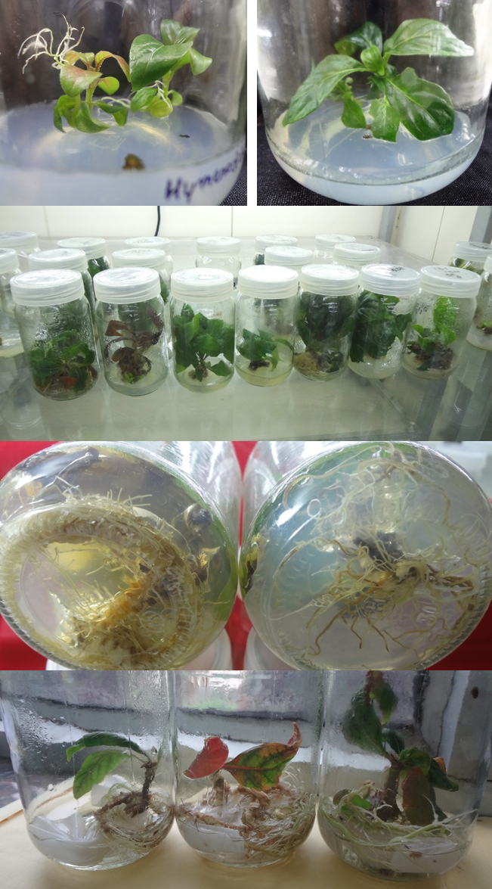
e
d
c
a

Fig. 1. Micropropagation of H. orixense. a) in vitro seed germination, b) shoot initiation, c) multiplication of shoots, d-e) in vitro root formation in H. orixense under semi-solid and liquid medium conditions.

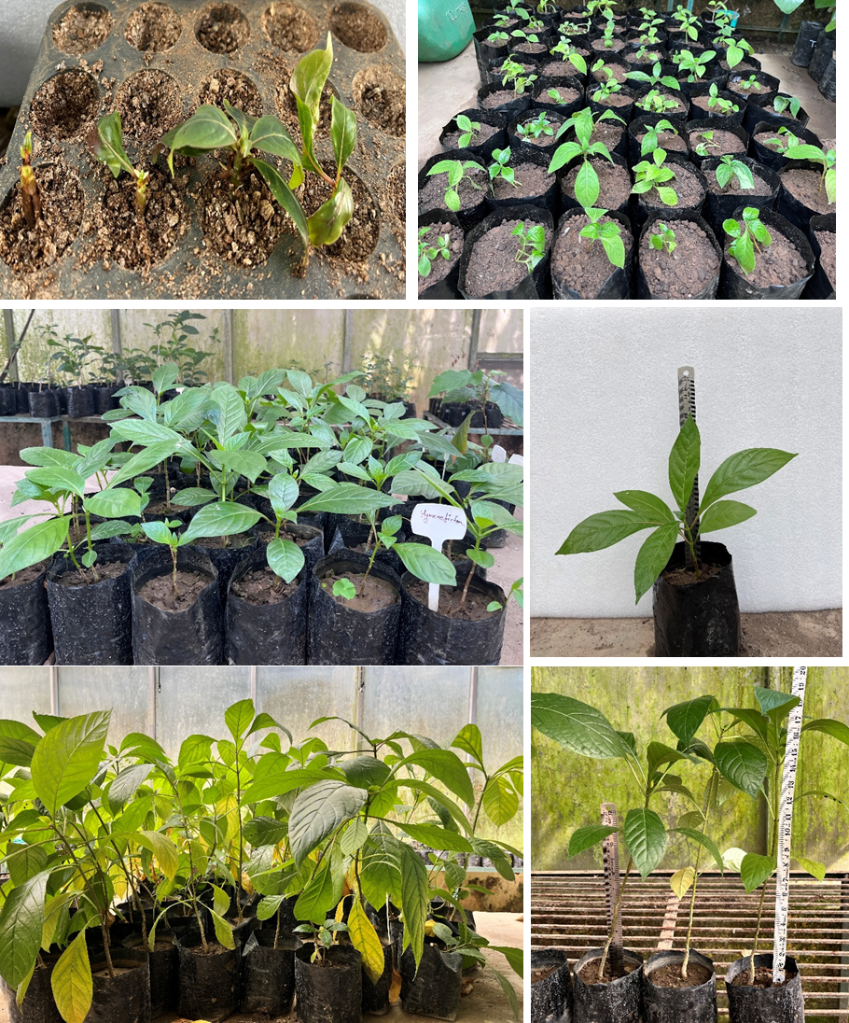
f
e
d
c
b
a

Figure 2. Hardening of tissue-culture plants in H. orixense. a) transfer of in vitro rooted plantlets to vermiculite:sand:garden-soil mix, b-d) Plants after 6-8 months of growth in greenhouse, e-f) Plants after more than 01 year of growth

4. Conclusion

Plant tissue culture is the best alternative for mass propagation of species with low seed viability and also for multiplication of quality material if the species has commercial or medicinal importance. In the present study a step-wise propagation method has been optimized for H. orixense that yields well rooted and acclimatized plants at the end of the cycle. H. orixense. Since the species is highly medicinal, the propagation method described here would be very useful in multiplication of desired genotypes with superior phytochemical constituents and also for conservation of this species ex situ.
AcknowledgEments

Authors acknowledge funding from National Authority CAMPA, MoEF&CC, Govt. of India for execution of project “National Program for conservation and Development of Forest Genetic resources: Pilot Project on ‘Creation of Centre of excellence on forest genetic resources (CoFGR)”
Competing interests

Authors declare that no competing interests exist

Authors’ Contributions

Conceptualization: [SY, AT]; Methodology: [SY, KP, PK]; Formal Analysis and Investigation: [SY, KP, PK]; Writing - Original Draft Preparation: [SY, KP]; Writing - Review and Editing: [AT, SY, SG, DS]; Resources: [AT, SY]; Supervision: [AT]. All authors read and approved the final manuscript.”

DISCLAIMER (ARTIFICIAL INTELLIGENCE)
Author(s) hereby declare that NO generative AI technologies such as Large Language Models (ChatGPT, COPILOT, etc.) and text-to-image generators have been used during the writing or editing of this manuscript.

References
- Razafimandimbison, S.G. and Bremer, B. (2006). Taxonomic revision of the tribe Hymenodictyeae (Rubiaceae, Cinchonoideae). Botanical Journal of the Linnean Society, 152(3), 331-386. https://doi.org/10.1111/j.1095-8339.2006.00567.x
- Islam, A., Hao, H., Hossain, M.K. and Rahman, M. (2022). Nursery Growing Media Practice: Impact on Seed Germination and Initial Seedling Development of Hymenodictyon orixensis (Roxb.) Mabberley - A Vulnerable Native Tree Species. Journal of Forest and Environmental Science, 38(1), 38-47.
- Roy, B.C., Sharma, B.P., Thakur, K. and Mishra, S. (2026). Ethnomedicinal and ecological importance of Hymenodictyon orixense. In book: Medicinal Trees of India, Vol - IV (4th Ed., pp. 57–64). Ambika Prasad Research Foundation Publisher. https://doi.org/10.5281/zenodo.19246089
- Esha, R.T., Chowdhury, M.R., Adhikary, S., Haque, K.M.A., Acharjee, M., Nurunnabi, M., Khatun, Z., Lee Y.K. and Rahmatullah, M. (2012). Medicinal plants used by tribal medicinal practitioners of three clans of the Chakma tribe residing in Rangamati district, Bangladesh. American-Eurasian Journal of Sustainable Agriculture, 6(2), 74-84.
- Jagtap, S.D., Deokule, S.S. and Bhosle, S.V. (2006). Some unique ethnomedicinal uses of plants used by the Korku tribe of Amravati district of Maharashtra, India. Journal of Ethnopharmacology, 107(3), 463-469. https://doi.org/10.1016/j.jep.2006.04.002
- Swe, N.N. (2008). Scopoletin from Hymenodictyon orixense (Roxb.) Mabb. Journal of the Myanmar Academy of Arts and Science, 6(4), 193–203.
- Chakraborty, P., Sasi, S., Nair, A.A., Anjum, N. and Tripathi, Y.C. (2017). Medicinal applications, phytochemistry and pharmacology of Hymenodictyon excelsum (Roxb.) Wall: A Review. Organic & Medicinal Chemistry International Journal, 2(3), 1-5.
- Pradhan, R., Manohara, T.N., Suresh, H.S. and Nayak, A.P. (2020). An ethnomedicinal study of important medicinal plants in Kudermukh National Park of Karnataka: A review. International Journal of Current Microbiology and Applied Sciences, 9(9), 3477-3490. https://doi.org/10.20546/ijcmas.2020.909.432
- Chandra, A., Negi, R., Verma, P.K., Naithani, H.B., Saxena, J., Kewat, A., Prajapati, S., Kishwan, S., Baig, S., Semwal, D. and Umasankar. (2022). In: Ginwal HS, Mathur PK, Rawat A, Singh S. (Eds.) Conservation of Forest Genetic Resources, State Report-Uttarakhand, Pilot Project, National Program for Conservation and Development of Forest Genetic Resources. Forest Research Institute, ICFRE, (pp. 1-840).
- Bhardwaj, S., Kumari, M., Chethan, T., Hosamani, M., Paul, M., Moirangthem, A., Dash, A.P. and Verma, S. (2025). Advances in Micropropagation and Tissue Culture for Horticultural Crops: A Review. Plant Cell Biotechnology and Molecular Biology, 26(11-12), 166-182. https://doi.org/10.56557/pcbmb/2025/v26i11-1210039
- Minj, S., Lakra, A., Baghel, P., Xaxa, S., Sahu, T. and Jha, Z., (2025). In vitro Propagation of Eucalyptus Hybrids: Optimizing Tissue Culture for Sustainable Paper Industry Practices. Plant Cell Biotechnology and Molecular Biology, 26(7-8), 203-211. https://doi.org/10.56557/pcbmb/2025/v26i7-89432
- Murashige, T. and Skoog, F. (1962). A revised medium for rapid growth and bio assays with tobacco tissue cultures. Physiologia Plantarum, 15, 473-497.
https://doi.org/10.1111/j.1399-3054.1962.tb08052.x
- Abu-Romman, S.M., Al-Hadid, K.A. and Arabiyyat, A.R. (2015). Kinetin is the most effective cytokinin on shoot multiplication from cucumber. Journal of Agricultural Science, 7(10), 159-165. http://dx.doi.org/10.5539/jas.v7n10p159.
- Martins, J.P.R., Wawrzyniak, M.K., Ley-López, J.M. Kalemba, E.M., Mendes, M.M. and Chmielarz, P. (2022). 6-Benzylaminopurine and kinetin modulations during in vitro propagation of Quercus robur (L.): an assessment of anatomical, biochemical, and physiological profiling of shoots. Plant Cell Tissue and Organ Culture 151, 149–164. https://doi.org/10.1007/s11240-022-02339-9
- Patel, A.K., Lodha, D. and Shekhawat, N.S. (2020). An improved micropropagation protocol for the ex-situ conservation of Mitragyna parvifolia (Roxb.) Korth. (Rubiaceae): an endangered tree of pharmaceutical importance. In Vitro Cellular and Developmental Biology – Plant, 56(6), 817–826. https://doi.org/10.1007/s11627-020-10089-6
- Aremu, A. O., Bairu, M. W., Doležal, K., Finnie, J. F., and Van Staden, J. (2012). Topolins: a panacea to plant tissue culture challenges? Plant Cell, Tissue and Organ Culture, 108(1), 1-16. https://doi.org/10.1007/s11240-011-0007-7
- Gonbad, R.A., Rani Sinniah, U., Aziz M.A. and Mohamad, R. (2014). Influence of cytokinins in combination with GA₃ on shoot multiplication and elongation of tea clone Iran 100 (Camellia sinensis (L.) O. Kuntze). Scientific World Journal, 2014, 943054. https://doi.org/10.1155/2014/943054.
- Huang, H., Wei, Y., Zhai, Y., Ouyang, K., Chen, X., and Bai, L. (2020) High frequency regeneration of plants via callus-mediated organogenesis from cotyledon and hypocotyl cultures in a multipurpose tropical tree (Neolamarkia cadamba). Scientific Reports, 10, 4558. https://doi.org/10.1038/s41598-020-61612-z
- Murthy, B.N.S., Murch, S.J. and Saxena, P.K. (1998). Thidiazuron: A potent regulator ofin vitro plant morphogenesis. In Vitro Cellular & Developmental Biology-Plant, 34, 267–275 https://doi.org/10.1007/BF02822732
- Manokari, M., Cokul Raj, M., Dey, A., Faisal, M., Alatar, A.A. and Shekhawat, A.M.S. (2024). Micro-morpho-anatomical changes in leaf structure of plantlets during in vitro propagation (micropropagation) of Gardenia jasminoides J. Ellis. Vegetos, 37, 107-116. https://doi.org/10.1007/s42535-023-00577-6
- Isogai, S., Touno, K., and Shimomura, K. (2008). Gibberellic acid improved shoot multiplication in Cephaelis ipecacuanha. In Vitro Cellular & Developmental Biology-Plant, 44(3), 216-220.
- Tung, H.T., Luan, V.Q., Van Anh, L.T., and Nhut, D.T. (2022). Stem Elongation for Plant Micropropagation. In Nhut, D.T., Tung, H.T., Yeung, E.CT. (eds) Plant Tissue Culture: New Techniques and Application in Horticultural Species of Tropical Region. Springer, Singapore. https://doi.org/10.1007/978-981-16-6498-4_7
- Bhusare, B.P., John, C.K., Bhatt, V.P. and Nikam, T.D. (2018). In vitro propagation of Digitalis lanata Ehrh. through direct shoot regeneration – A source of cardiotonic glycosides. Industrial Crops and Products, 121, 313-319. https://doi.org/10.1016/j.indcrop.2018.05.019
- Arya, A., Sharma, V., Tyagi, P.K., Gola, D. and Husen, A. (2022). Role of cytokinins in adventitious root formation. In Husen A (ed): Environmental, physiological and chemical controls of adventitious rooting in cuttings, Elsevier, Amsterdam, Netherland. (pp. 239-249). https://doi.org/10.1016/B978-0-323-90636-4.00017-9
- Anitha, S. and Pullaiah, T. (2001). In Vitro Propagation of Sterculia foetida Linn (Sterculiaceae). Plant Cell Biotechnology and Molecular Biology, 2(3-4), 139-144.

