Medicinal Plant Diversity, Traditional Therapeutics and Conservation Perspectives in Odisha, India
ABSTRACT
Medicinal plants constitute an essential component of traditional healthcare systems and continue to play a significant role in primary healthcare, pharmaceutical research, and biodiversity conservation. Odisha, located in eastern India, possesses rich floristic diversity owing to its varied ecological regions, including coastal ecosystems, central plateaus, forested landscapes, and the Eastern Ghats. The state is inhabited by numerous tribal communities that have preserved extensive ethnomedicinal knowledge through generations. This review synthesizes available information on medicinal plant diversity, traditional therapeutic applications, phytochemical constituents, ethnopharmacological significance, and conservation perspectives in Odisha. Information was compiled from published scientific literature, ethnobotanical studies, books, and government reports. Several medicinal plant species, including Tinospora cordifolia, Andrographis paniculata, Rauvolfia serpentina, Ocimum sanctum, Curcuma longa, and Azadirachta indica, are widely utilized for the treatment of infectious diseases, metabolic disorders, respiratory ailments, inflammatory conditions, and general health maintenance. The review further highlights the importance of bioactive phytochemicals such as alkaloids, flavonoids, phenolic compounds, terpenoids, and glycosides that contribute to the pharmacological properties of medicinal plants. Traditional medicinal knowledge preserved by indigenous communities remains an important resource for future drug discovery and sustainable healthcare development. However, habitat degradation, overexploitation, deforestation, and loss of traditional knowledge threaten medicinal plant resources in the region. Strengthening conservation strategies, scientific validation, sustainable utilization practices, and community participation is essential for safeguarding Odisha's medicinal plant heritage and promoting its contribution to healthcare and biodiversity conservation.
Keywords
Biodiversity conservation, Ethnopharmacology, Indigenous healthcare, Medicinal plants, Odisha, Phytochemistry, Traditional therapeutics.
1.INTRODUCTION
Medicinal plants continue to play a crucial role in global healthcare systems and remain important sources of bioactive compounds for pharmaceutical development. Natural products and their derivatives contribute significantly to modern drug discovery, particularly in the treatment of infectious diseases, inflammatory disorders, metabolic complications, and cancer. Recent advances in pharmacognosy, phytochemistry, metabolomics, and biotechnology have renewed scientific interest in medicinal plants as valuable resources for therapeutic innovation and evidence-based healthcare applications (Atanasov et al., 2021; Nasim et al., 2022).
India possesses remarkable biological diversity and a long-standing tradition of plant-based healthcare systems, including Ayurveda and numerous indigenous medicinal practices. Traditional medicinal knowledge remains particularly important in rural and tribal communities where medicinal plants continue to support primary healthcare needs. The increasing scientific validation of ethnomedicinal practices has strengthened the relevance of medicinal plants in contemporary healthcare research and phytopharmaceutical development (Atanasov et al., 2021; Devkota, 2021).
Odisha, located in eastern India, is recognized for its diverse ecological landscapes comprising coastal plains, river basins, forest ecosystems, central plateaus, and the Eastern Ghats hill ranges. These heterogeneous environmental conditions support substantial medicinal plant diversity and provide suitable habitats for numerous therapeutically important species. Ecological factors, climatic variability, and traditional resource utilization practices collectively influence the distribution and conservation of medicinal plant resources in the region (Zhang et al., 2022; Jiang et al., 2022).
The state is inhabited by several indigenous tribal communities, including Kondh, Saora, Bonda, Juang, Gond, and Santhal populations, who possess extensive ethnomedicinal knowledge regarding plant identification, harvesting, preparation, and therapeutic utilization. Traditional medicinal systems preserved by these communities contribute significantly to local healthcare management and represent valuable repositories of ethnopharmacological information. Such indigenous knowledge systems have attracted increasing scientific attention because of their potential contributions to natural product research and future drug discovery initiatives (Atanasov et al., 2021; Nasim et al., 2022).
Several medicinal plant species widely distributed in Odisha, including Tinospora cordifolia, Andrographis paniculata, Rauvolfia serpentina, Curcuma longa, Ocimum sanctum, and Azadirachta indica, possess diverse phytochemical constituents exhibiting antimicrobial, antioxidant, anti-inflammatory, hepatoprotective, immunomodulatory, and antidiabetic properties. Scientific investigations have increasingly validated the pharmacological significance of these medicinal plants and highlighted their therapeutic potential in modern healthcare research (Devkota, 2021; Atanasov et al., 2021).
Despite their immense medicinal, ecological, and socioeconomic importance, medicinal plant resources face increasing threats from habitat degradation, deforestation, climate change, unsustainable harvesting practices, urbanization, and erosion of traditional knowledge systems. Conservation and sustainable utilization of medicinal plants have therefore emerged as important priorities for biodiversity management and long-term healthcare sustainability (Chen et al., 2016; Zhang et al., 2022; Jiang et al., 2022).
The present review aims to critically synthesize available information regarding medicinal plant diversity, traditional therapeutic applications, phytochemical characteristics, ethnopharmacological significance, and conservation perspectives in Odisha, India. The review further highlights future research opportunities associated with sustainable utilization, biodiversity conservation, and medicinal plant-based drug discovery.
2. METHODOLOGY OF LITERATURE REVIEW
The present review was conducted through a comprehensive survey of published scientific literature related to medicinal plant diversity, ethnobotany, ethnopharmacology, phytochemistry, traditional therapeutics, and conservation in Odisha, India. Relevant literature was retrieved from electronic databases including Scopus, Web of Science, PubMed, Google Scholar, ScienceDirect, and SpringerLink.
The literature search was performed using combinations of keywords such as "medicinal plants", "ethnobotany", "ethnopharmacology", "traditional medicine", "phytochemistry", "biodiversity conservation", "Odisha", "Eastern Ghats", and "tribal healthcare". Peer-reviewed journal articles, books, book chapters, review papers, government reports, and publications from recognized national and international organizations were considered.
Studies published primarily in English between 2000 and 2025 were screened for relevance. Publications specifically addressing medicinal plant diversity, traditional therapeutic applications, phytochemical composition, pharmacological properties, ethnomedicinal practices, and conservation issues were included in the review. Duplicate records, studies lacking scientific relevance, unpublished reports, and non-accessible literature were excluded.
Information extracted from selected sources was critically evaluated, organized thematically, and synthesized to provide an integrated overview of medicinal plant resources, ethnopharmacological significance, and conservation perspectives in Odisha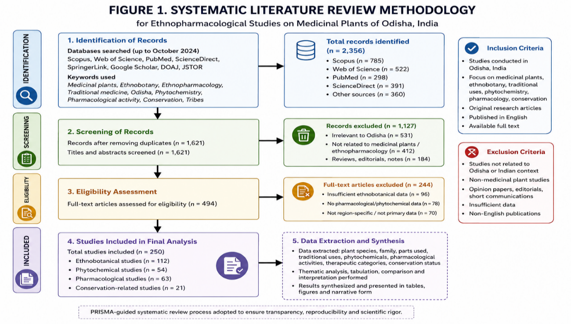
Fig 1 : The systematic workflow adopted for literature collection, screening, selection, and analytical synthesis is presented
3. ECOLOGICAL DIVERSITY AND ETHNOBOTANICAL SIGNIFICANCE OF ODISHA
Odisha is one of the biologically diverse states of eastern India, characterized by a wide range of ecological habitats including coastal plains, river valleys, wetlands, central plateaus, dense forests, and the Eastern Ghats hill ranges. These diverse ecosystems support rich floral diversity and provide suitable habitats for numerous medicinally important plant species. The variation in climate, topography, and vegetation across the state contributes significantly to the distribution and conservation of medicinal plant resources (Jain, 1991; Schippmann et al., 2002).
The Eastern Ghats and forested regions of Odisha are particularly important reservoirs of biodiversity and medicinal plant wealth. These ecosystems harbor numerous species that have traditionally been utilized for healthcare, food security, and livelihood support. Medicinal plants occurring in these regions constitute an important component of local healthcare systems and contribute to the sustainable utilization of biological resources. Furthermore, the ecological diversity of Odisha provides opportunities for the conservation of plant genetic resources with significant pharmacological and economic value (Fabricant & Farnsworth, 2001; Newman & Cragg, 2020).
Odisha is home to several indigenous tribal communities, including the Kondh, Saora, Bonda, Juang, Gond, and Santhal groups, who possess extensive traditional knowledge regarding medicinal plant identification, collection, preparation, and therapeutic utilization. This ethnobotanical knowledge has been transmitted through generations and continues to play a crucial role in primary healthcare, particularly in remote and forest-dependent regions. Traditional healers and community elders maintain valuable information concerning plant-based remedies used for the treatment of fever, gastrointestinal disorders, respiratory ailments, skin diseases, inflammatory conditions, and other common health problems (Martin, 1995; Ragupathy & Newmaster, 2009).
Ethnobotanical studies have demonstrated that indigenous knowledge systems serve as important foundations for ethnopharmacological investigations and natural product research. Several medicinal plant species traditionally used by tribal communities have subsequently attracted scientific attention because of their bioactive phytochemical constituents and therapeutic potential. Consequently, the documentation and preservation of traditional medicinal knowledge are essential for promoting future drug discovery, healthcare innovation, and sustainable resource management (Fabricant & Farnsworth, 2001; Mahomoodally, 2013; Newman & Cragg, 2020).
Despite their ecological and cultural significance, medicinal plant resources in Odisha face increasing threats from habitat degradation, deforestation, unsustainable harvesting practices, urbanization, and the gradual erosion of traditional knowledge systems. Therefore, integrated conservation strategies involving scientific research, community participation, sustainable harvesting practices, and biodiversity management are necessary to ensure the long-term preservation of medicinal plant diversity and ethnobotanical heritage in the state (Schippmann et al., 2002; Newman & Cragg, 2020).
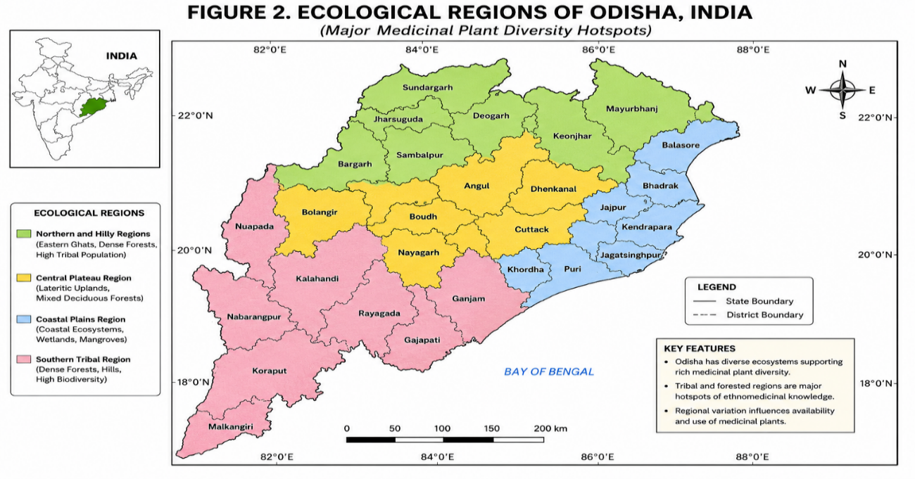
Fig 2 : The major ecological regions and medicinal plant diversity hotspots of Odisha are illustrated
4. REGION-WISE MEDICINAL PLANT DIVERSITY AND ETHNOPHARMACOLOGICAL SIGNIFICANCE
Odisha exhibits remarkable ecological heterogeneity, which contributes significantly to the distribution and utilization of medicinal plant resources across different geographical regions. Variations in climate, soil characteristics, vegetation types, and topography have resulted in distinct patterns of medicinal plant diversity throughout the state. Traditional communities inhabiting these regions have developed extensive knowledge regarding the identification, collection, preparation, and therapeutic use of medicinal plants. Consequently, medicinal plant utilization varies according to ecological conditions, local healthcare needs, and cultural traditions. Understanding regional distribution patterns is important for documenting ethnobotanical knowledge, promoting sustainable utilization, and supporting biodiversity conservation initiatives (Jain, 1991; Martin, 1995; Ragupathy & Newmaster, 2009).
4.1 Coastal Odisha
The coastal region of Odisha is characterized by tropical climatic conditions, sandy soils, estuarine ecosystems, mangrove-associated habitats, and agricultural landscapes that support a variety of medicinal plant species. Local communities traditionally utilize numerous plant resources for the treatment of common ailments, including gastrointestinal disorders, skin diseases, respiratory infections, and inflammatory conditions.
Common medicinal plant species reported from coastal ecosystems include Ocimum sanctum, Azadirachta indica, Aloe vera, and Cocos nucifera, which are widely recognized in traditional medicine for their antimicrobial, anti-inflammatory, wound-healing, and therapeutic properties (Jain, 1991; Fabricant & Farnsworth, 2001; Mahomoodally, 2013).
Traditional healthcare practices in coastal Odisha continue to rely on locally available medicinal plants because of their accessibility, affordability, and cultural acceptance. These plant resources contribute significantly to primary healthcare and represent an important component of traditional medicinal knowledge systems (Martin, 1995; Ragupathy & Newmaster, 2009).
4.2 Central Odisha and Plateau Regions
The central and plateau regions of Odisha comprise mixed deciduous forests, agricultural landscapes, and rural settlements that support diverse medicinal plant populations. The ecological characteristics of these regions provide suitable habitats for numerous medicinally important species utilized in traditional healthcare systems.
Common medicinal plant species reported from these regions include Tinospora cordifolia, Curcuma longa, Syzygium cumini, and Withania somnifera, which have been extensively documented for their antioxidant, antidiabetic, immunomodulatory, hepatoprotective, and adaptogenic properties (Kamboj, 2000; Fabricant & Farnsworth, 2001; Newman & Cragg, 2020).
Traditional healers and local communities utilize these species for managing fever, metabolic disorders, digestive problems, inflammatory diseases, and general health maintenance. The continued use of medicinal plants in these regions highlights the importance of conserving both biological resources and associated traditional knowledge systems (Jain, 1991; Martin, 1995).
4.3 Tribal and Eastern Ghats Hilly Regions
The Eastern Ghats and tribal-dominated regions of Odisha represent important centers of medicinal plant diversity and ethnobotanical knowledge. Dense forests, mountainous terrain, and relatively undisturbed habitats support numerous medicinal plant species that have been utilized by indigenous communities for generations.
Several medicinal plant species including Rauvolfia serpentina, Andrographis paniculata, Gloriosa superba, and Hemidesmus indicus are traditionally utilized for the management of hypertension, malaria, neurological disorders, inflammatory diseases, skin ailments, and reproductive health conditions (Jain, 1991; Ragupathy & Newmaster, 2009; Mahomoodally, 2013).
Indigenous tribal communities such as the Kondh, Saora, Bonda, Juang, Gond, and Santhal possess extensive ethnomedicinal knowledge regarding medicinal plant collection, preparation, dosage, and therapeutic applications. This knowledge represents an invaluable cultural and scientific resource that contributes to healthcare security, ethnopharmacological research, and future drug discovery efforts (Martin, 1995; Fabricant & Farnsworth, 2001; Newman & Cragg, 2020).
Table 1. Region-wise medicinal plant diversity and ethnopharmacological significance in Odisha, India
Region of Odisha | Major Ecological Characteristics | Common Medicinal Plant Species | Major Traditional Therapeutic Applications | Ethnopharmacological Significance
Coastal Odisha | Coastal plains, wetlands, estuaries, mangrove-associated ecosystems, humid climate | Azadirachta indica, Ocimum sanctum, Aloe vera, Curcuma longa, Phyllanthus amarus, Centella asiatica, Moringa oleifera | Skin infections, respiratory disorders, fever, liver disorders, gastrointestinal complications, inflammatory diseases | High dependence on locally available medicinal flora for primary healthcare; strong use of antimicrobial and hepatoprotective plants
Central Odisha | Mixed deciduous forests, agricultural landscapes, lateritic uplands, semi-urban ecosystems | Tinospora cordifolia, Terminalia chebula, Andrographis paniculata, Tridax procumbens, Syzygium cumini, Adhatoda vasica | Gastrointestinal disorders, diabetes, fever, inflammatory diseases, wound healing, respiratory infections | Moderate to high medicinal plant diversity with increasing pharmacological validation of traditional therapeutics
Tribal and Hilly Regions | Dense forests, Eastern Ghats landscapes, hilly terrains, relatively undisturbed ecosystems | Rauvolfia serpentina, Withania somnifera, Tinospora cordifolia, Gloriosa superba, Asparagus racemosus, Hemidesmus indicus | Malaria, fever, reproductive disorders, snakebite, inflammation, musculoskeletal disorders, respiratory infections | Highest ethnomedicinal richness and strong oral traditional knowledge systems among tribal communities
Gandhamardan Hill Ranges | Biodiversity-rich forest ecosystem with high floristic heterogeneity | Rauvolfia serpentina, Andrographis paniculata, Ocimum sanctum, Terminalia chebula | Antipyretic, antimicrobial, anti-inflammatory, neurological disorders | Recognized hotspot of medicinal plant diversity and traditional therapeutic heritage
Forest Ecosystems of Southern Odisha | Moist deciduous and semi-evergreen forests with tribal dominance | Azadirachta indica, Tinospora cordifolia, Withania somnifera, Asparagus racemosus | Antimalarial, immunomodulatory, hepatoprotective, reproductive healthcare | Strong ecological dependence and high ethnopharmacological relevance among indigenous populations
5. QUANTITATIVE ETHNOBOTANICAL ANALYSIS
Quantitative ethnobotany provides valuable tools for assessing the cultural significance, utilization patterns, and therapeutic importance of medicinal plants within traditional healthcare systems. The application of quantitative indices enables researchers to systematically evaluate ethnobotanical knowledge and identify plant species with high medicinal relevance. Such approaches facilitate the comparison of ethnomedicinal information across different communities and contribute to the scientific validation of traditional medicinal practices (Heinrich et al., 1998; Ragupathy & Newmaster, 2009).
Several quantitative indices are commonly employed in ethnobotanical investigations. The Use Value (UV) is used to assess the relative importance of a plant species based on the frequency of its reported uses. Species with higher UV values are generally considered more culturally significant and widely utilized within local communities. The Informant Consensus Factor (ICF) measures the degree of agreement among informants regarding the use of plants for specific disease categories. High ICF values indicate strong consensus and may suggest the effectiveness or cultural importance of particular medicinal remedies (Heinrich et al., 1998).
The Fidelity Level (FL) is another important quantitative parameter that evaluates the proportion of informants who use a particular plant species for the same therapeutic purpose. High FL values reflect greater specificity of use and may indicate promising candidates for pharmacological investigation. Similarly, the Relative Frequency of Citation (RFC) provides information regarding the popularity and recognition of medicinal plants among community members. These indices collectively contribute to a better understanding of ethnomedicinal knowledge systems and facilitate the identification of priority species for conservation and scientific research (Ragupathy & Newmaster, 2009; Mahomoodally, 2013).
Quantitative ethnobotanical approaches play an important role in documenting traditional knowledge, identifying culturally significant medicinal plants, and supporting evidence-based conservation strategies. Integration of quantitative analysis with phytochemical and pharmacological investigations can further strengthen the scientific foundation of traditional medicine and promote sustainable utilization of medicinal plant resources (Fabricant & Farnsworth, 2001; Newman & Cragg, 2020).
Table 2. Common quantitative indices used in ethnobotanical studies.
Index | Purpose
Use Value (UV) | Measures the relative importance of a plant species
Informant Consensus Factor (ICF) | Assesses agreement among informants
Fidelity Level (FL) | Evaluates specificity of plant use for a particular ailment
Relative Frequency of Citation (RFC) | Indicates popularity and recognition of medicinal plants
Source: Adapted from Heinrich et al. (1998), Ragupathy and Newmaster (2009), and Mahomoodally (2013)
6. THERAPEUTIC CATEGORY-WISE ANALYSIS OF MEDICINAL PLANTS
Medicinal plants utilized in Odisha are traditionally employed for the treatment of a wide range of health disorders. Traditional knowledge accumulated over generations has contributed significantly to community healthcare systems, particularly in rural and tribal regions. Modern phytochemical and pharmacological studies have increasingly validated many traditional therapeutic applications, highlighting the importance of medicinal plants as potential sources of bioactive compounds and novel therapeutic agents (Fabricant & Farnsworth, 2001; Mahomoodally, 2013; Newman & Cragg, 2020).
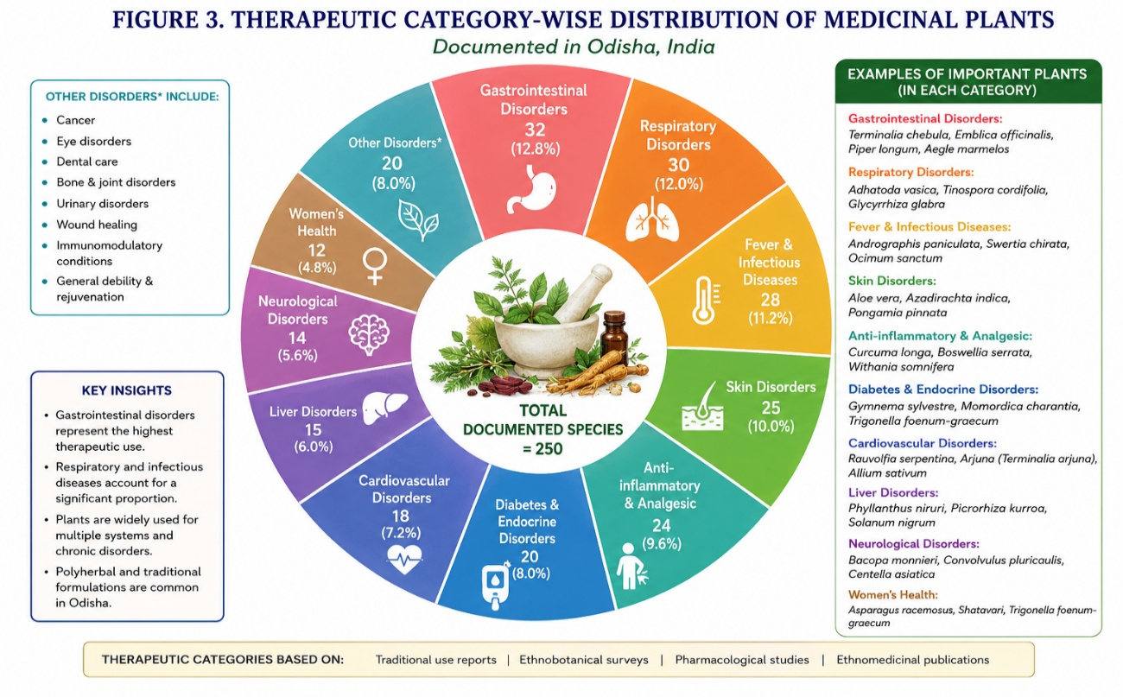
Fig 3: Therapeutic Category-wise Distribution of Medicinal plants
6.1 Gastrointestinal Disorders
Gastrointestinal disorders constitute one of the most common health problems treated using medicinal plants in traditional healthcare systems. Species such as Aegle marmelos, Terminalia chebula, Phyllanthus amarus, and Mentha spicata are traditionally used for the management of diarrhea, dysentery, indigestion, constipation, and stomach ailments. These plants contain diverse phytochemicals including tannins, flavonoids, alkaloids, and phenolic compounds that contribute to their therapeutic effects. Experimental studies have reported antimicrobial, antioxidant, gastroprotective, and anti-inflammatory activities in several of these species, supporting their traditional use in gastrointestinal healthcare (Kamboj, 2000; Mahomoodally, 2013; Newman & Cragg, 2020).
6.2 Febrile and Antimalarial Disorders
Medicinal plants have long been utilized in traditional medicine for the treatment of fever and malaria-associated symptoms. Commonly used species include Andrographis paniculata, Tinospora cordifolia, Azadirachta indica, and Swertia chirayita. These plants are recognized for their antipyretic, immunomodulatory, antimicrobial, and antiplasmodial properties. Scientific investigations have demonstrated that several plant-derived compounds possess significant activity against infectious agents and contribute to disease management. The continued exploration of traditional medicinal plants remains important for the discovery of novel antimalarial and anti-infective agents (Fabricant & Farnsworth, 2001; Farnsworth et al., 1985; Newman & Cragg, 2020).
6.3 Respiratory Disorders
Traditional medicinal systems frequently utilize plant-based remedies for respiratory ailments including cough, asthma, bronchitis, sore throat, and respiratory infections. Medicinal plants such as Ocimum sanctum, Adhatoda vasica, Zingiber officinale, and Glycyrrhiza glabra are commonly employed for these conditions. The therapeutic effectiveness of these species has been attributed to their anti-inflammatory, antimicrobial, expectorant, and antioxidant activities. Pharmacological investigations have supported the traditional use of several respiratory medicinal plants, indicating their potential role in respiratory healthcare management (Kamboj, 2000; Mahomoodally, 2013).
6.4 Dermatological Disorders
A variety of medicinal plants are traditionally applied for the treatment of skin diseases, wounds, burns, fungal infections, and inflammatory skin conditions. Species such as Aloe vera, Azadirachta indica, Curcuma longa, and Centella asiatica are widely recognized for their wound-healing and dermatological applications. Bioactive compounds present in these plants exhibit antimicrobial, antioxidant, anti-inflammatory, and tissue-regenerative properties that contribute to skin health and wound repair. Scientific evidence has increasingly validated the dermatological importance of these medicinal plants (Fabricant & Farnsworth, 2001; Mahomoodally, 2013; Newman & Cragg, 2020).
6.5 Metabolic and Lifestyle Disorders
The prevalence of metabolic disorders such as diabetes, obesity, hypertension, and cardiovascular diseases has increased globally, leading to renewed interest in medicinal plants with therapeutic potential. Traditional medicinal systems in Odisha utilize species including Syzygium cumini, Gymnema sylvestre, Momordica charantia, and Withania somnifera for the management of metabolic conditions. Numerous phytochemicals including flavonoids, alkaloids, terpenoids, and phenolic compounds have demonstrated antidiabetic, antioxidant, cardioprotective, and anti-inflammatory activities. These findings support the potential role of medicinal plants in complementary approaches to metabolic disease management (Kamboj, 2000; Mahomoodally, 2013; Newman & Cragg, 2020).
6.6 Reproductive and Women's Health Disorders
Medicinal plants are also traditionally employed for reproductive healthcare, maternal well-being, menstrual disorders, and postpartum recovery. Species such as Asparagus racemosus, Hemidesmus indicus, Saraca asoca, and Withania somnifera have been utilized in traditional systems for supporting reproductive health and improving general well-being. Pharmacological studies have identified bioactive constituents that may contribute to hormonal regulation, antioxidant protection, and reproductive health support. Although additional clinical investigations are required, existing evidence highlights the importance of these plants within traditional healthcare systems (Fabricant & Farnsworth, 2001; Mahomoodally, 2013).
6.7 Scientific Validation and Future Prospects
The therapeutic applications of medicinal plants documented in traditional healthcare systems are increasingly supported by phytochemical, pharmacological, and biomedical research. Numerous plant-derived compounds have contributed directly or indirectly to modern drug discovery, demonstrating the scientific value of traditional medicinal knowledge. Continued integration of ethnobotanical information with phytochemical characterization, pharmacological evaluation, and clinical research will enhance understanding of medicinal plant efficacy and safety. Such interdisciplinary approaches are essential for promoting evidence-based utilization, conservation, and sustainable development of medicinal plant resources (Farnsworth et al., 1985; Fabricant & Farnsworth, 2001; Newman & Cragg, 2020).
Table 3. Therapeutic category-wise medicinal plants and ethnopharmacological applications in Odisha
Therapeutic Category | Common Medicinal Plant Species | Traditional Therapeutic Applications | Major Pharmacological Properties
Gastrointestinal Disorders | Terminalia chebula, Aegle marmelos, Phyllanthus amarus, Holarrhena antidysenterica | Diarrhea, dysentery, indigestion, gastric ulcers, abdominal pain | Gastroprotective, antimicrobial, anti-inflammatory
Antimalarial and Febrile Disorders | Andrographis paniculata, Tinospora cordifolia, Azadirachta indica, Swertia chirayita | Malaria, fever, body pain, infection-related symptoms | Antimalarial, antipyretic, immunomodulatory
Anti-inflammatory and Musculoskeletal Disorders | Curcuma longa, Withania somnifera, Vitex negundo, Zingiber officinale | Arthritis, joint pain, inflammation, swelling, wound-associated discomfort | Anti-inflammatory, analgesic, antioxidant
Respiratory Disorders | Ocimum sanctum, Adhatoda vasica, Piper longum, Glycyrrhiza glabra | Cough, asthma, bronchitis, throat irritation, respiratory infections | Bronchodilatory, expectorant, antimicrobial
Antidiabetic and Metabolic Disorders | Syzygium cumini, Gymnema sylvestre, Momordica charantia, Tinospora cordifolia | Blood glucose regulation, metabolic disorders, diabetes management | Hypoglycemic, antioxidant, metabolic regulatory
Dermatological Disorders | Azadirachta indica, Aloe vera, Curcuma longa, Centella asiatica | Skin infections, burns, wounds, inflammatory skin diseases | Antimicrobial, wound-healing, dermatoprotective
Reproductive Health Disorders | Asparagus racemosus, Withania somnifera, Hemidesmus indicus | Reproductive weakness, menstrual complications, fertility support | Adaptogenic, reproductive health supportive
Neurological and Stress-related Disorders | Rauvolfia serpentina, Withania somnifera, Bacopa monnieri | Hypertension, insomnia, stress, neurological disorders | Neuroprotective, sedative, adaptogenic
General Immunity and Health Promotion | Tinospora cordifolia, Ocimum sanctum, Moringa oleifera | General weakness, immune support, fatigue management | Immunomodulatory, antioxidant, nutritional support
Source: Compiled and modified from Panda et al. (2020), Mishra et al. (2021), and Rout et al. (2021).
7. PHYTOCHEMICAL DIVERSITY AND PHARMACOLOGICAL SIGNIFICANCE OF MEDICINAL PLANTS
Medicinal plants contain a diverse array of secondary metabolites that contribute to their therapeutic properties and pharmacological activities. These bioactive compounds play important roles in plant defense mechanisms and have attracted considerable scientific attention because of their potential applications in modern medicine. Phytochemical investigations have demonstrated that medicinal plants are rich sources of alkaloids, flavonoids, phenolic compounds, terpenoids, glycosides, tannins, saponins, and other bioactive constituents that exhibit a wide range of biological activities (Fabricant & Farnsworth, 2001; Newman & Cragg, 2020).
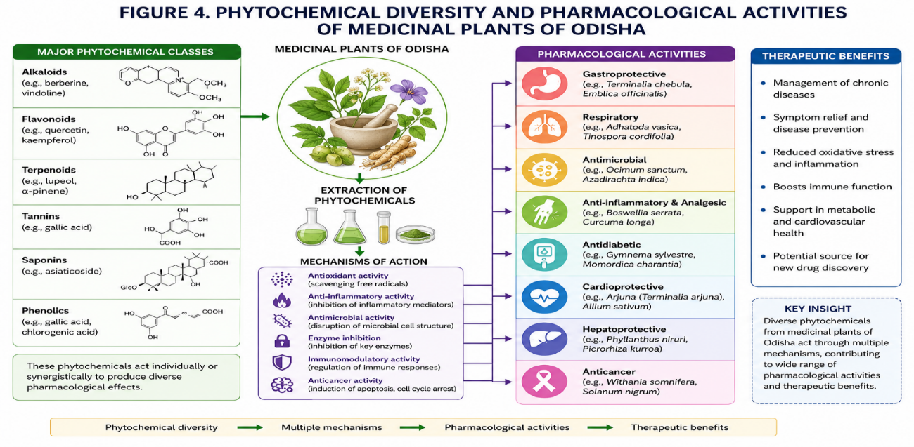
Fig 4: Phytochemical Diversity and Pharmacological Activities of Medicinal Plant of Odisha
7.1 Alkaloids
Alkaloids constitute one of the most important groups of bioactive compounds found in medicinal plants. These nitrogen-containing compounds possess diverse pharmacological activities, including analgesic, antimicrobial, antihypertensive, antimalarial, and anticancer effects. Several medicinal plants traditionally used in Odisha contain alkaloids that contribute significantly to their therapeutic potential. The discovery of numerous plant-derived pharmaceuticals has highlighted the importance of alkaloids in drug development and healthcare applications (Farnsworth et al., 1985; Rates, 2001; Newman & Cragg, 2020).
7.2 Flavonoids and Phenolic Compounds
Flavonoids and phenolic compounds are widely distributed in medicinal plants and are recognized for their strong antioxidant properties. These compounds help neutralize reactive oxygen species and protect biological systems against oxidative stress. Scientific studies have demonstrated that flavonoids exhibit anti-inflammatory, antimicrobial, cardioprotective, hepatoprotective, and antidiabetic activities. The presence of these compounds in medicinal plants contributes significantly to their therapeutic effectiveness and health-promoting properties (Ainsworth & Gillespie, 2007; Mahomoodally, 2013).
7.3 Terpenoids and Essential Oils
Terpenoids represent another important class of phytochemicals commonly found in medicinal plants. These compounds are responsible for various biological activities, including antimicrobial, anti-inflammatory, antioxidant, and anticancer effects. Essential oils rich in terpenoid constituents have been extensively used in traditional medicine for the treatment of respiratory disorders, skin infections, digestive problems, and inflammatory conditions. The pharmacological potential of terpenoids continues to attract considerable interest in natural product research and drug discovery programs (Fabricant & Farnsworth, 2001; Rates, 2001).
7.4 Glycosides, Tannins, and Saponins
Glycosides, tannins, and saponins contribute significantly to the medicinal value of numerous plant species. Glycosides are associated with cardioprotective, antimicrobial, and therapeutic activities, whereas tannins possess astringent, antioxidant, and antimicrobial properties. Saponins are known for their anti-inflammatory, immunomodulatory, and cholesterol-lowering effects. These phytochemical groups collectively enhance the pharmacological importance of medicinal plants and support their traditional therapeutic applications (Mahomoodally, 2013; Newman & Cragg, 2020).
Table 4. Major medicinal plants of Odisha, phytochemical constituents, and pharmacological activities
Medicinal Plant Species | Family | Major Phytochemical Constituents | Reported Pharmacological Activities | Traditional Therapeutic Applications
Tinospora cordifolia | Menispermaceae | Alkaloids, diterpenoids, glycosides, flavonoids | Immunomodulatory, antidiabetic, antioxidant, anti-inflammatory | Fever, diabetes, immune disorders, general weakness
Andrographis paniculata | Acanthaceae | Andrographolide, flavonoids, diterpenoids | Antimicrobial, antimalarial, anti-inflammatory, hepatoprotective | Malaria, fever, liver disorders, infections
Rauvolfia serpentina | Apocynaceae | Reserpine, ajmaline, alkaloids | Antihypertensive, neuropharmacological, sedative | Hypertension, neurological disorders, insomnia
Ocimum sanctum | Lamiaceae | Eugenol, flavonoids, phenolics, essential oils | Antioxidant, antimicrobial, immunomodulatory | Respiratory infections, cough, fever
Curcuma longa | Zingiberaceae | Curcuminoids, terpenoids, polyphenols | Anti-inflammatory, antioxidant, wound-healing | Inflammation, skin disorders, wound healing
Azadirachta indica | Meliaceae | Azadirachtin, limonoids, flavonoids | Antimicrobial, antifungal, anti-inflammatory | Skin infections, fever, wound treatment
Terminalia chebula | Combretaceae | Tannins, gallic acid, flavonoids | Gastroprotective, antioxidant, antimicrobial | Digestive disorders, diarrhea, ulcers
Phyllanthus amarus | Phyllanthaceae | Lignans, flavonoids, tannins | Hepatoprotective, antiviral, antioxidant | Liver disorders, jaundice, gastrointestinal diseases
Withania somnifera | Solanaceae | Withanolides, alkaloids, steroidal lactones | Adaptogenic, anti-inflammatory, immunomodulatory | Stress, weakness, inflammatory disorders
Syzygium cumini | Myrtaceae | Anthocyanins, flavonoids, alkaloids | Antidiabetic, antioxidant, hypoglycemic | Diabetes, metabolic disorders
Asparagus racemosus | Asparagaceae | Saponins, flavonoids, steroidal compounds | Reproductive health support, antioxidant | Female reproductive disorders, weakness
Adhatoda vasica | Acanthaceae | Vasicine, alkaloids, essential oils | Bronchodilatory, expectorant, antimicrobial | Asthma, bronchitis, respiratory infections
Source: Compiled from Farnsworth et al. (1985), Fabricant and Farnsworth (2001), Rates (2001), Mahomoodally (2013), and Newman and Cragg (2020).
7.5 Pharmacological Significance and Future Perspectives
The pharmacological significance of medicinal plants is closely linked to the diversity and complexity of their phytochemical constituents. Numerous modern drugs have originated directly or indirectly from plant-derived compounds, demonstrating the continued importance of medicinal plants as sources of therapeutic agents. Advances in phytochemical screening, bioactivity-guided isolation, metabolomics, and pharmacological evaluation have improved scientific understanding of medicinal plant efficacy and safety. Continued integration of traditional knowledge with modern phytochemical and pharmacological research will facilitate the identification of novel bioactive compounds and support future drug discovery initiatives (Farnsworth et al., 1985; Fabricant & Farnsworth, 2001; Newman & Cragg, 2020).
7.5 Emerging Pharmacological and Phytopharmaceutical Perspectives
Recent advances in phytochemistry, molecular pharmacology, metabolomics, and computational biology have significantly enhanced scientific understanding regarding medicinal plant-derived bioactive compounds (Verma et al., 2022; Yadav et al., 2021).
Integration of traditional ethnomedicinal knowledge with modern pharmacological validation may facilitate discovery of novel therapeutic agents and development of evidence-based phytopharmaceutical products (Newman and Cragg, 2020; Kumar et al., 2021). Medicinal plants of Odisha therefore represent an important resource for future interdisciplinary research associated with herbal drug discovery, functional therapeutics, and sustainable healthcare innovation (Fabricant and Farnsworth, 2001; Verma et al., 2022).
8. ETHNOPHARMACOLOGICAL SIGNIFICANCE OF MEDICINAL PLANTS
Ethnopharmacology represents an interdisciplinary field that investigates the relationships between traditional medicinal knowledge, medicinal plant utilization, and scientific evaluation of therapeutic efficacy. Traditional healthcare systems have accumulated extensive knowledge regarding the identification, preparation, and application of medicinal plants for the treatment of various diseases. Such knowledge serves as an important foundation for pharmacological investigations and natural product research (Martin, 1995; Fabricant & Farnsworth, 2001).
The indigenous communities of Odisha possess rich ethnomedicinal traditions that have been transmitted through generations. Traditional healers utilize numerous plant species for the management of gastrointestinal disorders, respiratory ailments, fever, skin diseases, inflammatory conditions, and metabolic disorders. These practices provide valuable information regarding potentially bioactive plant species and contribute significantly to ethnopharmacological research (Ragupathy & Newmaster, 2009; Mahomoodally, 2013).
Ethnopharmacological knowledge has played an important role in the discovery of therapeutically significant compounds and pharmaceutical agents. The systematic investigation of medicinal plants traditionally used in community healthcare systems has facilitated the identification of bioactive compounds with antimicrobial, antioxidant, anti-inflammatory, antidiabetic, anticancer, and immunomodulatory properties. Consequently, traditional medicinal knowledge continues to serve as a valuable resource for drug discovery and the development of novel therapeutic agents (Farnsworth et al., 1985; Fabricant & Farnsworth, 2001).
Scientific validation of ethnomedicinal claims through phytochemical, pharmacological, and toxicological studies is essential for establishing the efficacy and safety of medicinal plants. Integration of traditional knowledge with modern scientific methodologies enhances understanding of plant-based therapies and supports evidence-based utilization of medicinal resources. Such approaches also contribute to the conservation of traditional knowledge systems and promote sustainable healthcare practices (Mahomoodally, 2013; Newman & Cragg, 2020).
Furthermore, ethnopharmacological research contributes to biodiversity conservation by highlighting the medicinal value of plant resources and emphasizing the importance of protecting ecosystems that support medicinal plant diversity. Documentation and preservation of indigenous knowledge are therefore crucial not only for cultural heritage conservation but also for future healthcare innovation and sustainable utilization of biological resources (Ragupathy & Newmaster, 2009; Newman & Cragg, 2020).
In conclusion, the ethnopharmacological significance of medicinal plants extends beyond traditional healthcare applications and encompasses scientific research, drug discovery, biodiversity conservation, and sustainable development. Continued collaboration among indigenous communities, researchers, healthcare professionals, and conservation agencies is essential for safeguarding ethnomedicinal knowledge and maximizing the potential benefits of medicinal plant resources (Fabricant & Farnsworth, 2001; Newman & Cragg, 2020).
9. CONSERVATION CHALLENGES AND SUSTAINABILITY OF MEDICINAL PLANTS
Medicinal plants constitute an essential component of biodiversity and traditional healthcare systems. They provide valuable therapeutic resources, support rural livelihoods, and contribute significantly to pharmaceutical research and drug discovery. However, increasing anthropogenic pressures, habitat degradation, and unsustainable resource utilization threaten the long-term survival of numerous medicinal plant species. Effective conservation and sustainable management strategies are therefore necessary to ensure the continued availability of medicinal plant resources and associated traditional knowledge systems (Schippmann et al., 2002; Newman & Cragg, 2020).
9.1 Deforestation and Habitat Degradation
Deforestation and habitat degradation represent major threats to medicinal plant diversity. Expansion of agricultural activities, urbanization, infrastructure development, mining operations, and forest resource extraction have resulted in significant alterations to natural ecosystems. Habitat loss reduces species abundance, disrupts ecological interactions, and negatively affects the regeneration potential of medicinal plant populations. Furthermore, fragmentation of forest habitats can limit genetic diversity and increase the vulnerability of plant species to environmental disturbances. Conservation of natural habitats is therefore fundamental for maintaining medicinal plant diversity and ecosystem stability (Martin, 1995; Schippmann et al., 2002; Newman & Cragg, 2020).
9.2 Overharvesting and Unsustainable Utilization
Growing demand for medicinal plant materials has intensified harvesting pressure on wild populations. Unsustainable collection practices, particularly involving roots, bark, rhizomes, and whole plants, can significantly reduce population size and impair natural regeneration. Several medicinally important species are increasingly threatened because of excessive exploitation and inadequate management practices. Sustainable harvesting protocols, cultivation initiatives, and community-based conservation programs are necessary to minimize pressure on natural populations and promote long-term resource sustainability (Farnsworth et al., 1985; Schippmann et al., 2002; Newman & Cragg, 2020).
9.3 Climate Change and Environmental Stress
Climate change poses additional challenges to medicinal plant conservation by altering temperature regimes, precipitation patterns, and ecosystem dynamics. Changes in environmental conditions may affect species distribution, growth, reproductive success, and phytochemical composition. Extreme climatic events such as droughts, floods, and heat stress can further threaten vulnerable plant populations. Understanding the impacts of climate variability on medicinal plant resources is important for developing adaptive conservation strategies and ensuring future resource availability (Schippmann et al., 2002; Mahomoodally, 2013).
9.4 Loss of Traditional Knowledge
Traditional ethnomedicinal knowledge represents an invaluable cultural resource that has been developed through generations of observation and practical experience. However, modernization, migration, changing lifestyles, and reduced transmission of traditional practices to younger generations have contributed to the gradual erosion of indigenous knowledge systems. Documentation, preservation, and promotion of traditional medicinal knowledge are therefore essential for safeguarding cultural heritage and supporting future ethnopharmacological research (Martin, 1995; Ragupathy & Newmaster, 2009).
9.5 Sustainable Conservation Strategies
Sustainable conservation of medicinal plant resources requires an integrated approach involving scientific research, policy support, community participation, and environmental education. In situ conservation through protected areas and habitat management should be complemented by ex situ conservation strategies such as botanical gardens, seed banks, tissue culture repositories, and cultivation programs. Community-based conservation initiatives can further enhance resource protection while supporting local livelihoods and traditional healthcare systems. Such integrated approaches contribute to biodiversity conservation, sustainable utilization, and long-term ecosystem resilience (Schippmann et al., 2002; Fabricant & Farnsworth, 2001; WHO, 2013).
9.6 Future Perspectives
Future conservation efforts should emphasize interdisciplinary research integrating ethnobotany, phytochemistry, pharmacology, biotechnology, and biodiversity conservation. Advances in molecular biology, sustainable cultivation technologies, and phytochemical screening can improve understanding of medicinal plant resources and facilitate evidence-based conservation planning. Strengthening collaboration among researchers, policymakers, healthcare professionals, conservation agencies, and indigenous communities will be crucial for ensuring the sustainable utilization and preservation of medicinal plant diversity for future generations (Fabricant & Farnsworth, 2001; Newman & Cragg, 2020).

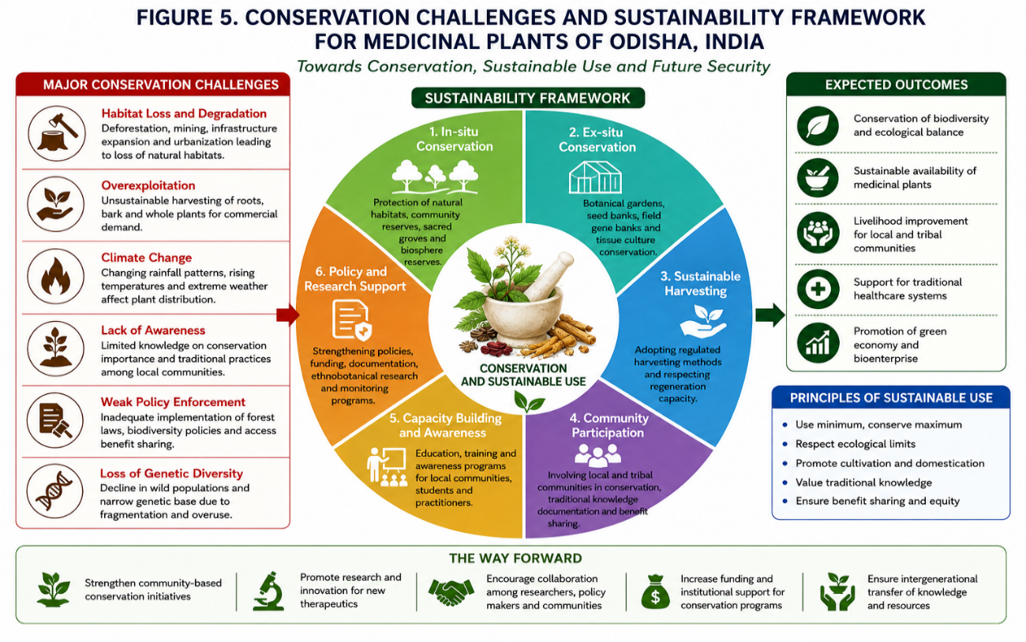
Fig 5: Conservation Challenges And Sustainability Framework For Medicinal Plant of Odisha, India
CONCLUSION
Medicinal plants represent invaluable biological resources that contribute significantly to traditional healthcare systems, biodiversity conservation, and pharmaceutical research. Odisha possesses rich medicinal plant diversity supported by diverse ecological habitats and extensive ethnomedicinal knowledge maintained by indigenous and local communities. The documentation and scientific evaluation of medicinal plants are essential for preserving traditional knowledge and promoting sustainable utilization of plant resources.
Numerous medicinal plant species have demonstrated considerable therapeutic potential owing to the presence of bioactive phytochemicals such as alkaloids, flavonoids, terpenoids, phenolic compounds, glycosides, and tannins. Scientific investigations have increasingly validated many traditional medicinal applications, highlighting the importance of medicinal plants as promising sources of novel therapeutic agents and future drug development initiatives (Fabricant & Farnsworth, 2001; Newman & Cragg, 2020).
Despite their importance, medicinal plant resources face significant challenges including habitat degradation, overexploitation, biodiversity loss, climate-related pressures, and erosion of traditional knowledge systems. Effective conservation strategies involving sustainable harvesting, habitat protection, cultivation programs, community participation, and policy support are therefore essential to ensure long-term resource sustainability (Schippmann et al., 2002; WHO, 2013).
Future research should emphasize phytochemical characterization, pharmacological validation, quality standardization, conservation biology, and interdisciplinary collaboration. The integration of traditional ethnobotanical knowledge with modern scientific approaches will contribute to biodiversity conservation, evidence-based healthcare, and the discovery of new plant-derived therapeutics. Continued efforts in research, conservation, and sustainable utilization will ensure that medicinal plant resources remain valuable assets for present and future generations (Ragupathy & Newmaster, 2009; Newman & Cragg, 2020).

RESEARCH GAPS AND FUTURE DIRECTIONS
Despite substantial progress in ethnobotanical and medicinal plant research, several important knowledge gaps remain regarding the diversity, utilization, pharmacological validation, and conservation of medicinal plants. Many traditionally used medicinal species continue to lack comprehensive phytochemical characterization, pharmacological evaluation, toxicological assessment, and clinical validation. Addressing these gaps is essential for enhancing the scientific credibility and therapeutic application of medicinal plant resources (Fabricant & Farnsworth, 2001; Newman & Cragg, 2020).
One major research gap is the limited scientific validation of traditional ethnomedicinal claims. Although numerous medicinal plants are widely utilized in traditional healthcare systems, only a small proportion have undergone rigorous laboratory and clinical investigations. Future research should focus on bioactivity-guided studies, mechanism-based investigations, and evidence-based evaluation of therapeutic efficacy and safety (Farnsworth et al., 1985; Yuan et al., 2016).
Another important challenge involves the documentation and preservation of traditional knowledge. Rapid socio-economic changes, urbanization, and declining intergenerational knowledge transfer threaten the continuity of indigenous ethnomedicinal practices. Systematic documentation and digital preservation initiatives are therefore necessary to safeguard valuable traditional knowledge and support future ethnopharmacological research (Martin, 1995; Ragupathy & Newmaster, 2009).
Further research is also needed to improve the quality control, standardization, and authentication of herbal medicines. Variations in plant origin, harvesting practices, processing methods, and storage conditions can influence phytochemical composition and therapeutic effectiveness. The development of standardized protocols and quality assurance measures will contribute significantly to the safety, efficacy, and global acceptance of medicinal plant products (WHO, 2013; Zhang et al., 2021).
Conservation-related research represents another important priority. Habitat degradation, biodiversity loss, climate variability, and unsustainable harvesting continue to threaten medicinal plant resources. Future studies should integrate ecological monitoring, sustainable harvesting approaches, cultivation strategies, and community-based conservation programs to ensure long-term resource sustainability (Schippmann et al., 2002; WHO, 2013).
Advances in biotechnology, metabolomics, genomics, and natural product research offer new opportunities for medicinal plant investigation. Integration of traditional knowledge with modern scientific methodologies can facilitate the discovery of novel bioactive compounds, improve understanding of therapeutic mechanisms, and accelerate the development of plant-derived pharmaceuticals. Such interdisciplinary approaches will strengthen the scientific foundation of medicinal plant research and support future healthcare innovations (Fabricant & Farnsworth, 2001; Newman & Cragg, 2020).
In conclusion, future research should emphasize scientific validation, conservation, quality standardization, and interdisciplinary collaboration. Strengthening the integration of ethnobotanical knowledge with contemporary scientific techniques will contribute to sustainable utilization, biodiversity conservation, and the development of evidence-based medicinal plant therapies (Yuan et al., 2016; Newman & Cragg, 2020).

Disclaimer (Artificial intelligence)

Author(s) hereby declare that NO generative AI technologies such as Large Language Models (ChatGPT, COPILOT, etc.) and text-to-image generators have been used during the writing or editing of this manuscript.

REFERENCES
- Ainsworth EA, Gillespie KM (2007). Estimation of total phenolic content and other oxidation substrates in plant tissues using Folin–Ciocalteu reagent. Nature Protocols 2(4): 875–877. https://doi.org/10.1038/nprot.2007.102
- Fabricant DS, Farnsworth NR (2001). The value of plants used in traditional medicine for drug discovery. Environmental Health Perspectives 109(Suppl 1): 69–75. https://doi.org/10.1289/ehp.01109s169
- Farnsworth NR, Akerele O, Bingel AS, Soejarto DD, Guo Z (1985). Medicinal plants in therapy. Bulletin of the World Health Organization 63(6): 965–981.
- Heinrich M, Ankli A, Frei B, Weimann C, Sticher O (1998). Medicinal plants in Mexico: Healers’ consensus and cultural importance. Social Science & Medicine 47(11): 1859–1871. https://doi.org/10.1016/S0277-9536(98)00181-6
- Jain SK (1991). Dictionary of Indian Folk Medicine and Ethnobotany. Deep Publications, New Delhi.
- Kamboj VP (2000). Herbal medicine. Current Science 78(1): 35–39.
- Mahomoodally MF (2013). Traditional medicines in Africa: An appraisal of ten potent African medicinal plants. Evidence-Based Complementary and Alternative Medicine 2013: 617459. https://doi.org/10.1155/2013/617459
- Martin GJ (1995). Ethnobotany: A Methods Manual. Chapman & Hall, London.
- Newman DJ, Cragg GM (2020). Natural products as sources of new drugs over nearly four decades from 01/1981 to 09/2019. Journal of Natural Products 83(3): 770–803. https://doi.org/10.1021/acs.jnatprod.9b01285
- Ragupathy S, Newmaster SG (2009). Valorizing traditional knowledge of medicinal plants through ethnobotanical studies. Journal of Ethnobiology and Ethnomedicine 5: 10. https://doi.org/10.1186/1746-4269-5-10
- Rates SMK (2001). Plants as source of drugs. Toxicon 39(5): 603–613. https://doi.org/10.1016/S0041-0101(00)00154-9
- Schippmann U, Leaman DJ, Cunningham AB (2002). Impact of cultivation and gathering of medicinal plants on biodiversity. In: Biodiversity and the Ecosystem Approach in Agriculture, Forestry and Fisheries. FAO, Rome.
- WHO (2013). WHO Traditional Medicine Strategy 2014–2023. World Health Organization, Geneva.
- Yuan H, Ma Q, Ye L, Piao G (2016). The traditional medicine and modern medicine from natural products. Molecules 21(5): 559. https://doi.org/10.3390/molecules21050559
- Zhang J, Wider B, Shang H, Li X, Ernst E (2021). Quality assessment and standardization of herbal medicines. Journal of Ethnopharmacology 273: 113940. https://doi.org/10.1016/j.jep.2021.113940
- Balick MJ, Cox PA (1996). Plants, People and Culture: The Science of Ethnobotany. Scientific American Library, New York.

- Cox PA, Balick MJ (1994). The ethnobotanical approach to drug discovery. Scientific American 270(6): 82–87.
- Cragg GM, Newman DJ (2013). Natural products: A continuing source of novel drug leads. Biochimica et Biophysica Acta 1830(6): 3670–3695.

- Cunningham AB (2001). Applied Ethnobotany: People, Wild Plant Use and Conservation. Earthscan Publications, London.

- Ekor M (2014). The growing use of herbal medicines and issues relating to adverse reactions and challenges in monitoring safety. Frontiers in Pharmacology 4: 177.

- Gurib-Fakim A (2006). Medicinal plants: Traditions of yesterday and drugs of tomorrow. Molecular Aspects of Medicine 27(1): 1–93.

- Hamilton AC (2004). Medicinal plants, conservation and livelihoods. Biodiversity and Conservation 13: 1477–1517.

- Heinrich M (2000). Ethnobotany and its role in drug development. Phytotherapy Research 14(7): 479–488.

- Kala CP (2005). Indigenous uses and structure of medicinal plants in biodiversity-rich areas of the Indian Himalaya. Journal of Ethnobiology and Ethnomedicine 1: 15.

- Pei SJ (2001). Ethnobotanical approaches of traditional medicine studies: Some experiences from Asia. Journal of Ethnopharmacology 74(1): 99–100.

- Sofowora A (2008). Medicinal Plants and Traditional Medicine in Africa. 3rd Edition. Spectrum Books Ltd., Ibadan.

- Tiwari P, Kumar B, Kaur M, Kaur G, Kaur H (2011). Phytochemical screening and extraction: A review. International Pharmaceutica Sciencia 1(1): 98–106.

- Van Wyk BE, Wink M (2015). Medicinal Plants of the World. CABI Publishing, Wallingford.

- Cordell GA (2011). Sustainable medicines and global health care. Planta Medica 77(11): 1129–1138.

- Canter PH, Thomas H, Ernst E (2005). Bringing medicinal plants into cultivation: Opportunities and challenges for biotechnology. HerbalGram 67: 34–51.

