Original Research Article
“Prevalence and Determinants of Spirometric Abnormalities among Individuals Undergoing Pulmonary Function Testing in South Gujarat, India.”
ABSTRACT
Introduction: Pulmonary function tests (PFTs) are widely used for detecting ventilatory abnormalities and assessing respiratory health. Spirometry plays an important role in the diagnosis, classification, and monitoring of respiratory diseases. However, data regarding spirometric patterns and their associated determinants in the Indian population remain limited. This study aimed to determine the prevalence and distribution of spirometric abnormalities and evaluate their association with demographic and lifestyle factors among individuals undergoing pulmonary function testing.
Methods: A cross-sectional study was conducted from January to June 2024 among 875 participants undergoing spirometry at tertiary care hospitals and community-based health check-up camps in South Gujarat, India. Spirometry was performed as per the American Thoracic Society (ATS) and European Respiratory Society (ERS) guidelines using a Spirolab portable spirometer. Pulmonary function patterns were classified as normal, obstructive, restrictive, or mixed ventilatory defects. Severity of impairment was graded as mild, moderate, or severe according to standard interpretative criteria. Association of spirometric patterns with demographic or lifestyle variables was tested using chi-square tests.
Results: Out of 875 participants, 50.4% had normal spirometry and 49.6% had abnormal pulmonary function findings. The most common abnormality was restrictive ventilatory defect (44.7%), followed by obstructive (3.2%) and mixed ventilatory defects (1.7%). 25.26% of participants had mild impairment, 18.63% had moderate impairment, and 4.0% had severe impairment. There was a significant association between spirometric abnormalities with age group (p < 0.0001), sex (p = 0.0081), and smoking status (p < 0.0001). There was no significant association between body mass index (BMI) and spirometric patterns (p = 0.6155).
Conclusion: Abnormal spirometric findings were common among participants in this population. The strong association of age, sex, and smoking status with pulmonary function abnormalities highlights the importance of spirometry in respiratory screening and smoking-related health interventions.

INTRODUCTION
Pulmonary function tests (PFTs) using spirometry are objective tools for measuring lung function and have an important role in the diagnosis, assessment, and follow-up of respiratory diseases. Compared to advanced imaging and invasive diagnostic techniques, spirometry is one of the most practical, non-invasive, inexpensive, and reproducible methods for the assessment of respiratory function. Spirometric parameters such as forced expiratory volume in 1 second (FEV1), forced vital capacity (FVC), and the FEV1/FVC ratio are routinely used to identify obstructive, restrictive, and mixed (obstruction with restriction) ventilatory abnormalities. The standardized interpretation of spirometry based on the American Thoracic Society (ATS) and European Respiratory Society (ERS) recommendations has improved the reliability and comparability of pulmonary function assessment in clinical and research settings [1, 2]. Unlike radiological investigations, spirometry provides a quantitative functional evaluation of airway limitation and lung mechanics and allows for the early detection of respiratory impairment before the occurrence of major clinical symptoms [1, 2].
Pulmonary function testing is therefore now widely recommended for screening, diagnosis, severity assessment, and follow-up of chronic respiratory diseases such as chronic obstructive pulmonary disease (COPD), asthma, and occupational lung diseases [3, 4]. Recent studies have also highlighted the importance of spirometry in respiratory screening in the community and early detection of undiagnosed pulmonary dysfunction [5].
Abnormal pulmonary function is associated with increased respiratory morbidity, reduced quality of life, and increased mortality even in subjects without previously known respiratory disease [6]. Population-based studies have demonstrated the prevalence of abnormal spirometric patterns in apparently healthy individuals and in community-based populations [7, 8]. Furthermore, recent epidemiological studies have indicated an alarming increase in the burden of chronic respiratory diseases and undiagnosed airflow limitation, particularly in low- and middle-income countries [9].
Several demographics, environmental, and lifestyle factors affect pulmonary function. Aging has been associated with a progressive decline in lung elasticity, respiratory muscle strength, and chest wall compliance, leading to a decline in spirometric values over time [10]. Sex differences in lung size, airway dimensions, hormonal influences, and patterns of occupational exposure may also explain differences in pulmonary function between males and females [11]. Smoking remains the most important preventable risk factor for chronic airflow limitation and chronic obstructive pulmonary disease (COPD), and both current and former smokers have been shown to have significantly higher frequencies of spirometric abnormalities [12, 13]. Tobacco exposure remains one of the major causes of chronic respiratory disease worldwide in the 2024 report of the Global Initiative for Chronic Obstructive Lung Disease (GOLD) [3]. Changes in respiratory mechanics, decreased chest wall compliance, and decreased lung volumes [14, 15] may also have an impact on pulmonary function in relation to body mass index (BMI) and obesity. However, previous studies have reported inconsistent associations between BMI and spirometric abnormalities, suggesting that fat distribution, physical activity, and metabolic health may affect the association [15].
Although spirometry is an integral part of respiratory evaluation, Indian data on the prevalence and determinants of spirometric abnormalities is still limited, particularly in large community-based populations. Hence, the present study was conducted to determine the prevalence and patterns of spirometric abnormalities and their association with demographic and lifestyle factors among individuals undergoing pulmonary function testing in South Gujarat, India.

MATERIALS AND METHODS

Study Design
A cross-sectional study was conducted in South Gujarat, India, over a period of six months from January to June 2024. Pulmonary function testing was carried out at tertiary care centers and during community-based free health check-up camps organized with the support of healthcare institutions and social organizations.

Ethical Approval
The study protocol was approved by the Institutional Ethics Committee of Sarvajanik University (Reference no. RK/PhD/002/2026-27; approved on 16 January 2024). Written informed consent was obtained from all participants before enrollment. The study was conducted in accordance with the ethical principles of the Indian Council of Medical Research (ICMR) guidelines.

Study Population
Participants aged 18 years or older who voluntarily participated and were able to perform acceptable spirometry were included in the study. Participants with contraindications to spirometry, severe cardiopulmonary instability, recent thoracic or abdominal surgery, active respiratory infection, or known severe respiratory illness were excluded.
A total of 912 individuals participated initially. After exclusion of children and participants with incomplete eligibility or contraindications, 875 participants were included in the final analysis.

Data Collection
Demographic and clinical information, including age, sex, smoking status, height, and weight, was collected using a structured questionnaire.
Smoking status was divided into:
• Non-smoker
• Current smoker
• Former smoker
Body mass index (BMI) was calculated by dividing weight in kg by height in m squared (kg/m²) and was categorized according to the World Health Organization criteria.

Spirometry Procedure
Pulmonary function testing was performed with the Spirolab Touch Screen Portable Spirometer. The equipment was in accordance with ATS/ERS recommendations. The spirometry was performed according to the ATS/ERS standardization guidelines. Participants sat comfortably, wore a nose clip, and used a disposable mouthpiece. They were instructed to take a maximal inhalation and to exhale forcefully for at least six seconds. From the spirometric test, three parameters were recorded:
• Forced expiratory volume in one second (FEV1)
• Forced vital capacity (FVC)
• FEV1/FVC ratio
At least three acceptable and repeatable trials were collected per participant, and the highest values were used for analysis as recommended elsewhere.

Interpretation of Spirometry
Pulmonary function patterns were classified as:
- Normal
- Obstructive ventilatory defect
- Restrictive ventilatory defect
- Mixed ventilatory defect
Severity of pulmonary impairment was categorized as mild, moderate, or severe according to ATS/ERS interpretative guidelines.

Statistical Analysis
Data were entered into Microsoft Excel 2019 and analyzed using JMP Student Edition (SAS Institute Inc., USA). Categorical variables were summarized using frequencies and percentages.
Associations between spirometric patterns and demographic variables, including age group, sex, smoking status, and BMI categories, were evaluated using chi-square tests. A p-value <0.05 was considered statistically significant.

RESULTS

Participant Characteristics
A total of 875 participants were included in the study. Among them, 666 (76.1%) were male and 209 (23.9%) were female. Participants were categorized into three age groups: young adults, adults, and seniors. Participants were grouped according to smoking status, like non-smokers, current smokers, and former smokers. BMI classification was in four categories: normal BMI, overweight, obese, and underweight. Demographic characteristics, smoking status, and BMI classification of participants were revealed in Table 1.
Table 1. Demographic Characteristics, Smoking Status, and BMI Classification of Participants
Category | Subcategory | Count | Percentage
Age Group | Young adults | 292 | 33.4%
Age Group | Adults | 479 | 54.7%
Age Group | Seniors | 104 | 11.9%
Smoking Status | Non-smokers | 735 | 84.0%
Smoking Status | Current smokers | 95 | 10.9%
Smoking Status | Former smokers | 45 | 5.1%
BMI Classification | Normal BMI | 425 | 48.6%
BMI Classification | Overweight | 276 | 31.5%
BMI Classification | Obese | 97 | 11.1%
BMI Classification | Underweight | 77 | 8.8%

Distribution of Spirometric Patterns
Normal pulmonary function was observed in 441 participants (50.4%), while abnormal spirometry was identified in 434 participants (49.6%).
Abnormal spirometric patterns included:
- Restrictive ventilatory defects in 391 (44.7%) participants.
- Obstructive ventilatory defects in 28 participants (3.2%)
- Mixed ventilatory defects in 15 participants (1.7%)
Severity classification among abnormal cases showed the following:
- Mild impairment: 221 (25.26%)
- Moderate impairment: 163 (18.63%)
- Severe impairment: 35 (4.0%)

Association between sex and spirometric pattern:
Male participants were found to have a higher proportion of normal spirometry as compared to female participants, as seen in Figure 1. Restrictive ventilatory defects were commonly found in both sexes, while obstructive patterns were relatively more in females.
A statistically significant association was observed between sex and spirometric pattern (Pearson χ² = 11.8, df = 3, p = 0.0081).
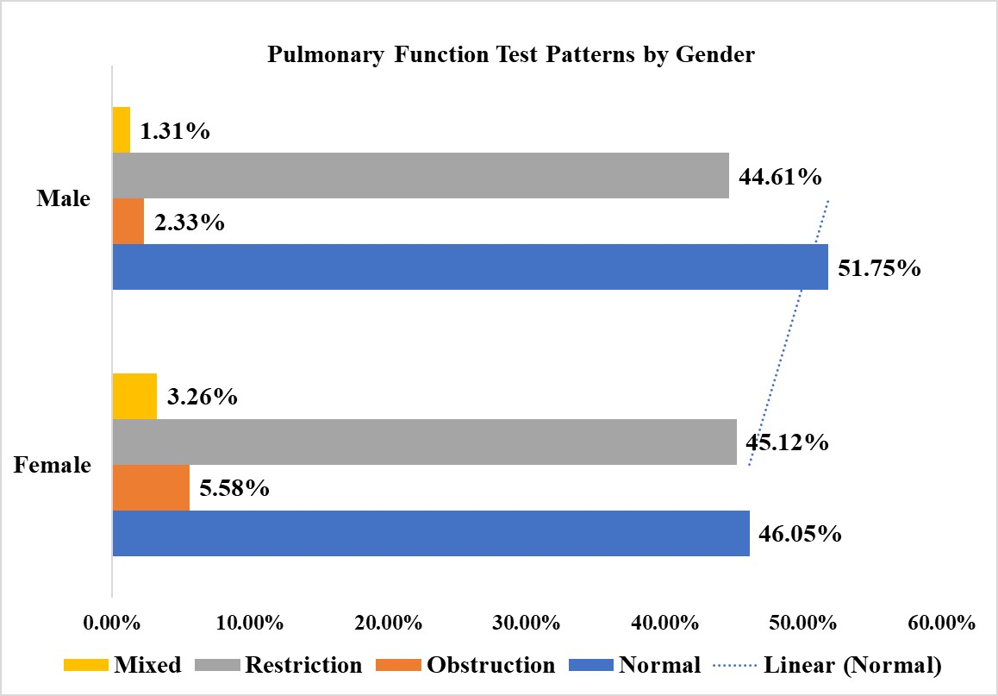
Figure 1. Distribution of Participants’ Gender as per Pulmonary Function Pattern.
Association Between Age Group and Spirometric Pattern:
Older participants demonstrated a greater prevalence of obstructive and mixed ventilatory defects compared with younger participants. Associations between PFTs and age groups are illustrated in Figure 2. Restrictive abnormalities were common in all age groups. There was a significant association between age group and spirometric pattern (Pearson χ 2 = 67.1, p < 0.0001).
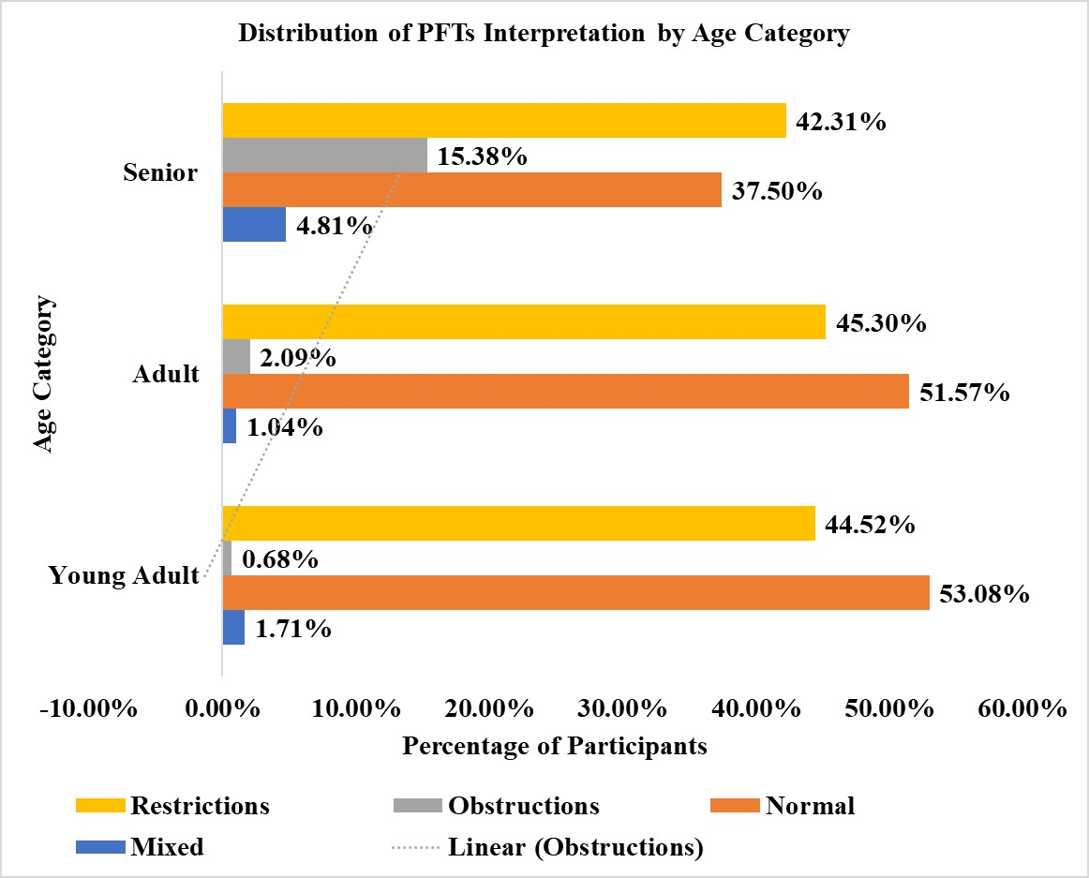

Figure 2. Distribution of Participants’ Age Groups as per Pulmonary Function Pattern.
Association Between Smoking Status and Spirometric Pattern:
Non-smokers had normal spirometry most commonly, whereas smokers and ex-smokers had a higher prevalence of obstructive and mixed ventilatory defects. Figure 3 illustrates the potential variation of PFT patterns based on smokers' status (never, current, and ex-smokers).
Smoking status was significantly associated with spirometric abnormalities (Pearson χ² = 37.948, p < 0.0001).
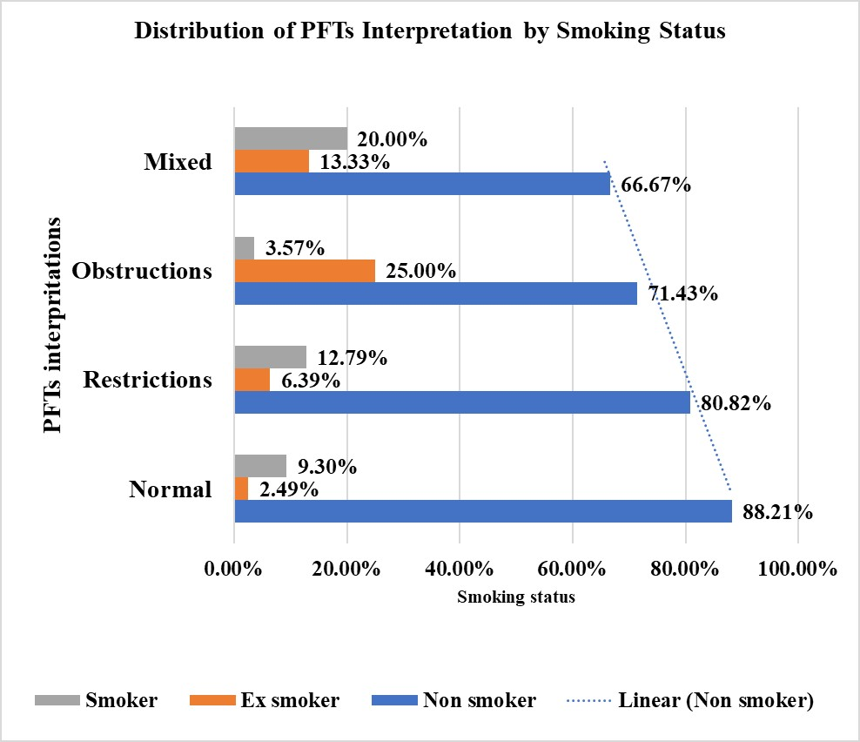
Figure 3. Distribution of Participants' Smoking Status as per Pulmonary Function Pattern
Association Between BMI and Spirometric Pattern:
Spirometric patterns were distributed similarly across all BMI categories, as seen in Figure 4. Restrictive abnormalities remained the most frequent abnormal finding in all groups.
No statistically significant association was observed between BMI category and spirometric pattern (Pearson χ² = 7.306, p = 0.605).

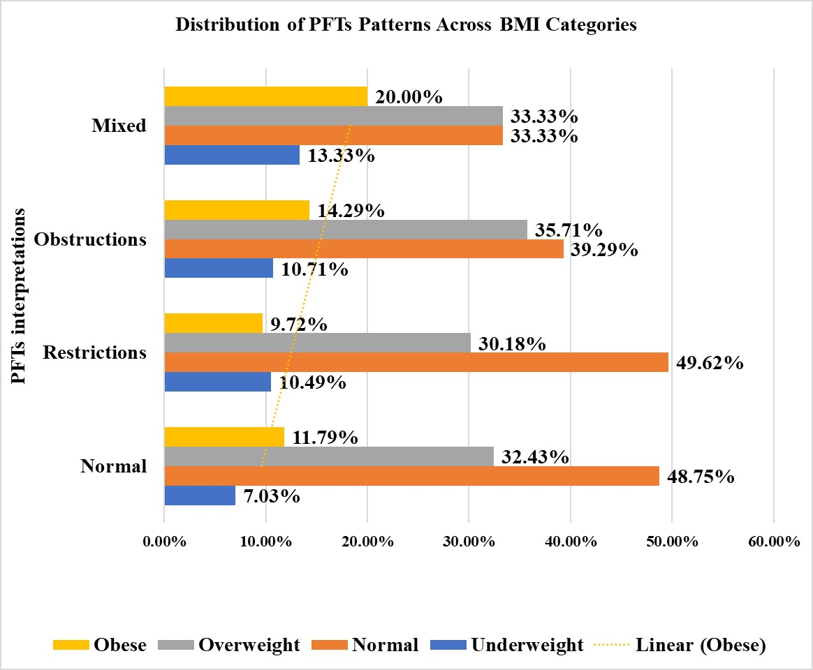
Figure 4. Distribution of Participants' BMI Categories as per Pulmonary Function Pattern.

DISCUSSION:
The present study showed a significant burden of spirometric abnormalities among individuals undergoing pulmonary function testing in South Gujarat, with nearly half of the study participants exhibiting abnormal patterns of pulmonary function. Restrictive ventilatory defects were the most common abnormality detected in the study population. The results of the current study suggest that subclinical or undiagnosed respiratory dysfunction may be common even in community-based health screening programs. Similar findings have been demonstrated in previous population-based and occupational studies that have reported a significant prevalence of abnormal spirometric patterns in adults [7, 8, 16]. The prevalence of abnormal spirometry observed in this study corroborates with findings from earlier epidemiological studies from India and elsewhere. Population-based studies have shown that restrictive and obstructive spirometric abnormalities still occur in apparently healthy individuals and may be suggestive of underlying environmental, occupational, or smoking-related exposures [8, 16]. Several studies among occupational groups in India have also reported a high prevalence of restrictive ventilatory defects, highlighting the role of occupational and environmental exposures in contributing to respiratory impairment [16]. These findings emphasize the need for early screening with spirometry and respiratory health surveillance in high-risk populations.
The present study showed a significant association of age with abnormal pulmonary function patterns with relatively higher frequencies of obstructive abnormalities among the older participants as compared to the younger participants. This is biologically plausible as aging is associated with progressive loss of elastic recoil of the lung, reduced chest wall compliance, weakening of respiratory muscles, and deterioration of pulmonary reserve [10]. Longitudinal studies have shown consistent age-related decrements in FEV1 and FVC with an accelerated decline in older populations [17]. The observed decline in pulmonary function with increasing age may also be a surrogate for cumulative environmental and smoking-related exposure with advancing age. Gender-based differences in spirometric patterns were also observed in this study. These differences could be attributed to the differences in lung size, airway size, body composition, occupational exposure, and smoking behavior between males and females [11]. Previous studies have suggested that smoking-related decrements in pulmonary function may be more pronounced among females despite relatively preserved baseline spirometric values in never-smokers [18]. Sociocultural and environmental factors may further contribute to differential respiratory risk profiles between sexes in the Indian population.
There was a strong and statistically significant association between smoking status and abnormal spirometric results. The frequency of obstructive and mixed ventilatory defects was higher in current smokers and ex-smokers than in non-smokers. These results are in line with previous evidence that chronic tobacco exposure causes airway inflammation, oxidative stress, mucociliary dysfunction, and progressive airflow limitation resulting in COPD [3, 12]. Previous studies have demonstrated that a considerable proportion of smokers have undiagnosed airflow obstruction detected by spirometry [19]. The results of the present study further underline the importance of smoking cessation strategies and routine pulmonary function testing in smoking-exposed individuals.
Obesity and increased BMI can have an effect on respiratory mechanics and lung compliance, but no statistically significant association was observed between BMI categories and spirometric patterns in the present study. In the literature, the relationship between obesity and pulmonary function has been reported as heterogeneous, and the respiratory effects of obesity may depend on fat distribution, abdominal adiposity, physical activity, and associated metabolic factors [14, 15]. Some studies have shown reductions in lung volumes and respiratory compliance in obese individuals, whereas others have demonstrated variable associations across different spirometric phenotypes [20]. The absence of a statistically significant association in this present study should be interpreted in the light of these complex interactions.
The findings of this study have important implications for public health, particularly in developing countries where respiratory diseases are often underdiagnosed. Community-based spirometry screening has the potential to identify pulmonary dysfunction early and to initiate preventive interventions in high-risk groups [5, 19]. Surveillance of respiratory disease can be improved by routine assessment of pulmonary function in community health programs and by supporting smoking cessation and occupational health efforts. Strengths of this study include a relatively large sample, community and hospital-based participants, and use of ATS/ERS standardized spirometry protocols to improve reliability and generalizability of the findings [1, 2]. Some limitations of the study must also be acknowledged. The study was cross-sectional in design and therefore cannot provide causal inferences or longitudinal assessment of change in pulmonary function over time. Self-reporting of smoking history may introduce reporting bias. In addition, detailed assessment of environmental and occupational exposure data was not performed, and post-bronchodilator spirometry was not performed, which can influence the spirometric interpretation in some participants.
In conclusion, abnormal spirometric findings were common in individuals undergoing pulmonary function testing in South Gujarat. Age, sex, and smoking status were important determinants of pulmonary function abnormalities, while BMI was not significantly associated in this study population. These results emphasize the need for standardized spirometry assessment and specific screening for respiratory health, especially among smokers and older people.
CONCLUSION
This population-based study demonstrated a high prevalence of spirometric abnormalities among individuals in South Gujarat. Restrictive ventilatory defects were the most common abnormality identified. Abnormal pulmonary function patterns were significantly associated with age, sex, and smoking status. The results highlight the usefulness of spirometry as a screening and diagnostic tool in the assessment of respiratory health in clinical and community settings. Community-based respiratory screening and smoking cessation interventions can assist in the early detection and prevention of chronic respiratory disease.
PUBLIC HEALTH IMPLICATION
The findings underscore the importance of community-based spirometry screening for the early identification of pulmonary dysfunction, especially among smokers and older persons.
Limitations:
Cross-sectional self-reported status of smoking habits could potentially be underreported. Moreover, other external environmental influences, such as air quality and occupational exposure, were not adjusted for and potentially interfered with the results.
Conflict of interest
The authors declare no conflicts of interest.
Ethical approval
The study protocol was approved by the Institutional Ethics Committee of Sarvajanik University (Reference No. RK/PhD/002/2026-27; approved on 16 January 2024). Written informed consent was obtained from all participants before enrollment.
Disclaimer (Artificial intelligence)
Author(s) hereby declare that NO generative AI technologies such as Large Language Models (ChatGPT, COPILOT, etc.) and text-to-image generators have been used during the writing or editing of this manuscript.

FINAL REFERENCES
- Graham BL, Steenbruggen I, Miller MR, et al. (2019). Standardization of spirometry 2019 update: An official American Thoracic Society and European Respiratory Society technical statement. Am J Respir Crit Care Med. 200(8):e70-e88. doi:10.1164/rccm.201908-1590ST.
- Stanojevic S, Kaminsky DA, Miller MR, et al. (2022). ERS/ATS technical standard on interpretive strategies for routine lung function tests. Eur Respir J. 60(1):2101499. doi:10.1183/13993003.01499-2021.
- Global Initiative for Chronic Obstructive Lung Disease (GOLD). (2024). Global strategy for the diagnosis, management, and prevention of COPD: 2024 report. Available from: GOLD 2024 Report
- Pellegrino R, Viegi G, Brusasco V, et al. (2005). Interpretative strategies for lung function tests. Eur Respir J. 26(5):948-968.
- Labaki WW, Han MK. (2021). Improving detection of early chronic obstructive pulmonary disease. Ann Am Thorac Soc. 18(5):757-763.
- Mannino DM, Buist AS. (2007). Global burden of COPD: Risk factors, prevalence, and future trends. Lancet. 370(9589):765-773.
- Burney PG, Hooper R. (2011). Forced vital capacity, airway obstruction, and survival in a general population sample from the USA. Thorax. 66(1):49-54.
- Vollmer WM, Gíslason Þ, Burney P, et al. (2009). Comparison of spirometry criteria for the diagnosis of COPD: Results from the BOLD study. Eur Respir J. 34(3):588-597.
- Soriano JB, Kendrick PJ, Paulson KR, et al. (2020). Prevalence and attributable health burden of chronic respiratory diseases, 1990–2017. Lancet Respir Med. 8(6):585-596.
- Janssens JP, Pache JC, Nicod LP. (1999). Physiological changes in respiratory function associated with ageing. Eur Respir J. 13(1):197-205.
- Harms CA. (2006). Does gender affect pulmonary function and exercise capacity? Respir Physiol Neurobiol. 151(2-3):124-131.
- Forey BA, Thornton AJ, Lee PN. (2011). Systematic review with meta-analysis of the epidemiological evidence relating smoking to COPD, chronic bronchitis and emphysema. BMC Pulm Med. 11:36.
- US Department of Health and Human Services. (2014). The health consequences of smoking—50 years of progress: A report of the Surgeon General. Atlanta: USDHHS.
- Salome CM, King GG, Berend N. (2010). Physiology of obesity and effects on lung function. J Appl Physiol. 108(1):206-211.
- Littleton SW. (2012). Impact of obesity on respiratory function. Respirology. 17(1):43-49.
- Meo SA. (2004). Spirometric evaluation of lung function among textile workers. Int J Occup Med Environ Health. 17(4):451-455.
- Sharma G, Goodwin J. (2006). Effect of aging on respiratory system physiology and immunology. Clin Interv Aging. 1(3):253-260.
- Aryal S, Diaz-Guzman E, Mannino DM. (2014). Influence of sex on chronic obstructive pulmonary disease risk and treatment outcomes. Int J Chron Obstruct Pulmon Dis. 9:1145-1154.
- Represas-Represas C, Botana-Rial M, Leiro-Fernandez V, et al. (2010). Screening of chronic obstructive pulmonary disease with pocket spirometry in primary care. Respiration. 80(4):289-295.
- Peters U, Suratt BT, Bates JHT, Dixon AE. (2018). Beyond BMI: Obesity and lung disease. Chest. 153(3):702-709.

