Original Research Article

Long-Term Assessment of Forest Fire Dynamics and Terrain Influences Using Remote Sensing Data in Ratapani Wildlife Sanctuary, Madhya Prdesh, India

.
ABSTRACT

Forest fires are major ecological disturbances influencing vegetation dynamics and ecosystem functioning in tropical dry deciduous forests. The present study assessed the spatial and temporal distribution of forest fires in Ratapani Wildlife Sanctuary (RWS), Central India, using remote sensing and GIS techniques. Multi-temporal Landsat series data, MODIS active fire products and DEM-derived topographic variables were integrated for a 22-year period (2002–2023) to analyse forest fire frequency, hotspot distribution and the influence of topographic factors on recurrent fire occurrence. Forest fire frequency mapping revealed that the very high fire frequency class occupied the largest proportion (47.9%) of the sanctuary area, indicating repeated fire incidences across major parts of the landscape. MODIS fire analysis showed strong annual and seasonal variation, with maximum fire activity recorded during 2021–2022 and peak fire occurrence during February–April. Hotspot analysis identified the central and southeastern regions of the sanctuary as highly fire-prone zones. Topographic analysis indicated that moderate elevations (500–550 m), gentle slopes (0–10°), south-facing aspects and rugged terrain conditions were more vulnerable to recurrent forest fires. These results suggest that topographic influence and vegetation structure jointly regulate fire regimes in RWS. The findings enhance our understanding of long-term fire dynamics and terrain influences in Ratapani Wildlife Sanctuary, providing valuable scientific support for fire risk assessment, monitoring and conservation planning.

Keywords: Forest fire; MODIS; Remote sensing; GIS; Topographic factors; Ratapani Wildlife Sanctuary; Central India

1. INTRODUCTION

Forest fire is an important ecological disturbance that plays a significant role in shaping forest ecosystems at both landscape and regional scales (Negi, 2019; Bargali et al., 2022a). It influences vegetation distribution, species regeneration, biodiversity and soil characteristics, thereby affecting the overall structure and functioning of forest ecosystems. The long-term impacts of forest fire are largely determined by the frequency and seasonal occurrence of fire events. Repeated fires can alter vegetation structure, regeneration patterns and ecosystem functioning; however, certain species develop adaptive traits such as thick bark and post-fire regeneration ability that help them survive under recurrent fire conditions (Khan & Tripathi, 1989; Fule et al., 2021). Although natural wildfires have played an important role in shaping the evolution and distribution of forest ecosystems, anthropogenic disturbances and changing climatic conditions have considerably altered present-day fire regimes and fire occurrence patterns (Pausas & Keeley, 2009; Artés et al., 2017; Talukdar et al., 2024). Forest fires can exert both beneficial and adverse ecological effects depending on their intensity and frequency (Banerjee, 2021). Low and moderate intensity fires can enhance nutrient recycling, promote fresh vegetation growth and create favourable habitat conditions for several wildlife species. In contrast, high-intensity fires may lead to nutrient loss, soil erosion, reduction in soil biota, forest biomass and biodiversity. Forest fires also contribute significantly to greenhouse gas emissions, thereby influencing global climate change, which may further increase the frequency and intensity of future fire events (Mupfiga et al., 2025). Forest fire occurrence and spread are controlled by a combination of climatic, topographic, fuel and anthropogenic factors (Prentice et al., 2011; Bousquet et al., 2022). Among these, topographic parameters such as elevation, slope, aspect and Terrain Ruggedness Index (TRI) are considered important predictors of forest fire occurrence in the Indian context (Banerjee, 2021). These terrain characteristics regulate local temperature, moisture availability, vegetation distribution and fuel flammability, thereby influencing fire susceptibility and spread (Zhang et al., 2017). Topography also affects the direction and rate of fire movement through variations in solar radiation, wind movement and microclimatic conditions. Higher elevations generally experience lower fire frequency due to cooler and more humid conditions, although severe fires may occur where fuel accumulation is high. Climate further plays a crucial role in determining fuel load and fuel flammability by controlling vegetation growth and moisture conditions (Meyn et al., 2007; Zubkova et al., 2019). Consequently, meteorological parameters such as precipitation, temperature, humidity and wind speed are widely used to understand forest fire characteristics, occurrence and spread. These meteorological conditions can act as both triggering and conditioning factors for the initiation and propagation of forest fires (Turco et al., 2013). Therefore, accurate estimation and monitoring of forest fires require detailed spatial and temporal analyses (Bilgili et al., 2019; Sevinc et al., 2020). Geospatial technologies such as remote sensing and Geographic Information Systems (GIS) have become important tools for monitoring and analysing forest fire dynamics, including fire assessment, burned area mapping and post-fire evaluation (Sahu et al., 2024). Satellite-based remote sensing enables efficient detection of active fire locations, burned scars and vegetation changes over large spatial and temporal scales (Roy et al., 2008). Previous studies have widely utilized multi-sensor and multi-temporal satellite datasets for assessing vegetation fires and understanding forest fire patterns under different environmental conditions (Reddy & Sarika, 2022). These geospatial approaches provide reliable and cost-effective techniques for long-term forest fire monitoring, hotspot identification and fire risk assessment. Advances in remote sensing technology, geospatial analysis and machine learning techniques have greatly enhanced the capability to understand and monitor forest fire dynamics in recent years (Singh & Jeganathan, 2024). Satellite-based observations provide valuable information on the spatial and temporal variability of fire events and help in analysing long-term trends of forest fire occurrence. Burned area and active fire products generated from satellite datasets are widely used for evaluating fire distribution and fire behaviour patterns (Justice et al., 2002; Kumar et al., 2022). Various satellite sensors such as Landsat Thematic Mapper (TM), Enhanced Thematic Mapper Plus (ETM+), Operational Land Imager (OLI), Indian Remote Sensing Linear Imaging Self-Scanning Sensor-III (IRS LISS-III), Advanced Wide Field Sensor (AWiFS), Moderate Resolution Imaging Spectroradiometer (MODIS), Visible Infrared Imaging Radiometer Suite (VIIRS), Sentinel-1 Synthetic Aperture Radar (SAR) and Sentinel-2 Multispectral Instrument (MSI) have been extensively applied for vegetation fire detection and monitoring under different environmental conditions (Reddy & Sarika, 2022). Among these, NASA’s FIRMS offers near real-time active fire information using MODIS and VIIRS sensors onboard Terra, Aqua and NOAA-20 satellites (Singh & Jeganathan, 2024). These satellite systems also enable continuous monitoring of vegetation cover and landscape changes over broad spatial scales. In addition, recent improvements in climate modelling and numerical weather prediction have enhanced the prediction of extreme fire-weather conditions through improved forecasting capability and higher spatial resolution. Consequently, data-driven geospatial approaches are increasingly being adopted for wildfire prediction, hotspot identification and forest fire risk assessment (Jain et al., 2020). Despite the increasing application of remote sensing and GIS techniques in forest fire studies, long-term geospatial assessment of forest fire frequency and its relationship with topographic factors remains limited in Ratapani Wildlife Sanctuary and several other ecologically important forest landscapes of Madhya Pradesh and Central India. In particular, studies integrating multi-temporal satellite datasets with topographic analysis for understanding recurrent fire patterns are still lacking in many tiger reserves, protected areas and reserved forests of the region. Therefore, the present study aims to assess the spatial and temporal distribution of forest fires in Ratapani Wildlife Sanctuary using a 22-year dataset (2002–2023) derived from Landsat series, MODIS active fire data and DEM-based topographic analysis. The study further evaluates the influence of terrain characteristics on recurrent forest fire occurrence in Ratapani Wildlife Sanctuary.

2. material and methods

2.1 Study Area
Ratapani Wildlife Sanctuary (RWS) is located in the Raisen district of Madhya Pradesh, India, within the Vindhyan hill ranges between 22.816223–23.106725 N latitude and 77.337314–78.067924 E longitude (Fig. 1). The sanctuary extends across an elevation range of 300–674 m above mean sea level and experiences a subtropical climatic regime characterized by three distinct seasons: summer (March–May), monsoon (June–September) and winter (December–February). The region receives an average annual rainfall of approximately 1100–1450 mm, primarily through the southwest monsoon. Summer temperatures generally range between 38°C and 42°C and may occasionally exceed 45°C, whereas winter temperatures vary from 8°C to 12°C and can fall below 5°C during colder periods. The geology of the sanctuary is predominantly composed of Vindhyan sandstone and shale formations, while sandy loam and shallow gravelly soils are commonly distributed throughout the area. Several reservoirs and seasonal streams, including the Barna and Kolar reservoirs, support the hydrological network of Ratapani Wildlife Sanctuary. The vegetation of the sanctuary is mainly represented by tropical dry deciduous forest following the classification of Champion and Seth (1968). The forest landscape is dominated by Tectona grandis, accounting for nearly 55% of the forest composition, while the remaining mixed forest vegetation includes species such as Butea monosperma, Terminalia tomentosa, Miliusa tomentosa, Diospyros melanoxylon and Chloroxylon swietenia. The sanctuary presently covers an area of approximately 825.90 km² encompassing the forest ranges of Barkheda, Bineka, Dahod and Delawari. Considering to its ecological significance potential, the area was declared the 57th Tiger Reserve of India in December 2024, with an expanded landscape area of 1271.465 km² comprising 763.812 km² core area and 507.653 km² buffer area.
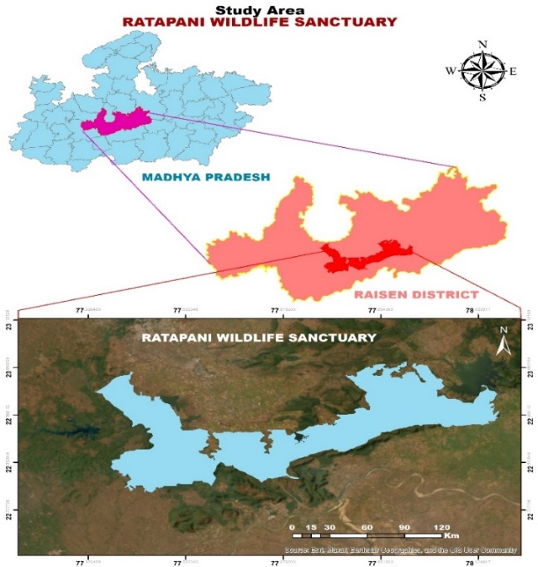
Fig. 1 Location map of Ratapani Wildlife Sanctuary
2.2 Forest fire frequency mapping
The base map of Ratapani Wildlife Sanctuary was prepared using Survey of India toposheets at 1:50,000 scale. The administrative and forest boundaries of the sanctuary were verified using records obtained from the National Tiger Conservation Authority (NTCA) and the Obaidullaganj forest division. Forest fire analysis was performed using multi-temporal satellite datasets acquired from Landsat 7 ETM+, Landsat 8–9 OLI/TIRS, MODIS and Sentinel-2 platforms for the period 2002–2023. Landsat series imagery was primarily utilized because of its free accessibility, continuous long-term archive availability, suitable temporal resolution of 16 days and comparatively higher spatial resolution of 30 m, making it highly effective for long-term forest fire detection and monitoring. Landsat 7 ETM+ Collection 2 Level-1 (C2 L1) imagery was used from January 2002 to April 2013, whereas Landsat 8–9 OLI/TIRS Collection 2 Level-1 datasets were employed from May 2013 to June 2023. Additionally, Sentinel-2 imagery acquired during February 2018 and March 2023 was also used for detailed burned area interpretation. All satellite datasets used in this study were selected with cloud cover below 30%. Burned areas were identified through on-screen visual interpretation using Near Infrared (NIR) and Short-Wave Infrared (SWIR) spectral bands. False Colour Composite (FCC) combinations of 5–4–1 for Landsat 7 ETM+, 7–5–2 for Landsat 8–9 OLI/TIRS and 12–8A–4 for Sentinel-2 imagery were used to improve the identification of fire-affected patches. Monthly fire maps prepared for the fire season period extending from January to June were integrated to generate annual fire distribution maps for each study year. Subsequently, all yearly fire raster layers were converted into vector format and assigned unique values, where burned areas were coded as 1 and unburned areas as 0, followed by reconversion into raster datasets. The final forest fire frequency map was generated by integrating all yearly raster layers using the raster calculator tool in ArcGIS 10.8 software. Based on fire return interval analysis, the study area was categorized into five fire frequency classes, namely Control class (CC), Low class fire frequency (LCFF), Moderate class fire frequency (MCFF), High class fire frequency (HCFF) and Very high class fire frequency (VHCFF), corresponding to no fire return interval (CC), approximately 11 years, 5 years, 3 years and less than 2 years of fire return interval, respectively.
2.3 Geospatial Analysis of MODIS Active Fire
Geospatial analysis of active forest fire occurrences in Ratapani Wildlife Sanctuary was carried out using Moderate Resolution Imaging Spectroradiometer (MODIS) active fire datasets obtained from (NASA FIRMS, 2023). MODIS active fire data derived from Terra and Aqua satellites were used for the period 2002–2023 to assess the spatial and temporal distribution of forest fire events within the sanctuary. The MODIS active fire product with 1 km spatial resolution and high temporal resolution provides multiple daily observations during daytime and nighttime, making it suitable for continuous forest fire monitoring and hotspot detection (Giglio et al., 2016). All MODIS fire point datasets were downloaded in vector format and processed in ArcGIS 10.8 software. The fire point data were projected into the UTM coordinate system and clipped using the sanctuary boundary. Annual-wise and seasonal month-wise fire point distributions were analyzed to identify the temporal variation, spatial concentration and recurrence of active fire events within the sanctuary landscape.
2.4 Topographic DEM based analysis
Topographic analysis of Ratapani Wildlife Sanctuary was carried out using Shuttle Radar Topography Mission (SRTM) Digital Elevation Model (DEM) data (SRTM1N22E077V3) from (USGS, 2023). The SRTM DEM dataset with 30 m spatial resolution was used to generate topographic variables including elevation, slope, aspect, hillshade and Terrain Ruggedness Index (TRI). All DEM datasets were processed in ArcGIS 10.8 software using spatial analyst tools. Elevation, slope, aspect and hillshade maps were generated directly from the DEM raster, while TRI was derived to evaluate terrain heterogeneity and ruggedness within the sanctuary landscape. The generated topographic layers were further integrated with forest fire frequency zones and MODIS fire points (2002-2023) to analyze the influence of terrain characteristics on the spatial distribution of forest fire occurrences. Forest fire hotspot analysis in Ratapani Wildlife Sanctuary was carried out using MODIS active fire data (2002–2023) obtained from NASA FIRMS. The fire point data were processed in ArcGIS and analysed using the Getis-Ord Gi* statistic to identify hotspot and cold spot zones based on z-score values. Fire intensity distribution was further interpolated using the Inverse Distance Weighted (IDW) method based on Fire Radiative Power (FRP) values. The resulting raster surface was classified into five fire intensity zones: very low, low, moderate, high, and very high.

3. results and discussion

3.1 Forest fire frequency zones in Ratapani Wildlife Sanctuary
Forest fire frequency analysis of RWS revealed considerable spatial variation in recurrent fire occurrences during the study period (2002–2023). Among all fire frequency classes, the Very high class fire frequency (VHCFF) occupied the largest area of the sanctuary, covering approximately 384.53 km², followed by high class fire frequency (HCFF) occupying 142.16 km². Low class Fire frequency (LCFF) and moderate class fire frequency (MCFF) covered 108.95 km² and 83.47 km² respectively, whereas the control class (CC) represented only 83.84 km² of the total geographical area. The dominance of very high fire frequency zones indicates the occurrence of repeated forest fire incidences across a major portion of the sanctuary landscape (Fig. 2). The percentage distribution of forest fire frequency classes indicated the dominance of recurrent fire-affected areas within RWS. The very high class fire frequency (VHCFF) occupied the largest proportion of the sanctuary area (47.9%), followed by high class fire frequency (HCFF) covering 17.7%. Low class fire frequency (LCFF) represented 13.6% of the total area, whereas both the control class (CC) and moderate class fire frequency (MCFF) each accounted for approximately 10.4% of the sanctuary landscape (Fig. 3). Range-wise analysis further demonstrated considerable variation in fire frequency distribution across different forest ranges. In Barkheda range (Fig. 4a), the very high class fire frequency zone (VHCFF) occupied the maximum area (159.40 km²), followed by high class fire frequency (HCFF) covering 47.87 km², while moderate class fire frequency (MCFF) occupied the lowest area (21.51 km²). Similarly, Bineka range (Fig. 4b) was also dominated by VHCFF covering 107.88 km², whereas the control class (CC) occupied comparatively smaller area (23.17 km²). In Dahod range (Fig. 4c), VHCFF covered 54.20 km² followed by HCFF (31.73 km²), while the control class (CC) represented 20.45 km² of the range area. Among all ranges, Delawari range (Fig. 4d) exhibited comparatively lower spatial extent under different fire frequency classes; however, VHCFF still occupied the maximum area (64.54 km²), followed by HCFF (24.17 km²). The control class (CC), LCFF and MCFF covered relatively smaller areas of 16.35 km², 14.01 km² and 13.90 km² respectively. Overall, the results indicate that Barkheda and Bineka ranges experienced comparatively higher recurrent fire incidences, whereas Dahod and Delawari ranges showed relatively moderate fire frequency distribution patterns within the sanctuary landscape.

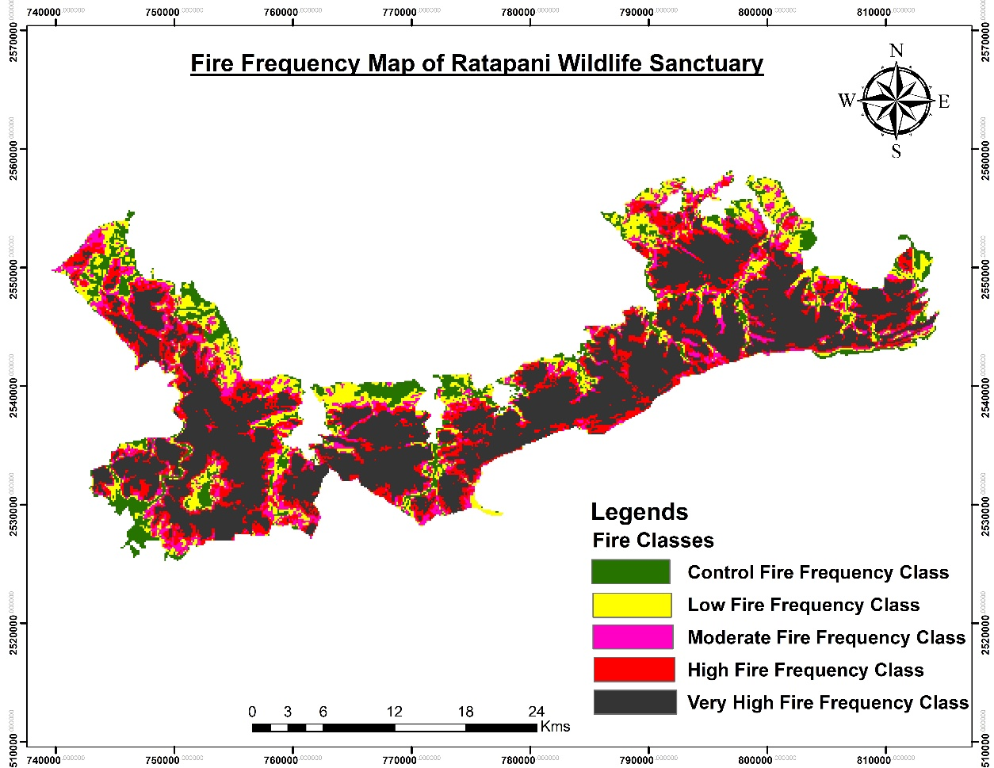
Fig. 2 Fire frequency map of Ratapani Wildlife Sanctuary (2002-2023)
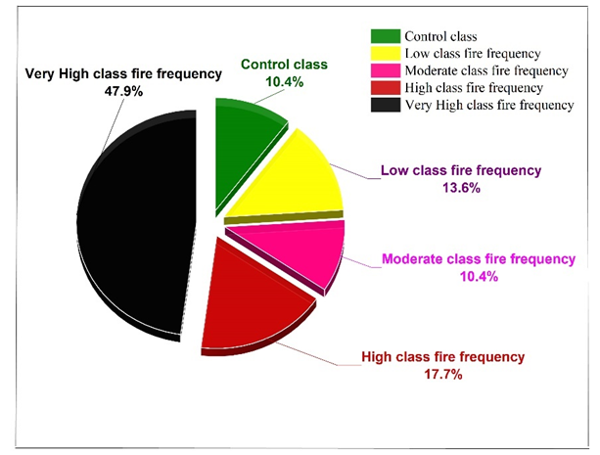
Fig. 3 Percentage distribution of forest fire frequency classes in Ratapani Wildlife Sanctuary

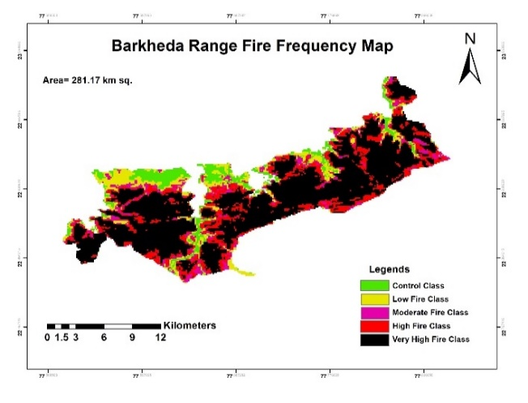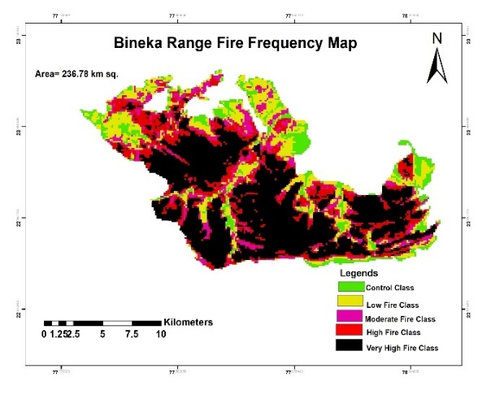
(b) Ratapani
(a) Ratapani
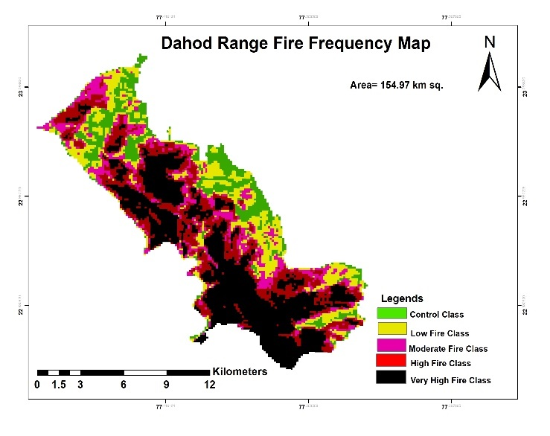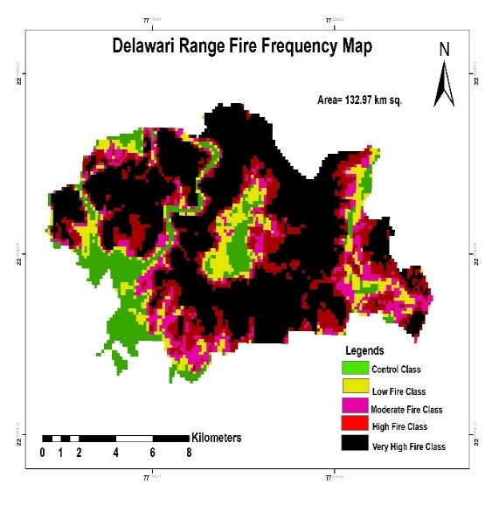
(d) Ratapani
(c)Ratapani
Fig. 4 (a-d) Range wise fire frequency map of Ratapani Wildlife Sanctuary
3.2 Geospatial distribution of MODIS fire occurrences
Annual forest fire occurrence analysis in RWS revealed substantial inter-annual variation in MODIS active fire points during the study period (Fig. 5). The highest number of fire points was recorded in 2021 (191 fire points), followed by 2022 (162 fire points), 2019 (147 fire points) and 2011 (145 fire points). In contrast, comparatively lower fire incidences were observed during 2003 (18 fire points), 2015 (21 fire points) and 2020 (37 fire points). The results further indicate an increasing trend in fire occurrences after 2015, with repeated high fire incidences recorded during 2016–2022. Moderate fire occurrences were observed during 2004–2009 and 2011–2012, whereas relatively fewer fire events were recorded during the initial study years and some isolated periods. Overall, the temporal distribution pattern demonstrates considerable year-to-year fluctuations in forest fire occurrences within the sanctuary landscape. Monthly distribution of MODIS active fire points in RWS showed clear seasonal variation in forest fire occurrences during the study period. The maximum number of fire points was recorded in March (938 fire points), followed by April (434 fire points) and February (364 fire points). In contrast, comparatively fewer fire points were observed during January (118 fire points) and May (42 fire points), while only negligible fire incidences were recorded during June, October, November and December (Fig. 6). These findings indicate that the major fire season in the sanctuary mainly occurs during the dry summer months from February to April. Similarly, year-wise burned area analysis derived from Landsat imagery showed noticeable fluctuations during 2002–2023. The highest burned area was recorded in 2021, followed by 2022 and 2019, whereas relatively lower burned area was observed during 2003, 2015 and 2020 (Fig. 7). The temporal pattern of burned area broadly corresponded with the annual distribution of MODIS active fire points, indicating that years with higher fire incidences generally experienced greater spatial extent of burned area within the sanctuary landscape. Overall, the results suggest an increasing trend in forest fire activity and burned area in recent years within the sanctuary landscape. The Getis–Ord Gi* hotspot analysis of MODIS fire data revealed a distinct spatial variation in fire occurrence across RWS (Fig. 8). The z-score values ranged from -2.38 to 4.81, indicating statistically significant cold spots and hot spots of fire activity. Areas with high positive z-score values (up to 4.81) represented very high fire hotspot zones, indicating strong clustering of repeated fire incidences, mainly distributed in the central and southeastern parts of the sanctuary. In contrast, negative z-score values (up to -2.38) indicated low fire occurrence or cold spot regions, primarily observed in the peripheral forest areas. The results suggest that certain regions of RWS experience recurrent and concentrated fire events, highlighting their vulnerability to frequent forest fires and the need for priority-based fire management strategies.

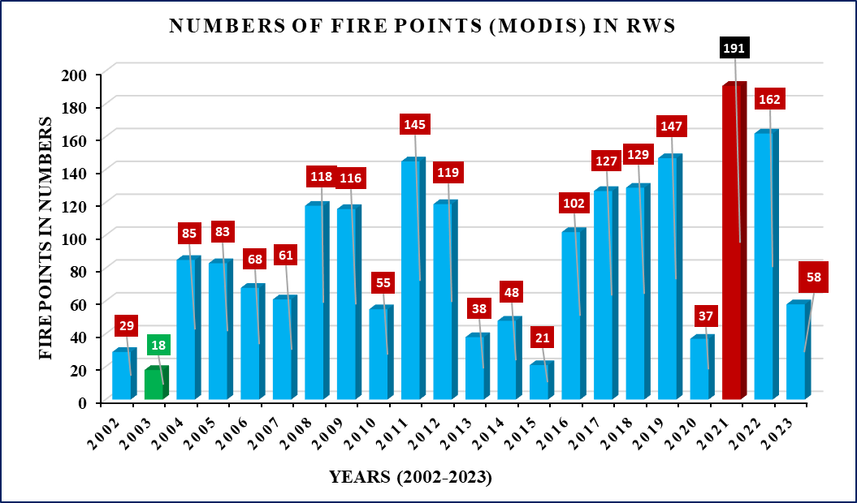

Fig. 5 Year-wise distribution of MODIS fire points in Ratapani Wildlife Sanctuary during 2002–2023

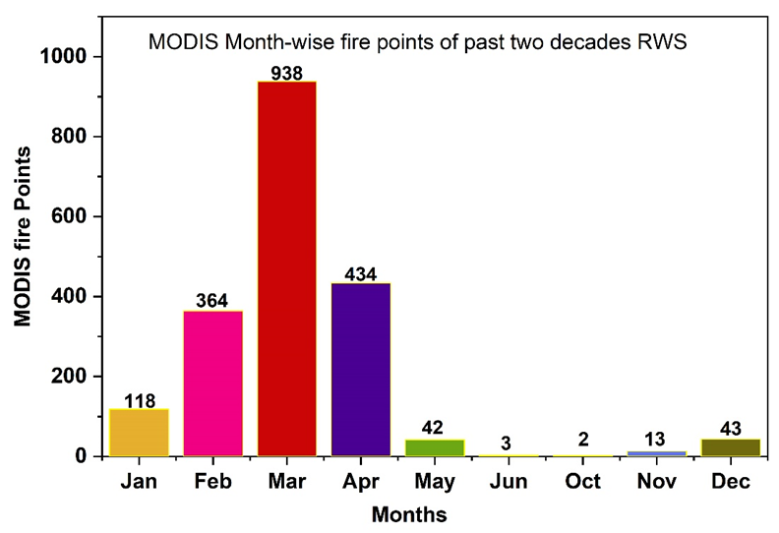
Fig. 6 Month-wise distribution of MODIS fire points in Ratapani Wildlife Sanctuary during 2002–2023

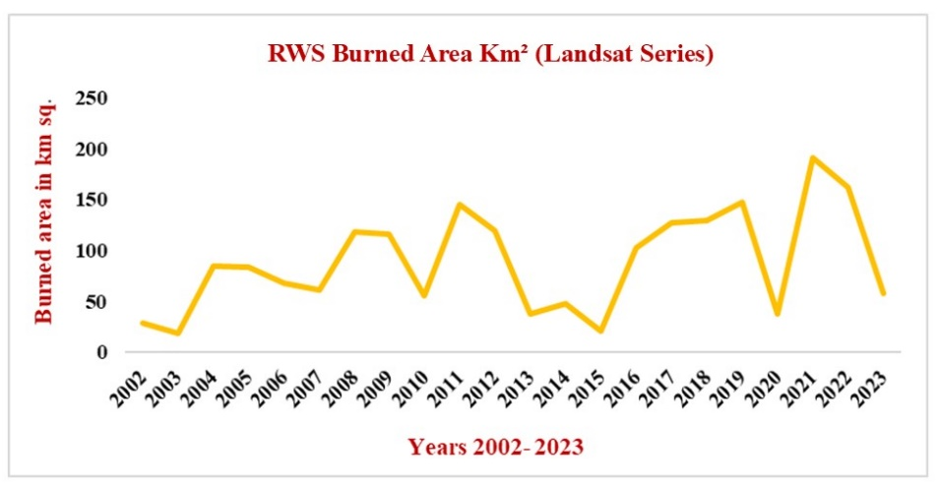
Fig. 7 Year-wise variation in Landsat-derived burned area in Ratapani Wildlife Sanctuary during 2002–2023

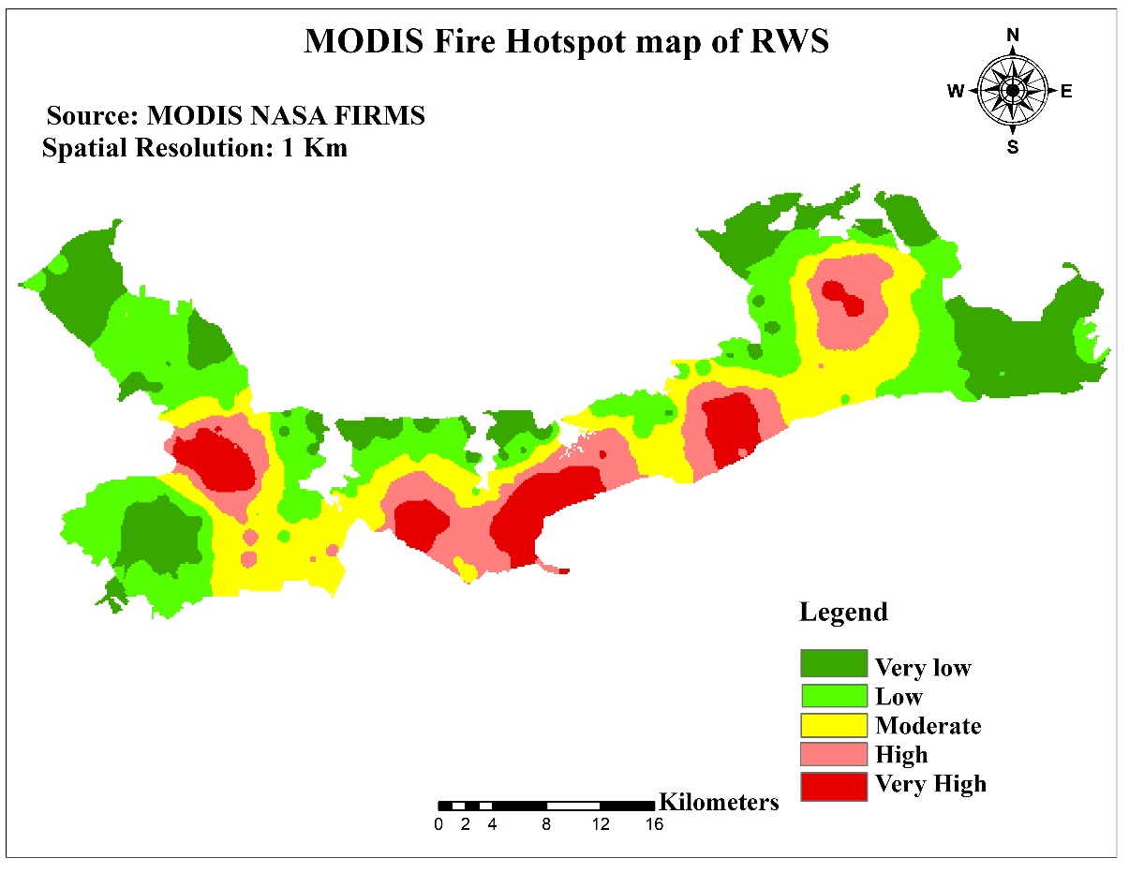
Fig. 8 Fire hotspot density Map of RWS based on MODIS data (2002–2023)

3.3 Influence of topography on forest fire distribution
The terrain of the sanctuary showed pronounced variation in elevation, slope gradient and aspect orientation. Elevation within the study area ranged from 309 m to 654 m above mean sea level (Fig. 9a) indicating heterogeneous terrain conditions across the sanctuary landscape. Higher elevation zones were mainly observed in the southwestern and northeastern parts of the sanctuary, whereas comparatively lower elevation areas were concentrated along valley regions, central drainage channels and elongated low-lying corridors. The number of MODIS fire points increased gradually from lower elevations and reached a peak at 550 m elevation with 579 fire points. Beyond this elevation, fire incidences decreased considerably, with only 26 fire points recorded at 650 m elevation. The findings suggest that moderate elevation zones (500–550 m) were more prone to forest fire occurrence (Fig. 10). The highest number of MODIS fire points was recorded at 5° slope with 1016 fire points. Fire incidences decreased progressively with increasing slope gradient, and only 2 fire points were recorded at 35° slope. The results indicate that gentle slopes (0–10°) were more vulnerable to forest fires, whereas steeper slopes experienced comparatively lower fire occurrence (Fig 11.). This pattern may be due to higher human disturbances, easier accessibility, and continuous dry vegetation cover in gentle slope areas, which increase the probability of fire ignition and spread. In contrast, steeper slopes are comparatively less accessible and contain discontinuous vegetation, resulting in fewer fire incidences. The analysis of MODIS fire points under different aspect classes (Fig. 9c) revealed significant variation in fire occurrence across the sanctuary. The highest number of fire points was recorded in the south-facing aspect under the very high fire frequency class (203 fire points), followed by southeast (185 fire points) and southwest aspects (162 fire points) (Table. 1). In contrast, comparatively fewer fire incidences were observed in north- and west-facing slopes. The results indicate that southern and southeastern aspects were more vulnerable to forest fires than northern aspects. The analysis of MODIS fire points under different hill shade (Fig. 9d) illumination classes revealed that fire incidences were highest in deep shadow areas. The very high fire frequency class recorded the maximum fire points in deep shadow zones (707 fire points), followed by moderate illumination areas (260 fire points). Comparatively lower fire incidences were observed in moderate shadow and neutral flat light conditions (Table. 1). The higher fire occurrence in deep shadow areas may be associated with dense vegetation and fuel accumulation in shaded terrain conditions, whereas illuminated areas may support comparatively lower fuel continuity. The Terrain Ruggedness Index (Fig. 9e) analysis of Ratapani Wildlife Sanctuary revealed considerable spatial variation in terrain characteristics, with TRI values ranging from 0 to 78.75. The mean TRI values showed a gradual increase from the control class to higher fire frequency classes. The control class recorded the lowest TRI value (0.53 ± 0.11), whereas the very high fire frequency class exhibited the highest TRI value (16.81 ± 13.37). Moderate and high fire frequency classes showed intermediate TRI values of 6.84 ± 8.01 and 8.85 ± 9.32, respectively (Table. 2). The results indicate that areas with higher terrain ruggedness were associated with increased fire frequency in Ratapani Wildlife Sanctuary.

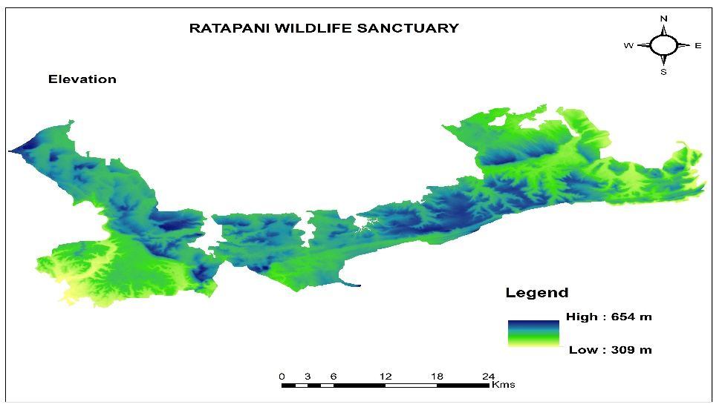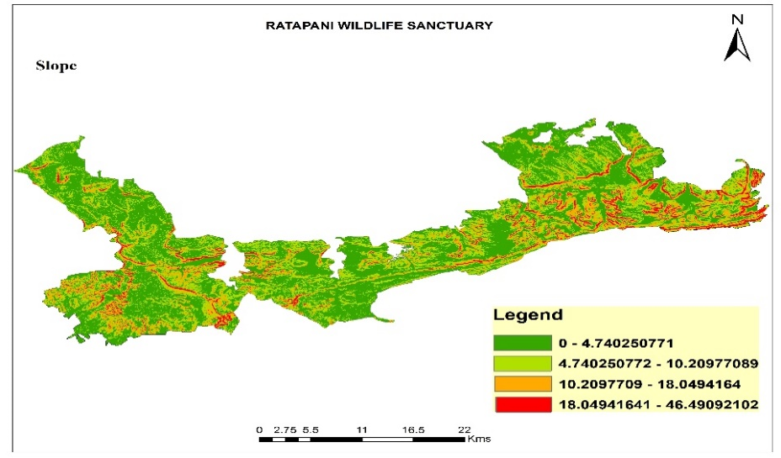
(a) (b)

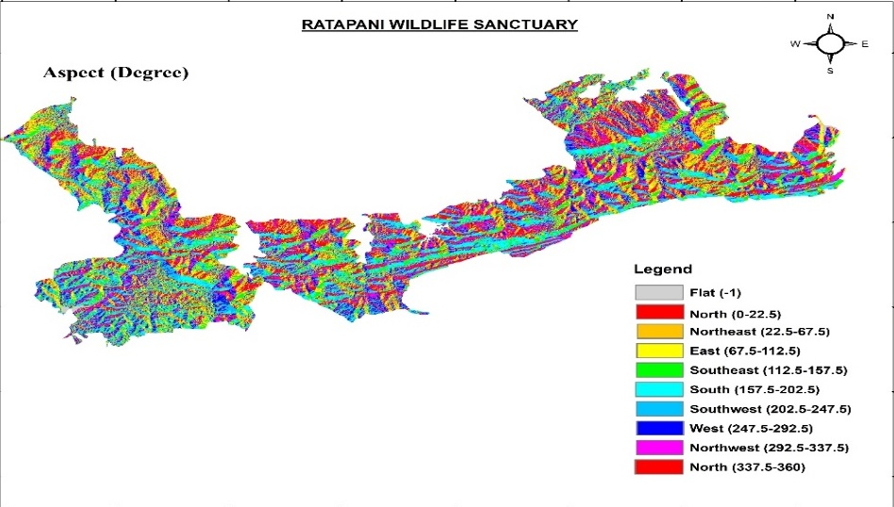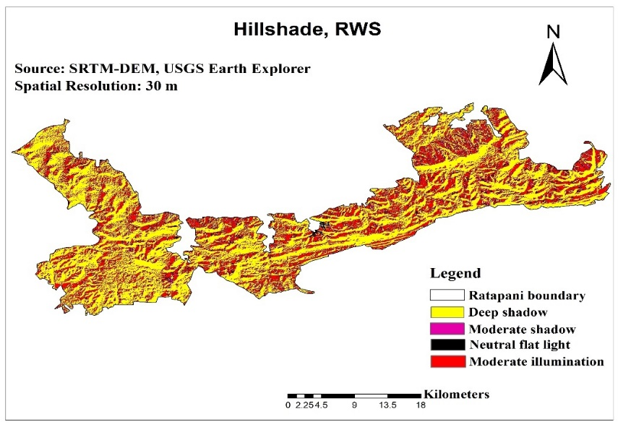
(c) (d)

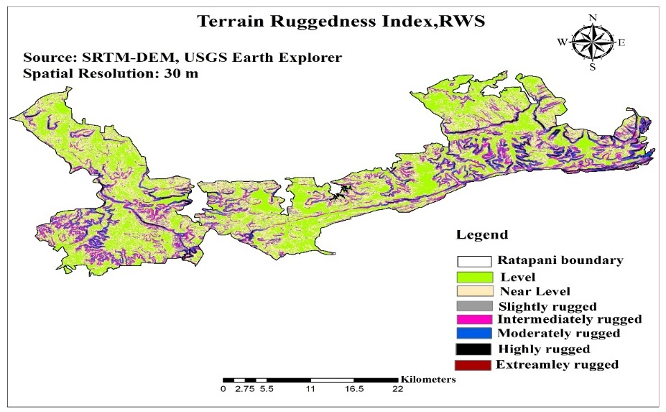
(e)
Fig. 9 (a-e): (a) Elevation (b) Slope, (c) Aspect, (d) Hillshade and (e) TRI map of RWS

4 Discussion
4.1 Spatial distribution and fire frequency patterns in Ratapani Wildlife Sanctuary
The forest fire frequency analysis of RWS revealed significant spatial variation in recurrent fire occurrences, with the very high fire frequency class occupying the maximum area of the sanctuary (Fig. a-d). Similar Landsat-based fire frequency mapping was carried out in Panna Tiger Reserve, Madhya Pradesh, where the landscape was classified into different fire frequency zones using Landsat 5, 7 and 8 satellite imagery (Ray et al., 2021). In similar study, Bargali et al. (2023) prepared fire frequency maps for the forests of Uttarakhand, Western Himalaya, and categorized the study area into no fire, low, moderate and high fire frequency classes using Landsat satellite data. These findings indicate the widespread occurrence of recurrent fire zones within the dry deciduous forests of RWS.
4.2 Spatio-temporal distribution of MODIS fire occurrences
The analysis of MODIS active fire data showed significant annual and seasonal fluctuations in forest fire occurrence across RWS. Fire incidences and burned area increased noticeably after 2015, with the highest fire activity observed during 2021 and 2022. Seasonal analysis further revealed that forest fires were mainly concentrated during the dry summer period from February to April, especially in March. Similar findings were reported by Verma et al. (2019), who observed a high concentration of MODIS active fire points in dry deciduous forests of Madhya Pradesh. The higher fire incidences in RWS may be associated with the dry deciduous vegetation type, where accumulation and continuity of dry grass and litter fuel increase fire susceptibility and spread (Kodandapani et al., 2008). Hotspot analysis further indicated significant clustering of fire occurrences in the central and southeastern parts of the sanctuary, whereas peripheral regions showed comparatively lower fire activity (Fig. 8). These findings suggest that repeated fire events are concentrated in specific regions of RWS due to favourable topographic and environmental conditions. Furthermore, anthropogenic activities may also contribute to recurrent fire occurrence in Ratapani Wildlife Sanctuary. Human-induced factors such as grazing pressure, resource collection activities and accidental or intentional fire ignitions may influence fire occurrence in accessible forest areas. Such anthropogenic drivers have been reported as important factors influencing fire occurrence in several tropical dry deciduous forests of Central India (Talukdar et al., 2024). However, the interpretation of MODIS-based fire occurrence patterns should consider certain methodological constraints. Given the 1 km spatial resolution of MODIS, smaller or low-intensity fire events may remain undetected. Nevertheless, MODIS was considered the most appropriate dataset for the present investigation because it provides a consistent and continuous fire record spanning more than two decades, whereas comparable fire datasets such as VIIRS are available only for relatively recent years and therefore do not adequately cover the entire study period.
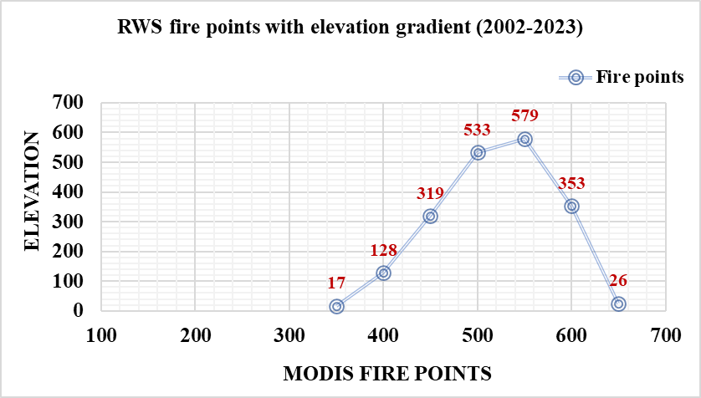
Fig. 10 Distribution of MODIS fire points across different elevation classes in RWS

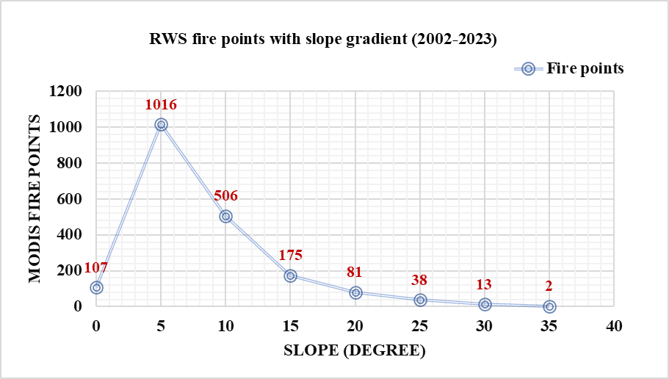
Fig. 11 Distribution of MODIS fire points across different elevation classes in RWS

Table. 1 Distribution of MODIS fire points (2002-2023) in Aspect and Hill shade illumination classes in Ratapani Wildlife Sanctuary.

Parameter | Aspect class | Value | CC | LCFF | MCFF | HCFF | VHCFF
Aspect | North | 22.5 | 0 | 2 | 9 | 22 | 110
 | Northeast | 67.5 | 0 | 12 | 11 | 38 | 145
 | East | 112.5 | 0 | 7 | 10 | 42 | 122
 | Southeast | 157.5 | 0 | 2 | 26 | 27 | 185
 | South | 202.5 | 0 | 6 | 14 | 51 | 203
 | Southwest | 247.5 | 0 | 4 | 13 | 37 | 162
 | West | 292.5 | 0 | 10 | 10 | 34 | 107
 | North west | 337.5 | 0 | 7 | 18 | 38 | 147
 | North | 360 | 0 | 3 | 7 | 25 | 117
 | Hill shade value
Hill shade illumination | Deep shadow | 50 | 0 | 26 | 63 | 185 | 707
 | Moderate shadow | 100 | 0 | 9 | 19 | 36 | 129
 | Neutral flat light | 150 | 0 | 5 | 17 | 41 | 199
 | Moderate illumination | 200 | 0 | 7 | 23 | 54 | 260

4.3 Role of topographic factors in forest fire distribution
Elevation influences temperature, moisture conditions and vegetation distribution, thereby affecting forest fire vulnerability (Zhang et al., 2017). Central Indian forests also show variation in fire occurrence along elevation gradients (Sahu et al., 2024). In the present study, MODIS fire points increased gradually with elevation and reached a peak at 550 m elevation, beyond which fire incidences declined considerably. Moderate elevation zones (500–550 m) were found to be more vulnerable to forest fire occurrence. Similar findings were reported by Kumar et al. (2022), who observed that moderate elevations are often associated with drier vegetation and greater fire susceptibility in dry teak forests. Likewise, Gill and Taylor (2009) reported shorter fire return intervals at lower to moderate elevations due to variations in fuel moisture and vegetation composition. The comparatively lower fire incidences at higher elevations in RWS may be associated with cooler and more humid environmental conditions, which reduce fire susceptibility (Harlow et al., 2004). Martin et al. (2016) reported that fire spreads more rapidly on steep slopes due to the chimney effect. Similarly, Pragya et al. (2023) also suggested that steep slopes enhance upward heat movement and accelerate fire spread. However, the present study observed higher fire incidences on gentle slopes (0–10°), Only a few fire points were recorded on steep slopes (>35°). This difference may be linked to higher human disturbances, easier accessibility and continuous dry vegetation cover in gentle slope areas of RWS. Topographic factors such as aspect, slope and altitude play an important role in predicting forest fire occurrence (Banerjee, 2021). In the present study, south- and southeast-facing slopes recorded the highest number of MODIS fire points, particularly under the very high fire frequency class, whereas comparatively fewer fire incidences were observed on north-facing slopes. These findings suggest that southern aspects were more vulnerable to forest fires in RWS. Similar observations were reported by Ray et al. (2005), who identified dry conditions and reduced soil moisture as major factors increasing fire susceptibility. South-facing slopes generally receive greater solar radiation, resulting in drier vegetation and fuel conditions that favour fire ignition and spread. In the present study, TRI values increased gradually from the control class to higher fire frequency classes, with the very high fire frequency class showing the highest mean TRI value (16.81 ± 13.37). These findings indicate that areas with rugged terrain experienced comparatively higher fire frequency in RWS. Similar observations were reported by Zhang et al. (2017), who suggested that topographic conditions influence local temperature, moisture availability and fuel flammability, thereby affecting forest fire occurrence. The progressive increase in mean elevation, slope and terrain ruggedness index (TRI) from the control class to higher fire frequency classes further highlights the important role of topographic factors in recurrent fire occurrence. Therefore, the results suggest that topographic factors such as elevation, slope, aspect and terrain ruggedness, along with vegetation condition, largely control the spatial distribution and recurrence of forest fires in Ratapani Wildlife Sanctuary (Table. 2).

Table. 2 Values of Topographic, Climatic and Vegetation variables across different fire frequency classes in Ratapani Wildlife Sanctuary.
Variables | CC | LCFF | MCFF | HCFF | VHCFF
Elevation | 437.08 ±62.97 | 454.67 ±54.49 | 462.09 ±59.07 | 478.6 ±58.61 | 500.29 ±57.41
Slope | 4.20 ±4.708 | 4.75 ±4.9503 | 5.14 ±4.834 | 5.76 ±5.1208 | 7.19 ±5.7607
Hillshade | 69.85 ±72.37 | 64.67 ±70.62 | 59.17 ±69.76 | 60.11 ±69.95 | 60.55 ±69.77
Aspect | 173.81 ±115.55 | 172.83 ±113.75 | 175.00 ±108.41 | 176.28 ±109.53 | 175.92 ±110.8
NDVI | 0.40 ±0.0637 | 0.41 ±0.051 | 0.42 ±0.05 | 0.42 ±0.03 | 0.43 ±0.02
LST | 37.59 ±1.54 | 37.74 ±1.86 | 37.46 ±1.43 | 37.27 ±1.45 | 36.79 ±1.10
Minimum temperature | 19.05 ±0.10 | 19.05 ±0.097 | 19.05 ±0.09 | 19.06 ±0.09 | 19.07 ±0.09
Maximum temperature | 34.99 ±0.13 | 34.96 ±0.13 | 34.98 ±0.14 | 34.97 ±0.13 | 34.99 ±0.14
Precipitation | 1.49 ±0.057 | 1.50 ±0.05 | 1.50 ±0.05 | 1.50 ±0.04 | 1.51 ±0.04
TRI | 0.53 ±0.11 | 7.14 ±8.49 | 6.84 ±8.01 | 8.85 ±9.32 | 16.81 ±13.37
Fire patch size | - | 0.75 ±0.35 | 0.05 ±0.12 | 0.11 ±0.27 | 1.96 ±9.62
Note: Values in Mean (± SD)

4. Conclusion

The present study demonstrated significant spatial and temporal variation in forest fire occurrence within Ratapani Wildlife Sanctuary using remote sensing and GIS techniques. The analysis revealed that the very high fire frequency class occupied the largest proportion of the sanctuary, indicating repeated and concentrated fire incidences across major parts of the landscape. MODIS fire analysis further showed strong annual and seasonal fluctuations, with maximum fire activity recorded during 2021–2022 and peak fire occurrence concentrated during the dry summer months from February to April. Hotspot analysis identified the central and southeastern regions of the sanctuary as highly vulnerable fire-prone zones.
The study further highlighted the important role of topographic factors in controlling forest fire distribution within the sanctuary. Moderate elevation zones, gentle slopes, south-facing aspects and rugged terrain conditions were found to be more vulnerable to recurrent forest fires. Areas with higher Terrain Ruggedness Index (TRI) values showed comparatively greater fire frequency, while NDVI patterns indicated the influence of vegetation and fuel availability on fire occurrence. Overall, the findings suggest that terrain characteristics and vegetation conditions largely regulate the spatial distribution and recurrence of forest fires in RWS. The integration of Landsat series, MODIS fire data and DEM-based topographic analysis proved effective for long-term forest fire assessment and hotspot identification in Central Indian dry deciduous forests. However, despite the ecological importance of tiger reserves, protected areas and reserved forests in Madhya Pradesh and Central India, remote sensing-based studies focusing on forest fire frequency, hotspot distribution and topographic influence are still limited. Therefore, further geospatial investigations based studies are needed across tiger reserves, wildlife sanctuaries and protected forest landscapes of Central India to improve understanding of forest fire dynamics and support effective fire management and conservation planning. The present study contributes toward filling this research gap by providing baseline scientific information on forest fire frequency, active fire distribution and topographic controls in Ratapani Wildlife Sanctuary.

Competing interests

Authors have declared that no competing interests exist.

Consent (where ever applicable)

N/A

Ethical approval (where ever applicable)
N/A

Disclaimer (Artificial intelligence)

Author(s) hereby declare that NO generative AI technologies such as Large Language Models (ChatGPT, COPILOT, etc.) and text-to-image generators have been used during the writing or editing of this manuscript.

References

Artés, T., Cencerrado, A., Cortés, A., & Margalef, T. (2017). Time aware genetic algorithm for forest fire propagation prediction: exploiting multi‐core platforms. Concurrency and Computation: Practice and Experience, 29(9), e3837.
Banerjee, P. (2021). Maximum entropy-based forest fire likelihood mapping: analysing the trends, distribution, and drivers of forest fires in Sikkim Himalaya. Scandinavian Journal of Forest Research, 36(4), 275-288.
Bargali, H., Calderon, L. P. P., Sundriyal, R. C., & Bhatt, D. (2022a). Impact of forest fire frequency on floristic diversity in the forests of Uttarakhand, western Himalaya. Trees, Forests and People, 9, 100300.
Bilgili, E., Coskuner, K. A., Usta, Y., Saglam, B., Kucuk, O., Berber, T., & Goltas, M. (2019). Diurnal surface fuel moisture prediction model for Calabrian pine stands in Turkey. iForest-Biogeosciences and Forestry, 12(3), 262.
Bousquet, E., Mialon, A., Rodriguez-Fernandez, N., Mermoz, S., & Kerr, Y. (2022). Monitoring post-fire recovery of various vegetation biomes using multi-wavelength satellite remote sensing. Biogeosciences, 19(13), 3317-3336.
Champion HG, Seth SK. A revised survey of the forest types of India. New Delhi: Government of India Publications; 1968.
Fulé, P. Z., Garkoti, S. C., & Semwal, R. L. (2021). Frequent burning in chir pine forests, Uttarakhand, India. Fire Ecology, 17(1), 20.
Giglio, L., Schroeder, W., & Justice, C. O. (2016). The collection 6 MODIS active fire detection algorithm and fire products. Remote sensing of environment, 178, 31-41.
Gill, L., & Taylor, A. H. (2009). Top-down and bottom-up controls on fire regimes along an elevational gradient on the east slope of the Sierra Nevada, California, USA. Fire Ecology, 5(3), 57-75.
Harlow, R. C., Burke, E. J., Scott, R. L., Shuttleworth, W. J., Brown, C. M., & Petti, J. R. (2004). Research Note: Derivation of temperature lapse rates in semi-arid south-eastern Arizona. Hydrology and Earth System Sciences, 8(6), 1179-1185.
Jain, P., Coogan, S. C., Subramanian, S. G., Crowley, M., Taylor, S., & Flannigan, M. D. (2020). A review of machine learning applications in wildfire science and management. Environmental Reviews, 28(4), 478-505.
Justice, C. O., Giglio, L., Korontzi, S., Owens, J., Morisette, J. T., Roy, D., ... & Kaufman, Y. (2002). The MODIS fire products. Remote sensing of Environment, 83(1-2), 244-262.
Khan, M. L., & Tripathi, R. S. (1989). Effects of stump diameter, stump height and sprout density on the sprout growth of four tree species in burnt and unburnt forest plots. Acta Oecologica, 10(4), 303–316.
Kodandapani, N., Cochrane, M. A., & Sukumar, R. (2008). A comparative analysis of spatial, temporal, and ecological characteristics of forest fires in seasonally dry tropical ecosystems in the Western Ghats, India. Forest Ecology and Management, 256(4), 607-617.
Kumar, S., Ghosh, S. K., & Pateriya, B. (2022). Spatio-temporal shift in fire activity in the Indo-Gangetic region. Geocarto International, 1-19.
Martin, D., Tomida, M., & Meacham, B. (2016). Environmental impact of fire. Fire Science Reviews, 5(1), 5.
Meyn, A., White, P. S., Buhk, C., & Jentsch, A. (2007). Environmental drivers of large, infrequent wildfires: the emerging conceptual model. Progress in Physical Geography, 31(3), 287-312.
Mupfiga, U., Mutanga, O., & Dube, T. (2025). Assessing drivers of vegetation fire occurrence in Zimbabwe-Insights from Maxent modelling and historical data analysis. Remote Sensing Applications: Society and Environment, 37, 101404.
National Aeronautics and Space Administration. (2023). Fire Information for Resource Management System (FIRMS). NASA Earth Science Data Systems. https://firms.modaps.eosdis.nasa.gov/
Negi, G. C. S. (2019). Forest fire in Uttarakhand: causes, consequences and remedial measures. International Journal of Ecology and Environmental Sciences, 45(1), 31-37.
Pausas, J. G., & Keeley, J. E. (2009). A burning story: the role of fire in the history of life. BioScience, 59(7), 593-601.
Pragya, Kumar, M., Tiwari, A., Majid, S. I., Bhadwal, S., Sahu, N., ... & Avtar, R. (2023). Integrated spatial analysis of forest fire susceptibility in the Indian Western Himalayas (IWH) using remote sensing and GIS-based fuzzy AHP approach. Remote Sensing, 15(19), 4701.
Prentice, I. C., Kelley, D. I., Foster, P. N., Friedlingstein, P., Harrison, S. P., & Bartlein, P. J. (2011). Modeling fire and the terrestrial carbon balance. Global Biogeochemical Cycles, 25(3).
Ray, D., Nepstad, D., & Moutinho, P. (2005). Micrometeorological and canopy controls of fire susceptibility in a forested Amazon landscape. Ecological Applications, 15(5), 1664-1678.
Ray, T., Malasiya, D., Rajpoot, R., Verma, S., Dar, J. A., Dayanandan, A., ... & Khan, M. L. (2021). Impact of forest fire frequency on tree diversity and species regeneration in tropical dry deciduous forest of Panna Tiger Reserve, Madhya Pradesh, India. Journal of Sustainable Forestry, 40(8), 831-845.
Reddy, C. S., & Sarika, N. (2022). Monitoring trends in global vegetation fire hot spots using MODIS data. Spatial information research, 30(5), 617-632.
Roy, D. P., Boschetti, L., Justice, C. O., & Ju, J. (2008). The collection 5 MODIS burned area product—Global evaluation by comparison with the MODIS active fire product. Remote sensing of Environment, 112(9), 3690-3707.
Sahu, V., Khan, M. A., & Madguni, O. D. (2024). Assessing forest fire dynamics and risk zones in Central Indian forests: a comparative study of the Khandwa and North Betul forest divisions of Madhya Pradesh. Environmental monitoring and assessment, 196(9), 810.
Sevinc, V., Kucuk, O., & Goltas, M. (2020). A Bayesian network model for prediction and analysis of possible forest fire causes. Forest Ecology and Management, 457, 117723.
Singh, S. S., & Jeganathan, C. (2024). Using ensemble machine learning algorithm to predict forest fire occurrence probability in Madhya Pradesh and Chhattisgarh, India. Advances in Space Research, 73(6), 2969-2987.
Talukdar, N. R., Ahmad, F., Goparaju, L., Choudhury, P., Arya, R., Qayum, A., & Rizvi, J. (2024). Forest fire estimation and risk prediction using multispectral satellite images: Case study. Natural Hazards Research, 4(2), 304-319.
Turco, Marco, Maria Carmen Llasat, Jost Von Hardenberg, and Antonello Provenzale. "Impact of climate variability on summer fires in a Mediterranean environment (northeastern Iberian Peninsula)." Climatic Change 116, no. 3 (2013): 665-678.
United States Geological Survey. (2023). EarthExplorer. U.S. Department of the Interior. https://earthexplorer.usgs.gov/
Verma, S., Dar, J. A., Malasiya, D., Khare, P. K., Dayanandan, S., & Khan, M. L. (2019). A MODIS-based spatiotemporal assessment of agricultural residue burning in Madhya Pradesh, India. Ecological Indicators, 105, 496-504.
Zhang, Y., Lim, S., & Sharples, J. J. (2017). Wildfire occurrence patterns in ecoregions of New South Wales and Australian Capital Territory, Australia. Natural Hazards, 87(1), 415-435.
Zubkova, M., Boschetti, L., Abatzoglou, J. T., & Giglio, L. (2019). Changes in fire activity in Africa from 2002 to 2016 and their potential drivers. Geophysical research letters, 46(13), 7643-7653.

