Management of Symptomatic Reticular Oral Lichen Planus Involving the Buccal and Labial Mucosa: A Case Report

.

ABSTRACT (Arial, Bold, 11 font, left aligned, caps)

Aim: This case report aims to describe a symptomatic presentation of reticular Oral Lichen Planus (OLP) and emphasize the therapeutic effectiveness of topical corticosteroid therapy along with the importance of multidisciplinary management in symptomatic control.
Case Presentation: A 35-year-old female patient presented with a three-month history of persistent burning sensation in the oral cavity, which intensified on consumption of spicy and hot foods, with a VAS score of 8/10. The patient had no significant medical history, deleterious habits, trauma, or cheek biting habit. Intraoral examination revealed characteristic bilateral interlacing white striations involving the buccal mucosa extending from the oral commissure to the pterygomandibular region. Additional similar striae were noted on the upper and lower left labial mucosa. The lesions were non-scrapable, non-tender on palpation, and showed no signs of induration. Two small keratotic white patches were also present on the dorsal surface of the tongue. Based on clinical features, a diagnosis of reticular OLP was considered. The patient was managed with topical clobetasol propionate 0.05% applied three times daily for 15 days, along with dietary modification and referral for psychological evaluation to address stress and sleep-related concerns.
Discussion: Oral Lichen Planus is a chronic immune-mediated disorder characterized by T-cell mediated epithelial injury. Although the reticular variant is commonly asymptomatic, patients may experience burning sensation due to mucosal hypersensitivity or external irritants. Topical corticosteroids remain the mainstay of treatment owing to their potent anti-inflammatory action.
Conclusion: The present case was reported to demonstrate the clinical features of symptomatic reticular Oral Lichen Planus and to describe the patient's response to topical corticosteroid therapy during follow-up.
Note: Review paper may have different types of subsections.

Keywords: Oral Lichen Planus; Reticular Oral Lichen Planus; Wickham's Striae; Clobetasol Propionate; Topical Corticosteroid Therapy; Burning Sensation; Buccal Mucosa

1. INTRODUCTION (Arial, Bold, 11 font, left aligned, caps)

Oral Lichen Planus (OLP) is a chronic inflammatory mucocutaneous disorder of probable autoimmune origin that primarily affects the oral stratified squamous epithelium.¹
It is widely accepted to be mediated by a T-cell driven immune response, resulting in basal keratinocyte apoptosis and chronic mucosal inflammation.¹^{,2}
The global prevalence of OLP is estimated to range between 0.5% and 2%, with a predilection for middle-aged females.²
Among intraoral sites, the buccal mucosa is most frequently involved, often showing bilateral and symmetrical distribution with characteristic Wickham’s striae.³
Clinically, OLP presents in multiple forms such as reticular, erosive, atrophic, papular, and plaque-like variants, of which the reticular type is the most commonly encountered.³^{,6}
Although reticular OLP is typically asymptomatic, a subset of patients may experience burning sensation, particularly when exposed to spicy, hot, or acidic dietary irritants.⁴
Recent literature also suggests a strong association between psychosocial stress, sleep disturbances, and exacerbation of OLP symptoms, indicating a possible neuro-immunological component in disease expression.⁵
Because of its chronic nature and potential for symptom fluctuation, OLP requires long-term monitoring and individualized therapeutic strategies, especially in symptomatic cases.⁴
Topical corticosteroids remain the first-line treatment for symptomatic OLP due to their potent anti-inflammatory and immunosuppressive effects on T-cell mediated mucosal damage.⁵^{,15,16}

2. Case Presentation

A 35-year-old female patient reported to the Department of Oral Medicine and Radiology in Sinhgad Dental hospital , Pune with a chief complaint of burning sensation in the oral cavity for the past three months. The burning sensation was moderate to severe in intensity (VAS score: 8/10) and was aggravated on consumption of spicy and hot food. There was no relevant medical history and drug history, no deleterious habits, and no history of trauma or cheek biting. General examination revealed no paleness or any other condition.Dental history revealed only previous dental extractions.

Clinical examination revealed two small white patches on the dorsal surface of the tongue measuring approximately 0.5 cm each (fig 1).

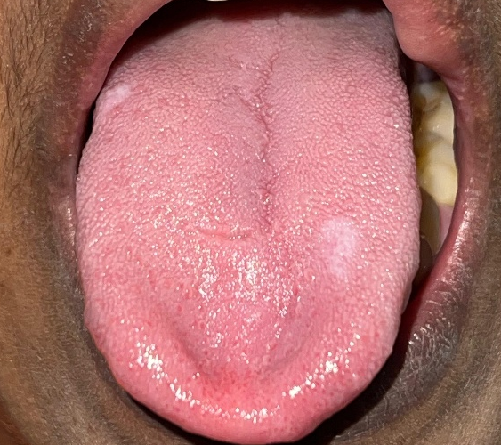

Fig 1 Patches on tongue
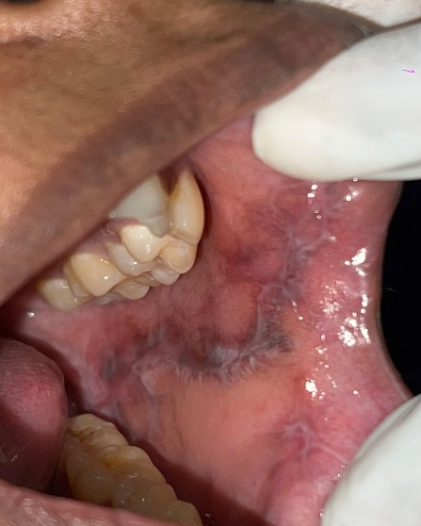
Bilateral lace-like, reticular white striations were present on the right and left buccal mucosa, On right buccal mucosa striae seen on pterygomandibular raphe and left buccal mucosa, extending from the corner of the mouth to the pterygomandibular raphe. The lesions measured approximately 6 × 2 cm on the right side (fig 2 A) and 3 × 2 cm on the left side (fig 2 B).
Fig 2 A-striae on left buccal mucosa B- straies on right buccal mucosa

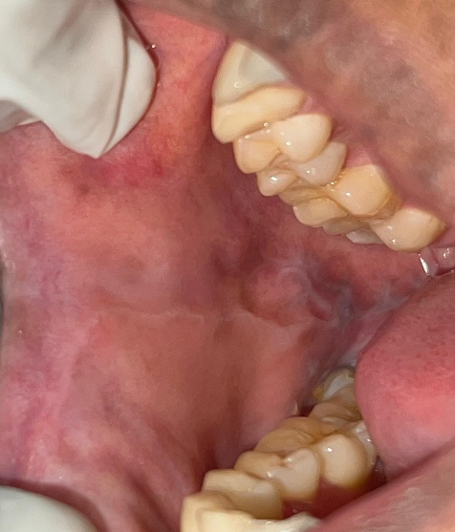
Striae were also observed on the lower left labial mucosa, opposite the region of the canine and first premolar teeth, extending for approximately 1 cm (fig 3 A) .

B
A

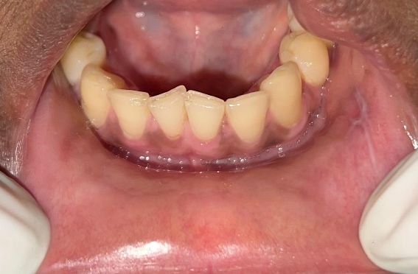
Similar striae were noted on the upper left labial mucosa, opposite the lateral incisor and canine teeth region, measuring approximately 2 cm in length. (fig 3 B )

The lesions were non-scrapable and non-tender on palpation, with no induration, and the only presenting symptom was burning sensation. The margins were irregular but flat.
Based on the clinical findings, a provisional diagnosis of Oral Lichen Planus (reticular type) was made
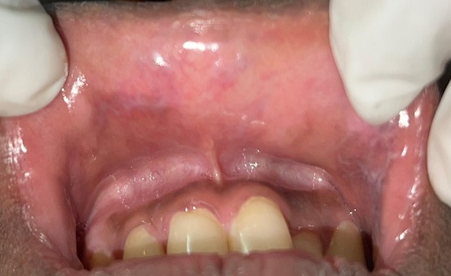
A
B

Fig. 3. A– striae on upper left labial mucosa B-striae on lower left labial mucosa

2.1 Management and follow-up
- Clobetasol propionate 0.05% topical application three times daily for 15 days
- Advised avoidance of spicy and hot food
- Referred to the psychiatry department for evaluation of sleep cycle disturbance and stress management
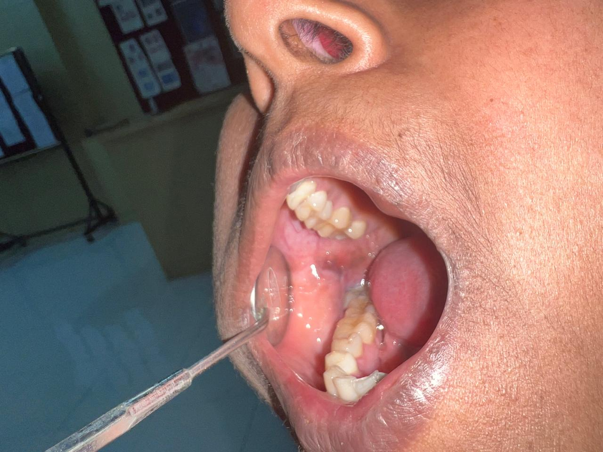
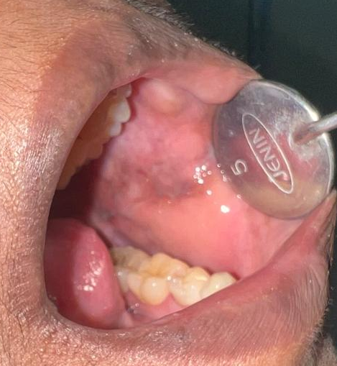
At 30-day follow-up, the patient showed marked improvement in symptoms. The burning sensation reduced significantly, with the VAS score decreasing from 8 to 3. Clinically, partial regression of reticular striations and reduction in erythema were observed. However, residual pigmentation was still present on the affected buccal mucosa, indicating incomplete resolution of the lesion. (fig 4 A & B)
B
A
B
A
Fig 4 A & B Follow up
B
A
Differential Diagnosis
1.Oral Lichenoid Lesions / Lichenoid Reaction ^{6,7}
2. Oral leukoplakia⁸
3. Frictional Keratosis⁹
4. Discoid Lupus Erythematosus (DLE)^{6,10}
5. White Sponge Nevus¹⁰
6.Oral Graft Versus Host Disease (GVHD)⁶

3. discussion

Oral Lichen Planus (OLP) is a chronic immune-mediated inflammatory disorder of the oral mucosa, with a well-established T-cell–mediated pathogenesis. It is characterized by cytotoxic CD8+ lymphocyte attack against basal keratinocytes, leading to apoptosis and degeneration of the basal cell layer. This immune dysregulation results in a chronic relapsing–remitting disease pattern affecting oral mucosal integrity. ⁹
Epidemiologically, OLP demonstrates a prevalence of approximately 0.5% to 2%, with a marked predilection for middle-aged females, typically in the fourth to sixth decade of life. ¹³

Hormonal influences, immune modulation, and psychosocial factors have all been suggested as contributing elements in its etiopathogenesis.¹⁴

Clinically, OLP presents in multiple forms including reticular, erosive, atrophic, plaque-like, papular, and bullous variants. Among these, the reticular type is the most frequently encountered and is characterized by interlacing white keratotic lines known as Wickham’s striae. These lesions are most commonly seen on the buccal mucosa in a bilateral and symmetrical distribution, which is considered highly suggestive of OLP.^{6,9,10}

Although reticular OLP is often asymptomatic, a subset of patients may present with burning sensation, particularly when exposed to thermal, spicy, or acidic dietary triggers.⁴ The presence of burning symptoms in reticular lesions, as observed in the present case, may be attributed to subtle epithelial barrier disruption or subclinical inflammatory activity.⁴

Psychological stress, anxiety, and sleep disturbances have been increasingly recognized as important modifying factors in OLP. Studies suggest that psychoneuroimmunological interactions may influence disease onset, severity, and recurrence, possibly through altered cytokine expression and immune response modulation. This supports the multidisciplinary approach adopted in the present case, including psychiatric referral.^{13.17}
Histopathologically, OLP is characterized by saw-tooth rete ridges, liquefaction degeneration of the basal cell layer, Civatte (colloid) bodies, and a dense band-like lymphocytic infiltrate at the epithelial–connective tissue interface. While biopsy remains the gold standard for confirmation, classic clinical presentation such as bilateral reticular striations often allows for clinical diagnosis without invasive procedures.^{6,7}

Management of symptomatic OLP primarily involves topical corticosteroids, which remain the first-line therapeutic agents. High-potency corticosteroids such as clobetasol propionate act by suppressing T-lymphocyte activation, cytokine release, and inflammatory mediator production. Clinical studies have demonstrated significant improvement in both symptomatic relief and lesion regression with topical corticosteroid therapy.^{7,14,15}

In addition to pharmacological therapy, elimination of local irritants and patient counseling play an important role in disease control. ⁷

Long-term follow-up is essential, as OLP is a chronic relapsing condition with a low but documented risk of malignant transformation, particularly in erosive and atrophic forms. Therefore, regular monitoring is recommended even in clinically stable cases.

This report describes a single patient, limiting the generalizability of the findings. Histopathological confirmation was not performed, and the follow-up period was relatively short. Therefore, long-term treatment outcomes, recurrence, and malignant transformation could not be assessed.

4. Conclusion

Reticular Oral Lichen Planus is a chronic inflammatory condition that may present with minimal clinical changes but can significantly impact patient comfort when symptomatic. Early recognition of characteristic clinical features such as bilateral lace-like striations is essential for timely diagnosis and appropriate management. This case highlights that even reticular variants, typically considered asymptomatic, may present with notable burning sensation requiring intervention. Topical high-potency corticosteroids, along with elimination of local irritants and psychological evaluation when indicated, can provide effective symptomatic relief and clinical improvement. Regular follow-up is important due to the chronic and recurrent nature of the disease and its potential for long-term complications. A multidisciplinary approach ensures better patient compliance, symptom control, and overall quality of life.

Consent (where ever applicable)

As per international standards or university standards, patient(s) written consent has been collected and preserved by the author(s).

Ethical approval (where ever applicable)

As per international standards or university standards written ethical approval has been collected and preserved by the author(s).

References

1 Arnold DL, Krishnamurthy K. Lichen planus. InStatPearls [Internet] 2024 Oct 29. StatPearls Publishing.
2 Duś-Ilnicka I, et al. Different approaches to oral lichen planus treatment. Int J Mol Sci. 2026;27(2):914. doi:10.3390/ijms27020914
3 Eisen D, Carrozzo M, Bagan JV, Thongprasom K. Oral lichen planus: clinical features and management. Oral Dis. 2005;11(6):338–349.
4 Lodi G, Scully C, Carrozzo M, Griffiths M, Sugerman PB, Thongprasom K. Current controversies in oral lichen planus: diagnosis and management. Oral Dis. 2005;11(6):336–345.
5 Wu T, Bai Y, Jing Y, Chen F. What can we learn from treatments of oral lichen planus?. Frontiers in Cellular and Infection Microbiology. 2024 Feb 15;14:1279220.
6. Burkits textbook (2021) of oral medicine and Radiology (13th ed)
7. Al-Hashimi I, Schifter M, Lockhart PB, Wray D, Brennan M, Migliorati CA, Axéll T, Bruce AJ, Carpenter W, Eisenberg E, Epstein JB. Oral lichen planus and oral lichenoid lesions: diagnostic and therapeutic considerations. Oral Surgery, Oral Medicine, Oral Pathology, Oral Radiology, and Endodontology. 2007 Mar 1;103:S25-e1.
8. Warnakulasuriya S. Clinical features and presentation of oral potentially malignant disorders. Oral surgery, oral medicine, oral pathology and oral radiology. 2018 Jun 1;125(6):582-90.
9. Neville, B. W. (2017). Oral and maxillofacial pathology (4th ed.). Elsevier. https://www.elsevier.com/books/oral-and-maxillofacial-pathology/neville/978-1-4557-7052-6
10. Scully C, Carrozzo M.Oral mucosal disease: lupus erythematosus.Br J Oral Maxillofac Surg. 2008;46(6):494–498.
11. Krupaa RJ, Sankari SL, Masthan KM, Rajesh E: Oral lichen planus: an overview. J Pharm Bioallied Sci. 2015, 7:S158-61. 10.4103/0975-7406.155873
12. Katta R: Lichen planus. Am Fam Physician. 2000, 61:3319-24, 3327-8.
13. McCartan BE, Healy CM. The reported prevalence of oral lichen planus: a review and critique. J Oral Pathol Med. 2008;37(8):447–453
14. Thongprasom K, Dhanuthai K.Oral lichen planus: a literature review and update.
Oral Surgery, Oral Medicine, Oral Pathology, Oral Radiology. 2014;117(2):e1–e13.
15. Zheng T, Liu C, Wang Y, Zhou R, Wu D, Tan J, Zhu K. Efficacy and safety of topical clobetasol propionate in comparison with alternative treatments in oral lichen planus: an updated systematic review and meta-analysis. Frontiers in Medicine. 2024 May 24;11:1391754.
16. Gränse F, Kroona L, Truedsson A, Larsson Wexell C, Götrick B. Topical clobetasol propionate 0.025% oral gel in the treatment of oral lichen planus: a double-blind, randomized placebo-controlled trial. BMC Oral Health. 2026 May 20.
17. Vaidya AU, Khorate MM, Chinam N, Figueiredo N. Efficacy of aloe vera and clobetasol propionate in the management of oral lichen planus: A randomized parallel clinical trial. Frontiers in dentistry. 2023 Mar 15;20:4.

