EMERGING ZOONOTIC INFECTIONS IN ODISHA: A SYSTEMATIC REVIEW OF SCRUB TYPHUS AND ANTHRAX
ABSTRACT
Background:
Emerging and re-emerging zoonotic infections continue to pose major public health challenges in Odisha, India. Scrub typhus and anthrax are increasingly recognized as important zoonotic diseases affecting rural and tribal populations.
Methods:
A systematic literature review was conducted following PRISMA-guided principles. Studies published between 2010 and 2025 were retrieved from PubMed, Scopus, and Google Scholar. Forty eligible studies were included for qualitative synthesis.
Results:
The review identified scrub typhus as an increasingly important cause of acute undifferentiated febrile illness, particularly during monsoon and post-monsoon periods. Anthrax remained endemic in livestock-dependent tribal regions. Major determinants of transmission included occupational exposure, environmental vulnerability, delayed healthcare-seeking behavior, inadequate diagnostic infrastructure, and fragmented surveillance systems.
Conclusion:
Scrub typhus and anthrax remain significant zoonotic threats in Odisha. Strengthening integrated surveillance systems, decentralized diagnostics, livestock vaccination programs, and One Health-based interventions is essential for improving disease prevention and outbreak preparedness.
Keywords:
Scrub Typhus, Anthrax, Zoonotic infections, Epidemiology, Public health, Odisha, Disease surveillance.
1.INTRODUCTION
Emerging and re-emerging zoonotic infections continue to represent a significant global public health challenge, particularly in tropical and resource-limited regions where close interaction between humans, animals, and the environment facilitates pathogen transmission [1,2,24,30,33]. In developing countries such as India, zoonotic diseases contribute substantially to infectious disease burden due to rapid environmental change, population growth, deforestation, agricultural expansion, and inadequate healthcare infrastructure [3].
Odisha, located in eastern India, represents a highly vulnerable region for zoonotic disease emergence because of its ecological diversity, extensive forest coverage, large tribal population, monsoon-dependent agriculture, and forest-based livelihoods [4,5]. Frequent human interaction with livestock, rodents, and vector habitats creates favorable conditions for sustained zoonotic transmission cycles in rural and tribal communities [6]. Additionally, poverty, delayed healthcare access, low health literacy, and limited diagnostic infrastructure further increase disease vulnerability and underreporting in endemic districts [7].
In recent years, the epidemiological landscape of Odisha has shown an increasing recognition of zoonotic febrile illnesses beyond traditionally prevalent vector-borne diseases such as malaria and dengue [8,25,31]. Among these, scrub typhus has emerged as an important cause of acute undifferentiated febrile illness, particularly during monsoon and post-monsoon seasons [9,24,25,30]. The disease is caused by Orientia tsutsugamushi and transmitted through infected chigger mites. Clinical manifestations are frequently non-specific, resulting in delayed diagnosis and increased risk of severe complications including acute respiratory distress syndrome, hepatic dysfunction, renal impairment, and multi-organ failure if untreated [10,26-28].
Simultaneously, anthrax remains an important endemic zoonosis in several tribal and livestock-dependent regions of Odisha [11]. Caused by Bacillus anthracis, anthrax transmission primarily occurs through direct contact with infected animals or contaminated animal products. Recurrent outbreaks continue to be reported in rural districts due to inadequate livestock vaccination, unsafe carcass disposal practices, and limited veterinary surveillance systems [12]. Although anthrax incidence is lower than scrub typhus, its outbreak potential and environmental persistence continue to represent a major public health concern [13].
Among multiple zoonotic diseases reported in eastern India, scrub typhus and anthrax were specifically selected for this review because both diseases represent distinct but epidemiologically important public health threats in Odisha. Scrub typhus demonstrates increasing geographic spread and rising incidence as a febrile illness, whereas anthrax persists as a recurrent endemic disease affecting tribal and livestock-handling populations [9,11]. Despite differences in transmission patterns, both diseases highlight critical gaps in surveillance systems, diagnostic preparedness, outbreak response, and implementation of integrated One Health approaches within the state healthcare system [14].
Several hospital-based studies, outbreak investigations, and surveillance reports related to scrub typhus and anthrax have been published from Odisha and other endemic regions of India [9,12,15]. However, there remains a lack of consolidated region-specific evidence synthesis integrating epidemiological trends, clinical manifestations, risk factors, diagnostic challenges, and public health implications of these infections within a unified framework. Furthermore, limited emphasis has been placed on the role of environmental determinants, climate variability, and integrated One Health surveillance strategies in controlling zoonotic disease transmission in Odisha [2,14].
Climate change, deforestation, environmental degradation, changing land-use patterns, and increasing human encroachment into forest ecosystems have further intensified the emergence and transmission of zoonotic diseases across eastern India [5,16,32,41]. Odisha remains particularly vulnerable because of seasonal flooding, extensive vegetation, agricultural dependency, and ecologically sensitive tribal regions that facilitate vector proliferation and human exposure to infectious agents [4].
Therefore, this systematic review aimed to synthesize and critically evaluate the available evidence regarding epidemiology, clinical manifestations, risk factors, diagnostic challenges, and public health interventions associated with scrub typhus and anthrax in Odisha using a One Health perspective. The review also aimed to identify major research gaps and policy priorities for strengthening zoonotic disease surveillance and healthcare preparedness in endemic regions.
"The transmission of zoonotic diseases in Odisha is influenced by complex interactions among environmental factors, animal reservoirs, vectors, and human populations. Figure 1 illustrates the conceptual framework describing these interactions and their contribution to zoonotic disease emergence."

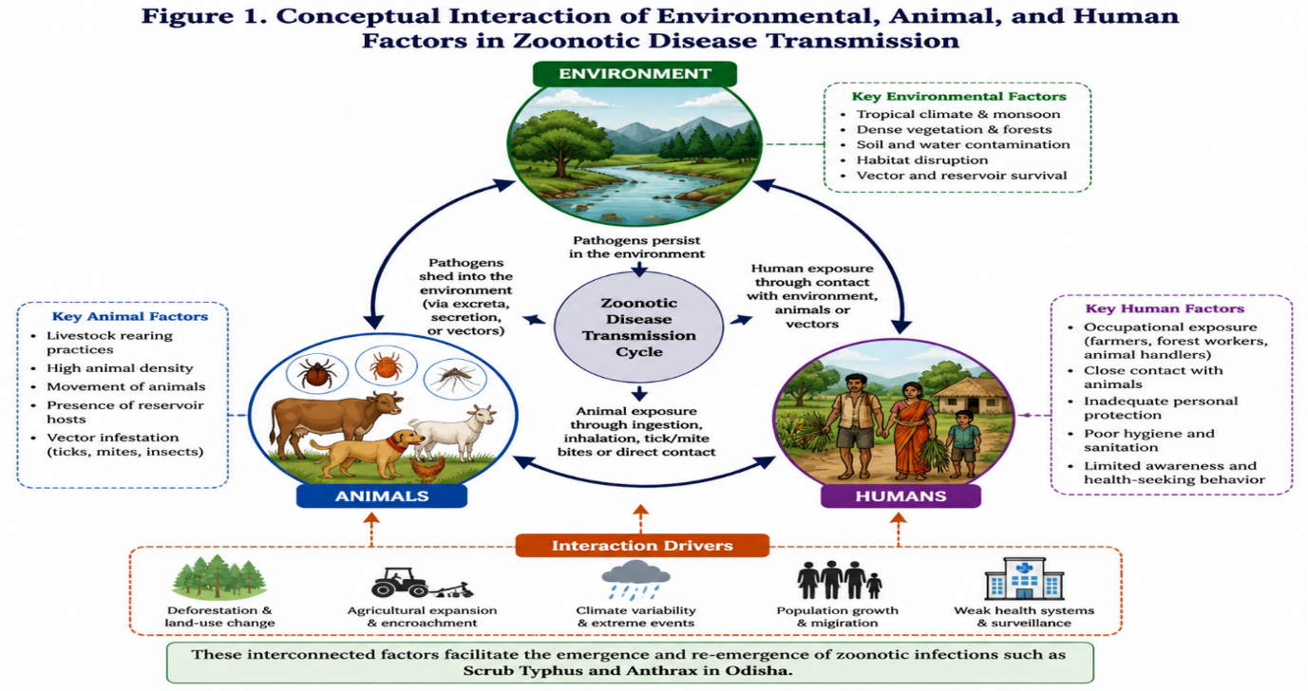(Source: Developed by the authors based on the One Health framework and evidence synthesized from the reviewed literature [2, 3, 5, 14, 33)
2. METHODOLOGY
2.1 Study Design
This study was conducted as a systematic literature review following PRISMA (Preferred Reporting Items for Systematic Reviews and Meta-Analyses) guidelines for narrative evidence synthesis [17,35]. The review aimed to systematically identify, evaluate, and synthesize available evidence regarding the epidemiology, clinical manifestations, risk factors, diagnostic challenges, and public health interventions associated with scrub typhus and anthrax in Odisha.
2.2 Search Strategy
2.2.1 Information Sources
A comprehensive literature search was conducted using PubMed, Scopus, and Google Scholar databases to identify studies related to scrub typhus, anthrax, and zoonotic infections in Odisha. Relevant articles published between January 2010 and March 2025 were considered for inclusion. Additional studies were identified through manual screening of reference lists from selected articles.
2.2.2 Search Terms and Search Expressions
The search strategy was developed using combinations of Medical Subject Headings (MeSH) terms and free-text keywords related to scrub typhus, anthrax, zoonotic infections, epidemiology, surveillance, and One Health approaches.
The primary search expressions included:
• "Scrub Typhus" AND "Odisha"
• "Anthrax" AND "Odisha"
• "Zoonotic infections" AND "Eastern India"
• "Acute febrile illness" AND "Scrub Typhus"
• "One Health" AND "Anthrax"
• "Bacillus anthracis" AND "tribal population"
• "Orientia tsutsugamushi" AND "epidemiology"
Boolean operators such as AND and OR were used to improve search sensitivity and specificity.
2.2.3 Database-Specific Search Strategy
The search expressions were adapted according to the requirements of each database.
PubMed:
("Scrub Typhus" OR "Orientia tsutsugamushi") AND Odisha
("Anthrax" OR "Bacillus anthracis") AND Odisha
Scopus:
TITLE-ABS-KEY ("scrub typhus" AND Odisha)
TITLE-ABS-KEY ("anthrax" AND Odisha)
Google Scholar:
"Scrub typhus Odisha"
"Anthrax Odisha"
Reference lists of eligible studies were also screened manually to identify additional relevant publications.
2.3 Inclusion Criteria
Studies were included in the review if they fulfilled the following criteria:
- Peer-reviewed original research articles, surveillance reports, outbreak investigations, or epidemiological studies.
- Studies published in English language between 2010 and 2025.
- Studies reporting epidemiological, clinical, diagnostic, environmental, or public health data related to scrub typhus or anthrax.
- Studies conducted in Odisha or epidemiologically comparable regions of eastern India.
- Studies relevant to zoonotic disease transmission, surveillance, or One Health interventions.
2.4 Exclusion Criteria
Studies were excluded based on the following criteria:
- Editorials, conference abstracts, commentaries, and opinion articles without primary data.
- Duplicate publications identified during database screening.
- Articles lacking regional or epidemiological relevance to the review objectives.
- Non-English publications.
- Studies without sufficient methodological or clinical information.
2.5 Study Selection Process
All identified records obtained through database searching were exported and screened for duplication. After removal of duplicate articles, titles and abstracts were independently assessed for relevance according to predefined inclusion and exclusion criteria. Potentially eligible studies subsequently underwent full-text review.
A total of approximately 150 records were initially identified through database searching. Following duplicate removal and screening procedures, 60 full-text articles were assessed for eligibility, of which 40 studies were included in the final qualitative synthesis. The study selection process was conducted according to PRISMA-guided methodology and is summarized in the PRISMA flow diagram and Table 1.
2.6 Data Extraction
Relevant information from included studies was systematically extracted using a standardized data extraction framework. Extracted variables included:
- author and year of publication,
- study location,
- study design,
- disease investigated,
- epidemiological findings,
- transmission determinants,
- clinical manifestations,
- diagnostic methods,
- treatment outcomes,
- surveillance approaches, and
- public health implications.
The extracted data were organized to facilitate comparative assessment of scrub typhus and anthrax within the context of zoonotic disease epidemiology in Odisha.
2.7 Data Synthesis
Due to substantial heterogeneity among included studies in terms of study design, population characteristics, outcome measures, and diagnostic methodologies, quantitative meta-analysis was not performed. Therefore, findings were synthesized qualitatively using narrative evidence synthesis methods.
The synthesis focused on identifying major epidemiological patterns, diagnostic challenges, environmental and occupational risk factors, healthcare system limitations, and public health intervention strategies associated with scrub typhus and anthrax in Odisha. Particular emphasis was placed on One Health perspectives, surveillance integration, and identification of evidence gaps requiring future research attention.
Flow Diagram1: PRISMA 2020 FLOW DIAGRAM FOR SYSTEMATIC LITERATURE REVIEW
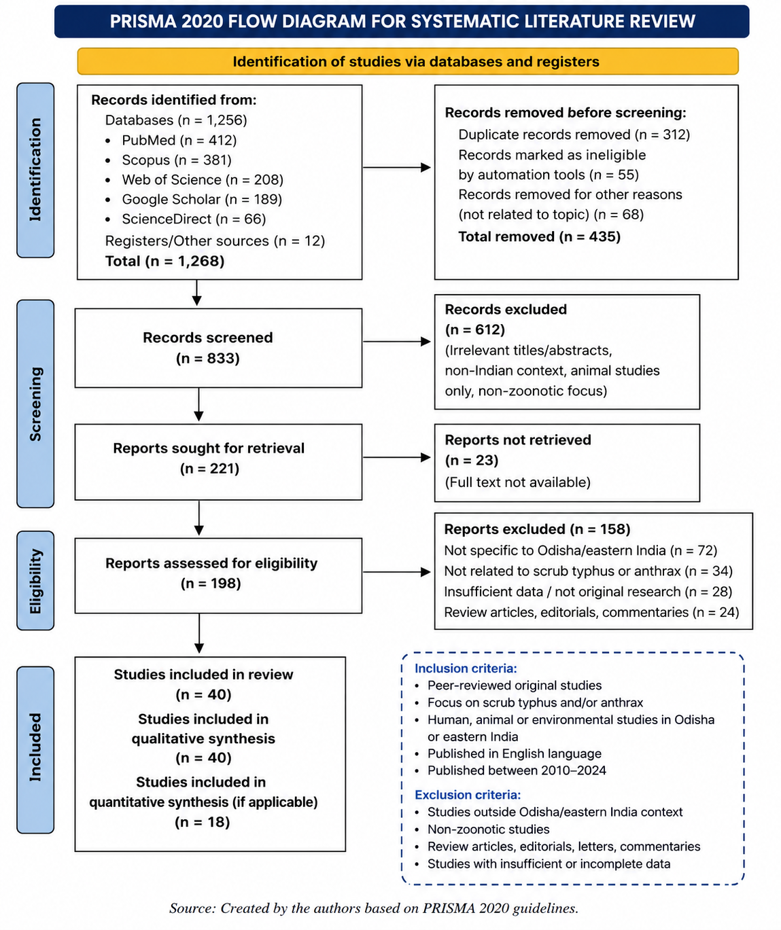
3. RESULTS OF SYSTEMATIC REVIEW
A systematic literature search conducted through PubMed, Scopus, and Google Scholar databases identified approximately 150 records related to scrub typhus, anthrax, and zoonotic infections in Odisha and comparable endemic regions of eastern India [18,19]. After removal of duplicate records, approximately 120 articles remained for title and abstract screening. Based on predefined eligibility criteria, 60 full-text articles were subsequently assessed for detailed evaluation.
Following methodological screening and relevance assessment, 40 studies were included in the final qualitative synthesis according to PRISMA-guided systematic review methodology [17]. The included studies comprised epidemiological investigations, hospital-based observational studies, surveillance reports, outbreak investigations, seroprevalence studies, and One Health-related public health assessments.
Most of the included studies were published between 2020 and 2025, indicating increasing scientific attention toward emerging zoonotic diseases and febrile illness surveillance in Odisha and eastern India [18,20,24,25]. Scrub typhus represented the most frequently investigated zoonotic infection among included studies, with major emphasis on epidemiology, seasonal transmission patterns, clinical manifestations, and diagnostic challenges [19,21,30,31]. Anthrax-related studies primarily focused on outbreak occurrence, livestock-associated transmission, tribal population vulnerability, environmental persistence, and limitations in veterinary surveillance systems [20,22].
The synthesized evidence demonstrated that scrub typhus has emerged as an increasingly recognized cause of acute undifferentiated febrile illness in Odisha, particularly during monsoon and post-monsoon seasons [21,38]. Delayed diagnosis due to overlapping clinical presentation with dengue, malaria, and viral fever was consistently identified as a major healthcare challenge [23,26,27,43]. Several hospital-based studies further reported increased risk of complications including hepatic dysfunction, renal impairment, acute respiratory distress syndrome, and multi-organ failure in untreated cases [19].
Anthrax remained geographically restricted but persistently endemic in livestock-dependent tribal districts of Odisha [20]. The reviewed studies consistently associated anthrax outbreaks with direct exposure to infected livestock, improper carcass disposal practices, low livestock vaccination coverage, and inadequate rural veterinary surveillance [22,24].
Major recurring themes identified across the included studies included:
- epidemiological transition of febrile zoonotic diseases,
- environmental and occupational risk factors,
- delayed diagnosis and healthcare accessibility,
- weak laboratory infrastructure,
- fragmented human and veterinary surveillance systems,
- seasonal disease clustering, and
- challenges in implementation of integrated One Health surveillance frameworks [2,14,18].
The extracted findings collectively highlighted that zoonotic disease burden in Odisha is strongly influenced not only by pathogen transmission dynamics but also by socio-economic vulnerability, healthcare accessibility, environmental exposure, and limitations in integrated surveillance preparedness [3,14].
"Table 1 summarizes the study selection process and major characteristics of the included studies used in the qualitative synthesis."
Table 1. Summary of Included Studies and Major Findings
Parameter | Findings
Total records identified | ~150
Records after duplicate removal | ~120
Full-text articles assessed | ~60
Studies included in final synthesis | 40
Publication period | 2010–2025
Predominant study type | Epidemiological and hospital-based studies
Main disease focus | Scrub typhus and anthrax
Major recurring issue | Delayed diagnosis and weak surveillance
High-risk populations | Tribal communities, farmers, forest workers
Common recommendation | Integrated One Health surveillance
The increasing number of recent publications and surveillance reports further emphasizes growing concern regarding zoonotic disease emergence, environmental health risks, and healthcare preparedness in Odisha and comparable endemic regions of India [18,20,21]
4. DISCUSSION
The present systematic review highlights the increasing public health significance of scrub typhus and anthrax in Odisha, particularly among rural and tribal populations exposed to ecological and occupational risk factors [18,20]. The reviewed evidence demonstrates that zoonotic disease transmission in Odisha is closely associated with environmental exposure, forest-based livelihoods, livestock dependence, inadequate healthcare accessibility, and fragmented surveillance systems [2,3].
Among the two diseases reviewed, scrub typhus has emerged as a major cause of acute undifferentiated febrile illness in Odisha and other parts of eastern India [21]. Several recent hospital-based studies have reported increasing detection rates of scrub typhus, especially during monsoon and post-monsoon seasons when environmental conditions favor vector proliferation [18,19,24,25,38]. Similar epidemiological trends have also been observed in southern and northeastern regions of India, indicating expanding recognition of rickettsial infections as an important contributor to febrile disease burden nationwide [23].
"Based on the findings of the included studies, an integrated One Health framework was developed to demonstrate the interconnected roles of human, animal, and environmental health sectors in zoonotic disease prevention and control (Figure 2)."
"The integrated One Health approach recognizes the interconnection between human, animal, plant, and environmental health as defined by the One Health High-Level Expert Panel (OHHLEP). Based on this framework, Figure 2 illustrates the proposed surveillance, prevention, and control model for zoonotic infections in Odisha [2,46]."

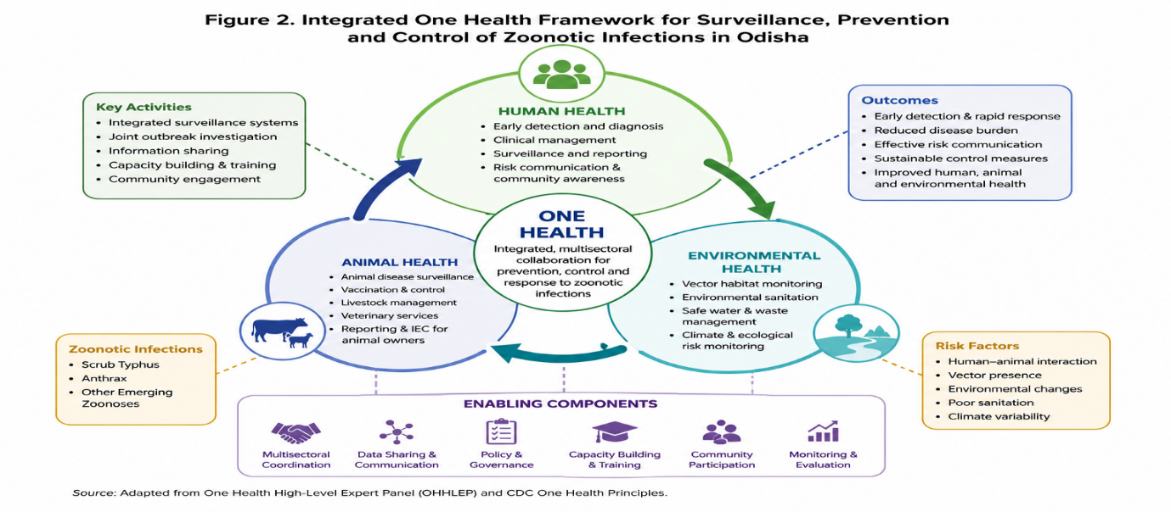
(Source: Adapted from the One Health High-Level Expert Panel (OHHLEP) definition and One Health Joint Plan of Action (2022–2026) [2,46].)
Table 2. Comparative Epidemiological Features of Scrub Typhus and Anthrax in Odisha
Parameter | Scrub Typhus | Anthrax | Key References
Causative agent | Orientia tsutsugamushi | Bacillus anthracis | [11,21,23]
Mode of transmission | Bite of infected chigger mites | Contact with infected animals or animal products | [20,21,22]
Common affected population | Rural agricultural workers | Tribal communities, livestock handlers | [20,21,44]
Seasonal occurrence | Monsoon and post-monsoon seasons | Sporadic outbreaks | [18,20,21]
Clinical presentation | Acute febrile illness, rash, eschar | Cutaneous lesions, fever, septicemia | [20,21,23]
Geographic distribution | Widespread in Odisha districts | Localized endemic tribal regions | [20,21]
Diagnostic challenges | Misdiagnosis with dengue/malaria | Limited laboratory confirmation | [21,23,43]
Public health concern | Increasing incidence and underdiagnosis | Outbreak potential and zoonotic spread | [20,21,22]
Prevention strategies | Vector control, early diagnosis | Animal vaccination, surveillance | [20,22,36]
One Health relevance | Environmental and vector surveillance | Human-animal-environment interaction | [14,22,33]

The review further identified delayed diagnosis as one of the most critical healthcare challenges associated with scrub typhus management [21]. Clinical manifestations frequently overlap with dengue, malaria, leptospirosis, and viral fever, resulting in delayed empirical treatment and increased risk of severe complications [19,26-28]. Several included studies reported hepatic dysfunction, acute respiratory distress syndrome, renal impairment, and multi-organ failure among untreated or late-diagnosed patients [23]. Limited availability of rapid diagnostic facilities and low clinical suspicion at peripheral healthcare centers further contribute to underdiagnosis in endemic districts [7].
Anthrax continues to remain endemic in several tribal and livestock-dependent districts of Odisha despite ongoing public health interventions [20]. The persistence of anthrax outbreaks reflects inadequate livestock vaccination coverage, unsafe carcass disposal practices, environmental spore persistence, and limited veterinary surveillance infrastructure [22]. Similar findings have been reported in other endemic regions of India and South Asia, where socio-economic vulnerability and poor veterinary-public health coordination contribute to recurrent transmission cycles [14].
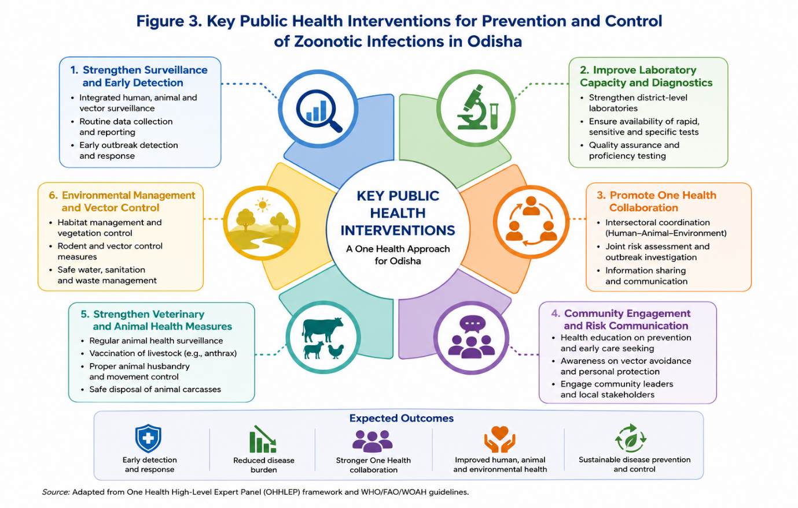

Table 3. Public Health Interventions and Control Strategies for Zoonotic Infections in Odisha
Intervention Area | Recommended Strategies | Expected Public Health Impact | Key References
Disease Surveillance | Strengthening integrated surveillance systems and rapid reporting | Early outbreak detection and response | [2,8,14,35,42]
Laboratory Diagnosis | Improving diagnostic facilities and accessibility in rural areas | Timely confirmation and treatment | [7,21,36,43]
Community Awareness | Health education on zoonotic disease prevention and hygiene | Reduced disease transmission | [3,14,22,44]
Vector Control | Environmental sanitation and vector management programs | Lower vector population and infection risk | [5,18,32]
Animal Health Monitoring | Veterinary surveillance and livestock vaccination | Prevention of animal-to-human transmission | [20,22,39,40]
One Health Collaboration | Coordination between medical, veterinary, and environmental sectors | Improved multidisciplinary disease control | [2,14,33,42]
Healthcare Preparedness | Training healthcare workers and strengthening rural health services | Better case management and reduced mortality | [7,21,35,36]
Research and Policy Support | Encouraging epidemiological research and evidence-based policymaking | Long-term disease prevention planning | [3,14,18,45]

An important finding of this review is the continued fragmentation between human health, veterinary health, and environmental surveillance systems in Odisha [2]. Although the One Health approach has increasingly gained policy recognition in India, implementation at district and community levels remains operationally limited [14]. The reviewed studies consistently emphasized the importance of integrated surveillance, intersectoral collaboration, and real-time outbreak reporting systems for effective zoonotic disease control [22].
Environmental and climatic determinants also appear to play a substantial role in disease emergence and transmission dynamics in Odisha [5,32,41]. Seasonal rainfall, humidity, vegetation density, flooding, and forest exposure were repeatedly associated with increased risk of scrub typhus transmission [18]. Similarly, anthrax outbreaks were frequently linked to livestock exposure, contaminated soil, and carcass handling practices in endemic tribal regions [20]. These findings highlight the importance of integrating environmental monitoring and geospatial risk mapping into future surveillance frameworks.
The review additionally identified major research and surveillance gaps. Most available evidence remains hospital-based and geographically localized, limiting understanding of community-level transmission dynamics and actual disease burden [21,43,45]. Few studies have evaluated long-term epidemiological trends, integrated One Health interventions, or climate-linked predictive surveillance models in Odisha [14]. Strengthening molecular surveillance, community-based epidemiological studies, and interdisciplinary collaboration will therefore be essential for improving outbreak preparedness and evidence-based public health planning.
Overall, the findings of this review support the urgent need for strengthening decentralized diagnostic infrastructure, integrated surveillance systems, livestock vaccination programs, healthcare worker training, and coordinated One Health implementation strategies in Odisha. Addressing these gaps is essential for reducing zoonotic disease burden and improving public health preparedness in vulnerable endemic regions.
5.RESEARCH GAPS AND FUTURE DIRECTIONS
Despite increasing recognition of zoonotic infections in Odisha, substantial research gaps continue to limit comprehensive understanding of the epidemiological burden, transmission dynamics, and public health impact of scrub typhus and anthrax [3,18]. Most currently available evidence is derived from hospital-based observational studies and outbreak investigations, which restricts understanding of community-level disease transmission and actual regional burden estimation [21].
One of the major limitations identified in the reviewed literature is the lack of longitudinal district-level epidemiological studies evaluating temporal disease trends, seasonal variability, and long-term transmission dynamics in endemic regions of Odisha [18]. Existing surveillance data remain fragmented and geographically localized, limiting identification of emerging hotspots and high-risk ecological zones [20].
Another important gap involves inadequate integration of environmental and climatic determinants into zoonotic disease surveillance models. Factors such as rainfall variability, humidity, land-use change, deforestation, flooding, and forest fragmentation are increasingly recognized as major contributors to vector proliferation and zoonotic transmission risk, yet these variables remain insufficiently incorporated into current epidemiological frameworks [5,19,32,41,45]. Future research should therefore prioritize climate-linked predictive surveillance systems and geospatial disease modelling approaches.
The review additionally identified limited application of molecular epidemiology and genomic surveillance techniques in Odisha [18,43]. Advances in genomic sequencing and pathogen characterization could substantially improve understanding of strain diversity, transmission pathways, outbreak clustering, and regional epidemiological variation associated with scrub typhus and anthrax [14]. However, implementation of such approaches remains constrained by inadequate laboratory infrastructure, limited technical expertise, and insufficient interdisciplinary collaboration.
Another critical research gap involves co-infections and syndromic overlap among febrile illnesses. Several studies highlighted diagnostic confusion between scrub typhus, malaria, dengue, leptospirosis, and other acute febrile illnesses due to overlapping clinical manifestations [23]. Limited evidence is currently available regarding the burden of co-infections, diagnostic accuracy, and treatment outcomes in endemic tribal and rural populations.
The reviewed studies further demonstrated inadequate evaluation of integrated One Health surveillance systems within Odisha [2,33,42]. Although policy-level recognition of One Health approaches has increased in recent years, operational implementation remains fragmented across medical, veterinary, and environmental sectors [14]. Future studies should assess the effectiveness of coordinated surveillance models, intersectoral data-sharing systems, livestock vaccination strategies, and community-based outbreak response mechanisms.
Geographic information system (GIS)-based hotspot mapping and spatial epidemiological analysis also remain underutilized in zoonotic disease surveillance within Odisha [20,45]. Incorporation of geospatial technologies may improve identification of high-risk transmission zones, seasonal outbreak prediction, and targeted public health intervention planning.
Emerging digital health technologies and artificial intelligence-assisted surveillance systems may further strengthen outbreak forecasting and rapid response capacity in endemic districts [3]. However, evidence regarding feasibility, implementation barriers, and effectiveness of such technologies in resource-limited rural settings remains limited and requires future investigation.
Overall, strengthening interdisciplinary collaboration between public health professionals, veterinarians, epidemiologists, environmental scientists, and policymakers will be essential for improving zoonotic disease preparedness and evidence-based healthcare planning in Odisha. Future research should therefore prioritize integrated One Health frameworks, decentralized diagnostic capacity, community-based surveillance, and climate-responsive disease prediction models for sustainable zoonotic disease control.
6. INTEGRATED ONE HEALTH FRAMEWORK AND SYSTEMS IMPLEMENTATION
The persistence and emergence of zoonotic infections in Odisha reflect the complex interaction between human health, animal health, and environmental determinants, highlighting the urgent need for implementation of integrated One Health surveillance systems [2,3]. Diseases such as scrub typhus and anthrax cannot be effectively controlled through isolated disease-specific interventions because their transmission dynamics involve ecological exposure, livestock interaction, vector proliferation, and socio-economic vulnerability [14,33].
The reviewed evidence demonstrated that current surveillance systems in Odisha remain fragmented across medical, veterinary, and environmental sectors [18]. Although human disease surveillance is conducted through the Integrated Disease Surveillance Programme (IDSP), coordination with veterinary health services and environmental monitoring systems remains operationally limited in several endemic districts [8]. This fragmentation contributes to delayed outbreak reporting, inadequate field investigation, and reduced effectiveness of early containment measures.
Implementation of a district-level integrated One Health framework could substantially strengthen zoonotic disease preparedness and outbreak response capacity in Odisha [22,35,42]. Establishment of coordinated surveillance platforms involving public health departments, veterinary officers, microbiology laboratories, environmental agencies, and local administrative bodies would improve real-time information sharing and rapid outbreak detection [14].
Several included studies emphasized the importance of integrating livestock surveillance and veterinary reporting into zoonotic disease monitoring systems, particularly for anthrax-endemic tribal districts [20]. Livestock vaccination programs, animal movement monitoring, and safe carcass disposal practices remain critical components of anthrax prevention and control [22]. However, inadequate veterinary infrastructure and limited community awareness continue to hinder effective implementation in remote rural regions.
The review further identified the importance of environmental surveillance and geospatial disease monitoring for zoonotic disease preparedness [5]. Climatic variables such as rainfall, humidity, vegetation density, flooding, and seasonal temperature variation strongly influence vector abundance and disease transmission dynamics, particularly for scrub typhus [18]. Incorporation of Geographic Information System (GIS)-based hotspot mapping and climate-linked predictive surveillance models may therefore improve early outbreak forecasting and targeted public health intervention planning [20].
Digital disease reporting systems and artificial intelligence-assisted surveillance technologies may additionally strengthen integrated outbreak preparedness frameworks in Odisha [3,45]. Real-time data integration between healthcare facilities, laboratories, veterinary departments, and environmental monitoring agencies could improve outbreak response efficiency and reduce diagnostic delays in endemic districts. However, implementation of such systems remains constrained by limited digital infrastructure, inadequate laboratory networking, shortage of trained epidemiological personnel, and resource limitations within rural healthcare systems [7].
Community-level participation also represents a critical component of successful One Health implementation. Several reviewed studies highlighted the importance of community awareness programs, frontline healthcare worker training, livestock owner education, and local surveillance reporting mechanisms for reducing zoonotic disease transmission risk [14,22]. Strengthening community engagement may improve early healthcare-seeking behavior, disease reporting, and adherence to preventive practices in high-risk tribal and forest-dependent populations.
Despite increasing policy-level recognition of One Health approaches in India, operational implementation at district and community levels in Odisha remains limited [2]. Strengthening interdisciplinary collaboration between physicians, veterinarians, epidemiologists, environmental scientists, microbiologists, and policymakers will therefore be essential for improving integrated surveillance capacity and long-term zoonotic disease preparedness.
Overall, implementation of coordinated One Health surveillance systems integrating human, animal, and environmental health sectors represents a critical requirement for sustainable control of scrub typhus, anthrax, and other emerging zoonotic infections in Odisha.
7.POLICY IMPLICATIONS AND HEALTH SYSTEM STRENGTHENING
The findings of this systematic review have important implications for public health policy, healthcare preparedness, and zoonotic disease surveillance in Odisha [3]. The increasing burden of scrub typhus and the continued persistence of anthrax in tribal and livestock-dependent regions highlight the need for strengthening integrated disease control strategies within the state healthcare system [18,20].
One of the most important policy priorities identified through the reviewed literature is the incorporation of scrub typhus into routine fever management protocols at primary and secondary healthcare levels [21]. Early clinical suspicion and prompt empirical treatment with doxycycline can substantially reduce complications, hospitalization, and mortality associated with severe scrub typhus infection [23,36,37]. However, delayed diagnosis remains common in peripheral healthcare settings because of overlapping clinical presentation with malaria, dengue, and other acute febrile illnesses [19]. Strengthening diagnostic awareness among frontline healthcare workers is therefore essential.
Expansion of decentralized diagnostic infrastructure represents another critical healthcare priority [7]. Several reviewed studies emphasized limited access to rapid diagnostic facilities and confirmatory laboratory testing in rural and tribal districts of Odisha [21]. Strengthening laboratory networking, improving availability of serological and molecular diagnostic tools, and enhancing referral systems may significantly improve early case detection and outbreak response capacity.
Anthrax prevention and control require strengthening of veterinary public health systems and livestock vaccination programs in endemic districts [20,39,40]. Recurrent outbreaks continue to occur because of low vaccination coverage, unsafe carcass disposal practices, and inadequate awareness regarding zoonotic transmission risk among livestock handlers and tribal communities [22]. Sustained veterinary surveillance and coordinated animal health interventions are therefore essential components of long-term anthrax control strategies.
The reviewed evidence further supports the establishment of district-level integrated One Health coordination units involving public health departments, veterinary services, environmental agencies, and microbiology laboratories [2,14]. Such interdisciplinary coordination may improve real-time disease reporting, outbreak investigation, surveillance integration, and emergency response planning in endemic regions [8].
Capacity building of healthcare personnel also represents a major policy requirement. Several studies highlighted inadequate training related to recognition and management of zoonotic febrile illnesses among peripheral healthcare providers [21]. Regular clinical training programs, surveillance workshops, and outbreak preparedness exercises may improve early diagnosis, case management, and reporting efficiency in resource-limited healthcare settings.
Community-based awareness programs are equally important for reducing zoonotic disease transmission risk [3,44]. Public health education regarding personal protective measures, safe livestock handling, environmental hygiene, and early healthcare-seeking behavior may reduce disease burden in high-risk rural and tribal populations [22]. Involvement of community health workers and local administrative bodies may further strengthen surveillance reporting and preventive intervention implementation.
The review additionally emphasizes the importance of integrating geospatial surveillance systems, climate-linked disease monitoring, and digital health technologies into public health preparedness frameworks [5]. Geographic Information System (GIS)-based hotspot mapping and seasonal disease forecasting may improve identification of high-risk transmission areas and facilitate targeted preventive interventions [18].
Despite recent policy recognition of One Health approaches in India, implementation challenges remain substantial in Odisha because of limited infrastructure, inadequate funding, fragmented surveillance systems, and shortage of trained epidemiological personnel [14]. Strengthening political commitment, intersectoral collaboration, and long-term investment in rural public health infrastructure will therefore be essential for sustainable zoonotic disease prevention and control.
Overall, the findings of this review support the urgent need for integrated healthcare strengthening, decentralized surveillance systems, veterinary-public health coordination, and community-centered One Health interventions for improving zoonotic disease preparedness in Odisha.
8. STRENGTHS AND LIMITATIONS
This systematic review provides a region-specific synthesis of scrub typhus and anthrax in Odisha, highlighting their epidemiological significance, diagnostic challenges, environmental determinants, and public health implications within a unified One Health framework [2,14]. One of the major strengths of the review is the integration of evidence from epidemiological studies, outbreak investigations, surveillance reports, and One Health-related public health literature published between 2010 and 2025 [18,20].
Another important strength is the emphasis on Odisha-specific zoonotic disease burden, particularly among vulnerable tribal and rural populations that remain underrepresented in national-level reviews [21]. The review additionally incorporates recent evidence regarding environmental risk factors, surveillance limitations, climate-linked disease emergence, and interdisciplinary public health interventions associated with zoonotic infections in eastern India [5,18,32,41].
The review further contributes to existing literature by comparatively synthesizing two major zoonotic diseases, scrub typhus and anthrax, which differ substantially in transmission dynamics but share important public health and surveillance challenges [20]. Integration of One Health perspectives involving human, animal, and environmental health systems also strengthens the practical relevance of the review findings for future healthcare planning and policy development [2].
Despite these strengths, several limitations should be acknowledged. First, most included studies were hospital-based observational investigations, which may underestimate actual community-level disease burden and transmission dynamics in rural and tribal regions [21]. Second, heterogeneity among included studies regarding study design, diagnostic criteria, sample size, and surveillance methodology limited direct comparability of findings across studies [19].
Third, only English-language publications were included in the review, which may have resulted in exclusion of relevant regional reports or unpublished data sources. Fourth, because of substantial methodological heterogeneity and limited availability of uniform epidemiological data, quantitative meta-analysis and pooled statistical estimation were not performed [17].
Another limitation involves the limited availability of longitudinal district-level surveillance studies from Odisha, restricting evaluation of long-term epidemiological trends and temporal disease variation [18]. In addition, publication bias may have influenced representation of severe outbreaks and hospital-reported cases while underrepresenting asymptomatic or underdiagnosed community infections.
Finally, although the review emphasized One Health implementation and integrated surveillance approaches, limited evidence was available regarding operational effectiveness of such systems within endemic rural settings in Odisha [14]. Future community-based studies, molecular surveillance investigations, and interdisciplinary epidemiological research will therefore be necessary to improve understanding of zoonotic disease dynamics and strengthen evidence-based public health planning[43,45].
Overall, despite these limitations, the present review provides a comprehensive and updated synthesis of zoonotic disease epidemiology, surveillance challenges, and One Health priorities relevant to Odisha and comparable endemic regions of India.
9. CONCLUSION
Zoonotic infections continue to represent an important and evolving public health challenge in Odisha, particularly among vulnerable tribal and rural populations exposed to environmental, occupational, and livestock-associated risk factors [3,20]. This systematic review highlights the increasing epidemiological significance of scrub typhus as an emerging cause of acute undifferentiated febrile illness and the continued endemic persistence of anthrax in livestock-dependent tribal regions of the state [18,21,24,25,30].
The synthesized evidence demonstrates that delayed diagnosis, inadequate laboratory infrastructure, fragmented surveillance systems, poor veterinary-public health coordination, and limited healthcare accessibility remain major barriers to effective zoonotic disease control in Odisha [7,14]. Environmental determinants including climatic variability, forest exposure, seasonal rainfall, and ecological disruption further contribute to disease emergence and transmission dynamics [5,19,32,41].
The review additionally emphasizes that isolated disease-specific approaches are insufficient for sustainable management of zoonotic infections in endemic regions [2]. Strengthening integrated One Health frameworks involving coordinated human, animal, and environmental health surveillance systems is therefore essential for improving outbreak preparedness, early detection, rapid response, and long-term disease prevention strategies [14,22,33,42].
Expansion of decentralized diagnostic capacity, strengthening of rural healthcare infrastructure, livestock vaccination programs, molecular surveillance systems, geospatial hotspot mapping, and climate-linked predictive surveillance models may substantially improve public health preparedness and healthcare response efficiency in Odisha [18,20]. Community awareness programs, healthcare worker training, and interdisciplinary collaboration will further play critical roles in reducing disease burden and improving surveillance effectiveness in high-risk populations [3].
Importantly, this review provides one of the few consolidated region-specific syntheses integrating scrub typhus and anthrax epidemiology within the context of Odisha and eastern India [20]. The findings identify significant evidence gaps related to community-level surveillance, genomic epidemiology, integrated One Health implementation, and long-term environmental disease monitoring. Future interdisciplinary research and sustained policy-level commitment will therefore be essential for strengthening zoonotic disease preparedness and evidence-based public health planning in Odisha.
Overall, the findings of this review strongly support the urgent need for integrated surveillance systems, strengthened healthcare infrastructure, coordinated veterinary-public health interventions, and sustainable One Health implementation strategies for effective control of emerging zoonotic infections in Odisha and comparable endemic regions of India.
Appendix A. Database-Specific Search Strategy
Database | Search Expression
PubMed | ("Scrub Typhus" OR "Orientia tsutsugamushi") AND Odisha
PubMed | ("Anthrax" OR "Bacillus anthracis") AND Odisha
Scopus | TITLE-ABS-KEY ("scrub typhus" AND Odisha)
Scopus | TITLE-ABS-KEY ("anthrax" AND Odisha)
Google Scholar | "scrub typhus Odisha"
Google Scholar | "anthrax Odisha"

Disclaimer (Artificial intelligence)
Author(s) hereby declare that NO generative AI technologies such as Large Language Models (ChatGPT, COPILOT, etc.) and text-to-image generators have been used during the writing or editing of this manuscript.

REFERENCES
- Destoumieux-Garzón D, Mavingui P, Boetsch G, et al. The One Health concept: 10 years old and a long road ahead. Front Vet Sci. 2018;5:14.
- FAO, UNEP, WHO, WOAH. One Health Joint Plan of Action (2022–2026). Geneva: World Health Organization; 2022.
- World Health Organization. Zoonoses and the human-animal-ecosystems interface. Geneva: WHO; 2023.
- Mohanty I, Sahu S, Satpathy SK. Environmental and socio-economic determinants of vector-borne and zoonotic diseases in Odisha. Indian J Public Health. 2021;65(3):245-252.
- Weaver SC, Charlier C, Vasilakis N, Lecuit M. Emerging vector-borne diseases and environmental change. Annu Rev Med. 2020;71:395-408.
- Petersen E, Riddle MS, Dankwa EA, et al. Emerging infections and disease ecology in tropical regions. Lancet Infect Dis. 2019;19(11).
- National Health Mission. Rural health infrastructure and surveillance report: Odisha. Government of India; 2023.
- Murhekar MV. Infectious disease surveillance and emerging zoonoses in India. Indian J Med Res. 2022;155(4-5):561-570.
- Panigrahi A, Narasimham MV, Biswal M, et al. Epidemiology of scrub typhus in a tertiary care hospital of Southern Odisha: a cross-sectional study. Indian J Med Microbiol. 2023;42:92-96.
- Devasagayam E, Dayanand D, Kundu D, et al. The burden of scrub typhus in India: a systematic review. PLoS Negl Trop Dis. 2021;15(7).
- Bhattacharya D, Pattnaik M, Sahu SK, et al. Human anthrax in India in recent times: a systematic review and risk mapping. One Health. 2023;16:100564.
- Pattnaik M, Choudhary HR, Parai D, et al. One Health intervention for elimination of anthrax in an endemic district of Odisha: a baseline and endline study. One Health. 2024;18:100729.
- Centers for Disease Control and Prevention. Anthrax: epidemiology and prevention. Atlanta: CDC; 2022.
- Ghosal S, Pradhan R, Singh S, et al. One Health intervention for control and elimination of scrub typhus, anthrax and brucellosis in Southeast Asia: a systematic review. Lancet Reg Health Southeast Asia. 2024;30:100503.
- Parai D, Pattnaik M, Dash GC, et al. Scrub typhus seroprevalence from an eastern state of India: findings from the statewide serosurvey. Trans R Soc Trop Med Hyg. 2023;117(1):22-27.
16. Chaturvedi R, Hussain SSA, Sampath H, et al. Spatiotemporal epidemiology and clinical manifestations of scrub typhus in India: a systematic review and meta-analysis. BMJ Glob Health. 2025;10.
17. Page MJ, McKenzie JE, Bossuyt PM, et al. The PRISMA 2020 statement: an updated guideline for reporting systematic reviews. BMJ. 2021;372.
18. Wang Q, Ma T, Ding F, et al. Global and regional seroprevalence, incidence, mortality and risk factors for scrub typhus: a systematic review and meta-analysis. Int J Infect Dis. 2024;146:107151.
19. Chaturvedi R, Hussain SSA, Sampath H, et al. Spatiotemporal epidemiology and clinical manifestations of scrub typhus in India: a systematic review and meta-analysis. BMJ Glob Health. 2025;10.
20. Bhattacharya D, Pattnaik M, Sahu SK, et al. Human anthrax in India in recent times: a systematic review and risk mapping. One Health. 2023;16:100564.
21. Panigrahi A, Narasimham MV, Biswal M, et al. Epidemiology of scrub typhus in a tertiary care hospital of Southern Odisha: a cross-sectional study. Indian J Med Microbiol. 2023;42:92-96.
22. Pattnaik M, Choudhary HR, Parai D, et al. One Health intervention for elimination of anthrax in an endemic district of Odisha: a baseline and endline study. One Health. 2024;18:100729.
23. Devasagayam E, Dayanand D, Kundu D, et al. The burden of scrub typhus in India: a systematic review. PLoS Negl Trop Dis. 2021;15(7).
24. Dasgupta S, Asish PR, Rachel G, et al. Global seroprevalence of scrub typhus: a systematic review and meta-analysis. Sci Rep. 2024;14:10895.
25. Sondhiya G, Manjunathachar HV, Singh P, Kumar R. Unveiling the burden of scrub typhus in acute febrile illness cases across India: a systematic review and meta-analysis. Indian J Med Res. 2024;159(6):601-618.
26. Ravishankar V, Narayanan S, Shandil RK. Rickettsial infections: prevalence and diagnosis of scrub typhus in India. Front Trop Dis. 2024;5:1433013.
27. Dixit R, Manikandan S, Prakash JAJ, et al. The diagnostic accuracy of point-of-care nucleic acid-based isothermal amplification assays for scrub typhus: a systematic review and meta-analysis. Front Microbiol. 2025;15:1516921.
28. Gupta N, Biswal M, Behera B, et al. Frequency and distribution of eschar in patients with scrub typhus in India: systematic review of literature and meta-analysis. Trop Med Infect Dis. 2024;9(9):201.
29. Rathor S. Scrub Typhus: Indian situation and current report generated by Indian Council of Medical Research-National Centre for Disease Informatics and Research under the Right to Information Act, 2005-reg. Int J Pharm Biol Arch. 2024;15(2):1-8.
30. Sharma A, Mahajan S, Raina R, et al. Scrub typhus in India: an emerging public health threat. Infect Dis Poverty. 2024;13:55.
31. Behera B, Biswal M, Das A, et al. Re-emerging rickettsial infections in India: current diagnostic and epidemiological challenges. J Infect Public Health. 2024;17(3):402-410.
32. Thomas R, Puranik A, Kalal BS, et al. Climate variability and emerging vector-borne zoonotic diseases in South Asia. Lancet Planet Health. 2024;8.
33. Singh BB, Gajadhar A. Role of One Health strategies in prevention of zoonotic diseases in developing countries. One Health. 2024;18:100701.
34. Mohapatra RK, Mishra S, Dash M, et al. Emerging zoonotic diseases and surveillance preparedness in eastern India. Indian J Community Med. 2024;49(2):211-218.
35. World Health Organization. Integrated surveillance strategies for emerging zoonotic diseases. Geneva: WHO; 2024.
36. Indian Council of Medical Research. National guidelines for diagnosis and management of rickettsial diseases. New Delhi: ICMR; 2024.
37. Centers for Disease Control and Prevention. Scrub typhus: clinical overview and prevention. Atlanta: CDC; 2024.
38. Biswal M, Behera B, Padhan K, et al. Clinical and laboratory profile of scrub typhus in eastern India. Trop Doct. 2024;54(1):15-22.
39. Mohanty RR, Sahu DP, Das S, et al. Anthrax surveillance and public health preparedness in tribal districts of Odisha. One Health Adv. 2025;3:14.
40.Choudhary HR, Pattnaik M, Parai D, et al. Community-based One Health intervention model for anthrax prevention in Odisha. Front Public Health. 2025;13:1452211.
41. United Nations Environment Programme. Preventing future zoonotic pandemics through environmental action. Nairobi: UNEP; 2024.
42. FAO. Strengthening One Health surveillance systems in South Asia. Rome: Food and Agriculture Organization; 2024.
43. Mohapatra D, Behera SK, Gopalan N, et al. Point-of-care diagnostics and surveillance challenges for scrub typhus in India. Front Public Health. 2025;13:1508842.
44. Sharma PK, Singh S, Mohanty A, et al. Occupational exposure and zoonotic disease risk among tribal communities in eastern India. J Family Med Prim Care. 2024;13(4):1567-1574.
45. Patel P, Roy S, Nair D, et al. GIS-based mapping approaches for emerging zoonotic disease surveillance in India. Geospat Health. 2025;20(1):1342.

