Case report
Black hairy tongue in an elderly patient: A case report

ABSTRACT
Aims: Black hairy tongue is a benign acquired disorder characterised by elongation, defective desquamation, and discolouration of the filiform papillae on the dorsal surface of the tongue. Although it is commonly associated with poor oral hygiene, tobacco use, staining beverages, xerostomia, and selected medications, it may also occur without these factors. This case report presents an elderly patient with black hairy tongue and highlights the value of clinical recognition and conservative management.
Case Presentation: A 72-year-old male patient presented with persistent dark discolouration of the tongue for the previous 2–3 years. He had no pain, burning sensation, altered taste, or halitosis, and his main concern was the aesthetic appearance. His medical and drug history was non-contributory, and he reported no tobacco use, alcohol consumption, or deleterious oral habits. He had used complete dentures for 7 years. Intraoral examination showed diffuse blackish-brown discolouration over the posterior two-thirds of the dorsal tongue, with a hairy, carpet-like appearance and elongated filiform papillae. The lateral borders and tip of the tongue were relatively normal. The diagnosis of black hairy tongue was made clinically, and no additional laboratory investigations were performed.
Management and Outcome: The patient was managed conservatively with gentle brushing of the dorsal tongue, use of a tongue cleaner, reinforcement of oral hygiene, once-daily antiseptic mouthwash, adequate hydration, denture cleaning, night-time denture removal, and reassurance. Follow-up showed a marked reduction in pigmentation and improvement in tongue texture, with gradual resolution of the hairy appearance.
Conclusion: Black hairy tongue is a benign and reversible condition. Careful clinical assessment, patient education, oral and denture hygiene, and mechanical debridement can support favourable outcomes while avoiding unnecessary interventions.
Keywords: Black hairy tongue; Lingua villosa nigra; Filiform papillae; Oral pigmentation; Tongue discolouration; Conservative management; Mechanical debridement; Oral hygiene; Denture hygiene; Elderly patient; Case report

1. INTRODUCTION
Black hairy tongue (BHT) is a benign, acquired condition of the oral cavity characterised by elongation and defective desquamation of the filiform papillae on the dorsal surface of the tongue, resulting in a characteristic “hairy” appearance. Discolouration may range from black to brown, yellow, or green due to the accumulation of chromogenic microorganisms, food debris, and extrinsic staining factors (Gurvits & Tan, 2014).
The condition is relatively uncommon, with a reported prevalence of less than 1% in the general population, although higher rates have been observed in elderly individuals and those with predisposing factors (Schlager et al., 2017). The pathogenesis involves impaired desquamation of the keratinised layer of the filiform papillae, leading to hypertrophy and elongation, which in turn promote retention of debris and microorganisms (Thompson & Kessler, 2010).
Several contributing factors have been implicated, including poor oral hygiene, tobacco use, excessive coffee or tea intake, xerostomia, and the use of certain medications such as antibiotics (Manabe et al., 1999). However, in some cases, no clear aetiological factor can be identified, making the diagnosis primarily clinical.
Clinically, BHT is usually asymptomatic and often detected incidentally, although some patients may present with halitosis, altered taste sensation, or aesthetic concerns. Despite its striking appearance, the condition is benign and carries no risk of malignant transformation (Acosta Torres et al., 2022).
Management is primarily conservative and includes the elimination of predisposing factors, maintenance of proper oral hygiene, and mechanical debridement of the tongue. Most cases respond well to these measures, with gradual resolution.
Although black hairy tongue is typically benign and clinically recognisable, reports in elderly complete denture wearers without common precipitating factors remain limited. Such presentations may create diagnostic uncertainty and may lead to unnecessary investigations or treatment when clinicians are unfamiliar with the condition. The present case report describes the clinical presentation and successful conservative management of black hairy tongue in an elderly patient. It highlights the importance of accurate clinical diagnosis, patient education, and conservative management, thereby increasing awareness among dental practitioners and contributing to the existing literature on this benign oral condition.

2. CASE PRESENTATION
A 72-year-old male patient presented to the outpatient department with a chief complaint of persistent dark discolouration of the tongue for the past 2–3 years. The patient reported no associated symptoms, such as pain, burning sensation, altered taste, or halitosis. His primary concern was the aesthetic appearance of the tongue.
The patient’s medical and drug history was non-contributory. There was no history of tobacco use, alcohol consumption, or other deleterious oral habits. However, the patient had been a complete denture wearer for the past 7 years.
On intraoral examination, the dorsal surface of the tongue, predominantly involving the posterior two-thirds, exhibited diffuse blackish-brown discolouration with a characteristic hairy or carpet-like appearance. The lesion was non-scrapable and demonstrated elongated filiform papillae. The lateral borders and tip of the tongue appeared relatively normal, with preserved mucosal integrity (Figure 1).
Based on the clinical findings, a diagnosis of black hairy tongue was established. No additional laboratory investigations were performed, as the diagnosis was made clinically.
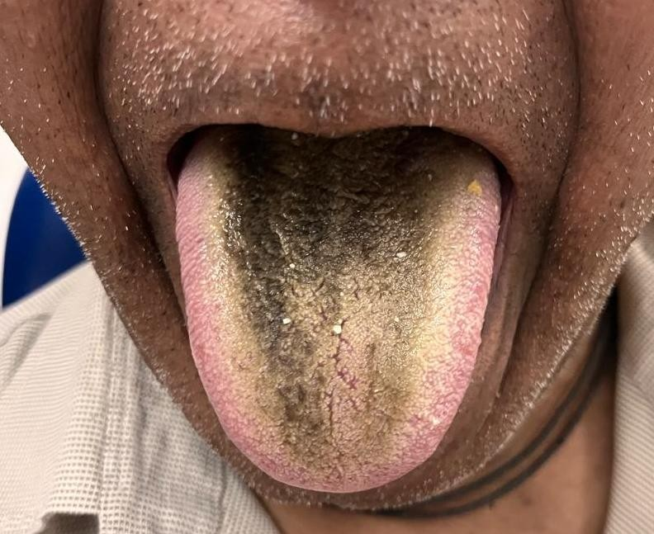
Figure 1. Dorsal surface of the tongue showing blackish-brown discolouration with elongated filiform papillae characteristic of black hairy tongue.

2.1 Management
Mechanical debridement:
The patient was instructed to perform gentle brushing of the dorsal surface of the tongue twice daily using a soft toothbrush, along with the use of a tongue cleaner/scraper to aid removal of elongated filiform papillae.
Oral hygiene maintenance:
Optimal oral hygiene practices, including regular tooth brushing and cleansing of the oral cavity, were reinforced.
Adjunctive mouthwash therapy:
The patient was advised to use an antiseptic mouthwash (chlorhexidine 0.12% or hexetidine mouthwash) once daily to reduce microbial load and prevent further accumulation of debris.
Hydration:
Adequate fluid intake was encouraged to reduce oral dryness and facilitate natural desquamation.
Denture hygiene:
Considering the patient’s long-term denture use, instructions were given for:
• Regular cleaning of the denture
• Removal at night
• Use of appropriate denture-cleansing solutions
Patient education and reassurance:
The patient was reassured about the benign and reversible nature of the condition and motivated to adhere to oral hygiene measures.

2.2 Follow-up
At follow-up, the patient showed a marked reduction in pigmentation and improvement in the texture of the tongue, with gradual resolution of the hairy appearance, confirming a favourable response to conservative management (Figure 2).
Antifungal agents and keratolytic therapies have been reported in the literature; however, they were not indicated in the present case because infection was absent and the response to conservative measures was satisfactory.
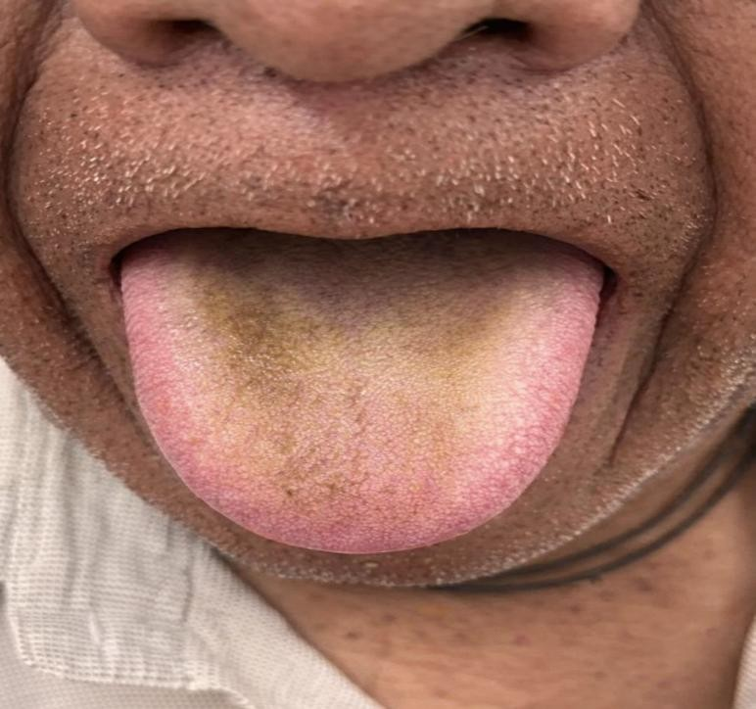
Figure 2. Post-treatment image showing reduced pigmentation and improved tongue appearance.

3. DISCUSSION
Black hairy tongue (BHT), or lingua villosa nigra, is a benign clinical entity characterised by marked hypertrophy and elongation of the filiform papillae on the dorsal surface of the tongue (Gurvits & Tan, 2014; Schlager et al., 2017). Although historical reviews from 1939 and 1940 described BHT as a condition of “little clinical significance”, it remains a source of aesthetic concern and diagnostic interest in oral medicine (Kennedy & Howles, 1940; Swinburne, 1939). Pathogenesis and architectural organisation: the primary defect in BHT is failure of the filiform papillae to undergo normal desquamation, leading to an accumulation of keratin (Reamy et al., 2010; Schlager et al., 2017; Vañó-Galván & Jaén, 2008). Under normal physiological conditions, these papillae are less than 1 mm in length; however, in BHT, they can reach lengths exceeding 12–18 mm (Hamad & Warren, 2018).
The three-dimensional cytoarchitecture of this condition was detailed by Manabe et al. (1999), who showed that “hairs” are secondary papillae composed of a central column of epithelial cells expressing hair-type keratins (Greco et al., 1997; Manabe et al., 1999). These structures fail to shed, creating what early researchers described as a “field of corn laid low by the wind” (Kennedy & Howles, 1940; Swinburne, 1939). Scanning electron microscopy further confirms that these elongated papillae consist of accumulated keratinised layers that trap debris and chromogenic microorganisms (Harada & Gaafar, 1977). Aetiology in the edentulous patient: while BHT is frequently associated with tobacco use and antibiotic therapy, cases occurring in the absence of these factors—as seen in the present case—highlight the importance of local oral environment shifts (Gurvits & Tan, 2014; Khasawneh et al., 2013; Tsioutis et al., 2025).
In edentulous patients, long-term denture wear (7 years in this case) plays a critical role in the pathogenesis. According to the literature on older edentulous individuals, the presence of a prosthesis can alter the oral microflora and decrease natural mechanical friction between the tongue and hard palate during mastication and speech (Ren et al., 2020; Schlager et al., 2017). This lack of “mechanical debridement” is a key factor in the retention of keratinised layers on the filiform papillae (Gurvits & Tan, 2014; Reamy et al., 2010). Furthermore, dentures can act as a reservoir for chromogenic (porphyrin-producing) bacteria and fungi, which migrate to the dorsal tongue and produce the characteristic black pigmentation within the elongated papillae (Ren et al., 2020; Unal et al., 2024).
Comparison with recently published cases further supports the findings of the present report. Fahdawi et al. (2024) described black hairy tongue in a patient following co-amoxiclav therapy and emphasised the importance of prompt clinical recognition, elimination of predisposing factors, and reinforcement of oral hygiene measures for successful management. Similarly, Sun and Yang (2023) reported the development of black hairy tongue following prolonged antibiotic therapy, with complete resolution after withdrawal of the offending agents and conservative treatment. Consistent with these reports, our patient demonstrated significant clinical improvement following mechanical debridement and maintenance of oral hygiene, highlighting the benign and reversible nature of black hairy tongue when appropriately diagnosed and managed.
Current evidence supports conservative management as the first-line treatment for black hairy tongue (Gurvits & Tan, 2014; Reamy et al., 2010; Schlager et al., 2017). Mechanical debridement of the dorsal tongue using a soft toothbrush or tongue scraper, together with maintenance of good oral hygiene, remains the most effective therapeutic approach (Gurvits & Tan, 2014; Reamy et al., 2010; Schlager et al., 2017). Patients should be advised to eliminate predisposing factors such as tobacco use, excessive consumption of staining beverages, poor oral hygiene, and prolonged use of offending medications whenever possible (Gurvits & Tan, 2014; Reamy et al., 2010; Schlager et al., 2017; Thompson & Kessler, 2010). In edentulous individuals, regular denture cleaning and periodic dental follow-up are important preventive measures to minimise microbial accumulation and recurrence (Reamy et al., 2010; Schlager et al., 2017). These interventions not only promote lesion resolution but also help prevent recurrence, highlighting the generally benign and reversible nature of the condition when appropriately managed (Gurvits & Tan, 2014; Schlager et al., 2017).
Differential diagnosis in oral medicine: From a diagnostic perspective, it is essential to distinguish BHT from oral hairy leukoplakia, a viral condition associated with the Epstein–Barr virus, and pseudo-BHT, which involves extrinsic staining of the tongue without hallmark papillary hypertrophy (Reamy et al., 2010; Schlager et al., 2017; Tsioutis et al., 2025). The success of conservative management through mechanical debridement and improved oral hygiene in this case further confirms the diagnosis of true BHT by addressing defective desquamation of the filiform papillae (Gurvits & Tan, 2014; Okumura & Kawashima, 2023).

4. LIMITATIONS
The limitations of this report should be considered when interpreting its findings. As a single case report, the observations cannot be generalised to all elderly patients, complete denture wearers, or individuals with black hairy tongue. The diagnosis was made clinically, and microbiological investigation was not performed; therefore, the specific contribution of chromogenic bacteria, fungi, or other microorganisms to the tongue discolouration could not be confirmed. Similarly, no laboratory or histopathological assessment was undertaken, because the clinical features were considered sufficient for diagnosis and the patient responded well to conservative measures. Follow-up demonstrated improvement, but the duration was limited, so long-term recurrence and sustained adherence to oral and denture hygiene measures could not be evaluated. Finally, because several local factors may coexist in older denture wearers, the relative influence of prolonged denture use, oral hygiene status, and reduced mechanical debridement could not be separated in this individual case with certainty overall.

5. CONCLUSIONS
This case report describes black hairy tongue in an elderly complete denture wearer who presented with long-standing blackish-brown discolouration of the dorsal tongue without pain, burning sensation, altered taste, halitosis, tobacco use, alcohol intake, or contributory drug history. The diagnosis was established clinically on the basis of elongated, pigmented filiform papillae and the characteristic hairy appearance of the posterior dorsal tongue. Conservative management, including mechanical debridement, reinforcement of oral hygiene, adjunctive antiseptic mouthwash use, hydration, denture hygiene measures, and patient reassurance, was associated with a marked reduction in pigmentation and improvement in tongue texture during follow-up. The case reinforces that black hairy tongue, although visually striking, is a benign and reversible oral condition when correctly recognised and managed. It also emphasises the importance of considering local factors, including denture-related changes and reduced mechanical cleansing, particularly in older patients without common predisposing factors. Careful clinical examination, clear patient education, and avoidance of unnecessary interventions are central to management. Continued oral and denture hygiene, together with periodic dental review, may help maintain resolution and reduce the likelihood of recurrence in similar presentations. Clinicians should also distinguish this condition from other pigmented or white lesions of the tongue to guide appropriate, proportionate care.

COMPETING INTERESTS
The authors declare that no competing interests exist.

CONSENT
Written informed consent was obtained from the patient for publication of this case report and accompanying images.

REFERENCES
Acosta Torres, J. R., Matamoro Fernández, S., Santamarina Álvarez, L., & López Toro, M. L. (2022). Lengua vellosa negra en lactante [Black hairy tongue in an infant]. Revista Cubana de Pediatría, 94(2), e1521. https://revpediatria.sld.cu/index.php/ped/article/view/1521
Greco, S., Mazzaglia, G., Caputi, A. P., & Pagliaro, L. (1997). Glossitis, stomatitis, and black tongue with lansoprazole plus clarithromycin and other antibiotics. Annals of Pharmacotherapy, 31(12), 1548. https://doi.org/10.1177/106002809703101220
Fahdawi, A., Aung, Z. Y., & Iqbal, M. S. (2024). A case report of a co-amoxiclav-induced black hairy tongue. Cureus, 16(4), e58657. https://doi.org/10.7759/cureus.58657
Gurvits, G. E., & Tan, A. (2014). Black hairy tongue syndrome. World Journal of Gastroenterology, 20(31), 10845–10850. https://doi.org/10.3748/wjg.v20.i31.10845
Hamad, Y., & Warren, D. K. (2018). Black hairy tongue. The New England Journal of Medicine, 379(10), e16. https://doi.org/10.1056/NEJMicm1800351
Harada, Y., & Gaafar, H. (1977). Black hairy tongue: A scanning electron microscopic study. The Journal of Laryngology & Otology, 91(1), 91–96. https://doi.org/10.1017/S0022215100083408
Kennedy, C. B., & Howles, J. K. (1940). Black hairy tongue: A report of three cases. Archives of Dermatology and Syphilology, 42(4), 566–569.
Khasawneh, F. A., Moti, D. F., & Zorek, J. A. (2013). Linezolid-induced black hairy tongue: A case report. Journal of Medical Case Reports, 7, Article 46. https://doi.org/10.1186/1752-1947-7-46
Manabe, M., Lim, H. W., Winzer, M., & Loomis, C. A. (1999). Architectural organization of filiform papillae in normal and black hairy tongue epithelium: Dissection of differentiation pathways in a complex human epithelium according to their patterns of keratin expression. Archives of Dermatology, 135(2), 177–181. https://doi.org/10.1001/archderm.135.2.177
Okumura, H., & Kawashima, A. (2023). Black hairy tongue due to antibiotics. BMJ Case Reports, 16(8), e255112. https://doi.org/10.1136/bcr-2023-255112
Reamy, B. V., Derby, R., & Bunt, C. W. (2010). Common tongue conditions in primary care. American Family Physician, 81(5), 627–634. https://www.aafp.org/pubs/afp/issues/2010/0301/p627.html
Ren, J., Zheng, Y., Du, H., Wang, S., Liu, L., Duan, W., Zhang, Z., Heng, L., & Yang, Q. (2020). Antibiotic-induced black hairy tongue: Two case reports and a review of the literature. Journal of International Medical Research, 48(10), 0300060520961279. https://doi.org/10.1177/0300060520961279
Schlager, E., St Claire, C., Ashack, K., & Khachemoune, A. (2017). Black hairy tongue: Predisposing factors, diagnosis, and treatment. American Journal of Clinical Dermatology, 18(4), 563–569. https://doi.org/10.1007/s40257-017-0268-y
Sun, K. W., & Yang, Z. C. (2023). Long-term use of triple antibiotic-induced black hairy tongue: A case report. SAGE Open Medical Case Reports, 11, 2050313X231204136. https://doi.org/10.1177/2050313X231204136
Swinburne, G. (1939). Black hairy tongue. The Journal of Laryngology & Otology, 54(7), 386–399.
Thompson, D. F., & Kessler, T. L. (2010). Drug-induced black hairy tongue. Pharmacotherapy, 30(6), 585–593. https://doi.org/10.1592/phco.30.6.585
Tsioutis, C., Symvoulidis, P., Solonos Haralambous, M., Lambrianides, S., Zavridis, P., Papakostas, P., & Agouridis, A. P. (2025). Black hairy tongue syndrome: Case report and review of the literature. BioMed, 5(4), 22. https://doi.org/10.3390/biomed5040022
Unal, O., Turker, A. H., & Akcam, F. Z. (2024). A case report of black hairy tongue (melanotrichia linguae or lingua pilosa nigra). Cureus, 16(5), e60685. https://doi.org/10.7759/cureus.60685
Vañó-Galván, S., & Jaén, P. (2008). Black hairy tongue. Cleveland Clinic Journal of Medicine, 75(12), 847–848. https://doi.org/10.3949/ccjm.75.12.847

