Identity of Pseuderanthemum latifolium (Vahl.) B. Hansen (Acanthaceae) in coastal Odisha, India, after 30 years: A note on taxonomy, distribution and threat assessment

Abstract: Pseuderanthemum latifolium (Vahl.) B. Hansen, a rare member of Acanthaceae, was relocated from Mahavinayak, a sacred hill forest in Jajpur district, coastal Odisha, India, during floristic exploration of the family Acanthaceae. The species has previously been treated in regional literature as Pseuderanthemum malabaricum (C.B. Clarke) Gamble, now regarded as a synonym of P. latifolium. Earlier documentation from Odisha was associated with the Northern Circars, including Ganjam district, and recent field observations indicate its relocation in the state after about 30 years. The present note provides an updated taxonomic account based on field collection, examination of vegetative and reproductive characters, comparison with herbarium material and consultation of relevant literature and online databases. The plants were observed growing sporadically in shaded rock crevices under forest canopy, and only three to four individuals were recorded at the study site. Diagnostic characters, phenology, habitat and ecology, systematic position, distributional notes, a colour photo plate and photomicrographs are presented to support reliable identification and future comparison in subsequent surveys. A preliminary threat assessment was also undertaken using the Geospatial Conservation Assessment Tool by incorporating 139 GBIF occurrence points and two user points. The estimated extent of occurrence was 55,097,853.217 km², while the area of occupancy was 336.000 km². On the basis of Criterion B1, the taxon falls under Least Concern, whereas Criterion B2 indicates Endangered status. Considering the restricted and sporadic occurrence observed in Odisha, the study emphasises the need for continued field verification, habitat monitoring and site-level conservation attention for this species in coastal Odisha.
Keywords: Pseuderanthemum latifolium; Acanthaceae; coastal Odisha; Mahavinayak Hill; taxonomy; distribution; threat assessment; GeoCAT; area of occupancy; sacred hill forest; conservation
Introduction:
The family Acanthaceae, belonging to the order Lamiales, is represented by 191 genera and 4,900 species worldwide (Manzitto-Tripp et al., 2022). In India, the family is represented by 352 species under 44 genera (Karthikeyan et al., 2009). Similarly, in Odisha, the family includes 29 genera and 79 species (Saxena & Brahmam, 1995). Members of the family are distributed worldwide in tropical and subtropical regions. This angiospermic dicotyledonous family has a broad spectrum of diversity in life form, morphology and physiology. It includes herbs, shrubs, trees, climbers, mangroves and a few xerophytic species, most of which flower in winter.
The genus Pseuderanthemum Radlk. belongs to the tribe Justicieae of the subfamily Acanthoideae (Olmstead et al., 2016) within Acanthaceae. This genus is distinguished by leaves that are green on the abaxial surface, usually with a lighter green band along the veins on the upper surface, ovate leaves with an acute apex, a puberulous ovary (Choopan et al., 2018), an elongated slender corolla tube, two stamens with spreading limbs and approximately 60 species globally (Scotland & Vollesen, 2000). Pseuderanthemum has a native range in tropical and subtropical regions. Several species of the genus are ornamental and cultivated in different parts of the world. In Odisha, the genus is represented by a single species, Pseuderanthemum malabaricum (C.B. Clarke) Gamble (Saxena & Brahmam, 1995), which is now treated as a synonym of Pseuderanthemum latifolium (Vahl.) B. Hansen. However, the species is wild and has a very scarce distribution in tropical and subtropical regions (POWO, 2026).
During the floristic investigation of the diversity of the family Acanthaceae in Odisha, the first author noticed an interesting taxon growing in the Mahavinayak hill forest area of Jajpur district (Fig. 1). After critical observation, detailed analysis of vegetative and reproductive characters, consultation of herbarium specimens at RPRC, Bhubaneswar, CSIR-IMMT, Bhubaneswar, and scrutiny of existing literature (Gamble, 1924; Haines, 1921-1925; Mooney, 1950; Saxena & Brahmam, 1995; Dhatchanamoorthy et al., 2015; POWO, 2026), the taxon was identified as Pseuderanthemum latifolium (Vahl.) B. Hansen. The species was previously reported from the Northern Circars of Odisha. After nearly 30 years since the detailed floristic documentation of Odisha by Saxena and Brahmam (1995), the species appeared to be confined to that region, although several floristic studies have been conducted by different researchers (Sahoo et al., 2014; Sahu & Dhal, 2012; Pal et al., 2022; Nayak et al., 2024).
Despite the earlier record of Pseuderanthemum latifolium from Odisha and subsequent floristic investigations in different parts of the state, recent locality-specific documentation of the species from coastal Odisha remains limited. Updated evidence on its correct taxonomic identity, present distribution and preliminary conservation status is therefore necessary for supporting habitat-level conservation planning.
The present study highlights the detailed taxonomic characterisation of the species, along with notes on its ecology, phenology and distribution, which will be helpful for conservation biologists and policy makers in relation to habitat protection and species conservation. The study also reviews different pharmaceutical possibilities through phytochemical analysis. Ethanolic extracts prepared from shade-dried leaves revealed the presence of several important phytochemicals in Pseuderanthemum malabaricum (syn. Pseuderanthemum latifolium). Preliminary phytochemical screening revealed the presence of coumarins, flavonoids, phenols, saponins and terpenoids. Gas chromatography-mass spectroscopy (GC-MS) revealed about 10 different types of chemical compounds in variable quantities. Some of them, such as 3-dihydro-3,5-dihydroxy-6-methyl-(DDMP), 2-furancarboxaldehyde-5-(hydroxymethyl)-(5HMF), 4H-pyran-4-one-2 and 1-(+)-ascorbic acid-2-6-dihexadecanoate, were reported to possess antioxidant and anticancer properties (Sujana et al., 2023). The ethanolic leaf extract also exhibits anthelmintic properties (Hema & Keshamma, 2025).
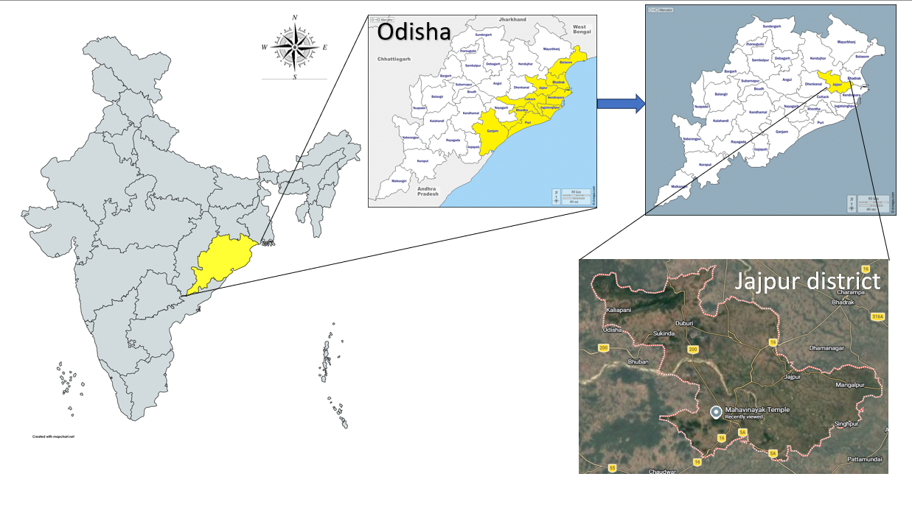
Fig. 1. Map of the study area (Mahavinayak Hill).
Materials and Methods: Extensive field studies were conducted during October-March from 2024 to 2026 to explore different species belonging to the family Acanthaceae in the coastal districts of Odisha. An interesting species was observed from the Mahavinayak sacred hill of Jajpur district, Odisha, India. The plants were distributed sporadically in rock crevices in the shaded regions of the forest canopy. The sample specimen was collected, washed gently and allowed to dry. Fresh flowering twigs were also collected for microscopic observation. A healthy specimen was processed for herbarium preservation. For correct identification of the species, several publications, herbaria, e-texts and e-resources were consulted. Besides the taxonomic enumeration of the species, a threat assessment was conducted because the species is very rare in its natural habitat. The assessment was undertaken by recording the presence of the species from recent research papers, herbaria and plant database information facilities. The Geospatial Conservation Assessment Tool was used to determine the worldwide distribution and geographical range of the species. About 139 GBIF points and two user points were incorporated for threat assessment (Fig. 4). Criteria B1 and B2 were used (IUCN Standards and Petitions Committee, 2019) to calculate the Extent of Occurrence (EOO) and Area of Occupancy (AOO).
Table 1. Geographical range in the form of B1 (Extent of Occurrence) or B2 (Area of Occupancy).
Geographical range in the form of
B1 (Extent Of Occurrence) or B2 (Area Of Occupancy)
B1 | Critically endangered | Endangered |  |  | Vulnerable
B1 | < 100km² | < 5000 km² |  |  | < 20,000 km²
B2 | < 10 km² | < 500 km² |  |  | < 2000 km²
At least 2 of the following 3 (a, b &c)
- Severely fragmented or number of locations | = 1 |  | ≤ 5 | ≤ 10
b. continuing decline observed, estimated, inferred or projected in any of (i) Extent of occurrence, (ii) area of occupancy (iii) area extent and / or quality of habitat. (iv) number of locations or sub populations, (v) number of mature individuals.

c. Extreme fluctuations in any one-(i) extent of occurrence (ii) area of occupancy (iii) number of locations, subpopulations (iv) number of mature individuals.

Taxonomic Treatment:
Pseuderanthemum latifolium (Vahl.) B. Hansen (Hansen, 1989). Pseuderanthemum malabaricum (C.B. Clarke) Gamble, Fl. Madras: 1064 (1924); Eranthemum malabaricum C.B. Clarke, in J.D. Hooker, Fl. Brit. India 4: 497 (1884).
Description: Annual erect herb growing in rock crevices under shade; height up to 90-120 cm; spike 25-50 cm; flower subsessile; one to three flowers at an inflorescence apex, with one flower blooming at a time; bracteolate; bracteoles small, up to 3 mm, glandular. Flowers sessile; corolla tube white, elongated, about 2 cm; petals five, white, subequal, gamopetalous, 1-1.5 cm each; flower 3.5-4 cm; bracts two; calyx small; sepals five, glandular (ca. 7 mm); stamens two, epipetalous; filament 1.7 cm; anthers purple, 2 mm, oblique (not parallel); carpel 1.5 cm; style 1.2 cm; ovary 2 mm; ovules four; fruit a capsule with constriction, measuring about 1.7 cm; seeds four (ca. 3 mm); apex curved; retinacula distinct; seed surface rugose.
Anatomy: All species belonging to the genus Pseuderanthemum possess cystoliths in their leaf epidermis inside specialised epidermal cells known as lithocysts. The cystoliths are common in the leaves of P. latifolium and occur as rod-shaped crystals. All calcium carbonate crystals or cystoliths are located in the epidermal layer. They never completely fill the cell lumen (Choopan & Grote, 2015).
Habit: Annual erect herb (up to 90-120 cm).
Habitat and Ecology: The native range of this species is generally South Asia, i.e. from the Indian subcontinent to China and Malesia. It is a herb that grows primarily in the wet tropical biome under the shade of large trees in dense forest.
Flowering and Fruiting: November-February.
Specimen Examined: INDIA, Odisha, Jajpur district, Mahavinayak Hill, N 20°42.291′ E 86°05.167′, 143 m amsl, Jena N.K. FMU EVS 1504.
Distribution: Northern Circars, India, Sri Lanka (Saxena & Brahmam, 1995); Eastern Ghats: Dindigul district, Karanthamalai (Dhatchanamoorthy et al., 2015); Mahavinayak Hill, Jajpur, Odisha (present collection).
Systematic Position (POWO, 2026)
Kingdom - Plantae
Division - Streptophyta
Class - Equisetopsida
Order - Lamiales
Family - Acanthaceae
Genus - Pseuderanthemum
Species - latifolium

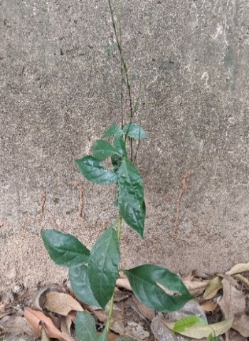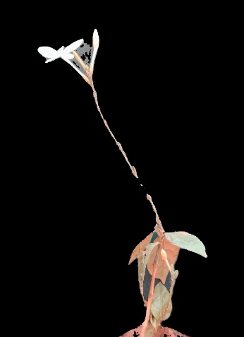
a.
b.
Fig. 2. a. Plant in its natural habitat; b. plant with flowering.

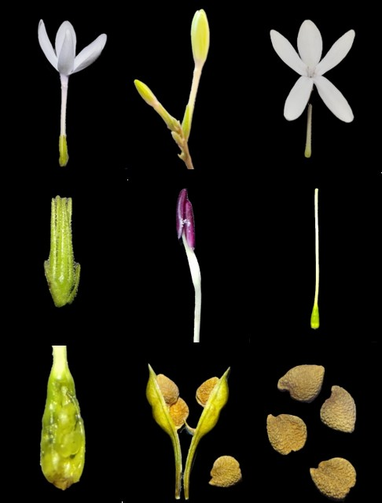
i.
f.
h.
g.
e.
d.
b.
c.
a.
2 mm
1 mm
0.5 cm
1 mm
1 mm
1 cm
1 cm

Fig. 3. a. Flower; b. buds; c. corolla; d. calyx with bracts; e. stamen; f. carpel; g. ovary; h. capsule with seeds; i. seeds.

Threat Assessment and Conservation Status: Anthropogenic activities are mainly responsible for the survival of many species. Human population growth, per capita consumption, expanding urbanisation and agriculture are key factors in habitat loss and fragmentation (Forester & Machlis, 1996). There is also a limitation of data regarding the status of many species (Brooks et al., 2006). As a rapidly growing nation, India also harbours such factors, leading to serious biodiversity loss. Odisha, an eastern coastal state, is experiencing rapid industrialisation, encroachment by invasive species and habitat loss, which act as driving forces in endangering many important species. Hence, threat assessment of selected species can be a necessary step for conservation biologists to understand the status of important species and protect them from the verge of extinction. Pseuderanthemum latifolium is considered rare by some authors (Dhatchanamoorthy et al., 2015). However, its conservation status needs to be assessed.
Results and Discussion:
The exploration of vegetation and the study of distribution of members of the family Acanthaceae in the coastal districts of Odisha revealed many interesting rare species that have not been commonly recorded in the recent past. Pseuderanthemum latifolium was observed in a sacred hill of Jajpur district, Odisha, India, during this field survey. The species has reported phytochemical constituents that require further investigation for potential pharmaceutical applications. Its distribution also signifies the importance of extensive field studies for the exploration of taxa.
A systematic conservation status was evaluated by following existing documents and herbaria. The distribution and occurrences of the species were studied from the herbaria of CAL, IMMT Herbarium, Bhubaneswar, Regional Plant Resource Centre (RPRC-Bhubaneswar), digital herbaria such as IVH-BSI and JCB Herbarium. Different plant information database systems, including GBIF, POWO and JSTOR (https://plants.jstor.org), were also consulted to understand the status, global distribution and recent occurrences for evaluation and threat assessment.
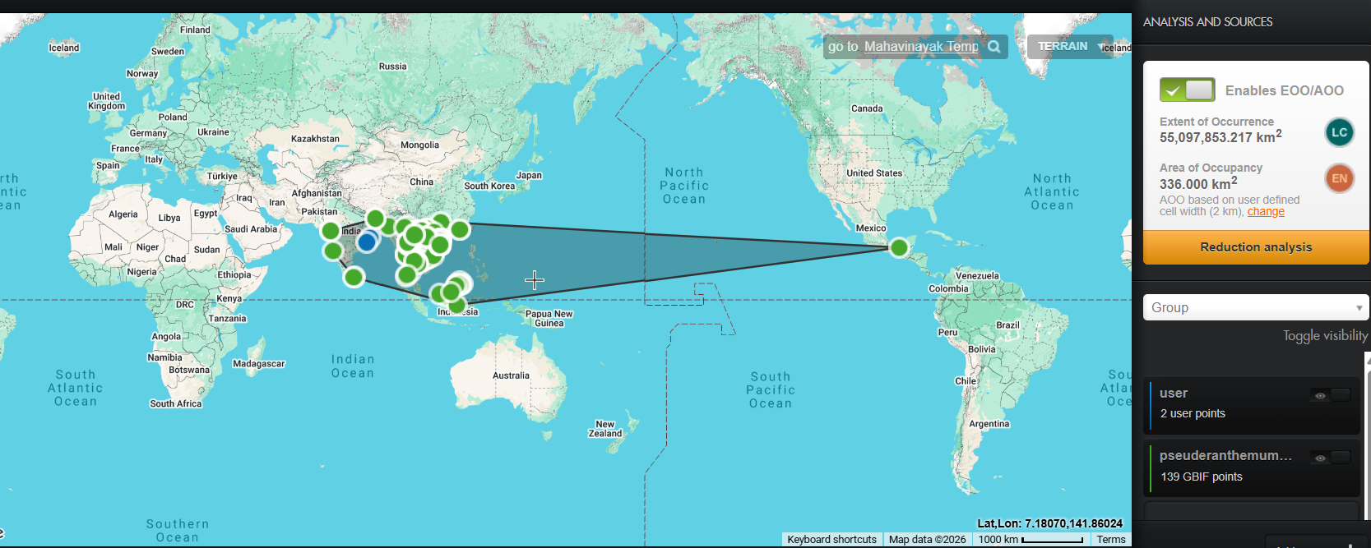
Fig. 4. Threat assessment and conservation status using the Geospatial Conservation Assessment Tool.
Table 2. Threat assessment of Pseuderanthemum latifolium (Vahl.) B. Hansen.
Name of the species | B1-EOO  (km²) | B2-AOO (km²)
Pseuderanthemum latifolium (Vahl.) B. Hansen | 55,097,853.217 | 336.000
Pseuderanthemum latifolium (Vahl.) B. Hansen | LC  < 5000 km² | EN  < 500 km²
Extent of Occurrence (EOO), Area of Occupancy (AOO), EN - Endangered, LC - Least Concern (criteria B1 EOO and B2 AOO) (Das & Lahiri, 2022; IUCN Standards and Petitions Committee, 2019).
During the field exploration in the study area (Fig. 1), only three to four individuals were observed in the region. This species was reported from some parts of the Northern Circars, a narrow strip of territory on the eastern coast of the Indian peninsula in Andhra Pradesh and Odisha, in Ganjam district about 30 years ago by Saxena and Brahmam. No further report or relocation of this species has been recorded in the recent past. The population of this species is dwindling in its natural habitat. In the present study, the species was relocated in the study area (Fig. 1) in Jajpur district, inside a sacred hill forest of Odisha, India. Therefore, Criteria B1 and B2 were taken into consideration (IUCN Standards and Petitions Committee, 2019) for threat assessment of the species.
From the geographical coordinates searched through GBIF-Global Biodiversity Information Facility (139 GBIF points) and the present study (using two user points), the Extent of Occurrence (EOO) was found to be 55,097,853.217 km², which places it in the category of Least Concern (LC). However, the Area of Occupancy (AOO) was calculated by GeoCAT as 336 km². Again, as far as the subcriteria are concerned, it comes under b(ii), decline in area of occupancy, and c(iii), number of locations. Hence, the use of the Geospatial Conservation Assessment Tool reveals that the present status of the species is Endangered (EN) (Fig. 4). However, the species Pseuderanthemum latifolium is very rarely observed in the state of Odisha.
Conclusions: The present study confirms the relocation of Pseuderanthemum latifolium (Vahl.) B. Hansen from Mahavinayak Hill in Jajpur district, coastal Odisha, after about 30 years of its earlier documentation from the state. The record is important because the species has often been cited under the synonym Pseuderanthemum malabaricum, and its correct identification is essential for floristic documentation, herbarium comparison and conservation planning. The study provides a consolidated taxonomic treatment, including diagnostic morphological characters, anatomical notes, habitat information, phenology, distribution and photographic evidence, to facilitate reliable recognition of the taxon in the field. The observation of only three to four individuals at the study site indicates the need for careful monitoring of the local population. The threat assessment based on GeoCAT shows a broad extent of occurrence but a restricted area of occupancy, resulting in different outcomes under Criterion B1 and Criterion B2. This highlights the importance of combining geospatial analysis with field observations while assessing rare and sporadically distributed taxa. Protection of shaded rock-crevice habitats within sacred hill forests, along with repeated surveys in coastal Odisha and adjoining regions, would help improve understanding of the species’ distribution, persistence and conservation requirements. Such information can support future evidence-based local conservation decisions.
Limitations: The present study is based on field observations from a single confirmed locality in Mahavinayak Hill, where only three to four individuals were recorded. Therefore, the local population size, recruitment pattern and long-term survival trend could not be assessed in detail. The threat assessment relied on available GBIF records and two user points; consequently, the results may be influenced by uneven collection intensity, historical occurrence data and possible gaps in georeferenced records. The study did not include molecular analysis, population genetics or experimental ecological assessment, which may further support taxonomic confirmation and conservation evaluation. Pharmacological information was reviewed from earlier reports, but no new phytochemical or bioactivity experiments were conducted. Seasonal surveys were undertaken during the stated exploration period, yet additional observations across multiple years and habitats are required to confirm the full phenological range, local abundance and habitat specificity of the species in Odisha with greater confidence.
Disclaimer (Artificial intelligence)

Author(s) hereby declare that NO generative AI technologies such as Large Language Models (ChatGPT, COPILOT, etc.) and text-to-image generators have been used during the writing or editing of this manuscript.
References
- Brooks, T. M., Mittermeier, R. A., da Fonseca, G. A. B., Gerlach, J., Hoffmann, M., Lamoreux, J. F., Mittermeier, C. G., Pilgrim, J. D., & Rodrigues, A. S. L. (2006). Global biodiversity conservation priorities. Science, 313(5783), 58–61. https://doi.org/10.1126/science.1127609
- Choopan, T., & Grote, P. J. (2015). Cystoliths in the leaves of the genus Pseuderanthemum (Acanthaceae) in Thailand. NU International Journal of Science, 12(2), 13–20. https://www.sci.nu.ac.th/sciencejournal/index.php/sci/article/view/276/pdf
- Choopan, T., Grote, P. J., Chayamarit, K., & Simpson, D. A. (2018). An annotated checklist of the genus Pseuderanthemum Radlk. (Acanthaceae) in Thailand. Thai Forest Bulletin (Botany), 46(1), 90–111. https://doi.org/10.20531/tfb.2018.46.1.13
- Das, M., & Lahiri, S. (2022). Threat assessment of two Himalayan endemic alpine plant species and conservation implications. International Journal of Bioresource Science, 9(2), 139–144. https://doi.org/10.30954/2347-9655.02.2022.11
- Dhatchanamoorthy, N., Arumugam, T., & Raja, P. (2015). First report of Pseuderanthemum malabaricum (Acanthaceae): Rare species of central and southern Eastern Ghats of Tamil Nadu, India. Elixir Applied Botany, 84, 33639–33640. https://www.elixirpublishers.com/articles/1678441575_201507035.pdf
- Forester, D. J., & Machlis, G. E. (1996). Modeling human factors that affect the loss of biodiversity. Conservation Biology, 10(4), 1253–1263. https://doi.org/10.1046/j.1523-1739.1996.10041253.x
- Gamble, J. S. (1924). Flora of the Presidency of Madras. West, Newman & Adlard. https://www.biodiversitylibrary.org/bibliography/21628
- Haines, H. H. (1921–1925). The botany of Bihar and Orissa: An account of all the known indigenous plants of the province and of the most important or most commonly cultivated exotic ones. Adlard & Son. https://doi.org/10.5962/bhl.title.11031
- Hansen, B. (1989). Notes on SE Asian Acanthaceae 1. Nordic Journal of Botany, 9(2), 209–215. https://doi.org/10.1111/j.1756-1051.1989.tb02117.x
- Hema, G., & Keshamma, E. (2025). Anthelmintic activity of ethanolic leaf extract of Pseuderanthemum latifolium: An in-vitro study. Cuestiones de Fisioterapia, 54(3), 1093–1104. https://doi.org/10.48047/g8bqrd07
- Hooker, J. D. (1872–1897). The flora of British India (Vol. 4). L. Reeve & Co. https://www.biodiversitylibrary.org/bibliography/678
- IUCN Standards and Petitions Committee. (2019). Guidelines for using the IUCN Red List categories and criteria (Version 14). IUCN. https://www.iucnredlist.org/resources/redlistguidelines
- Karthikeyan, S., Sanjappa, M., & Moorthy, S. (2009). Flowering plants of India: Dicotyledons (Vol. 1, Acanthaceae–Avicenniaceae). Botanical Survey of India. https://www.ipni.org/p/20012499-1
- Manzitto-Tripp, E. A., Darbyshire, I., Daniel, T. F., Kiel, C. A., & McDade, L. A. (2022). Revised classification of Acanthaceae and worldwide dichotomous keys. Taxon, 71(1), 103–153. https://doi.org/10.1002/tax.12600
- Mooney, H. F. (1950). Supplement to the botany of Bihar and Orissa. Catholic Press. https://www.si.edu/object/supplement-botany-bihar-and-orissa-herbert-mooney-published-author-under-authority-government-orissa%3Asiris_sil_170302
- Nayak, S., Mandal, K., Priyadarshini, S., Mishra, D., Sahu, S. C., Kumar, M., Sarangi, K., Mallik, P. S., & Dhal, N. K. (2024). Phytodiversity study of Nayagarh Forest Division, Odisha. Asian Journal of Conservation Biology, 13(2), 215–231. https://doi.org/10.53562/ajcb.79572
- Olmstead, R. G., Albach, D., Beardsley, P., Bedigian, D., Bremer, B., Cantino, P., Chau, J., Clark, J. L., Drew, B., Garnock-Jones, P., Grose, S., Harley, R., Ihlenfeldt, H. D., Li, B., Lohmann, L., Mathews, S., McDade, L., Müller, K., Norman, E., O’Leary, N., Oxelman, B., Reveal, J., Scotland, R., Smith, J., Tank, D., Tripp, E., Wagstaff, S., & Wallander, E. (2016). A synoptical classification of the Lamiales (Version 2.6.2). https://www.ncbi.nlm.nih.gov/Taxonomy/Browser/wwwtax.cgi?id=4136&lvl=0
- Pal, B., Tudu, S., & Sahu, S. C. (2022). Floral diversity of Panchalingeshwar: A sacred hill of Odisha, India. Nelumbo, 64(2), 119–135. https://doi.org/10.20324/nelumbo/v64/2022/169609
- POWO. (2026). Plants of the World Online. Royal Botanic Gardens, Kew. Retrieved April 10, 2026, from https://powo.science.kew.org/
- Sahoo, R. C., Sahu, D., & Misra, M. K. (2014). Angiosperm diversity of sandy coast of Balasore District, Odisha, India. Nelumbo, 56, 89–123. https://doi.org/10.20324/nelumbo/v56/2014/86676
- Sahu, S. C., & Dhal, N. K. (2012). Floristic diversity of Mandargiri hills, Angul, Odisha: An overview. Journal of Economic and Taxonomic Botany, 36(3), 554–562.
- Saxena, H. O., & Brahmam, M. (1995). Flora of Orissa (Vol. 3). Orissa Forest Development Corporation. https://collections.si.edu/search/detail/edanmdm%3Asiris_sil_626635
- Scotland, R. W., & Vollesen, K. (2000). Classification of Acanthaceae. Kew Bulletin, 55(3), 513–589. https://doi.org/10.2307/4118776
- Sujana, K., Surendra, A. V., Kishore, K. V., Reehana, S. K., & Himakalyani, C. B. (2023). Phytochemical analysis and characterization of ethanolic extract of Pseuderanthemum malabaricum whole plant. In M. Murahari, B. N. Nalluri, & G. Chakravarthi (Eds.), Current trends in drug discovery, development and delivery (CTD4-2022) (Vol. 358, pp. 735–748). Royal Society of Chemistry. https://doi.org/10.1039/9781837671090-00735

