Integrated GC–MS characterisation, molecular docking, and ADMET evaluation of bioactive compounds from the methanolic extract of Barleria longiflora L.f.

Abstract
Plants are important sources of structurally diverse bioactive compounds with potential relevance to drug discovery. Barleria longiflora L.f., a member of the family Acanthaceae, has reported traditional medicinal uses, but its phytochemical profile and predicted pharmacological potential remain insufficiently characterised. This study evaluated the methanolic extract of B. longiflora through preliminary phytochemical screening, gas chromatography-mass spectrometry (GC-MS), molecular docking and in silico ADMET analysis. Qualitative phytochemical screening indicated the presence of tannins, alkaloids, carbohydrates, glycosides and steroids, whereas flavonoids, proteins, saponins, triterpenoids and starch were not detected. GC-MS analysis identified three major compounds: oleic acid, stearic acid and palmitic acid, with peak areas of 76.15%, 22.44% and 1.41%, respectively, and retention times of 6.465, 8.242 and 11.977 min. The identified compounds were docked against selected target proteins, namely Aldose Reductase Enzyme (2FZD), the extracellular domain of human HER2 (1N8Z), Cyclooxygenase protein (6COX) and Sterol Carrier Protein-2 (1PZ4), using AutoDock Vina. Among the evaluated targets, Aldose Reductase showed comparatively stronger predicted binding interactions, with binding affinities of -5.6 kcal/mol for oleic acid, -7.3 kcal/mol for stearic acid and -6.1 kcal/mol for palmitic acid. ADMET prediction indicated molecular weights below 500 g/mol, high intestinal absorption and a bioavailability score of 0.85 for all three compounds. Palmitic acid was predicted to cross the blood-brain barrier, whereas oleic acid and stearic acid were not. Overall, the findings indicate that B. longiflora contains bioactive fatty acids with predicted drug-like properties and ligand-protein interaction potential, supporting further experimental validation in future studies.
Keywords: Barleria longiflora L.f.; GC-MS; methanolic extract; phytochemical screening; molecular docking; ADMET prediction; oleic acid; stearic acid; palmitic acid; aldose reductase; pharmacokinetic properties

- Introduction
Human interactions with herbs and medicinal plants date back to the earliest civilisations. Throughout history, plants have served as an invaluable natural resource, providing a wide range of bioactive compounds that form the basis of both traditional remedies and many modern pharmaceuticals (Khan et al., 2016; Rashid et al., 2022). Medicinal plants are valuable sources of bioactive compounds with applications in pharmaceuticals, food additives, agrochemicals and industrial products. As a result, pharmaceutical companies are increasingly investing in the development of cost-effective plant-based medicines derived from natural extracts (Yuvasri et al., 2026; Bray et al., 2018).
Medicinal plants are rich in lipids, phytochemicals, pharmaceutical compounds and fragrances, making them valuable in industries such as food, medicine and cosmetics. Traditional plant-based medicines are a key component of healthcare systems in countries such as India, particularly in underdeveloped regions. The presence of phytochemicals is a major factor in their therapeutic efficacy (Velmurugan & Anand, 2017). Medicinal plants are widely used for primary healthcare in developing nations and remain popular in developed countries because of growing interest in natural remedies. Documenting traditional knowledge of medicinal plants has contributed significantly to drug discovery and provides valuable information for biodiversity conservation, taxonomy, pharmacology and natural resource management (Rashid et al., 2024).
In the rural northeastern region of India, traditional remedies are widely used because of the diverse plant life and the socioeconomic conditions of its inhabitants (Ningombam & Singh, 2014). Medicinal plants occupy an important place in traditional healthcare systems, such as Siddha, Ayurveda and Unani, because of their wide range of therapeutic properties. Recent experimental studies using animal models have further supported the effectiveness of these traditional remedies, highlighting their potential as natural sources of medicines with minimal adverse effects (Sheeba & Asha, 2009; Murugan et al., 2022). Medicinal plants in this region are rich sources of bioactive compounds with diverse biological properties. Local treatments primarily involve crude extracts containing various phytochemicals, which are used to address a wide range of diseases (Sahoo & Manchikanti, 2013). Traditional medicinal plants play a significant role in healthcare because of their ability to alleviate various disorders linked to microbial infections and oxidative stress (Kumar et al., 2022). Documentation of the ethnomedicinal uses of plants contributes significantly to several scientific disciplines, including ecology, pharmacology, taxonomy, watershed management and wildlife conservation, while preserving traditional knowledge systems (Rashid et al., 2024).
Barleria longiflora L.f., a plant native to peninsular India (Narayanasamy & Natesan, 2020), has been traditionally used to treat conditions such as kidney stones, cough, dropsy and inflammation (Cittrarasu et al., 2019). Dried whole-plant powder taken with water is used to treat poisonous bites (Chennaiyan et al., 2016). Several species in the genus Barleria are extensively used in folk medicine and have been confirmed to contain various bioactive compounds with therapeutic properties, including analgesic, anti-inflammatory, anticancer, antidiabetic, antitumour, anti-amoebic, antibacterial and antiviral activities (Gnanadhas et al., 2025). Although many plant species are rich in secondary metabolites, only a few have been thoroughly investigated and recognised as significant sources of bioactive compounds. The development of effective screening methods for new chemical compounds and quality control is critical (Malongane et al., 2017). Research on these bioactive compounds has led to the development of powerful new medicines (Yadav et al., 2017). GC-MS is a standard technique for identifying various compounds in plants (Satapute et al., 2019). According to Razack et al. (2015), GC-MS is a reliable method for identifying numerous substances in plant extracts. In addition, recent advances in computing have introduced sophisticated tools for drug discovery, enabling the screening of potential drugs derived from bioactive plant compounds (Sliwoski et al., 2014).
Diabetes mellitus (DM), a common metabolic disorder, is characterised by high blood sugar levels due to insufficient insulin production, improper insulin utilisation or both (Grover et al., 2021). Breast cancer, the most common cancer worldwide, is another significant health concern. According to the World Health Organization (WHO), approximately 2.1 million women develop breast cancer every year, with around 627,000 deaths attributed to the disease in 2018, accounting for 15% of cancer deaths among women. Furthermore, mosquitoes, as major vectors for disease transmission, pose a substantial threat to human populations, particularly in tropical regions (Georges et al., 2008). With rising global temperatures, the risk of mosquito-borne diseases is expected to increase in warmer, densely populated areas (Colón-González et al., 2021). Inflammation plays a critical role in the immune response, acting as the body's first defence against disease. However, the intensity and duration of inflammation are crucial. Chronic inflammation resulting from a prolonged or inadequate response is linked to the development of various cancers (Schottenfeld & Beebe-Dimmer, 2006).
Computational prediction models are vital for predicting drug properties, including effects, absorption and toxicity, and contribute to pharmaceutical and technological advancements (Loza-Mejía et al., 2018). Molecular docking is a cost-effective method that is particularly useful for providing essential insights into drug-protein interactions and for assessing the predicted binding of drugs to target sites on proteins (Megantara et al., 2022). Although B. longiflora has reported ethnomedicinal uses and related Barleria species have been associated with diverse biological activities, the phytochemical composition of its methanolic extract and the predicted interaction profile of its major constituents against selected proteins remain insufficiently characterised. In particular, evidence integrating GC-MS-based identification, molecular docking and ADMET prediction for this species is limited. Therefore, this study aimed to identify bioactive compounds from the methanolic extract of B. longiflora and to assess, through in silico approaches, their predicted interactions with selected target proteins associated with cancer, inflammation, diabetes and vector-related biological processes. The findings from in silico studies are intended to serve as a roadmap for further formulation development and experimental testing in physical laboratories.
2. Materials and Methods
2.1. Plant Collection and Extract Preparation
Fresh leaves of Barleria longiflora L.f. were selected for the present study and collected from the Narthamalai Hills, Pudukkottai District, Tamil Nadu, India, during December 2024. Taxonomic identification and authentication of the plant material were carried out by the Department of Botany, Annai Vailankanni Arts and Science College, Thanjavur, Tamil Nadu, India. The collected leaves were thoroughly washed under running tap water to remove adhering dust and soil particles, followed by rinsing with distilled water. The cleaned samples were spread on blotting paper and shade-dried at room temperature. After complete drying, the plant material was finely powdered using a tissue blender. Approximately 30 g of the powdered sample was subjected to Soxhlet extraction with methanol for 8 h to obtain the methanolic leaf extract, following the method described by Iniya Udhaya et al. (2017).
2.2. Preliminary Phytochemical Analysis

A standard qualitative phytochemical screening method was used to analyse the chemical constituents present in the methanolic extract of B. longiflora (Lee & Kim, 2019).

2.3. GC-MS Analysis
Phytoconstituents in the methanolic extract of B. longiflora were identified using a Thermo Scientific GC-MS instrument. After the extract was dissolved in a solvent, the mixture was filtered. A DB 35-MS capillary standard non-polar column was used for chromatography. Helium was used as the carrier gas. The sample was injected in split mode. The transfer line temperature was maintained at 280 °C, while the injector temperature was fixed at 240 °C. After 2 min at 50 °C, the column temperature was raised to 260 °C at a rate of 5 °C per min and maintained for 10 min. The sample was scanned by the device in the mass spectral range of 42-350 m/z. The National Institute of Standards and Technology (NIST) library was used to evaluate the obtained GC-MS compound peaks.
2.4. Molecular Docking Studies
The predicted interaction potential of the identified bioactive compounds was evaluated against selected target proteins associated with cancer, inflammation, diabetes and vector-related biological processes. Ligand structures were obtained from PubChem and converted into suitable formats using Open Babel. Energy minimisation was performed before docking analysis. Structure-based molecular docking was performed with target proteins, including Aldose Reductase Enzyme (2FZD), the crystal structure of the extracellular domain of human HER2 (1N8Z), Cyclooxygenase (6COX) protein and Sterol Carrier Protein-2 (1PZ4) (Tiwari et al., 2011). Protein structures were prepared by removing water molecules and heteroatoms, adding polar hydrogen atoms and assigning charges using AutoDock Tools. Docking was performed using AutoDock Vina. As the present study was based on blind docking, validation methods such as redocking, RMSD calculation or comparison with reference inhibitors were not performed. Therefore, the docking results should be considered preliminary predictions that require further validation through experimental and additional computational studies. The results were analysed and visualised using tools such as Biovia Discovery Studio (Anita & Selvaraj, 2022).

2.5. ADMET Prediction of Bioactive Compounds from B. longiflora
The pharmacokinetic (PK) profile of a drug or ligand describes its absorption, distribution, metabolism and excretion (ADME) throughout the body. In essence, PK tracks the movement of a drug from entry into the body to its elimination. Computational tools such as SwissADME (http://www.swissadme.ch/index.php) can predict a drug's PK profile (Muthukrishnan et al., 2025).

3. Results
3.1. Phytochemical Screening
Phytochemical analysis of the methanol extract of B. longiflora aerial parts identified several phytochemicals, including tannins, alkaloids, carbohydrates, glycosides and steroids (Table 1).

3.2. GC-MS Analysis of B. longiflora
GC-MS analysis of the methanol extract of B. longiflora identified oleic acid, stearic acid and palmitic acid, with retention times of 6.465, 8.242 and 11.977 min, respectively (Table 2 and Figure 1).

3.3. ADMET Prediction of Bioactive Compounds from B. longiflora
The ADMET properties of phytocompounds from the methanolic extract of B. longiflora were evaluated. The identified compounds displayed molecular weights below 500 g/mol. The three compounds had Log P values ranging from 4.19 to 4.67. Their TPSA value was within the limit of 37.30 Å, while the Log S values ranged from -5.02 to -5.73. The Fraction Csp3 values ranged from 0.83 to 0.94, and the number of rotatable bonds per compound ranged from 14 to 16. The most effectively interacting phytocompounds were found to largely adhere to Lipinski's rule of five (LRO5), with only one exception. Among the analysed phytocompounds, palmitic acid could cross the blood-brain barrier (BBB), whereas oleic acid and stearic acid could not. All compounds demonstrated high intestinal absorption. A bioavailability score of 0.85 was documented for oleic acid, stearic acid and palmitic acid.
Regarding enzyme inhibition, oleic acid and palmitic acid each inhibited two CYP450 enzymes, specifically CYP1A2 and CYP2C9. Meanwhile, stearic acid inhibited only one CYP450 enzyme, CYP1A2. The phytocompounds with negative log Kp values demonstrated lower skin permeability. All the analysed compounds shared this feature uniformly. Properties related to cytochrome enzyme inhibition and skin permeation are presented in Table 3.

3.4. Molecular Docking
The 3D structures of phytocompounds identified from the GC-MS analysis of the B. longiflora methanol extract (Figure 2) were docked against target proteins, including Aldose Reductase, the HER2 extracellular domain, Cyclooxygenase and Sterol Carrier Protein-2 (Figure 3).
The docking results, including binding energy and hydrogen bond count, are detailed in Table 4. Compared with other target proteins, this study demonstrated promising results for bioactive compounds from B. longiflora, specifically against the Aldose Reductase Enzyme (Table 5). The 2D and 3D structures are illustrated in Figure 4. Notably, the phytocompound stearic acid exhibited a favourable binding affinity (BA) of -7.3 kcal/mol, with four hydrogen bond (HB) interactions involving THR19, TRP20, TYR48 and ALA43 (Figure 4b). Similarly, palmitic acid displayed a binding affinity of -6.1 kcal/mol against the Aldose Reductase Enzyme (2FZD), forming hydrogen bond interactions with amino acid residues in the binding pocket, with an HB interaction involving the TYR48 amino acid (Figure 4c). In contrast, oleic acid exhibited the lowest BA (-5.6 kcal/mol), with three HB interactions involving TRP219, TRP295 and ARG296 of the Aldose Reductase Enzyme (2FZD) (Figure 4a).
The interaction of all ligands with the HER2 protein (Table 6) is depicted in Figure 5. Oleic acid exhibited a favourable BA (-5.3 kcal/mol), with two HB interactions involving ALA43 and GLY111 (Figure 5a). Likewise, stearic acid demonstrated a binding affinity of -4.8 kcal/mol against the HER2 protein, forming hydrogen bond interactions with VAL3 and THR5 (Figure 5b). Palmitic acid showed a binding affinity of -4.7 kcal/mol with the HER2 protein, forming hydrogen bond interactions with GLY41, LYS42 and TYR95 (Figure 5c).
In the context of the Cyclooxygenase (6COX) protein (Table 7), the 2D and 3D interactions are depicted in Figure 6. The phytocompound palmitic acid demonstrated a favourable binding affinity (-5.4 kcal/mol), with an HB interaction involving VAL523 (Figure 6c). Moreover, oleic acid exhibited a BA of -5.3 kcal/mol against the 6COX protein, with HB interactions involving GLY225 and ASN375 (Figure 6a). In addition, stearic acid showed a BA of -5.3 kcal/mol, with two HB interactions involving GLN192 and SER353 (Figure 6b).

Finally, the interaction of all ligands with Sterol Carrier Protein-2 (Table 8) is illustrated in Figure 7. Oleic acid showed a favourable BA (-3.5 kcal/mol), with two HB interactions involving ALA13 and GLU17 (Figure 7a). Likewise, palmitic acid showed a BA of -3.3 kcal/mol (Figure 7c). Moreover, stearic acid demonstrated a BA of -3.2 kcal/mol (Figure 7b).
4. Discussion
The significance of computational chemistry in drug development lies in its use of virtual screening to streamline processes and lower costs. Among the valuable techniques, molecular docking assists in discovering new ligands for target proteins, thereby supporting structure-based drug design (Balachandran et al., 2024). With the increasing prevalence of new diseases and drug resistance, plant-based products are gaining attention as potential sources of promising agents (Kitchen et al., 2004). Throughout history, plants have been widely used for medicinal purposes, with various parts and whole plants employed to treat different diseases. We investigated the aerial parts of the B. longiflora methanol extract using phytochemical screening and in silico docking, exploring the possible molecular interactions of identified compounds with selected target proteins. The findings indicate predicted binding of selected bioactive compounds to their respective receptors, highlighting molecular docking as a useful tool for inhibitor discovery. B. longiflora is known for its potential analgesic, antitumour, antihyperglycaemic, antiamoebic, anti-inflammatory, antidiabetic, antimicrobial, hepatoprotective and nephroprotective effects (Piscopo & Ellul, 2020). The screening of B. longiflora revealed the presence of tannins, alkaloids, carbohydrates, glycosides and steroids, consistent with findings from previous research (Chung et al., 2011).
In our study, GC-MS analysis of the methanol extract of B. longiflora revealed the presence of three bioactive compounds: oleic acid, stearic acid and palmitic acid. These compounds exhibited peak areas of 76.15%, 22.44% and 1.41%, respectively. Moreover, according to Baskaran et al. (2016), GC-MS analyses of the ethanolic extract of B. longiflora leaves identified 23 different phytocompounds. Furthermore, the ethanolic stem extract of B. longiflora contained 16 phytocompounds, while the root extract contained 25 other bioactive compounds.
Molecular docking studies were performed to investigate the interactions between identified phytocompounds from B. longiflora and various target proteins. Our study aimed to identify phytochemicals that may bind to these target proteins with high affinity. We identified compounds that conform to LRO5, suggesting favourable drug-like characteristics. The investigation explored BA, HB roles and ligand-amino acid interactions. In addition, the binding affinities of all ligands were quantified in kcal/mol (Baskaran et al., 2016). The study's examination of residual interactions precisely identified the amino acid binding sites of the protein-ligand complex. All bioactive compounds exhibited promising binding affinities with the Aldose Reductase Enzyme. For instance, oleic acid, stearic acid and palmitic acid demonstrated BA values of -5.6, -7.3 and -6.1 kcal/mol, respectively. The presence of an HB suggests that these ligands had an optimal BA with the target protein, as detailed by Kılınç (2021).
Moreover, Cyclooxygenase 2 showed significant binding affinities with the bioactive compounds oleic acid, stearic acid and palmitic acid, with values of -5.3, -5.3 and -5.4 kcal/mol, respectively. These results align with the findings of previous research conducted by Sohilait et al. (2017). All ligands, when interacting with the HER2 protein, produced binding affinities of -5.3, -4.8 and -4.7 kcal/mol, respectively. These observations support the findings of earlier research by Muthukrishnan et al. (2024). Lastly, Sterol Carrier Protein-2, another target protein, also demonstrated binding affinities with bioactive compounds such as oleic acid, stearic acid and palmitic acid, with binding affinities of -3.5, -3.2 and -3.3 kcal/mol, respectively. These findings align with earlier research carried out by Anita and Selvaraj (2022). Our study investigated the bioactive compounds present in B. longiflora that interact with various types of target proteins. Ultimately, we found that these compounds exhibited the highest BA for the Aldose Reductase Enzyme compared with the other target proteins.
Physicochemical properties play a crucial role in determining the drug-likeness of compounds (Hodgson, 2001). Compounds with molecular weights below 500 g/mol are particularly favourable because they demonstrate enhanced absorption, diffusion and transport potential. The lipophilic nature of a compound significantly influences its solubility, selectivity and permeability, all of which are vital factors for drug-like compounds. The ideal XlogP3 value for identifying prospective lead compounds is thought to be between -0.7 and +5.0. Deviation from this range is undesirable. Increased metabolic turnover, limited solubility, insufficient intestinal absorption and the possibility of harm to critical organs can all result from a compound's elevated lipophilicity (Arnott & Planey, 2012).
The polarity of the compounds fell within the permissible drug-likeness range of 20-130 Å, and their solubility did not exceed 6. The aqueous solubility of a compound is directly determined by its molecular structure and weight. To achieve efficient sp3 hybridisation, the fraction of carbons should not fall below 0.25, and all examined compounds displayed values higher than 0.25. The flexibility of a compound relies on the presence of rotatable bonds, which should be limited to a maximum of nine. The study demonstrated that all examined compounds had more than nine rotatable bonds. The compounds were described based on LRO5 properties and molecular characteristics. This rule is beneficial in drug design. The study shows that the analysed phytocompounds adhere to Lipinski's criteria, with a solitary violation. LRO5 was used as a filtering tool to identify promising drug candidates (Lipinski et al., 2012).
The methanol extract derived from B. longiflora was found to contain components with significant potential for gastrointestinal absorption. According to Pires et al. (2018), it has been suggested that these chemicals exhibit permeability when delivered orally, allowing them to pass through the gastrointestinal tract. The BBB is a physiological barrier that separates the brain from the bloodstream and consists of a layer of microvascular endothelial cells. The ability to traverse the BBB is paramount for chemicals intended to interact with the central nervous system.
Regarding the phytocompounds under investigation, it was observed that oleic acid and stearic acid did not exhibit any propensity to traverse the BBB. This finding suggests a reduced likelihood of deleterious consequences within the central nervous system. P-glycoproteins (P-gp) are transporter proteins in cell membranes that affect drug absorption and elimination (El-Kattan & Varma, 2012). The predicted bioavailability score for all compounds was 0.85 according to SwissADME analysis, signifying conformity to LRO5 and suggesting a 55% probability of being bioavailable. Bioavailability is vital in drug design, indicating how much of an oral dose enters the bloodstream. Gastrointestinal absorption mainly determines a drug's bioavailability. For good oral bioavailability and absorption, a drug should possess favourable aqueous solubility (Veber et al., 2002).
The vital role of the cytochrome P450 monooxygenase enzyme in drug metabolism and elimination within biological systems is well established. Current research identifies approximately 80% of molecules as substrates for five isoforms (Stegemann et al., 2007). When compounds do not inhibit these enzymes, they are likely to transform and become orally bioavailable, thereby preventing expected adverse reactions. However, caution is warranted, as inhibiting these CYP isomers with the same compounds can disrupt metabolism, accumulate toxins and result in poor bioavailability (Srimai et al., 2013). The skin's selective barrier regulates compound penetration, which is crucial for assessing substances requiring transdermal administration. The log Kp value, with a more negative value indicating lower permeability, is used to evaluate skin permeability. In this study, all compounds demonstrated negative log Kp values, suggesting impermeability through the skin (Raies & Bajic, 2016).

5. Conclusions
The present study examined the phytochemical constituents, GC-MS profile, molecular docking interactions and in silico ADMET properties of the methanolic extract of Barleria longiflora L.f. Preliminary phytochemical screening confirmed the presence of tannins, alkaloids, carbohydrates, glycosides and steroids. GC-MS analysis identified oleic acid, stearic acid and palmitic acid as the major detected compounds, with peak areas of 76.15%, 22.44% and 1.41%, respectively. Molecular docking suggested that these compounds interacted with all selected target proteins, with comparatively stronger predicted binding against Aldose Reductase Enzyme. Among the ligands, stearic acid showed the most favourable binding affinity with Aldose Reductase, followed by palmitic acid and oleic acid. ADMET prediction indicated that the identified compounds had molecular weights below 500 g/mol, high intestinal absorption and a bioavailability score of 0.85, while palmitic acid alone was predicted to cross the blood-brain barrier. These results provide preliminary computational evidence that the identified fatty acids may contribute to the bioactive potential of B. longiflora. However, the findings should be interpreted cautiously because they are based on phytochemical identification and in silico prediction. Compound isolation, in vitro assays, toxicity studies and in vivo validation are required to confirm biological activity, safety and therapeutic relevance with greater confidence.
6. Limitations
This study has several limitations. The investigation relied on phytochemical screening, GC-MS identification, molecular docking and computational ADMET prediction, without experimental validation of the predicted biological activities. Docking results provide only an estimate of ligand-protein interaction and cannot confirm pharmacological efficacy, toxicity, bioavailability or mechanism of action in biological systems. Only three compounds detected in the methanolic extract of Barleria longiflora were evaluated, and these compounds may not represent the complete chemical diversity of the plant extract. The study did not include in vitro enzyme inhibition, anticancer, anti-inflammatory, antidiabetic or larvicidal assays to support the computational findings. Docking scores may also vary according to ligand preparation, receptor preparation, grid parameters and scoring functions. Therefore, the present findings should be considered preliminary and hypothesis-generating. Further studies involving compound isolation, quantitative validation, biological assays, toxicity evaluation and in vivo confirmation are required to establish the relevance of the identified compounds more confidently.

Conflict of Interest
The authors declare no conflict of interest.

Disclaimer (Artificial intelligence)

Author(s) hereby declare that NO generative AI technologies such as Large Language Models (ChatGPT, COPILOT, etc.) and text-to-image generators have been used during the writing or editing of this manuscript.

REFERENCES

Anita, A., & Selvaraj, D. (2022). In silico molecular docking study of plant-based compounds from Lantana camara L. against Aedes aegypti L. protein. International Journal of Mosquito Research, 9, 97–106.
Arnott, J. A., & Planey, S. L. (2012). The influence of lipophilicity in drug discovery and design. Expert Opinion on Drug Discovery, 7(10), 863–875. https://doi.org/10.1517/17460441.2012.714363
Balachandran, P., Muthukrishnan, S., Kasi, G., Raman, C., Pandiyan, J., & Balakrishnan, S. E. (2024). Unveiling the phytochemical profile and in silico studies on bioactive compounds from Falconeria insignis Royle against various target proteins: A computational approach. Journal of Natural Remedies, 24(8), 1717–1729. https://doi.org/10.18311/jnr/2024/36369
Baskaran, A., Karthikeyan, V., & Rajasekaran, C. S. (2016). Gas chromatography–mass spectrometry (GC-MS) analysis of ethanolic extracts of Barleria longiflora L.f. World Journal of Pharmacy and Pharmaceutical Sciences, 5(4), 1233–1246. https://www.wjpps.com/wjpps_controller/abstract_id/4896
Bray, F., Ferlay, J., Soerjomataram, I., Siegel, R. L., Torre, L. A., & Jemal, A. (2018). Global cancer statistics 2018: GLOBOCAN estimates of incidence and mortality worldwide for 36 cancers in 185 countries. CA: A Cancer Journal for Clinicians, 68(6), 394–424. https://doi.org/10.3322/caac.21492
Chennaiyan, V., Sivakami, R., & Jeyasankar, A. (2016). Evaluating ecofriendly botanicals of Barleria longiflora Linn. f. (Acanthaceae) against armyworm Spodoptera litura Fab. and cotton bollworm Helicoverpa armigera Hübner (Lepidoptera: Noctuidae). Annual Research & Review in Biology, 10(3), 1–9. https://doi.org/10.9734/ARRB/2016/23691
Chung, P. Y., Navaratnam, P., & Chung, L. Y. (2011). Synergistic antimicrobial activity between pentacyclic triterpenoids and antibiotics against Staphylococcus aureus strains. Annals of Clinical Microbiology and Antimicrobials, 10, Article 25. https://doi.org/10.1186/1476-0711-10-25
Cittrarasu, V., Balasubramanian, B., Kaliannan, D., Park, S., Maluventhan, V., Kaul, T., & Arumugam, M. (2019). Biologically mediated Ag nanoparticles from Barleria longiflora for antimicrobial activity and photocatalytic degradation of methylene blue. Artificial Cells, Nanomedicine, and Biotechnology, 47(1), 2424–2430. https://doi.org/10.1080/21691401.2019.1626407
Colón-González, F. J., Sewe, M. O., Tompkins, A. M., Sjödin, H., Casallas, A., Rocklöv, J., Caminade, C., & Lowe, R. (2021). Projecting the risk of mosquito-borne diseases in a warmer and more populated world: A multi-model, multi-scenario intercomparison modelling study. The Lancet Planetary Health, 5(7), e404–e414. https://doi.org/10.1016/S2542-5196(21)00132-7
El-Kattan, A., & Varma, M. (2012). Oral absorption, intestinal metabolism and human oral bioavailability. In Topics on drug metabolism (pp. 1–34). InTech. https://doi.org/10.5772/31087
Georges, K., Jayaprakasam, B., Dalavoy, S. S., & Nair, M. G. (2008). Pest-managing activities of plant extracts and anthraquinones from Cassia nigricans from Burkina Faso. Bioresource Technology, 99(6), 2037–2045. https://doi.org/10.1016/j.biortech.2007.02.049
Gnanadhas, F., Ramanathan, T., & Selvakumar, P. (2025). Barleria longiflora L.f.—A promising source for therapeutics. In Therapeutic plants: Recent advances in the use of herbs as alternative medications (pp. 229–243). Bentham Science Publishers. https://doi.org/10.2174/9789815322910125010014
Grover, A., Sharma, K., Gautam, S., Gautam, S., Gulati, M., & Singh, S. K. (2021). Diabetes and its complications: Therapies available, anticipated and aspired. Current Diabetes Reviews, 17(4), 397–420. https://doi.org/10.2174/1573399816666201103142957
Hodgson, J. (2001). ADMET—Turning chemicals into drugs. Nature Biotechnology, 19(8), 722–726. https://doi.org/10.1038/90761
Iniya Udhaya, C., & John Peter Paul, J. (2017). Screening of anti-oxidant activity of methanolic extract of Gracilaria fergusonii J. Ag. (red seaweed) in Hare Island, Thoothukudi, Tamil Nadu, India. Indo American Journal of Pharmaceutical Sciences, 4(9), 2724–2727. https://doi.org/10.5281/zenodo.886262
Khan, I., Najeebullah, Ali, S. M., & Shinwari, Z. K. (2016). Phytopharmacological and ethnomedicinal uses of the genus Berberis (Berberidaceae): A review. Tropical Journal of Pharmaceutical Research, 15(9), 2047–2057. https://doi.org/10.4314/tjpr.v15i9.30
Kılınç, N. (2021). Inhibition profiles and molecular docking studies of antiproliferative agents against aldose reductase enzyme. International Journal of Chemistry and Technology, 5(1), 77–82. https://doi.org/10.32571/ijct.944049
Kitchen, D. B., Decornez, H., Furr, J. R., & Bajorath, J. (2004). Docking and scoring in virtual screening for drug discovery: Methods and applications. Nature Reviews Drug Discovery, 3(11), 935–949. https://doi.org/10.1038/nrd1549
Kumar, R. S., Ponmozhi, M., Viswanathan, P., & Nalini, N. (2002). Activity of Cassia auriculata leaf extract in rats with alcoholic liver injury. Journal of Nutritional Biochemistry, 13(11), 665–670. https://doi.org/10.1016/S0955-2863(02)00234-1
Lee, K., & Kim, D. (2019). In silico molecular binding prediction for human drug targets using deep neural multi-task learning. Genes, 10(11), Article 906. https://doi.org/10.3390/genes10110906
Lipinski, C. A., Lombardo, F., Dominy, B. W., & Feeney, P. J. (2012). Experimental and computational approaches to estimate solubility and permeability in drug discovery and development settings. Advanced Drug Delivery Reviews, 64, 4–17. https://doi.org/10.1016/j.addr.2012.09.019
Loza-Mejía, M. A., Salazar, J. R., & Sánchez-Tejeda, J. F. (2018). In silico studies on compounds derived from Calceolaria: Phenylethanoid glycosides as potential multitarget inhibitors for the development of pesticides. Biomolecules, 8(4), Article 121. https://doi.org/10.3390/biom8040121
Malongane, F., McGaw, L. J., & Mudau, F. N. (2017). The synergistic potential of various teas, herbs and therapeutic drugs in health improvement: A review. Journal of the Science of Food and Agriculture, 97(14), 4679–4689. https://doi.org/10.1002/jsfa.8472
Megantara, S., Wathoni, N., Mohammed, A. F. A., Suhandi, C., Ishmatullah, M. H., & Putri, M. F. (2022). In silico study: Combination of α-mangostin and chitosan conjugated with trastuzumab against human epidermal growth factor receptor 2. Polymers, 14(13), Article 2747. https://doi.org/10.3390/polym14132747
Murugan, R., Kanimozhi, G., Sathya, M., & Anandharaj, B. (2022). Evaluation of preliminary phytochemical screening of five important medicinal plants in Euphorbiaceae family. International Journal of Botany Studies, 7(1), 277–280.
Muthukrishnan, S., Raman, C., Chandrasekaran, G., Soundhirapandi, P., Chinnappan, G., Prakasam, R., & others. (2025). Comprehensive analysis of Crotalaria willdenowiana DC.: GC-MS profiling, antioxidant and anticancer activities, molecular docking studies, and in silico ADME profiling. 3 Biotech, 15, Article 243. https://doi.org/10.1007/s13205-025-04409-z
Muthukrishnan, S., Sekar, S., Raman, C., Pandiyan, J., & Ponnaiah, J. (2024). Phytochemical analysis, physicochemical, pharmacokinetic properties and molecular docking studies of bioactive compounds in Ottelia alismoides (L.) Pers. against breast cancer proteins. In Silico Pharmacology, 12, Article 53. https://doi.org/10.1007/s40203-024-00227-y
Narayanasamy, D., & Natesan, B. (2020). Endemic vascular plants from the Coromandel Coast of Tamil Nadu, Southern India. In S. Kumar (Ed.), Endangered plants. IntechOpen. https://doi.org/10.5772/intechopen.94333
Ningombam, D. S., & Singh, P. K. (2014). Ethnobotanical study of Phlogacanthus thyrsiformis Nees: A conserved medicinal plant of Manipur, Northeast India. International Journal of Herbal Medicine, 1(5), 10–14.
Pires, D. E. V., Kaminskas, L. M., & Ascher, D. B. (2018). Prediction and optimization of pharmacokinetic and toxicity properties of ligands. In Computational drug discovery and design (pp. 271–284). Humana Press. https://doi.org/10.1007/978-1-4939-7756-7_14
Piscopo, N., & Ellul, P. (2020). Diverticular disease: A review on pathophysiology and recent evidence. Ulster Medical Journal, 89(2), 83–88. https://pmc.ncbi.nlm.nih.gov/articles/PMC7576390/
Raies, A. B., & Bajic, V. B. (2016). In silico toxicology: Computational methods for the prediction of chemical toxicity. Wiley Interdisciplinary Reviews: Computational Molecular Science, 6(2), 147–172. https://doi.org/10.1002/wcms.1240
Rashid, S., Ali, S. A., Manikandan, S., & Lakshmanan, G. M. A. (2022). TLC profiling and phytochemical evaluation of Bergenia ligulata Wall. and Podophyllum hexandrum Royle—An endangered medicinal plant. Indian Journal of Natural Sciences, 13(73), 46111–46118.
Rashid, S., Shah, A. F., Abas, G., Balaiyan, A., & Dar, M. A. (2024). Ethnobotanical survey and traditional use of indigenous plants by shepherd, Gujjar and Bakerwal communities from Narwav forest ranges of District Baramulla, Jammu and Kashmir, India. African Journal of Biological Sciences, 6(10), 4089–4099. https://doi.org/10.33472/AFJBS.6.10.2024.4089-4099
Razack, S., Hemanth Kumar, K., Nallamuthu, I., Naika, M., & Khanum, F. (2015). Antioxidant and biomolecule oxidation protective activities of Nardostachys jatamansi DC. and its phytochemical analysis by RP-HPLC and GC-MS. Antioxidants, 4(1), 185–203. https://doi.org/10.3390/antiox4010185
Sahoo, N., & Manchikanti, P. (2013). Herbal drug regulation and commercialization: An Indian industry perspective. Journal of Alternative and Complementary Medicine, 19(12), 957–963. https://doi.org/10.1089/acm.2012.0275
Satapute, P., Paidi, M. K., Kurjogi, M., & Jogaiah, S. (2019). Physiological adaptation and spectral annotation of arsenic- and cadmium-resistant and susceptible strains of Pseudomonas taiwanensis. Environmental Pollution, 251, 555–563. https://doi.org/10.1016/j.envpol.2019.05.054
Schottenfeld, D., & Beebe-Dimmer, J. (2006). Chronic inflammation: A common and important factor in the pathogenesis of neoplasia. CA: A Cancer Journal for Clinicians, 56(2), 69–83. https://doi.org/10.3322/canjclin.56.2.69
Sheeba, M. S., & Asha, V. V. (2009). Cardiospermum halicacabum ethanol extract inhibits LPS-induced COX-2, TNF-α and iNOS expression, which is mediated by NF-κB regulation, in RAW264.7 cells. Journal of Ethnopharmacology, 124(1), 39–44. https://doi.org/10.1016/j.jep.2009.04.020
Sliwoski, G., Kothiwale, S., Meiler, J., & Lowe, E. W., Jr. (2014). Computational methods in drug discovery. Pharmacological Reviews, 66(1), 334–395. https://doi.org/10.1124/pr.112.007336
Sohilait, M. R., Pranowo, H. D., & Haryadi, W. (2017). Molecular docking analysis of curcumin analogues with COX-2. Bioinformation, 13(11), 356–359. https://doi.org/10.6026/97320630013356
Srimai, V., Ramesh, M., Satya Parameshwar, K., & Parthasarathy, T. (2013). Computer-aided design of selective cytochrome P450 inhibitors and docking studies of alkyl resorcinol derivatives. Medicinal Chemistry Research, 22, 5314–5323. https://doi.org/10.1007/s00044-013-0532-5
Stegemann, S., Leveiller, F., Franchi, D., de Jong, H., & Lindén, H. (2007). When poor solubility becomes an issue: From early stage to proof of concept. European Journal of Pharmaceutical Sciences, 31(5), 249–261. https://doi.org/10.1016/j.ejps.2007.05.110
Tiwari, P., Kumar, B., Kaur, M., Kaur, G., & Kaur, H. (2011). Phytochemical screening and extraction: A review. Internationale Pharmaceutica Sciencia, 1(1), 98–106.
Veber, D. F., Johnson, S. R., Cheng, H.-Y., Smith, B. R., Ward, K. W., & Kopple, K. D. (2002). Molecular properties that influence the oral bioavailability of drug candidates. Journal of Medicinal Chemistry, 45(12), 2615–2623. https://doi.org/10.1021/jm020017n
Velmurugan, G., & Anand, S. P. (2017). GC-MS analysis of bioactive compounds on ethanolic leaf extract of Phyllodium pulchellum L. Desv. International Journal of Pharmacognosy and Phytochemical Research, 9(1), 114–118. https://doi.org/10.25258/ijpapr.v9i1.8051
Yadav, R., Khare, R. K., & Singhal, A. (2017). Qualitative phytochemical screening of some selected medicinal plants of Shivpuri District (M.P.). International Journal of Life Sciences Scientific Research, 3(1), 844–847. https://iijls.com/currentissue/Qualitative_Phytochemical_Screening_Some_Selected_Medicinal_Plants_Shivpuri.pdf
Yuvasri, C., Dhanavel, D., Venkatesalu, V., & Gopalakrishnan, M. (2026). Antibacterial properties of leaf extracts of Coldenia procumbens L. and determination of phytochemical constituents using FT-IR and GC-MS. Pharmacological Research: Natural Products, Article 100530.

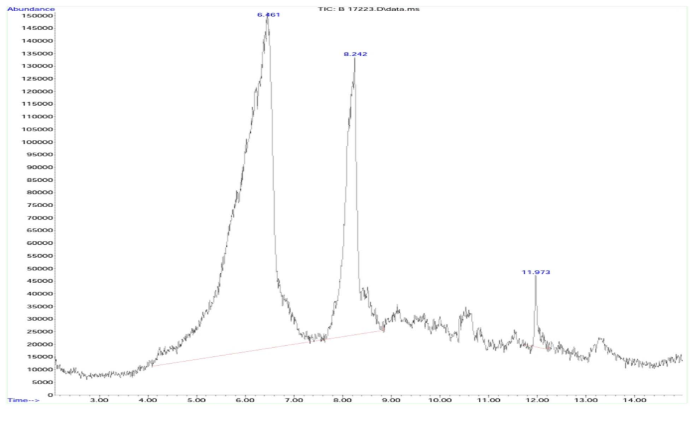
Figure 1 The GC–MS chromatogram of the methanol extract of B. longiflora

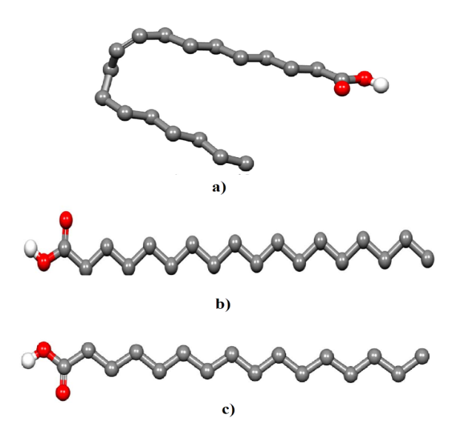
Figure 2 The 3D structure of the identified phytocompounds from B. longiflora; a) Oleic Acid b) Stearic Acid c) Palmitic Acid.

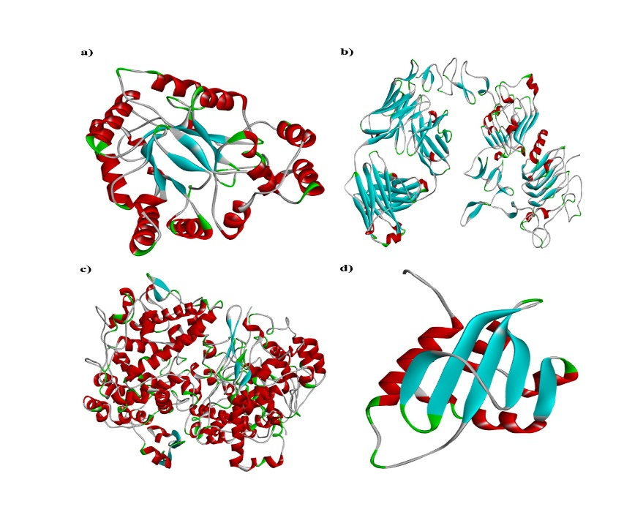
Figure 3 3D Structure of Target Proteins a) Aldose Reductase Enzyme, b) Crystal Structure of the Extracellular Domain of Human HER2 c) Cyclooxygenase Protein d) Sterol Carrier Protein-2.
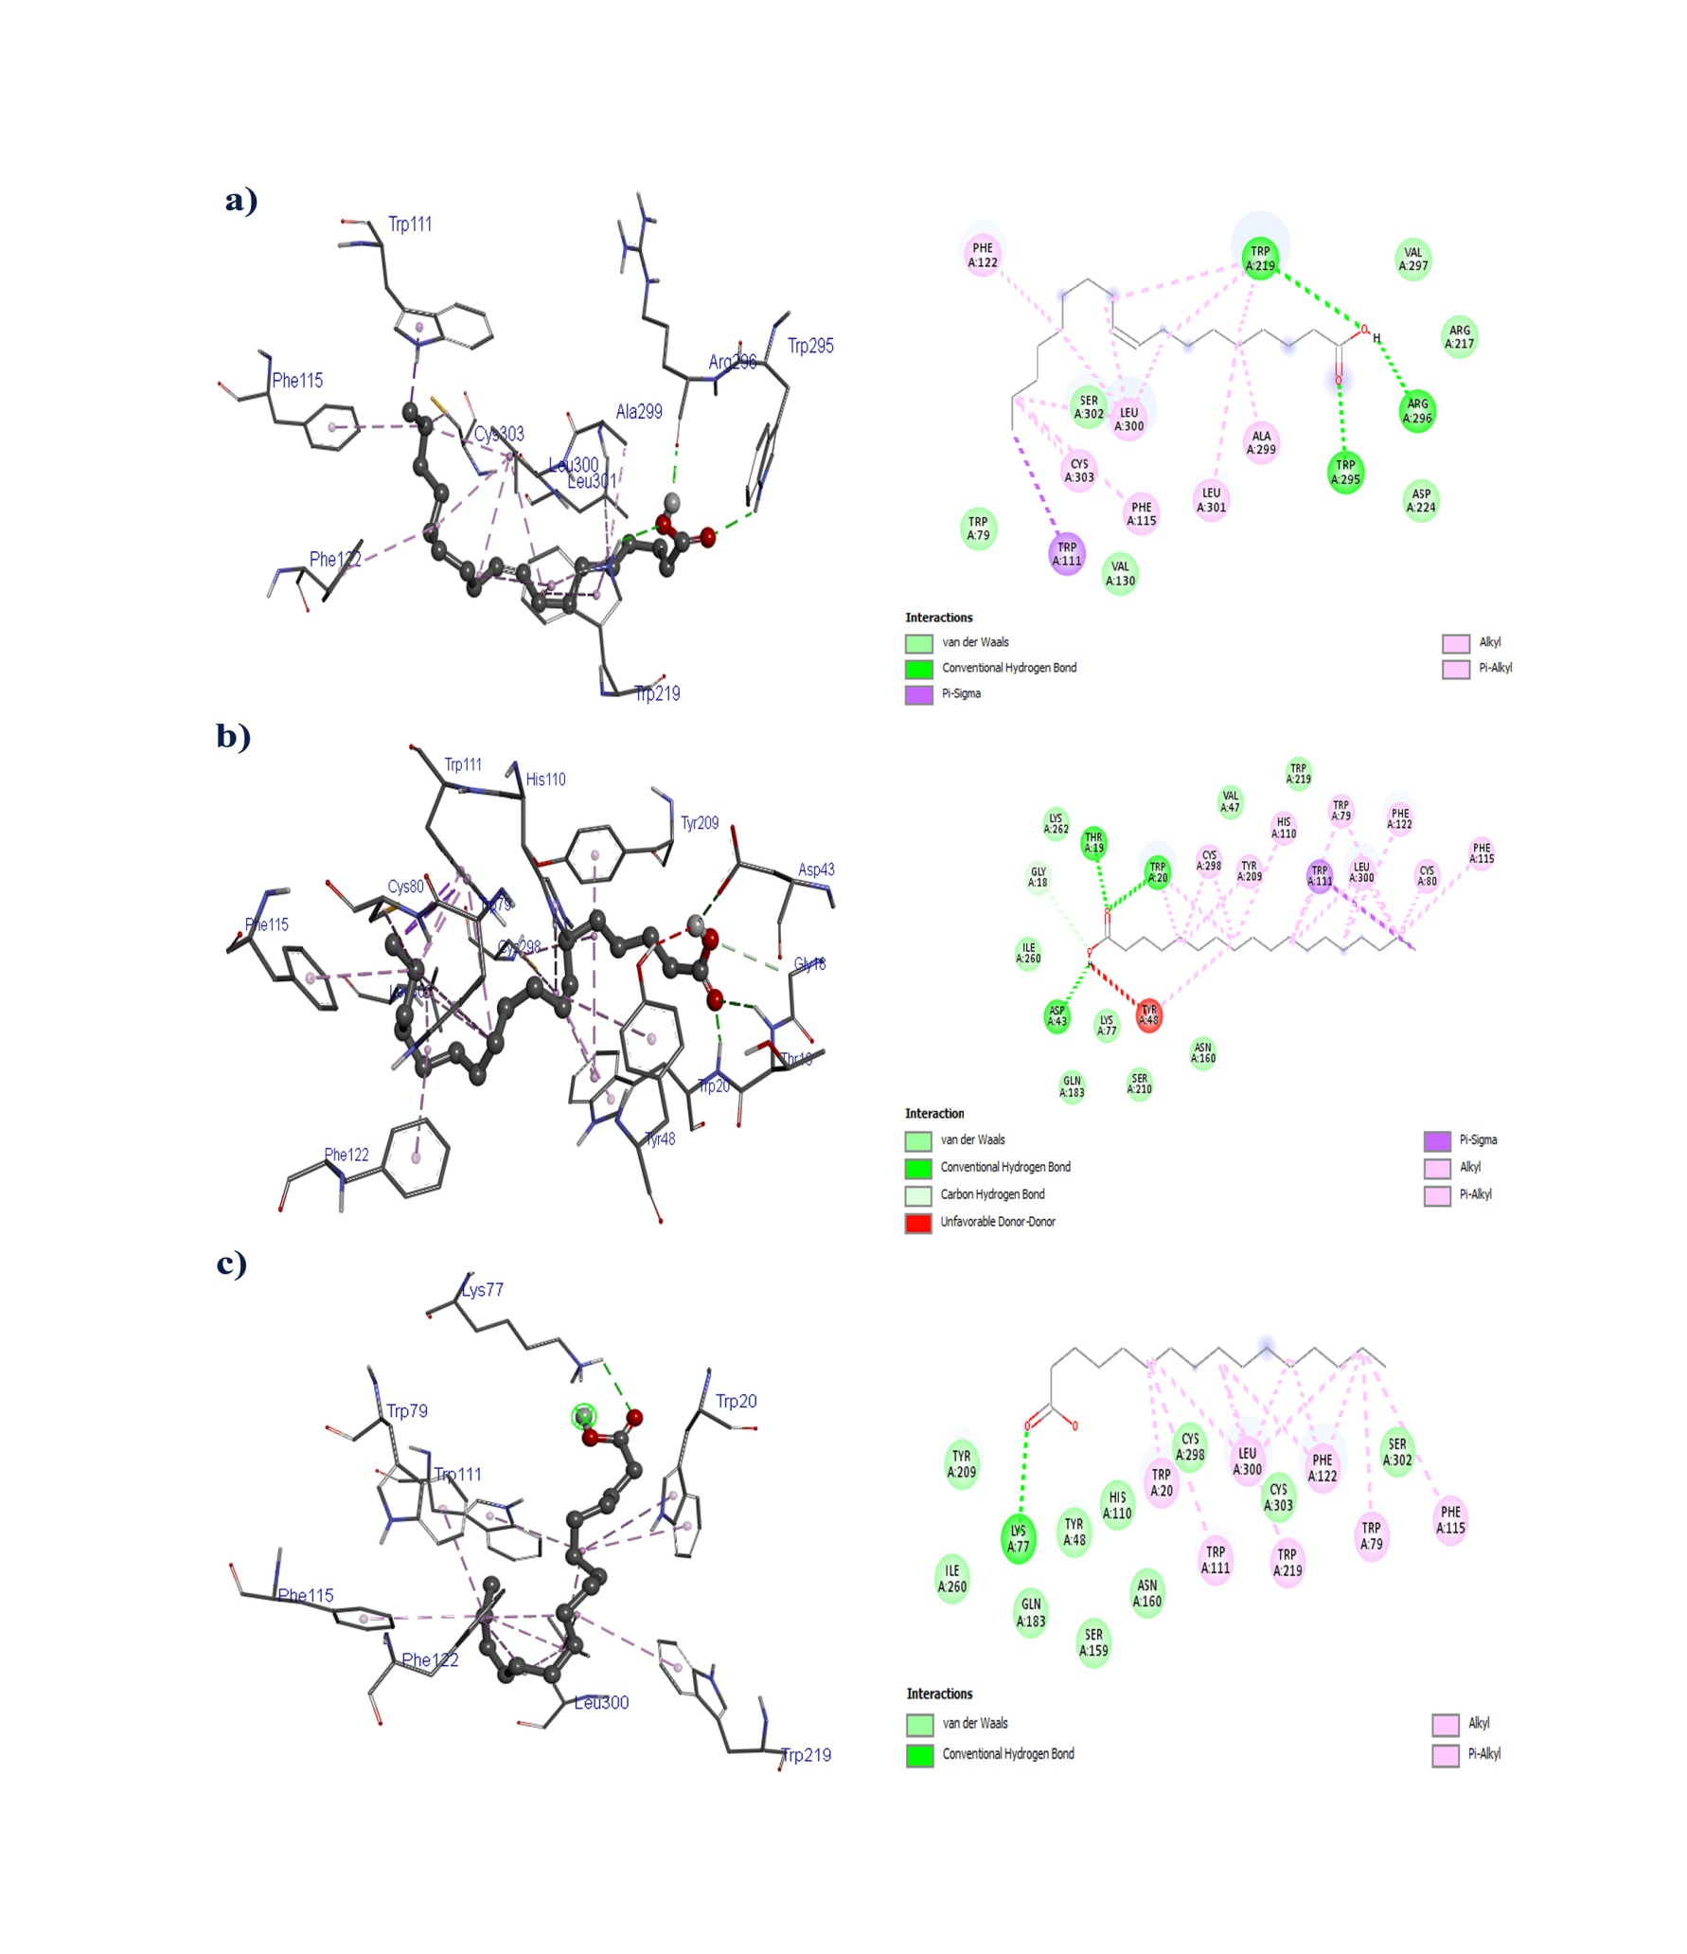
Figure 4 3D and 2D Structure of Aldose Reductase Enzyme against a) Oleic acid, b) Stearic acid, c) Palmitic acid.
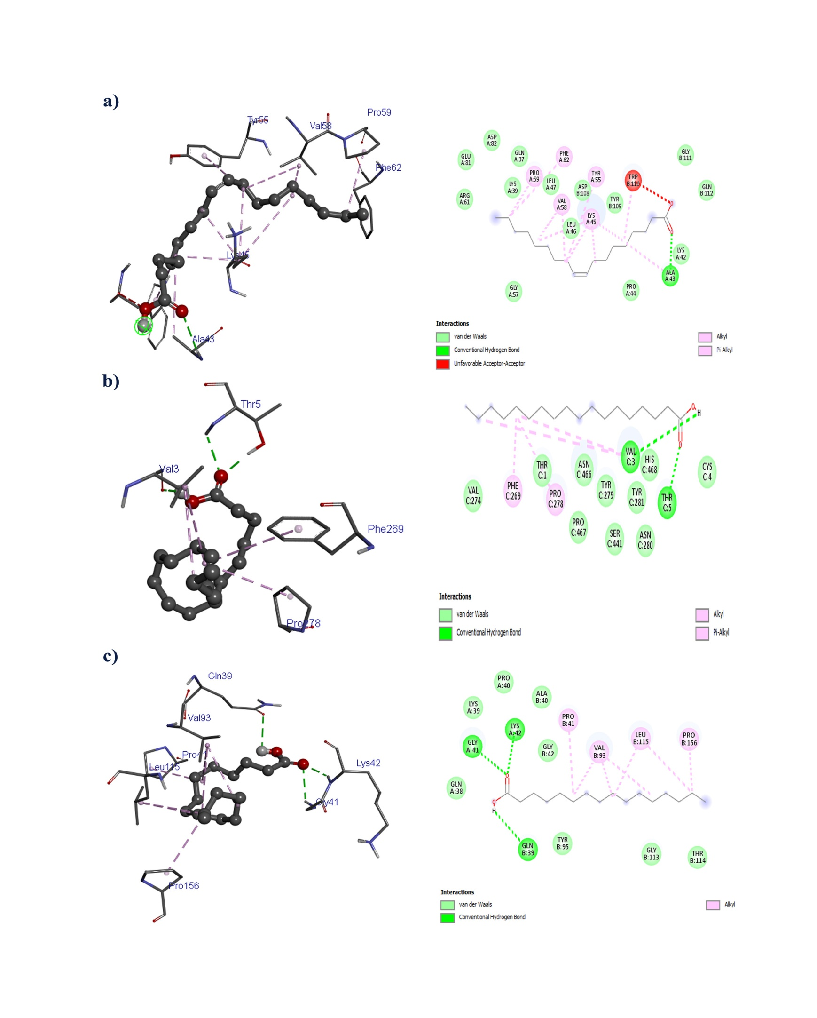

Figure 5 3D and 2D Crystal structure of the extracellular domain of human HER2 protein against, a) Oleic acid, b) Stearic acid, c) Palmitic acid.
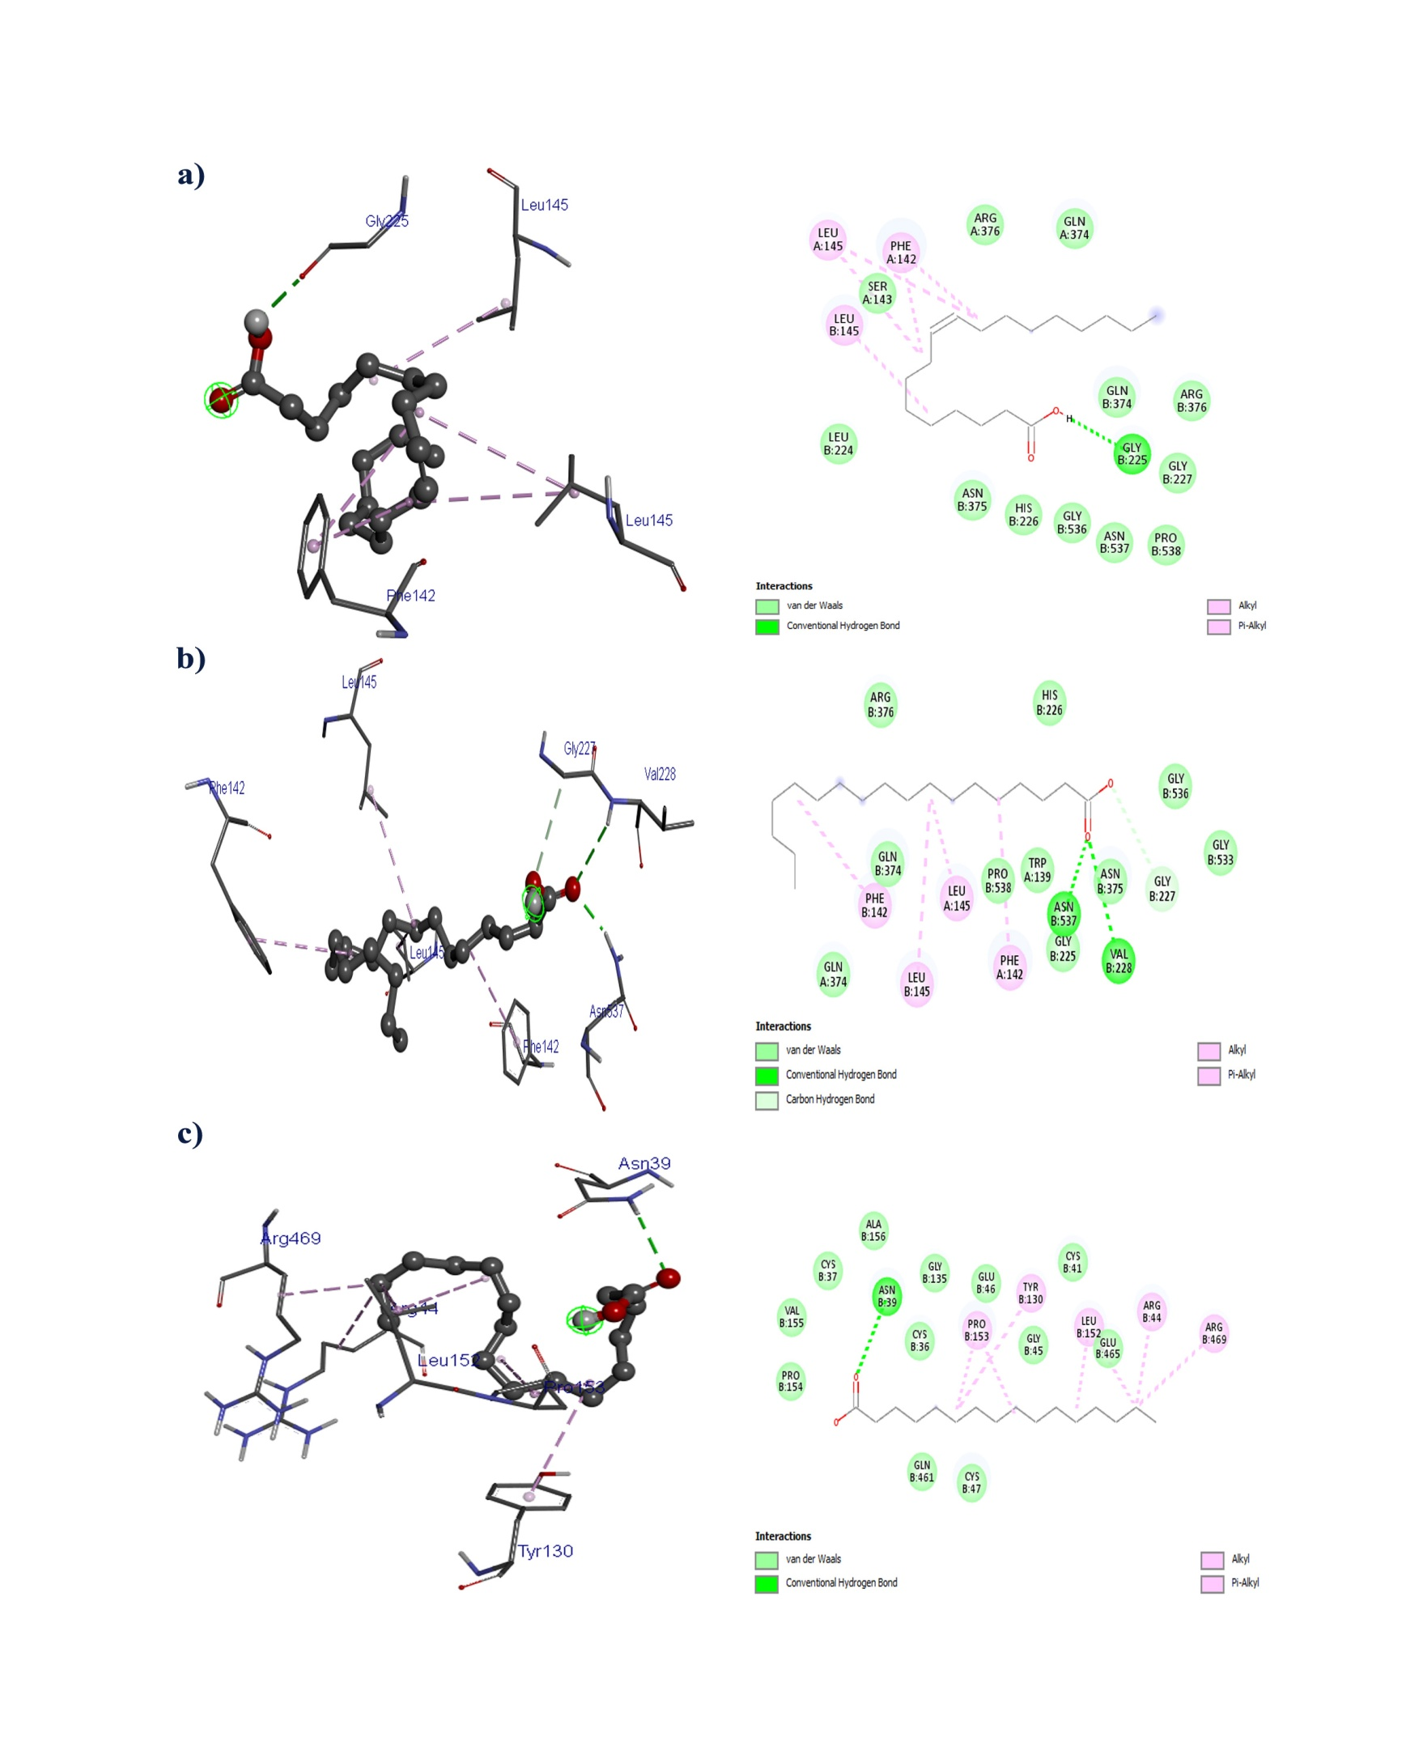

Figure 6 3D and 2D Structure of Cyclooxygenase Protein against a) Oleic acid, b) Stearic acid, c) Palmitic acid.
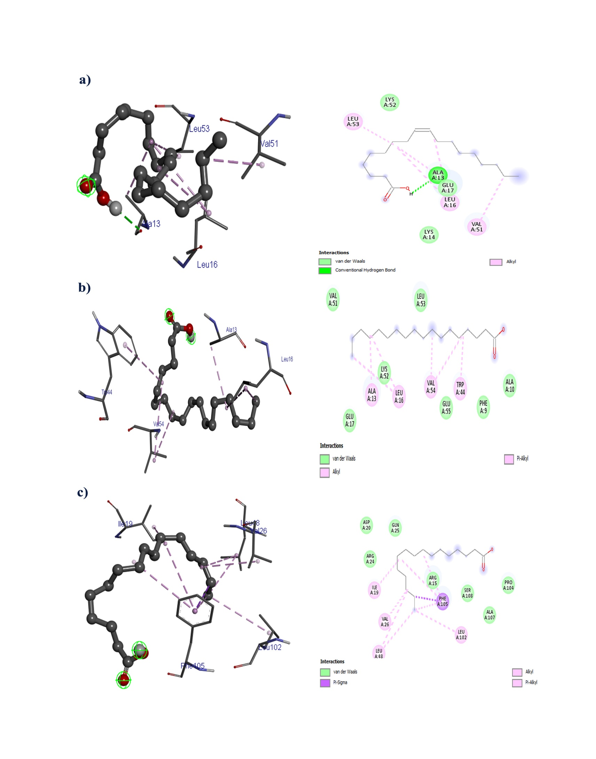
Figure 7 3D and 2D Structure of Sterol Carrier Protein-2 against a) Oleic acid, b) Stearic acid, c) Palmitic acid.

Table 1 Preliminary phytochemical analysis of methanol leaf extract of B. longiflora
S. No | Phytochemical | Methanol Extract
1. | Tannins | +
2. | Alkaloids | +
3. | Flavonoids | -
4. | Proteins | -
5. | Carbohydrates | +
6. | Glycosides | +
7. | Saponins | -
8. | Triterpenoids | -
9. | Steroids | +
10. | Starch | -
Presence (+) Absence (-)

Table 2 GC-MS analysis from methanol extract of B. longiflora
Peak No | Peak Name | Compound  Name | Molecular  Weight | Molecular  Formula | Area % | RT
1. | Oleic Acid | Oleic Acid | 282.5 | C₁₈H₃₄O₂ | 76.15 | 6.465
2. | Octadecanoic acid | Stearic Acid | 284.5 | C₁₈H₃₆O₂ | 22.44 | 8.242
3. | n Hexadecanoic acid | Palmitic Acid | 256.42 | C₁₆H₃₂O₂ | 1.41 | 11.977

Table 3 ADMET properties of identified compounds in B. longiflora
Compound Name | Oleic Acid | Stearic Acid | Palmitic Acid
Molecular Weight | 282.5 | 284.5 | 256.42
Log P | 4.57 | 4.67 | 4.19
TPSA(Å) | 37.30 | 37.30 | 37.30
Log S (ESOL) | -5.41 | -5.73 | -5.02
Fraction Csp3 | 0.83 | 0.94 | 0.94
Rotatable bonds | 15 | 16 | 14
Lipinski Rule of Five | Yes | Yes | Yes
BBB | No | No | Yes
HIA | High | High | High
PGP | No | No | No
Bioavailability Score | 0.85 | 0.85 | 0.85
CYP1A2 inhibitor | Yes | Yes | Yes
CYP2C19 inhibitor | No | No | No
CYP2C9 inhibitor | Yes | No | Yes
CYP2D6 inhibitor | No | No | No
CYP3A4 inhibitor | No | No | No
Log Kp (cm/s) | -2.60 | -2.19 | -2.77

Table 4 Molecular Docking score for bioactive compounds in B. longiflora against target proteins
Target Protein  (PDB ID) | Phytocompound | Binding Affinity (kcal/mol) | Number Hydrogen Bond
Aldose Reductase Enzyme (2FZD) | Oleic Acid | -5.6 | 3
Aldose Reductase Enzyme (2FZD) | Stearic Acid | -7.3 | 4
Aldose Reductase Enzyme (2FZD) | Palmitic Acid | -6.1 | 1
Crystal structure of extracellular domain of human HER2 (1N8Z), | Oleic Acid | -5.3 | 2
 | Stearic Acid | -4.8 | 3
 | Palmitic Acid | -4.7 | 3
Cyclooxygenase (6COX) protein | Oleic Acid | -5.3 | 2
Cyclooxygenase (6COX) protein | Stearic Acid | -5.3 | 2
Cyclooxygenase (6COX) protein | Palmitic Acid | -5.4 | 1
Sterol Carrier Protein-2 (1PZ4). | Oleic Acid | -3.5 | 2
Sterol Carrier Protein-2 (1PZ4). | Stearic Acid | -3.2 | -
Sterol Carrier Protein-2 (1PZ4). | Palmitic Acid | -3.3 | -

Table 5 Molecular Docking score for bioactive compounds in B. longiflora against Aldose Reductase Enzyme (2FZD)
S. No | Compound Name | Binding Affinity  (kcal/mol) | Hydrogen Bond Interaction | Distance  Å | Hydrophobic Interaction | Distance  Å
1. | Oleic Acid | -5.6 | TRP219  TRP295  ARG296 | 3.35  3.10  2.87 | TRP79  TRP111  PHE115  PHE122  PHE122  TRP219  TRP219  ALA299  LEU300  LEU300  ARG217 | 3.79  3.77  3.64  3.79  3.73  3.81  3.64  3.74  3.60  3.67  5.36
2. | Stearic Acid | -7.3 | THR19  TRP20  TYR48  TYR48 | 3.25  3.07  4.10  4.10 | TRP20  TRP20  TYR48  TRP79  TRP111  TRP111  TRP111  TYR209  TYR209  TYR209  LEU300  LYS77 | 3.81  3.77  3.71  3.50  3.93  3.72  3.96  3.77  3.90  3.71  3.58  5.45
3. | Palmitic Acid | -6.1 | LYS77  TYR48 | 3.07  3.55 | TRP20  TRP20  TRP20  TRP79  TRP111  PHE115  PHE122  TRP219  LEU300  LEU300  HIS110 | 3.81  3.74  3.62  3.57  3.93  3.97  3.70  3.68  3.94  3.33  5.13

Table 6 Molecular Docking score for bioactive compounds in B. longiflora Against Crystal structure of the extracellular domain of human HER2 (1N8Z)
S. No | Compound Name | Binding Affinity  (kcal/mol) | Hydrogen Bond Interaction | Distance  Å | Hydrophobic Interaction | Distance  Å
1. | Oleic Acid | -5.3 | ALA43  GLY111 | 3.71  3.09 | LYS45  LEU47  TYR55  TYR55  VAL58  VAL58  PHE62  TRP110 | 3.67  3.77  3.95  3.65  3.79  3.81  3.53  3.93
2. | Stearic Acid | -4.8 | VAL3  THR5  THR5 | 2.94  3.00  2.91 | THR1  VAL3  VAL3  PHE269  PHE269  VAL274  PRO278  PRO278  TYR279  TYR281  HIS468 | 3.48  3.70  3.88  3.72  3.51  3.70  3.80  3.60  3.95  3.50  5.42
3. | Palmitic Acid | -4.7 | GLY41  LYS42  TYR95 | 3.04  3.09  4.03 | PRO41  VAL93  LEU115  LEU115  PRO156 | 3.90  3.49  3.61  3.70  3.88

Table 7 Molecular Docking score for bioactive compounds in B. longiflora against Cyclooxygenase (6COX) protein

S. No | Compound Name | Binding Affinity  (kcal/mol) | Hydrogen Bond Interaction | Distance  Å | Hydrophobic Interaction | Distance  Å
1. | Oleic Acid | -5.3 | GLY225  ASN375 | 2.92  3.90 | PHE142  LEU145  LEU145  GLN374 | 3.50  3.60  3.64  3.78
2. | Stearic Acid | -5.3 | GLN192  SER353 | 3.77  3.25 | LEU352  LEU352  TYR385  TRP387  PHE518  PHE518  VAL523  VAL523  HIS90 | 3.83  3.94  3.73  3.70  3.84  3.62  3.72  3.61  4.18
3. | Palmitic Acid | -5.4 | VAL523 | 3.16 | LEU352  LEU352  LEU384  TYR385  TRP387  PHE518 | 3.69  3.61  3.76  3.30  3.67  3.88

Table 8 Molecular Docking Value of bioactive compounds in B. longiflora against sterol carrier protein-2 (1PZ4)
S. No | Compound Name | Binding Affinity  (kcal/mol) | Hydrogen Bond Interaction | Distance  Å | Hydrophobic Interaction | Distance  Å
1. | Oleic Acid | -3.5 | ALA13  GLU17 | 3.02  3.08 | ALA13  LEU16  LEU16  VAL51  LEU53 | 3.76  3.51  3.73  3.71  3.76
2. | Stearic Acid | -3.2 | - | - | ASP6  ALA10  TRP44  TRP44 | 3.72  3.67  3.64  3.73
3. | Palmitic Acid | -3.3 | - | - | ASP6  ALA13  TRP44  TRP44  TRP44  LEU53  VAL54 | 3.66  3.49  3.56  3.53  3.41  3.60  3.76

