Original Research Article
Chemometric Evaluation of Nutritional and Phytochemical Variability in Selected Indigenous Leafy Vegetables from Southeastern Nigeria

Abstract
Introduction: Indigenous leafy vegetables are important sources of nutrients and bioactive compounds that contribute to food security and health promotion. This study aimed to evaluate the proximate and phytochemical composition of selected indigenous leafy vegetables from Southeastern Nigeria and to characterise their nutritional and pharmacognostic variability using multivariate statistical approaches.
Methods: Fresh leaves of Telfairia occidentalis, Amaranthus viridis, Solanum melongena, Ocimum gratissimum, and Gongronema latifolium were analysed using standard AOAC methods for proximate composition and established procedures for phytochemical determination. Principal component analysis (PCA), hierarchical cluster analysis (HCA), heatmap visualisation, and Pearson correlation analysis were applied to assess compositional relationships among the vegetables.
Results: Significant differences (p < 0.05) were observed in both proximate and phytochemical parameters. Moisture was the predominant proximate component, ranging from 38.47-55.06%FW, while protein content ranged from 10.63-25.37%DW, with Amaranthus viridis recording the highest value. Ash content varied between 8.79 and 13.99%, whereas fat, fibre, and carbohydrate contents ranged from 2.90-5.83%DW, 7.62-9.46%DW, and 6.02-18.57%DW, respectively. Phytochemical analysis revealed substantial variability among the vegetables. Solanum melongena exhibited the highest alkaloid (4.14 mg/g DW), flavonoid (5.71 mg QE/g DW), and total phenol (10.85 mg GAE/g DW) contents, while Ocimum gratissimum recorded the highest terpene (3.55 %DW) and glycoside (11.43 %DW) concentrations. Gongronema latifolium was distinguished by exceptionally high saponin (31.20 %DW) and tannin (26.58 mg TAE/g DW) contents. PCA of proximate and phytochemical datasets showed that the first two principal components accounted for 87.08% and 82.12% of the total variance, respectively. HCA and heatmap analyses further revealed distinct clustering patterns among the vegetables based on their nutritional and phytochemical attributes.
Conclusion: The findings demonstrate that the investigated vegetables possess complementary nutritional and pharmacognostic profiles, supporting their utilisation as functional foods, nutraceutical resources, and valuable components of dietary diversification strategies aimed at improving food and nutrition security.
Keywords: Indigenous leafy vegetables; proximate composition; phytochemicals; principal component analysis; hierarchical cluster analysis; functional foods; Nigeria; Telfairia occidentalis; Amaranthus viridis; Solanum melongena; Ocimum gratissimum; Gongronema latifolium.
1. Introduction
Indigenous leafy vegetables (ILVs) constitute an integral component of diets across sub-Saharan Africa, particularly in Nigeria, where they contribute substantially to household food security, dietary diversity, and rural livelihoods (Wireko-Manu et al., 2020; Smith & Eyzaguirre, 2007). In Southeastern Nigeria, these vegetables are deeply embedded in cultural food systems and are routinely incorporated into traditional dishes, thereby serving as accessible and affordable sources of essential nutrients for both urban and rural populations (Smith & Eyzaguirre, 2007). Their importance is heightened in low-income settings where reliance on plant-based diets is prevalent and where ILVs often provide critical micronutrients, such as iron, calcium, and provitamin A carotenoids, that may otherwise be deficient in staple-based diets (Wireko-Manu et al., 2020). Beyond their nutritional contributions, ILVs also play socio-economic roles through local trade and subsistence farming, reinforcing their relevance within sustainable food systems (Ngidi et al., 2023). This nutritional and socio-economic importance has stimulated scientific interest in the nutritional and bioactive constituents responsible for their health-promoting properties, particularly phytochemicals.
Phytochemicals, which encompass diverse classes such as alkaloids, flavonoids, tannins, saponins, and phenolic compounds, are secondary metabolites synthesised by plants that contribute to defence mechanisms and ecological adaptation (Liu, 2013; Scalbert et al., 2005). In human nutrition, these compounds are increasingly recognised for their potent biological activities, including antioxidant, anti-inflammatory, antimicrobial, and anticarcinogenic effects (Liu, 2013). Diets rich in phytochemical-containing vegetables have been associated with reduced risks of chronic diseases, such as cardiovascular disorders, diabetes, and certain cancers, largely due to their ability to scavenge free radicals, modulate enzymatic activity, and regulate pathways linked to oxidative stress and inflammation (Scalbert et al., 2005; Dai & Mumper, 2010). Consequently, the phytochemical composition of leafy vegetables has become a focal point in both nutritional science and pharmacognosy, linking dietary intake with therapeutic potential.
While proximate constituents and phytochemicals underscore their biological relevance, their concentrations and composition are not uniform, giving rise to significant variability across plant species and environments (Pandey & Rizvi, 2009). Such variability may arise from genetic differences, environmental factors such as soil composition, climatic conditions, seasonal changes, and agronomic practices, as well as post-harvest handling and processing methods (Pandey & Rizvi, 2009; Manach et al., 2004). This heterogeneity has important implications for both nutritional quality and therapeutic efficacy, as differences in nutritional and phytochemical profiles can influence the potency, consistency, and bioavailability of health-promoting compounds (Manach et al., 2004). The complexity introduced by this variability necessitates systematic comparative evaluation of commonly consumed indigenous species, thereby directing attention to specific vegetables widely utilised in Southeastern Nigeria.
Among these, Telfairia occidentalis Hook. f. [ugu] is one of the most widely consumed leafy vegetables in Southeastern Nigeria, valued for its high iron content and its traditional use in the management of anaemia and general body weakness (Kayode & Kayode, 2011). Amaranthus viridis L. [inine] is similarly important, recognised for its rich composition of vitamins, minerals, and antioxidant phytochemicals, and is frequently consumed as both food and herbal remedy (Fasuyi, 2006). Solanum melongena L. [Añara], whose leaves are incorporated into local soups, possesses notable phenolic compounds and has been associated with antioxidant and hypoglycaemic activities (Chinedu et al., 2011). Ocimum gratissimum L. [nchuanwu] is widely used as both a culinary herb and a medicinal plant, with documented antimicrobial, anti-inflammatory, and anti-diarrhoeal properties attributed to its essential oils and phytochemical constituents (Prabhu et al., 2009). In addition, Gongronema latifolium Benth. [utazi] is a bitter vegetable traditionally used in the management of diabetes, hypertension, and gastrointestinal disorders, reflecting its diverse pharmacological activities (Morebise et al., 2002). The convergence of nutritional and medicinal attributes across these species highlights their importance as functional foods and underscores the need for detailed nutritional and phytochemical characterisation.
Despite the recognised value of these indigenous vegetables, existing studies have largely focused on proximate composition or isolated phytochemical determinations, with limited integration of comprehensive analytical frameworks (Adebooye & Opabode, 2005). In particular, studies employing advanced statistical tools to evaluate patterns of nutritional and phytochemical variability across multiple species remain scarce, especially within the context of Southeastern Nigeria. This lack of multivariate insight restricts the ability to identify relationships among phytochemicals, classify vegetables based on compositional similarities, and fully interpret their nutritional and pharmacognostic relevance. Such limitations highlight a critical gap in current knowledge that warrants a more robust analytical approach.
To address this limitation, multivariate statistical techniques such as principal component analysis, hierarchical cluster analysis, and discriminant analysis provide powerful tools for exploring complex phytochemical datasets (Abdi & Williams, 2010; Jolliffe & Cadima, 2016). These methods enable dimensionality reduction, identification of key contributing variables, and visualisation of relationships among samples, thereby offering a more holistic understanding of phytochemical diversity (Abdi & Williams, 2010). By capturing interactions and correlations that are often overlooked in univariate analyses, multivariate approaches enhance the interpretation of biochemical data and support more informed conclusions regarding the classification and functional potential of plant species (Jolliffe & Cadima, 2016; Bro & Smilde, 2014). This analytical strength makes them particularly suitable for studies involving multiple nutritional and phytochemical parameters across different indigenous vegetables.
Beyond their immediate nutritional and medicinal relevance, indigenous leafy vegetables also hold significant promise in the development of functional foods, nutraceuticals, and plant-derived pharmaceuticals (Liu, 2013). Their rich reservoir of bioactive compounds positions them as valuable candidates in the search for natural therapeutic agents, particularly in response to increasing concerns over synthetic drug resistance and adverse side effects. Furthermore, the integration of traditional knowledge with modern scientific investigation provides a pathway for sustainable utilisation and conservation of these plant resources, reinforcing their importance within both local and global health contexts.
Against this backdrop, the present study is designed to investigate the proximate and phytochemical variability of selected indigenous leafy vegetables from Southeastern Nigeria using multivariate analytical approaches, with a view to elucidating their nutritional and pharmacognostic implications. By integrating quantitative phytochemical and proximate profiling with advanced statistical tools, this study aims to provide deeper insight into compositional diversity, identify key discriminating phytochemicals, and contribute to the evidence-based utilisation of these vegetables in nutrition and health.
2. Materials and Methods
2.1 Study Area and Sample Collection
Fresh leaves of Telfairia occidentalis (ugu), Amaranthus viridis (inine), Solanum melongena (Añara), Ocimum gratissimum (nchuanwu), and Gongronema latifolium (utazi) were purchased from Eke Oko Market in Orumba North Local Government Area, Anambra State, Nigeria. The geographical location of Oko lies approximately at latitude 6.00° N and longitude 7.07° E.
The plant materials were authenticated by Dr. U.J. Afugbuom in the Department of Biology, Federal Polytechnic Oko, Anambra State, Nigeria. Voucher specimens were deposited in the Herbarium of the Department of Biology, Federal Polytechnic Oko, Anambra State, Nigeria, under voucher numbers FPB/TOL/001 (Telfairia occidentalis), FPB/AVI/002 (Amaranthus viridis), FPB/SME/003 (Solanum melongena), FPB/OGR/004 (Ocimum gratissimum), and FPB/GLA/005 (Gongronema latifolium).
2.2 Sample Preparation
Fresh leaf samples were sorted to remove dirt, damaged portions, and foreign materials. The samples were washed thoroughly under running tap water and rinsed with distilled water. A portion of the fresh samples was used for moisture determination. The remaining samples were shade-dried at ambient temperature (25-30 °C) for 14 days until a constant weight was obtained. The dried samples were ground into a fine powder using a mechanical grinder and passed through a 40-mesh sieve to obtain a uniform particle size. The powdered samples were stored in airtight containers at room temperature until analysis.
2.3. Proximate Composition
Proximate parameters (moisture, ash, crude protein, lipid, fibre, and carbohydrate) were determined in triplicate following standard AOAC (2016) procedures. Moisture content was determined using fresh leaf samples by the oven-drying method and expressed on a fresh weight basis (% FW). Ash content was determined by muffle furnace incineration. Crude protein was analysed using the Kjeldahl method (conversion factor = 6.25), lipid by Soxhlet extraction with n-hexane, and crude fibre by sequential acid-base digestion. Ash, crude protein, lipid, fibre, and carbohydrate contents were determined using dried powdered samples and expressed on a dry weight basis (% DW). Total carbohydrate content was calculated by difference after accounting for moisture, ash, crude protein, crude fat, and crude fibre contents.
2.4 Preparation of Extracts
A measured quantity of 10 g of each powdered sample was weighed and extracted with 100 mL of 80% methanol by cold maceration for 48 hours with intermittent agitation. The mixtures were filtered using Whatman No. 1 filter paper, and the filtrates were concentrated using a rotary evaporator at a temperature not exceeding 40 °C. The concentrated extracts were stored at 4 °C prior to phytochemical analysis.

2.5. Phytochemical Composition
Phytochemical constituents (alkaloids, flavonoids, saponins, tannins, total phenols, terpenes, and glycosides) were determined in triplicate using standard analytical procedures.
Alkaloid content was quantified by the alkaline precipitation gravimetric method described by Harborne (1984) and expressed as milligrams per gram dry weight (mg/g DW). Flavonoid content was determined using the aluminium chloride colorimetric assay with quercetin as the reference standard. Absorbance was measured at 415 nm and results were expressed as mg quercetin equivalents per gram dry weight (mg QE/g DW).
Total phenolic content was determined using the Folin-Ciocalteu method with gallic acid as the reference standard. Absorbance was measured at 765 nm and results were expressed as mg gallic acid equivalents per gram dry weight (mg GAE/g DW).
Tannin content was determined according to AOAC (2016) procedures using tannic acid as the reference standard. Absorbance was measured at 760 nm and results were expressed as mg tannic acid equivalents per gram dry weight (mg TAE/g DW).
Saponin content was determined according to AOAC (2016) procedures and expressed as percentage dry weight (% DW). Terpene content was determined following the method of Trease and Evans (2009) and expressed as percentage dry weight (% DW). Glycoside content was determined according to Trease and Evans (2009) through extraction and hydrolysis procedures and expressed as percentage dry weight (% DW).
2.6 Statistical Analysis
All experimental analyses were performed in triplicate, and the results were expressed as the mean ± standard deviation (SD). Statistical analyses were conducted using IBM SPSS Statistics version 23.0 (IBM Corp., Armonk, NY, USA).
One-way analysis of variance (ANOVA) was used to determine significant differences among the proximate and phytochemical parameters of the selected leafy vegetables. Where significant differences were detected, Tukey’s Honestly Significant Difference (HSD) post hoc test was applied for multiple comparisons at a significance level of p < 0.05.
To evaluate compositional variability and relationships among the vegetable species, multivariate statistical techniques were employed. Principal component analysis (PCA) was performed to reduce data dimensionality and identify the variables contributing most to sample discrimination, while hierarchical cluster analysis (HCA) and clustered heatmap visualisation were used to assess similarities and grouping patterns among the vegetable species based on their compositional profiles.
All experimental determinations were carried out in triplicate (n = 3) for each vegetable species. Pearson correlation analysis was performed using all individual observations (N = 15; five vegetable species analysed in triplicate), whereas PCA, HCA, and heatmap analyses were conducted using the mean values of each vegetable species to evaluate interspecific nutritional and phytochemical relationships.
2.6 Quality Control and Assurance
All reagents used were of analytical grade, and all instruments were calibrated prior to analysis. Blanks, standards, and replicate determinations were included to ensure accuracy, precision, and reproducibility of results.
3. Results
3.1.1 Proximate Composition of Selected Vegetables
The proximate composition analysis showed considerable variation among the selected leafy vegetables, with moisture content ranging from 38.47±1.36% to 55.06±5.73%, ash from 8.79±1.10% to 13.99±0.65%, protein from 10.63±2.89% to 25.37±0.40%, fat from 2.90±0.07% to 5.83±0.17%, fibre from 7.62±0.90% to 9.46±2.05%, and carbohydrate from 6.02±0.80% to 18.57±4.55% (Table 1). Solanum melongena recorded the highest moisture content (55.06±5.73%), whereas Gongronema latifolium had the lowest (38.47±1.36%), while the highest ash content (13.99±0.65%) was observed in Ocimum gratissimum and the lowest (8.79±1.10%) in Solanum melongena. The highest protein content was found in Amaranthus viridis (25.37±0.40%), closely followed by Ocimum gratissimum (24.91±0.40%), whereas Solanum melongena contained the lowest protein level (10.63±2.89%); additionally, Ocimum gratissimum exhibited the highest fat content (5.83±0.17%) and Gongronema latifolium recorded the highest carbohydrate content (18.57±4.55%). One-way ANOVA revealed significant differences among the vegetables for moisture (F = 4.31, p = 0.03), ash (F = 11.41, p = 0.0009), protein (F = 29.70, p = 1.58 × 10⁻⁵), and fat (F = 250.68, p = 5.59 × 10⁻¹⁰) contents. However, fibre (F = 0.26) and carbohydrate (F = 2.00) contents did not differ significantly among the vegetables (p > 0.05), while Tukey’s HSD test indicated significant differences between means bearing different superscript letters within the same column at p ≤ 0.05.
Table 1: Proximate Composition of Selected Indigenous Leafy Vegetables from Southeastern Nigeria
Parameter | Moisture  (% FW) | Ash  (% DW) | Protein  (% DW) | Fat  (% DW) | Fibre  (% DW) | Carbohydrate  (% DW)
Telfairia occidentalis | 46.23±9.79^{ab} | 10.75±1.75^{bc} | 16.99±3.23^{b} | 3.78±0.05^{c} | 9.46±2.05ª | 12.77±5.85ª
Amaranthus viridis | 40.83±4.77^{ab} | 12.19±0.24^{ab} | 25.37±0.400ª | 3.79±0.07^{c} | 7.62±0.90ª | 10.20±5.37ª
Solanum melongena | 55.06±5.728ª | 8.79±1.10^{c} | 10.63±2.89^{c} | 2.90±0.07^{d} | 8.05±1.11ª | 14.56±9.00ª
Ocimum gratissimum | 40.59±1.45^{ab} | 13.99±0.65ª | 24.91±0.40ª | 5.83±0.17ª | 8.66±2.10ª | 6.02±0.80ª
Gongronema latifolium | 38.47±1.36^{b} | 11.87±0.22^{ab} | 17.56±0.26^{b} | 4.31±0.17^{b} | 9.22±4.87ª | 18.57±4.55ª
F (4,10) | 4.31* | 11.41** | 29.70*** | 250.68**** | 0.26^{ns} | 2.00^{ns}
Values are expressed as mean ± SD (n = 3). Moisture content was determined using fresh leaf samples and is expressed on a fresh weight basis (% FW), whereas ash, crude protein, crude fat, crude fibre, and carbohydrate contents were determined from dried powdered samples and are expressed on a dry weight basis (% DW). Means within a column bearing different superscript letters differ significantly at p < 0.05 according to Tukey's HSD test following one-way ANOVA. Reported F-values correspond to one-way ANOVA comparisons among the vegetable species for each proximate parameter. ns = not significant; *p < 0.05; **p < 0.01; ***p < 0.001; ****p < 0.0001.
As previously observed in Table 1, moisture content was the most abundant proximate component across all the vegetables, with the highest value recorded in Solanum melongena (55.06%) and the lowest in Gongronema latifolium (38.47%) (Figure 1). The graphical trend further shows that Amaranthus viridis and Ocimum gratissimum contained relatively high protein levels of 25.37% and 24.91%, respectively, whereas Solanum melongena had the lowest protein content of 10.63%. Similar to the pattern presented in Table 1, fat content remained the least abundant proximate constituent across the vegetables, ranging from 2.90% to 5.83%. Carbohydrate content exhibited noticeable variation among the species, with Gongronema latifolium recording the highest value (18.57%) and Ocimum gratissimum the lowest (6.02%). The intersecting and non-parallel profiles of the proximate parameters across the vegetable species indicate variations in their compositional patterns, confirming the interaction between plant species and proximate composition (Figure 1).
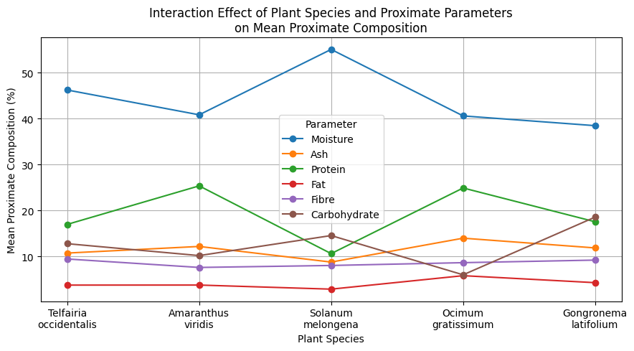

Figure 1. Interaction effect of plant species and proximate parameters on mean proximate composition (%) of selected edible vegetables.
3.1.2. Principal Component Analysis (PCA)
As shown by the proximate composition data in Table 1 and the interaction pattern in Figure 1, the variation among the measured nutritional parameters was further summarised using principal component analysis. Table 2 shows that the first principal component (PC1) had an eigenvalue of 3.52 and accounted for 63.54% of the total variance in the dataset, representing the largest proportion of variability among the vegetables. The second principal component (PC2) had an eigenvalue of 1.35 and explained an additional 23.54% of the variance, bringing the cumulative variance explained by the first two components to 87.08%. The third principal component (PC3) contributed 8.86% of the total variance, increasing the cumulative variance explained to 95.94%, while PC4 and PC5 accounted for only 2.64% and 1.42% of the variance, respectively. Collectively, the first three principal components captured over 90% of the total variability in the proximate composition data, whereas PC6 had an eigenvalue of 0.00 and contributed no additional variance (Table 2).
Table 2. Eigenvalues and percentage variance explained by principal components derived from proximate composition data of selected vegetables.
Component | Eigenvalue | Variance Explained (%) | Cumulative Variance (%)
PC1 | 3.52 | 63.54 | 63.54
PC2 | 1.35 | 23.54 | 87.08
PC3 | 1.08 | 8.86 | 95.94
PC4 | 0.38 | 2.64 | 98.58
PC5 | 0.09 | 1.42 | 100.00
PC6 | 0.00 | 0.00 | 100.00
Consistent with Table 2, the first two principal components explained 87.08% of the total variation in proximate composition, with PC1 accounting for 63.54% and PC2 accounting for 23.54% of the variance (Figure 2). The biplot shows Ocimum gratissimum and Amaranthus viridis clustered on the negative side of PC1 in association with ash, protein, and fat, reflecting their relatively high ash contents (13.99% and 12.19%), protein contents (24.91% and 25.37%), and elevated fat concentrations reported in Table 1. In contrast, Solanum melongena and Gongronema latifolium were positioned on the positive side of PC1 and were more closely associated with moisture and carbohydrate, corresponding to the highest moisture content in S. melongena (55.06%) and the highest carbohydrate content in G. latifolium (18.57%). The carbohydrate vector showed a strong positive association with PC2, which agrees with its high PC2 loading (0.7968) and contribution (45.66%) reported in Table 3, while moisture was oriented in the opposite direction with a PC2 loading of -0.5649. The separation of the vegetable species across the ordination space indicates that differences in moisture, carbohydrate, ash, protein, and fat contents were the principal factors responsible for the observed nutritional variability among the selected indigenous leafy vegetables.
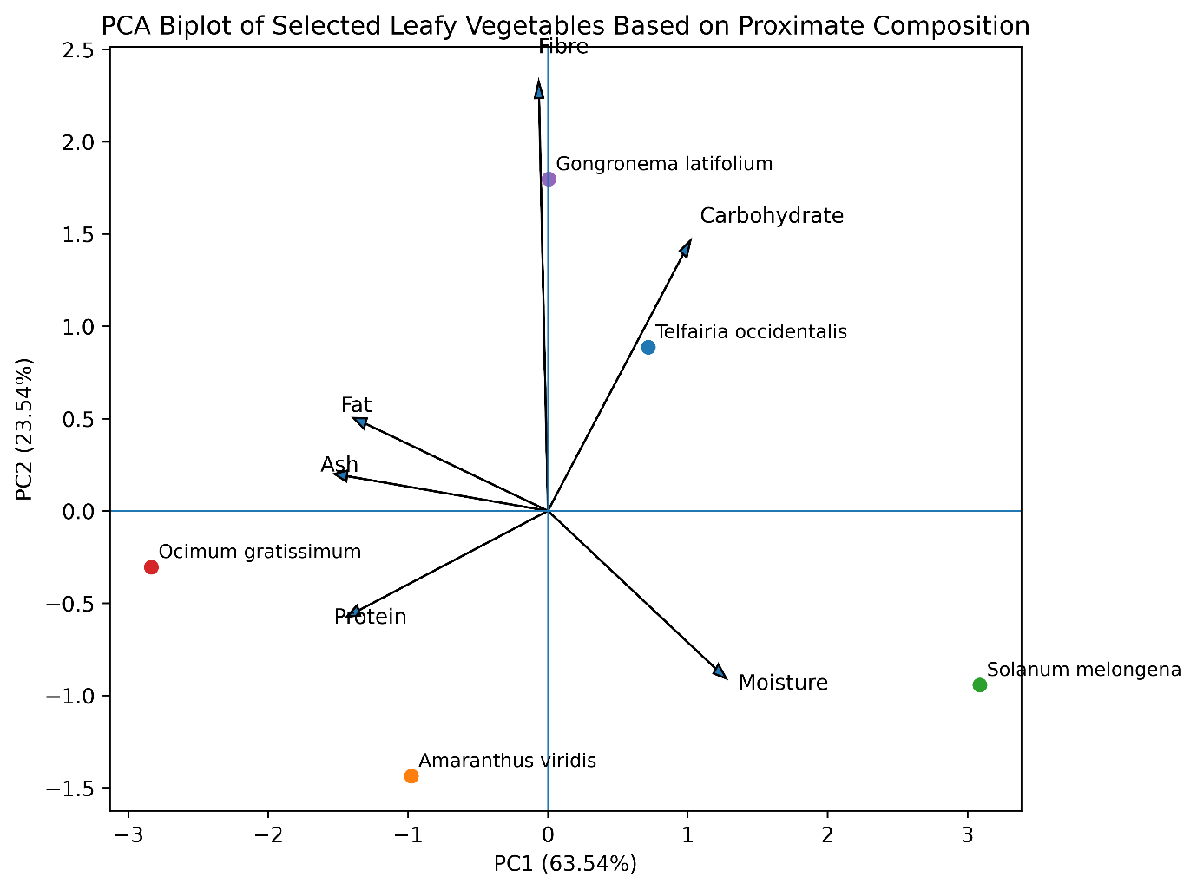

Figure 2. Principal Component Analysis (PCA) biplot showing the relationship between selected indigenous leafy vegetables and their proximate composition parameters.
Consistent with the PCA biplot in Figure 2, which showed the separation of vegetables along the principal component axes, Table 3 reveals the relative contributions of the proximate composition parameters to PC1 and PC2. For PC1, ash, protein, and fat exhibited the highest negative loadings of -0.5288, -0.5028, and -0.4871, contributing 23.44%, 22.28%, and 21.58% of the variance, respectively, while moisture had the highest positive loading (0.4050) and contributed 17.95% (Table 3). In contrast, PC2 was dominated by carbohydrate, which recorded the highest positive loading (0.7968) and the greatest contribution (45.66%), followed by moisture with a negative loading of -0.5649 and a contribution of 32.37%. Fibre showed relatively low influence on both principal components, contributing only 4.10% to PC1 and 9.97% to PC2, with loadings of -0.0925 and -0.1740, respectively. These results indicate that variation along PC1 was driven mainly by ash, protein, fat, and moisture, whereas carbohydrate and moisture were the principal determinants of variation along PC2, corroborating the vector orientations and lengths observed in Figure 2.
Table 3. Loading matrix and percentage contribution of proximate composition parameters to the first two principal components (PC1 and PC2).
Variable | PC1 Loading | PC2 Loading | PC1 Contribution (%) | PC2 Contribution (%)
Moisture | 0.4050 | -0.5649 | 17.95 | 32.37
Ash | -0.5288 | 0.0809 | 23.44 | 4.64
Protein | -0.5028 | -0.0858 | 22.28 | 4.92
Fat | -0.4871 | -0.0426 | 21.58 | 2.44
Fibre | -0.0925 | -0.1740 | 4.10 | 9.97
Carbohydrate | 0.2404 | 0.7968 | 10.65 | 45.66
3.1.3. Hierarchical Cluster Analysis (HCA)
Consistent with the separation of vegetable species observed in the PCA biplot (Figure 2), the hierarchical cluster analysis dendrogram in Figure 3 grouped the vegetables into clusters based on similarities in their proximate composition profiles. The closest association was observed between Telfairia occidentalis and Gongronema latifolium, which clustered together at a Ward linkage distance of approximately 2.1, indicating the highest degree of similarity among the vegetables (Figure 3). Solanum melongena subsequently joined this cluster at a higher linkage distance of about 4.2, suggesting a moderate level of similarity with Telfairia occidentalis and Gongronema latifolium. Similarly, Amaranthus viridis and Ocimum gratissimum formed a separate cluster at a linkage distance of approximately 3.0, reflecting comparable proximate composition characteristics between the two vegetables. The two major clusters were finally merged at the highest Ward linkage distance of about 5.4, indicating that the Amaranthus viridis-Ocimum gratissimum group was substantially distinct from the cluster comprising Solanum melongena, Telfairia occidentalis, and Gongronema latifolium (Figure 3).

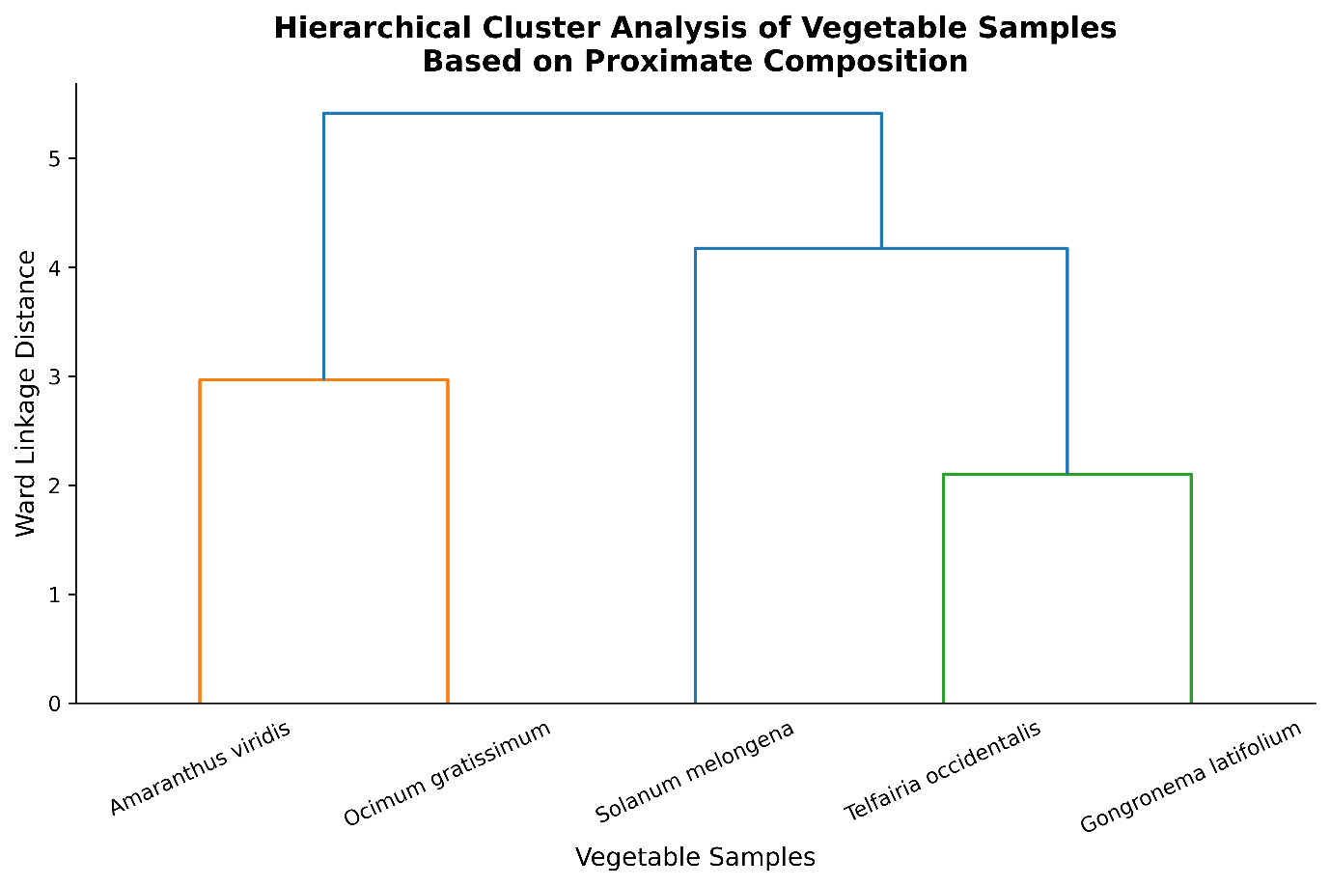

Figure 3. Hierarchical Cluster Analysis (HCA) Dendrogram Showing the Similarity Relationships among Selected Leafy Vegetables Based on Proximate Composition
3.1.4. Heatmap Analysis
Consistent with the clustering pattern observed in Figure 3, the clustered heatmap in Figure 4 reveals distinct variations in the standardised proximate composition profiles of the selected vegetables. Ocimum gratissimum exhibited high standardised values for ash and fat, with particularly strong positive intensity for fat, while also showing relatively low carbohydrate levels, as indicated by the contrasting colour pattern (Figure 4). Solanum melongena was characterised by the highest standardised moisture content and comparatively low protein, ash, and fat values, producing a distinct profile that agrees with its separation from the other vegetables in the cluster analysis. Telfairia occidentalis and Gongronema latifolium displayed similar colour distributions across several proximate parameters, especially fibre and carbohydrate, supporting their close association in the dendrogram shown in Figure 3. In addition, Amaranthus viridis exhibited relatively high protein content but low fibre content, and the overall variation in colour intensity across the heatmap confirms the heterogeneity in proximate composition among the vegetable species previously identified by the PCA and HCA analyses (Figure 4).

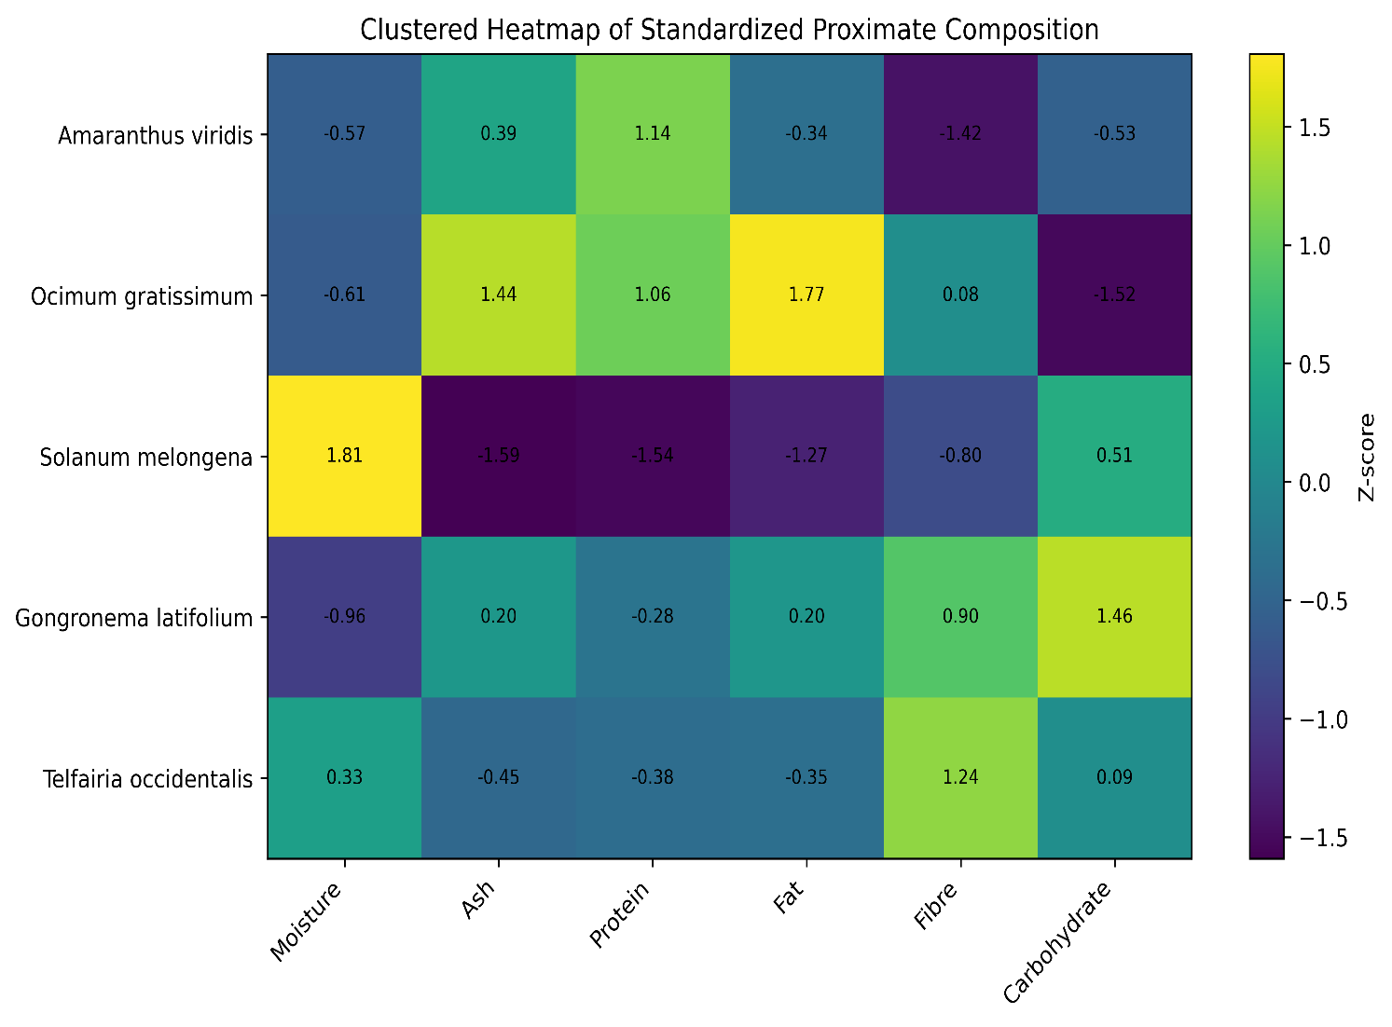

Figure 4. Clustered Heatmap Showing the Nutritional Similarities among Selected Indigenous Vegetables Based on Standardized Proximate Composition Data.
3.1.5. Correlation Analysis
Building on the multivariate analyses presented in Figures 2-4, Table 4 presents the Pearson correlation coefficients among the proximate composition parameters of the selected leafy vegetables. Several significant relationships were observed among the nutritional components. Ash exhibited strong positive correlations with fat (r = 0.847, p < 0.001) and protein (r = 0.833, p < 0.001), indicating that vegetables with higher mineral content tended to contain higher levels of lipids and proteins. Moisture content showed significant negative correlations with ash (r = -0.722, p = 0.002), protein (r = -0.632, p = 0.012), and fat (r = -0.553, p = 0.033), suggesting that increased water content was associated with lower concentrations of these nutrients. Protein was positively correlated with fat (r = 0.670, p = 0.006) but negatively correlated with carbohydrate content (r = -0.518, p = 0.048), indicating a tendency for vegetables richer in protein to contain lower levels of carbohydrates. In contrast, fibre showed very weak and non-significant correlations with the other proximate parameters (r = -0.189 to 0.109; p > 0.05), suggesting that fibre content varied largely independently of the other nutritional components (Table 4).

Table 4. Pearson Correlation Matrix for Proximate Parameters (n = 15) of Selected Leafy Vegetables
Variable | Moisture | Ash | Protein | Fat | Fibre | Carbohydrate
Moisture | 1.000 | -0.722 (0.002) | -0.632 (0.012) | -0.553 (0.033) | -0.189 (0.499) | -0.250 (0.368)
Ash | -0.722 (0.002) | 1.000 | 0.833 (<0.001) | 0.847 (<0.001) | 0.043 (0.879) | -0.341 (0.214)
Protein | -0.632 (0.012) | 0.833 (<0.001) | 1.000 | 0.670 (0.006) | 0.028 (0.921) | -0.518 (0.048)
Fat | -0.553 (0.033) | 0.847 (<0.001) | 0.670 (0.006) | 1.000 | 0.109 (0.698) | -0.396 (0.144)
Fibre | -0.189 (0.499) | 0.043 (0.879) | 0.028 (0.921) | 0.109 (0.698) | 1.000 | -0.186 (0.506)
Carbohydrate | -0.250 (0.368) | -0.341 (0.214) | -0.518 (0.048) | -0.396 (0.144) | -0.186 (0.506) | 1.000
Values are Pearson correlation coefficients (r). Corresponding p-values are shown in parentheses.
3.2. Phytochemical Composition
The quantitative phytochemical analysis revealed marked variations among the selected indigenous leafy vegetables, with values ranging from 0.68±0.11 to 4.14±0.13 mg/g DW for alkaloids, 1.88±0.11 to 5.71±0.10 mg QE/g DW for flavonoids, 0.56±0.07 to 31.20±0.10 % DW for saponins, 0.33±0.06 to 26.58±0.03 mg TAE/g DW for tannins, 0.23±0.03 to 10.85±0.09 mg GAE/g DW for total phenols, 0.03±0.03 to 3.55±0.07 % DW for terpenes, and 1.22±0.02 to 11.43±0.04 % DW for glycosides (Table 5). Solanum melongena recorded the highest alkaloid (4.14±0.13 mg QE/g DW), flavonoid (5.71±0.10 mg QE/g DW), and total phenol (10.85±0.09 mg GAE/g DW) contents, while Gongronema latifolium exhibited the highest tannin (26.58±0.03 mg TAE/g DW) and saponin (31.20±0.10 %DW) concentrations. The highest terpene (3.55±0.07 %DW) and glycoside (11.43±0.04 %DW) contents were observed in Ocimum gratissimum, whereas Telfairia occidentalis generally recorded the lowest values for flavonoids (1.88±0.11 mg QE/g), tannins (0.33±0.06 mg TAE/g), total phenols (0.23±0.03 mg GAE/g), and terpenes (0.03±0.03%). One-way ANOVA indicated highly significant differences among the vegetables for all phytochemical parameters, with F-values ranging from 166.45 for alkaloids to 108,417.01 for tannins and corresponding probability values between 4.2 × 10 ⁹⁻ and 3.9 × 10 ²³ ⁻ . Furthermore, Tukey’s HSD post hoc test showed that means bearing different superscript letters within each column differed significantly at p < 0.05, confirming statistically distinct phytochemical profiles among the evaluated leafy vegetables.

Table 5: Quantitative Phytochemical Composition of Selected Indigenous Leafy Vegetables from Southeastern Nigeria
Parameter | Alkaloid (mg/g DW) | Flavonoids (mg QE/g DW) | Saponin (% DW) | Tannins (mg TAE/g DW) | Total Phenols (mg GAE/g DW) | Terpenes (% DW) | Glycoside (% DW)
Telfairia occidentalis | 2.60±0.20ᵇ | 1.88±0.11ᵉ | 1.72±0.11ᶜ | 0.33±0.06ᵉ | 0.23±0.03ᵉ | 0.03±0.03ᵈ | 2.52±0.03ᵈ
Amaranthus viridis | 3.67±0.29ᵃ | 5.43±0.11ᵇ | 0.56±0.07ᵈ | 8.55±0.05ᶜ | 6.90±0.06ᶜ | 0.44±0.03ᵇ | 7.03±0.03ᶜ
Solanum melongena | 4.14±0.13ᵃ | 5.71±0.10ᵃ | 0.57±0.21ᵈ | 15.55±0.10ᵇ | 10.85±0.09ᵃ | 0.49±0.02ᵇ | 10.63±0.07ᵇ
Ocimum gratissimum | 2.53±0.11ᵇ | 3.96±0.08ᶜ | 2.97±0.15ᵇ | 0.83±0.00ᵈ | 7.14±0.16ᵇ | 3.55±0.07ᵃ | 11.43±0.04ᵃ
Gongronema latifolium | 0.68±0.11ᶜ | 3.59±0.02ᵈ | 31.20±0.10ᵃ | 26.58±0.03ᵃ | 0.72±0.05ᵈ | 0.27±0.02ᶜ | 1.22±0.02ᵉ
F (4,10) | 166.45* | 886.86ª | 29001.2^{b} | 108417.01^{c} | 8322.06^{d} | 4292.36e | 38417.9^{f}
Values are expressed as mean ± SD (n = 3). Means within a column bearing different superscript letters differ significantly at p < 0.05 according to Tukey's HSD test following one-way ANOVA. Reported F-values correspond to comparisons among vegetable species for each phytochemical parameter. *p = 4.2 × 10⁻⁹; ªp = 1.05 × 10⁻¹²; ^{b}p = 2.9 × 10⁻²⁰; ^{c}p = 3.9 × 10⁻²³; ^{d}p = 1.5 × 10⁻¹⁷; ^{e}p = 4.0 × 10⁻¹⁶; ^{f}p = 7.0 × 10⁻²¹.
The interaction plot reveals pronounced differences in phytochemical concentrations among the vegetable species, with each plant exhibiting a distinct phytochemical profile (Figure 5). The most prominent feature is the exceptionally high saponin concentration in Gongronema latifolium (31.20%), which greatly exceeded the values recorded in Telfairia occidentalis (1.72%), Amaranthus viridis (0.56%), Solanum melongena (0.57%), and Ocimum gratissimum (2.97%). Similarly, G. latifolium recorded the highest tannin content (26.58 mg TAE/g), whereas S. melongena showed the highest alkaloid (4.14 mg QE/g), flavonoid (5.71 mg QE/g), and total phenol (10.85 mg GAE/g) concentrations among the vegetables. Distinct peaks were also observed for terpene (3.55%) and glycoside (11.43%) contents in O. gratissimum, indicating a phytochemical composition different from the other species. Overall, the interaction pattern highlights substantial variation in the distribution and abundance of phytochemical constituents across the selected indigenous leafy vegetables.
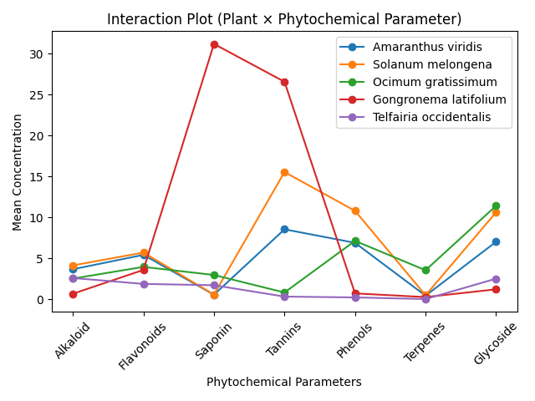

Figure 5. Interaction effect of plant species and phytochemical parameters on mean phytochemical concentration
3.2.2. Principal Component Analysis (PCA)
Consistent with the substantial variation in phytochemical concentrations observed in Table 5, the principal component analysis reduced the seven phytochemical variables into a smaller number of components that explained most of the variability among the vegetables (Table 6). PC1 had the highest eigenvalue (4.009) and accounted for 57.27% of the total variance, indicating that more than half of the phytochemical variation was associated with a single principal component. PC2 contributed an additional 24.86% of the variance, increasing the cumulative variance explained by the first two components to 82.12%, which captured the majority of the information contained in the dataset. The inclusion of PC3, with an eigenvalue of 1.170, further increased the cumulative variance explained to 98.83%, leaving only 1.17% of the total variation distributed among the remaining four components. The very low contributions of PC4 (1.03%), PC5 (0.13%), PC6 (0.01%), and PC7 (0.00%) indicate that the phytochemical variability among the selected vegetables was largely summarised by the first three principal components.
Table 6. Eigenvalues and percentage variance explained by principal components derived from phytochemical composition data of selected vegetables
PC | Eigenvalue | Variance Explained (%) | Cumulative Variance (%)
PC1 | 4.009 | 57.27 | 57.27
PC2 | 1.740 | 24.86 | 82.12
PC3 | 1.170 | 16.71 | 98.83
PC4 | 0.072 | 1.03 | 99.87
PC5 | 0.009 | 0.13 | 99.99
PC6 | 0.0004 | 0.01 | 100.00
PC7 | 0.0001 | 0.00 | 100.00
In agreement with the variance structure reported in Table 6, the first two principal components explained 82.12% of the total phytochemical variation, with PC1 and PC2 accounting for 57.27% and 24.86%, respectively (Figure 6). The biplot shows Gongronema latifolium positioned on the positive side of PC1 and closely associated with the saponin vector, reflecting its exceptionally high saponin content (31.20%) reported in Table 5. Solanum melongena occurred on the negative side of both PC1 and PC2, in close proximity to the flavonoid and phenol vectors, consistent with its relatively high flavonoid (5.71 mg QE/g) and phenol (10.85 mg GAE/g) concentrations. Ocimum gratissimum was located in the upper-left quadrant near the terpene vector, corresponding to its highest terpene content (3.55%), whereas Telfairia occidentalis was separated along the positive PC2 axis and showed greater association with alkaloids. The wide dispersion of the vegetable species across the ordination space indicates marked phytochemical heterogeneity, with saponins, tannins, flavonoids, phenols, terpenes, alkaloids, and glycosides contributing to the observed separation pattern.

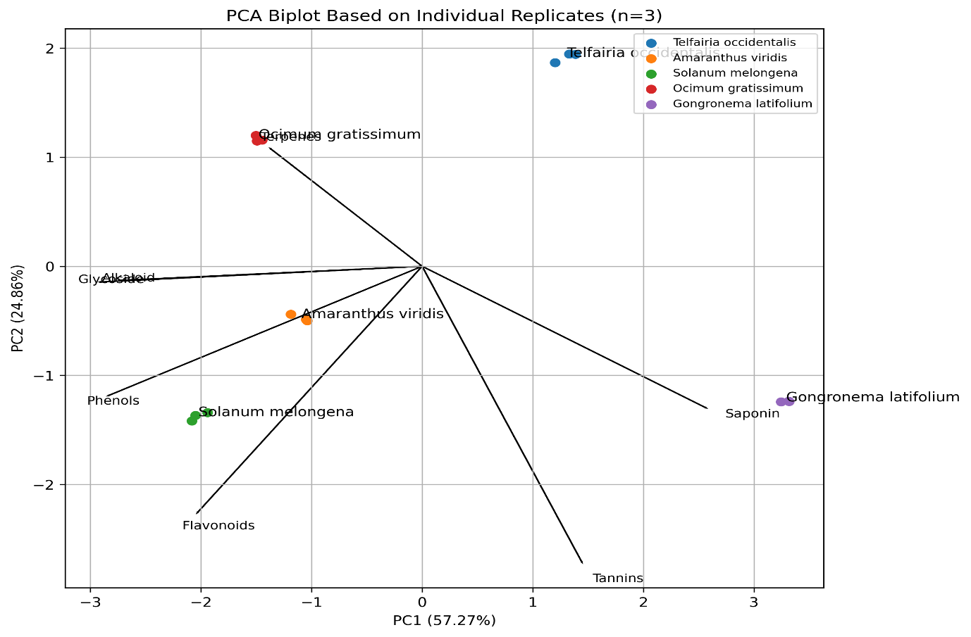

Figure 6. Principal Component Analysis (PCA) Biplot Showing the Relationship Between the Mean Phytochemical Profiles of Five Selected Indigenous Leafy Vegetables
Consistent with the separation pattern observed in Figure 6, glycosides, phenols, alkaloids, and saponins were the major variables influencing PC1, contributing 21.99%, 20.89%, 19.08%, and 17.07% of the total variation in this component, respectively (Table 7). Glycosides (-0.939), phenols (-0.915), and alkaloids (-0.875) exhibited the highest absolute loadings on PC1, indicating that these phytochemicals played dominant roles in distinguishing the vegetable species along the first principal axis. In contrast, PC2 was primarily influenced by tannins and flavonoids, which contributed 43.90% and 30.46%, respectively, with strong positive loadings of 0.874 and 0.728. Most contributors to PC2 such as glycosides (0.12%) and alkaloids (0.10%) had minimal influence on species separation along this axis, suggesting that variation in PC2 was largely driven by differences in tannin and flavonoid contents. The loading pattern therefore supports the clustering observed in Figure 6, where species differentiation was principally associated with variations in glycosides, phenols, alkaloids, saponins, tannins, and flavonoids.
Table 7. Loading matrix and percentage contribution of phytochemical composition parameters to the first two principal components (PC1 and PC2).
Variable | PC1 Loading | PC2 Loading | PC1 Contribution (%) | PC2 Contribution (%)
Alkaloid | -0.875 | 0.041 | 19.08 | 0.10
Flavonoids | -0.655 | 0.728 | 10.70 | 30.46
Saponin | 0.827 | 0.418 | 17.07 | 10.06
Tannins | 0.465 | 0.874 | 5.40 | 43.90
Phenols | -0.915 | 0.382 | 20.89 | 8.41
Terpenes | -0.442 | -0.348 | 4.88 | 6.95
Glycoside | -0.939 | 0.047 | 21.99 | 0.12
3.2.3. Hierarchical Cluster Analysis (HCA)
Consistent with the PCA results in Figure 6, the dendrogram grouped the vegetables according to similarities in their phytochemical composition, revealing distinct clustering patterns among the species (Figure 7). Amaranthus viridis and Solanum melongena clustered together at the shortest linkage distance, indicating the highest degree of phytochemical similarity between them, which corresponds with their relatively high flavonoid, phenol, alkaloid, and glycoside contents reported in Table 5. Ocimum gratissimum joined this cluster at a higher linkage distance, suggesting moderate similarity but with notable differences arising from its elevated terpene (3.55%) and glycoside (11.43%) concentrations. Telfairia occidentalis formed a separate branch from the aforementioned cluster, reflecting its generally lower concentrations of most phytochemicals, particularly phenols (0.23 mg GAE/g), tannins (0.33 mg TAE/g), and terpenes (0.03%). Gongronema latifolium appeared as the most distinct species, clustering separately from the others due to its exceptionally high saponin (31.20%) and tannin (26.58 mg TAE/g) contents, which contributed substantially to its phytochemical uniqueness.
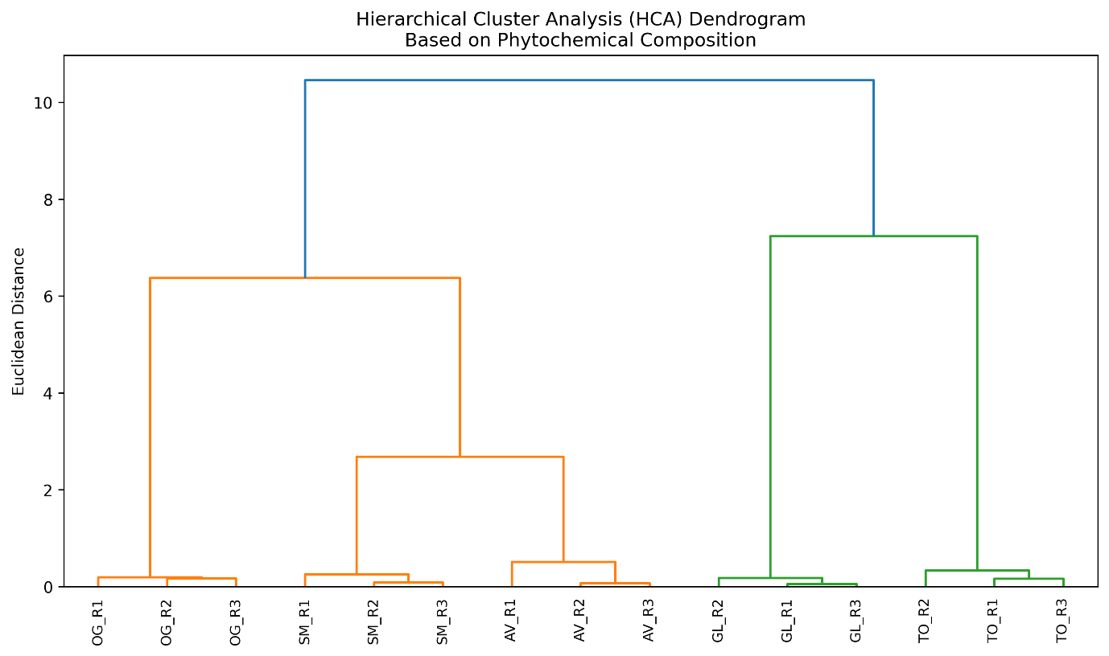

Figure 7. Hierarchical Cluster Analysis (HCA) Dendrogram Showing the Similarity Relationships Among Selected Indigenous Leafy Vegetables Based on Phytochemical Composition
The clustered heatmap revealed clear variations in phytochemical abundance among the selected vegetables and generally supported the grouping patterns observed in the PCA biplot (Figure 6) and HCA dendrogram (Figure 7). High-intensity colour patterns were observed for saponins (31.20%) and tannins (26.58 mg TAE/g) in Gongronema latifolium, distinguishing it from the other vegetables and confirming its unique phytochemical profile (Figure 8). Solanum melongena and Amaranthus viridis exhibited similar colour distributions for alkaloids, flavonoids, phenols, and glycosides, reflecting the close relationship between these species observed in the dendrogram. The heatmap also highlighted the high terpene (3.55%) and glycoside (11.43%) contents of Ocimum gratissimum, which differentiated it from the A. viridis-S. melongena cluster despite some shared phytochemical characteristics. Overall, the clustering of both variables and species indicates that phytochemicals such as saponins, tannins, phenols, flavonoids, alkaloids, and glycosides were the principal contributors to the observed similarities and differences among the indigenous leafy vegetables.
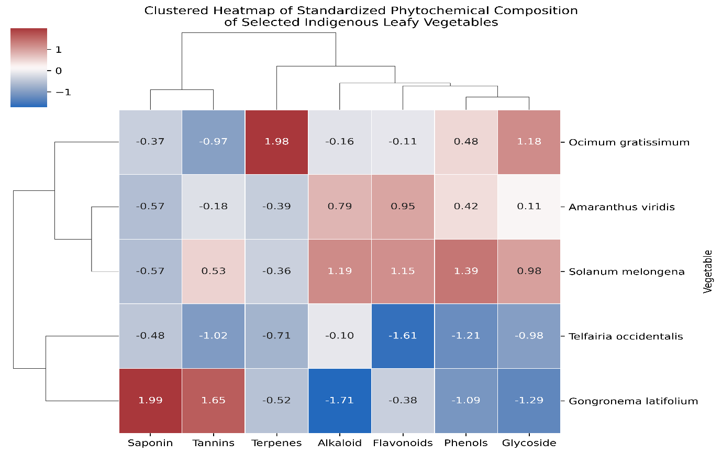

Figure 8. Clustered Heatmap Showing the Phytochemical Similarities among Selected Indigenous Leafy Vegetables Based on Standardized Phytochemical Composition Data
3.2.5. Correlation Analysis
Pearson correlation analysis revealed several significant associations among the phytochemical constituents, supporting the clustering patterns observed in the PCA, HCA, and heatmap analyses (Table 8). The strongest positive correlation was observed between phenols and glycosides (r = 0.916, p < 0.001), followed by phenols and flavonoids (r = 0.863, p < 0.001), indicating that these phytochemicals tended to accumulate together across the vegetable samples. Alkaloids also showed a strong positive correlation with phenols (r = 0.773, p < 0.001) and a moderate positive correlation with glycosides (r = 0.670, p = 0.006). Conversely, saponins exhibited a strong negative correlation with alkaloids (r = -0.881, p < 0.001) and significant negative correlations with phenols (r = -0.563, p = 0.029) and glycosides (r = -0.636, p = 0.011), indicating contrasting accumulation patterns among these phytochemical groups. A strong positive correlation was also observed between saponins and tannins (r = 0.787, p < 0.001). Flavonoids showed significant positive correlations with alkaloids (r = 0.584, p = 0.022), phenols (r = 0.863, p < 0.001), and glycosides (r = 0.636, p = 0.011). In contrast, terpenes displayed weak and largely non-significant associations with most phytochemical constituents, except for a moderate positive correlation with glycosides (r = 0.661, p = 0.007). These relationships suggest coordinated biosynthesis or accumulation of certain phytochemical classes, particularly phenols, flavonoids, glycosides, and alkaloids, within the studied leafy vegetables.
Table 8. Pearson Correlation Matrix for Phytochemical Parameters (n = 15) of Selected Leafy Vegetables
Variable | Alkaloid | Flavonoids | Saponin | Tannins | Phenols | Terpenes | Glycoside
Alkaloid | 1.000 | 0.584 (0.022) | -0.881 (<0.001) | -0.412 (0.127) | 0.773 (<0.001) | -0.020 (0.944) | 0.670 (0.006)
Flavonoids | 0.584 (0.022) | 1.000 | -0.230 (0.410) | 0.313 (0.256) | 0.863 (<0.001) | 0.065 (0.818) | 0.636 (0.011)
Saponin | -0.881 (<0.001) | -0.230 (0.410) | 1.000 | 0.787 (<0.001) | -0.563 (0.029) | -0.203 (0.469) | -0.636 (0.011)
Tannins | -0.412 (0.127) | 0.313 (0.256) | 0.787 (<0.001) | 1.000 | -0.074 (0.793) | -0.436 (0.104) | -0.355 (0.194)
Phenols | 0.773 (<0.001) | 0.863 (<0.001) | -0.563 (0.029) | -0.074 (0.793) | 1.000 | 0.343 (0.211) | 0.916 (<0.001)
Terpenes | -0.020 (0.944) | 0.065 (0.818) | -0.203 (0.469) | -0.436 (0.104) | 0.343 (0.211) | 1.000 | 0.661 (0.007)
Glycoside | 0.670 (0.006) | 0.636 (0.011) | -0.636 (0.011) | -0.355 (0.194) | 0.916 (<0.001) | 0.661 (0.007) | 1.000
Values are Pearson correlation coefficients (r). Corresponding p-values are shown in parentheses.
4. Discussion
The present study revealed substantial nutritional and phytochemical heterogeneity among the selected indigenous leafy vegetables, highlighting their complementary roles in nutrition and traditional medicine. The observed variability reflects species-specific metabolic adaptations and suggests that these vegetables possess distinct nutritional and pharmacognostic attributes that may contribute differently to human health.
The proximate composition analysis demonstrated that moisture constituted the dominant component across all vegetables, which is consistent with reports for many tropical leafy vegetables (Ashfaq et al., 2024). High moisture levels enhance palatability and nutrient bioavailability but may also increase susceptibility to post-harvest deterioration (Venkatesan & Muniyan, 2024). The relatively high protein contents observed in Amaranthus viridis and Ocimum gratissimum indicate their potential contribution to dietary protein intake, particularly in regions where animal protein remains unaffordable. Similar findings have been reported for Amaranthus species by Osei et al. (2025), who attributed their high protein content to efficient nitrogen assimilation and rapid vegetative growth. The elevated ash contents observed in these vegetables further suggest a rich mineral reserve, corroborating previous reports that indigenous leafy vegetables constitute important sources of micronutrients required for metabolic and physiological functions (Mungofa et al., 2022; Joyce Malebo, 2024). Conversely, the low-fat content recorded across all species supports their suitability for low-calorie diets and aligns with earlier findings for African leafy vegetables (Lugumira et al., 2025). The comparatively higher carbohydrate content observed in Gongronema latifolium suggests greater energy-supplying potential, while its moderate fibre content may provide additional gastrointestinal health benefits. Differences in proximate composition among species may be attributed to genetic factors, environmental conditions, soil nutrient status, plant age, and agronomic practices, all of which are known to influence nutrient accumulation in vegetables (Tola et al., 2025; Managa & Nemadodzi, 2023).
The multivariate analyses further clarified the nutritional relationships among the vegetables. Principal component analysis demonstrated that most of the observed variability was explained by a small number of nutritional attributes, primarily protein, ash, fat, moisture, and carbohydrate contents. The clustering of Amaranthus viridis and Ocimum gratissimum reflected their similar nutrient-dense profiles, characterised by elevated protein and mineral contents, whereas Solanum melongena and Gongronema latifolium were more strongly associated with moisture and carbohydrate accumulation. Similar PCA-based discrimination of indigenous vegetables has been reported by Letsoalo et al. (2026) and Lara-Arevalo et al. (2024), who identified protein and mineral content as major determinants of nutritional differentiation among African leafy vegetables. The agreement between PCA and hierarchical clustering provides consistent evidence for the observed groupings and suggests that these species may be classified into nutritionally distinct categories. Such differentiation is important for dietary planning because it indicates that the vegetables are complementary rather than nutritionally redundant.
Marked differences were also observed in phytochemical composition, indicating substantial variation in potential biological activities among the vegetables. Solanum melongena was characterised by relatively high concentrations of flavonoids, phenolics, and alkaloids, compounds widely recognised for their antioxidant, anti-inflammatory, and disease-preventive properties (Contreras-Angulo, 2022; Saha et al., 2023). Similar phytochemical profiles have been reported in Solanum species and have been associated with strong free-radical scavenging activities and protection against oxidative stress-related disorders (Zadra et al., 2012; Elizalde-Romero et al., 2021). In contrast, Gongronema latifolium exhibited remarkably elevated levels of saponins and tannins, supporting its extensive ethnomedicinal use in the management of diabetes, inflammation, and infectious diseases across West Africa (Ojo et al., 2020). The high terpene and glycoside contents observed in Ocimum gratissimum further reinforce its medicinal importance, particularly considering the documented antimicrobial, anti-inflammatory, and cardioprotective activities of these phytochemical classes (Maphetu et al., 2026; Ugbogu et al., 2021). Variations in phytochemical abundance among species may arise from differences in genotype, ecological conditions, plant developmental stage, and environmental stress responses, all of which influence secondary metabolite biosynthesis.
The PCA and HCA based on phytochemical composition revealed clearer species discrimination than that observed for proximate composition, suggesting that phytochemical traits provide stronger chemotaxonomic resolution. The distinct separation of Gongronema latifolium from all other vegetables was largely driven by its elevated saponin and tannin contents, whereas Amaranthus viridis and Solanum melongena clustered together due to similarities in flavonoid, phenolic, alkaloid, and glycoside profiles. Comparable observations have been reported in chemometric studies of medicinal plants where phenolics, flavonoids, and saponins constituted the major variables driving species differentiation (Sharifi et al., 2025; Bas, 2026). The strong concordance among PCA, HCA, and heatmap analyses suggests that multivariate statistical tools are useful for identifying key nutritional and pharmacologically relevant markers in indigenous vegetables.
The findings demonstrate that the investigated vegetables possess distinct yet complementary nutritional and phytochemical characteristics. While Amaranthus viridis and Ocimum gratissimum appear particularly valuable as protein- and mineral-rich vegetables, Solanum melongena may serve as a rich source of antioxidant phytochemicals, whereas Gongronema latifolium demonstrated comparatively high concentrations of saponins and tannins, suggesting potential pharmacognostic relevance. The integration of compositional analysis with multivariate statistics therefore provides a comprehensive framework for identifying indigenous vegetables with enhanced nutritional and therapeutic value. These findings support the promotion of dietary diversification using indigenous vegetables and provide scientific evidence for their potential utilisation in functional foods, nutraceutical development, and ethnopharmacological applications.
5. Conclusion
This study demonstrated significant (p < 0.05) nutritional and phytochemical variability among selected indigenous leafy vegetables from Southeastern Nigeria, confirming that substantial compositional differences exist among the investigated species. The proximate composition analysis revealed distinct nutritional profiles, with some species exhibiting comparatively higher protein and mineral contents, while others were characterized by greater moisture and carbohydrate levels. Similarly, substantial differences were observed in the distribution of bioactive compounds, indicating varying pharmacognostic potentials among the vegetables.
The multivariate analyses effectively discriminated the vegetables based on their compositional characteristics and identified the key nutritional and phytochemical variables responsible for species differentiation. The close agreement among principal component analysis, hierarchical cluster analysis, and heatmap visualization provided consistent support for the observed compositional patterns and highlighted the usefulness of chemometric approaches in evaluating indigenous plant resources.
The findings indicate that the studied vegetables possess complementary nutritional and phytochemical attributes that could contribute to improved dietary quality and health promotion. In particular, their richness in essential nutrients and bioactive compounds underscores their potential value as functional foods and sources of nutraceutical ingredients. The study therefore provides scientific evidence supporting the increased utilisation, conservation, and promotion of indigenous leafy vegetables as affordable resources for enhancing food and nutrition security while also serving as reservoirs of pharmacologically important phytochemicals.
6. Study Limitation
This study was limited to five indigenous leafy vegetable species collected from a single geographical location in Southeastern Nigeria. As environmental conditions, soil characteristics, seasonal variations, and agronomic practices can influence nutritional and phytochemical composition, the findings may not fully represent the variability of these species across different regions. In addition, the study focused on quantitative phytochemical screening and multivariate analysis without evaluating the biological activities or bioavailability of the identified compounds. The exploratory PCA and HCA analyses were based on a limited number of vegetable species and should therefore be interpreted as preliminary chemometric assessments. Consequently, the observed clustering patterns should be interpreted with caution until validated using larger datasets comprising additional species and geographical locations. Future studies should incorporate samples from multiple locations and seasons, as well as in vitro and in vivo bioactivity assessments, to further validate the nutritional and pharmacognostic potential of these vegetables.
Competing Interest
The authors have declared that they have no known competing financial interests, non-financial interests, or personal relationships that could have appeared to influence the work reported in this paper.
Declaration of AI Use
This manuscript was prepared through the combined contributions of all author(s), including contributions to the study design, data, content development, results, interpretation, and related scholarly work. The author(s) acknowledge the use of Grammarly and ChatGPT to assist with grammar checking, language refinement, and reference formatting. These AI-assisted tools were not used as authors and did not replace the intellectual contributions or scholarly judgement of the author(s). All AI-assisted outputs, including content, references, and interpretations, were carefully reviewed, revised, verified, and approved by the author(s). The author(s) accept full responsibility for the accuracy, integrity, and final content of the manuscript.

References
Abdi, H. and Williams, L.J. (2010). Principal Component Analysis. Wiley Interdisciplinary Reviews: Computational Statistics, 2, 433-459. https://doi.org/10.1002/wics.101.
Adebooye, O., & Opabode, J. (2005). Status of conservation of the indigenous leaf vegetables and fruits of Africa. African Journal of Biotechnology, 3(12), 700–705. https://doi.org/10.4314/ajb.v3i12.15041
AOAC. (2016). Official Methods of Analysis. 20th ed. Washington DC: Association of Official Analytical Chemists, AOAC Inc., Washington DC.
Ashfaq, A., Khan, Z. I., Arif, M., Abbas, G., Abbas, T., Gatasheh, M. K., Shaffique, S., & Shah, A. A. (2024). The proximate composition of vegetables enriched by incorporation of municipal solid waste into fertilizers and its impacts on environment and human health. BMC Plant Biology, 24(1), 887. https://doi.org/10.1186/s12870-024-05581-9
Bas, T. G. (2026). Dietary Polyphenols (Flavonoids) Derived from Plants for Use in Therapeutic Health: Antioxidant Performance, ROS, Molecular Mechanisms, and Bioavailability Limitations. International Journal of Molecular Sciences, 27(3), 1404. https://doi.org/10.3390/ijms27031404
Bro R. & Smilde, A. K. (2014). Principal component analysis. Anal Methods; 6:2812-2831. https://doi.org/10.1039/C3AY41907J
Chinedu, S.N., Olasumbo, A.C., Eboji, O.K., Emiloju, O.C., Arinola, O.K. & Dania, D.I. (2011). Proximate and Phytochemical Analyses of Solanum aethiopicum L. and Solanum macrocarpon L. Fruits. Research Journal of Chemical Sciences; 1[3]:63-71.
Contreras-Angulo, L. A., Moreno-Ulloa, A., Carballo-Castañeda, R. A., León-Felix, J., Romero-Quintana, J. G., Aguilar-Medina, M., Ramos-Payán, R., & Heredia, J. B. (2022). Metabolomic Analysis of Phytochemical Compounds from Agricultural Residues of Eggplant (Solanum melongena L.). Molecules (Basel, Switzerland), 27(20), 7013. https://doi.org/10.3390/molecules27207013
Dai, J., & Mumper, R. J. (2010). Plant phenolics: extraction, analysis and their antioxidant and anticancer properties. Molecules (Basel, Switzerland), 15(10), 7313–7352. https://doi.org/10.3390/molecules15107313
Elizalde-Romero, C. A., Montoya-Inzunza, L. A., Contreras-Angulo, L. A., Heredia, J. B., & Gutiérrez-Grijalva, E. P. (2021). Solanum Fruits: Phytochemicals, Bioaccessibility and Bioavailability, and Their Relationship with their Health-Promoting Effects. Frontiers in Nutrition, 8, 790582. https://doi.org/10.3389/fnut.2021.790582
Fasuyi, A.O. (2006). Nutritional potentials of some tropical vegetable leaf meals: Chemical characterization and functional properties. Afr J Biotechnol; 5(1): 49-53. https://doi.org/10.5897/AJB2006.000-5008
Harborne, J. B. (1984). Phytochemical Methods: A guide to modern techniques of plant analysis. Springer Dordrecht. https://doi.org/10.1007/978-94-009-5570-7
Jolliffe, I. T., & Cadima, J. (2016). Principal component analysis: a review and recent developments. Philosophical transactions. Series A, Mathematical, Physical, and Engineering Sciences, 374(2065), 20150202. https://doi.org/10.1098/rsta.2015.0202
Joyce Malebo, N. (2024). Nutritional and Functional Value of African Leafy Vegetables: Advantages and Limitations. In Plant-Based Diet. IntechOpen. https://doi.org/10.5772/intechopen.112972
Kayode, A.A.A. and Kayode, O.T. (2011) Some Medicinal Values of Telfairia occidentalis: A Review. American Journal of Biochemistry and Molecular Biology, 1, 30-38. https://doi.org/10.3923/ajbmb.2011.30.38.
Lara-Arevalo, J., Laar, A., Chaparro, M. P., & Drewnowski, A. (2024). Nutrient-Dense African Indigenous Vegetables and Grains in the FAO Food Composition Table for Western Africa (WAFCT) Identified Using Nutrient-Rich Food (NRF) Scores. Nutrients, 16(17), 2985. https://doi.org/10.3390/nu16172985
Letsoalo, M.M., Mpai, S., Beta, T., Madala, N.E. & Ndhlala, A.R. (2026). Identifying food-based medicinal indigenous leafy vegetables and evaluating their bioactive compounds in the Ga-Molepo community of Limpopo Province. Front. Food Sci. Technol. 6:1796647. https://doi:10.3389/frfst.2026.1796647
Liu R. H. (2013). Health-promoting components of fruits and vegetables in the diet. Advances in Nutrition (Bethesda, Md.), 4(3), 384S–92S. https://doi.org/10.3945/an.112.003517
Lugumira, R., Tafiire, H., Vancoillie, F., Ssepuuya, G., & Van Loey, A. (2025). Nutrient and Phytochemical Composition of Nine African Leafy Vegetables: A Comparative Study. Foods (Basel, Switzerland), 14(8), 1304. https://doi.org/10.3390/foods14081304
Manach, C., Scalbert, A., Morand, C., Rémésy, C., & Jiménez, L. (2004). Polyphenols: food sources and bioavailability. The American Journal of Clinical Nutrition, 79(5), 727–747. https://doi.org/10.1093/ajcn/79.5.727
Managa, G. M., & Nemadodzi, L. E. (2023). Comparison of Agronomic Parameters and Nutritional Composition on Red and Green Amaranth Species Grown in Open Field Versus Greenhouse Environment. Agriculture, 13(3), 685. https://doi.org/10.3390/agriculture13030685
Maphetu, N., Unuofin, J. O., Oladipo, A. O., & Lebelo, S. L. (2026). Ocimum gratissimum: Chemical Composition, Phytochemical Properties, Antioxidants, and Pharmacological Activities: A Review. Plants, 15(11), 1662. https://doi.org/10.3390/plants15111662
Morebise, O., Fafunso, M. A., Makinde, J. M., Olajide, O. A., & Awe, E. O. (2002). Anti-inflammatory property of the leaves of Gongronema latifolium. Phytotherapy Research: PTR, 16 Suppl 1, S75–S77. https://doi.org/10.1002/ptr.784
Mungofa, N., Sibanyoni, J. J., Mashau, M. E., & Beswa, D. (2022). Prospective Role of Indigenous Leafy Vegetables as Functional Food Ingredients. Molecules (Basel, Switzerland), 27(22), 7995. https://doi.org/10.3390/molecules27227995
Ngidi, M. S. C., Zulu, S. S., Ojo, T. O., & Hlatshwayo, S. I. (2023). Effect of Consumers’ Acceptance of Indigenous Leafy Vegetables and Their Contribution to Household Food Security. Sustainability, 15(6), 4755. https://doi.org/10.3390/su15064755
Ojo, O. A., Osukoya, O. A., Ekakitie, L. I., Ajiboye, B. O., Oyinloye, B. E., Agboinghale, P. E., & Kappo, A. P. (2020). Gongronema latifolium leaf extract modulates hyperglycaemia, inhibits redox imbalance and inflammation in alloxan-induced diabetic nephropathy. Journal of Diabetes and Metabolic Disorders, 19(1), 469–481. https://doi.org/10.1007/s40200-020-00533-0
Osei, E. D., Afedzi, A. E. K., Amotoe-Bondzie, A., Ivanišová, E., Encina-Zelada, C. R., Czaplicki, S., Čičová, I., Jančo, I., Gálik, B., & Afoakwah, N. A. (2025). Nutritional and Bioactive Characterization of Amaranthaceae Seeds from Peru, Slovakia, and Poland: A Comparative Study. Food Science & Nutrition, 13(9), e70901. https://doi.org/10.1002/fsn3.70901
Pandey, K. B., & Rizvi, S. I. (2009). Plant polyphenols as dietary antioxidants in human health and disease. Oxidative Medicine and Cellular Longevity, 2(5), 270–278. https://doi.org/10.4161/oxim.2.5.9498
Prabhu, K.S., Lobo, R., Shirwaikar, A.A. & Shirwaikar, A. (2009). Ocimum gratissimum: A review of its chemical, pharmacological and ethnomedicinal properties. The Open Complementary Medicine Journal; 1:1-15 https://benthamopen.com/contents/pdf/toaltmedj/toaltmedj-1-1.pdf
Saha, P., Singh, J., Bhanushree, N., Harisha, S.M., Tomar, B.S., Rathinasabapathi, B. (2023). Eggplant (Solanum melongena L.) Nutritional and Health Promoting Phytochemicals. In: Kole, C. (eds) Compendium of Crop Genome Designing for Nutraceuticals. Springer, Singapore. https://doi.org/10.1007/978-981-19-4169-6_53
Scalbert, A., Johnson, I. T., & Saltmarsh, M. (2005). Polyphenols: antioxidants and beyond. The American Journal of Clinical Nutrition, 81(1 Suppl), 215S–217S. https://doi.org/10.1093/ajcn/81.1.215S
Sharifi, Z., Eisvand, H. R., Aliahmadi, A., & Ahadi, H. (2025). Solvent-dependent variation in phenolic profiles, antioxidant and antibacterial activities across wild populations of Allium jesdianum. BMC Plant Biology, 25(1), 1760. https://doi.org/10.1186/s12870-025-07684-3
Shayanowako, A. I. T., Morrissey, O., Tanzi, A., Muchuweti, M., Mendiondo, G. M., Mayes, S., Modi, A. T., & Mabhaudhi, T. (2021). African Leafy Vegetables for Improved Human Nutrition and Food System Resilience in Southern Africa: A Scoping Review. Sustainability, 13(5), 2896. https://doi.org/10.3390/su13052896
Smith, F. and Eyzaguirre, P. (2007) African Leafy Vegetables: Their Role in the World Health Organization’s Global Fruit and Vegetables Initiative. African Journal of Food, Agriculture, Nutrition and Development, 7, 1-9.
Tola M. D., Yetenayet B.T Y., Smetanska, I., & Ozmutlu, O. (2025). Influence of species, source of origin and maturity stages on nutritional composition, bioactive compounds and antioxidant potentials of underutilized nettle (Urtica spp.) leaf. Journal of Agriculture and Food Research, 22, Article 102154. https://doi.org/10.1016/j.jafr.2025.102154
Trease GE, Evans WC. (2009). Pharmacognosy. 16th ed. London: W.B. Saunders, Philadelphia, 365-650.
Ugbogu, O. C., Emmanuel, O., Agi, G. O., Ibe, C., Ekweogu, C. N., Ude, V. C., Uche, M. E., Nnanna, R. O., & Ugbogu, E. A. (2021). A review on the traditional uses, phytochemistry, and pharmacological activities of clove basil (Ocimum gratissimum L.). Heliyon, 7(11), e08404. https://doi.org/10.1016/j.heliyon.2021.e08404
Venkatesan, U., & Muniyan, R. (2024). Review on the extension of shelf life for fruits and vegetables using natural preservatives. Food Science and Biotechnology, 33(11), 2477–2496. https://doi.org/10.1007/s10068-024-01602-3
Wireko-Manu, F.D., Shirley Isibhakhomen Ejoh, David Page, Catherine M. G. C. Renard. (2020). Estimation of Micronutrient Contents in Traditional Green Leafy Vegetables and Their Potential Contribution to Dietary Recommended Intakes. Journal of Food and Nutrition Sciences, 8(1), 15-23. https://doi.org/10.11648/j.jfns.20200801.13.
Zadra, M., Piana, M., Brum, T. F., Boligon, A. A., Freitas, R. B., Machado, M. M., Stefanello, S. T., Soares, F. A., & Athayde, M. L. (2012). Antioxidant Activity and phytochemical composition of the leaves of Solanum guaraniticum A. St.-Hil. Molecules (Basel, Switzerland), 17(11), 12560–12574. https://doi.org/10.3390/molecules171112560

