Original Research Article

Sustainable Valorization of Banana Peel Waste Through Incorporation into Functional Dhokla

Premix

ABSTRACT

The study focused primarily on food waste valorization, using banana peel waste to prepare an instant dhokla premix enriched with banana peel powder (BPP), followed by an evaluation of its nutritional quality. Banana peels, commonly discarded during processing despite their richness in minerals and bioactive constituents, were converted into powder and incorporated into different dhokla premix formulations. The research was carried out at Babasaheb Bhimrao Ambedkar University during the academic session 2025–2026. Four formulations were developed, including a control (T0) and three fortified variants (T1, T2, and T3) containing increasing levels of BPP. All samples were assessed for proximate composition and cooking quality. Banana peel powder (BPP) fortification slightly reduced moisture content while maintaining protein, fat, fibre, and carbohydrate levels. Ash content increased, indicating improved mineral content. Sensory evaluation showed the highest acceptability for the control sample (7.86), while the 5% BPP formulation (T2) achieved comparable acceptability (7.67). These findings are consistent with previous studies reporting that moderate BPP incorporation enhances nutritional quality without significantly affecting consumer acceptance. Among the developed products, the 5% BPP formulation (T2) demonstrated the most desirable balance between nutritional enhancement and product acceptability without inducing significant organoleptic degradation. Overall, the study highlights the potential of banana peel powder as a sustainable ingredient for the preparation of nutritious, ready-to-cook traditional foods while encouraging effective utilization of fruit processing waste.

Keywords: BPP(banana peel powder), dhokla premix, food waste valorization, mineral fortification, ready-to-cook snack

INTRODUCTION

Due to modernization, Indian consumers are busier than ever, and as a result, they are increasingly looking for food products that are healthy, easy to prepare, and clearly labeled with what they contain (Sundaram, 2012). By adopting ready-to-cook meal solutions, households are effectively balancing time efficiency with the nutritional quality essential for a health-conscious lifestyle (Chhabra & Kaur, 2022).

Moving away from conventional disposal practices that carry significant environmental consequences, and instead channeling agricultural residues toward innovative recycling and value-added processing, has become an essential step in reducing pollution and building a more sustainable, circular bioeconomy (Rao & Rathod, 2019). The recovery of bioactive compounds from tropical fruit residues offers a sustainable pathway to address global food security challenges while providing functional ingredients for the development of innovative, health-promoting food products (Cheok et al., 2018).
Food waste and agro-processing residues are no longer being seen merely as trash; increasingly, they are being recognized as renewable resources with real potential to be converted into something far more useful, including bioactive compounds, biopolymers, biofuels, and organic fertilizers. Within the framework of a circular economy, making meaningful use of food industry by-products does more than just cut down on waste; it supports environmental sustainability and opens up genuinely valuable economic opportunities for the food sector as a whole(Sarker et al., 2024). Banana peel valorization involves converting banana processing waste into value-added functional ingredients and sustainable products due to its rich fibre, phenolic compounds, and biopolymer content (Chandrasekaran, 2018).

Table 1: Nutritional Composition and Food Applications of Selected Fruit Processing By-products

Fruit name | Non-  edible portion | Rich in | Application in food
Pomogrante | 50% | Phenolic acids, flavonoids, hydrolizable tannins | Reformulated meat product,
Watermelon | 32% | Minerals, vitamins, vanillin, cinnamic acid | Cake, pasta
Mango | 25% | Polyphenol, carotenoids, cellulose, lignin, pectin | Ice cream pasta, beverages

Note: data synthesized from [12],[9],[16],[20],[8],[3],[1]

Banana peel, routinely discarded as a by-product of banana processing, has been steadily gaining scientific attention for reasons that make its disposal seem all the more wasteful. It is naturally rich in dietary fibre, proteins, essential minerals, phenolic compounds, carotenoids, and antioxidant constituents, a nutritional profile that makes it a genuinely promising candidate for application in functional foods, nutraceuticals, and pharmaceutical formulations (Ashka et al., 2023). Banana is one of the most extensively cultivated and consumed fruits worldwide, contributing significantly to global fruit production, with India ranking as the largest (Mohapatra et al., 2010) Banana peel is a nutrient-dense reservoir of bioactive phenolic compounds with significant therapeutic potential, warranting comprehensive recovery strategies for high-value applications in the food and pharmaceutical sectors (Vu et al., 2018).
Dhokla is a traditional steamed, fermented cereal–pulse snack from Gujarat, prepared mainly from rice and Bengal gram batter, and is valued for its light texture, good protein quality, and enhanced nutrient bioavailability due to lactic acid fermentation (Soumya et al., 2023).
The present study aimed to develop a functional dhokla premix enriched with banana peel powder and evaluate its sensory, physical, nutritional, and microstructural characteristics.
- material and methods

  - Procurement of raw materials

    - Location and Time of Conducting Research

The above study was conducted in the Department of Food and Nutrition, Babasaheb Bhimrao Ambedkar University, Lucknow, during the period of January 2026 to May 2026.

Source of Raw Material

Fresh gram flour (besan), rice flour, raw banana, spices, salt, and other required ingredients were procured from the local market of Lucknow. The raw materials were carefully selected based on their freshness, quality, and suitability for the preparation of banana peel powder incorporated into the dhokla premix.

Preparation of banana peel powder

The bananas were washed in tap water, and the peels were carefully removed with a knife, making sure the pulp portion was not cut. The peels were cut into 2-4 cm pieces (Zaini et al.,2020). and then dipped in a 0.5% citric acid solution for about 10 min, which inhibits the browning of the peels (via enzymatic reaction). The liquid is run off, and the surface water on the peels was removed using tissue paper. Then the peels were dried in a dehydrator at a temperature of 40 C for 48 h. Further, the peels are ground after drying and sieved using a 60 mesh size sieve to obtain a fine powder (Akram et al., 2022
). The powder is stored in an airtight glass container for the preparation of fortified dhokla premix.

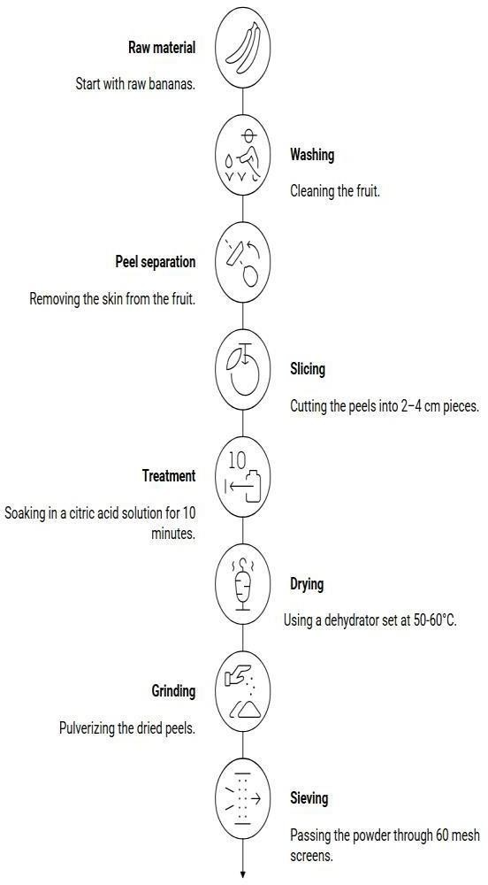

Figure. 1 Preparation steps of banana peel powder

  - Formulation of BPP fortified Dhokla Premix

To develop the fortified dhokla premix, banana peel powder (BPP) was incorporated into a composite flour base of rice flour, gram flour, and black gram flour. Four treatments were prepared: a control (T₀) with no BPP, and three fortified variants — T₁, T₂, and T₃ — containing 2%, 5%, and 8% BPP, respectively. This incremental approach aimed to identify the most nutritionally and functionally optimal fortification level.
Before formulation, all raw materials were cleaned and sieved to obtain a uniform particle size and to eliminate foreign matter. The ingredients were weighed according to the formulation proportions and blended thoroughly to ensure uniform distribution of banana peel powder within the flour matrix.

Table 2. Formulation of Banana Peel Powder Incorporated Dhokla Premix

Treatment | Composite Flour Blend* (%) | Banana Peel  Powder (%)
T₀ (Control) | 100 | 0
T₁ | 98 | 2
T₂ | 95 | 5
T₃ | 92 | 8

Note: Composite flour blend comprised rice flour, gram flour, and black gram flour in the ratio of 3:1:1, respectively.

Preparation of Dhokla from Premix

The dhokla was prepared by following the method outlined by (Ravi et al. 2010). With a few adjustments to suit our specific formulation and experimental needs better. The premix obtained from each treatment was reconstituted with water to prepare a batter of suitable consistency. The batter was allowed to ferment at room temperature for about 8 hrs to facilitate proper aeration and the development of the characteristic texture. After fermentation, the leavening and seasoning ingredients were incorporated uniformly into the batter.
The batter was poured into greased steaming trays and cooked by steaming until a soft and spongy structure was achieved. A toothpick is used to check whether the dhokla is cooked or not. The prepared dhokla samples were cooled to room temperature and evaluated for sensory attributes.

Physical analysis

To evaluate the effect of BPP after cooking, its physical properties were systematically assessed. The key parameters assessed included cooking time, weight, and height (Soumya et al., 2023) & (Mudgal et al., 2023)

Cooking time

The duration required to completely cook the dhokla batter under steaming conditions was recorded as the cooking time. A measured quantity of prepared batter was poured into a lightly greased mould and placed in a pre-heated steamer under uniform steaming conditions. Timing began at the moment steaming commenced and continued until the sample was fully cooked. To confirm doneness, the toothpick test was employed a clean toothpick upon insertion indicated that the sample had cooked through completely. Results were reported in minutes.

Weight

The weight of the dhokla samples was measured to evaluate changes occurring during thermal processing. After steaming and subsequent cooling to room temperature, individual samples were weighed using a calibrated analytical balance. The recorded values were expressed in grams (g).

Height

The vertical rise of the dhokla samples was measured to evaluate their expansion behavior and overall sponginess after cooking. Each cooled sample was placed on a level surface, and its height was measured from the base to the top using a standardized scale. The values were recorded and expressed in centimeters (cm).

Sensory Evaluation

Sensory acceptability of the control (standard) and banana peel powder-incorporated dhokla formulations was assessed through a structured hedonic evaluation conducted with a panel of 30 semi-trained panelists. All participating panelists evaluated the control sample alongside three experimental formulations containing varying concentrations of banana peel powder, thereby enabling a comprehensive comparative sensory profile across all developed treatments. All samples coded with control, T1, T2 and T3 to avoid bias
Each panelist independently assessed the samples for overall acceptability using a standard 9-point hedonic scale, where a score of 1 represented "dislike extremely," a score of 5 denoted "neither like nor dislike," and a score of 9 indicated "like extremely." This scaling system is widely validated for food acceptability studies and has been extensively employed in the sensory evaluation of traditional and functional food products.

Proximate analysis

Proximate analysis was performed to evaluate the nutritional value of the prepared dhokla premix based on standard AOAC protocols.

SPSS

The one-way ANOVA test was applied to assess the effect of fortification level on the sensory scores of fortified dhokla premix. The data were analyzed using SPSS statistical software (version 20), and differences among treatment means for various attributes were considered statistically significant at p
< 0.05

SCANNING ELECTRON MICROSCOPE
The T2 sample containing 5% banana peel powder (bpp) was selected for sem analysis. Samples were oven-dried to remove moisture and mounted on aluminum stubs using conductive carbon tape. The mounted samples were sputter-coated with a thin gold–palladium layer under vacuum conditions to improve conductivity. Sem imaging was performed at an accelerating voltage of 5–20 kV under high vacuum. Micrographs were captured at different magnifications to evaluate surface morphology, pore structure, compactness, and structural changes caused by bpp incorporation.

RESULTS AND DISCUSSION

Physical Characterization

The physical analysis of the dhokla formulations indicates significant variations in processing requirements and expansion characteristics resulting from banana peel powder incorporation. The cooking time decreased progressively from 10.0 minutes (control) to 6.5 minutes in T3, suggesting that the additives may have influenced heat transfer rates or starch gelatinization kinetics. While the control

sample exhibited the highest degree of vertical expansion (height increase of 1.5 cm), the treatment formulations showed a trend toward reduced height post-cooking, likely due to changes in batter viscosity and gas retention capacity. Furthermore, the increase in post-cooking weight for T2 and T3, in contrast to the mass loss observed in T0 and T1, suggests higher moisture retention potential within the fortified matrices, which could contribute to improved product yield and texture.

Table 3. Physical Parameters of Banana Peel Powder Incorporated Dhokla Formulations

Formulati on | Weight Before  Cooking (g) | Weight After  Cooking (g) | Cooking  Time (min) | Height Before  Cooking (cm) | Height after Cooking(cm)
T0  (Control) | 350 | 335 | 10.0 | 2.0 | 3.5
T1 | 354 | 338 | 8.0 | 2.0 | 3.2
T2 | 362 | 375 | 7.0 | 2.0 | 3.0
T3 | 360 | 374 | 6.5 | 2.0 | 2.8

Sensory Evaluation

Sensory evaluation of the developed dhokla samples was carried out using a 9-point hedonic scale by 30 semi-trained panelists. The mean sensory acceptability scores are presented in Table 4.

Table 4 Mean Sensory Acceptability Scores of Fortified Dhokla Samples

Sr.  No. | Sample Code | Mean Sensory Score
1 | Control (C) | 7.86
2 | T1 | 7.20
3 | T2 | 7.67
4 | T3 | 7.20

The control sample showed the highest sensory acceptability score (7.86). Among the fortified samples, T2 recorded the highest score (7.67), indicating better retention of sensory qualities after fortification. Samples T1 and T3 obtained equal scores (7.20), showing acceptable sensory quality with slight variations in taste, texture, and flavor. The results indicate that formulation T2 was the most acceptable fortified sample and can be considered suitable for further product development and commercialization.

Proximate analysis
Based on the comprehensive sensory profile formulation, T2 (containing 5% banana peel powder) achieved the highest overall acceptability score among all fortified variations, showing no significant deviation from the control sample in terms of texture and flavor. Consequently, T2 was strategically selected as the optimized formulation for advanced characterization, including proximate composition. Table 5 Proximate Composition of Control and T2 Formulations (g/100 g)

Parameter | Control | T2
Moisture | 11.17 | 10.77
Ash | 1.30 | 1.86
Protein (db) | 12.59 | 12.36
Fat | 2.24 | 2.30
Fiber | 2.62 | 2.59
Carbohydrates | 72.71 | 72.70

The proximate analysis revealed marginal variations between the control and T2 formulations, suggesting that the incorporation of the experimental ingredient did not significantly alter the macronutrient profile of the final product. The most notable observation is the increase in ash content. The increased ash content from 1.30 g/100 g in the control to 1.86 g/100 g in T2, observed in T2, may be attributed to the mineral-rich nature of banana peel powder. Similar findings were reported by (Akhter et al., 2024), who observed increased mineral content in bakery products fortified with banana peel powder.
The reduction in moisture content may be due to the high dietary fibre content of banana peel powder, which binds water and reduces free moisture. Comparable results were reported by (Zaini et al., 2020).
Protein, fat, and carbohydrate levels remained relatively stable, indicating that the substitution levels utilized in T2 successfully maintained the nutritional consistency of the base product while enhancing its mineral profile.

Spss

Table 6 Descriptive Statistics of Overall Sensory Acceptability of Banana Peel Powder Incorporated Dhokla Samples

Sample | Mean ± SD | Range
Control (C) | 7.87 ± 0.97 | 5–9
T1 | 7.20 ± 0.85 | 6–9
T2 | 7.67 ± 0.92 | 5–9
T3 | 7.20 ± 1.00 | 5–9
Overall | 7.48 ± 0.97 | 5–9
Note: Values are expressed as Mean ± Standard Deviation (n = 30). Sensory evaluation was performed using a 9-point hedonic scale.
The descriptive statistics indicated that the control sample (C) obtained the highest overall sensory acceptability score (7.87 ± 0.97), followed by T2 (7.67 ± 0.92). Samples T1 and T3 showed comparatively lower mean acceptability scores (7.20 ± 0.85 and 7.20 ± 1.00, respectively).
The results suggest that moderate incorporation of banana peel powder maintained acceptable sensory quality, whereas higher incorporation levels may have slightly reduced consumer acceptability. Overall, all formulations achieved scores above 7, indicating good sensory acceptance among the panelists.

Table 7 Post Hoc Multiple Comparison (LSD Test) for Overall Sensory Acceptability of Banana Peel Powder Incorporated Dhokla Samples

Comparison | Mean Difference | p-value | Significance
C vs T1 | 0.67 | 0.007 | Significant
C vs T2 | 0.20 | 0.410 | Non-significant
C vs T3 | 0.67 | 0.007 | Significant
T1 vs T2 | -0.47 | 0.056 | Non-significant
T1 vs T3 | 0.00 | 1.000 | Non-significant
T2 vs T3 | 0.47 | 0.056 | Non-significant
Note: Values are expressed as mean differences. Significance was evaluated at the 5\% level (p < 0.05) using the Least Significant Difference (LSD) post hoc test following one-way Analysis of Variance (ANOVA). p-values < 0.05 indicate statistically significant differences.
The post hoc LSD analysis revealed significant differences in overall sensory acceptability between the control sample (C) and samples T1 and T3 (p = 0.007). However, no significant difference was observed between the control sample and T2 (p = 0.410), indicating that the sensory quality of T2 was comparable to the control. Comparisons among T1, T2, and T3 did not show statistically significant differences (p > 0.05). These findings suggest that the formulation represented by T2 maintained sensory acceptability close to the control sample and may be considered the most acceptable level of banana peel powder incorporation among the treated samples. The ANOVA results demonstrated a statistically significant difference in the overall sensory acceptability among the different dhokla formulations (F = 3.889, p = 0.011). This indicates that the incorporation levels of banana peel powder significantly influenced the sensory characteristics of the developed products.
The linear component was also significant (p = 0.047), suggesting that changes in banana peel powder concentration had a measurable linear effect on overall acceptability. Furthermore, the significant deviation from linearity (p = 0.025) indicates that the relationship between banana peel powder incorporation and sensory acceptability was not completely linear, implying that certain incorporation levels performed better than others. Overall, the findings suggest that moderate incorporation of banana peel powder could maintain desirable sensory quality, while higher or lower levels may negatively affect consumer acceptability.

SEM

Morphological and Elemental Analysis

Table 8 Elemental Composition of Banana Peel Powder by EDS Analysis

Element | Weight  (%) | Atomic  (%)
Carbon (C) | 51.76 | 59.19
Oxygen (O) | 46.97 | 40.33
Potassium (K) | 0.53 | 0.19
Chlorine (Cl) | 0.49 | 0.19
Phosphorus  (P) | 0.24 | 0.11

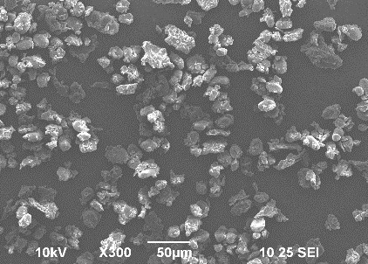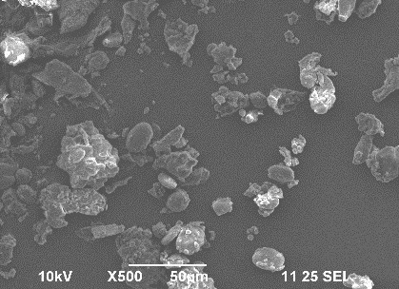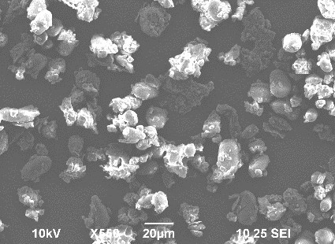

Figure 2. Scanning Electron Microscopy (SEM) Micrographs of Banana Peel Powder Showing Particle Morphology and Surface Characteristics
The SEM micrographs revealed that banana peel powder (BPP) possessed heterogeneous, irregularly shaped particles with varying sizes and rough surface textures. The particles appeared as aggregated clusters with angular and fragmented structures, indicating the disruption of cellular tissues during drying and grinding processes. The rough and porous surface morphology observed in the micrographs suggests the presence of fibrous components such as cellulose, hemicellulose, and lignin, which are characteristic constituents of banana peel. The irregular particle geometry increases the specific surface area, potentially enhancing water absorption, swelling capacity, and interaction with other food matrix components. Furthermore, the absence of a smooth and compact structure indicates a highly porous nature that may facilitate the retention of bioactive compounds and improve functional properties when incorporated into food formulations. These structural characteristics support the suitability of banana peel powder as a functional ingredient for the development of value-added food products.

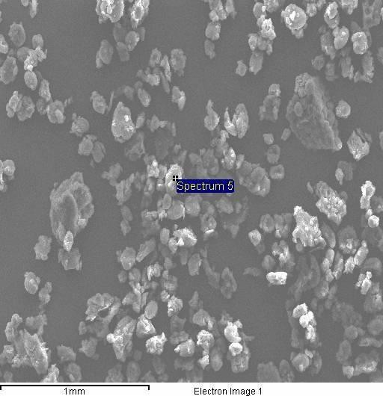
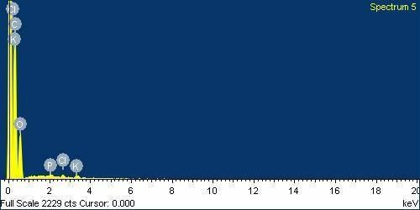

Fig 3. SEM-EDS Analysis and Elemental Mapping of the Experimental Sample

The SEM–EDS spectrum demonstrated the elemental composition of banana peel powder, confirming the presence of several essential mineral elements. Carbon (C) and oxygen (O) were the predominant elements, reflecting the organic nature of the sample and the abundance of carbohydrate-rich structural polymers. Minor peaks corresponding to phosphorus (P), potassium (K), and other trace minerals were also detected, indicating the mineral-rich composition of banana peel powder. The high carbon and oxygen content is associated with dietary fiber constituents such as cellulose, hemicellulose, and pectin,

whereas the presence of potassium and phosphorus contributes to the nutritional value of the material. The elemental distribution observed through EDS analysis confirms that banana peel powder is a valuable source of both dietary fiber and essential minerals. These findings further support its utilization as a sustainable functional ingredient for food fortification and food waste valorization applications.

Limitation
While banana peel powder boosts nutrition, adding over 5-10% lowers consumer aceptance due to bitterness and astrigency from endogenous tannis. Furthermore, the high dietary fibre disrupts the structural matrix, change the traditional light, aerated sponginess of dhokla into a tough, excessivey chewy crumb texture.

CONCLUSION
The present study successfully established the feasibility of incorporating banana peel powder into an instant dhokla premix as a practical and scientifically sound strategy for agro-industrial waste valorization. Among the formulations evaluated, 5% BPP substitution (T2) was identified as the optimal level, demonstrating that fortification at this concentration preserved the fundamental macronutrient integrity of the premix with protein, fat, fibre, and carbohydrate contents remaining largely unaltered The findings of the present study are consistent with earlier research on the utilization of banana peel powder in various food products, where its incorporation was shown to enhance mineral and dietary fibre content while maintaining the overall nutritional quality and acceptability of the product. Cooking performance assessments further corroborated the functional suitability of the fortified premix, with BPP incorporation contributing to reduced cooking time and enhanced water uptake and retention capacity, albeit with a progressive decline in product height at higher substitution levels, reaffirming the criticality of fortification level optimization. Similar improvements in hydration properties have been reported by earlier researchers, who attributed these effects to the high fibre content and water-binding capacity of banana peel powder. Collectively, these results position banana peel powder as a low-cost, nutritionally valuable functional ingredient capable of enhancing the dietary quality of traditional ready-to-cook snack formats without adversely affecting their compositional profile, thereby offering a replicable waste-to-wealth model consistent with circular food economy principles. Future research should address comprehensive sensory profiling, shelf-life and storage stability evaluation, bioactive compound characterization, and optimization of peel processing conditions to support the scalable, industrial-level application of this fortified premix. Therefore, the developed BPP-enriched dhokla premix represents a promising approach for converting food processing waste into commercially viable functional foods.

Declaration of AI Use
This manuscript was prepared through the combined contributions of all author(s), including contributions to the study design, data, content development, results, interpretation, and related scholarly work. The author(s) acknowledge the use of Grammarly and ChatGPT to assist with grammar checking, language refinement, reference formatting. These AI-assisted tools were not used as authors and did not replace the intellectual contributions or scholarly judgment of the author(s). All AI-assisted outputs, including content, references, and interpretations, were carefully reviewed, revised, verified, and approved by the author(s). The author(s) accept full responsibility for the accuracy, integrity, and final content of the manuscript.

Refrences

- Acun, S., Gül, H. and Seyrekoğlu, F., 2025. Innovative Utilization of Watermelon By-Product Powders to Enhance Fresh Pasta Quality: Improving Nutritional Value and Functional Properties. Food Science & Nutrition, 13(7), p.e70572.
- Akhter, M.J., Al-Amin, M., Hossain, M.A. and Kamal, M.M., 2024. Enriching wheat bread with banana peel powder: impact on nutritional attributes, bioactive compounds, and antioxidant activity. International Journal of Food Science, 2024(1), p.2662967.
- Akram, T., Mustafa, S., Ilyas, K., Tariq, M.R., Ali, S.W., Ali, S., Shafiq, M., Rao, M., Safdar, W., Iftikhar, M. and Hameed, A., 2022. Supplementation of banana peel powder for the development of functional broiler nuggets. PeerJ, 10, p.e14364.
- Al-Sayed, H.M. and Ahmed, A.R., 2013. Utilization of watermelon rinds and sharlyn melon peels as a natural source of dietary fiber and antioxidants in cake. Annals of Agricultural Sciences, 58(1), pp.83-95.
- Ashka, F., Dubey, P.K., Kumar, S. and Dubey, P., 2023. Banana Peels as Bioactive Ingredient Systematic Review of Nutritional and Pharmacological Attributes. JFCN, 9, pp.577-587.
- Chandrasekaran, M. ed., 2012. Valorization of food processing by-products. CRC press.
- Cheok, C.Y., Mohd Adzahan, N., Abdul Rahman, R., Zainal Abedin, N.H., Hussain, N., Sulaiman, R. and Chong, G.H., 2018. Current trends of tropical fruit waste utilization. Critical reviews in food science and nutrition, 58(3), pp.335-361.
- Chhabra, I. and Kaur, A., 2022. Development of a convenient, nutritious ready to cook packaged product using millets with a batch scale process development for a small-scale enterprise. Journal of Food Science and Technology, 59(2), pp.488-497.
- Gladvin, G., Sudhaakr, G., Swathi, V. and Santhisri, K.V., 2017. Mineral and vitamin compositions contents in watermelon peel (Rind). International Journal of Current Microbiology and Applied Sciences, 5(5), pp.129-133.
- Gullón, P., Astray, G., Gullón, B., Tomasevic, I. and Lorenzo, J.M., 2020. Pomegranate peel as suitable source of high-added value bioactives: Tailored functionalized meat products. Molecules, 25(12), p.2859.
- Mohapatra, D., Mishra, S. and Sutar, N., 2010. Banana and its by-product utilisation: an overview. Journal of scientific and industrial research, 69(5), pp.323-329.
- Mudgal, D., Singh, S., Singh, J., Chauhan, N., Kumar, V. and Singh, B.R., 2023. Physical and Sensory Attributes of Dhokla Made with Sweet Potato and Flaxseed Flours. Current Journal of Applied Science and Technology, 42(34), pp.9-14.

- Pathak, P.D., Mandavgane, S.A. and Kulkarni, B.D., 2017. Valorization of pomegranate peels: A biorefinery approach. Waste and biomass valorization, 8(4), pp.1127-1137.
- Rao, P. and Rathod, V., 2019. Valorization of food and agricultural waste: a step towards greener future. The Chemical Record, 19(9), pp.1858-1871.
- Ravi, U., Menon, L. and Anupama, M., 2010. Formulation and quality assessment of instant dhokla mix with incorporation of pumpkin flour. J. Sci. Ind. Res, 69, pp.956-960.
- Sarker, A., Ahmmed, R., Ahsan, S.M., Rana, J., Ghosh, M.K. and Nandi, R., 2024. A comprehensive review of food waste valorization for the sustainable management of global food waste. Sustainable Food Technology, 2(1), pp.48-69.
- Serna-Cock, L., García-Gonzales, E. and Torres-León, C., 2016. Agro-industrial potential of the mango peel based on its nutritional and functional properties. Food Reviews International, 32(4), pp.364-376.
- Soumya, C.H., Lakshmi, J., Lakshmi, K. and Baig, M.S., 2023. Formulation, physico-chemical and sensory assessment of instant dhokla mixes prepared with red and white kidney bean flours.
- Sundaram, N., 2012. A market study on key determinants of Ready-to-Eat/cook products with respect to tier-I cities in Southern India. ZENITH International Journal of Multidisciplinary Research, 2(6), pp.168-180.
- Vu, H.T., Scarlett, C.J. and Vuong, Q.V., 2018. Phenolic compounds within banana peel and their potential uses: A review. Journal of functional foods, 40, pp.238-248.
- Wongkaew, M., Chaimongkol, P., Leksawasdi, N., Jantanasakulwong, K., Rachtanapun, P., Seesuriyachan, P., Phimolsiripol, Y., Chaiyaso, T., Ruksiriwanich, W., Jantrawut, P. and Sommano, S.R., 2021. Mango peel pectin: Recovery, functionality and sustainable uses. Polymers, 13(22), p.3898.
- Zaini, H. B. M., Sintang, M. D. B., & Pindi, W. (2020). The roles of banana peel powders to alter technological functionality, sensory and nutritional quality of chicken sausage. Food science & nutrition, 8(10), 5497-5507.

