Original Research Article
Development and Characterization of Value-Added Breakfast Cereal Enriched with Banana Blossom

ABSTRACT
Banana blossom is an edible flower rich in macro- and micronutrients. It also contains dietary fibre and antioxidants; therefore, it may be beneficial in managing diabetes, cardiovascular diseases and constipation. The present study aimed to develop a novel breakfast cereal enriched with banana blossom flour and to analyse its nutritional and sensory properties. Moreover, this study provides insight into process standardisation and supports technological advancement for commercial-scale production. The fresh blossoms were pre-treated with natural citric acid to avoid enzymatic browning by lowering the pH and inhibiting polyphenol oxidase. Four formulations of the product were prepared, and sensory evaluation was performed. Thirty untrained panellists evaluated the product using a hedonic scale. Among the formulations, F2, which contained 3 g of banana blossom flour, showed the best results. The sensory evaluation scores were statistically evaluated by ANOVA, which revealed that formulation F2 had the highest acceptability compared with all other formulations. Taste had the highest mean score of 8.60, whereas appearance, texture and smell each had a mean score of 8.57. The proximate analysis results showed relatively low moisture and fat contents of 4.00% and 4.95%, respectively, while the product proved to be a good source of plant protein (17.60%). It was also a rich source of carbohydrate and fibre, with values of 71.17% and 24.76%, respectively. These promising proximate and nutritional results indicate its suitability for incorporation into breakfast cereal. Rapid urbanisation has increased the demand for nutritionally rich ready-to-eat breakfast cereals. Commercially available variants are often high in added sugars and low in dietary fibre and other essential nutrients. Banana blossom, an underutilised agricultural by-product containing essential nutrients, enhances the nutritional quality of cereal and may support healthier food choices.
Keywords: Banana Blossom, breakfast cereal, proximate, sensory, dietary fibre

- INTRODUCTION
Banana (Musa paradisiaca) is one of the most delicious and widely consumed foods worldwide (Pereira & Maraschin, 2015). Bananas are predominantly cultivated in tropical countries (Tasnim et al., 2020). Hence, India is the world's largest producer of banana (Elaveniya & Jayamuthunagai, 2014). A distinctive morphological feature is present at the tip of banana bunches. This attractive terminal inflorescence is characterised by a compact, maroon-coloured, leafy conical structure composed of overlapping bracts (Tasnim et al., 2020). This terminal inflorescence is generally termed banana blossom or banana heart (Lau et al., 2020). It is mostly consumed in the eastern part of India. This edible flower (Komal & Kaur, 2019) is a rich source of antioxidants, such as phenols and flavonoids (Lakshmi et al., 2024). It also contains significant amounts of protein, dietary fibre, vitamins and minerals, such as magnesium, iron, copper and potassium (Kajal et al., 2026). Due to its rich nutrient profile, it may also provide potential health benefits. Its antioxidant and fibre properties help manage diabetes (de Oliveira Vilhena et al., 2018), cholesterol levels, constipation and cardiovascular diseases (Chiang et al., 2021). Being rich in iron, it supports haemoglobin formation, which helps prevent anaemia (Sheng et al., 2010). Despite its nutritional value, the use of banana blossom has decreased because of its lengthy and labour-intensive preparation procedure, which involves removing the outer bracts, separating the florets, removing inedible parts and extensive cleaning and washing (Ambrose et al., 2018).
'Breakfast' is the first meal of the day. It is an important meal that can have a considerable impact on health (Betts et al., 2016). Starting the day with a good breakfast is associated with positive health and nutritional outcomes (Tolfrey & Zakrzewski, 2012). Hence, choosing the right breakfast cereal plays a significant role in maintaining a better and more nutritious lifestyle. Breakfast cereals are minimally processed ready-to-eat or ready-to-serve products that are gaining importance and attention in today's busy lifestyle because of their convenience and nutritional and health-related benefits (Kapoor & Haripriya, 2020). Breakfast cereal primarily consists of whole grains, such as rolled oats (Welch, 2011), wheat, barley and corn flakes, as well as different kinds of seeds, which make it a valuable source of antioxidants, vitamins, minerals and dietary fibre (Comerford, 2026). It is usually consumed with milk, yoghurt or fruit juice. It is crispy in nature, and additional components are sometimes added to enrich it with nutrients. Consumption of a healthy breakfast cereal has been associated with multiple health benefits, such as improving digestive and cardiovascular health, lowering cholesterol and blood sugar levels and helping to prevent lifestyle-related disorders (Nirmala Prasadi & Joye, 2020). Its antioxidant-rich properties play a significant role in reducing oxidative stress (Ryan et al., 2011). More significantly, its shelf-stable nature plays an important role in a busy lifestyle because it requires no lengthy preparation and can therefore serve as a wholesome breakfast meal. The present study mainly focuses on the incorporation of underutilised yet nutritionally rich banana blossom into breakfast cereal to enhance its nutritional and functional properties. The replacement of wheat flour with a functional ingredient has been shown to be nutritionally enriching (Tasnim et al., 2020). Enriching breakfast cereal with banana blossom may provide a source of dietary fibre, antioxidants, bioactive compounds, vitamins and minerals (Joshi & Srivastava, 2024). In this study, banana blossoms were treated with natural citric acid (lime juice) to prevent enzymatic browning by lowering the pH and inhibiting polyphenol oxidase. Enzymatic browning generally causes the loss of many nutrients present in food; therefore, its prevention was an essential step in the study (Tasnim et al., 2020). However, limited information is available on the incorporation of banana blossom flour into ready-to-eat breakfast cereal and its combined nutritional, sensory and microbial characterisation. This study aimed to develop a novel breakfast cereal enriched with banana blossom flour and to analyse its nutritional and sensory properties. Moreover, this study provides insight into process standardisation and supports technological advancement for commercial-scale production.

- MATERIALS AND METHODS

  - Locale of Study
The main study and analysis were conducted at Babasaheb Bhimrao Ambedkar University, Lucknow. Some of the ingredients were also collected from Kolkata.
  - Period of Study
The study was conducted systematically from January 2026 to May 2026.
  - Materials
Fresh banana blossoms (Musa acuminata Colla) were obtained from a local vegetable market in Kolkata, West Bengal. The blossoms were selected based on their maturity, freshness and absence of microbial or visible spoilage. To prevent enzymatic browning, the blossoms were pre-treated by soaking in a natural citric acid solution (Kaewjumpol et al., 2021; Legowo et al., 2024). Other ingredients required for product formulation included rolled oats, amaranth, chia seeds, corn flour, cinnamon powder, cocoa powder and monk fruit sweetener, which were purchased from standard grocery stores in Lucknow, Uttar Pradesh. High-quality materials were selected and stored under appropriate ambient conditions.
  - Preparation of Banana Blossom Flour (BBF)
The preparation of banana blossom flour was carried out following a systematic processing method to ensure maximum nutrient retention and maintain good product quality. The following steps were performed during flour preparation (Tasnim et al., 2020):
Initially, the procured banana blossoms were washed thoroughly under potable running water to remove dirt and extraneous matter. The maroon-coloured bracts were then removed carefully, one after another. The inner edible white florets, arranged in an overlapping pattern beneath each bract, were separated manually. The separated white florets were further cleaned to remove unwanted portions. Excess surface moisture was removed by gently spreading the florets on sterile filter paper under ambient conditions. The blossoms were then subjected to pre-treatment by soaking them in natural citric acid (lemon juice), prepared using 2 tbsp diluted in 1 litre of water, for at least 1 hour. This pre-treatment was mainly carried out to inhibit enzymatic browning caused by polyphenol oxidase, which reacts with oxygen in the air. In this reaction, phenolic compounds are converted into brown pigments called melanin. This pre-treatment was also performed to minimise nutrient degradation in the banana blossom. After the soaking process was completed, the blossoms were drained completely to remove surface moisture. The drained blossoms were then uniformly sliced to an approximate thickness of 3 mm to ensure proper drying. They were then spread uniformly in sterile trays of the dehydrator at 50°C for 18 h to achieve adequate moisture removal and enhance shelf-life stability. Finally, upon completion of the dehydration procedure, the dried banana blossom slices were allowed to cool at room temperature and were then finely ground using a mixer grinder to obtain a fine powder. The resulting powder was sieved using a 250 micrometre sieve to ensure uniform particle size and was named Banana Blossom Flour (BBF). Finally, the BBF was stored in airtight containers at room temperature until further use.

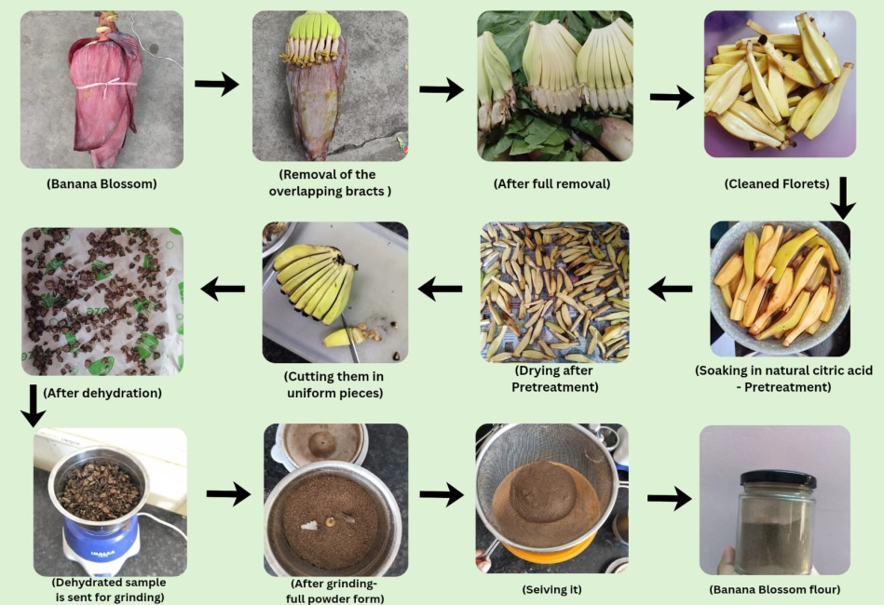

(Fig.1 Flowchart depicts the step by step procedure of making of Banana Blossom Flour)

  - Preparation of Breakfast Cereal Enriched with Banana Blossom Flour (BBF)
After the preparation of banana blossom flour, the next step of the study was to incorporate it as a functional ingredient in breakfast cereal. The base of the breakfast cereal was prepared by supplementing regular wheat flour with corn flour, amaranth flour, ground oats and ground chia seeds. Cocoa powder was added to provide a chocolate flavour to the cereal and make it more appetising. Sugar was substituted with a natural sweetener called monk fruit sweetener, which is a high-intensity, zero-calorie sweetener. It provides sweetness 150-200 times greater than regular sugar and also has antioxidant properties. Monk fruit contains natural compounds called mogrosides, which are responsible for its sweetness. All ingredients, including BBF, were weighed separately using a weighing balance. They were then mixed according to the formulations for four different samples to form dough. The control sample did not contain BBF.
Four different doughs were then kneaded according to the various compositions. The dough was properly kneaded using the correct proportion of water and melted butter. After this, the dough was flattened and given appropriate shapes; in this study, a crescent-moon shape was produced using a spoon. The shaped pieces were placed on butter paper in a baking tray and put into a microwave oven to bake at 155-165°C for 15-20 min. After the required time, the product was removed and placed at room temperature to cool. Finally, after cooling, the breakfast cereal was ready to be served with hot or cold milk according to consumer preference. It can also be consumed as bite-sized pieces for breakfast without the addition of milk.
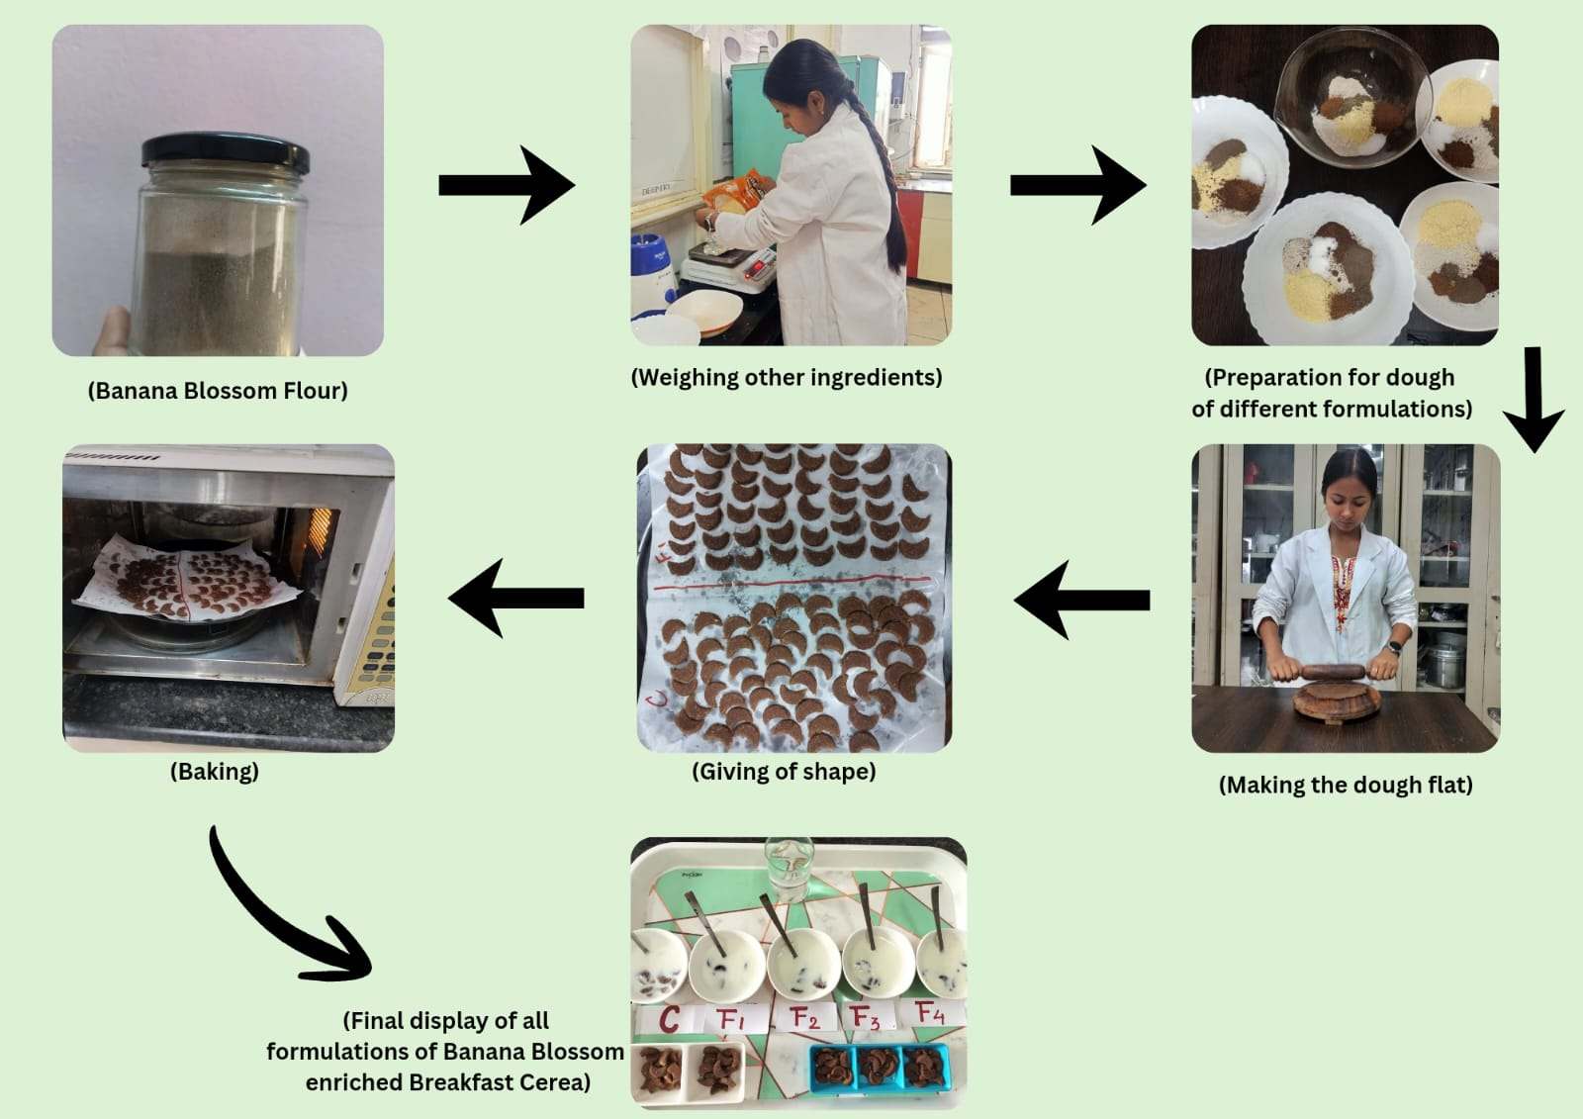

(Fig.2 Flowchart depicts the step by step procedure of the Breakfast cereal from the banana blossom flour)
(Table no. 1 Formulation table for banana blossom enriched breakfast cereal)
INGREDIENTS(gm) | CONTROL | FI | F2 | F3 | F4
Oats Flour | 25 | 20 | 15 | 10 | 5
Corn Flour | 15 | 20 | 25 | 30 | 35
Amaranthus Flour | 6 | 5 | 5 | 5 | 5
Chia Seeds (grinded) | 2 | 1 | 1 | 1 | 1
Cinnamon Powder | 2 | 1 | 1 | 1 | 1
Cocoa Powder | 2 | 2 | 2 | 2 | 2
Sweetener | 2 | 2 | 2 | 2 | 2
Banana Blossom Flour | 0 | 2 | 3 | 4 | 5

  - Proximate Analysis of Banana Blossom Flour and Banana Blossom-Enriched Breakfast Cereal
AOAC International guidelines (2019) were used to determine the moisture, ash, crude protein, crude fat and crude fibre contents of the cereal. This analysis is essential for determining the nutrient content of the newly developed product. Carbohydrate was estimated using the difference method (Beshaw et al., 2022).
2.6.1. Estimation of Moisture Content
The moisture content of the samples was determined using the oven-drying method. The amount of weight loss that occurred in the samples was used to determine the moisture content of the sample. A clean and dry Petri dish was weighed three times after drying in a hot-air oven at 105°C. The Petri dish containing the sample was then weighed as W1 and placed in an oven at 105°C for 4 h. It was then weighed again as W2 (Alam et al., 2023).
%Moisture = (W₁) – (W₂) × 100
Weight of sample (W)g
2.6.2. Estimation of Fat content
The Soxhlet method was used to estimate the fat content of the samples. Moisture-free samples were placed in a thimble attached to a stand and placed in a pre-weighed Soxhlet beaker. The beaker was filled with petroleum ether. The beaker was then connected to the Soxhlet apparatus, and the samples were extracted for 2 h at 80°C in the first cycle and 2 h at 120°C in the final cycle. Finally, the beaker was dried in a hot-air oven at 105°C for 30 min. Crude fat percentage was calculated as follows (Watkins, 2023):
% Crude Fat= Wt. of ether soluble material (W2 - W1) x 100
Weight of Sample (W)g
Where,
W1=Wt. of round bottom flask
W2=Wt. of round bottom flask + fat
W=Wt. of sample
W2-W1=Wt. of ether soluble material.
2.6.3. Estimation of Protein Content
The protein concentration was determined by the Kjeldahl method, consisting of digestion, distillation and titration. Approximately 0.3 g of the sample was digested with a catalyst mixture and concentrated sulphuric acid at 440°C for 5-6 h, resulting in a bright greenish-blue solution. The digest was diluted to 100 ml, and 10 ml of this digest was distilled with 30% sodium hydroxide. After release, the ammonia was collected in boric acid using a mixed indicator and titrated against 0.1 N hydrochloric acid. A blank was prepared in a similar manner, and its nitrogen value was used to calculate the protein content.
% Nitrogen= (Sample titre - Blank titre) x Normality of HCL × 14 × 100 x 100
(Wt. of sample x aliquot taken for distillation) × 1000
A conversion factor of 6.25 was used to convert nitrogen into protein content.
Protein % = Nitrogen% × 6.25
2.6.4. Estimation of Ash Content
To estimate ash content, the dry charring method was used. First, the constant weight of the silica crucible was established by drying it three consecutive times in a hot-air oven at 105°C. Then, 2 g of the sample was taken in a silica crucible and ignited on a Bunsen burner until the fumes stopped (charring process). It was then transferred to an electric muffle furnace until clean ash was obtained. The furnace temperature was raised to 550°C. The residue was noted and reported as a percentage (Ture & Bekele, 2024).
% Ash = (W2-W1) x 100
W(g)
Where,
W=Wt. of sample
W1-Constant Wt. of Crucible
W2- Final Wt. of crucible+ ash
2.6.5. Estimation of Fibre Content
To determine fibre content, a moisture- and fat-free sample was used. A 10 g sample was added to sulphuric acid (1.25%). The mixture was boiled for 30 min for digestion. The sample was filtered using filter paper and washed with warm water to remove residual acid. The residue was transferred to a beaker. Then, 10 ml of NaOH (1.25%) was added to the beaker. Distilled water was added to the sample, which was then boiled for 40 min. The sample was filtered again and washed with hot water until alkali-free. The sample was placed in a crucible and heated in an oven at 85°C, and the oven temperature was set at 130°C for 2 h. The second weighing was repeated, after which the sample was burned at 600°C, cooled and washed again. After charring, it was cooled in a desiccator and weighed. Fibre weight in the sample was determined by the weight lost during charring (Jenfa et al., 2024).
Fiber % = Wt of dried sample before ashing – Wt of sample after ashing × 100
Initial weight of sample

2.6.6. Estimation of Carbohydrate Content
Carbohydrate percentage was estimated using the difference method (Amusan et al., 2024).
% Carbohydrates = 100-(Moisture % + protein%+ fat% +Ash %)
  - Organoleptic Analysis of Banana Blossom-Enriched Breakfast Cereal
Sensory evaluation, or organoleptic analysis, was performed by 30 untrained panellists who were given different formulations of banana blossom flour-containing samples to taste and evaluate. The samples were randomly coded (Lyon et al., 1992). Panellists were asked to rate the randomly coded samples on a 1-9 point hedonic scale (1 = dislike extremely, 2 = dislike very much, 3 = dislike moderately, 4 = dislike slightly, 5 = neither dislike nor like, 6 = like slightly, 7 = like moderately, 8 = like very much and 9 = like extremely) based on different sensory attributes, including appearance, taste, odour, texture and overall acceptability (Wichchukit & O'Mahony, 2015).
  - Microbial Analysis of Banana Blossom-Enriched Breakfast Cereal
    - Total Plate Count
The total plate count technique (TPC) was used to quantify the total viable aerobic microbial (TVAM) load of the food matrix. The homogenised samples were serially diluted in sterile diluent, and aliquots were placed on a nutritionally complete agar medium and either poured or spread. Plates were incubated under optimal conditions with respect to both time and temperature to allow viable cells to grow into large colonies. Visible colonies were counted, and each colony was considered to have originated from a single progenitor cell or a localised group. Results were reported as colony-forming units per gram or millilitre of sample. High counts were used as an indicator of poor hygienic processing and poor shelf stability.
TPC (CFU/g) = (Number of Colonies ×Dilution Factor) / Amount of Sample Plated
    - Total Yeast and Mould Count
Yeast and mould count (YMC) is a microbiological method used to measure the population of yeast and mould microorganisms in a food product. It is a significant parameter for determining the microbiological quality, degree of spoilage and storage stability of food products.
The sample was plated on an appropriate selective culture medium and incubated under controlled conditions to allow yeasts and moulds to grow. Viable yeast and mould cells multiplied and grew into visible colonies on the agar surface during the incubation period. The numbers of these colonies were counted and expressed as colony-forming units (CFU). The test is useful for assessing fungal contamination and predicting the shelf life and safety of food products, as excessive growth of yeasts and moulds can cause food spoilage, produce off-flavours and reduce product quality.
Yeast and Mold (CFU/g) = (Number of Colonies ×Dilution Factor) / Amount of Sample Plated
  - Statistical Analysis of Banana Blossom-Enriched Breakfast Cereal
Sensory and proximate data were analysed using one-way analysis of variance (ANOVA) with a post hoc test to identify significant differences among the means at p < 0.05. IBM SPSS Software (Version 20.0) was used for statistical analysis of the sensory scores.
- RESULTS AND DISCUSSION
  - Nutritional Composition of Banana Blossom Flour (BBF)
Table 2 shows that BBF had a moderate moisture content (8.25%), which indicates the need for proper storage and dehydration to prevent spoilage. Fat was relatively low (2.12%); therefore, BBF can be considered a low-fat ingredient for breakfast meals. The protein content (14.75%) reflects that it is a notable source of plant-based protein. The ash content (4.38%) indicates the presence of minerals. The most prominent component was carbohydrate content (70.05%). This shows that BBF is a rich source of energy, making it suitable for addition to staple food items. The notable crude fibre content (15.85%) indicates that BBF may support digestive health and be relevant to cardiovascular disease management. The nutritional composition of BBF indicates that it is rich in macro- and micronutrients and fibre, making it a valuable ingredient (Tasnim et al., 2020).
  - Nutritional Composition of Banana Blossom-Enriched Breakfast Cereal
Table 2 shows that the breakfast cereal enriched with BBF had lower moisture content (4.00%) than BBF, which may support a longer shelf life. Fat content was slightly higher (4.95%) and contributed to the energy value of the cereal. The protein content (17.60%) indicates that the breakfast cereal is a good source of plant-based protein. It had a lower ash content, suggesting lower mineral content in the cereal. The carbohydrate content of 71.17% makes BBF a suitable ingredient for breakfast cereal. It acts as a source of energy, which is appropriate for the first meal of the day. The high crude fibre content (24.76%) may be beneficial for reducing blood sugar levels, maintaining digestive health and supporting satiety.
The nutritional analysis showed that banana blossom-enriched breakfast cereal is a good source of energy, plant-based protein and fibre, making it suitable as a meal to start the day. The developed product was nutritionally enriched and showed potential functional qualities.
(Table 2 The Nutritional Composition of Banana Blossom Flour(BBF) and the BBF enriched Breakfast cereal)
Parameters |  | BBF |  | BBF-enriched Breakfast Cereal
Moisture (%) |  | 8.25±0.28 |  | 4.00±0.12
Fat (%) |  | 2.12±0.34 |  | 4.95±0.27
Protein (%) |  | 14.75±0.55 |  | 17.60±0.29
Ash (%) |  | 4.38±0.11 |  | 2.27±0.09
Carbohydrate (%) |  | 70.05±0.46 |  | 71.17±0.42
Crude Fibre (%) |  | 15.85±0.28 |  | 24.76±0.18

(Table 3 Statistical analysis showing F- Value and P- Value of Proximate Composition parameters of Banana Blossom Flour and Banana Blossom enriched breakfast cereal)
Parameter |  | F-Value |  |  | P- Value
Moisture (%) |  | 75.058 |  |  | 0.001
Fat (%) |  | 29.939 |  |  | 0.005
Protein (%) |  | 63.844 |  |  | 0.001
Ash (%) |  | 92.685 |  |  | 0.001
Fibre (%) |  | 289.680 |  |  | 0.000
Carbohydrate (%) |  | 96.490 |  |  | 0.001

One-way ANOVA was used as the statistical test to determine the significant difference in values at p < 0.05. The results in Table 3 show that there were significant differences between BBF and BBF-enriched breakfast cereal for all nutritional parameters.
Moisture, fat, protein, ash, fibre and carbohydrate contents between BBF and BBF-enriched breakfast cereal were significantly different (p < 0.05), as analysed by one-way ANOVA. In general, the proximate analyses confirm that the use of banana blossom flour affected and improved the nutritional composition of the developed breakfast food.

  - Organoleptic Analysis of Banana Blossom-Enriched Breakfast Cereal

(Table 4 Overall Sensory Scored of Breakfast Cereal)
Treatment | Organoleptic Evaluation
Treatment | Appearance | Taste | Smell | Texture
C | 8.37±0.56^{be} | 8.33±0.61^{d} | 8.20±0.71^{ce} | 8.20±0.66^{c}
F1 | 7.97±0.67^{ac} | 8.20±0.76^{c} | 7.97±0.67^{c} | 7.97±0.72^{c}
F2 | 8.57±0.57^{bde} | 8.60±0.50^{bde} | 8.57±0.50^{bd} | 8.57±0.50^{bde}
F3 | 8.13±0.73^{c} | 7.97±0.76^{ac} | 7.97±0.72^{c} | 8.03±0.72^{c}
F4 | 7.87±0.73^{ac} | 8.20±0.6^{c} | 7.73±0.74^{c} | 8.00±0.64^{c}
(a= comparison with control, b= comparison with F1, c= comparison with F2, d= comparison with F3, e= comparison with F4)
The organoleptic assessment indicated notable differences (p = 0.05) among the treatments regarding appearance, flavour, aroma and texture. The comparison identified F2 as the most acceptable sample. Regarding appearance, sample F2 achieved the highest rating, and ANOVA showed significant differences when compared with F1, F3 and F4. The control (C) group also showed significant differences from all formulations. Samples F1 and F4 received lower scores for appearance and differed significantly from most other treatments. In terms of flavour, substantial variations were noted among the samples. Sample F2 emerged as the most favoured and showed significant differences from F1, F3 and F4, whereas the control (C) was similar to F1 and F4 but differed from F3 and F2.
In terms of aroma, sample F2 again received the highest acceptability score of 8.57 and was significantly different from the other samples. The control sample (C) showed significant differences from both F2 and F4 but was similar to F1 and F3. The evaluation of texture also revealed significant variations among the treatments. Sample F2 received the highest rating and was significantly different from all other samples. The control (C), F1, F3 and F4 showed minimal variation among them and were statistically similar in texture. Overall, sample F2 emerged as the most preferred formulation across all sensory characteristics. Although differences were noted among the other treatments, all samples fell within an acceptable range, demonstrating good sensory quality.
  - Microbial Analysis of Banana Blossom-Enriched Breakfast Cereal
    - Total Plate Count
The total plate count (TPC) of the banana blossom-enriched breakfast cereal was found to be 5.80 × 10² CFU/g (580 CFU/g). The low microbial count is an indicator of good manufacturing practices and effective thermal processing. No elevated counts were found; thus, the product development process did not introduce any undesirable microbes into the final product. This indicates that the food product is microbiologically safe for human consumption. Overall, the total plate count result indicates that the banana blossom-enriched breakfast cereal was processed following food safety protocols and prepared in a hygienic environment. This also increases the shelf life of the developed product.
3.4.2. Total Yeast and Mould Count
The yeast and mould count in the banana blossom-enriched breakfast cereal was found to be less than 10 CFU/g (<10 CFU/g). This shows that there was no significant growth of yeast and mould in the cereal matrix. Thus, the matrix suggests low water activity under standard storage conditions. Hence, it can be concluded that the breakfast cereal is microbiologically safe, stable and of good hygienic quality.
  - Statistical Analysis
Table 3 shows the results derived from one-way ANOVA of nutritional parameters, including moisture (%), ash (%), fat (%), protein (%), fibre (%) and carbohydrate (%) of BBF and BBF-enriched breakfast cereal. The results determined that there were significant differences (p < 0.05) among the proximate compositions.
Table 4 clearly shows that, among all formulations, F2 recorded the highest scores for appearance (8.57 ± 0.57), taste (8.60 ± 0.50), smell (8.57 ± 0.50) and texture (8.57 ± 0.50), indicating the highest overall acceptability.
The analyses were performed using IBM SPSS Software (Version 20.0).
CONCLUSION
Banana blossom, or banana heart, is one of the most underutilised parts of the banana plant (Lau et al., 2020). It has considerable nutritional value; therefore, its addition to breakfast cereal can support the development of a nutritionally enriched food product (Thagunna et al., 2023). The research was mainly carried out to study the development and characterisation of the developed product through proximate and sensory analyses. It showed that the product is rich in energy, potassium, calcium, phosphorus and fibre (Zou et al., 2022). The proximate analysis determined that the breakfast cereal had carbohydrate, protein and fibre contents of 71.17%, 17.60% and 24.76%, respectively, compared with banana blossom flour itself; thus, it provides considerable energy (Edima-Nyah et al., 2024). This makes it suitable as a breakfast meal. It is also rich in dietary fibre and protein (Begum & Deka, 2019). The cereal had low moisture content, which indicates that it can be stored for a longer period. The organoleptic evaluation clearly showed that formulation F2 had the best overall acceptability in appearance, taste, smell and texture. The study can be continued further by using other pre-treatment techniques, drying methods, structural analysis and antioxidant property evaluation.

LIMITATIONS
The study mainly focused on nutritional, proximate and microbial analyses, whereas other bioactive components were not discussed in detail. The sensory analysis was conducted with a limited panel size; therefore, the findings may not represent all consumer preferences. The study was conducted under controlled laboratory conditions, so real-market acceptability, large-scale industrial processing and commercial feasibility were not established. Cost analysis was not estimated, and long-term stability was not extensively studied.

Declaration of AI Use
This manuscript was prepared through the combined contributions of all author(s), including contributions to the study design, data, content development, results, interpretation, and related scholarly work. The author(s) acknowledge the use of Grammarly and ChatGPT to assist with grammar checking, language refinement, reference formatting. These AI-assisted tools were not used as authors and did not replace the intellectual contributions or scholarly judgment of the author(s). All AI-assisted outputs, including content, references, and interpretations, were carefully reviewed, revised, verified, and approved by the author(s). The author(s) accept full responsibility for the accuracy, integrity, and final content of the manuscript.

REFERENCES
AOAC International. (2019). Official methods of analysis of AOAC International (21st ed.; G. W. Latimer Jr., Ed.). https://www.aoac.org/official-methods-of-analysis/
Alam, M., Biswas, M., Hasan, M. M., Hossain, M. F., Zahid, M. A., Al-Reza, M. S., & Islam, T. (2023). Quality attributes of the developed banana flour: Effects of drying methods. Heliyon, 9(7), Article e18312. https://doi.org/10.1016/j.heliyon.2023.e18312
Ambrose, D. C. P., Sumithra, V., Vijay, K., & Vinodhini, K. (2018). Techniques to improve the shelf life of freshly harvested banana blossoms. Current Agriculture Research Journal, 6(2), 141–149. https://doi.org/10.12944/CARJ.6.2.02
Amusan, T. O., Ogunbiyi, O. J., Shoge, M., Jemkur, M., & Joseph, P. S. (2024). Evaluation of phytochemical compounds and proximate analysis of doum palm fruit (Hyphaene thebaica) blend with turmeric powder (Curcuma longa). BMC Chemistry, 18, Article 140. https://doi.org/10.1186/s13065-024-01256-6
Begum, Y. A., & Deka, S. C. (2019). Chemical profiling and functional properties of dietary fibre rich inner and outer bracts of culinary banana flower. Journal of Food Science and Technology, 56(12), 5298–5308. https://doi.org/10.1007/s13197-019-04000-4
Beshaw, T., Demssie, K., Tefera, M., & Guadie, A. (2022). Determination of proximate composition, selected essential and heavy metals in sesame seeds (Sesamum indicum L.) from the Ethiopian markets and assessment of the associated health risks. Toxicology Reports, 9, 1806–1812. https://doi.org/10.1016/j.toxrep.2022.09.009
Betts, J. A., Chowdhury, E. A., Gonzalez, J. T., Richardson, J. D., Tsintzas, K., & Thompson, D. (2016). Is breakfast the most important meal of the day? Proceedings of the Nutrition Society, 75(4), 464–474. https://doi.org/10.1017/S0029665116000318
Chiang, S.-H., Yang, K.-M., Lai, Y.-C., & Chen, C.-W. (2021). Evaluation of the in vitro biological activities of banana flower and bract extracts and their bioactive compounds. International Journal of Food Properties, 24(1), 1–16. https://doi.org/10.1080/10942912.2020.1856134
Comerford, K. B. (2026). The impacts of ready-to-eat-cereals and cereal fibers on gut health, body weight, and cardiometabolic health. Frontiers in Nutrition, 13, Article 1717345. https://doi.org/10.3389/fnut.2026.1717345
de Oliveira Vilhena, R., Fachi, M. M., Marson, B. M., Dias, B. L., Pontes, F. L. D., Tonin, F. S., & Pontarolo, R. (2018). Antidiabetic potential of Musa spp. inflorescence: A systematic review. Journal of Pharmacy and Pharmacology, 70(12), 1583–1595. https://doi.org/10.1111/jphp.13020
Edima-Nyah, A. P., Ekanem, K. E., Ntukidem, V. E., & Ogbonna, C. V. (2024). Chemical, microbial, and sensory properties of breakfast cereals made from yellow maize and soybean flour blends with firmly ripe banana flavoring. IPS Journal of Nutrition and Food Science, 3(3), 227–233. https://doi.org/10.54117/ijnfs.v3i3.55
Elaveniya, E., & Jayamuthunagai, J. (2014). Functional, physicochemical and anti-oxidant properties of dehydrated banana blossom powder and its incorporation in biscuits. International Journal of ChemTech Research, 6(9), 4446–4454. https://sphinxsai.com/2014/RTBCE/6/%284446-4454%29%20014.pdf
Jenfa, M. D., Adelusi, O. A., Aderinoye, A., Coker, O. J., Martins, I. E., & Obadina, O. A. (2024). Physicochemical compositions, nutritional and functional properties, and color qualities of sorghum–orange-fleshed sweet potato composite flour. Food Science & Nutrition, 12(4), 2364–2378. https://doi.org/10.1002/fsn3.3922
Joshi, P., & Srivastava, A. (2024). Enhancing nutrition and value: Innovative uses of banana blossom in functional food products. Journal of Medicinal and Aromatic Plant Sciences, 46(4), 143–150. https://doi.org/10.62029/jmaps.v46i4.joshi
Kaewjumpol, G., Srisamlee, S., Beckles, D. M., & Luengwilai, K. (2021). Enzymatic browning in banana blossoms and techniques for its reduction. Horticulturae, 7(10), Article 373. https://doi.org/10.3390/horticulturae7100373
Kajal, Pandey, A. K., Singh, S., Sangamesh, Dev, R., Gurjar, T., & Patel, A. (2026). Nutritional, mineral and polyphenolic characterisation of dried banana inflorescence powder from different Musa cultivars. Plant Science Today. Advance online publication. https://doi.org/10.14719/pst.13471
Kapoor, T., & Haripriya, A. (2020). Formulation and evaluation of functional, nutritional and sensory properties of inulin incorporated ready-to-eat multi-grain breakfast cereal. The Indian Journal of Nutrition and Dietetics, 57(4), 422. https://doi.org/10.21048/IJND.2020.57.4.25805
Komal, & Kaur, P. (2019). Development of value-added product and evaluation of banana blossom incorporated nut chocolate. International Journal of Trend in Scientific Research and Development, 3(5), 1930–1931. https://www.ijtsrd.com/home-science/food-and-nutrition/26383/development-of-value-added-product-and-evaluation-of-banana-blossom-incorporated-nut-chocolate/komal
Lakshmi, S., Padmavathy, K., Jayamathi, G., Prabu, D., & Sathyapriya, B. (2024). Phytochemical analysis and antioxidant potential of methanol extract of banana blossom. Research Journal of Pharmacy and Technology, 17(8), 3587–3592. https://doi.org/10.52711/0974-360X.2024.00560
Lau, B. F., Kong, K. W., Leong, K. H., Sun, J., He, X., Wang, Z., Mustafa, M. R., Ling, T. C., & Ismail, A. (2020). Banana inflorescence: Its bio-prospects as an ingredient for functional foods. Trends in Food Science & Technology, 97, 14–28. https://doi.org/10.1016/j.tifs.2019.12.023
Legowo, A. M., Pramono, Y. B., Hintono, A., Setiani, B. E., Nabila, A. Z., & Handoko, N. R. K. (2024). Inhibition of Maillard reaction of kepok banana flour with citric acid. Indonesian Journal of Agricultural Research, 7(1), 29–37. https://doi.org/10.32734/injar.v7i1.15207
Lyon, D. H., Francombe, M. A., Hasdell, T. A., & Lawson, K. (Eds.). (1992). Guidelines for sensory analysis in food product development and quality control. Springer. https://doi.org/10.1007/978-1-4615-1999-7
Nirmala Prasadi, V. P., & Joye, I. J. (2020). Dietary fibre from whole grains and their benefits on metabolic health. Nutrients, 12(10), Article 3045. https://doi.org/10.3390/nu12103045
Pereira, A., & Maraschin, M. (2015). Banana (Musa spp.) from peel to pulp: Ethnopharmacology, source of bioactive compounds and its relevance for human health. Journal of Ethnopharmacology, 160, 149–163. https://doi.org/10.1016/j.jep.2014.11.008
Ryan, L., Thondre, P. S., & Henry, C. J. K. (2011). Oat-based breakfast cereals are a rich source of polyphenols and high in antioxidant potential. Journal of Food Composition and Analysis, 24(7), 929–934. https://doi.org/10.1016/j.jfca.2011.02.002
Sheng, Z.-W., Ma, W.-H., Jin, Z.-Q., Bi, Y., Sun, Z.-G., Dou, H.-T., Gao, J.-H., Li, J.-Y., & Han, L.-N. (2010). Investigation of dietary fiber, protein, vitamin E and other nutritional compounds of banana flower of two cultivars grown in China. African Journal of Biotechnology, 9(25), 3888–3895. https://doi.org/10.5897/AJB10.253
Tasnim, T., Das, P. C., Begum, A. A., Nupur, A. H., & Mazumder, M. A. R. (2020). Nutritional, textural and sensory quality of plain cake enriched with rice rinsed water treated banana blossom flour. Journal of Agriculture and Food Research, 2, Article 100071. https://doi.org/10.1016/j.jafr.2020.100071
Thagunna, B., Kandel, K., & Lamichhane, B. (2023). Banana blossom: Nutritional value, health benefits and its utilization. Reviews in Food and Agriculture, 4(2), 66–70. https://doi.org/10.26480/rfna.02.2023.66.70
Tolfrey, K., & Zakrzewski, J. K. (2012). Breakfast, glycaemic index and health in young people. Journal of Sport and Health Science, 1(3), 149–159. https://doi.org/10.1016/j.jshs.2012.09.001
Ture, E., & Bekele, M. (2024). Optimal biscuit baking condition and characterization of the biscuit physiochemical, functional, antioxidant, anti-nutrient and textural properties. Cogent Food & Agriculture, 10(1), Article 2412368. https://doi.org/10.1080/23311932.2024.2412368
Watkins, P. (2023). Comparing the use of chloroform to petroleum ether for Soxhlet extraction of fat in meat. Animal Production Science, 63(14), 1445–1449. https://doi.org/10.1071/AN23014
Welch, R. W. (2011). Nutrient composition and nutritional quality of oats and comparisons with other cereals. In F. H. Webster & P. J. Wood (Eds.), Oats: Chemistry and technology (2nd ed., pp. 95–107). AACC International. https://doi.org/10.1094/9781891127649.006
Wichchukit, S., & O’Mahony, M. (2015). The 9-point hedonic scale and hedonic ranking in food science: Some reappraisals and alternatives. Journal of the Science of Food and Agriculture, 95(11), 2167–2178. https://doi.org/10.1002/jsfa.6993
Zou, F., Tan, C., Zhang, B., Wu, W., & Shang, N. (2022). The valorization of banana by-products: Nutritional composition, bioactivities, applications, and future development. Foods, 11(20), Article 3170. https://doi.org/10.3390/foods11203170

