Virtual Laboratory Modelling: Its Impact on Learners’ Conceptual Understanding in Science

ABSTRACT
This study investigated the impact of virtual laboratories on learners’ conceptual understanding of photosynthesis. A quasi-experimental pretest–posttest design with comparison groups was employed. The experimental group received ICT-integrated instruction through virtual laboratory simulations, whereas the control group received traditional teacher-centred instruction based on lectures, textbook readings and teacher-directed activities. The study was conducted among learners studying photosynthesis within the science curriculum at a public high school in Tema, Ghana. The final analytic sample comprised 85 learners who completed the required assessments. Data were analysed using descriptive statistics and Welch’s t-test. The pretest results showed no statistically significant difference between the experimental and control groups (t = 0.04, p = .971, Hedges’ g = 0.01), indicating comparable prior knowledge before the intervention. The posttest results showed a statistically significant difference in favour of the experimental group (t = 3.97, p < .001, Hedges’ g = 0.97). Based on conventional benchmarks, this effect size indicates a large effect and suggests that learners who engaged with the virtual laboratory demonstrated stronger acquisition of photosynthesis concepts than those taught through the traditional approach. The findings indicate that virtual laboratories can support the teaching and learning of complex biological processes by providing interactive visualisations, structured practice and opportunities for active engagement. The study recommends that educators select ICT tools that are aligned with specific learning objectives and constructivist learning principles, including scaffolding, timely feedback, learner interaction and visual representation of abstract processes. The findings should be interpreted within the study’s quasi-experimental design, sample and contextual limitations.
Keywords: Virtual laboratories; virtual laboratory modelling; ICT integration; conceptual understanding; science education; photosynthesis; secondary school learners; quasi-experimental design; constructivist learning; Ghana
INTRODUCTION
The instruction and acquisition of biochemistry, specifically the intricate molecular mechanisms integral to photosynthesis, constitute one of the most formidable challenges in contemporary science education. As a fundamental biological process, photosynthesis provides a foundational framework for explaining energy transformation within living systems and sustains most life on Earth. Despite its critical significance, empirical research consistently demonstrates that learners across all educational levels encounter substantial difficulties in comprehending the core conceptual frameworks associated with photosynthesis. Notably, misconceptions established during childhood exhibit considerable resilience and frequently persist into adulthood, including among educators themselves (Jančaříková & Jančařík, 2022). These persistent conceptual inaccuracies create a cascading effect: inadequately prepared educators may inadvertently perpetuate erroneous conceptual frameworks, thereby impeding student comprehension and academic achievement in biochemistry education.
The pedagogical challenges associated with acquiring knowledge of photosynthesis arise from multiple interrelated factors. The biochemical processes involved encompass intricate molecular interactions, including electron transport chains, enzyme-catalysed reactions and energy transformations occurring at microscopic scales. This inherent complexity makes such processes difficult for students to visualise and conceptualise without appropriate pedagogical scaffolding. Furthermore, Jančaříková and Jančařík (2022) contend that advances in molecular life sciences have increasingly dismantled traditional epistemological boundaries among disciplines such as chemistry, biology, physics, medicine, mathematics and computer science. This growing interdisciplinarity requires learners to synthesise knowledge across multiple scientific domains concurrently, which may precipitate cognitive overload and conceptual dissonance. One promising pedagogical intervention for addressing these educational challenges is the strategic integration of Information and Communication Technology (ICT) into science education curricula.
The integration of Information and Communication Technology (ICT) has gained substantial recognition as an effective pedagogical strategy for enhancing the teaching and learning of complex scientific concepts. Among these technological innovations, virtual laboratories have emerged as particularly salient instructional tools. Virtual laboratories attained significant prominence during the COVID-19 pandemic by providing an innovative mechanism for students to engage in experimental activities remotely when access to physical laboratories was constrained. These platforms enable learners to conduct experiments in flexible and accessible environments, thereby reducing disruptions to conventional instructional practices (Vasiliadou, 2020). Furthermore, the incorporation of virtual simulation experiments into conventional laboratory instruction has been shown to enhance students’ conceptual understanding and retention of experimental procedures and underlying theoretical paradigms (Sun et al., 2023). This evidence suggests that virtual laboratories may achieve optimal pedagogical efficacy when used to complement, rather than replace, traditional hands-on instruction, thereby fostering hybrid learning environments that maximise educational outcomes and instructional effectiveness.
Although the literature indicates that virtual laboratories can support science learning, the manuscript shows that evidence is still needed on how such tools influence learners’ conceptual understanding of photosynthesis in authentic secondary school contexts. In particular, there remains a need to compare virtual laboratory instruction with traditional teacher-centred approaches using baseline and post-intervention measures. Addressing this gap is important because photosynthesis involves abstract biochemical processes that learners often find difficult to visualise and explain.
Purpose of the study
The purpose of this study was to investigate the impact of virtual laboratories on students’ conceptual understanding of photosynthesis. This study contributes to bridging the gap between educational theory and practice by providing empirical evidence on the effectiveness of virtual laboratories, while also offering practical recommendations for their implementation across diverse educational contexts.
Objective
To evaluate the effectiveness of virtual laboratories in enhancing learners’ conceptual understanding of photosynthesis relative to traditional instructional methods.
Research questions
The study sought to answer the following question: How does teaching with virtual laboratories compare with traditional teaching methods in terms of learners’ conceptual understanding of photosynthesis?
LITERATURE REVIEW
Challenges in photosynthesis
Research consistently identifies photosynthesis as one of the most challenging topics in science education. A comprehensive review of 80 systematically selected articles revealed that misconceptions formed during childhood are robust and often persist into adulthood, including among teachers (Jančaříková & Jančařík, 2022). This finding is particularly concerning because it suggests a cyclical pattern in which misconceptions may be transmitted from teachers to learners across generations.
Studies indicate that learners often fail to recognise fundamental differences between photosynthesis and respiration, including their distinct chemical pathways, locations within the plant and the conditions under which they occur (Parker et al., 2012). Several persistent misconceptions about photosynthesis have been documented. For instance, many learners confuse photosynthesis with plant respiration and believe that respiration occurs only in leaves through specialised structures such as pores. Additionally, students often assert that plants produce oxygen throughout the entire day and that the primary source of plant nutrition is water containing dissolved mineral substances (Svandova, 2014).
Barman et al. (2006) note that elementary learners frequently believe that food must originate from outside an organism. While this is true for animals, plants synthesise sugars and starches through photosynthesis. This misconception may stem from students’ tendency to attribute human characteristics to plants (anthropomorphism). The confusion is further exacerbated by the common reference to fertiliser as ‘plant food’, which learners may misinterpret as the primary source of energy for plants.
ICT integration in science education
The integration of Information and Communication Technology (ICT) in science education is strongly grounded in constructivist learning theory. Hardman (2019) asserts that there is a robust connection between constructivist theory and the use of technology in education. Constructivism posits that learners actively construct knowledge through experiences, interactions and reflection, making ICT tools particularly effective for facilitating meaningful and student-centred learning experiences.
Despite its potential benefits, ICT integration faces substantial challenges. For instance, a physics teacher eager to incorporate ICT tools and web-based experiments reported feeling overwhelmed by the abundance of available options and uncertain about which tools to select or how to integrate them effectively into lessons. Anderman et al. (2012) similarly emphasise the need for systematic guidance and support for educators seeking to integrate ICT tools effectively. Furthermore, teachers’ use of ICT in teaching and learning is influenced by their training, expertise and technical skills (Asianoa et al., 2022), underscoring the importance of comprehensive teacher preparation and ongoing professional development in successful ICT integration initiatives.
Although the short-term benefits of ICT integration have been documented, Crogman et al. (2025) note that further research is needed to examine the long-term retention effects of ICT-mediated learning compared with traditional instructional approaches. This represents a significant gap in current understanding regarding the sustained impact of technology-enhanced instruction.
Concept of virtual laboratories
Virtual laboratories are interactive digital simulations of activities typically conducted in physical laboratory settings. According to Badillo et al. (2020), virtual laboratories replicate the tools, equipment, tests and procedures used in chemistry, biochemistry, physics, biology and related disciplines. They offer several advantages, including reduced costs, increased accessibility, enhanced safety and the capacity to visualise processes that are difficult or impossible to observe in traditional laboratory environments.
Virtual laboratories have demonstrated particular promise for teaching photosynthesis. These virtual activities provide flexible approaches for engaging undergraduate students in scientific practices. Through online simulations, students can conduct virtual experiments on key biochemical reactions occurring during photosynthesis. In a typical virtual photosynthesis laboratory, students manipulate variables such as light intensity, light colour and the distance of the light source from the plant. The plant is depicted in a beaker with a test tube, where bubbling indicates the rate of photosynthesis, which students can measure over time (Hardman, 2019). Such interactive experiences enable students to explore cause-and-effect relationships within biochemical processes, thereby facilitating deeper conceptual understanding.
Research on the effectiveness of virtual laboratories has yielded positive outcomes. Virtual experimental platforms in chemistry laboratory education have demonstrated a significant impact on students’ experimental self-efficacy. Students who engage with virtual laboratories report greater confidence in their experimental abilities and demonstrate improved understanding of complex biochemical processes.
METHOD
Design
The study employed a quasi-experimental pretest–posttest design with comparison groups to examine the impact of virtual laboratories on students’ conceptual understanding of photosynthesis. In this design, the experimental group received ICT-integrated instruction through virtual laboratories, which provided interactive, simulation-based learning experiences aligned with the photosynthesis curriculum. In contrast, the control group received traditional teacher-centred instruction, consisting primarily of lectures, textbook readings and teacher-directed activities without the use of virtual laboratory tools.
This quasi-experimental design was selected because the study utilised intact classes, that is, pre-existing instructional groups that were already organised within the school’s regular curriculum. Random assignment of individual students to experimental or control conditions was therefore impractical and potentially disruptive to the school’s instructional schedule. The use of intact classes is a common and accepted approach in educational research when working within authentic school settings, as it allows researchers to investigate the effects of instructional interventions while maintaining the natural classroom structure (Creswell & Creswell, 2023).
The pretest–posttest structure enabled the researchers to assess students’ conceptual understanding of photosynthesis before and after the instructional intervention, thereby allowing for the measurement of within-group changes and between-group differences. This design strengthens the study’s internal validity by establishing baseline equivalence between groups and controlling for pre-existing differences in prior knowledge. Additionally, the inclusion of a control group receiving traditional instruction provides a comparative benchmark for evaluating the relative effectiveness of the virtual laboratory intervention.
Setting, population and sampling technique
The study was conducted with learners studying photosynthesis as part of the science curriculum at a reputable public high school in Tema, Ghana. The final sample consisted of 85 learners who completed both the pre-intervention and post-intervention assessment instruments, ensuring data completeness for analysis. Participants represented a diverse mix of genders and spanned multiple grade levels (Forms 1–3), reflecting the typical composition of secondary science classes in Ghanaian public schools.
A convenience sampling approach was employed to select the participating school and classes, given their accessibility and willingness to collaborate on the research project. Intact classes, which were pre-existing instructional groups organised by the school’s administrative structure, were assigned to experimental and control conditions based on administrative constraints, including scheduling requirements and classroom availability. This approach is consistent with quasi-experimental design principles, which are commonly used in educational research when random assignment of individual participants is impractical or disruptive to normal school operations (Creswell & Creswell, 2023).
To mitigate potential selection bias arising from the use of intact classes, the experimental and control groups were matched as closely as possible on key demographic and academic variables. Specifically, the groups were equated on prior science achievement, based on the previous term’s science grades, age and patterns of technological access, including availability of personal devices and home internet connectivity. This matching process strengthened the study’s internal validity by ensuring that observed differences in posttest outcomes could be more confidently attributed to the instructional intervention rather than to pre-existing differences between groups.
All participants were provided with informed consent prior to participation in the study, and the research protocol adhered to ethical standards for educational research involving minors. The study was conducted over a period of four weeks during the second term of the academic year, aligning with the scheduled instruction of photosynthesis within the national science curriculum.
Data collection instruments
Pretest and posttest assessments were employed as the primary instruments for data collection in this quasi-experimental study. The pretest was designed to measure learners’ prior knowledge of photosynthesis before the implementation of the virtual laboratory intervention, thereby establishing a baseline for comparison across the experimental and control groups. This initial assessment ensured that any observed differences in posttest outcomes could be attributed to the instructional intervention rather than to pre-existing differences in conceptual understanding.
The posttest was administered immediately after completion of the instructional period to assess learners’ conceptual knowledge and retention of photosynthesis concepts. Instruction was delivered through two distinct approaches: the experimental group received instruction through the virtual laboratory, which provided interactive simulations and hands-on experimentation in a digital environment, whereas the control group received instruction through the traditional lecture-based method, consisting of teacher-centred presentations, textbook readings and instructor-directed activities.
Reliability and validity
Internal consistency of the scales was evaluated using Cronbach’s alpha, with a threshold of ≥0.70 considered acceptable for research purposes (Nunnally & Bernstein, 1994). Item–total correlations were examined to refine the scales, identifying and removing items with weak correlations (<0.30) to enhance measurement precision. Content validity was established by systematically aligning knowledge items with the national photosynthesis curriculum and recognised conceptual benchmarks in science education. Test items covered key conceptual domains, including the chemical equation of photosynthesis, chloroplast and chlorophyll function, light-dependent and light-independent reactions, factors affecting photosynthesis rates and common misconceptions about photosynthesis versus respiration.
Three experienced biology teachers, each with at least five years of secondary science instruction, reviewed the test items to evaluate validity, clarity and alignment with instructional objectives. Their expert feedback strengthened content validity and ensured that items were accessible at the targeted grade levels. Items were designed to assess students’ knowledge and comprehension levels according to Bloom’s taxonomy (Bloom et al., 1956), including multiple-choice and short-answer questions requiring recall, explanation and application to novel scenarios. A pilot test with 20 students from a comparable school identified ambiguous items and verified timing requirements. Minor revisions improved clarity and reduced response time.
Procedures
Phase 1: Pre-Intervention
During the first phase, a pretest was administered to all participating classes in Week 1. The purpose of the pretest was to establish baseline data on learners’ prior knowledge of photosynthesis before the intervention. This baseline served as a reference point for evaluating learning outcomes following the instructional intervention.
Phase 2: Intervention (2–3 Weeks)
The second phase involved the instructional intervention, which lasted approximately two to three weeks.
Experimental Group: Virtual Laboratory Instruction. Learners in the experimental group engaged in virtual laboratory sessions designed to enhance their understanding of photosynthesis. These sessions included simulations of key processes such as the light-dependent reactions, the production of ATP and NADPH and the stages of the Calvin cycle. Visualisations were also used to illustrate the ultrastructure of the chloroplast and the flow of energy and carbon during photosynthesis. The digital tools incorporated embedded quizzes with immediate feedback, allowing learners to revisit activities and practise concepts until mastery was achieved. Instructional tasks were scaffolded to support learning, and optional collaborative activities were included to align with constructivist learning principles.
Control Group: Traditional Lecture Method. Learners in the control group received instruction through traditional methods, including textbook readings and teacher-led lectures. The same curriculum content and equivalent instructional time were maintained as in the experimental group. The teacher covered key processes such as the light-dependent reactions, the production of ATP and NADPH and the Calvin cycle using textbook explanations and images. Visual aids from the textbook were used to illustrate chloroplast structure and the flow of energy and carbon during photosynthesis. Quizzes were administered with immediate feedback, and instructional tasks were structured to support learning. Optional collaborative activities were also included to reflect constructivist principles.
Phase 3: Post-Intervention
The final phase occurred after the instructional period. A posttest was administered to both the experimental and control groups within one week of completing the intervention. This assessment measured learners’ knowledge following instruction and enabled comparison with pretest results. Additionally, learners provided reflections on their learning experiences, offering further insight into the effectiveness of the instructional approaches.
Data analysis plan
Descriptive statistics, including normalised test scores, were used to summarise learners’ knowledge levels. Additionally, Welch’s t-test was employed to determine whether there were statistically significant differences in knowledge between groups.
RESULTS AND DISCUSSION
Pretest knowledge by group (normalised)
Table 1. Descriptive statistics for pretest knowledge scores
Group | N | M | SD
Control | 29 | 0.283 | 0.147
Experimental | 56 | 0.284 | 0.131

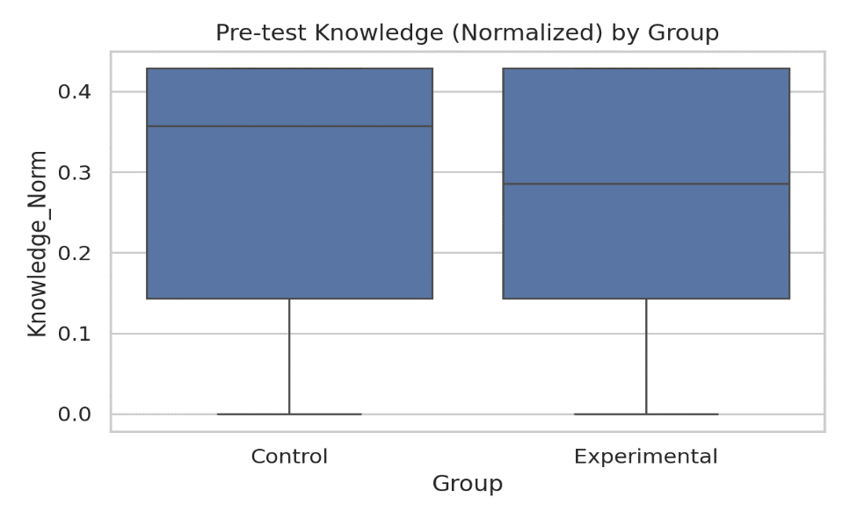

Figure 1. Pretest knowledge by group
As shown in Table 1 and Figure 1, the two groups demonstrated comparable baseline knowledge of photosynthesis at pretest, with nearly identical mean scores (Control: M = 0.283, SD = 0.147; Experimental: M = 0.284, SD = 0.131). This similarity indicates that the groups were equivalent before the intervention, an essential prerequisite for quasi-experimental designs. At posttest, the experimental group outperformed the control group, with a statistically significant difference and a small-to-moderate effect size.
This pattern aligns with guidance on quasi-experimental pretest–posttest designs, which emphasises that comparable baseline measures are critical for strengthening internal validity (Capili & Anastasi, 2024; Harris et al., 2006). Furthermore, the finding that the experimental group demonstrated statistically significantly greater gains at posttest is consistent with science education research on photosynthesis, in which instructional interventions targeting misconceptions yield larger improvements in treated groups compared with control groups (Adcock, 2003; Anderson et al., 1990).
Posttest knowledge by group (normalised)
Table 2. Descriptive statistics for posttest knowledge scores
Group | N | M | SD
Control | 31 | 0.419 | 0.096
Experimental | 54 | 0.497 | 0.068

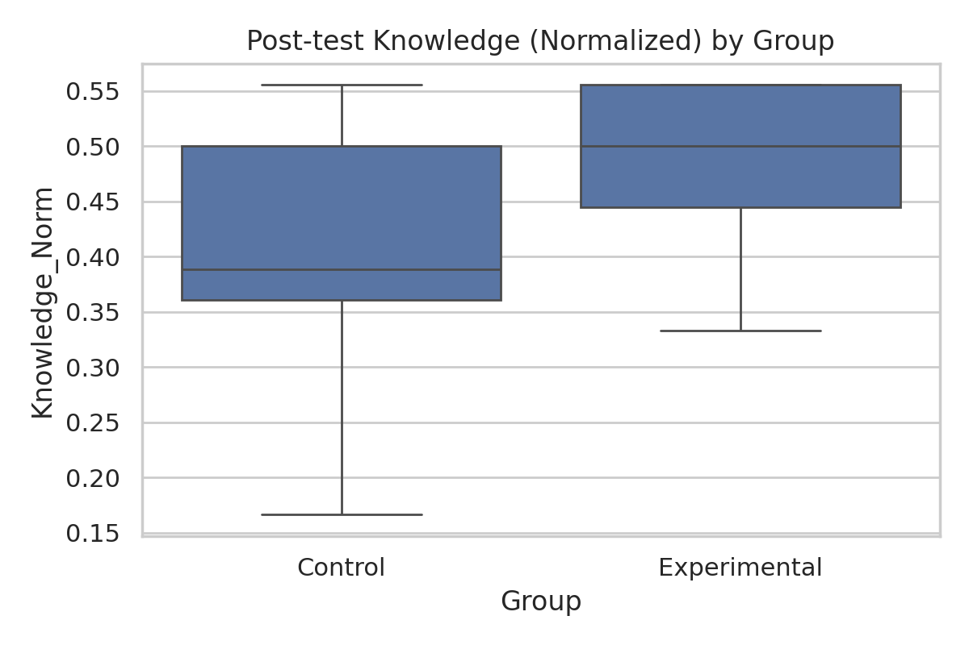

Figure 2. Posttest knowledge by group
As shown in Table 2 and Figure 2, both groups demonstrated improvement from baseline following the instructional intervention. However, the experimental group achieved higher posttest knowledge scores (M = 0.497, SD = 0.068) compared with the control group (M = 0.419, SD = 0.096). Additionally, the experimental group exhibited less variability in scores, as indicated by its smaller standard deviation. These results indicate that posttest knowledge favoured the experimental group, with a statistically significant difference and a large effect size.
Welch’s t-tests were employed to account for potential heterogeneity of variance (Delacre et al., 2017), and effect sizes were calculated using Hedges’ g (Hedges, 1981). The Welch’s t-test revealed no significant difference in pretest knowledge between the control and experimental groups (t = 0.04, p = 0.971, Hedges’ g = 0.01), confirming baseline equivalence. In contrast, posttest knowledge scores differed significantly, with the experimental group outperforming the control group (t = 3.97, p < .001, Hedges’ g = 0.97). According to conventional benchmarks (Cohen, 1988; Kassa et al., 2024), an effect size of 0.97 represents a large effect, suggesting that virtual laboratories had a substantial positive impact on students’ acquisition of photosynthesis knowledge. This finding aligns with research demonstrating that multimedia and ICT-based instruction can enhance student achievement in biology topics (Ferede et al., 2024).
Implications
The present study is significant across multiple dimensions because it addresses critical challenges in science education while contributing to broader educational goals. Specifically, it examines one of the persistent problems in biochemistry education: misconceptions about photosynthesis formed during childhood are robust and often persist into adulthood, including among teachers themselves. By investigating how virtual laboratories can transform the teaching and learning of complex biochemical processes such as photosynthesis, this study directly addresses this fundamental issue and offers a promising instructional approach for mitigating the perpetuation of conceptual errors across generations.
Limitations
This study should be interpreted in light of several limitations. The use of convenience sampling and intact classes limited random assignment and may restrict the generalisability of the findings beyond the participating public high school in Tema, Ghana. Although the groups were matched as closely as possible, unmeasured differences in motivation, prior exposure to ICT tools and learning preferences may have influenced the outcomes. The intervention was implemented over a relatively short period of two to three weeks, and the posttest was administered shortly after instruction; therefore, the study did not determine whether the observed gains were sustained over time. Variation in access to ICT infrastructure and occasional technical difficulties may also have affected implementation consistency. In addition, individual cognitive styles and learning needs were not fully examined. Budgetary and time constraints further limited the range of virtual laboratory tools that could be evaluated in the local study context overall.

CONCLUSIONS AND RECOMMENDATIONS
The findings of this study indicate that virtual laboratory instruction improved learners’ conceptual understanding of photosynthesis when compared with traditional teacher-centred instruction. The experimental and control groups demonstrated comparable baseline knowledge at pretest, while the experimental group achieved significantly higher posttest scores after the intervention. The large effect size (Hedges’ g = 0.97) suggests that interactive simulations can support learners in engaging with abstract processes such as light-dependent reactions, ATP and NADPH production, chloroplast structure and the Calvin cycle. These outcomes should, however, be interpreted within the study’s quasi-experimental design and contextual limitations. The results support the careful integration of virtual laboratories as complementary instructional tools rather than as replacements for teacher guidance or practical science experiences. Teachers should select digital tools that align with curriculum objectives, provide meaningful visualisation, promote active knowledge construction and offer timely feedback. Schools should also provide reliable devices, internet access and technical support to enable effective implementation. In addition, teachers require appropriate preparation to integrate virtual laboratories purposefully into science lessons. Overall, the study provides evidence that well-planned virtual laboratory activities can enhance conceptual learning in photosynthesis when implemented within a structured pedagogical framework and adequate institutional support in broadly similar science classroom contexts.

Ethical Approval and consent
Official permission to conduct the study was obtained from the relevant school authorities before the commencement of data collection. Ethical considerations were carefully observed throughout the research process. Informed consent was obtained from all participating learners after a clear and comprehensive explanation of the study’s purpose, procedures and potential benefits had been provided.
Participants were explicitly informed of their right to decline participation or withdraw from the study at any point without penalty or negative consequences. To ensure ethical integrity, confidentiality and anonymity were strictly maintained. Learners’ identities were not recorded in any reports or publications, and all data collected were securely stored and used solely for research purposes. Furthermore, data were handled with care during collection, analysis and interpretation to prevent potential misuse or unauthorised access.

Disclaimer (Artificial intelligence)
The author(s) hereby declare that no generative AI technologies including large language models (e.g., ChatGPT, Copilot) or text-to-image generators were used during the writing or editing of this manuscript.
References
- Adcock, B. C. (2003). Examining the impact of directly addressing a major misconception about photosynthesis prior to instruction [Master’s thesis, North Carolina State University]. NC State Theses and Dissertations. https://repository.lib.ncsu.edu/items/580e2d35-6c5e-4ef0-8d37-ba6f9946ea47
- Anderman, E. M., Sinatra, G. M., & Gray, D. L. (2012). The challenges of teaching and learning about science in the twenty-first century: Exploring the abilities and constraints of adolescent learners. Studies in Science Education, 48(1), 89–117. https://doi.org/10.1080/03057267.2012.655038
- Anderson, C. W., Sheldon, T. H., & Dubay, J. (1990). The effects of instruction on college nonmajors’ conceptions of respiration and photosynthesis. Journal of Research in Science Teaching, 27(8), 761–776. https://doi.org/10.1002/tea.3660270806
- Asianoa, R., Kuupille, F., Segbefia, S. K., & Asenso, J. A. (2022). Examining the integration of ICT into teaching and learning: A study of colleges of education in the Volta Region. Integrated Journal for Research in Arts and Humanities, 2(6), 15–24. https://doi.org/10.55544/ijrah.2.6.3
- Badillo, J., Londino-Smolar, G., & Savvides, P. (2020). 7 things you should know about virtual labs. EDUCAUSE. https://library.educause.edu/resources/2020/8/7-things-you-should-know-about-virtual-labs
- Bloom, B. S. (Ed.), Engelhart, M. D., Furst, E. J., Hill, W. H., & Krathwohl, D. R. (1956). Taxonomy of educational objectives: The classification of educational goals: Handbook I: Cognitive domain. David McKay Company.
Nunnally, J. C., & Bernstein, I. H. (1994). Psychometric theory (3rd ed.). McGraw-Hill.
- Capili, B., & Anastasi, J. K. (2024). An introduction to types of quasi-experimental designs. AJN, American Journal of Nursing, 124(11), 50–52. https://doi.org/10.1097/01.NAJ.0001081740.74815.20
- Cohen, J. (1988). Statistical power analysis for the behavioral sciences (2nd ed.). Lawrence Erlbaum Associates. https://doi.org/10.4324/9780203771587
- Kassa, M. M., Azene, M. K., Mengstie, S. M., & Ferede, M. W. (2024). Effect of using multimedia and dynamic classroom integrated instruction on grade 11 students’ biology academic achievement. Heliyon, 10(18), Article e37315. https://doi.org/10.1016/j.heliyon.2024.e37315
- Creswell, J. W., & Creswell, J. D. (2023). Research design: Qualitative, quantitative, and mixed methods approaches (6th ed.). SAGE Publications. https://us.sagepub.com/en-us/nam/research-design/book270550
- Crogman, H. T., Cano, V. D., Pacheco, E., Sonawane, R. B., & Boroon, R. (2025). Virtual reality, augmented reality, and mixed reality in experiential learning: Transforming educational paradigms. Education Sciences, 15(3), Article 303. https://doi.org/10.3390/educsci15030303
- Delacre, M., Lakens, D., & Leys, C. (2017). Why psychologists should by default use Welch’s t-test instead of Student’s t-test. International Review of Social Psychology, 30(1), 92–101. https://doi.org/10.5334/irsp.82
- Hardman, J. (2019). Towards a pedagogical model of teaching with ICTs for mathematics attainment in primary school: A review of studies 2008–2018. Heliyon, 5(5), Article e01726. https://doi.org/10.1016/j.heliyon.2019.e01726
- Jančaříková, K., & Jančařík, A. (2022). How to teach photosynthesis? A review of academic research. Sustainability, 14(20), Article 13529. https://doi.org/10.3390/su142013529
- Nunnally, J. C., & Bernstein, I. H. (1994). Psychometric theory (3rd ed.). McGraw-Hill.
- Parker, J. M., Anderson, C. W., Heidemann, M., Merrill, J., Merritt, B., Richmond, G., & Urban-Lurain, M. (2012). Exploring undergraduates’ understanding of photosynthesis using diagnostic question clusters. CBE—Life Sciences Education, 11(1), 47–57. https://doi.org/10.1187/cbe.11-07-0054
- Harris, A. D., McGregor, J. C., Perencevich, E. N., Furuno, J. P., Zhu, J., Peterson, D. E., & Finkelstein, J. (2006). The use and interpretation of quasi-experimental studies in medical informatics. Journal of the American Medical Informatics Association, 13(1), 16–23. https://doi.org/10.1197/jamia.M1749
- Sun, L., Liu, D., Lian, J., & Yang, M. (2023). Application of flipped classroom combined with virtual simulation platform in clinical biochemistry practical course. BMC Medical Education, 23, Article 771. https://doi.org/10.1186/s12909-023-04735-x
- Švandová, K. (2014). Secondary school students’ misconceptions about photosynthesis and plant respiration: Preliminary results. EURASIA Journal of Mathematics, Science and Technology Education, 10(1), 59–67. https://doi.org/10.12973/eurasia.2014.1018a
- Vasiliadou, R. (2020). Virtual laboratories during coronavirus (COVID-19) pandemic. Biochemistry and Molecular Biology Education, 48(5), 482–483. https://doi.org/10.1002/bmb.21407
- Hedges, L. V. (1981). Distribution theory for Glass’s estimator of effect size and related estimators. Journal of Educational Statistics, 6(2), 107–128. https://doi.org/10.3102/10769986006002107
- Barman, C. R., Stein, M., McNair, S., & Barman, N. S. (2006). Students’ ideas about plants & plant growth. The American Biology Teacher, 68(2), 73–79. https://doi.org/10.1662/0002-7685(2006)068%5B0073:SIAPPG%5D2.0.CO;2

