Original Research Article
Evaluation of Antifungal Activities of Silver Nanoparticles Impregnated Hydrogel for Advanced Biomedical Applications

ABSTRACT

Fungal infections associated with wounds and biomedical devices continue to pose a serious challenge for health-care, thus the development of effective antimicrobial materials is needed. Here, we have synthesised an antifungal hydrogel using silver nanoparticles (AgNPs) and explored its potential for biomedical applications. AgNPs were synthesised by green route and were loaded into a tri-polymeric hydrogel matrix containing κ-carrageenan (k-C), polyethylene glycol (PEG) and polyvinylpyrrolidone (PVP). The prepared hydrogel showed good transparency, structural stability and uniform distribution of AgNPs in the polymeric network. The antifungal activity of the AgNP loaded hydrogel was studied against Aspergillus niger in both therapeutic and prevention model. The hydrogel was found to effectively inhibit fungal growth on contaminated potato dextrose agar (PDA) surfaces in the treatment model with a clear zone of inhibition as compared to the nanoparticle-free control. The prevention model consisted of a biphasic nutrient-rich hydrogel system, with one half consisting of AgNPs and the other half as control. The AgNP-containing area showed complete inhibition of fungal colonization, while the control side showed extensive fungal growth. The results showed that the addition of AgNPs into the hydrogel matrix did not influence its antifungal activity. The advantages of biocompatible polymeric network and potent antifungal activity of AgNPs make this hydrogel a promising candidate for wound dressings, infection control and other biomedical applications. The present study offers the potential of AgNPs based hydrogel as advanced antimicrobial biomaterials, and a stepping stone for future studies including physicochemical characterisation, biocompatibility evaluation and in vivo wound healing investigation.

Keywords: Silver nanoparticles, Antifungal hydrogel, κ-Carrageenan, Polyethylene glycol, Polyvinylpyrrolidone, Aspergillus niger, Biomedical applications.

- INTRODUCTION

Skin wounds continue to pose a significant global healthcare challenge, contributing to increased morbidity, prolonged hospitalisation , disability, and mortality. The healing of acute and chronic wounds is a highly complex biological process involving hemostasis, inflammation, proliferation, and tissue remodeling.(Sulastri et al., 2023). However, wound repair is often impaired by several factors, including microbial infections, ischemia, excessive inflammatory responses, metabolic and endocrine disorders, and compromised immune function. These complications can delay tissue regeneration, promote chronic ulceration, increase susceptibility to recurrent infections, and ultimately diminish patients' quality of life.(Shahrousvand et al., 2023).
Traditional wound dressings, such as medical gauze, are widely used because of their low cost, ease of application, and accessibility. Despite these advantages, conventional dressings exhibit several limitations, including poor moisture retention, inadequate protection against microbial contamination, and adhesion to newly formed tissue, which may cause additional trauma during dressing removal(Pereira & Faria, 2024). Consequently, the development of advanced wound dressings capable of providing an optimal healing environment has become an important area of biomedical research. An ideal wound dressing should possess high exudate absorption capacity, moisture-retaining ability, gas permeability, antimicrobial activity, biocompatibility, biodegradability, mechanical flexibility, and the ability to reduce oxidative stress and pain during dressing changes.(P. Singh et al., 2023).

Among the various biomaterials investigated for wound management, hydrogels have emerged as highly promising candidates. Hydrogels are three-dimensional hydrophilic polymer networks capable of absorbing and retaining large amounts of water while maintaining their structural integrity through physical or chemical crosslinking.(Linima et al., 2023). Their high water content, biocompatibility, tunable mechanical properties, and structural resemblance to natural extracellular matrices make them particularly suitable for wound healing, tissue engineering, regenerative medicine, and drug delivery applications(Mirzaei et al., 2023),(Liu & Chen, 2024).

Hydrogels can be fabricated from either natural or synthetic polymers. Natural hydrogel-forming biopolymers include carrageenan, collagen, chitosan, gelatin, fibrin, silk fibroin, alginate, and hyaluronic acid, whereas synthetic hydrogels are commonly prepared from polymers such as polyvinyl alcohol (PVA), poly(acrylic acid) (PAA), poly(lactic acid) (PLA), poly(lactic-co-glycolic acid) (PLGA), poly(hydroxyethyl methacrylate) (PHEMA), polyvinylpyrrolidone (PVP), and polyethylene glycol (PEG).(Satchanska et al., 2024) Synthetic polymers generally offer superior mechanical strength, stability, and tunable physicochemical properties.(Dreiss, 2020). Among them, PEG and PVP is widely used in hydrogel formulations because of its excellent hydrophilicity, non-toxicity, and biocompatibility, particularly in drug delivery applications.Zhao et al., 2023). PEG-based hydrogels are frequently combined with other biomaterials to optimize their physicochemical and biological properties(Wang et al., 2023). PVP can absorb up to 100 times its weight in water. This helps to keep the wound moist which is important for healing. A moist wound will heal more quickly than a dry one and is less likely to become infected(Xu et al., 2023).

Carrageenan, a naturally derived sulfated polysaccharide extracted from red algae, has gained substantial interest as a hydrogel-forming biomaterial for wound healing applications.(Pereira & Faria, 2024). Composed primarily of galactose and its derivatives, carrageenan exhibits excellent gel-forming ability along with several beneficial biological activities, including anticoagulant, antiviral, antibacterial, anti-inflammatory, and wound-healing properties. These characteristics make carrageenan an attractive component for the development of multifunctional wound dressings(Michalec et al., 2025).

Microbial infection remains one of the most critical barriers to successful wound healing. The accumulation of wound exudates provides a favorable environment for microbial proliferation and biofilm formation, which can delay tissue regeneration and increase the risk of local and systemic infections (Benali et al., 2023). To address this challenge, antimicrobial agents have been incorporated into wound dressings to enhance their therapeutic efficacy. Among these agents, silver nanoparticles (AgNPs) have attracted considerable attention because of their broad-spectrum antimicrobial activity(Aldakheel et al., 2023). Silver has long been recognized for its antimicrobial properties; however, nanoscale silver demonstrates enhanced biological activity due to its increased surface area and improved interaction with microbial cells.(Eker et al., 2025),(Fahim et al., 2024). Nanoparticle stability is a crucial factor influencing their functionality and biomedical performance, (Soltau Missio Pinheiro et al., 2023). Generally, nanoparticles can be stabilized through electrostatic stabilization, steric stabilization, or electrosteric stabilization, (Rodrigues et al., 2020). Various stabilizing agents such as surfactants, polymers, dendrimers, and biomacromolecules have been utilized to improve nanoparticle stability and prevent aggregation. Among polymeric stabilizers, hydrogels represent an important class of materials that have received substantial attention, particularly for biomedical and pharmaceutical applications. (Luceri et al., 2023), (Rodrigues et al., 2020).

AgNPs exert their antimicrobial effects through multiple mechanisms, including disruption of cell membrane integrity, generation of reactive oxygen species, inhibition of cellular respiration, interference with DNA replication, and induction of oxidative stress (Althobaiti et al., 2023), (Menichetti et al., 2023).The ability of AgNPs to target multiple cellular pathways simultaneously reduces the likelihood of microbial resistance development, making them particularly effective against multidrug-resistant pathogens(Ardjoum et al., 2022). Recent studies have highlighted the therapeutic potential of silver-based wound dressings. Clinical investigations have demonstrated that silver-containing dressings can significantly reduce surgical site infections and accelerate wound healing compared with conventional dressings.(Haroon et al., 2023),(Akin et al., 2022). Furthermore, AgNP-based wound dressings have shown enhanced healing performance in chronic wounds, including pressure ulcers, thereby supporting their application in advanced wound care systems.(Pangli et al., 2021)

Considering the favorable biological properties of carrageenan, PEG, PVP, and silver nanoparticles, the development of a composite hydrogel integrating these materials offers a promising strategy for wound healing applications.(Benali et al., 2023) Therefore, the present study aimed to develop a novel PVP/PEG-based hydrogel incorporated with green-synthesized silver nanoparticles and evaluate its suitability as an advanced wound dressing material. A comparative assessment was performed between hydrogels containing AgNPs and those without AgNPs to investigate their antimicrobial activity, and wound-healing potential. The findings demonstrated that the AgNP-loaded hydrogel was non-toxic, exhibited significant antifungal activity, and effectively promoted wound healing, highlighting its potential for biomedical and therapeutic applications.

- MATERIAL AND METHODS
2.1. Materials
k-carrageenan (k-C), polyethylene glycol (PEG), polyvinylpyrrolidone (PVP) ,KCl and AgNO3 were utilized for hydrogel synthesis. All solutions were prepared utilizing MilliQ water. Distilled water was utilized for the preparation of any solutions in antifungal study. The Fungal strains of Aspergillus niger were obtained from the Microbiology Department of Shobhit University. These strains were then cultured in nutrient broth and incubated at 32°C for 24 to 42 hours. After incubation, potato dextrose agar media were prepared and poured into petri dishes for further analysis.
2.2 Experimental Section
2.2.1 Synthesis of k-C/PEG/PVP Hydrogels
A suitable clinically relevant tri-polymeric hydrogel system (k-C/PEG/PVP) was prepared by blending k-carrageenan (k-C) , polyvinylpyrrolidone (PVP) ,and polyethylene glycol (PEG) addressing its potential biomedical applications like wound healing. Prior to the hydrogel fabrication, aqueous solutions of individual polymer were prepared using distilled water. A 1.0 % (w/v) k-carrageenan (k-C) , 7% (w/v) PVP, and 1.5%( w/v) PEG(Sigma, USA) was prepared by dissolving in 50 ml distilled water at 80 °C for 30 min with gentle stirring according to (De Silva et al., 2011). These polymeric solutions were then blended at 80 °C with vigorous stirring to ensure homogeneous mixing. The sol-gel transition occurred at temperature below 30 °C.
2.2.2 Preparation of AgNPs Impregnated-Hydrogel
To evaluate the antifungal potential of the developed hydrogel system, AgNPs at an optimized concentration of 10 ppm were incorporated into the κ-carrageenan (k-C)/polyethylene glycol (PEG)/polyvinylpyrrolidone (PVP) hydrogel matrix during formulation. Briefly, 1 mL of AgNP suspension was mixed with 10 mL of the tri-polymeric k-C/PEG/PVP solution and poured into a Petri dish. The mixture was allowed to stand under controlled conditions until a uniform hydrogel layer with an approximate thickness of 1 mm was formed. Subsequently, the hydrogel was treated with 0.2 M potassium chloride (KCl) solution to facilitate interchain crosslinking and enhance structural stability. The crosslinked hydrogel sheets were then cut into small pieces and thoroughly washed with distilled water to remove any residual KCl. The purified and stabilized AgNP-loaded hydrogel sheets were subsequently utilized to assess their antifungal activity against Aspergillus niger.

2.2.3 Antifungal Properties of AgNPs Impregnated-Hydrogel
2.3.3.1. Antifungal activities: The Treatment Approach Using an In Vitro Model simulating Contaminated Wound
A 100 µL fungal suspension of Aspergillus niger was uniformly spread onto the surface of solidified nutrient agar plates and allowed to air dry for a short period under aseptic conditions. Subsequently, AgNP-impregnated hydrogel pieces were carefully placed onto the inoculated agar surface. Hydrogel sheets without AgNP incorporation served as the control group (Figure 1C, a). The plates were then incubated at 37 °C for 24–48 h, after which fungal growth and inhibition at the interface between the agar medium and the hydrogel sheets were examined and recorded.

2.3.3.2. Antifungal activities: The Preventive Approach Using an In Vitro Model simulating Fresh Wound
A seamless biphasic hydrogel plate was fabricated in which one half of the hydrogel contained AgNPs, while the other half served as the control. Briefly, 2 mL of sterile nutrient broth medium (5%, w/v; Sigma, USA) was thoroughly mixed with 25 mL of the tri-polymeric κ-carrageenan (k-C)/polyethylene glycol (PEG)/polyvinylpyrrolidone (PVP) composite solution . The resulting solution was divided into two equal portions. AgNPs were incorporated into one portion, whereas the second portion remained nanoparticle-free and served as the control.
Both hydrogel formulations were simultaneously poured into opposite sides of a 30 mm Petri plate, allowing the two solutions to meet and form a continuous interface along the central line. The plate was then maintained at room temperature (25 °C) under laminar airflow conditions to facilitate the sol–gel transition. Following complete gelation, 100 µL of an Aspergillus niger spore suspension was uniformly spread over the hydrogel surface and incubated at 25 °C for 3–5 days to evaluate fungal growth and inhibition across the biphasic hydrogel system (Figure 1A).
All experiments described in Section 2.3 were performed in triplicate under aseptic conditions within a laminar airflow cabinet to ensure reproducibility and prevent microbial contamination.
2.3. Statistical analysis
All the experiments were performed in triplicates and results are expressed as mean ± standard deviation.

3. Results
3.1 Preparation of k-C-PEG/PVP Hydrogels
The synthesis of the κ-carrageenan (k-C)/polyethylene glycol (PEG)/ polyvinylpyrrolidone (PVP) hydrogel was carried out as illustrated in Figure 1. Briefly, the PEG chains were crosslinked within the polymeric network through ionic interactions induced by potassium chloride (KCl), resulting in the formation of a stable hydrogel matrix. The successful formation of the hydrogel was evidenced by the appearance of transparent and uniform hydrogel sheets, as shown in Figure 1.

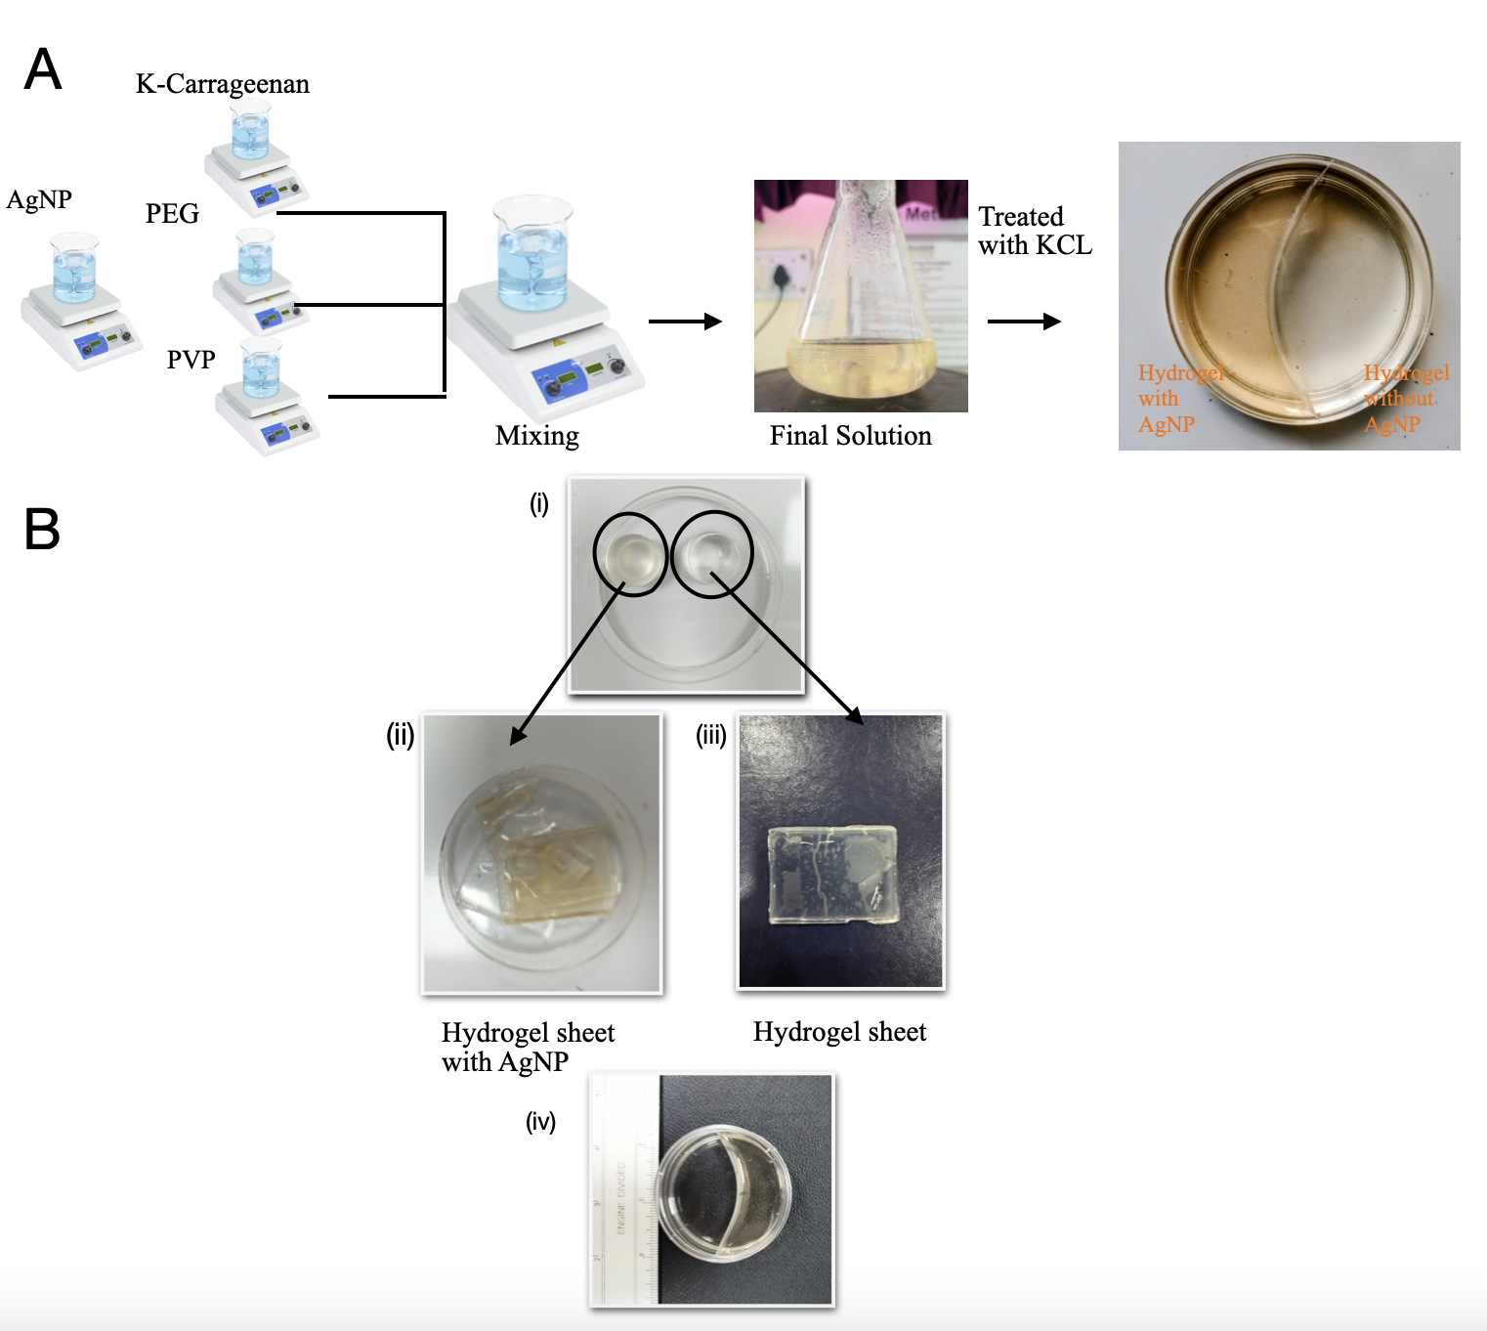

Figure 1. Antimicrobial hydrogel preparation; (A) representing the fabrication of AgNPs (10 ppm) impregnated clinically relevant tri-polymeric hydrogel composed of k-carrageenan, polyethylene glycol and polyvinylpyrrolidone (PVP) (k-C-PEG-PVP), including the cross-linking mechanism in presence of potassium chloride (KCl) and its envisioned application for the treatment of contaminated atopic chronic wounds, (B) Images representing the impregnation of AgNPs into the hydrogel system. (ii) The brown-colored hydrogel blocks or sheets indicate successful incorporation of AgNPs, (iii) whereas the transparent hydrogels serve as the control and (iv) shows biphasic hydrogel system consisting of one half Containing hydrogel and other half have AgNP incorporated hydrogel.

3.2 Preparation of AgNPs Impregnated-Hydrogel
To assess whether the antifungal activity of AgNPs was retained after incorporation into a polymeric matrix, the nanoparticles were embedded within a clinically relevant κ-carrageenan (k-C)/polyethylene glycol (PEG)/polyvinylpyrrolidone (PVP) hydrogel system with potential applications in wound healing. For this purpose, a tri-polymeric hydrogel composed of k-C, PEG, and PVP was fabricated, and AgNPs were incorporated during the hydrogel preparation process. The resulting hydrogel was transparent and exhibited a light brown coloration, indicating the successful incorporation of AgNPs into the polymeric network (Figure B). The AgNP-loaded hydrogel was subsequently evaluated using two different approaches to investigate its antifungal efficacy: (i) treatment of contaminated wound models and (ii) prevention of fungal colonization and growth.

3.2.1 Treatment of Contaminated Wound Approach
For this purpose, a uniform fungal lawn of Aspergillus niger was first established on the surface of solidified agar plates to simulate a contaminated wound environment. AgNP-impregnated hydrogel sheets were then carefully placed onto the inoculated agar surface. A distinct zone of inhibition was observed at the interface between the agar medium and the AgNP-loaded hydrogel sheets (left), indicating effective suppression of fungal growth. In contrast, substantial fungal growth was observed beneath and around the control hydrogel sheets lacking AgNPs (right), confirming the absence of antifungal activity in the control system (Figure 2).
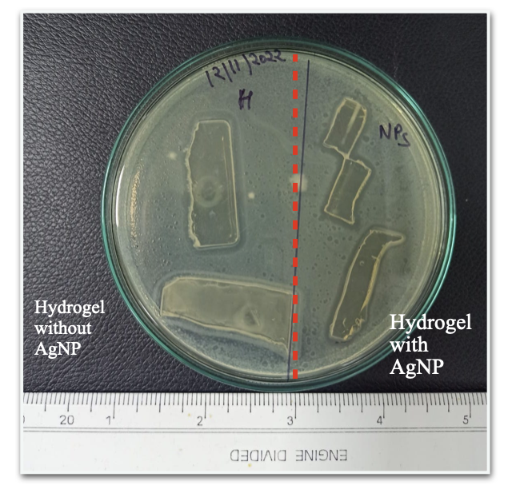

Figure 2. Evaluation of the Antifungal Activity of AgNP-Loaded Hydrogels Using Therapeutic and Models. (A) Treatment of contaminated wound approach; representation of a simulated contaminated wound, where an agar plate with bacteria spread onto its surface acts as a contaminated wound bed, and the application of AgNP-impregnated hydrogel represents the treatment, and image showing successful killing of A. Niger following the treatment with AgNPs impregnated hydrogel system.

3.2.2 The Preventive Approach
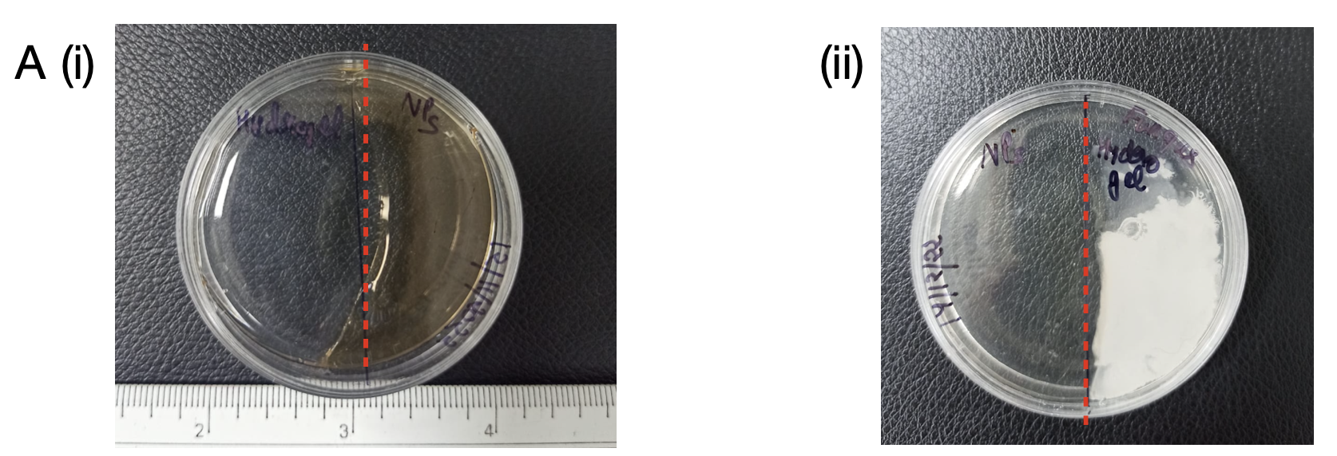
To simulate a freshly formed wound susceptible to microbial contamination, a seamless biphasic nutrient-rich hydrogel plate was fabricated, with one half (50%) impregnated with AgNPs and the other half serving as the control. A suspension of Aspergillus niger was then uniformly spread across the entire hydrogel surface. Following incubation, no fungal growth was observed on the AgNP-loaded region of the hydrogel, whereas the control region exhibited extensive fungal colonization and was completely covered by fungal growth (Figure 3(ii)). These findings demonstrate the effective preventive antifungal activity of the AgNP-impregnated hydrogel against A. niger.
Figure 3. Evaluation of the Antifungal Activity of AgNP-Loaded Hydrogels Using Preventive Approach; representing the preparation of a seamless biphasic hydrogel plate, where one half contains AgNPs, simulating a fresh wound bed protected by the antimicrobial hydrogel layer, and figure showing the biphasic hydrogel (i) Control; the biphasic hydrogel plate, where the AgNP-containing region (left) exhibits a characteristic brown coloration, indicating successful nanoparticle incorporation, and (ii) Test; fungal growth occurring exclusively on the control region (right), whereas no fungal colonization is observed on the AgNP-loaded hydrogel, confirming its preventive antifungal efficacy.

4. DISCUSSIONS
Antimicrobial resistance (AMR) has emerged as a major global healthcare challenge, largely driven by the excessive and inappropriate use of antibiotics. One promising strategy to mitigate this issue is the development of alternative antimicrobial agents, such as silver nanoparticles (AgNPs), which exhibit broad-spectrum antibacterial activity while reducing dependence on conventional antibiotics. Although AgNPs can be applied directly in solution form, the present study focused on their incorporation into a biopolymeric hydrogel matrix to develop an effective antimicrobial wound dressing for the management of atopic, chronic, and infected wounds.
To verify the retention of antifungal efficacy within a three-dimensional polymeric network, AgNPs were incorporated into a di-polymeric hydrogel composed of polyethylene glycol (PEG) and carrageenan. Both polymers are extensively studied, biocompatible, FDA-approved materials widely utilized in biomedical applications due to their non-toxic nature and favorable physicochemical properties. The antimicrobial performance of the AgNP-loaded hydrogel was assessed using two different approaches: treatment of contaminated wounds and prevention of wound contamination. In the treatment model, agar plates were used to simulate wound beds, while fungal growth on the agar surface represented an infected wound environment. Application of the AgNP-impregnated hydrogel resulted in significant fungal inhibition, indicating its effectiveness in treating contaminated wounds. In the preventive model, AgNPs were incorporated into a nutrient-rich hydrogel system prior to fungal inoculation, thereby simulating a wound dressing containing embedded antimicrobial agents. The complete absence of fungal growth on the AgNP-loaded hydrogel confirmed the sustained antifungal activity of the nanoparticles and highlighted the hydrogel's potential to prevent microbial colonization and infection(Pangli et al., 2021).
Since the principal aim of this study was to develop AgNP-based antimicrobial materials, the synthesis conditions and nanoparticle concentration were optimized primarily based on antibacterial performance. Consequently, this work focused on the AgNPs successful incorporation into a clinically relevant hydrogel system intended for atopic wound-healing applications. However, further investigations are required to comprehensively evaluate its physicochemical and biological properties, including rheological and mechanical behavior, swelling capacity, water uptake, biodegradation characteristics, and in vitro biocompatibility. These studies will provide a deeper understanding of the hydrogel's performance and further validate its suitability for biomedical and wound-care applications.
5. CONCLUSION
A silver nanoparticle (AgNP)-loaded hydrogel system was successfully developed and evaluated for both therapeutic and preventive wound-healing applications. These findings indicate that the AgNPs retained their antifungal efficacy even after incorporation into the hydrogel matrix, highlighting the potential of such hydrogel systems as antimicrobial wound dressings. Therefore, the developed AgNP-loaded hydrogel represents a promising platform for the prevention and treatment of fungal infections in wound-healing applications as compared to without AgNP-loaded hydrogel. In the current study, considering all these favourable characteristics, carrageenan-based hydrogels was fabricated and green synthesized AgNPs were incorporated to represent a promising platform for biomedical applications. The integration of biocompatible hydrogels with antimicrobial nanoparticles offers opportunities to develop multifunctional materials with enhanced therapeutic efficacy and improved biological performance.

CONFLICTS OF INTEREST
There are no conflicts to declare

Disclaimer(Artificial intelligence )

We hereby declare that NO generative AI technologies such as Large Language Models (ChatGPT, COPILOT,etc.) and text-to-image generators have been used during the writing or editing this manuscript.

REFERENCES:

- Akin, T., Kendirci, M., Akgün, A. E., Çetinkaya, E., Er, S., Akin, M., & Yasti, A. Ç. (2022). Applying a silver-containing dressing to the incision site and its effect on the development of surgical site infection after ostomy closure: A prospective randomized clinical pilot study. Wound Management & Prevention, 68(4), 34–43. https://doi.org/10.25270/wmp.2022.4.3443

- Aldakheel, F. M., Sayed, M. M. E., Mohsen, D., Fagir, M. H., & El Dein, D. K. (2023). Green synthesis of Silver Nanoparticles loaded hydrogel for wound healing; Systematic review. Gels (Basel, Switzerland), 9(7), 530. https://doi.org/10.3390/gels9070530

- Althobaiti, F., Abu Ali, O. A., Kamal, I., Alfaifi, M. Y., Shati, A. A., Fayad, E., Elbehairi, S. E. I., Elshaarawy, R. F. M., & El-Fattah, W. A. (2023). New ionic liquid microemulsion-mediated synthesis of silver nanoparticles for skin bacterial infection treatments. Antibiotics (Basel, Switzerland), 12(2), 247. https://doi.org/10.3390/antibiotics12020247

- Ardjoum, N., Shankar, S., Chibani, N., Salmieri, S., & Lacroix, M. (2022). In situ synthesis of silver nanoparticles in pectin matrix using gamma irradiation for the preparation of antibacterial pectin/silver nanoparticles composite films. Food Hydrocolloids, 121(107000), Not Available. https://doi.org/10.1016/j.foodhyd.2021.107000

- Benali, F., Boukoussa, B., Issam, I., Iqbal, J., Mokhtar, A., Hachemaoui, M., Habeche, F., Hacini, S., & Abboud, M. (2023). Zinc nanoparticles encapsulated in porous biopolymer beads for
- reduction of water pollutants and antimicrobial activity. International Journal of Biological Macromolecules, 248(125832), 125832. https://doi.org/10.1016/j.ijbiomac.2023.125832

- De Silva, D. A., Hettiarachchi, B. U., Nayanajith, L. D. C., Milani, M. D. Y., & Motha, J. T. S. (2011). Development of a PVP/kappa-carrageenan/PEG hydrogel dressing for wound healing applications in Sri Lanka. Journal of the National Science Foundation of Sri Lanka, 39(1), 25. https://doi.org/10.4038/jnsfsr.v39i1.2920

- Dreiss, C. A. (2020). Hydrogel design strategies for drug delivery. Current Opinion in Colloid & Interface Science, 48, 1–17. https://doi.org/10.1016/j.cocis.2020.02.001

- Eker, F., Akdaşçi, E., Duman, H., Bechelany, M., & Karav, S. (2025). Green synthesis of silver nanoparticles using plant extracts: A comprehensive review of physicochemical properties and multifunctional applications. International Journal of Molecular Sciences, 26(13), 6222. https://doi.org/10.3390/ijms26136222

- Fahim, M., Shahzaib, A., Nishat, N., Jahan, A., Bhat, T. A., & Inam, A. (2024). Green synthesis of silver nanoparticles: A comprehensive review of methods, influencing factors, and applications. JCIS Open, 16(100125), 100125. https://doi.org/10.1016/j.jciso.2024.100125

- Frediansyah, A. (2021). The antiviral activity of iota-, kappa-, and lambda-carrageenan against COVID-19: A critical review. Clinical Epidemiology and Global Health, 12(100826), 100826. https://doi.org/10.1016/j.cegh.2021.100826

- Gul, A., Fozia, Shaheen, A., Ahmad, I., Khattak, B., Ahmad, M., Ullah, R., Bari, A., Ali, S. S., Alobaid, A., Asmari, M. M., & Mahmood, H. M. (2021). Green synthesis, characterization, enzyme inhibition, antimicrobial potential, and cytotoxic activity of plant mediated silver nanoparticle using Ricinus communis leaf and root extracts. Biomolecules, 11(2), 206. https://doi.org/10.3390/biom11020206

- Haroon, B., Sohail, M., Minhas, M. U., Mahmood, A., Hussain, Z., Ahmed Shah, S., Khan, S., Abbasi, M., & Kashif, M. U. R. (2023). Nano-residronate loaded κ-carrageenan-based injectable hydrogels for bone tissue regeneration. International Journal of Biological Macromolecules, 251(126380), 126380. https://doi.org/10.1016/j.ijbiomac.2023.126380

- Linima, V. K., Ragunathan, R., & Johney, J. (2023). Biogenic synthesis of RICINUS COMMUNIS mediated iron and silver nanoparticles and its antibacterial and antifungal activity. Heliyon, 9(5), e15743. https://doi.org/10.1016/j.heliyon.2023.e15743

- Liu, B., & Chen, K. (2024). Advances in hydrogel-based drug delivery systems. Gels (Basel, Switzerland), 10(4), 262. https://doi.org/10.3390/gels10040262

- Luceri, A., Francese, R., Lembo, D., Ferraris, M., & Balagna, C. (2023). Silver nanoparticles: Review of antiviral properties, mechanism of action and applications. Microorganisms, 11(3), 629. https://doi.org/10.3390/microorganisms11030629

- Menichetti, A., Mavridi-Printezi, A., Mordini, D., & Montalti, M. (2023). Effect of size, shape and surface functionalization on the antibacterial activity of silver nanoparticles. Journal of Functional Biomaterials, 14(5), 244. https://doi.org/10.3390/jfb14050244

- Michalec, S., Nieckarz, W., Klimek, W., Lange, A., Matuszewski, A., Piotrowska, K., Hotowy, A., Kunowska-Slósarz, M., & Sosnowska, M. (2025). Green synthesis of silver nanoparticles from Chlorella vulgaris aqueous extract and their effect on salmonella enterica and chicken embryo growth. Molecules (Basel, Switzerland), 30(7), 1521. https://doi.org/10.3390/molecules30071521

- Mirzaei, A., Esmkhani, M., Zallaghi, M., Nezafat, Z., & Javanshir, S. (2023). Biomedical and environmental applications of carrageenan-based hydrogels: A review. Journal of Polymers and the Environment, 31(5), 1679–1705. https://doi.org/10.1007/s10924-022-02726-5

- Pangli, H., Vatanpour, S., Hortamani, S., Jalili, R., & Ghahary, A. (2021). Incorporation of silver nanoparticles in hydrogel matrices for controlling wound infection. Journal of Burn Care & Research: Official Publication of the American Burn Association, 42(4), 785–793. https://doi.org/10.1093/jbcr/iraa205

- Pereira, J. S., & Faria, R. X. (2024). Molecular aspects of carrageenan in the pharmaceutical and food industries. Current Nutrition and Food Science, 20(4), 466–475. https://doi.org/10.2174/1573401319666230418123401

- Rodrigues, M. C., Rolim, W. R., Viana, M. M., Souza, T. R., Gonçalves, F., Tanaka, C. J., Bueno-Silva, B., & Seabra, A. B. (2020). Biogenic synthesis and antimicrobial activity of silica-coated silver nanoparticles for esthetic dental applications. Journal of Dentistry, 96(103327), 103327. https://doi.org/10.1016/j.jdent.2020.103327

- Satchanska, G., Davidova, S., & Petrov, P. D. (2024). Natural and synthetic polymers for biomedical and environmental applications. Polymers, 16(8), 1159. https://doi.org/10.3390/polym16081159

- Shahrousvand, M., Mirmasoudi, S. S., Pourmohammadi-Bejarpasi, Z., Feizkhah, A., Mobayen, M., Hedayati, M., Sadeghi, M., Esmaelzadeh, M., Mirkatoul, F. B., & Jamshidi, S. (2023). Polyacrylic acid/ polyvinylpyrrolidone hydrogel wound dressing containing zinc oxide nanoparticles promote wound healing in a rat model of excision injury. Heliyon, 9(8), e19230. https://doi.org/10.1016/j.heliyon.2023.e19230

- Singh, A., Gautam, P. K., Verma, A., Singh, V., Shivapriya, P. M., Shivalkar, S., Sahoo, A. K., & Samanta, S. K. (2020). Green synthesis of metallic nanoparticles as effective alternatives to treat antibiotics resistant bacterial infections: A review. Biotechnology Reports (Amsterdam, Netherlands), 25(e00427), e00427. https://doi.org/10.1016/j.btre.2020.e00427

- Singh, P., Verma, C., Gupta, A., Mukhopadhyay, S., & Gupta, B. (2023). Development of κ- carrageenan-PEG/lecithin bioactive hydrogel membranes for antibacterial adhesion and painless detachment. International Journal of Biological Macromolecules, 247.

- Soltau Missio Pinheiro, L. D., Sentena, N. Z., Sangoi, G. G., Vizzotto, B. S., de Oliveira Pinto, E., Pavoski, G., Romano Espinosa, D. C., Machado, A. K., & Leonardo da Silva, W. (2023). Copper nanoparticles from acid ascorbic: Biosynthesis, characterization, in vitro safety profile and antimicrobial activity. Materials Chemistry and Physics, 307(128110), 128110. https://doi.org/10.1016/j.matchemphys.2023.128110

- Sulastri, E., Lesmana, R., Zubair, M. S., Abdelwahab Mohammed, A. F., Elamin, K. M., & Wathoni, N. (2023). Ulvan/Silver nanoparticle hydrogel films for burn wound dressing. Heliyon, 9(7), e18044. https://doi.org/10.1016/j.heliyon.2023.e18044

- Vanlalveni, C., Ralte, V., Zohmingliana, H., Das, S., Anal, J. M. H., Lallianrawna, S., & Rokhum, S. L. (2024). A review of microbes mediated biosynthesis of silver nanoparticles and their enhanced antimicrobial activities. Heliyon, 10(11), e32333. https://doi.org/10.1016/j.heliyon.2024.e32333
- Wang, Z., Ye, Q., Yu, S., & Akhavan, B. (2023). Poly ethylene glycol (PEG)-based hydrogels for drug delivery in cancer therapy: A comprehensive review. Advanced Healthcare Materials, 12(18), e2300105. https://doi.org/10.1002/adhm.202300105

- Wasilewska, A., Klekotka, U., Zambrzycka, M., Zambrowski, G., Święcicka, I., & Kalska-Szostko, B. (2023). Physico-chemical properties and antimicrobial activity of silver nanoparticles fabricated by green synthesis. Food Chemistry, 400(133960), 133960. https://doi.org/10.1016/j.foodchem.2022.133960

- Xu, X., Zeng, Y., Chen, Z., Yu, Y., Wang, H., Lu, X., Zhao, J., & Wang, S. (2023). Chitosan-based multifunctional hydrogel for sequential wound inflammation elimination, infection inhibition, and wound healing. International Journal of Biological Macromolecules, 235(123847), 123847. https://doi.org/10.1016/j.ijbiomac.2023.123847

- Zhao, L., Zhou, Y., Zhang, J., Liang, H., Chen, X., & Tan, H. (2023). Natural polymer-based hydrogels: From polymer to biomedical applications. Pharmaceutics, 15(10), 2514. https://doi.org/10.3390/pharmaceutics15102514

