Original Research Article

Genetic transformation of purslane (Portulaca oleracea L.) plants by Ri plasmids isolated from Agrobacterium rhizogenes ATCC 15834

Abstract
This study evaluated the genetic transformation of purslane (Portulaca oleracea L.) using the direct injection of Ri plasmids isolated from Agrobacterium rhizogenes ATCC 15834. Ri plasmid DNA was obtained from bacterial cultures incubated for 24, 48 and 72 hours, producing concentrations of 14.49, 27.75 and 19.59 ng µl-1, respectively, with a purity ratio of 1.8. Fifteen-day-old purslane seedling stems were inoculated with the three plasmid concentrations, while control samples were treated with sterile distilled water. The transformation response was assessed by the formation of tissue masses and hairy roots at the injection sites, followed by the establishment of hairy root cultures on solid MS medium. Among the tested treatments, 27.75 ng µl-1 was the most effective concentration, giving 92% hairy root formation after 10 days, with 3.2 hairy roots per responsive stem and 285 tissue masses. The concentrations of 14.49 and 19.59 ng µl-1 produced lower responses, with hairy root formation percentages of 40% and 64%, respectively, while the control treatment showed no tissue masses or hairy roots. Hairy roots induced by 27.75 ng µl-1 were successfully excised and maintained as dense, branched cultures after subculturing at 20-day intervals. Molecular confirmation was performed by extracting genomic DNA from transformed tissue masses and hairy roots, as well as from non-transformed control roots. Polymerase chain reaction analysis using rolA-specific primers produced a 248 bp amplified band in transformed tissue masses and hairy roots, whereas no corresponding band was detected in the control sample. These findings confirm the genetic transformation of purslane using isolated Ri plasmids.
Keywords: Purslane, transgenesis, A. rhizogenes ATCC 15834, Ri plasmids.

1. Introduction
Genetic transformation is defined as the process by which a fragment of chromosomal or plasmid DNA is introduced into a recipient cell, integrated with its genetic material and subsequently expressed (Tripathi and Shukla, 2024). This process enables the introduction of genes that may be used in agriculture, particularly in important crops, through the production of new and genetically diverse plant material (Keshavareddy et al., 2018). One approach for achieving genetic transformation involves Agrobacterium rhizogenes, a Gram-negative, rod-shaped bacterium (Foti and Pavli, 2020). This bacterium carries the Ri plasmid, which is the causative agent of hairy root disease (Malarz et al., 2023). Infection occurs when the bacterium transfers a segment of its plasmid, known as transfer DNA (T-DNA), into wounded plant cells, where it becomes incorporated into the plant cell genome, followed by gene expression and the appearance of the characteristic trait in the infected plant (Ying et al., 2023).
Hairy roots arise through the transfer and stable integration of foreign genetic material carried by the T-DNA region of the bacterial Ri plasmid into the plant genome (Urquiza-López et al., 2025). In plant biotechnology, hairy root cultures serve as an effective system for generating high-value secondary metabolites, expressing recombinant proteins and supporting molecular breeding research (Gad et al., 2025).
Genetic transformation using A. rhizogenes is characterised by ease of application and broad success across various plant species, such as Brassica oleracea var. italica (Sultan and Mohammed, 2020), Brassica napus L. (Qaddawi et al., 2024), Matricaria chamomilla L. (Al-Obaidi, 2024), Helianthus annuus L. (Al-sinjiri, 2022), Raphanus sativus (Mohammed, 2020) and Daucus carota L. (Mohammed and Al-Mallah, 2013). Purslane (Portulaca oleracea L.) belongs to the family Portulaceae. It is an annual herbaceous plant with green to red-tinged stems, obovate leaves and yellow flowers (De Souza et al., 2022). It is found in many regions worldwide because of its ability to tolerate drought and salinity (Ahmed et al., 2025). It is highly valued for its nutritional content, including ω-3 fatty acids, vitamins and minerals, as well as for its medicinal properties in traditional therapeutic practices (Xu et al., 2024).
Although A. rhizogenes-mediated hairy root induction has been reported in several plant species and purslane is recognised for its nutritional and medicinal value, information on the direct use of isolated Ri plasmids from A. rhizogenes ATCC 15834 for transforming purslane remains limited. In particular, the comparative response of purslane seedling stems to different concentrations of isolated Ri plasmids and the molecular confirmation of rolA gene presence in the resulting tissue masses and hairy roots require further clarification.
This study aimed to investigate the potential of purslane (Portulaca oleracea L.) for genetic improvement and to evaluate the efficiency of Ri plasmids isolated from A. rhizogenes ATCC 15834 at three different concentrations in mediating genetic transformation, followed by molecular verification of the transformation.

2. Materials and Methods
2.1 Surface sterilisation of purslane (Portulaca oleracea L.) seeds
The seeds of purslane (Portulaca oleracea L.) were obtained from a local market in Mosul, Iraq, and surface-sterilised by submerging them in 70% ethanol for 45 seconds, followed by immersion in 2% sodium hypochlorite solution for 10 minutes. The seeds were then rinsed three times with sterile distilled water (Moghadam et al., 2013). Ten to twelve sterilised seeds were placed in each 100 ml glass jar containing 30 ml of solid MS medium (Murashige and Skoog, 1962). The samples were maintained at 24 ± 2°C in a dark growth room. After germination, which occurred after three days, the seedlings were transferred to a light regime of 16 hours of light (2000 lux) and 8 hours of darkness.
2.2 Isolation of Ri plasmids
A suspension of A. rhizogenes ATCC 15834 was prepared by inoculating a loopful of bacterial culture into three separate vials, each containing 10 ml of liquid YEB medium (Vincent, 1970). The cultures were incubated separately for 24, 48 and 72 h. Ri plasmid DNA was isolated from 1.5 ml of each bacterial suspension using the method described by Sambrook et al. (1989). The concentration and purity of the isolated plasmid DNA were determined using a NanoDrop spectrophotometer (Biodrop, England) by measuring absorbance at wavelengths of 260 and 280 nm (Dhahi et al., 2011).
2.3 Inoculation of purslane (Portulaca oleracea L.) seedling stems with Ri plasmids derived from Agrobacterium rhizogenes ATCC 15834 using the direct injection method
Fifteen-day-old purslane seedlings were carefully removed, and stem segments approximately 1.5 cm in length were excised. The stem segments were inoculated using the direct injection method with a fine needle (insulin syringe), the tip of which had previously been immersed in Ri plasmid suspensions obtained from A. rhizogenes ATCC 15834 cultures incubated for 24, 48 and 72 hours, respectively. Each stem segment was pierced at both the apical and lateral regions to facilitate plasmid delivery (Al-Mallah and Mohammed, 2012). Control samples were treated in the same manner using sterile distilled water instead of plasmid suspension. Following inoculation, all stem segments were placed vertically on solid MS medium. The cultures were incubated in a growth chamber at 24 ± 2°C under a light intensity of 400 lux.
2.4 Induction of hairy root cultures
Individual hairy roots or small clusters (2–3 cm in length) that developed on the inoculated seedling stems were excised and transferred to 9-cm-diameter Petri dishes containing 25 ml of solid MS medium. The hairy root cultures were maintained by subculturing at 20-day intervals. During each subculture, the roots were divided into several segments and individually transferred to fresh MS medium of the same composition (Mohammed and Masyab, 2020).
2.5 Detection of the genetic transformation of tissue masses and hairy roots at the molecular level by polymerase chain reaction (PCR)
Genomic DNA was extracted from tissue masses and hairy roots that developed on stem segments genetically transformed with 27.75 ng µl-1 of Ri plasmids derived from A. rhizogenes ATCC 15834 after 20 days of growth. Genomic DNA was also extracted from the roots of non-transformed purslane seedlings grown for the same period and used as a control. DNA extraction was performed using the Add Prep Genomic DNA Extraction Kit (Korea). The concentration of the extracted DNA was determined using a NanoDrop spectrophotometer (Dhahi et al., 2011). The quality of the extracted DNA was evaluated by electrophoresis on a 1.0% agarose gel stained with Safe Red dye (Korea) at 80 V for 1 hour (Weigand et al., 1993). The extracted DNA samples were subsequently subjected to polymerase chain reaction (PCR) analysis to confirm the success of the genetic transformation process.
Amplification was performed using rolA-gene-specific primers, which generated an amplicon of 248 bp, according to Rahimi et al. (2008). The nucleotide sequence of the primers is presented below.
F=5΄-CGTTGTCGGAATGGCCCAGACC-3΄,
R=5΄-CGTAGGTCTGAATATTCCGGTCC-3΄
The PCR reaction mixture was prepared in premix tubes by adding the required components. DNA amplification was performed using a thermal cycler (T100™ Thermal Cycler, Bio-Rad, USA). The cycling programme included initial denaturation at 95°C for 10 minutes, followed by 35 cycles of denaturation at 95°C for 1 minute, primer annealing at 55°C for 1 minute and extension at 72°C for 1 minute. A final extension step was performed at 72°C for 10 minutes. The amplified products were then separated on a 1.0% (w/v) agarose gel and visualised after staining with Safe Red dye.
3. Results
3.1 Concentration and purity of Ri plasmids isolated from A. rhizogenes ATCC 15834
The results showed differences in the concentrations of Ri plasmids isolated from A. rhizogenes ATCC 15834, which were associated with the duration of bacterial incubation. The highest plasmid concentration, 27.75 ng µl-1, was obtained from cultures incubated for 48 hours, followed by concentrations of 19.59 ng µl-1 and 14.49 ng µl-1 from cultures incubated for 72 hours and 24 hours, respectively. The purity ratio was 1.8 for all isolated plasmid samples.
3.2 Induction of hairy roots from purslane (Portulaca oleracea L.) seedling stems
The results indicated the success of the genetic transformation process in purslane seedling stems when they were directly injected with different concentrations of Ri plasmids isolated from A. rhizogenes ATCC 15834. This was evidenced by the appearance of tissue masses in varying numbers at the inoculation sites, as well as the formation of hairy root protrusions from the inoculated stem sections at different locations. The concentration of 27.75 ng µl-1 was the most effective in stimulating tissue masses, with 285 tissue masses formed and a hairy root formation percentage of 92%, as shown in Table 1 after 10 days. The tissue masses began to appear as small protrusions that developed into clusters surrounding the stems at specific locations, as shown in Figure 1B and D. In contrast, the control samples did not show any appearance of tissue masses or hairy roots, as shown in Figure 1A.
Table 1: Production of hairy roots from purslane (Portulaca oleracea L.) seedling stems after inoculation with different concentrations of Ri plasmids isolated from A. rhizogenes ATCC 15834 and the number of tissue masses
Ri plasmid  concentration  (ng µl-1) | Stems  inoculated/  responsive | Hairy root  production  (%) | Hairy roots/  responsive stem | Days to  hairy root  production | Total tissue  masses  formed
14.49 | 50/20 | 40 | 1.6 | 12 | 125
27.75 | 50/46 | 92 | 3.2 | 10 | 285
19.59 | 50/32 | 64 | 2.5 | 11 | 200
(control) | 50/0 | 0 | 0 | 0 | 0

The data in the table above were obtained based on the changes resulting from inoculation with different concentrations of Ri plasmids isolated from A. rhizogenes ATCC 15834 by direct injection into plant tissues. The values presented represent the cumulative results obtained during the study period for the injected seedlings.
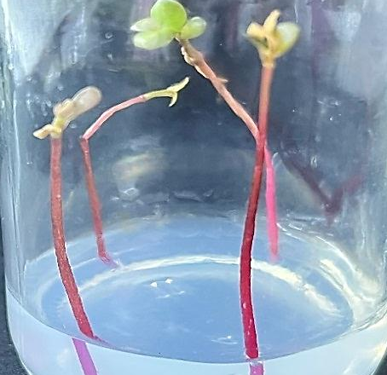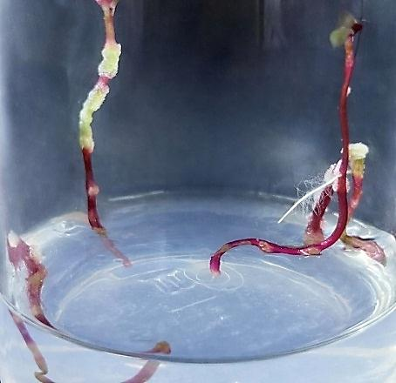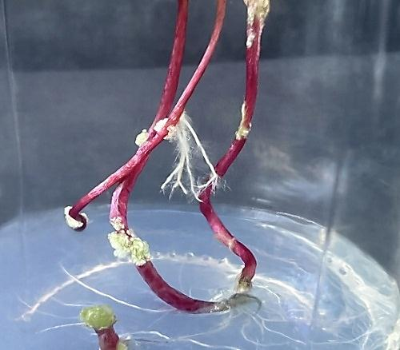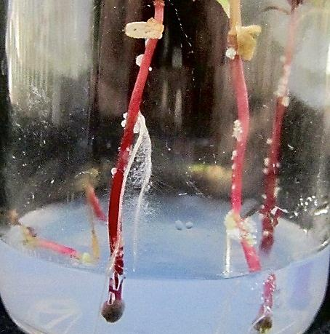
A
D
C
B

Figure 1: Tissue masses and hairy roots produced on the stems of purslane seedlings injected with different concentrations of Ri plasmids isolated from A. rhizogenes ATCC 15834 (notice the tissue masses) after 15 days of initiation
A) Control sample. B) Hairy roots produced on seedling stems injected with 14.49 ng µl-1 plasmids. C) Hairy roots produced on seedling stems injected with 27.75 ng µl-1 plasmids. D) Hairy roots produced on seedling stems injected with 19.59 ng µl-1 plasmids.
3.3 Maintenance of hairy root cultures
The results showed that, when the hairy roots formed at the inoculation sites in purslane seedling stems were excised and cultured individually on solid MSO medium in Petri dishes, only the hairy roots induced by inoculation with 27.75 ng µl-1 Ri plasmids isolated from A. rhizogenes ATCC 15834 continued to grow and established dense cultures with new branching upon subculture every 20 days (Figure 2). The other concentrations failed to establish stable cultures.

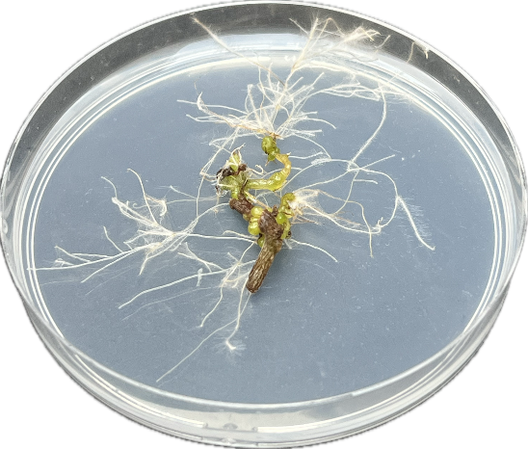
Figure 2: Hairy root culture established from roots excised from seedling stems inoculated with 27.75 ng µl-1 of Ri plasmids
The purity and concentration of the extracted DNA
The concentrations of DNA extracted from the tissue masses and hairy roots formed after inoculation with 27.75 ng µl-1, in addition to the roots of control seedlings, were 862, 917 and 634 ng µl-1, respectively, with a purity ratio of 1.8.
3.4 Evidence for the genetic transformation of purslane plants at the molecular biological level
The specific rolA polymerase chain reaction test showed the presence of clear bands in each chromosomal DNA sample recovered from the tissue masses and hairy roots (Figure 3). This band was absent from the DNA of the control sample. It corresponded to a molecular size of 248 bp, which was the same size as the amplified product obtained using the specific primers used in the study. The data show how the genetic transformation process occurred in purslane plants, including the transfer and integration of T-DNA genes from the bacterial strains used into the plant cell genome and the expression of those genes.

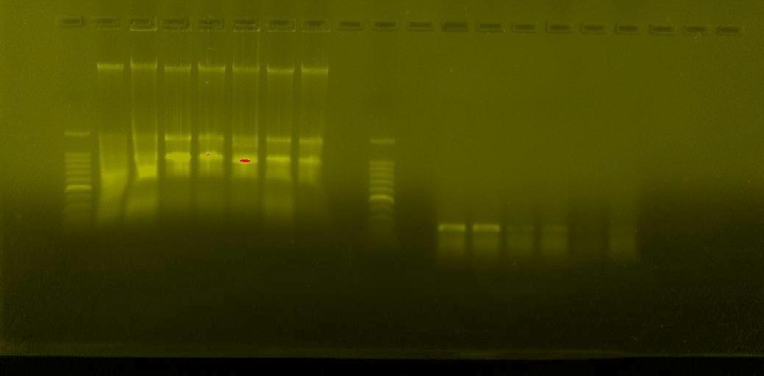
1500 bp
500 bp
248 bp
M
1
3
5
2

Figure 3: Presence of rolA genes in DNA samples amplified and extracted from genetically transformed tissue masses and hairy roots with A. rhizogenes ATCC 15834 plasmids at concentration:
Lanes (M): DNA lambda; (1): roots of purslane plant seedlings (control); (3): genetically transformed tissue masses with 27.75 ng µl-1; (4): genetically transformed hairy roots with 27.75 ng µl-1.

4. Discussion
The successful genetic transformation of purslane (Portulaca oleracea L.) may be attributed to the efficiency of the direct injection method in transferring plasmids, as well as the tolerance of purslane plant tissues to the inoculation process. The formation of hairy roots represents the first morphological evidence of successful genetic transformation, indicating effective and stable integration of T-DNA from the Ri plasmid into the plant genome (Ma et al., 2022). The wounds induced during inoculation are a critical factor for initiating the genetic transformation process, as they facilitate the entry of foreign T-DNA into plant cells. An increase in the concentration of Ri plasmids used for inoculating plant explants has a direct effect on the efficiency and frequency of genetic transformation, in addition to variation in the response of the plant tissues employed (Khan et al., 2018).
Ri plasmids isolated from A. rhizogenes ATCC 15834 were employed because of their proven effectiveness in achieving successful genetic transformation in several plant species, including sugar beet (Beta vulgaris subsp.) (Al-Mallah and Al-Nema, 2012), cabbage (Brassica oleracea var.) (Masyab and Al-Mallah, 2019) and wormwood (Artemisia herba-alba) (Al-Jubouri, 2024). Furthermore, direct treatment of plant tissues with bacterial cultures may lead to contamination, requiring the application of antibiotics and additional decontamination steps. Conversely, the use of isolated plasmids eliminates the risk of bacterial contamination, thereby reducing processing time and simplifying the transformation procedure (Bahari et al., 2020).
The success of this method may be related to the ability of stem tissues to tolerate the injection process, even at a relatively high DNA concentration. According to Mohammed and Masyab (2020), the introduction of T-DNA genes into the cell genome caused a hormonal imbalance that resulted in the formation of these roots. The increase in DNA quantity in genetically transformed samples supports the efficient transfer of T-DNA genes into the plant cell genome, which facilitated the synthesis of proteins, amino acids and nucleic acids (Park et al., 2010). Overall, the polymerase chain reaction (PCR) results confirmed the success of genetic transformation and provided clear molecular evidence of the integration and expression of the target genes in the purslane cell genome (Balasubramanian et al., 2018; Lacroix and Citovsky, 2019).

5. Conclusions
This study established the successful genetic transformation of purslane (Portulaca oleracea L.) seedling stems using Ri plasmids isolated from Agrobacterium rhizogenes ATCC 15834 through the direct injection method. The response of the plant tissues differed according to plasmid concentration, with 27.75 ng µl-1 producing the highest transformation response. This concentration resulted in 92% hairy root formation after 10 days, with 3.2 hairy roots per responsive stem and 285 tissue masses, while the lower concentrations produced reduced responses and the control treatment showed no transformation-related growth. The hairy roots induced by 27.75 ng µl-1 were capable of continued growth on solid MS medium and formed dense, branched cultures after subculturing at 20-day intervals. Molecular analysis provided further evidence of transformation, as the rolA-specific polymerase chain reaction produced a 248 bp band in transformed tissue masses and hairy roots but not in control roots. These results indicate that the direct injection of isolated Ri plasmids can mediate genetic transformation in purslane under the conditions used in this study. The protocol may provide a useful basis for further work on purslane transformation and hairy root culture establishment, provided that additional optimisation and validation are undertaken in future carefully designed studies.

6. Limitations
This study was limited to the direct injection of three concentrations of Ri plasmids isolated from Agrobacterium rhizogenes ATCC 15834 into purslane seedling stems under controlled culture conditions. Therefore, the results describe the response of the tested explant type and do not compare other transformation methods, explant sources or culture conditions. Stable hairy root cultures were established only from the treatment with 27.75 ng µl-1, while roots induced by the other concentrations did not remain stable after transfer to solid MS medium. Molecular confirmation was based on amplification of the rolA gene using polymerase chain reaction; additional molecular analyses were not conducted to assess copy number, insertion patterns or expression levels. The study also did not evaluate long-term genetic stability, plant regeneration from transformed roots or possible changes in biochemical composition. Further work is required to validate the protocol across broader experimental conditions and to assess its practical applications.
Disclaimer (Artificial intelligence)

Authors hereby declare that NO generative AI technologies such as Large Language Models (ChatGPT, COPILOT, etc.) and text-to-image generators have been used during the writing or editing of this manuscript.

Acknowledgement
The authors are very grateful to the University of Mosul/College of Science for the facilities provided, which helped to improve the quality of this work.

References
- Al-Jubouri, T. S. (2024). Isolation and identification of Artemisinin compound from the tissues of genetically transformed A. herba-alba plant with the Ri plasmid vector. PhD. Thesis/ Department of Biology, College of Science, Mosul University/ Iraq
- Al-Mallah, M. K. and Al-Nema, Q. S. (2016),"Putative genetically modified callus derived from transformed hairy roots induced on sugarbeet (Beta vulgaris) explants by Agrobacterium rhizogenes 1601 harbouring Riplasmid", Iraqi J. Biotech., 11(2): 4. https://doi.org/10.24126/jobrc.2013.7.1.252.
- Al-Mallah, M. K. and Mohammed, A. A. (2012). Transfer of Ri T-DNA genes of Agrobacterium rhizogenes R1601 via direct microinjection and Co_cultivation to carrot, Daucus carota L. tissue and production of transformed hairy root cultures. Iraq J. Biotech, 11, 227-239.
- Al-Obaidi, A.M.I.Y. (2024). Role the rol genes of Agrobacterium in Stimulating biosynthesis the Apigenin and Chamazulene compounds in Matricaria chamomilla L. plant Tissues. MSc. Department of Biology/ College of Science/ Mosul University/ Iraq.
- Al-sinjiri, A.M.H.S. (2022). Efficiency the Helianthus annus plant tissues which genetically transformed with Agrobacterium rhizogenes ATCC 15834 in phytoremediation. MSc. Department of Biology/ College of Science/ Mosul University/ Iraq.
- Bahari, Z. ; Sazegari, S. ; Niazi, A. and Afsharifar, A. (2020). The application of an Agrobacterium-mediated in planta transformation system in a Catharanthus roseus medicinal plant. Czech J. Genet. Plant Breed, 56(1): 34-41. https://doi.org/10.17221/153/2018-cjgpb.
- Balasubramanian, M.; Anbumegala, M.; Surendran. R.; Arun, M. and Shanmugam, G. (2018). Elite hairy roots of Raphanus sativus L. as a source of antioxidants and flavonoids. 3 Biotech., 8(128): 1-15. https://doi.org/10.1007/s13205-018-1153-y.
- De Souza, P. G., Rosenthal, A., Ayres, E. M. M.,and Teodoro, A. J. (2022). Potential functional food products and molecular mechanisms of Portulaca oleracea L. on Anticancer Activity: A Review. Oxidative medicine and cellular longevity, (1), 7235412. https://doi.org/10.1155/2022/7235412.
- Dhahi, S.J. ; Al-Assie, A.H. and Omear, H.A. (2011). Application of the randomly amplified polymorphic DNA (RAPD) marker to analyze the genetic variability in species of the fungus Alternaria. Raf. J. Sci., 22: 1-16. https://doi.org/10.33899/rjs.2011.32446.
- Foti, C.,and Pavli, O. I. (2020). High-efficiency Agrobacterium rhizogenes- mediated transgenic hairy root induction of Lens culinaris. Agronomy, 10(8), 1170. https://doi.org/10.3390/agronomy10081170.
- Gad, K., Huu, C. N., Plaschil, S., Kappel, C.,and Lenhard, M. (2025). Genetic transformation of Primula sieboldii using Agrobacterium rhizogenes and whole-plant regeneration from transgenic hairy roots. Frontiers in Plant Science, 16, 1623387. https://doi.org/10.3389/fpls.2025.1623387.
- Keshavareddy, G., Kumar, A.R.V. and Ramu, V.S. (2018). Methods of plant transformation-a review. Int. J. Curr. Microbiol. Appl. Sci, 7(7), pp.2656-2668. https://doi.org/10.20546/ijcmas.2018.707.312.
- Khan, N.; Bano, A. and Zandi, P. (2018). Effects of exogenously applied plant growth regulators in combination with PGPR on the physiology and root growth of chickpea (Cicer arietinum) and their role in drought tolerance. J. plant interactions, 13(1), 239-247. https://doi.org/10.1080/17429145.2018.1471527.
- Lacroix, B. and Citovsky, V. (2019). Pathways of DNA transfer to plants from Agrobacterium tumefaciens and related bacterial species. Annu. Rev. Phytopathol., 25(57): 231–251. https://doi.org/10.1146/annurev-phyto-082718-100101.
- Ma, H., Meng, X., Xu, K., Li, M., Gmitter Jr, F. G., Liu, N.,and Duan, S. (2022). Highly efficient hairy root genetic transformation and applications in citrus. Frontiers in Plant Science, 13, 1039094. https://doi.org/10.3389/fpls.2022.1039094.
- Malarz, J., Yudina, Y. V., and Stojakowska, A. (2023). Hairy root cultures as a source of phenolic antioxidants: simple phenolics, phenolic acids, phenylethanoids, and hydroxycinnamates. International Journal of Molecular Sciences, 24(8), 6920. https://doi.org/10.3390/ijms24086920.
- Moghadam, Y. A., Piri, K. H., Bahramnejad, B.,and Habibi, P. (2013). Methyl jasmonate and salicylic acid effects on the dopamine production in hairy cultures of Portulaca oleracea (Purslan). Bulletin of Environment, Pharmacology and Life Sciences, 2(6), 89-94. https://doi.org/10.1055/s-0031-1282278.
- Ahmed, M. I. A., AlJuhaimi, F., Özcan, M. M., Uslu, N.,and Karrar, E. (2025). Determination of the distribution of bioactive compounds, antioxidant activities, polyphenols and macro and microelement contents in different parts of wild and cultivated purslane (Portulaca oleracea L.) plants. Journal of Food Measurement and Characterization, 1-11. https://doi.org/10.1007/s11694-025-03221-w.
- Mohammed, A. A. (2020). Efficiency the hairy roots of radish (Raphanus Sativus) plant which genetic transformed by Agrobacterium Rhizogenes ATCC15834 for anthocyanin production. EurAsian J. Bios. 14(2): 6437-6441.
- Mohammed, A. and M. Al-Mallah, (2013). Determination of β-carotene in Carrot (Daucus carota L.) plants regenerated from stems callus. Rafidain Journal of Science, 24(5): 27-36. https://doi.org/10.33899/rjs.2013.74507.
- Mohammed, A.A. and Masyab, H.M. (2020). Genetic transformation of Nigella sativa L. plants with Agrobacterium rhizogenes 35S GUS R1000 and estimation of Thymoquinone level in transformed hairy roots cultures. Plant Arch. 20 (1): 3649-3652.
- Mohammed, A.A. and Masyab, H.M. (2020). Genetic transformation of Nigella sativa L. plants with Agrobacterium rhizogenes 35S GUS R1000 and estimation of Thymoquinone level in transformed hairy roots cultures. Plant Arch. 20 (1): 3649-3652.
- Murashige, T. and Skoog, F. (1962). A revised medium for rapid growth and bioassay with tobacco tissue culture. Physiol. Plant., 15(3): 473 -479. https://doi.org/10.1111/j.1399-3054.1962.tb08052.x.
- Musaib, H. M., and Al-Mallah, M. Q. (2019). Genetic manipulation for cytokinin production in genetically modified cabbage plants and compensation for its absence in the medium (Patent No. 5646). Central Agency for Standardization and Quality Control / Baghdad / Iraq. https://doi.org/10.22401/jnus.18.4.03.
- Park, N.I.; Park, J.H.; Lee, C.Y.; Lee, S.Y. and Park, S.U. (2010). Agrobacterium rhizogenes-mediated transformation of β- glucuronidase reporter gene in hairy roots of Angelica gigas Nakai. Plant Omics J., 3:115-120. https://doi.org/10.1007/s12033-011-9420-8.
- Qaddawi, Z. T., Sultan, S. J.,and Mohammed, A. A. H. (2024). Efficiency of direct injection and co-cultivation methods in genetic transformation of oilseed rape (Brassica napus L.) seedlings leaves by Agrobacterium rhizogenes ATCC15834. Malaysian Journal of Microbiology, 20(5). https://doi.org/10.21161/mjm.230241.
- Rahimi, K.; Haghbeen, K.; Marefatjo, J.; Jazii, F.R. and Sheikhani, R. (2008). Successful production of hairy root of Valeriana. https://doi.org/10.3923/biotech.2008.200.204.
- Sambrook, J.; Fritschi, E.F. and Maniatis, T. (1989). Molecular cloning: A laboratory manual, Cold Spring Harbor Laboratory Press, New York, USA.
- Sultan, S.J., Mohammed, A.A.-H. (2020). Genetic transformation of broccoli (Brassica oleracea var. Italica) plant by plasmids of A. rhizogenes R1601 and their molecular detection. Biochemical and Cellular Archives. 20(2): 5491–5496.
- Tripathi, A.,and Shukla, S. (2024). Methods of genetic transformation: major emphasis to crop plants. J Microbiol. Biotechnol. food Sci., 13(4), e10276-e10276
- Urquiza-López, A., Bazaldúa, C., Cardoso-Taketa, A. T. and Villarreal, M. L. (2025). Compounds from medicinal plants produced in hairy root and transgenic hairy root cultures: a review. PeerJ, 13, e19967. https://doi.org/10.7717/peerj.19967.
- Vincent, J. M. (1970). A manual for the Practical Study of Root Nodule Bactria.IBP Handbook No.15. Oxford: Blackwell Scientific Publication, Oxford, PP. 113-131.
- Wang, M., Li, C., Li, J., Hu, W., Yu, A., Tang, H. and Zhang, H. (2023). Extraction, purification, structural characteristics, biological activity and application of polysaccharides from Portulaca oleracea L.(Purslane): a review. Molecules, 28(12), 4813. https://doi.org/10.3390/molecules28124813.
- Weigand, F.; Baum, M. and Udupa, S. (1993). DNA molecular Marker Techniques". Technical Manual. No.20. International Center for Agricultural Research in the Dry Area. Aleppo, Syria.
- Xu, M., Zhao, X., Fang, J., Yang, Q., Li, P. and Yan, J., (2024). An Effective Somatic-Cell Regeneration and Genetic Transformation Method Mediated by Agrobacterium tumefaciens for Portulaca oleracea L. Plants, 13(17), p.2390. https://doi.org/10.3390/plants13172390.
- Ying, W., Wen, G., Xu, W., Liu, H., Ding, W., Zheng, L. and Wang, X. (2023). Agrobacterium rhizogenes: paving the road to research and breeding for woody plants. Frontiers in Plant Sci., 14, 1196561. https://doi.org/10.3389/fpls.2023.1196561.

