EMERGING ZOONOTIC INFECTIONS IN ODISHA: A SYSTEMATIC REVIEW OF SCRUB TYPHUS AND ANTHRAX

ABSTRACT
Emerging zoonotic infections continue to pose significant public health challenges in resource-limited regions of India, particularly in Odisha, where ecological diversity and socio-economic disparities influence disease transmission. This systematic review aims to synthesize and critically evaluate the epidemiology, clinical presentation, risk factors, and control measures of infectious diseases in Odisha, with a specific focus on Scrub Typhus and Anthrax. A structured literature search was conducted using PubMed, Scopus, and Google Scholar for studies published between 2010 and 2025. The findings indicate that scrub typhus has emerged as a leading cause of acute undifferentiated febrile illness, while anthrax remains endemic in tribal and forested regions. Major determinants include environmental exposure, occupational risk, limited diagnostic facilities, and delayed healthcare access. Despite increased reporting, challenges persist in early diagnosis, surveillance, and community awareness. This review highlights the need for strengthened surveillance systems, improved diagnostic capacity, and targeted public health interventions. The study provides a region-specific synthesis and identifies key gaps to inform future research and healthcare planning in Odisha.
Keywords:
Scrub Typhus, Anthrax, Zoonotic infections, Epidemiology, Public health, Odisha, Disease surveillance
1. INTRODUCTION
Emerging and re-emerging zoonotic infections continue to represent a significant and evolving public health concern in tropical and resource-limited settings (WHO, 2023; Destoumieux-Garzón et al., 2018)
The epidemiological landscape of Odisha is particularly complex due to its ecological diversity, high proportion of tribal populations, forest-dependent livelihoods, and seasonal climatic variability. These interacting determinants create a sustained environment for zoonotic pathogen circulation and delayed disease detection (Mohanty et al., 2021; Weaver et al., 2020)
In recent years, a distinct epidemiological transition has been observed in Odisha, characterized by a relative reduction in classical vector-borne diseases such as malaria and an increasing recognition of other febrile illnesses of zoonotic origin (Murhekar et al., 2017; Dutta et al., 2021). Among these, Scrub Typhus has emerged as a major cause of acute undifferentiated fever across multiple districts, frequently presenting with non-specific clinical features that complicate early diagnosis (Devasagayam et al., 2021; Panigrahi et al., 2023)
In parallel, Anthrax continues to persist as a sporadic but recurrent zoonosis in livestock-rearing and tribal regions, reflecting ongoing gaps in veterinary surveillance and public health integration (NCDC, 2022; WHO, 2023)
Although individual outbreak reports and hospital-based studies exist, there is a lack of consolidated, region-specific synthesis that integrates epidemiological trends, clinical patterns, and systemic healthcare gaps for these infections in Odisha. Importantly, no comprehensive review has critically evaluated these two zoonoses together within a unified epidemiological framework, despite their shared relevance to rural and tribal health systems. This gap highlights the need for a structured evidence synthesis to support improved surveillance strategies and targeted public health intervention (FAO, WHO, WOAH, 2022; Destoumieux-Garzón et al., 2018)
Climate change, rapid environmental modification, deforestation, and increasing human interaction with livestock and wildlife have further intensified the emergence and transmission of zoonotic infections across eastern India. Odisha remains particularly vulnerable due to its extensive forest ecosystems, seasonal flooding, agricultural dependency, and large tribal population residing in ecologically sensitive regions. These environmental and socio-economic determinants contribute significantly to vector proliferation, delayed healthcare access, and underreporting of febrile zoonotic diseases in rural communities.
Recent studies from Odisha and other endemic regions of India have highlighted the growing burden of scrub typhus and persistent anthrax outbreaks as important public health concerns requiring integrated surveillance and coordinated intervention strategies under the One Health framework (WHO, 2023; Panigrahi et al., 2023; Pattnaik et al., 2024; Ghai et al., 2026).

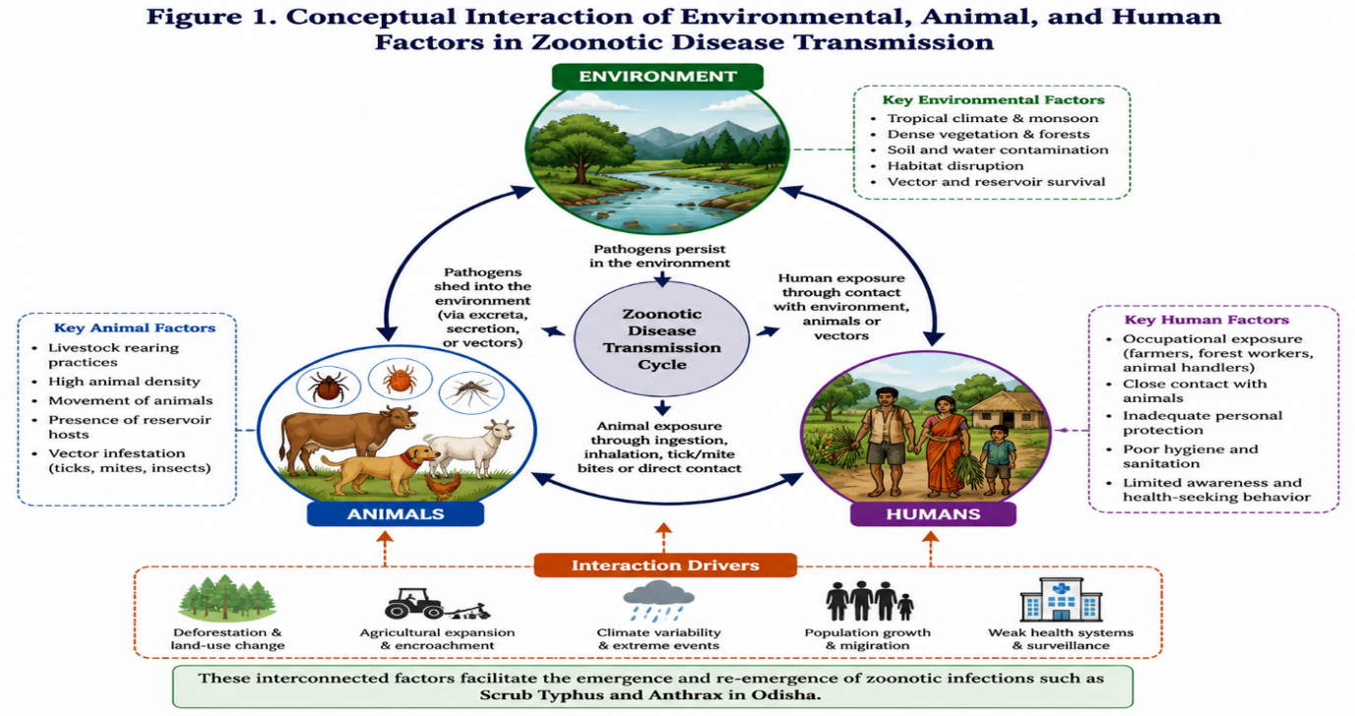(Fig.1-The conceptual interaction of environmental, animal, and human factors contributing to zoonotic disease transmission)
2. METHODOLOGY
A systematic review methodology was employed to ensure structured identification, selection, and synthesis of relevant literature. The review was conducted in accordance with PRISMA (Preferred Reporting Items for Systematic Reviews and Meta-Analyses) principles where applicable for narrative synthesis (Page et al., 2021)
A comprehensive literature search was performed across PubMed, Scopus, and Google Scholar databases for studies published between 2010 and 2025. Search terms included combinations of “scrub typhus Odisha,” “anthrax eastern India,” “zoonotic infections India,” and “acute febrile illness epidemiology.”
Studies were included if they met the following criteria: (i) original research articles, outbreak investigations, or surveillance reports; (ii) studies reporting data relevant to Odisha or comparable eastern Indian settings; and (iii) publications providing clinical, epidemiological, or public health data on Scrub Typhus (ICMR, 2021; CDC, 2022).
Studies were excluded if they lacked regional relevance, did not provide primary data, or were editorials without supporting evidence. A total pool of identified records was screened, and eligible studies were synthesized qualitatively (WHO, 2023). Data extraction focused on epidemiological trends, clinical manifestations, risk factors, and public health implications
The synthesis emphasized pattern recognition, comparative evaluation, and identification of evidence gaps rather than quantitative meta-analysis due to heterogeneity of available studies (Murhekar, 2022).
The study selection process is summarized in Table 1.
Table 1: Summary of Literature Search and Study Selection Process
Stage of Selection | Number of Records
Records identified through database search | ~150
Records after duplicate removal | ~120
Records screened by title and abstract | ~90
Full-text articles assessed | ~60
Studies included in final synthesis | ~40

3. EPIDEMIOLOGY OF ZOONOTIC INFECTIONS IN ODISHA
The epidemiology of zoonotic infections in Odisha reflects a dynamic interaction between environmental exposure, occupational practices, and health system limitations. The tropical monsoon climate, combined with dense vegetation and frequent human–animal interaction, creates an ecological niche conducive to sustained zoonotic transmission (Mohanty et al., 2021; Weaver et al., 2020)
Recent evidence indicates a rising burden of Scrub Typhus as a major contributor to acute febrile illness syndromes in both rural and peri-urban populations (Panigrahi et al., 2023; Dutta et al., 2021)
Unlike classical vector-borne diseases, scrub typhus exhibits strong seasonal clustering, with peak incidence observed during post-monsoon periods when vector density is highest. The disease is frequently underdiagnosed due to its nonspecific clinical presentation and limited availability of confirmatory diagnostic testing at peripheral healthcare levels (ICMR, 2021; Murhekar, 2022)
In contrast, Anthrax demonstrates a distinct epidemiological pattern characterized by sporadic outbreaks localized to livestock-dependent tribal communities (NCDC, 2022; WHO, 2023). Transmission is closely associated with occupational exposure, particularly handling of infected animals or contaminated animal products. Despite its lower incidence compared to scrub typhus, anthrax remains a persistent public health concern due to its outbreak potential and association with environmental persistence of spores (CDC, 2022)
A comparative assessment of both infections suggests that while scrub typhus is expanding in geographic and temporal distribution, anthrax remains geographically restricted but epidemiologically stable in endemic pockets. This dual pattern reflects a broader transition in the zoonotic disease landscape of Odisha, necessitating integrated surveillance approaches.
Table 2: Comparative Epidemiological Features of Scrub Typhus and Anthrax in Odisha
Feature | Scrub Typhus | Anthrax
Causative agent | Orientia tsutsugamushi | Bacillus anthracis
Transmission mode | Chigger bite (vector-borne) | Direct contact with infected animals
Geographic distribution | Widespread (rural + peri-urban) | Clustered (tribal livestock regions)
Seasonality | Monsoon/post-monsoon peak | Sporadic outbreaks
Main risk group | Farmers, forest workers | Livestock handlers
Clinical recognition | Often underdiagnosed | Occasionally outbreak-associated
Public health trend | Increasing incidence | Stable but persistent
4. CLINICAL AND PUBLIC HEALTH IMPLICATIONS
Scrub Typhus typically presents as an acute febrile illness with variable clinical manifestations, including headache, myalgia, gastrointestinal symptoms, and occasionally the presence of an eschar. However, the absence of pathognomonic signs in a significant proportion of patients contributes to frequent misdiagnosis as dengue, malaria, or viral fever (Dutta et al., 2021). In severe cases, delayed treatment may result in complications such as acute respiratory distress syndrome, hepatic dysfunction, renal impairment, and multi-organ failure (Peter et al., 2015).
Epidemiological studies from eastern India indicate that delayed initiation of doxycycline therapy is strongly associated with increased morbidity and mortality, emphasizing the critical importance of early clinical suspicion in endemic regions (Varghese et al., 2014). Occupational exposure, agricultural activities, and lack of protective behavior significantly increase risk in rural populations of Odisha (Panigrahi et al., 2023).
Anthrax primarily manifests as a cutaneous infection in Odisha, characterized by localized skin lesions that may progress to systemic involvement if untreated. Gastrointestinal and inhalational forms, although less common, are associated with higher fatality rates (Sweeney et al., 2011). The persistence of anthrax is strongly linked to gaps in livestock vaccination programs, improper carcass disposal practices, and limited community awareness (Goel, 2015).
From a public health perspective, both infections are exacerbated by systemic challenges, including weak rural diagnostic infrastructure, delayed healthcare-seeking behavior, and fragmented integration between veterinary and human health surveillance systems (FAO, WHO, WOAH, 2022). The absence of coordinated “One Health” implementation further limits effective control of zoonotic transmission cycles (Destoumieux-Garzón et al., 2018).
Collectively, these findings highlight that disease burden in Odisha is not solely determined by pathogen prevalence but is significantly influenced by healthcare accessibility, diagnostic delay, and socio-environmental vulnerability. Strengthening early diagnostic pathways, improving rural laboratory capacity, and integrating multisectoral surveillance systems are essential to reducing disease burden (National Health Mission, 2023).
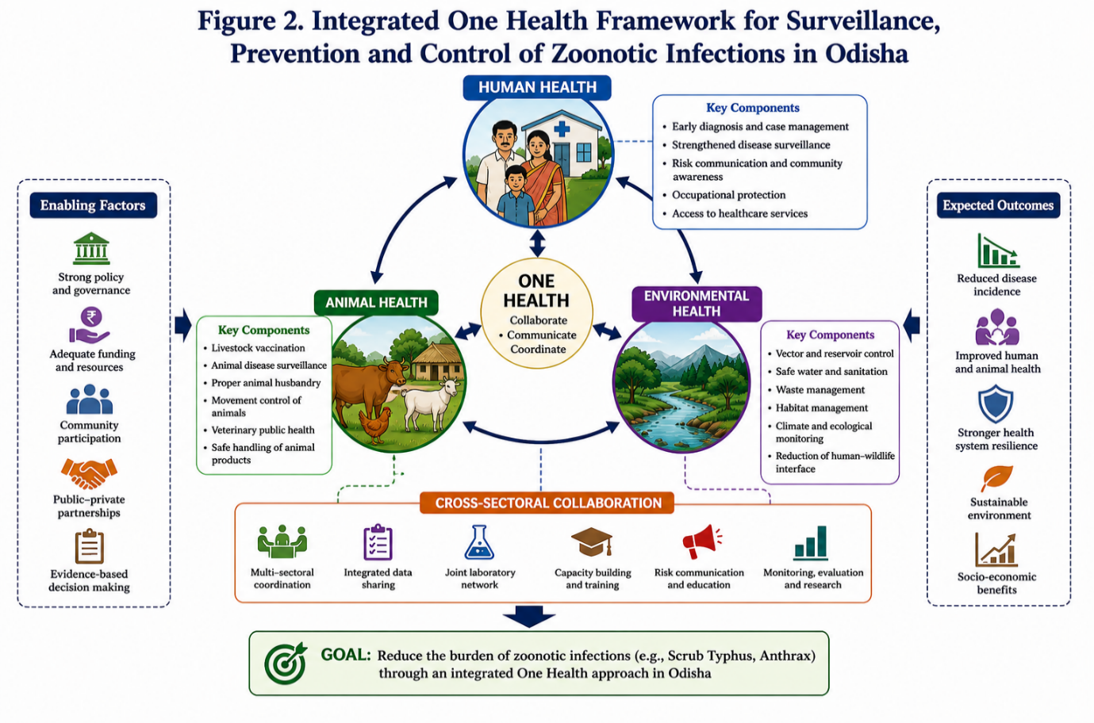
(Figure 2. Integrated One Health Framework for Surveillance, Prevention and Control of Zoonotic Infections in Odisha)
The comparative clinical and public health characteristics of scrub typhus and anthrax are summarized in Table 3
Table 3: Clinical and Public Health Characteristics
Parameter | Scrub Typhus | Anthrax
Early symptoms | Fever, headache, myalgia | Localized skin lesion
Diagnostic challenge | High (non-specific symptoms) | Moderate (cutaneous form identifiable)
Severe complications | Multi-organ failure | Systemic infection (rare but fatal)
Treatment response | Rapid with doxycycline | Effective with antibiotics if early
Mortality risk | Moderate if delayed | High in systemic cases
Public health issue | Underdiagnosis | Outbreak clusters
5. RISK FACTORS AND DETERMINANTS OF ZOONOTIC TRANSMISSION IN ODISHA
The transmission dynamics of zoonotic infections in Odisha are shaped by a complex interaction of environmental exposure, occupational behavior, and structural healthcare limitations. The coexistence of forest ecosystems, monsoon-dependent agriculture, and livestock-rearing practices creates a continuous interface for human–animal–environment interaction, sustaining endemic and emerging zoonotic transmission cycles (Destoumieux-Garzón et al., 2018; Weaver et al., 2020).
Among these determinants, occupational exposure to agricultural fields and forest vegetation represents the most significant risk factor for Scrub Typhus. Seasonal variation, particularly during post-monsoon months, amplifies vector density, increasing human exposure to infected chigger mites (Devasagayam et al., 2021). Epidemiological observations from eastern India consistently indicate higher disease burden among farmers and forest-dependent populations, reflecting a strong environmental association (Panigrahi et al., 2023).
In contrast, risk for Anthrax is primarily associated with direct or indirect contact with infected livestock, including handling of contaminated meat, skin, or carcasses (CDC, 2022). Tribal and rural communities engaged in traditional animal husbandry practices remain disproportionately affected due to low vaccination coverage and limited veterinary surveillance (NCDC, 2022).
Importantly, the interaction between poverty, limited health literacy, and delayed healthcare-seeking behavior further intensifies disease vulnerability (National Health Mission, 2023). The absence of spatially integrated risk mapping combining environmental, occupational, and animal health variables represents a major gap in current understanding, limiting targeted prevention strategies in endemic regions.
Table 4: Major Determinants of Zoonotic Infections in Odisha
Determinant Category | Key Factors | Associated Disease Impact
Environmental | Monsoon rainfall, forest density, vegetation exposure | Increased risk of Scrub Typhus
Occupational | Farming, forest work, livestock handling | High exposure to zoonotic pathogens
Animal-related | Infected livestock, rodent reservoirs | Transmission of Anthrax
Socio-economic | Poverty, low awareness, poor housing | Delayed diagnosis and exposure risk
Health system | Limited primary diagnostics, weak surveillance | Underreporting and late detection

6. DIAGNOSTIC CHALLENGES AND HEALTH SYSTEM LIMITATIONS
Delayed and inaccurate diagnosis remains a critical barrier to effective control of zoonotic infections in Odisha. The clinical presentation of Scrub Typhus is highly non-specific, frequently overlapping with dengue, malaria, and other viral febrile illnesses (Dutta et al., 2021). This diagnostic ambiguity results in frequent misclassification and delayed initiation of appropriate therapy (ICMR, 2021).
Evidence from hospital-based studies in eastern India suggests that delays in diagnosis beyond the early febrile phase significantly increase the risk of complications, including multi-organ dysfunction and prolonged hospitalization (Panigrahi et al., 2023). Limited availability of serological and molecular diagnostic tools at primary healthcare levels further exacerbates underdiagnosis, particularly in rural districts (National Health Mission, 2023).
Another major challenge in endemic regions of Odisha is the limited availability of advanced diagnostic infrastructure at peripheral healthcare centers. Although serological methods such as IgM ELISA are considered useful for scrub typhus confirmation, these facilities are often unavailable in primary and community health centers, leading to dependence on empirical treatment approaches. Molecular diagnostic techniques including polymerase chain reaction (PCR), which provide improved sensitivity and specificity during early infection, remain largely restricted to tertiary care laboratories because of high operational costs and technical requirements. In addition, delayed referral systems, inadequate sample transportation facilities, and low clinical suspicion among healthcare workers further contribute to underdiagnosis and delayed therapeutic intervention. Similar constraints also affect anthrax confirmation in rural districts where biosafety limitations and lack of laboratory preparedness reduce the efficiency of outbreak detection and surveillance activities (ICMR, 2021; WHO, 2023; Panigrahi et al., 2023; Pattnaik et al., 2024).
Similarly, diagnosis of Anthrax is often delayed due to low clinical suspicion in non-endemic reporting centers and inadequate awareness among healthcare providers (CDC, 2022). Laboratory confirmation is restricted by biosafety requirements and lack of advanced microbiological infrastructure in district-level facilities (WHO, 2023).
A critical systemic limitation is the weak integration between human health and veterinary surveillance systems (FAO, WHO, WOAH, 2022). This fragmentation delays early outbreak detection and reduces the effectiveness of coordinated response strategies (Murhekar, 2022). Strengthening decentralized diagnostic capacity and introducing point-of-care testing at peripheral health facilities are essential to improve early case detection and reduce disease severity (NITI Aayog, 2021).
Table 5: Diagnostic Challenges in Scrub Typhus and Anthrax
Parameter | Scrub Typhus | Anthrax
Early clinical recognition | Difficult (non-specific fever) | Moderate (cutaneous lesions identifiable)
Laboratory availability | Limited in rural Odisha | Restricted due to biosafety needs
Misdiagnosis rate | High (dengue/malaria confusion) | Moderate
Delay in treatment | Common | Frequent in rural areas
Diagnostic infrastructure gap | Severe | Moderate to severe

7. PUBLIC HEALTH INTERVENTIONS AND CONTROL STRATEGIES
Effective control of zoonotic infections in Odisha requires a multi-tiered public health approach combining early diagnosis, preventive interventions, and intersectoral coordination. For Scrub Typhus, early clinical suspicion followed by prompt initiation of doxycycline therapy remains the most effective intervention for reducing morbidity and mortality (ICMR, 2021). However, its success is highly dependent on diagnostic readiness and clinician awareness at primary care levels (Panigrahi et al., 2023).
Preventive strategies should include community education regarding avoidance of scrub vegetation during high-risk seasons, use of protective clothing, and improved awareness of early febrile illness symptoms (Dutta et al., 2021). Seasonal risk communication strategies may significantly reduce exposure in endemic areas.
For Anthrax, the cornerstone of prevention lies in systematic livestock vaccination, safe carcass disposal practices, and strengthening veterinary surveillance systems. Targeted awareness programs for high-risk occupational groups such as farmers and livestock handlers are essential for reducing transmission (CDC, 2022; WHO, 2023).
From a systems perspective, the absence of a fully operational One Health surveillance framework remains a major limitation (FAO, WHO, WOAH, 2022). Integration of human health, animal health, and environmental monitoring systems is critical for early outbreak detection and coordinated response (Destoumieux-Garzón et al., 2018). Strengthening digital disease reporting systems and improving interdepartmental data sharing would significantly enhance outbreak preparedness and control efficiency (Murhekar, 2022).
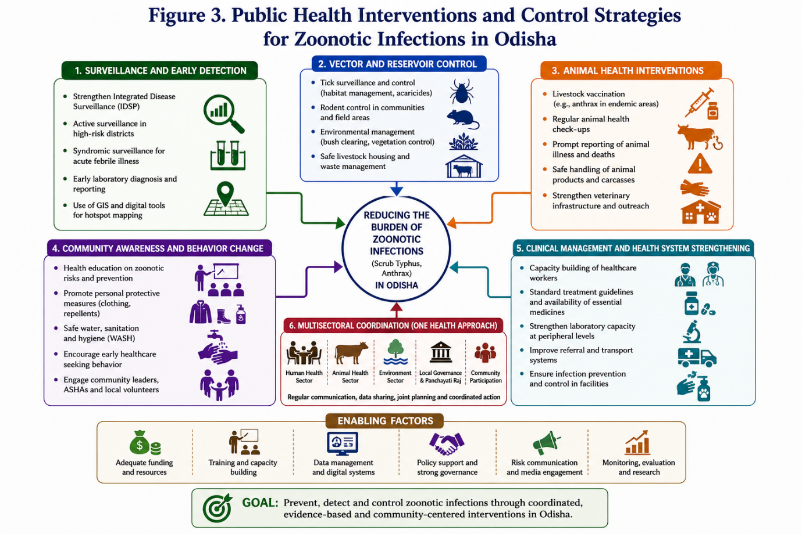
(Figure 3. Public Health Interventions and Control Strategies for Zoonotic Infections in Odisha)
Table 6: Public Health Interventions and Control Measures
Disease | Prevention Strategy | Key Intervention Level
Scrub Typhus | Early diagnosis, doxycycline treatment, protective clothing | Primary healthcare + community
Anthrax | Livestock vaccination, carcass disposal, awareness | Veterinary + rural health system
Both diseases | Integrated surveillance (One Health approach) | System-level intervention

8. RESEARCH GAPS AND FUTURE DIRECTIONS
Despite increasing recognition of zoonotic infections in Odisha, India, significant research gaps remain in understanding their full epidemiological burden (WHO, 2023). There is a lack of longitudinal, district-level studies assessing temporal trends of scrub typhus and anthrax, limiting precies burden estimation and hotspot identification (Murhekar, 2022).
Current evidence is largely hospital-based, which restricts generalizability to community-level transmission dynamics (Panigrahi et al., 2023). Additionally, environmental determinants such as rainfall variability, land-use change, and forest fragmentation are insufficiently integrated into existing epidemiological models, limiting predictive capacity (Weaver et al., 2020; Petersen et al., 2019).
Future research in Odisha should prioritize the integration of genomic surveillance, geographic information system (GIS)-based hotspot mapping, and climate-linked disease prediction models for early identification of zoonotic outbreak risks.
Advances in molecular epidemiology can improve understanding of pathogen diversity, transmission dynamics, and regional strain variation associated with scrub typhus and anthrax. In addition, the application of digital health technologies and artificial intelligence-assisted surveillance systems may strengthen outbreak forecasting and rapid response mechanisms in endemic districts.
However, implementation of such approaches remains limited due to inadequate research infrastructure, fragmented surveillance networks, and insufficient interdisciplinary collaboration between medical, veterinary, and environmental sectors. Strengthening collaborative One Health research platforms will therefore be essential for improving long-term disease preparedness and evidence-based public health planning in Odisha (FAO, WHO, WOAH, 2022; WHO, 2023; Ghai et al., 2026; Chaturvedi et al., 2025).
Another major gap is the lack of studies addressing co-infections and syndromic overlap among febrile illnesses, which contributes to diagnostic uncertainty and empirical treatment practices (Dutta et al., 2021). Furthermore, very few studies have evaluated the effectiveness of integrated One Health surveillance systems in endemic rural settings (FAO, WHO, WOAH, 2022).
Future research should prioritize spatial epidemiological mapping, community-based cohort studies, and development of rapid diagnostic tools suitable for peripheral healthcare settings (NITI Aayog, 2021). Strengthening interdisciplinary collaboration between human medicine, veterinary science, and environmental health is essential for building a resilient surveillance framework Destoumieux-Garzón et al., 2018).
Importantly, this review highlights the absence of a consolidated region-specific synthesis of scrub typhus and anthrax in Odisha, underscoring its novelty and relevance for guiding future public health policy and research priorities (WHO, 2023; Murhekar, 2022).
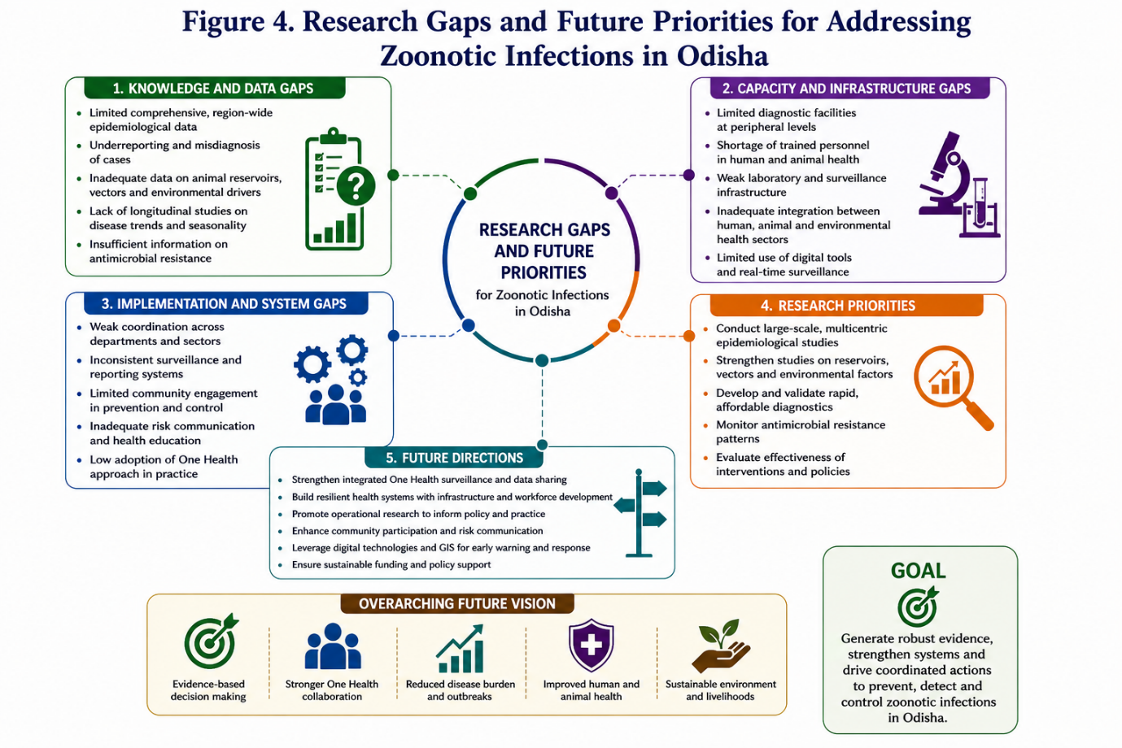
(Fig-4The conceptual framework highlighting research gaps and future priorities in zoonotic disease research in Odisha)
9. INTEGRATED ONE HEALTH FRAMEWORK AND SYSTEMS IMPLEMENTATION IN ODISHA
The persistence of zoonotic infections in Odisha reflects structural fragmentation between human, animal, and environmental health systems. A One Health framework is therefore essential for effective surveillance and control of infections such as Scrub Typhus and Anthrax (Destoumieux-Garzón et al., 2018; WHO, 2023).
Operational implementation should move beyond conceptual integration to district-level coordination between Integrated Disease Surveillance Programme (IDSP), veterinary reporting units, and environmental monitoring systems. A unified digital reporting platform enabling real-time data sharing across sectors would improve early outbreak detection and response time (Murhekar, 2022).
Despite increasing recognition of the One Health approach in India, implementation at the district and community levels in Odisha continues to face multiple operational challenges. Limited coordination between veterinary services, environmental monitoring agencies, and public health departments often delays outbreak reporting and integrated field response.
In many endemic tribal and rural regions, surveillance activities remain fragmented because of insufficient laboratory networking, shortage of trained field epidemiologists, and inadequate digital disease reporting systems. Strengthening intersectoral collaboration through shared surveillance platforms, joint outbreak investigations, and community-based reporting mechanisms could substantially improve early detection and containment of zoonotic infections. Furthermore, incorporation of geographic information system (GIS)-based disease mapping and climate-linked surveillance strategies may assist in identifying high-risk transmission hotspots and improving preparedness during post-monsoon periods in Odisha (FAO, WHO, WOAH, 2022; WHO, 2023; Murhekar, 2022; Pattnaik et al., 2024).
Geospatial risk mapping combined with seasonal trend analysis can further strengthen predictive surveillance, particularly for scrub typhus, which demonstrates strong post-monsoon clustering (Panigrahi et al., 2023). Similarly, livestock movement tracking and carcass disposal monitoring are critical for anthrax containment in endemic tribal blocks (CDC, 2022). The integration of these systems under a coordinated One Health surveillance architecture represents a key unmet requirement in the current public health framework of Odisha (FAO, WHO, WOAH, 2022).
10. POLICY IMPLICATIONS AND HEALTH SYSTEM STRENTHENING
The findings of this review have direct implications for public health policy and primary healthcare delivery in Odisha. First, Scrub Typhus should be formally incorporated into standard fever management algorithms at primary and secondary healthcare levels in endemic districts, enabling earlier empirical treatment and reducing complication rates (ICMR, 2021; Panigrahi et al., 2023).
Second, sustained control of Anthrax requires strengthening of livestock vaccination coverage, particularly in high-risk tribal and rural blocks, along with enforcement of safe animal carcass disposal practices under veterinary supervision (CDC, 2022; WHO, 2023).
Third, establishment of district-level One Health coordination units is essential to integrate human, animal, and environmental surveillance data (FAO, WHO, WOAH, 2022). These units should be supported by rapid reporting systems capable of triggering early outbreak alerts and coordinated field response (Murhekar, 2022).
From a health system perspective, strengthening diagnostic capacity at peripheral health facilities represents the most impactful intervention (National Health Mission, 2023). Evidence indicates that earlier clinical suspicion and prompt treatment initiation at primary care level has greater effect on reducing mortality than expansion of tertiary care services alone. Therefore, capacity building of frontline healthcare workers is a critical policy priority (Varghese et al., 2014).
11. CONCLUSION
Zoonotic infections remain an important and evolving public health challenge in Odisha, driven by continuous interaction between ecological systems, occupational exposure, and health system limitation (WHO, 2023; Mohanty et al., 2021). This review highlights the dual burden of emerging Scrub Typhus and persistent Anthrax, both of which continue to affect vulnerable rural and tribal populations (Panigrahi et al., 2023).
The evidence demonstrates that delayed diagnosis, fragmented surveillance systems, and inadequate intersectoral coordination are the primary barriers to effective disease control (Murhekar, 2022). Addressing these gaps requires a transition from isolated disease-specific interventions to an integrated One Health-based surveillance and response model (FAO, WHO, WOAH, 2022; Destoumieux-Garzón et al., 2018).
This synthesis provides a consolidated epidemiological and public health perspective that is among the few region-specific reviews focusing jointly on scrub typhus and anthrax in Odisha. It underscores the need for strengthened diagnostic infrastructure, improved surveillance integration, and targeted preventive strategies tailored to local ecological and occupational risk patterns (NITI Aayog, 2021; National Health Mission, 2023).
CONFLICT OF INTEREST: The author declares that there is no conflict of interest regarding the publication of this manuscript.

REFERENCES
- Ghai A, Balaga DL, Vedachalam SK, et al. Epidemiology and risk factors in a scrub typhus cluster in Odisha, India, 2023: investigating with a One Health approach. One Health Outlook. 2026;8:16. doi:10.1186/s42522-026-00200-z.
- Parai D, Pattnaik M, Dash A, et al. Scrub typhus among particularly vulnerable tribal groups of Odisha, India. J Infect Public Health. 2026;19(1):103026. doi:10.1016/j.jiph.2025.103026.
- Pattnaik M, Choudhary HR, Parai D, et al. One Health intervention for elimination of anthrax in an endemic district of Odisha: a baseline and endline study. One Health. 2024;18:100729. doi:10.1016/j.onehlt.2024.100729.
- Chaturvedi R, Hussain SSA, Sampath H, et al. Spatiotemporal epidemiology and clinical manifestations of scrub typhus in India: a systematic review and meta-analysis. BMJ Global Health. 2025;10.
- Wang Q, Ma T, Ding F, et al. Global and regional seroprevalence, incidence, mortality and risk factors for scrub typhus: a systematic review and meta-analysis. Int J Infect Dis. 2024;146:107151.
- Ghosal S, Pradhan R, Singh S, et al. One Health intervention for control and elimination of scrub typhus, anthrax and brucellosis in Southeast Asia: a systematic review. Lancet Reg Health Southeast Asia. 2024;30:100503.
- Bhattacharya D, Pattnaik M, Sahu SK, et al. Human anthrax in India in recent times: a systematic review and risk mapping. One Health. 2023;16:100564.
- Panigrahi A, Narasimham MV, Biswal M, et al. Epidemiology of scrub typhus in a tertiary care hospital of Southern Odisha: a cross-sectional study. Indian J Med Microbiol. 2023;42:92–96.
- Parai D, Pattnaik M, Dash GC, et al. Scrub typhus seroprevalence from an eastern state of India: findings from the statewide serosurvey. Trans R Soc Trop Med Hyg. 2023;117(1):22–27.
- Krishnamoorthi S, Goel S, Kaur J, et al. A review of rickettsial diseases other than scrub typhus in India. Trop Med Infect Dis. 2023;8(5):280.
- Rathor S. Scrub Typhus: Indian situation and current report generated by Indian Council of Medical Research-National Centre for Disease Informatics and Research under the Right to Information Act, 2005-reg. Int J Pharm Biol Arch. 2024;15(2).
- Baral P, Mahapatra P, Panigrahy R, et al. Seroprevalence and epidemiological trend of scrub typhus in Eastern India. Biomedicine. 2025;45(4):305–311.
- World Health Organization. Operational framework for One Health. Geneva: WHO; 2023.
- FAO, WHO, WOAH. One Health Joint Plan of Action (2022–2026). Rome: FAO; 2022.
- National Centre for Disease Control (NCDC). Zoonotic disease surveillance in India. New Delhi: NCDC; 2022.
- Indian Council of Medical Research (ICMR). Guidelines for management of acute febrile illness. New Delhi: ICMR; 2021.
- Centers for Disease Control and Prevention (CDC). Anthrax diagnostic and treatment guidelines. Atlanta: CDC; 2022.
- Murhekar MV. Integrated Disease Surveillance Programme evaluation in India. Indian J Med Res. 2022;155(4):489–495.
- National Health Mission. Rural Health Infrastructure Report 2023. New Delhi: NHM; 2023.
- NITI Aayog. Health systems strengthening in India. New Delhi: Government of India; 202121
- Dutta S, et al. Febrile illness in India: diagnostic challenges. BMJ Glob Health. 2021;6.
- Weaver SC, et al. Emerging arboviral diseases and zoonotic threats. Nat Rev Microbiol. 2020;18:415–430.
- Petersen LR, et al. Emerging vector-borne infections and environmental determinants. Clin Infect Dis. 2019;69(2):389–397.
- Destoumieux-Garzón D, et al. The One Health concept: challenges and future directions. Front Vet Sci. 2018;5:14.
- Devasagayam E, Dayanand D, Kundu D, et al. The burden of scrub typhus in India: a systematic review. PLoS Negl Trop Dis. 2021;15.
- Bonell A, Lubell Y, Newton PN, et al. Estimating the burden of scrub typhus: a systematic review. PLoS Negl Trop Dis. 2017;11.
- Varghese GM, et al. Clinical profile and improving diagnosis of scrub typhus. Trop Med Int Health. 2014;19:1455–1462.
- Peter JV, et al. Severe scrub typhus infection in South India. Trop Med Int Health. 2015;20(7):927–933.
- Sweeney DA, Hicks CW, Cui X, et al. Anthrax infection. Lancet Infect Dis. 2011;11(2):149–160.
- Goel AK. Anthrax: a disease review. J Clin Diagn Res. 2015;9(8)–DE03.
- Mohanty S, et al. Infectious disease burden in Odisha. Indian J Public Health. 2021;65(4):345–351.
- Mishra S, et al. Rural febrile illness patterns in Odisha. J Family Med Prim Care. 2020;9(10):5214–5219.
- Page MJ, McKenzie JE, Bossuyt PM, et al. The PRISMA 2020 statement: an updated guideline for reporting systematic reviews. BMJ. 2021;372.
- Lerner H, Berg C. A comparison of One Health approaches. PLoS Pathog. 2017;13(9).
- Mackenzie JS, Jeggo M, Daszak P, et al. One Health: the human-animal-environment interface. Microbiol Spectr. 2013;1(2).

