Current Status, Traditional Uses, and Conservation Perspectives of Pethia manipurensis, an Endangered Endemic Fish of Loktak Lake, Manipur

Abstract
Pethia manipurensis is an endemic and endangered fish species of Loktak Lake, Manipur, currently facing decline in its population due to habitat degradation and environmental changes. This preliminary study was conducted to document the current status, traditional uses, threats, and conservation needs of this fish. A questionnaire based survey was carried out during the year 2024- 2025 across multiple sites of Loktak Lake, Manipur, including fishers, fish vendors, farmers, women involved in fish processing, and community elders. Data were analyzed using descriptive statistics. The study revealed that all the respondents perceived a decline in the abundance of P. manipurensis, with ecosystem changes (50%) and pollution (40%) identified as the major problem. P. manipurensis was also considered as an important traditional food fish, with drying being the most common preservation method. Respondents also reported its ethno-medicinal use in the treatment of laryngitis and dysentery, as well as its cultural significance in rituals and marriage ceremonies. Community support for conservation of this fish was high, with most respondents emphasizing awareness programs, government intervention, and scientific research as main conservation strategies. The study shows that P. manipurensis possesses ecological, nutritional, ethno-medicinal, cultural, and potential ornamental value. The documented decline in its population highlights the urgent need for conservation actions, including habitat restoration, pollution control, captive breeding, community participation, and sustainable resource management. As a preliminary findings, this study provides baseline information that could support future research and the development of conservation strategies for the long-term survival of P. manipurensis in Loktak Lake, Manipur.
Keywords: Pethia manipurensis, Loktak Lake, Endemic fish, Ethno-medicine, Conservation, Traditional knowledge

Introduction
Freshwater ecosystems provide the highest amount of biodiversity on earth, and are currently the most threatened ecosystem in terms of biological diversity. Freshwater ecosystems occupies less than one percent of the planet, but have the highest diversity of life on the earth (Strayer & Dudgeon, 2010). The amount of freshwater biodiversity around the world has dramatically decreased, and many species of freshwater fish are now on the brink of extinction due to destructive human activities such as habitat destruction, overfishing, chemical pollution, and climate change (Reid et al., 2019). The northeast region of India is one among the largest sites for endemism and biodiversity in the world (Chatterjee et al., 2006).
Manipur, an attractive and isolated part of north-eastern India, boasts many endemic plants and animals including fishes across different ecosystems. The ecological significance of Manipur within the global context can be established based on its place in the Indo-Burma mega-biodiversity hotspot and through its many indigenous types of plants and animals (Wildlife Wing, Forest Department, Government of Manipur, 2020). Among the natural resources of Manipur, one of the most significant is Loktak Lake (Ramsar site number 463), the largest freshwater lake within northeast India and most known for its floating phumdis and diverse aquatic ecosystem (Paonam & Chatterjee, 2023; Singh et al., 2024; Singha & Sharma, 2025). The water quality of Loktak Lake has been reported to have declined (Mayanglambam & Neelam, 2022), mainly due to eutrophication and sedimentation (Das Kangabam & Govindaraju, 2019), which may contributes to loss in fish habitats. These impacts have placed enormous strain on many fish species including Pethia manipurensis, which is a small freshwater fish indigenous to Loktak Lake of Manipur (Sobita et al., 2019).
Fish species such as Raiamas guttatus and Syncrossus berdmorei, which was earlier found in the Loktak lake of Manipur have already disappeared (Vishwanath, 2017) and fishes including P. manipurensis population is declining and fear of disappearing in the nearby future cannot be ruled out. Therefore, there is an urgent need for conserving this fish species for both economic and ecological reasons. Such conservation steps will potentially help to improve the population of the fish communities in order to save one species from further becoming extinct.
P. manipurensis, an endemic fish of Loktak lake is not abundantly found currently in the Loktak lake and considered as endangered with a declining population trend listed in IUCN Red List (Menon et. al., 2000). P. manipurensis is consider as an economically important fish having both food and potential ornamental value (Ngangbam & Nongmaithem, 2025). There is huge potential for promoting this species as an ornamental fish .This will not only leads to enhancing income generation of the local people but will help in conserving this endemic fish.
Some fishes in northeast India are not only consumed for food, but also used within the ethno-medicinal systems. For example, in a recent study of fish-based traditional medicine in Northeast India, it was noted that the ichthyofauna of the region contributes significantly to ethnomedicine by detailing the documented historical use of fishes including P. manipurensis in the treatment for digestive problems, mainly among the women after childbirth (Khesoh et al., 2026). With this background, this study was conducted to document the present population, distribution and current major threats to P. manipurensis, and to raise public awareness of conservation strategies among the local communities. This finding will contribute to a comprehensive conservation strategy for P. manipurensis and will provide critical information about P. manipurensis ecology, population dynamics, and conservation requirements to provide a sustainable management strategy in order to allow for long-term persistence of the species.

Materials and Methods

Study Area
The study was conducted at multiple sites across Loktak Lake, Manipur representing key habitats of P. manipurensis during 2024-2025 (n=100). These include known fish breeding grounds such as shallow and vegetated zones along the lake periphery, and open-water fishing zones where the species has been historically caught. Specific sampling locations were selected based on earlier sightings of P. manipurensis, information as provided by local fishers. Respondents for this studies were mainly from fishing and farming households having experience in fish harvesting, processing, and traditional knowledge related to endemic fish species of the Loktak lake. The survey covered different places of the lake to collect representative information on the traditional uses, cultural importance, abundance, and conservation status of P. manipurensis.

Survey Design and Data Collection
Field surveys using a semi-structured questionnaire were conducted to collect data that documented local knowledge about how P. manipurensis is used for food, medicine, culture, and ceremony, as well as to obtain information about local perceptions of how commonly P. manipurensis occurs in the community, why its population numbers have declined, and the conservation needs of this species (Figure 1).
Fishers, fish vendors, women who prepare and process fish; farmers, and older members of the community who have traditional ecological and medicinal knowledge were interviewed through purposive sampling, to ensure to include individuals who are familiar with P. manipurensis. Demographic information about respondents including: age, gender, and occupation; historical and current distribution of P. manipurensis; methods of preparing and preserving food; how to prepare and use P. manipurensis for medicinal purposes; cultural and ceremonial importance of this species; and community solutions for the conservation of P. manipurensis were included on the semi-structured questionnaire. The interviews were conducted in the local language and were transcribed during face to face interviews (Figure 1).
Data collected were compiled and analysed using descriptive statistics to provide a basic analysis of the characteristics being studied. Descriptive statistics included frequencies and percentages on each question in the various response categories, including demographic characteristics, usage patterns, medicinal uses, cultural significance, and perceived reason for the decline, and conservation preferences. All interview participants provided informed consent prior to their interview, and were informed of the study's purpose and the voluntary nature of their participation. The data collected during the survey was used solely for research purposes.
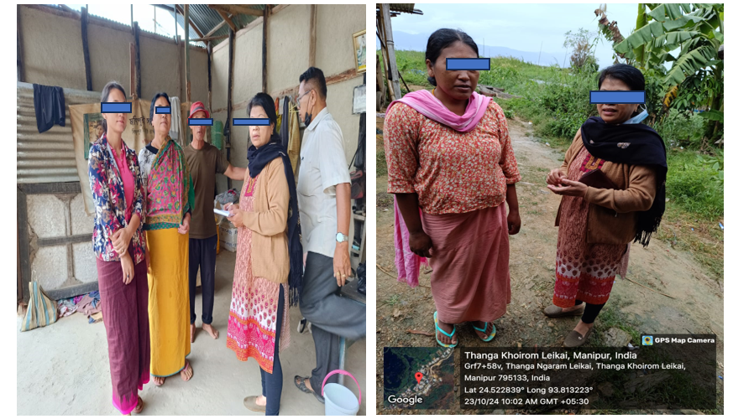

Figure 1: Primary data collection through respondent interviews with focus on demographic characteristics, usage patterns, medicinal uses, cultural significance, and reason for the decline, and conservation preferences related to P. manipurenesis.
Results
This study highlights that P. manipurensis is an important indigenous food, medicinal, cultural and endangered fish species found in Loktak lake, Manipur. According to the respondents, the fish was less abundant today compared with the past. The main reasons of decreases were environmental changes and water pollution. It's commonly used as a food, dried (mostly) for preservation, as a medicine, and in rituals and beliefs. The high level of community support for the fish's conservation indicates awareness among the people of its scarcity and their willingness to help in its conservation. Thus, raising public awareness, government initiative, scientific studies and harvesting management are required to conserve P. manipurensis.
The survey indicates that the majority of respondents were 20-70 years old (60%) followed by 25% below 20 years and 15% above 70 years. There were more females (70%) than males (30%) which suggest the high involvement of women in knowledge of local food preparation, consumption and use of traditional fish. The majority of respondents were from fishery and farming backgrounds (85%) and this increases the trustworthiness of information provided since they are directly related to fish gathering, use and local ecosystem monitoring (Figure 2).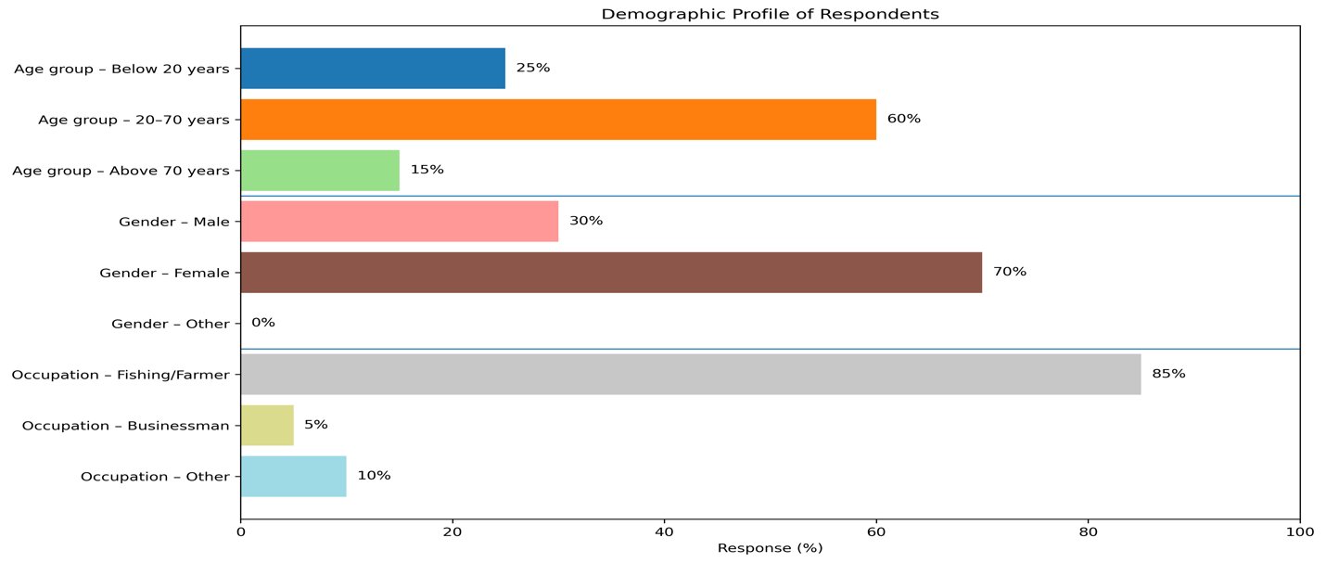
Figure 2: Demographic profile of the respondents showing age distribution, gender, and occupation of individuals participating in the study.
The study also showed alarming decrease in the availability of P. manipurensis in the Loktak lake. According to 70% of the respondents, in the past, the fish is available in large quantity but today the fish is available only in very small quantity. All the respondents (100%) indicated that the abundance of the fish has declined substantially in the Loktak lake and now available only in small quantities. The main reasons being ecosystem change (50%) and pollution (40%) followed by overfishing and other reasons. Furthermore, 70% of the respondents believed that the continued decline in fish population could further lead to the extinction of P. manipurensis (Figure 3).

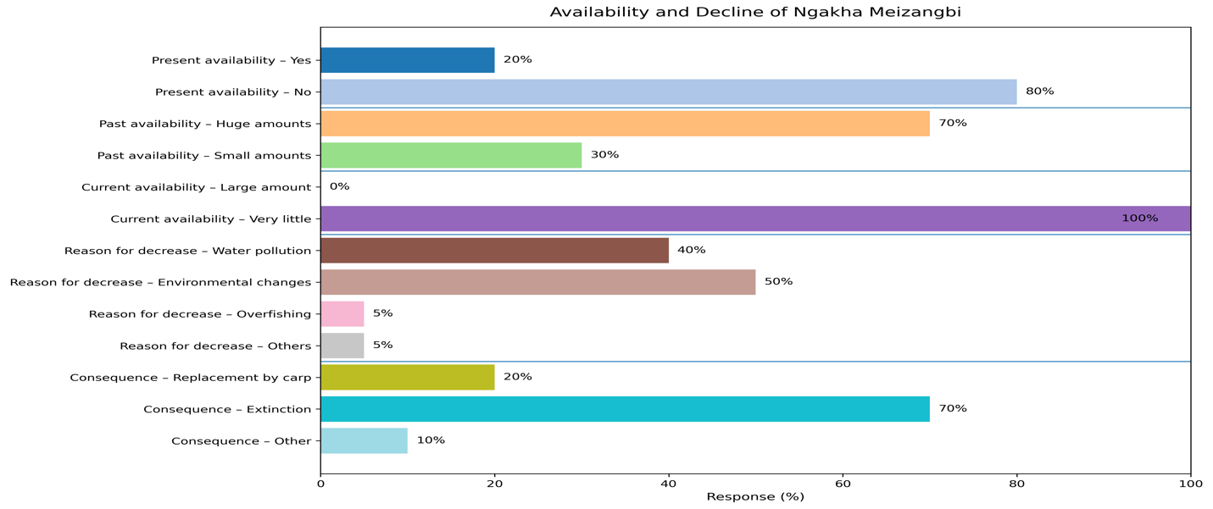
Figure 3: Respondents’ perceptions of the availability, decline of fish population and consequence of Pethia manipurensis.

The survey also shows that P. manipurensis was commonly used as food, and 60% respondents reported that it was mainly used by boiling and frying. Approximately 80% respondents found it as delicious and preserved by drying. P. manipurensis is mainly consumed as a traditional food item. Drying was the most common preservation method indicating its importance in household storage and traditional food systems. 50 % of the respondents considered it as mainly a food item, while 40% considered it both food and medicine, showing its dual nutritional and ethno-medicinal value (Figure 4).
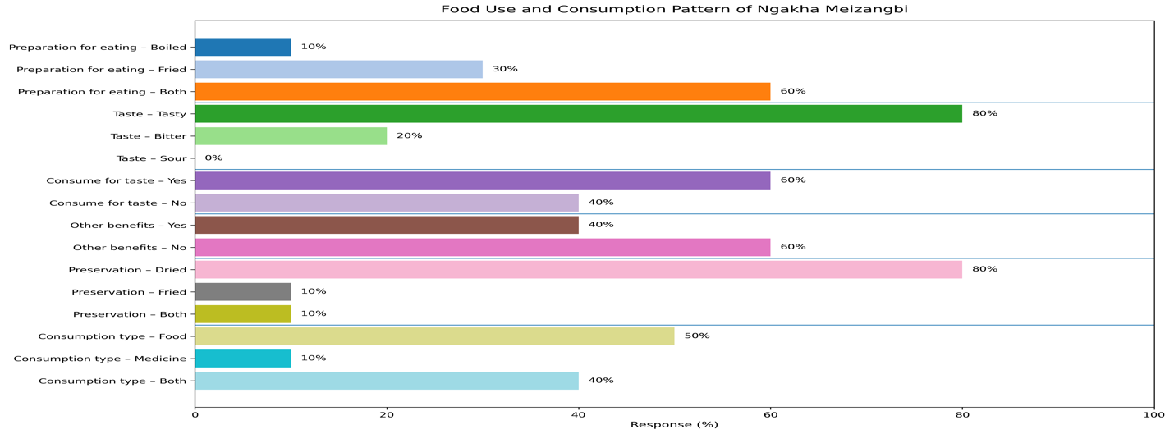Figure 4: Food use and consumption pattern of P. manipurensis
The medicinal use of P. manipurensis is strongly reflected in the survey. Respondents reported its use in treating laryngitis (15 %) and dysentery (15 %) (Figure 5), with the majority indicating that it is used for both conditions (30 %). The preferred medicinal preparation method was boiling, suggesting that traditional healing practices rely on simple household preparation methods. The finding also shows that 100% of respondents support conservation, indicating that the community recognizes its medicinal and cultural importance. Ethno-medicinal reports of fish are very common in the northeastern region of India and P. manipurensis is reported to be used for the treatment of gastrointestinal disorders (Figure 5).

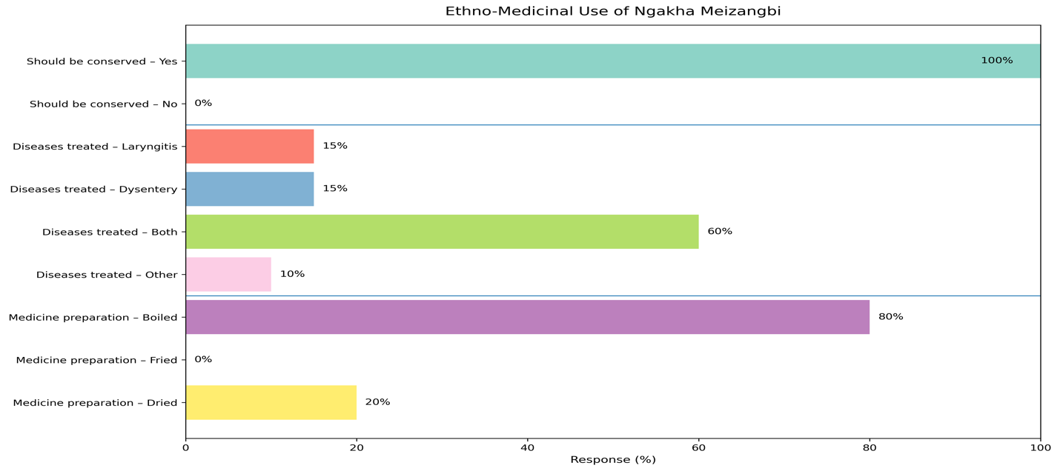
Figure 5: Ethno-medicinal use of P. manipurensis.
The survey also indicates that the fish was culturally significant with 80% of the respondents reporting it to be important for cultural use and 70% important for marriage rituals (Figure 6). A very high proportion of respondents considered it an essential fish, showing that it is not only a dietary resource but also part of local identity, ritual value, and traditional belief systems.

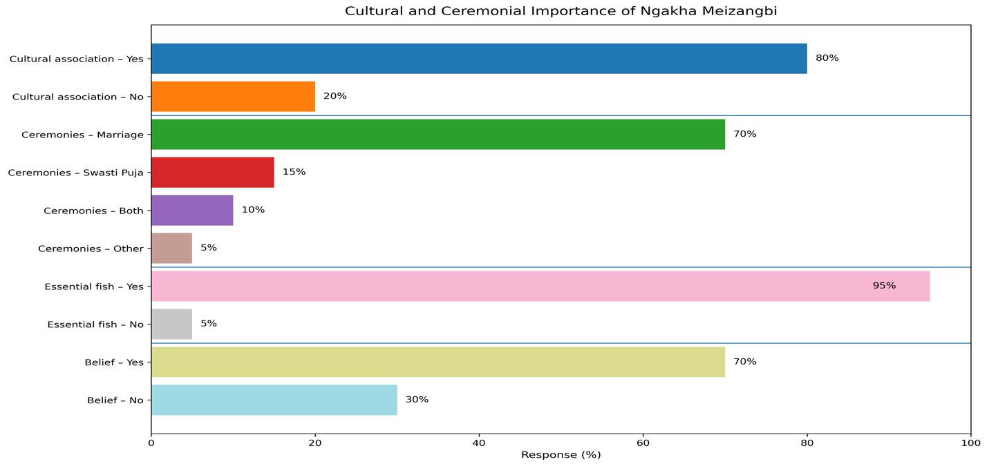
Figure 6: Cultural and ceremonial importance of P. manipurensis.

The conservation response was highly positive (Figure 7). Most respondents (90%) supported conservation and considered P. manipurensis, a very important fish species that needs conservation. The strongest suggested conservation measure was community awareness, followed by government plans and scientific research. This indicates that conservation should not depend only on laboratory and policy based work but should also include local participation, public awareness, habitat protection, and traditional knowledge preservation.
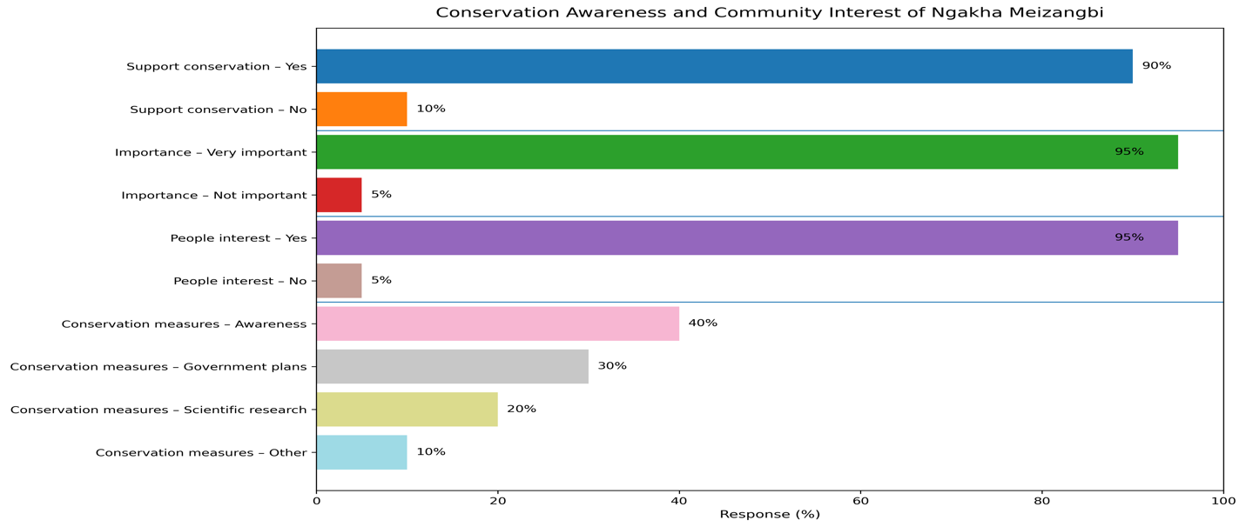
Figure 7: Conservation awareness and community interest of P. manipurensis

Discussion
This study highlights that P. manipurensis is still significant from food security point of view. In Manipur, P. manipurensis is an important small indigenous food fish that is usually prepared and cooked by boiling, frying, or drying. Small indigenous fishes are rich in nutrients since they are usually consumed whole and provide good source of protein, fats, vitamins, minerals and omega-3 fatty acids needed for rural traditional diets (Bipinchandra et al., 2025; Chutia et al., 2024; Roos et al., 2002). This supports the current survey result that majority of the respondents used P. manipurensis predominantly as food and as a good dietary source. Recent studies on the indigenous fishes of Northeast India indicate that these fish help to fulfill the dietary requirements for rural and economically marginalized communities (Pegu et al., 2023; Islam et al., 2023). P. manipurensis has been known to be used for treating laryngitis and dysentery mostly after boiling by the respondents highlighting its ethnomedicinal and cultural uses (Personal Communication). In Northeast India, use of fish-based traditional medicines is reported, which includes the use of ichthyofauna in ethno-medicinal practices and the specific link of P. manipurensis and other fishes to gastrointestinal disorders, particularly among women after childbirth (Khesoh et al., 2026). Small indigenous fishes including P. manipurensis and its connection with marriage rituals, household rituals and food taboo are also associated with its use in society and Manipuri culinary culture (Kabui et al., 2025; Khesoh et al., 2026).
The survey reveals a significant decrease in the species' abundance, as majority of the respondent’s report its abundance had declined from earlier to low availability. This finding is further supported by FishBase database, which classifies P. manipurensis as endangered based on IUCN criteria (IUCN, 2015; FishBase, 2026). Therefore, the conservation of P. manipurensis symbolizes the protection of an undiscovered resource for bioactive compounds of medicinal importance. These fish could provide both a source of nutrition and functional foods. Therefore, pursuing multiple strategies for this fish's conservation is necessary for future generations.
Sustainable conservation should include controlled harvesting, fishing bans during breeding season, restoration of wetlands, pollution control, breeding, and awareness among the community. Overall, the successful conservation of this endemic species requires an integrated approach combining scientific research, habitat restoration, captive breeding, and sustainable utilization.
Conclusion
This preliminary study supports the need for greater conservation attention for P. manipurensis, an endemic and endangered fish species of Loktak Lake, Manipur due to its ecological, nutritional, ethno-medicinal, cultural and potential ornamental value. The study indicates a decline in its population largely due to environmental changes and pollution. Therefore, conservation efforts are urgently needed to preserve this species. The current status of P. manipurensis, traditional uses by local people, perceived threats to populations, and conservation needs have been documented for this fish and will provide a basis for future research in ecology, biology, and conservation for this species and other fish species. In order to promote long-term survival of this species, integrated management practices by the scientific community, habitat restoration, captive breeding programs, community involvement and sustainable management of resources must be implemented.

References
Bipinchandra, U., Nongmaithem, B. D., Meetei, K. B., & Ngangbam, A. K. (2025). Role of Puntius sophore (Hamilton, 1822) in Small-Scale Fisheries, Rural Livelihoods, and Traditional Knowledge Systems. Asian Journal of Current Research, 10(4), 136-141.
Chatterjee, S., Saikia, A., Dutta, P., Ghosh, D., Pangging, G., & Goswami, A. K. (2006). Biodiversity significance of North east India. WWF-India, New Delhi, 30, 1-71.
Chutia, D., Talukdar, M., Deka, A., Nath, J. K., Saikia, A., & Sarma, D. (2024). Exploring the Nutritional, Ornamental, and Conservation Aspects of a Few Indigenous Small Fishes (ISFs) Belonging to the Genera Puntius and Pethia from Northeast India. In Perspectives and Applications of Indigenous Small Fish in India: An Introduction (pp. 351-361)
Das Kangabam, R., & Govindaraju, M. (2019). Anthropogenic activity-induced water quality degradation in the Loktak lake, a Ramsar site in the Indo-Burma biodiversity hotspot. Environmental Technology, 40(17), 2232–2241. https://doi.org/10.1080/09593330.2017.1378267
FishBase. (2026). Pethia manipurensis (Menon, Rema Devi & Vishwanath, 2000): Field guide summary. FishBase. (Accessed on June 4th, 2026).
IUCN. 2015. The IUCN Red List of Threatened Species. Version 2015.1. www.iucnredlist.org (Accessed on 7th April 2026).
Islam, W. N., Sharma, D. K., & Das, A. N. (2023). Small Indigenous Fishes as a Potent Bioresource of Northeast India. Journal of Fisheries and Environment, 47(3), 84-101.
Kabui, K. K., Rawson, A., & Athmaselvi, K. A. (2025). Selected fermented foods of Manipur, India: Traditional preparation methods, nutritional profile, and health benefits. Food Chemistry Advances, 6, 100864.
Khesoh, V., Phukan, M. M., & Pankaj, P. P. (2026). Fish as medicine: indigenous traditional knowledge and practices in Northeast India. Journal of Fisheries, 14(1), 141302-141302.
Mayanglambam, B., & Neelam, S. S. (2022). Physicochemistry and water quality of Loktak Lake water, Manipur, India. International Journal of Environmental Analytical Chemistry, 102(7), 1638-1661.
Menon, A.G.K., Devi, K.R. and Vishwanath, W., 2000. A new species of Puntius (Cyprinidae: Cyprininae) from Manipur, India. Journal-Bombay natural history society, 97(2), pp.263-268.
Ngangbam, A. K., & Nongmaithem, B. D. (2025, January 28). Conservation strategies of the IUCN Red List of Threatened Species, Pethia manipurensis, a freshwater fish species endemic to Loktak Lake, Manipur, India. E-Pao.net.
Paonam, J., & Chatterjee, S. (2023). Evaluating the land use land cover dynamics of Loktak Lake, A Ramsar Wetland of international importance in North East India. International Journal of Ecology and Environmental Sciences, 49(5), 459-470.
Pegu, A., Kalita, R., Das, P., & Baruah, C. (2023). Nutritional composition of small indigenous species of fishes of Northeast India: A systematic review. Journal of Applied and Natural Science, 15(2), 649.
Ramsar Sites Information Service. https://rsis.ramsar.org/ris/463. (Accessed on 2nd October 2026).
Singh, T. M., Thakur, B., Sarma, P., Singh, M. S., & Devi, A. (2024). Seasonal variation in the macrophyte species of Loktak Lake, a Ramsar Site in the North East India. Journal of Bioresources, 11(2), 47-52.
Singha, K. R., & Sharma, P. (2025). A review of Ramsar sites in Northeast India. Discover Water, 5(1), 109.
Sobita, N., Basudha, C., & Sharma, S. K. (2019). Molecular characterization of an indigenous barb Pethia manipurensis (Cyprinidae: Barbinae) from Manipur, India and its relationship with other cyprinid fishes inferring from mitochondrial cox1 gene sequences. Indian Journal of Animal Research, 53(2), 181–186. https://doi.org/10.18805/ijar.B-347
Strayer, D. L., & Dudgeon, D. (2010). Freshwater biodiversity conservation: recent progress and future challenges. Journal of the North American Benthological Society, 29(1), 344-358.
Reid, A. J., Carlson, A. K., Creed, I. F., Eliason, E. J., Gell, P. A., Johnson, P. T., & Cooke, S. J. (2019). Emerging threats and persistent conservation challenges for freshwater biodiversity. Biological reviews, 94(3), 849-873.
Roos, N., Thilsted, S. H., & Wahab, M. A. (2002). Culture of small indigenous fish species in seasonal ponds in Bangladesh: the potential for production and impact on food and nutrition security. In Rural aquaculture (pp. 245-252). Wallingford UK: CABI Publishing.
Vishwanath, W., 2017. Diversity and conservation status of freshwater fishes of the major rivers of northeast India. Aquatic Ecosystem Health & Management, 20(1-2), pp.86-101.
Wildlife Wing, Forest Department, Government of Manipur. (2020). 65th Wildlife Week Celebration 2020: Souvenir—Sustaining all life on Earth, Lamlak-kee Thawai (The Soul of Nature) (A. K. Joshi, L. Lukhoi Singh, S. Khuraijam, L. Ibohanbi Singh, & L. Biramangol Singh, Eds.). Wildlife Wing, Forest Department, Government of Manipur.

