Identity of Pseuderanthemum latifoilum (Vahl.) B. Hansen (Acanthaceae) in Coastal Odisha, India after 30 years: A note on Taxonomy, Distribution and Threat assessment

Abstract:
Pseuderanthemum latifolium (Vahl.) B. Hansen is relocated in the Mahavinayak, a sacred hill forest in the Jajpur district of Odisha, India during the exploration of diversity of family Acanthaceae. This species was documented as Pseuderanthemum malabaricum in different literatures. This is a rare plant found in degraded or deciduous forests. The native range of this species is South Asia. First report of this species was in northern circars in the Ganjam district of the state in 1995. However recent explorations reveal its relocation after about 30 years. Detailed description, taxonomic note, phenology, colour photo plate and photomicrographs are provided for easy identification of the taxon.
Key words: Pseuderanthemum latifolium, Acanthaceae, Coastal Odisha, rare, India
Introduction:
The family Acanthaceae belonging to order Lamiales is represented by 191 genera and 4900 species world-wide (Manzitto-Tripp et al, 2022). In India the family is represented by 352 species under 44 genera (Karthikeyan et al, 2009). Similarly in Odisha the family has 29 genera and 79 species (Saxena & Brahmam, 1995). The members of the family are distributed World-wide in the tropics and subtropics. This angiospermic dicot family has a broad spectrum of diversity in life form, morphology and physiology. There are herbs, shrubs, trees, climbers, mangroves and few xerophytic species mostly flower in winter.
The genus Pseuderanthemum Radlk belongs to the tribe Justicieae of the subfamily Acanthoideae (Olmstead et al, 2016) of family Acanthaceae. This genus is distinguished by presence of leaves green on abaxial surface, normally with lighter green band along veins on upper surface, ovate with acute apex; ovary puberulous (Choopan et al, 2018), elongated slender corolla tube, stamen 2 with spreading limbs, represented by 60 species globally (Scotland & Vollesen,2000). Pseuderanthemum has a native range of habitat in the tropical and subtropical regions. Several species of the genus are ornamental and cultivated in different parts of the World. The genus is represented by a single species in Odisha, i.e. Pseuderanthemum malabaricum (C.B.Cl.) Gamble (Saxena & Brahmam, 1995), which is now synonym of Pseuderanthemum latifolium (Vahl.) B. Hansen. However, the species is a wild species with very scarce distribution in the tropical and subtropical regions (POWO 2026).
During the floristic investigation of diversity of family Acanthaceae in Odisha, the first author noticed an interesting taxon growing in the Mahavinayak hill forest area of Jajpur district (Fig. 1). After critical observation, detailed analysis of vegetative and reproductive characters followed by consultation of herbarium specimen at RPRC, Bhubaneswar, CSIR-IMMT, Bhubaneswar and scrutiny of existing literature (Gamble 1924; Haines 1925; Mooney 1950; Saxena & Brahmam 1995; Dhatchanamoorthy et al 2015; POWO 2026) the identity of the taxon was found to be Pseuderanthemum latifolium (Vahl.) B. Hansen. Which was previously reported from the Northern Circar of Odisha. After completion of the 30 years from the detailed floristic study carried out by Saxena and Brahmam (1994-1996) in Odisha, the species was confined to that region, although several floristic studies were conducted by different researchers (Sahu et al., Pal et al., 2022; Nayak et al. 2024, Sahu & Dhal, 2012).
Present study highlights the detailed taxonomic characterisation of the species along with notes on ecology, phenology and distribution of the taxa, which will be helpful for the conservation biologist and policy makers regarding habitat protection and species conservation. The study also reviewed different pharmaceutical possibilities through phytochemical analysis. Ethanolic extracts prepared from shade dried leaves reveals presence of many important phytochemicals in Pseuderanthemum malabaricum (Syn-Pseuderanthemum latifolium) . The preliminary phytochemical screening revealed presence of coumarins, flavonoids, phenols, saponins and terpenoids. Gas chromatography-Mass spectroscopy (GC-MS) revealed about 10 different types of chemical compounds with variable quantities. Some of them such as 3-dihydro-3, 5-dihydroxy-6-methyl-(DDMP), 2-Furancarboxaldehyde-5 (hydroxymethyl) - (5HMF), 4H-Pyran-4-one-2 and 1-(+)-ascorbic acid-2-6- dihexadecanoate were detected with ant-oxidant and anti-cancer properties. (K. Sujana et al,2023). The ethanolic extracts of leaf also exhibit anti-helminthic properties (Hema & Keshamma, 2025).
What is your Aim and Hypothesis?
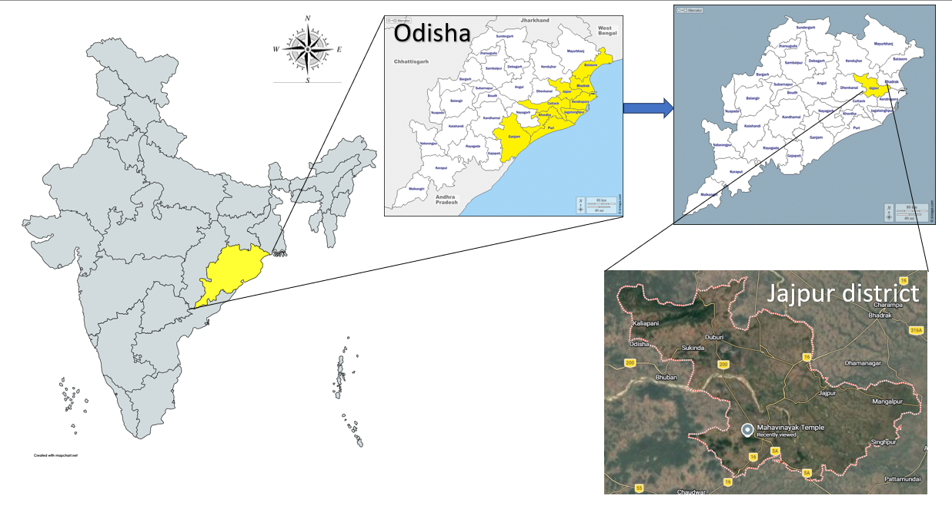
Fig. 1: Map of study area (Maha Vinayak Hill)
Materials & Methods: Extensive field studies were made during October-March from 2024-2026 for exploration of different species belonging to family Acanthaceae in the coastal districts of Odisha. An interesting species was observed from Mahavinayak sacred hill of Jajpur district of Odisha, India. The plants were distributed sporadically in the rock crevices in the shady regions of forest canopy. The sample specimen was collected, washed gently and allowed for drying. Fresh flowering twigs were also collected for microscopic observation. A healthy specimen was processed to keep a herbarium. For correct identification of the species, a number of literatures, herbaria, e-text, e-resources were followed. Besides the taxonomic enumeration of the species, threat assessment was conducted as the species is very rare in the natural habitat as well as in the study area.
Results
Taxonomic Treatment:
Pseuderanthemum latifolium Hansen, B. (1989). In: Nordic J. Bot. 9(2): 213. Pseuderanthemum malabaricum (C.B. Clarke) Gamble. Fl. Madras:1064(1924), Eranthemum malabaricum C.B. Clarke.J.D.Hooker, Fl. Brit. India 4: 497 (1884).
Description: Annual erect herb growing in rock crevices under shade, height up to 90-120 cms, spike 25-50 cms, flower subsessile, 1-3 flowers on an inflorescence apex, one flower bloom at a time, bracteolate, bracteoles small up to 3 mm, glandular. Flowers sessile, corolla tube white elongated about 2 cms, petals 5 white, sub equal, gamopetalous, petals 1-1.5 cms each, flower 3.5-4 cms, bracts 2, calyx small, sepals 5, glandular (7 mm ca.), stamens 2, epipetalous, filament 1.7 cm, anthers purple 2 mm, oblique (not parallel), carpel 1.5 cms, style 1.2 cm, ovary 2 mm, ovules 4,fruits capsule with constriction measuring about 1.7 cm , seeds 4 (3 mm ca.), apex curved, retinacula distinct, seed surface rugose.
Anatomy: All the species belonging to genus Pseuderanthemum possess cystolith in their leaf epidermis inside specialised epidermal cells known as lithocysts. The cystoliths are common in the leaves of P. latifolium and found as rod-shaped crystals. All calcium carbonate crystals or cystoliths are located in the epidermal layer. They never completely fill up the cell lumen. (Choopan & Grote, 2015).
Habit: Annual erect herb (up to 90-120 cms).
Habitat & Ecology: The native range of this species is generally South Asia i.e, from Indian Subcontinent to China and Malesia. It is a herb and grows primarily in the wet tropical biome under shade of large trees in dense forest.
Flowering & Fruiting: Nov- Feb
Specimen Examined: INDIA, Odisha, Jajpur district, Mahavinayak Hill, N 20⁰42.291’ E 86⁰05.167’, 143 mAMSL, Jena N.K. FMU EVS 1504.
Distribution: Northern Circar, India, Sri Lanka, (Saxena & Brahmam, 1995), Eastern Ghats: Dindigul District: Karanthamalai Dhatchanamoorthy. et al 2015, Mahavinayak Hill, Jajpur, Odisha. (Present Collection)
Systematic Position (POWO 2026)
Kingdom - Plantae
Division - Streptophyta
Class - Equisetopsida
Order - Lamiales
Family - Acanthaceae
Genus - Pseuderanthemum
Species - latifolium

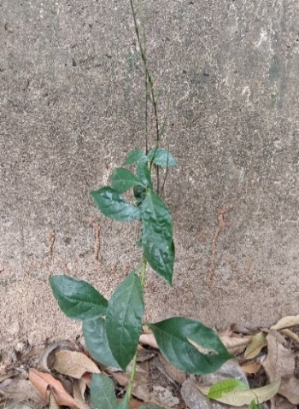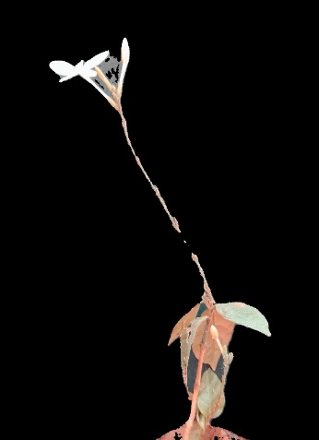
a.
b.
Fig. 2 a. Plant in its natural habitat, b. Plant with flowering

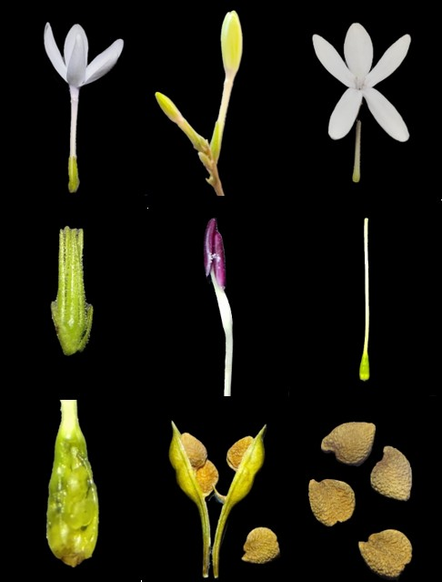
i.
f.
h.
g.
e.
d.
b.
c.
a.
2 mm
1 mm
0.5 cm
1 mm
1 mm
1 cm
1 cm

Fig. 3 a. Flower, b. buds, c. Corolla, d. Calyx with bracts, e. stamen, f. Carpel, g. Ovary, h. capsule with seeds, i. seeds

Threat Assessment & Conservation status: Anthropogenic activities are mainly responsible for the survival of any species. Human population growth, per capita consumption, expanding urbanisation and agriculture are key factors of habitat loss and fragmentation (Forester & Machlist, 1996). There is also limitation of data regarding the status of many species (Brooks, 2006)Being a rapidly growing nation India is also harbouring such factors leading to serious biodiversity loss. Odisha, an eastern coastal state is experiencing rapid industrialisation, encroachment of invasive species, habitat loss that act as driving force for endangering many important species. Hence a threat assessment to select species can be a necessary step for conservation biologists to know the status of different important species and protect them from the verge of extinction.The species Pseuderanthemum latifolium is considered as rare by some authors (Dhatchanamoorthy,2015). However, its conservation status needs to be assessed. A systematic conservation status was evaluated by following existing documents and herbaria. The distribution, occurrences of the species were studied from herbaria of CAL, IMMT Herbarium, Bhubaneswar, Regional Plant Resource Centre (RPRC-Bhubaneswar), digital herbaria like IVH-BSI and JCB Herbarium. Different Plant information database systems (GBIF-Global Biodiversity Information Facility, POWO, JSTOR (https://plants.jstor.org), were also followed for knowing the status, global distribution and recent occurrences for easy evaluation and threat assessment.
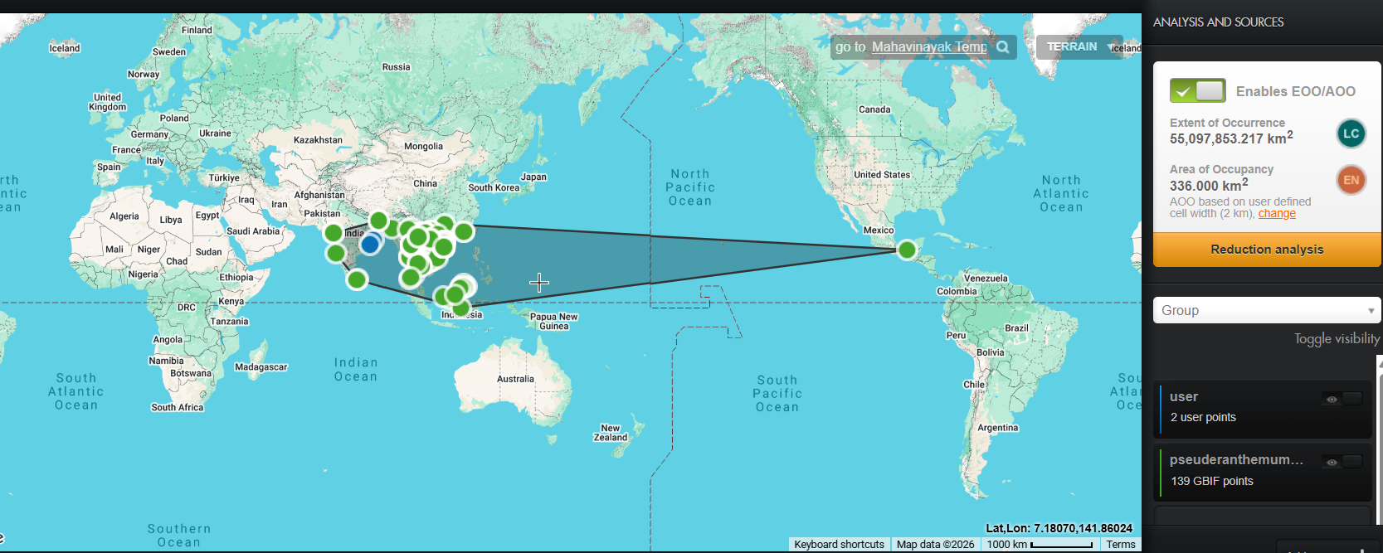
Fig-4 Threat assessment & Conservation status using Geo-CAT
Name of the species | B1-EOO  (km²) | B2-AOO (km²)
Pseuderanthemum latifoilum (Vahl.) B. Hansen | 55,097,853.217 | 326.000
Pseuderanthemum latifoilum (Vahl.) B. Hansen | LC  < 5000 km² | EN  < 500 km²
Extent of Occurrence (EOO), Area of Occupancy (AOO), EN- Endangered LC- Least Concerned (criteria B1 EOO & B2 AOO) (Das & Lahiri, 2022, IUCN Ver 14, 2019)
Discussion:
During the field exploration in the study area Fig-1, only 3-4 individuals were observed in the region. Again, this species was reported in some parts of northern circars (a narrow strip of territory in the eastern coast of Indian peninsula present in Andhra Pradesh and Odisha) in the Ganjam district about 30 years back Saxena and Brahmam. The population of this species is dwindling in its natural habitat. In the present study the species was relocated in the study are (Fig-1) in the Jajpur district inside a sacred hill forest of Odisha, India. Use of Geospatial Conservation Assessment tool reveals that the species is endangered-EN (Fig-4) and very rarely observed in the State of Odisha. Criterion B1 EOO (Extent of Occurrence) and Criterion B2 (Area Of Occupancy) were taken into consideration (IUCN, Ver-14, 2019) for threat assessment.
Conclusion
References
Brooks TM, Mittermeier RA, da Fonseca GA, Gerlach J, Hoffmann M, Lamoreux JF, Mittermeier CG, Pilgrim JD, Rodrigues AS. Global biodiversity conservation priorities. Science. 2006 Jul 7;313(5783):58-61. doi: 10.1126/science.1127609. PMID: 16825561.
Choopan, T., Grote, P. J., Chayamarit, K., & Simpson, D. A. (2018). An annotated checklist of the genus Pseuderanthemum Radlk.(Acanthaceae) in Thailand. Thai Forest Bulletin (Botany), 46(1), 90-111.
Dhatchanamoorthy, N., Arumugam, T., & Raja, P. (2015). First report of Pseuderanthemum malabaricum (Acanthaceae)–Rare species of central and southern Eastern Ghats of Tamil Nadu, India.
Haines H.H (1921–1925) The Botany of Bihar and Orissa. Adlard & Son, London.
Hansen, B. (1989), Notes on SE Asian Acanthaceae 1. Nordic Journal of Botany, 9: 209- 215. https://doi.org/10.1111/j.1756-1051.1989.tb02117.x
Hooker JD (1872–1897) The flora of British India, vol 4 Vols. L. Reeve & Co., London.
Karthikeyan S, Sanjappa M, Moorthy S. Flowering plants of India. Dicotyledons: vol. 1. Acanthaceae-Avicenniaceae. Botanical Survey of India, 2010.
Manzitto‐Tripp EA, Darbyshire I, Daniel TF, Kiel CA, McDade LA. Revised classification of Acanthaceae and worldwide dichotomous keys. Taxon, 2022:71(1):103-53.
Mooney HF (1950) Supplement to the botany of Bihar and Orissa. Catholic, Ranchi.
Nayak, S., Mandal, K., Priyadarshini, S., Mishra, D., Sahu, S. C., Kumar, M., ... & Dhal, N. K. (2024). Phytodiversity study of Nayagarh Forest Division, Odisha. Asian Journal of Conservation Biology, 13(2), 215-231.
POWO (2026). "Plants of the World Online. Facilitated by the Royal Botanic Gardens, Kew. Published on the Internet; https://powo.science.kew.org/ Retrieved 10 April 2026."
Sahu, S. C., & Dhal, N. K. (2012). Floristic diversity of Mandargiri hills, Angul, Odisha: an overview.
Saxena HO, Brahmam M. Flora of Orissa, Volume III, Orissa Forest Development Corporation, Bhubaneswar, 1995.
Scotland, R. W., & Vollesen, K. (2000). Classification of acanthaceae. Kew bulletin, 513-589.
Sujana, K., Surendra, A. V., Kishore, K. V., Reehana, S. K., & Himakalyani, C. B. (2023). Phytochemical Analysis and Characterization of Ethanolic Extract of Pseuderanthemum malabaricum Whole Plant.
Bhattarai U, Tetali P, Kelso S. Contributions of vulnerable hydrogeomorphic habitats to endemic plant diversity on the Kas Plateau, Western Ghats. Springer plus. 2012 Oct 4;1:25. doi: 10.1186/2193-1801-1-25. PMID: 23961355; PMCID: PMC3725892.
IUCN. 2012a. Guidelines for Application of IUCN Red List Criteria at Regional and National Levels: Version 4.0. Gland, Switzerland and Cambridge, UK: IUCN. iii + 41pp
IUCN. 2012b. IUCN Red List Categories and Criteria: Version 3.1. Second edition. Gland, Switzerland and Cambridge, UK: IUCN. iv + 32pp.
IUCN. 2019. IUCN Standards and Petitions Committee. Guidelines for Using the IUCN Red List Categories and Criteria. Version 14. Prepared by the Standards and Petitions Committee. Gland, Switzerland.
Hema, G., & Keshamma, E. (2025). Anthelmintic activity of ethanolic leaf Extract of Pseuderanthemum latifolium: an in-vitro study. Cuestiones de Fisioterapia, 54(3), 1604-1615.
Choopan, T., & Grote, P. J. (2015). Cystoliths in the leaves of the genus Pseuderanthemum (Acanthaceae) in Thailand. NU. International Journal of Science, 12(2), 13-20.
Olmstead R, Albach D, Beardsley P, Bedigian D et al. (2016) A synoptical classification of the Lamiales Version 2.6.2 [updated 12 April, 2016],
McDade LA, Daniel TF, Masta SE, Riley KM. (2000) Phylogenetic relationships within the tribe Justicieae (Acanthaceae): Evidence from molecular sequences, morphology, and cytology. Annals of the Missouri Botanical Garden 87(4): 435–458. 10.2307/2666140
Das, M. and Lahiri, S. (2022). Threat Assessment of Two Himalayan Endemic Alpine Plant Species and Conservation Implications. Int. J. Bioresource Sci., 09(02): 139-144.
Forester, D.J. and Machlist, G.E. (1996), Modeling Human Factors That Affect the Loss of Biodiversity. Conservation Biology, 10: 1253-1263. https://doi.org/10.1046/j.1523- 1739.1996.10041253.x.

