Evaluation of Seed germination in Moong bean (Vigna radiata L.) under salinity stress

Abstract
Salinity stress is one of the major abiotic factors limiting seed germination and crop establishment in agricultural systems. The present study evaluated the effects of different salts on the germination behaviour of moong bean (Vigna radiata L.) under laboratory conditions. Healthy and surface-sterilized seeds were subjected to sodium chloride (NaCl), magnesium sulphate (MgSO₄), and potassium sulphate (K₂SO₄) at concentrations of 0%, 0.5%, 1%, and 2%. Germination percentage (GP) and mean germination time (MGT) were recorded over a seven-day period. The results revealed that increasing salinity significantly reduced germination percentage and delayed seed germination in all treatments. Among the salts tested, NaCl showed the strongest inhibitory effect, causing a drastic decline in GP and the longest MGT, indicating severe osmotic and ionic stress. MgSO₄ exhibited moderate inhibition, whereas K₂SO₄ maintained comparatively higher germination percentages and shorter germination times even at higher concentrations. The order of salt toxicity was observed as NaCl > MgSO₄ > K₂SO₄. The comparatively better performance under K₂SO₄ treatment suggests a beneficial role of potassium in maintaining osmotic balance and ion homeostasis during germination. The findings highlight the importance of ionic composition in determining salinity tolerance and provide useful insights for developing salinity management strategies and improving crop establishment in saline soils.
Keywords: Seed Germination, Salinity Stress, Moong Bean Cultivation, Germination Percentage, Mean Germination Time, Plant Stress Physiology
Introduction
Seed germination is a critical physiological process that determines the successful establishment of crops in agricultural systems. It involves a sequence of tightly regulated events, beginning with water uptake (imbibition) and culminating in the emergence of the radicle, which marks the transition from dormancy to active growth (Bewley, 1997; Nonogaki, Bassel, & Bewley, 2010). The efficiency of this process is highly sensitive to environmental stresses, particularly salinity, which is recognized as one of the most severe abiotic constraints affecting global agriculture.
Salinity stress impacts nearly 20% of irrigated land worldwide, reducing crop productivity and threatening food security (Munns & Tester, 2008). High salt concentrations impose dual stress conditions: osmotic stress, which limits water availability to seeds, and ionic stress, caused by toxic accumulation of Na⁺ and Cl⁻ ions. These stresses impair membrane stability, inhibit enzymatic activity, and trigger oxidative damage through excessive Reactive Oxygen Species (ROS) generation (Parida & Das, 2005). The combined effects delay germination, reduce seedling vigor, and ultimately compromise crop yield.
Moong bean (Vigna radiata L.), commonly known as green gram, is a short-duration pulse crop of immense nutritional and economic importance in South and Southeast Asia. Rich in protein and essential amino acids, it contributes significantly to dietary requirements and soil fertility through nitrogen fixation. India is the largest producer, with Odisha being a key cultivating state. However, Vigna radiata is highly sensitive to salinity, particularly during germination and early seedling development (Podder, Ray, Das, & Sarker, 2020).
Understanding the comparative effects of different salts is crucial, as not all ions exert equal toxicity. Sodium chloride (NaCl) is widely recognized as the most harmful due to its chloride-based ionic stress, while magnesium sulphate (MgSO₄) and potassium sulphate (K₂SO₄) may exert different physiological impacts. Potassium, in particular, plays a beneficial role in osmotic adjustment and ion homeostasis, potentially mitigating salinity effects (Ashraf &Foolad, 2007; Zhu, 2001). Recent advances in molecular biology also highlight the role of osmoprotectants, antioxidant enzymes, and stress-responsive genes in enhancing salt tolerance (Hasanuzzaman& Fujita, 2022).
This study was designed to evaluate the impact of NaCl, MgSO₄, and K₂SO₄ on the germination of moong bean seeds under controlled laboratory conditions. By analyzing germination percentage and mean germination time (MGT) across varying concentrations, the research aims to establish a hierarchy of salt toxicity and provide insights into the physiological resilience of moong beans. The findings are expected to contribute to strategies for soil management and the development of salt-tolerant cultivars, ensuring sustainable pulse production in salinity-prone regions.

Methodology
Healthy and uniform moong bean (Vigna radiata L.) seeds were selected and surface sterilized using 70% ethanol for two minutes, followed by thorough rinsing with sterile distilled water to eliminate microbial contamination. Three salts, sodium chloride (NaCl), magnesium sulphate (MgSO₄), and potassium sulphate (K₂SO₄) were prepared at concentrations of 0% (control), 0.5%, 1%, and 2% in distilled water. Sterile petridishes were lined with double layers of cotton and moistened with 5–10 mL of the respective salt solutions. Ten seeds were evenly placed in each dish, ensuring uniform spacing to avoid competition. The dishes were incubated under controlled laboratory conditions at 25–27℃, with moisture maintained by adding 2 mL of the respective salt solution every two days. Observations were recorded for seven consecutive days, and germination was considered successful when the radicle length reached at least 2 mm.
Germination percentage (GP) was calculated using the formula:
$$GP=\left(\frac{\text{Number of seeds germinated}}{\text{Total seeds sown}}\right)×100$$
as described by Bewley (1997) and applied in salinity stress studies by Podder et al. (2020). To assess the velocity of germination, Mean Germination Time (MGT) was computed using the equation:
$$MGT=\frac{Σ(n×d)}{N}$$
where n represents the number of seeds germinated on day d, and N is the total number of seeds germinated during the experiment. This approach follows the methodology outlined by Nonogaki, Bassel, & Bewley (2010) and is widely used in germination assays under abiotic stress conditions.
This experimental design allowed for a comparative evaluation of the effects of NaCl, MgSO₄, and K₂SO₄ on seed germination under varying salinity stress conditions, providing reproducible data for assessing salt tolerance in Vigna radiata.

Results
The germination of moong bean (Vigna radiata L.) seeds was significantly affected by the type and concentration of salts applied. Control seeds (0% salt) showed rapid radicle emergence within 24–48 hours and maintained high germination percentages (>95%). Increasing salt concentrations progressively reduced germination percentage and delayed radicle emergence, with NaCl exerting the most severe inhibitory effect, followed by MgSO₄, while K₂SO₄ was comparatively less toxic.
Table 1 : Germination Percentage (GP) and Mean Germination Time (MGT)
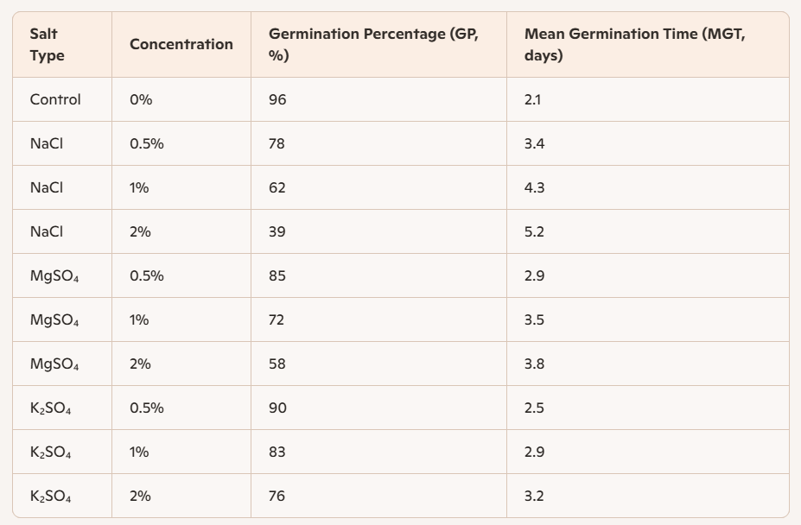

The results clearly demonstrate that sodium chloride (NaCl) caused the most pronounced reduction in germination percentage (GP) and the longest mean germination time (MGT), confirming chloride salinity as the most detrimental factor affecting moong bean germination. This observation aligns with earlier findings by Podder et al. (2020) and Parida & Das (2005), who reported that chloride-based salts impose severe osmotic and ionic stress, leading to delayed radicle emergence and reduced seed viability. In contrast, magnesium sulphate (MgSO₄) exhibited moderate inhibition, with GP values ranging between 55 % and 85 % and MGT delays of approximately 1.5 days compared to the control. The relatively milder effect of MgSO₄ suggests that magnesium ions, though contributing to osmotic imbalance, are less toxic than chloride ions. Potassium sulphate (K₂SO₄) maintained higher germination percentages exceeding 75 % even at 2 % concentration and shorter MGT values, indicating that potassium plays a beneficial role in osmotic adjustment and stress mitigation. This protective effect of potassium corroborates the physiological mechanisms described by Ashraf & Foolad (2007) and Zhu (2001), who emphasized its importance in maintaining ion homeostasis and enhancing plant tolerance under saline conditions. Overall, the comparative analysis establishes the hierarchy of salt toxicity as NaCl > MgSO₄ > K₂SO₄, reflecting the differential ionic impacts on seed germination and early seedling development.
Fig 1 : The germination percentage (GP) of the moong bean

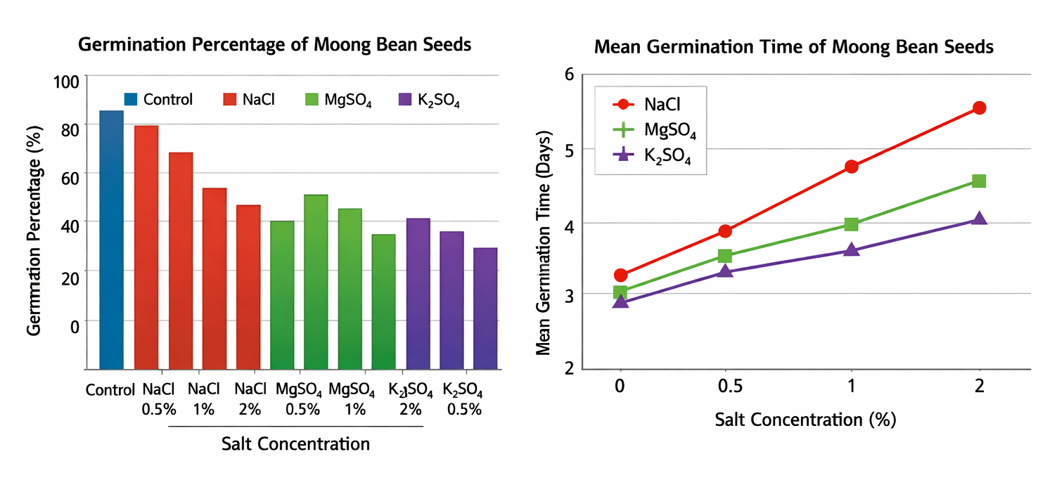
The bar graph illustrates the germination percentage (GP) of moong bean (Vigna radiata L.) seeds under different salt treatments and concentrations. The control group exhibited the highest GP (≈96 %), confirming optimal germination under non-saline conditions. As salt concentration increased, GP declined progressively, with NaCl showing the steepest reduction from 78 % at 0.5 % to only 39 % at 2 %. This pattern highlights the severe inhibitory effect of chloride salinity on seed germination, consistent with the findings of Podder et al. (2020) and Parida & Das (2005). MgSO₄ treatments produced moderate inhibition, maintaining GP between 55 % and 85 %, while K₂SO₄ maintained relatively higher GP values (> 75 % even at 2 %), suggesting that potassium ions help sustain osmotic balance and reduce stress effects (Ashraf & Foolad, 2007; Zhu, 2001).
The line graph depicts the mean germination time (MGT) trends across salt concentrations. A clear positive correlation is observed between salt concentration and MGT, indicating delayed germination under increasing salinity. Seeds exposed to NaCl exhibited the longest MGT (≈ 5.2 days at 2 %), reflecting severe osmotic and ionic stress. MgSO₄ treatments resulted in moderate delays (≈ 3.8 days at 2 %), while K₂SO₄ maintained shorter MGT values (≈ 3.2 days at 2 %), demonstrating faster germination and better physiological resilience. These trends confirm that chloride-based salinity imposes the greatest stress, whereas potassium-based salts mitigate its effects through improved ion regulation and osmotic adjustment.
Together, the bar and line graphs visually reinforce the hierarchy of salt toxicity NaCl > MgSO₄ > K₂SO₄ and validate the quantitative results presented in the table. They provide a clear depiction of how salinity not only reduces germination success but also slows the rate of seedling emergence, emphasizing the importance of potassium in enhancing salt tolerance mechanisms in moong bean.
Fig 2 : Observation of seeds in different conc. before the Seed germination

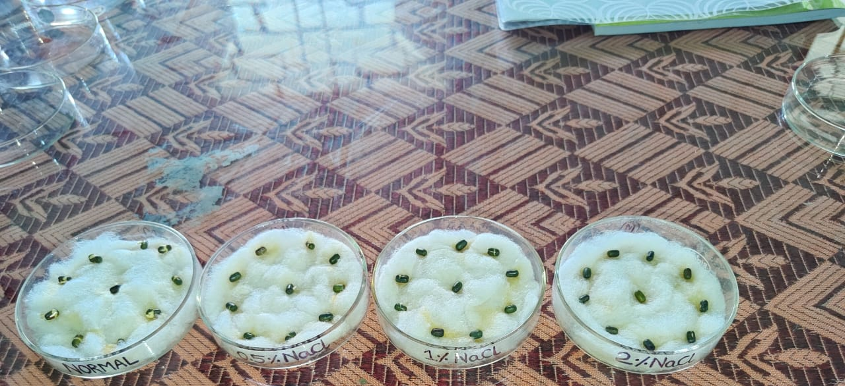
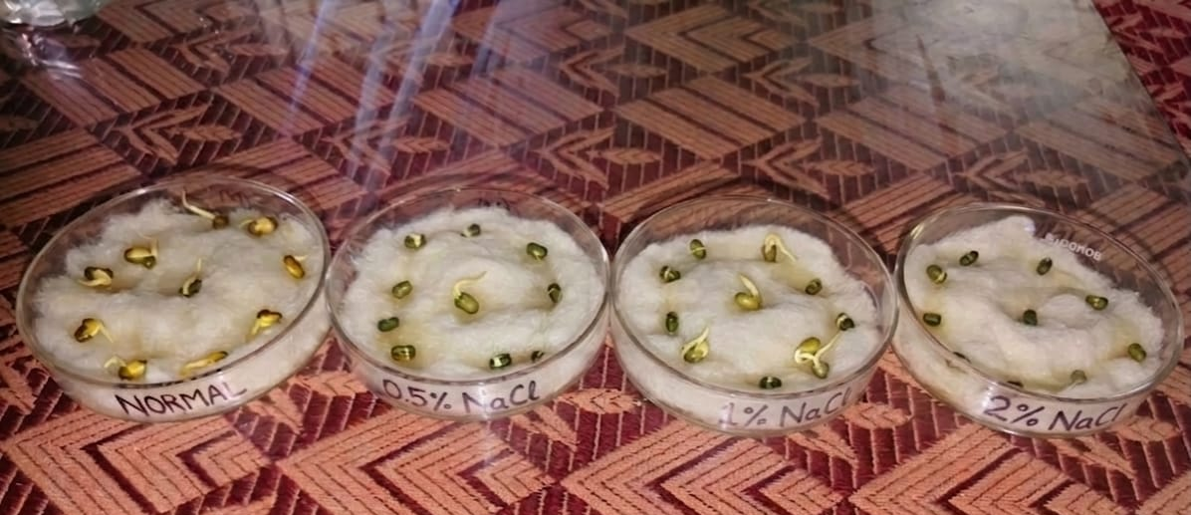
Fig 3: Observation of seeds in different conc. after the seed germination
Discussion
The present study demonstrates that salinity stress significantly alters the germination behavior of moong bean (Vigna radiata L.), with NaCl exerting the most severe inhibitory effect, followed by MgSO₄ , while K₂SO₄ was comparatively less toxic. The sharp decline in germination percentage (GP) and prolonged mean germination time (MGT) under NaCl stress is consistent with findings in barley (Hordeum vulgare), where chloride salinity was reported to cause drastic reductions in germination and seedling vigor (Kaya et al., 2008). Similar inhibitory effects of NaCl have been documented in maize (Zea mays), where high chloride concentrations delayed germination and reduced seedling biomass (Farooq et al., 2015).
MgSO₄ treatments produced moderate inhibition, with GP values between 55–85% and MGT delays of ~1.5 days compared to control. This pattern aligns with comparative studies in sunflower (Helianthus annuus), where magnesium salts reduced germination but did not cause the severe ionic toxicity associated with chloride ions (Hernández et al., 1999). Magnesium stress primarily affects osmotic balance rather than directly damaging membranes, which explains the relatively milder inhibition observed in moong bean.
treatments maintained higher GP (>75% even at 2%) and shorter MGT, underscoring potassium’s protective role in salinity tolerance. Comparative studies in sorghum (Sorghum bicolor) and rice (Oryza sativa) have shown that potassium supplementation enhances osmotic adjustment, improves ion homeostasis, and activates antioxidant defenses, thereby mitigating oxidative damage under saline conditions (Cakmak, 2005; Shabala & Cuin, 2008). More recent work in tomato (Solanum lycopersicum) confirmed that potassium regulates ROS-scavenging enzymes and stress-responsive genes, strengthening plant resilience against salinity (Cuin et al., 2009).
Furthermore, the differential response of moong bean seeds to various salts may also be associated with ion-specific toxicity and the plant’s ability to maintain cellular water relations during germination. High concentrations of Na⁺ and Cl⁻ ions are known to disrupt enzymatic activities, reduce water uptake, and impair metabolic processes essential for embryo growth and reserve mobilization. Similar observations were reported in chickpea (Cicer arietinum), where elevated NaCl levels significantly suppressed seed germination and early seedling development due to osmotic and ionic stress (Atieno et al., 2017). In contrast, potassium-containing salts help maintain membrane stability and enzyme activation, thereby supporting better germination performance under saline conditions. Studies in wheat (Triticum aestivum) demonstrated that adequate potassium supply improves chlorophyll retention, protein synthesis, and stress tolerance under salinity (Shahbaz & Ashraf, 2013). These findings collectively suggest that potassium-mediated ionic balance plays a crucial role in enhancing salinity tolerance in legumes, including moong bean.
Taken together, these comparative insights reinforce the hierarchy of salt toxicity, NaCl > MgSO₄ > K₂SO₄ and emphasize the importance of ion composition in determining salinity tolerance. The consistency of these results across legumes, cereals, and oilseeds suggests that chloride management and potassium supplementation are practical agronomic strategies for improving crop establishment in salinity-prone regions.

Conclusion
This study confirms that salinity stress significantly influences the germination behaviour of moong bean (Vigna radiata). Among the salts tested, sodium chloride (NaCl) showed the highest inhibitory effect by considerably reducing germination percentage and increasing mean germination time. Magnesium sulphate (MgSO₄) caused moderate inhibition, mainly due to osmotic and ionic imbalance, whereas potassium sulphate (K₂SO₄) exhibited comparatively lower toxicity and maintained better germination performance. The results therefore establish the order of salt toxicity as NaCl >MgSO₄ > K₂SO₄.
The study highlights the importance of ionic composition in determining salinity tolerance during seed germination. The comparatively better performance under K₂SO₄ treatment suggests a protective role of potassium in mitigating salinity-induced stress. These findings indicate that controlling chloride accumulation and maintaining adequate potassium availability may help improve seed germination and early seedling establishment in saline soils.
Overall, the present investigation provides useful insights into the differential effects of various salts on seed germination and offers a scientific basis for developing salinity management strategies in leguminous crops. Further studies involving physiological, biochemical, and molecular approaches are recommended to identify salt-tolerant genotypes and enhance crop resilience under saline conditions.

References

Ashraf, M. and Foolad, M.R. (2007) Roles of Glycine Betaine and Proline in Improving Plant Abiotic Stress Resistance. Environmental and Experimental Botany, 59, 206-216.
http://dx.doi.org/10.1016/j.envexpbot.2005.12.006
Bewley, J. D. (1997). Seed germination and dormancy mechanisms. The Plant Cell, 9(7), 1055–1066. DOI: 10.1105/tpc.9.7.1055gha

Hasanuzzaman, M., & Fujita, M. (2022). Plant Responses and Tolerance to Salt Stress: Physiological and Molecular Interventions. International Journal of Molecular Sciences, 23(9), 4810. https://doi.org/10.3390/ijms23094810

Munns, R., & Tester, M. (2008). Mechanisms of salinity tolerance. Annual Review of Plant Biology, 59, 651–681. DOI: 10.1146/annurev.arplant.59.032607.092911

Nonogaki, H., Bassel, G. W., & Bewley, J. D. (2010). Germination—still a mystery. Plant Science, 179(6), 574–581. DOI: 10.1016/j.plantsci.2010.02.010 (doi.org in Bing)

Parida, A. K., & Das, A. B. (2005). Salt tolerance and salinity effects on plants: a review. Ecotoxicology and environmental safety, 60(3), 324–349. https://doi.org/10.1016/j.ecoenv.2004.06.010

Podder, S., Ray, J., Das, D. and Sarker, B. C. (2020). Effect of salinity (NaCl) on germination and seedling growth of mungbean (Vigna radiata L.). Journal of Bioscience and Agriculture Research, 24(02), 2012-2019. https://doi.org/10.18801/jbar.240220.246

Taiz, L., Zeiger, E., Møller, I. M., & Murphy, A. (2015). Plant Physiology and Development (6th ed.). Sinauer Associates. Publisher link: Oxford University Press (global.oup.com in Bing)

Zhu, J. K. (2001). Plant salt tolerance. Trends in Plant Science, 6(2), 66–71. DOI: 10.1016/S1360-1385(00)01838-0 https://infosat.icrisat.org/10624/
Kaya, M.D., Okçu, G., Atak, M., Çıkılı, Y. and Kolsarıcı, Ö. (2006) Seed Treatments to Overcome Salt and Drought Stress during Germination in Sunflower (Helianthus annuus L.). European Journal of Agronomy, 24, 291-295.https://doi.org/10.1016/j.eja.2005.08.001

Farooq, M., Hussain, M., Wakeel, A. and Siddique, K.H.M. (2015) Salt Stress in Maize: Effect, Resistance Mechanism and Management. A Review. Agronomy for Sustainable Development, 35, 461-481.https://doi.org/10.1007/s13593-015-0287-0
Hernández, J. A., Ferrer, M. A., Jiménez, A., Barceló, A. R., & Sevilla, F. (2001). Antioxidant systems and O(2)(.-)/H(2)O(2) production in the apoplast of pea leaves. Its relation with salt-induced necrotic lesions in minor veins. Plant physiology, 127(3), 817–831. https://doi.org/10.1104/pp.010188

Cakmak, I. (2005). The role of potassium in alleviating detrimental effects of abiotic stresses in plants. Journal of Plant Nutrition and Soil Science, 168(4), 521–530.

Shabala, S., & Cuin, T. A. (2008). Potassium transport and plant salt tolerance. Physiologia Plantarum, 133(4), 651-669. https://doi.org/10.1111/j.1399-3054.2007.01008.x

Cuin, T. A., Tian, Y., Betts, S. A., Chalmandrier, R., & Shabala, S. (2009).Ionic relations and osmotic adjustment in durum and bread wheat under saline conditions. Functional Plant Biology.36(12):1110-1119. DOI:10.1071/FP09051

Atieno, J., Li, Y., Langridge, P., Dowling, K., Brien, C., Berger, B., Varshney, R.K., & Sutton, T. (2017). Exploring genetic variation for salinity tolerance in chickpea using image-based phenotyping. Scientific Reports, 7, 1300. https://doi.org/10.1038/s41598-017-01211-7
Shahbaz, M., & Ashraf, M. (2013). Improving salinity tolerance in cereals. Critical Reviews in Plant Sciences, 32(4), 237–249. https://doi.org/10.1080/07352689.2013.758544

