Original Research Article
Development of Value-Added Breakfast Cereal Enriched with Banana Blossom: Process Optimization, Nutritional Characterization, and Sensory Acceptability

ABSTRACT
Banana blossom is an edible flower rich in macro and micro nutrients. It also has a good amount of dietary fibre and antioxidants hence are beneficial in managing diabetes, cardiovascular diseases, and constipation. The present study aimed to develop novel breakfast cereal enriched with banana blossom flour and analyze its nutritional and sensory propertires .Moreover; this study provides insight into process standardization, support technological advancement for commercial-scale production. The fresh blossoms were pre-treated with natural citric acid to avoid enzymatic browning by lowering pH and inhibiting polyphenol oxidase. 4 formulations were made out of which the F2 formulation which contained 3gm banana blossom shows the best results in proximate analysis. F2 also showed the best overall acceptability in sensory analysis which was performed by 30 untrained panellist through hedonic scales.
Keywords: Banana Blossom, breakfast cereal, nutritional, sensory

- INTRODUCTION
Banana (Musa Paradisica) is one of the most delicious and widely consumed foods all over the world(Pereira and Maraschin 2015). Bananas are predominantly cultivated in tropical countries (Tasnim, Das et al. 2020). Hence, India is the world’s largest producer of banana(Elaveniya and Jayamuthunagai 2014). What’s interesting is the distinctive morphological feature present at the tip of this banana bunches. This attractive terminal inflorescence part is characterized by compact, maroon-coloured, leafy conical structure composed of overlapping bracts(Tasnim, Das et al. 2020). This terminal inflorescence is generally termed as banana blossom or banana heart(Elaveniya and Jayamuthunagai 2014). It is mostly consumed in the eastern part of India. This edible flower(Komal and Kaur 2019) is a rich source of antioxidants like phenols and flavonoids(Elaveniya and Jayamuthunagai 2014). It also contains significant amount protein, dietary fibre, vitamins and minerals like- Magnesium, Iron Copper and Potassium(Komal and Kaur 2019). Due to its rich nutrient profile, it has also serves some potential health benefits. Its high antioxidant and fibre properties help manage diabetes, cholesterol levels(Elaveniya and Jayamuthunagai 2014), constipation and cardiovascular diseases(Komal and Kaur 2019). Being rich in iron it supports haemoglobin formation which prevents anaemia(Sheng, Ma et al. 2010). Despite being nutritionally valuable, the usage of banana blossom has been reduced due to its lengthy and labour intensive preparation procedure which involves removing of the outer bracts, separation of florets, removal of inedible part, and extensive cleaning and washing(Ambrose, Sumithra et al. 2018).
‘Breakfast’ is the first meal of the day. It is the most important and essential meal which creates a heavy impact on our health(Betts, Chowdhury et al. 2016). Starting your day with a good breakfast brings a lot of positive health and nutritional outcome(Tolfrey and Zakrzewski 2012). Hence, choosing a right breakfast cereal plays a significant role in maintaining better and nutritional lifestyle. Breakfast cereals are a minimal processed ready-to-eat or ready-to-serve dish which is gaining importance and attention in today’s busy life due to its convenience, numerous nutritional and health benefits(Kapoor and Haripriya 2020). Breakfast cereal primarily consists of whole grains like rolled oats(Welch 2011), wheat, barley, corn flakes and different kinds of seeds which make this a valuable source of antioxidants, vitamins, minerals and dietary fibres(Comerford 2026). It is usually taken with milk, yogurt or fruit juice. It is crispy in nature and sometimes additional components are added to make it more enriched with nutrients. Consumption of a healthy breakfast cereal is being associated with multiple health benefits like improving digestive health, cardiovascular health; lowering of cholesterol and blood sugar levels also prevention of lifestyle related disorders(Joye 2020). Its antioxidant rich properties play significant role in reducing oxidative stress(Ryan, Thondre et al. 2011). More significantly, its shelf stability feature acts the main role in busy lifestyle as it requires no lengthy preparation hence becomes a wholesome breakfast meal. This present study mainly focuses on the incorporation of an underutilised yet nutritionally rich banana blossom in breakfast cereal to enhance its nutritional and functional properties. The replacement of wheat flour with functional ingredient has always proven to be nutritionally enriching(Tasnim, Das et al. 2020). Enriching the breakfast cereal with banana blossom will act as great source of dietary fibres, antioxidants, bioactive compounds, vitamins and minerals(Joshi and Srivastava 2024). In this study banana blossoms were treated with natural citric acid (lime juice) to prevent enzymatic browning by lowering the pH and inhibiting polyphenol oxidase. Enzymatic browning generally causes loss of a lot of nutrients present in the food hence prevention of this was one of the very essential step of the study (Tasnim, Das et al. 2020). This study aimed to develop a novel breakfast cereal enriched with banana blossom flour and to analyze its nutritional and sensory properties. Moreover, this study provides insight into the process standardization, support technological advancement for commercial-scale production.

- MATERIALS AND METHODS
  - Materials
Fresh banana blossoms were procured from the local vegetable market of Kolkata, West Bengal. The blossoms were selected based on their maturity, freshness, absence of any kind of microbial or visible spoilage. Other ingredients required for the formulation of the product includes rolled oats, amaranthus, chia seeds, corn flour, cinnamon powder, cocoa powder and monk fruit sweetner which were purchased from standard grocery store of Lucknow, Uttar Pradesh. All best quality materials were chosen and stored under appropriate ambient conditions.
  - Preparation of Banana Blossom Flour(BBF)
The preparation of banana blossom flour was carried out, following a systematic processing method to ensure maximum nutrient retention and maintain good product quality. The following steps were performed in preparation of the flour:
Initially, the procured banana blossoms were washed thoroughly under potable running water to remove all the dirt and presence of extraneous matter. Then the marooned coloured bracts were removed carefully one after the other sequentially. The inner edible white florets arranged in an overlapping pattern beneath each bract were then separated manually. The separated white florets were further cleaned to remove the unwanted portions. Excess surface moisture was removed by gently spreading the florets on a sterile filter paper under ambient conditions. The blossoms were then subjected to the process of pre-treatment by soaking them in natural citric acid (lemon juice) for at least an hour. This process of pre-treatment was mainly carried out to inhibit enzymatic browning caused by an enzyme polyphenol oxidase which reacts with oxygen in air. In this reaction the phenolic compounds gets converted into brown coloured pigments called melanin. This pre-treatment is also performed to minimize the nutrient degradation of the banana blossom. After completion of the soaking process, in the next step the blossoms were drained completely to remove the moisture present in the surface. The drained blossoms were then uniformly sliced to an approximately thickness of 3mm to cause proper drying Then spread uniformly in sterile trays of the dehydrator at 50º C for 18hrs to achieve adequate removal of moisture and enhance shelf life stability. Lastly, upon completion of the dehydration procedure the dried banana blossoms sliced were now allowed to cool down under room temperature then finely ground using a mixer grinder to obtain finely grounded powder. Then the resulting powder was sieved to ensure uniform particle size which was named as Banana Blossom Flour (BBF). Finally the BBF was stored in air tight containers at room temperature until further use.

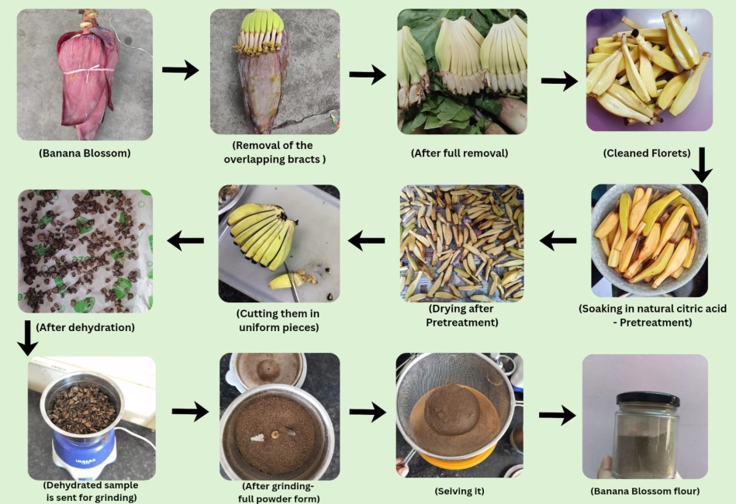

(Fig.1 Flowchart depicts the step by step procedure of making of Banana Blossom Flour)

  - Preparation of Breakfast cereal enriched with Banana Blossom Flour (BBF)
After the preparation of the banana blossom flours it was now time to incorporate it as a functional ingredient in breakfast as a cereal. The base of the breakfast cereal was prepared by supplementing the regular wheat flour by corn flour, amaranthus flour, grinded oats and grinded chia seeds. Along with this, cocoa powder was added to provide a chocolaty flavour to the cereal and to make it more appetising. Sugar was substituted by a natural sweetener called ‘Monk fruit sweetener’ which is a high intensity, zero calorie sweetener. It provides sweetness 150-200 times more than regular sugar also has antioxidant properties. Monk fruit has a natural compound, mogrosides which is responsible for the sweetness. All the ingredients including the BBF were weighted separately using a weigh balance. Then were mixed according to the formulations for 4 different samples to form dough. The control sample did not contain the BBF.
Four different dough were then kneaded according to the various compositions. The dough was properly kneaded using correct proportion of water and melted butter. After this, the dough was flattened and then given appropriate shapes (here the shape of a crescent moon is given using a spoon). Then the shaped pieces were placed over a butter paper in the baking tray and put into a microwave oven to bake at 155-165⁰C for 15-20mins. After the adequate time it was taken out and place in room temperature to cool down. Lastly, after getting cooled the breakfast cereal was now ready to be served with hot/ cold milk as per consumer choice. It can even be consumed as bites for breakfast without addition of milk.
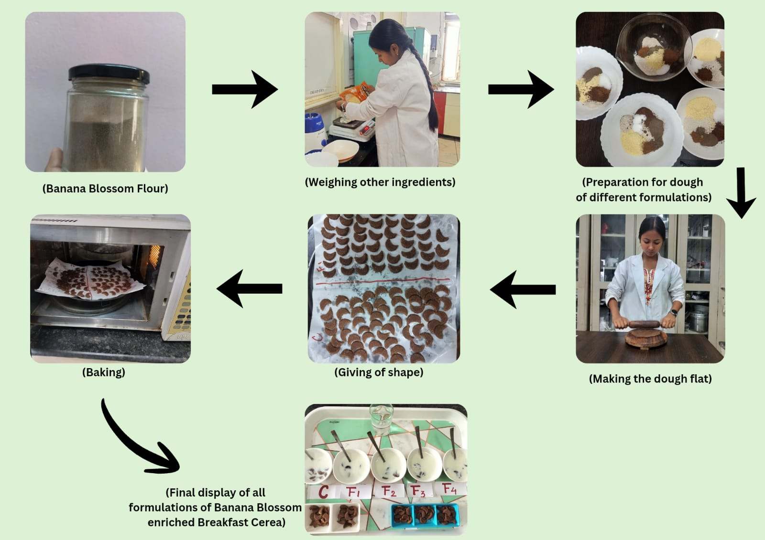

(Fig.2 Flowchart depicts the step by step procedure of the Breakfast cereal from the banana blossom flour )
(Table no. 1 Formulation table for banana blossom enriched breakfast cereal)
INGREDIENTS(gm) | CONTROL | FI | F2 | F3 | F4
Oats Flour | 25 | 20 | 15 | 10 | 5
Corn Flour | 15 | 20 | 25 | 30 | 35
Amaranthus Flour | 6 | 5 | 5 | 5 | 5
Chia Seeds (grinded) | 2 | 1 | 1 | 1 | 1
Cinnamon Powder | 2 | 1 | 1 | 1 | 1
Cocoa Powder | 2 | 2 | 2 | 2 | 2
Sweetener | 2 | 2 | 2 | 2 | 2
Banana Blossom Flour | 0 | 2 | 3 | 3 | 3

  - Proximate analysis of Banana blossom flour.
Moisture content, ash content, crude protein, crude fibre and crude fat was determined by the AOAC published guidelines and methods (2019). Carbohydrate was estimated according to the guidelines by Food and Agriculture Organisation(Beshaw, Demssie et al. 2022).
  - Proximate analysis of Banana blossom enriched breakfast cereal
The AOAC guidelines (2019) helped in determining the moisture, ash, crude protein, crude fat, and crude fibre content of the cereal. It is very essential in determining the nutrient content of the novel product development. The carbohydrate was determined by the guidelines of FAO(Thiex 2009).
  - Organoleptic Analysis of Banana blossom enriched breakfast cereal
Sensory evaluation or organoleptic analysis was performed by 30 untrained panellists, who were given samples to taste and evaluate which were of different formulations of banana blossom flour, these were coded randomly(Lyon, Francombe et al. 2012). Panellists were asked to rate the randomly coded samples on a 1-9 point hedonic scale (1- dislike extremely, 2- dislike very much, 3- dislike moderately, 4- dislike slightly, 5- neither dislike nor like, 6- like slightly, 7- like moderately, 8- like very much, 9- like extremely) on the basis of different sensory attributes like appearance, taste, odour, texture and overall acceptability(Wichchukit and O'Mahony 2015).

- RESULTS AND DISCUSSION
  - Nutritional Composition of Banana Blossom Flour (BBF)
The table no 1 shows that the BBF has a moderate content of moisture (8.25%) which indicates the need for proper storage and dehydration for preventing spoilage. Fat is relatively low in amount (2.12%) hence can be BBF can be considered as a low fat ingredient for breakfast meals. The (14.75%) protein content reflects that it has a impressive amount of plant based protein source. The ash content (4.38%) says that it has a little amount of minerals in it. The most highlighting part is the carbohydrate content (70.05 %.) This shows that BBF is an extremely rich source of energy, thus making it suitable for adding in staple food items for the benefit of mankind. The notably good amount of crude fibre content (15.85%) makes BBF aid digestive health, cardiovascular diseases. The nutritional composition of BBF determines, it is nutritionally rich in macro, micro nutrients, and fibre making it a valuable ingredient.
  - Nutritional Composition of Banana blossom enriched breakfast cereal
From the table it is understood that the breakfast cereal enriched with BBF has a comparative lesser moisture (4.00%) than the BBF, thus have a longer shelf life. Fat content is a bit higher (4.95%) but contributes to make the cereal a source of energy. The protein content (17.60%) determines that the breakfast cereal is a good source of plant based protein. It has a less amount of ash thus there can be presence of very less minerals in the cereal. The impressive amount of carbohydrate makes BBF the most suitable ingredient for breakfast cereal. It acts as a source of immense energy which is absolutely perfect as the first meal for the day. The notable high crude fibre content (24.765%) is beneficial for reducing blood sugar level, maintain digestive health and satiety.
The nutritional analysis has showed that banana blossom enriched breakfast cereal is a good source of energy, plant based protein, fibre thus making it perfect as a starting meal of the day. The developed product is nutritionally enriched and has many therapeutic qualities.
(Table 2 The Nutritional Composition of Banana Blossom Flour(BBF) and the BBF enriched Breakfast cereal)
Parameters |  | BBF |  | BBF-enriched Breakfast Cereal
Moisture (%) |  | 8.25±0.28 |  | 4.00±0.12
Fat (%) |  | 2.12±0.34 |  | 4.95±0.27
Protein (%) |  | 14.75±0.55 |  | 17.60±0.29
Ash (%) |  | 4.38±0.11 |  | 2.27±0.09
Carbohydrate (%) |  | 70.05±0.46 |  | 71.17±0.42
Crude Fibre (%) |  | 15.85±0.28 |  | 24.76±0.18

  - Organoleptic analysis of banana blossom enriched breakfast cereal

(Table 3 Overall Sensory Scored of Breakfast Cereal)
Treatment | Organoleptic Evaluation
Treatment | Appearance | Taste | Smell | Texture
C | 8.37±0.56^{be} | 8.33±0.61^{d} | 8.20±0.71^{ce} | 8.20±0.66^{c}
F1 | 7.97±0.67^{ac} | 8.20±0.76^{c} | 7.97±0.67^{c} | 7.97±0.72^{c}
F2 | 8.57±0.57^{bde} | 8.60±0.50^{bde} | 8.57±0.50^{bd} | 8.57±0.50^{bde}
F3 | 8.13±0.73^{c} | 7.97±0.76^{ac} | 7.97±0.72^{c} | 8.03±0.72^{c}
F4 | 7.87±0.73^{ac} | 8.20±0.6^{c} | 7.73±0.74^{c} | 8.00±0.64^{c}
(a= comparison with control, b= comparison with F1, c= comparison with F2, d= comparison with F3, e= comparison with F4)
The organoleptic assessment indicated notable differences (p =0.05) among the treatments regarding appearance, flavour, aroma, and texture. Regarding appearance, sample F2 achieved the highest rating and ANNOVA displayed significant differences when compared to F1, F3, and F4. The control (C) group also showed significant differences from F1 and F4, while it was similar to F2 and F3. Samples F1 and F4 received lower scores for appearance and significantly differed from most other treatments. In terms of flavour, substantial variations were noted among the samples. Sample F2 emerged as the most favoured and showed significant differences from F1, F3, and F4, whereas the control (C) was similar to F1 and F4 but differed from F3. Sample F3 was rated lower in taste acceptability compared to the others.
In terms of aroma, sample F2 again received the highest acceptability and was significantly different from the other samples. The control sample (C) showed significant differences from both F2 and F4 but was akin to F1 and F3. There were no significant differences among samples F1, F3, and F4, which all received relatively lower scores. The evaluation of texture also revealed significant variations among the treatments. Sample F2 received the highest rating and was significantly different from all other samples. The control (C), F1, F3, and F4 displayed minimal variation among them and were statistically similar in texture. Overall, sample F2 emerged as the most preferred formulation across all sensory characteristics. While differences were noted among the other treatments, all samples fell within an acceptable range, demonstrating good sensory quality.
CONCLUSION
Banana Blossom or the banana heart is one of the most underutilised parts in the banana tree(Lau, Kong et al. 2020). It has a lot of nutritional values thus addition of this in a breakfast cereal makes it a perfect combination of nutritionally enriched food product(Thagunna, Kandel et al. 2023). The research was mainly carried out to perform the sensory analysis and to study the organoleptic properties of the developed product. It showed that it is rich in energy, potassium, calcium, phosphorus and fibre(Zou, Tan et al. 2022). The sensory analysis determines that the breakfast cereal has richer content of carbohydrates than the banana blossom flour itself thus provides a lot of energy(Edima-Nyah, Ntukidem et al. 2024).This makes it a perfect breakfast meal to start the day perfectly. It is also rich in dietary fibre and protein(Begum and Deka 2019). The cereal has a less moisture content which shows that it can be stored for a longer period of time. The organoleptic evaluation clearly states that F2 formulation has the best overall acceptability, in appearance, taste, smell and texture. The study can be further continued on structural analysis and antioxidant properties.

REFERENCES
- Ambrose, D. C., et al. (2018). "Techniques to Improve the Shelf Life of Freshly Harvested Banana Blossoms." Current Agriculture Research Journal 6(2).

- Begum, Y. A. and S. C. Deka (2019). "Chemical profiling and functional properties of dietary fibre rich inner and outer bracts of culinary banana flower." Journal of food science and technology 56(12): 5298-5308.

- Beshaw, T., et al. (2022). "Determination of proximate composition, selected essential and heavy metals in sesame seeds (Sesamum indicum L.) from the Ethiopian markets and assessment of the associated health risks." Toxicology Reports 9: 1806-1812.

- Betts, J. A., et al. (2016). "Is breakfast the most important meal of the day?" Proceedings of the Nutrition Society 75(4): 464-474.

- Comerford, K. B. (2026). "The impacts of ready-to-eat-cereals and cereal fibers on gut health, body weight, and cardiometabolic health." Frontiers in Nutrition Volume 13 - 2026.

- Edima-Nyah, A. P., et al. (2024). "Chemical, Microbial, and Sensory Properties of Breakfast Cereals Made from Yellow Maize and Soybean Flour Blends with Firmly Ripe Banana Flavoring." IPS Journal of Nutrition and Food Science 3(3): 227-233.

- Elaveniya, E. and J. Jayamuthunagai (2014). "Functional, physicochemical and anti-oxidant properties of dehydrated banana blossom powder and its incorporation in biscuits." International Journal of ChemTech Research 6(9): 4446-4454.

- Joshi, P. and A. Srivastava (2024). "Enhancing nutrition and value: Innovative uses of banana blossom in functional food products." Journal of Medicinal and Aromatic Plant Sciences 46(4): 143-150.

- Joye, I. J. (2020). "Dietary fibre from whole grains and their benefits on metabolic health." Nutrients 12(10): 3045.

- Kapoor, T. and A. Haripriya (2020). "Formulation and evaluation of functional, nutritional and sensory properties of inulin incorporated ready to eat multi-grain breakfast cereal." Indian Journal of Nutrition and Dietetics 57(4): 422.

- Komal, D. and P. Kaur (2019). "Development of value added product and evaluation of banana blossom incorporated nut chocolate." Development 3(5): 1930-1931.

- Lau, B. F., et al. (2020). "Banana inflorescence: Its bio-prospects as an ingredient for functional foods." Trends in Food Science & Technology 97: 14-28.

- Lyon, D. H., et al. (2012). Guidelines for sensory analysis in food product development and quality control, Springer Science & Business Media.

- Pereira, A. and M. Maraschin (2015). "Banana (Musa spp) from peel to pulp: ethnopharmacology, source of bioactive compounds and its relevance for human health." Journal of ethnopharmacology 160: 149-163.

- Ryan, L., et al. (2011). "Oat-based breakfast cereals are a rich source of polyphenols and high in antioxidant potential." Journal of food composition and analysis 24(7): 929-934.

- Sheng, Z.-W., et al. (2010). "Investigation of dietary fiber, protein, vitamin E and other nutritional compounds of banana flower of two cultivars grown in China." African Journal of Biotechnology 9(25): 3888-3895.

- Tasnim, T., et al. (2020). "Nutritional, textural and sensory quality of plain cake enriched with rice rinsed water treated banana blossom flour." Journal of Agriculture and Food Research 2: 100071.

- Thagunna, B., et al. (2023). "Banana blossom: nutritional value, health benefits and its utilization." Reviews in Food and Agriculture 4(2): 66-70.

- Thiex, N. (2009). "Evaluation of analytical methods for the determination of moisture, crude protein, crude fat, and crude fiber in distillers dried grains with solubles." Journal of AOAC international 92(1): 61-73.

- Tolfrey, K. and J. K. Zakrzewski (2012). "Breakfast, glycaemic index and health in young people." Journal of Sport and Health Science 1(3): 149-159.

- Welch, R. W. (2011). "Nutrient composition and nutritional quality of oats and comparisons with other cereals."

- Wichchukit, S. and M. O'Mahony (2015). "The 9‐point hedonic scale and hedonic ranking in food science: some reappraisals and alternatives." Journal of the Science of Food and Agriculture 95(11): 2167-2178.

- Zou, F., et al. (2022). "The valorization of banana by-products: nutritional composition, bioactivities, applications, and future development." Foods 11(20): 3170.

