Correlation and Path Coefficient Analysis for Seed Yield and Its Component Traits in Indian Mustard (Brassica juncea L.) F₁ Hybrids
Abstract
The present investigation was conducted to assess the association among seed yield and its component traits in F₁ hybrids of Indian mustard (Brassica juncea L.) and to identify important characters for selection. Forty-eight F₁ hybrids were evaluated during the Rabi season of 2024–25 at the Research Farm, Faculty of Agriculture Science and Technology, AKS University, Satna, Madhya Pradesh, India. The experiment was laid out in a randomized block design with three replications, and observations were recorded for thirteen phenological, morphological, yield-attributing, and quality traits. Analysis of variance indicated highly significant differences among the genotypes for all traits, suggesting the presence of sufficient variability for selection. Genotypic correlations were generally higher than phenotypic correlations, indicating that the observed associations were largely influenced by genetic factors. Seed yield per plant showed positive association with harvest index, number of primary branches per plant, oil content, test weight, number of siliquae on the main raceme, and number of seeds per siliqua. Days to 50% flowering and days to maturity showed negative associations with seed yield, indicating the relative advantage of early flowering and early maturing hybrids under the experimental conditions. Path coefficient analysis showed that number of siliquae on the main raceme exerted the highest positive direct effect on seed yield at both genotypic and phenotypic levels. Test weight, number of primary branches per plant, main raceme length, siliqua length, and days to maturity also showed positive direct effects. The study indicates that selection based on number of siliquae on the main raceme, test weight, primary branches per plant, main raceme length, and siliqua length may be useful for improving seed yield in Indian mustard.
Keywords: Brassica juncea, correlation analysis, path coefficient analysis, seed yield, oil content, yield components, Indian mustard.
1. Introduction
Indian mustard (Brassica juncea (L.) Czern & Coss.) is a major rabi oilseed crop valued for edible oil and protein, and it also contributes to fodder, green manure and several industrial uses (Verma et al., 2023). Quantification of genetic variability using parameters such as genotypic and phenotypic coefficients of variation, heritability and genetic advance provides an objective basis to identify traits with sufficient additive genetic variance and predictable response to selection(Katare et al., 2025). However, genetic improvement also depends on understanding whether improvement in seed yield can be achieved indirectly through correlated traits, since correlations reveal the strength and direction of association among characters under a given environment (Gupta et al., 2025). Since correlation does not distinguish whether an association is due to direct influence or mediated through other traits, path coefficient analysis is used to partition correlations into direct and indirect effects and identify causal traits that should be prioritized in selection indices for yield improvement (Chaitanya et al., 2024).Consequently, breeding programs can more effectively enhance productivity by targeting traits that exhibit significant positive correlations with seed yield, as these associations provide a reliable basis for identifying the primary architectural and physiological components that drive genetic yield potential. Furthermore, by employing path coefficient analysis, researchers can delineate whether these observed correlations stem from true direct influences on yield or are merely consequences of indirect associations mediated through other traits (Chaitanya et al., 2024). This refined understanding facilitates the construction of comprehensive selection indices, enabling more precise, genotype-based interventions that accelerate the development of high-yielding Indian mustard cultivars tailored for optimal performance under diverse environmental conditions (Tiwari et al., 2025).
2. Materials and Methods
The experimental material comprised 48 Indian mustard (Brassica juncea L.) F₁ hybrids evaluated during the Rabi season 2024-25 at the research farm of the Faculty of Agriculture Science and Technology, AKS University, Satna (M.P.), India. The field trial was laid out in a Randomized Block Design (RBD) with three replications. Each genotype was grown in a separate plot in each replication, and observations were recorded from representative competitive plants in each plot for computing plot means used in subsequent statistical analyses.
3. Statistical analysis
Statistical analyses were performed in R and Python. ANOVA (RCBD) was computed in R, and correlation coefficients were partitioned into direct and indirect effects on seed yield using the path.analysis() function from the agricolae package. Python was used for data cleaning, reshaping, and reproducible data handling using pandas dataframes prior to statistical computations. Data analysis was performed using R 4.4.1 (agricolae, metan packages) and Python 3.12 (statsmodels, pandas, scipy).
4. Results and Discussion
4.1. Analysis of variance
Analysis of variance revealed highly significant (P ≤ 0.01) differences among the genotypes for all 13 traits studied (Table 1). The treatment mean squares were also highly significant for plant height, number of primary and secondary branches per plant, length of main raceme, length of siliqua, number of siliquae on the main raceme, and number of seeds per siliqua, indicating the existence of wide variability for important yield-contributing traits. Similarly, significant differences were observed for test weight, oil content, harvest index, and seed yield per plant, reflecting substantial genetic diversity for productivity and quality traits (Sandhu et al., 2017). The relatively low error mean squares compared with treatment mean squares indicated good experimental precision and reliability of the data. Overall, the results confirmed the availability of ample genetic variation among the genotypes, providing opportunities for effective selection and genetic improvement of seed yield and its associated traits in Indian mustard (Katare et al., 2025).
4.2. Correlation Coefficient Analysis of Parents and their Crosses
Correlation analysis was performed at both genotypic and phenotypic levels to determine the nature and magnitude of associations among seed yield and its component traits in Indian mustard (Tables 2 and 3; Figures 1 and 2).
At the genotypic level, seed yield per plant exhibited significant positive correlations with harvest index (r = 0.762), number of primary branches per plant (r = 0.722), oil content (r = 0.610), test weight (r = 0.457), number of siliquae on the main raceme (r = 0.426), and number of seeds per siliqua (r = 0.278). These associations indicate that genotypes possessing superior assimilate partitioning efficiency, higher branching ability, bold seeds, greater oil accumulation, and enhanced reproductive capacity tend to produce higher seed yield. In contrast, seed yield per plant showed significant negative correlations with days to maturity (r = −0.656) and days to 50% flowering (r = −0.581), suggesting that early flowering and early maturing genotypes were more productive under the prevailing environmental conditions (Yirga, 2017).
Days to 50% flowering exhibited strong positive correlations with days to maturity (r = 0.843), number of secondary branches per plant (r = 0.592), main raceme length (r = 0.632), and plant height (r = 0.387), indicating that late-flowering genotypes generally possessed greater vegetative growth and raceme development. Similarly, days to maturity was positively associated with plant height, branching traits, main raceme length, and number of siliquae on the main raceme, while showing strong negative associations with number of seeds per siliqua (r = −0.869), oil content (r = −0.983), harvest index (r = −0.594), and seed yield per plant (r = −0.656). These relationships suggest that prolonged vegetative growth may adversely affect reproductive efficiency and oil accumulation (Kumar et al., 2023).
Branching traits exhibited strong positive interrelationships. Number of primary branches per plant was highly correlated with it (r = 0.855), main raceme length (r = 0.810), and number of siliquae on the main raceme (r = 0.843), whereas number of secondary branches also showed strong positive associations with main raceme length (r = 0.820) and number of siliquae on the main raceme (r = 0.888). These findings indicate that increased branching contributes substantially to the development of siliqua-bearing structures. However, both branching traits were negatively associated with oil content and harvest index, reflecting a possible competition between vegetative growth and assimilate allocation towards reproductive sinks (Naik & Mehandi, 2025).
Main raceme length and number of siliquae on the main raceme were strongly and positively associated with each other (r = 0.826), confirming their close role in determining yield architecture. However, both traits exhibited strong negative correlations with oil content, indicating a trade-off between pod production and oil accumulation. Likewise, plant height showed positive associations with raceme length and siliqua number but negative associations with number of seeds per siliqua, oil content, and harvest index. Number of seeds per siliqua exhibited positive correlations with test weight (r = 0.403), harvest index (r = 0.573), and seed yield per plant (r = 0.278), suggesting that increased seed number contributes directly to yield improvement when supported by efficient assimilate partitioning. Test weight was positively associated with oil content (r = 0.799), seed yield per plant (r = 0.457), and number of seeds per siliqua, indicating that bold-seeded genotypes possess greater yield and oil-producing potential. Oil content showed strong positive associations with harvest index (r = 0.610) and seed yield per plant (r = 0.610), highlighting the possibility of simultaneous improvement in seed yield and oil percentage (Ashmi et al., 2025).
The phenotypic correlations largely followed the same trend as the genotypic correlations, although their magnitudes were comparatively lower. Seed yield per plant exhibited significant positive associations with number of seeds per siliqua (r = 0.864), number of primary branches per plant (r = 0.516), test weight (r = 0.440), oil content (r = 0.268), and harvest index (r = 0.286), whereas significant negative correlations were observed with days to 50% flowering (r = −0.481) and days to maturity (r = −0.457). Similar positive relationships among branching traits, raceme length, siliqua number, test weight, and oil content were also observed at the phenotypic level, confirming the consistency of these associations across different levels of analysis (Lakra et al., 2020).
4.3. Path Coefficient Analysis of Parents and Their Crosses
Path coefficient analysis was performed at both genotypic and phenotypic levels to partition the correlation coefficients into direct and indirect effects and to identify the most important traits contributing toward seed yield per plant (Tables 4 and 5).
At the genotypic level, number of siliquae on the main raceme exerted the highest positive direct effect on seed yield per plant (0.6311), followed by days to maturity (0.5688), number of primary branches per plant (0.5661), test weight (0.5127), main raceme length (0.4809), siliqua length (0.3858), and harvest index (0.2034). These results indicate that these traits contribute directly to yield formation and therefore can serve as effective selection criteria in breeding programs. Among these, number of siliquae on the main raceme emerged as the most influential yield component owing to its high direct effect and substantial positive indirect contributions through days to maturity and main raceme length. Similarly, days to maturity exhibited a strong positive direct effect and favorable indirect effects through main raceme length, number of siliquae on the main raceme, and test weight, suggesting that optimum crop duration facilitates greater assimilate accumulation and efficient seed filling (Gaur et al., 2026).
Number of primary branches per plant also showed a high positive direct effect on seed yield, reflecting its importance in supporting raceme development and pod production. Likewise, main raceme length recorded a substantial positive direct effect and contributed indirectly through number of siliquae on the main raceme and days to maturity. Siliqua length and test weight further exhibited positive direct effects, indicating that longer siliquae and bold seeds contribute significantly to productivity. Conversely, the number of seeds per siliqua exhibited the highest negative direct effect on seed yield per plant (-1.3491), followed by the number of secondary branches per plant (-0.8393), plant height (-0.3662), days to 50% flowering (-0.2165), and oil content (-0.0734). Although some of these traits showed favorable correlations with yield, their direct effects were negative, indicating that their influence on productivity was largely mediated through other associated traits. The strong negative direct effect of number of seeds per siliqua suggests the existence of a biological trade-off between seed number and other important yield attributes such as seed size, pod number, and oil accumulation. Similarly, excessive secondary branching appeared detrimental to yield owing to increased competition for assimilates among reproductive structures (Asselin et al., 2020).
Plant height exhibited a moderate negative direct effect, indicating that excessive vegetative growth may reduce reproductive efficiency and seed production. However, positive indirect effects through days to maturity and number of siliquae on the main raceme partially compensated for this negative influence. Days to 50% flowering also exerted a negative direct effect, suggesting that early flowering genotypes possess greater yield potential under the prevailing environmental conditions. At the phenotypic level, the number of siliquae on the main raceme recorded the highest positive direct effect on seed yield per plant (0.9205), followed by test weight (0.5127), siliqua length (0.3898), number of primary branches per plant (0.3879), main raceme length (0.2730), and days to maturity (0.1831). These findings demonstrate that the contribution of these traits to seed yield was consistently expressed under field conditions and was less affected by environmental fluctuations. The exceptionally high direct effect of the number of siliquae on the main raceme confirms its pivotal role as the primary determinant of seed yield in Indian mustard (Naik et al., 2025).
Test weight also exhibited a strong positive direct effect and favorable indirect contributions through days to maturity and number of siliquae on the main raceme, indicating that bold-seeded genotypes are generally more productive. Likewise, siliqua length and the number of primary branches per plant exerted positive direct effects and contributed indirectly through pod-bearing traits, further emphasizing their significance in yield improvement. Among the negatively contributing traits at the phenotypic level, the number of seeds per siliqua (-1.0414) and the number of secondary branches per plant (-0.4279) recorded the highest negative direct effects, followed by oil content (-0.4866), plant height (-0.2294), harvest index (-0.1024), and days to 50% flowering (-0.0989). The negative direct effect of number of seeds per siliqua was partly compensated by favorable indirect effects through test weight and harvest index, whereas number of secondary branches contributed positively through number of siliquae on the main raceme and primary branches. Similarly, oil content showed a negative direct effect but maintained positive indirect associations through test weight and number of siliquae on the main raceme (Singh et al., 2021).
The residual effect was 0.2943 at the genotypic level and 0.2591 at the phenotypic level, indicating that the traits included in the analysis accounted for approximately 70.57% and 74.09% of the total variation in seed yield per plant, respectively. This suggests that the majority of variation in seed yield was explained by the traits considered in the present investigation (Siles et al., 2021).
Conclusions
The study revealed significant variability among the evaluated F₁ hybrids of Indian mustard for all the traits studied, indicating adequate scope for selection and genetic improvement. Seed yield per plant was positively associated with harvest index, number of primary branches per plant, oil content, test weight, number of siliquae on the main raceme, and number of seeds per siliqua. Negative associations of seed yield with days to 50% flowering and days to maturity suggested that early flowering and early maturing hybrids may be advantageous under the prevailing experimental conditions. Path coefficient analysis further indicated that number of siliquae on the main raceme was the most important trait contributing directly to seed yield at both genotypic and phenotypic levels. Other traits showing positive direct effects included test weight, number of primary branches per plant, main raceme length, siliqua length, and days to maturity. These traits may therefore be considered useful selection criteria in Indian mustard breeding programmes. Overall, the findings suggest that simultaneous selection for siliqua number on the main raceme, seed weight, primary branching, raceme length, and siliqua length can support improvement of seed yield in Indian mustard hybrids.
Limitations
The study was conducted during a single Rabi season at one location; therefore, the stability of trait associations across environments could not be assessed. The experimental material was limited to F₁ hybrids, and the results may not be directly applicable to other breeding populations or advanced generations. Environmental effects, genotype-by-environment interaction, and multi-location performance were not evaluated. The methodology provides limited information on plot size, spacing, crop management, sampling procedure, and trait measurement protocols, which may affect reproducibility. Correlation and path coefficient analyses indicate statistical associations among traits, but they do not establish direct biological causation. Some traits showed complex direct and indirect effects, suggesting that selection decisions should be supported by further validation. Future studies involving larger genetic material, multi-season and multi-location testing, and more detailed agronomic and genetic evaluation would strengthen the reliability of the findings.

Disclaimer (Artificial intelligence)
Author(s) hereby declares that NO generative AI technologies such as Large Language Models (ChatGPT, COPILOT, etc.) and text-to-image generators have been used during the writing or editing of this manuscript.
Conflict of interest: There is no conflict of interest.
References
Ashmi, A. H., Manne, B., & Lal, G. M. (2025). Genetic variability and trait association studies in Indian mustard (Brassica juncea L. Czern & Coss). International Journal of Agriculture and Food Science, 7(8), 1355–1361. https://doi.org/10.33545/2664844x.2025.v7.i8m.713
Asselin, S. R., Brûlé‐Babel, A. L., Tassel, D. L. V., & Cattani, D. J. (2020). Genetic Analysis of Domestication Parallels in Annual and Perennial Sunflowers (Helianthus spp.): Routes to Crop Development. Frontiers in Plant Science, 11, 834–834. https://doi.org/10.3389/fpls.2020.00834
Chaitanya, G. K., Tevari, P., & Hanumanthappa, D. (2024). Path analysis: An overview and its application in social sciences. International Journal of Agriculture Extension and Social Development, 7(4), 299–303. https://doi.org/10.33545/26180723.2024.v7.i4d.556
Gaur, R. S., Singh, B., Kumar, A., Pandey, A. P., Verma, N. K., & Mehandi, S. (2026). Multivariate Analysis in Indian Mustard (Brassica juncea (L.) Czern & Coss.). Journal of Advances in Biology & Biotechnology, 29(1), 973–984. https://doi.org/10.9734/jabb/2026/v29i13591
Gupta, K. K., Singh, M. K., Singh, S., & Raghuvanshi, A. (2025). Genetic Variability, Heritability, Correlation and Path Analysis of Quantitative Traits in Indian Mustard (Brassica juncea L.). Journal of Experimental Agriculture International, 47(6), 27–33. https://doi.org/10.9734/jeai/2025/v47i63467
Katare, K. K., Sapkal, D., Gawali, K., Rathod, M., & Sarda, A. (2025). Genetic variability and divergence in Indian mustard [Brassica juncea (L.) Czern & Coss.]. International Journal of Research in Agronomy, 8(6), 1149–1152. https://doi.org/10.33545/2618060x.2025.v8.i6n.3159
Kumar, R., Pandey, M. K., Priyanka, N., & Kumar, V. (2023). Character Association and Path Analysis Studies in Indian Mustard [Brassica juncea L.]. In Research Square. https://doi.org/10.21203/rs.3.rs-3252020/v1
Lakra, A., Tantuway, G., Tirkey, A. E., & Srivastava, K. (2020). Genetic variability and Trait association studies in Indian mustard (Brassica juncea L. Czern & Coss). International Journal of Current Microbiology and Applied Sciences, 9(1), 2556–2563. https://doi.org/10.20546/ijcmas.2020.901.290
Mehandi, S., & Mishra, S. P. (2023). Genetic diversity and population structure analyses in mungbean (Vigna radiata L. Wilczek). Journal of Food Chemistry & Nanotechnology, 9(S1), S316–S322. https://doi.org/10.17756/jfcn.2023-s1-041
Naik, B. N. K., & Mehandi, S. (2025). Heterosis and combining ability study for yield contributing traits in chickpea (Cicer arietinum L.). Journal of Food Chemistry & Nanotechnology, 11(S1), S54–S58. https://doi.org/10.17756/jfcn.2025-s1-009
Naik, B. N. K., Mehandi, S., Harikesh, Gupta, S. K., & Mishra, S. P. (2025). Multivariate analysis in chickpea (Cicer arietinum L.) genotypes. Journal of Food Legumes, 38(4), 34–40. https://doi.org/10.53550/jfl.v38.i4.301
Sandhu, R., Rai, S., Bharti, R., Kour, A., Gupta, S., & Verma, A. K. (2017). Studies on Genetic Diversity among Various Genotypes of Brassica napus L. Using Morphological Markers. International Journal of Current Microbiology and Applied Sciences, 6(7), 469–480. https://doi.org/10.20546/ijcmas.2017.607.056
Siles, L., Hassall, K. L., Gritsch, C. S., Eastmond, P. J., & Kurup, S. (2021). Uncovering Trait Associations Resulting in Maximal Seed Yield in Winter and Spring Oilseed Rape. Frontiers in Plant Science, 12, 697576–697576. https://doi.org/10.3389/fpls.2021.697576
Singh, K. Y. M., Yadav, R., & Prasad, S. S. D. (2021). Direct and Indirect Effect of Different Yield Contributing Traits in Indian Mustard (Brassica juncea L. Czern & Coss). International Journal of Current Microbiology and Applied Sciences, 10(2), 3107–3111. https://doi.org/10.20546/ijcmas.2021.1002.339
Tiwari, A., Kumar, A., Singh, D., Tripathi, P., Singh, S., Singh, S., Kumar, A., & Kumar, A. (2025). Genetic Variability and Improvement in Indian Mustard (Brassica juncea L.). Journal of Advances in Biology & Biotechnology, 28(10), 591–606. https://doi.org/10.9734/jabb/2025/v28i103085
Verma, S., Dubey, N., Singh, K. H., Parmar, N., Singh, L., Sharma, D., Rana, D., Thakur, K. D., Vaidya, D., & Thakur, A. K. (2023). Utilization of crop wild relatives for biotic and abiotic stress management in Indian mustard [Brassica juncea (L.) Czern. & Coss.]. Frontiers in Plant Science, 14, 1277922–1277922. https://doi.org/10.3389/fpls.2023.1277922
Yirga, B. K. (2017). Correlation and cluster analysis of white seeded sesame (Sesamum indicum L.) genotypes oil yield in northern Ethiopia. African Journal of Agricultural Research, 12(12), 970–978. https://doi.org/10.5897/ajar2016.11314

Table 1: Skeleton of ANOVA table for the experiment design of mustard genotypes
Traits | Source of Variation
Traits | Replication (df=2) | Treatment (df=48) | Error (df=96)
Days to 50% flowering | 3.48 | 37.15** | 1.64
Days to maturity | 2.31 | 6.58** | 2.75
Plant height | 5.06 | 86.37** | 11.02
Number of primary branches per plant | 0.24 | 0.34** | 0.12
Number of secondary branches per plant | 0.41 | 0.61** | 0.07
Length of main receme | 57.82 | 284.64** | 8.01
Length of siliqua | 0.02 | 1.63** | 0.02
Number of siliquae on main raceme | 146.33 | 171.48** | 7.24
Number of seeds per siliqua | 28.15 | 101.82** | 5.71
Test weight | 0.01 | 1.14** | 0.11
Oil content | 0.74 | 6.88** | 3.29
Harvest index | 42.76 | 61.43** | 8.12
Seed yield per plant | 0.56 | 6.27** | 1.42
*, ** indicate significance at the 0.05 and 0.01 probability levels, respectively

Table 2. Genotypic Correlation Coefficients among 13 Traits in the Indian Mustard F₁ Generation
Traits | DFF | DM | PH | NPB | NSB | MRL | SL | NSM | NSS | TW | OC | HI | SYP
DFF | 1.000
DM | 0.843** | 1.000
PH | 0.387** | 0.546** | 1.000
NPB | 0.306** | 0.551** | 0.301* | 1.000
NSB | 0.592** | 0.829** | 0.579** | 0.855** | 1.000
MRL | 0.632** | 0.838** | 0.812** | 0.810** | 0.820** | 1.000
SL | 0.340 | 0.345* | 0.316 | 0.483** | 0.295 | 0.385 | 1.000
NSM | 0.655** | 0.852** | 0.612** | 0.843** | 0.888** | 0.826** | 0.6841** | 1.000
NSS | -0.664** | -0.869** | -0.594** | -0.428** | -0.383 | -0.298 | -0.298 | -0.298 | 1.000
TW | 0.350 | 0.442** | 0.221 | 0.354 | 0.353 | 0.389 | -0.120 | 0.403** | 0.4032** | 1.000
OC | -0.668** | -0.983** | -0.601** | -0.5845** | -0.915** | -0.915** | -0.266 | -0.951** | 0.398 | 0.799** | 1.000
HI | -0.563** | -0.594** | -0.363 | -0.504** | -0.5685** | -0.5504** | -0.028 | -0.5413** | 0.573** | 0.152 | 1.934 | 1.000
SYP | -0.581** | -0.656** | -0.076 | 0.722** | -0.144 | -0.141 | 0.280 | 0.4257** | 0.278 | 0.457** | 0.610** | 0.762** | 1.000
*, ** indicate significance at the 0.05 and 0.01 probability levels, respectively

Table 3. Phenotypic Correlation Coefficients among 13 Traits in the Indian Mustard F₁ Generation
Traits | DFF | DM | PH | NPB | NSB | MRL | SL | NSM | NSS | TW | OC | HI | SYP
DFF | 1.000
DM | 0.651** | 1.000
PH | 0.340** | 0.426** | 1.000
NPB | 0.267 | 0.496** | 0.285 | 1.000
NSB | 0.523** | 0.748** | 0.540** | 0.855** | 1.000
MRL | 0.562** | 0.765** | 0.766** | 0.716** | 0.818** | 1.000
SL | 0.297 | 0.305 | 0.338 | 0.419 | 0.294 | 0.387 | 1.000
NSM | 0.076 | 0.749** | 0.577** | 0.812** | 0.819** | 0.882** | 0.605** | 1.000
NSS | -0.5883** | -0.784** | -0.555** | -0.427** | -0.383 | -0.291 | -0.220 | -0.304 | 1.000
TW | 0.298 | 0.403 | 0.374 | 0.354 | 0.353 | 0.387** | -0.121 | 0.402 | 0.401** | 1.000
OC | 0.289 | 0.265 | 0.526** | 0.527** | 0.831** | -0.861** | -0.235 | 0.885** | 0.380 | 0.357 | 1.000
HI | -0.421** | -0.4857** | -0.273 | -0.345 | -0.484** | -0.475** | -0.019 | -0.488** | 0.553** | 0.190 | 0.752** | 1.000
SYP | -0.481** | -0.457** | -0.051 | 0.516** | -0.136 | -0.134 | 0.266 | -0.197 | 0.864** | 0.440** | 0.268 | 0.286 | 1.000
*, ** indicate significance at the 0.05 and 0.01 probability levels, respectively

Table 4. Genotypic Path Coefficients among 12 traits with Seed yield per plant in the Indian Mustard F₁ Generation
Traits | DFF | DM | PH | NPB | NSB | MRL | SL | NSM | NSS | TW | OC | HI
DFF | -0.2165 | -0.1825 | -0.0838 | -0.0664 | -0.1283 | -0.137 | -0.0736 | -0.1418 | -0.1437 | 0.0758 | 0.1448 | 0.122
DM | 0.4794 | 0.5688 | 0.3109 | 0.3139 | 0.4717 | 0.4767 | 0.1965 | 0.485 | 0.4947 | 0.2518 | 0.5594 | -0.3384
PH | -0.1418 | -0.2001 | -0.3662 | -0.1139 | -0.2121 | -0.3097 | -0.134 | -0.224 | -0.2176 | -0.1538 | -0.2201 | -0.1177
NPB | 0.1705 | 0.1792 | 0.1729 | 0.5661 | 0.2859 | 0.267 | 0.1877 | 0.286 | 0.2802 | 0.197 | 0.325 | 0.2271
NSB | -0.4975 | -0.6961 | -0.4862 | -0.7183 | -0.8393 | -0.6889 | -0.2472 | -0.692 | -0.7034 | -0.2926 | -0.7261 | -0.4771
MRL | 0.2996 | 0.3967 | 0.389 | 0.2272 | 0.3835 | 0.4809 | 0.2473 | 0.3858 | 0.4009 | 0.2419 | 0.3926 | 0.2525
SL | 0.1312 | 0.1333 | 0.1412 | 0.0458 | 0.1316 | 0.1502 | 0.3858 | 0.1196 | 0.1169 | -0.1205 | 0.1038 | 0.0801
NSM | 0.484 | 0.5805 | 0.4172 | 0.3854 | 0.6164 | 0.6154 | 0.1392 | 0.6311 | 0.6245 | 0.2663 | 0.6357 | 0.3599
NSS | -0.9264 | -1.2135 | -0.8291 | -0.5276 | -1.1672 | -1.2675 | -0.4157 | -1.3131 | -1.3491 | -0.3651 | -1.3852 | -0.7998
TW | 0.3493 | 0.3033 | 0.2878 | 0.1849 | 0.2491 | 0.3235 | 0.0822 | 0.3249 | 0.3233 | 0.5127 | 0.3297 | 0.2034
OC | 0.0491 | 0.0721 | 0.0441 | 0.0429 | 0.0671 | 0.0698 | 0.0195 | 0.0705 | 0.0715 | 0.0293 | -0.0734 | -0.0875
HI | -0.1147 | -0.121 | -0.0739 | -0.0822 | -0.1156 | -0.112 | 0.0056 | -0.1101 | -0.1099 | 0.3039 | 0.2428 | 0.2034

RESIDUAL EFFECT = 0.2943

Table 5. Phenotypic Path Coefficients among 12 Traits with Seed yield per plant in the Indian Mustard F₁ Generation
Traits | DFF | DM | PH | NPB | NSB | MRL | SL | NSM | NSS | TW | OC | HI
DFF | -0.0989 | -0.0644 | -0.0337 | -0.0264 | -0.0518 | -0.0556 | -0.0294 | -0.0573 | 0.0582 | 0.0925 | 0.0553 | 0.0416
DM | 0.1192 | 0.1831 | 0.0781 | 0.0908 | 0.137 | 0.1385 | 0.0565 | 0.1373 | 0.1373 | 0.0737 | 0.149 | 0.0889
PH | -0.0781 | -0.0979 | -0.2294 | -0.0653 | -0.1239 | -0.1728 | -0.0747 | -0.1251 | -0.1251 | -0.0784 | -0.2046 | -0.1389
NPB | -0.1036 | 0.1924 | 0.1104 | 0.3879 | 0.3299 | 0.1847 | 0.146 | 0.1854 | 0.1867 | 0.0901 | 0.2096 | -0.0238
NSB | -0.2241 | -0.3203 | -0.2311 | -0.3639 | -0.4279 | -0.3051 | -0.1251 | -0.3055 | -0.3573 | -0.1924 | -0.3664 | -0.1887
MRL | 0.106 | 0.1425 | 0.1445 | 0.0898 | 0.1585 | 0.273 | 0.1264 | 0.1858 | 0.1771 | 0.0808 | 0.1623 | 0.0893
SL | 0.1185 | 0.1733 | 0.1347 | 0.0475 | 0.1316 | 0.1502 | 0.3898 | 0.1196 | 0.1169 | -0.1205 | 0.1038 | 0.0801
NSM | 0.5336 | 0.6903 | 0.5273 | 0.4399 | 0.754 | 0.8125 | 0.2825 | 0.9205 | 0.8598 | 0.2774 | 0.8954 | 0.4303
NSS | -0.6533 | -0.8716 | -0.6164 | -0.5344 | -0.9272 | -1.0052 | -0.3296 | -1.0131 | -1.0414 | -0.3864 | -1.0482 | -0.5984
TW | 0.22 | 0.297 | 0.2929 | 0.1713 | 0.2569 | 0.3441 | 0.0882 | 0.3222 | 0.295 | 0.5127 | 0.3297 | 0.2034
OC | -0.2714 | -0.382 | -0.2559 | -0.2622 | -0.4036 | -0.4182 | -0.114 | -0.4209 | -0.404 | -0.2633 | -0.4866 | -0.3654
HI | 0.0431 | 0.0497 | 0.0279 | 0.0353 | 0.0496 | 0.0485 | -0.0019 | 0.0479 | 0.05 | 0.0133 | -0.077 | -0.1024

RESIDUAL EFFECT = 0.2591
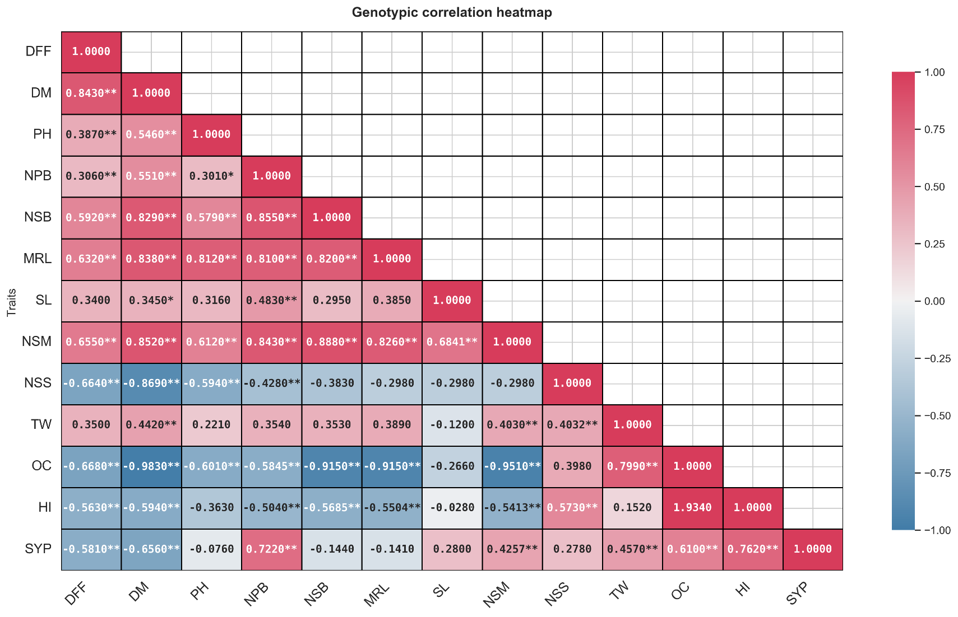
Figure 1. Genotypic correlation heatmap in maize crosses
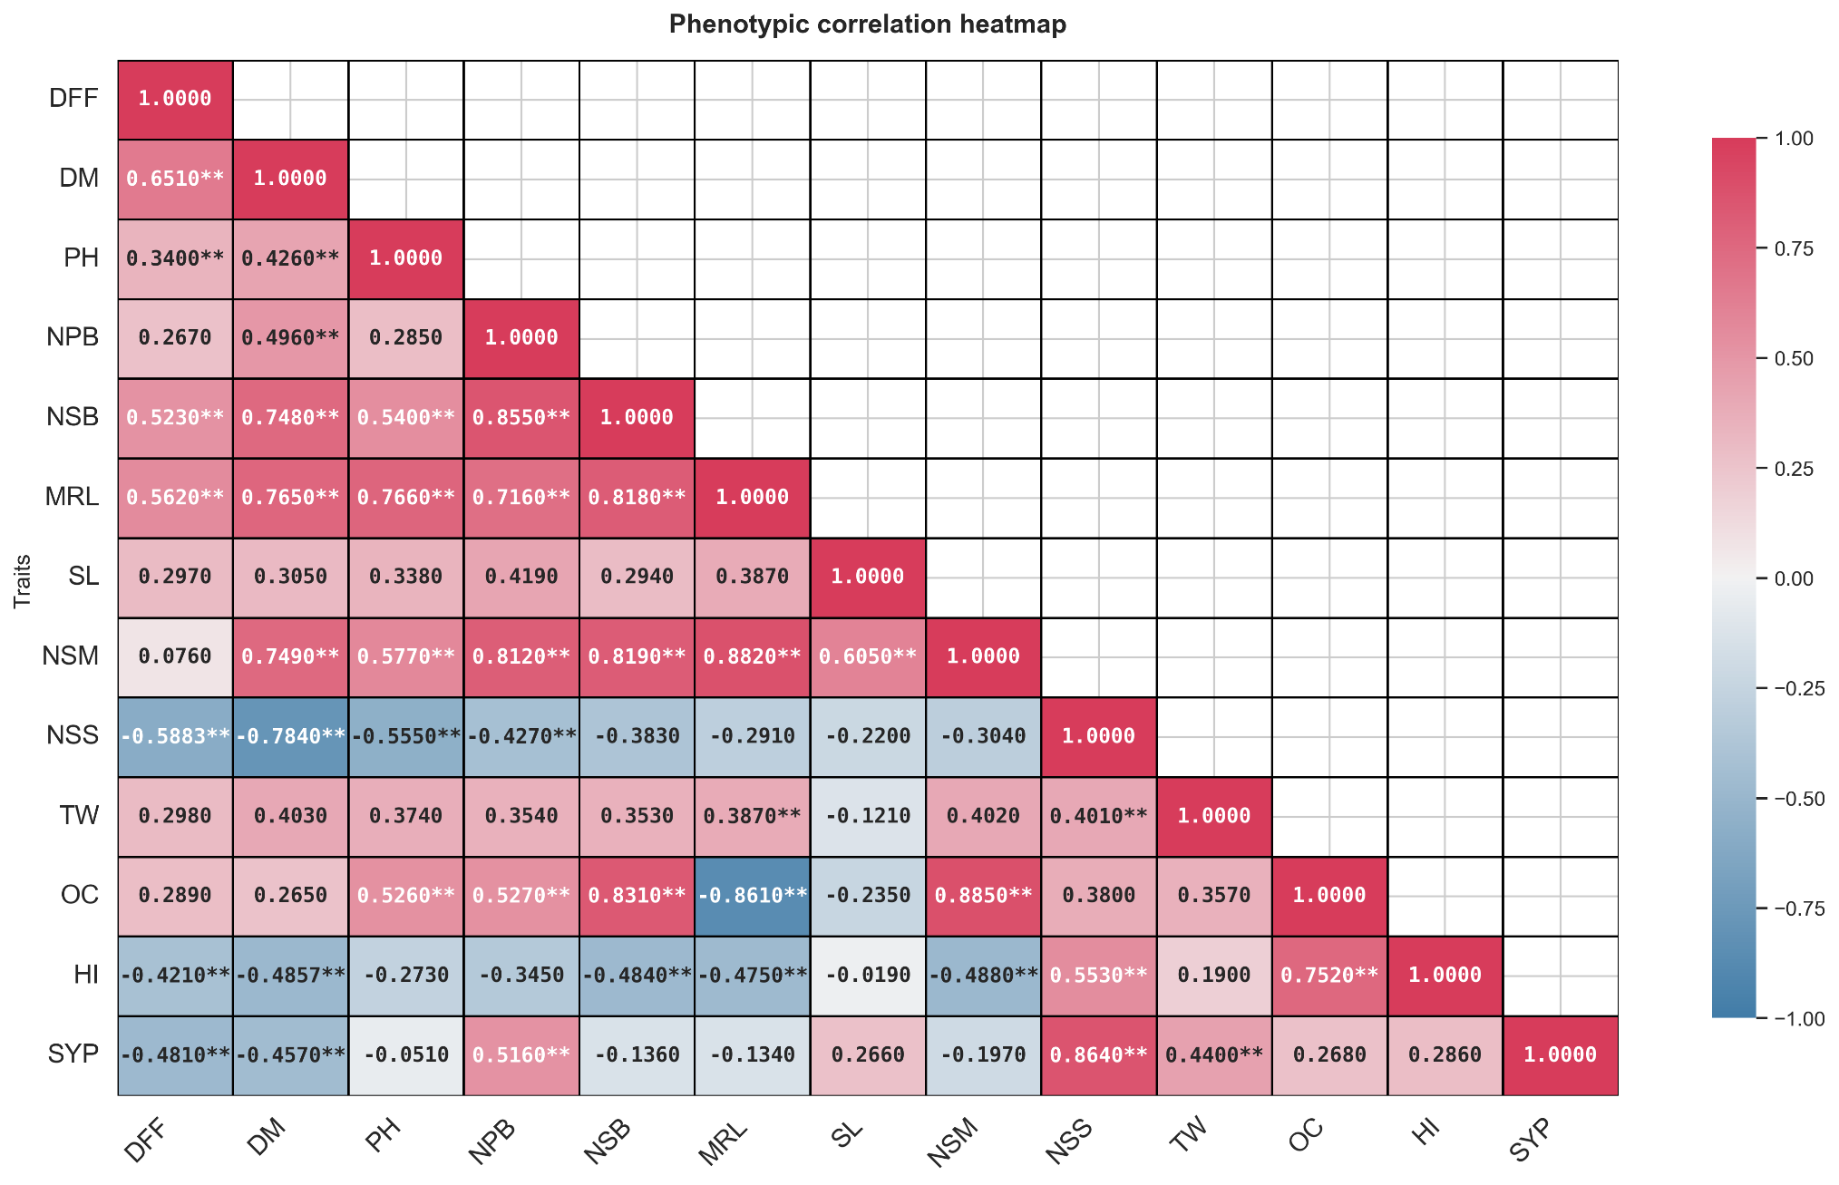
Figure 2. Phenotypic correlation heatmap in Indian Mustard crosses

