Original Research Article
Dynamics of physico-chemical quality parameters of cherry tomato as influenced by pruning intensities and planting dates under controlled conditions

Abstract
Cherry tomato is one of the high-value vegetables known for its taste, nutritional quality and increasing consumer demand. However, present production practices are largely yield-oriented with limited emphasis on fruit quality leaving room for other interventions. In this context, a study was conducted under protected cultivation during 2020–2021 to evaluate the effect of pruning intensities and planting dates on physico-chemical quality attributes of cherry tomato. The experiment was laid out in a factorial randomized block design with three pruning levels and three planting dates. Results generated from study revealed that two-stem pruning significantly improved fruit quality, recording higher fruit size (27.84 mm), ascorbic acid (37.16 mg 100 g⁻¹), lycopene (6.10 mg 100 g⁻¹), and sugar–acid ratio (26.40), along with lower titratable acidity (0.29%) compared to three-stem pruning and unpruned tomato. While, early planting (15th October) further enhanced quality attributes, with maximum ascorbic acid (40.76 mg 100 g⁻¹), lycopene (6.73 mg 100 g⁻¹), TSS (8.37 °Brix), sugar–acid ratio (28.59), and lower acidity of 0.31% compared to delayed planting. Further, interaction effect showed that two-stem pruning with early planting (P₂D₁) produced superior fruit quality, including maximum fruit size (28.76 mm) and improved overall quality balance. It is concluded that two-stem pruning combined with mid-October planting is an effective strategy for improving physico-chemical quality and marketability of cherry tomato under protected cultivation.
Key words: Cherry tomato, Pruning intensity, Planting date, Physico-chemical quality, Protected cultivation
INTRODUCTION
Cherry tomato (Solanum lycopersicumm var. cerasiform) has recently gained its importance as a premium vegetable due to its taste, better nutrional value and overall increasing consumer preferences in fresh and processed markets. Cherry tomato being rich in various bioactive compounds like ascorbic acid, lycopene and soluble sugars plays a crucial role in contribution to dietary diversification. n recent years, the demand for high-quality produce has increased significantly. Earlier, the main focus in crop production was mostly on increasing yield, but now greater importance is also being given to improving the physical and chemical qualities of fruits that influence market value, consumer acceptance, and preference (Razzak et al., 2013). However, traditional cultivation practices, even under protected conditions, mainly concentrate on maximizing yield and often fail to properly improve fruit quality. This can result in variations in fruit composition and inconsistent market standards (Rai et al., 2014). Improper canopy management and unsuitable planting time can disturb the normal physiological balance of the crop. This may cause excessive vegetative growth, poor source–sink balance, and uneven accumulation of important quality compounds in fruits (Lhamo et al., 2022). Therefore, there is a need to improve crop management practices in protected cultivation systems so that plant growth and nutrient utilization remain balanced, leading to better productivity and improved fruit quality.Among different management practices, pruning is considered one of the most important because it helps regulate plant architecture, canopy conditions, and distribution of assimilates within the plant. By influencing the source–sink relationship and pruning intensity, it directly affects fruit growth and quality characteristics such as sugars, acids, and pigments. Earlier studies have shown that proper pruning improves light penetration and enhances fruit quality, while too much or too little pruning can create growth imbalance and negatively affect quality traits. Lahmao et al. (2022) reported that pruning significantly enhances fruit quality in tomato by increasing fruit size, firmness, and soluble solids content, as the removal of suckers and lower leaves directs assimilates towards fruit development, though it may reduce total fruit number. Rao et al. (2022) revealed that two-stem pruning (T₂) resulted in improved vitamin C content and total soluble solids in cherry tomato. However, in contrast, Mourão et al. (2017) reported that fruit quality parameters, including firmness, soluble solids, acidity, pH, and dry matter content, were not significantly affected by pruning systems. On the other hand, the optimum time of planting is a crucial factor governing overall crop performance by determining the environmental conditions prevailing during different growth stages. Variations in temperature and incoming solar radiation associated with different planting windows significantly affect metabolic activities, thereby influencing the synthesis and accumulation of quality-related compounds. Early planting often ensures favourable conditions for growth and fruit development, whereas delayed planting may expose the crop to suboptimal environments, leading to deterioration in fruit quality (Singh et al., 2025). Further, Hossain et al. (2021) reported that planting dates play an important role in the dynamics of quality parameters such as vitamin C and total soluble solids (°Brix), with early planting improving these attributes. Although the individual effects of pruning and planting time on tomato have been extensively investigated, their interactive influence on physico-chemical quality attributes under protected cultivation, particularly in subtropical environments, remains inadequately explored. The interplay between canopy regulation and planting window is of critical importance, as these factors collectively modulate physiological processes, assimilate partitioning, and the biosynthesis of quality-related metabolites in developing fruits. In this context, a comprehensive understanding of their combined effects is essential for refining production strategies. Therefore, the present investigation was undertaken to elucidate the dynamics of physico-chemical quality parameters of cherry tomato as influenced by pruning intensity and planting date under protected cultivation, with the aim of developing an effective management framework for enhancing fruit quality under subtropical conditions.

Material and Methods
The investigation was conducted during 2020–2021 (rabi) under a polyhouse at the Division of Vegetable Science and Floriculture, SKUAST-Jammu, Main Campus, Chatha situated in the subtropical plains of Jammu and Kashmir, India (Fig 1.)
Experimental design and treatments
The experiment was laid out in a factorial randomized block design with three replications. The experiment evaluated three pruning intensities and three planting dates (Table 1). Healthy seedlings of cherry tomato cv. SJCT-01 were transplanted with a crop geometry of 90 cm × 40 cm.
Crop management
Pottrays were used for raising seedlings using a mixture of vermicompost cocopeat and sand in a ratio of 1:1:1. After twenty five days of sowing obtained seeedlings were transplanted under green house. Fertizers (120:100:60 kg N:P₂O₅:K₂O ha⁻¹) were applied to each treatment in splits. Further, irrigation and plant protection measures, were followed uniformly for all treatments to maintain healthy and uniform population.
Quality parameters
Fruits from five randomly selected plants in each plot were harvested and subjected to detailed analysis of physico-chemical quality attributes. Fruit size (mm) was quantified in terms of equatorial diameter using a digital vernier caliper and expressed as the mean value. Total soluble solids (°Brix) were determined using a hand refractometer following standard procedures outlined by AOAC (1994). Ascorbic acid content (mg 100 g⁻¹) was estimated through the dye titration method employing 2,6-dichlorophenol indophenol, as described by Rangana (1976). Lycopene content (mg 100 g⁻¹) was quantified spectrophotometrically after extraction with acetone and petroleum ether, following the protocol of Rangana (1976). Titratable acidity (%) was determined by titration against standard NaOH using phenolphthalein as an indicator (Rangana, 2001). The sugar–acid ratio was subsequently computed as the ratio of total soluble solids to titratable acidity, serving as an integrative index of fruit quality.
Statistical analysis
The experimental data generated from the study was rigorously subjected to analysis of variance (ANOVA) in accordance with the factorial randomized block design to discern the magnitude and significance of treatment effects. The treatment means were further tested for statistical significance using the critical difference (CD) at the 5% probability level by following the standard method suggested by Gomez and Gomez (1984). This helped in obtaining reliable and accurate interpretation of the observed results.
Determining Overall Fruit Quality analysis using Principle Component Analysis
Principal Component Analysis (PCA) was carried out to study the combined effect of pruning intensity and planting date on the physico-chemical quality of cherry tomato fruits. The analysis was performed using OriginPro 2024 software. Mean values of six quality parameters were included in the study: fruit size (mm), ascorbic acid content (mg 100 g⁻¹), lycopene content (mg 100 g⁻¹), total soluble solids (°Brix), titratable acidity (%), and sugar–acid ratio.Before conducting PCA, the data were standardized through Z-score normalization to reduce the influence of different measurement units and to make all variables comparable. The standardized data were then analyzed using the correlation matrix. Eigenvalues, percentage contribution of variance, and component loadings were calculated. The first two principal components, PC1 and PC2, were selected for interpretation because they explained most of the total variation in the dataset. A biplot was also prepared to clearly show the relationship between treatments and different fruit quality characteristics.
Results and discussion
Effect of pruning and planting time on fruit size
Size of fruits of cherry tomato differed significantly under the influence of pruning intensities where values for fruit size ranged from 21.27 mm to 27.84 mm across treatments. However, significantly highest fruit size (27.84 mm) was observed under two-stem pruning (P₂) while lowest fruit diameter (21.27 mm) was recorded in cherry tomato that were not pruned (P₁). Similarly, planting time also resulted In significant improvement of fruit size of cherry tomato where earliest planting i.e 15th October (D₁) recorded the maximum fruit size (25.44 mm), followed by plants transplanted on 30th October (D2: 24.50 mm) while the smallest fruits (23.76 mm) were observed under late planting (15th November; D₃), indicating a gradual decline with delay in planting (Fig 2). Moreover, a significant interaction among planting dates and pruning intensities was observed where larger fruits with a size of 28.76 mm were observed under two-stem pruning when planted early on 15th October (P₂D₁), however it was statistically at par to fruit size recorded under P₂D₂. While, late planting with three stems pruned (P₁D₃) yielded minimum fruit size of 20.62 mm. The significant increase in fruit size under two-stem pruning may be attributed to improved assimilate partitioning and reduced intra-plant competition, establishing a balanced source–sink relationship that favours greater allocation of photosynthates towards developing fruits. Similar trends have been reported in tomato, where strategic canopy regulation enhances light interception and assimilate use efficiency, resulting in larger fruits (Sharma et al., 2021; Rao et al., 2022). In contrast, smaller fruits under no pruning (P₁) may be due to excessive vegetative growth and increased sink competition, limiting assimilate availability for individual fruits, as also noted by Appolloni et al. (2023). Early planting (D₁) producing larger fruits could be attributed to favourable temperature and radiation conditions during fruit development, which enhance photosynthesis and cell expansion (Hossain et al., 2021; Lahmao et al., 2022). Conversely, delayed planting (D₃) likely exposed the crop to suboptimal conditions, reducing metabolic efficiency and fruit growth (Singh et al., 2025). Furthermore, the superior performance under combined treatments suggests that optimal pruning, when synchronized with favourable planting time, maximizes fruit development through improved resource-use efficiency (Hossain et al., 2021).
Effect of pruning and planting time on ascorbic acid content
Ascorbic acid content varied significantly under different pruning systems and planting dates (Fig 3). Significantly highest ascorbic acid content (37.16 mg 100 g⁻¹) was recorded under two-stem pruning (P₂) over other pruning treatments. While, tomato crop which was transplanted earliest on 15th October (D₁) recorded the highest ascorbic acid content of 40.76 mg 100 g⁻¹ among planting time treatments. The lowest ascorbic acid content of 34.12 mg 100 g⁻¹ was recorded under no pruning (P₁), whereas the lowest ascorbic acid (31.46 mg 100 g⁻¹) was recorded in plants planted on 15th November (D₃) depicting a consistent decline in ascorbic acid content with delay in planting. Further a non-significant interaction was observed among pruning systems and planting dates. The reasons for higher ascorbic acid content under two-stem pruning may be attributed to improved canopy regulation and enhanced source–sink balance, which facilitates greater synthesis and accumulation of vitamin C in fruits. Similar improvements under regulated pruning have been reported due to better light penetration and metabolic efficiency (Malewski and Markakis. (1971); Goda et al. (2014); Rao et al., 2022). The superior performance under early planting (15th October) could be linked to favourable temperature and radiation conditions during fruit development, which promote biosynthesis of ascorbic acid. In contrast, delayed planting likely exposed the crop to suboptimal environmental conditions, reducing metabolic activity and consequently vitamin C accumulation (Singh et al., 2015; Hossain et al., 2021)
Effect of pruning and planting time on lycopene content
A significant difference with respect to lycopene content of cherry tomato under different pruning intensities and planting dates was observed where, significantly higher lycopene content (6.10 mg 100 g⁻¹) was recorded plants under two-stem pruning (P₂). Similarly, tomato crop transplanted on 15th October (D₁) recorded the highest lycopene content of 6.73 mg 100 g⁻¹ among planting time treatments. However, the lowest lycopene content (5.30 mg 100 g⁻¹) among pruning treatments was recorded under no pruning (P₁), whereas the lowest lycopene content (4.72 mg 100 g⁻¹) among planting treatments was recorded in plants planted on 15th November (D₃). Further the results also revealed that a significant interaction was observed among pruning systems and planting dates, where maximum lycopene content was recorded under the treatment combination of two-stem pruning with 15th October planting (P₂D₁), which was at par with P₃D₁ (Table 2). The higher lycopene content observed under two-stem pruning may be attributed to improved canopy architecture and enhanced light distribution within the plant canopy, which promotes carotenoid biosynthesis. Proper light interception and uniform light distribution play an important role in improving photosynthesis and the movement of assimilates within the plant, which ultimately increases the accumulation of important compounds such as lycopene in tomato fruits (Dannehl et al., 2021; Heuvelink et al., 2024). The better performance observed under early planting may be due to favourable temperature and light conditions during fruit development, since lycopene formation during ripening is strongly affected by environmental factors (Liu et al., 2012).On the other hand, delayed planting may have exposed the crop to less suitable environmental conditions, which could reduce metabolic activity and carotenoid synthesis, resulting in lower lycopene content. Similar findings were also reported by Hossain et al. (2021) and Rao et al. (2022). In addition, the significant interaction between pruning and planting time indicates that proper pruning along with timely planting creates a better canopy microclimate. This improves light use efficiency and supports greater carotenoid production, which has also been highlighted in recent studies related to light-regulated fruit quality in tomato (Heuvelink et al., 2024).
Effect of pruning and planting time on total soluble solids (TSS)
The total soluble solids (TSS) content of cherry tomato was significantly influenced by both pruning intensity and planting date (Table 3). Among the pruning treatments, plants maintained under three-stem pruning (P₃) recorded the highest TSS value of 8.40 °Brix. In terms of planting dates, the crop transplanted on 15th October (D₁) showed the maximum TSS content of 8.37 °Brix. On the other hand, the lowest TSS value among pruning treatments was observed under two-stem pruning (P₂) with 7.33 °Brix, while delayed planting on 15th November (D₃) recorded the minimum TSS content of 7.13 °Brix. The interaction effect between pruning intensity and planting date was found to be non-significant. The higher TSS content observed under three-stem pruning may be due to the presence of greater leaf area, which could have improved photosynthetic activity and increased the production and movement of carbohydrates towards the fruits. This ultimately resulted in higher accumulation of soluble solids in the fruits. In comparison, plants under two-stem pruning may have produced lower TSS because of comparatively reduced leaf area, which may have limited carbohydrate production and sugar accumulation. Similar observations regarding the role of canopy structure in improving TSS through better assimilate production and distribution have also been reported in tomato by Alam et al. (2016) and Dannehl et al. (2021).The higher TSS recorded under early planting (15th October) may be associated with favourable environmental conditions during fruit growth and development. Suitable temperature and better availability of sunlight during this period likely improved photosynthetic efficiency and supported greater movement of assimilates towards developing fruits. As a result, higher amounts of soluble sugars accumulated in the fruits, improving sweetness and overall TSS. In contrast, delayed planting may have exposed the crop to less favourable temperature and light conditions during important reproductive stages, reducing photosynthesis and carbohydrate synthesis. This could have limited sugar accumulation in fruits, leading to lower TSS values (Shopova, 2023). Similar results were also reported by Hossain et al. (2021), who observed better fruit quality in tomato under early sowing compared to late sowing.
Effect of pruning and planting time on titratable acidity
In the present study, titratable acidity was significantly affected by pruning intensity. The lowest acidity (0.29%) was recorded in plants pruned to two stems (P₂), while the highest acidity (0.38%) was observed under three-stem pruning (P₃). Planting time also showed a significant effect, with early planting resulting in lower and more desirable acidity (0.31%) compared to delayed planting treatments. A significant interaction effect between pruning intensity and planting date was also observed. The minimum titratable acidity was recorded in plants subjected to two-stem pruning with early planting (P₂D₁). This indicates that proper canopy management along with favourable planting conditions can help in maintaining balanced acid levels in cherry tomato fruits (Table 4). The higher acidity observed under three-stem pruning may be due to changes in the source–sink relationship caused by excessive removal of vegetative growth. Such conditions can influence the distribution of assimilates and fruit metabolic processes. When the canopy becomes more concentrated, developing fruits may compete more for available photosynthates, which can slow down the conversion of organic acids into sugars during ripening. As a result, more organic acids remain in the fruits, leading to increased titratable acidity. (Bhagawati et al., 2015) In contrast, two-stem pruning (P₂) likely provided a more balanced canopy structure, optimizing leaf area for photosynthesis while maintaining an efficient distribution of assimilates to the developing fruits. This improved balance may have promoted better utilization of organic acids during fruit maturation, resulting in comparatively lower acidity and improved eating quality (Zhang et al., 2025; Lahmao et al., 2022). Early planting reduced acidity due to favourable temperature and radiation, which enhanced photosynthesis and accelerated conversion of organic acids into sugars, improving the sugar–acid balance preferred for fresh consumption. In contrast, delayed planting exposed plants to suboptimal conditions, slowing metabolic activity and organic acid breakdown, leading to higher acidity in fruits. The interaction effect showed minimum acidity under two-stem pruning with early planting (P₂D₁), indicating that a balanced canopy along with favourable environment improved assimilate distribution and reduced acid accumulation, resulting in better fruit quality (Rao et al., 2022.
Effect of pruning and planting time on sugar–acid ratio
It is clearly evident from table 6 that sugar–acid ratio was significantly influenced by pruning treatments, with the highest sugar-acid ratio (26.40) recorded under two-stem pruning (P₂), which was at par with no pruning (P₁) but significantly higher than three-stem pruning (P₃). Further, it was revealed that planting time also exerted a significant effect, with early planting (15th October; D₁) recording higher sugar-acid ratio of 28.59 compared to delayed planting dates. Moreover, it was also revealed that a significant interaction between the two factors was observed with respect o sugar-acid ratio where maximum sugar–acid ratio recorded under the combination of two-stem pruning with early planting (P₂D₁), followed by no pruning with 30th October planting (P₁D₂). The results of the present study showed that titratable acidity was significantly influenced by pruning intensity. Among the different pruning treatments, plants maintained with two stems (P₂) recorded the lowest acidity (0.29%), whereas the highest acidity (0.38%) was observed in plants under three-stem pruning (P₃). Planting date also had a noticeable effect on acidity levels. Early planted crops showed lower and more acceptable acidity (0.31%) compared to crops planted later. The interaction between pruning intensity and planting time was also found to be significant. The lowest titratable acidity was recorded in plants pruned to two stems and planted early (P₂D₁). This suggests that suitable canopy management along with timely planting creates favourable conditions for maintaining balanced fruit acidity in cherry tomato (Table 4). Higher acidity in plants under three-stem pruning may be related to changes in the source–sink balance caused by greater removal of vegetative growth. Such changes can affect the movement and utilization of assimilates within the plant. Under these conditions, developing fruits may face stronger competition for photosynthates, which may reduce the conversion of organic acids into sugars during fruit ripening. Consequently, a higher amount of organic acids remains in the fruits, resulting in increased titratable acidity. Similar results have been reported by Ambroszczyk et.al. (2008), Ali and Darakci (2009), Prema et al. (2011) and Hernandez et al. (2016). The interaction effect further highlighted that the combination of two-stem pruning with early planting (P₂D₁) produced the maximum sugar–acid ratio, followed by no pruning with 30th October planting (P₁D₂). This indicates that an optimum canopy structure combined with favourable climatic conditions creates a synergistic effect, improving assimilate distribution, enhancing sugar synthesis, and reducing relative acidity. Overall, these treatments significantly improved the eating quality of cherry tomato fruits.
Principal component analysis of overall fruit quality attributes
The Principal Component Analysis (PCA) showed that the first principal component (PC1) explained 55.44% of the total variation, while the second principal component (PC2) accounted for 22.67%. Together, these two components explained 78.11% of the total variability present in the dataset (Table 6), indicating that they were sufficient to represent most of the variation among the treatments.The loading values of different variables on PC1 showed positive associations for fruit size (0.32), ascorbic acid (0.50), lycopene (0.51), total soluble solids (0.17), and sugar–acid ratio (0.46), whereas titratable acidity (-0.38) showed a negative association. This indicates that PC1 mainly represented overall fruit quality, where higher PC1 values were related to better fruit size, improved nutritional quality, higher sweetness, and lower acidity.The PCA biplot clearly explained the relationship between treatments and fruit quality traits. Treatments located on the positive side of PC1 were associated with better quality parameters. Among all treatment combinations, P₂D₁ (two-stem pruning with 15th October planting) was positioned prominently in the positive quadrant of PC1 and was closely associated with the vectors of ascorbic acid, lycopene, and sugar–acid ratio. This suggests that P₂D₁ produced the best overall fruit quality. On the other hand, treatments such as P₁D₃ and P₃D₃ were located on the negative side of PC1, indicating comparatively poorer fruit quality due to lower values of desirable traits and higher acidity levels.The clear separation of treatments in the biplot confirms that pruning intensity and planting date had a strong effect on cherry tomato fruit quality (Figure 4). Overall, the PCA results supported the findings obtained from individual parameter analysis and showed that two-stem pruning combined with early planting provided the most suitable balance of physical and biochemical traits, resulting in superior fruit quality under protected cultivation conditions. The better performance of P₂D₁ may be due to improved canopy management under two-stem pruning, which enhanced light interception and assimilate distribution, along with favourable temperature and light conditions provided by early planting that promoted the synthesis and accumulation of important quality-related compounds (Hossain et al., 2021; Rao et al., 2021).
Conclusion
The study clearly establishes that both pruning intensity and planting time decisively shape the physico-chemical quality profile of cherry tomato. Among pruning treatments, two-stem pruning consistently emerged as the most efficient canopy management strategy, producing superior fruit quality in terms of size, nutritional enrichment, and balanced acid–sugar composition. Early planting (15th October) further amplified these advantages by aligning crop growth with favourable environmental conditions, thereby enhancing metabolic efficiency and assimilate accumulation. The combined effect of two-stem pruning with early planting demonstrated a clear synergistic advantage, delivering the best overall fruit quality across key parameters. Therefore, maintaining an appropriate canopy architecture with optimum pruning intensity alongside an optimized planting window offers a highly efficient strategy to elevate both the nutritional and market quality of cherry tomato especially under protected conditions.

References
Lhamo, T., Gyalmo, T., Pem, T., & Bajgai, Y. (2022). Effect of different pruning systems on yield and quality of tomato grown under greenhouse conditions. Bhutanese Journal of Agriculture, 5(1), 71–82.
Association of Official Analytical Chemists (AOAC). (1994). Official methods of analysis (16th ed.). AOAC International, Arlington, VA, USA.
Ambroszczyk, A. M., Cebula, S., & Sekara, A. (2008). The effect of plant pruning on light conditions and vegetative development of eggplant (Solanum melongena L.) in greenhouse cultivation. Vegetable Crops Research Bulletin, 68, 57–70.
Hernández, V., Hellín, P., Fenoll, J., Molina, M. V., Garrido, I., & Flores, P. (2016, June). Impact of high temperature stress on ascorbic acid concentration in tomato. In VIII International Postharvest Symposium: Enhancing Supply Chain and Consumer Benefits—Ethical and Technological Issues (pp. 985–990).
Rai, G. K., Kumar, R., Kumar, R. R., & Dogra, S. (2014). Free radical scavenging antioxidant phytochemicals in cherry tomato (Solanum lycopersicum var. cerasiforme). Bangladesh Journal of Botany, 43(3), 255–260.
Razzak, H. A., Ibrahim, A., Wahb-Allah, M., & Alsadon, A. (2013). Response of cherry tomato (Solanum lycopersicum var. cerasiforme) to pruning systems and irrigation rates under greenhouse conditions. Asian Journal of Crop Science, 5(3), 275–285.
Ali, E. C. E., & Darakci, N. (2009). Effect of number of different stems on fruit quality characteristics and yield in tomatoes (Lycopersicon lycopersicum L.). Journal of Applied Biological Sciences, 3(2), 175–178.
Bhagawati, R., Bhagawati, K., Choudhary, V. K., Rajkowa, D. J., & Sharma, R. (2015). Effect of pruning intensities on performance of fruit plants under mid-hill condition of Eastern Himalayas: A case study on guava. International Letters of Natural Sciences, 46.
Dannehl, D., Schwend, T., Veit, D., Schmidt, U., & Ulrichs, C. (2021). Effects of different pruning systems on light distribution and fruit quality of greenhouse tomatoes. Horticulturae, 7(3), 65. https://doi.org/10.3390/horticulturae7030065
Heuvelink, E., Marcelis, L. F. M., & Körner, O. (2024). Light and temperature interactions affecting tomato fruit quality and carotenoid accumulation. Frontiers in Plant Science, 15, 1354821. https://doi.org/10.3389/fpls.2024.1354821
Liu, L., Shao, Z., Zhang, M., & Wang, Q. (2012). Regulation of carotenoid metabolism in tomato. Molecular Plant, 5(4), 865–877. https://doi.org/10.1093/mp/sss016
Rangana, S. (1976). Manual of analysis of fruit and vegetable products. Tata McGraw-Hill Publishing Company.
Rangana, S. (2001). Handbook of analysis and quality control for fruit and vegetable products (2nd ed.). Tata McGraw-Hill Publishing Company.
Gomez, K. A., & Gomez, A. A. (1984). Statistical procedures for agricultural research (2nd ed.). John Wiley & Sons.
Mourão, I., Brito, L. M., Moura, L., Ferreira, M. E., & Costa, S. R. (2017). The effect of pruning systems on yield and fruit quality of grafted tomato. Horticultura Brasileira, 35, 247–251.
Singh, U., Sharma, Y. K., Bagri, R. K., Choudhary, A. K., & Mahawar, A. K. (2024). Effect of planting time and variety on growth and yield attributes of tomato in semi-arid conditions of Rajasthan.
Rao, R. L., Singh, D., Prasad, V. M., & Antony, P. (2022). Effect of pruning methods on growth, yield and quality of cherry tomato (Solanum lycopersicum var. cerasiforme) under polyhouse conditions. International Journal of Plant & Soil Science, 34(23), 749–753.
Singh, A., Jain, P. K., Sharma, H. L., & Singh, Y. (2015). Effect of planting date and integrated nutrient management on production potential of tomato (Solanum lycopersicon Mill.) under polyhouse conditions. Journal of Crop and Weed, 11, 28–33.
Malewski, W., & Markakis, P. (1971). Ascorbic acid content of the developing tomato fruit. Journal of Food Science, 36, 537.
Goda, Y., Mohamed, A. A., Helaly, A. A., & El-Zeiny, O. A. H. (2014). Effect of shoot pruning on growth, yield, and fruit quality of husk tomato (Physalis pubescens L.). Journal of American Science, 10(1), 5–10.
Figure 1: Location of the Experimental site

Table 1: Treatment details

Factor | Treatment Code | Description
A: Pruning Intensity | P1 | No pruning
A: Pruning Intensity | P2 | Two-stem pruning
A: Pruning Intensity | P3 | Three-stem pruning
B: Planting Date | D1 | 15th October
B: Planting Date | D2 | 30th October
B: Planting Date | D3 | 15th November

Figure 2: Effect of pruning intensities and planting dates and their interaction, on fruit size of cherry tomato (P₁ = No pruning, P₂ = Two-stem pruning, P₃ = Three-stem pruning; D₁ = 15th October, D₂ = 30th October, D₃ = 15th November. Bars represent mean values, and different letters indicate significant differences among treatments (p ≤ 0.05).
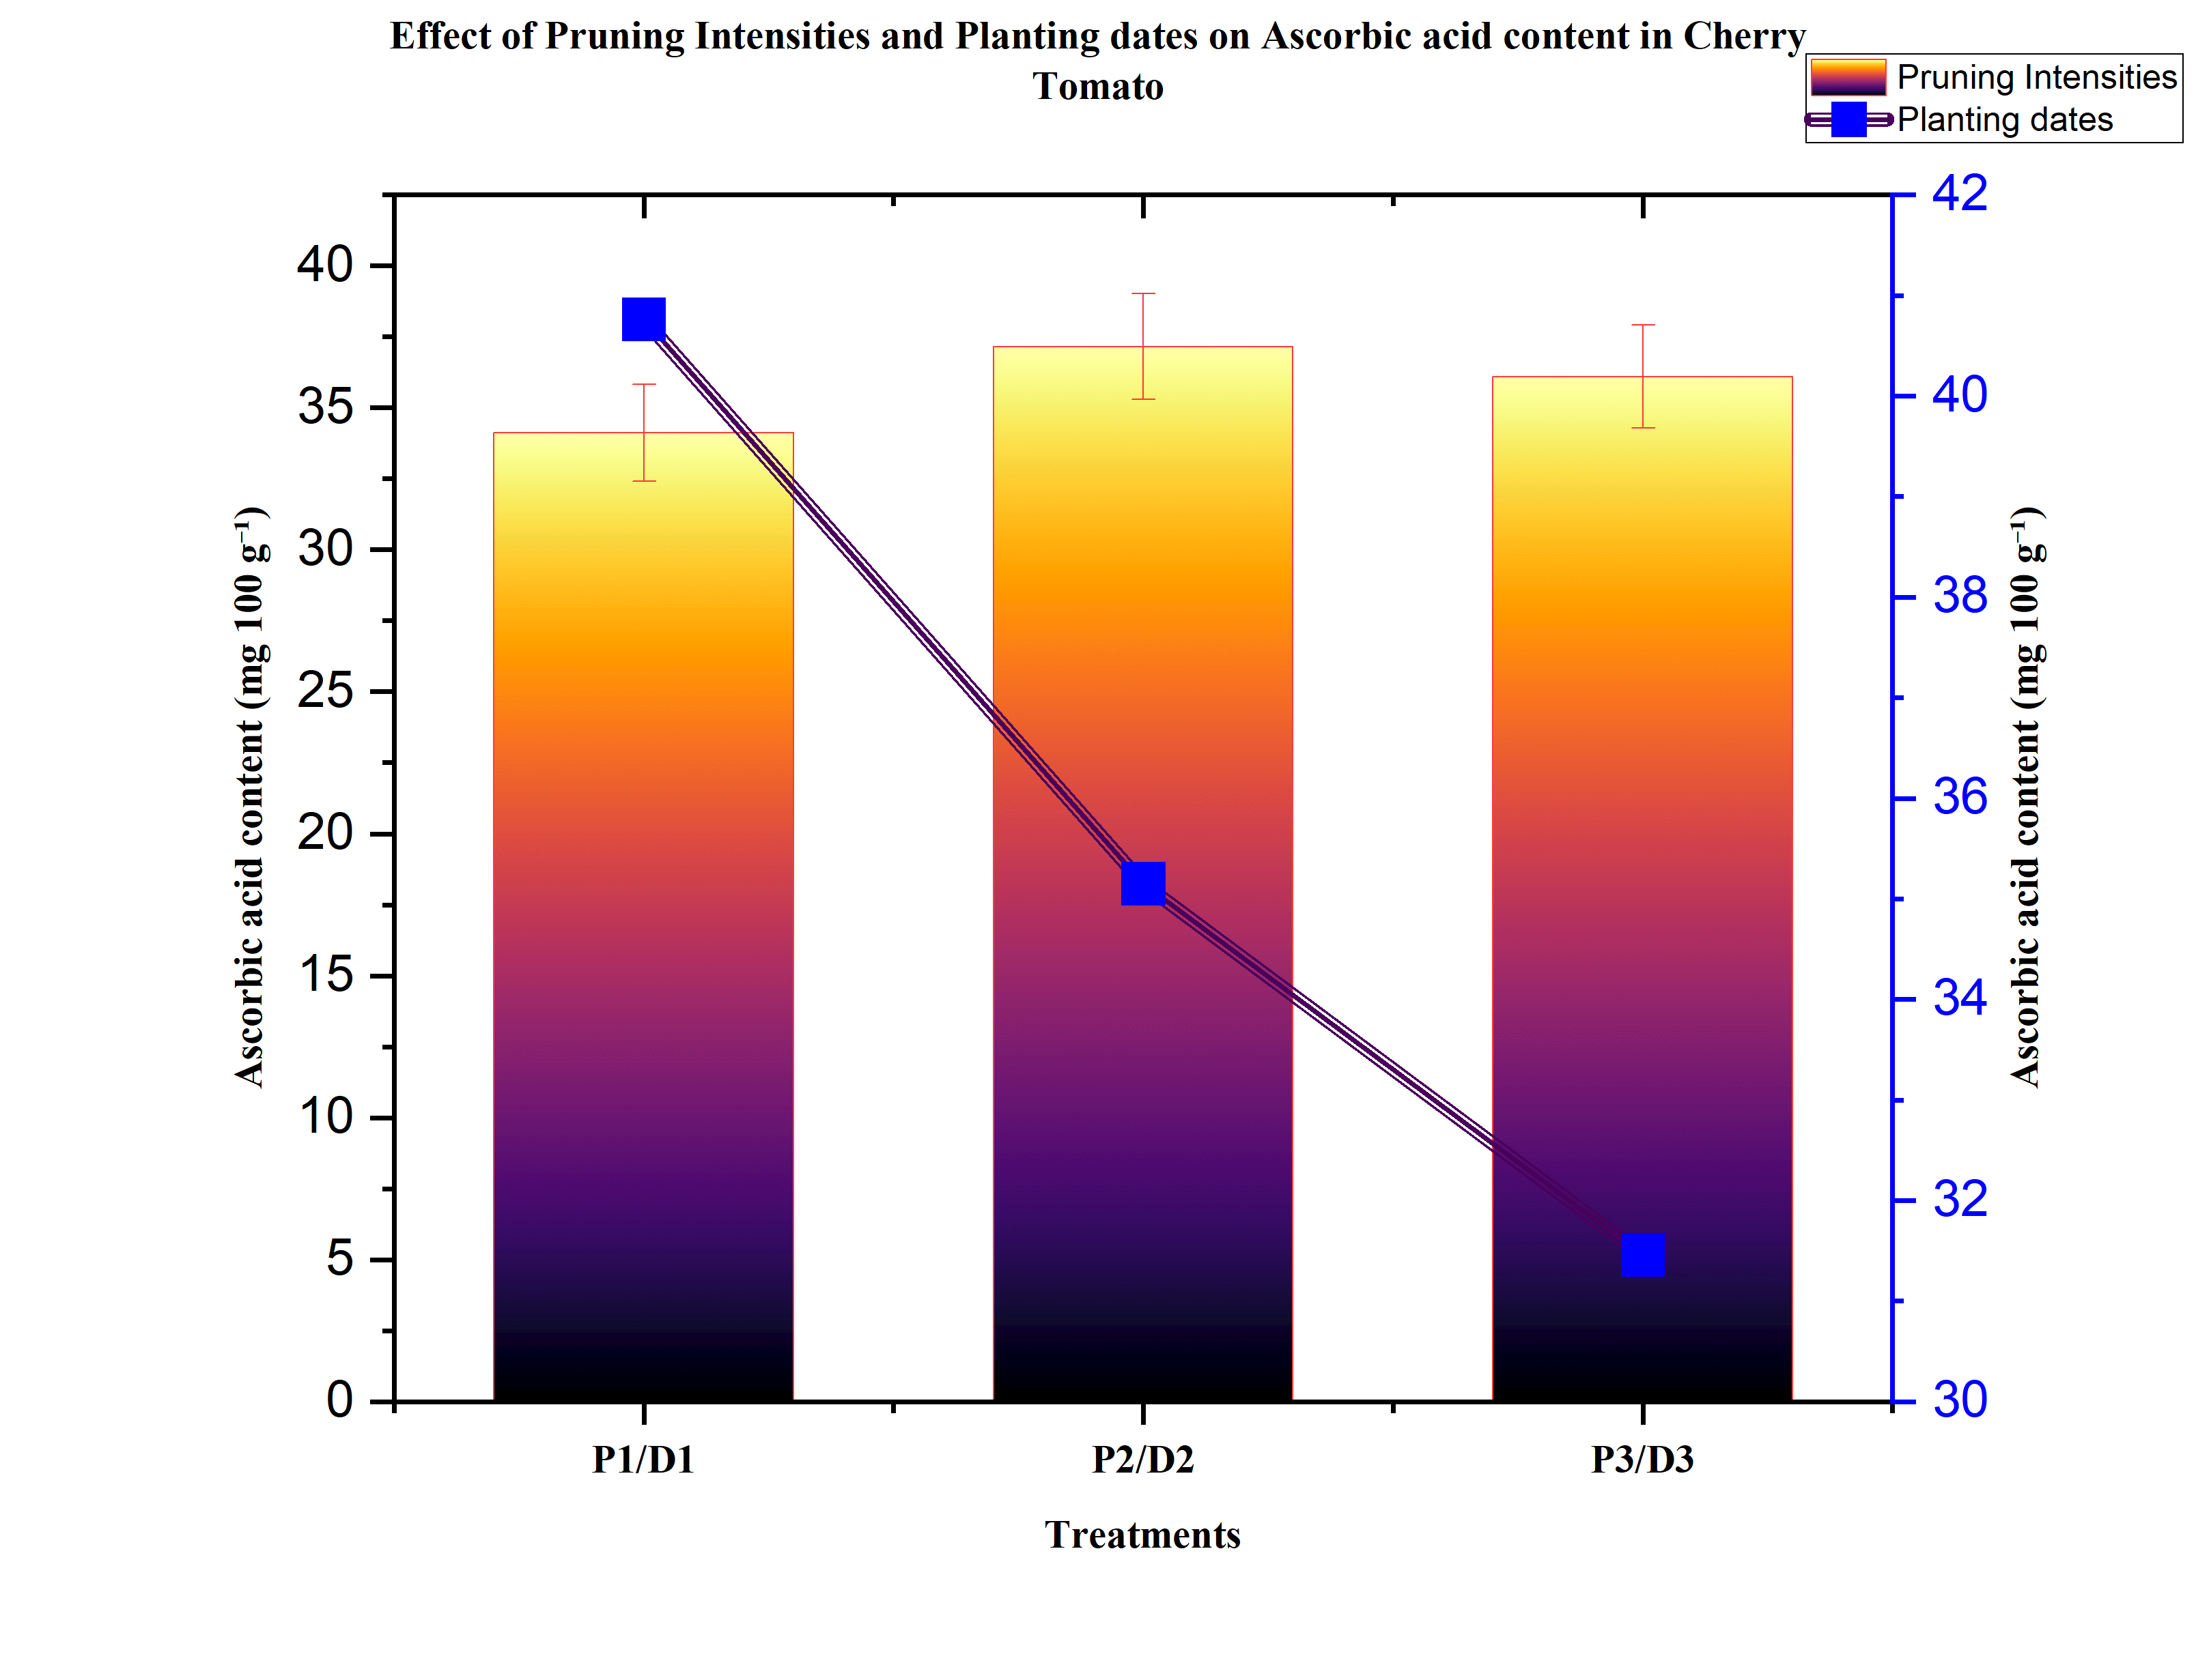
Figure 3: Effect of pruning intensities and planting dates on ascorbic acid content of cherry tomato (P₁ = No pruning, P₂ = Two-stem pruning, P₃ = Three-stem pruning; D₁ = 15th October, D₂ = 30th October, D₃ = 15th November. Bars represent mean values.

Table 2: Lycopene content in cherry tomato as influenced by pruning intensities and planting dates
Treatments | Lycopene content (mg 100g⁻¹)
Treatments | D₁ (15th Oct) | D₂ (30th Oct) | D₃ (15th Nov) | Mean
P₁ (No pruning) | 6.20 | 5.67 | 4.02 | 5.30
P₂ (Two-stem pruning) | 7.20 | 5.90 | 5.20 | 6.10
P₃ (Three-stem pruning) | 6.80 | 6.57 | 4.94 | 6.10
Mean | 6.73 | 6.05 | 4.72 | -
Source | SEm (±) | SE(d) | CD (0.05) | CV (%)
P | 0.08 | 0.11 | 0.25 | 4.25
D | 0.08 | 0.11 | 0.25 | -
P × D | 0.14 | 0.20 | 0.43 | -

Table 3: Total soluble salts (TSS) in cherry tomato as influenced by pruning intensities and planting dates
Treatments | TSS (ºB)
Treatments | D₁ (15th Oct) | D₂ (30th Oct) | D₃ (15th Nov) | Mean
P₁ (No pruning) | 7.30 | 8.30 | 7.00 | 7.53
P₂ (Two-stem pruning) | 8.00 | 7.80 | 6.20 | 7.33
P₃ (Three-stem pruning) | 8.00 | 9.00 | 8.20 | 8.40
Mean | 7.77 | 8.37 | 7.13 | -
Source | SEm (±) | SE(d) | CD (0.05) | CV (%)
P | 0.21 | 0.30 | 0.64 | 8.21
D | 0.21 | 0.30 | 0.64 | -
P × D | 0.37 | 0.52 | NS | -

Table 4: Acidity in cherry tomato as influenced by pruning intensities and planting dates

Treatments | Acidity (%)
Treatments | D₁ (15th Oct) | D₂ (30th Oct) | D₃ (15th Nov) | Mean
P₁ (No pruning) | 0.29 | 0.26 | 0.37 | 0.31
P₂ (Two-stem pruning) | 0.23 | 0.35 | 0.28 | 0.29
P₃ (Three-stem pruning) | 0.31 | 0.40 | 0.42 | 0.38
Mean | 0.28 | 0.34 | 0.36 | -
Source | SEm (±) | SE(d) | CD (0.05) | CV (%)
P | 0.01 | 0.01 | 0.03 | 9.82
D | 0.01 | 0.01 | 0.03 | -
P × D | 0.02 | 0.02 | 0.05 | -

Table 5: Sugar:Acid ratio in cherry tomato as influenced by pruning intensities and planting dates
Treatments | Sugar:Acid ratio
Treatments | D₁ (15th Oct) | D₂ (30th Oct) | D₃ (15th Nov) | Mean
P₁ (No pruning) | 25.17 | 31.92 | 18.92 | 25.34
P₂ (Two-stem pruning) | 34.78 | 22.29 | 22.14 | 26.40
P₃ (Three-stem pruning) | 25.81 | 22.50 | 19.52 | 22.61
Mean | 28.59 | 25.57 | 20.19 | -
Source | SEm ± | SE(d) | CD (0.05) | CV (%)
P | 0.66 | 0.93 | 1.98 | 7.98
D | 0.66 | 0.93 | 1.98 | -
P × D | 1.14 | 1.61 | 3.42 | -

Table 6: Variance Explained by PCA
Component | Variance (%) | Cumulative (%)
PC1 | 55.44 | 55.44
PC2 | 22.67 | 78.11

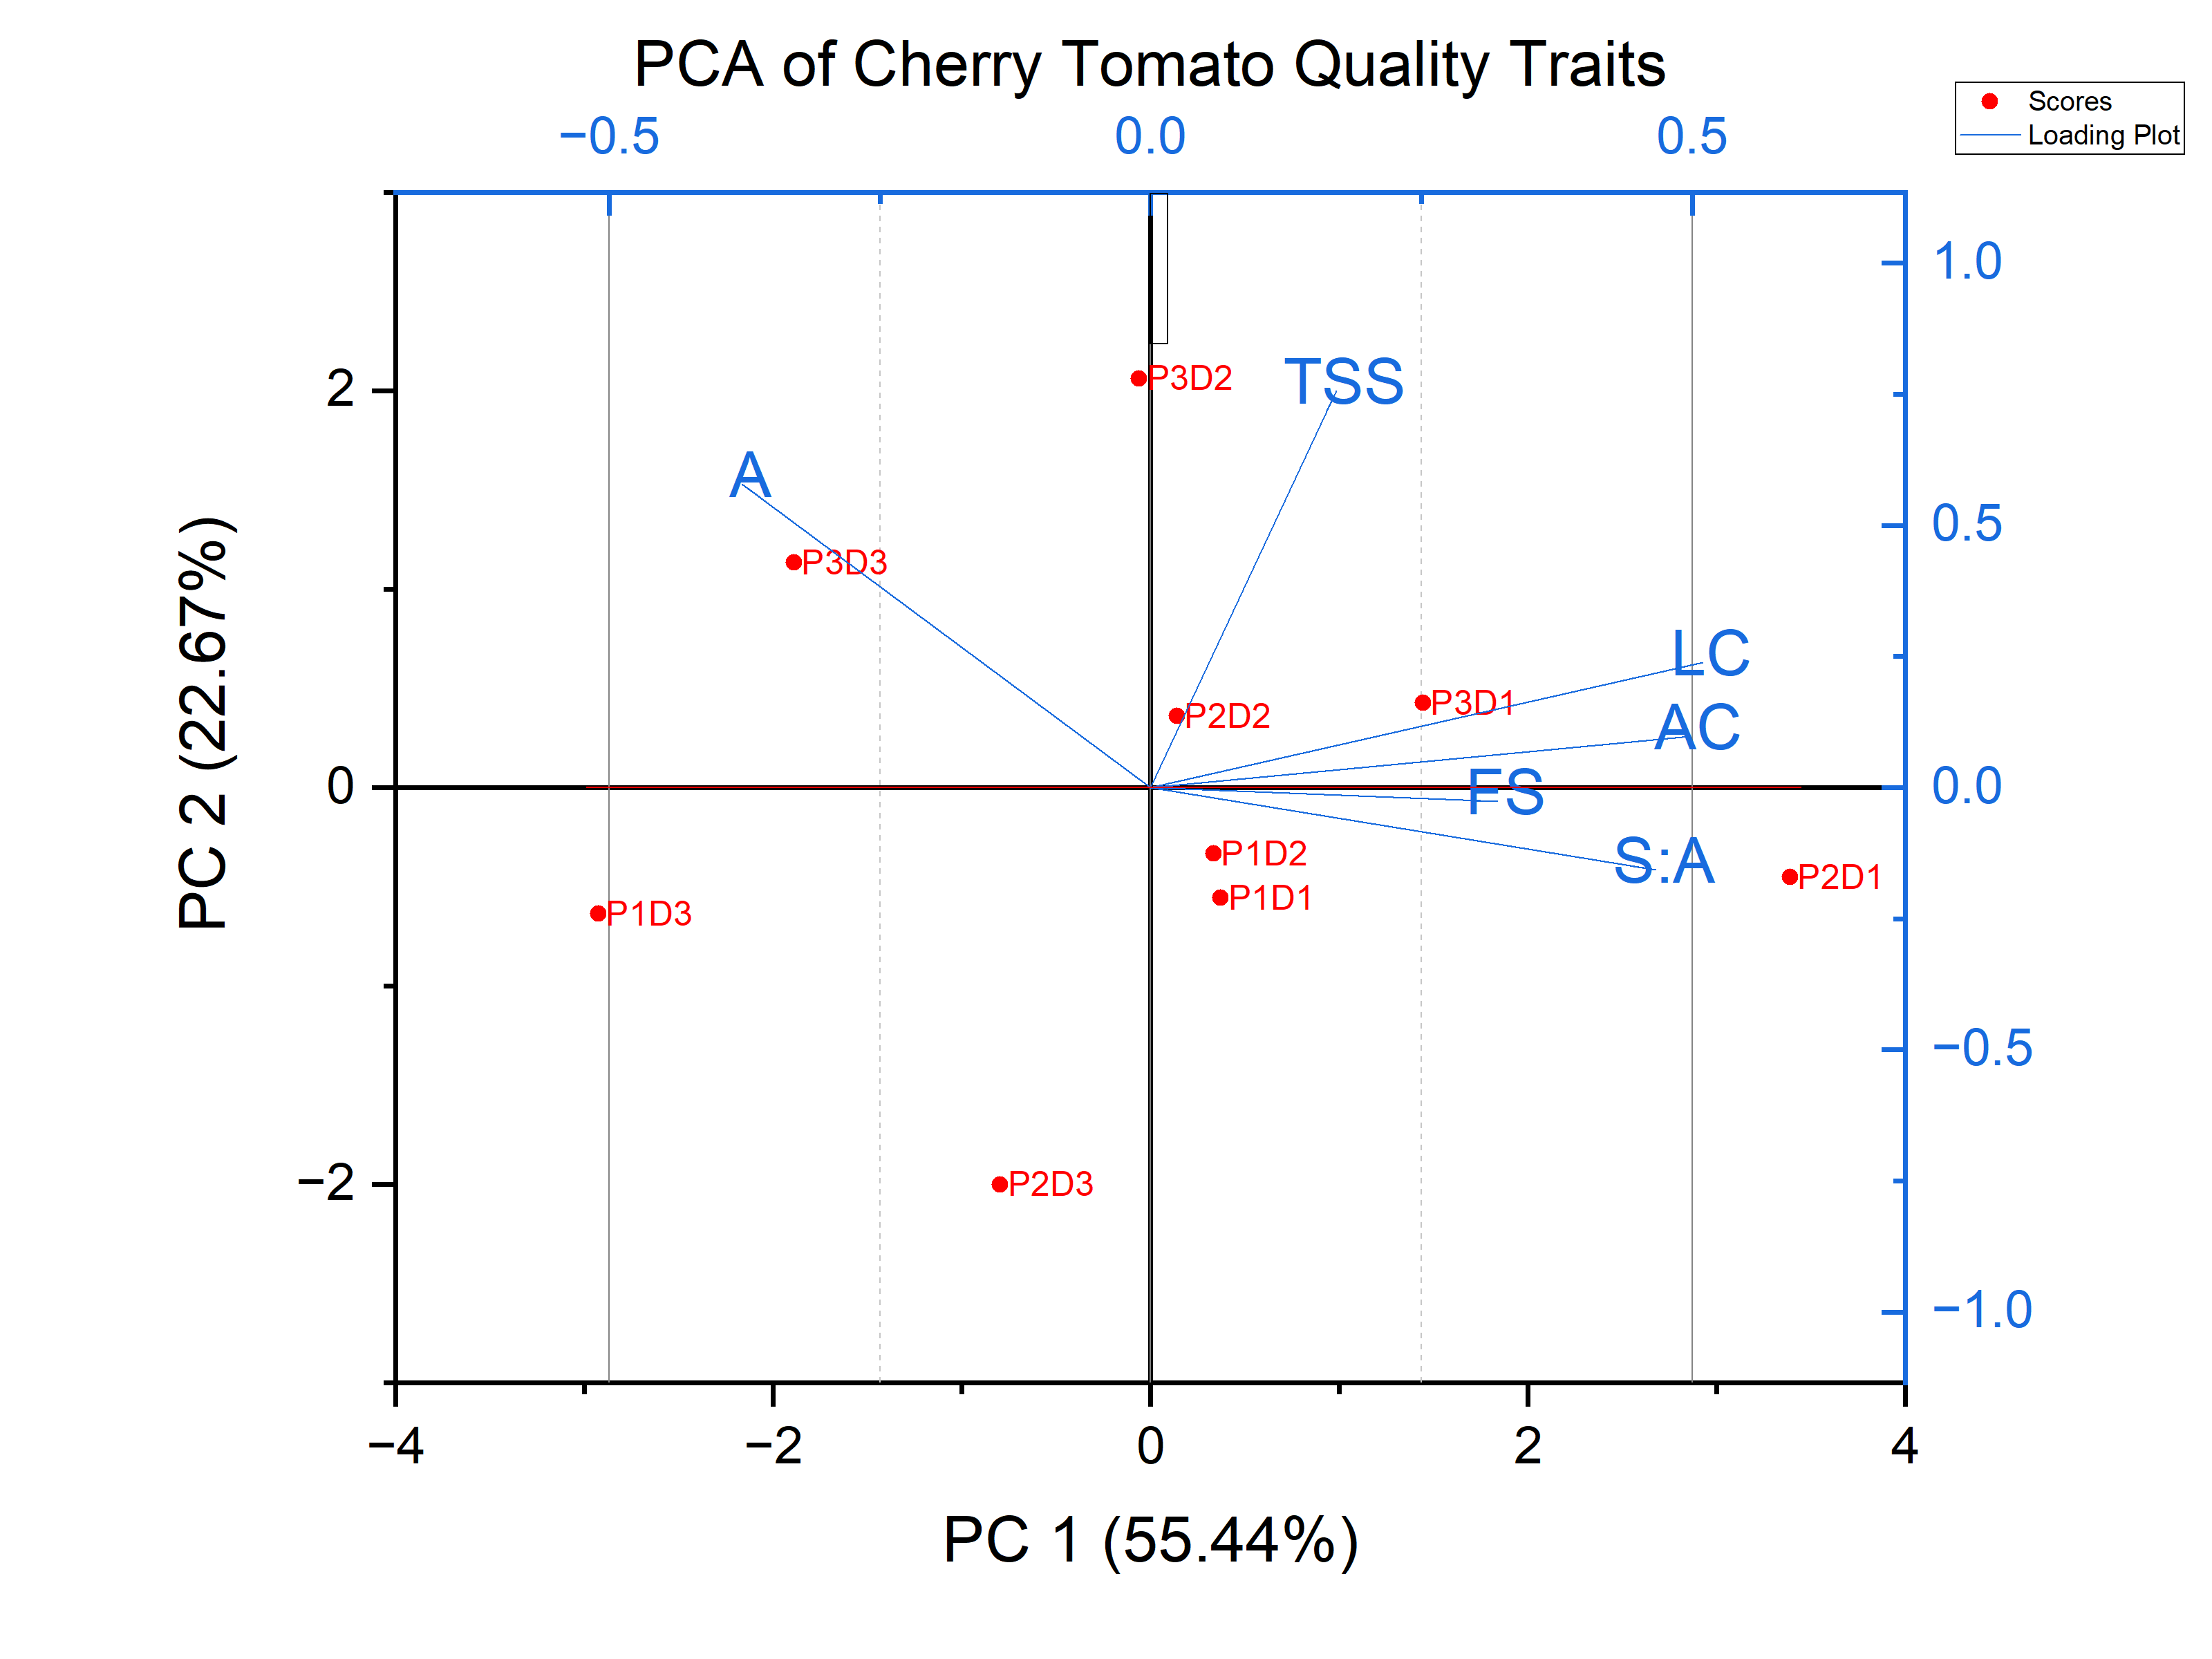
Figure 4: PCA biplot showing the association of pruning intensity and planting dates with physico-chemical quality attributes of cherry tomato (A: Acidity; AC: Ascorbic acid content; TSS: Total soluble salts; LC: Lycopene content; S:A: Sugar:Acid ratio)

