Medicinal Plant Diversity, Traditional Therapeutics and Conservation Perspectives in Odisha, India

ABSTRACT
Odisha, India, is recognized for its rich biological diversity and extensive indigenous medicinal knowledge associated with traditional healthcare systems. The present review provides a comprehensive synthesis of medicinal plant diversity, traditional therapeutic applications, pharmacological relevance, and conservation perspectives across different ecological regions of Odisha. Relevant scientific literature published between 2020 and 2025 was systematically collected from Scopus, PubMed, Web of Science, Google Scholar, and ScienceDirect databases. More than 50 scientific reports involving over 150 medicinal plant species belonging to more than 60 families were critically evaluated. Comparative analysis demonstrated substantial regional variation in medicinal plant utilization and therapeutic practices. Tribal and forested ecosystems exhibited comparatively greater medicinal plant diversity and broader therapeutic applications including malaria, inflammation, gastrointestinal disorders, respiratory infections, diabetes, and reproductive health complications. Frequently utilized medicinal species such as Tinospora cordifolia, Andrographis paniculata, Rauvolfia serpentina, and Ocimum sanctum showed significant ethnopharmacological importance and experimentally validated pharmacological activities. Phytochemical investigations further revealed the occurrence of alkaloids, flavonoids, terpenoids, tannins, glycosides, and phenolic compounds associated with antimicrobial, antioxidant, anti-inflammatory, hepatoprotective, antidiabetic, and immunomodulatory properties. A major strength of this review lies in integrating ecological diversity, traditional therapeutic knowledge, pharmacological evidence, and conservation perspectives within a unified ethnopharmacological framework. The review additionally highlights emerging opportunities involving network ethnopharmacology, metabolomics, and artificial intelligence-assisted drug discovery, while emphasizing the importance of sustainable conservation and preservation of indigenous medicinal knowledge systems.
KEYWORDS
Medicinal plant diversity, Ethnopharmacology, Traditional therapeutics, Biodiversity conservation, Indigenous healthcare systems, Phytochemical profiling, Medicinal flora, Natural product drug discovery, Sustainable utilization
1.INTRODUCTION
Medicinal plants have been utilized for centuries as fundamental components of traditional healthcare systems and continue to play a crucial role in primary healthcare management worldwide (Farnsworth et al., 1985; Fabricant and Farnsworth, 2001; Alamgir, 2017). The World Health Organization has recognized the increasing global reliance on herbal medicines and plant-derived therapeutics for the treatment and prevention of numerous diseases (WHO, 2013; Bodeker et al., 2005). Medicinal plants contain diverse bioactive phytochemicals, including alkaloids, flavonoids, terpenoids, tannins, glycosides, and phenolic compounds, which exhibit significant pharmacological activities (Mishra et al., 2021; Sivakumar and Chen, 2021) such as antimicrobial, antioxidant, anti-inflammatory, antidiabetic, hepatoprotective, and anticancer properties. In recent decades, increasing scientific interest in ethnopharmacology and phytomedicine has further emphasized the therapeutic and pharmaceutical potential of medicinal plant resources (Kumar et al., 2021; Newman and Cragg, 2020).
India is recognized as one of the world’s major biodiversity-rich countries (Jain, 1991; Kala, 2005; Samal, 2021) with extensive traditional medicinal knowledge systems such as Ayurveda, Siddha, Unani, and folk medicine. The country possesses diverse ecological and climatic conditions that support rich medicinal plant diversity and ethnobotanical traditions across different geographical regions. Odisha, located in the eastern part of India, represents an ecologically and culturally significant state characterized by coastal plains, forest ecosystems, river basins, wetlands, and Eastern Ghats hill ranges. The state is inhabited by numerous tribal communities (Rout et al., 2021; Uprety et al., 2020) possessing substantial indigenous knowledge regarding medicinal plant identification, preparation, and therapeutic utilization for the management of various diseases and healthcare conditions.
Traditional medicinal practices in Odisha extensively utilize plant-based formulations for the treatment of fever, malaria, gastrointestinal disorders, respiratory infections, skin diseases, inflammatory conditions, diabetes, reproductive disorders, and musculoskeletal complications. Several medicinal plant species traditionally used by indigenous communities have attracted scientific attention due to their pharmacological efficacy and phytochemical richness (Panda et al., 2020; Sharma et al., 2021). Modern phytochemical and pharmacological investigations have validated the presence of therapeutically important bioactive compounds in many medicinal plants of Odisha, thereby highlighting their potential applications in herbal drug development, phytopharmaceutical research, and evidence-based traditional medicine (Sivakumar and Chen, 2021; Mishra et al., 2021).
Despite the immense ethnopharmacological importance of medicinal plants, increasing anthropogenic pressure, deforestation, habitat fragmentation, overexploitation, mining activities, climate change, and urbanization have significantly threatened medicinal plant diversity and associated traditional knowledge systems in Odisha (Schippmann et al., 2002; Singh et al., 2022; Sharma et al., 2023). In addition, erosion of indigenous healthcare knowledge due to modernization and reduced intergenerational knowledge transfer presents an additional conservation challenge. Although several ethnobotanical studies have been conducted in different regions of Odisha, comprehensive review-based synthesis integrating ecological diversity, traditional therapeutics, phytochemistry, pharmacology, quantitative ethnobotany, and conservation perspectives remains comparatively limited.
The present review aims to comprehensively analyze the medicinal plant diversity, ethnopharmacological significance, phytochemical composition, pharmacological properties, therapeutic applications, quantitative ethnobotanical indices, conservation challenges, and future research perspectives associated with medicinal plants of Odisha, India (Kumar et al., 2021; Verma et al., 2022).The review further emphasizes the importance of integrating traditional ethnomedicinal knowledge with modern scientific approaches, biodiversity conservation strategies, and emerging technologies such as artificial intelligence-assisted drug discovery and computational ethnopharmacology for sustainable healthcare and phytopharmaceutical development (Yadav et al., 2021; Verma et al., 2022)..
2. METHODOLOGY OF LITERATURE REVIEW
The present review was conducted using a systematic literature survey approach to collect and analyze published information related to medicinal plant diversity, ethnobotany, phytochemistry, pharmacology, conservation biology, and ethnopharmacological practices in Odisha, India (Martin, 1995; Jain and Rao, 1977). Relevant scientific literature was retrieved from multiple electronic databases including Google Scholar, Scopus, Web of Science, PubMed, ScienceDirect, and ResearchGate (Kumar et al., 2021; Samal, 2021). Various combinations of keywords such as “medicinal plants of Odisha,” “ethnobotany,” “ethnopharmacology,” “traditional medicine,” “phytochemistry,” “pharmacological activities,” and “medicinal plant conservation” were utilized during the literature search process.
The review primarily included peer-reviewed research articles, review papers, ethnobotanical surveys, pharmacological investigations, phytochemical studies, biodiversity reports, and government publications associated with medicinal plants and traditional therapeutic practices in Odisha (Chassagne et al., 2021; Rout et al., 2021). Studies lacking scientific relevance, incomplete datasets, duplicated records, and unrelated publications were excluded from the final analysis. Emphasis was given to scientifically validated reports addressing medicinal plant utilization, bioactive phytochemicals, therapeutic applications, conservation status, and quantitative ethnobotanical indices (Sivakumar and Chen, 2021; Mishra et al., 2021)..
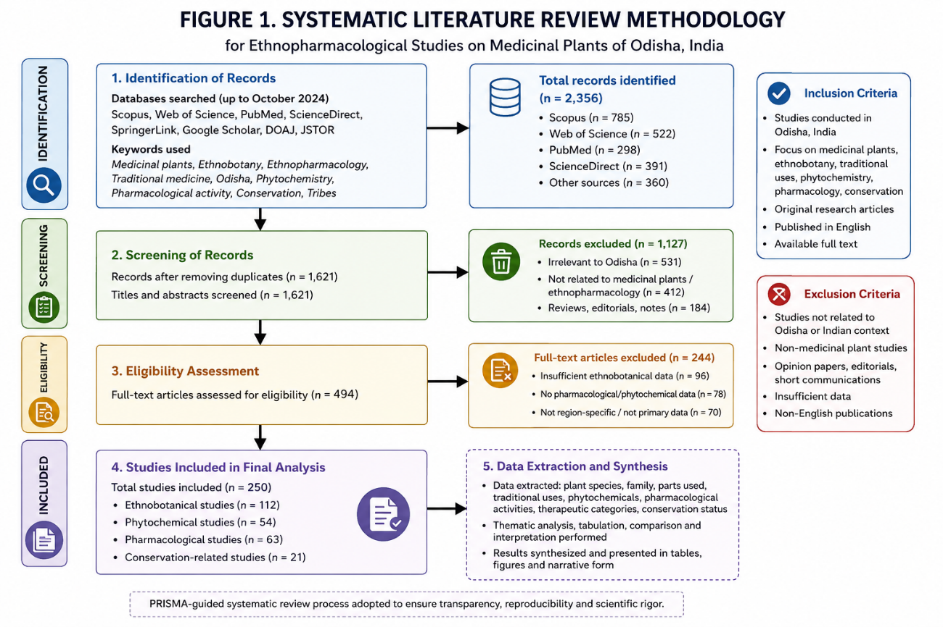
Fig 1 : The systematic workflow adopted for literature collection, screening, selection, and analytical synthesis is presented
Relevant information regarding medicinal plant species, taxonomic classification, ecological distribution, therapeutic applications, phytochemical constituents, pharmacological properties, conservation challenges, and ethnobotanical indices was systematically extracted and comparatively analyzed (Heinrich et al., 1998; Phillips and Gentry, 1993). The collected literature was further categorized into thematic sections including ecological diversity, region-wise medicinal plant distribution, therapeutic applications, phytochemical diversity, quantitative ethnobotany, conservation biology, and future research perspectives. Comparative synthesis of available scientific evidence was performed to identify major research trends, therapeutic significance, and emerging interdisciplinary approaches in ethnopharmacological research (Kumar et al., 2021; Verma et al., 2022).
3. ECOLOGICAL DIVERSITY AND ETHNOBOTANICAL SIGNIFICANCE OF ODISHA
Odisha possesses remarkable ecological heterogeneity that contributes significantly to the distribution and diversity of medicinal plant resources (Tripathy et al., 2021; Samal, 2021). The state encompasses coastal plains, river basins, central tablelands, forest ecosystems, wetlands, and Eastern Ghats hill ranges that collectively create diverse microclimatic and edaphic conditions favorable for medicinal plant growth (Rout et al., 2021). Variations in rainfall, altitude, soil composition, and temperature across different ecological regions further support rich floristic diversity and region-specific medicinal vegetation. Forest ecosystems of Odisha constitute an important reservoir of medicinally valuable angiosperms, shrubs, climbers, grasses, and pteridophytes traditionally utilized in indigenous healthcare systems (Tripathy et al., 2021; Uprety et al., 2020).
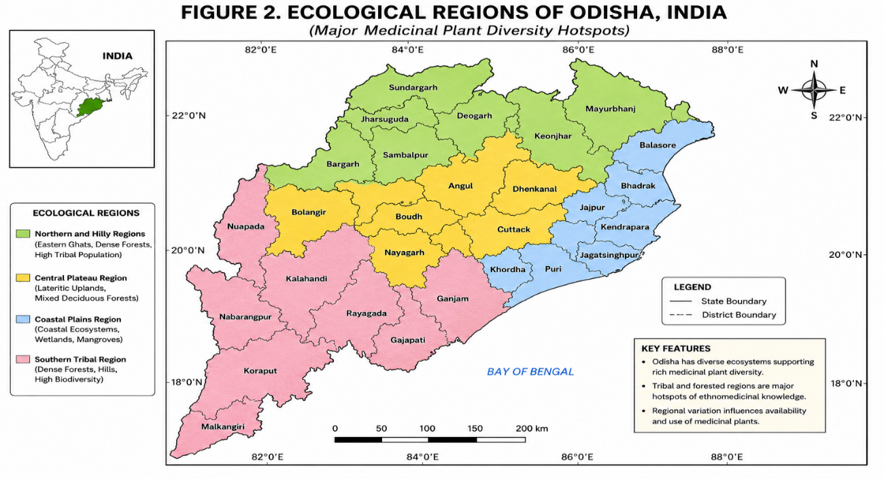
Fig 2 : The major ecological regions and medicinal plant diversity hotspots of Odisha are illustrated
The ethnobotanical significance of Odisha is closely associated with its extensive tribal population and forest-dependent communities (Jain, 1991; Rout et al., 2021). Several indigenous tribal groups, including Kondh, Saora, Bonda, Juang, Gond, and Santhal communities, possess substantial traditional knowledge regarding medicinal plant identification, harvesting, preparation, and therapeutic utilization (Tripathy et al., 2021). These communities have historically depended upon locally available plant resources for primary healthcare management due to limited accessibility to modern medical facilities in remote forested and hilly regions. Traditional ethnomedicinal knowledge is generally transmitted orally across generations and represents an important component of the biocultural heritage of Odisha (Nijar, 2010; Uprety et al., 2020).
The diverse ecological landscapes of Odisha support numerous medicinal plant species with broad therapeutic applications in traditional healthcare systems (Samal, 2021; Das et al., 2020). Commonly utilized medicinal plants include Tinospora cordifolia, Andrographis paniculata, Ocimum sanctum, Rauvolfia serpentina, Curcuma longa, and Azadirachta indica, among many others. These species are traditionally employed for the treatment of fever, malaria, gastrointestinal disorders, inflammatory diseases, respiratory infections, skin diseases, diabetes, reproductive complications, and musculoskeletal disorders (Panda et al., 2020). Medicinal formulations prepared from roots, bark, leaves, rhizomes, seeds, flowers, and latex constitute an integral part of ethnopharmacological practices in rural and tribal regions of the state.
In recent years, increasing scientific attention has been directed toward the phytochemical and pharmacological validation of medicinal plants traditionally used in Odisha. Numerous studies have demonstrated the presence of bioactive compounds such as alkaloids, flavonoids, terpenoids, tannins, glycosides, phenolics, and essential oils that exhibit antimicrobial, antioxidant, anti-inflammatory, hepatoprotective, antidiabetic, immunomodulatory, and anticancer activities (Mishra et al., 2021; Sivakumar and Chen, 2021). The integration of ethnobotanical knowledge with modern pharmacological investigations has further highlighted the potential of Odisha’s medicinal plant resources for phytopharmaceutical development, biodiversity conservation, and sustainable healthcare applications (Kumar et al., 2021; Verma et al., 2022).
4. REGION-WISE MEDICINAL PLANT DIVERSITY AND ETHNOPHARMACOLOGICAL SIGNIFICANCE
Medicinal plant diversity and ethnopharmacological practices in Odisha exhibit substantial regional variation due to differences in ecological conditions, forest distribution, climatic factors, and indigenous healthcare traditions (Tripathy et al., 2021; Rout et al., 2021). Coastal ecosystems, central tablelands, river basins, tribal-dominated forest regions, and Eastern Ghats hill ranges collectively support diverse medicinal flora and therapeutic practices (Samal, 2021). Several medicinal plant species are traditionally utilized across different regions for the management of fever, gastrointestinal disorders, inflammatory diseases, respiratory infections, diabetes, dermatological complications, and reproductive health disorders (Das et al., 2020; Panda et al., 2020). Region-wise medicinal plant diversity and ethnopharmacological applications are summarized in Table 1.
4.1 Coastal Odisha
Coastal Odisha is characterized by humid climatic conditions, estuarine ecosystems, saline soils, mangrove-associated vegetation, and dense rural settlements that support diverse medicinal plant resources (Rout et al., 2021). Traditional healthcare practices in coastal districts extensively utilize medicinal plants for the treatment of skin infections, respiratory disorders, digestive complications, fever, and wound healing (Tripathy et al., 2021). Common medicinal plant species reported from coastal ecosystems include Ocimum sanctum, Azadirachta indica, Aloe vera, and Cocos nucifera.
The ethnomedicinal practices of coastal communities involve the utilization of leaves, bark, roots, latex, and essential oils for preparation of herbal formulations. Several medicinal plants from coastal ecosystems possess antimicrobial, anti-inflammatory, antioxidant, and dermatoprotective properties that contribute to their therapeutic importance in traditional healthcare systems (Mishra et al., 2021; Sivakumar and Chen, 2021).
4.2 Central Odisha and Plateau Regions
Central Odisha and plateau regions contain dry deciduous forests, agricultural landscapes, and moderate rainfall conditions favorable for diverse medicinal plant growth (Samal, 2021). Forest-dependent rural communities traditionally utilize medicinal plants for management of fever, inflammatory diseases, metabolic disorders, gastrointestinal complications, and musculoskeletal disorders.
Common medicinal plant species reported from these regions include Tinospora cordifolia, Curcuma longa, Syzygium cumini, and Withania somnifera. Scientific investigations have demonstrated significant pharmacological activities including antioxidant, antidiabetic, hepatoprotective, and immunomodulatory effects associated with these medicinal plants (Panda et al., 2020; Mishra et al., 2021).
4.3 Tribal and Eastern Ghats Hilly Regions
The Eastern Ghats and tribal-dominated hilly regions of Odisha represent important biodiversity hotspots with substantial ethnobotanical richness (Tripathy et al., 2021; Uprety et al., 2020). Indigenous tribal communities such as Kondh, Saora, Bonda, Juang, and Gond populations possess extensive traditional knowledge regarding medicinal plant identification, harvesting, preparation, and therapeutic applications (Jain, 1991).
Several medicinal plant species including Rauvolfia serpentina, Andrographis paniculata, Gloriosa superba, and Hemidesmus indicus are traditionally utilized for treatment of hypertension, malaria, neurological disorders, inflammatory diseases, and reproductive complications. The rich ethnopharmacological heritage of these tribal regions represents an important source of biocultural knowledge and potential phytopharmaceutical resources (Kumar et al., 2021; Verma et al., 2022).
Table 1. Region-wise medicinal plant diversity and ethnopharmacological significance in Odisha, India
Region of Odisha | Major Ecological Characteristics | Common Medicinal Plant Species | Major Traditional Therapeutic Applications | Ethnopharmacological Significance
Coastal Odisha | Coastal plains, wetlands, estuaries, mangrove-associated ecosystems, humid climate | Azadirachta indica, Ocimum sanctum, Aloe vera, Curcuma longa, Phyllanthus amarus, Centella asiatica, Moringa oleifera | Skin infections, respiratory disorders, fever, liver disorders, gastrointestinal complications, inflammatory diseases | High dependence on locally available medicinal flora for primary healthcare; strong use of antimicrobial and hepatoprotective plants
Central Odisha | Mixed deciduous forests, agricultural landscapes, lateritic uplands, semi-urban ecosystems | Tinospora cordifolia, Terminalia chebula, Andrographis paniculata, Tridax procumbens, Syzygium cumini, Adhatoda vasica | Gastrointestinal disorders, diabetes, fever, inflammatory diseases, wound healing, respiratory infections | Moderate to high medicinal plant diversity with increasing pharmacological validation of traditional therapeutics
Tribal and Hilly Regions | Dense forests, Eastern Ghats landscapes, hilly terrains, relatively undisturbed ecosystems | Rauvolfia serpentina, Withania somnifera, Tinospora cordifolia, Gloriosa superba, Asparagus racemosus, Hemidesmus indicus | Malaria, fever, reproductive disorders, snakebite, inflammation, musculoskeletal disorders, respiratory infections | Highest ethnomedicinal richness and strong oral traditional knowledge systems among tribal communities
Gandhamardan Hill Ranges | Biodiversity-rich forest ecosystem with high floristic heterogeneity | Rauvolfia serpentina, Andrographis paniculata, Ocimum sanctum, Terminalia chebula | Antipyretic, antimicrobial, anti-inflammatory, neurological disorders | Recognized hotspot of medicinal plant diversity and traditional therapeutic heritage
Forest Ecosystems of Southern Odisha | Moist deciduous and semi-evergreen forests with tribal dominance | Azadirachta indica, Tinospora cordifolia, Withania somnifera, Asparagus racemosus | Antimalarial, immunomodulatory, hepatoprotective, reproductive healthcare | Strong ecological dependence and high ethnopharmacological relevance among indigenous populations
5. QUANTITATIVE ETHNOBOTANICAL ANALYSIS
Quantitative ethnobotany plays a crucial role in evaluating the cultural significance, therapeutic reliability, utilization frequency, and traditional healthcare importance of medicinal plant species (Heinrich et al., 1998; Phillips and Gentry, 1993). Various quantitative ethnobotanical indices are commonly utilized to assess the degree of consensus among indigenous communities, frequency of medicinal plant utilization, and relative therapeutic importance associated with ethnomedicinal practices (Rout et al., 2021; Kala, 2005). These analytical approaches provide scientific support for identification of highly valued medicinal plant species and facilitate prioritization for pharmacological validation and conservation planning (Kumar et al., 2021).
Use Value (UV) is an important quantitative index that reflects the relative importance and utilization intensity of medicinal plant species within traditional healthcare systems (Phillips and Gentry, 1993). Higher UV values generally indicate broader ethnomedicinal applications and increased therapeutic dependence among local communities. Relative Frequency Citation (RFC) represents the frequency with which a medicinal plant species is mentioned by informants during ethnobotanical surveys and provides insights into cultural familiarity and medicinal relevance (Heinrich et al., 1998). Several medicinal plants of Odisha, including Tinospora cordifolia, Ocimum sanctum, and Andrographis paniculata, exhibit comparatively high UV and RFC values due to their widespread therapeutic applications (Rout et al., 2021).
Informant Consensus Factor (ICF) is widely utilized to evaluate the level of agreement among indigenous communities regarding medicinal plant utilization for specific disease categories (Heinrich et al., 1998; Kala, 2005).
Higher ICF values generally indicate greater therapeutic reliability and cultural consistency in ethnomedicinal practices. Fidelity Level (FL) represents the percentage of informants claiming the use of a particular medicinal plant species for treatment of a specific disease condition (Phillips and Gentry, 1993). Medicinal plants demonstrating high FL values are often considered therapeutically significant and may possess greater pharmacological potential for future scientific investigations (Rout et al., 2021).
Table 2. Quantitative ethnobotanical indices of major medicinal plants reported from Odisha
Medicinal Plant Species | Use Value (UV) | Informant Consensus Factor (ICF) | Fidelity Level (FL %) | Relative Frequency Citation (RFC) | Major Therapeutic Application
Tinospora cordifolia | 0.89 | 0.84 | 91 | 0.82 | Fever, diabetes, immune disorders
Andrographis paniculata | 0.85 | 0.81 | 88 | 0.79 | Malaria, fever, infections
Rauvolfia serpentina | 0.76 | 0.78 | 85 | 0.71 | Hypertension, neurological disorders
Ocimum sanctum | 0.81 | 0.80 | 87 | 0.76 | Respiratory infections, fever
Terminalia chebula | 0.79 | 0.83 | 89 | 0.74 | Gastrointestinal disorders
Phyllanthus amarus | 0.72 | 0.77 | 84 | 0.68 | Liver disorders, jaundice
Curcuma longa | 0.83 | 0.79 | 86 | 0.77 | Inflammation, wound healing
Azadirachta indica | 0.80 | 0.82 | 88 | 0.75 | Skin diseases, antimicrobial therapy
Withania somnifera | 0.74 | 0.75 | 82 | 0.69 | Stress, inflammatory disorders
Syzygium cumini | 0.70 | 0.73 | 80 | 0.65 | Diabetes and metabolic disorders
Abbreviations
- UV = Use Value
- ICF = Informant Consensus Factor
- FL = Fidelity Level
- RFC = Relative Frequency Citation
Source: Compiled and modified from Heinrich et al. (1998), Phillips and Gentry (1993), and Rout et al. (2021).
Quantitative ethnobotanical analysis provides important scientific evidence for validating traditional medicinal knowledge and identifying priority medicinal plant species for phytochemical, pharmacological, and conservation-oriented investigations (Kumar et al., 2021; Verma et al., 2022). Integration of ethnobotanical indices with modern scientific approaches can further contribute toward sustainable utilization, biodiversity conservation, evidence-based phytomedicine development, and preservation of indigenous healthcare knowledge systems in Odisha
6. THERAPEUTIC CATEGORY-WISE ANALYSIS OF MEDICINAL PLANTS
Medicinal plants of Odisha are traditionally utilized for the management of a wide range of disease conditions and healthcare complications (Das et al., 2020; Samal, 2021). Indigenous healthcare systems and ethnomedicinal practices extensively employ plant-based formulations for treatment of gastrointestinal disorders, febrile diseases, inflammatory complications, respiratory infections, dermatological conditions, diabetes, reproductive disorders, and neurological complications. Several medicinal plants used traditionally by local communities have also demonstrated scientifically validated pharmacological activities supporting their ethnotherapeutic relevance (Panda et al., 2020; Mishra et al., 2021).
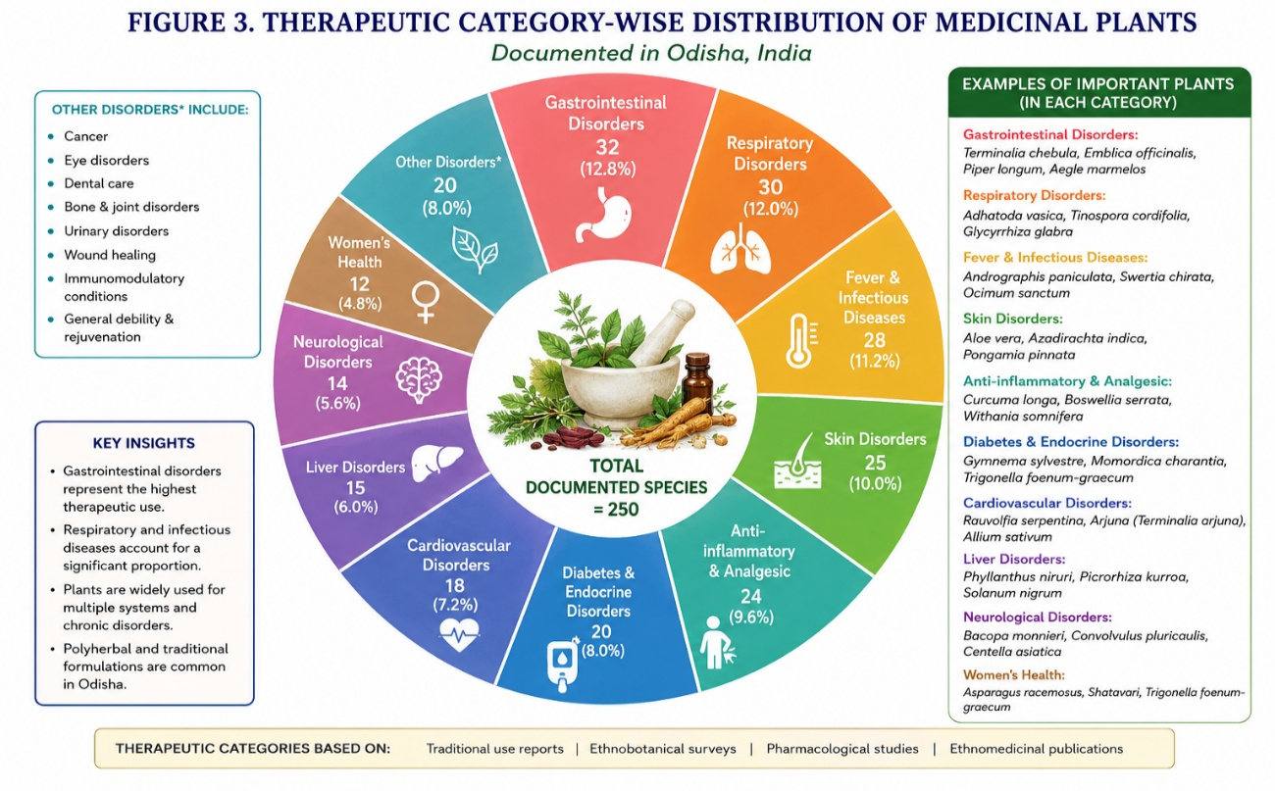
6.1 Gastrointestinal Disorders
Medicinal plants such as Terminalia chebula, Aegle marmelos, and Phyllanthus amarus are traditionally utilized for treatment of diarrhea, dysentery, indigestion, gastric ulcers, and abdominal discomfort (Rout et al., 2021; Sharma et al., 2021). These medicinal plants possess gastroprotective, antimicrobial, and anti-inflammatory properties that contribute to their therapeutic effectiveness in traditional medicine (Sivakumar and Chen, 2021).
6.2 Febrile and Antimalarial Disorders
Traditional healthcare systems in Odisha frequently utilize Andrographis paniculata, Tinospora cordifolia, and Azadirachta indica for treatment of fever, malaria, and infection-associated complications (Panda et al., 2020; Tripathy et al., 2021). These medicinal plants exhibit antipyretic, immunomodulatory, antimicrobial, and antimalarial activities validated through various pharmacological studies (Mishra et al., 2021).
6.3 Respiratory Disorders
Medicinal plants including Ocimum sanctum, Adhatoda vasica, and Piper longum are extensively utilized for management of cough, asthma, bronchitis, and respiratory infections (Sharma et al., 2021; Panda et al., 2020). Their bronchodilatory, expectorant, and antimicrobial activities further support their ethnopharmacological importance (Sivakumar and Chen, 2021) .
6.4 Inflammatory and Musculoskeletal Disorders
Curcuma longa, Withania somnifera, and Vitex negundo are commonly used for treatment of inflammation, arthritis, muscular pain, and joint disorders (Pradhan et al., 2020; Mishra et al., 2021). These medicinal plants contain bioactive phytochemicals possessing antioxidant and anti-inflammatory properties that contribute to pain management and tissue recovery (Sivakumar and Chen, 2021).
6.5 Antidiabetic and Metabolic Disorders
Several medicinal plant species including Syzygium cumini, Gymnema sylvestre, and Momordica charantia are traditionally employed for blood glucose regulation and management of metabolic disorders (Mishra et al., 2021; Samal, 2021). Scientific investigations have demonstrated significant hypoglycemic and antioxidant activities associated with these medicinal plants (Sivakumar and Chen, 2021).
6.6 Dermatological and Reproductive Health Disorders
Medicinal plants such as Azadirachta indica, Aloe vera, and Asparagus racemosus are utilized for treatment of skin infections, wound healing, reproductive complications, and female health disorders (Panda et al., 2020; Sharma et al., 2021). Their antimicrobial, wound-healing, and reproductive health-supportive properties further emphasize their therapeutic significance (Mishra et al., 2021).
Table 3. Therapeutic category-wise medicinal plants and ethnopharmacological applications in Odisha
Therapeutic Category | Common Medicinal Plant Species | Traditional Therapeutic Applications | Major Pharmacological Properties
Gastrointestinal Disorders | Terminalia chebula, Aegle marmelos, Phyllanthus amarus, Holarrhena antidysenterica | Diarrhea, dysentery, indigestion, gastric ulcers, abdominal pain | Gastroprotective, antimicrobial, anti-inflammatory
Antimalarial and Febrile Disorders | Andrographis paniculata, Tinospora cordifolia, Azadirachta indica, Swertia chirayita | Malaria, fever, body pain, infection-related symptoms | Antimalarial, antipyretic, immunomodulatory
Anti-inflammatory and Musculoskeletal Disorders | Curcuma longa, Withania somnifera, Vitex negundo, Zingiber officinale | Arthritis, joint pain, inflammation, swelling, wound-associated discomfort | Anti-inflammatory, analgesic, antioxidant
Respiratory Disorders | Ocimum sanctum, Adhatoda vasica, Piper longum, Glycyrrhiza glabra | Cough, asthma, bronchitis, throat irritation, respiratory infections | Bronchodilatory, expectorant, antimicrobial
Antidiabetic and Metabolic Disorders | Syzygium cumini, Gymnema sylvestre, Momordica charantia, Tinospora cordifolia | Blood glucose regulation, metabolic disorders, diabetes management | Hypoglycemic, antioxidant, metabolic regulatory
Dermatological Disorders | Azadirachta indica, Aloe vera, Curcuma longa, Centella asiatica | Skin infections, burns, wounds, inflammatory skin diseases | Antimicrobial, wound-healing, dermatoprotective
Reproductive Health Disorders | Asparagus racemosus, Withania somnifera, Hemidesmus indicus | Reproductive weakness, menstrual complications, fertility support | Adaptogenic, reproductive health supportive
Neurological and Stress-related Disorders | Rauvolfia serpentina, Withania somnifera, Bacopa monnieri | Hypertension, insomnia, stress, neurological disorders | Neuroprotective, sedative, adaptogenic
General Immunity and Health Promotion | Tinospora cordifolia, Ocimum sanctum, Moringa oleifera | General weakness, immune support, fatigue management | Immunomodulatory, antioxidant, nutritional support
Source: Compiled and modified from Panda et al. (2020), Mishra et al. (2021), and Rout et al. (2021).
7. PHYTOCHEMICAL DIVERSITY AND PHARMACOLOGICAL SIGNIFICANCE OF MEDICINAL PLANTS
Medicinal plants of Odisha possess substantial phytochemical diversity that contributes significantly to their therapeutic and pharmacological importance (Mishra et al., 2021; Sivakumar and Chen, 2021). Various medicinal plant species traditionally utilized in indigenous healthcare systems contain bioactive secondary metabolites including alkaloids, flavonoids, terpenoids, tannins, glycosides, phenolic compounds, saponins, and essential oils (Panda et al., 2020; Kumar et al., 2021). These phytochemicals exhibit diverse biological activities and play an important role in the prevention and treatment of numerous diseases. Increasing scientific interest in phytochemistry and ethnopharmacology has further emphasized the importance of medicinal plants as potential sources of novel therapeutic compounds and phytopharmaceutical agents (Newman and Cragg, 2020; Fabricant and Farnsworth, 2001).
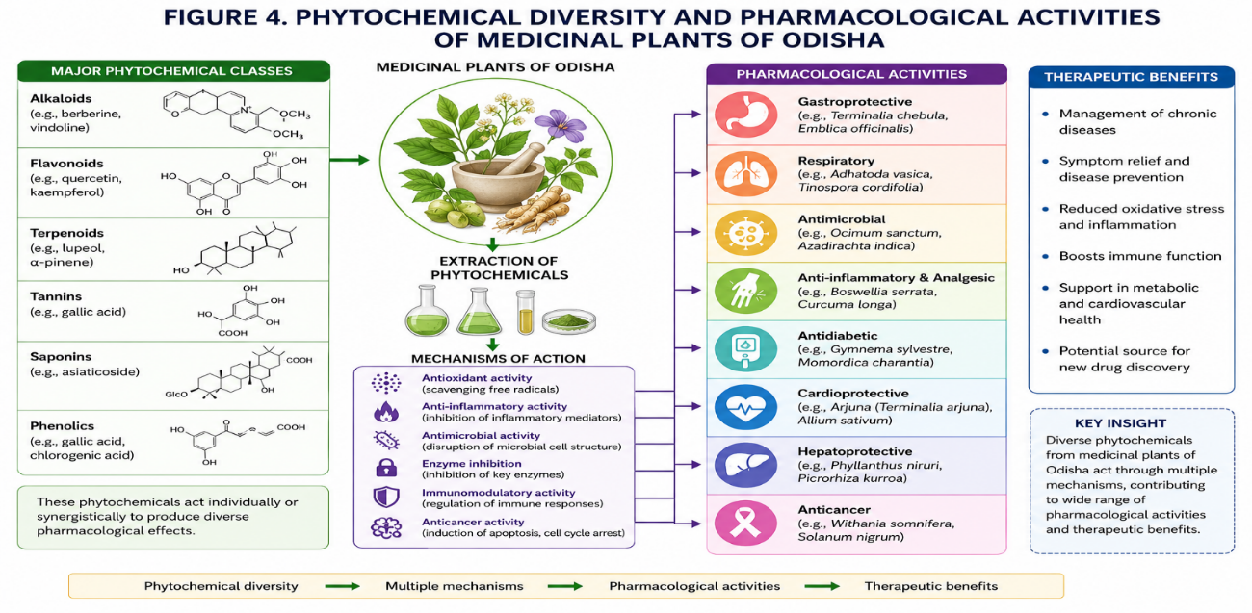
7.1 Alkaloids and Their Pharmacological Importance
Alkaloids represent an important class of nitrogen-containing bioactive compounds exhibiting significant pharmacological activities (Sivakumar and Chen, 2021).
Medicinal plants such as Rauvolfia serpentina and Adhatoda vasica contain therapeutically important alkaloids including reserpine and vasicine that demonstrate antihypertensive, bronchodilatory, neuroprotective, and antimicrobial activities (Panda et al., 2020; Mishra et al., 2021). Alkaloid-rich medicinal plants are widely utilized in traditional healthcare systems for treatment of neurological disorders, respiratory complications, hypertension, and infectious diseases (Samal, 2021)..
7.2 Flavonoids and Phenolic Compounds
Flavonoids and phenolic compounds are extensively distributed among medicinal plants and contribute significantly to antioxidant and anti-inflammatory activities (Ainsworth and Gillespie, 2007; Mishra et al., 2021). Medicinal plants including Ocimum sanctum, Phyllanthus amarus, and Syzygium cumini possess substantial flavonoid and phenolic content associated with free radical scavenging and cellular protective mechanisms. These phytochemicals exhibit considerable therapeutic potential against oxidative stress-related disorders, inflammatory diseases, metabolic complications, and cardiovascular abnormalities (Sivakumar and Chen, 2021).
7.3 Terpenoids and Essential Oils
Terpenoids and essential oils constitute another major class of bioactive compounds present in several medicinal plants of Odisha (Pradhan et al., 2020; Panda et al., 2020). Curcuma longa, Azadirachta indica, and Andrographis paniculata contain diverse terpenoid compounds demonstrating antimicrobial, hepatoprotective, anti-inflammatory, and immunomodulatory activities. Essential oil-producing medicinal plants further contribute to traditional therapeutic formulations used for respiratory infections, dermatological diseases, and wound healing applications (Mishra et al., 2021).
7.4 Antioxidant and Antimicrobial Activities
Numerous medicinal plants traditionally utilized in Odisha exhibit strong antioxidant and antimicrobial activities due to the presence of multiple phytochemical constituents (Chassagne et al., 2021; Sharma et al., 2021). Antioxidant phytochemicals protect biological systems from oxidative stress and cellular damage, whereas antimicrobial compounds inhibit pathogenic microorganisms associated with infectious diseases (Mishra et al., 2021). Scientific investigations have validated the therapeutic potential of several medicinal plants against bacterial, fungal, viral, and inflammatory conditions, thereby supporting their ethnomedicinal applications (Sivakumar and Chen, 2021; Panda et al., 2020).
Table 4. Major medicinal plants of Odisha, phytochemical constituents, and pharmacological activities
Medicinal Plant Species | Family | Major Phytochemical Constituents | Reported Pharmacological Activities | Traditional Therapeutic Applications
Tinospora cordifolia | Menispermaceae | Alkaloids, diterpenoids, glycosides, flavonoids | Immunomodulatory, antidiabetic, antioxidant, anti-inflammatory | Fever, diabetes, immune disorders, general weakness
Andrographis paniculata | Acanthaceae | Andrographolide, flavonoids, diterpenoids | Antimicrobial, antimalarial, anti-inflammatory, hepatoprotective | Malaria, fever, liver disorders, infections
Rauvolfia serpentina | Apocynaceae | Reserpine, ajmaline, alkaloids | Antihypertensive, neuropharmacological, sedative | Hypertension, neurological disorders, insomnia
Ocimum sanctum | Lamiaceae | Eugenol, flavonoids, phenolics, essential oils | Antioxidant, antimicrobial, immunomodulatory | Respiratory infections, cough, fever
Curcuma longa | Zingiberaceae | Curcuminoids, terpenoids, polyphenols | Anti-inflammatory, antioxidant, wound-healing | Inflammation, skin disorders, wound healing
Azadirachta indica | Meliaceae | Azadirachtin, limonoids, flavonoids | Antimicrobial, antifungal, anti-inflammatory | Skin infections, fever, wound treatment
Terminalia chebula | Combretaceae | Tannins, gallic acid, flavonoids | Gastroprotective, antioxidant, antimicrobial | Digestive disorders, diarrhea, ulcers
Phyllanthus amarus | Phyllanthaceae | Lignans, flavonoids, tannins | Hepatoprotective, antiviral, antioxidant | Liver disorders, jaundice, gastrointestinal diseases
Withania somnifera | Solanaceae | Withanolides, alkaloids, steroidal lactones | Adaptogenic, anti-inflammatory, immunomodulatory | Stress, weakness, inflammatory disorders
Syzygium cumini | Myrtaceae | Anthocyanins, flavonoids, alkaloids | Antidiabetic, antioxidant, hypoglycemic | Diabetes, metabolic disorders
Asparagus racemosus | Asparagaceae | Saponins, flavonoids, steroidal compounds | Reproductive health support, antioxidant | Female reproductive disorders, weakness
Adhatoda vasica | Acanthaceae | Vasicine, alkaloids, essential oils | Bronchodilatory, expectorant, antimicrobial | Asthma, bronchitis, respiratory infections
Source: Compiled and modified from Mishra et al. (2021), Panda et al. (2020), and Sivakumar and Chen (2021).

7.5 Emerging Pharmacological and Phytopharmaceutical Perspectives
Recent advances in phytochemistry, molecular pharmacology, metabolomics, and computational biology have significantly enhanced scientific understanding regarding medicinal plant-derived bioactive compounds (Verma et al., 2022; Yadav et al., 2021).
Integration of traditional ethnomedicinal knowledge with modern pharmacological validation may facilitate discovery of novel therapeutic agents and development of evidence-based phytopharmaceutical products (Newman and Cragg, 2020; Kumar et al., 2021). Medicinal plants of Odisha therefore represent an important resource for future interdisciplinary research associated with herbal drug discovery, functional therapeutics, and sustainable healthcare innovation (Fabricant and Farnsworth, 2001; Verma et al., 2022).
8. ETHNOPHARMACOLOGICAL SIGNIFICANCE OF MEDICINAL PLANTS
Ethnopharmacology represents an interdisciplinary scientific approach that investigates the traditional utilization of medicinal plants and their therapeutic relevance in indigenous healthcare systems (Heinrich et al., 1998; Kumar et al., 2021). In Odisha, ethnopharmacological practices have been preserved for generations among tribal and rural communities that extensively depend upon plant-based remedies for treatment of various diseases and healthcare complications (Tripathy et al., 2021; Rout et al., 2021). Traditional medicinal knowledge associated with medicinal plants plays a crucial role in primary healthcare management, particularly in remote forested and tribal regions where accessibility to modern medical facilities remains limited (Uprety et al., 2020).
Several indigenous tribal communities of Odisha, including Kondh, Saora, Bonda, Juang, Gond, and Santhal populations, possess substantial knowledge regarding medicinal plant identification, harvesting, preparation, dosage formulation, and therapeutic applications (Jain, 1991; Rout et al., 2021). Traditional healers and local practitioners utilize different plant parts such as roots, bark, leaves, rhizomes, flowers, fruits, seeds, and latex for preparation of herbal decoctions, pastes, powders, infusions, and extracts (Martin, 1995; Samal, 2021). These ethnomedicinal practices are commonly employed for treatment of fever, malaria, gastrointestinal disorders, respiratory infections, inflammatory diseases, skin complications, reproductive disorders, and musculoskeletal abnormalities (Tripathy et al., 2021).
Scientific investigations conducted on several medicinal plants traditionally utilized in Odisha have validated the presence of diverse bioactive phytochemicals possessing significant pharmacological properties. Medicinal plant species such as Tinospora cordifolia, Andrographis paniculata, Curcuma longa, Ocimum sanctum, and Rauvolfia serpentina have demonstrated antimicrobial, antioxidant, anti-inflammatory, antidiabetic, hepatoprotective, immunomodulatory, and neuroprotective activitie s(Panda et al., 2020; Mishra et al., 2021).
Such pharmacological validation strengthens the scientific credibility of traditional medicinal systems and highlights their potential applications in phytopharmaceutical and evidence-based herbal medicine research (Kumar et al., 2021).
Ethnopharmacological knowledge in Odisha is closely associated with cultural traditions, spiritual beliefs, ecological interactions, and community-based healthcare systems (Leonti and Casu, 2013; Nijar, 2010). Traditional medicinal practices represent an important component of the biocultural heritage of indigenous communities and contribute significantly to preservation of ethnobotanical diversity and local healthcare identity. Oral transmission of medicinal knowledge across generations has historically facilitated continuity of ethnomedicinal practices and sustainable utilization of medicinal plant resources (Uprety et al., 2020).
Despite their immense ethnopharmacological significance, traditional medicinal knowledge systems and medicinal plant resources face increasing threats due to modernization, habitat destruction, deforestation, urbanization, overexploitation, and reduced intergenerational knowledge transfer (Schippmann et al., 2002; Singh et al., 2022). Scientific documentation, digital preservation, sustainable medicinal plant cultivation, community participation, and interdisciplinary ethnopharmacological research are therefore essential for conserving indigenous medicinal knowledge and promoting sustainable healthcare applications(Verma et al., 2022; Kumar et al., 2021). Integration of traditional ethnomedicine with modern pharmacology, biotechnology, and artificial intelligence-assisted drug discovery may further enhance future phytopharmaceutical development and evidence-based therapeutic innovation (Yadav et al., 2021; Verma et al., 2022).
9. CONSERVATION CHALLENGES AND SUSTAINABILITY OF MEDICINAL PLANTS
Medicinal plant diversity in Odisha represents an important biological and ethnopharmacological resource; however, increasing anthropogenic and environmental pressures have significantly threatened the sustainability of medicinal plant populations and associated traditional knowledge systems (Schippmann et al., 2002; Tripathy et al., 2021).
Rapid ecological degradation, habitat fragmentation, overexploitation, climate change, mining activities, and urbanization have collectively contributed to declining medicinal plant diversity across several ecological regions of the state (Singh et al., 2022; Sharma et al., 2023). Sustainable conservation and resource management strategies are therefore essential for ensuring long-term preservation of medicinal plant biodiversity and ethnomedicinal heritage (Uprety et al., 2020).
9.1 Deforestation and Habitat Degradation
Deforestation and habitat destruction constitute major threats to medicinal plant diversity in Odisha (Schippmann et al., 2002; Singh et al., 2022). Expansion of agriculture, infrastructure development, industrialization, and forest land conversion have resulted in fragmentation of natural habitats and reduction of forest-associated medicinal flora (Sharma et al., 2023). Several medicinal plant species dependent on forest ecosystems have experienced declining population density due to habitat disturbance and ecological imbalance. Loss of natural habitats also adversely affects ecological interactions essential for medicinal plant regeneration and survival (Tripathy et al., 2021).
9.2 Overharvesting and Unsustainable Utilization
Excessive harvesting of medicinal plants from wild ecosystems for commercial and traditional utilization has significantly increased pressure on natural plant populations (Schippmann et al., 2002). Unsustainable collection of roots, bark, rhizomes, and whole plants often reduces regenerative capacity and threatens long-term survival of medicinally important species. Increasing market demand for herbal products and phytopharmaceutical raw materials has further intensified overexploitation of several economically valuable medicinal plants in Odisha (Newman and Cragg, 2020; Sharma et al., 2023).
9.3 Climate Change and Ecological Disturbance
Climate change-associated environmental fluctuations including irregular rainfall patterns, temperature variation, drought stress, and ecological instability may alter medicinal plant distribution, growth patterns, and phytochemical composition (Singh et al., 2022). Sensitive medicinal plant species adapted to specific ecological conditions are particularly vulnerable to climatic disturbances and ecosystem degradation. Changes in climatic conditions may additionally affect traditional harvesting seasons and ecological availability of medicinal resources in forested and tribal regions (Tripathy et al., 2021).
9.4 Loss of Indigenous Knowledge Systems
Traditional ethnomedicinal knowledge associated with medicinal plants is increasingly threatened by modernization, migration, sociocultural transformation, and reduced intergenerational knowledge transmission (Nijar, 2010; Uprety et al., 2020).
Younger generations in several tribal and rural communities are gradually shifting toward modern healthcare systems, resulting in erosion of orally transmitted ethnobotanical knowledge (Leonti and Casu, 2013). Loss of indigenous medicinal knowledge may therefore reduce future accessibility to valuable ethnopharmacological information and traditional healthcare practices.
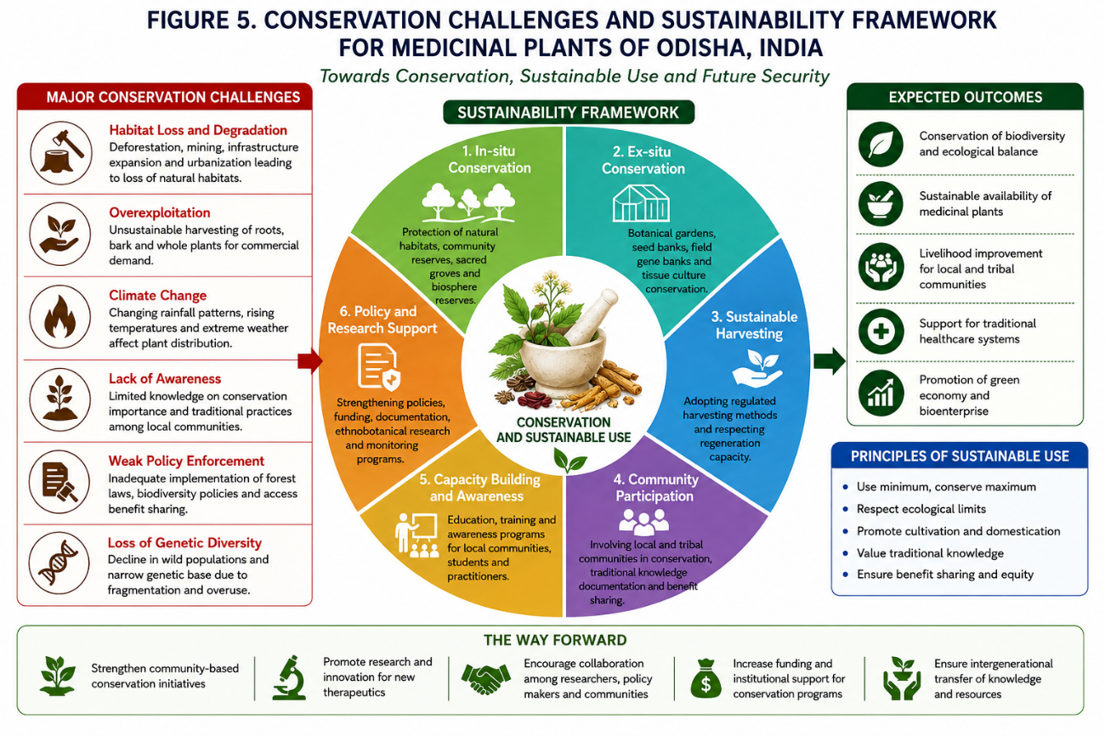

Table 5. Major conservation challenges and sustainable management strategies for medicinal plants in Odisha
Conservation Challenge | Major Causes | Impact on Medicinal Plant Diversity | Sustainable Management and Conservation Strategies
Deforestation and Habitat Loss | Forest clearing, infrastructure development, agricultural expansion | Decline in natural medicinal plant populations and habitat fragmentation | In-situ forest conservation, afforestation programs, protected area management
Mining Activities | Mineral extraction in forested and hilly regions | Ecological degradation, soil disturbance, biodiversity loss | Ecological restoration, biodiversity monitoring, regulated mining practices
Unsustainable Harvesting | Excessive collection of roots, bark, rhizomes, and whole plants | Reduced regeneration capacity and population decline | Sustainable harvesting protocols, cultivation-based utilization, community awareness
Climate Change | Temperature fluctuations, irregular rainfall, drought stress | Altered species distribution and phytochemical variability | Climate-resilient conservation planning, ecological monitoring, germplasm preservation
Urbanization and Industrialization | Expansion of urban settlements and industrial zones | Loss of medicinal plant habitats and ecological imbalance | Greenbelt development, habitat restoration, environmental impact assessment
Erosion of Indigenous Knowledge | Modernization, migration, reduced oral knowledge transfer | Decline of traditional ethnomedicinal practices | Digital documentation, ethnomedicinal databases, community education programs
Overexploitation of Wild Resources | Commercial demand and unregulated medicinal plant trade | Threat to rare and endemic medicinal species | Medicinal plant cultivation, regulated trade systems, ex-situ conservation
Invasive Species and Ecological Disturbance | Spread of invasive flora and ecosystem imbalance | Suppression of native medicinal plant diversity | Ecosystem management and invasive species control programs
Lack of Scientific Cultivation Practices | Limited farmer awareness and technical support | Continued pressure on wild medicinal resources | Training programs, biotechnology-assisted propagation, nursery development
Limited Conservation Policy Implementation | Weak monitoring and insufficient policy integration | Reduced effectiveness of biodiversity conservation programs | Strengthening conservation policies and interdisciplinary collaboration
Source: Compiled and modified from Schippmann et al. (2002), Sharma et al. (2023), and Singh et al. (2022).
9.5 Sustainable Conservation Strategies and Future Perspectives
Sustainable conservation of medicinal plant diversity requires integration of ecological preservation, scientific cultivation, community participation, policy implementation, and modern technological approaches (Sharma et al., 2023; Uprety et al., 2020).
In-situ and ex-situ conservation programs, medicinal plant cultivation, tissue culture-based propagation, biodiversity monitoring, ecological restoration, and community-based conservation initiatives can significantly contribute toward long-term sustainability of medicinal plant resources (Schippmann et al., 2002). Documentation of indigenous ethnomedicinal knowledge, strengthening conservation policies, and interdisciplinary research integration may further facilitate sustainable utilization and preservation of medicinal plant biodiversity in Odisha. Emerging technologies including geospatial biodiversity mapping, artificial intelligence-assisted monitoring, and biotechnology-based conservation approaches additionally offer promising opportunities for future medicinal plant conservation and sustainable phytopharmaceutical development (Verma et al., 2022; Yadav et al., 2021).
10. RESEARCH GAPS AND FUTURE DIRECTIONS
Despite substantial ethnobotanical richness and increasing scientific investigations associated with medicinal plants of Odisha, several important research gaps continue to limit comprehensive understanding of their therapeutic potential, conservation status, phytochemical diversity, and pharmacological validation (Kumar et al., 2021; Tripathy et al., 2021). Existing studies are often geographically restricted, species-specific, or focused on isolated ethnomedicinal observations without extensive interdisciplinary integration (Rout et al., 2021; Samal, 2021).
Comprehensive scientific approaches integrating ethnobotany, phytochemistry, pharmacology, biotechnology, conservation biology, and computational analysis are therefore necessary for advancing evidence-based medicinal plant research and sustainable phytopharmaceutical development (Verma et al., 2022; Yadav et al., 2021).
10.1 Gaps in Ethnobotanical Documentation
Although numerous tribal and rural communities in Odisha possess extensive traditional medicinal knowledge, systematic documentation of ethnomedicinal practices remains incomplete in several ecologically sensitive and remote regions (Jain, 1991; Uprety et al., 2020). Many indigenous healthcare practices continue to be transmitted orally across generations and remain vulnerable to erosion due to sociocultural transformation and modernization (Nijar, 2010). Insufficient ethnobotanical databases, limited regional surveys, and inadequate digital preservation further restrict accessibility to valuable traditional medicinal knowledge and associated biocultural information (Rout et al., 2021).
10.2 Limited Phytochemical and Pharmacological Validation
Several medicinal plants traditionally utilized in Odisha have not yet undergone comprehensive phytochemical characterization and pharmacological evaluation (Mishra et al., 2021; Sivakumar and Chen, 2021). Existing studies are frequently limited to preliminary screening of bioactive compounds without extensive investigation of molecular mechanisms, toxicity profiles, therapeutic efficacy, and clinical applicability (Panda et al., 2020). Advanced analytical techniques including metabolomics, proteomics, molecular docking, and systems pharmacology are therefore required for comprehensive validation of medicinal plant-derived therapeutic compounds (Verma et al., 2022; Yadav et al., 2021).
10.3 Conservation and Sustainability Challenges
Insufficient ecological monitoring, inadequate conservation planning, habitat degradation, and unsustainable harvesting practices continue to threaten medicinal plant diversity in Odisha (Schippmann et al., 2002; Sharma et al., 2023).
Lack of large-scale medicinal plant cultivation programs and limited integration between conservation policies and community participation further complicate sustainable resource management. Future conservation initiatives should therefore emphasize biodiversity mapping, ecological restoration, climate-resilient conservation strategies, and community-based medicinal plant management programs (Singh et al., 2022).
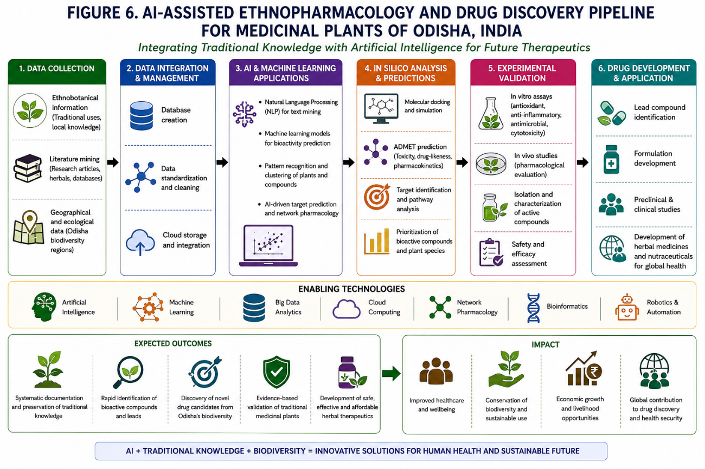

Table 6. Emerging scientific approaches and future applications in ethnopharmacological research of medicinal plants
Emerging Scientific Approach | Principle/Application | Relevance to Medicinal Plant Research | Potential Future Outcomes
Network Ethnopharmacology | Multi-target analysis of phytochemical interactions and therapeutic pathways | Understanding synergistic effects of polyherbal formulations | Development of multi-target phytopharmaceuticals
Metabolomics | Comprehensive profiling of plant metabolites and bioactive compounds | Identification of therapeutic biomarkers and phytochemical diversity | Discovery of novel bioactive metabolites
Molecular Docking | Computational prediction of ligand–target interactions | Screening of phytochemicals against disease-associated proteins | Accelerated drug discovery and therapeutic validation
Artificial Intelligence-assisted Drug Discovery | AI-based prediction of pharmacological activity and bioactive compounds | Rapid screening and prioritization of medicinal plant compounds | Precision phytopharmaceutical development
Genomics and Transcriptomics | Analysis of genetic and gene expression profiles | Understanding biosynthetic pathways and medicinal traits | Improved medicinal plant breeding and conservation
Nanotechnology-based Herbal Formulations | Nano-encapsulation and targeted delivery of herbal compounds | Enhancement of bioavailability and therapeutic efficiency | Advanced herbal drug delivery systems
Geospatial Biodiversity Mapping | GIS-based ecological distribution analysis | Monitoring medicinal plant diversity and habitat conservation | Improved conservation planning and resource management
Computational Biology | Integration of biological data and predictive modeling | Understanding molecular mechanisms of herbal therapeutics | Evidence-based pharmacological validation
Digital Ethnomedicinal Databases | Electronic documentation of traditional medicinal knowledge | Preservation and accessibility of indigenous healthcare information | Long-term biocultural conservation
Biotechnology-assisted Propagation | Tissue culture and micropropagation techniques | Mass propagation of rare and threatened medicinal species | Sustainable medicinal plant cultivation and germplasm conservation
. Source: Compiled and modified from Verma et al. (2022), Yadav et al. (2021), and Sharma et al. (2023).
10.4 Emerging Technologies and Future Perspectives
Recent advances in artificial intelligence, computational biology, molecular pharmacology, genomics, transcriptomics, nanotechnology, and bioinformatics have created new opportunities for medicinal plant research and phytopharmaceutical innovation (Verma et al., 2022; Yadav et al., 2021). Integration of traditional ethnomedicinal knowledge with AI-assisted drug discovery, molecular docking, geospatial biodiversity mapping, and biotechnology-based propagation may significantly accelerate identification of novel therapeutic compounds and sustainable medicinal resource management .(Newman and Cragg, 2020; Kumar et al., 2021).
Future interdisciplinary collaboration among ethnobotanists, pharmacologists, biotechnologists, ecologists, and data scientists will therefore be essential for promoting evidence-based herbal medicine research, biodiversity conservation, and sustainable healthcare development (Fabricant and Farnsworth, 2001).
11. CONCLUSION
Medicinal plant diversity of Odisha represents an important ecological, ethnobotanical, and ethnopharmacological resource with substantial therapeutic and socioeconomic significance (Tripathy et al., 2021; Kumar et al., 2021). Diverse ecological regions including coastal plains, forest ecosystems, river basins, and Eastern Ghats hilly terrains support numerous medicinal plant species traditionally utilized by tribal and rural communities for management of fever, gastrointestinal disorders, inflammatory diseases, respiratory infections, diabetes, dermatological complications, and reproductive health disorders (Rout et al., 2021; Samal, 2021). Indigenous ethnomedicinal knowledge associated with these medicinal plants constitutes an important component of the biocultural heritage of Odisha (Uprety et al., 2020; Nijar, 2010).
Scientific investigations have validated the presence of diverse bioactive phytochemicals possessing antimicrobial, antioxidant, anti-inflammatory, antidiabetic, hepatoprotective, immunomodulatory, and neuroprotective activities in several medicinal plant species traditionally utilized in Odisha (Mishra et al., 2021; Sivakumar and Chen, 2021). However, increasing anthropogenic pressure, habitat degradation, overexploitation, climate change, mining activities, and erosion of indigenous knowledge systems continue to threaten medicinal plant biodiversity and sustainable utilization (Schippmann et al., 2002; Singh et al., 2022). Strengthening conservation strategies, medicinal plant cultivation, ecological restoration, and documentation of traditional knowledge therefore remains essential for long-term sustainability and preservation of ethnopharmacological resources (Sharma et al., 2023).
Integration of traditional ethnomedicinal knowledge with modern phytochemistry, pharmacology, biotechnology, artificial intelligence-assisted drug discovery, and computational ethnopharmacology offers promising opportunities for future phytopharmaceutical development and evidence-based herbal medicine research (Verma et al., 2022; Yadav et al., 2021).
Interdisciplinary collaboration among ethnobotanists, pharmacologists, ecologists, conservation biologists, and healthcare researchers may further facilitate sustainable medicinal plant utilization, biodiversity conservation, and healthcare innovation( Fabricant and Farnsworth, 2001; Kumar et al., 2021). Medicinal plants of Odisha therefore represent valuable natural resources with significant potential for future therapeutic advancement, sustainable healthcare systems, and biodiversity-based socioeconomic development (Newman and Cragg, 2020).

REFERENCE
- Ainsworth EA, Gillespie KM (2007) Estimation of total phenolic content and other oxidation substrates in plant tissues using Folin–Ciocalteu reagent. Nature Protocols 2(4): 875–877. https://doi.org/10.1038/nprot.2007.102.
- Alamgir ANM (2017) Therapeutic use of medicinal plants and their extracts. Progress in Drug Research 73: 1–27. https://doi.org/10.1007/978-3-319-63862-1_1.
- Bhat JA, Kumar M, Bussmann RW (2021) Ecological and ethnobotanical perspectives of medicinal plants in India. Sustainability 13(13): 7463. https://doi.org/10.3390/su13137463.
- Bodeker G, Ong CK, Grundy C et al. (2005) WHO global atlas of traditional, complementary and alternative medicine. World Health Organization, Geneva.
- Calixto JB (2005) Twenty-five years of research on medicinal plants in Latin America. Journal of Ethnopharmacology 100(1–2): 131–134. https://doi.org/10.1016/j.jep.2005.05.004.
- Chassagne F, Samarakoon T, Porras G et al. (2021) A systematic review of plants with antibacterial activities. Journal of Ethnopharmacology 267: 113544. https://doi.org/10.1016/j.jep.2020.113544.
- Das G, Patra JK, Debnath T et al. (2020) Traditional medicinal plants and their role in healthcare management. Microbial Pathogenesis 148: 104404. https://doi.org/10.1016/j.micpath.2020.104404.
- Fabricant DS, Farnsworth NR (2001) The value of plants used in traditional medicine for drug discovery. Environmental Health Perspectives 109(Suppl 1): 69–75. https://doi.org/10.1289/ehp.01109s169.
- Farnsworth NR, Akerele O, Bingel AS et al. (1985) Medicinal plants in therapy. Bulletin of the World Health Organization 63(6): 965–981.
- Ghorbani A (2005) Studies on pharmaceutical ethnobotany in the region of Turkmen Sahra, north of Iran. Journal of Ethnopharmacology 102(1): 58–68. https://doi.org/10.1016/j.jep.2005.05.035.
- Heinrich M, Ankli A, Frei B et al. (1998) Medicinal plants in Mexico: Healers’ consensus and cultural importance. Social Science & Medicine 47(11): 1859–1871. https://doi.org/10.1016/S0277-9536(98)00181-6.
- Jain SK (1991) Dictionary of Indian Folk Medicine and Ethnobotany. Deep Publications, New Delhi.
- Jain SK, Rao RR (1977) A Handbook of Field and Herbarium Methods. Today and Tomorrow’s Printers and Publishers, New Delhi.
- Kala CP (2005) Indigenous uses and structure of medicinal plants in Uttaranchal, India. Journal of Ethnobiology and Ethnomedicine 1: 9. https://doi.org/10.1186/1746-4269-1-9.
- Kamboj VP (2000) Herbal medicine. Current Science 78(1): 35–39.
- Kumar M, Bussmann RW, Mukesh KR (2021) Ethnobotany and ethnopharmacology of medicinal plants: Future perspectives. Frontiers in Pharmacology 12: 731197. https://doi.org/10.3389/fphar.2021.731197.
- Leonti M, Casu L (2013) Traditional medicines and globalization. Current Drug Targets 14(14): 1555–1557. https://doi.org/10.2174/13894501113149990170.
- Mahomoodally MF (2013) Traditional medicines in Africa: An appraisal of ten potent African medicinal plants. Evidence-Based Complementary and Alternative Medicine 2013: 617459. https://doi.org/10.1155/2013/617459.
- Martin GJ (1995) Ethnobotany: A Methods Manual. Chapman & Hall, London.
- Mishra AP, Sharifi-Rad M, Shariati MA et al. (2021) Bioactive compounds and health-promoting potential of medicinal plants. Molecules 26(7): 1795. https://doi.org/10.3390/molecules26071795.
- Newman DJ, Cragg GM (2020) Natural products as sources of new drugs over nearly four decades. Journal of Natural Products 83(3): 770–803. https://doi.org/10.1021/acs.jnatprod.9b01285.
- Nijar GS (2010) Traditional knowledge systems, international law and national challenges. European Intellectual Property Review 32(2): 53–57.
- Panda SK, Das G, Leyssen P et al. (2020) Antiviral, antimicrobial and anti-inflammatory medicinal plants of India. Journal of Ethnopharmacology 247: 112253. https://doi.org/10.1016/j.jep.2019.112253.
- Patra JK, Das G, Fraceto LF et al. (2021) Nano based drug delivery systems for herbal medicines. Journal of Drug Delivery Science and Technology 61: 102170. https://doi.org/10.1016/j.jddst.2020.102170.
- Phillips O, Gentry AH (1993) The useful plants of Tambopata, Peru: Statistical hypotheses tests with a new quantitative technique. Economic Botany 47(1): 15–32. https://doi.org/10.1007/BF02862203.
- Prance GT (2001) Discovering the plant world. Taxon 50(2): 345–359. https://doi.org/10.2307/1223885.
- Pradhan D, Suri KA, Pradhan DK, Biswasroy P (2020) Golden heart of nature: Curcuma longa Linn. for future therapeutics. Journal of Traditional and Complementary Medicine 10(6): 501–511. https://doi.org/10.1016/j.jtcme.2020.08.005.
- Ragupathy S, Newmaster SG (2009) Valorizing the ‘Irulas’ traditional knowledge of medicinal plants in the Kodiakkarai Reserve Forest, India. Journal of Ethnobiology and Ethnomedicine 5: 10. https://doi.org/10.1186/1746-4269-5-10.
- Rates SMK (2001) Plants as source of drugs. Toxicon 39(5): 603–613. https://doi.org/10.1016/S0041-0101(00)00154-9.
- Rout SD, Panda T, Mishra N (2021) Quantitative ethnobotany and medicinal plant utilization in Eastern India. Tropical Ecology 62: 336–349. https://doi.org/10.1007/s42965-021-00142-7.
- Samal J (2021) Diversity of medicinal plants and ethnomedicinal practices in India. Journal of Ayurveda and Integrative Medicine 12(3): 456–464. https://doi.org/10.1016/j.jaim.2020.05.005.
- Schippmann U, Leaman DJ, Cunningham AB (2002) Impact of cultivation and gathering of medicinal plants on biodiversity. In: Biodiversity and the Ecosystem Approach in Agriculture, Forestry and Fisheries. FAO, Rome.
- Sharma A, Flores-Vallejo RDC, Cardoso-Taketa A et al. (2021) Antibacterial activities of medicinal plants used in ethnomedicine. Microbial Pathogenesis 152: 104620. https://doi.org/10.1016/j.micpath.2020.104620.
- Sharma P, Kumar P, Sharma R (2023) Medicinal plant conservation and sustainable utilization strategies. Sustainability 15(3): 2145. https://doi.org/10.3390/su15032145.
- Shinwari ZK (2010) Medicinal plants research in Pakistan. Journal of Medicinal Plants Research 4(3): 161–176. https://doi.org/10.5897/JMPR09.301.
- Singh R (2015) Medicinal plants: A review. Journal of Plant Sciences 3(1): 50–55. https://doi.org/10.11648/j.jps.20150301.18.
- Singh R, Devi S, Sharma P (2022) Climate change impacts on medicinal plant diversity. Ecological Indicators 141: 109123. https://doi.org/10.1016/j.ecolind.2022.109123.
- Sivakumar D, Chen J (2021) Phytochemical profiling and therapeutic applications of medicinal plants. Food Bioscience 42: 101170. https://doi.org/10.1016/j.fbio.2021.101170.
- Sofowora A (1993) Medicinal Plants and Traditional Medicine in Africa. Spectrum Books Ltd., Ibadan.
- Sultana S, Khan A, Safhi MM et al. (2020) Role of medicinal plants in traditional healthcare systems. Saudi Journal of Biological Sciences 27(12): 3646–3657. https://doi.org/10.1016/j.sjbs.2020.08.023.
- Tripathy B, Panda SK, Mohanty RB (2021) Medicinal plant diversity in tribal dominated districts of Odisha. Journal of Threatened Taxa 13(9): 19221–19233. https://doi.org/10.11609/jott.7123.13.9.19221-19233.
- Uprety Y, Asselin H, Boon E et al. (2020) Traditional use of medicinal plants in South Asia and conservation implications. Journal of Ethnobiology and Ethnomedicine 16: 43. https://doi.org/10.1186/s13002-020-00384-5.
- Verma RK, Kumar S, Lal S (2022) Network pharmacology approaches in herbal medicine research. Briefings in Bioinformatics 23(4): bbac126. https://doi.org/10.1093/bib/bbac126.
- WHO (2013) WHO Traditional Medicine Strategy 2014–2023. World Health Organization, Geneva.
- Yadav DK, Kumar S, Choi EH et al. (2021) Molecular docking and computational approaches in medicinal plant research. Current Pharmaceutical Design 27(36): 3838–3854. https://doi.org/10.2174/1381612827666210614121020.
- Yuan H, Ma Q, Ye L, Piao G (2016) The traditional medicine and modern medicine from natural products. Molecules 21(5): 559. https://doi.org/10.3390/molecules21050559.
- Zhang J, Wider B, Shang H et al. (2021) Quality assessment and standardization of herbal medicines. Journal of Ethnopharmacology 273: 113940. https://doi.org/10.1016/j.jep.2021.113940.

