Original Research Article
To Evaluate Current Lung Capacity by Pulmonary Function Tests (PFTs).

Abstract: Introduction: Pulmonary function tests (PFTs) are essential for the identification and quantification of respiratory diseases; however, comprehensive data on spirometric patterns and determinants in India are limited. This study aimed to determine the distribution of PFT patterns and their association with demographic and lifestyle factors in adults undergoing spirometry. Methods: This study included 875 volunteers whose spirometry was performed at tertiary care centers and in community-based health check-up camps conducted in South Gujarat, India, by using ERS and ATS, which have provided guidelines. There are four categories of lung function results: normal, restrictive, obstructive, and mixed and three levels of severity for abnormal PFT: mild, moderate, and severe. The relationships of the patterns of PFT were evaluated with the chi-square test. Results : Of these 875 subjects, normal PFTs were evident in 50.4%. Mild, moderate, severe, and mixed ventilatory abnormalities were found in 25.26%, 18.63%, 4.0%, and 1.71% of the cases, respectively. PFT patterns also significantly showed gender (p = 0.0081) and age group differences (p < 0.0001). Smoking had a significant relationship with abnormal PFT patterns (p < 0.0001); an obstructive and mixed pattern was mostly found in active and ex-smokers, but there was no significant association between BMI levels and PFT patterns (p = 0.6155. Conclusions: A considerable number of adults had pulmonary dysfunction, even among the subjects recruited from society through the health check-up camps. Age, sex, and smoking were also associated with spirometric abnormalities, emphasizing the use of spirometry in clinical assessment as well as community screening for respiratory health.
Keywords: Body mass index; Pulmonary function tests; Respiratory health; Spirometry; Smoking.

INTRODUCTION
Pulmonary function tests (PFTs) using spirometry provide an objective assessment of lung function and play a key role in the diagnosis and monitoring of respiratory diseases. Spirometric variables: Forced expiratory volume in one second (FEV 1), forced vital capacity (FVC), and FEV 1 / FVC ratio are used to determine obstructive, restrictive, and mixed ventilatory defects [1, 2]. Moreover, abnormal pulmonary functions are associated with increased respiratory morbidity, weakened quality of life, and increased mortality, even in the absence of a diagnosed respiratory condition [3]. Population studies have demonstrated significant inter-individual variations in spirometric findings, which can be associated with factors such as age, sex, smoking habits, and anthropometric indices [4, 5].
As people age, physiological deterioration of the lungs, including loss of elasticity and decreased strength of respiratory muscles, leads to lower spirometric values [6]. Sex-related differences in lung size and the dimension of the airway are contributing factors to sex differences in pulmonary function among populations [7]. Cigarette smoking continues to be the most significant modifiable risk factor for airflow limitation and chronic airway disease, as both active and former smokers have remained with spirometric abnormalities [8, 9]. Body mass index (BMI) has a big effect on how well the lungs perform. Obesity, although it could influence respiratory mechanics and lung volumes, has also shown inconsistent associations with spirometric impairment [10]. Indian data regarding the prevalence of pulmonary function patterns and their predictors are sparse, and few are from the large hospital-based cohort. The current study was conducted to determine spirometric patterns and their relation with age, gender, smoking status, and BMI in adults who were referred to have pulmonary function tests.
MATERIALS AND METHODS
A cross-sectoral study followed STROBE guidelines for observational research conducted in South Gujarat for six months (January–June 2024), and free health check-up camps were organized at different districts with the help of Cipla, Shivam Chest Clinic, Kiran Hospital, Vrudam Hospital, Sadvichar Trust, and other organizations. The study protocol was approved by the Institutional Ethical Committee of Sarvajanik University Ethics Committee (reference no. RK/PhD/002/2026-27, dated 16/01/2024) and conducted per ICMR/Indian ethical guidelines. Individuals were chosen through the simple random sampling method from the participants who had registered their names in the medical screening camps. We also included and enrolled any adult 18 years or older who was willing to participate in the study and who gave written informed consent. Patients with a previous history of severe respiratory disease or those having comorbidities that contraindicated the PFT were not included in the study [1, 11].
Demographic and clinical data (age, sex, smoking status, height, and weight) were obtained through a standard questionnaire. There were three categories based on smoking history: smoker, ex-smoker, and non-smoker. Body weight and height were measured by a calibrated digital weighing scale and stadiometer, respectively. Body mass index (BMI) was measured as weight (kg)/height² (m²) and classified using the World Health Organization criteria. BMI was recorded because changes in body composition are known to affect pulmonary mechanics and spirometric variables [12].
PFTs were performed using the Spirolab Touch Screen Portable Desktop Spirometer. The equipment is compliant with recommendations of the American Thoracic Society (ATS) and European Respiratory Society (ERS). Spirometry was performed according to the ATS/ERS criteria with subjects in a seated position, wearing a nose clip and using a disposable mouthpiece [1, 2, 11, 13]. Subjects were asked to breathe in maximally and then to breathe out forcefully and for as long as possible (minimum 6 seconds). The measured values were the forced expiratory volume at one second (FEV), the forced vital capacity (FVC), and the ratio of FEV to FVC [1, 11].
At least three acceptable and repeatable trials were collected per participant, and the highest values were used for analysis as recommended elsewhere. Types of pulmonary function results were defined as normal, restrictive, obstructive, or mixed (restriction with obstructions) ventilatory dysfunction [2, 13] Severity of disease was categorized as mild, moderate, or severe as per the conventional spirometric criteria and the latest interpretative guidelines [2]
STATISTICAL ANALYSIS
Data were entered in Microsoft Excel 2019 and exported to JMP Student Edition (SAS Institute Inc., 2023) for analysis. Statistical analysis was carried out at a significance level of 5% (p < 0.05), with 95% confidence intervals [14] Categorical variables, including gender, smoking status, BMI categories, and spirometry outcomes, were summarized using descriptive statistics, including percentages and frequencies. We did other tests, like chi-square tests, looking for interactions between lung abnormalities and variables like age, gender, classification of BMI, and smoking status.

RESULTS
Participant Overview
A total of 912 volunteers participated in the investigation. Out of them, children were (n=26, 2.9%) excluded from the PFT. Medical history led to the exclusion of 11 participants [known tuberculosis before (n = 3), recent bypass surgery (n = 4), and other (n = 4)]. Of the 875 participants, all met inclusion criteria and were from various parts of South Gujarat, India.
Prevalence of Pulmonary Function Patterns
Among the 875 participants included in the study, normal pulmonary function was observed in 50.40% (n = 441). Abnormalities are further categorized as mild, moderate, severe, and mixed (restriction with obstruction) based on severity of lung functionality impairment. Abnormal PFT patterns were identified in 49.60% (n=434) of participants. Mild obstructive or restrictive impairment was present in 25.26% (n = 221), moderate impairment in 18.63% (n = 163), severe pulmonary impairment in 4.00% (n = 35), and combined obstructive and restrictive defects in 1.71% (n = 15).
Abnormal Pulmonary Function Test (PFT) results are also classified into three patterns, like obstructive, restrictive, and mixed patterns (obstruction with restriction), based on spirometry measurements like FVC, FEV1, and FEV1/FVC. Among abnormal PFT results, 44.70% (n = 391) exhibited restrictive patterns, 3.20% (n = 28) showed obstructive patterns, and 1.70% (n = 15) had mixed ventilatory defects.
Distribution of Participant’s Gender as per Pulmonary Function Pattern
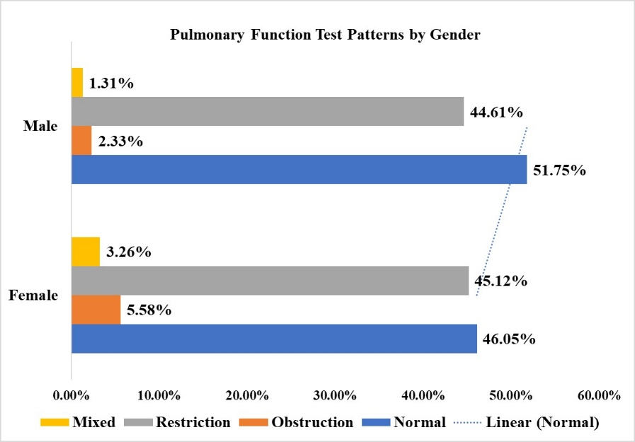
Among 875 participants, 209 (23.90%) were females and 666 (76.10%) were males. Distribution of participants’ gender as per Pulmonary Function Test (PFT) interpretations was collapsed into four clinically meaningful categories (normal, obstructive, restrictive, and mixed) for statistical analysis, which is shown in Fig. 1. A higher ratio of normal PFT results was observed in males, while restrictive patterns were similarly observed in females and males. However, obstructive patterns were observed higher in females. Mixed patterns were rare in both male and female groups.
The chi-square test was used to statistically analyze the correlation between gender and PFT interpretation category, revealing a significant relationship (Pearson χ² = 11.8, df = 3, p = 0.0081; likelihood ratio χ², p = 0.0158); however, the magnitude of this association was small (R² = 0.0067). This is indicative of a small effect of gender on pulmonary function.
Fig. 1. Distribution of Participants’ Gender as per Pulmonary Function Pattern.

Distribution of Participant’s Age Groups as per Pulmonary Function Pattern
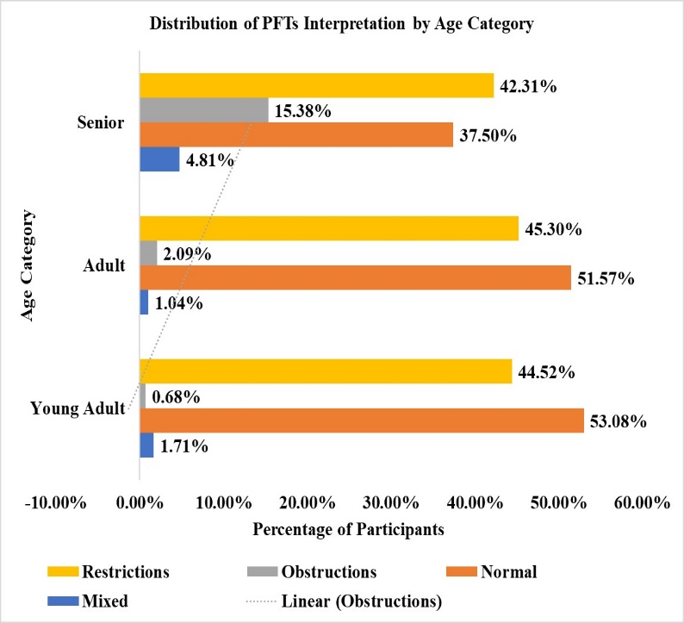
Participants’ age was classified into three groups: young adults, adults, and seniors. Participants included 292 young adults (33.37%), 479 adults (54.74%), and 104 seniors (11.89%). Adults were the most common age group in the study.
Associations between PFTs and age groups are illustrated in Fig. 2. Seniors represented a small proportion of the participants and showed a similar distribution of normal and restrictive patterns. Adults and young adults most frequently demonstrated normal or restrictive pulmonary function patterns, whereas seniors exhibited a relatively higher proportion of obstructive patterns compared with adults and young adults. Seniors demonstrated a higher proportion of obstructive patterns, while adults and young adults most frequently exhibited normal or restrictive findings.
Fig. 2. Distribution of Participants’ Age Groups as per Pulmonary Function Pattern.

A statistically significant association was observed between age group and pulmonary function category. The Likelihood Ratio chi-square test indicated significance (χ² = 45.4, p < 0.0001), which was supported by the Pearson chi-square test (χ² = 67.1, p < 0.0001). The strength of the association was small (R²(U) = 0.0293). The low p-value (p-value < 0.0001) suggested that the observed and expected distributions exhibited significant differences. This finding indicates that the severity of lung functionalities and age groups are highly correlated.
Distribution of Participant’s Smoking Status as per Pulmonary Function Pattern
Individuals were categorized into three groups based on how long they had been smoking: non-smokers (never smokers), smokers (current smokers), and ex-smokers (smoking in past). Non-smokers, smokers, and ex-smoking participants were 735 (84.00%), 95 (10.90%), and 45 (5.10%), respectively. The group with the most common smoking habit was comprised of never-smokers.
Fig. 3 illustrates the potential variation of PFT patterns based on smokers' status (never, current, and ex-smokers). Normal PFT results were most frequent in non-smokers, followed by restrictive ventilatory disturbance. Obstructive and combined obstructive–restrictive patterns were uncommon in this group.
In the smoker group, mixed (obstructive-restrictive) patterns of PFT results were most frequently observed, which were followed by restrictive ventilatory defective PFT results. Obstructive patterns and a normal condition were less observed in the smoker group.
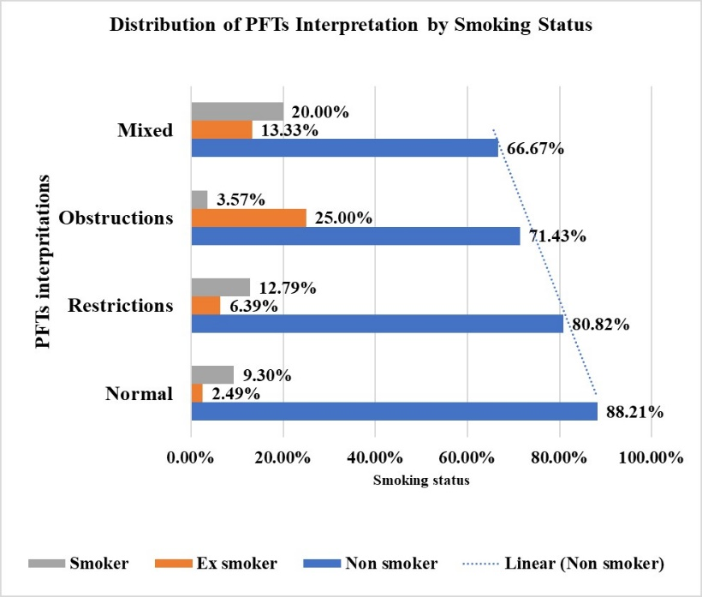
The ex-smokers had a prevalence of abnormal PFT patterns, with obstructive ventilatory impairment. Normal patterns and restrictive patterns were seen in very few participants.
The statistical analysis indicated that smoking status was significantly associated with the PFT pattern. The chi-square values of the Pearson and likelihood ratio tests were 37.948 (p < 0.0001) and 28.529 (p < 0.0001), respectively, suggesting that smoking status was significantly associated with abnormal PFT results. Non-smokers predominantly had normal PFTs, whereas those who smoked and ex-smokers had a restrictive obstruction as well as a mixed obstruction. Former smokers had the lowest relevant normal PFT rate and the highest rate of detected obstructive dysfunction.
Fig. 3. Distribution of Participants' Smoking Status as per Pulmonary Function Pattern.

Distribution of Participant’s BMI Categories as per Pulmonary Function Pattern
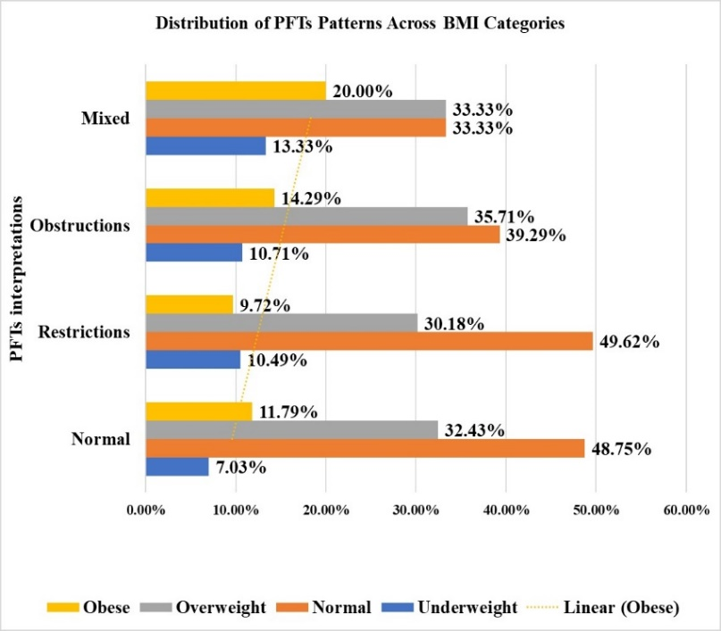
Participants were divided into 4 groups according to their BMI: normal BMI was present in 48.61% (n = 425), overweight in 31.50% (n = 276), obese in 11.09% (n = 97), and underweight in 8.80% (n = 77).
PFT categories were distributed similarly in all BMI groups, as seen in Fig. 4, with approximately half having normal PFTs, which is followed by restrictive patterns in all BMI categories. Obstructive and mixed patterns were rare in all BMI groups.
The frequency of association between the BMI category and the pattern of PFT was analyzed by a chi-square test. There was no statistically significant relationship between BMI and PFT patterns, Pearson’s χ² = 7.306, p = 0.605. Results were consistent when the likelihood ratio test was used, χ² = 7.208, p = 0.6155. The effect size was small (R² = 0.005), meaning that the BMI category only explained a small amount of the variation in PFT categorization.
Fig. 4. Distribution of Participants' BMI Categories as per Pulmonary Function Pattern.

DISCUSSION
The current study shows a higher prevalence of abnormal PFT patterns after undergoing spirometry, representing a high burden of respiratory dysfunction in the population. Population-based studies in India and elsewhere have recorded a comparable prevalence of abnormal spirometry [4, 15]. Age was highly associated with impairment of pulmonary function, which agrees with the fact that there is an age-related physiological effect on lung functions. Gender-based variances of spirometric patterns revealed by our study could be due to differences with lung volumes, occupational exposures, and smoking habits [7]
A history of smoking was identified as a significant factor contributing to the decreased pulmonary functions. The higher prevalence of obstructive disorders in smokers and former smokers is consistent with the established effects of smoke exposure on airway inflammation and airflow obstruction [8, 9, 16] In contrast, BMI was not related to pulmonary function patterns. Obesity has been reported to affect respiratory mechanics but may have a heterogeneous impact on spirometric variables and can be modified by factors such as fat distribution and physical activity [10, 17] An advantage of our study is the larger sample size and use of standard spirometry methods. Nevertheless, the study is cross-sectional and has an inability to make inferences about causality and no longitudinal follow-up to evaluate lung function changes over time. [18]
In summary, on the basis of spirometry, abnormal pulmonary function was frequent in adults. Age, gender, and smoking were demonstrated to be the notable instruments predicting the spirometry patterns and therefore can serve as useful screening tools to promote respiratory health by regular monitoring of pulmonary function and also advocating for anti-smoking campaigns.
CONCLUSION
This population-based study of South Gujarat participants provides useful information about the prevalence and determinants of PFT abnormalities. Impaired pulmonary function was frequent in adults performing spirometry. Age, sex, and smoking status were important factors influencing spirometric patterns, indicating effects of both routine pulmonary function testing and strategies for smoking cessation on respiratory health promotion.
Limitations
Cross-sectional self-reported status of smoking habits could potentially be underreported. Moreover, other external environmental influences, such as air quality and occupational exposure, were not adjusted for and potentially interfered with the results.

Conflict of interest
The authors declare no conflicts of interest.
Ethical approval
The study was approved by the Sarvajanik University Ethics Committee (Ethical Approval No. RK/PhD/002/2026-27, Date 16/01/2024) and conducted per ICMR/Indian ethical guidelines. Informed consent was obtained from all participants.

REFERENCE
- Graham BL, Steenbruggen I, Miller MR, Barjaktarevic IZ, Cooper BG, Hall GL, Hallstrand TS, Kaminsky DA, McCarthy K, McCormack MC, Oropez CE. Standardization of spirometry 2019 update. An official American thoracic society and European respiratory society technical statement. American Journal of respiratory and Critical Care Medicine. 2019 Oct 15;200(8):e70-88.
- Stanojevic S, Kaminsky DA, Miller MR, Thompson B, Aliverti A, Barjaktarevic I, Cooper BG, Culver B, Derom E, Hall GL, Hallstrand TS. ERS/ATS technical standard on interpretive strategies for routine lung function tests. European Respiratory Journal. 2022 Jul 13;60(1).
- Mannino DM, Buist AS. Global burden of COPD: risk factors, prevalence, and future trends. The Lancet. 2007 Sep 1;370(9589):765-73.
- Burney PG, Hooper R. Forced vital capacity, airway obstruction, and survival in a general population sample from the USA. Thorax. 2011 Jan 1;66(1):49-54.
- Vollmer WM, Gíslason Þ, Burney P, Enright PL, Gulsvik A, Kocabas A, Buist AS. Comparison of spirometry criteria for the diagnosis of COPD: results from the BOLD study. European Respiratory Journal. 2009 Aug 31;34(3):588-97.
- Janssens JP, Pache JC, Nicod LP. Physiological changes in respiratory function associated with ageing. European Respiratory Journal. 1999 Jan 1;13(1):197-205.
- Harms CA. Does gender affect pulmonary function and exercise capacity?. Respiratory physiology & neurobiology. 2006 Apr 28;151(2-3):124-31.
- A Report of the Surgeon General US Department of Health and Human Services, National Center for Chronic Disease Prevention and Health Promotion, Office on Smoking and Health, Atlanta, GA. 2014 Jan.
- Forey BA, Thornton AJ, Lee PN. Systematic review with meta-analysis of the epidemiological evidence relating smoking to COPD, chronic bronchitis and emphysema. BMC pulmonary medicine. 2011 Jun 14;11(1):36.
- Salome CM, King GG, Berend N. Physiology of obesity and effects on lung function. J Appl Physiol 2010;108:206-11.
- Miller MR, Hankinson J, Brusasco V, Burgos F, Casaburi R, Coates A, Crapo R, Enright P, Van der Grinten CP, Gustafsson P, Jensen R. ATS/ERS task force. Standardisation of spirometry. Eur Respir J. 2005 Aug 1;26(2):319-38.
- World Health Organization. Obesity: Preventing and managing the global epidemic. Report of a WHO consultation. Geneva: WHO; 2000.
- Pellegrino R, Viegi G, Brusasco V, Crapo RO, Burgos F, Casaburi RE, Coates A, Van Der Grinten CP, Gustafsson P, Hankinson J, Jensen R. Interpretative strategies for lung function tests. European respiratory journal. 2005 Nov 1;26(5):948-68.
- Kirkwood BR, Sterne JA. Essential medical statistics. John wiley & sons; 2010 Sep 16.
- Gupta D, Aggarwal A, Jindal S. Pulmonary effects of passive smoking: the Indian experience. Tobacco Induced Diseases. 2002;1(June):129.
- Global Initiative for Chronic Obstructive Lung Disease (GOLD). Global strategy for the diagnosis, management, and prevention of COPD. 2023 report.
- Littleton SW. Impact of obesity on respiratory function. Respirology. 2012 Jan;17(1):43-9.
- Fletcher C, Peto R. The natural history of chronic airflow obstruction. Br Med J. 1977 Jun 25;1(6077):1645-8.

